**TWITTER EMOTION ANALYSIS**

A Project Report

submitted in partial fulfillment of the requirements

of

…………….Track Name Certificate……

BY

V.L.SUBASHINI,950821103050

Under the Esteemed Guidance of

**Name of Guide**

**P.Raja**

**Dr.K.Sumangala**

**ACKNOWLEDGEMENT**

We would like to take this opportunity to express our deep sense of gratitude to all individuals who helped us directly or indirectly during this thesis work.

Firstly, we would like to thank my supervisor, …………….., for being a great mentor and the best adviser I could ever have. His advice, encouragement and critics are source of innovative ideas, inspiration and causes behind the successful completion of this dissertation. The confidence shown on me by him was the biggest source of inspiration for me. It has been a privilege working with him from last one year. He always helped me during my thesis and many other aspects related to academics. His talks and lessons not only help in thesis work and other activities of college but also make me a good and responsible professional.

……...

#### …..

……

….

……

#### ABSTRACT

This paper addresses he problem of sentiment analysis in twitter; that is classifying tweets according to the sentiment expressed in them: positive, negative or neutral. Twitter is an online micro-blogging and social-networking platform which allows users to write short status updates of maximum length 140 characters. Due to this large amount of usage we hope to achieve a reflection of public sentiment by analyzing the sentiments expressed in the tweets. Analyzing the public sentiment is important for many applications such as firms trying to find out the response of their products in the market, predicting political elections and predicting socioeconomic phenomena like stock exchange. The aim of this project is to develop a functional classifier for accurate and automatic sentiment classification of an unknown tweet stream

**TABLE OF CONTENTS**

Abstract

List of Figures

List of Tables

**Chapter 1.**  **Introduction**  **1**

1.1 Problem statement 1

1.2 Problem defnition 1

1.3 Expected outcomes 1

1.4. Organisation of the report

**Chapter 2.**  **Literature Survey**  **1**

2.1 1

2.2 G 1

**Chapter 3.**  **Proposed Methodology** **2**

3.1 H 2

3.2 I… 2

**Chapter 4.**  **Implementation and Results**  **4**

5.1. O 4

5.2. P 4

**Chapter 5.**  **Conclusion**  **5**

**Github Link......................................................................................................................**

**Video Link........................................................................................................................**

**References** **…..**

**LIST OF FIGURES**

|  |  | **Page No.** |
| --- | --- | --- |
|  |  |  |
|  |  |  |
|  |  |  |
|  |  |  |
|  |  |  |
|  |  |  |
|  |  |  |
|  |  |  |
|  |  |  |

**LIST OF TABLES**

|  |  | **Page No.** |
| --- | --- | --- |
|  |  |  |
|  |  |  |
|  |  |  |
|  |  |  |
|  |  |  |
|  |  |  |
|  |  |  |
|  |  |  |
|  |  |  |

**CHAPTER 1**

**INTRODUCTION**

**CHAPTER 1**

**INTRODUCTION**

1. **Problem Statement:**

In this research, we aim to address the following problem statement:

How can we predict the twitter sentimental analysis

1. **Problem Definition:**

This project will be helpful to the companies ,political parties as well as to the common people .It will be helpful to the political parties for reviewing about the program that they are going to do are the program that they have performed .Similarly, companies also can get review about their new project on newly released hardware or software .Also ,the movie maker can take review 3 on the currently running movie .By analyzing the tweets analyzer can get result on how positive or negative or neutral or people about it.

**1.3. Expected outcomes:**

1. Identification of the dominant emotions expressed in the tweets analyzed.

2. Understanding of the overall sentiment (positive, negative, neutral) of the tweets.

3. Detection of any trends or patterns in emotional expression over time or in response to specific events.

4. Insights into the demographic or geographic factors influencing emotional expression on Twitter.

5. Recommendations for brands or organizations on how to effectively engage with their audience based on emotional analysis.

1. **Organization of the Report**

The remaining report is organized as follows:

Chapter 2

Chapter 3

Chapter 4

Chapter 5

Chapter 6

**CHAPTER 2**

**LITERATURE SURVEYCHAPTER 2**

**LITERATURE SURVEY**

1. **Paper-1**

**Robust Real-Time Face Detection by Paul Viola and Michael A. Jones, 2003**

* 1. **Brief Introduction of Paper:**

Twitter sentiment analysis involves analyzing the emotions, opinions, and attitudes expressed in tweets posted on the Twitter platform. By applying natural language processing (NLP) and machine learning techniques, researchers and businesses can extract insights from tweets to understand public sentiment towards specific topics, brands, events, or individuals. This analysis helps in various applications, including market research, brand reputation management, political polling, and customer service optimization. The goal is to classify tweets as positive, negative, or neutral, providing valuable insights into public perception and sentiment trends in real-time.

* 1. **Techniques used in Paper:**

1. Lexicon-Based Approach

2. Machine Learning

3. Deep Learning

4. Hybrid Approaches

5. Aspect-Based Sentiment Analysis

**CHAPTER 3**

**PROPOSED METHODOLOGY**

**3.1 SYSTEM DESIGN:**

**1.Lexicon-Based with Machine Learning Enhancement:**

Start with a lexicon-based approach to quickly classify tweets based on predefined sentiment dictionaries. Then, employ machine learning techniques to refine the classifications, considering contextual nuances and sarcasm that may not be captured by lexicons alone.

**2. Topic Modeling and Sentiment Analysis:**

Utilize topic modeling techniques such as Latent Dirichlet Allocation (LDA) to identify key topics or themes within Twitter data. Then, perform sentiment analysis specifically on tweets related to each topic, allowing for more focused and accurate sentiment classification**.**

**3. Emotion Detection using Deep Learning:**

Implement deep learning models such as Recurrent Neural Networks (RNNs) or Transformer-based architectures like BERT for emotion detection in tweets. These models can capture complex linguistic features and context, enabling more nuanced sentiment analysis by identifying specific emotions expressed in tweets.

**4. Transfer Learning:**

Pre-train sentiment analysis models on large general-domain datasets, then fine-tune them on smaller, domain-specific Twitter datasets. Transfer learning allows leveraging knowledge learned from one task or domain to improve performance on a related task or domain with limited labeled data.

**5. Temporal Analysis:**

Analyze sentiment trends over time by incorporating temporal features such as timestamps and trends in sentiment fluctuations. This approach can reveal insights into how sentiment evolves in response to events, news cycles, or trending topics on Twitter.

**6. User Influence Analysis:**

Consider the influence of Twitter users on sentiment analysis by incorporating features such as user engagement metrics (e.g., followers, retweets, likes) and social network analysis techniques. This can help identify influential users whose sentiments have a significant impact on overall sentiment trends.

**7. Multimodal Sentiment Analysis:**

Integrate textual analysis with analysis of other modalities such as images, videos, or emojis in tweets. This holistic approach captures sentiment expressed through various means, enhancing the understanding of sentiment in multimodal Twitter data.

**3.2. Modules used:**

1.natural language processing

2.sentimental analysis

3.machine learning models

4.feature extraction

5.topic modeling

6.data visualization

7.APIs and libraries

* 1. **Flow Diagram**

A Data Flow Diagram (DFD) is a graphical representation of the "flow" of data through an information system, modeling its process aspects. A DFD is often used as a preliminary step to create an overview of the system, which can later be elaborated. DFDs can also be used for the visualization of data processing (structured design).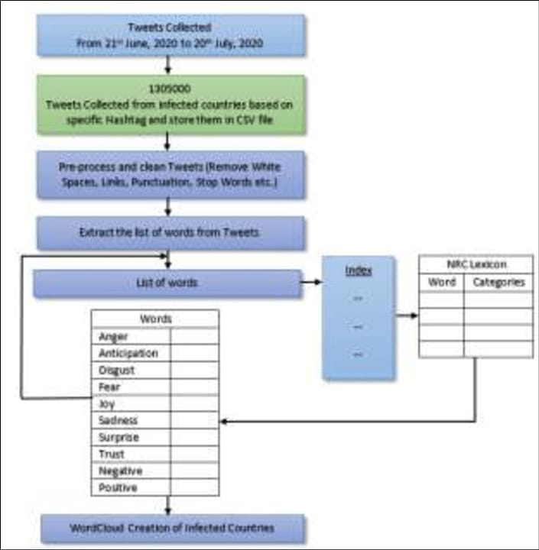

* + 1. **DFD Level 0**
    2. **DFD Level 1 - Student Face Registration Module:**
    3. **DFD Level 1 - Student Face Recognition Module:**
    4. **DFD Level 1 - Concentration Analysis Module:**
  1. **Advantages:**

**1. Real-time Insights:**

Twitter provides a continuous stream of real-time data, allowing for immediate analysis of public sentiment and emotions surrounding events, products, or topics.

**2. Brand Perception:**

Emotional analysis helps businesses gauge how their brand is perceived by the public, enabling them to tailor their marketing strategies accordingly.

**3. Crisis Management:**

Identifying and analyzing emotional responses during crises can help organizations assess the severity of the situation and respond effectively to mitigate negative sentiment**.**

**4. Product Feedback:**

Emotional analysis of tweets can provide valuable feedback on products or services, helping companies understand customer satisfaction and areas for improvement.

**5. Trend Identification:**

By tracking emotional trends on Twitter, businesses can identify emerging topics or issues of concern, allowing them to stay ahead of the curve in their industry.



* + 1. **Requirement Specification**
    2. **Hardware Requirements:**

**1. Processor:** A multi-core processor (e.g., Intel Core i5 or higher) to handle data processing efficiently.

**2. Memory (RAM):** At least 8GB RAM for handling large datasets and running analytical algorithms smoothly.

**3. Storage**: SSD storage for fast data retrieval and processing.

**4. Graphics Processing Unit (GPU):** Optional but beneficial for accelerating certain deep learning models used in sentiment analysis.

**5. Network Connectivity**: High-speed internet connection to fetch real-time Twitter data.

**6. Software**: Depending on the analysis techniques, you might need software frameworks like Python (with libraries like NLTK, TextBlob, TensorFlow, etc.), R, or specific sentiment analysis tools.

* + 1. **Software Requirements:**

**1. Programming Language: analysis.** Python is commonly used due to its extensive libraries for natural language processing (NLP) and sentiment

**2. NLP Libraries:**

Libraries such as NLTK (Natural Language Toolkit), spaCy, TextBlob, or StanfordNLP for text preprocessing, tokenization, and part-of-speech tagging.

**3. Sentiment Analysis Libraries:**

Libraries like VADER (Valence Aware Dictionary and sEntiment Reasoner), TextBlob, or pre-trained models from libraries like TensorFlow or PyTorch for sentiment analysis.

**4. Twitter API:** Access to the Twitter API to fetch real-time or historical tweets. Libraries like Tweepy in Python make it easy to interact with the Twitter API.

**5. Data Visualization**: Libraries like Matplotlib, Seaborn, or Plotly for visualizing sentiment analysis results.

**6. Optional:** If using deep learning techniques, TensorFlow or PyTorch for building and training neural networks.

**7. Development Environment**: IDEs like Jupyter Notebook, PyCharm, or VSCode for writing and testing code.

**8. Dependencies Management:** Tools like pip (for Python) or Conda for managing package dependencies.

**CHAPTER 4**

**Implementation and Result**

**CHAPTER 4**

**IMPLEMENTATION and RESULT**

1. **Results of Face Detection**
2. **Results of Face Recognition**
3. **Result Of Concentration Analysis**

**PROGRAM**

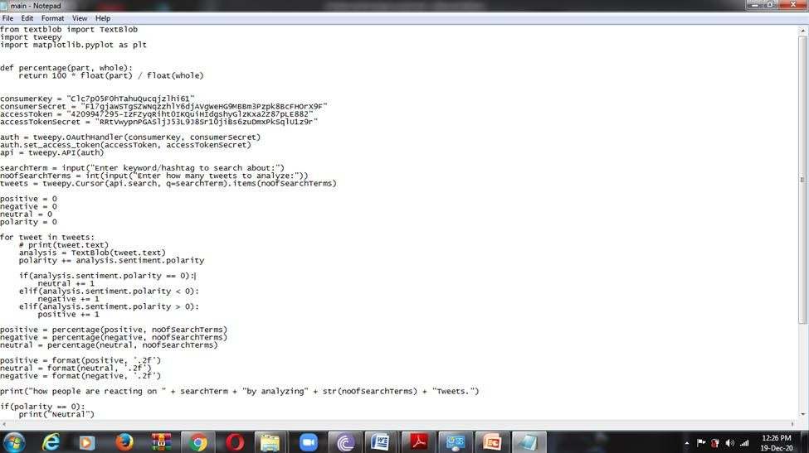

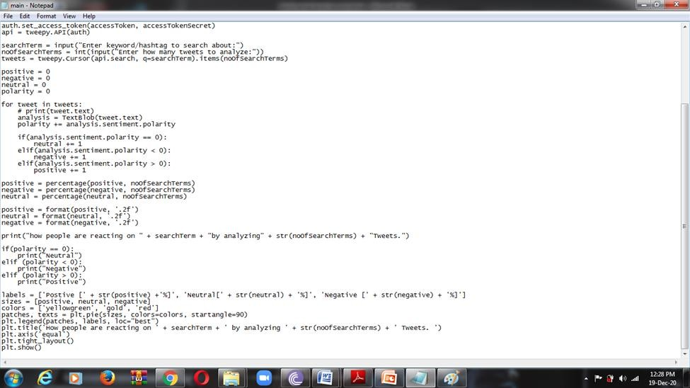

**OUTPUT**

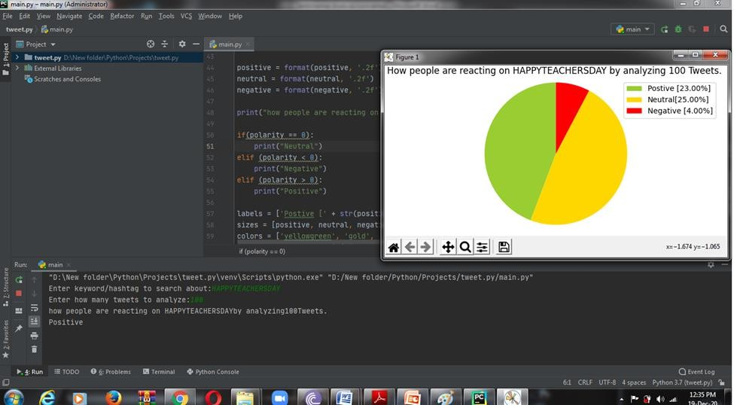

**CHAPTER 5**

**CONCLUSIONCHAPTER 5**

**CONCLUSION**

**ADVANTAGES:**

**1. Real-time Insights*: Twitter provides a stream of real-time data, allowing sentiment analysis to capture current opinions and reactions to events, products, or topics as they unfold.**

**2. *Customer Feedback*: Sentiment analysis on Twitter can help businesses understand customer opinions and sentiments regarding their products, services, or brands. This feedback can be used for product improvement, marketing strategies, and customer satisfaction management.**

**3. *Brand Monitoring*: By analyzing sentiment on Twitter, businesses can monitor their brand reputation, identify potential crises or negative publicity, and promptly address issues before they escalate.**

**4. *Market Research*: Twitter sentiment analysis enables businesses to gain insights into market trends, consumer preferences, and competitor activities. This information can inform strategic decision-making and market positioning.**

**5. *Campaign Evaluation*: Companies can assess the effectiveness of their marketing campaigns, product launches, or events by analyzing sentiment on Twitter. Positive sentiment indicates successful engagement, while negative sentiment may signal areas for improvement.**

**6. *Event Tracking*: Sentiment analysis on Twitter can track public sentiment around events, conferences, or product launches in real-time. This information can help event organizers gauge audience reactions and adjust strategies accordingly.**

**7. *Political Analysis*: Twitter sentiment analysis is used in political campaigns and research to gauge public opinion, assess candidate popularity, and monitor sentiment towards political issues and policies.**

**8. *Predictive Analytics*: By analyzing historical Twitter data and sentiment trends, businesses and researchers can develop predictive models to anticipate market movements, consumer behavior, or social phenomena.**

**Overall, Twitter sentiment analysis provides valuable insights for businesses, marketers, researchers, and policymakers to make informed decisions, enhance customer experiences, and stay ahead of trends and challeng**

**SCOPE:**

**1. Sentiment Analysis: Determining the overall sentiment (positive, negative, neutral) of tweets to understand the general mood or opinion around a particular topic, brand, event, etc.**

**2. Emotion Detection: Identifying and categorizing specific emotions expressed in tweets, such as joy, anger, sadness, surprise, etc., to gain deeper insights into how people are feeling about a given subject.**

**3. Trend Analysis: Examining trends in emotional expression over time, such as spikes in certain emotions during specific events or changes in sentiment towards a brand or product.**

**4. Geographic Analysis: Analyzing emotional expression based on geographic location to understand regional variations in sentiment or to target specific audiences more effectively.**

**5. Demographic Analysis: Exploring emotional patterns based on demographic factors such as age, gender, occupation, etc., to tailor messaging or marketing strategies accordingly.**

**6. Influencer Analysis: Identifying key influencers or opinion leaders within a specific emotional context to leverage their influence for brand promotion or engagement.**

**7. Crisis Management: Monitoring and analyzing emotional responses during crisis situations to assess public sentiment, address concerns, and manage reputation effectively.**

**8. Customer Feedback Analysis: Using emotional analysis to extract valuable insights from customer feedback on products, services, or brand experiences to improve offerings and customer satisfaction.**

**9. Competitor Analysis: Comparing emotional responses towards competitors to identify strengths, weaknesses, opportunities, and threats in the market landscape.**

**10. Brand Perception Analysis: Evaluating how emotions expressed towards a brand impact its overall perception and reputation among consumers.**

**By defining the scope of Twitter emotional analysis based on specific objectives and desired outcomes, organizations can gain actionable insights to inform decision-making, improve customer engagement, and enhance brand strategies effectively.**

**REFERENCE**

[1] Albert Biffet and Eibe Frank. Sentiment Knowledge Discovery in Twitter Streaming Data. Discovery Science, Lecture Notes in Computer Science,2010, Volume 6332/2010, 1 15, DOI: 10.1007/978-3-642-16184-1_1

[2] Alec Go, Richa Bhayani and Lei Huang. Twitter Sentiment Classification using Distant Supervision. Project Technical Report, Stanford University,2009.

[3] Alexander Pak and Patrick Paroubek. Twitter as a Corpus for Sentiment Analysis and Opinion Mining. In Proceedings of international conference on Language Resources and Evaluation (LREC),2010.

[4] Andranik Tumasjan, Timm O. Sprenger, Philipp G. Sandner and Isabell M. Welpe. Predicting Elections with Twitter: What 140 Characters Reveal about Political Sentiment. In Proceedings of AAAI Conference on Weblogs and Social Media (ICWSM),2010.

[5] Bo Pang, Lillian Lee and Shivakumar Vaithyanathan. Thumbs up? Sentiment Classification using Machine Learning Techniques. In Proceedings of the Conference on Empirical Methods in Natural Language Processing (EMNLP),2002.

[6] Chenhao Tan, Lilian Lee, Jie Tang, Long Jiang, Ming Zhou and Ping Li. User Level Sentiment Analysis Incorporating Social Networks. In Proceedings of ACM Special Interest Group on Knowledge Discovery and Data Mining (SIGKDD), 2011

. [7] Efthymios Kouloumpis, Theresa Wilson and Johanna Moore. Twitter Sentiment Analysis: The Good the Bad and the OMG! In Proceedings of AAAI Conference on Weblogs and Social Media (ICWSM),2011.

**GIT Hub Link of Project Code:**