Input given inside user.txt file

run in terminal inside the folder susmaga_algo:
python3 susmaga.py

Output:
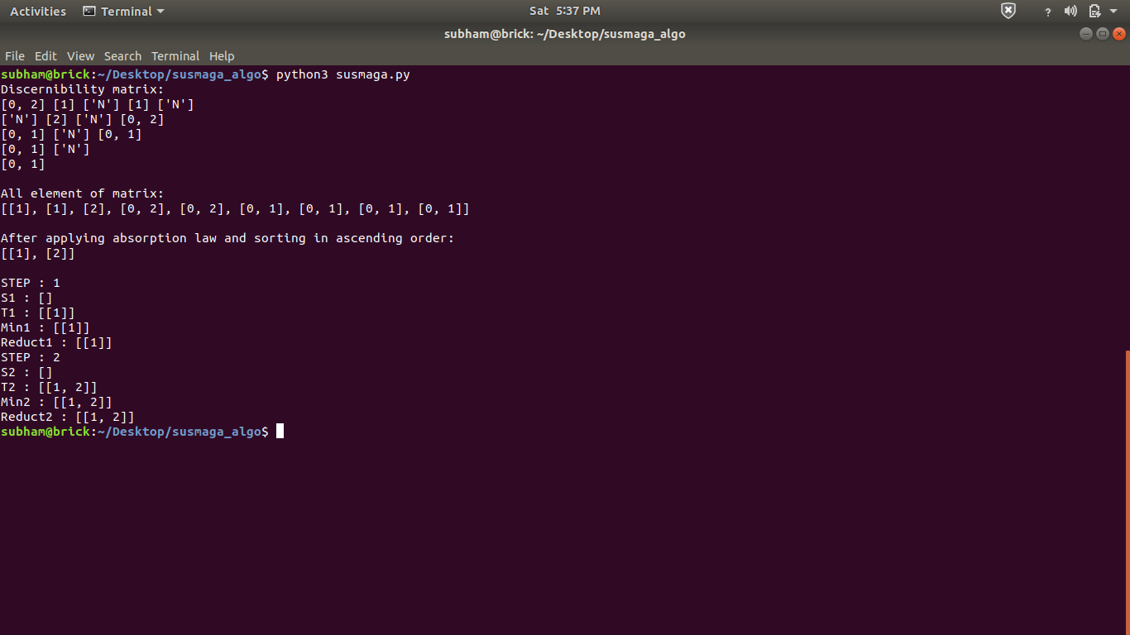

To test reduct computation run reduct_test.py file in terminal:
python3 reduct_test.py

Output:
