PROJECT REPORT
CLOUD ARCHITECTURE DESIGN AWS CLOUD PROJECT

Smart Storage Tier Recommender for Cancer Imaging Archives
Clinical Context and Pretrained MRI Analysis
Submitted by:
Pratyush Chandrasekhar – 24BIT0226
Mehul Anand – 24BIT0185
Subhrojyoti Das – 24BIT0194
Programme / Branch / Year: B.Tech. – Information Technology – III Year
Course Code and Name: BCSE355L – Cloud Architecture Design
Institution: Vellore Institute of Technology, Vellore
Course Instructor / Guide: Dr. Priya V
GitHub Repository: https://github.com/SUBHRO71/SmartStorageTierRecommenderForMedicalSector_Cloud_Project_2026
Date of Submission: 16/10/2026

Abstract
Medical imaging archives must balance storage cost with the time required to retrieve complete studies. A study can include multiple MRI sequences and associated clinical context; moving only some members or archiving an actively used study can make the archive difficult to use. CloudTierRecommender addresses this problem through a study-oriented storage workspace and an explicit access-constrained cost policy. The implemented local application uses React and Vite for the interface and Flask with SQLite for persistent studies, object metadata and audit events. It imports DICOM and NIfTI files, records checksums and measured sizes, validates DICOM identities, and joins allowlisted clinical CSV fields using exact subject identifiers. NIfTI previews support three anatomical planes. A frozen MONAI BraTS SegResNet adapter analyses four preprocessed MRI sequences and records nested tumour-region masks, volumes and model provenance. These measurements support research inspection and do not produce a diagnosis or retrieval probability. Storage recommendations compare S3 Standard, Standard-IA, Glacier Flexible Retrieval and Deep Archive after applying active-use, hold, access-time and completeness constraints. Placement and complete-study restore are implemented as explicit local simulations. The retained earlier chest X-ray application includes AWS API and inference Lambda handlers and a SAM infrastructure template covering S3, DynamoDB, Cognito, API Gateway, CloudFront, EventBridge, SNS, CloudWatch and IAM. Current validation includes 28 passing automated tests and a successful frontend build. The model compatibility record uses synthetic inputs; real TCIA or BraTS cohort evaluation, clinical accuracy assessment, v2 cloud execution and measured AWS savings remain future work.

Keywords
Cancer imaging archive; Amazon S3; study bundle; clinical linkage; NIfTI; DICOM; pretrained SegResNet; storage cost simulation.

Table of Contents
- 1 Introduction
- 2 Literature Survey and Related Work
- 3 Project Objectives
- 4 Novelty Summary
- 5 System and Architecture
- 6 Dataset and Input Description
- 7 AWS Services and Deployment Status
- 8 Methodology and Implementation
- 9 Implemented Modules and Evidence
- 10 Testing Results and Observations
- 11 Discussion Limitations and Risks
- 12 Team Contribution and Version Control
- 13 Conclusion and Future Enhancements
- References
- Appendix A Project Timeline
- Appendix B Completion Review

1 Introduction

1 1 Background
Medical imaging archives contain related studies, series and files that must remain usable together. MRI studies commonly require several complementary sequences, and associated clinical fields must be linked to the correct subject. Storage-class selection therefore needs explicit access requirements and reliable bundle metadata alongside a monetary comparison. The current project centres on a local cancer-imaging archive, with Amazon S3 classes serving as the target storage policy vocabulary.

1 2 Problem Statement
The problem is to recommend the lowest modeled-cost class for a complete imaging study while respecting a declared maximum access delay, active-use periods, manual holds, sequence completeness and clinical-linkage status. A cheap recommendation is insufficient if the study is incomplete or its use requires immediate access. The current implementation makes these constraints visible, evaluates object-level fees, and requires a reviewable action before recording simulated placement.

1 3 Motivation and Significance
The literature review motivates transparent cloud cost modeling, medical-data preparation and auditable archive operations. The current project translates these concerns into a working study workspace. It keeps research segmentation, clinical linkage and storage policy separately inspectable so an administrator can understand a recommendation without treating image-derived measurements as evidence of future retrieval.

1 4 Scope
Included in the current local release: study and object persistence; validated DICOM/NIfTI uploads; exact clinical CSV matching; three-plane NIfTI previews; a frozen four-sequence MRI segmentation worker; explicit study access requirements; per-tier modeled costs; reviewed local placement, local bundle restore and audit history; responsive archive overview, explorer, quality queue, imports, operations and cost pages. The earlier X-ray application and AWS implementation remain available separately. Excluded from completion claims: local model training, clinical diagnosis, automatic raw-DICOM preprocessing, provider-driven dataset acquisition, live hospital integration, v2 AWS study operations and production governance.

1 5 Report Organisation
The report retains the original literature survey and academic structure while describing the current study-archive implementation. Sections 3 to 6 cover objectives, contribution, architecture and inputs. Sections 7 to 10 distinguish AWS infrastructure, implemented local behavior and validation evidence. Sections 11 to 13 record limitations, team ownership and remaining milestones.

2 Literature Survey and Related Work
Fifteen papers were reviewed, five by each member (P1–P5 Pratyush Chandrasekhar, P6–P10 Subhrojyoti Das, P11–P15 Mehul Anand). Ten are from Springer, MDPI, Nature Portfolio and Frontiers journals; P6–P10 are recent (2025–2026) arXiv preprints, chosen because they are the most current work on learned storage placement and open medical-imaging platforms. P5, P11 and P15 (2022) fall outside the preferred 2023–2026 window but are kept because they are the closest prior work on learning where healthcare data should be stored. Table 1 summarises each paper and its relation to this project.
Table 1. Literature survey of the 15 reviewed papers.
Paper ID | Full citation / DOI / URL | Problem addressed | Method / architecture | Dataset / evaluation | Key findings
P1 | Khan, Matskin, Prodan, Bussler, Roman & Soylu (2024). Computing, 106, 3389–3418. doi:10.1007/s00607-024-01281-2 | Cut cloud storage cost by placing objects in the right tier | Rule-based score from size, age and access frequency → premium/hot/cold/archive; game-theory variant tunes weights | Synthetic data from a Kaggle access log: 871 days, 14,321 files, ~2.9 M reads; 1–67 TB; Google Cloud prices | Four-tier placement lowers cost; game-theory variant slightly cheaper and faster; transition and early-deletion fees omitted
P2 | Shakor & Khaleel (2024). Electronics, 13(24), 4860. doi:10.3390/electronics13244860 | Survey of deep learning + cloud for big medical image data | Systematic review of 37 papers (2019–Nov 2024) plus hospital case studies | No experiment; e.g. 5 hospitals, 1.2 M scans/year on hybrid cloud | Retrieval time 5–7 min → ~30 s; ~40% lower infrastructure cost; storage cost is a major problem; DL used only for diagnosis
P3 | Urbaniak (2024). Applied Sciences, 14(22), 10524. doi:10.3390/app142210524 | Effect of lossy JPEG/JPEG2000 compression on deep learning | Review of studies training/testing on compressed, uncompressed and mixed images | Prior studies on MNIST, CIFAR-10, mammography, digital pathology | 85% compression kept ~95% performance (pathology); no agreed safe limit per modality; compression fixed for whole archive
P4 | Dai (2025). Scientific Reports, 15, 40008. doi:10.1038/s41598-025-23582-y | Compress medical images without losing diagnostic detail | Wavelet transform + cross-attention module + small autoencoder; learned decoder | LIDC-IDRI, LUNA16, MosMed CT (70/15/15, 5-fold) + brain MRI; PSNR, SSIM, time | PSNR 40.43 dB, SSIM 0.9715, 635 ms/image on CPU; beats JPEG2000, HEVC, BPG; attention output discarded after compression
P5 | Mani, Kavitha, Band, Mosavi, Hollins & Palanisamy (2022). Frontiers in Public Health, 9, 831404. doi:10.3389/fpubh.2021.831404 | Recommend where to store EHR data blocks | Experts rate storage options on five criteria; MLP, Random Forest, Random Tree, IB1 (WEKA) and a DL model | Synthetic 1,200- and 2,000-record sets from expert ratings; accuracy, precision, recall, F1 | Random Forest 98.21% on 1,200 records, DL 88.70%; storage choice can be learned, but only once, on text, from opinion
P6 | Nadig, Arulchelvan, Bera, Shahroodi, Singh, Kakolyris, Yuksel, Sadrosadati, Park & Mutlu (2025). Harmonia. arXiv:2503.20507 | Data placement and migration in hybrid storage | Two cooperating RL agents: placement and migration; tiny models | 25 real traces (SYSTOR17, RocksDB, YCSB, MLPerf, LLM, Meta Baleen unseen); real SSD/HDD hardware | 29.3–44.8% lower latency, +136.7% IOPS; 240 ns per decision, 206 KiB; behaviour-only, no cloud bill
P7 | Bera, Nadig & Mutlu (2026). ML-driven intelligent memory system design. arXiv:2603.14583 | Self-optimising memory and storage | Overview of Pythia (RL prefetcher), Hermes (perceptron) and Sibyl (RL data placement) | Sibyl: 14 MSR Cambridge enterprise traces on real machines; six behavioural inputs | Sibyl beats heuristics by 19.9–45.9% and prior ML by 34.1–68.8%; cold-start problem for new data
P8 | Gupta & Bhayani (2025). Cold-RL: offline RL cache eviction for NGINX. arXiv:2508.12485 | Replace LRU eviction with a learned policy | Dueling DQN scores K LRU candidates on age, size, hits, TTL; trained offline from logs | Replayed NGINX access logs; 25, 100, 400 MB caches; hit rate, CPU | Hit rate 14.36% → 35.38% (25 MB) and 75.30% → 86.75% (100 MB); <2% CPU; binary keep/evict; no cost
P9 | Akünal, Bujotzek, Denner, Hamm, Kades, Schader, Scherer, Nolden, Neher, Floca & Maier-Hein (2025). Kaapana. arXiv:2512.09644 | Open platform for AI in medical imaging research | Kubernetes/Helm, Airflow, MinIO (S3), OpenSearch DICOM index, Keycloak, PACS, nnU-Net | Deployment evidence: RACOON, CCE-DART, DKTK, NeuroRad | Working hospital-grade platform with S3-compatible storage and DICOM index, but flat storage with no tiering or cost awareness
P10 | Deng, Tang, Huang et al. (2026). Project Imaging-X. arXiv:2603.27460 | Catalogue open medical imaging datasets | Survey of 1,000+ datasets by modality, task, region, annotation; metadata-driven fusion | The catalogue itself; public portal and table | No public dataset records who retrieved which scan when; the retrieval label must be derived
P11 | Mondal, Mukhopadhyay & Chattopadhyay (2022). Complex & Intelligent Systems, 8, 489–505. doi:10.1007/s40747-021-00517-4 | Automatic storage-space recommendation for object storage | Ganglia records 18 server metrics; Fisher/F-score/Lll21 selection + SVM/K-NN/NN → Cassandra, MongoDB or HDFS | Self-generated health workload (sensor streams, documents, files), 1:1:1 classes | Lll21 + K-NN best; decides from server readings, never file content; offline; no cost model
P12 | Amaithi Rajan, Vetriselvi, Ajitesh & Praveen Kumar (2025). Scientific Reports, 15, 32965. doi:10.1038/s41598-025-16903-8 | Secure, fault-tolerant medical image storage and retrieval | SFMedIR: federated ConvNeXt hashing, quantum-chaos encryption, master/slave shadow storage; Docker on EC2 | Alzheimer MRI, Brain Tumour MRI (7,023), Kidney CT; PGD attacks | ~90% retrieval accuracy, robust under attack; every image stored the same, cost never measured
P13 | Lemaréchal, Couture, Pelletier, … Ingrisch & Després (2025). J. Imaging Informatics in Medicine, 39(2), 1783–1795. doi:10.1007/s10278-025-01554-y | Research platform for medical imaging data science | PARADIM: Karnak, Kheops, Orthanc, Keycloak + MFA, OHIF, Kubernetes job manager | Real institutional CT, MRI, RT collections; ~10 ethics-approved projects | Complete DICOM pipeline with audit, but single storage class, no archiving, no cost figures
P14 | Vahdati, Khosravi, Mahmoudi, … Gichoya & Erickson (2024). J. Imaging Informatics in Medicine, 37(5), 2015–2024. doi:10.1007/s10278-024-01083-0 | Open-source tools to make imaging data AI-ready | SIIM survey: 54 responses from 26 centres → 28 tools grouped by preparation stage | Survey responses; no images analysed | Useful tool map (de-identification, conversion, labelling); storage only a tick-box; no cost or tiering
P15 | Hai, Zhou, Srividhya, Jain, Young & Agrawal (2022). Journal of Cloud Computing, 11, 22. doi:10.1186/s13677-022-00294-6 | Cloud medical-record recommendation with privacy | BVFLEMR: Hyperledger Fabric blockchain + vertical federated learning + LightGBM, N-gram and sentiment | Unnamed EHR dataset fed at 20–100% | Precision 0.953, recall 0.932, F1 0.950; text only; all records stored permanently at one cost

2 1 Synthesis and Comparison
The original review groups related work into storage placement, medical image analysis and imaging platforms. Storage studies discuss access behavior, placement mechanisms or cost, while imaging work covers analysis, compression, retrieval or data preparation. These findings motivate the project but do not validate its current MRI adapter or cost outcomes. Table 2 retains the original paper comparison and updates the project row for the implemented v2 scope.
For the current version, the practical connection is a shared archive workspace rather than a learned clinical retrieval predictor. Segmentation outputs are available for inspection; access requirements and completeness determine storage eligibility. A comparison against S3 Intelligent-Tiering, or an ablation showing value from image-derived signals, has not been implemented or evaluated.
Table 2. Comparison of the reviewed work against the properties required by this project (Yes / Part / No).
Paper | Medical data | Uses image content | Uses access history | Multiple cloud storage classes | Monetary cost model | Re-evaluates placement over time | Security / compliance
P1 | No | No | Yes | Yes (4) | Part | Part | No
P2 | Yes | Yes (diagnosis) | No | Part | Part | No | Yes
P3 | Yes | Yes | No | No | Part | No | No
P4 | Yes | Yes | No | No | No | No | No
P5 | Yes (EHR) | No | No | Part (3) | Part | No | Yes
P6 | No | No | Yes | Part (devices) | No | Yes | No
P7 | No | No | Yes | Part (devices) | No | No | No
P8 | No | No | Yes | No (2-way) | No | Yes | No
P9 | Yes | Yes (diagnosis) | No | No | No | No | Yes
P10 | Yes | No | No | No | No | No | Part
P11 | Part | No | No | Part (DBs) | No | No | No
P12 | Yes | Yes (retrieval) | No | No | No | No | Yes
P13 | Yes | Part | Part | No | No | No | Yes
P14 | Yes | No | No | No | No | No | Part
P15 | Yes (EHR) | No | No | No | No | No | Yes
This project v2 | Yes research archive | Yes for inspection | Declared workload | Four target S3 classes | Partial explicit fees | Local reviewed actions | Local demo AWS v1 configured

2 2 Individual Research Gap Analysis
The original individual analyses cover P1 to P5 for Pratyush Chandrasekhar, P6 to P10 for Subhrojyoti Das, and P11 to P15 for Mehul Anand. Table 3 preserves their research questions and possible improvements as literature-stage proposals. Suggested training, image-based retrieval prediction and compression changes in that table are not claims about implemented v2 behavior.
Table 3. Individual research gap analysis (condensed from each member's report).
Paper ID | Existing method | Advantages | Limitations | Research gap identified by student | Possible improvement
Student 1 – Pratyush Chandrasekhar (24BIT0226): papers P1–P5
P1 | Score from size, age and access frequency; fixed thresholds map to four tiers; game-theory variant | Four tiers match S3; simple, fast, platform-independent | Synthetic data; omits transition and early-deletion fees; hand-set thresholds; never opens the file | Two scans with equal size, age and views are treated identically even if one is clinically important; no legal retention rule | Add an image-derived input and DICOM details; learn thresholds from re-access history; include S3 transfer charges
P2 | Systematic review of DL + cloud for medical imaging | Quantifies cloud benefits (30 s retrieval, ~40% cost cut); names storage as a key cost | No experiment or code; hospital figures unverifiable; DL only for diagnosis | Shows storage is costly and DL reads scans well but never feeds the model's output back to storage | One model pass serves both the clinician and the tier decision; evaluate on retrieval time, monthly bill and compliance
P3 | Review of lossy JPEG/JPEG2000 effects on DL | Real numbers on space vs. accuracy; DICOM-allowed formats only | Studies conflict; no safe limit per modality; compression fixed for whole archive | Compression and storage class are one decision seen from two sides, yet neither varies per scan | Make compression a second output: full quality in hot tiers, proven-safe ratio in deep archive
P4 | Wavelet + cross-attention + autoencoder compression | Beats JPEG2000/HEVC/BPG; attention protects important regions; CPU-trainable | Mostly CT/brain MRI; 635 ms/image; maths metrics only; no storage or cost view | The attention map already locates medically important content but is discarded after compression | Feed an image-importance score into the tier decision; evaluate with downstream task accuracy and the S3 bill
P5 | Expert-rated criteria + classifiers recommend a storage location | Closest prior work; multi-criteria; privacy built in; reports F1 | Trained on opinion, imbalanced classes, label fixed once, text only, three broad options, 2022 | Decision taken once at arrival, never revisited, and never looks at image content | Train on re-access behaviour, work per scan with image features, re-check with Lifecycle; penalise wrong archiving more
Student 2 – Subhrojyoti Das (24BIT0194): papers P6–P10
P6 | Two cooperating RL agents for placement and migration | Large latency/IOPS gains; 3–4 devices; 240 ns, 206 KiB; generalises to unseen traces | No medical data; behaviour-only inputs; "cost" means hardware; tuned once; no retention | A follow-up oncology CT and a routine X-ray with equal behaviour are placed identically; cost is not a cloud bill | Keep placement + migration; add image and DICOM inputs; reward the real S3 bill; make the penalty asymmetric
P7 | Overview of Pythia, Hermes and Sibyl (RL placement) | Learning beats rules by 19.9–68.8%; real hardware; inputs stated openly | Six behavioural inputs only; enterprise traces; cold start; devices not cloud classes | Sibyl's six inputs state the project's gap in one line: none describes what the data is, so new scans are placed blindly | Extend inputs with metadata and a learned image feature to solve the cold-start problem on day one
P8 | Dueling DQN replaces LRU eviction; trained offline from logs | Offline training from recorded logs; inputs map to scan attributes; <2% CPU; public code | Web cache, two outcomes, binary reward, no money, benefit shrinks with cache size | A two-way, equal-cost decision cannot express that wrongly archiving a needed scan is far worse than overpaying | Reuse the offline pipeline; widen to four S3 classes; reward in money with a heavy penalty for wrong archiving
P9 | Kaapana: Kubernetes, Airflow, MinIO, OpenSearch, Keycloak, PACS, nnU-Net | Proven in real networks; S3-compatible; DICOM index already built; free | Flat storage, no cost awareness, no lifecycle, AI only diagnostic, no storage metrics | Owns every ingredient (index, S3 store, scheduler, DL) yet connects none of them to placement | Run the tier recommender as a scheduled job that writes S3 lifecycle decisions
P10 | Catalogue of 1,000+ open imaging datasets with fusion paradigm | Solves dataset search; records limitations; current (2026); free portal | Catalogue only; all diagnostic; no access logs; many PNG/JPEG without DICOM headers | Over 1,000 datasets exist, yet none records retrievals, so the label must be derived rather than downloaded | Pick a dataset with repeated patient studies; derive a follow-up proxy label; state it openly and test sensitivity
Student 3 – Mehul Anand (24BIT0185): papers P11–P15
P11 | Server metrics + feature selection + classifier choose Cassandra/MongoDB/HDFS | Proves a model can choose storage; removes manual schema edits; useful 9-way comparison | Offline, uncorrectable; three classes, no DICOM; one workstation; small self-made data; no cost or security | Decides by watching the server, not the data, so two CT scans written together look identical; picks a database, not a priced class | Use image + metadata + access history; output an S3 class tied to cost; re-check via Lifecycle
P12 | SFMedIR: federated ConvNeXt hashing, encryption, shadow storage on EC2 | Content codes for scans; privacy via FL; security + fault tolerance + accuracy together | Idealised network; small simulation; cost and delay unmeasured; same storage for every image; custom crypto | Builds an image code that describes content, but uses it only for search, never for placement | Point the content representation at retrieval likelihood; use S3 SSE and replication; report the bill and restore time
P13 | PARADIM: Karnak, Kheops, Orthanc, Keycloak, OHIF, Kubernetes jobs | Complete DICOM pipeline; strong governance and audit; free components | On-premises only; no tiers, archive or cost figures; heavy DevOps; partly manual labelling | Records who opened which scan and when, yet uses it only for traceability; old scans stay on expensive storage for ever | Rebuild the flow on AWS (S3, Lambda, Cognito) and add a model that uses access history to choose the S3 class
P14 | SIIM survey of 28 open-source data-preparation tools | Saves tool-selection time; whole pipeline; real centres; flags cloud/FL support | Nothing measured; ~11% response; dates quickly; no pipeline design; no cost | Stops where storage begins; metadata produced during preparation is thrown away instead of reused | Chain tools automatically on AWS and keep modality, body part, size and quality as model features
P15 | BVFLEMR: blockchain + vertical FL + LightGBM recommendation | Learning-based healthcare decision; LightGBM fast baseline; full audit; reports F1 | Dataset unnamed; recall drops as data grows; blockchain cost unmeasured; text only; one storage setting | Intelligence sits in front of a storage layer with one setting; nothing predicts re-access, the one prediction that decides the bill | Predict per-scan re-access, choose an S3 class, keep only a hash in a ledger, report cost and restore time

2 3 Consolidated Research Gap
The retained review identifies a project opportunity at the intersection of medical archive context, explicit storage costs and auditable operations. The current implementation addresses a narrower and testable part of that opportunity: complete-study metadata, exact clinical linkage, inspectable pretrained MRI outputs and a cost comparison constrained by declared access needs. It does not establish a globally novel algorithm or show that tumour measurements predict access. Retrieval forecasting and cohort-level cost evaluation remain separate research questions.

3 Project Objectives
The following six objectives describe the current implementation. Completion is assessed through the code, automated checks and explicitly bounded evidence in Section 10.
Objective 1 Study import and integrity. Persist study and sequence membership, measured bytes, checksums and source declarations. Reject malformed files and inconsistent DICOM identities without leaving partial studies. Success criterion: corresponding import and integrity regression tests pass.
Objective 2 Clinical context and MRI inspection. Support exact clinical joins, missing or ambiguous states, real NIfTI slice previews and frozen four-sequence segmentation with input and checkpoint provenance. Success criterion: import and preview tests pass and synthetic adapter evidence records masks, volumes and runtime. Clinical accuracy is a separate future assessment.
Objective 3 Transparent storage policy. Compare four S3 classes using object-level storage, transition, retrieval, archive metadata and temporary-copy costs, after explicit access and completeness constraints. Success criterion: monetary components sum to each candidate total and guarded study cases remain in Standard.
Objective 4 Reviewed study operations. Record complete-bundle local placement and restore with optimistic version checks and append-only events. Success criterion: stale placement is rejected and the complete local bundle is available after simulated restore.
Objective 5 Cloud integration foundation. Retain the implemented v1 AWS handlers and SAM stack while separating the v2 local archive from unsupported cloud execution. Success criterion for current scope: cloud-handler tests pass and the v2 DynamoDB-mode gate is explicit. Live v2 deployment remains pending.
Objective 6 Usable archive workspace. Provide overview, study exploration, clinical and policy detail, MRI workbench, imports, quality queue, operations and cost comparison. Success criterion: production build passes; recorded browser and responsive checks support usability at desktop and phone widths.

3 1 Expected Outcomes
Delivered outcomes are the local study archive, validated import and clinical linkage, MRI previews and pretrained inference adapter, explicit storage policy, audited local operations, redesigned interface, retained v1 AWS code and this report. Acceptance evidence comprises 28 automated tests rerun on 16 October 2026, the production frontend build, and the repository model compatibility record dated 11 October 2026. Real-data performance, observed S3 transitions and actual savings are not acceptance results of this local milestone.

4 Novelty Summary
Table 4 describes implemented integration choices and the evidence available for each. These are project contributions within the reviewed scope, rather than claims of a new segmentation model or validated clinical retrieval predictor.
Table 4. Novelty dimensions.
Contribution | Prior motivation | Current implementation | Evidence and boundary
Complete study context | Object-only placement can miss related members | Explicit MRI roles, clinical state and study-level operations | Import and bundle tests; no provider acquisition
Transparent eligibility | Cost alone can overlook access requirements | Holds, active use, access hours and completeness guards before cost selection | Guard tests; no clinical safety claim
Research MRI inspection | Medical archive platforms need analysis provenance | Frozen SegResNet masks, volumes and input/checkpoint hashes | Synthetic adapter record; cohort accuracy pending
Auditable operations | Asynchronous or stale updates can mislead users | Version checks, append-only local events, separate v1 AWS mechanism | Regression tests; v2 cloud execution pending

The contribution is a reviewable study archive linking MRI sequence sets, clinical identifiers, pretrained analysis provenance and access-constrained cost recommendations. Published weights run without local training. V2 placement and restore are local simulations.

5 System and Architecture

5 1 System Overview
React/Vite and Flask/SQLite serve archive administrators, researchers and operators. Validated local imports create persistent study/object records. NIfTI previews and frozen SegResNet support inspection. The study-policy-v2.1 function returns eligible-class costs and a reason. Reviewed local placement and restore append audit events. The retained v1 AWS path is shown separately in Figure 1.

5 2 Retained AWS Architecture and Current Boundary
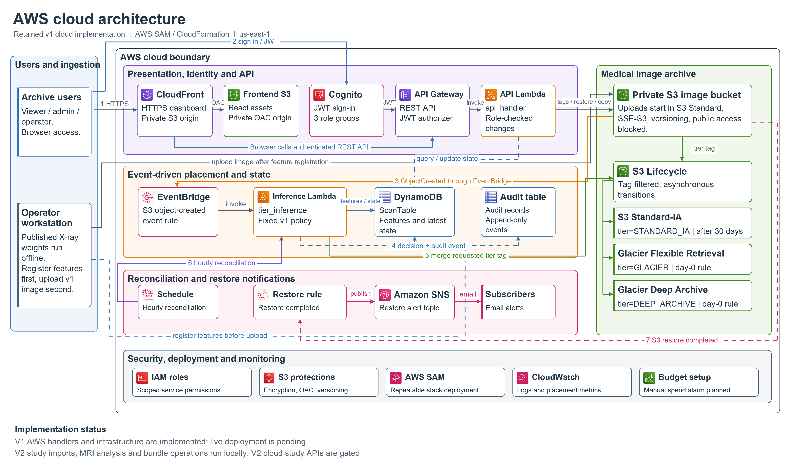
Figure 1. Implemented v1 AWS design and the separate v2 local archive. AWS resources are defined in code; live deployment and v2 study execution are pending.
The cloud resources below describe the retained v1 scan implementation in aws/template.yaml. They do not provide an operational cloud backend for the current study archive.
- Presentation. CloudFront with Origin Access Control serves a private S3 frontend build over HTTPS.
- Authentication. Cognito and API Gateway authorizers protect the v1 cloud API. Handler group checks distinguish viewer, archive-admin and operator mutations. The current local workspace uses demonstration authentication.
- API operations. The v1 cloud handler implements DynamoDB scan state and audit records, S3 tags, restore requests and warmer-class copy operations. These are code paths tested with mocked AWS calls.
- Ingestion. The retained X-ray workflow extracts published TorchXRayVision scores offline and registers features before uploading an image. This is separate from the v2 DICOM/NIfTI multipart import.
- Placement. The v1 S3-event handler applies the shared legacy decision engine, preserves existing tags and records pending state. Missing features leave the object in Standard.
- Lifecycle. The template defines tag-filtered S3 transitions. A tag request is not evidence that a transition has happened; actual changes require a deployed account and later reconciliation.
- Reconciliation. The retained EventBridge schedule invokes the v1 handler to inspect observed class and restore headers and update records.
- Notifications. The configured EventBridge restore-completed path publishes to SNS. Delivery has not been demonstrated in a deployed account.
- Infrastructure boundary. The SAM stack defines private encrypted buckets, role-based access and managed services. V2 archive APIs return HTTP 501 in DynamoDB mode. Study-bundle cloud persistence, placement, restore and member-level reconciliation remain to be implemented.

5 3 Current Study Archive Architecture
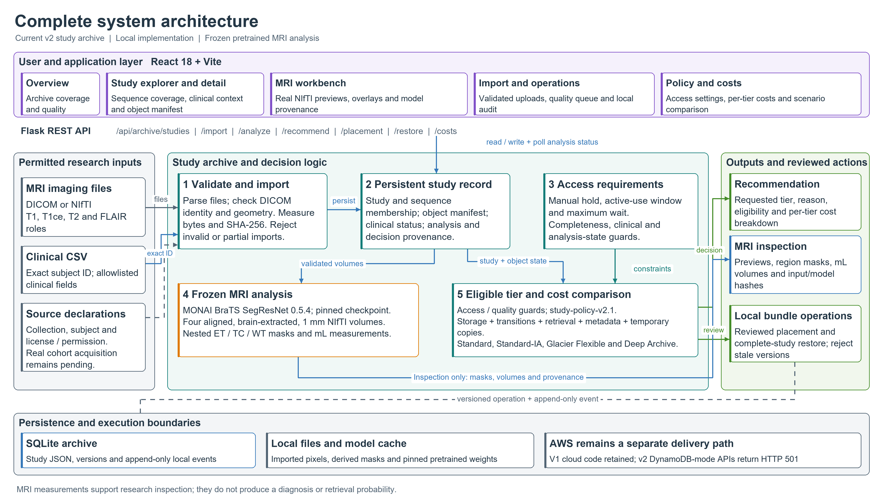
Figure 2. Current local study workflow. MRI outputs support inspection; declared access requirements and completeness constrain storage recommendations.
Import assigns T1, T1ce, T2 and FLAIR roles, validates files and records checksums and bytes. DICOM headers are checked against subject and study identifiers; exact clinical CSV matching yields verified, ambiguous or unmatched linkage. For inference, the adapter orders channels as T1ce, T1, T2 and FLAIR and requires matching shape/affine, 1 mm spacing and operator-attested alignment and brain extraction. SegResNet returns TC, WT and ET masks, nested ET within TC within WT, plus mL measurements and provenance. Independently, the policy uses holds, active-use flags, declared access hours, completeness, clinical status, analysis state and object size to determine eligible tiers, then chooses the lowest modeled monetary total.

5 4 Workflow Use Cases
The current local workflow has the following main use cases.
UC1 Import study. Declare collection, subject and permission; upload imaging with explicit sequence roles and optional clinical CSV. Parsed files become one persistent study. Invalid uploads are rejected and cleaned up.
UC2 Inspect study. Use the explorer and clinical, metadata and policy tabs. NIfTI files provide axial, coronal and sagittal previews. Synthetic sample records contain no pixels and show no invented analysis.
UC3 Run MRI analysis. Download the pinned checkpoint, import four preprocessed NIfTI volumes, attest preprocessing and start the local worker. Inspect status, overlays, volumes, input hashes and model provenance after successful completion.
UC4 Review storage. Set access tolerance, active use and hold flags with a reason; recompute policy; request version-checked local placement. Restore records complete-bundle availability in the local simulation.
UC5 Review archive cost and quality. Compare All Standard, Age-based, Current placement and Study policy under the same horizon and declared workload. Review missing sequences, clinical-linkage issues, holds and failed analyses.

5 5 Security Availability and Scalability Design
The current local archive persists SQLite study records and append-only application events. Mutations use study versions to reject stale actions; worker completion merges results without overwriting newer access settings. Startup marks interrupted analyses as failed. File hashes and model hashes support integrity and reproducibility. Clinical imports retain allowlisted fields; raw files remain local and are not automatically de-identified. The local authentication path is a demonstration identity, and server-side archive role enforcement is not claimed. The retained AWS design adds Cognito, IAM roles, private buckets, encryption, versioning and DynamoDB recovery; it still needs deployment evidence. Large-archive pagination, robust queued workers, governance and production monitoring remain future work.

6 Dataset and Input Description
Current runtime inputs are permitted local DICOM or NIfTI files and optional clinical CSV records. TCIA collections and BraTS-compatible MRI are the target research context, but no real patient cohort was acquired in this implementation. The sample cohort and model compatibility inputs are synthetic. NIH ChestX-ray14 belongs to the retained earlier X-ray evaluation direction.
Table 5. Dataset details.
Input attribute | Current implementation and evidence
Target domain | Cancer imaging studies with complete T1, T1ce, T2 and FLAIR MRI sequence sets.
Target sources | Permitted TCIA/other research collections and BraTS-compatible prepared MRI. No real cohort was downloaded for this milestone.
Accepted files | NIfTI .nii/.nii.gz and DICOM .dcm; optional UTF-8 clinical CSV. Local upload, not an automated provider download.
Current cohort | Explicit sample import: 12 synthetic study records, 46 objects, no image pixels or fabricated inference.
Declared sample size | 2,540,699,648 bytes in metadata. Ten complete studies and eleven synthetically verified clinical records. These are not measured real dataset counts.
Imported file evidence | File bytes and SHA-256 measured at import; source subject, collection and permission/license are required.
Clinical attributes | Allowlisted diagnosis, age, sex, grade, IDH and MGMT. Exact subject-ID match; unmatched and ambiguous states remain visible.
Analysis inputs | Four preprocessed, aligned, brain-extracted, 1 mm NIfTI volumes; adapter channel order T1ce, T1, T2, FLAIR.
Model fixture | Synthetic four-volume functional run recorded on 11 October 2026; no patient accuracy or diagnosis.
Permission and privacy | Dataset-specific terms apply. Upload declarations do not automatically de-identify raw files or establish patient correspondence.
Legacy dataset | NIH ChestX-ray14 is retained for the earlier X-ray direction; it is not the implemented v2 cancer cohort.

6 1 Data Preparation Plan
Imports require a source subject ID, collection and permission/license declaration. Clinical CSV matching uses subject_id, PatientID or ID and retains allowlisted diagnosis, age, sex, grade, IDH and MGMT values; common UCSF equivalents are recognized. Duplicate matching rows remain ambiguous. An exact join confirms the supplied identifier match, not independently verified patient identity; NIfTI subject correspondence remains a source declaration unless supported by a provider crosswalk. Raw DICOM conversion, registration and brain extraction are offline prerequisites for the MRI worker. No patient split, independent cohort metric or retrieval-log evaluation has been completed for v2.

7 AWS Services and Deployment Status
Table 6 identifies the AWS services defined for the retained v1 application. Configured means present in implementation or infrastructure code, rather than deployed. The current v2 study archive executes locally and does not yet use these resources for bundle operations.
Table 6. AWS services planning.
AWS service | Purpose in this project | Input/output or integration | Status | Security / cost considerations
Amazon S3 | Private image bucket (four storage classes) and private frontend bucket | ingest_scan.py uploads; ObjectCreated → tier_inference; tag-filtered Lifecycle; API tags, restores, copies | V1 configured not deployed | Block Public Access, SSE-S3, versioning, retained on delete. Standard-IA: 30-day minimum and 128 KB floor; Glacier 90 days; Deep Archive 180 days
AWS Lambda (EC2 not used) | api_handler (REST API) and tier_inference (placement + hourly reconciliation); Python 3.12, 256 MB, 30 s | API Gateway → api_handler; S3 event and EventBridge → tier_inference | V1 configured not deployed | Scoped execution roles; no PyTorch in package; pay per request, no idle cost (EC2 rejected, ADR-001)
Amazon DynamoDB (RDS not used) | ScanTable (latest state) and DecisionAuditTable (append-only) | Read/written by both Lambdas | V1 configured not deployed | On-demand billing; point-in-time recovery; key-value access suits the hot path (RDS rejected, ADR-004)
Amazon API Gateway | REST entry point for /api/* routes | Dashboard → API Gateway → api_handler | V1 configured not deployed | Cognito authorizer on every route; CORS limited to the frontend origin; default throttling
Amazon Cognito / AWS IAM | User pool and web client; viewer, archive-admin and operator groups; Lambda execution roles | JWT used by the dashboard and validated by API Gateway | V1 configured not deployed | Password policy ≥ 12 characters; group checks on mutations; MFA not yet enabled (planned)
Amazon CloudWatch | Lambda logs and custom placement metrics | tier_inference → PutMetricData | V1 configured not deployed | Alarms and log retention to be added; metric permission is the only wildcard resource
Amazon SNS | Alert topic for restore-completed notifications (e-mail) | EventBridge rule → SNS → subscribers | V1 configured not deployed | Topic policy allows publishing from EventBridge only; free e-mail allowance
Amazon CloudFront | HTTPS delivery of the React build | CloudFront → private frontend bucket (OAC) | V1 configured not deployed | Redirect to HTTPS; bucket not publicly readable
Amazon EventBridge | Hourly reconciliation schedule; S3 Object Restore Completed rule | Schedule → tier_inference; rule → SNS | V1 configured not deployed | No cost at this volume
AWS SAM / CloudFormation | Single deployable stack; deploy.ps1 packages, deploys and publishes the frontend | All resources above | V1 configured not deployed | Repeatable, reviewable infrastructure; no console drift
AWS Budgets | Spend alarm at US$1 before any resource is created | E-mail alert | Planned manual setup | Main protection against unexpected cost

7 1 AWS Deployment and Network Design
The checked-in engineering price snapshot uses us-east-1 and a review date of 21 September 2026. The deployment script packages the retained Lambda functions, deploys the SAM stack, builds the frontend and publishes its assets. This workflow requires AWS credentials, user/group setup and post-deployment evidence. The current local archive runs at frontend port 5173 and Flask port 5000 with SQLite. Selecting DynamoDB mode explicitly disables v2 archive endpoints. A future study-aware deployment must add bundle persistence, object operations and reconciliation before the v2 interface can claim cloud execution.

7 2 Cost Estimation
The current cost view is a declared-workload simulation using the checked-in price snapshot, not a live pricing feed or an AWS bill. Table 7 lists the model assumptions and exclusions. Prices must be reviewed before deployment; this report does not claim that the September snapshot is current AWS pricing.
Table 7. Implemented monetary model assumptions and exclusions.
Model item | Implemented assumption | Scope
Price source | USD us-east-1 engineering snapshot reviewed 21 September 2026 | No live price refresh
Storage | Per-object billable size and minimum duration by tier | Four class candidates
Transitions and retrieval | Per-object request charges and declared access count | Workload scenario
Archive metadata | 8 KiB at Standard plus 32 KiB at archive rate per archived object | Included
Temporary restored copy | One day of Standard storage for each modeled archive access | Scenario assumption
Excluded costs | Prior-tier exit charges, egress, compute, previews and other services | No actual bill claim
No monthly service spend or measured cloud savings are asserted. A deployment budget and service estimates must be established for the chosen account, region and workload. The comparison in Section 10 demonstrates the implemented simulator on declared synthetic object sizes. It excludes prior-tier exit charges, egress, compute, preview storage and other service overhead.

8 Methodology and Implementation Plan

8 1 Overall Methodology
The project progressed from literature and architecture work in July, through the local X-ray and AWS code in September, to the cancer-imaging study archive on 11 October 2026. V2 replaced image-based retrieval scoring as the main product story with explicit study access constraints, complete sequence sets, clinical linkage and pretrained MRI inspection. The frozen-model approach remains: published weights are used without local training. This report records the current implementation and the validation rerun on 16 October 2026.

8 2 Tools and Technologies
Table 8. Tools and technologies.
Technology | Use | Current evidence
React 18 Vite Tailwind Recharts | Archive workspace, routing and cost visualizations | Production build passed 16 October 2026
Python Flask SQLite | Persistent local archive, APIs and append-only events | 28 regression cases passed
NiBabel pydicom NumPy Pillow | File validation, geometry, arrays and previews | Synthetic NIfTI and DICOM fixtures tested
MONAI PyTorch | Frozen BraTS SegResNet adapter | Bundle 0.5.4; recorded runtime MONAI 1.5.2 and torch 2.11.0 CPU
SAM boto3 AWS services | Retained v1 cloud API, event inference and infrastructure | Mocked cloud tests; live deployment pending
Git unittest | Source history and behavior verification | V2 commits dated 11 October 2026; tests rerun 16 October

8 3 Step by Step Implementation Plan
Step 1 Scope and architecture. Define complete-study storage optimization as the goal; record v2 requirements and dashboard behavior. Status: documented in the PRD, dashboard specification and implementation record.
Step 2 Input pipeline. Implement DICOM/NIfTI uploads, explicit sequence roles, file integrity and exact clinical joins. Status: implemented and regression-tested with synthetic fixtures; real cohort acquisition pending.
Step 3 Research inspection. Implement real NIfTI previews and a frozen MONAI SegResNet worker with pinned weights and preprocessing gates. Status: implemented; repository synthetic compatibility evidence available; clinical evaluation pending.
Step 4 Policy and operations. Implement access constraints, component costs, guarded recommendations, version-checked local placement, bundle restore and audit. Status: implemented and tested locally.
Step 5 Archive interface. Deliver overview, study explorer and detail, MRI workbench, imports, quality queue, operations and costs, with responsive navigation and reduced-motion support. Status: implemented; production build passed.
Step 6 Verification. Run the complete regression suite and reproduce a synthetic sample cost scenario. Status: 28 tests passed and sample comparison reproduced on 16 October 2026. Model cohort metrics remain pending.
Step 7 Cloud and evaluation. Acquire permitted data, assess segmentation accuracy and preprocessing, implement v2 study cloud operations, deploy and capture actual transitions, restores, monitoring and billing. Status: future milestones; retained v1 cloud implementation is not evidence of completed v2 delivery.

8 4 Evaluation Metrics
Current metrics emphasize functional correctness, provenance and explicit model scope. Cohort accuracy and live-cloud metrics are future evaluation requirements rather than reported achievements.
Table 9. Evaluation metrics.
Metric | Method | Current result or boundary
Functional regression | Run complete Python unittest discovery | 28 of 28 passed on 16 October 2026
Frontend build | Build React/Vite production bundle | Passed on 16 October 2026
Import integrity | Parse files, check identity and hashes, reject malformed inputs | Fixture tests passed
Constraint correctness | Test holds, access limits, clinical/sequence gaps and analysis state | Guard tests passed; no clinical safety measurement
Cost arithmetic | Sum storage, transition, retrieval, metadata and temporary copy | Totals tested; synthetic scenario reproduced
MRI outputs | Check masks, volumes and provenance on synthetic inputs | Functional record available; Dice/HD95 pending
Live cloud placement and spend | Observe real S3 state, restores and AWS billing | Not measured; v2 cloud pending

9 Implemented Modules and Evidence
The current repository includes c1f5152 (local study policy and MRI pipeline), a5248e0 (responsive cancer-imaging dashboard) and dcff096 (v2 product scope), all dated 11 October 2026. Table 10 maps delivered components to their code. Figures 3 to 6 show the current local interface captured on 16 October 2026.

9 1 Implemented Modules
Table 10. Implemented and planned modules.
Module | Implemented behavior | Technology | Evidence | Status
Study persistence | Studies, sequence/object metadata, versioning and append-only events | SQLite | archive.py | Local complete
Import and clinical join | DICOM/NIfTI parsing, identity guards, checksums, exact CSV matches | pydicom NiBabel CSV | archive.py; test_archive.py | Local complete
MRI preview | Real three-plane NIfTI PNG previews and prediction overlays | NiBabel Pillow | archive_routes.py | Local complete
MRI worker | Pinned SegResNet, geometry/intensity gates, masks, volumes and provenance | MONAI PyTorch | mri_inference.py; compatibility JSON | Functional synthetic evidence
Study policy | Explicit eligibility and per-object monetary comparison | Python policy v2.1 | archive.py; component tests | Local complete
Bundle operations | Reviewed placement, restore, stale update rejection and events | Flask SQLite | archive_routes.py; archive tests | Local simulation
Archive interface | Overview, explorer, workbench, imports, quality, operations and costs | React Vite | frontend/src/archive; production build | Local complete
Retained v1 cloud | Cloud API, inference/reconciliation handlers and SAM resources | AWS SAM Lambda | aws/; cloud and event tests | Implemented not deployed
Real cohort and v2 cloud | Provider acquisition, cohort evaluation and AWS study execution | Future integrations | No completed evidence | Pending

9 2 Interface Captures and Implementation Evidence
Figures 3 to 6 were captured from the current local React interface connected to Flask on 16 October 2026. A fresh temporary archive was populated using the explicit sample-cohort action. All 12 study records are synthetic metadata; they contain no patient pixels or inferred MRI results. The overview, study explorer, workbench and cost comparison provide current interface evidence. No AWS console or billing evidence is presented.
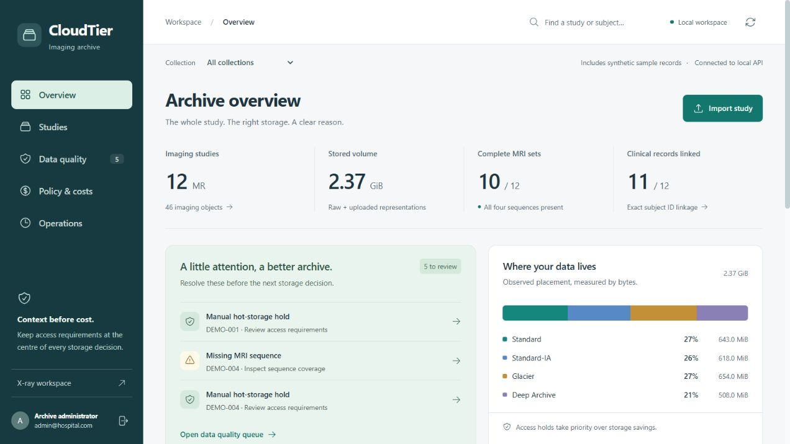
Figure 3. Current archive overview with synthetic study counts, sequence coverage, clinical-linkage coverage and quality issues.
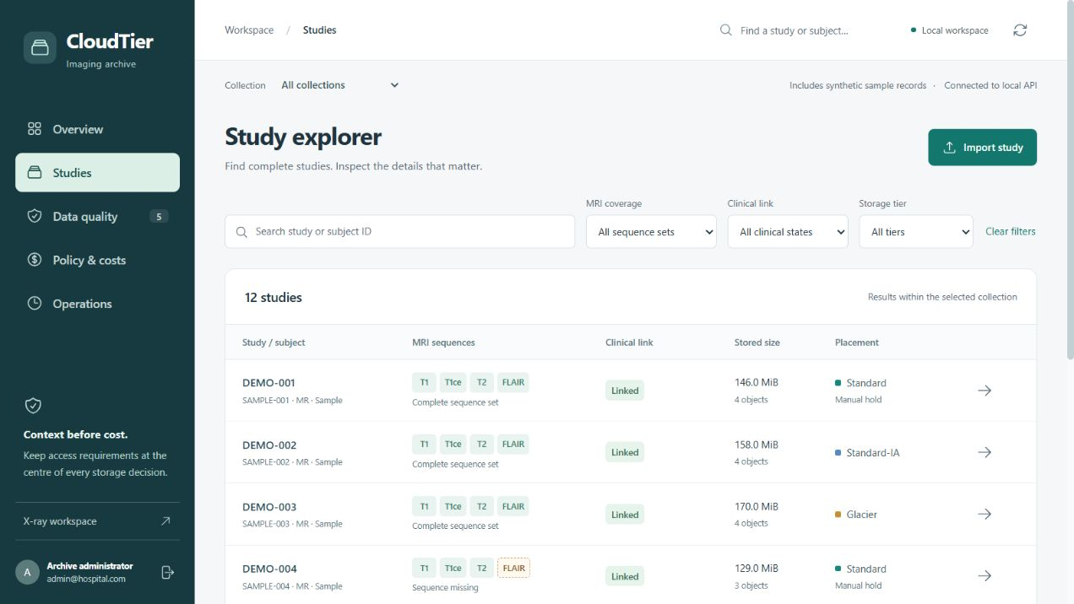
Figure 4. Current study explorer with sequence, clinical and storage filters. Displayed records belong to the labelled synthetic sample.
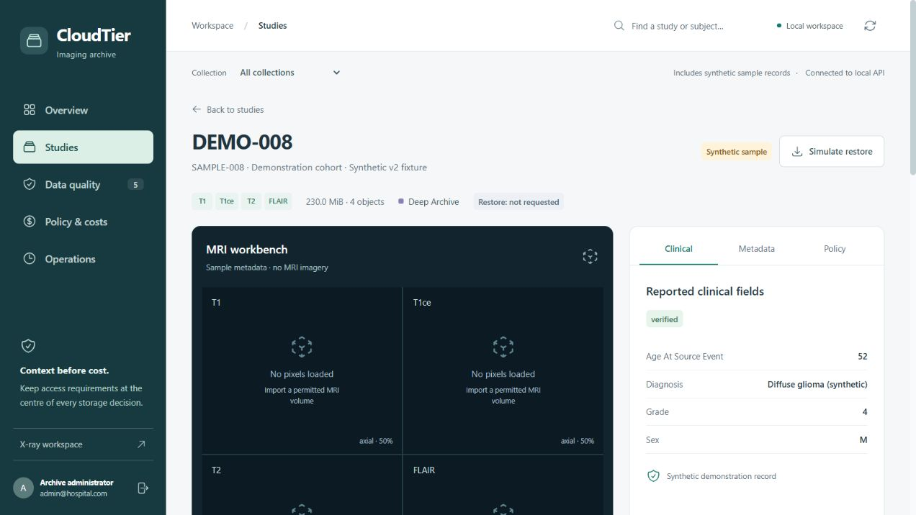
Figure 5. Current study detail and MRI workbench. Sample records correctly show no loaded pixels; MRI analysis requires permitted imported volumes.
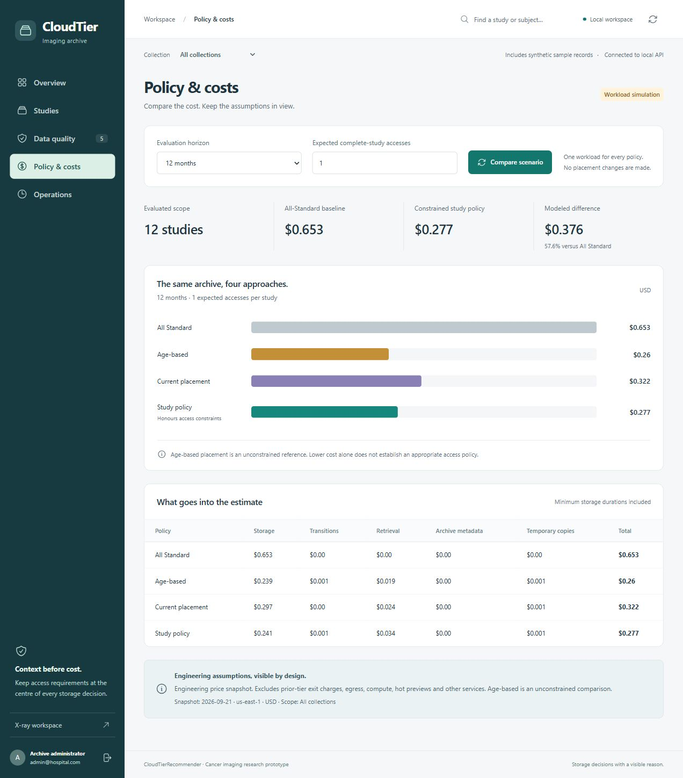
Figure 6. Current cost simulation using 12 synthetic studies, a 12-month horizon and one declared access. Detailed totals appear in Table 12.

9 3 GitHub Repository
Repository: https://github.com/SUBHRO71/SmartStorageTierRecommenderForMedicalSector_Cloud_Project_2026 (name follows the ProjectName_Cloud_Project_2026 format). Main folders:
- README.md, LICENSE (MIT), .gitignore – overview, local run and deployment instructions
- docs/ – research gap analyses (Student 1–3), Phase I report and Part D documentation
- architecture/ contains the v2 PRD, dashboard specification, local implementation and verification record, retained architecture and decision records.
- dataset/ – dataset rules and README (raw data is not committed)
- src/ contains ml_model/ (MRI adapter, legacy extractor and decision engine), backend/ (archive persistence, routes and local API), and frontend/ (current archive and retained X-ray screens).
- aws/ – template.yaml, deploy.ps1, ingest_scan.py, Lambda handlers, IAM policy references, cost_estimates.md
- tests/ covers the archive, legacy local API, cloud API and event inference. results/v2_model_compatibility.json records the synthetic MRI run; other historical results are not current validation.

10 Testing Results and Observations

10 1 Test Plan and Test Cases
Table 11. Test plan and test cases.
Check | Scenario | Fixture or method | Expected | Observed | Result
A01 | Empty archive and idempotent sample | Fresh temporary SQLite | No silent seeds; 12 explicit records | As expected | Pass
A02 | Access and quality constraints | Holds, hours, gaps and failed analysis | Protected cases stay Standard | As expected | Pass
A03 | Placement version and restore | Stale/current study versions | Reject stale; restore bundle | As expected | Pass
A04 | NIfTI and clinical import | Synthetic volumes and exact CSV | Measured sizes, hashes and PNG | As expected | Pass
A05 | Ambiguous clinical join | Duplicate exact CSV IDs | Ambiguous; guarded policy | As expected | Pass
A06 | Input/workload validation | Invalid types and nonfinite values | Reject invalid request | As expected | Pass
A07 | Cost totals and sequence gates | Six-month fixture scenario | Components sum; incomplete rejected | As expected | Pass
A08 | Malformed file cleanup | Invalid NIfTI bytes | No partial records/files | As expected | Pass
A09 | DICOM integrity | Synthetic headers and mismatch | Extract geometry; reject mismatch | As expected | Pass
A10 | V2 cloud gate | DynamoDB-mode archive API | HTTP 501 | As expected | Pass
A11 | Interrupted worker | RUNNING record with active hold | Mark failed; preserve access | As expected | Pass
B01 | Legacy local API | 5 automated cases | Valid API and operations | 5 passed | Pass
B02 | Cloud API | 5 cases with mocked AWS | Role checks and cloud calls | 5 passed | Pass
B03 | Decision engine | 4 automated cases | Costs, guards, serializable policy | 4 passed | Pass
B04 | Event handler | 3 cases with mocked AWS | Safe missing features and tags | 3 passed | Pass
B05 | Frontend production | Vite build | Production assets emitted | Build passed | Pass
B06 | Real cohort and AWS | External milestones | Cohort metrics and observed transitions | Not executed | Pending

10 2 Results
Verification rerun on 16 October 2026: all 28 unittest cases passed, comprising 11 archive tests, 5 local legacy API tests, 5 cloud API tests, 4 decision-engine tests and 3 event-handler tests. The React/Vite production build passed with separate archive route chunks. A fresh temporary archive reproduced the 12-study synthetic sample: 46 declared objects, 10 complete studies, 11 synthetically linked clinical records and 3 studies protected by an active-use flag or hold. Declared object sizes total 2,540,699,648 bytes; these are sample metadata sizes, not downloaded MRI pixels. The model evidence dated 11 October records a synthetic 32-cube run using MONAI 1.5.2 and PyTorch 2.11.0 CPU, producing TC 5.362 mL, WT 7.930 mL and ET 1.931 mL in 0.85 seconds. Those values are synthetic outputs, not patient measurements, clinical accuracy or a runtime benchmark for full MRI volumes.

10 3 Baseline Comparison
Table 12 was reproduced from /api/archive/costs with a fresh sample import, horizon 12 months and one declared study access. Each policy is evaluated on the same 12 synthetic studies using the 21 September 2026 engineering snapshot. Current placement means the fixture tier mix; Study policy means the recommended constrained placement. Age-based is an unconstrained baseline and can ignore protections.
Table 12. Reproduced v2 cost simulation for 12 synthetic studies over 12 months with one declared access per study.
Policy | 12 month modeled USD | Difference from All Standard | Interpretation
All Standard | 0.653093 | Baseline | Immediate access baseline
Age-based | 0.260177 | 60.16% lower | Unconstrained age rule
Current placement | 0.321772 | 50.73% lower | Synthetic fixture tier mix
Study policy | 0.277186 | 57.56% lower | Explicit access constraints
The study-policy scenario is about 57.56% below the All Standard modeled total for this synthetic workload. This demonstrates arithmetic and policy behavior only. It does not estimate real hospital savings or compare against S3 Intelligent-Tiering. There is no measured v2 wrongly-archived rate because no real retrieval log or v2 retrieval label has been evaluated.

10 4 Results Summary
Table 13 separates delivered functional objectives from the external validation and cloud work still required.
Table 13. Objective status.
Objective | Status | Evidence and boundary
1 Import and integrity | Met locally | Validated fixture imports, hashes and cleanup tests
2 Clinical and MRI inspection | Implemented; partial evaluation | Exact joins and real previews tested; synthetic adapter evidence; cohort accuracy pending
3 Transparent storage policy | Met locally | Eligibility rules and cost component tests
4 Reviewed study operations | Met as local simulation | Stale placement rejection and bundle restore tests
5 Cloud foundation | V1 implemented; v2 pending | Mocked handler tests and explicit HTTP 501 gate
6 Archive workspace | Met locally | Production build and prior responsive/browser record

11 Discussion Limitations and Risk Analysis

11 1 Discussion
The current archive improves inspectability by making sequence completeness, clinical linkage, access expectations and operation history explicit. The constraints prevent automatic cold recommendations for missing sequence sets, unresolved clinical linkage, active use, manual holds and unfinished or failed analyses. These checks implement product rules; they do not prove clinical safety. Segmentation provides a research view and provenance, while workload accesses are declared independently. The earlier 72-record X-ray analysis and its policy calibration problem belong to v1 and are not used to validate v2. The retained fixed legacy coefficients remain uncalibrated.

11 2 Limitations
Technical, data and evaluation limitations are listed below.
- Data and linkage. No real TCIA/BraTS cohort was downloaded for this milestone. Exact CSV matching checks supplied identifiers; source declarations and crosswalk quality still determine whether a clinical association is correct.
- MRI prerequisites and validity. Raw DICOM is not converted or registered automatically. The adapter expects preprocessed aligned, brain-extracted 1 mm NIfTI inputs. Synthetic compatibility evidence does not establish Dice, HD95, diagnostic utility or generalization.
- Model reproducibility. Bundle release 0.5.4 is pinned to revision 04689f51062d1ec889c8af2e78fc0369c6fda36d. The checkpoint SHA-256 is 860ccb3f1c21c99d0410ad8a1ac4ef6b8fab60cec0a503b0ba42675741a750ae. Runtime versions are recorded; independent cohort accuracy and overlap audits remain pending.
- Cloud boundary. V2 bundle placement and restore are local simulations. V2 archive calls return HTTP 501 in DynamoDB mode. Member-level pending, mixed and failure states and actual AWS reconciliation are unfinished.
- Governance and security. Local demonstration authentication is not production access control. Imported raw files are retained locally and are not automatically de-identified. Production use requires consent/license review, role enforcement, lifecycle governance and suitable monitoring.
- Scale and cost. The local inventory is returned in one response and the analysis worker is a local background thread. Production pagination, indexing and robust queues are future work. Costs omit prior-tier exit charges, egress, compute, hot previews and other services.
- Evidence scope. The browser and responsive record dated 11 October covers widths 1440, 1024, 768, 499 and 390 pixels. Current verification reruns tests and build and captures desktop overview, explorer, workbench and costs. A full responsive or clinical evaluation was not repeated.

11 3 Risks and Mitigation
Table 14. Risks and mitigation.
Risk | Impact | Implemented mitigation or boundary | Remaining work
Incorrect subject association | High | Exact CSV matches; ambiguous states; DICOM identity checks | Verify source crosswalks and permissions
Unusable incomplete bundle | High | Completeness and clinical guards; complete local operations | Cloud member-level reconciliation
Model misuse or invalid inputs | High | Preprocessing attestation, geometry/intensity checks, research labels | Independent accuracy and preprocessing audit
Misleading cost claims | Medium | Declared workload, component breakdown and exclusions | Realistic workload and full cloud bill evaluation
Concurrent or interrupted operations | Medium | Version checks, atomic worker merge, startup recovery | Durable workers and production queues
Unauthorized raw-data access | High | Local-only prototype and allowlisted clinical display | Production access control and governance

12 Team Contribution and Version Control
Primary ownership follows the repository README: Pratyush Chandrasekhar owns frontend, testing and CloudFront; Subhrojyoti Das owns backend, database, authentication and infrastructure; Mehul Anand owns dataset, inference, S3 and metrics. Paper assignments are P1 to P5, P6 to P10 and P11 to P15 respectively for Pratyush, Subhrojyoti and Mehul. The student labels in Table 15 use the same README mapping.
Table 15. Team contribution.
Activity | Pratyush Chandrasekhar 24BIT0226 | Subhrojyoti Das 24BIT0194 | Mehul Anand 24BIT0185
Literature | P1 to P5 | P6 to P10 | P11 to P15
Primary README ownership | Frontend testing CloudFront | Backend database auth infrastructure | Dataset inference S3 metrics
Interface work | Frontend ownership; UI history | API and current archive integration | Dataset/operator requirements
Backend and infrastructure | Frontend integration | Local/API persistence and infrastructure ownership | S3 and inference integration ownership
MRI and dataset | Inspection UI support | Adapter and archive integration in current implementation | Dataset and inference ownership
Testing and evidence | Frontend testing ownership | Regression/API integration | Metrics ownership
Documentation | Literature analysis and report | Architecture and implementation records | Literature analysis and report

12 1 Branch and Pull Request Workflow
The repository documents main, develop and feature branches for integration and review. Historical pull requests belong to the earlier implementation and are not evidence that the v2 changes were reviewed through new pull requests. The current local history records the v2 implementation and scope commits listed in Section 9. A release tag or cloud deployment is not asserted in this report.

12 2 Contribution Evidence
Table 16 records local Git history observed during finalization. Author counts reflect commit author strings, not a complete measure of individual work or independent proof of contribution ownership.
Table 16. GitHub contribution evidence.
Member | Local author evidence | README branch | Count | Attribution boundary
Pratyush Chandrasekhar | pratyush-chandrasekhar | feature/student1 | 39 | Author string count; current task allocation from README
Subhrojyoti Das | SUBHRO71 plus two name variants | feature/student2 | 25 plus 1 plus 1 | Separate author strings; v2 commits listed in Section 9
Mehul Anand | No separately identified author in local shortlog | feature/student3 | N/A | Count not established. Dataset/inference ownership recorded in README.
Local shortlog contains 39 commits under pratyush-chandrasekhar, 25 under SUBHRO71 and one each under SUBHROJYOTI DAS and Subhrojyoti Das. The latter names are retained as separate author strings; identities and missing member attribution are not guessed. No per-student review or pull-request target is claimed to have been met.

13 Conclusion and Future Enhancements

13 1 Conclusion
CloudTierRecommender now provides a usable local cancer-imaging archive with validated file import, exact clinical linkage, persistent study records, NIfTI previews, a frozen pretrained MRI adapter and an explicit access-constrained storage comparison. Version-checked placement and bundle restore are audited local simulations. All 28 automated tests and the production frontend build passed during finalization. The retained v1 AWS handlers and SAM stack provide a cloud foundation. Real cohort evaluation, study-aware AWS execution, production governance and measured savings remain future milestones; the current results establish functional behavior and reproducibility rather than clinical or deployment validity.

13 2 Future Enhancements
Next steps, in order of priority:
- Acquire a permitted real imaging cohort and its actual clinical export/crosswalk; document release, subject counts, source permissions and missingness.
- Validate preprocessing, checkpoint compatibility and segmentation accuracy on an independent cohort; report appropriate Dice/HD95 results and audit overlap with model development data.
- Implement v2 DynamoDB/S3 bundle execution, object-level observed states, partial failure handling and complete-study cloud restore before claiming v2 deployment.
- Harden authentication, server-side roles, raw-file governance, monitoring and audit protection; add bounded pagination and robust queued inference.
- Review price assumptions and evaluate costs on realistic workload traces, including excluded charges. Compare all policies under identical access constraints.
- Deploy in a permitted AWS account, observe actual Lifecycle and restore outcomes, and capture monitoring and billing evidence. Keep research segmentation separate from any future validated retrieval forecasting.

References

[1] Khan, A. Q., Matskin, M., Prodan, R., Bussler, C., Roman, D., & Soylu, A. (2024). Cloud storage tier optimization through storage object classification. Computing, 106, 3389–3418. https://doi.org/10.1007/s00607-024-01281-2
[2] Shakor, M. Y., & Khaleel, M. I. (2024). Recent advances in big medical image data analysis through deep learning and cloud computing. Electronics, 13(24), 4860. https://doi.org/10.3390/electronics13244860
[3] Urbaniak, I. A. (2024). Using compressed JPEG and JPEG2000 medical images in deep learning: A review. Applied Sciences, 14(22), 10524. https://doi.org/10.3390/app142210524
[4] Dai, F. (2025). Deep learning based medical image compression using cross attention learning and wavelet transform. Scientific Reports, 15, 40008. https://doi.org/10.1038/s41598-025-23582-y
[5] Mani, V., Kavitha, C., Band, S. S., Mosavi, A., Hollins, P., & Palanisamy, S. (2022). A recommendation system based on AI for storing block data in the electronic health repository. Frontiers in Public Health, 9, 831404. https://doi.org/10.3389/fpubh.2021.831404
[6] Nadig, R., Arulchelvan, V., Bera, R., Shahroodi, T., Singh, G., Kakolyris, A., Yuksel, I. E., Sadrosadati, M., Park, J., & Mutlu, O. (2025). Harmonia: Enhancing data placement and migration in hybrid storage systems via multi-agent reinforcement learning (arXiv:2503.20507). arXiv. https://doi.org/10.48550/arXiv.2503.20507
[7] Bera, R., Nadig, R., & Mutlu, O. (2026). Machine learning-driven intelligent memory system design: From on-chip caches to storage (arXiv:2603.14583). arXiv. https://doi.org/10.48550/arXiv.2603.14583
[8] Gupta, A., & Bhayani, A. (2025). Cold-RL: Learning cache eviction with offline reinforcement learning for NGINX (arXiv:2508.12485). arXiv. https://doi.org/10.48550/arXiv.2508.12485
[9] Akünal, Ü., Bujotzek, M., Denner, S., Hamm, B., Kades, K., Schader, P., Scherer, J., Nolden, M., Neher, P., Floca, R., & Maier-Hein, K. (2025). Kaapana: A comprehensive open-source platform for integrating AI in medical imaging research environments (arXiv:2512.09644). arXiv. https://doi.org/10.48550/arXiv.2512.09644
[10] Deng, Z., Tang, C., Huang, Z., et al. (2026). Project Imaging-X: A survey of 1000+ open-access medical imaging datasets for foundation model development (arXiv:2603.27460). arXiv. https://doi.org/10.48550/arXiv.2603.27460
[11] Mondal, A. S., Mukhopadhyay, A., & Chattopadhyay, S. (2022). Machine learning-driven automatic storage space recommendation for object-based cloud storage system. Complex & Intelligent Systems, 8, 489–505. https://doi.org/10.1007/s40747-021-00517-4
[12] Amaithi Rajan, A., Vetriselvi, V., Ajitesh, M., & Praveen Kumar, R. (2025). Secure and fault tolerant cloud based framework for medical image storage and retrieval in a distributed environment. Scientific Reports, 15, 32965. https://doi.org/10.1038/s41598-025-16903-8
[13] Lemaréchal, Y., Couture, G., Pelletier, F., Lefol, R., Asselin, P.-L., Ouellet, S., Bernard, J., Ebrahimpour, L., Manem, V. S. K., Topalis, J., Schachtner, B., Jodogne, S., Joubert, P., Jeblick, K., Ingrisch, M., & Després, P. (2025). PARADIM: A platform to support research at the interface of data science and medical imaging. Journal of Imaging Informatics in Medicine, 39(2), 1783–1795. https://doi.org/10.1007/s10278-025-01554-y
[14] Vahdati, S., Khosravi, B., Mahmoudi, E., Zhang, K., Rouzrokh, P., Faghani, S., Moassefi, M., Tahmasebi, A., Andriole, K. P., Chang, P., Farahani, K., Flores, M. G., Folio, L., Houshmand, S., Giger, M. L., Gichoya, J. W., & Erickson, B. J. (2024). A guideline for open-source tools to make medical imaging data ready for artificial intelligence applications: A Society of Imaging Informatics in Medicine (SIIM) survey. Journal of Imaging Informatics in Medicine, 37(5), 2015–2024. https://doi.org/10.1007/s10278-024-01083-0
[15] Hai, T., Zhou, J., Srividhya, S. R., Jain, S. K., Young, P., & Agrawal, S. (2022). BVFLEMR: An integrated federated learning and blockchain technology for cloud-based medical records recommendation system. Journal of Cloud Computing, 11, 22. https://doi.org/10.1186/s13677-022-00294-6
[16] Amazon Web Services. Amazon S3 pricing. https://aws.amazon.com/s3/pricing/ . The implemented engineering snapshot is dated 21 September 2026; it is not a live price quotation.
[17] Wang, X., Peng, Y., Lu, L., Lu, Z., Bagheri, M., & Summers, R. M. (2017). ChestX-ray8: Hospital-scale chest X-ray database and benchmarks on weakly-supervised classification and localization of common thorax diseases. In Proceedings of the IEEE Conference on Computer Vision and Pattern Recognition (pp. 2097–2106). https://doi.org/10.1109/CVPR.2017.369
[18] Cohen, J. P., Viviano, J. D., Bertin, P., Morrison, P., Torabian, P., Guarrera, M., Lungren, M. P., Chaudhari, A., Brooks, R., Hashir, M., & Bertrand, H. (2022). TorchXRayVision: A library of chest X-ray datasets and models. In Proceedings of Machine Learning Research, 172, 231–249 (MIDL 2022). https://github.com/mlmed/torchxrayvision
[19] Amazon Web Services. (2026). Managing the lifecycle of objects (Amazon S3 User Guide). https://docs.aws.amazon.com/AmazonS3/latest/userguide/object-lifecycle-mgmt.html
[20] Amazon Web Services. (2026). AWS Serverless Application Model (AWS SAM) Developer Guide. https://docs.aws.amazon.com/serverless-application-model/
[21] Das, S., Chandrasekhar, P., & Anand, M. (2026). Smart Storage Tier Recommender for the Medical Sector [Source code]. GitHub. https://github.com/SUBHRO71/SmartStorageTierRecommenderForMedicalSector_Cloud_Project_2026
[22] MONAI. BraTS MRI segmentation bundle. Published model repository. https://huggingface.co/MONAI/brats_mri_segmentation . Implemented release 0.5.4 and pinned revision are recorded in Section 11.

Appendix A Project Timeline
Table 17. Project timeline.
Phase | Start | End | Owners | Status and evidence
Literature and gap review | July 2026 | July 2026 | All | Retained analyses and report survey
V1 local and AWS implementation | September 2026 | 24 September 2026 | All | Local X-ray app and AWS code; deployment pending
V2 study archive and MRI adapter | 11 October 2026 | 11 October 2026 | Project team | c1f5152; current archive modules
V2 dashboard and product scope | 11 October 2026 | 11 October 2026 | Project team | a5248e0 and dcff096
Current verification and report | 16 October 2026 | 16 October 2026 | Project team | 28 tests, production build, synthetic cost rerun
Real cohort and cloud milestones | Future | Future | Project team | Acquisition, accuracy and v2 deployment pending

Appendix B Completion Review
Completed: abstract describes the current study archive, research MRI path, storage policy, AWS boundary and evidence.
Completed: original 15-paper survey and individual research-gap analyses retained as prior research context.
Completed: current objectives are mapped to implemented behavior and explicit validation boundaries.
Completed: dataset section distinguishes real imports, synthetic sample metadata and synthetic model fixtures.
Completed: current local architecture and retained AWS architecture are separately explained.
Completed: module evidence, 28 passing tests, successful frontend build and reproducible cost scenario are recorded.
Completed: model release, revision, checkpoint checksum, runtime and synthetic-input limitations are documented.
Completed: unfinished provider acquisition, clinical evaluation and study-aware cloud operations are identified as future work.
Pending milestone: real-data MRI accuracy assessment and retrieval/workload evaluation.
Pending milestone: deployed v2 AWS transitions, restores, observability and billing evidence.
Completed: member names and registration numbers retained; unverified contribution counts are not invented.
Completed: no credentials or raw clinical records are included in the report.
Completed: current implementation and remaining project milestones are documented.

