RESULTS OF MY BASE MODEL USING ARIMA:(2,1,2)
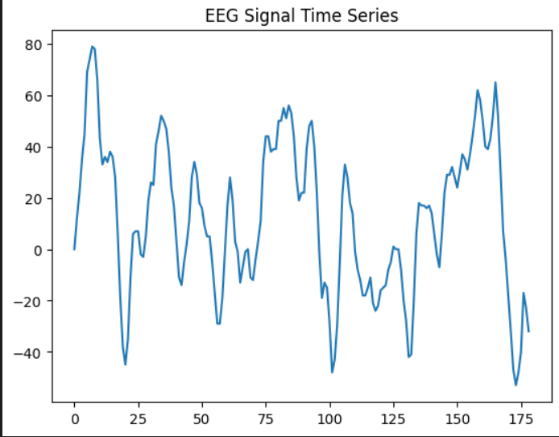

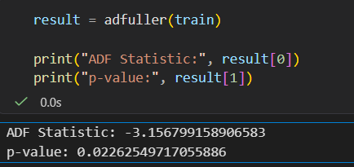
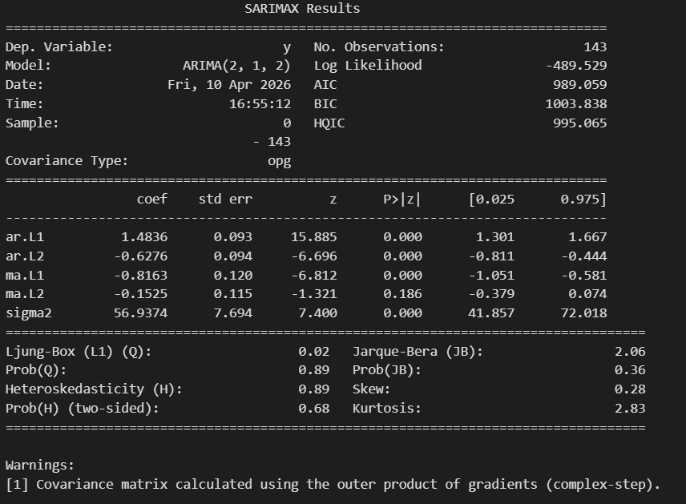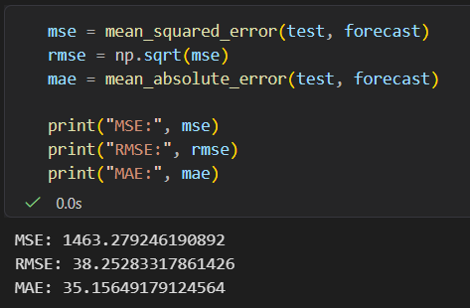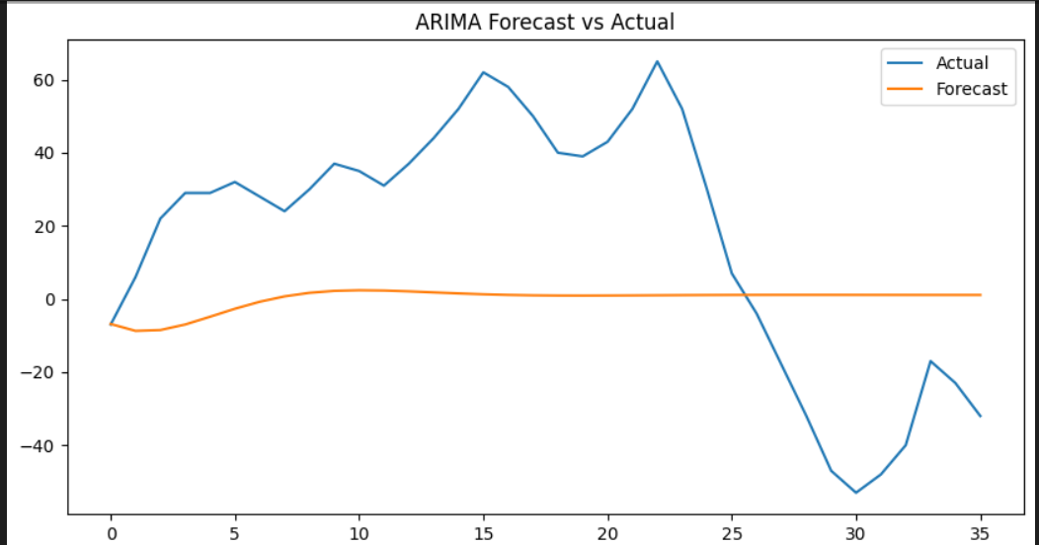
Evaluation Metrics
- MSE = 1463.279
  - The squared prediction error is relatively high
  - Indicates the model has noticeable deviation from actual values
- RMSE = 38.252
  - On average, predictions differ from actual EEG values by about 38 units
- MAE = 35.156
  - The average absolute error is about 35 units per prediction
  - Errors are consistent since MAE ≈ RMSE
ADF Test (Your Output)
- ADF Statistic = -3.156
  - Value is sufficiently negative, indicating stability in the series
- p-value = 0.0226
  - Since it is less than 0.05 → the EEG signal is stationary
  - No further differencing needed beyond d = 1

Model Details (Your Output)
- ARIMA(2,1,2)
  - Model is using 2 past values and 2 past errors after differencing once
  - Suitable for capturing short-term EEG dependencies
- Log Likelihood = -489.529
  - Indicates the model fit; moderately good fit (less negative is better)

Coefficient Results (Your Output)
- ar.L1 = 1.4836 (p = 0.000)
  - Strong and significant influence of the immediate past value
- ar.L2 = -0.6276 (p = 0.000)
  - Second previous value also significantly affects prediction
- ma.L1 = -0.8163 (p = 0.000)
  - Strong correction based on past prediction error
- ma.L2 = -0.1525 (p = 0.186)
  - Not significant → this term does not contribute meaningfully
- sigma² = 56.9374
  - Residual error variance is moderate

Model Selection Metrics (Your Output)
- AIC = 989.059
  - Indicates model quality; used for comparison
- BIC = 1003.838
  - Slightly higher due to penalty on complexity

Residual Diagnostics (Your Output)
- Ljung-Box p-value = 0.89
  - Residuals are random → model has captured patterns well
- Jarque-Bera p-value = 0.36
  - Residuals follow normal distribution
- Heteroskedasticity p-value = 0.68
  - Variance of errors is constant (no instability)
  - Final Meaning of Output
- The model is statistically valid and well-fitted
- Most parameters are significant except ma.L2
- Residuals behave ideally (random, normal, stable)
- Prediction error is moderate (~35–38 units)
- Model performance is acceptable but can be improved

