**KOVAI.CO ASSESSMENT**

**Task 1: Prime Dataset**

**Exploratory Data Analysis:**

1. Reading the dataset using pandas

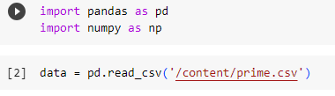

1. Examining the dataset

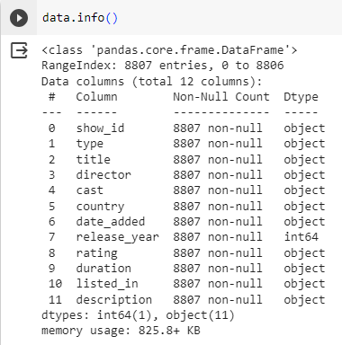

1. Checking for null values and replacing it with ‘unknown’ or ‘NA’

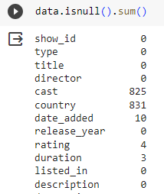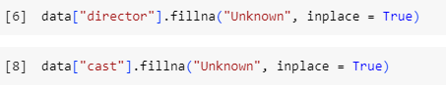

**INSIGHTS:**

1. **Rating vs Director:**

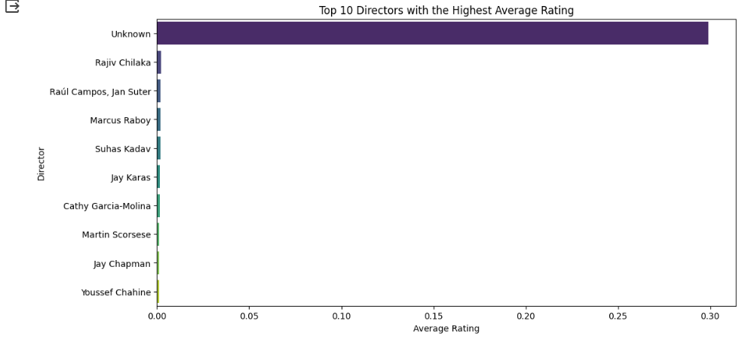

In above diagram we listed top 10 directors whose movies have highest rating. we can infer that the top rating movie’s director names are unknown.

1. **Distribution of Content Types (TV Shows vs. Movies)**

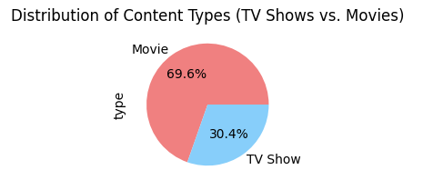

The provided code creates a pie chart to visualize the distribution of content types, specifically TV Shows and Movies, in your dataset. From the pie chart we can infer that people watch mostly movies

1. **Top three countries that watches TV shows and movies most**

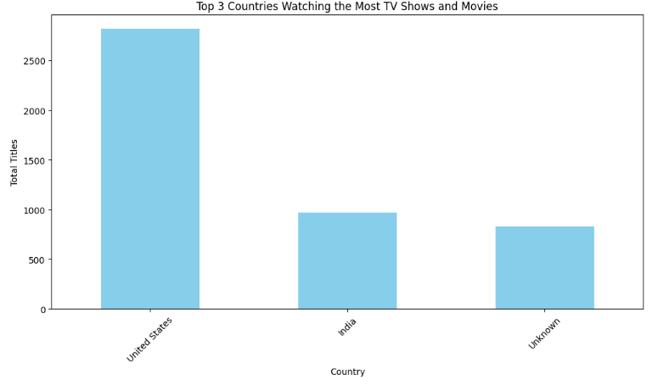

From the above figure we can infer that US watch most of TV shows and movies followed by INDIA