Lab 1 to 5
Question 1: Write a Python program that reads a short business scenario and identifies the most relevant threat-intelligence application area for that industry context (e.g., banking fraud prevention, healthcare data protection, e-commerce fraud prevention).
Answer :
import re
AREAS = {
"Banking Fraud Prevention": [
"bank", "banking", "atm", "transaction", "card", "credit", "debit",
"loan", "payment", "wire", "swift", "upi", "account takeover", "fraud",
"money", "wallet", "branch",
],
"Healthcare Data Protection": [
"hospital", "patient", "health", "healthcare", "medical", "clinic",
"ehr", "hipaa", "diagnosis", "pharmacy", "doctor", "records",
"ransomware",
],
"E-commerce Fraud Prevention": [
"e-commerce", "ecommerce", "online store", "checkout", "cart",
"shopping", "order", "refund", "chargeback", "seller", "marketplace",
"coupon", "customers", "promo",
],
"Critical Infrastructure Protection": [
"power", "grid", "energy", "scada", "ics", "plant", "utility",
"water", "oil", "gas", "pipeline", "railway", "manufacturing",
],
"Government and Defence Intelligence": [
"government", "ministry", "defence", "defense", "military",
"election", "nation", "espionage", "apt", "state-sponsored",
"embassy", "public sector",
],
"Telecom and Cloud Service Protection": [
"telecom", "isp", "cloud", "saas", "data center", "datacenter",
"5g", "network operator", "hosting", "subscriber",
],
}

def tokenize(text):
return re.sub(r"[^a-z0-9\-\s]", " ", text.lower())

def score_areas(scenario):
text = " " + tokenize(scenario) + " "
scores = {}
for area, words in AREAS.items():
hits = [w for w in words if f" {w} " in text or f" {w}s " in text
or (" " in w and w in text)]
scores[area] = hits
return scores

def identify_area(scenario):
scores = score_areas(scenario)
best = max(scores, key=lambda a: len(scores[a]))
if not scores[best]:
return None, scores
return best, scores

def main():
print("=== Threat Intelligence Application Area Identifier ===")
scenario = input("Enter a short business scenario:\n> ").strip()
if not scenario:
print("No scenario entered.")
return
best, scores = identify_area(scenario)
print("\n--- Keyword matches per area ---")
for area, hits in sorted(scores.items(), key=lambda x: -len(x[1])):
print(f"{area:40s} {len(hits)} {hits}")
if best:
print(f"\nMost relevant application area: {best}")
else:
print("\nNo clear industry context found. Please add more detail.")

if __name__ == "__main__":
main()
output:
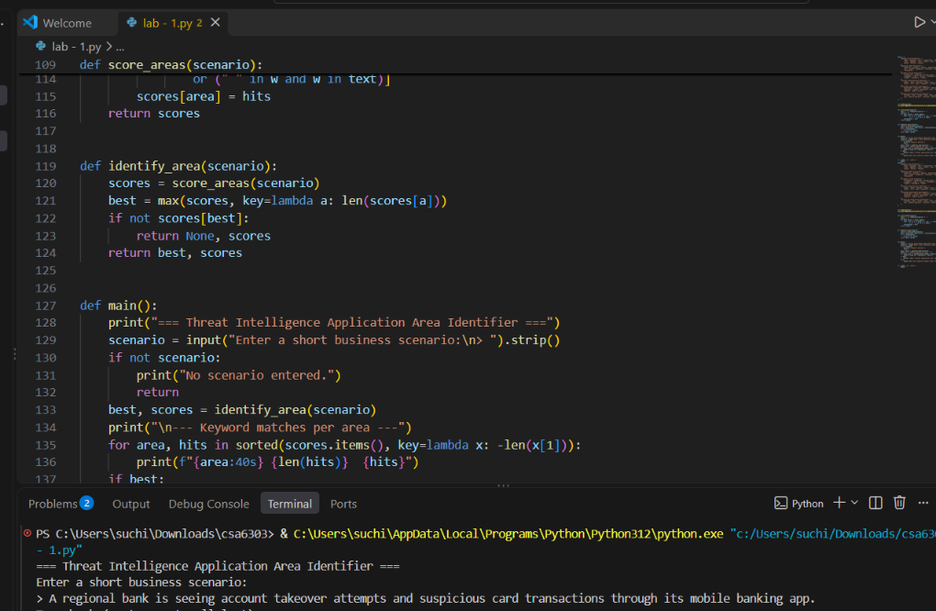

Question 2: Write a Python program to perform a simple vulnerability assessment by implementing a port scanner that identifies open ports on a target host.
Answer:
import socket
import sys
import threading
from datetime import datetime
from queue import Queue

COMMON_SERVICES = {
21: "FTP", 22: "SSH", 23: "Telnet", 25: "SMTP", 53: "DNS", 80: "HTTP",
110: "POP3", 135: "MS-RPC", 139: "NetBIOS", 143: "IMAP", 443: "HTTPS",
445: "SMB", 3306: "MySQL", 3389: "RDP", 5432: "PostgreSQL",
8080: "HTTP-Alt",
}

# Services that are risky when exposed
RISKY = {
21: "FTP sends credentials in clear text",
23: "Telnet is unencrypted; replace with SSH",
135: "MS-RPC exposure can aid remote attacks",
139: "NetBIOS exposure can leak information",
445: "SMB exposure is a common ransomware entry point",
3389: "RDP exposed to the network is a brute-force target",
}

def scan_port(host, port, timeout=0.5):
"""Return True if a TCP connection to host:port succeeds."""
s = socket.socket(socket.AF_INET, socket.SOCK_STREAM)
s.settimeout(timeout)
try:
return s.connect_ex((host, port)) == 0
except OSError:
return False
finally:
s.close()

def worker(host, q, results, lock):
while True:
try:
port = q.get_nowait()
except Exception:
return
if scan_port(host, port):
with lock:
results.append(port)
q.task_done()

def scan_host(host, start, end, threads=100):
q = Queue()
for p in range(start, end + 1):
q.put(p)
results, lock = [], threading.Lock()
pool = [threading.Thread(target=worker, args=(host, q, results, lock))
for _ in range(threads)]
for t in pool:
t.start()
for t in pool:
t.join()
return sorted(results)

def main():
host = input("Target host (IP or name) [127.0.0.1]: ").strip() or "127.0.0.1"
try:
start = int(input("Start port [1]: ") or 1)
end = int(input("End port [1024]: ") or 1024)
ip = socket.gethostbyname(host)
except (ValueError, socket.gaierror) as e:
print("Invalid input:", e)
sys.exit(1)
if not (1 <= start <= end <= 65535):
print("Port range must be within 1-65535 and start <= end.")
sys.exit(1)

print(f"\nScanning {host} ({ip}) ports {start}-{end}")
t0 = datetime.now()
open_ports = scan_host(ip, start, end)
print(f"Scan finished in {datetime.now() - t0}\n")

if not open_ports:
print("No open ports found in the range.")
return
print(f"{'PORT':<8}{'SERVICE':<12}ASSESSMENT")
for p in open_ports:
svc = COMMON_SERVICES.get(p, "unknown")
note = RISKY.get(p, "Review whether this service must be exposed")
print(f"{p:<8}{svc:<12}{note}")

if __name__ == "__main__":
main()
output:
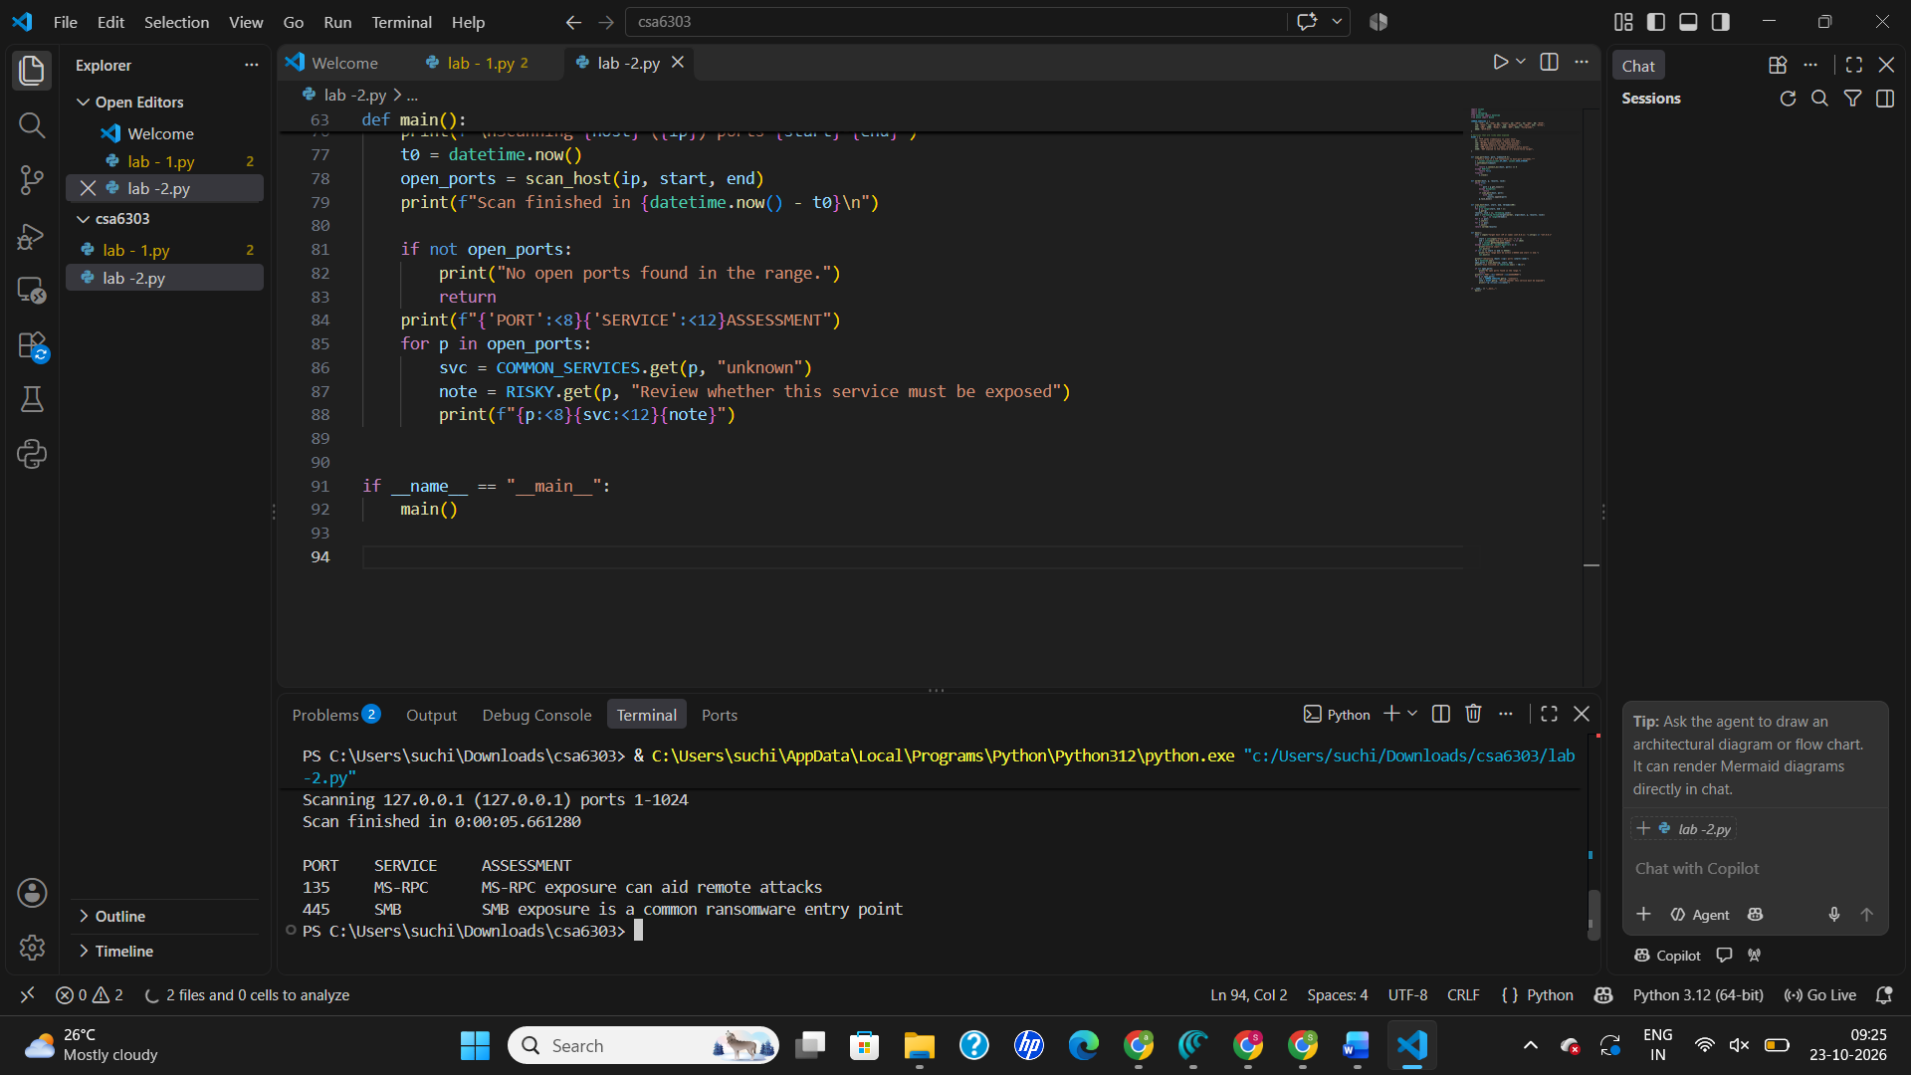

Question 3: Write a Python program to check a draft security policy document for required governance elements (scope, roles and responsibilities, enforcement, review cycle, approval authority) and report which are missing.
Answer (Python code):
import re

REQUIRED = {
"Scope": [r"\bscope\b", r"\bapplies to\b", r"\bapplicab", r"\ball employees\b"],
"Roles and Responsibilities": [
r"roles? and responsibilit", r"\bresponsib", r"\bciso\b",
r"\bdata owner\b", r"\bit security team\b", r"\baccountab",
],
"Enforcement": [
r"\benforce", r"\bdisciplinary\b", r"\bviolation", r"\bnon-?compliance\b",
r"\bpenalt", r"\bsanction",
],
"Review Cycle": [
r"\breview(ed)? (annually|every|quarterly|yearly|at least)",
r"\breview cycle\b", r"\bperiodic review\b", r"\bannual review\b",
r"\bevery (6|12|\d+) months\b", r"\breviewed\b.*\b(annually|yearly)\b",
],
"Approval Authority": [
r"\bapproved by\b", r"\bapproval authority\b", r"\bapproval\b",
r"\bsigned off\b", r"\bboard of directors\b", r"\bmanagement approval\b",
],
}

def check_policy(text):
low = text.lower()
present, missing = {}, []
for element, patterns in REQUIRED.items():
found = [p for p in patterns if re.search(p, low)]
if found:
present[element] = len(found)
else:
missing.append(element)
return present, missing

def read_policy():
print("Paste the policy text. Finish with a line containing only END,")
print("or press Enter now to load a file path instead.")
first = input("> ")
if first.strip() == "":
path = input("Policy file path: ").strip()
with open(path, encoding="utf-8") as f:
return f.read()
lines = [first]
while True:
line = input()
if line.strip().upper() == "END":
break
lines.append(line)
return "\n".join(lines)

def main():
print("=== Security Policy Governance Checker ===")
try:
text = read_policy()
except (OSError, EOFError) as e:
print("Could not read policy:", e)
return
present, missing = check_policy(text)

print("\n--- Result ---")
for element in REQUIRED:
status = "PRESENT" if element in present else "MISSING"
print(f"[{status:7}] {element}")
total = len(REQUIRED)
print(f"\nCoverage: {len(present)}/{total} required elements")
if missing:
print("Missing elements to add:", ", ".join(missing))
else:
print("All required governance elements are covered.")

if __name__ == "__main__":
main()
output:
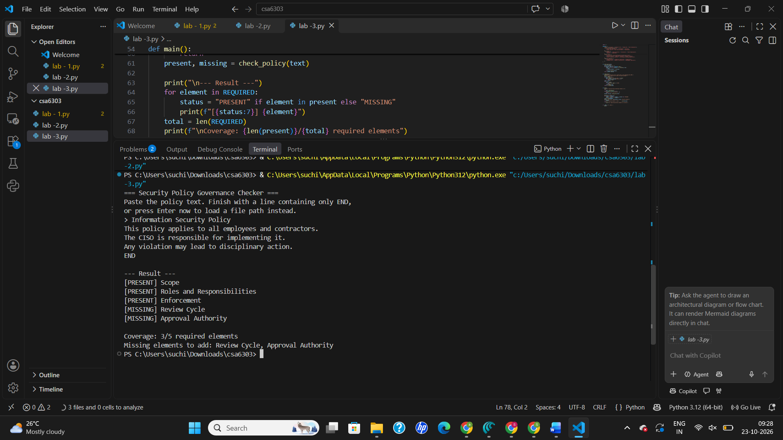

Question 4: Write a Python program to demonstrate the confidentiality property a VPN tunnel provides, showing that data captured in transit is unreadable without the shared key, using a simple symmetric stream cipher as a stand-in for a real VPN's encryption.
Answer :
import hashlib
import os

def keystream(key: bytes, nonce: bytes, length: int) -> bytes:
"""Generate a pseudo-random keystream from key+nonce using SHA-256 in counter mode."""
out = b""
counter = 0
while len(out) < length:
block = hashlib.sha256(key + nonce + counter.to_bytes(8, "big")).digest()
out += block
counter += 1
return out[:length]

def xor_bytes(data: bytes, ks: bytes) -> bytes:
return bytes(a ^ b for a, b in zip(data, ks))

def tunnel_send(plaintext: str, key: bytes) -> bytes:
"""Sender side of the 'tunnel': nonce || ciphertext."""
data = plaintext.encode()
nonce = os.urandom(8) # fresh nonce per packet
return nonce + xor_bytes(data, keystream(key, nonce, len(data)))

def tunnel_receive(packet: bytes, key: bytes) -> str:
nonce, ct = packet[:8], packet[8:]
pt = xor_bytes(ct, keystream(key, nonce, len(ct)))
return pt.decode(errors="replace")

def main():
shared_key = b"correct-horse-battery-staple" # known to both VPN endpoints
attacker_key = b"wrong-guess-by-eavesdropper"

message = "Username: admin | Password: S3cr3t@123 | Transfer Rs.50,000 to A/C 9876"
print("=== VPN Tunnel Confidentiality Demo ===")
print("\n1) Original data (client side):")
print(" ", message)

packet = tunnel_send(message, shared_key)
print("\n2) What an eavesdropper captures on the wire (hex):")
print(" ", packet.hex())

print("\n3) Attacker tries to read it WITHOUT the key (raw bytes):")
print(" ", packet[8:])

print("\n4) Attacker tries a WRONG key:")
print(" ", repr(tunnel_receive(packet, attacker_key)))

print("\n5) VPN server decrypts with the SHARED key:")
print(" ", tunnel_receive(packet, shared_key))

# Same message twice gives different ciphertext because of the nonce
p2 = tunnel_send(message, shared_key)
print("\n6) Same message sent again -> different ciphertext (nonce):",
p2.hex() != packet.hex())

assert tunnel_receive(packet, shared_key) == message
print("\nResult: data is confidential in transit; only key holders can read it.")

if __name__ == "__main__":
main()
output:
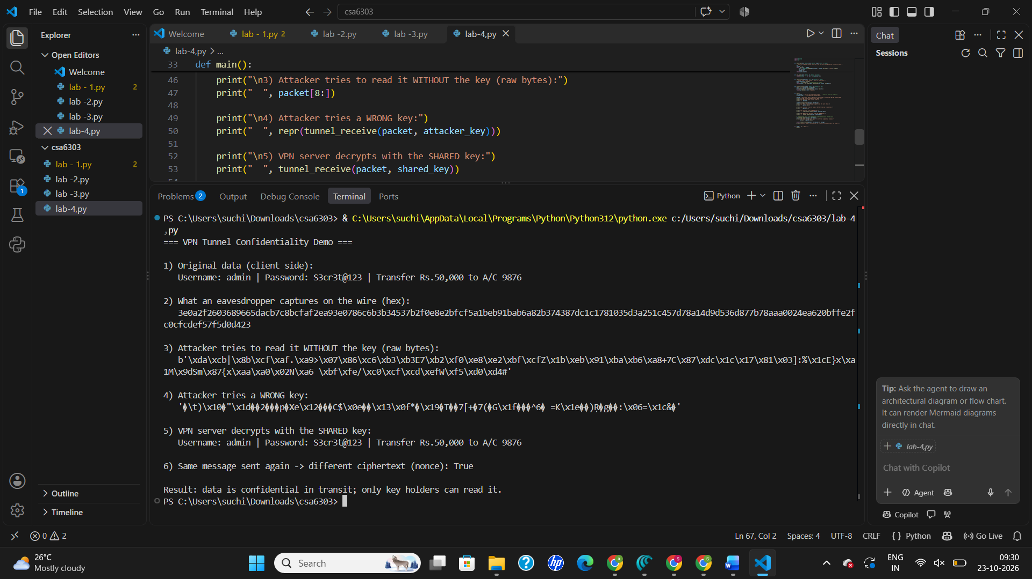

Question 5: Write a Python program using a keyword-based classifier that reads a description of a threat-intelligence report and its intended audience, and classifies it as Strategic, Tactical, or Operational.
Answer :
import re

KEYWORDS = {
"Strategic": [
"board", "executive", "ceo", "ciso", "c-suite", "leadership",
"long-term", "trend", "geopolitical", "risk", "investment", "budget",
"business impact", "roadmap", "strategy", "strategic", "policy",
"landscape", "annual", "decision-maker", "regulatory",
],
"Tactical": [
"ttp", "ttps", "tactics", "techniques", "procedures", "mitre",
"att&ck", "attack pattern", "detection rule", "yara", "sigma",
"soc", "security architect", "threat hunter", "threat hunting",
"playbook", "defensive", "adversary behaviour", "adversary behavior",
"campaign analysis", "red team",
],
"Operational": [
"incident", "incident response", "ongoing attack", "active campaign",
"imminent", "real-time", "real time", "ioc", "iocs", "indicator",
"ip address", "hash", "domain", "blocklist", "firewall rule",
"feed", "alert", "sysadmin", "analyst", "responder", "hours",
"immediate", "malware sample", "c2",
],
}

AUDIENCE_HINTS = {
"Strategic": ["board", "executive", "ceo", "ciso", "cxo", "leadership",
"management", "policy maker"],
"Tactical": ["soc", "security architect", "threat hunter", "detection engineer",
"red team", "blue team"],
"Operational": ["incident response", "responder", "sysadmin", "analyst",
"network defender", "ir team"],
}

def matches(text, words):
t = " " + re.sub(r"[^a-z0-9&\-\s]", " ", text.lower()) + " "
return [w for w in words if f" {w} " in t or f" {w}s " in t]

def classify(description, audience):
scores, evidence = {}, {}
for level, words in KEYWORDS.items():
d_hits = matches(description, words)
a_hits = matches(audience, AUDIENCE_HINTS[level])
# audience is a strong signal, so weight it double
scores[level] = len(d_hits) + 2 * len(a_hits)
evidence[level] = d_hits + a_hits
best = max(scores.values())
if best == 0:
return None, scores, evidence
winners = [l for l, s in scores.items() if s == best]
# tie-break by audience hints, then fixed order
if len(winners) > 1:
for l in winners:
if matches(audience, AUDIENCE_HINTS[l]):
return l, scores, evidence
return winners[0], scores, evidence

def main():
print("=== Threat Intelligence Report Classifier ===")
description = input("Describe the report:\n> ").strip()
audience = input("Intended audience:\n> ").strip()
if not description and not audience:
print("Nothing to classify.")
return
label, scores, evidence = classify(description, audience)
print("\n--- Scores ---")
for level, s in scores.items():
print(f"{level:12s} {s} {evidence[level]}")
print("\nClassification:", label or "Undetermined (add more detail)")

if __name__ == "__main__":
main()
output:
