SIMATS ENGINEERING
CSA6303- Threat Intelligence and Network Security
A1-Malware Analysis Assignment
Assessment Questions
Subject | Threat Intelligence | Total Marks | 50
Questions | 10 (all compulsory) | Marks per Question | 5
REg.No | 192365035 | Name | A.Sucharitha
Faculty | Dr.V.Parthipan | Slot | A
Instructions: Answer all questions. Each question carries 5 marks. Support answers with examples and diagrams where appropriate.
CO3: Perform threat analysis using intelligence models and utilize industry tools for monitoring and detection.
Code of Conduct:
I A.Sucharitha / 192365035 (Name / Reg No) certify that this submission is my original work and that I have adhered to the guidelines specified for this assessment. I understand that any violation of academic integrity rules will result in disciplinary action.
Signature of Student
sucharitha

Questions :
1. Malware Analysis Using Static Techniques: A security analyst receives a suspicious executable file attached to a phishing email. Before running the file, the analyst wants to examine its properties, file hash, strings, and imported functions. Explain how static malware analysis can help identify suspicious characteristics and assess the potential risk without executing the file.
2. Malware Analysis Using Dynamic Techniques: An organization suspects that an employee has downloaded a malicious program that may modify system files and communicate with an external server. Explain how dynamic malware analysis can be performed in an isolated virtual environment to observe the program's behavior and identify potential Indicators of Compromise (IoCs).
3. Malware Investigation Using a Threat Intelligence Platform: A company's security team discovers a suspicious file on an employee's computer. The file hash appears in a threat intelligence platform associated with a known malware family. Explain how the analyst can use threat intelligence sources to investigate the file, assess the reliability of the information, and recommend suitable containment measures.
4. Malware Detection Through Data Collection and Correlation: A university detects unusual processes on several computers, suspicious DNS requests, and unexpected outbound network connections. Explain how an analyst can collect and correlate endpoint logs, DNS records, firewall logs, and file hashes to determine whether the computers are infected with malware.
5. Malware Investigation Using SIEM Tools: A financial institution's Security Information and Event Management (SIEM) system generates alerts about suspicious process execution, repeated failed logins, and unusual network connections from the same workstation. Describe how the security analyst can use SIEM capabilities to correlate these events, investigate the possible malware infection, and prioritize the incident.
6. Malware Detection and Log Analysis Using Splunk: A company uses Splunk to monitor its network and endpoint logs. The security team suspects that malware is attempting to contact an external command-and-control server. Explain how Splunk can be used to search relevant logs, identify suspicious communication patterns, correlate events, and document evidence of possible malware activity.
7. Malware Investigation Using the ELK Stack: An e-commerce company uses the ELK Stack (Elasticsearch, Logstash, and Kibana) to monitor web server logs, firewall records, and endpoint events. The security team notices repeated connections to suspicious domains and unusual file activity. Explain how the ELK Stack can support malware investigation through log collection, processing, searching, visualization, and correlation.
8. Threat Hunting for Malware Activities: An organization's security team suspects that malware has infected an employee workstation but has not received any antivirus alerts. The workstation shows unusual CPU usage, unfamiliar processes, and connections to unknown external IP addresses. Describe a threat-hunting approach to investigate the workstation, identify suspicious behaviors, collect relevant IoCs, and recommend remediation measures.

9. Comparing Malware Analysis Tools Used in the IT Industry: A cybersecurity team needs to investigate a suspicious file and determine whether it contains malicious code. Compare static analysis tools, dynamic analysis tools, network traffic analyzers, and threat intelligence platforms in terms of their purpose and usefulness. Recommend an appropriate combination of tools for conducting a malware investigation.
10. Malware Analysis Report and Incident Response: A company discovers a suspicious executable on an employee's computer. Initial analysis identifies an unfamiliar process, a modified system configuration, and communication with a suspicious external domain. Prepare an outline for a malware analysis report that includes file information, analysis methodology, observed behavior, IoCs, threat intelligence findings, risk assessment, and recommended containment and recovery actions.

Answer 1: Malware Analysis Using Static Techniques
Static analysis examines a file's code, structure and metadata without executing it. It is the safest first step for the phishing attachment because nothing runs, and it quickly shows whether the file looks malicious and what it is likely to do.
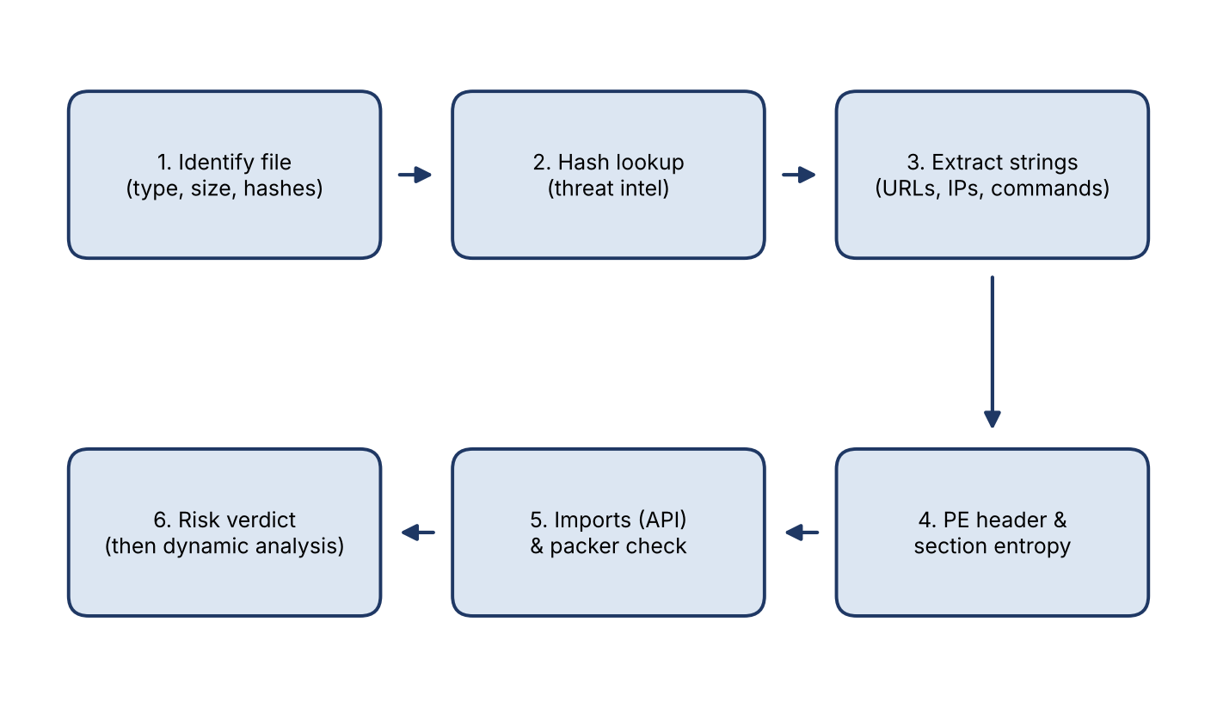
Fig. 1: Static analysis workflow
Steps and what each reveals
- File identification. Check the real file type from its magic bytes (file, Detect It Easy), not just the extension. An .pdf.exe or an executable disguised as a document is suspicious. Record file size and, in a safe copy, rename it to avoid accidental execution.
- File hash. Calculate MD5/SHA-1/SHA-256 (sha256sum, Get-FileHash) and search the hash on VirusTotal, MalwareBazaar or a threat-intelligence platform. A known detection gives instant classification; an unknown hash means a new or modified sample.
- Strings. Extract readable text with strings or FLOSS. Look for URLs, IP addresses, domain names, file paths, registry keys, PowerShell commands, user-agent strings, ransom notes or Base64 blobs. These reveal C2 servers and intent.
- PE header and sections. Open the file in PE-bear, PEview or CFF Explorer. Check the compile timestamp, number and names of sections, and entropy. Entropy above about 7 or odd section names (.UPX0) point to packing or encryption, which hides real code.
- Imported functions (IAT). Imports show capability without running the code (table below). A small import table with only LoadLibrary/GetProcAddress suggests the real imports are resolved at runtime to hide them.
- Digital signature, resources and YARA. An invalid or missing signature, embedded executables in resources, or a YARA rule match all raise risk. Optionally, disassemble in Ghidra or IDA to read the logic.
Imported API | Suspected behaviour
VirtualAlloc, WriteProcessMemory, CreateRemoteThread | Process injection / loading code in memory
URLDownloadToFile, InternetOpen, WinHttpSendRequest | Downloads payloads or contacts a C2 server
RegSetValueEx, CreateService | Persistence through registry or services
CryptEncrypt, CryptGenKey | Possible ransomware / data encryption
SetWindowsHookEx, GetAsyncKeyState | Keylogging / spyware
IsDebuggerPresent, GetTickCount | Anti-debug / anti-analysis

Risk assessment and limitations
Combining findings gives a risk verdict, for example: packed file + suspicious imports + embedded URL + no valid signature = high risk. Static analysis cannot see behaviour hidden by packing or encryption, so a suspicious result is followed by dynamic analysis in a sandbox.
Answer 2: Malware Analysis Using Dynamic Techniques
Dynamic analysis executes the sample in a controlled environment and records what it does to the system and the network. It shows real behaviour, even for packed malware that static analysis cannot read, and it is the best way to find IoCs for a program that modifies system files and contacts an external server.
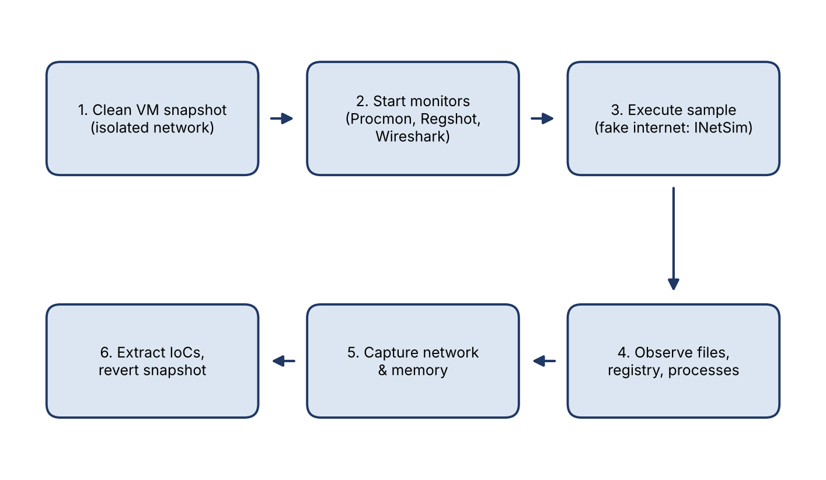
Fig. 2: Dynamic analysis in an isolated virtual lab
Safe lab setup
- A virtual machine (VMware/VirtualBox) with Windows installed, with a clean snapshot taken before each run.
- Network set to host-only/internal; no bridged adapter, no shared folders, no clipboard sharing. A fake internet (INetSim or FakeNet-NG) answers DNS/HTTP requests so the malware reveals its C2 behaviour without reaching the real internet.
- Analysis tools installed: Process Monitor, Process Explorer, Regshot, Autoruns, Wireshark, API Monitor. Alternatively use an automated sandbox such as Cuckoo or Any.Run.
Procedure and observations
- Take a baseline: snapshot the VM, run the first Regshot capture, and start Procmon and Wireshark.
- Execute the sample (with required privileges) and let it run for several minutes; interact with the system if the malware waits for input.
- File system: note files created, modified or deleted, such as dropped executables, changes to system folders or the hosts file.
- Registry and persistence: Regshot's second capture and Autoruns show new Run keys, services and scheduled tasks.
- Processes: watch child processes, injection into explorer.exe or svchost.exe, and created mutexes.
- Network: Wireshark/INetSim logs show DNS lookups, destination IPs, ports, protocols, beaconing intervals and HTTP headers.
- Collect a memory dump if needed, extract IoCs, then revert to the clean snapshot.
Indicators of Compromise identified
IoC type | Example from the analysis
File | Hashes, names and paths of dropped or modified files
Registry / persistence | Run keys, service names, scheduled-task names
Process | Process names, command lines, mutex names, injected processes
Network | C2 domains, IP addresses, ports, URI patterns, user-agent strings

Limitations: some malware detects virtual machines or delays execution (sleeps) to evade sandboxes, so analysts harden the VM and combine results with static analysis.
Answer 3: Malware Investigation Using a Threat Intelligence Platform
A threat intelligence platform (TIP) such as MISP, VirusTotal, AlienVault OTX or MalwareBazaar turns a single file hash into context about the malware family, its behaviour and related infrastructure.
Investigating the file
- Look up the hash in several sources and read the malware family, aliases, first-seen/last-seen dates, detection ratio and sandbox reports.
- Collect the linked IoCs: C2 domains and IPs, dropped file names, mutexes and registry keys, and the related campaign or threat actor.
- Map the behaviour to MITRE ATT&CK techniques to learn what the malware usually does next (credential theft, lateral movement, ransomware).
- Pivot into the environment: search SIEM, EDR, DNS and firewall logs for each IoC to find other infected hosts and see whether data has left.
Assessing the reliability of the information
Criterion | Question to ask
Source reputation | Is the feed from a trusted vendor, CERT or community with a track record?
Corroboration | Do two or more independent sources agree on the family and IoCs?
Timeliness | Is the intelligence recent? Old IPs and domains may now be reused by legitimate sites
Confidence & context | Does it include a confidence level, analysis report or sandbox evidence rather than only a hash match?
False positives | Could a legitimate tool be flagged (a single detection out of many engines)? Verify with local analysis
Relevance | Does the malware target our sector, region and operating systems?

The analyst treats the platform result as a lead and confirms it locally (sandbox run, log evidence) before taking drastic action.
Recommended containment measures
- Isolate the affected computer from the network using EDR, but keep it powered on to preserve memory evidence.
- Block the file hash in EDR/antivirus and block the C2 domains/IPs at DNS, proxy and firewall.
- Search the whole organisation for the hash and IoCs, and isolate any other matching machines.
- Reset passwords and revoke sessions for the affected user; check for lateral movement.
- Remove the malware and persistence (or re-image), patch the entry point, and monitor for reinfection.
Answer 4: Malware Detection Through Data Collection and Correlation
One alert type is rarely proof of infection. By collecting several data types from the affected computers and correlating them on host, IP and time, the analyst can decide whether the university's computers are infected.
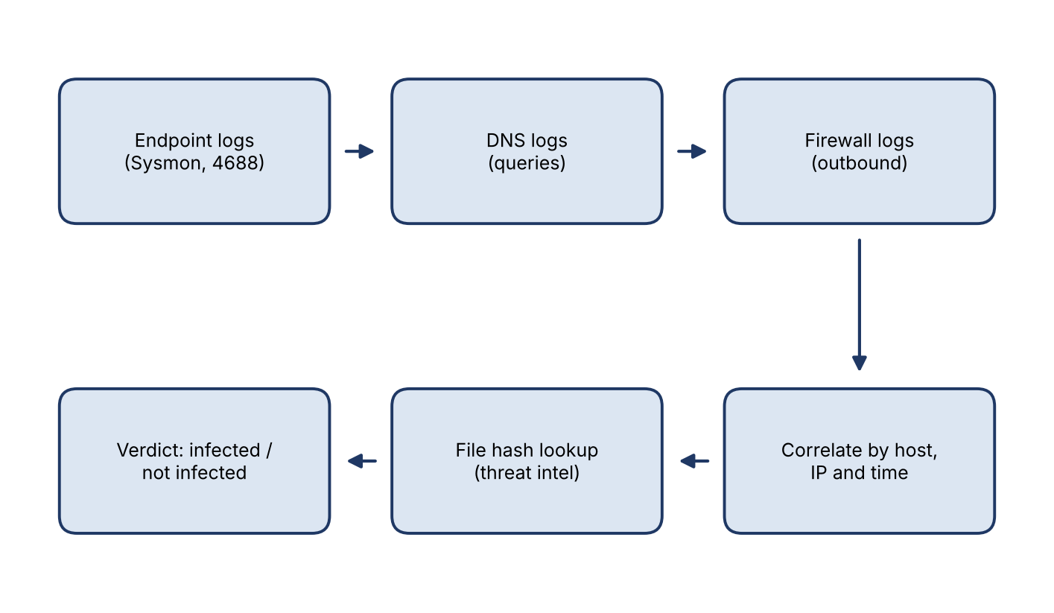
Fig. 3: Collection and correlation of evidence
Data to collect
Source | What to collect | What it can show
Endpoint logs | Sysmon (Event 1 process, 3 network, 11 file, 22 DNS), Windows 4688, PowerShell logs, EDR telemetry | Unusual processes, parent-child chains, files dropped, persistence
DNS records | DNS query logs, resolver logs, passive DNS | Requests to random or newly registered domains, DGA patterns, tunnelling, same domain queried by many hosts
Firewall logs | Allowed/denied connections, destination IP/port, bytes, time | Outbound connections to unknown IPs, beaconing, unusual ports, data volumes
File hashes | Hashes of suspicious executables from EDR or by direct calculation | Same hash on many machines indicates an outbreak; reputation lookup confirms malicious files

Correlation process
- Centralise and normalise logs in a SIEM or log platform, synchronising time stamps (NTP) so events line up.
- Link by host and time: for example, a rare process x.exe starts on PC-12 at 10:02, PC-12 queries random-name.xyz at 10:02, and the firewall shows PC-12 connecting to the resolved IP at 10:03.
- Verify the file hash in threat intelligence and a sandbox to confirm it is malicious.
- Scale out: search all computers for the same hash, domain and IP to measure how many are infected.
Deciding whether the machines are infected
A computer is considered infected when independent evidence agrees: a malicious or unknown process with a bad reputation, DNS and network traffic to the same suspicious destination at the matching time, and persistence or file changes. Isolated anomalies with no matching evidence are treated as false positives (for example, a software updater). Confirmed hosts are isolated and cleaned.
Answer 5: Malware Investigation Using SIEM Tools
The SIEM receives logs from endpoints, domain controllers, firewalls and proxies. It turns three separate alerts on the same workstation into one incident and helps the analyst decide how urgent it is.
Correlating the events
- Common key: the three alerts (suspicious process execution, repeated failed logins, unusual network connections) share the same workstation, so the SIEM groups them by host, user and time window.
- Correlation rule: suspicious process (Sysmon 1 / 4688) + >= 10 failed logins (4625) + outbound connection to a rare external IP within 30 minutes on the same host raises a single high-severity incident.
- ATT&CK mapping: Execution (T1059) → Credential Access / Brute Force (T1110) → Command and Control (T1071).
Investigating the possible infection
- Timeline: order all events from the host to see which happened first, such as the process starting before the failed logins and connections.
- Process analysis: check the process path, parent, command line, user and file hash; send the hash to threat intelligence.
- Login analysis: find the target of the failed logins (other servers or domain accounts), whether any succeeded, and whether the activity is lateral movement.
- Network analysis: enrich destination IPs and domains with reputation and GeoIP, and check data volume for exfiltration.
- Scope: search for the same hash, IP or domain on other workstations.
Prioritising the incident
Factor | Why it raises priority in a financial institution
Asset criticality | Workstation with access to payment, core-banking or customer data
Confidence | Several independent alerts correlate, with a threat-intelligence match
Spread / lateral movement | Failed or successful logins against other systems
Data exposure | Outbound traffic from a host that handles sensitive data
Privileges | Compromised account is an administrator or service account

Using the SIEM risk score and these factors, the incident is rated high/P1, assigned to an analyst, and handled through containment (isolate host via EDR, block IOCs, disable the account), eradication, recovery and a documented report. Lessons learned are converted into new correlation rules.
Answer 6: Malware Detection and Log Analysis Using Splunk
Splunk indexes endpoint and network logs so that analysts can search them with the Search Processing Language (SPL). Data arrives through Universal Forwarders and add-ons (Windows, Sysmon, firewall, DNS and proxy), and fields such as src_ip, dest_ip, query and process_name are extracted for searching.
Searching for command-and-control traffic
1. Rare or suspicious destinations. List destinations contacted by few hosts, and check them against a threat-intelligence lookup:
index=firewall action=allowed | rare limit=20 dest_ip
index=dns | eval len=len(query) | where len>40 | stats count by src, query
2. Beaconing (regular intervals). Calculate the time between connections from the same host to the same destination. A very low standard deviation suggests automated callbacks:
index=proxy | sort 0 src_ip dest_ip _time
| streamstats current=f last(_time) as prev by src_ip dest_ip
| eval delta=_time-prev
| stats count avg(delta) as avg stdev(delta) as sd by src_ip dest_ip
| where count>20 AND sd<5
3. Which process makes the connection (Sysmon Event 3):
index=sysmon EventCode=3 | stats dc(DestinationIp) count by host, Image
| where Image!="*\\chrome.exe" AND count>50
Correlating events
- Join process (Sysmon 1), DNS and firewall events by host and time using transaction, stats or join, to show one chain: process starts, DNS lookup, outbound connection.
- Use a threat-intelligence lookup file or the Enterprise Security threat-intel framework to flag known-bad IPs and domains.
- Save the search as an alert/correlation search so future occurrences create notable events.
Documenting evidence
- Save results as reports, export them as CSV/PDF, and record the exact SPL query, index, time range and the person who ran it.
- Build a dashboard of top suspicious destinations and beacon timelines, and attach screenshots to the case.
- Preserve raw logs (read-only) and note hashes of exported files to maintain chain of custody.
Answer 7: Malware Investigation Using the ELK Stack
The ELK Stack provides a pipeline from raw logs to searchable, visual evidence. Each component has a role in investigating repeated connections to suspicious domains and unusual file activity.
Component | Role in malware investigation
Beats (Filebeat, Winlogbeat, Packetbeat, Auditbeat) | Lightweight agents that collect web server, firewall, Windows/Sysmon and file-integrity events
Logstash | Processing pipeline: parses (grok), enriches (GeoIP, DNS, threat-intel translate) and normalises logs before indexing
Elasticsearch | Stores and indexes events, enabling fast full-text and field searches across all sources
Kibana | Searching (Discover), visualisation (Lens, maps), dashboards and the security app

Log collection and processing
Beats ship events to Logstash, which applies filters before sending them to Elasticsearch. A simple pipeline looks like this:
input { beats { port => 5044 } }
filter {
grok { match => { "message" => "%{COMBINEDAPACHELOG}" } }
geoip { source => "clientip" }
translate { field => "[dns][question][name]" dictionary_path => "bad_domains.yml"
destination => "[threat][match]" }
}
output { elasticsearch { hosts => ["es:9200"] index => "logs-%{+YYYY.MM.dd}" } }
Searching, visualisation and correlation
- Searching (KQL): destination.domain : "*suspicious*" and event.action : "connection_attempted" or event.code : 11 and file.path : *\\Temp\\*.exe to find odd file creation.
- Visualisation: a timeline of connections per domain, top-N destination domains, a geo map of destination IPs and a table of hosts contacting the same domain highlight patterns such as beaconing.
- Correlation: an Elastic Security EQL sequence links events in order, for example a process creation followed by a network connection to a rare domain from the same host within a time window, and raises a detection alert.
- Evidence: save searches and dashboards, export reports, and use the ECS field names so results are consistent across firewall, web and endpoint data.
Outcome: the analyst identifies which hosts contact the malicious domains, which process and file caused it, and the time span, then isolates the affected systems.
Answer 8: Threat Hunting for Malware Activities
The absence of an antivirus alert does not mean the workstation is clean. Modern malware (fileless, packed, or newly written) evades signatures, so a hunter looks for behaviour instead. Hypothesis: the workstation is running malware (a cryptominer or a remote-access trojan) that persists on the system and communicates with an external server.
Hunting approach
- Capture volatile data first. Record running processes, network connections and logged-on users (tasklist, netstat -ano, Get-NetTCPConnection) before rebooting. Take a memory image if possible.
- Process review. Use Process Explorer or EDR to find the process consuming CPU. Look for unsigned binaries, random names, names imitating system files (svch0st.exe), wrong parents (for example svchost.exe not started by services.exe) and executables in AppData or Temp.
- Network review. Match each unknown external IP to its owning process; check IP and domain reputation and the connection pattern (regular beaconing).
- Persistence check. Examine Autoruns, Run/RunOnce keys, scheduled tasks, services and WMI subscriptions.
- Log analysis. Review Sysmon, 4688 process creation, PowerShell script-block logs (4104) and DNS logs for encoded commands and unusual lookups.
- Memory and file analysis. Use Volatility (malfind) for injected code; hash suspicious files and check them in VirusTotal or a sandbox.
Observed behaviour | What it may indicate
Sustained high CPU from an unfamiliar process | Cryptomining or heavy malicious activity
Unfamiliar process in user-writable folder | Dropped malware or masquerading binary
Connections to unknown IPs at fixed intervals | C2 beaconing
Encoded PowerShell, new scheduled task or Run key | Fileless malware and persistence

IoCs to collect
File hashes, file names and paths, process names and command lines, registry keys, scheduled tasks/services, mutexes, destination IPs and domains, user-agent strings and the time of first activity.
Remediation
- Isolate the workstation; terminate the malicious process; remove files and persistence, or re-image if integrity is uncertain.
- Reset the user's passwords and revoke tokens; block IoCs on firewall, DNS and EDR.
- Sweep the environment for the same IoCs; patch the entry point; deploy EDR rules for the observed behaviour; train the user.
Answer 9: Comparing Malware Analysis Tools Used in the IT Industry
Tool category | Purpose | Examples | Usefulness / limitations
Static analysis tools | Inspect a file without running it: hashes, strings, headers, imports, disassembly | PEStudio, Detect It Easy, PE-bear, strings/FLOSS, Ghidra, IDA, YARA | Safe and fast; shows capabilities and embedded IoCs. Struggles with packed or obfuscated code and cannot show runtime behaviour
Dynamic analysis tools | Run the sample in a sandbox and observe behaviour | Cuckoo, Any.Run, Joe Sandbox, Process Monitor, Regshot, Process Explorer | Shows real file, registry, process and network activity and extracts IoCs. Takes more time; malware may detect the sandbox or require specific triggers
Network traffic analysers | Capture and analyse network communication caused by the malware | Wireshark, Zeek, Suricata, Fiddler, FakeNet-NG / INetSim | Reveals C2 servers, protocols, beaconing and data exfiltration. Encrypted traffic limits payload visibility
Threat intelligence platforms | Provide reputation, malware family, campaigns and related IoCs | VirusTotal, MISP, AlienVault OTX, MalwareBazaar, ThreatConnect | Fast triage and context; helps with scoping. Depends on data quality, and new or targeted malware may be unknown

Recommended combination for a malware investigation
- Triage: hash lookup in a threat-intelligence platform (VirusTotal, MISP) to see whether the file is already known.
- Static analysis: DIE and PEStudio for packing, imports and strings; YARA to match families.
- Dynamic analysis: run the file in an isolated sandbox (Cuckoo/Any.Run) with Procmon and Regshot to record behaviour.
- Network analysis: Wireshark/Zeek with a fake internet to capture C2 communication.
- Enrichment: return to the threat-intelligence platform with the new IoCs (domains, IPs, dropped file hashes) to identify the campaign.
- Deep analysis if needed: reverse-engineer with Ghidra/IDA, then record all results in a report and add detections to SIEM/EDR.
This layered approach is recommended because each tool covers the weakness of another: static analysis is safe but limited, dynamic analysis shows behaviour, network analysis reveals communication, and threat intelligence supplies context.
Answer 10: Malware Analysis Report and Incident Response
Suggested outline of the malware analysis report for the suspicious executable (unfamiliar process, modified system configuration, communication with a suspicious external domain):
1. Report details and executive summary
- Report title, case ID, date, analyst name, classification (TLP) and version.
- Summary for management: what was found, business impact, current status and key actions.
2. File information
Field | Details to record
File name / path / size | Original name, location on the computer, size in bytes
File type | PE32/PE64 executable, compile timestamp, packer if any
Hashes | MD5, SHA-1, SHA-256
Source and delivery | Email attachment, download or removable media; date and time first seen
Signature | Digital signature status and publisher

3. Analysis methodology
- Tools and environment: isolated VM and snapshot, static tools (PEStudio, strings, YARA), dynamic tools (Procmon, Regshot, Wireshark, sandbox) and threat-intelligence sources.
- Steps followed and time spent: static analysis, dynamic analysis, network analysis and threat intelligence enrichment; chain of custody for evidence.
4. Observed behaviour
- Process activity: the unfamiliar process, its parent, command line and any injected or child processes.
- System changes: modified system configuration (registry keys, startup entries, services, scheduled tasks, security settings, hosts file) and dropped files.
- Network activity: DNS requests, connections to the suspicious external domain, ports, protocols, beacon interval and data transferred.
5. Indicators of Compromise
IoC type | Value (to be filled from the analysis) | Context
File hash | SHA-256: <hash> | Malicious executable
Domain / IP | <suspicious-domain>[.]<tld> / <IP> | C2 communication
Registry / task | <registry key / task name> | Persistence
Process / mutex | <process name> / <mutex> | Runtime artefacts

6. Threat intelligence findings
- Malware family, aliases and campaign or actor; first-seen date and detection ratio.
- Related IoCs and ATT&CK techniques; reliability and confidence of each source.
7. Risk assessment
Factor | Assessment
Likelihood | High (confirmed malicious behaviour and C2 communication)
Impact | Based on data on the computer, privileges, systems reachable
Spread | Other hosts with the same IoCs found by enterprise search
Overall severity | Critical / High / Medium / Low, with justification

8. Containment, eradication and recovery actions
- Containment: isolate the host, block the domain/IP and file hash, disable or reset affected accounts.
- Eradication: remove the executable and persistence, restore modified configuration, or re-image the system; patch the entry vector.
- Recovery: restore from clean backup, return the system to the network, and monitor for reinfection for a defined period.
9. Recommendations, lessons learned and appendices
- Detection improvements (SIEM/EDR rules, YARA), user awareness training, email filtering and application allow-listing.
- Appendices: screenshots, logs, process trees, packet captures, tool output and the full IoC list.

