SIMATS ENGINEERING
CSA6303 – Threat Intelligence and Network Security
A1 – Threat Intelligence Report
Assessment Questions
Subject | Threat Intelligence | Total Marks | 50
Questions | 10 (all compulsory) | Marks per Question | 5
Reg. No | 192365035 | Name | A. Sucharitha
Faculty | Dr. V. Parthipan | Slot | A

Instructions: Answer all questions. Each question carries 5 marks. Support answers with examples and diagrams where appropriate.
Code of Conduct: I, A. Sucharitha (Reg No 192365035), certify that this submission is my original work and that I have adhered to the guidelines specified for this assessment. I understand that any violation of academic integrity rules will result in disciplinary action.
Signature of Student:
A.Sucharitha
Questions
Q1. Malware [5 Marks]
Define malware and explain any four types of malware (virus, worm, trojan, ransomware, spyware). For each type, state how it spreads and one impact on the victim.
Q2. Phishing [5 Marks]
Describe how a phishing attack is carried out. Differentiate between spear phishing, whaling and vishing, and list three measures an organisation can adopt to reduce phishing risk.
Q3. DoS and DDoS [5 Marks]
Distinguish between a Denial of Service (DoS) attack and a Distributed Denial of Service (DDoS) attack. Explain the working of a SYN flood and outline two mitigation techniques.
Q4. Man-in-the-Middle Attacks [5 Marks]
What is a Man-in-the-Middle (MITM) attack? Explain two techniques used to carry it out (for example ARP poisoning, rogue Wi-Fi access point, SSL stripping) and state how encryption helps defend against it.
Q5. Spoofing and Sniffing [5 Marks]
Compare spoofing and sniffing. Explain IP spoofing and ARP spoofing with an example each, and describe how packet sniffers such as Wireshark can be used both maliciously and legitimately.
Q6. Vulnerability Assessment [5 Marks]
Explain the vulnerability assessment process. Describe its main phases, and differentiate between vulnerability assessment and penetration testing. Name two commonly used scanning tools.
Q7. Vulnerability Scoring [5 Marks]
What are CVE and CVSS? Explain how CVSS scores help in prioritising vulnerabilities and why a high CVSS score alone may not decide the order of patching.
Q8. Threat Data Sources and OSINT [5 Marks]
Discuss the main sources of threat data (internal, external, open-source and commercial). Define Open-Source Intelligence (OSINT) and describe three OSINT sources or tools used in threat intelligence gathering.
Q9. Indicators of Compromise (IoCs) [5 Marks]
What are Indicators of Compromise (IoCs)? Classify them into network-based, host-based and file-based indicators with two examples of each, and explain how a security team uses IoCs during incident response.
Q10. Threat Feeds [5 Marks]
Explain what a threat intelligence feed is. Describe the common feed formats and sharing standards (STIX/TAXII), list two advantages and two limitations of using threat feeds, and name two example feeds.
Marking Scheme (for evaluator)
Q.No | Expected points and mark distribution (total 5)
1 | Definition (1); four types with spread method and impact (4 x 1 = 4).
2 | Attack flow (1.5); three variants differentiated (1.5); three countermeasures (2).
3 | DoS vs DDoS (1.5); SYN flood working (1.5); two mitigations such as rate limiting, SYN cookies, CDN/scrubbing, blackhole routing (2).
4 | Definition and interception concept (1); two techniques (2); defences such as TLS, HSTS, certificate validation, VPN (2).
5 | Comparison (1); IP and ARP spoofing with examples (2); sniffer dual use (1.5); one countermeasure (0.5).
6 | Phases: asset discovery, scanning, analysis and prioritisation, reporting, remediation (2); VA vs pen test (2); two tools such as Nessus, OpenVAS, Qualys (1).
7 | CVE meaning (1); CVSS meaning and severity ratings (1.5); role in prioritisation (1.5); context factors such as exploitability and asset criticality (1).
8 | Threat data source categories (2); OSINT definition (1); three OSINT sources or tools such as Shodan, VirusTotal, WHOIS, social media, dark web monitoring (2).
9 | Definition (1); classification with examples (3); use in detection and response (1).
10 | Definition (1); STIX/TAXII or similar formats (1.5); two advantages and two limitations (2); two example feeds such as AlienVault OTX, MISP, abuse.ch (0.5).

ANSWERS
Q1. Malware [5 Marks]
Definition
Malware (malicious software) is any program or code deliberately written to infiltrate, damage, disrupt, or gain unauthorised access to a computer system, network, or data without the owner's knowledge or consent. It is used to steal information, extort money, spy on users, or take control of devices.
Four types of malware
Type | Description | How it spreads | Impact on the victim
Virus | Attaches itself to a legitimate file or program and executes when the host is run; it needs user action to activate. | Infected email attachments, USB drives, pirated software, downloaded executables. | Corrupts or deletes files and slows the system, e.g. the ILOVEYOU virus overwrote user files.
Worm | Self-replicating, standalone program that needs no host file and no user action. | Exploits network vulnerabilities (e.g. open SMB ports) and mass-mails itself over the network. | Consumes bandwidth and resources, crashing networks, e.g. WannaCry used EternalBlue to spread.
Trojan | Appears as useful or genuine software but carries a hidden malicious payload; it does not self-replicate. | Fake software installers, cracked apps, malicious downloads, social engineering. | Opens a backdoor for attackers, leading to data theft or remote control (RAT), e.g. Zeus banking trojan.
Ransomware | Encrypts the victim's files or locks the system and demands payment for the key. | Phishing emails, exploit kits, unpatched services, exposed RDP. | Loss of access to data and business downtime, plus ransom demands (e.g. WannaCry, LockBit).
Spyware (additional): secretly monitors activity (keystrokes, screens) and spreads via bundled free software or malicious links, resulting in stolen passwords and privacy loss.
Q2. Phishing [5 Marks]
How a phishing attack is carried out
Phishing is a social-engineering attack in which the attacker impersonates a trusted entity (bank, employer, courier, government) to trick victims into revealing credentials or installing malware. A typical attack proceeds as follows:
- Reconnaissance: the attacker chooses targets and collects email addresses and context.
- Preparation: a convincing lure is built, such as a spoofed sender address and a cloned login page on a look-alike domain.
- Delivery: the message is sent by email, SMS or call and creates urgency ("account suspended, verify now").
- Victim interaction: the victim clicks the link, opens the attachment, or enters credentials.
- Harvest and exploitation: credentials or card details are captured, or malware is installed, then used for account takeover, fraud or lateral movement.
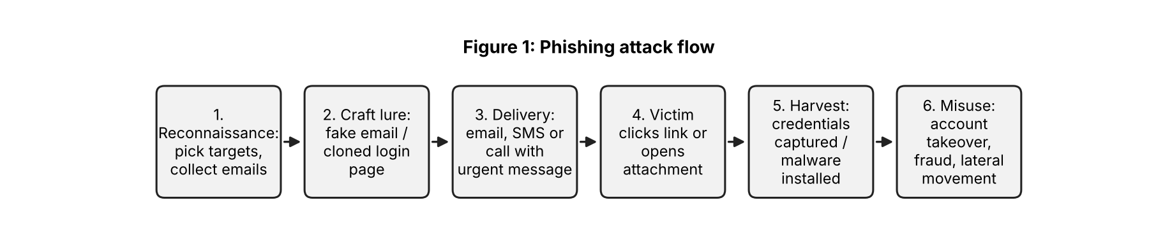
Spear phishing vs whaling vs vishing
Variant | Target | Method | Example
Spear phishing | A specific individual or small group. | Personalised email using researched details such as name, role, colleagues. | Email to an accountant that appears to come from their manager asking to open an invoice.
Whaling | Senior executives (CEO, CFO, directors). | Highly polished, high-stakes message about legal, tax or wire-transfer matters. | Fake CEO-fraud mail asking the CFO for an urgent fund transfer.
Vishing | Any individual, via voice calls. | Phone call (often with caller-ID spoofing) pressing the victim to share OTP or card details. | Caller posing as bank staff asking for an OTP to "stop a fraud".
Three measures to reduce phishing risk
- Security awareness training and phishing simulations so staff can recognise and report suspicious messages.
- Email security controls: SPF, DKIM and DMARC, spam/attachment filtering and link sandboxing to block spoofed and malicious mail.
- Multi-factor authentication (MFA) and a clear reporting process, so stolen passwords alone cannot be used to access accounts.
Q3. DoS and DDoS [5 Marks]
DoS vs DDoS
Basis | DoS | DDoS
Source of attack | A single machine or connection. | Many compromised machines (a botnet) at once.
Traffic volume | Limited by one attacker's bandwidth. | Very large, often hundreds of Gbps or more.
Detection and blocking | Easy: block the single source IP. | Hard: traffic comes from thousands of legitimate-looking IPs.
Tracing the attacker | Easier to trace. | Difficult: botnet owner hides behind the bots.
Example | Ping flood from one host. | Mirai botnet attack on Dyn DNS (2016).
Working of a SYN flood
A SYN flood exploits the TCP three-way handshake (SYN, SYN-ACK, ACK). The attacker sends a large number of SYN packets, usually with spoofed source IPs. The server replies with SYN-ACK, allocates an entry in its connection backlog queue and waits for the final ACK, which never arrives because the spoofed hosts never sent the SYN. These half-open connections fill the backlog queue until the server cannot accept new connections, so genuine users are denied service.
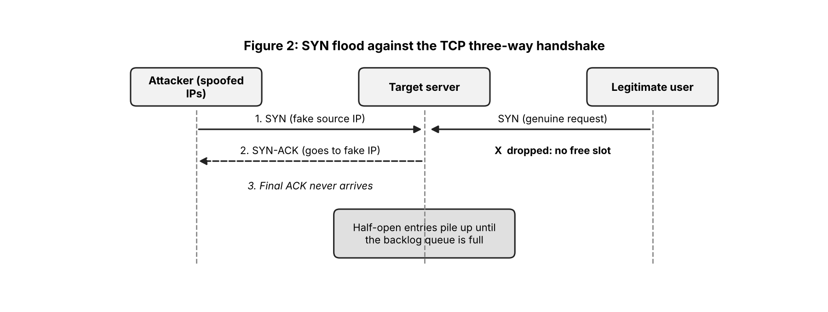
Two mitigation techniques
- SYN cookies: the server encodes connection state in the SYN-ACK sequence number and allocates memory only when a valid final ACK returns, so fake SYNs consume no backlog space.
- Rate limiting / CDN and scrubbing services: limit SYN requests per source and route traffic through a CDN or DDoS-scrubbing provider that filters malicious packets before they reach the server. (Blackhole routing is a last resort.)
Q4. Man-in-the-Middle Attacks [5 Marks]
Definition
A Man-in-the-Middle (MITM) attack occurs when an attacker secretly positions themselves between two communicating parties, intercepting, reading and possibly altering messages while both sides believe they are talking directly to each other. It threatens confidentiality and integrity, e.g. stealing login credentials or changing a bank transfer.
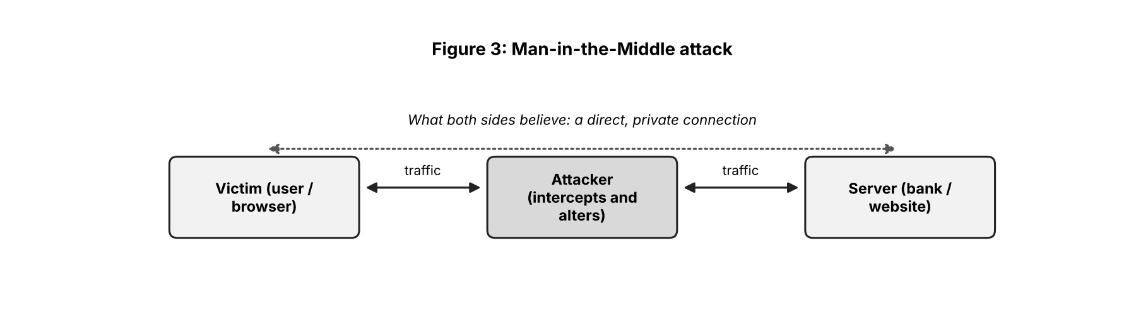
Two techniques
1. ARP poisoning (ARP spoofing): ARP has no authentication. The attacker sends forged ARP replies on a LAN, linking the attacker's MAC address with the gateway's IP (and with the victim's IP towards the gateway). Both devices update their ARP caches and send traffic through the attacker, who forwards it onward after inspecting or modifying it. Tools such as Ettercap and Bettercap automate this.
2. Rogue Wi-Fi access point (evil twin): the attacker sets up a hotspot with a familiar name (e.g. "Free_Airport_WiFi"). Users who connect send all their traffic through the attacker's device, which can capture unencrypted data and attempt SSL stripping. (SSL stripping downgrades HTTPS links to HTTP so that the victim browses in plain text.)
How encryption helps defend
- TLS/HTTPS encrypts data in transit, so intercepted traffic is unreadable ciphertext.
- Certificate validation lets the client verify the server's identity through a trusted CA, so an impostor's certificate triggers a warning.
- HSTS forces browsers to use HTTPS only, preventing SSL stripping.
- VPN wraps all traffic in an encrypted tunnel, which protects users on untrusted Wi-Fi.
Q5. Spoofing and Sniffing [5 Marks]
Comparison
Basis | Spoofing | Sniffing
Meaning | Faking an identity (IP, MAC, email, DNS) to impersonate a trusted source. | Capturing and inspecting network packets as they travel across the network.
Nature | Active attack: the attacker injects forged packets. | Mostly passive: the attacker only listens, which makes it hard to detect.
Goal | Bypass authentication or trust, redirect traffic, hide the source. | Steal credentials, session cookies and confidential data.
Examples | IP spoofing, ARP spoofing, email spoofing. | Wireshark and tcpdump capturing unencrypted HTTP or FTP logins.
IP spoofing
The attacker forges the source IP address in packet headers so that the packets appear to come from a trusted host. Example: in a DDoS reflection attack, the attacker sends DNS requests with the victim's IP as the source address, so the DNS servers send their large responses to the victim and flood it. IP spoofing is also used to bypass IP-based access control lists.
ARP spoofing
The attacker sends fake ARP replies on a local network to associate their own MAC address with another host's IP address. Example: on an office LAN, the attacker maps the gateway's IP (192.168.1.1) to the attacker's MAC. All of the victim's traffic then passes through the attacker, enabling sniffing or a MITM attack.
Packet sniffers such as Wireshark
Malicious use | Legitimate use
Capturing unencrypted passwords, cookies and emails on shared or compromised networks, especially with the NIC in promiscuous mode. | Network troubleshooting: diagnosing latency, packet loss and misconfigurations.
Mapping the network and finding services and hosts to attack next. | Security analysis: detecting intrusions, malware traffic and data exfiltration; digital forensics.
Harvesting session tokens for session hijacking. | Protocol analysis, learning, and verifying that applications encrypt their traffic.
Countermeasure: use end-to-end encryption (HTTPS/TLS, SSH, VPN), which makes sniffed data unreadable; static ARP entries or Dynamic ARP Inspection on switches stop ARP spoofing.
Q6. Vulnerability Assessment [5 Marks]
Vulnerability assessment (VA) is the systematic process of identifying, classifying and prioritising security weaknesses in systems, applications and networks, so they can be fixed before attackers exploit them.
Main phases
- Scoping and asset discovery: define the scope and inventory hosts, services, applications and their owners.
- Vulnerability scanning: run automated scanners against the assets to detect missing patches, misconfigurations and weak settings.
- Analysis and prioritisation: validate findings, remove false positives and rank them by severity (CVSS), exploitability and asset criticality.
- Reporting: document vulnerabilities, risk ratings, evidence and recommended fixes for technical staff and management.
- Remediation and re-scan: patch or mitigate, then re-scan to verify the fix and track progress.
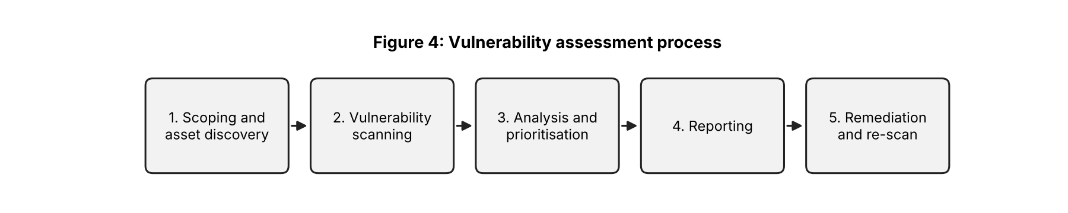
Vulnerability assessment vs penetration testing
Basis | Vulnerability assessment | Penetration testing
Objective | Find and list as many weaknesses as possible. | Exploit weaknesses to show real impact and attack paths.
Approach | Mostly automated scanning. | Manual, skilled, goal-driven testing supported by tools.
Depth | Broad but shallow; does not prove exploitability. | Narrower but deep; proves what an attacker could achieve.
Frequency and cost | Frequent (weekly or monthly), lower cost. | Periodic (annual or after major change), higher cost.
Output | Prioritised list of vulnerabilities. | Report of successful exploits, impact and remediation.
Two commonly used scanning tools
- Nessus (Tenable): commercial scanner with a large plugin database for network and compliance scanning.
- OpenVAS (Greenbone): open-source vulnerability scanner. (Qualys is a popular cloud-based alternative.)
Q7. Vulnerability Scoring [5 Marks]
CVE
CVE (Common Vulnerabilities and Exposures) is a public catalogue that gives each publicly known vulnerability a unique identifier in the form CVE-YEAR-NNNN (e.g. CVE-2021-44228 for Log4Shell). It is maintained by MITRE and gives everyone a common name to refer to the same flaw across scanners, advisories and patches.
CVSS and severity ratings
CVSS (Common Vulnerability Scoring System) is an open framework that rates the technical severity of a vulnerability on a scale of 0.0 to 10.0. The Base score depends on attack vector, complexity, privileges required, user interaction, and the impact on confidentiality, integrity and availability. It can be refined with Temporal and Environmental metrics.
Score | Severity | Typical response
0.0 | None | No action
0.1 – 3.9 | Low | Fix in routine maintenance
4.0 – 6.9 | Medium | Schedule within planned patch cycle
7.0 – 8.9 | High | Fix promptly
9.0 – 10.0 | Critical | Fix immediately
Role in prioritisation
With thousands of findings, CVSS gives teams an objective, standard way to rank vulnerabilities, so that Critical and High items are handled first, remediation deadlines (SLAs) can be set by severity, and reports can be compared across tools and organisations.
Why a high CVSS score alone should not decide the order
The Base score measures intrinsic severity, not the risk to a specific organisation. Other context factors matter:
- Exploitability: a medium-scored flaw with a public exploit that is actively used in attacks (e.g. listed in CISA's KEV catalogue, high EPSS) can be more urgent than a 9.8 that has no known exploit.
- Asset criticality: a flaw on an internet-facing payment server matters more than the same flaw on an isolated test machine.
- Exposure and compensating controls: network reachability, firewalls, segmentation or WAF rules can lower real risk; the business impact of an outage or data loss raises it.
Q8. Threat Data Sources and OSINT [5 Marks]
Main sources of threat data
Source | Description | Examples
Internal | Data generated inside the organisation; most relevant to its own environment. | Firewall, IDS/IPS, proxy and DNS logs, SIEM alerts, EDR telemetry, past incident reports, honeypots.
External | Information received from outside bodies such as industry peers, CERTs and government agencies. | CERT-In and US-CERT advisories, ISACs, vendor security bulletins, law-enforcement alerts.
Open-source | Freely available information and community-shared indicators. | AlienVault OTX, abuse.ch, MISP communities, security blogs, GitHub, CVE/NVD.
Commercial | Paid, curated and analysed intelligence with support and context. | Recorded Future, CrowdStrike Falcon Intelligence, Mandiant, Palo Alto Unit 42 feeds.
OSINT
Open-Source Intelligence (OSINT) is intelligence produced by collecting, analysing and correlating information from publicly available sources (websites, social media, public databases, forums, news, etc.) to answer a specific intelligence requirement. In threat intelligence it is used to identify attacker infrastructure, exposed assets and emerging threats at low cost.
Three OSINT sources/tools
- Shodan: a search engine for internet-connected devices; reveals exposed servers, open ports, cameras and outdated services belonging to an organisation or an attacker.
- VirusTotal: aggregates dozens of antivirus engines and URL scanners to check whether a file hash, domain or IP is malicious and to find related samples.
- WHOIS / domain lookup: shows registrant, registrar and creation date of domains, which helps spot newly registered phishing and look-alike domains and link them to the same actor. (Social media and dark-web monitoring are other common sources.)
Q9. Indicators of Compromise (IoCs) [5 Marks]
Indicators of Compromise (IoCs) are pieces of forensic evidence or artefacts observed on a network or system that show that a breach or malicious activity has occurred or is under way. They are the "fingerprints" attackers leave behind and are used to detect known threats.
Classification
Category | Description | Two examples
Network-based | Evidence seen in network traffic. | 1. Connections to a known malicious IP address or command-and-control domain.  2. Unusual outbound traffic volume or beaconing at fixed intervals (possible data exfiltration).
Host-based | Evidence on an endpoint or server. | 1. New or modified registry run keys, scheduled tasks or unknown services for persistence.  2. Unexpected processes, or multiple failed logins followed by a login from an unusual account.
File-based | Characteristics of malicious files. | 1. Hash values (MD5/SHA-256) matching known malware.  2. Suspicious file names or paths, or an unusual file size and signature, e.g. an executable in the Temp folder.
Use of IoCs during incident response
- Detection: IoCs are loaded into SIEM, EDR, IDS/IPS and firewalls, which then alert on matches.
- Triage and scoping: the team sweeps logs and endpoints for the IoCs to find all affected hosts and determine how far the attack has spread.
- Containment and eradication: malicious IPs and domains are blocked, infected hosts are isolated, and malware matching the hashes is removed.
- Recovery and sharing: systems are re-checked for IoCs after cleaning, and the IoCs are shared with partners (STIX/TAXII) and added to threat intelligence to prevent repeat attacks.
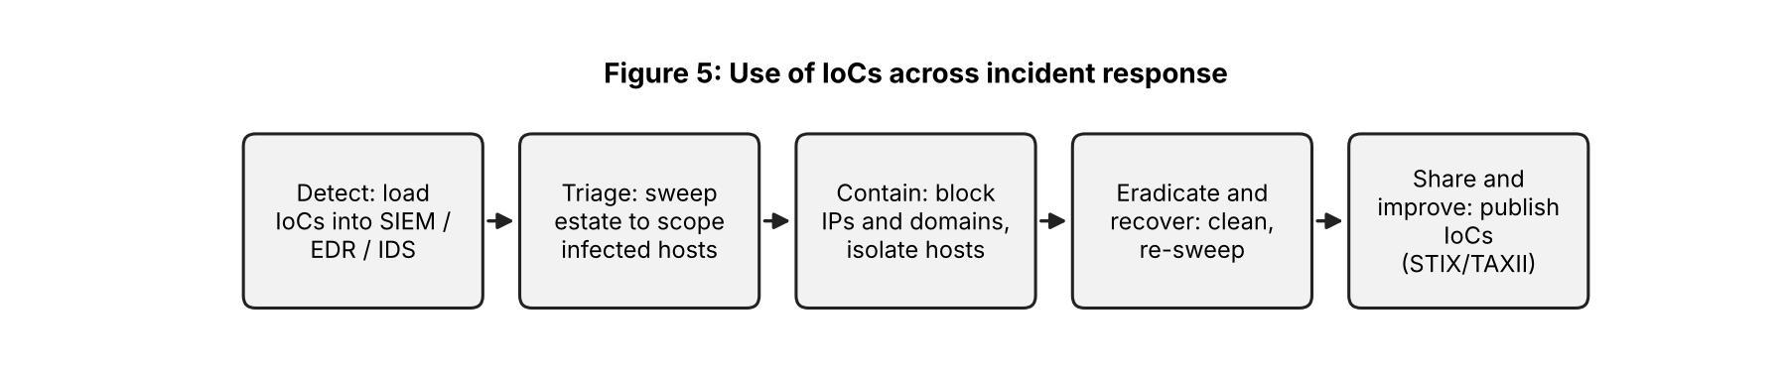
Q10. Threat Feeds [5 Marks]
What is a threat intelligence feed?
A threat intelligence feed is a continuously updated stream of machine-readable data about current threats, such as malicious IP addresses, domains, URLs, file hashes and attacker tactics. Security tools like SIEMs, firewalls and EDR consume feeds automatically to block or flag known-bad activity.
Common formats and sharing standards
- Simple formats: CSV, JSON, plain-text blocklists and RSS, easy to ingest but with little context.
- STIX (Structured Threat Information eXpression): a standard language and JSON format for describing threat intelligence, including indicators, malware, threat actors, campaigns and their relationships.
- TAXII (Trusted Automated eXchange of Intelligence Information): the transport protocol (over HTTPS) that defines how STIX data is exchanged between servers and clients, using collections and channels. STIX defines what is shared; TAXII defines how it is shared.
- Others: OpenIOC (XML) and the MISP format for sharing events and indicators.
Advantages and limitations
Advantages | Limitations
1. Provide timely, automated updates that let tools block known threats quickly and reduce detection time. | 1. High volume and false positives or stale indicators can cause alert fatigue if feeds are not filtered and aged out.
2. Add external context and visibility beyond the organisation's own logs, and save the effort of collecting data manually. | 2. Often lack context and relevance to the organisation, and indicators (IPs, domains) change fast, so feeds only catch already-known threats.
Two example feeds
- AlienVault OTX (Open Threat Exchange): free, community-driven platform sharing "pulses" of indicators.
- abuse.ch (e.g. URLhaus, Feodo Tracker) and MISP feeds: free feeds of malicious URLs, botnet C2 servers and malware hashes.

