CSA1064-SOFTWARE ENGINEER FOR CLOUD AND DEVOPS
Name: Athota Srivani Reg.No.:1G2372142

EXP- 1:
Create a Kanban Board to Visualize the Tasks.
- Create Columns for To Do, In-Progress and Done.
- Add Atleast 5 Sample Tasks
Move the Tasks across the Columns to Simulate the Workflow. Create a Kanban Board (Jira/Trello)
Aim
To create and simulate a Kanban workflow using Jira or Trello.
Procedure
- Login to Jira/Trello.
- Create a new Kanban board.
- Create columns: To Do, In Progress, Done.
- Add 2 to 3 tasks.
- Move tasks across columns to simulate workflow.
- Observe task progress.

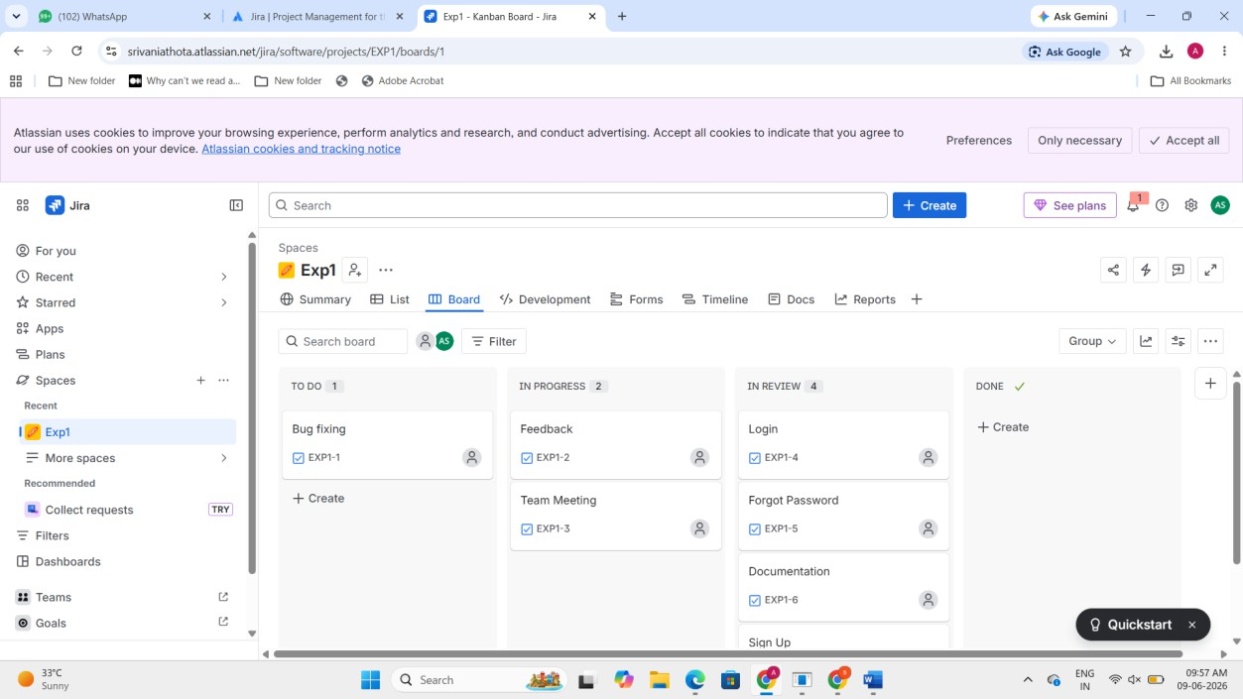
EXP- 2
Bus Ticket Booking Prototype (Figma) Aim
To design a simple Bus Ticket Booking System prototype using Figma.
Procedure
- Open Figma and create a new design file.
- Design screens:
  - Home Page
  - Search Bus
  - Seat Selection
  - Payment Page
- Add navigation links.
- Present prototype mode.

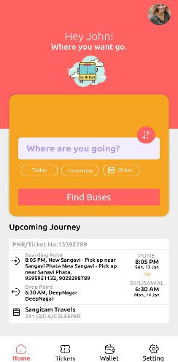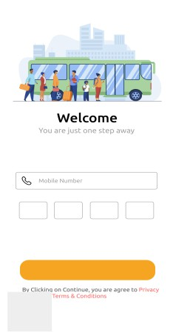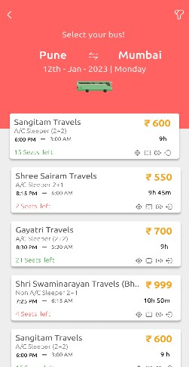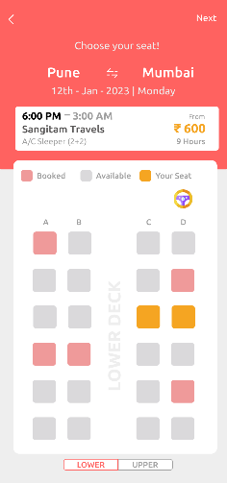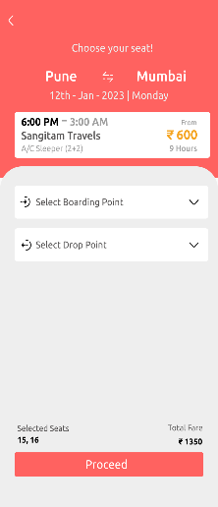
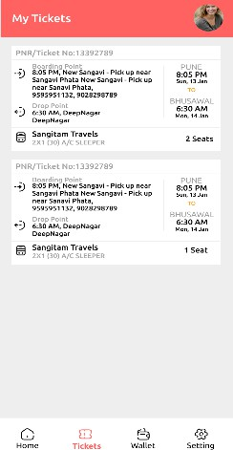
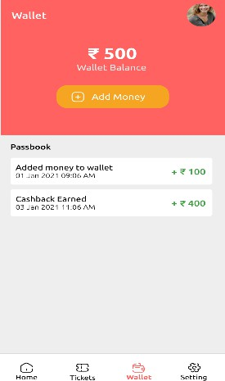

Result: Thus, The clickable prototype of Bus Ticket Booking System was created successfully.

EXP-3
E- Commerce Mobile App Prototype (Figma) Aim
To design a prototype for stakeholder feedback.
Procedure
- Create mobile frame in Figma.
- Design Home, Product Page, Cart, Checkout.
- Create two UI variations (to resolve conflict)

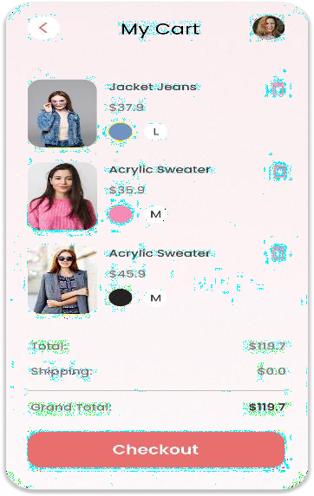

Result: Thus, The Prototype created and stakeholder feedback collected for UI finalization.
Exp-4:
The string is a sequence of characters placed in double quotes (” “). Performing different operations on string data is called String Handling. Strings are immutable. Whenever a change to a String is made, an entirely new String is created. If we want to store a group of characters we can use a char array. String provides various methods to perform different operations on strings. Using Raptor draw a flowchart to display the
total number of characters in the string and returns it.
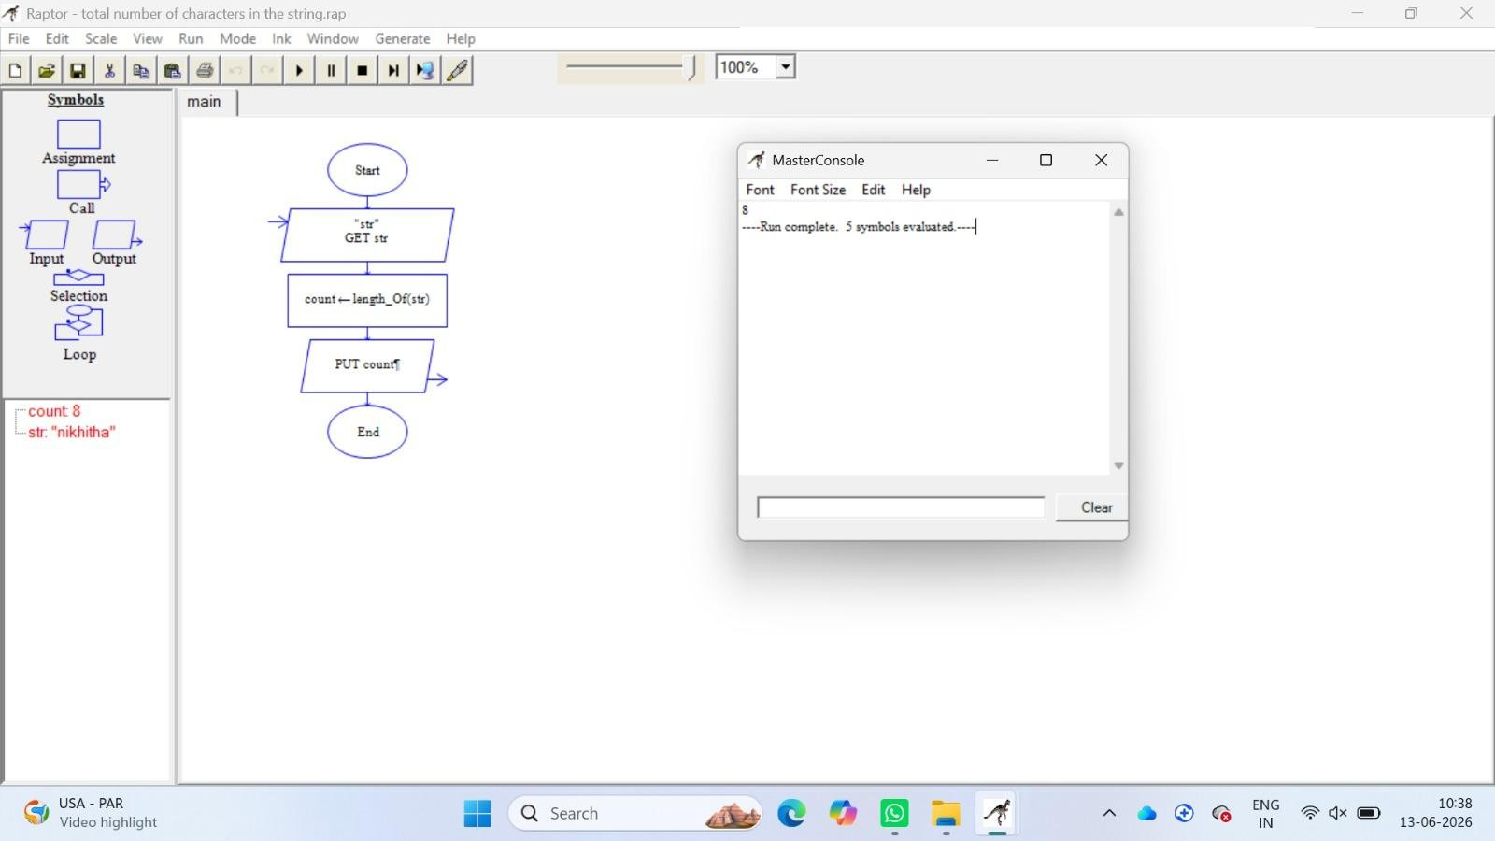

Exp-5:
Using Raptor – Draw and validate a flowchart for a given string of lower case English alphabets. One can choose any two characters in the string and replace all the
occurrences of the first character with the second character and replace all the occurrences of the second character with the first character. Using Raptor draw
and validate the flowchart lexicographically smallest string that can be obtained by doing this operation at most once.
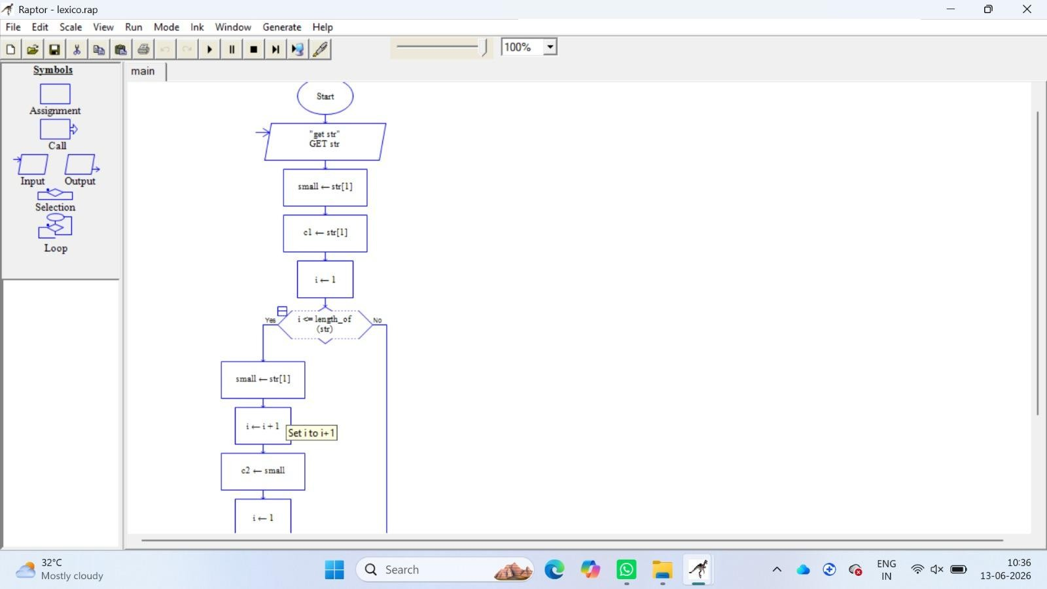

Exp-6:
An online food delivery platform enables customers to browse restaurants, view menus, place food orders, make online payments, and track delivery status.
Restaurants use the system to manage their menus and update order status, while delivery agents are responsible for accepting delivery requests and updating
delivery progress. Design a Class Diagram, Use case Diagram and Activity Diagram for the Online Food Delivery System showing the relevant classes, their attributes, methods, and relationships

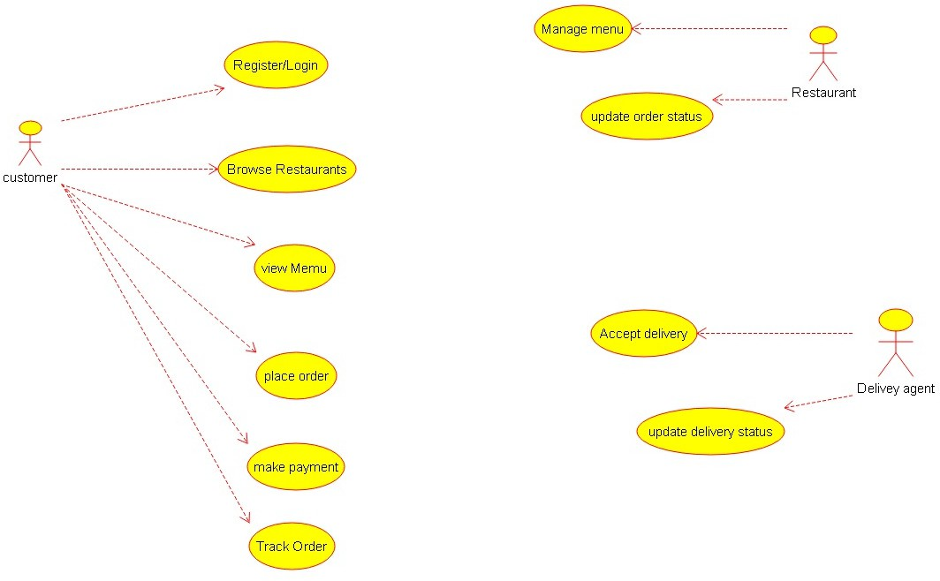

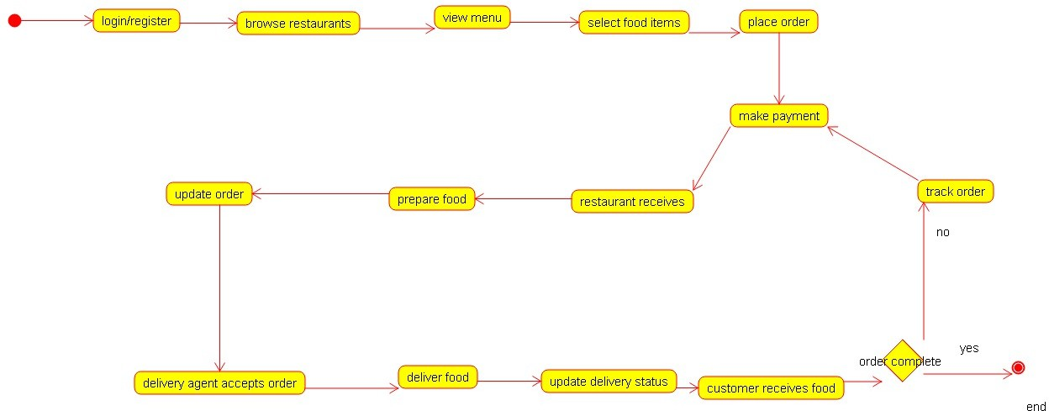

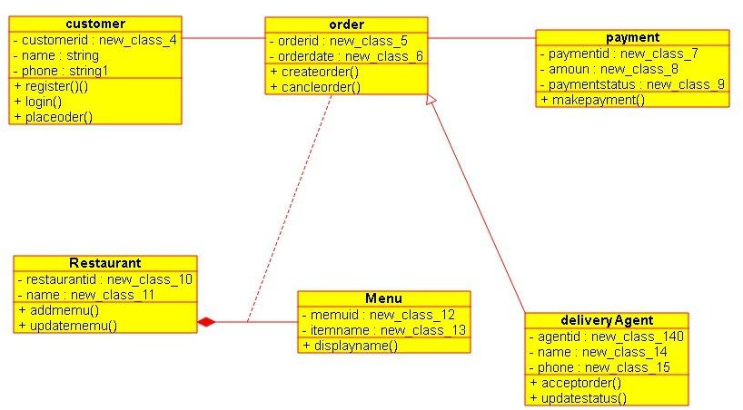

Exp-7:
A college employs a large number of security personnel who are assigned duties at various locations across the campus. Each security person follows a duty schedule that includes date, duty start time, duty end time, and assigned location, ensuring that every campus location is covered. If a security person takes leave, it is recorded manually, and at the end of each month, salaries are calculated based on duties performed and leaves taken. Since manual handling of duty allocation,
leave management, and salary calculation is time-consuming and complex, the college plans to develop an Online Security Management System to automate
these activities. Develop Class Diagram, Use case Diagram and Activity Diagram to represent the workflow of the Online Security Management System.







Exp-8:
Cyclomatic Complexity in Software Testing is a testing metric used for measuring the complexity of a software program. It is a quantitative measure of independent paths in the source code of a software program. Cyclomatic complexity can be calculated by using control flow graphs or with respect to functions, modules, methods or classes within a software program. Cyclomatic complexity for a flow
graph G is V(G)=E-N+2. Cyclomatic complexity is a software metric (measurement), used to indicate the complexity of a program, Cyclomatic complexity = E - N +
P where, E = number of edges in the flow graph, N = number of nodes in the flow graph, P = number of nodes that have exit points. Find Cyclomatic Complexity for a graph having number of edges as 17, number of nodes as 13 and number of
predicate nodes in the flow graph as 5.

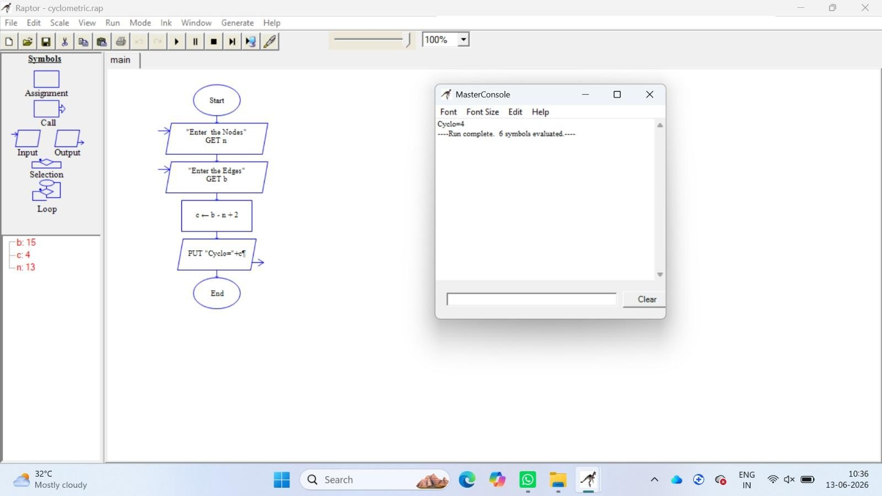
EXP -G
Create a Scrum Project in Jira.
- Add a backlog with at least 5 items (e.g., "Create user registration page", "Develop API for login").
- Prioritize the backlog and create a 1-week sprint.
- Move backlog items into the sprint and start the sprint.
Finally show the Screenshot of the sprint board at the start and end of the sprint. Aim
To create and manage a Scrum project in Jira.
Procedure
- Create Scrum project.
- Add 5 backlog items.
- Prioritize backlog.
- Create 1- week sprint.
- Move tasks to sprint.
- Start sprint.
- Update task status until completion.

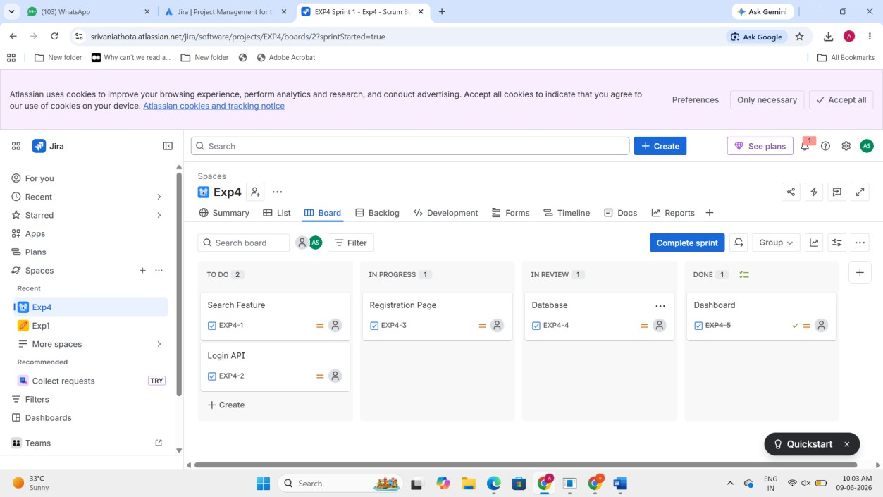
Exp-10:
Use the following requirements for a Library Management System:
  - Add a feature to search books by title and author.
  - Implement an online book reservation system.
  - Generate monthly reports on borrowed books for administrators.
  - Enable email notifications for overdue books.
  - Add support for QR code scanning for borrowing and returning books.
  - Create a user-friendly dashboard for librarians.
  - Allow users to review and rate books.
  - Integrate a chatbot for user assistance.
  - Develop a mobile app version of the system.
  - Provide multi-language support.

Categorize each requirement using MOSCOW Method (Must-Have, Should-Have, Could-Have, or Won’t-Have) based on the following criteria:
  - Impact on the users and stakeholders.
  - Feasibility considering time, budget, and resource constraints.
Finally Submit the completed Google Sheet or Excel file with all requirements categorized and justified.
Aim
To categorize requirements using MoSCoW method.
Procedure
- List all requirements.
- Analyze impact C feasibility.
- Categorize into:

●Must Have , Should Have
●Could Have
●Won’t Have
- Enter into Excel/Google Sheet.
- Add justification column.
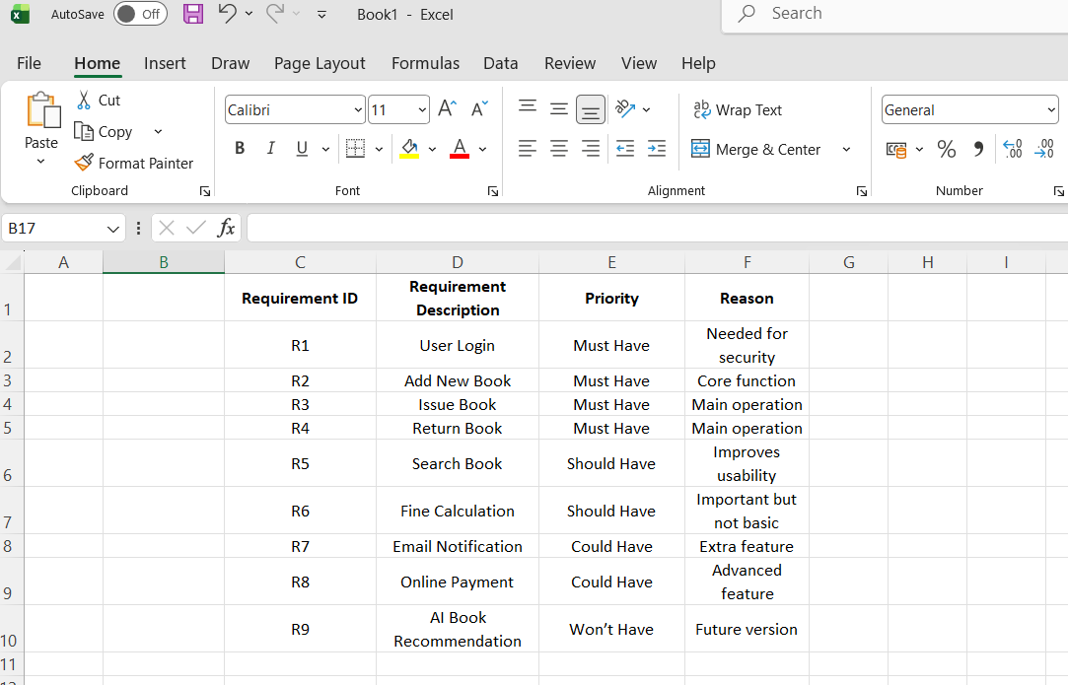
Result: Thus, The Requirements categorized successfully using MoSCoW prioritization
Exp-11:
Link Jira tasks with Confluence to streamline task tracking and progress monitoring for the Library Management System development.
  - Create a new page in Confluence titled "Library Management System Project Overview."
  - Embed at least 5 Jira issues related to the development of the Library Management System (e.g., tasks from the sprint like "Develop book search functionality," "Create user login page," etc.).
  - Use the Jira macro to display issues with status (e.g., "To Do," "In Progress," "Done").
  - Add a progress bar in the Confluence page to visually track the completion of each embedded Jira task (e.g., percentage of tasks completed in the sprint).
  - Submit a screenshot of the Confluence page showing the embedded Jira tasks and the progress bar.

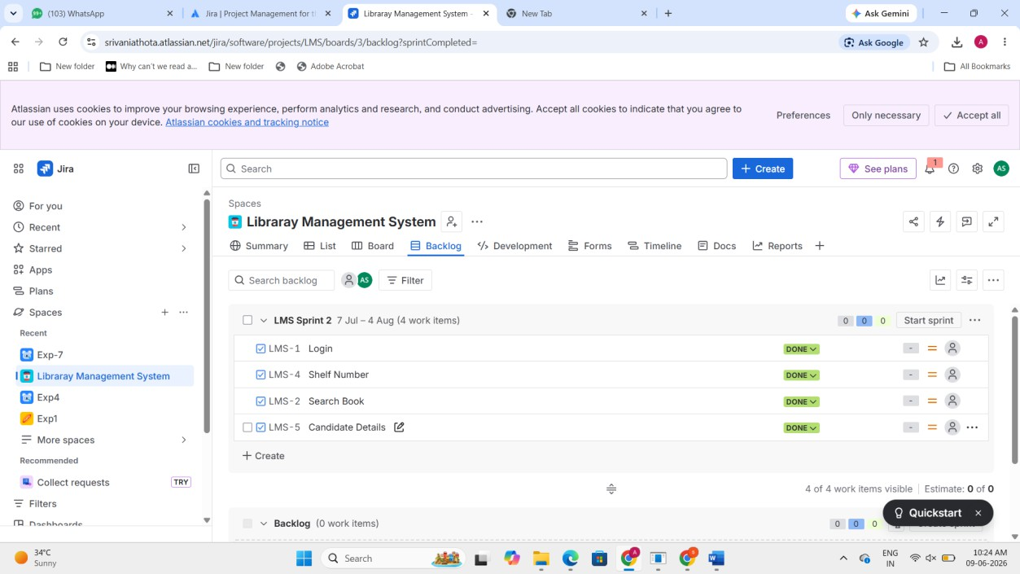

Exp-12:
You are designing a Task Management System for a small team. The system should include the following features:

- User Login and Role Assignment
- Task Creation and Assignment
- Task Prioritization and Deadlines
- Progress Tracking and Reporting
Task Management System – MoSCoW & Kano (Jira) Aim
To prioritize system requirements using MoSCoW and Kano models.
Procedure
- Create Jira project.
- Add features as issues.
- Categorize using MoSCoW.
- Apply Kano model classification.
- Document priority results.

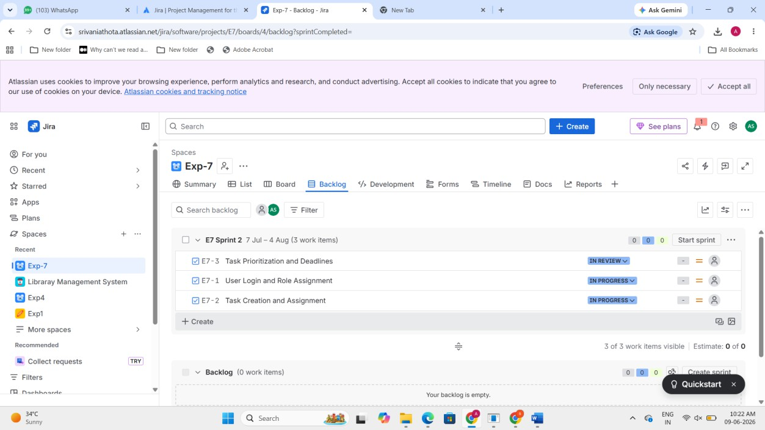
Exp-13:
You are tasked with developing an Online Learning Platform. The platform should include the following functionalities:

  - Course Enrollment and Registration
  - Video Lecture Streaming
  - Interactive Quizzes and Assignments
  - Progress Tracking Dashboard
  - Peer-to-Peer Discussion Forums
  - Certificate Generation
Use Jira to categorize and prioritize these requirements using MoSCoW and Kano techniques.
Aim
To categorize and prioritize platform requirements.
Procedure
- Create Jira backlog.
- Add all 6 features.
- Categorize using MoSCoW.

- Classify using Kano.
- Prioritize accordingly.
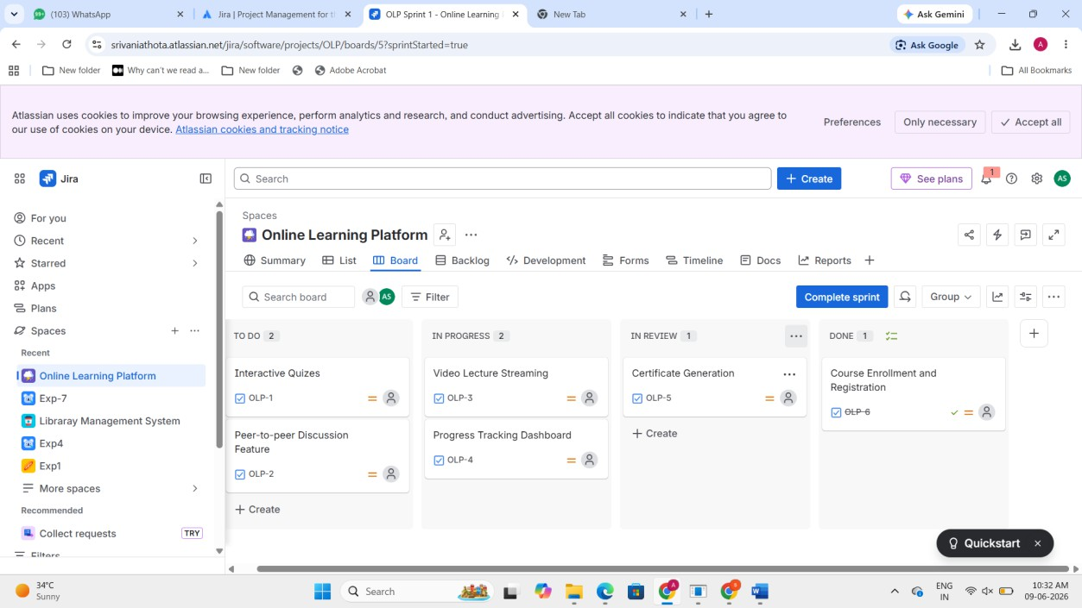
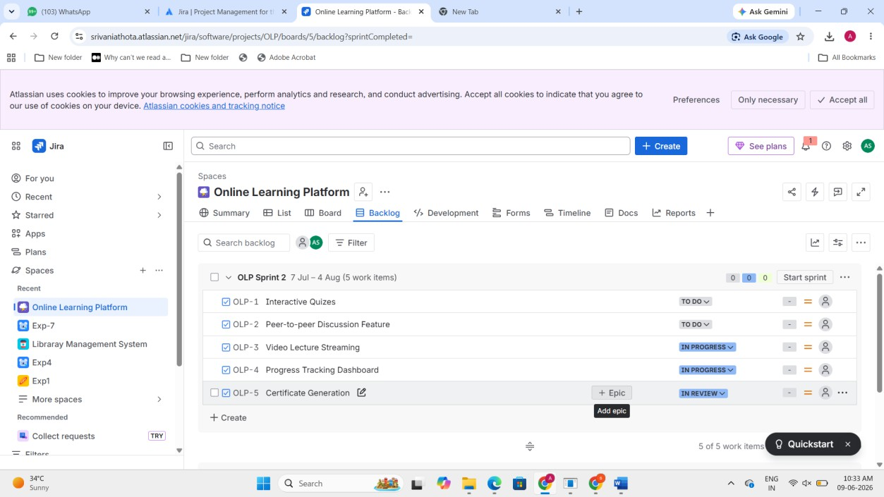

Exp-14:
Demonstrate how to work collaboratively in Git/GitHub on a project using the fork-and-pull request workflow.

Tasks:
  - Fork an existing public GitHub repository (e.g., a sample JavaScript or Python project).
  - Clone the forked repository to your local machine using Git.

  - Create a new branch for the feature or change you want to work on.
  - Make modifications or add new features (e.g., add a function, fix a bug, or update the README).
  - Commit your changes and push the branch to GitHub.
  - Go to the GitHub repository and create a pull request to merge your feature branch into the main branch.
  - Review the pull request and provide feedback on the changes.
  - Respond to feedback by making additional commits to the feature branch if necessary.
  - Once the pull request is approved, merge it into the main branch.
  - Finally submit the link to the pull request along with a summary of the changes you made and how you collaborated.

Aim
To demonstrate collaboration using fork and pull request workflow.

Procedure
- Fork the Repository. Open GitHub and select a public repository. Click on the Fork option to create a copy in your account.
- Clone the Repository. Copy the forked repository URL. Use the command: git clone https://github.com/your-username/repository-name.git
- Create a New Branch , Navigate into the project folder and create a branch: git checkout -b feature-branch
- Make Changes Modify files such as adding a new function or updating README.
- Commit Changes ,Stage and commit the changes: git add . git commit -m "Added new feature"
- Push Changes to GitHub git push origin feature-branch
- Create Pull Request
Go to GitHub → Click Compare & Pull Request .Add title and description → Create PR
- Review Process Team members review the code and provide suggestions.
- Update Based on Feedback Make necessary changes and push again:git add .
git commit -m "Updated based on review" git push origin feature-branch
- Merge Pull Request After approval, click Merge Pull Request to merge changes into main branch.

Exp-15:
Demonstrate how to work with Git branches and resolve merge conflicts when collaborating with others.
Tasks:
  - Clone a shared repository to your local machine.
  - Create a new branch and switch to it.
  - Make changes to a file (e.g., update a README or modify code in a specific function).
  - Commit your changes.
  - Push the changes to the remote repository.
  - Before merging, pull the latest changes from the main branch.
  - Switch back to your feature branch.
  - Merge the main branch into your feature branch.
  - If there are conflicts, resolve them manually by editing the conflicting files. After resolving conflicts, mark the conflicts as resolved.
  - Commit the resolved merge.
  - Push your feature branch with the merged changes to GitHub and create a pull request.
  - Submit a summary of the steps you performed, the conflicts you encountered, and how yo

Aim
To resolve merge conflicts using Git.

Procedure
- Clone the Repository , git clone https://github.com/yourusername/repository-name.gitcd repository-name
- Create and Switch to New Branch git checkout -b feature-branch
- Make Changes Edit a file (e.g., README.md or code file)
- Commit Changes git add . git commit -m "Updated file in feature branch"
- Push Branch to GitHub git push origin feature-branch
- Pull Latest Changes from Main git checkout main git pull origin main
- Switch Back to Feature Branch git checkout feature-branch
- Merge Main into Feature Branch git merge main
- Resolve Merge Conflicts (if any) Open conflicting files
- Mark Conflicts as Resolved git add .
- Commit Merge Resolution git commit -m "Resolved merge conflict"

- Push Updated Branch & Create PR git push origin feature-branch Go to GitHub → Create Pull Request

Result: Thus, The Merge conflicts resolved successfully and branch merged.

EXP- 16
Static Website with Docker Aim
To containerize and serve a static website using Docker.
Procedure
- Create a folder static-docker-website
- Create a new file named index.html and paste this code
<!DOCTYPE html>
<html>
<head>
<title>My Docker Website</title>
</head>
<body style="text-align:center;font-family:Arial">
<h1>Hello from Docker Container ¸s.˙•'7</h1>
<h2>Static Website Running using Nginx</h2>
<p>This website is containerized using Docker.</p>
</body>
</html>
- Create another named dockerfile and paste the code FROM nginx:alpine
COPY index.html /usr/share/nginx/html/index.html EXPOSE 80
- Open new terminal and run this 'docker build -t my-static-website .'

- In terminal run this command 'docker run -d -p 8080:80 my-static-website'
- Open the browser and search 'http://localhost:8080'
- In terminal type 'docker ps' and check the output.

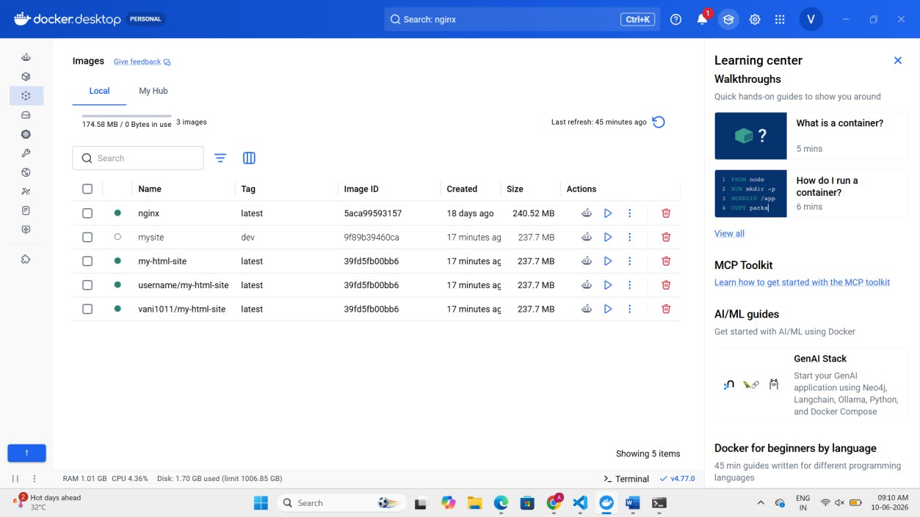
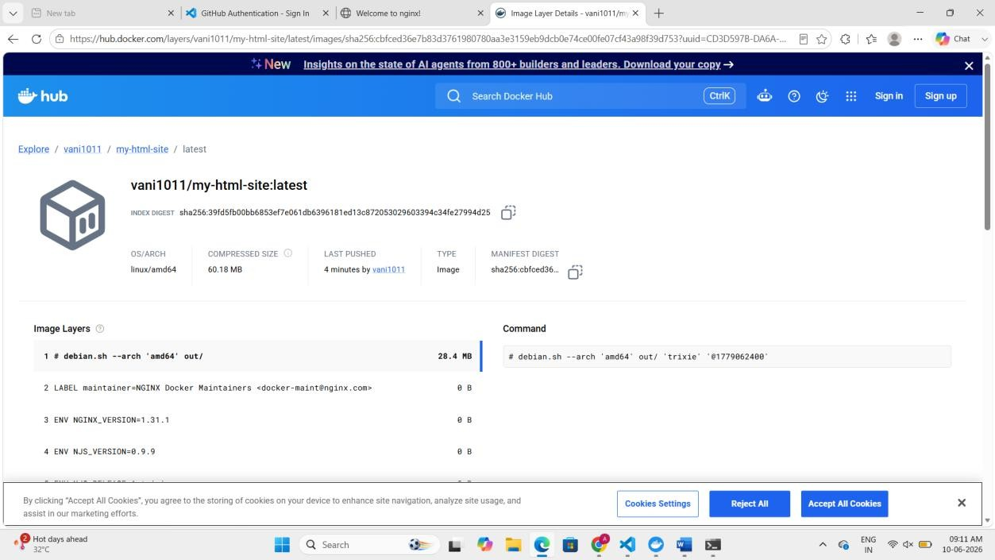

EXP- 17
Flask API with Docker s Kubernetes

Aim
To deploy a Flask API using Docker and Kubernetes.
Procedure
- Create a folder flask.api
- create a file in that folder named app.py and paste this code. from flask import Flask
app = Flask( name ) @app.route('/')
def home():
return "Hello from Flask API!" @app.route('/about')
def about():
return "This is a simple Flask API" if name == ' main ':
app.run(host='0.0.0.0', port=5000)
- Create another file named requirements.txt and write flask in that
- Create another file named dockerfile and paste this code FROM python:3.9
WORKDIR /app COPY . /app
RUN pip install -r requirements.txt EXPOSE 5000
CMD ["python", "app.py"]
- Open terminal and run this docker build -t vani1011 /flask-api . vani1011
- after run this in terminal docker images.
- in terminal run this docker login
- in same terminal run this command docker push yourdockerhubusername/flask-api
- open kubernets in docker and click on create cluster and wait for 2 min

- create a new file deployment.yaml and paste this code in that apiVersion: apps/v1
kind: Deployment metadata:
name: flask-deployment spec:
replicas: 2 selector:
matchLabels:
app: flask-api template:
metadata:
labels:
app: flask-api spec:
containers:
- name: flask-container
image: yourusername/flask-api ports:
- containerPort: 5000
- create another file named service.yaml and paste the code apiVersion: v1
kind: Service metadata:
name: flask-service spec:
type: NodePort selector:

app: flask-api ports:
- port: 5000
targetPort: 5000
nodePort: 30007
- Open new terminal and run this two commands kubectl apply -f deployment.yaml and kubectl apply -f service.yaml
- Then in terminal run kubectl get pods and kubectl get services
- Open browser and check http://localhost:30007 and http://localhost:30007/about.
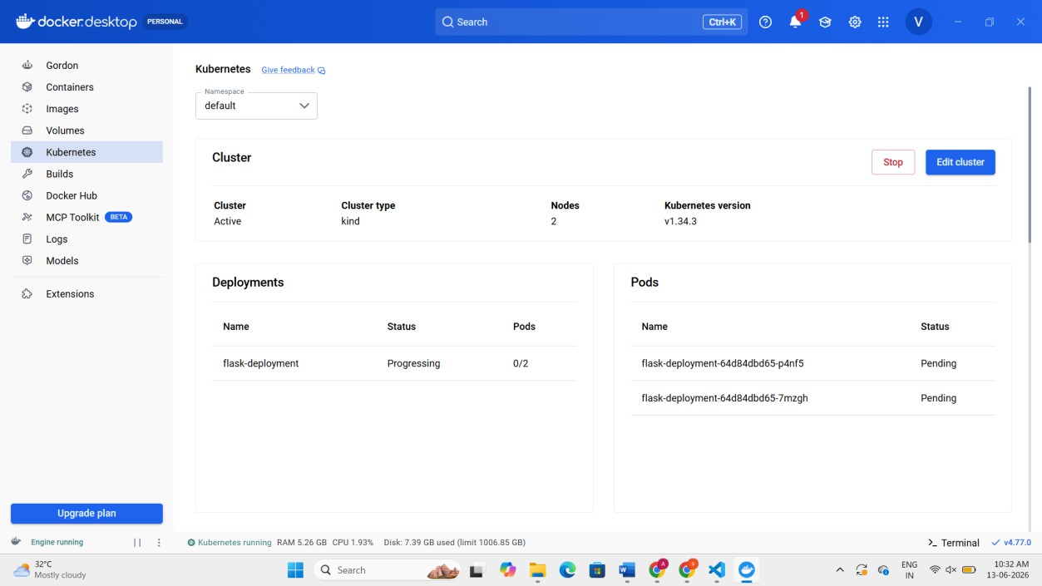

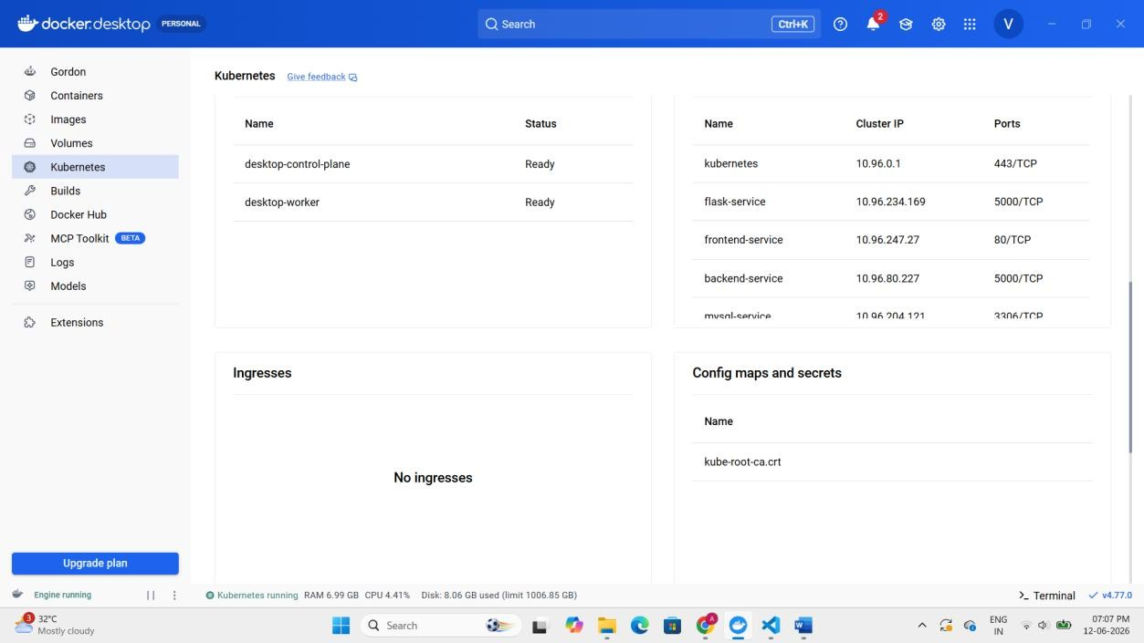
Result: Thus, The Flask API successfully deployed on Kubernetes cluster

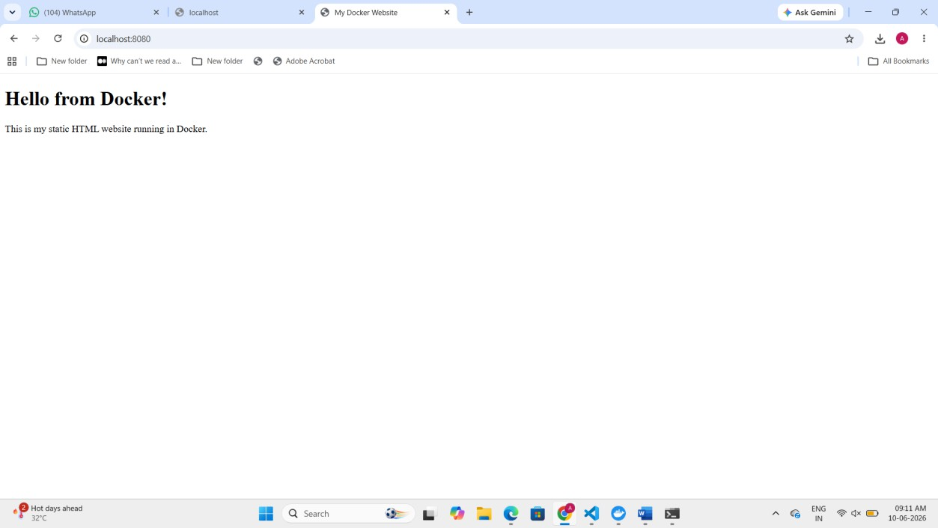
Exp-18:
Set up a CI/CD pipeline to automate the building, testing, and deployment of a containerized application.

Tasks:

  - Set up Jenkins on a local machine or server.
  - Create a Dockerfile to containerize a sample application.
  - Write a Jenkinsfile to automate the process of building the Docker container, running

tests, and deploying to a cloud platform (e.g., AWS or GCP).
  - Configure Jenkins to trigger builds upon code commits or pull requests.

Aim
  - To automate build and deployment using Jenkins.

Procedure
  - 1. Create a new folder sample.app
  - 2. Create a file app.py and paste the code.
  - from flask import Flask
  - app = Flask( name )
  - @app.route('/')
  - def home():
  - return "Hello from CI/CD Docker Pipeline!"
  - if name == " main ":
  - app.run(host='0.0.0.0', port=5000)
  - 3. Create a file named requirements.txt and type flask in that
  - 4. Create another new file named dockerfile and paste the code
  - FROM python:3.9
  - WORKDIR /app
  - COPY . /app
  - RUN pip install -r requirements.txt
  - EXPOSE 5000
  - CMD ["python", "app.py"]
  - 5. Create a jenkinsfile and paste this code
  - pipeline {
  - agent any
  - ​
  - stages {
  - ​
  - stage('Clone Repository') {
  - steps {
  - git 'https://github.com/yourusername/sample-app.git'
34. }
35. }
36.
- stage('Build Docker Image') {
- steps {
- sh 'docker build -t sample-app .'
40. }
41. }
42.
- stage('Run Tests') {
- steps {
- sh 'echo Running Tests...'
46. }
47. }
48.
- stage('Deploy Container') {
- steps {

- sh 'docker run -d -p 5000:5000 sample-app'
52. }
53. }
54. }
55. }
- 6. Open the browser and type 'http://localhost:8081'
- 7. Unlock the Jenkins. In terminal run 'docker exec jenkins-container cat /var/jenkins_home/secrets/initialAdminPassword'
- 8.Copy the password and unlock the Jenkins click one the install plugins
- 7. Login to Jenkins and create admin user and click save and continue.
- 8. Jenkins dashboard appears and click one the create new item with any name and select pipeline below and click on ok.
- 9. Now configuration page opens scroll until you see pipeline section and paste code in script box
pipeline {
- agent any
- ​
- stages {
- ​
- stage('Build Docker Image') {
- steps {
- sh 'docker build -t my-app .'
69. }
70. }
71.
- stage('Run Container') {
- steps {
- sh 'docker run -d -p 5000:5000 my-app'
75. }
76. }
77.
78. }
79. }
10. Save it and click on build now. check the console output

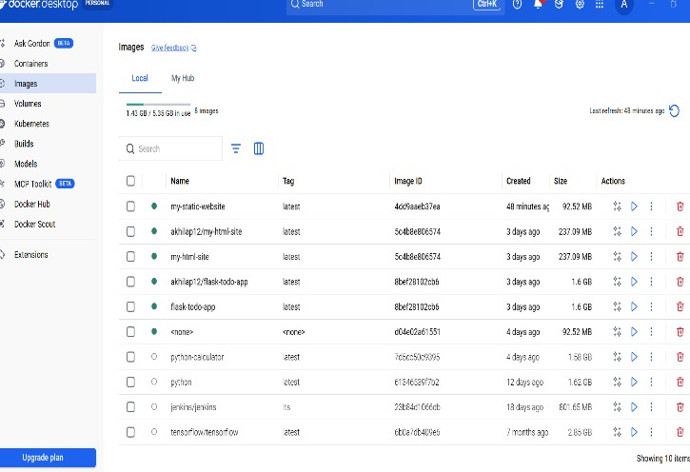

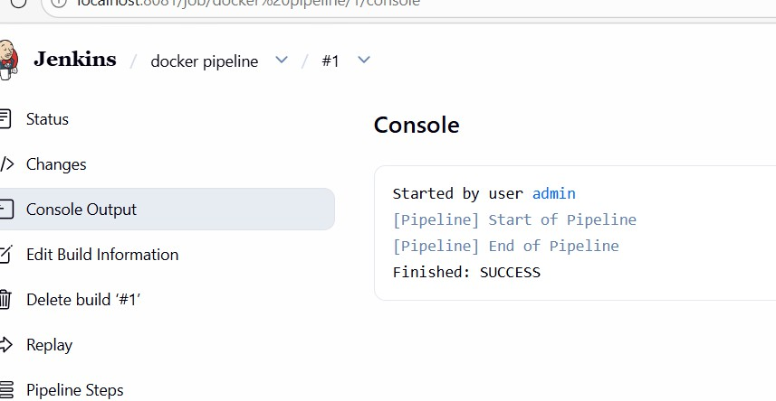
Result: Thus, The Static website successfully deployed in Docker container.
Exp-19:
Implement Continuous Deployment using GitHub Actions to deploy a Dockerized application. Tasks:
- Set up a GitHub repository and push a simple Dockerized application.
- Create a GitHub Actions workflow to automatically build and push the Docker image to Docker Hub or GitHub Container Registry.
- Automate deployment to a cloud platform (e.g., AWS ECS, Azure Kubernetes Service, or Google Kubernetes Engine).
Test the CI/CD pipeline by pushing new code changes and verifying that the deployment occurs automatically.

Aim
To automate Docker build and deployment using GitHub Actions.

Procedure
- create a folder docker-github-actions-app
- open it in vs code and create a file app.py and paste the code from flask import Flask
app = Flask( name ) @app.route('/')
def home():
**return "Hello from GitHub Actions CI/CD Pipeline!"**if name == " main ":

**app.run(host="0.0.0.0", port=5000)**
- create requirements.txt and write flask in that
- create a file dockerfile and paste the code FROM python:3.9
WORKDIR /app
COPY requirements.txt .
RUN pip install -r requirements.txt COPY . .
CMD ["python","app.py"]
- open new terminal and run this commands git init
git add .
git commit -m "Initial commit"
- open GitHub and create a new repository named docker-cicd-app
- run this in the terminal
git remote add origin https://github.com/yourusername/docker-cicd-app.git git branch -M main
git push -u origin main
- so, expected output for task 1 is GitHub shows initial commit and 3 files added
- click create new file in GitHub name it as .github/workflows/docker.yml
- paste the code and click on commit new file name: Docker CI/CD Pipeline
on: push:

**branches: \[ "main" ]**

jobs:
build:
**runs-on: ubuntu-latest**
**steps:**
**- name: Checkout code**
**uses: actions/checkout@v3**
**- name: Login to DockerHub**
**uses: docker/login-action@v2**
**with:**
**username: ${{ secrets.DOCKER\_USERNAME }}**
**password: ${{ secrets.DOCKER\_PASSWORD }}**

**- name: Build Docker Image**

**run: docker build -t ${{ secrets.DOCKER\_USERNAME }}/cicd-app .**

**- name: Push Docker Image**

**run: docker push ${{ secrets.DOCKER\_USERNAME }}/cicd-app**

- Then go to actions we will see Docker CI/CD Pipeline Workflow running... wait for some time till it completes.
- so, expected output for task 2 is docker ci/cd workflow is showing success
- Open settings on left side click on secrets and variables and click on repository secrets
- in name give docker_username in secret giver yourdockerusername and click on add secret
- again click on new repository secret and in name give docker_password and in secret write yourdockerpassword

- for 4th task open vs code and modify the code of app.py instead of this return "Hello from GitHub Actions CI/CD Pipeline!" paste this return "CI/CD Pipeline Updated Successfully!"
- in terminal run agiain this commands one by one, git pull origin main --allow-unrelated-histories, git add ., git commit -m "Updated project files" ,git push origin main
- Then go to settings actions there we will see updated project files

- in terminal docker push yourusername/cicd-app and docker run -d -p 5000:5000 username/cicd-app
- open browser and check http://localhost:5000
RESULT: Thus, The Application deployed automatically via GitHub Actions pipeline.

Exp-20:
Create a GitHub Repository and Implement Version Control
Tasks:
  - Set up a repository for a team project.
  - Create branches for individual modules.
  - Merge branches with pull requests after code reviews.
  - Resolve conflicts during branch merging.
  - Document the workflow using the README file. Submit the repository link

Aim
To implement version control workflow.

Procedure
- Create a GitHub Repository Go to GitHub → Click New Repository , Enter repository name, description Select Public/Private , Click Create Repository
- Clone Repository git clone https://github.com/your-username/repository-name.gitcd repository-name
- Create Branches for Modules git checkout -b module1 git checkout -b module2
- Work on Individual Modules Each team member works on their own branch Add code / update files

- Commit Changes git add . git commit -m "Added module functionality"
- Push Branches to GitHub git push origin module1 git push origin module2
- Create Pull Requests Go to GitHub → Click Compare & Pull Request Add title & description Submit PR for review
- Code Review Process Team members review changes Suggest improvements via comments
- Merge Branches After approval → Click Merge Pull Request
- Resolve Merge Conflicts (if any) Open conflicting files Edit and remove conflict markers: Then run: git add . git commit -m "Resolved conflicts"
- Update README File Include: Project description , Team members
- Push Final Changes git push origin main
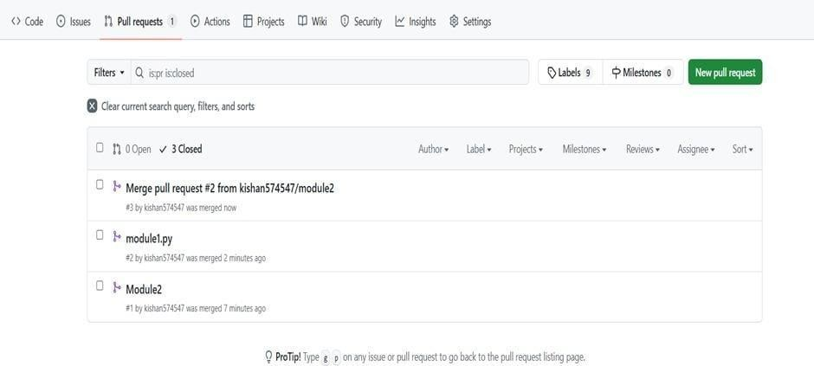
Result: Thus. The Merge conflicts resolved successfully and branch merged

EXP- 21
Containerize Flask To- Do App Aim
To containerize Flask To- Do application.
Procedure
- Create a folder named todo-flask-docker.
- Open the folder in VS code.

- Create a new file app.py and paste the code and save it.
from flask import Flask, request, redirect, url_for, render_template_string app = Flask( name )
todos = [] html = """
<h2>My To-Do List</h2>
<form method="POST">
<input type="text" name="task" placeholder="Enter task">
<input type="submit" value="Add Task">
</form>
<ul>
{% for todo in todos %}
<li>{{todo}}</li>
{% endfor %}
</ul> """
@app.route("/", methods=["GET", "POST"]) def index():
if request.method == "POST":
task = request.form.get("task") if task:
todos.append(task)
return redirect(url_for("index"))
return render_template_string(html, todos=todos) if name == " main ":
app.run(host="0.0.0.0", port=5000)
- Create another new file requirements.txt. Type Flask and save it.
- Create another new file named dockerfile and paste this code and save it.

FROM python:3.10 WORKDIR /app COPY . .
RUN pip install -r requirements.txt EXPOSE 5000
CMD ["python", "app.py"]
- Open new terminal and run ‘docker build -t flask-todo-app .’
- After run this ‘docker run -d -p 5000:5000 flask-todo-app’
- Open the browser and type ‘http://localhost:5000’ to see the output.
- In terminal run ‘docker login’
- To see the output in dockerhub type ‘docker tag flask-todo-app vani1011/flask-todo-app’ in the terminal.
- To push the image ‘docker push vani1011/flask-todo-app’ type it.

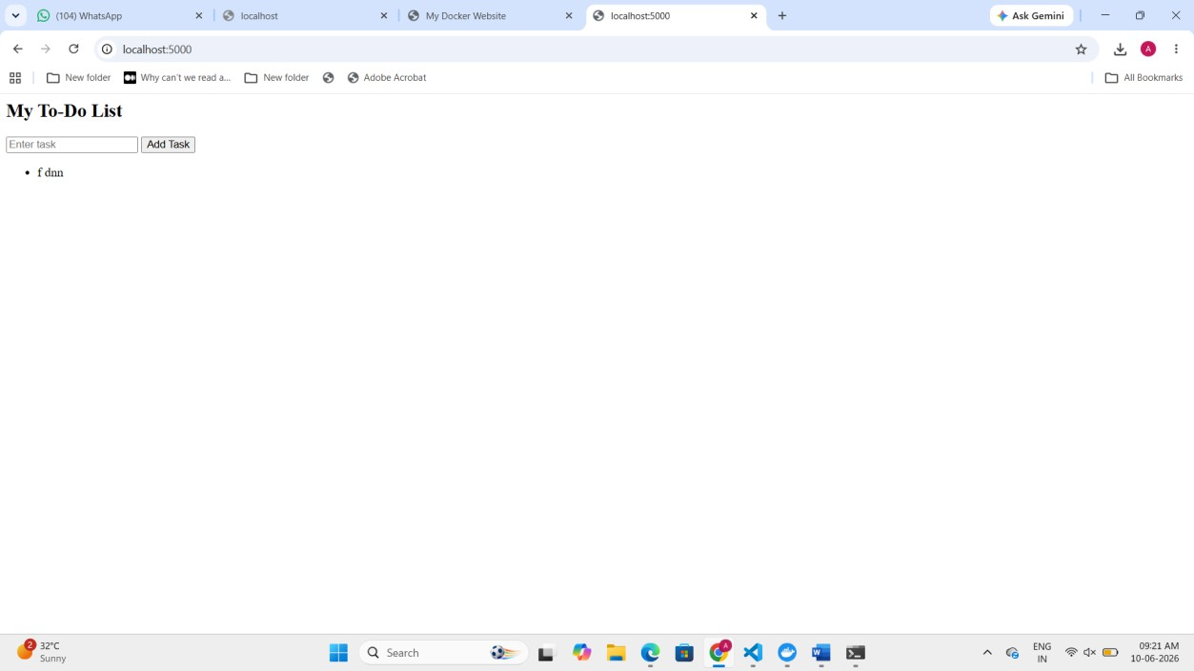

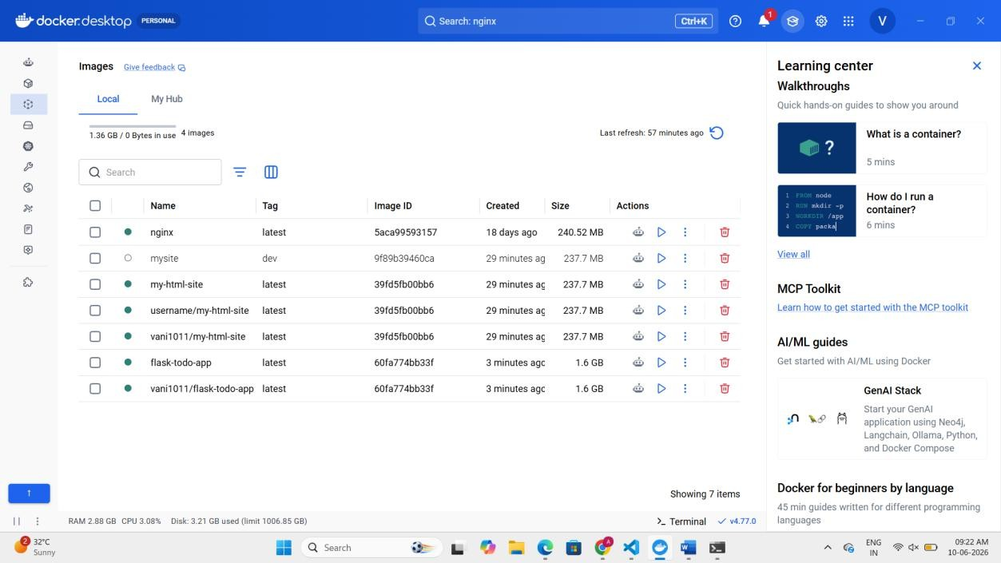

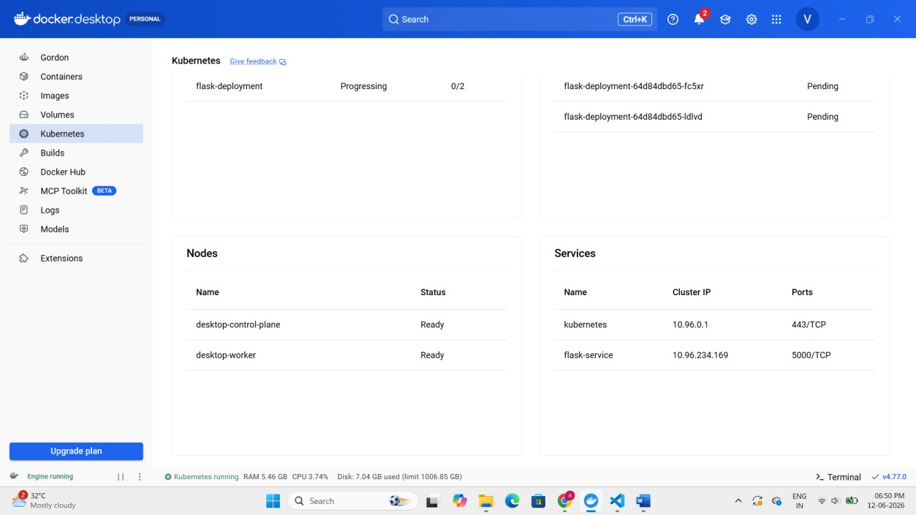

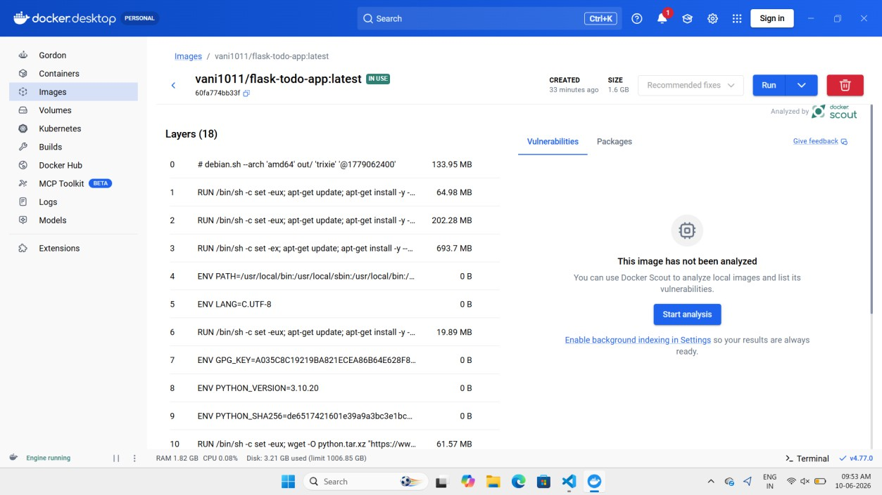
Result
Thus, The Flask To- Do app successfully containerized and deployed.
EXP- 22
Push s Pull Docker Image Aim
To demonstrate Docker image push and pull.
Procedure
- create a folder docker-html-site.
- create a html file named index.html. paste the html code in that file.
<!DOCTYPE html>
<html>
<head>
<title>My Docker Website</title>
</head>
<body>
<h1>Hello from Docker!</h1>
<p>This is my static HTML website running in Docker.</p>

</body>
</html>
- create a docker file and paste the code. then save it. FROM nginx:latest
COPY index.html /usr/share/nginx/html/index.html
- click on new terminal and run this 'docker build -t my-html-site .'
- check docker desktop to see the output.
- in the terminal run 'docker run -d -p 8080:80 my-html-site'.
- open browser and type 'http://localhost:8080'
- After, in terminal run 'docker login'
- after login tag the image like 'docker tag my-html-site username/my-html-site'.
- to push image to docker hub run 'docker push username/my-html-site'
- to pull the image run 'docker pull username/my-html-site'
- run the pulled image 'docker run -d -p 8080:80 username/my-html-site'
- open browser 'http://localhost:8080' to see the pulled image.
- To see the no. of repositories type 'docker ps'
- To see the no. of images in docker desktop type 'docker images'




EXP- 23
Multi- Container App with Kubernetes Aim
To deploy multi- container app using Kubernetes.
Procedure
- Create a folder named multi.app
- create a file app.py and paste the code

from flask import Flask app = Flask( name ) @app.route("/")
def home():
return "Backend API Running" if name == " main ":
app.run(host="0.0.0.0", port=5000)
- Create a file requiremnets.txt and write flask in it.
- Create another file dockerfile and paste this code. FROM python:3.9
WORKDIR /app COPY . .
RUN pip install -r requirements.txt EXPOSE 5000
CMD ["python","app.py"]
- create a file backend-deployment.yaml and paste the code apiVersion: apps/v1
kind: Deployment metadata:
name: backend spec:
replicas: 1 selector:
matchLabels: app: backend
template: metadata: labels:

app: backend spec:
containers:
- name: backend
image: yourusername/backend ports:
- containerPort: 5000
- Create another file frontend-deployment.yaml and paste the code apiVersion: apps/v1
kind: Deployment metadata:
name: frontend spec:
replicas: 2 selector:
matchLabels:
app: frontend template:
metadata:
labels:
app: frontend spec:
containers:
- name: frontend image: nginx ports:
- containerPort: 80
- create a file name mysqql-deployment.yaml and paste the code

apiVersion: apps/v1 kind: Deployment metadata:
name: mysql spec:
replicas: 1 selector:
matchLabels:
app: mysql template:
metadata:
labels:
app: mysql spec:
containers:
- name: mysql image: mysql:5.7 env:
  - name: MYSQL_ROOT_PASSWORD
value: password ports:
  - containerPort: 3306
- create a file named services.yaml and paste the code apiVersion: v1
kind: Service metadata:
name: frontend-service spec:

type: NodePort selector:
app: frontend ports:
- port: 80
targetPort: 80
nodePort: 30008

---

apiVersion: v1 kind: Service metadata:
name: backend-service spec:
selector:
app: backend ports:
- port: 5000
targetPort: 5000

---

apiVersion: v1 kind: Service metadata:
name: mysql-service spec:

selector:
app: mysql ports:
- port: 3306
- Open the new terminal and run this commands
  - kubectl apply -f backend-deployment.yaml
  - kubectl apply -f frontend-deployment.yaml
  - kubectl apply -f mysql-deployment.yaml
  - kubectl apply -f services.yaml
- run this in the terminal kubectl get services and open this http://localhost:30008 in browser
- to check monitor deployment run kubectl get deployments and to check pods continuously run kubectl get pods -w
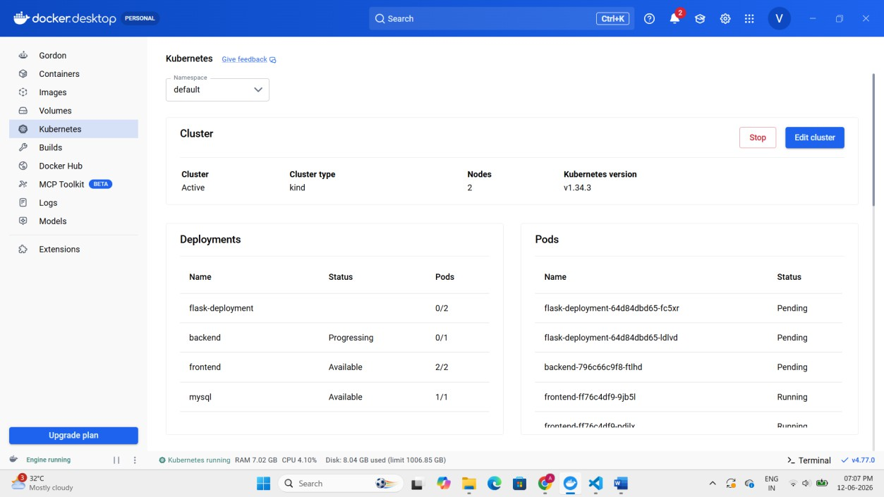
RESULT: Thus, The Multi- container application deployed and scaled successfully.
Exp-24:
Create a CI/CD Pipeline Using GitHub Actions Tasks:
- Set up a GitHub repository for a containerized Flask application.
- Define a GitHub Actions workflow file to automate testing and deployment.

- Add steps to build, test, and push Docker images to Docker Hub.
- Deploy the application to a cloud platform (Heroku/AWS). Submit the workflow file and deployment link.

Aim
To automate testing and deployment using GitHub Actions.

Procedure
- Create a folder named flask-cicd-app
- Open the folder in VS Code and create a file app.py and paste the code from flask import Flask

app = Flask( name )

@app.route('/') def home():
return "Flask CI/CD Pipeline Successful!"

if name == " main ": app.run(host="0.0.0.0", port=5000)
- Create a file requirements.txt and write flask
- Create a file Dockerfile and paste the code FROM python:3.9

WORKDIR /app

COPY requirements.txt .

RUN pip install -r requirements.txt

COPY . .
CMD ["python","app.py"]
- Open terminal and initialize git repository git init
git add .
git commit -m "Initial commit"
- Open GitHub and create a new repository named flask-cicd-app
- Run the following commands in terminal
git remote add origin https://github.com/yourusername/flask-cicd-app.git git branch -M main
git push -u origin main
- Click Create new file in GitHub and name it .github/workflows/ci-cd.yml
- Paste the workflow code and click Commit new file name: Flask CI/CD Pipeline

on:
push:
branches: ["main"]

jobs:
build:

runs-on: ubuntu-latest

steps:

- name: Checkout code uses: actions/checkout@v3

- name: Login to DockerHub uses: docker/login-action@v2 with:
username: ${{ secrets.DOCKER_USERNAME }} password: ${{ secrets.DOCKER_PASSWORD }}

- name: Build Docker Image
run: docker build -t ${{ secrets.DOCKER_USERNAME }}/flask-cicd-app .

- name: Push Docker Image
run: docker push ${{ secrets.DOCKER_USERNAME }}/flask-cicd-app
- Go to Actions tab in GitHub. You will see Flask CI/CD Pipeline Workflow running... Wait until the workflow completes.
- Open Settings → Secrets and variables → Actions. Click New repository secret. Add the first secret Name: DOCKER_USERNAME Secret: your docker hub username. Click Add secret.
- Add another secret Name: DOCKER_PASSWORD Secret: your docker hub password. Click Add secret.
- Modify the code in app.py in VS Code. Replace return "Flask CI/CD Pipeline Successful!" with return "CI/CD Deployment Successful!"
- Run the following commands in terminal git add .
git commit -m "Updated application" git push
- Go to GitHub → Actions You will see Flask CI/CD Pipeline Workflow triggered by push Pipeline runs automatically.

- Deploy the container locally (or on cloud) using Docker
docker login
docker build -t yourusername/flask-cicd-app . docker push yourusername/flask-cicd-app
docker run -d -p 5000:5000 yourusername/flask-cicd-app
- Open browser and check http://localhost:5000
- Go to AWS Console → EC2. Click Launch Instance. Choose Ubuntu Server.
- Allow ports 22 (SSH) and 5000 (HTTP) in the Security Group. Launch the instance.
- Use the AWS Connect → SSH client instructions or run: ssh ubuntu@<your-ec2-public-ip>
- Install Docker on the Server Run: sudo apt update sudo apt install docker.io -y
sudo systemctl start docker
- Pull the Image from Docker Hub docker pull yourusername/flask-cicd-app
- docker run -d -p 5000:5000 yourusername/flask-cicd-app
- http://<your-ec2-public-ip>:5000 search this in browser

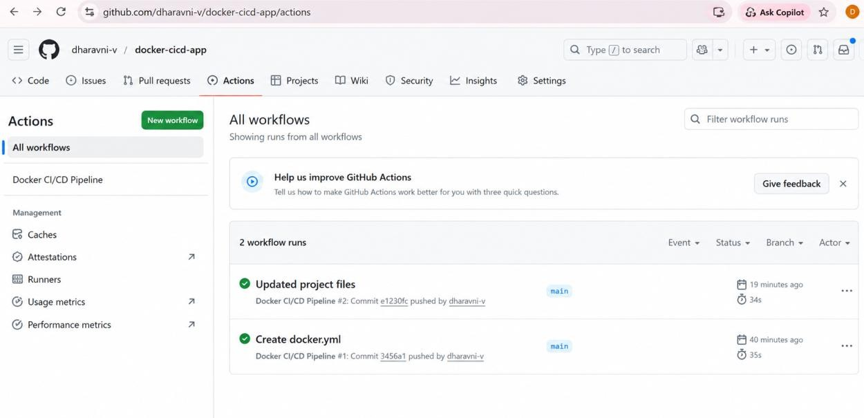
RESULT: Thus, The CI/CD pipeline executed successfully.

Exp-25:
Create a new GitHub repository for a personal project. Initialize the repository with a README.md file. Then, clone the repository to your local machine, make some changes to the README.md (e.g., add a project description), and push the changes back to
GitHub. Tasks:
  - Create a GitHub repository.
  - Clone the repository to your local machine.
  - Edit the README.md file.
Stage, commit, and push your changes to GitHub.

Aim
To create and update a GitHub repository.

Procedure
- Create a GitHub Repository Go to GitHub → Click New Repository Enter repository name Select Initialize with README.md Click Create Repository
- Clone the Repository git clone https://github.com/your-username/repository-name.git cd repository-name
- Edit README.md File Open the project in VS Code Modify README.md (example):
# My Project
This is a personal project created to demonstrate GitHub version control.
- Stage Changes git add README.md
- Commit Changes git commit -m "Updated README with project description"
- Push Changes to GitHub git push origin main

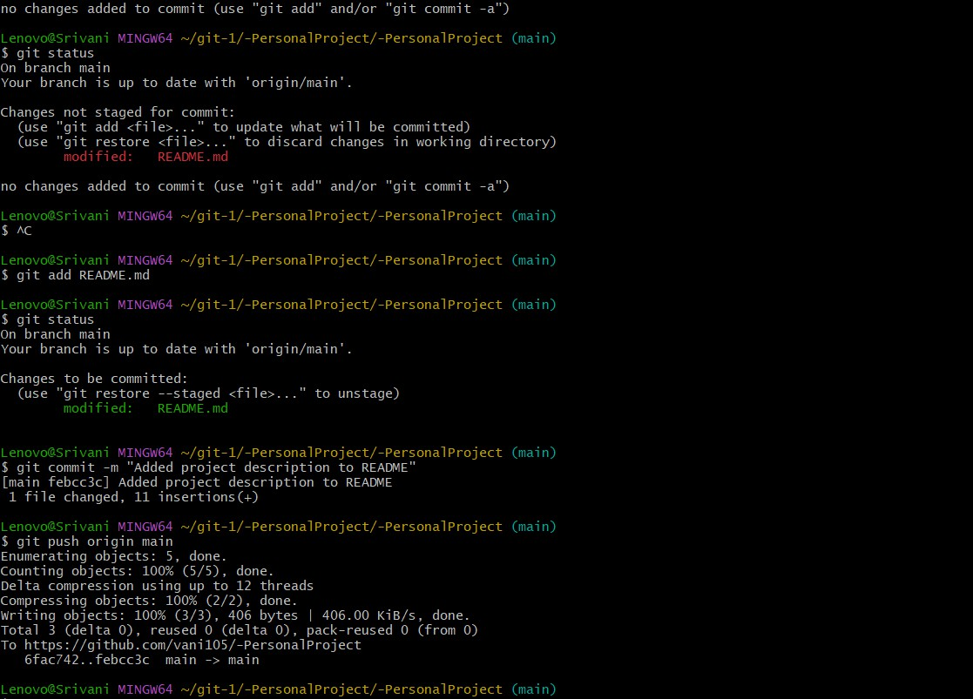

Exp-26:
Clone an existing GitHub repository to your local machine and make a small change in one of the files.

Tasks:
  - Choose an existing public GitHub repository (e.g., your own or a sample repository).
  - Clone the repository to your local machine using git clone
<repository_url>.
  - Navigate into the cloned repository directory and open one of the files.
  - Make a small edit, such as modifying a line of text or fixing a typo.
  - Save your changes.

Aim
  - To clone and edit a GitHub repository.

Procedure
  - 1. Choose a Repository Select any public GitHub repository (e.g., sample or personal repo) Copy the repository URL
  - 2. Clone the Repository git clone https://github.com/username/repository-name.git
  - 3. Navigate to Repository Folder cd repository-name

  - 4. Open a File Open the project in VS Code or any editor Select a file (e.g., README.md or .py/.js file)
  - 5. Make a Small Change Modify a line (example):
  - Before: This is sample project
After: This is a sample project (updated)
  - 6. Save Changes Save the file using Ctrl + S
Result: Merge conflicts resolved successfully and branch merged.
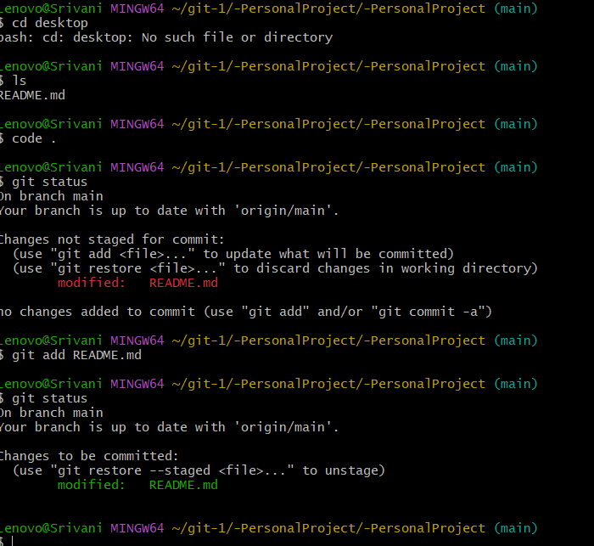

Exp-27:
After modifying a file in a cloned repository, commit the changes locally and push them to GitHub.

Tasks:
  - Clone a repository (from question 1).
  - Modify a file (e.g., README.md).

  - Stage the changes with git add.
  - Commit the changes with git commit -m "Updated README".
  - Push the changes to GitHub using git push.

Aim:
To commit and push changes to GitHub.

Procedure
- Clone the Repository git clone https://github.com/your-username/repository-name.git cd repository-name
- Modify a File Open the project in VS Code Edit README.md or any file Example change: Added project description in README file.
- Stage Change git add .
- Commit Changes git commit -m "Updated README"
- Push Changes to GitHub git push origin main
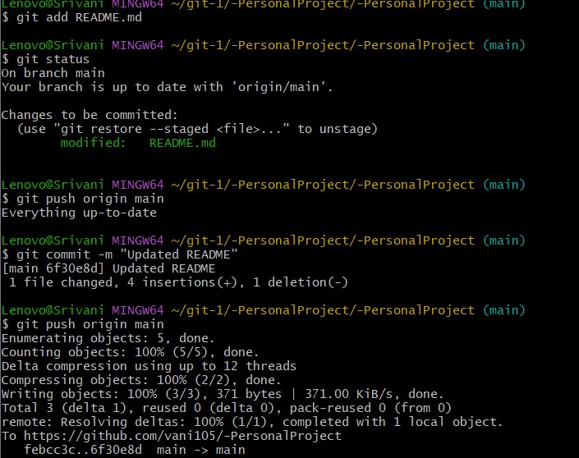

Result: Thus, The Merge conflicts resolved successfully and branch merged.

Exp-28:
You cloned a repository earlier, and now another collaborator has made changes to it. You need to pull the latest changes from GitHub to keep your local copy up to date.

Tasks:
  - Clone a repository (from previous questions).
  - Ask a collaborator to make a change and push it to the GitHub repository.
  - Use git pull origin main to pull the latest changes.
  - Verify that the changes made by your collaborator appear in your local repository.

Aim
To update local repository with remote changes.

Procedure
- Clone the Repository
git clone https://github.com/your-username/repository-name.git cd repository-name
- Collaborator Makes Changes
  - Another user edits a file (e.g., README.md)
  - Adds new content and pushes it to GitHub
- Pull Latest Changes git pull origin main

- Verify Changes
  - Open the project in VS Code
  - Check updated file (e.g., README.md)
  - Confirm collaborator’s changes are visible

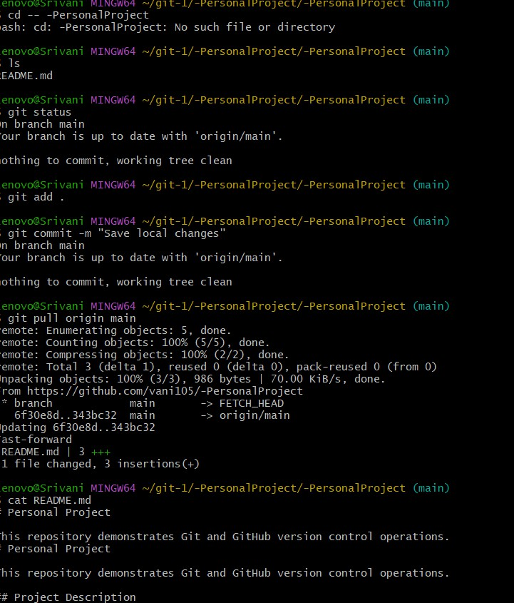

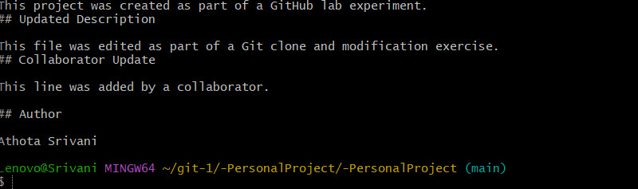
Result: Thus, The Merge conflicts resolved successfully and branch merged.

Exp-2G:
In your GitHub repository, create a new branch called feature-login. Implement a simple login function in a login.py file. After completing the function, create a pull request to merge feature-login into the main branch.
Tasks:

  - Create a new branch feature-login.
  - Add a login.py file with a simple login function.
  - Commit the changes and push them to GitHub.
  - Create a pull request from feature-login to main and merge it.

Aim
To implement login feature using Git branching.

Procedure
- Create and Switch to New Branch git checkout -b feature-login
- Create login.py File Create a new file and add a simple login function: def login(username, password):
if username == "admin" and password == "1234": return "Login Successful"
else:
return "Invalid Credentials"

# Example usage print(login("admin", "1234"))
- Stage Changes git add login.py

- Commit Changes git commit -m "Added login functionality"
- Push Branch to GitHub git push origin feature-login
- Create Pull Request
  - Go to GitHub repository
  - Click Compare & Pull Request
  - Add title and description
  - Click Create Pull Request
- Merge Pull Request
  - After review → Click Merge Pull Request
  - Confirm merge into main branch

Branch → Add File → Commit → Push → Pull Request → Merge

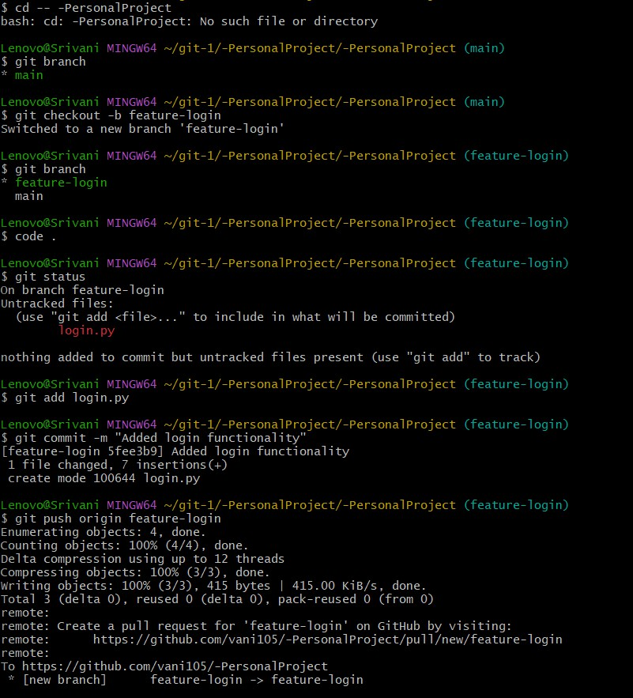
Result: Thus, The Merge conflicts resolved successfully and branch merged.

Exp-30:
You and your team are working on a project. One team member adds a new feature to the project. You need to fetch the latest changes, create a new branch, and implement your feature without affecting the existing code.

Tasks:

  - Fork a repository (you can use an existing repository or a partner’s repository).
  - Clone the repository to your local machine.
  - Create a new branch for your feature.
  - Implement your changes and push them to your forked repository. Submit a pull request to the original repository.

Fork & Implement Feature Aim
To collaborate using fork- based workflow.

Procedure
- Fork the Repository
  - Open the original repository on GitHub
  - Click Fork to create a copy in your account
- Clone the Forked Repository
git clone https://github.com/your-username/repository-name.git cd repository-name
- Create a New Branch
git checkout -b feature-new
- Implement Your Changes
  - Open project in VS Code
  - Add your feature or modify files
  - Ensure existing code is not affected
- Stage Changes git add .
- Commit Changes
git commit -m "Added new feature without affecting existing code"
- Push Changes to Forked Repository

git push origin feature-new
- Create Pull Request to Original Repository
  - Go to your fork on GitHub
  - Click Compare & Pull Request
  - Select base repository (original repo)
  - Add title and description
  - Click Create Pull Request
Fork → Clone → Branch → Develop → Commit → Push → Pull Request
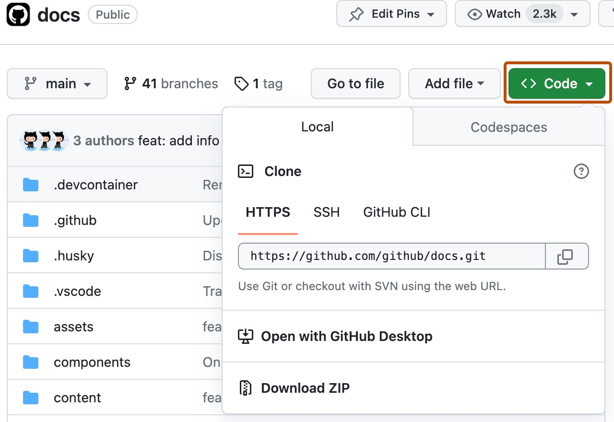
Result: Thus, The Merge conflicts resolved successfully and branch merged

