Community Hall Service Testing after version upgrade
- Create
- http://localhost:8881/chb-services/booking/v1/_search?tenantId=pg.citya&bookingNo=CHB-1013-000748&_=1757396551926
curl --location 'http://localhost:8881/chb-services/booking/v1/_search?tenantId=pg.citya&bookingNo=CHB-1013-000748&_=1757396551926' \
--header 'sec-ch-ua-platform: "macOS"' \
--header 'Referer: https://niuatt.niua.in/upyog-ui/citizen/chb/application/CHB-1013-000748/pg.citya' \
--header 'User-Agent: Mozilla/5.0 (Macintosh; Intel Mac OS X 10_15_7) AppleWebKit/537.36 (KHTML, like Gecko) Chrome/139.0.0.0 Safari/537.36' \
--header 'Accept: application/json, text/plain, */*' \
--header 'sec-ch-ua: "Not;A=Brand";v="99", "Google Chrome";v="139", "Chromium";v="139"' \
--header 'Content-Type: application/json;charset=UTF-8' \
--header 'sec-ch-ua-mobile: ?0' \
--data-raw '{"RequestInfo":{"apiId":"Rainmaker","authToken":"275d4391-66c1-4096-bf81-4f4e728d9f09","userInfo":{"id":811,"uuid":"f789d679-352d-4aec-8198-4d61af1e0566","userName":"8010012414","name":"OWNER","mobileNumber":"8010012414","emailId":"cghvjbnk@gmail.com","locale":null,"type":"CITIZEN","roles":[{"name":"Citizen","code":"CITIZEN","tenantId":"pg"}],"active":true,"tenantId":"pg","permanentCity":null},"msgId":"1757396551926|en_IN","plainAccessRequest":{}}}'
Response:
{
"responseInfo": {
"apiId": "Rainmaker",
"ver": null,
"ts": null,
"resMsgId": "Your community hall booking list fetched successfully",
"msgId": "1757396551926|en_IN",
"status": "SUCCESSFUL"
},
"count": 1,
"hallsBookingApplication": [
{
"bookingNo": "CHB-1013-000748",
"paymentDate": 0,
"applicationDate": 1756364021462,
"tenantId": "pg.citya",
"communityHallCode": "Sector_70",
"communityHallName": null,
"specialCategory": {
"category": "Below Poverty Line",
"discountRate": null
},
"purpose": {
"purpose": "Public Gathering",
"discountRate": null
},
"purposeDescription": "xzsfdfsd",
"receiptNo": null,
"permissionLetterFilestoreId": null,
"paymentReceiptFilestoreId": null,
"bookingSlotDetails": [
{
"capacity": "100 Person",
"bookingDate": "2025-08-30",
"bookingFromTime": "06:00",
"bookingToTime": "05:59",
"auditDetails": {
"createdBy": "f789d679-352d-4aec-8198-4d61af1e0566",
"lastModifiedBy": "b405e4d0-99ec-41b1-92e7-2ebda0321e0d",
"createdTime": 1756364021462,
"lastModifiedTime": 1756365300386
},
"slotId": "757bdd3e-edda-4351-9f0f-1e8fe37e6bf3",
"bookingId": "285d9c97-062f-4fde-90f4-0717e994b086",
"hallCode": "Hall Code-1",
"status": "PAYMENT_FAILED"
}
],
"applicantDetail": {
"applicantDetailId": "d0f88dfc-15bd-4253-882c-a5b5454a747f",
"bookingId": "285d9c97-062f-4fde-90f4-0717e994b086",
"applicantName": "keshav",
"applicantMobileNo": "8010012414",
"applicantAlternateMobileNo": "",
"applicantEmailId": "keshav@niua.org",
"accountNumber": "123123123",
"ifscCode": "PUNB0603800",
"bankName": "Punjab National Bank",
"bankBranchName": "CLPC NEW DELHI",
"accountHolderName": "keshav",
"refundType": null,
"refundStatus": null,
"auditDetails": {
"createdBy": "f789d679-352d-4aec-8198-4d61af1e0566",
"lastModifiedBy": "b405e4d0-99ec-41b1-92e7-2ebda0321e0d",
"createdTime": 1756364021462,
"lastModifiedTime": 1756365300386
}
},
"address": {
"addressId": "c4057ea9-c05b-4bbf-96f4-db4186b8234b",
"applicantDetailId": "d0f88dfc-15bd-4253-882c-a5b5454a747f",
"doorNo": null,
"houseNo": "dsfdsf",
"streetName": "dsfsdf",
"addressLine1": null,
"landmark": "dsfsdfds",
"city": "City A",
"cityCode": "1013",
"locality": "Main Road Abadpura",
"localityCode": "JLC476",
"pincode": "143001"
},
"auditDetails": {
"createdBy": "f789d679-352d-4aec-8198-4d61af1e0566",
"lastModifiedBy": "b405e4d0-99ec-41b1-92e7-2ebda0321e0d",
"createdTime": 1756364021462,
"lastModifiedTime": 1756365300386
},
"workflow": null,
"timerValue": 0,
"bookingId": "285d9c97-062f-4fde-90f4-0717e994b086",
"bookingStatus": "PAYMENT_FAILED",
"documents": [
{
"documentDetailId": "e9a14e07-a29c-4208-8c35-bfce865b0081",
"bookingId": "285d9c97-062f-4fde-90f4-0717e994b086",
"documentType": "APPLICANT.IDENTITYPROOF.AADHAAR",
"fileStoreId": "e250bbc5-864b-4c09-adab-0884181af865",
"auditDetails": {
"createdBy": "f789d679-352d-4aec-8198-4d61af1e0566",
"lastModifiedBy": "f789d679-352d-4aec-8198-4d61af1e0566",
"createdTime": 1756364021462,
"lastModifiedTime": 1756364021462
}
},
{
"documentDetailId": "4c831af2-638c-4b75-96f6-6b5d9e529abb",
"bookingId": "285d9c97-062f-4fde-90f4-0717e994b086",
"documentType": "APPLICANT.ADDRESSPROOF.ELECTRICITYBILL",
"fileStoreId": "131e458f-305e-4504-a576-b5651f22b484",
"auditDetails": {
"createdBy": "f789d679-352d-4aec-8198-4d61af1e0566",
"lastModifiedBy": "f789d679-352d-4aec-8198-4d61af1e0566",
"createdTime": 1756364021462,
"lastModifiedTime": 1756364021462
}
},
{
"documentDetailId": "84e2a4df-a9df-45dc-8642-189efd998d99",
"bookingId": "285d9c97-062f-4fde-90f4-0717e994b086",
"documentType": "APPLICANT.BANKACCOUNTPROOF.BANKPASSBOOK",
"fileStoreId": "c38fceac-d71c-40f5-aeaf-381aea2b2552",
"auditDetails": {
"createdBy": "f789d679-352d-4aec-8198-4d61af1e0566",
"lastModifiedBy": "f789d679-352d-4aec-8198-4d61af1e0566",
"createdTime": 1756364021462,
"lastModifiedTime": 1756364021462
}
}
]
}
]
}

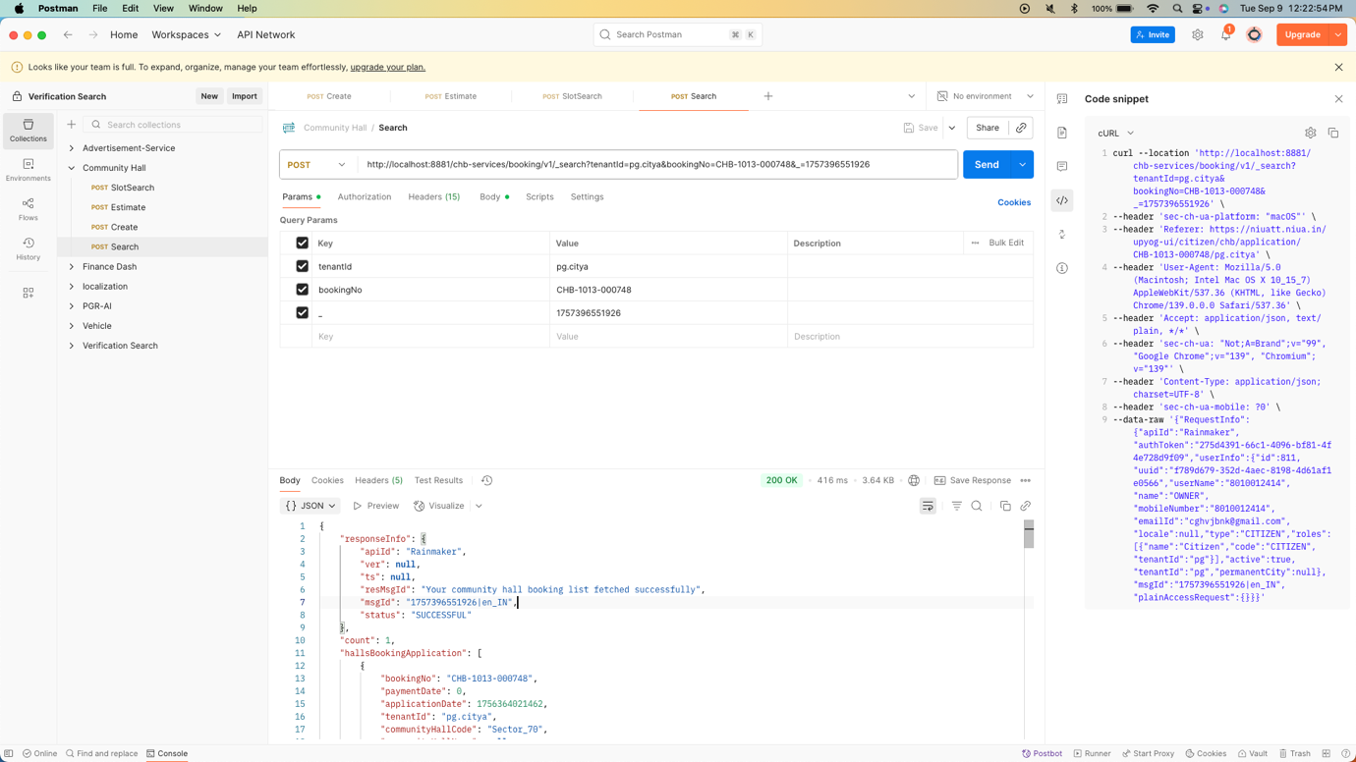

From env via port forward:
Response:
curl --location 'https://niuatt.niua.in/chb-services/booking/v1/_create' \
--header 'accept: application/json, text/plain, */*' \
--header 'accept-language: en-GB,en-US;q=0.9,en;q=0.8,hi;q=0.7' \
--header 'content-type: application/json;charset=UTF-8' \
--header 'origin: https://niuatt.niua.in' \
--header 'priority: u=1, i' \
--header 'referer: https://niuatt.niua.in/upyog-ui/citizen/chb/bookHall/acknowledgement' \
--header 'sec-ch-ua: "Not;A=Brand";v="99", "Google Chrome";v="139", "Chromium";v="139"' \
--header 'sec-ch-ua-mobile: ?0' \
--header 'sec-ch-ua-platform: "macOS"' \
--header 'sec-fetch-dest: empty' \
--header 'sec-fetch-mode: cors' \
--header 'sec-fetch-site: same-origin' \
--header 'user-agent: Mozilla/5.0 (Macintosh; Intel Mac OS X 10_15_7) AppleWebKit/537.36 (KHTML, like Gecko) Chrome/139.0.0.0 Safari/537.36' \
--header 'Cookie: _ga=GA1.1.1866793165.1747538221; _clck=7xvixy%7C2%7Cfw0%7C0%7C1964; _ga_E39TFV5YXM=GS2.1.s1747538268$o1$g1$t1747538317$j0$l0$h0; _ga_VZ9TNBTB3X=GS2.1.s1747538221$o1$g1$t1747538338$j0$l0$h0' \
--data-raw '{
"hallsBookingApplication": {
"tenantId": "pg.mohali",
"applicantDetail": {
"accountNumber": "123456789",
"ifscCode": "PUNB0730000",
"bankName": "Punjab National Bank",
"bankBranchName": "SRI VIJAY NAGAR",
"accountHolderName": "sdfdsf",
"applicantName": "Nikhil",
"applicantMobileNo": "8010012414",
"applicantAlternateMobileNo": "",
"applicantEmailId": "nikhil@gmail.com"
},
"address": {
"pincode": "143001",
"city": "City A",
"cityCode": "1013",
"locality": "Main Road Abadpura",
"localityCode": "JLC476",
"streetName": "sdfdsf",
"houseNo": "432432",
"landmark": "dsfsdfs"
},
"purposeDescription": "dsfsdf",
"documents": [
{
"documentType": "APPLICANT.BANKACCOUNTPROOF.BANKPASSBOOK",
"fileStoreId": "16803b82-7edf-4478-afa9-9b3d89832c30",
"documentUid": "16803b82-7edf-4478-afa9-9b3d89832c30"
},
{
"documentType": "APPLICANT.ADDRESSPROOF.ELECTRICITYBILL",
"fileStoreId": "559a8444-3211-4b53-b341-4a3829f51215",
"documentUid": "559a8444-3211-4b53-b341-4a3829f51215"
},
{
"documentType": "APPLICANT.IDENTITYPROOF.AADHAAR",
"fileStoreId": "cae5f98b-f519-4080-933d-9deb9d1b078e",
"documentUid": "cae5f98b-f519-4080-933d-9deb9d1b078e"
}
],
"bookingStatus": "BOOKING_CREATED",
"communityHallCode": "Sector_71",
"communityHallName": "Sector 71",
"specialCategory": {
"category": "None"
},
"purpose": {
"purpose": "None"
},
"bookingSlotDetails": [
{
"communityHallCode": "Sector_71",
"communityHallName": "Sector 71",
"hallCode": "Hall Code-1",
"bookingDate": "2025-09-22",
"bookingFromTime": "06:00",
"bookingToTime": "05:59",
"status": "BOOKING_CREATED",
"capacity": "100 Person"
},
{
"communityHallCode": "Sector_71",
"communityHallName": "Sector 71",
"hallCode": "Hall Code-1",
"bookingDate": "2025-09-23",
"bookingFromTime": "06:00",
"bookingToTime": "05:59",
"status": "BOOKING_CREATED",
"capacity": "100 Person"
}
],
"workflow": null
},
"RequestInfo": {
"apiId": "Rainmaker",
"authToken": "cfae2005-f9b2-490b-bbf1-14624a2bf0cf",
"userInfo": {
"id": 811,
"uuid": "f789d679-352d-4aec-8198-4d61af1e0566",
"userName": "8010012414",
"name": "OWNER",
"mobileNumber": "8010012414",
"emailId": "cghvjbnk@gmail.com",
"locale": null,
"type": "CITIZEN",
"roles": [
{
"name": "Citizen",
"code": "CITIZEN",
"tenantId": "pg"
}
],
"active": true,
"tenantId": "pg",
"permanentCity": null
},
"msgId": "1757331284227|en_IN",
"plainAccessRequest": {}
}
}'
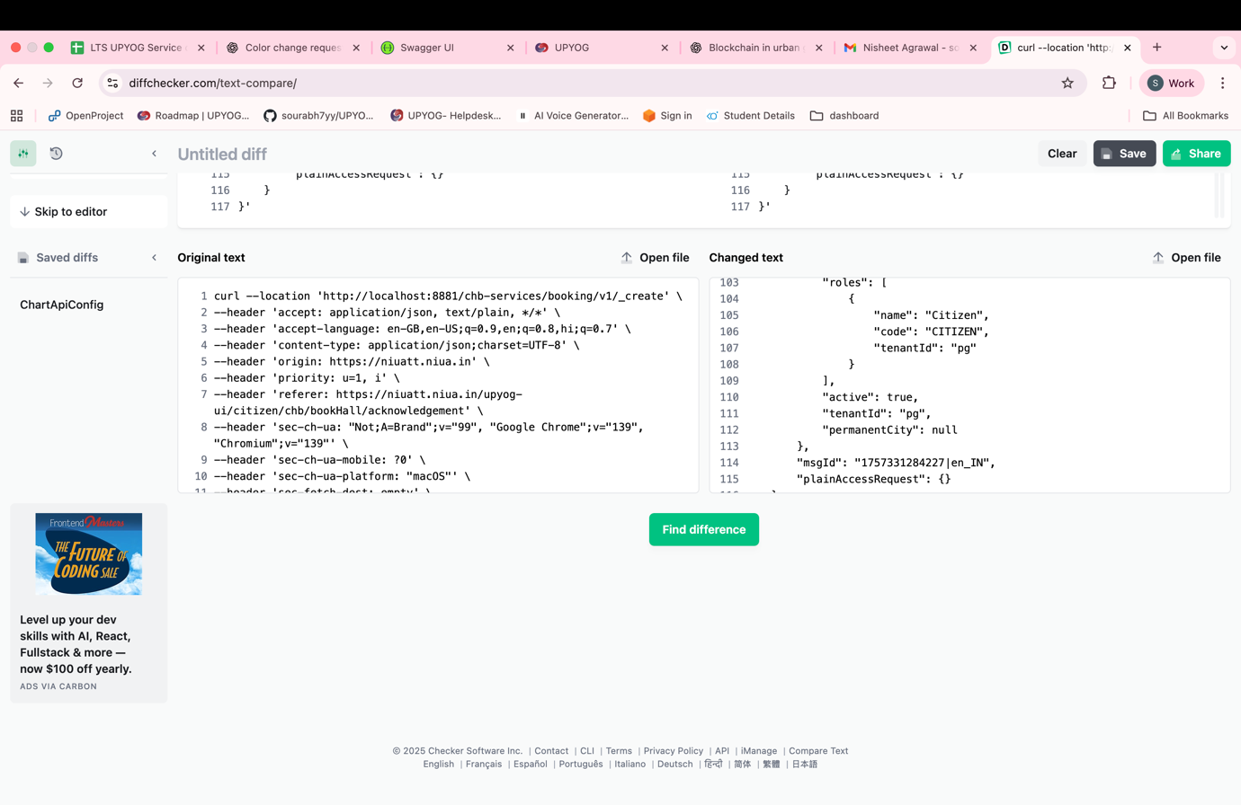

2. Search

Request Payload: http://localhost:8881/chb-services/booking/v1/_search?tenantId=pg.citya&bookingNo=CHB-1013-000748&_=1757396551926

curl --location 'http://localhost:8881/chb-services/booking/v1/_search?tenantId=pg.citya&bookingNo=CHB-1013-000748&_=1757396551926' \
--header 'sec-ch-ua-platform: "macOS"' \
--header 'Referer: https://niuatt.niua.in/upyog-ui/citizen/chb/application/CHB-1013-000748/pg.citya' \
--header 'User-Agent: Mozilla/5.0 (Macintosh; Intel Mac OS X 10_15_7) AppleWebKit/537.36 (KHTML, like Gecko) Chrome/139.0.0.0 Safari/537.36' \
--header 'Accept: application/json, text/plain, */*' \
--header 'sec-ch-ua: "Not;A=Brand";v="99", "Google Chrome";v="139", "Chromium";v="139"' \
--header 'Content-Type: application/json;charset=UTF-8' \
--header 'sec-ch-ua-mobile: ?0' \
--data-raw '{"RequestInfo":{"apiId":"Rainmaker","authToken":"275d4391-66c1-4096-bf81-4f4e728d9f09","userInfo":{"id":811,"uuid":"f789d679-352d-4aec-8198-4d61af1e0566","userName":"8010012414","name":"OWNER","mobileNumber":"8010012414","emailId":"cghvjbnk@gmail.com","locale":null,"type":"CITIZEN","roles":[{"name":"Citizen","code":"CITIZEN","tenantId":"pg"}],"active":true,"tenantId":"pg","permanentCity":null},"msgId":"1757396551926|en_IN","plainAccessRequest":{}}}'d1",
curl --location 'http://localhost:8881/chb-services/booking/v1/_search?tenantId=pg.citya&bookingNo=CHB-1013-000748&_=1757396551926' \
--header 'sec-ch-ua-platform: "macOS"' \
--header 'Referer: https://niuatt.niua.in/upyog-ui/citizen/chb/application/CHB-1013-000748/pg.citya' \
--header 'User-Agent: Mozilla/5.0 (Macintosh; Intel Mac OS X 10_15_7) AppleWebKit/537.36 (KHTML, like Gecko) Chrome/139.0.0.0 Safari/537.36' \
--header 'Accept: application/json, text/plain, */*' \
--header 'sec-ch-ua: "Not;A=Brand";v="99", "Google Chrome";v="139", "Chromium";v="139"' \
--header 'Content-Type: application/json;charset=UTF-8' \
--header 'sec-ch-ua-mobile: ?0' \
--data-raw '{"RequestInfo":{"apiId":"Rainmaker","authToken":"275d4391-66c1-4096-bf81-4f4e728d9f09","userInfo":{"id":811,"uuid":"f789d679-352d-4aec-8198-4d61af1e0566","userName":"8010012414","name":"OWNER","mobileNumber":"8010012414","emailId":"cghvjbnk@gmail.com","locale":null,"type":"CITIZEN","roles":[{"name":"Citizen","code":"CITIZEN","tenantId":"pg"}],"active":true,"tenantId":"pg","permanentCity":null},"msgId":"1757396551926|en_IN","plainAccessRequest":{}}}' "complaintTypes": 13}

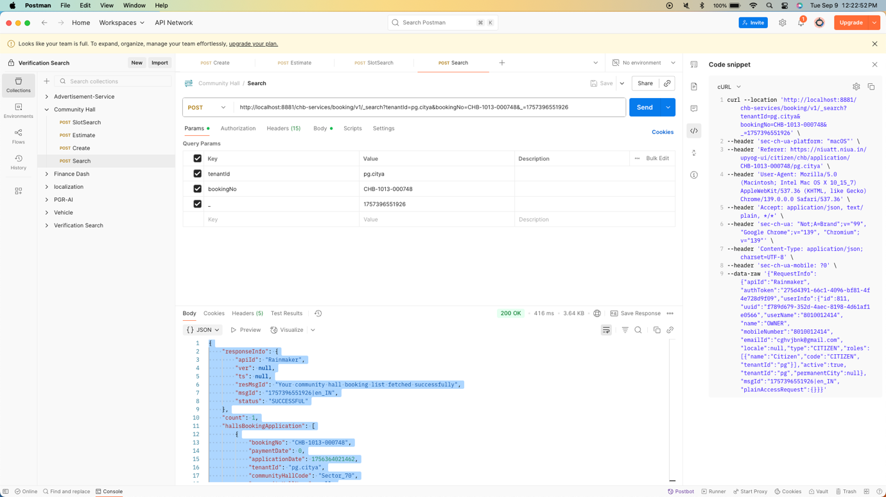

ON NIUATT

Request Payload:
curl --location 'https://niuat.niua.in/chb-services/booking/v1/_search?tenantId=pg.citya&bookingNo=CHB-1013-000748&_=1757396551926' \
--header 'sec-ch-ua-platform: "macOS"' \
--header 'Referer: https://niuatt.niua.in/upyog-ui/citizen/chb/application/CHB-1013-000748/pg.citya' \
--header 'User-Agent: Mozilla/5.0 (Macintosh; Intel Mac OS X 10_15_7) AppleWebKit/537.36 (KHTML, like Gecko) Chrome/139.0.0.0 Safari/537.36' \
--header 'Accept: application/json, text/plain, */*' \
--header 'sec-ch-ua: "Not;A=Brand";v="99", "Google Chrome";v="139", "Chromium";v="139"' \
--header 'Content-Type: application/json;charset=UTF-8' \
--header 'sec-ch-ua-mobile: ?0' \
--data-raw '{"RequestInfo":{"apiId":"Rainmaker","authToken":"275d4391-66c1-4096-bf81-4f4e728d9f09","userInfo":{"id":811,"uuid":"f789d679-352d-4aec-8198-4d61af1e0566","userName":"8010012414","name":"OWNER","mobileNumber":"8010012414","emailId":"cghvjbnk@gmail.com","locale":null,"type":"CITIZEN","roles":[{"name":"Citizen","code":"CITIZEN","tenantId":"pg"}],"active":true,"tenantId":"pg","permanentCity":null},"msgId":"1757396551926|en_IN","plainAccessRequest":{}}}'d1",
curl --location 'http://localhost:8881/chb-services/booking/v1/_search?tenantId=pg.citya&bookingNo=CHB-1013-000748&_=1757396551926' \
--header 'sec-ch-ua-platform: "macOS"' \
--header 'Referer: https://niuatt.niua.in/upyog-ui/citizen/chb/application/CHB-1013-000748/pg.citya' \
--header 'User-Agent: Mozilla/5.0 (Macintosh; Intel Mac OS X 10_15_7) AppleWebKit/537.36 (KHTML, like Gecko) Chrome/139.0.0.0 Safari/537.36' \
--header 'Accept: application/json, text/plain, */*' \
--header 'sec-ch-ua: "Not;A=Brand";v="99", "Google Chrome";v="139", "Chromium";v="139"' \
--header 'Content-Type: application/json;charset=UTF-8' \
--header 'sec-ch-ua-mobile: ?0' \
--data-raw '{"RequestInfo":{"apiId":"Rainmaker","authToken":"275d4391-66c1-4096-bf81-4f4e728d9f09","userInfo":{"id":811,"uuid":"f789d679-352d-4aec-8198-4d61af1e0566","userName":"8010012414","name":"OWNER","mobileNumber":"8010012414","emailId":"cghvjbnk@gmail.com","locale":null,"type":"CITIZEN","roles":[{"name":"Citizen","code":"CITIZEN","tenantId":"pg"}],"active":true,"tenantId":"pg","permanentCity":null},"msgId":"1757396551926|en_IN","plainAccessRequest":{}}}' "complaintTypes": 13}

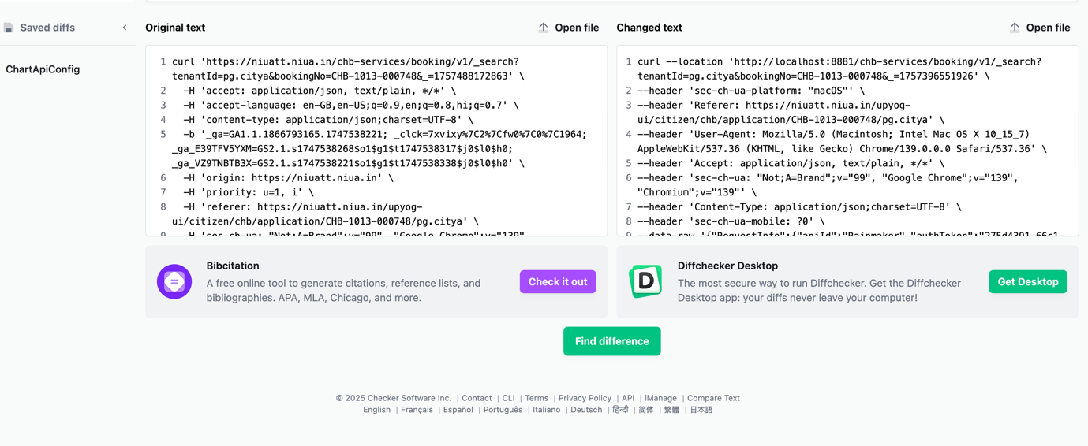

Response from environment:
{
"ResponseInfo": {
"apiId": "Rainmaker",
"ver": null,
"ts": null,
"resMsgId": "uief87324",
"msgId": null,
"status": "200 OK"
},
"Remittance": [
{
"tenantId": "pg.citya",
"id": "4b4b24594eea4c46b2bc6d15aa5e97fe",
"referenceNumber": "REF-002",
"referenceDate": 1719400000000,
"voucherHeader": null,
"function": null,
"fund": null,
"remarks": null,
"reasonForDelay": null,
"status": "APPROVED",
"bankaccount": "000000000002",
"auditDetails": {
"createdBy": "1",
"createdTime": 1751271212403,
"lastModifiedBy": "1",
"lastModifiedTime": 1751271212403
},
"remittanceReceipts": [],
"remittanceDetails": [
{
"tenantId": "pg.citya",
"id": "33e64b334bde41f0845222febaac3a99",
"remittance": "4b4b24594eea4c46b2bc6d15aa5e97fe",
"chartOfAccount": "COA-002",
"creditAmount": 1000,
"debitAmount": 0
}
],
"remittanceInstruments": [
{
"tenantId": "pg.citya",
"id": "d5c59c519cd54813b7ff08be0b72d1c8",
"remittance": "4b4b24594eea4c46b2bc6d15aa5e97fe",
"instrument": "CHQ-1234567",
"reconciled": null
}
]
}
]
}
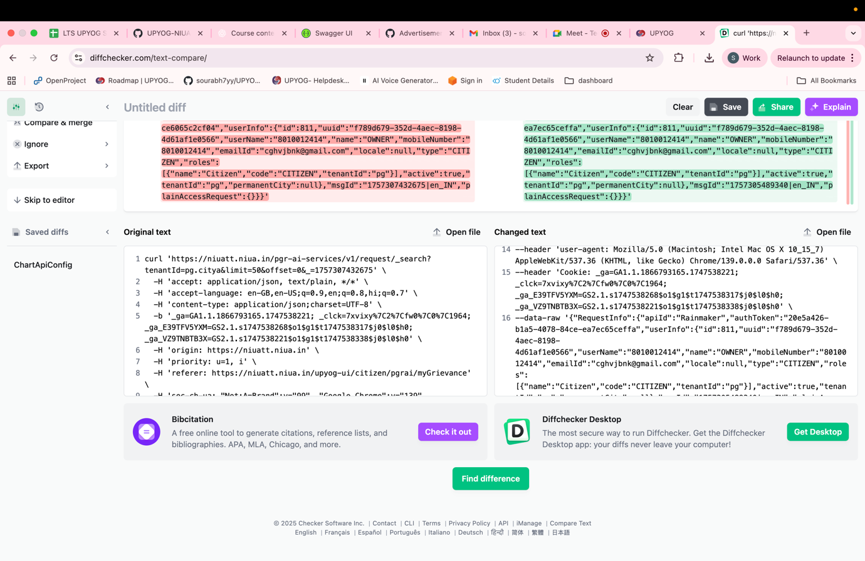

3. SLOT SEARCH
Request payload: http://localhost:8881/chb-services/booking/v1/_slot-search?tenantId=pg.mohali&communityHallCode=Sector_71&bookingStartDate=2025-09-22&bookingEndDate=2025-09-23&hallCode=Hall+Code-1&isTimerRequired=false&_=1757331173074

curl --location 'http://localhost:8881/chb-services/booking/v1/_slot-search?tenantId=pg.mohali&communityHallCode=Sector_71&bookingStartDate=2025-09-22&bookingEndDate=2025-09-23&hallCode=Hall+Code-1&isTimerRequired=false&_=1757331173074' \
--header 'accept: application/json, text/plain, */*' \
--header 'accept-language: en-GB,en-US;q=0.9,en;q=0.8,hi;q=0.7' \
--header 'content-type: application/json;charset=UTF-8' \
--header 'origin: https://niuatt.niua.in' \
--header 'priority: u=1, i' \
--header 'referer: https://niuatt.niua.in/upyog-ui/citizen/chb/bookHall/searchhall' \
--header 'sec-ch-ua: "Not;A=Brand";v="99", "Google Chrome";v="139", "Chromium";v="139"' \
--header 'sec-ch-ua-mobile: ?0' \
--header 'sec-ch-ua-platform: "macOS"' \
--header 'sec-fetch-dest: empty' \
--header 'sec-fetch-mode: cors' \
--header 'sec-fetch-site: same-origin' \
--header 'user-agent: Mozilla/5.0 (Macintosh; Intel Mac OS X 10_15_7) AppleWebKit/537.36 (KHTML, like Gecko) Chrome/139.0.0.0 Safari/537.36' \
--header 'Cookie: _ga=GA1.1.1866793165.1747538221; _clck=7xvixy%7C2%7Cfw0%7C0%7C1964; _ga_E39TFV5YXM=GS2.1.s1747538268$o1$g1$t1747538317$j0$l0$h0; _ga_VZ9TNBTB3X=GS2.1.s1747538221$o1$g1$t1747538338$j0$l0$h0' \
--data-raw '{"RequestInfo":{"apiId":"Rainmaker","authToken":"cfae2005-f9b2-490b-bbf1-14624a2bf0cf","userInfo":{"id":811,"uuid":"f789d679-352d-4aec-8198-4d61af1e0566","userName":"8010012414","name":"OWNER","mobileNumber":"8010012414","emailId":"cghvjbnk@gmail.com","locale":null,"type":"CITIZEN","roles":[{"name":"Citizen","code":"CITIZEN","tenantId":"pg"}],"active":true,"tenantId":"pg","permanentCity":null},"msgId":"1757331173074|en_IN","plainAccessRequest":{}}}'
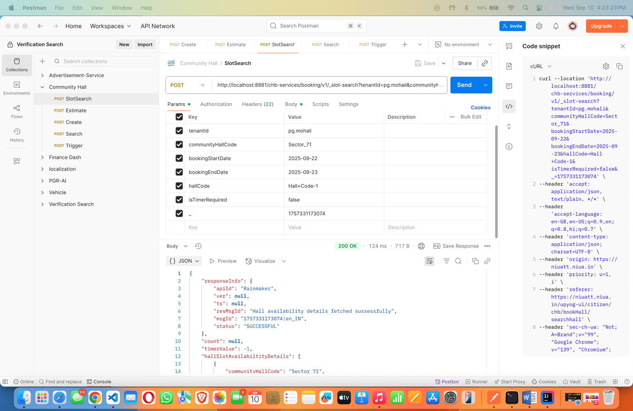

ON NIUATT
curl --location 'https://niuatt.niua.in/chb-services/booking/v1/_slot-search?tenantId=pg.mohali&communityHallCode=Sector_71&bookingStartDate=2025-09-22&bookingEndDate=2025-09-23&hallCode=Hall+Code-1&isTimerRequired=false&_=1757331173074' \
--header 'accept: application/json, text/plain, */*' \
--header 'accept-language: en-GB,en-US;q=0.9,en;q=0.8,hi;q=0.7' \
--header 'content-type: application/json;charset=UTF-8' \
--header 'origin: https://niuatt.niua.in' \
--header 'priority: u=1, i' \
--header 'referer: https://niuatt.niua.in/upyog-ui/citizen/chb/bookHall/searchhall' \
--header 'sec-ch-ua: "Not;A=Brand";v="99", "Google Chrome";v="139", "Chromium";v="139"' \
--header 'sec-ch-ua-mobile: ?0' \
--header 'sec-ch-ua-platform: "macOS"' \
--header 'sec-fetch-dest: empty' \
--header 'sec-fetch-mode: cors' \
--header 'sec-fetch-site: same-origin' \
--header 'user-agent: Mozilla/5.0 (Macintosh; Intel Mac OS X 10_15_7) AppleWebKit/537.36 (KHTML, like Gecko) Chrome/139.0.0.0 Safari/537.36' \
--header 'Cookie: _ga=GA1.1.1866793165.1747538221; _clck=7xvixy%7C2%7Cfw0%7C0%7C1964; _ga_E39TFV5YXM=GS2.1.s1747538268$o1$g1$t1747538317$j0$l0$h0; _ga_VZ9TNBTB3X=GS2.1.s1747538221$o1$g1$t1747538338$j0$l0$h0' \
--data-raw '{"RequestInfo":{"apiId":"Rainmaker","authToken":"cfae2005-f9b2-490b-bbf1-14624a2bf0cf","userInfo":{"id":811,"uuid":"f789d679-352d-4aec-8198-4d61af1e0566","userName":"8010012414","name":"OWNER","mobileNumber":"8010012414","emailId":"cghvjbnk@gmail.com","locale":null,"type":"CITIZEN","roles":[{"name":"Citizen","code":"CITIZEN","tenantId":"pg"}],"active":true,"tenantId":"pg","permanentCity":null},"msgId":"1757331173074|en_IN","plainAccessRequest":{}}}'

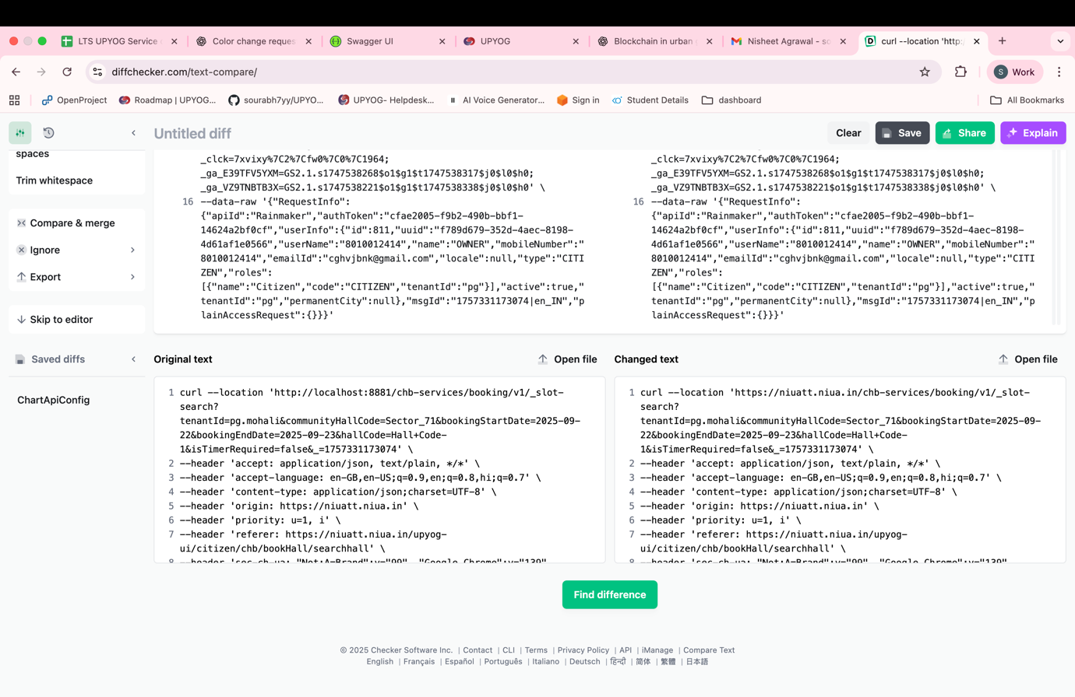

ESTIMATE

Curl- http://localhost:8881/chb-services/booking/v1/_estimate

curl --location 'http://localhost:8881/chb-services/booking/v1/_estimate' \
--header 'accept: application/json, text/plain, */*' \
--header 'accept-language: en-GB,en-US;q=0.9,en;q=0.8,hi;q=0.7' \
--header 'content-type: application/json;charset=UTF-8' \
--header 'origin: https://niuatt.niua.in' \
--header 'priority: u=1, i' \
--header 'referer: https://niuatt.niua.in/upyog-ui/citizen/chb/bookHall/applicant-details' \
--header 'sec-ch-ua: "Not;A=Brand";v="99", "Google Chrome";v="139", "Chromium";v="139"' \
--header 'sec-ch-ua-mobile: ?0' \
--header 'sec-ch-ua-platform: "macOS"' \
--header 'sec-fetch-dest: empty' \
--header 'sec-fetch-mode: cors' \
--header 'sec-fetch-site: same-origin' \
--header 'user-agent: Mozilla/5.0 (Macintosh; Intel Mac OS X 10_15_7) AppleWebKit/537.36 (KHTML, like Gecko) Chrome/139.0.0.0 Safari/537.36' \
--header 'Cookie: _ga=GA1.1.1866793165.1747538221; _clck=7xvixy%7C2%7Cfw0%7C0%7C1964; _ga_E39TFV5YXM=GS2.1.s1747538268$o1$g1$t1747538317$j0$l0$h0; _ga_VZ9TNBTB3X=GS2.1.s1747538221$o1$g1$t1747538338$j0$l0$h0' \
--data-raw '{"tenantId":"pg.mohali","bookingSlotDetails":[{"hallCode":"Hall Code-1","bookingDate":"2025-09-22","bookingFromTime":"06:00","bookingToTime":"05:59","status":"BOOKING_CREATED","capacity":"100 Person"},{"hallCode":"Hall Code-1","bookingDate":"2025-09-23","bookingFromTime":"06:00","bookingToTime":"05:59","status":"BOOKING_CREATED","capacity":"100 Person"}],"communityHallCode":"Sector_71","RequestInfo":{"apiId":"Rainmaker","authToken":"cfae2005-f9b2-490b-bbf1-14624a2bf0cf","userInfo":{"id":811,"uuid":"f789d679-352d-4aec-8198-4d61af1e0566","userName":"8010012414","name":"OWNER","mobileNumber":"8010012414","emailId":"cghvjbnk@gmail.com","locale":null,"type":"CITIZEN","roles":[{"name":"Citizen","code":"CITIZEN","tenantId":"pg"}],"active":true,"tenantId":"pg","permanentCity":null},"msgId":"1757331217143|en_IN","plainAccessRequest":{}}}'

RESONSE-
{
"responseInfo": {
"apiId": "Rainmaker",
"ver": null,
"ts": null,
"resMsgId": "Hall booking amount estimation details fetched sussessfully",
"msgId": "1757331217143|en_IN",
"status": "SUCCESSFUL"
},
"demands": [
{
"id": null,
"tenantId": "pg",
"consumerCode": null,
"consumerType": "CHB",
"businessService": "chb-services",
"payer": {
"id": null,
"userName": null,
"name": "OWNER",
"type": null,
"mobileNumber": "8010012414",
"emailId": "cghvjbnk@gmail.com",
"roles": null,
"tenantId": "pg",
"uuid": null
},
"taxPeriodFrom": 1757497703079,
"taxPeriodTo": 1758585600000,
"demandDetails": [
{
"id": null,
"demandId": null,
"taxHeadMasterCode": "BOOKING_FEES",
"taxAmount": 21000,
"collectionAmount": 0,
"additionalDetails": null,
"auditDetails": null,
"tenantId": "pg"
},
{
"id": null,
"demandId": null,
"taxHeadMasterCode": "SGST",
"taxAmount": 1890,
"collectionAmount": 0,
"additionalDetails": null,
"auditDetails": null,
"tenantId": "pg"
},
{
"id": null,
"demandId": null,
"taxHeadMasterCode": "CGST",
"taxAmount": 1890,
"collectionAmount": 0,
"additionalDetails": null,
"auditDetails": null,
"tenantId": "pg"
}
],
"auditDetails": null,
"additionalDetails": 24780,
"minimumAmountPayable": 0,
"status": null
}
]
}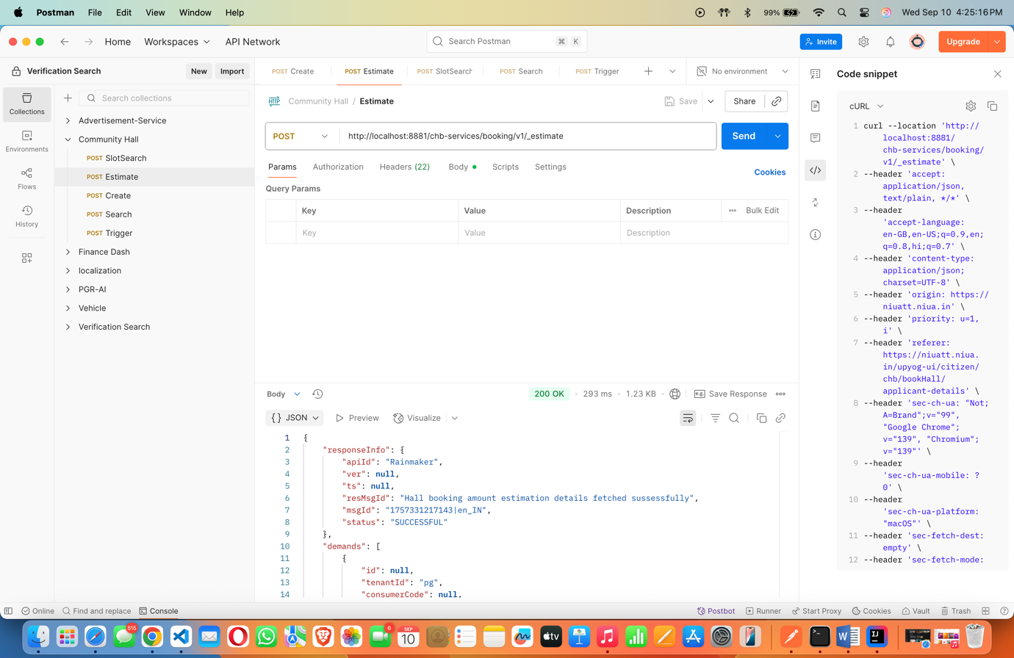

On NIUATT –

curl --location 'https://niuatt.niua.in/chb-services/booking/v1/_estimate' \
--header 'accept: application/json, text/plain, */*' \
--header 'accept-language: en-GB,en-US;q=0.9,en;q=0.8,hi;q=0.7' \
--header 'content-type: application/json;charset=UTF-8' \
--header 'origin: https://niuatt.niua.in' \
--header 'priority: u=1, i' \
--header 'referer: https://niuatt.niua.in/upyog-ui/citizen/chb/bookHall/applicant-details' \
--header 'sec-ch-ua: "Not;A=Brand";v="99", "Google Chrome";v="139", "Chrom
ium";v="139"' \
--header 'sec-ch-ua-mobile: ?0' \
--header 'sec-ch-ua-platform: "macOS"' \
--header 'sec-fetch-dest: empty' \
--header 'sec-fetch-mode: cors' \
--header 'sec-fetch-site: same-origin' \
--header 'user-agent: Mozilla/5.0 (Macintosh; Intel Mac OS X 10_15_7) AppleWebKit/537.36 (KHTML, like Gecko) Chrome/139.0.0.0 Safari/537.36' \
--header 'Cookie: _ga=GA1.1.1866793165.1747538221; _clck=7xvixy%7C2%7Cfw0%7C0%7C1964; _ga_E39TFV5YXM=GS2.1.s1747538268$o1$g1$t1747538317$j0$l0$h0; _ga_VZ9TNBTB3X=GS2.1.s1747538221$o1$g1$t1747538338$j0$l0$h0' \
--data-raw '{"tenantId":"pg.mohali","bookingSlotDetails":[{"hallCode":"Hall Code-1","bookingDate":"2025-09-22","bookingFromTime":"06:00","bookingToTime":"05:59","status":"BOOKING_CREATED","capacity":"100 Person"},{"hallCode":"Hall Code-1","bookingDate":"2025-09-23","bookingFromTime":"06:00","bookingToTime":"05:59","status":"BOOKING_CREATED","capacity":"100 Person"}],"communityHallCode":"Sector_71","RequestInfo":{"apiId":"Rainmaker","authToken":"cfae2005-f9b2-490b-bbf1-14624a2bf0cf","userInfo":{"id":811,"uuid":"f789d679-352d-4aec-8198-4d61af1e0566","userName":"8010012414","name":"OWNER","mobileNumber":"8010012414","emailId":"cghvjbnk@gmail.com","locale":null,"type":"CITIZEN","roles":[{"name":"Citizen","code":"CITIZEN","tenantId":"pg"}],"active":true,"tenantId":"pg","permanentCity":null},"msgId":"1757331217143|en_IN","plainAccessRequest":{}}}'

RESPONSE-

{
"responseInfo": {
"apiId": "Rainmaker",
"ver": null,
"ts": null,
"resMsgId": "Hall booking amount estimation details fetched sussessfully",
"msgId": "1757331217143|en_IN",
"status": "SUCCESSFUL"
},
"demands": [
{
"id": null,
"tenantId": "pg",
"consumerCode": null,
"consumerType": "CHB",
"businessService": "chb-services",
"payer": {
"id": null,
"userName": null,
"name": "OWNER",
"type": null,
"mobileNumber": "8010012414",
"emailId": "cghvjbnk@gmail.com",
"roles": null,
"tenantId": "pg",
"uuid": null
},
"taxPeriodFrom": 1757497703079,
"taxPeriodTo": 1758585600000,
"demandDetails": [
{
"id": null,
"demandId": null,
"taxHeadMasterCode": "BOOKING_FEES",
"taxAmount": 21000,
"collectionAmount": 0,
"additionalDetails": null,
"auditDetails": null,
"tenantId": "pg"
},
{
"id": null,
"demandId": null,
"taxHeadMasterCode": "SGST",
"taxAmount": 1890,
"collectionAmount": 0,
"additionalDetails": null,
"auditDetails": null,
"tenantId": "pg"
},
{
"id": null,
"demandId": null,
"taxHeadMasterCode": "CGST",
"taxAmount": 1890,
"collectionAmount": 0,
"additionalDetails": null,
"auditDetails": null,
"tenantId": "pg"
}
],
"auditDetails": null,
"additionalDetails": 24780,
"minimumAmountPayable": 0,
"status": null
}
]
}

