Structured Training Program: Wi-Fi
Module 1: Introduction and History of Wi-Fi
1. In which OSI layer the Wi-Fi standards/protocol fits?
The Wi-Fi and it’s protocol standards fits in the OSI layer 1 – Physcial Layer and OSI layer 2 – Datalink Layer.
Reasons for Layer 1:
- Signal Transmission: Wi-Fi operates using radio waves (2.4 GHz, 5 GHz, 6 GHz bands) to transmit raw bits between devices.
- Physical Specifications: 802.11 standards define the physical specifications, including modulation techniques (like OFDM, DSSS) and transceiver control.
- Hardware Interface: It manages the network interface card (NIC) and antenna interaction to put data onto the wireless medium
Reasons for Layer 2:
- Framing: Wi-Fi organizes bits received from the Physical layer into structured frames (802.11 frames).
- Media Access Control (MAC): Wi-Fi uses a MAC sublayer (IEEE 802.11 MAC) to manage how devices access the shared airwaves, utilizing techniques like Carrier Sense Multiple Access with Collision Avoidance (CSMA/CA).
- Node-to-Node Addressing: It utilizes MAC addresses to ensure frames are delivered to the correct device within the local network segment.
- Error Detection and Flow Control: It provides mechanisms for checking data errors and controlling data flow to ensure reliable transmission between nodes.
2. Can you share the Wi-Fi devices that you are using day to day life share that device’s wireless capability / properties after connecting to the network. Match your device to Wi-FI generation based on the capability
Device Name | Freq Band | Max Bandwidth / Channel | Non-Overlapping Channels | Max MIMO | Highest Modulation | Max PHY Data Rate | MU-MIMO | MU-OFDMA  (Shared Bandwidth) | TWT | Wi-Fi Generation
OnePlus Nord CE3 Lite 5G | 2.4 GHz, 5 GHz | 80 MHz | (approx) 6 (5 GHz) | 2×2 | 1024-QAM | (approx) 1200 Mbps | Yes | No | No | Wi-Fi 5 (802.11ac)
Cisco Wi-Fi 6 Router | 2.4 GHz, 5 GHz | 160 MHz | (approx) 8+ | 4×4 | 1024-QAM | (approx) 4800 Mbps | Yes | Yes | Yes | Wi-Fi 6 (802.11ax)
Dell Inspiron 14 (2024) | 2.4 GHz, 5 GHz | 160 MHz | (approx) 8+ | 2×2 | 1024-QAM | (approx) 2400 Mbps | Yes | Yes | Yes | Wi-Fi 6
Redmi Pad 6 | 2.4 GHz, 5 GHz | 80 MHz | (approx) 6 | 2×2 | 1024-QAM | (approx) 1200 Mbps | Yes | No | No | Wi-Fi 5 (802.11ac)
TP-Link Home Router | 2.4 GHz, 5 GHz | 80–160 MHz | (approx) 6–8 | 2×2 or 4×4 | 1024-QAM | (approx) 1200–3000 Mbps | Yes | Partial | No/Yes | Wi-Fi 5 / Wi-Fi 6

3. What is BSS and ESS ?
Basic Service Set (BSS):
Basic Service Set (BSS) is a single Acess Point (AP) connecting devices within a small range (called as cell) through a wireless medium commonly used in home routers.
Extended Service Set (ESS):
Extended Service Set (ESS) connect more than one BSS usually through Ethernet and allows user within the ESS to rome freely under a single Service Set Identifier (SSID).
Criteria | BSS | ESS
Structure | Consist of one AP and Client | Consist of 2 or more BSSs (multiple APs)
Coverage | Small (one cell) | Large (multiple cells)
SSID | Identified by MAC address of AP (BSSID) | All BSSs in ESS share the same service set identifier (SSID) and are distinguised by BSSIDs of individual AP
Roaming | Not possible without disconnection | Allows user to move between APs without disconnection
Example | A home router | University Campus with many APs

4. What are the basic functions of Wi-Fi access points ?
Basic Functions of Wi-Fi Access Points:
- Bridging Wired to Wireless: Connects directly to a wired Ethernet router, switch, or hub and converts that data into a wireless signal, allowing wireless devices to access the wired network.
- Extending Coverage (Repeater Mode): Acts as a repeater by extending the Wi-Fi signal to areas with low signal strength or dead spots, such as in large offices or homes.
- Wireless Connectivity Hub: Acts as the central point for wireless communications, facilitating communication between connected clients.
- VLAN Support (Segmentation): Supports multiple SSIDs, enabling segmentation of the network to provide separate connections for guests, IoT devices, or employees.
- Bridging Different Network Types: Can be configured to connect wireless-only devices to wired infrastructure, acting as a workgroup bridge.
5. Difference between Bridge Mode and Repeater Mode.\
Bridge Mode | Repeater Mode
Connect two different routers | Extend the network coverage to dead xones
Maitain faster Speed | Reduce througput as they act as Secondary APs
Best for connecting Distant Wireless Devices that need stable connection without running cable | Best for boosting signals into dead zones for mobile devices
Entire bandwidth is used for Secondary AP | Bandwidth is not fully used for Secondary AP they are split to use across both Primary and secondary AP equally using the same Wireless channel

6. What are the difference between IEEE 802.11a and IEEE 802.11b
Feature | IEEE 802.11a | IEEE 802.11b
Frequency | 5 GHz | 2.4 GHz
Max Speed | 54 Mbps | 11 Mbps
Range | Shorter | Longer
Interference | Low | High
Modulation | OFDM | DSSS
Channels | More | Limited (3)
Cost (initially) | Higher | Lower

7. Configure your modem/hotspot to operate only in 2.4 Ghz and connect your laptop / WI-Fi device and capture the propertoes in your wifi device. Repeat the same in 5Ghz and tabulate the difference you observe during this.
Properties in 2.4Ghz
Device used for hotspot: Oneplus Nord CE3 Lite 5G (Intel(R) Wi-Fi 6E AX211 160MHz)
Device used for Connection : Dell Inspiron 14 (Wi-Fi card - Intel(R) Wi-Fi 6E AX211 160MHz)
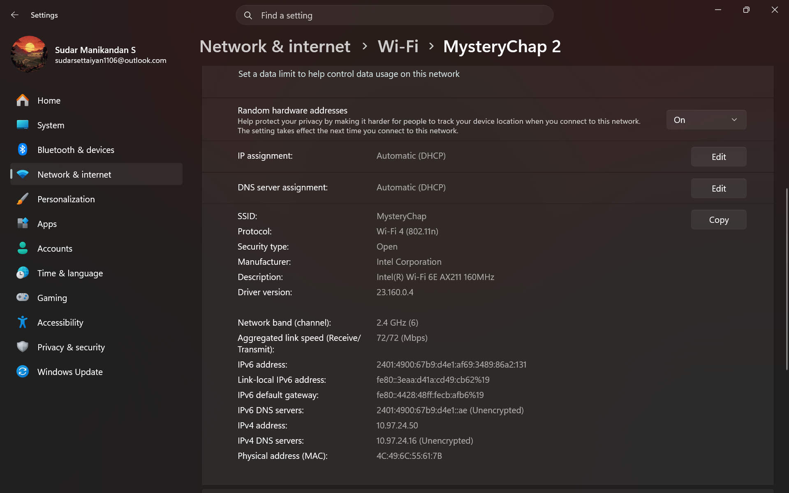
Properties in 5 GHz:
Device used for hotspot: Oneplus Nord CE3 Lite 5G (Intel(R) Wi-Fi 6E AX211 160MHz)
Device used for Connection : Dell Inspiron 14 (Wi-Fi card - Intel(R) Wi-Fi 6E AX211 160MHz)
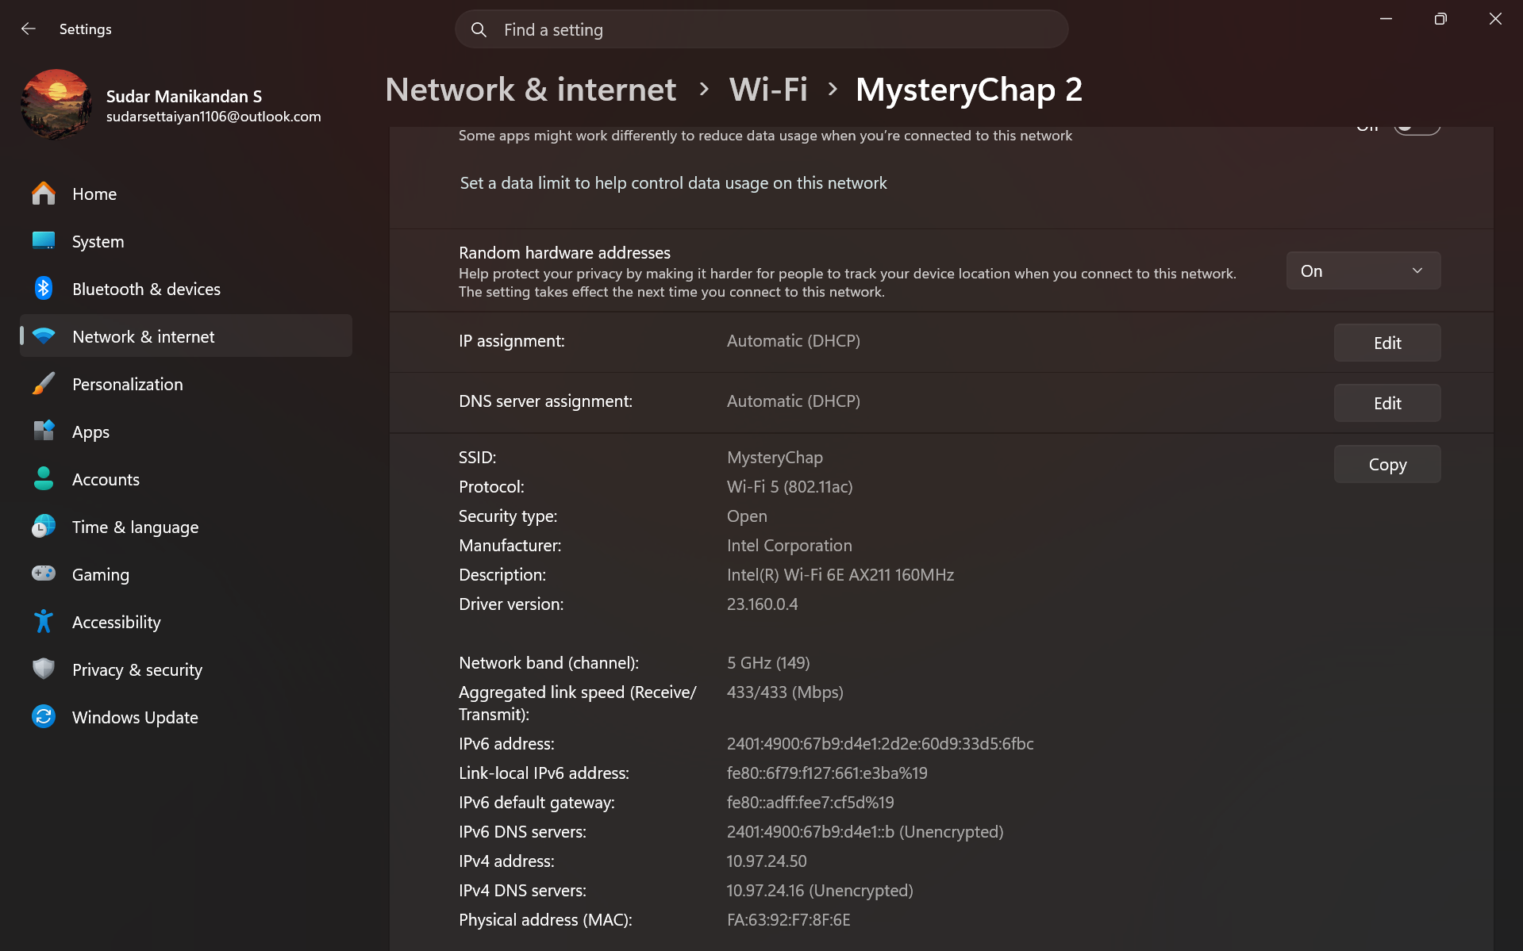
Feature | 2.4 GHz | 5 GHz
Wi-Fi Standard | Wi-Fi 4 (802.11n) | Wi-Fi 5 (802.11ac)
Frequency Band | 2.4 GHz | 5 GHz
Channel | 6 | 149
Speed (Rx/Tx) | 72 / 72 Mbps | 433 / 433 Mbps
Range | Longer | Shorter
Wall Penetration | Better | Weaker
Interference | High (inference from Bluetooth, microwave, etc.) | Low
Network Stability | More stable at distance | Best when near router

8. What is the difference between IEEE and WFA ?
Basis of Comparison | IEEE | WFA (Wi-Fi Alliance)
Full Form | Institute of Electrical and Electronics Engineers | Wi-Fi Alliance
Nature | Professional standards organization | Industry consortium
Primary Role | Develops technical standards | Certifies Wi-Fi devices
Main Function | Defines protocols (e.g., 802.11 series) | Ensures interoperability between devices
Focus Area | Design and specification of wireless communication | Testing, compatibility, and user experience
Output | Standards documents (802.11a/b/g/n/ac/ax) | “Wi-Fi CERTIFIED” label
Target Users | Engineers, researchers, developers | Manufacturers and consumers
Example | Defines how Wi-Fi works (e.g., modulation, frequency) | Tests if router and mobile can work together
Responsibility | Standard creation | Product validation
Dependency | Independent body | Uses IEEE standards for certification

9. List down the types of Wi-Fi internet connectivity backhauls share your home/college’s wireless internet connectivity backhaul name and its properties.
Types of Wi-Fi connectivity Backhauls:
- Fibre Optics
- MoCA
- Satellite
- Cellular
- Powerline Backhaul
The type of backhaul used in our college if Fibre Optics Backhaul:
Properties of Fibre Optics Backhaul:
- Low Latency
- Immune to interference
- Capable of transfering High bandwidth over long distance
- High reliablity and security
The type of backhaul used inour home is Cellular Backhaul:
Properties of Cellular Backhaul:
- Capable of handling large volume of data from multiple user (through 4G/LTE and 5g technology)
- Rapid deployment and easy mobility
- Variable Latency unlike Fibre Optics
10. List down the Wi-Fi topology and their use cases.
Wi-Fi topologies and their use cases:
1. Infrastructure Mode
Description: Devices connect through a central Access Point (AP) (router).
Use cases:
- Home Wi-Fi networks
- College/office networks
- Internet access for multiple devices
2. Repeater Mode
Description: Extends existing Wi-Fi by receiving and re-transmitting signals.
Use cases:
- Eliminating dead zones in large homes
- Extending campus/building coverage
- Improving weak signal areas

3. Bridge Mode
Description: Connects two networks (wired or wireless) at Layer 2.
Use cases:
- Connecting two buildings wirelessly
- Linking LANs without running cables
- Backbone connections in campuses
4. Ad-Hoc Mode
Description: Direct device-to-device connection without an AP.
Use cases:
- Quick file sharing between laptops
- Temporary networks (meetings, labs)
- Peer-to-peer communication
5. Mobile Hotspot Mode
Description: Smartphone or device acts as a Wi-Fi router.
Use cases:
- Sharing mobile data
- Internet access during travel
- Backup connection when broadband fails
6. Mesh Mode
Description: Multiple nodes form a self-healing network with seamless roaming.
Use cases:
- Smart homes with large coverage
- Hotels, malls, campuses
- IoT-heavy environments
7. Workgroup Bridge Mode (WGB)
Description: Connects wired devices to a wireless network via a bridge.
Use cases:
- Connecting printers, CCTV, or legacy devices
- Industrial equipment networking
- Smart classrooms/labs
8. IoT Gateway Mode
Description: Acts as a bridge between IoT devices and cloud/network.
Use cases:
- Smart home automation
- Industrial IoT (IIoT)
- Sensor data collection and processing

