Structured Training Program: Networking
Week 3
Module 6: Layer 3 Session 2
1. Capture and analyze ARP packets in wireshark. Inspect the ARP request and reply frames when your device attempts to find the router’s MAC address.
Discuss the imprtance of ARP in pakcket forwarding.

I have captured the following ARP packets
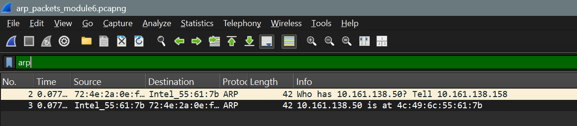
Inspecting the request ARP packet,
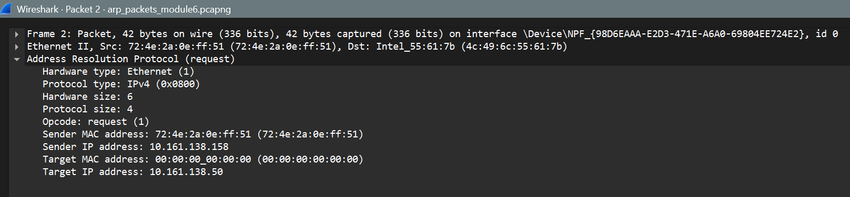
The packet consist of the following fields
Hardware Type (2 bytes): Specifies the type of data link layer technology used. It allows ARP to operate across different network technologies. For Ethernet networks, this value is 1.
Protocol Type (2 bytes): Identifies the network protocol whose address is being mapped to a MAC address. It is commonly IPv4 (0x0800).Hardware Size (1 byte): Specifies the length of the hardware address. For Ethernet, the MAC address length is 6 bytes (48 bits).
Protocol Size (1 byte): Specifies the length of the protocol address. For IPv4, the IP address length is 4 bytes (32 bits).
Opcode (2 bytes): Indicates the type of ARP message.
- – ARP Request
- – ARP Reply
Sender MAC Address (6 bytes): Specifies the MAC address of the sender (the device that generated the ARP request).
Sender IP Address (4 bytes): Specifies the IP address of the sender. This allows the receiving device to know where to send the ARP reply and helps the reciever devide to update it’s ARP cache if needed.
Target MAC Address (6 bytes): In an ARP request, this field is typically set to 00:00:00:00:00:00 because the sender does not yet know the MAC address of the target device.
Target IP Address (4 bytes): Specifies the IP address of the device whose MAC address is being requested. The ARP request is broadcast to all devices in the local network to find this address.
Inspecting the ARP reply packet,
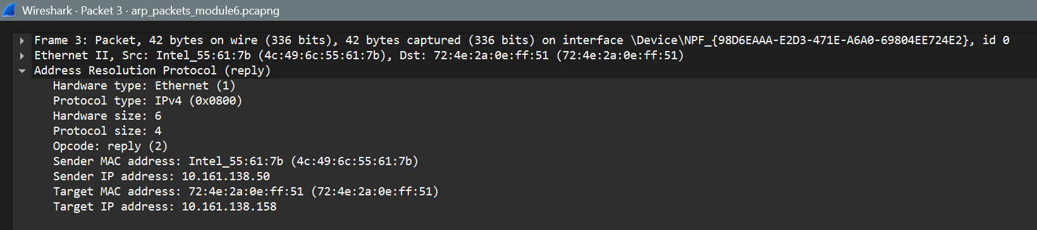
The packet structure of the ARP reply is similar to that of the ARP request. However, the main difference is that in the reply packet, the Target MAC Address field contains the actual MAC address of the requesting system, instead of being set to 00:00:00:00:00:00 as in the request packet.
Additionally, the Sender MAC Address field contains the MAC address of the device whose IP address was requested, indicating the mapping between the IP address and its corresponding MAC address. The ARP reply is then sent as a unicast packet directly to the requesting system.
Importance of ARP in packet Forwarding
- Maps Logical to Physical Addresses
- Enables Local Network Delivery (as within Local Network the switch needs MAC for delivery)

2. Manually configure static routes on a router to direct packet to different subnets. Use the ip route command and verify connectivity using ping and traceroute

- I have used the following topology to configure static routing
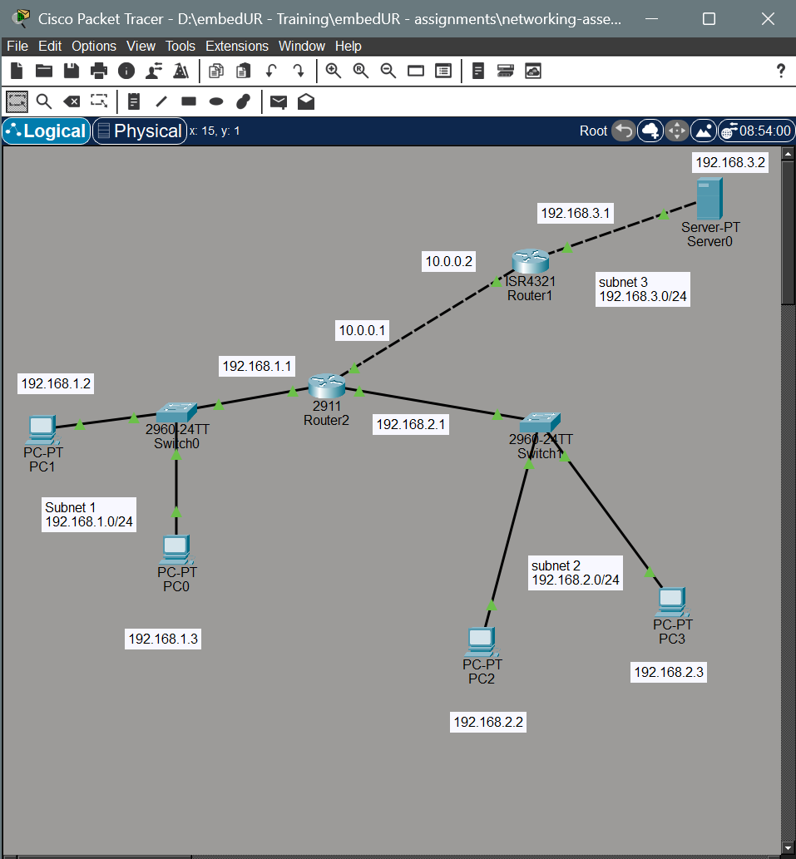
- Now configure the IP and gateway in each PC and router as mentioned in the topology
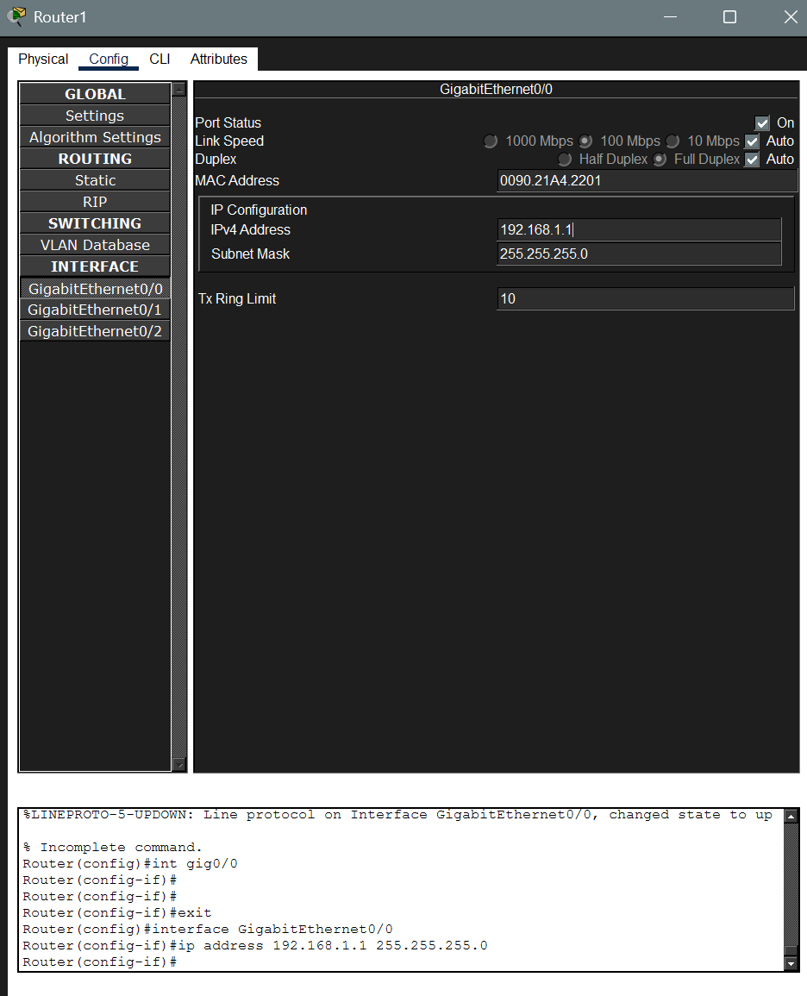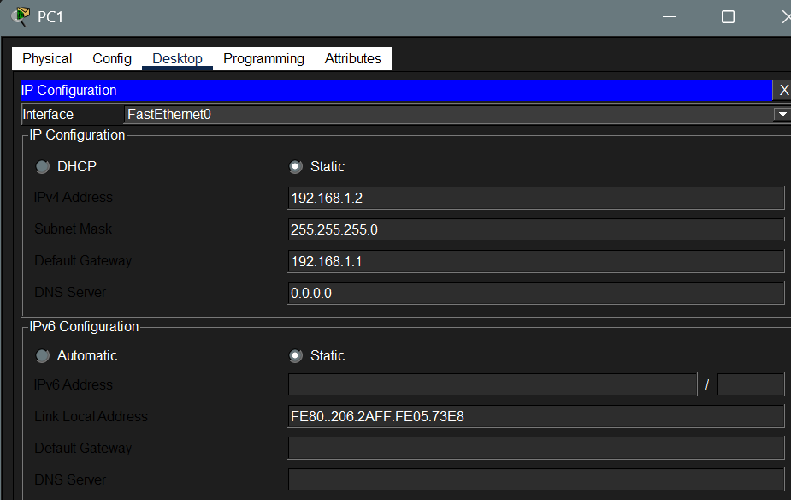

- Now add static routes in each router using the following commands,
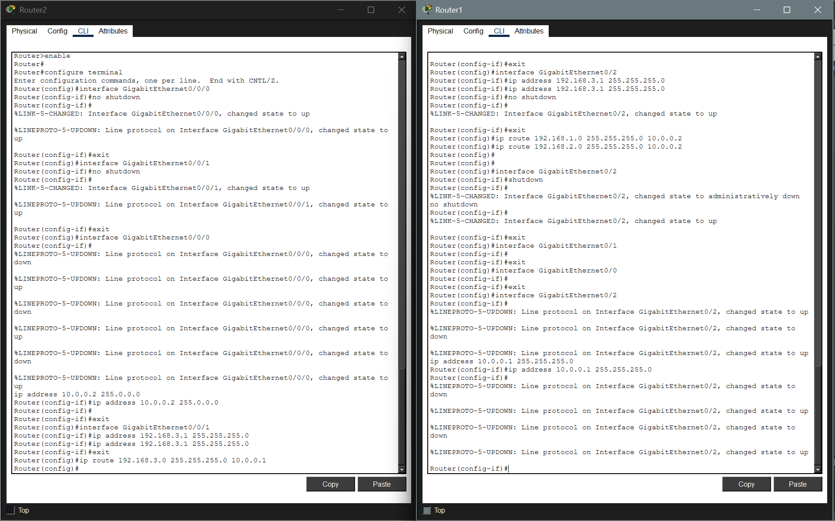
- Now ping the machine in subnet 192.138.3.0/24
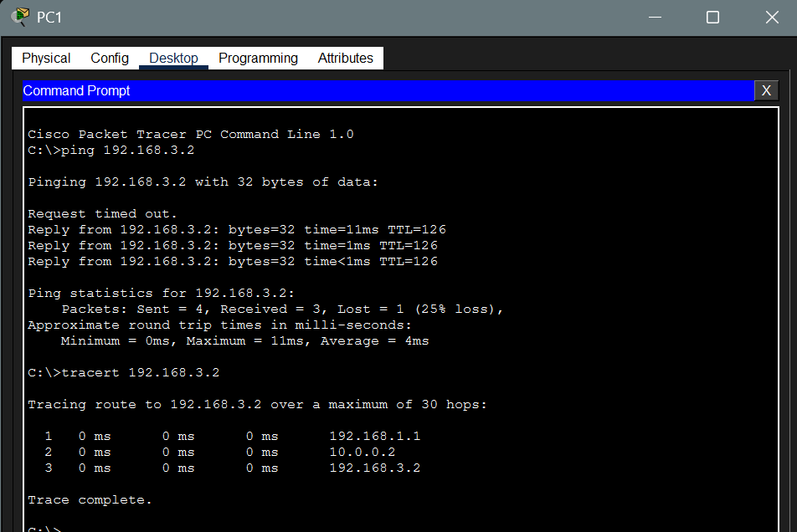

3. Given a network address of 10.0.0.0/24, divide it into 4 equal subnets
- Calculate the new subnet mask.
- Determine the valid host range.
- Assign IP address to devices in Packet Tracer and verify connectivity.

i. Calculate the new Subnet mask:
Current Subnet Mask: Decimal: 255.255.255.0; Binary: 11111111.11111111.11111111.00000000
The no of subnet bits ‘n’ must satisy, 2 ^ n >= no. of required subnets
So we get n => 2
New Subnet Mask: Decimal: 255.255.255.192; Binary: 11111111.11111111.11111111.11000000
ii. Determine the valid host range
Subnet | Network ID | First Usable Host | Last Usable Host | Broadcast Address
1 | 10.0.0.0 | 10.0.0.1 | 10.0.0.62 | 10.0.0.63
2 | 10.0.0.64 | 10.0.0.65 | 10.0.0.126 | 10.0.0.127
3 | 10.0.0.128 | 10.0.0.129 | 10.0.0.190 | 10.0.0.191
4 | 10.0.0.192 | 10.0.0.193 | 10.0.0.254 | 10.0.0.255

iii. Assign IP address to devices in packet tracer and verify the connectivity
I have used the following topology and assigned PC’s IP and gateway accordingly.
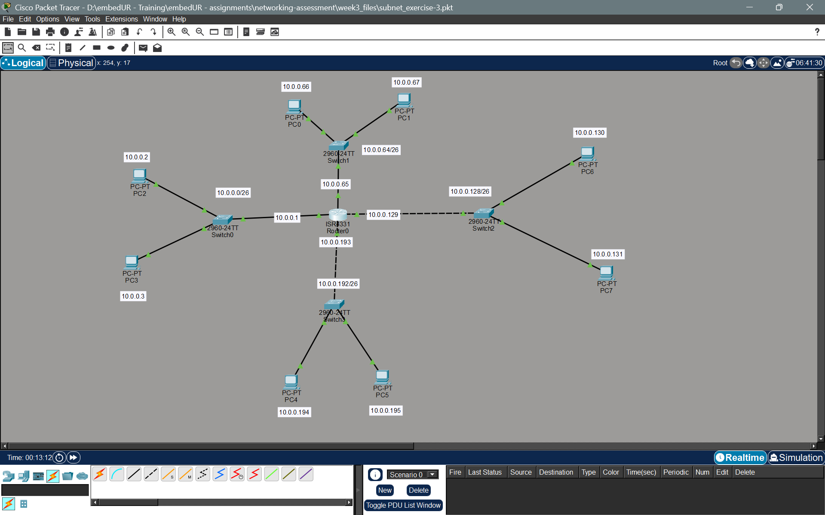
Checking the connectivity
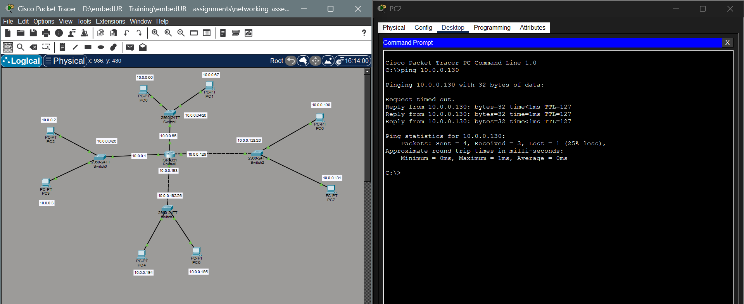

4. You are given three IP addresses: 192.168.10.5, 172.20.15.1 and 8.8.8.8
Identify the class of each IP address
Determine if it is a private or public IP
Explain how NAT would handle a private IP when accessing the internet

The classes of the given IP address and its types are as follow
IP Address | Class | Type | Reason
192.168.10.5 | Class C | Private | Falls within the Class C private range (192.168.0.0 – 192.168.255.255).
172.20.15.1 | Class B | Private | Falls within the Class B private range (172.16.0.0 – 172.31.255.255).
8.8.8.8 | Class A | Public | Falls outside the Class A private range (10.x.x.x) and it is a well known Google DNS IP

How NAT Handles Private IPs
Network Address Translation (NAT) acts as a mediator between a local private network and the public internet. Since private IP addresses are not "routable" on the public internet (meaning internet routers will drop packets coming from them), NAT is required for communication.
Steps Involved:
- Request: When your device (e.g., 192.168.XXX.XXX) sends a request to a website, the packet reaches your router.
- Translation: The router replaces your Private Source IP with its own Public IP address (assigned by your ISP).
- Mapping: The router makes a note in its NAT Table, recording which internal device made the request and which port was used.
- Response: When the website sends data back, it sends it to the router's Public IP. The router looks at its table, sees the request belongs to 192.168.10.5, translates the destination back to your private IP, and forwards the data to you.
Importance:
- It allows hundreds of devices to share a single public IP address (IP conservation).
- It hides the internal IP addresses of your network from the outside world (Security).

5. In CISCO Packet Tracer, configure NAT on a router to allow internal devices (192.168.1.x) to access the internet.
Test the connectivity by pinging an external public IP
Capture the traffic in wireshark and analyze the source IP before and after NAT translation.

To demonstreate the above NAT experiment I have used the following topology.
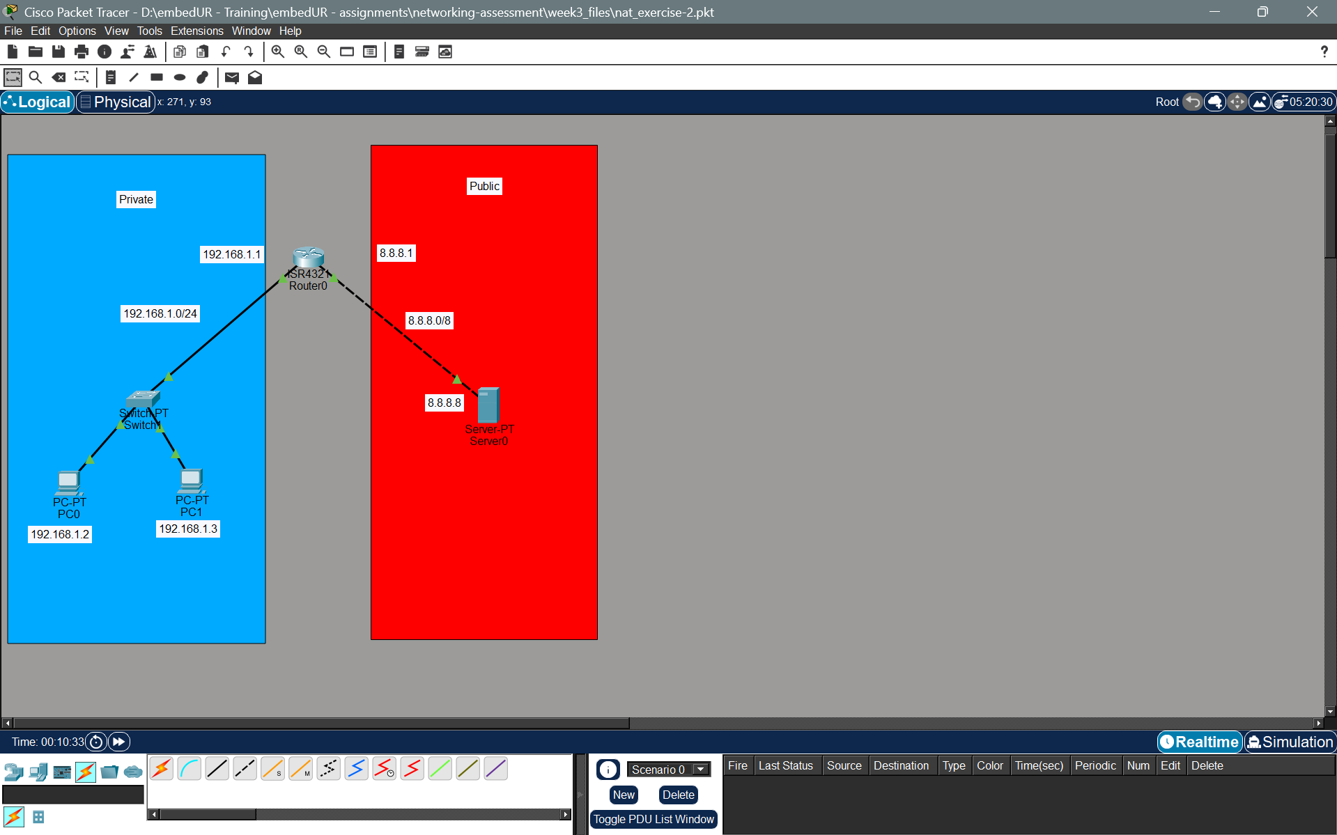
To create a NAT for a set of devices we need to
- Create a Access Control List of IPs allowed
- Create a pool of public IP available for translation
- Bind the IP address (in ACL) and the Pool of public addresses
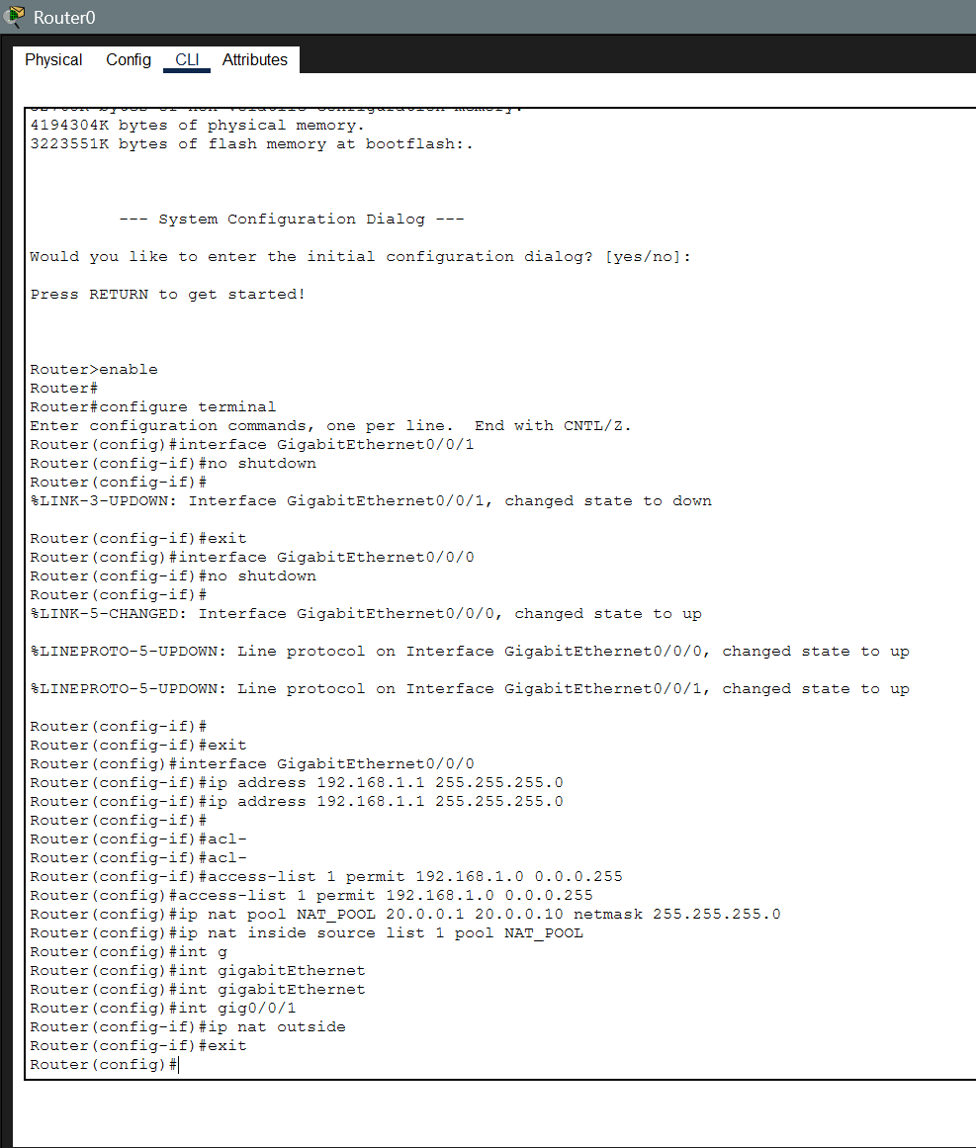
On Simulation mode I get the following packets at each stage
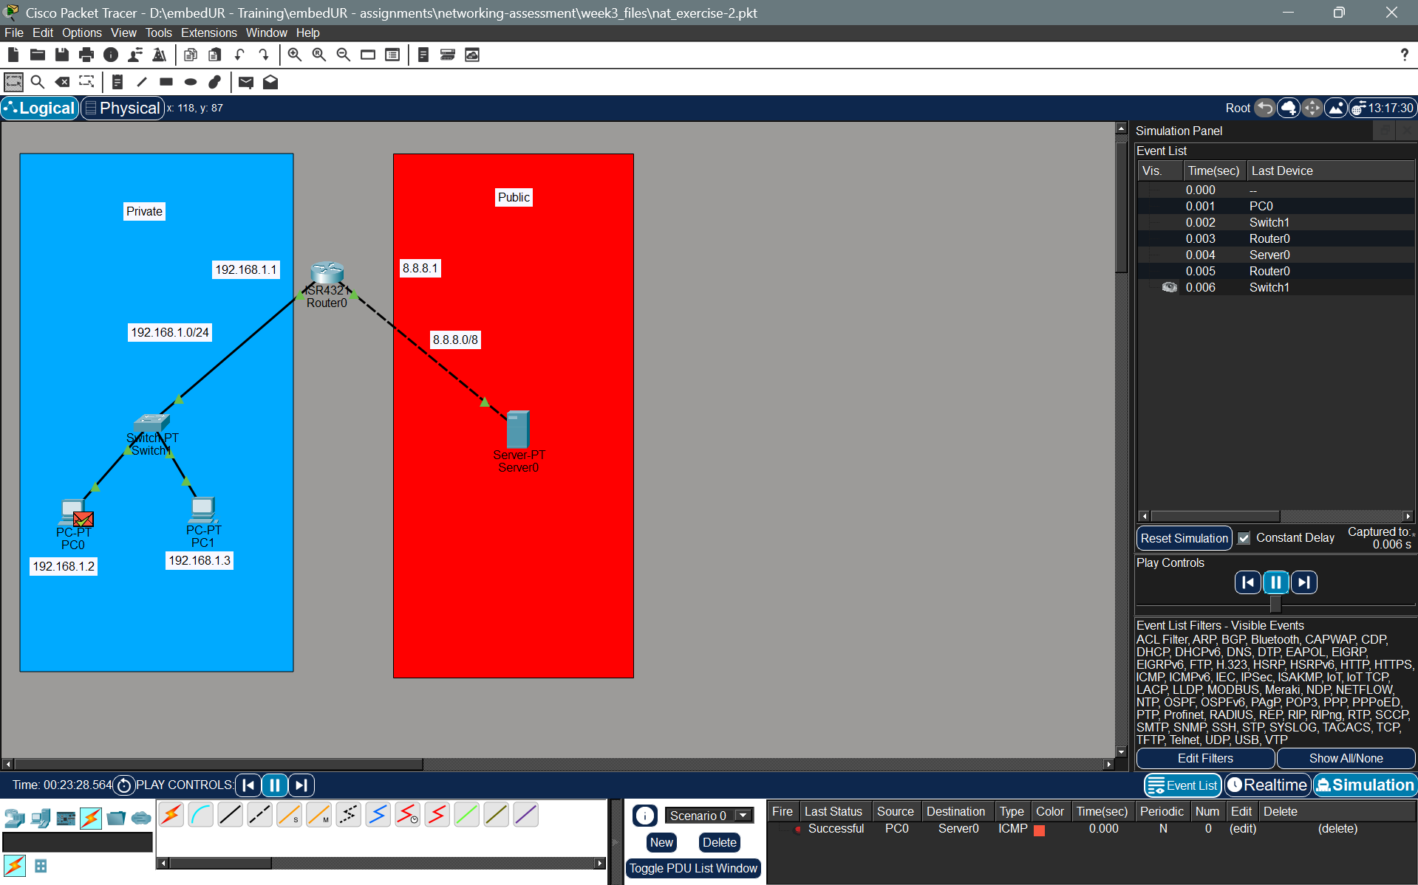
Let us see the packet in the LAN (private) and WAN (public) network.
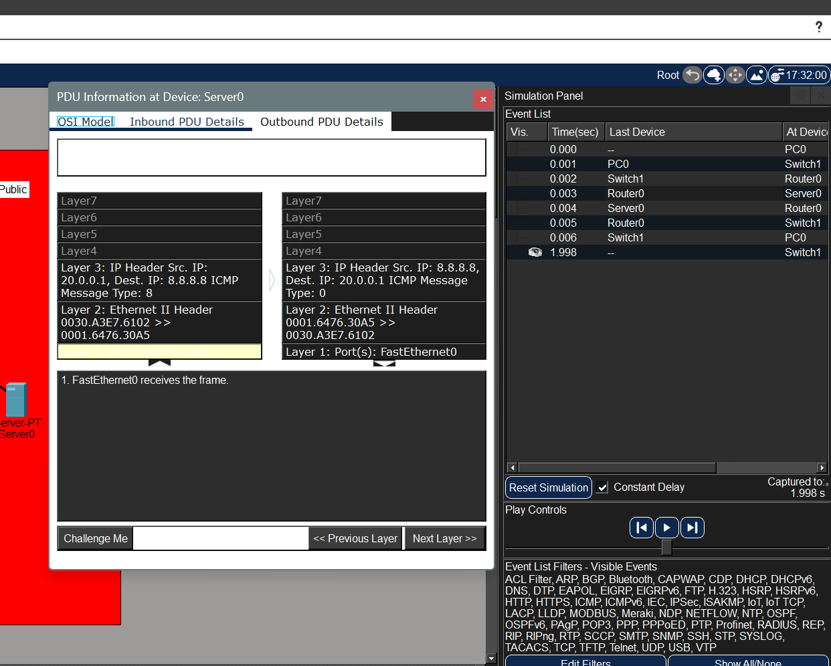
We can see that I have actually pinged from PC0 whose IP is 192.168.1.1 but as we have created a NAT Gateway, the IP sent to the server is 20.0.0.1. We can also see the NAT Table in the router for further confirmation.
