Structured Training Program: Networking
Week 4
Module 7: Layer 3 Session 3 & Module 8: Layer 4 – TCP, UDP, NAT and Firewall

1. Try Test-Connection/Test-NetConnection and nslookup commands for the below websites
www.google.com, www.facebook.com, www.amazon.com, www.github.com, www.cisco.com
Using Test-Connection on the following websites (with different avilable options)
- To check based on port.
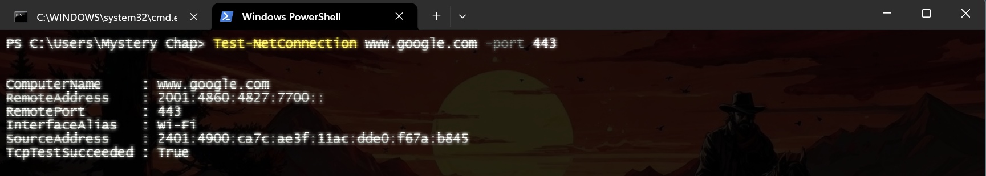
- To check Based on common TCP application layer protocol
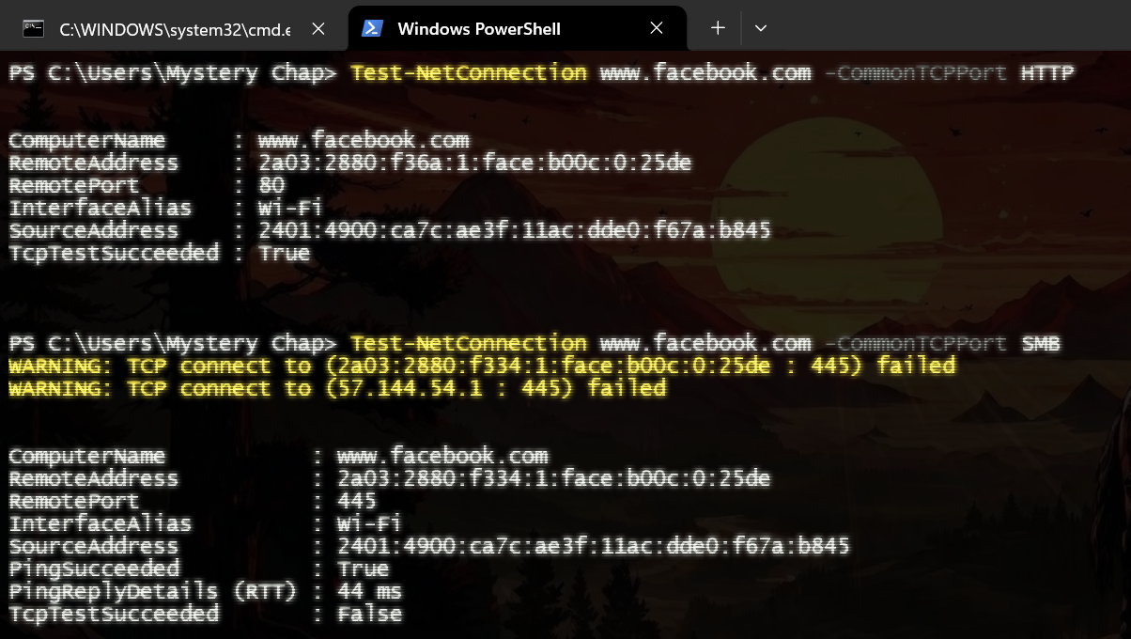
- To check the path it takes to reach from local machine
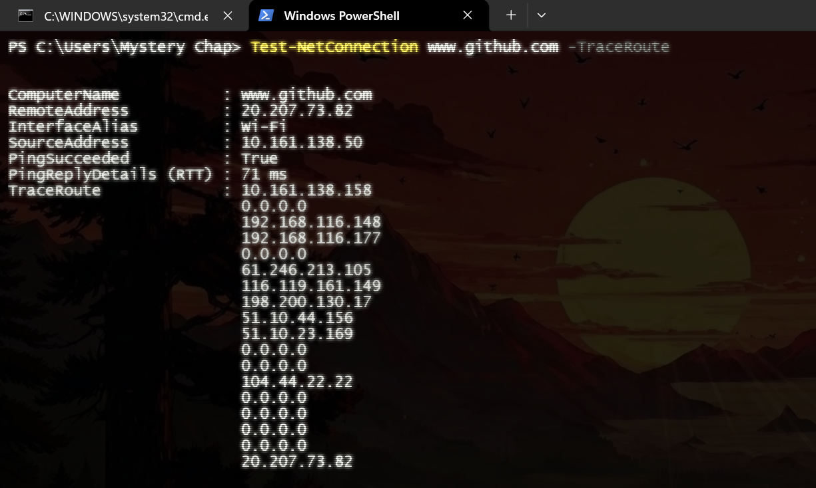

- To control the amount of information shown.
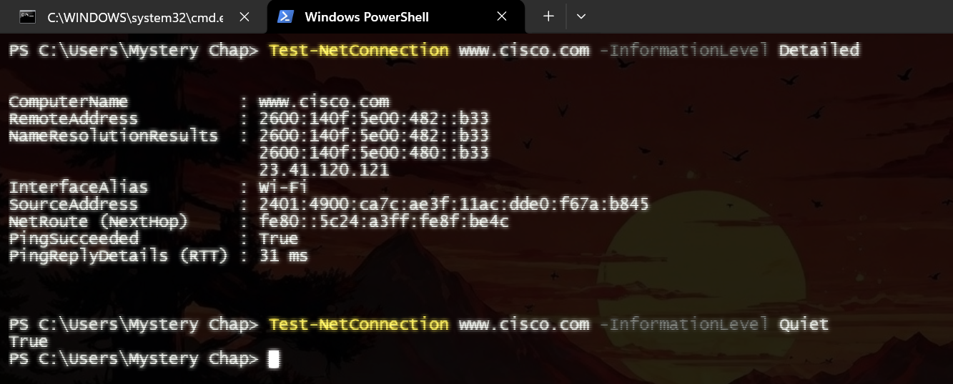

Using nslookup command to on different website
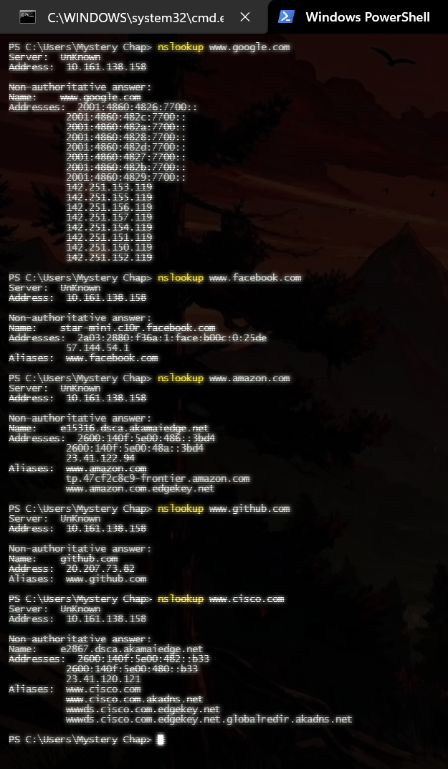

2. Use wireshark to capture and analyze DNS, TCP and UDP traffic and packet headers, packet flow, Options and flags

Analyzing DNS packet:
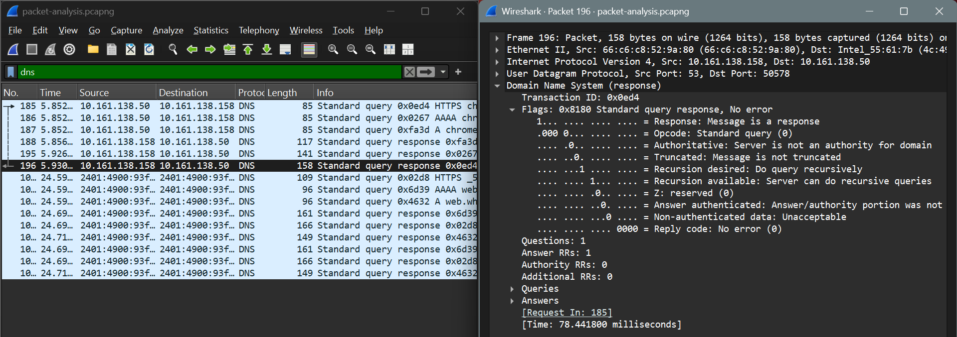
- Packet Header, Option and Flags:
The DNS packet header is of size 12 bytes, consisting of the following,
- Transaction ID (16 bits): A unique 16-bit identifier generated by the client. The server copies this same ID into the response, allowing the client to match the response to a specific query.
- Flags (16 bits): Most critical part contains several components:
  - QR (Query/Response) (1 bit): 0 for query, 1 for response.
  - Opcode (4 bits): Indicates the type of message. 0 for standard query, 1 for inverse query (obsolete), 2 for server status, and 5 for dynamic update.
  - AA (Authoritative Answer) (1 bit): Set to 1 if the responding server is the authority for the domain.
  - TC (Truncated) (1 bit): Set to 1 if the message is longer than 512 bytes (UDP) and was truncated.
  - RD (Recursion Desired) (1 bit): Set by the client to request that the server recursively resolve the query.
  - RA (Recursion Available) (1 bit): Set by the server to indicate whether it supports recursion.
  - Z (Reserved) (3 bits): Reserved for future use; must be 0.
  - RCODE (Return Code) (4 bits): Indicates the status of the response:
0: No Error (Success)
1: Format Error
2: Server Failure
3: Name Error (NXDOMAIN - Domain does not exist)
4: Not supported by server
5: non exection of query by serve rdue to policy reasons
- Number of questions (16 bits) – Specify the no. of questions in the question section
- Number of answer RRs (16 bits) – Specify the no. of answers in the answer section
- Number of authority RRs (16 bits) – Has a value of zero in request/query message and available only in response message. Gives info about no. of authoritative servers a doamin name has.
- Number of additional RRs (16 bits) – Tells about the additional information that helps the resolver. Has a value of zero in request/query message and available only in response message
The things above this comprise the header.
- Question: This section contains the actual question being asked to the DNS server.
- Answer: This section contains the official response to the query, if available.
- Authority: This section provides information about which DNS servers are authoritative (official owners) for the domain
- Additional: This section provides extra information that is not directly requested but is related to the answer or authority sections.
- DNS Packet Flow:
A DNS packet flow involves a client (browser) sending a UDP port 53 query to a recursive resolver, which then queries root, TLD, and authoritative servers to map a domain name to an IP address. The response travels back through these servers, usually being cached for future requests
  - User Request: The user types a domain (e.g., example.com) into the browser.
  - Recursive Query: The browser sends a DNS query packet (UDP, port 53) to the recursive resolver (often provided by the ISP).
  - Root Server Query: The resolver queries a DNS root nameserver.
  - TLD Server Query: The root server directs the resolver to a Top-Level Domain (TLD) server (e.g., .com).
  - Authoritative Server Query: The TLD server directs the resolver to the authoritative nameserver for example.com.
  - Answer Retrieval: The authoritative server returns the IP address to the resolver.
  - Final Response: The resolver sends the IP address back to the browser.
Observation on DNS:
  - Used UDP and port 53 for communication.
  - Since UDP is used the order of the packet is not preserved
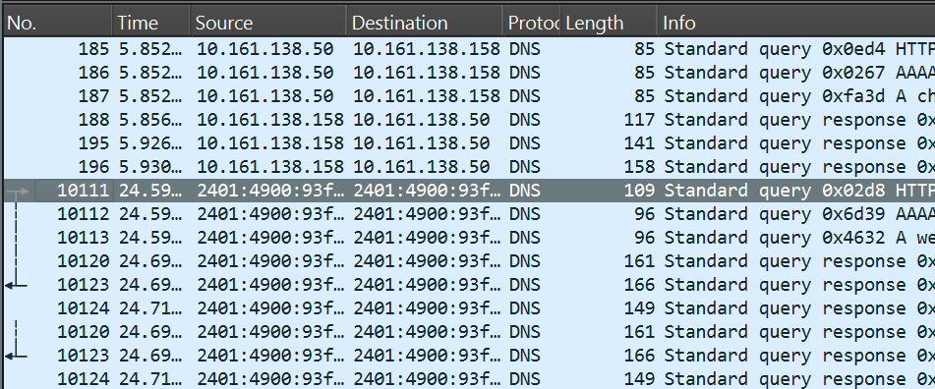

Analysing TCP packets:
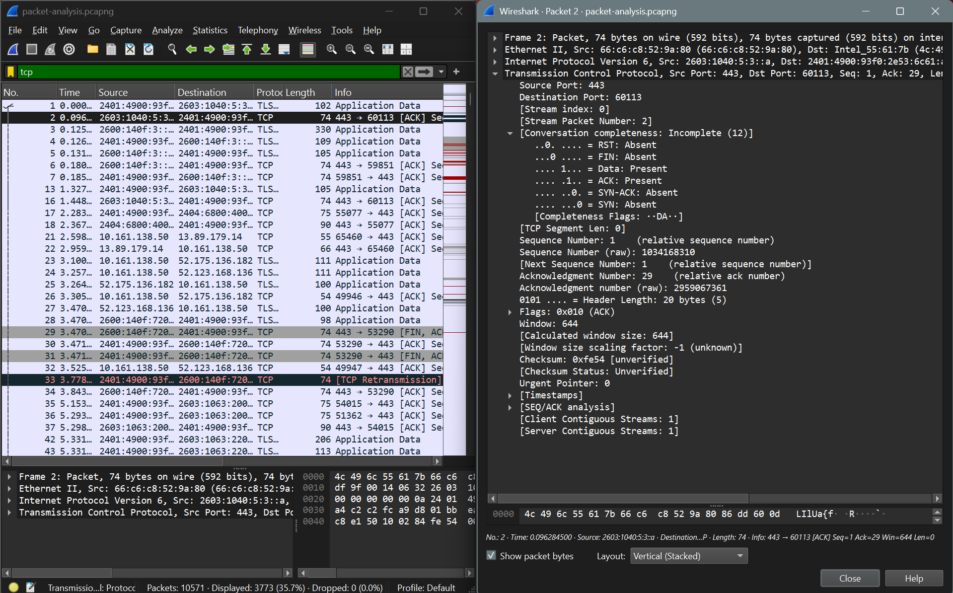
1. Packet Header, Options and Flag
The TCP packet header is of TCP header is 20 bytes minimum and can grow up to 60 bytes with options,consisting of,
a) Source Port (16 bits): The port number of the application on the sending device (e.g., a random high port like 51234 on your browser).
b) Destination Port (16 bits): The port number of the service on the receiving device (e.g., Port 80 for HTTP or 443 for HTTPS).
c) Sequence Number (32 bits): This is the "ID card" for each byte of data. It ensures that if packets arrive out of order, the receiver can reassemble them correctly. In a SYN packet, this is the Initial Sequence Number (ISN).
d) Acknowledgment Number (32 bits): Used only if the ACK flag is set. It tells the sender: "I have received everything up to byte X, and I am now expecting byte X+1."
e) Data Offset (4 bits): Specifies the size of the TCP header in 32-bit words. This is necessary because the Options field makes the header length variable.
f) Reserved (3 bits): Always set to 0. Reserved for future use (similar to the Z flag in DNS).
g) Flags (9 bits - The "Control" Bits): These are the most critical bits for managing the connection:
- NS/CWR/ECE (3 bits): Used for Congestion Notification (managing network traffic jams).
- URG (1 bit): Urgent pointer field setto know how important the data is.
- ACK (1 bit): Acknowledgment. Set in almost every packet after the first SYN.
- PSH (1 bit): Push. Tells the receiver to send the data to the app immediately, don't wait for the buffer to fill.
- RST (1 bit): Reset. Forcibly kills the connection due to an error.
- SYN (1 bit): Synchronize. Used to initiate a 3-way handshake.
- FIN (1 bit): Finish. Used to gracefully close a connection.
h) Window Size (16 bits): Used for Flow Control. The receiver uses this to say: "I can only handle X more bytes of data right now—don't send more than that!"
i) Checksum (16 bits): Used for error-checking the header and the data to ensure nothing was corrupted during transit.
2. TCP Packet Flow:
a) During session establishment
Before data can move, the two devices must agree on sequence numbers and capabilities (like Window Size). This is a three-step process:
- SYN (Synchronize): The client sends a packet with the SYN flag set and a random Initial Sequence Number (ISN)
- SYN-ACK (Synchronize-Acknowledgement): The server responds with both SYN and ACK flags set. It generates its own ISN (e.g., Seq=500) and sets the Acknowledgment number to the client's ISN + 1 (Ack=101).
- ACK: The client sends a final packet with the ACK flag set. It increments its sequence number (Seq=101) and sets the Acknowledgment to the server's ISN + 1 (Ack=501).
b) During session termination
Closing a connection is more complex because TCP is full-duplex. This means the Client can be finished sending data while the Server still has a few more bytes to "flush" out. Therefore, each side must close its half of the connection independently.
- FIN (Finish by client): The client sends a packet with FIN flag set.
- ACK (Acknowledgement): The server sends the ack that it received the FIN packet [CLOSE_WAIT].
- Fin (Finish by server): The server sends a packet with FIN flag set
- ACK (Acknowledgement): The client sends a final ACK [TIME_WAIT]

Analyzing UDP Packets
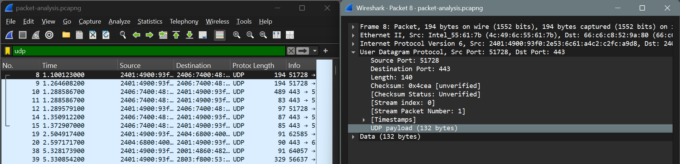
Packet Header, Options and Flags
The User Datagram Protocol header is very small (8 bytes) and has only 4 fields:
- Source Port (2 bytes) → Sender’s port number
- Destination Port (2 bytes) → Receiver’s port number
- Length (2 bytes) → Total length of UDP (header + data)
- Checksum (2 bytes) → Error detection (optional in IPv4, mandatory in IPv6)
The UDP packets doesn’t have an option field or a flag field as it is designed to be simple and fast with less overhead.
The UDP protocol doesn’t have any mechanism to ensure the packet delivery or any flow that needed to be followed except the TCP/IP stack.

3. Explore tracert/traceroute to websites and analyse the parameters in the output and explore different options for traceroute command
- Using Simple tracert with no flag
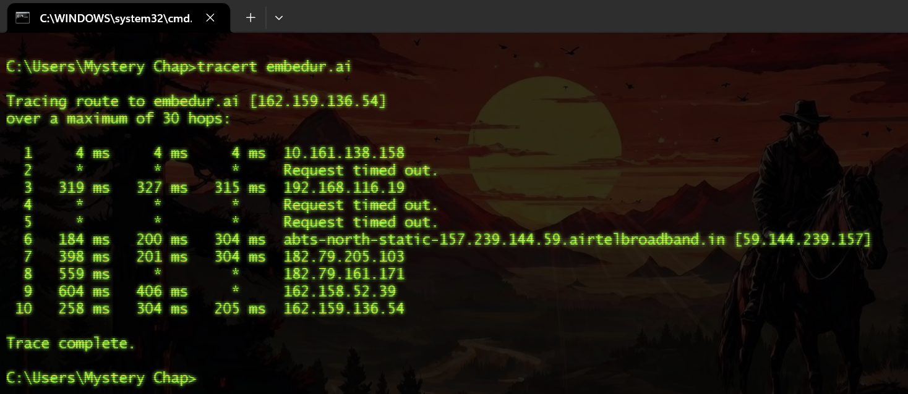

- Using tracert with -d flag => Prevents IP address resolution speeding up the process.
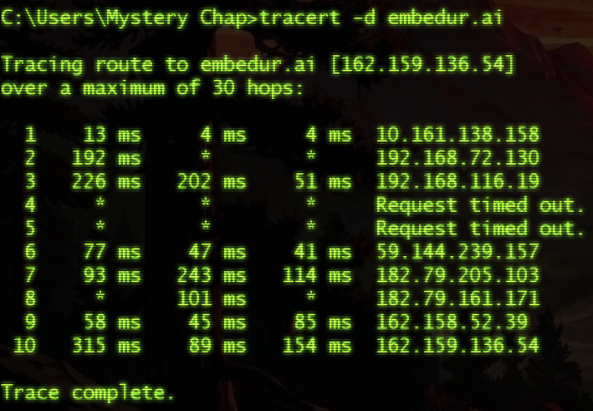
- Enforcing to use IPv4 only
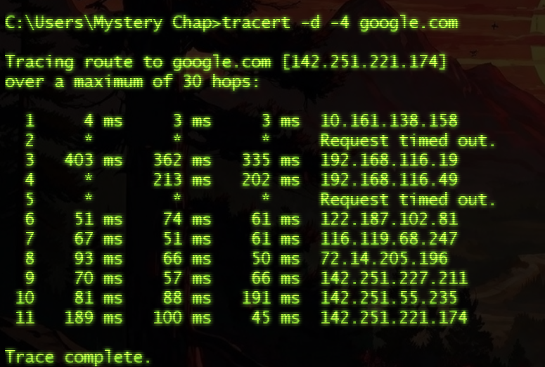
- Enforcing to use IPv6 only
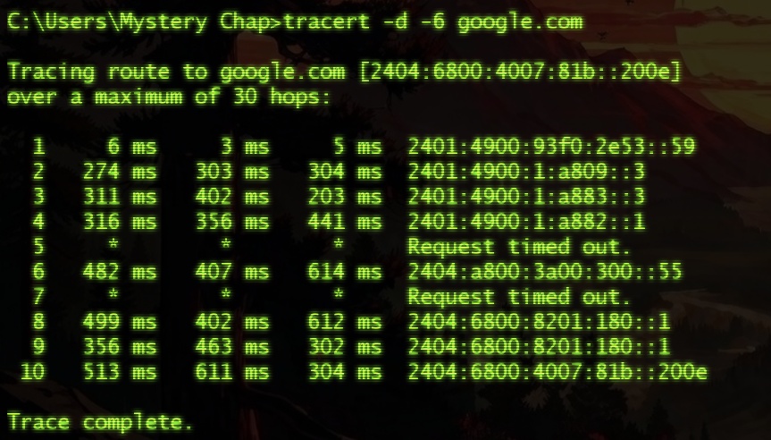
Similar to this there are many other flags. Such as specify max hops, trace RTT and timeout. The common symbols in tracert are,
a) * * * (Request Time Out): The packet did not return within the timeout period, often due to firewalls or high load.
b) !A: Administratively prohibited (blocked).
c) !N: Network unreachable.
d) !P: Protocol unreachable.

5) Set up a trunk port between switches and try ping between different VLANs
a) For experiment I have created the following topology,
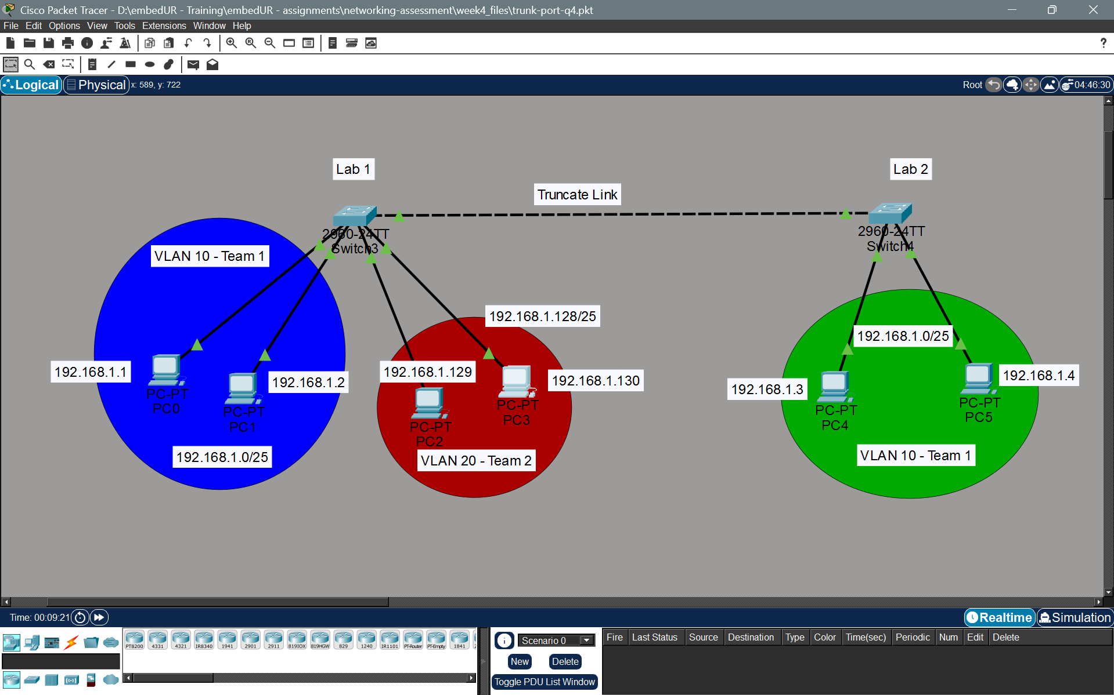
b) Create VLANs in the respective switches.
Switch 3
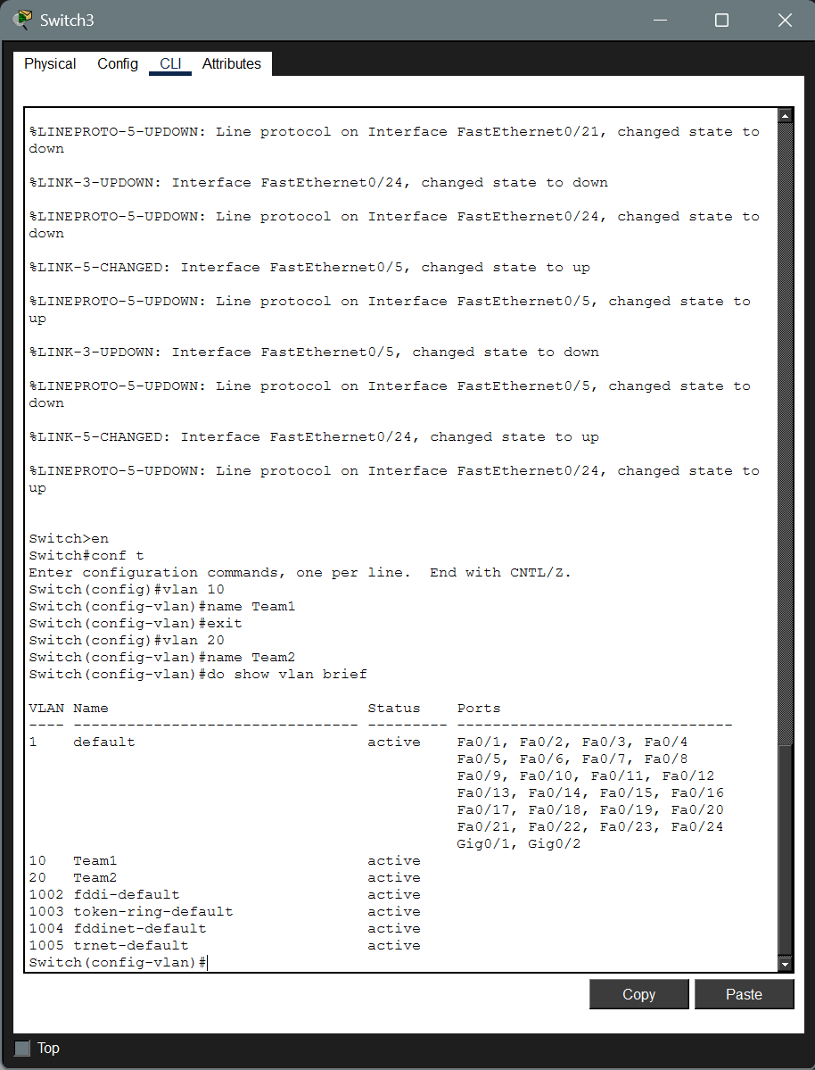
Switch 4:
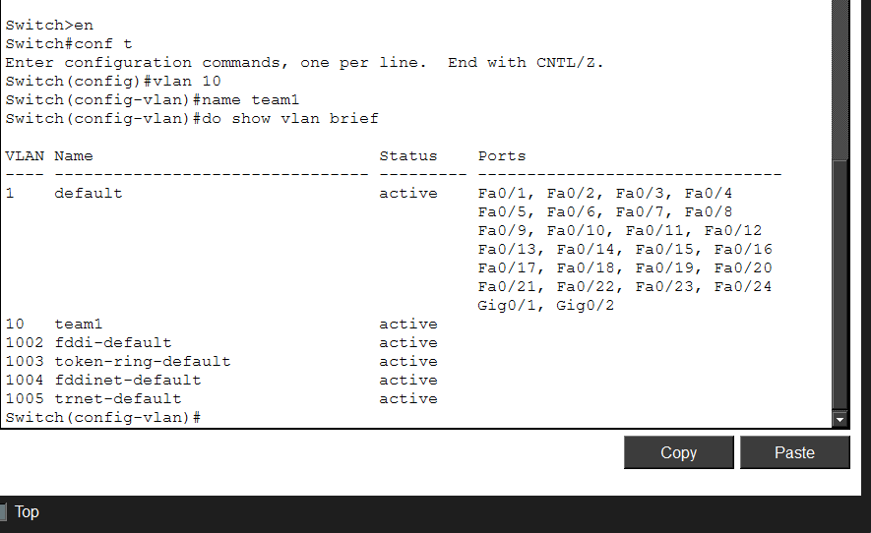
c) Configure the VLAN to the ports (access VLAN)
Switch 3:
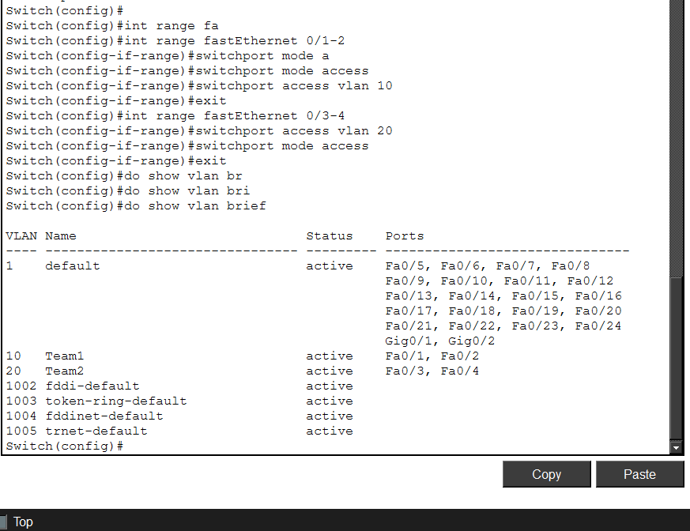
Switch 4:
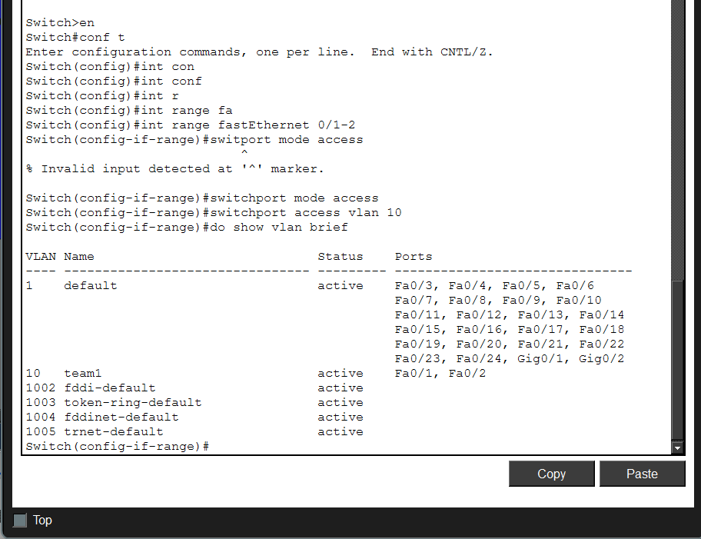
d) Now enable truncate port on the switches
Switch 3:
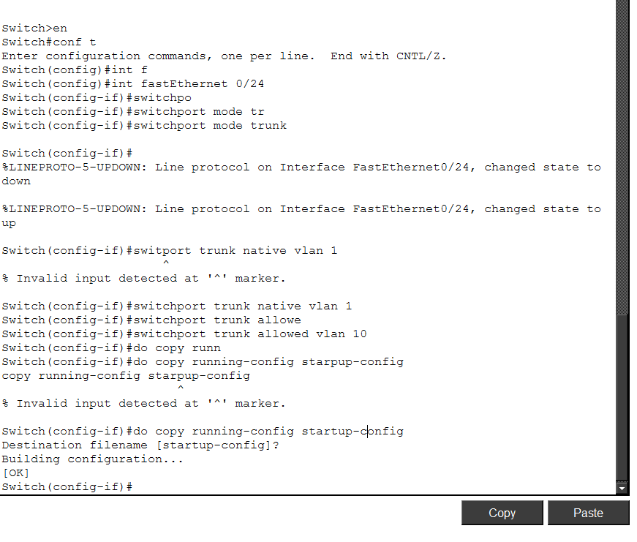
Switch 4:
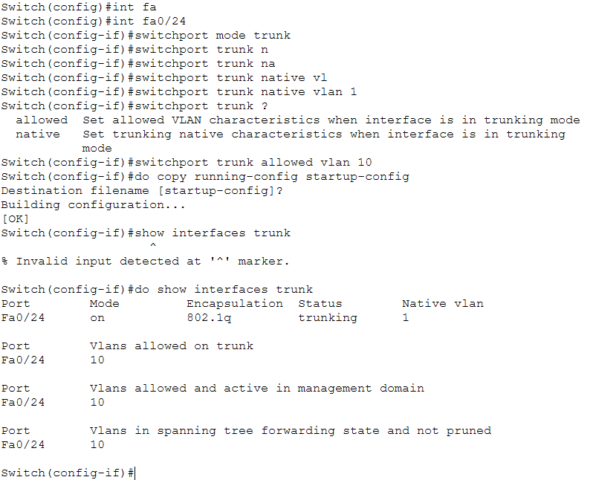
e) Configure the IP address in each system.
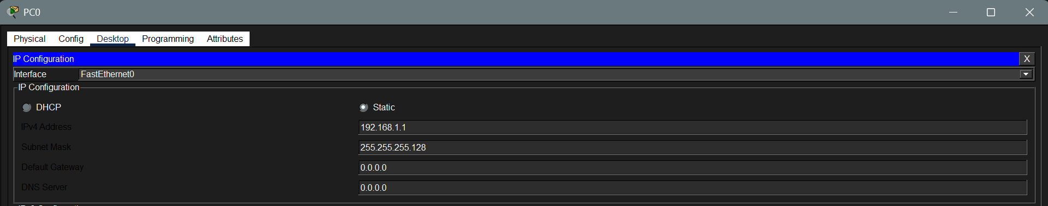

f) Now let us ping and test whether the system allows the traffic from VLAN 10 in Switch 3 to VLAN 10 in switch 4.
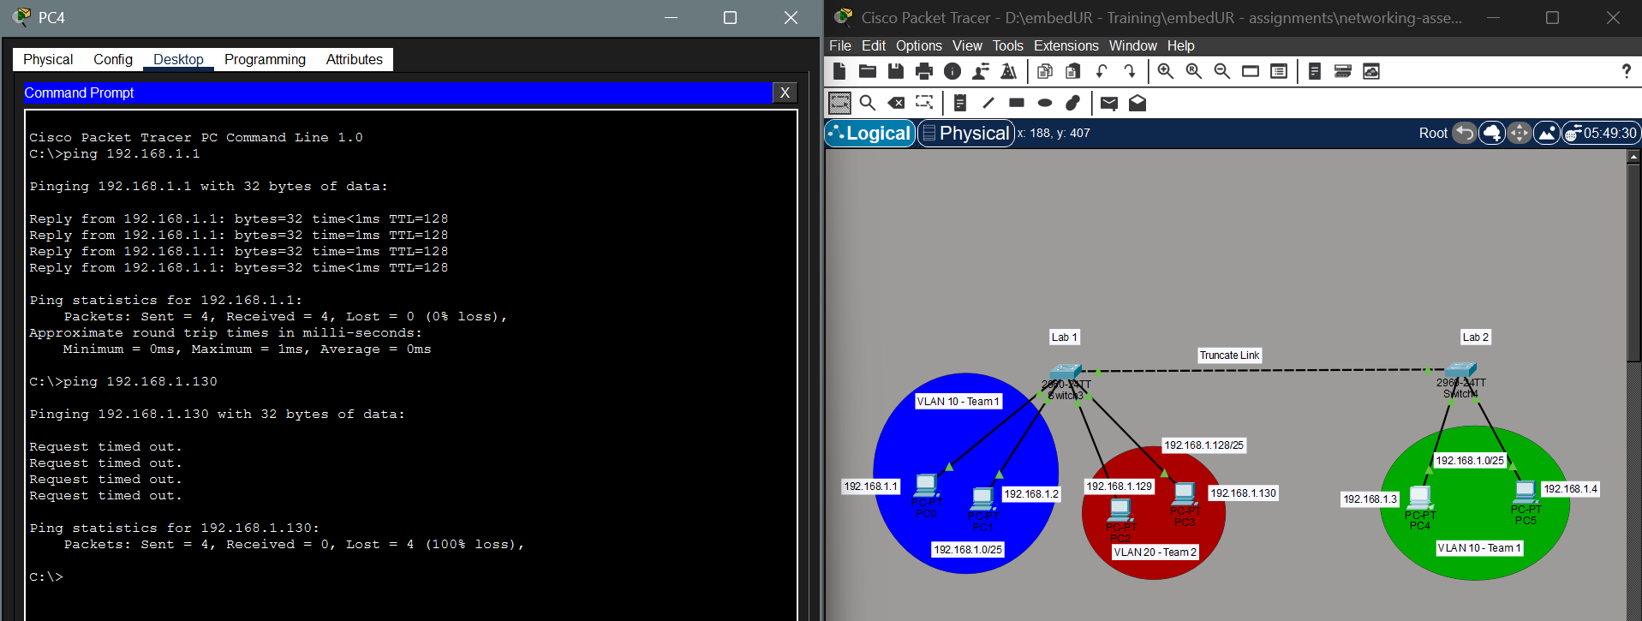
We can see that traffic from VLAN 10 – Switch 3 reaches the traffic from VLAN 10 – Switch 4. But the VLAN 20 didn’t get any traffic from VLAN 10 from switch 4.

6) Change the native VLAN on the trunk port. Test the VLAN mismatch and troubleshoot.
a) I have used the following Topology for this experiment.
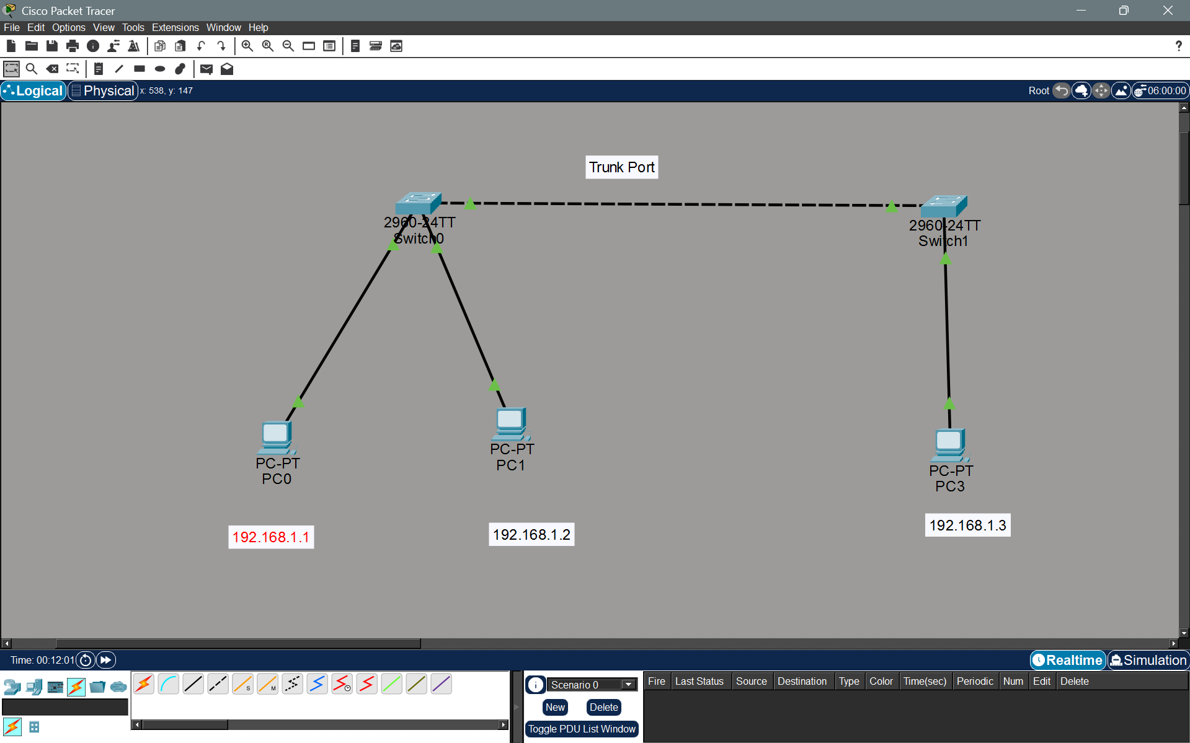

b) Configure the Trunk Port
Switch 0:
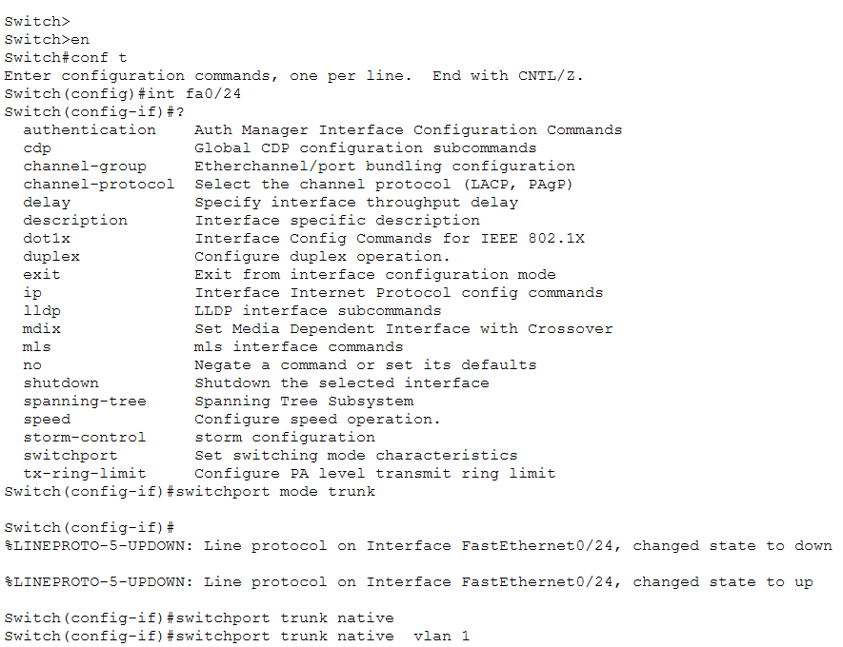
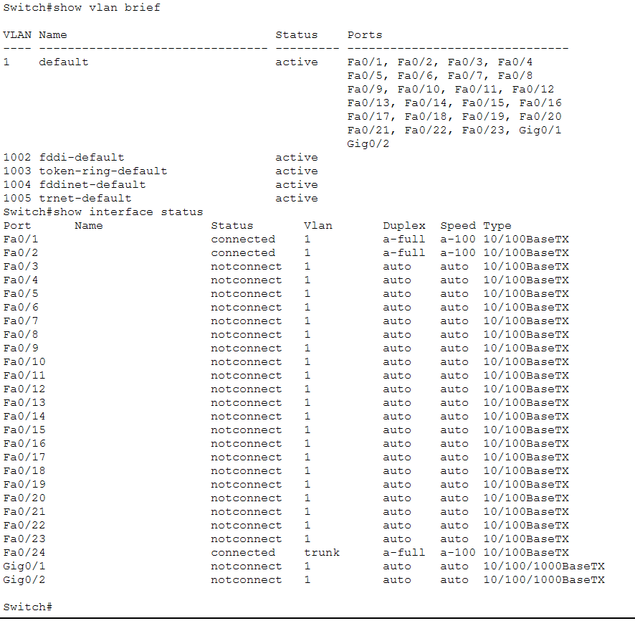
Similarly configure in switch 1 also

c) Now let us configure the IP to each system and check it works on Native VLAN 1 by default.
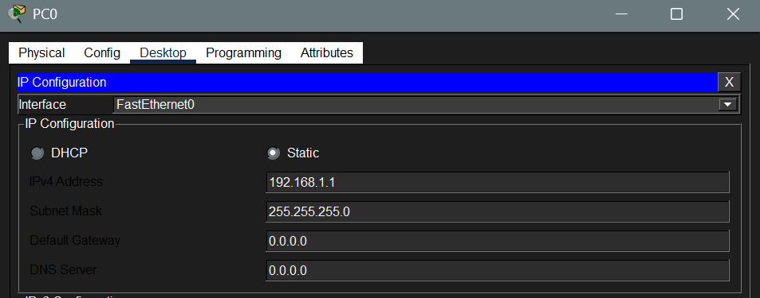
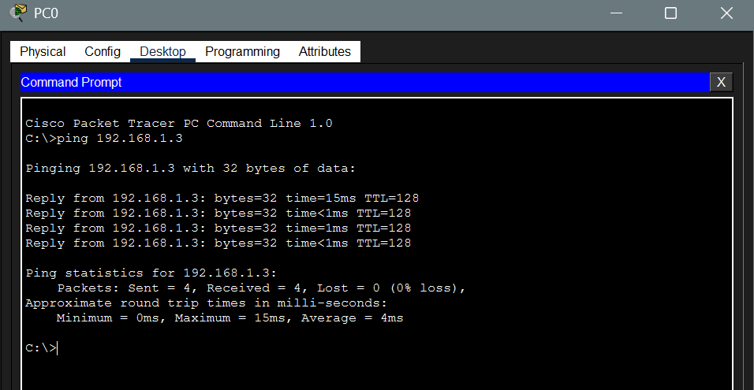
Ping works perfectly before changing the native VLAN 1.
e) No let us change the Native VLAN from 1 to another VLAN (VLAN 2 in my experiment)
Switch 0:
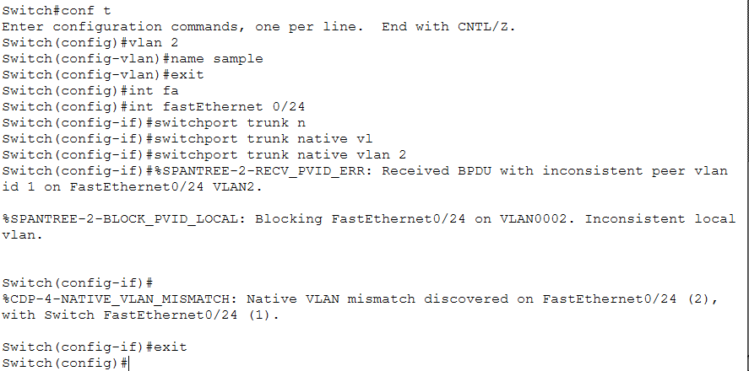

As soon as configured, we get the following warning, by which itself we can say there is a mismatch.
f) Now let us ping the Switch 1 system with this new configuration. This shows the packet didn’t transfer due to mismatch.
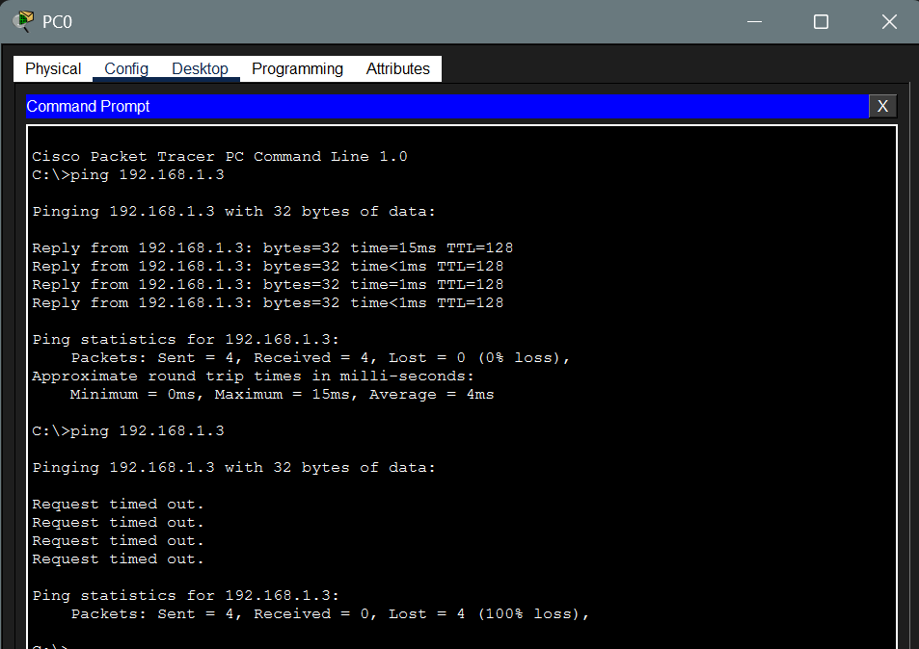
g) To troubleshoot the mismatch, we
i) Look for error message in console
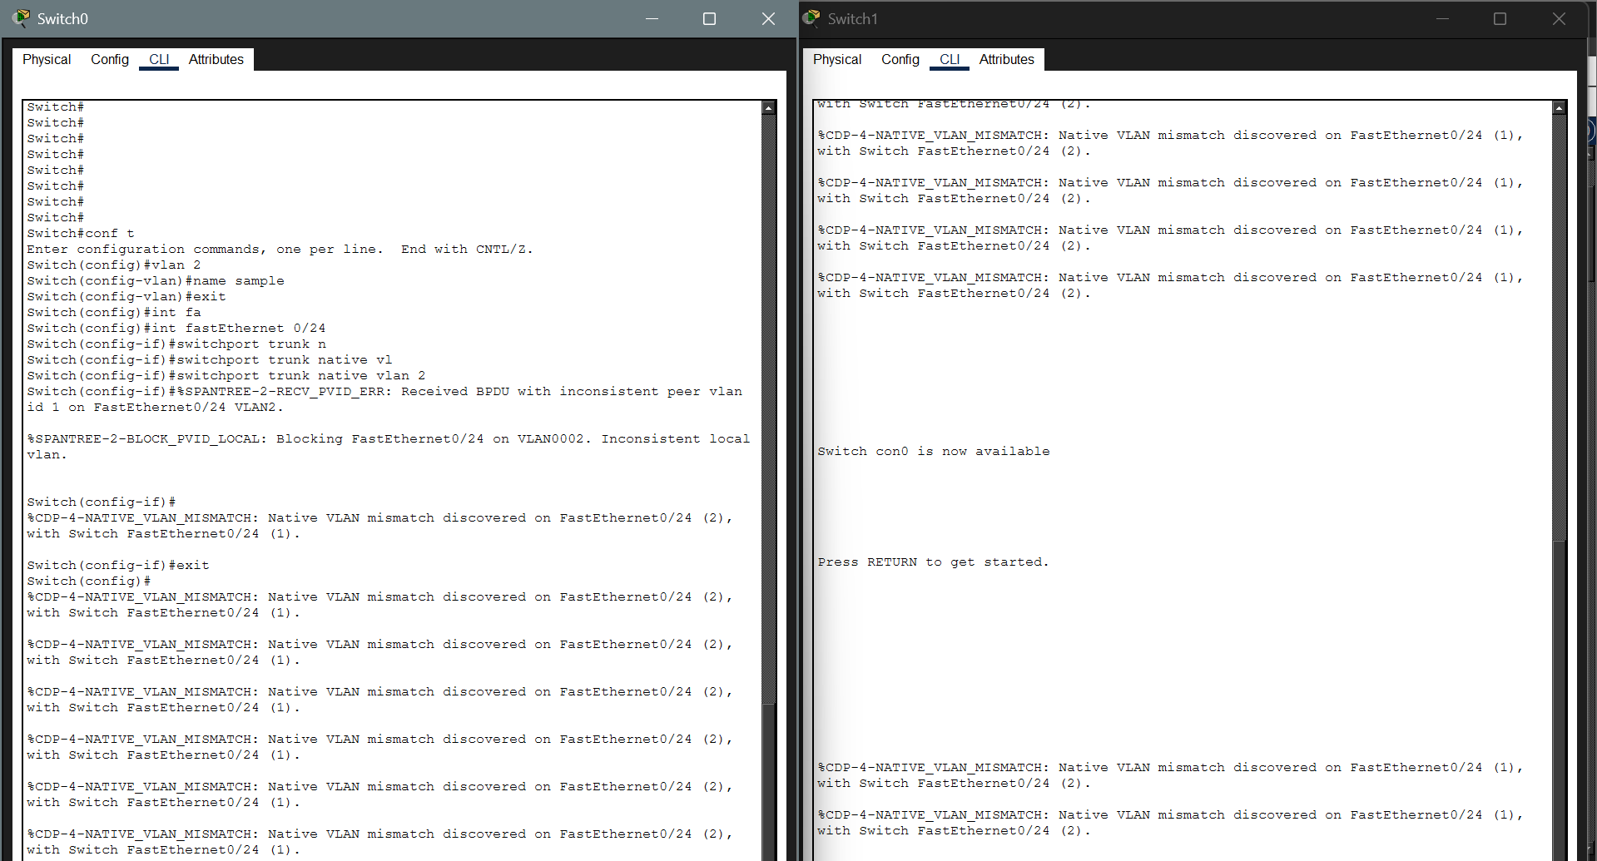
ii) Run show interface trunk to see conf detail in both switch
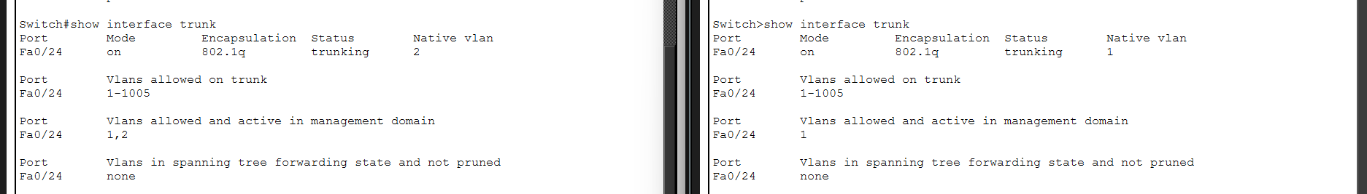
We can see there is a mismatch in VLAN IDs. Now we can correct it easily.

In switch 0, go to trunk interface, run switchport trunk native vlan 1
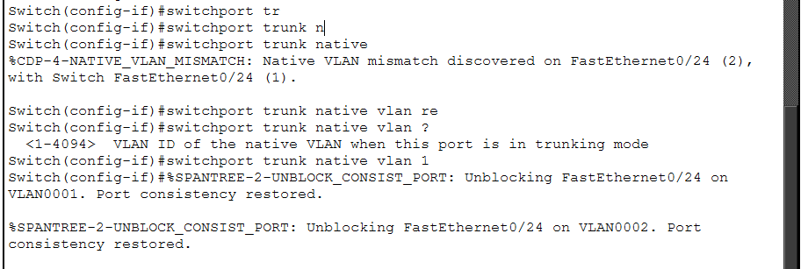
Now the connection is restored successfully.
7. Configure a management VLAN and assign an IP address for remote access. Test SSH or Telnet access to switch
I have used the below topology for the experiment
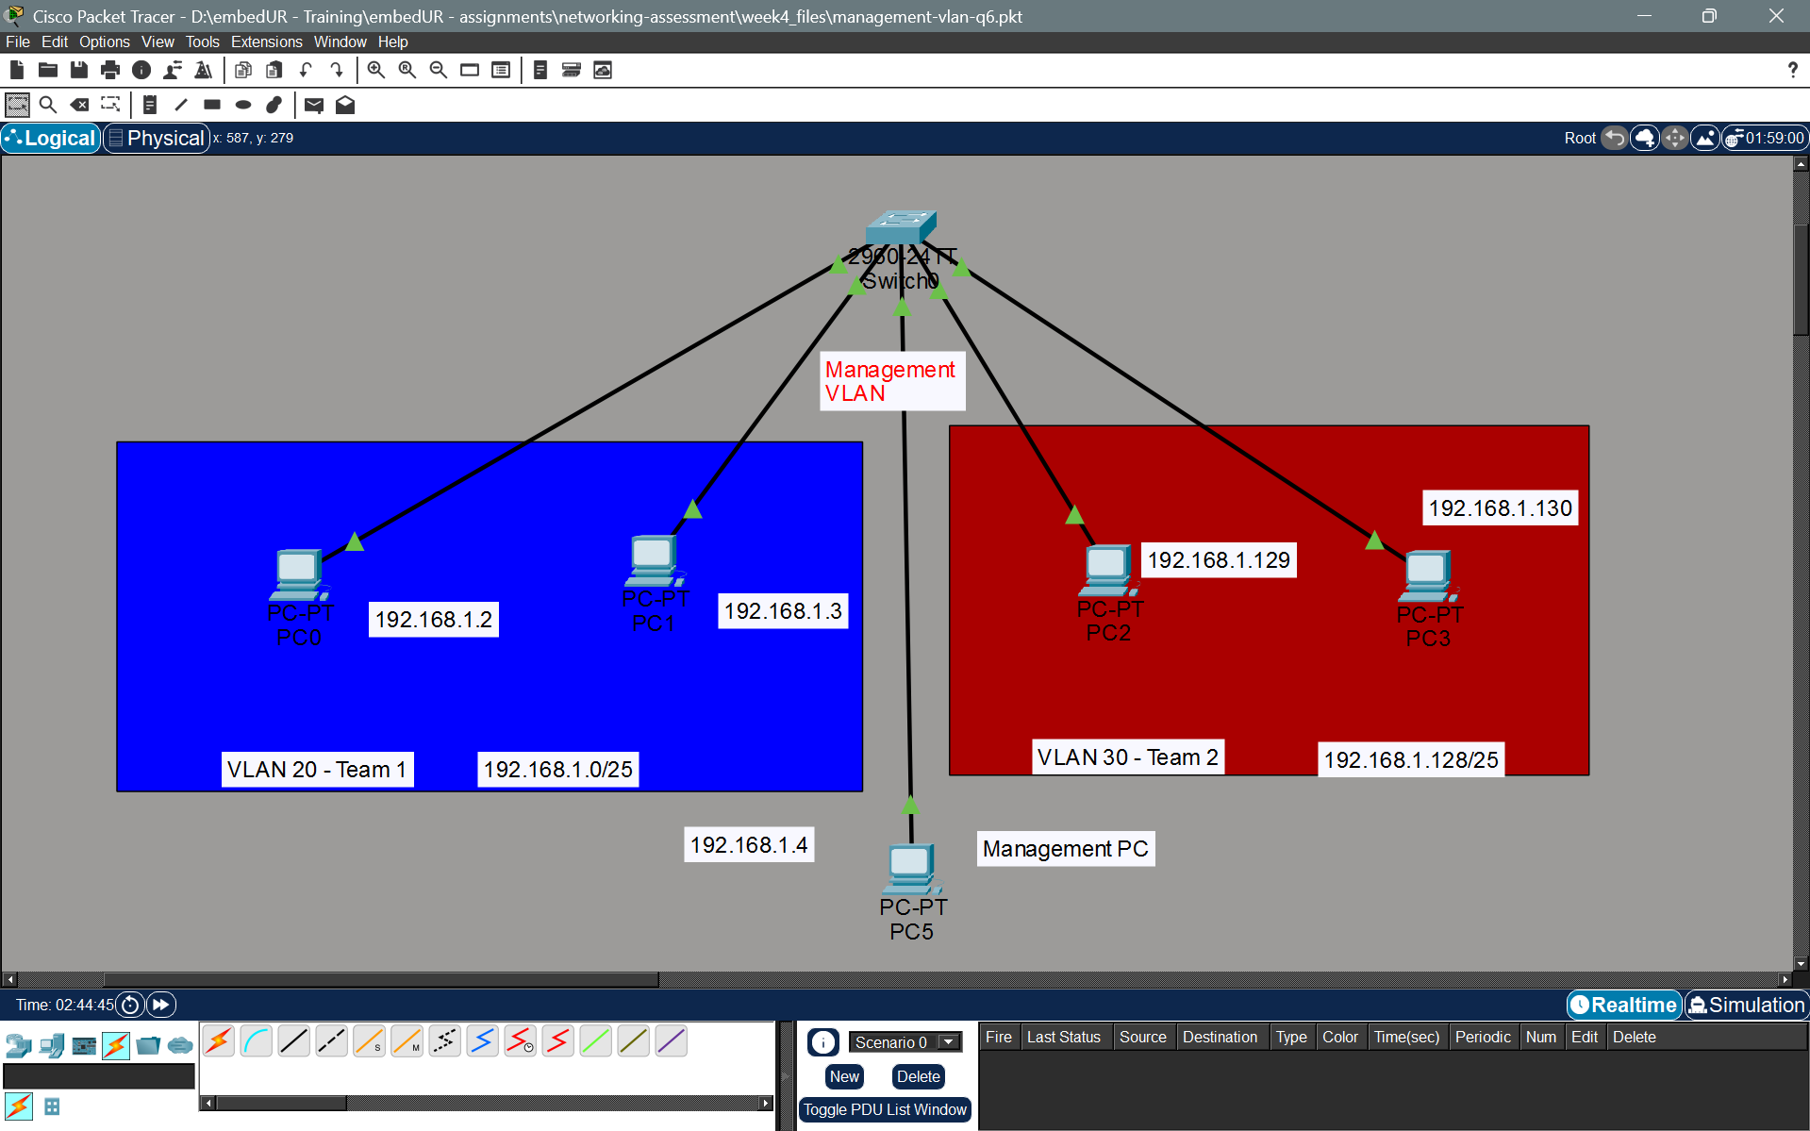
a) Create the VLANs in the switch 0
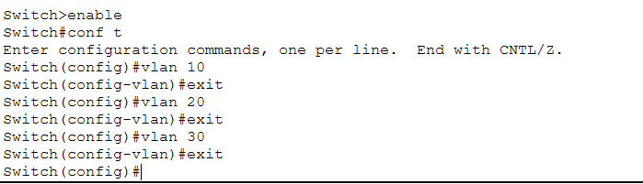

b) Assign the systems connected to the respective interfaces to the respective vlan
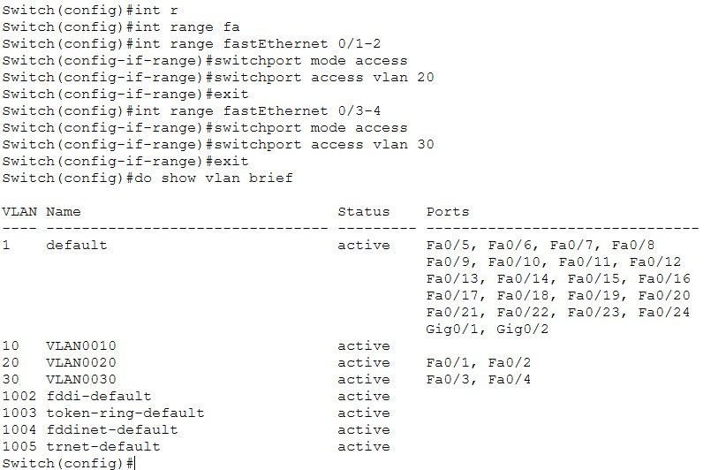
c) Configure management VLAN with IP using SVI
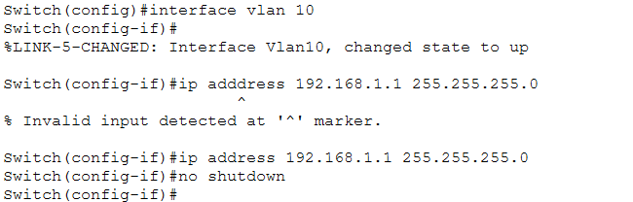
d) Assign an interface for Management VLAN 10 else it will be down.
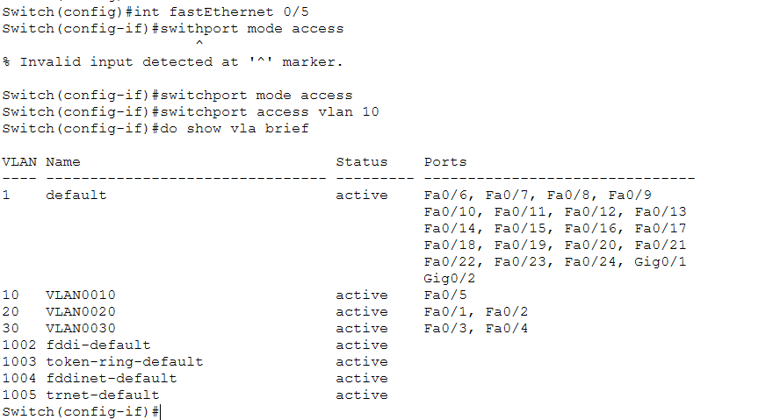

e) Configure SSH / TELNET service in the switch
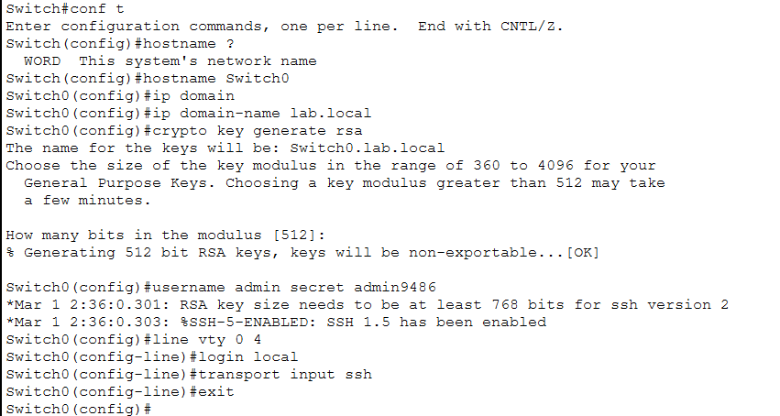
f) Now connect a PC to the port assigned for the management VLAN assign it an IP and use it access the management VLAN
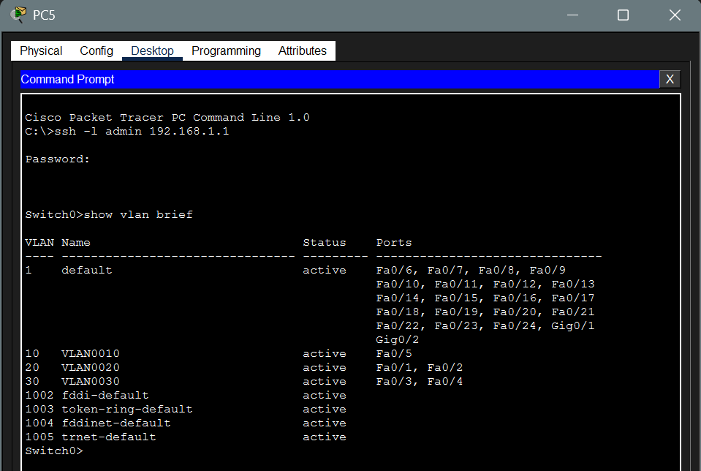
8. You have a CISCO switch and a VoIP phone that need to be placed in a voice VLAN (VLAN 20). The data for the PC should remain in a separate VLAN (VLAN 10). Configure the switch port to support both voice and data traffic
a) Create a topology with a CISCO VoIP phone (for voice VLAN) and PC (for data VLAN) through switch.
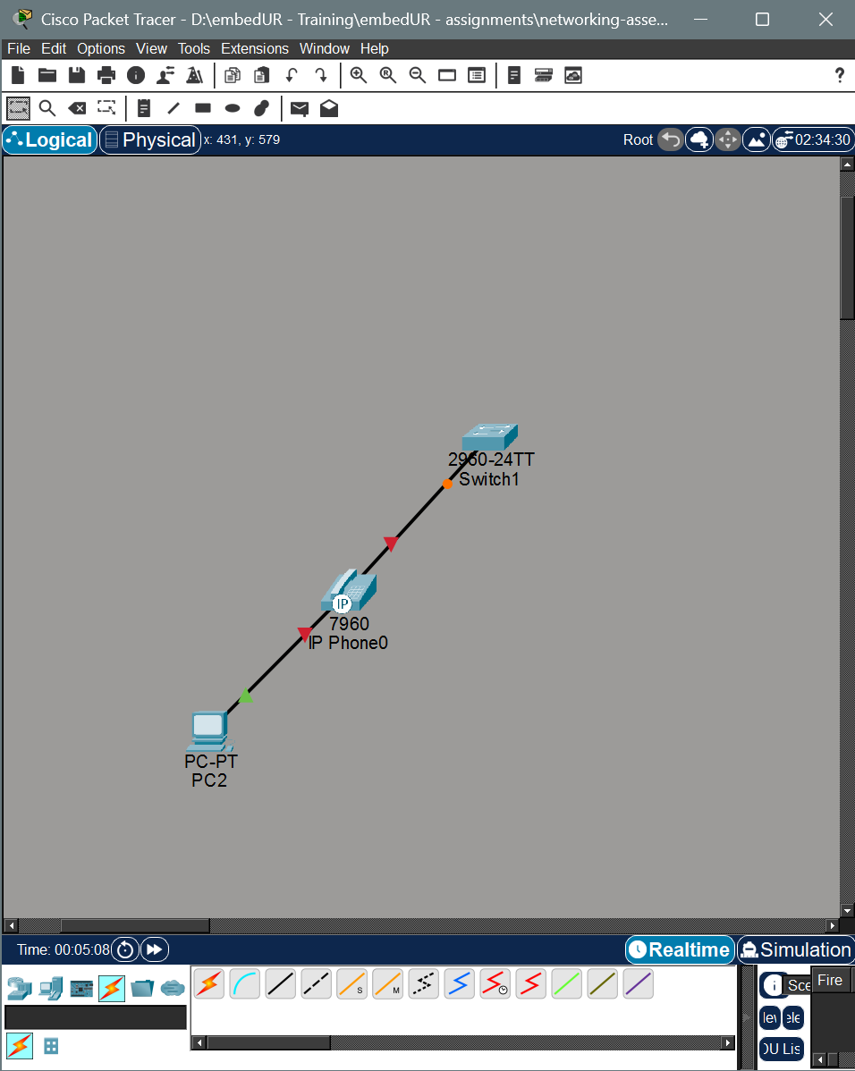

b) Now create and configure the VLAN for Voice and data.
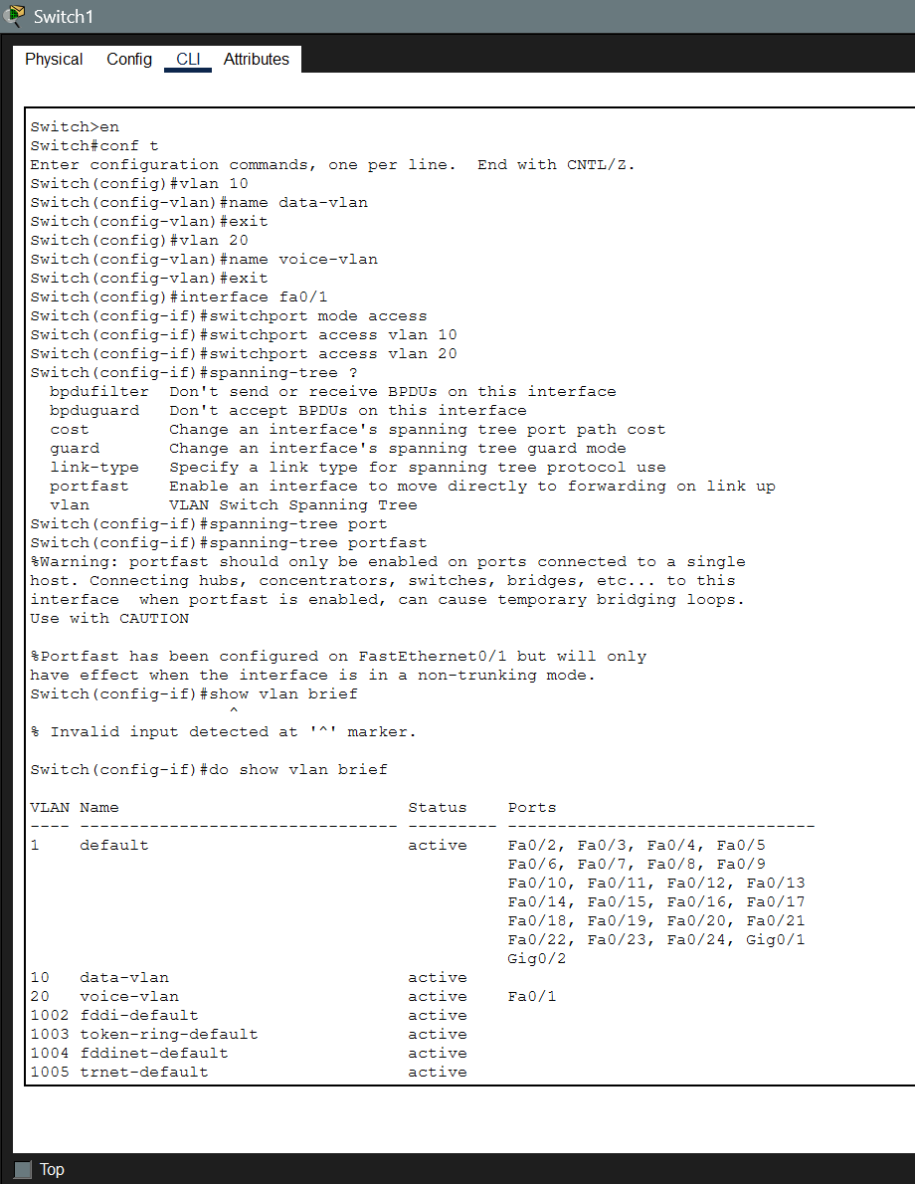

9) You configured VLAN 10 and 20 on your switch and assigned ports to each VLAN, however, devices in VLAN 10 can’t communicate with devices in VLAN 20. Troubleshoot the issue.
The issue can be solved with Intern-VLAN routing using VLAN’s SVI
a) Create a topology as follow
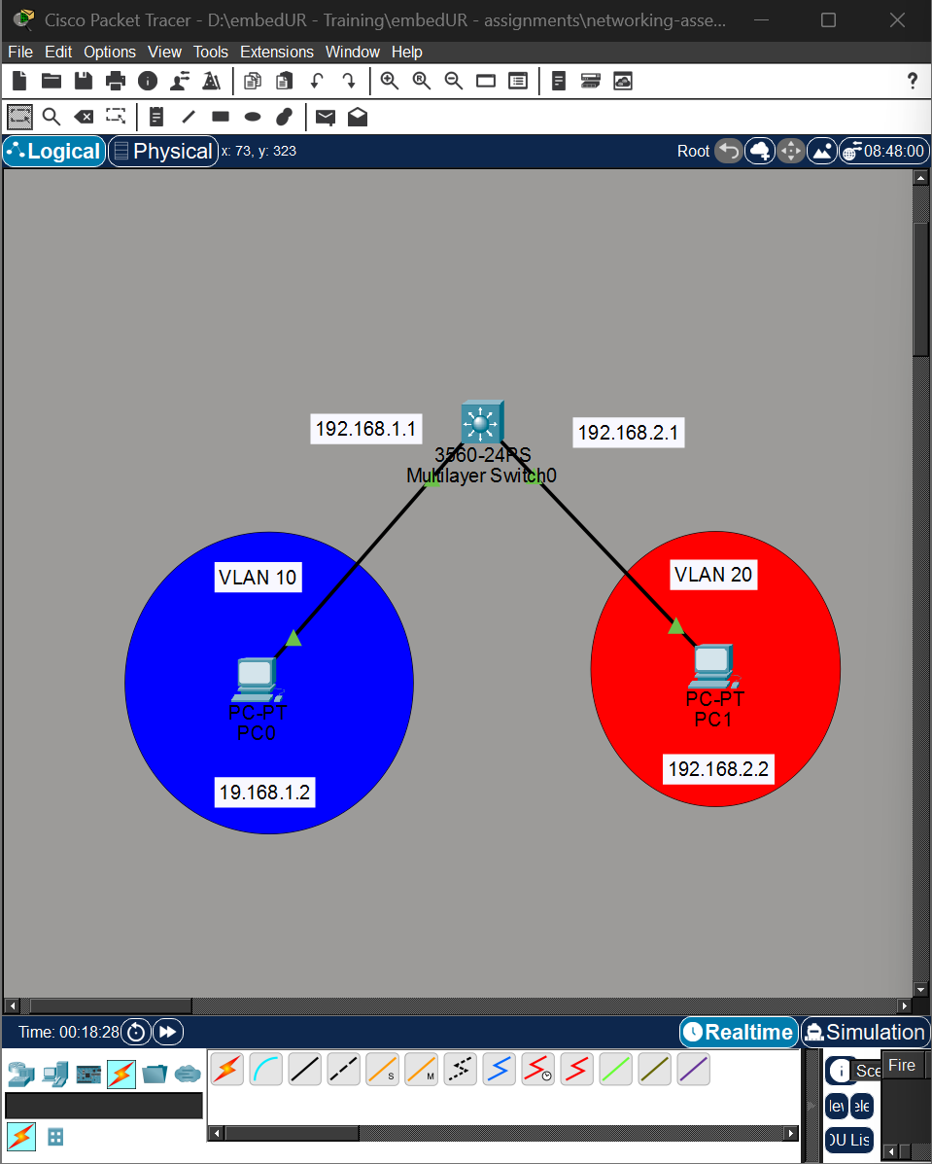
b) Now create VLAN interfaces and assign IP to them.
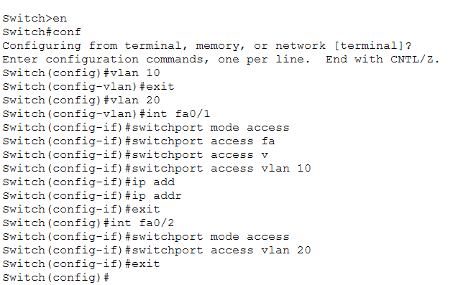
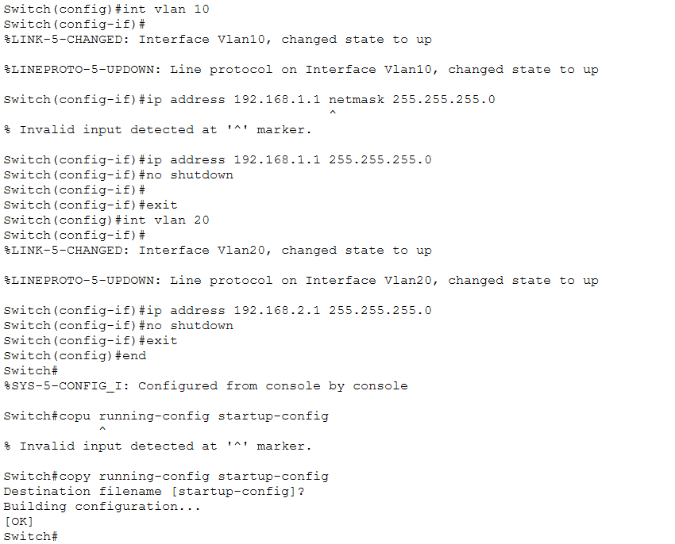
c) Now assign IP to the PCs and try pining the PC in different subnet
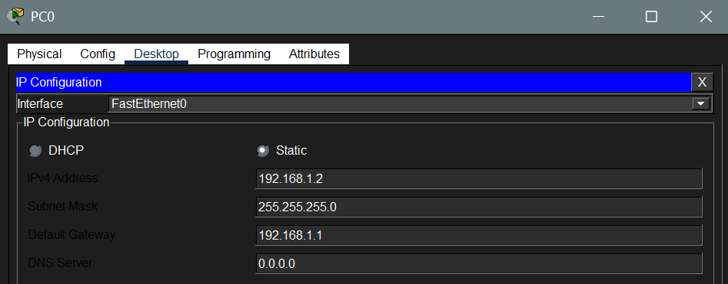
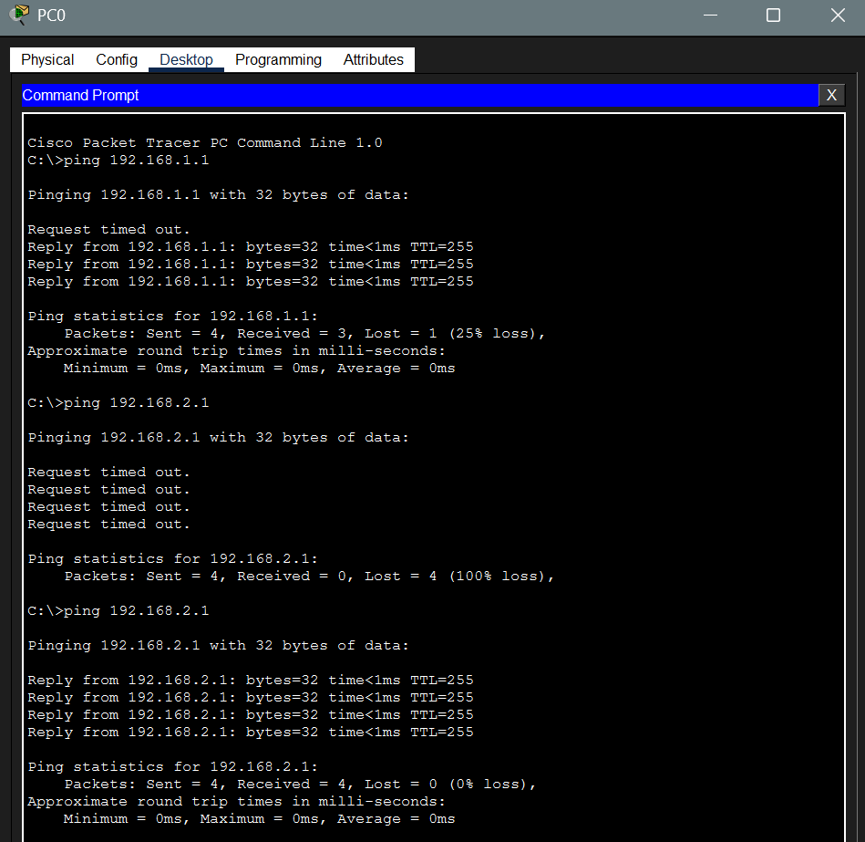



10. Try inter-VLAN routing using Router
I have used the following topology to try inter-VLAN routing using Router
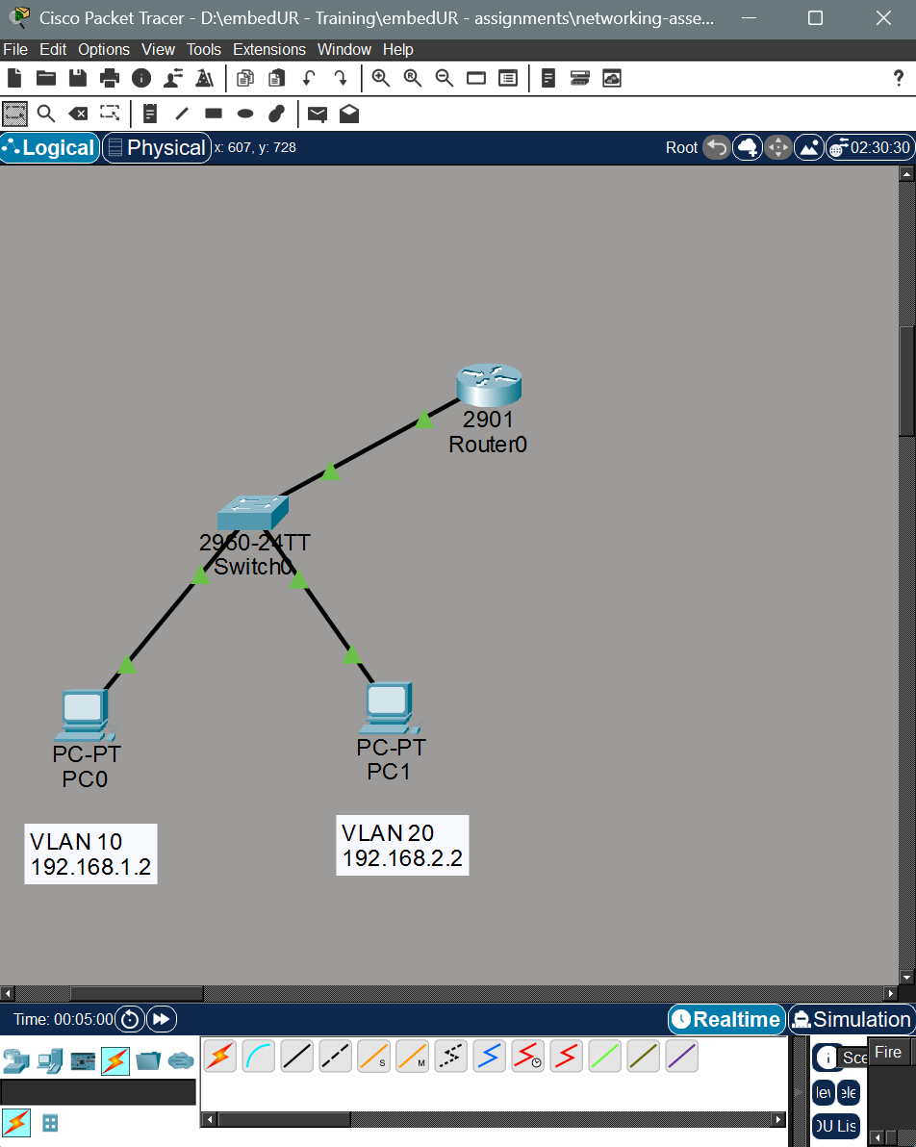

a) Configure the switch, create the corresponding VLANs and assign them to the particular ports.
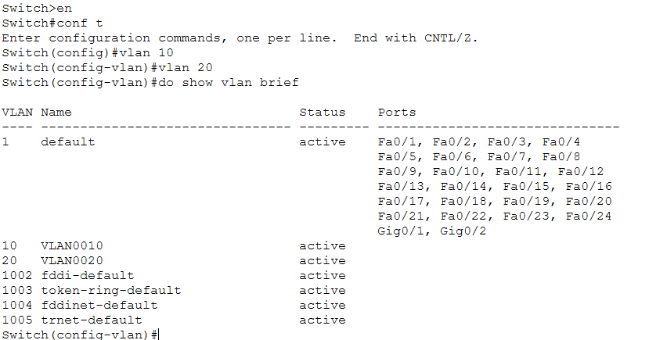
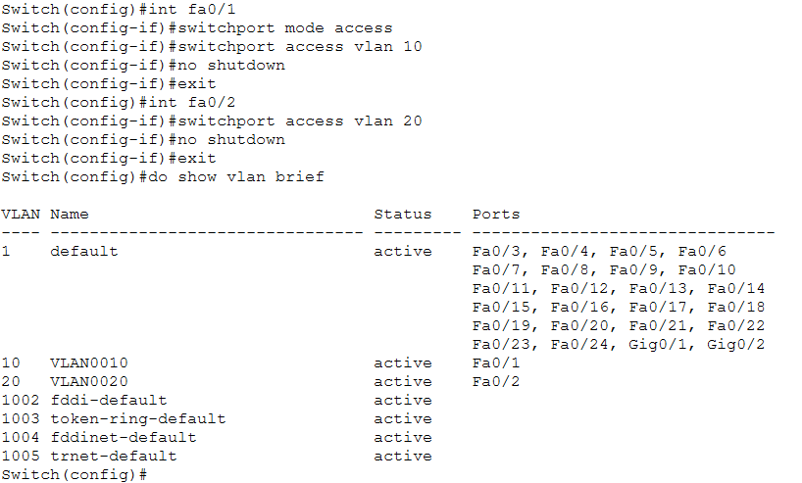
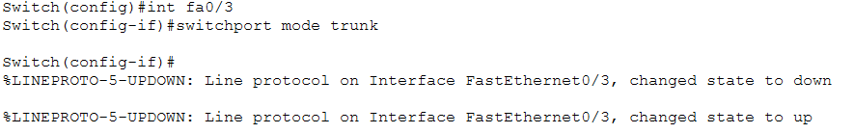
b) Now configure the router and create sub interfaces
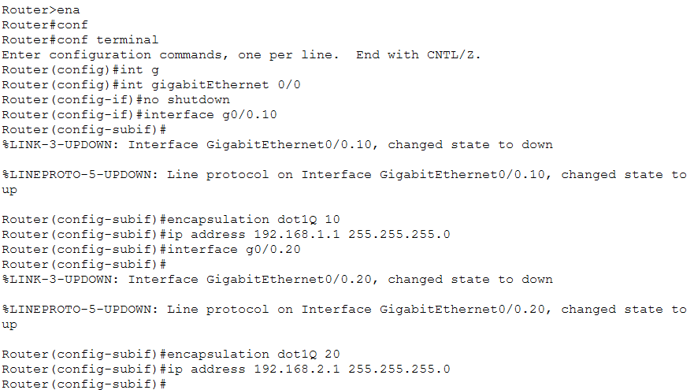

c) Now configure IP and Gateway in each PCs
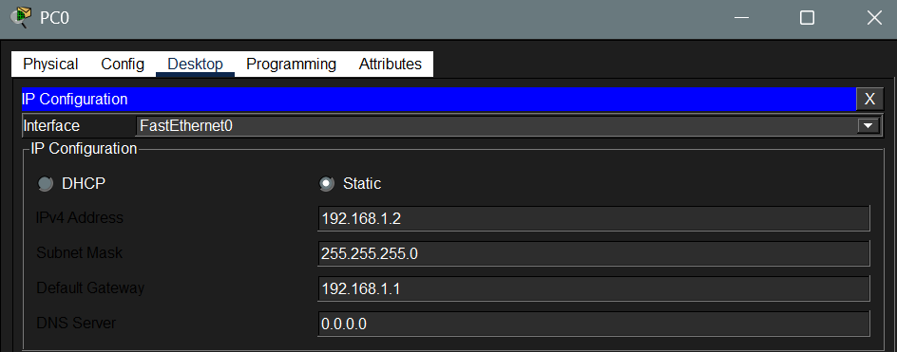
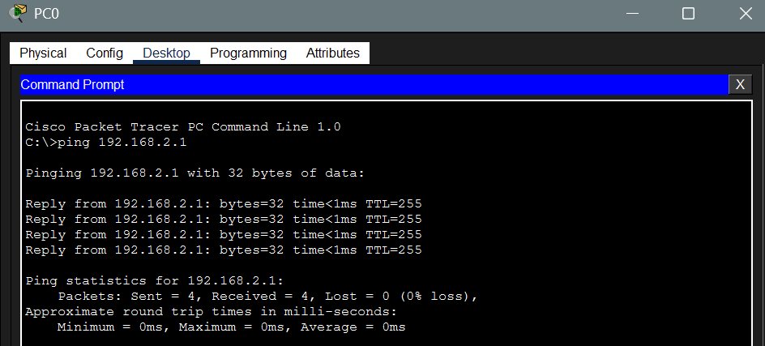

11. Implement ACL to restrict traffic based in source and destination ports. Test rules by simulating legitimate and unauthorized traffic.
To implement ACL in a router we use the following topology
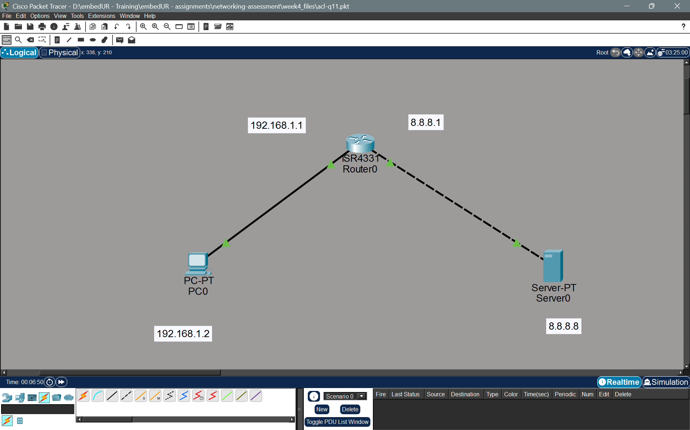
a) Assign IP address and Gateway address to the PC, Server and assign IP to the router Interfaces.
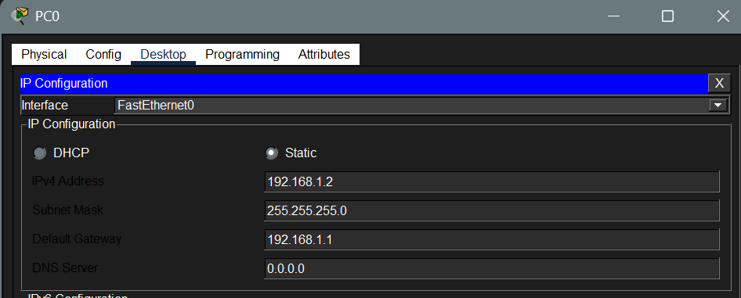
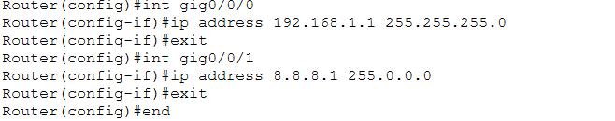
b) Configure the ACL using access-list command in the router. I am going to
i) Block traffic to port 80 (HTTP)
ii) Allow traffic to port 443 (HTTPS)
(Before doing this turn on HTTP & HTTPS services in the router)
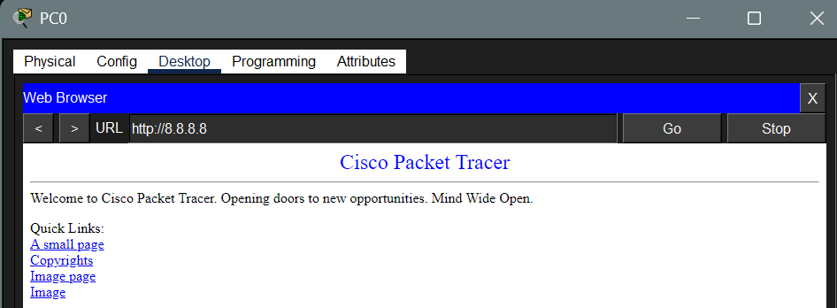
We need to create an extended ACL,
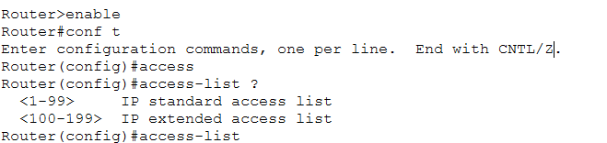
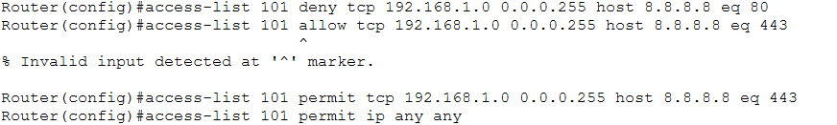
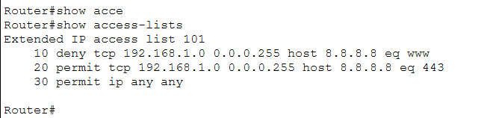
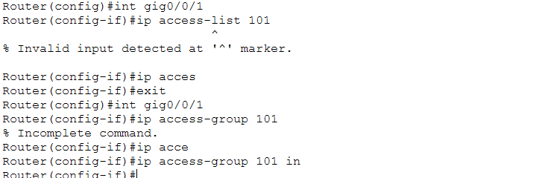
c) Now check the web server access from the client device.
Http access:
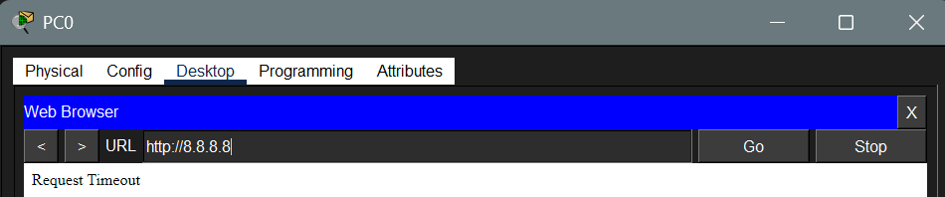
Https access:
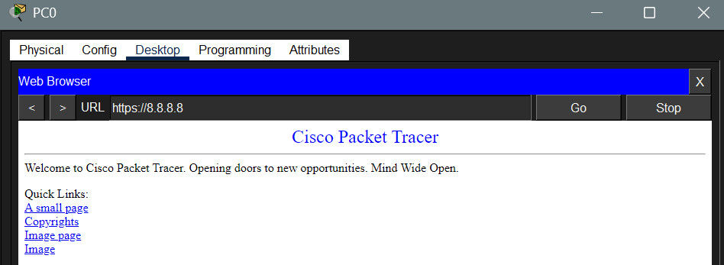
12) Configure a standard ACL on a router to allow traffic from a particular specific range of IP. Test connectivity and verify that the ACL is working as intended.
I have used the following topology fir this experiment,
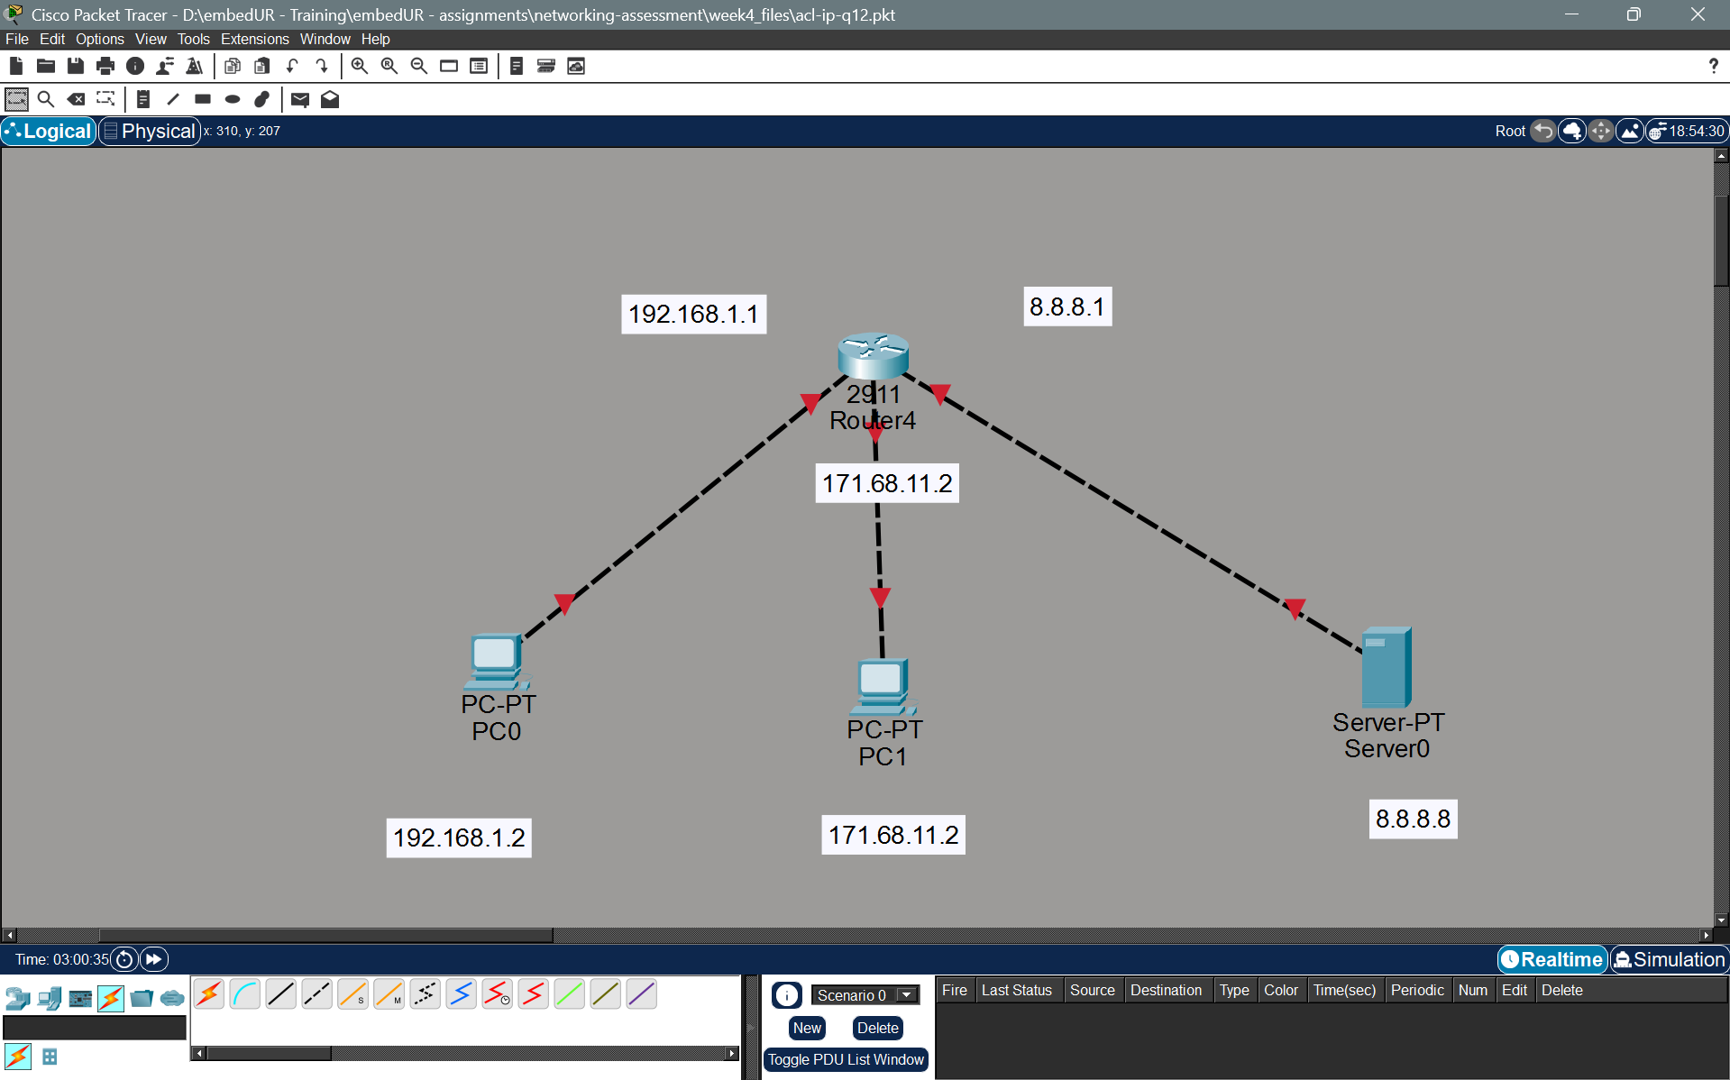

a) Assign IP to the PCs and the router interfaces
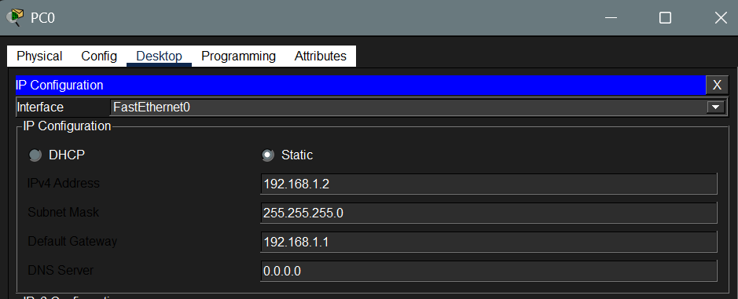
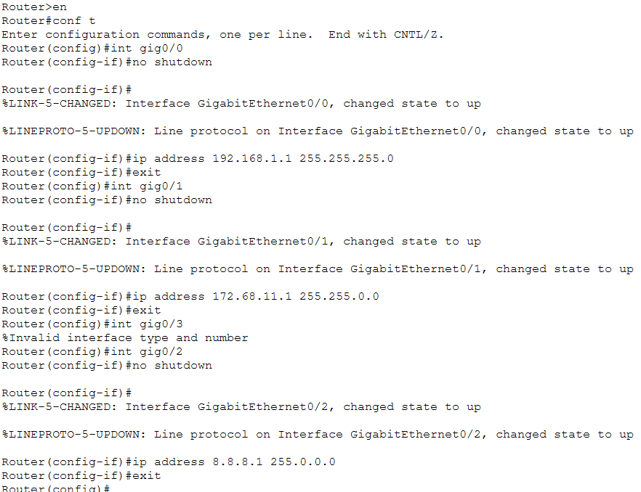
b) Try whether they are reachable.
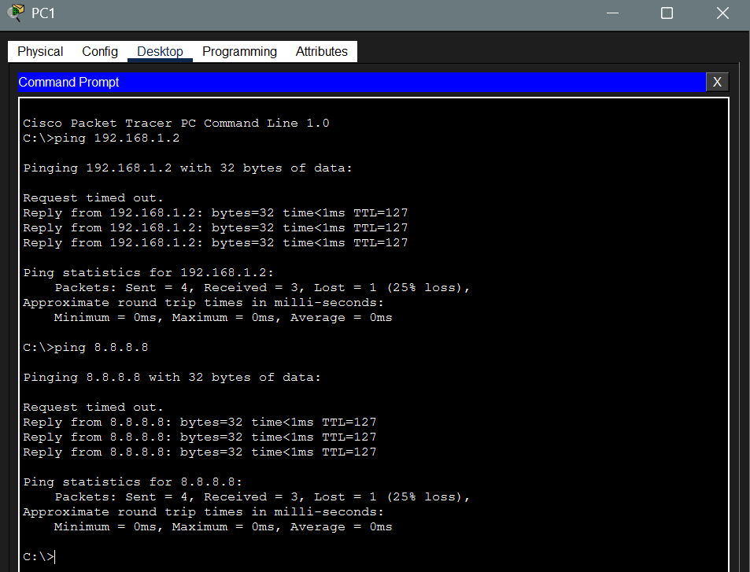

c) Now configure ACL using access-list command to block the access from a particular rage of IPs assume I am blocking access from 172.68.11.X to the server.
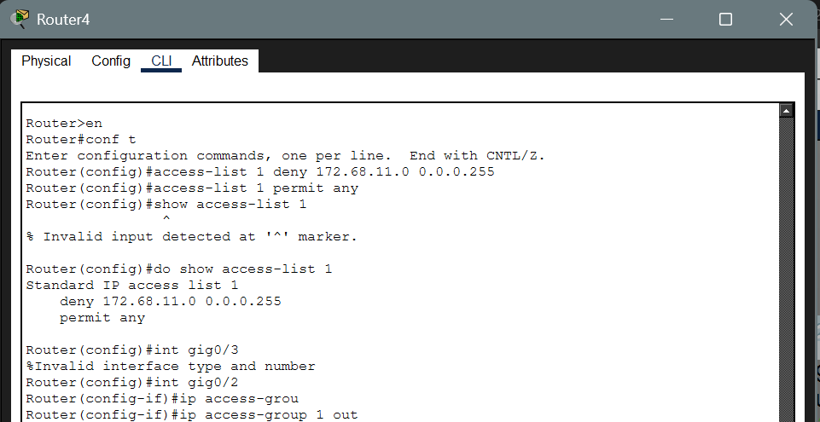
d) Now check the connectivity to the server from the PC1 to the Subnet 8.8.8.0/8
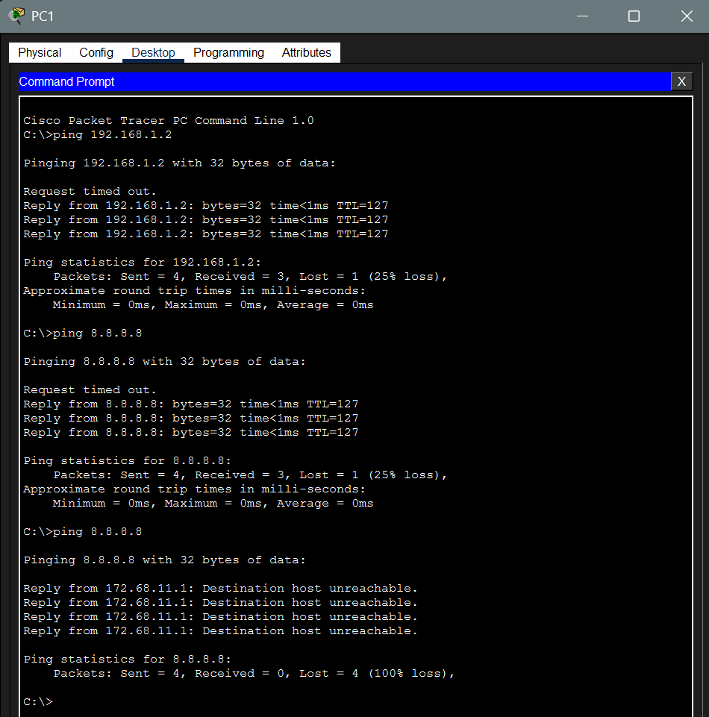

13) Create an extended ACL to block specific applications, such as HTTP or FTP traffic. Test the ACL rule by attempting to access the blocked services.
I have used the same topology and configuration as above.
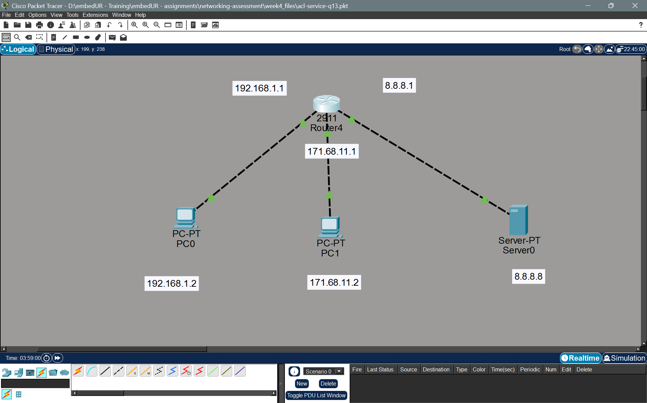
a) Start the HTTP / FTP service in the server and create the access-list to block it
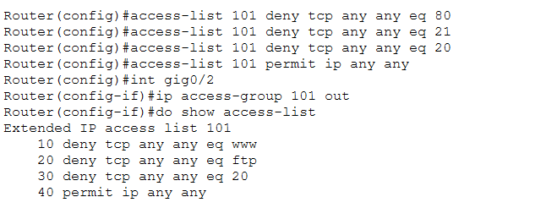
b) Check the connection
http: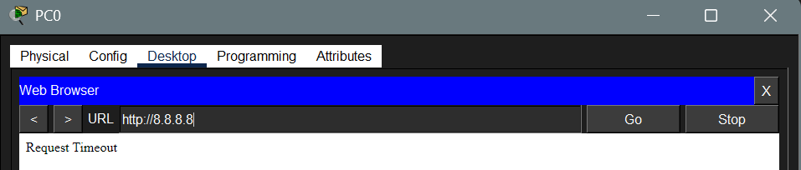
FTP (can access but FTP fails)
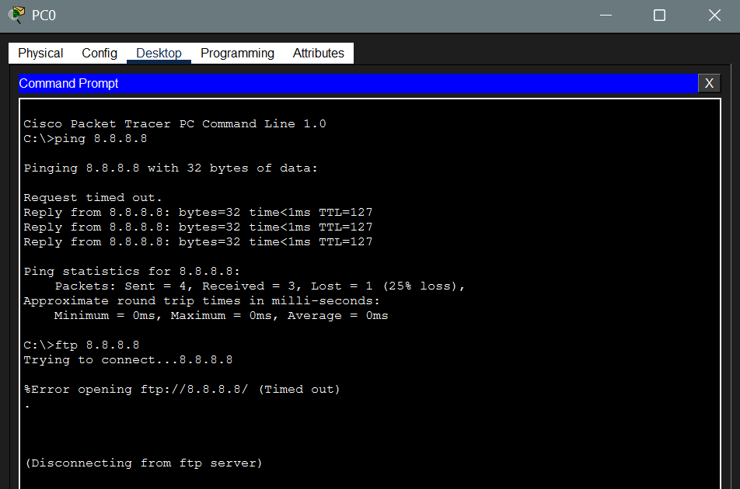


14) Try static NAT, Dynamic NAT and PAT to translate IPs
I have used the following topology for this experiment:
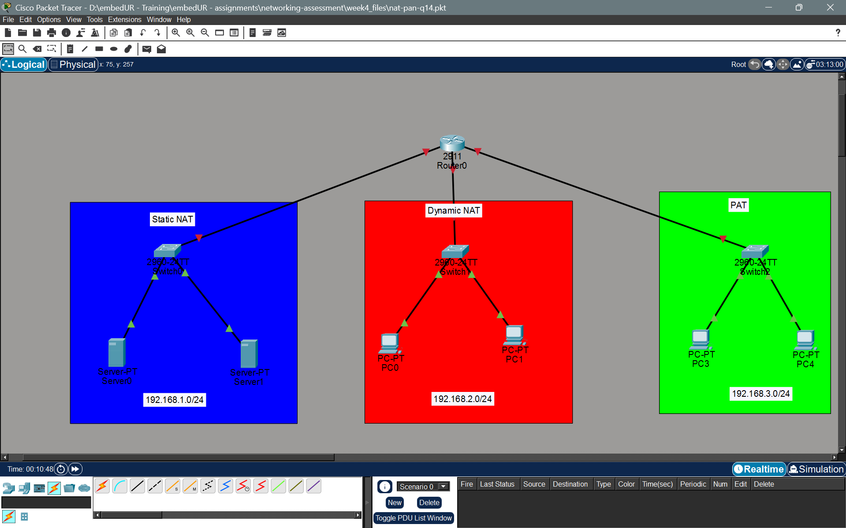

Assign IP to each interface, the PCs and the servers
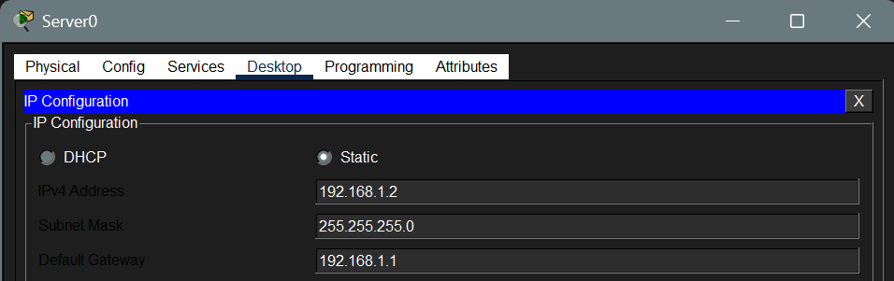
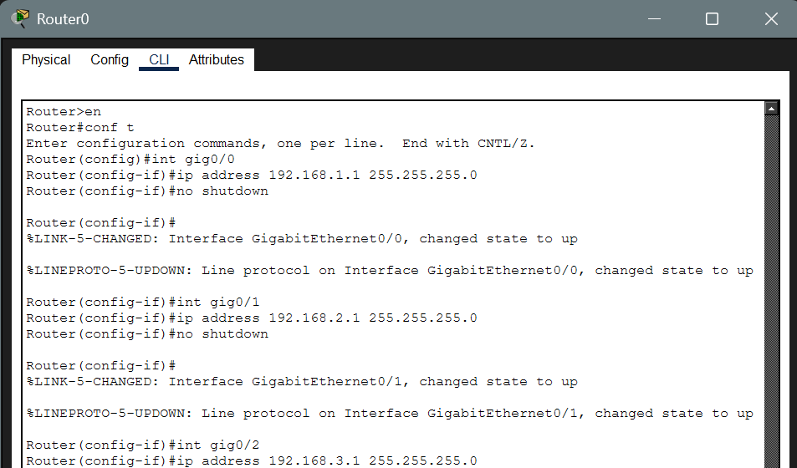
a) Static NAT:
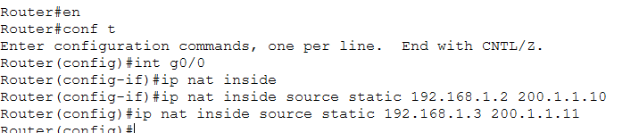
Test from WAN: (Before Reaching router & After reaching Router)
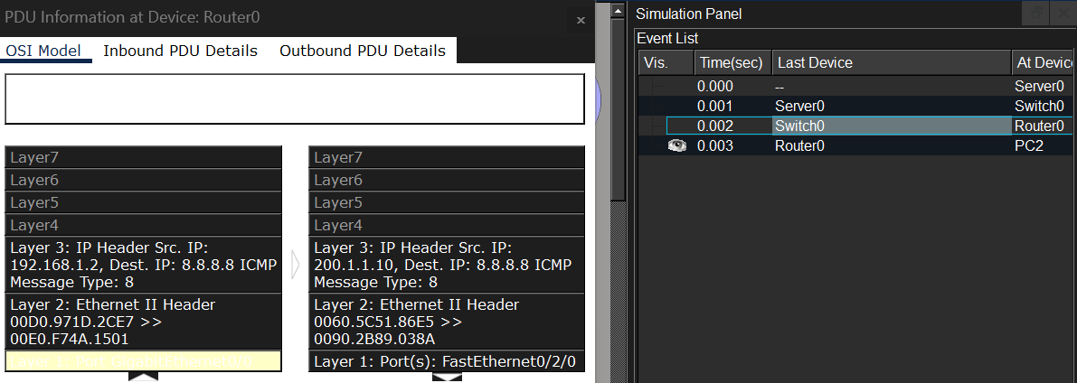
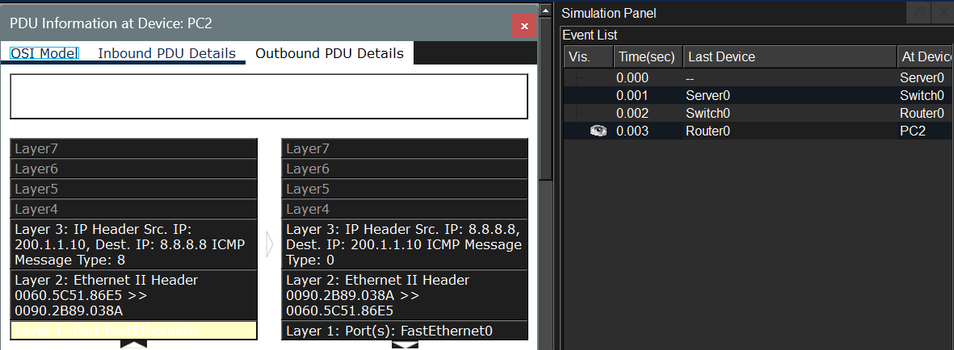

b) Dynamic NAT:
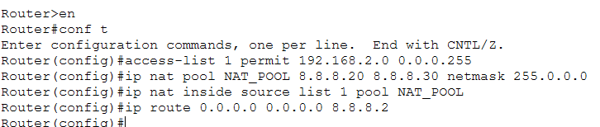
Testing from WAN (using NAT table)
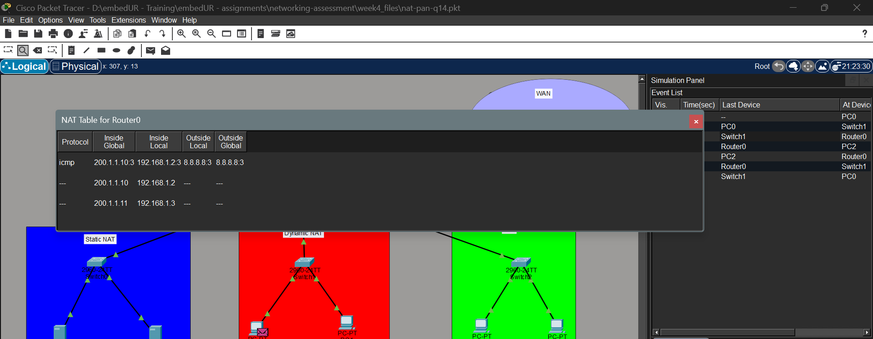
PAT:
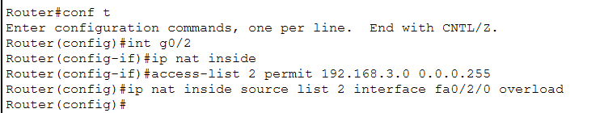

15) Download iperf in laptop/phone and make sure they are in same network. Try different iperf commands with tcp, udp, bidirectional, reverse, multicast, parrel options and analyze the bandwidth and rate of transmission, delay, jitter etc..,

