Structured Training Program: Networking
Week 3
Module 5: Layer 3 Session 1
1. Analyse the ARP packet using Wireshark. Inspect the ARP request and reply frames, and discuss the role of the sender’s IP and MAC address in these packets.
a) Captured an filterd only the ARP packet in the Wireshark.
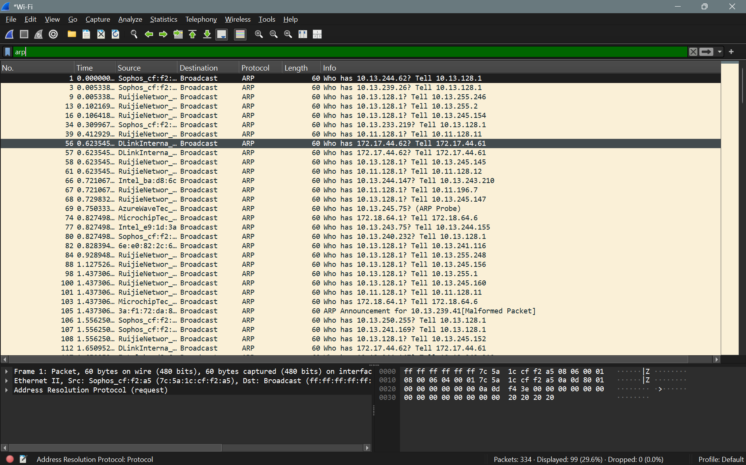
b) To inspect only the arp request packet we need to use the filter arp.opcode == 1.
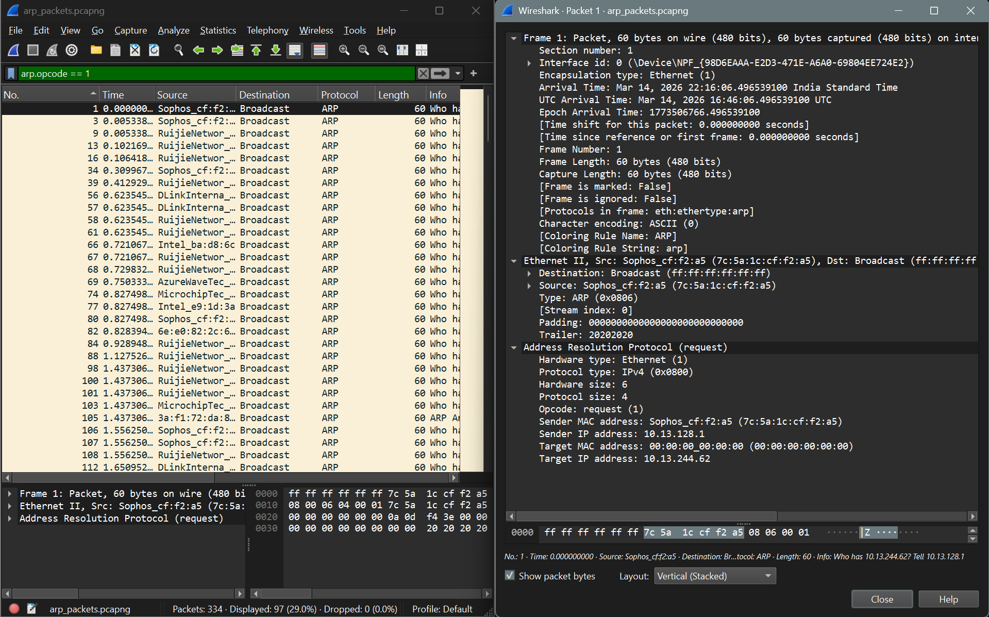
c) Inspecting the request packet I inferenced the folllowing things:
The packet consist of the following fields
- Hardware Type (2 bytes): Specifies the type of data link layer technology used. It allows ARP to operate across different network technologies. For Ethernet networks, this value is 1.
- Protocol Type (2 bytes): Identifies the network protocol whose address is being mapped to a MAC address. It is commonly IPv4 (0x0800).
- Hardware Size (1 byte): Specifies the length of the hardware address. For Ethernet, the MAC address length is 6 bytes (48 bits).
- Protocol Size (1 byte): Specifies the length of the protocol address. For IPv4, the IP address length is 4 bytes (32 bits).
- Opcode (2 bytes): Indicates the type of ARP message.
1 – ARP Request
2 – ARP Reply
- Sender MAC Address (6 bytes): Specifies the MAC address of the sender (the device that generated the ARP request).
- Sender IP Address (4 bytes): Specifies the IP address of the sender. This allows the receiving device to know where to send the ARP reply and helps the reciever devide to update it’s ARP cache if needed.
- Target MAC Address (6 bytes): In an ARP request, this field is typically set to 00:00:00:00:00:00 because the sender does not yet know the MAC address of the target device.
- Target IP Address (4 bytes): Specifies the IP address of the device whose MAC address is being requested. The ARP request is broadcast to all devices in the local network to find this address.
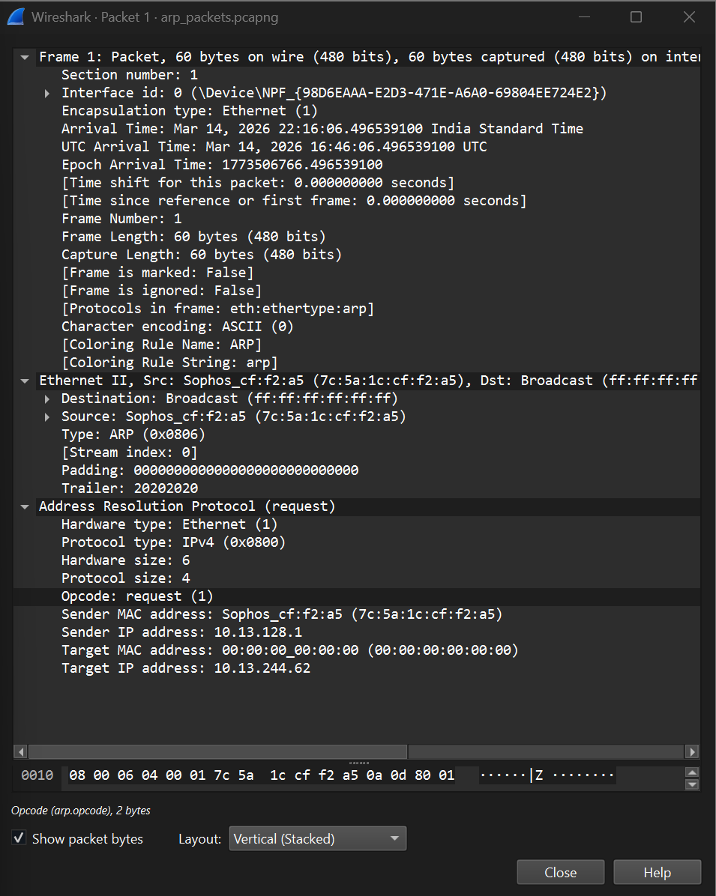
d) To filter the arp reply packets we need to set arp.opcode == 2
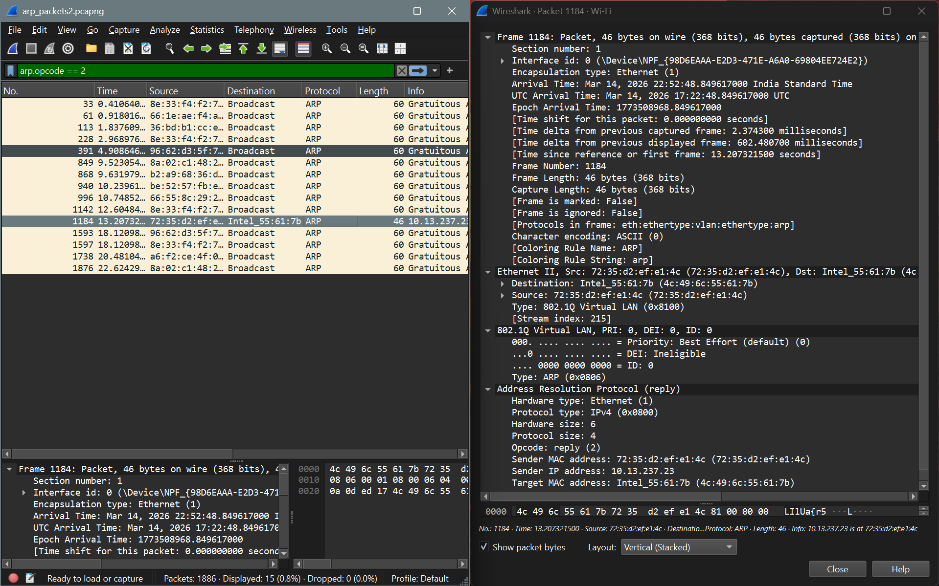
e) Inspecting the reply packet, I inferred that:
The packet structure of the ARP reply is similar to that of the ARP request. However, the main difference is that in the reply packet, the Target MAC Address field contains the actual MAC address of the requesting system, instead of being set to 00:00:00:00:00:00 as in the request packet. Additionally, the Sender MAC Address field contains the MAC address of the device whose IP address was requested, indicating the mapping between the IP address and its corresponding MAC address. The ARP reply is then sent as a unicast packet directly to the requesting system.
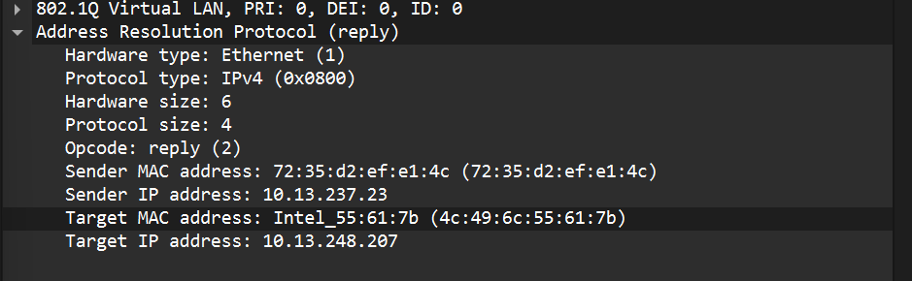
The following was the corresponding request packet of the response packet analysed
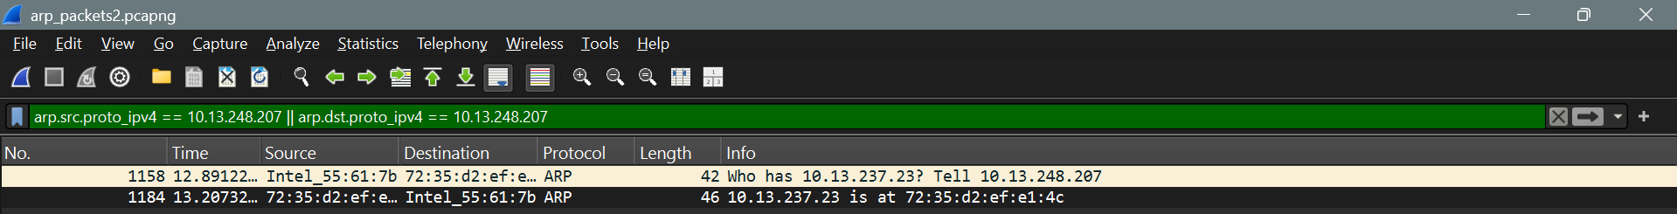
Apart from these 2 types of ARP packet there is another king of ARP reply packet called Gratuitous ARP. This ARP reply packets are broadcasted across the network to notify that their IP address has been changed or updated helping the systems in network to update their ARP cache table. This packet contains the src and dst IP as same.
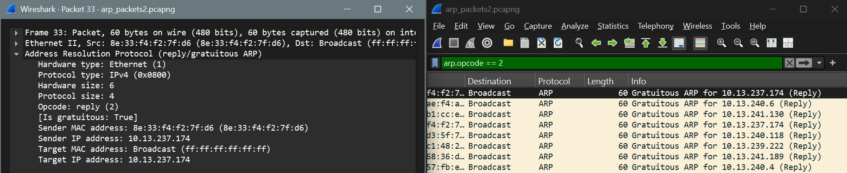

2) Using Packet Tracer, simulate an ARP spoofing attack. Analyze the behaviour of device on the network when they receive a malicious ARP response.
ARP Spoofing Attack:
An ARP spoofing attack (or ARP poisoning) is a type of man-in-the-middle (MITM) attack where an attacker sends falsified Address Resolution Protocol (ARP) messages over a local area network (LAN). This associates the attacker's MAC address with the IP address of a legitimate device, such as the default gateway, allowing them to intercept, modify, or stop traffic. To do this in a packet tracer we need
- Attacker Device
- Gateway
- Victim device
Steps:
a. Topology Setup
- Place a Switch.
- Add three PCs: Victim, Attacker, and Gateway (a PC or a router)
- Connect all devices to the switch using cables.
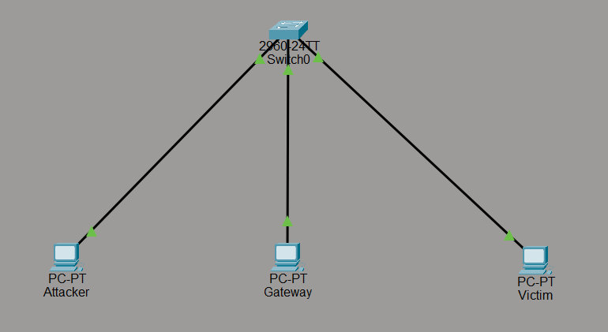

b. IP Configuration
- Gateway
  - IP Address: 192.168.1.1
  - Subnet Mask: 255.255.255.0
  - MAC Address: 00D0.D3EB.1B44
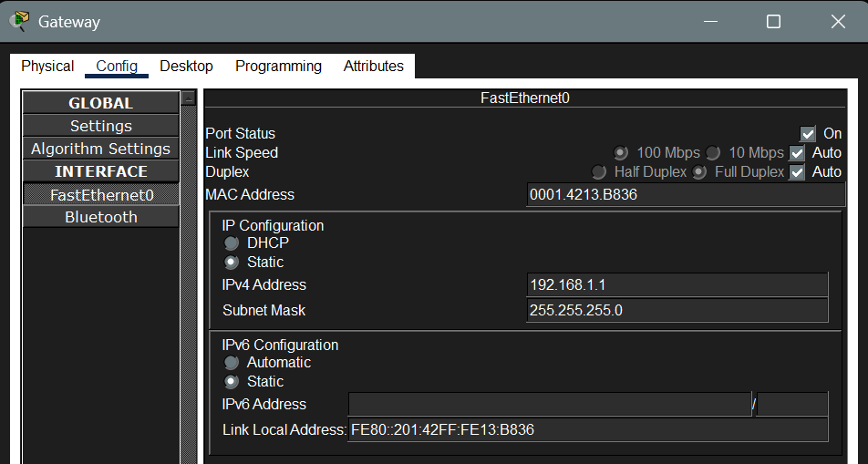
- Victim
  - IP Address: 192.168.1.10
  - Subnet Mask: 255.255.255.0
  - Default Gateway: 192.168.1.1
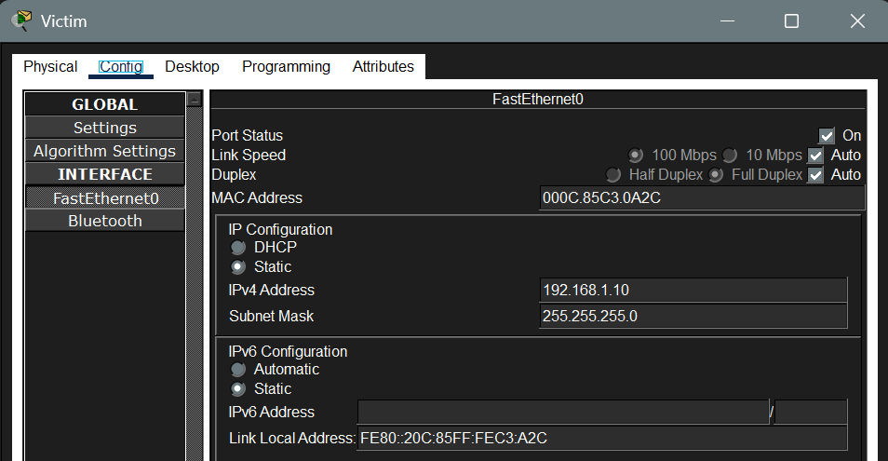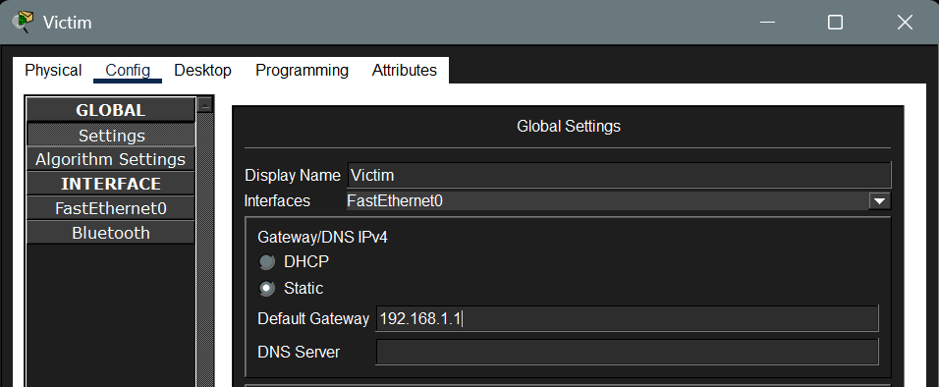

Attacker
  - IP Address: 192.168.1.20
  - Subnet Mask: 255.255.255.0
  - Default Gateway: 192.168.1.1
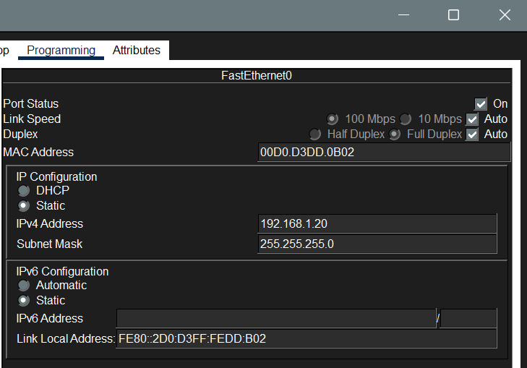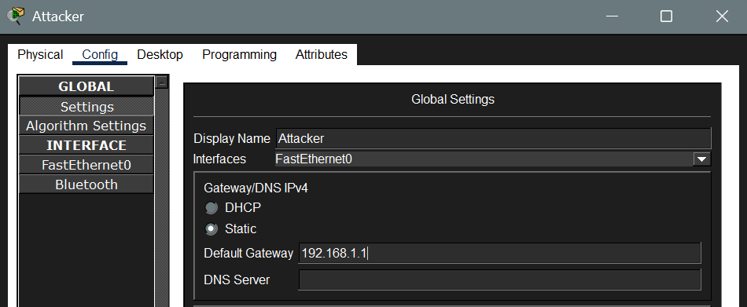
c. Establish Normal ARP Cache
- On the Victim PC, open the Command Prompt and ping the Gateway: ping 192.168.1.1
- Then type the following command on the Victim PC to verify the ARP table: arp -a
- Ensure it lists the correct MAC address of the Gateway: 00D0.D3EB.1B44
On this normal operation we get the following output
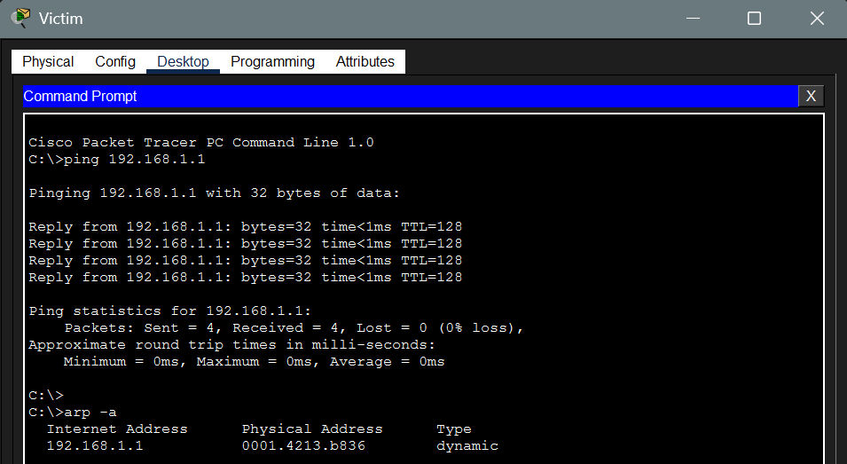
d. Now let us do ARP poisoning in the network. Create a Complex PDU packer after changing the MAC address of the attacker into the MAC of the Gateway. We can know the MAC Address of Gateway by pinging the gateway by this it gets stored in arp table. Now click on simulation. After simulation check on the Victim ARP cache it will be containing the attacker IP mapped to gateway MAC
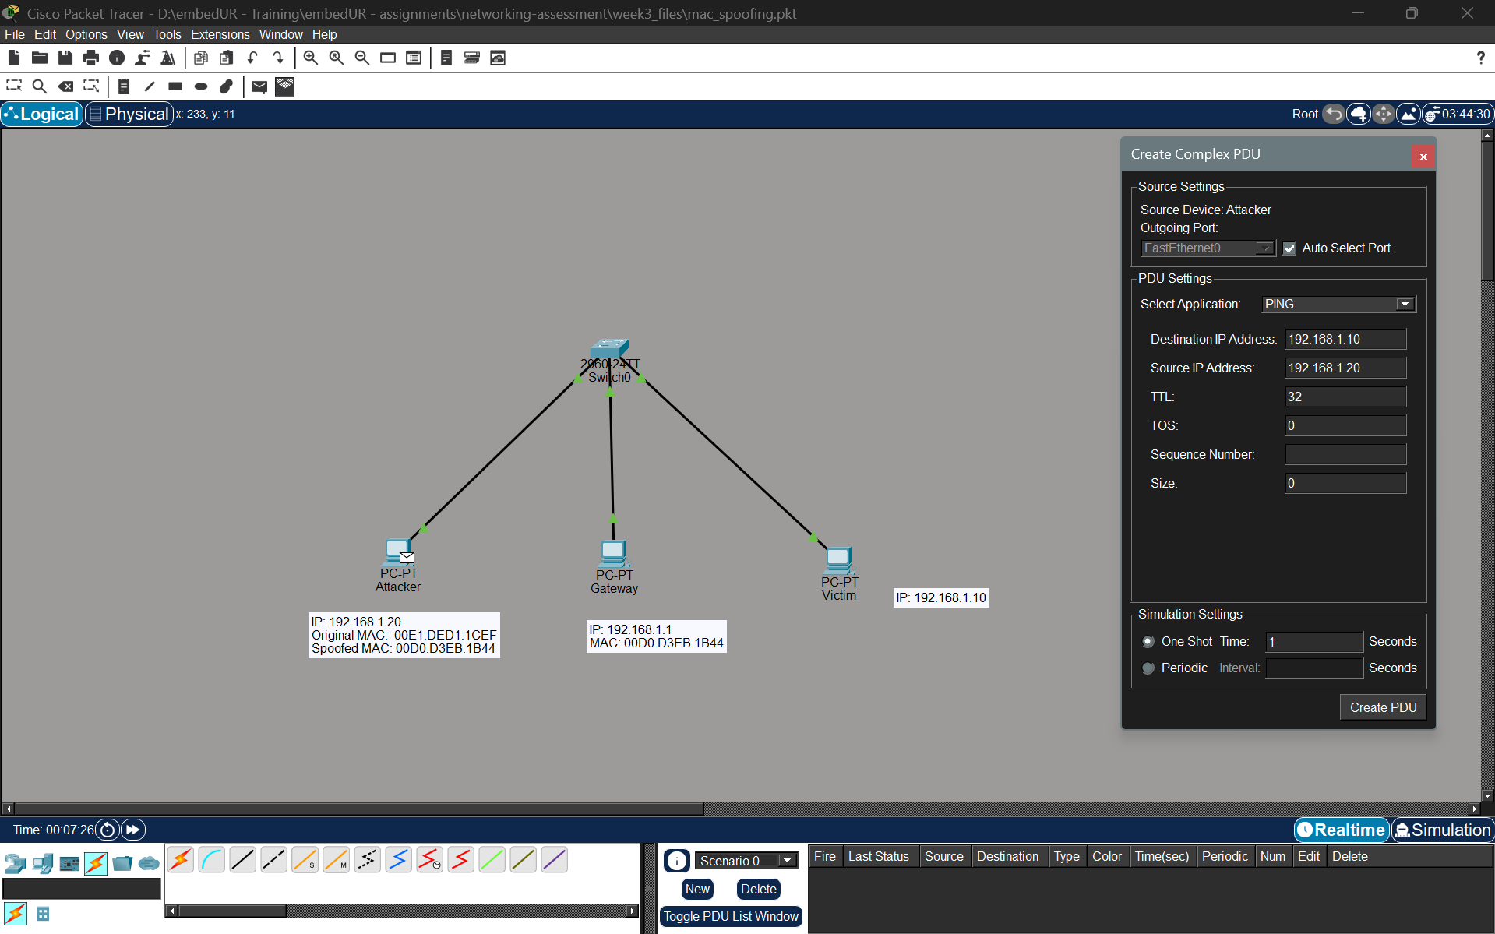
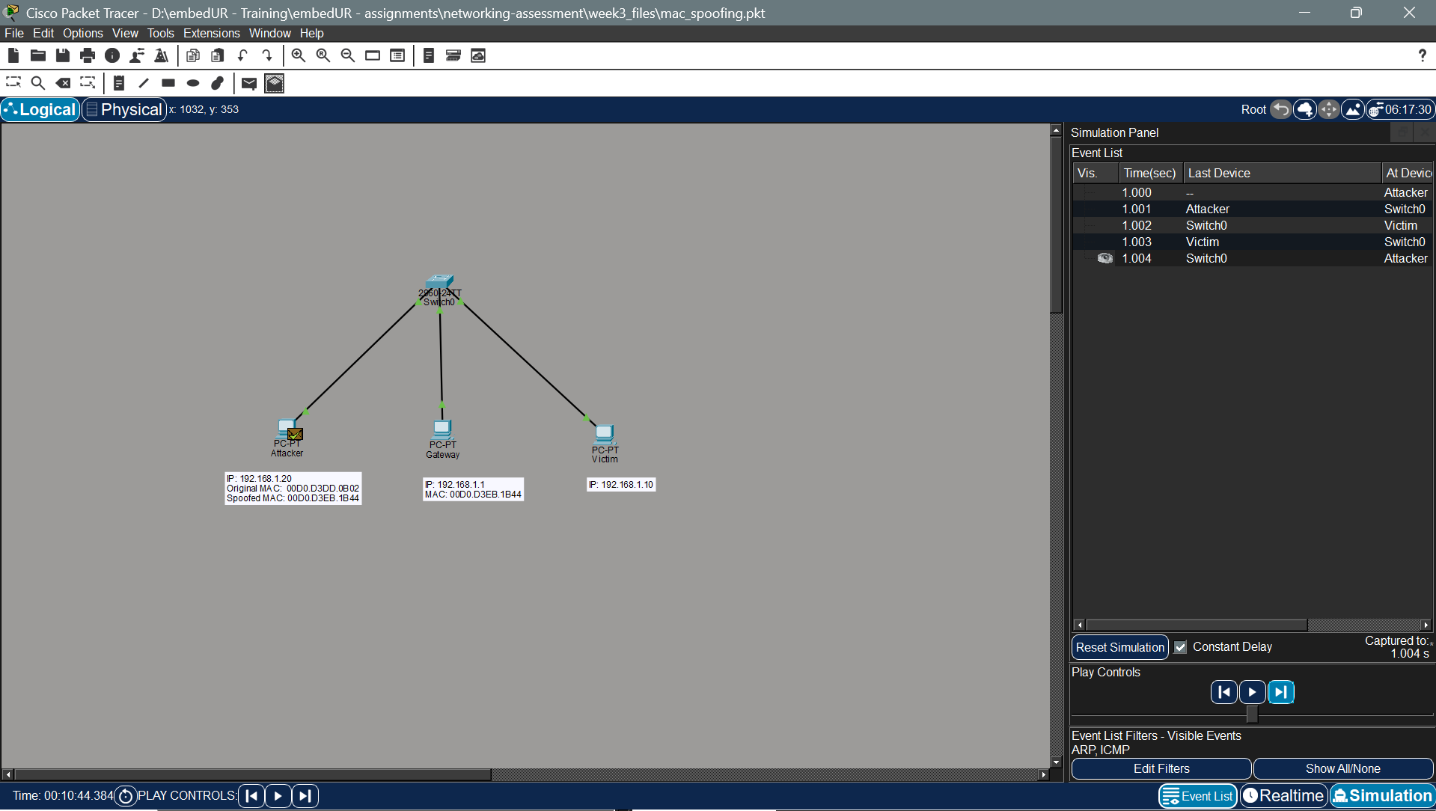
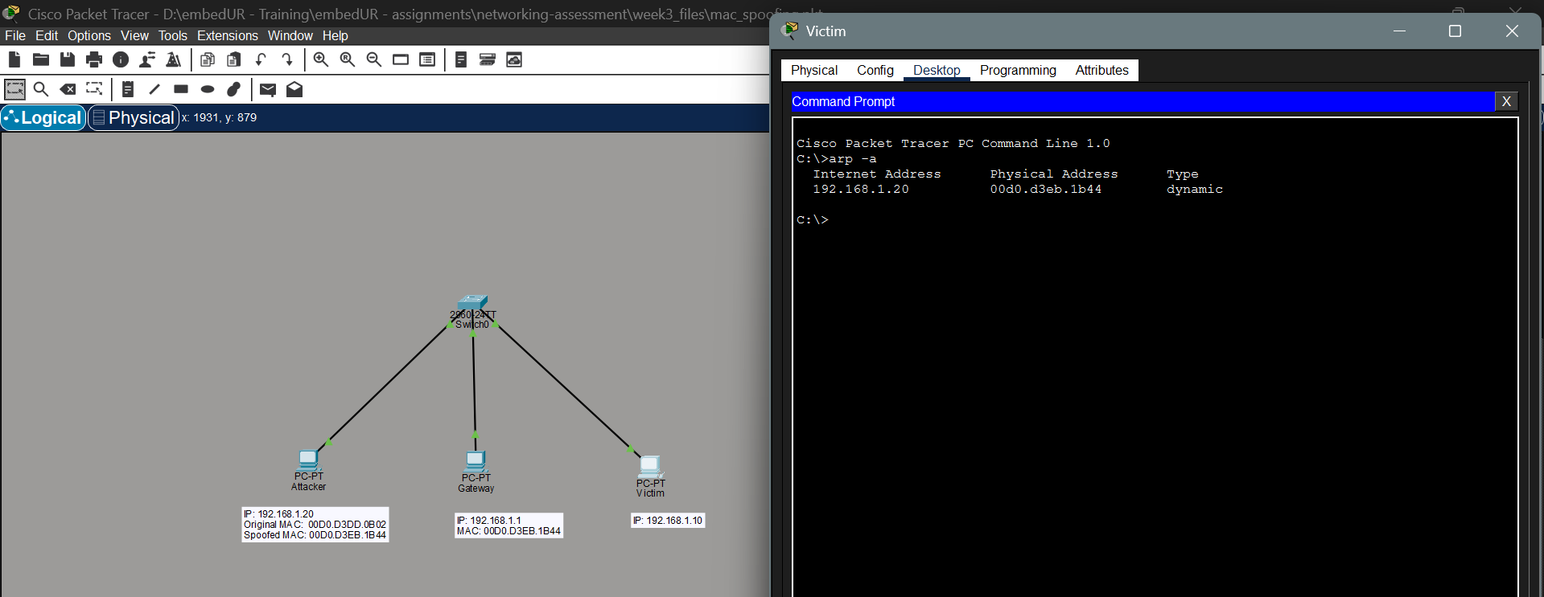
Because of this until the cache gets updated the packets to gateway are sent to Attacker device. To prevent this we can enable port security (Sticky MAC) on switch to lock MAC address to specific port in switch, and use DAI (Dynamic ARP Inspection).

3. Configure static IP on client device (like PC or mobile phone) and verify connectivity using ping
a. To configure a static IP address, I must either have a static IP assigned to me or know the subnet of the network I am connected to and select an IP address that does not conflict with other devices. Since choosing a random IP address in a public network may cause an IP collision, I am using my mobile hotspot to ensure that I can safely assign a static IP within its subnet.
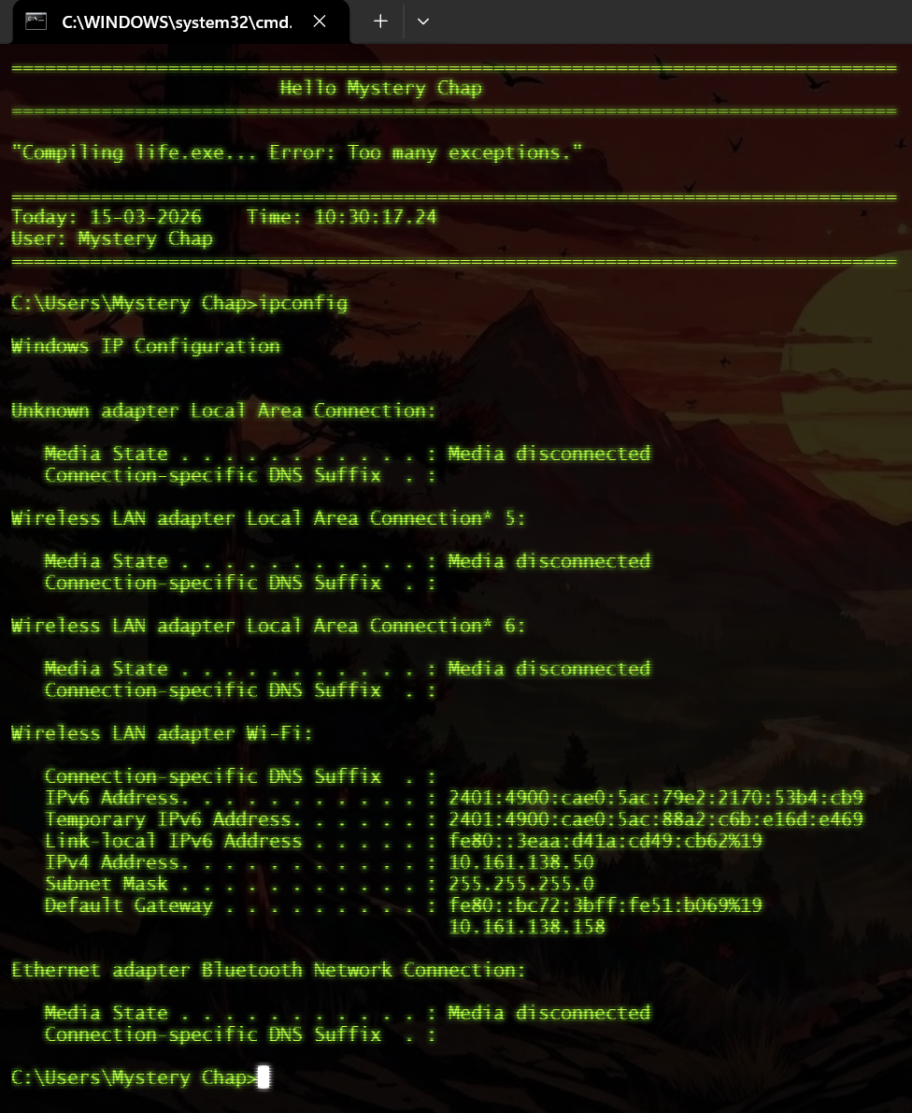
The above picture shows DHCP assigned IP. No we have to change the setting to assign a static IP
b. Go to Control Panel -> network and sharing -> Choose the network properties -> IPv4 properties and assign a static IP
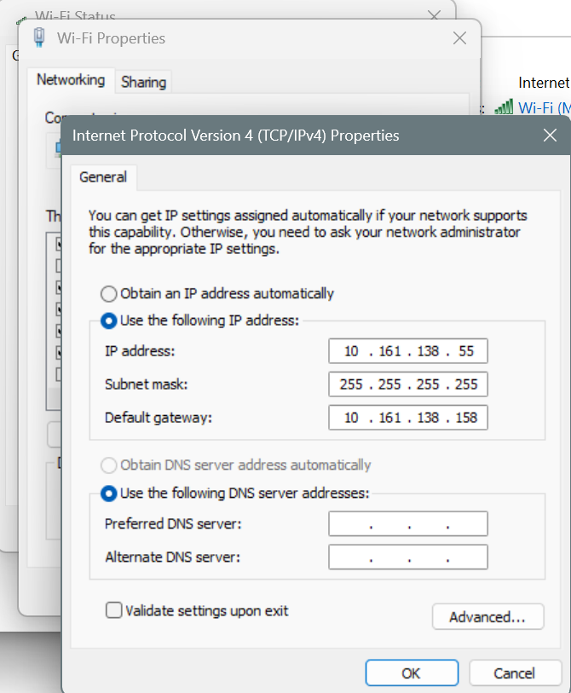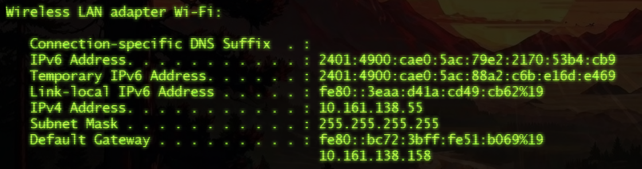
c. Ping a domain to check it works
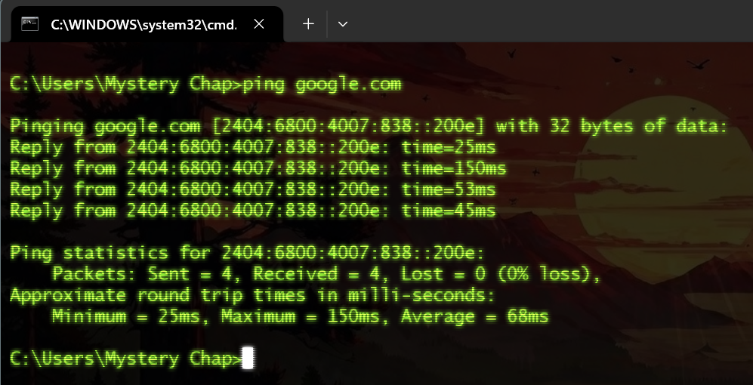
4. Use Wireshark to capture DHCP Discover, Offer, Request and Acknowledge message and explain the process.
To initiate the DHCP process we need to run the following command to force ask the DHCP server a IP.
ipconfig /release – releases the current IP and the setting related to it.
ipconfig /renew – gets a new IP from the DHCP server. During the following command only we can capture the DHCP packets and DORA process takes place.
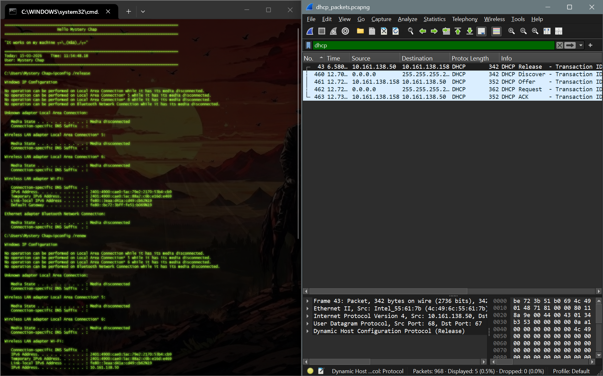
The DHCP automatically assigns IP to the devices in the network using 4 steps. (DORA)
a)Discovery: The client broadcasts a DHCPDISCOVER message to find available DHCP servers.
b)Offer: DHCP servers receive the broadcast and respond with a DHCPOFFER, which includes an IP address, subnet mask, gateway, and lease duration.
c)Request: The client receives the offer(s) and broadcasts a DHCPREQUEST, officially requesting the IP address from the chosen server.
d)Acknowledgment: The server sends a DHCPACK to confirm the lease, allowing the client to start using the network.
The client also checks the network for duplicate IP. If duplicate IP exist then the client sends DHCPDECLINE after ACK also during renewal the client may ask for its previous held IP, if that is already assigned to another device then the server will give NAK (Negative ACK). Apart from this if a client and server are different subnets then it uses a DHCP relay. I have also captured the packet for DHCP connection. When a client releases an IP it sends DHCPRELEASE in the network.
The entire DHCP process uses the UDP protocol at the transport layer.
5. Given an IP address range of 192.168.1.0/24. Divide the network into 4 subnets
Task: Manually calculate the new subnet mask and the range of valid IP address for each subnet.
Assign IP addresses from these subnets to devices in CISCO Packet tracer and verify the connectivity using ping between them

Calculation
The given network is 192.168.1.0/24.
The CIDR /24 indicates that:
- Network bits: 24 bits
- Host bits: 8 bits
The total number of IP addresses available in this network is:
2^8 = 256 IP addresses
Since the task is to divide this network into 4 subnets, the number of subnet bits (n) must satisfy the condition: 2^n ≥ number of required subnets
For 4 subnets: 2^n ≥ 4 -> n = 2
Therefore, 2 bits must be borrowed from the host portion to create the required subnets.

Originally, the subnet mask for /24 was: 255.255.255.0
Binary: 11111111.11111111.11111111.00000000
After borrowing 2 bits from the host portion, the new subnet mask becomes /26: 255.255.255.192
Binary: 11111111.11111111.11111111.11000000
Thus, the network 192.168.1.0/24 is divided into 4 subnets using the new subnet mask /26 (255.255.255.192)
Building this network in CISCO Packet Tracer
- Create a topology with a router and 4 switches and connect PC as required
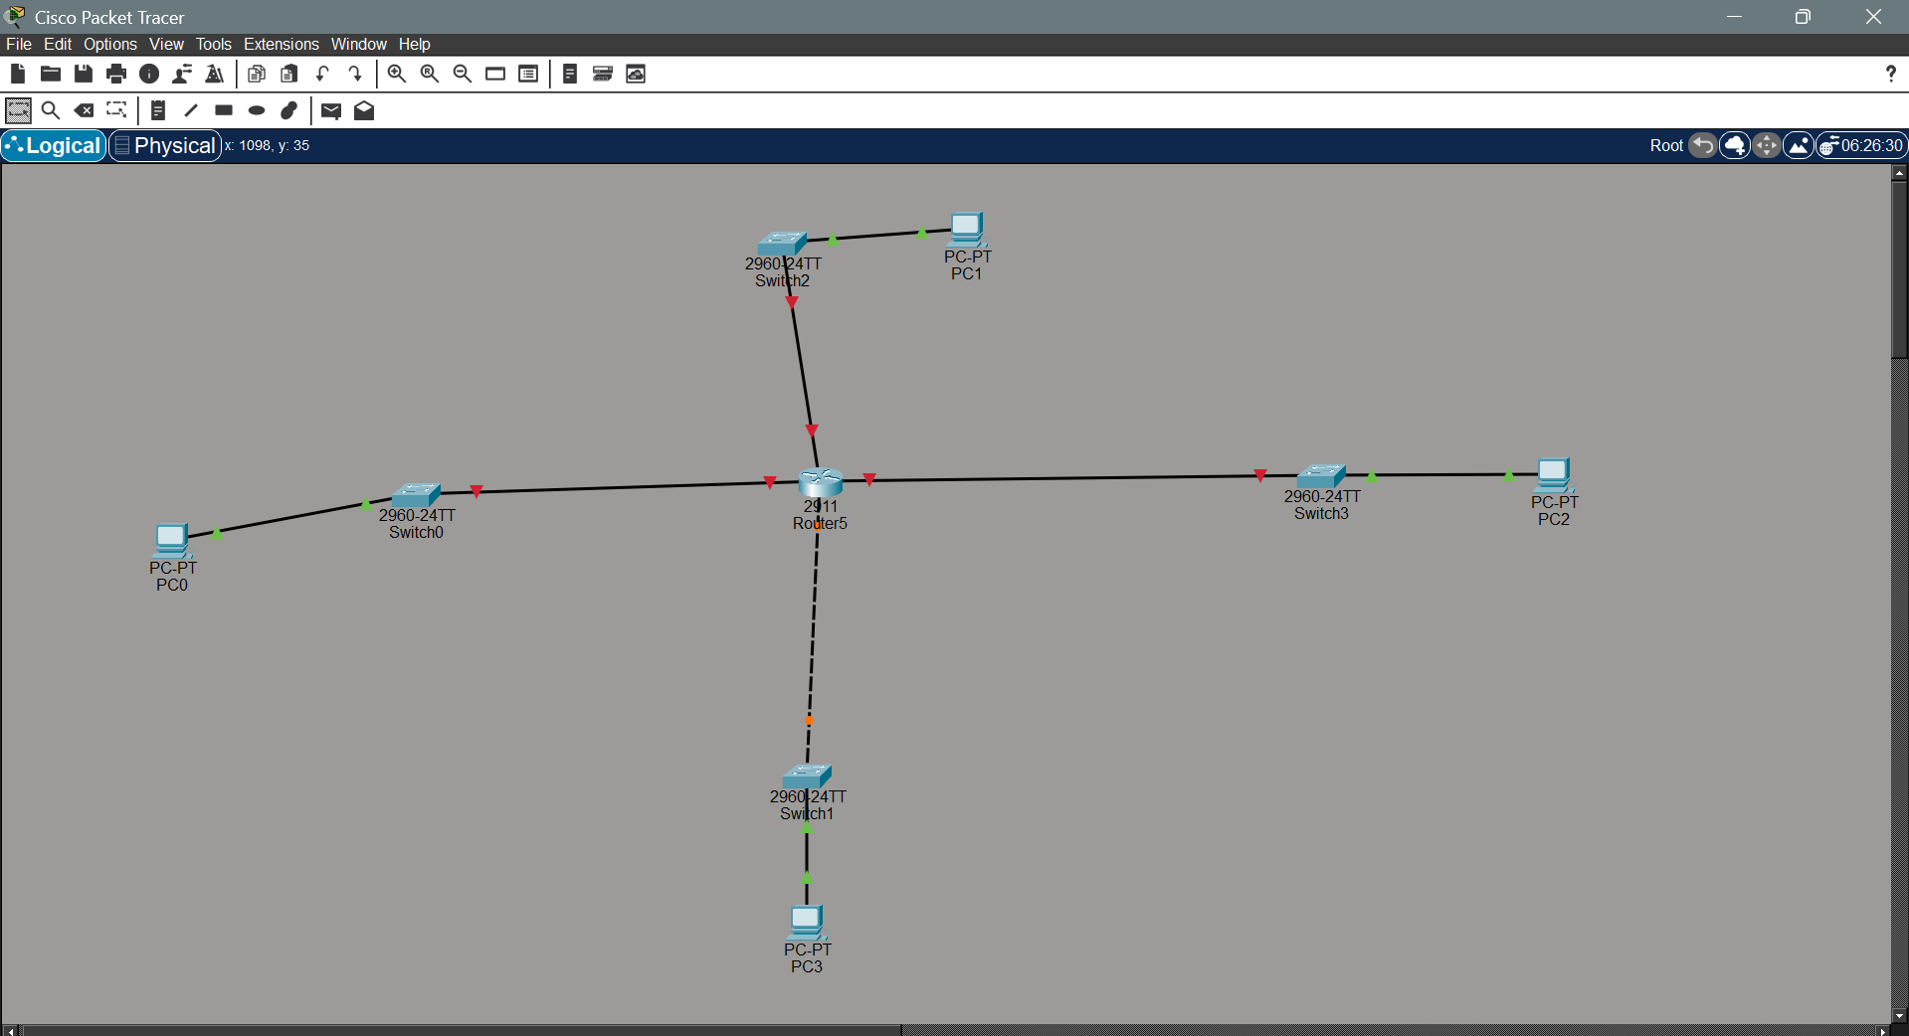
- Enter the IP address and subnet address in each port. Configure each port similarly
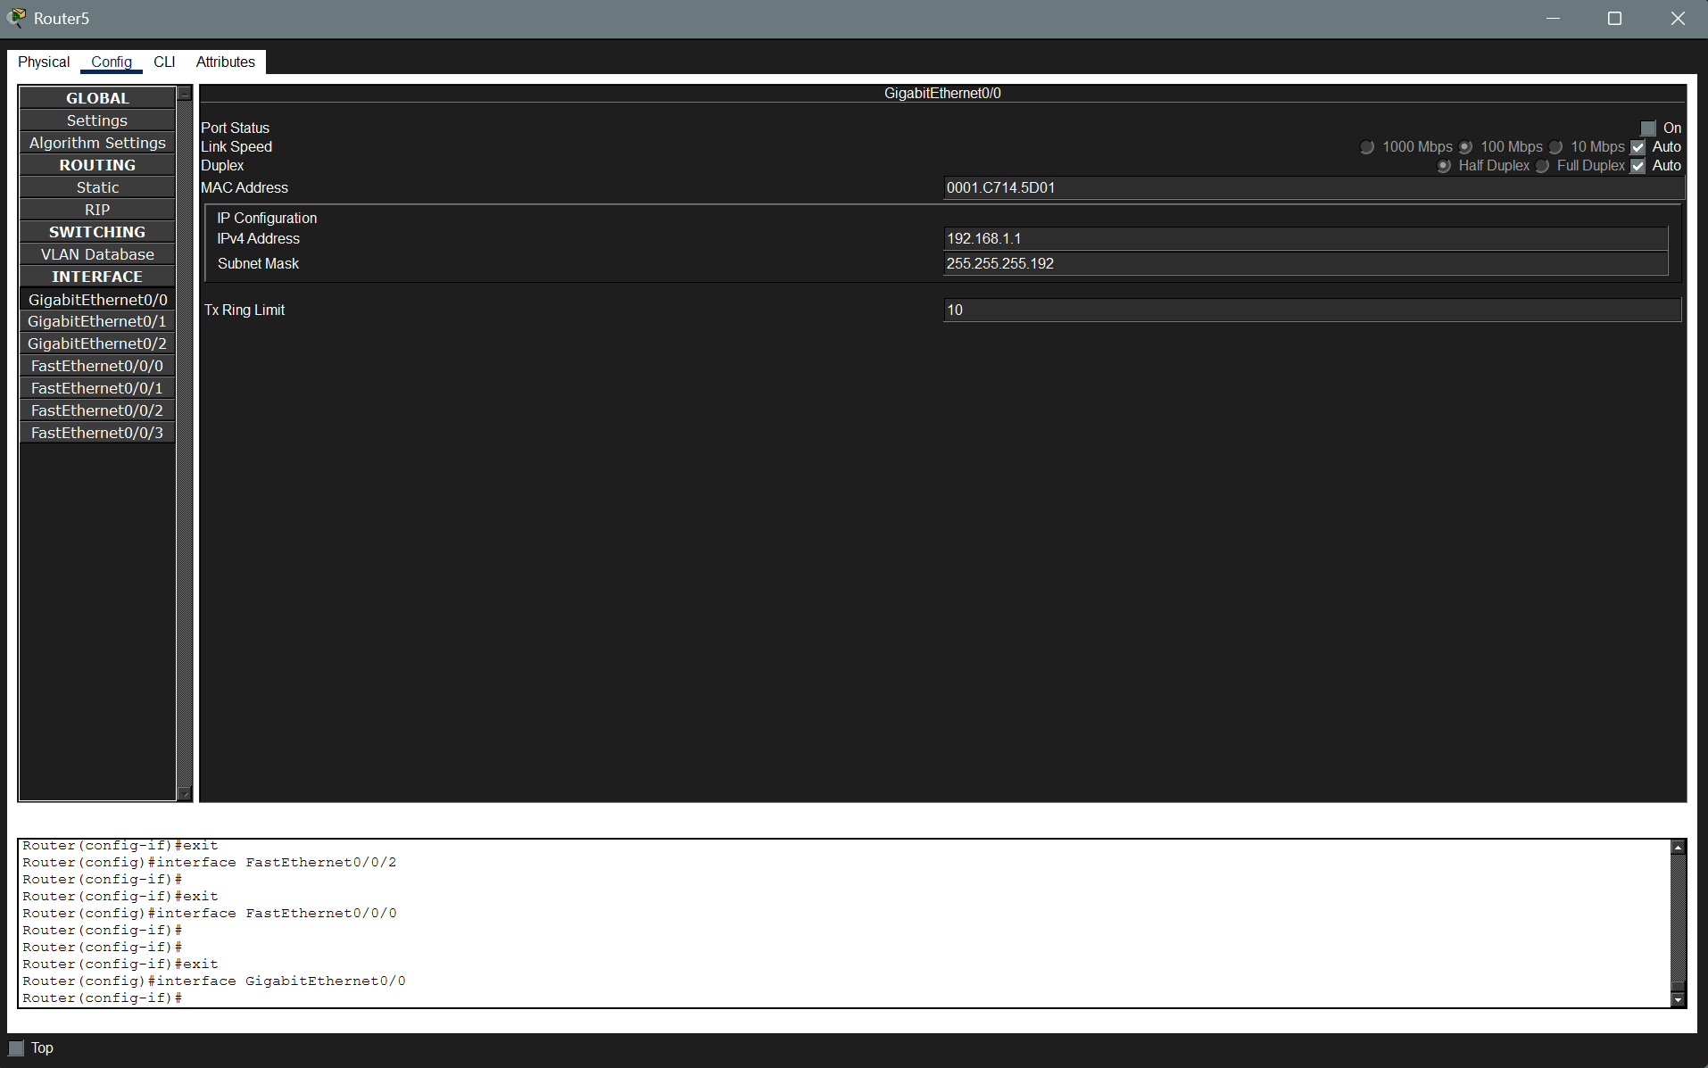
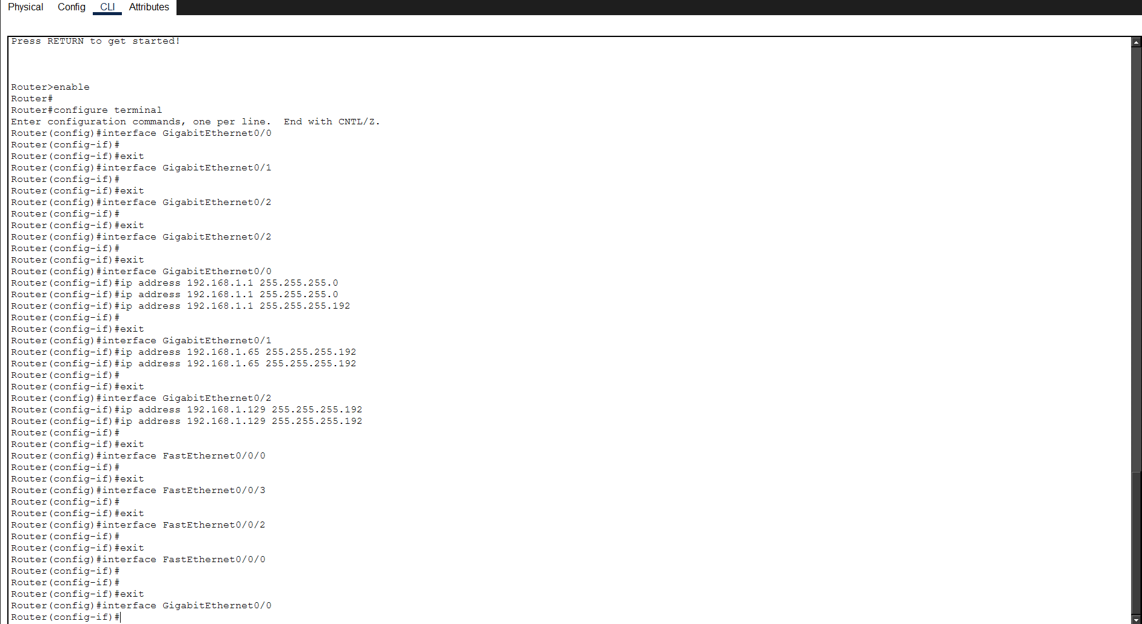
- Configure IP in each system according to its subnet along with the default gateway (IP address of the router port)
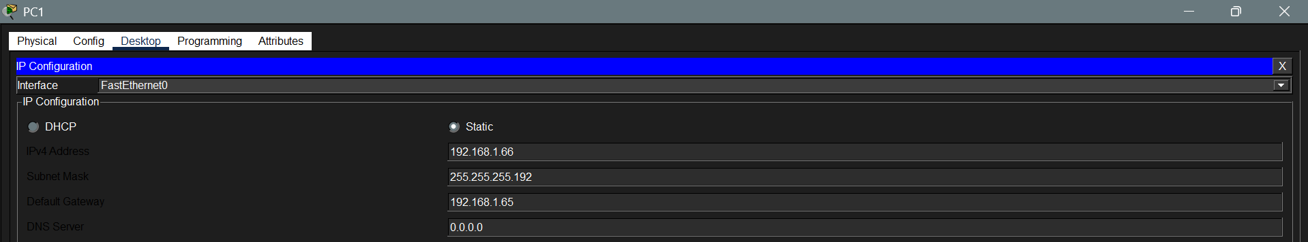
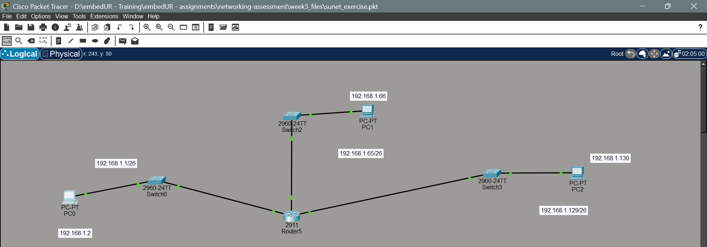
- Now ping one subnet from the other subnet
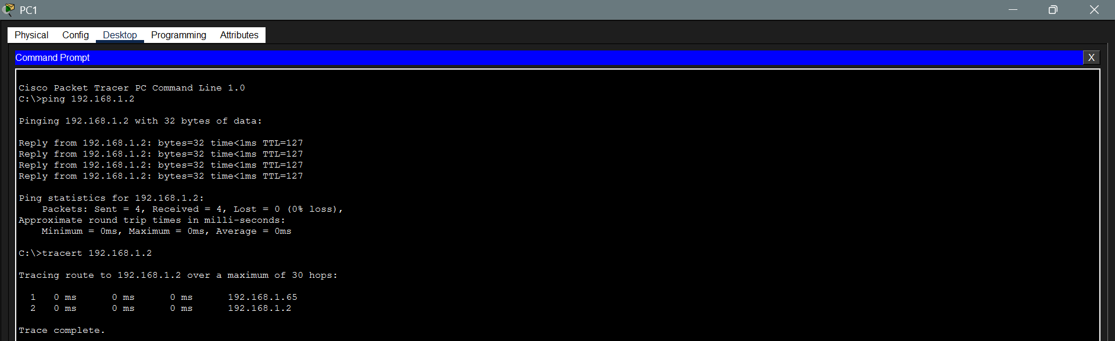
6. You are given 3 IP addresses: 10.1.1.1, 172.16.5.10 and 192.168.1.5.
Task: Identify the class of each IP addresses (Class A, B and C). What is the default subnet mask for each class ?
Provide the range of IP address for Each Class
IP Address | Class | Subnet Mask | Range (first octet)
10.1.1.1 | A | 255.0.0.0 | 1 – 126
172.16.5.10 | B | 255.255.0.0 | 128 – 191
192.168.1.5 | C | 255.255.255.0 | 192 – 223
7. In the CISCO Packet Tracer, create a small network with multiple devices (e.g 2 PCs and a router). Use a private IP address (e.g 192.168.1.x) on the PC and configure the router to perform a network address translation to allow PC to access the internet.
a. Create a topology with 2 PC (can be 2 or more), a switch (optional), a router and a server (to act as WAN component)
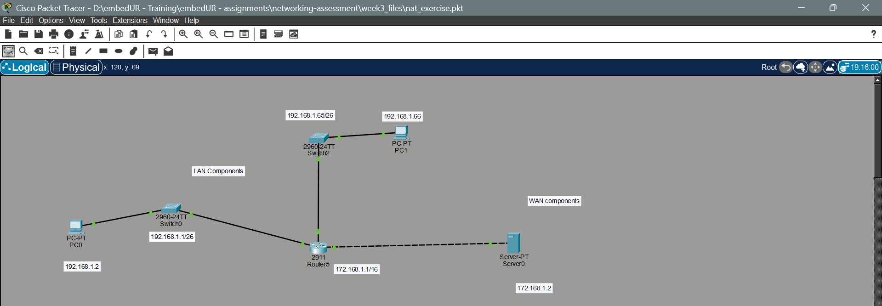
b. Now configure the router component with the following commands
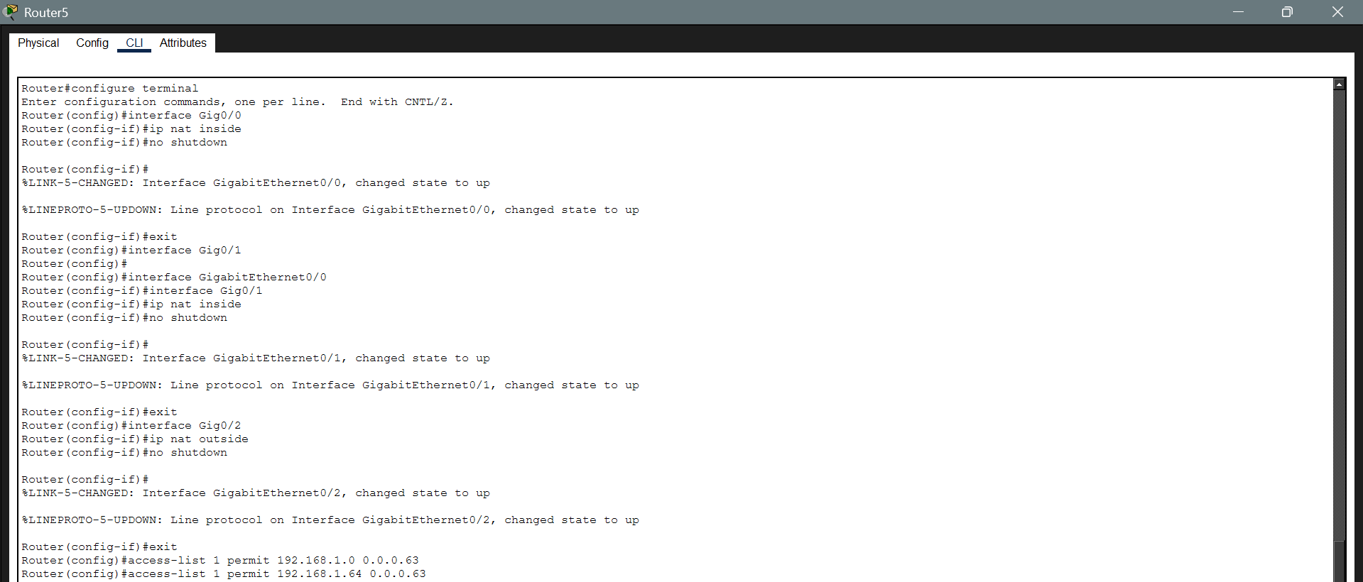
c. Now ping the WAN component system from the LAN(private IP system) component
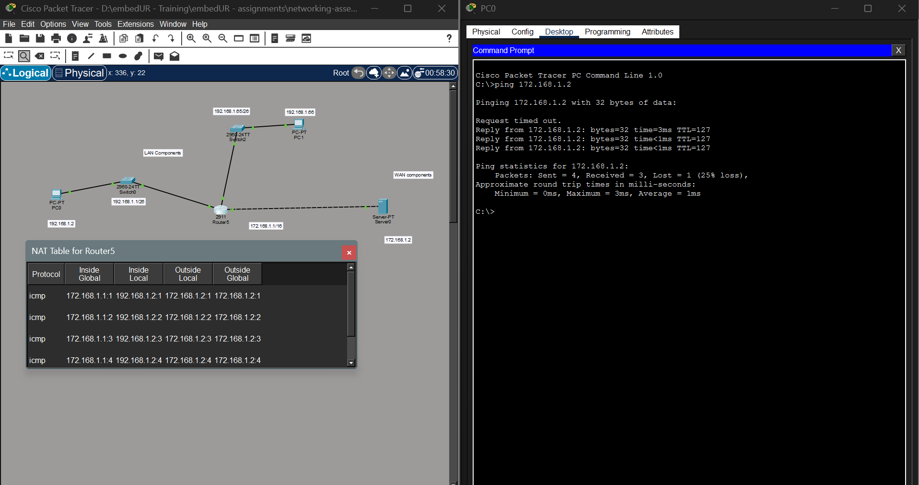
We can access the public component (WAN) from the private component but we can never access the private component from the public components.
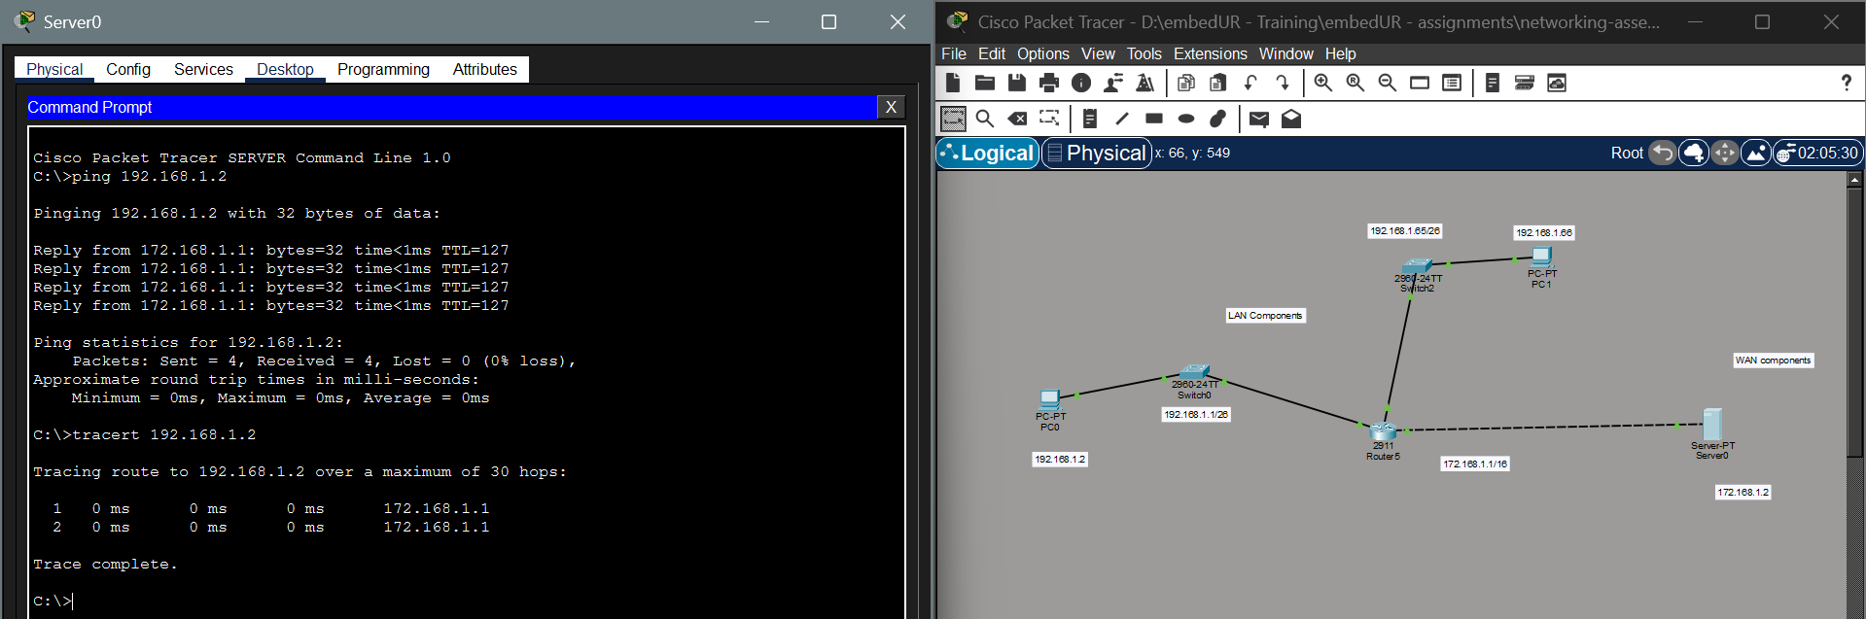
It only reached the router from where the packets will be send based on the NAT table.

