**1.** **import java.util.*;**

**import java.io.*;**

**class Main**

**{**

**public static void main(String[] args)**

**{**

**String a,b="";**

**char c;**

**int d=0,i;**

**try**

**{**

**Scanner sc=new Scanner(System.in);**

**System.out.println("Enter the string:");**

**a=sc.next();**

**d=a.length();**

**for(i=d-1;i>=0;i--)**

**{**

**b=b+a.charAt(i);**

**}**

**System.out.println("The Reverse of the string is:"+ b);**

**}**

**catch(Exception e)**

**{**

**System.out.println("Enter only string");**

**}**

**}**

**}**

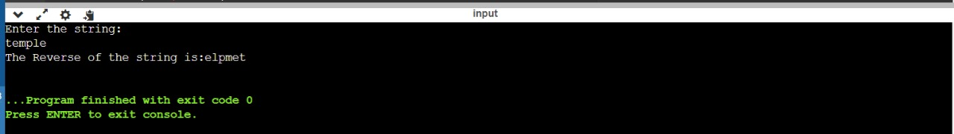

**2.** **import java.util.*;**

**class username{**

**public static void main(String args[])**

**{**

**String s1,s2;**

**boolean result;**

**Scanner s= new Scanner(System.in);**

**s1=s.nextLine();**

**s2=s.nextLine();**

**result=s1.equals(s2);**

**if (result==false)**

**{**

**System.out.println("User name is Invalid");**

**}**

**else**

**{**

**System.out.println("User name is valid");**

**}**

**}**

**}**

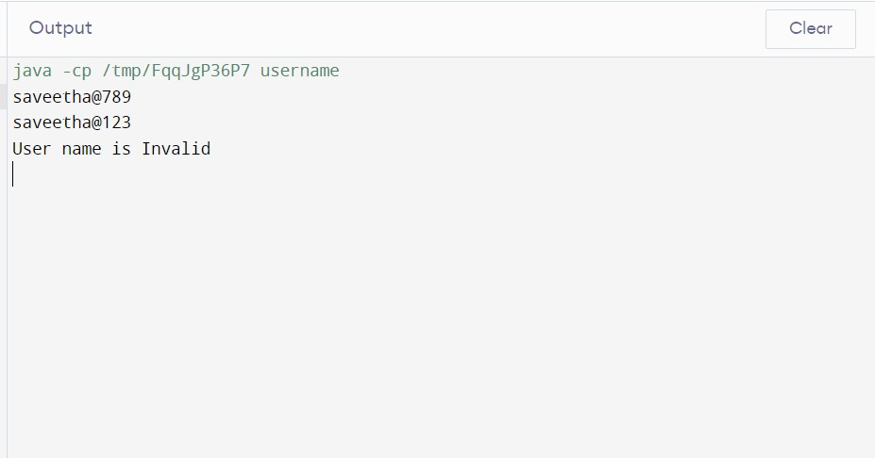

**3. import java.io.*;**

**import java.util.*;**

**class reverse**

**{**

**public static void main(String arg[])**

**{**

**try**

**{**

**Scanner sc=new Scanner(System.in);**

**int n,re=0,rem;**

**System.out.println("Enter a number:");**

**n=sc.nextInt();**

**while(n!=0)**

**{**

**rem=n%10;**

**re=re*10+rem;**

**n=n/10;**

**}**

**System.out.println("The reversed number is:"+re);**

**}**

**catch(Exception e)**

**{**

**System.out.println("Enter a valid number");**

**}**

**}**

**}**

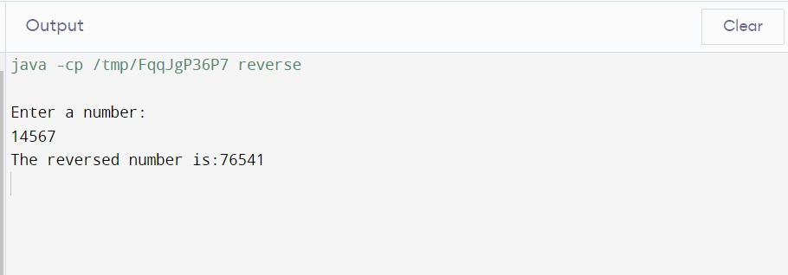

**4.** **import java.util.*;**

**class eligiblevote {**

**public static boolean checkInt(String s){**

**try{**

**int n = Integer.parseInt(s);**

**return true;**

**}**

**catch(NumberFormatException e){**

**System.out.println("Enter a Valid Age in Integer.");**

**return false;**

**}**

**}**

**public static void main(String[] Args){**

**Scanner sc = new Scanner(System.in);**

**String age;**

**System.out.println("Enter age : ");**

**age = sc.nextLine();**

**if(checkInt(age) == true ){**

**int a = Integer.parseInt(age);**

**if(a > 0){**

**if(a >= 18){**

**System.out.println("You are Eligible to Vote");**

**}**

**else{**

**int d = 18 - a;**

**System.out.println("Sorry ! You are Eligible after " + d + " years.\n");**

**}**

**}**

**else{**

**System.out.println("Enter a Valid Age.");**

**}**

**}**

**}**

**}**

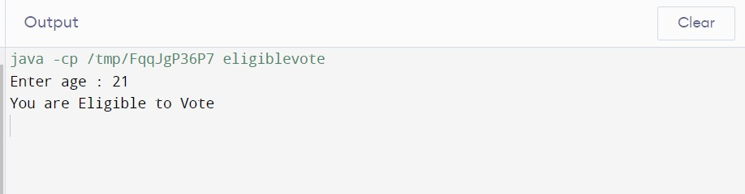

**5.** **import java.util.Scanner;**

**import java.io.*;**

**class GCD**

**{**

**static int gcd(int x, int y)**

**{**

**int r=0, a, b;**

**a = (x > y) ? x : y; // a is greater number**

**b = (x < y) ? x : y;**

**r = b;**

**while(a % b != 0)**

**{**

**r = a % b;**

**a = b;**

**b = r;**

**}**

**return r;**

**}**

**static int lcm(int x, int y)**

**{**

**int a;**

**a = (x > y) ? x : y; // a is greater number**

**while(true)**

**{**

**if(a % x == 0 && a % y == 0)**

**return a;**

**++a;**

**}**

**}**

**public static void main(String args[])**

**{**

**try**

**{**

**Scanner sc = new Scanner(System.in);**

**System.out.println("Enter N value: ");**

**int N=sc.nextInt();**

**if(N==2)**

**{**

**System.out.println("Enter the two numbers: ");**

**int x = sc.nextInt();**

**int y = sc.nextInt();**

**System.out.println("The GCD of two numbers is: " + gcd(x, y));**

**System.out.println("The LCM of two numbers is: " + lcm(x, y));**

**}**

**if(N==3)**

**{**

**System.out.println("Enter the three numbers: ");**

**int x = sc.nextInt();**

**int y = sc.nextInt();**

**int z = sc.nextInt();**

**int i;**

**int a=Math.max(x,Math.max(y,z));**

**while(true)**

**{**

**if(a % x == 0 && a % y == 0 && a%z==0)**

**{**

**break;**

**}**

**else**

**++a;**

**}**

**System.out.println("LCM of "+x+", "+y+" and "+z+" is "+a);**

**int b=Math.min(x,Math.min(y,z));**

**for(i=b;i>=0;i--)**

**{**

**if((x%i==0) && (y%i==0) && (z%i==0))**

**break;**

**}**

**System.out.println("GCD of "+x+", "+y+" and "+z+" is "+i);**

**}**

**}**

**catch(Exception e)**

**{**

**System.out.println("Enter only numbers");**

**}**

**}**

**}**

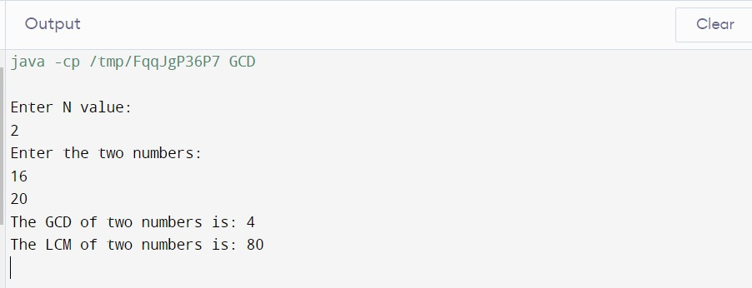

**6.** **import java.util.Scanner;**

**class RightTriangleStarPattern {**

**public static void main(String[] args) {**

**Scanner scanner = new Scanner(System.in);**

**System.out.print("Enter the number of rows for the right triangle: ");**

**int numRows = scanner.nextInt();**

**for (int i = 1; i <= numRows; i++) {**

**for (int j = 1; j <= numRows - i; j++) {**

**System.out.print(" ");**

**}**

**for (int k = 1; k <= i; k++) {**

**System.out.print("*");**

**}**

**System.out.println();**

**}**

**scanner.close();**

**}**

**}**

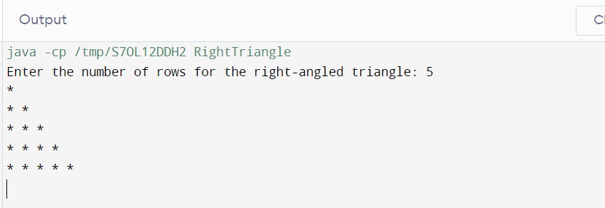

**7.** import java.util.Scanner;

public class PascalTriangle {

public static void main(String[] args) {

Scanner scanner = new Scanner(System.in

System.out.print("Enter the number of rows for the Pascal's Triangle: ");

int numRows = scanner.nextInt();

for (int i = 0; i < numRows; i++) {

// Print spaces for the left side of the triangle

for (int j = 0; j < numRows - i; j++) {

System.out.print("\t");

}

int value = 1;

for (int k = 0; k <= i; k++) {

System.out.print("\t" + value);

value = value * (i - k) / (k + 1);

}

System.out.println();

}

scanner.close();

}

}

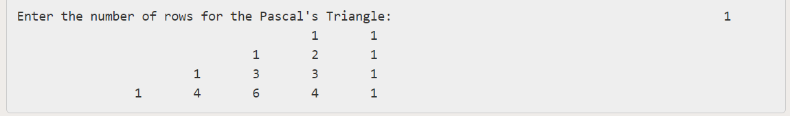

**8.** **import java.util.*;**

**class interest**

**{**

**public static void main(String[] args)**

**{**

**try**

**{**

**double p;**

**int n;**

**double r,i;**

**Scanner sc=new Scanner(System.in);**

**System.out.print("Is the person is senior citizen(y/n): ");**

**char g=sc.next().charAt(0);**

**System.out.println("Enter the principal amount:");**

**p=sc.nextDouble();**

**System.out.println("Enter the no.of.years:");**

**n=sc.nextInt();**

**if(g=='y'||g=='Y')**

**{**

**r=12;**

**i=p*n*r/100;**

**System.out.println("Interest:"+i);**

**}**

**if(g=='n'||g=='N')**

**{**

**r=10;**

**i=p*n*r/100;**

**System.out.println("Interest:"+i);**

**}**

**if(p<=0)**

**{**

**System.out.println("Enter the valid amount");**

**}**

**if(n<=0)**

**{**

**System.out.println("Enter the valid no.of.years");**

**}**

**}**

**catch(Exception e)**

**{**

**System.out.println("Enter the amount");**

**}**

**}**

**}**

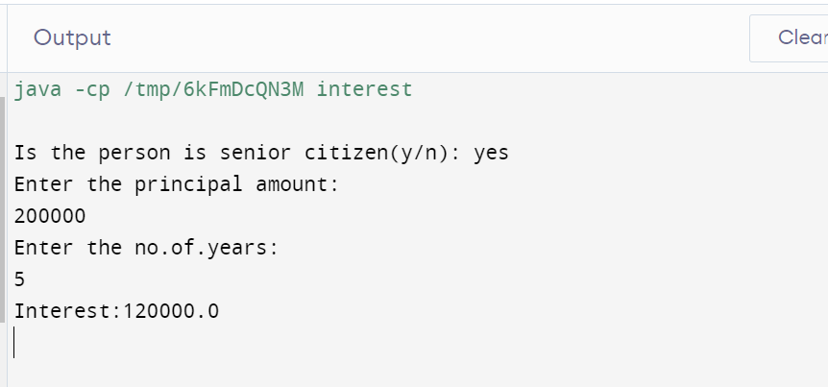

**9.** **import java.util.Scanner;**

**import java.io.*;**

**class DAY2EVENSUMOFFIBONACCISERIES {**

**public static void main(String[] args){**

**int my_input, i, sum;**

**System.out.println("Required packages have been imported");**

**Scanner my_scanner = new Scanner(System.in);**

**System.out.println("A reader object has been defined ");**

**System.out.println("Enter the value of N: ");**

**my_input = my_scanner.nextInt();**

**int fabonacci[] = new int[2 * my_input + 1];**

**fabonacci[0] = 0;**

**fabonacci[1] = 1;**

**sum = 0;**

**for (i = 2; i <= 2 * my_input; i++) {**

**fabonacci[i] = fabonacci[i - 1] + fabonacci[i - 2];**

**if (i % 2 == 0)**

**sum += fabonacci[i];**

**}**

**System.out.printf("Even sum of fibonacci series till number %d is %d" , my_input, sum);**

**}**

**}**

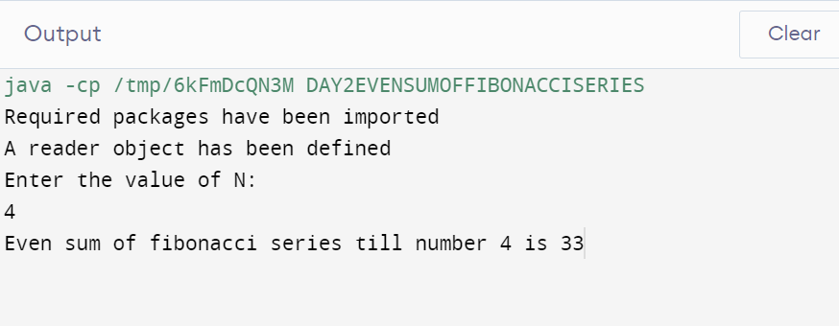

**10.** **import java.util.*;**

**class DAY2SKIPPING**

**{**

**public static void main(String[] args) {**

**try**

**{**

**Scanner obj=new Scanner(System.in);**

**System.out.println("M=");**

**int m=obj.nextInt();**

**System.out.println("N=");**

**int n=obj.nextInt();**

**System.out.println("K=");**

**int k=obj.nextInt();**

**if(m<=0 || n<=0 || k<=0)**

**{**

**System.out.println("invalid input");**

**}**

**else if(m<=n || k>=n || n<=m)**

**{**

**System.out.println("invalid input");**

**}**

**while(m<=n)**

**{**

**System.out.println(m);**

**m=m+k+1;**

**}**

**}**

**catch (Exception e){**

**System.out.println("invalid input");**

**}**

**}**

**}**

