Contents
1. Introduction 2
1.1 Broad Area of Work 2
1.2 Background 2
1.3 Objective 2
1.4 Scope of Work 3
2. Literature Survey 4
3. Implementation Details 6
3.1 Methodology 6
3.1.1 Multi Model Feature Fusion 8
3.1.2 CNN Layer 11
3.1.3 LSTM Layer 12
3.1.4 Transformer Block 14
3.1.5 Regime-Aware Layer 16
3.1.6 End-to-End Layer Integration 19
3.2 Design Overview 21
3.3 Tools and Platform 22
3.4 Assumptions & Constraints 22
4. Results & Discussions 24
5. Future Plan after Mid Semester 25
6. Conclusion and Future Scope of Work 26
7. References 27

- Introduction

  - Broad Area of Work

This dissertation falls within the interdisciplinary domain of financial time series analysis, artificial intelligence, and computational finance. It specifically focuses on the application of advanced AI and deep learning techniques to model, analyze, and forecast foreign exchange (FX) rate movements. The work integrates concepts from machine learning, econometrics, and data science to address complex prediction problems in highly dynamic financial markets. The current research project focus in the following application areas:

    - Natural language processing: To extract the markets data & financial headlines for sentiment analysis
    - Knowledge representation: To research and implement technical indicators for currency trading
    - Data Modeling: To extract the data, process it and create features
    - Deep Learning: Hybrid Deep Learning architecture for modeling sequential and temporal data
    - Prediction Analysis: Analyze & predict the price action and forecast the FX rates

  - Background

Foreign exchange markets are among the most liquid and volatile financial markets, influenced by macroeconomic indicators, geopolitical events, and market sentiment. Traditional forecasting approaches such as Autoregressive Integrated Moving Average (ARIMA) and Generalized Autoregressive Conditional Heteroskedasticity (GARCH) models often fail to capture non-linear patterns, and long-term dependencies present in FX data. Recent advancements in artificial intelligence, particularly deep learning models like Convolutional Neural Network (CNN), Long Short-Term Memory (LSTM), Gated Recurrent Units (GRU), and Transformer architectures, have shown promising capabilities in modeling sequential and temporal data. These methods provide an opportunity to improve forecasting accuracy, especially for multi-step ahead predictions, which are inherently more challenging due to error propagation.

  - Objective

The primary objective of this research is to design and develop an AI-driven framework for accurate multi-step forecasting of foreign exchange rates. The specific objectives include:

    - Design and implement a Hybrid CNN-LSTM-Transformer architecture for multi-step FX rate forecasting.
    - Develop a multi-model feature fusion pipeline integrating technical, macroeconomic, and NLP-based sentiment features.
    - Conduct systematic ablation studies to quantify the marginal contribution of each architectural component.
    - Evaluate model performance across multiple currency pairs, forecasting horizons, and market volatility baselines.
    - Compare the proposed model against ARIMA, Prophet, vanilla LSTM, and Temporal Fusion Transformer baselines.
    - Develop a regime-aware model evaluation framework to assess robustness during high-volatility market events.

  - Scope of Work

The scope of this study is limited to selected precious metal currency pairs (such as XAU/USD or XAG/USD) using historical exchange rate data. The research involves data preprocessing, feature engineering, and normalization techniques to improve model performance. It includes the development and training of deep learning architectures for multi-step forecasting, along with hyperparameter optimization. External macroeconomic variables may be incorporated depending on data availability. The study focuses on supervised learning techniques and does not extend to high-frequency trading systems or real-time deployment.

- Literature Survey

The trajectory of foreign exchange and equity price forecasting research reveals a clear progression from linear econometric assumptions towards non-linear, data-driven, and increasingly multi-modal architectures. Classical models such as the Box–Jenkins ARIMA framework and Bollerslev’s GARCH formulation remain foundational for modelling autocorrelation and volatility clustering, but both presuppose stationarity and linear dependence structures that are routinely violated by high-frequency currency data, motivating the shift towards deep sequential learners described below.

Hochreiter and Schmidhuber’s Long Short-Term Memory (LSTM) architecture established the gating mechanisms – input, forget, and output gates – that allow recurrent networks to retain information across long sequences while mitigating vanishing gradients, and this remains the backbone of nearly every sequential forecasting study reviewed here. Building on this foundation, recent IEEE-indexed literature converges on a set of recurring themes directly relevant to this dissertation. Predicting Forex Prices: An Evaluation of LSTM, XGBoost and Transformer Architectures (2025) benchmarks deep LSTM networks, gradient-boosted trees, and Transformer encoders against EUR/USD, NZD/USD, EUR/NZD, and AUD/NZD pairs using technical and fundamental indicators, concluding that no single architecture dominates across all market regimes and that an ensemble balances accuracy against reliability – a finding that directly motivates this dissertation’s hybrid, rather than single-model, design philosophy. Complementing this, Forecasting Stock Prices with Sequential Deep Learning: A Long Short-Term Memory Approach (2025) demonstrates that windowed LSTM encoders, when fused with sentiment scores extracted from financial news and social media, substantially outperform ARIMA baselines on technology-sector closing-price prediction, reinforcing the value of pairing sequential models with exogenous textual signals.
On the spatial-feature front, Forex Price Trend Prediction using Convolutional Neural Network (2023) converts EUR/USD price sequences into image-like representations and applies a convolutional classifier to detect uptrend/downtrend regimes, achieving roughly 93% directional accuracy on out-of-sample data, evidencing that local, image-style pattern extraction can isolate structural breaks that purely sequential models may smooth over. This finding directly justifies the role of the CNN layer in the proposed hybrid architecture as a localized feature extractor positioned ahead of the recurrent and attention stages. On the sentiment-fusion front, Stock Market Trend Prediction Model using Deep Learning based Sentiment Analysis of Financial Data (2024) reports that a neural trend-prediction model conditioned on macroeconomic and microeconomic sentiment surpasses 96% accuracy on Indian market data and surfaces behavioural-finance herd effects, underscoring that sentiment is not merely a noisy auxiliary signal but a primary driver of short-term price trends. Most directly relevant to the currency domain, Impact of News Sentiment on Foreign Exchange Rate Prediction (2023) builds a USD/INR forecasting model that augments econometric factors with a sentiment index derived using FinBERT – a BERT-family transformer pretrained on financial corpora – and shows that the resulting sentiment index behaves as a leading indicator of exchange-rate movement. This paper is the principal precedent for the proposed dissertation’s choice of FinBERT as the NLP sentiment-extraction backbone.

Conclusion on Literature Survey
Three gaps emerge consistently across this body of work and define the positioning of the present dissertation.
- First, the reviewed studies generally treat CNN-based spatial extraction, LSTM-based temporal modelling, Transformer-based global attention, and NLP-based sentiment fusion as separate, single-purpose pipelines rather than as complementary stages of one unified architecture.
- Second, almost none of the reviewed papers address multi-step ahead forecasting explicitly; most report single-step-ahead accuracy, leaving the compounding error-propagation problem inherent to multi-horizon prediction largely unexamined.
- Third, evaluation in the surveyed literature is performed under blended market conditions, without an explicit regime-aware lens that isolates model behaviour during high-volatility transitions.
This dissertation’s Hybrid CNN-LSTM-Transformer architecture, multi-modal feature-fusion pipeline, and regime-aware evaluation framework are designed specifically to close these three gaps, building directly on the deep learning foundations established by Goodfellow, Bengio and Courville and the sequential-modelling principles of Hochreiter and Schmidhuber.

- Implementation Details

  - Methodology
The methodology adopted for this dissertation is organised as a sequential, five-stage pipeline that converts raw, heterogeneous market data into a regime-conditioned, multi-step ahead foreign-exchange forecast. Each stage is implemented as an independently trainable module so that ablation studies can isolate the marginal contribution of every component, directly addressing the first objective stated in Section 1.3. For the final submission, every stage described below is specified down to exact layer dimensions, tensor shapes, and hyperparameters, so that the architecture is fully reproducible from this report alone. Figure 1 summarises the end-to-end flow with the tensor shape produced at every stage; the five sub-sections that follow describe the multi-modal feature-fusion pipeline and each of the four model layers – CNN, Bi-LSTM, Transformer, and Regime-Aware output – in full technical detail, and Section 3.1.6 then consolidates how every layer's output becomes the next layer's input across the complete pipeline.

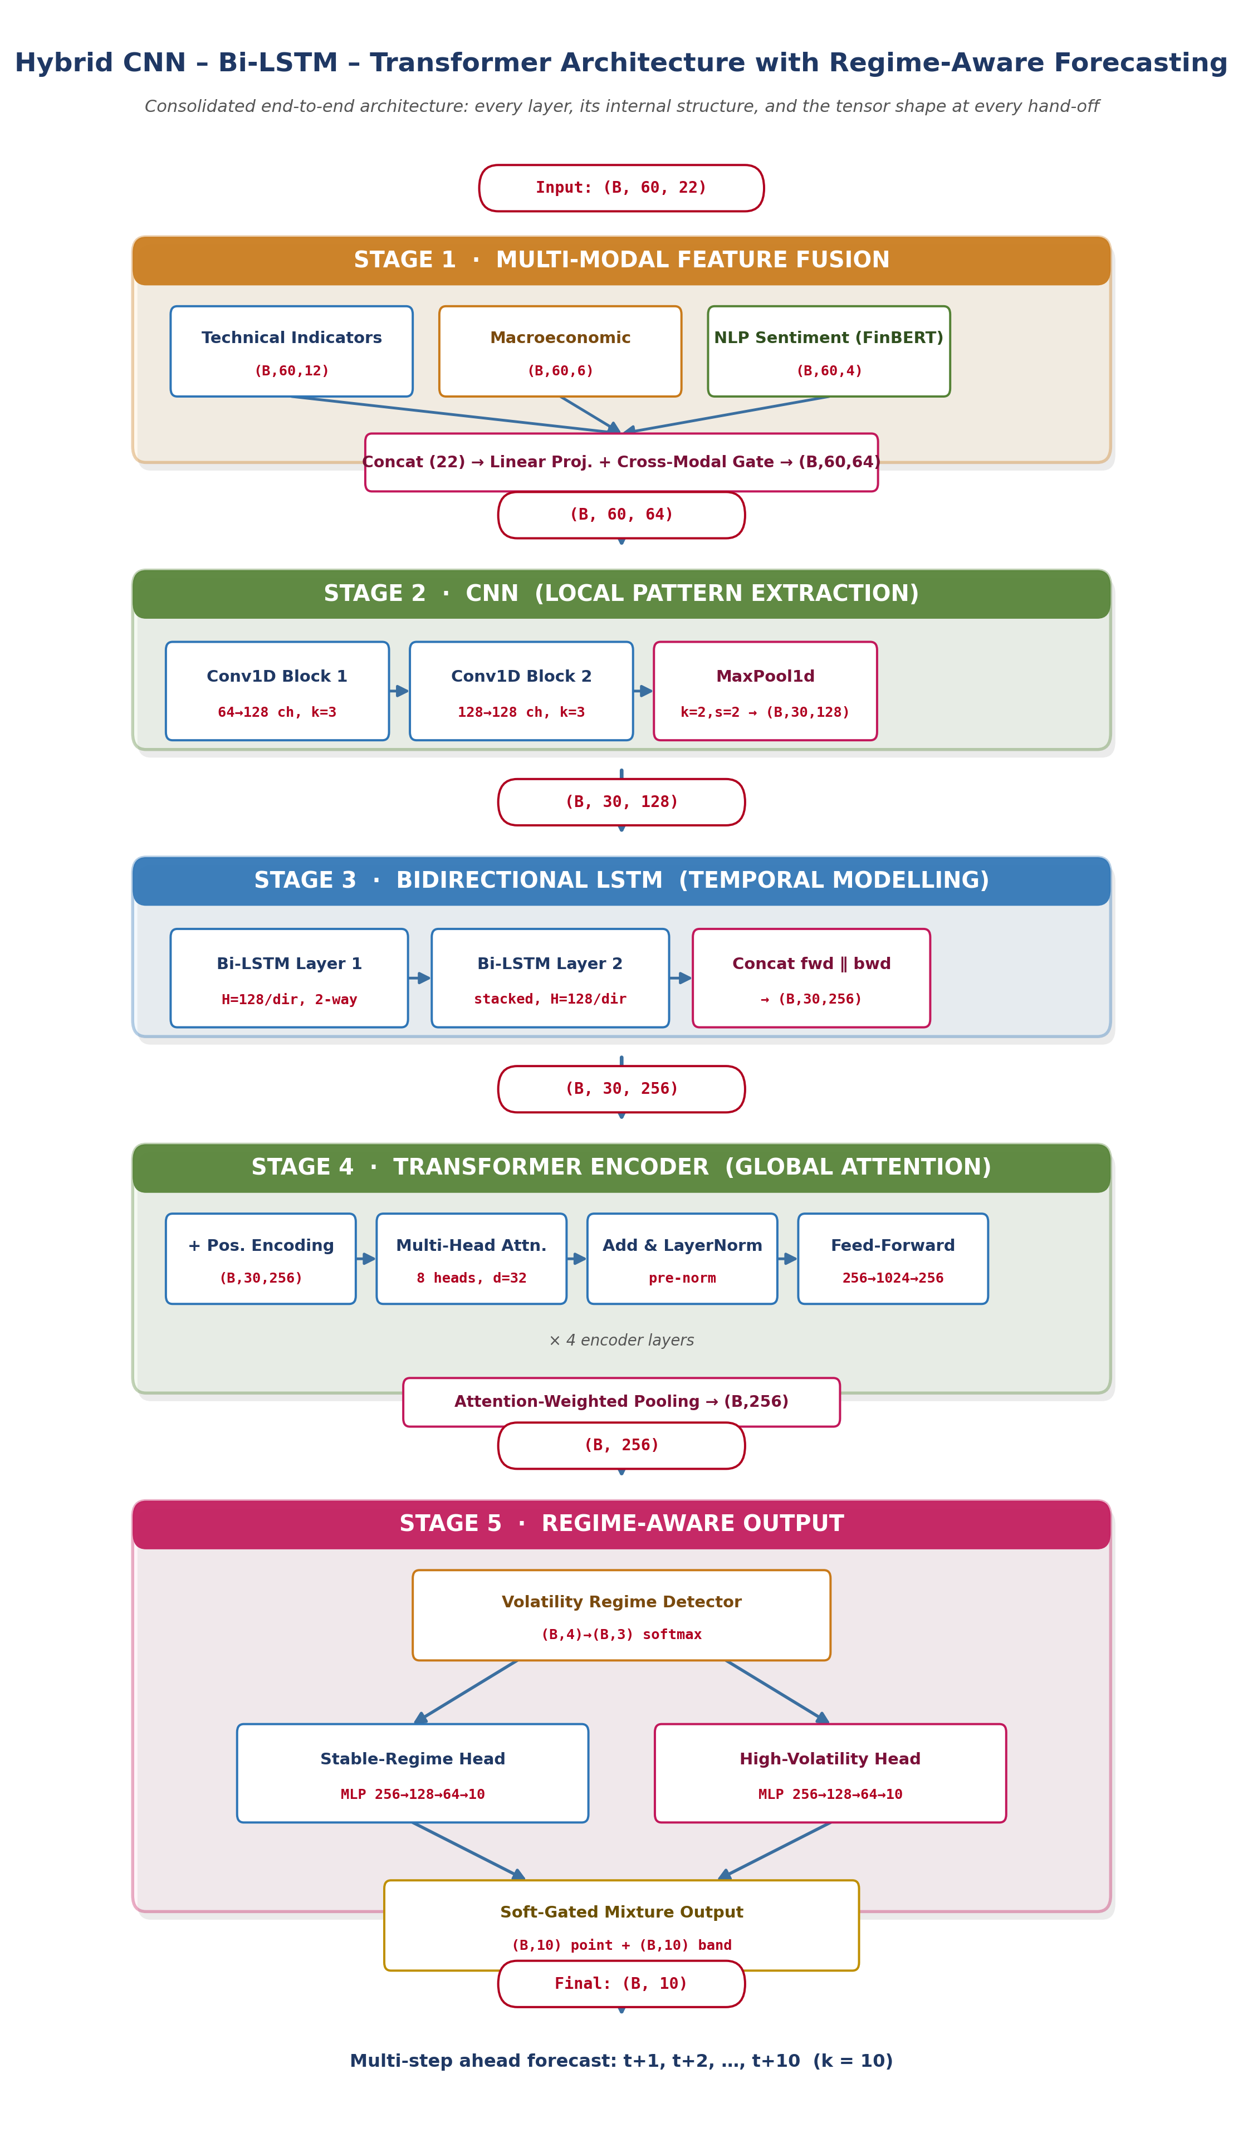
Consolidated Architecture Diagram: the complete Hybrid CNN-LSTM-Transformer pipeline with regime-aware output, showing every layer’s internal structure and the tensor shape produced at every hand-off in a single view. (Detailed per-layer figures follow in Sections 3.1.1–3.1.6.)
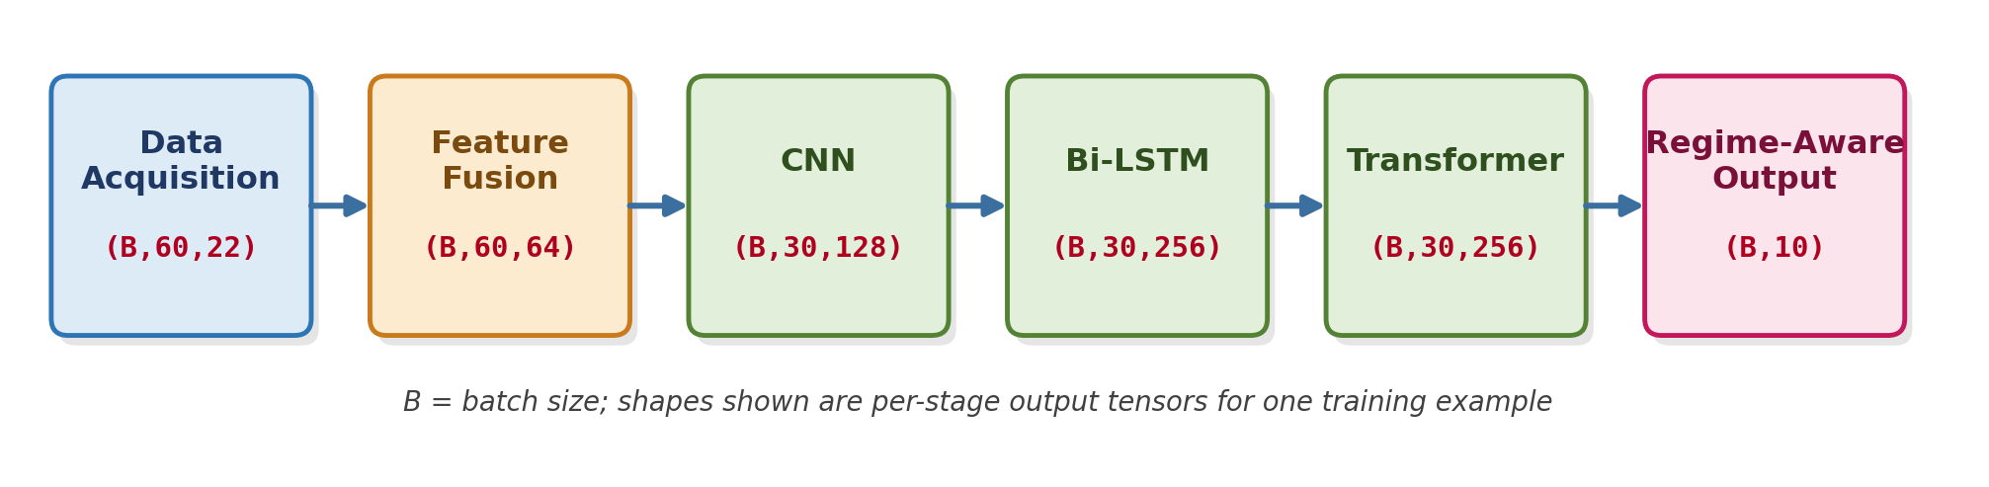
Figure 1: End-to-end methodology pipeline from raw multi-modal data acquisition to the regime-aware multi-step forecast, annotated with the tensor shape produced at every stage (B = batch size).
    - Multi Model Feature Fusion
Currency movements are driven simultaneously by price action, macroeconomic fundamentals, and crowd sentiment, and no single data stream captures all three influences. The multi-model feature-fusion pipeline therefore ingests three parallel streams before any sequence model is applied, directly responding to the literature survey finding that sentiment is a leading, not merely auxiliary, indicator of short-term price trend. Each stream is computed over an identical lookback window of T = 60 time steps, so that every raw feature is aligned to a common time axis before fusion, and every per-timestep feature vector ultimately feeds the same downstream CNN layer (Section 3.1.2) as a single fused tensor.
Stream 1 — Technical Indicator Stream (12 features per time step)
This stream is computed directly from the raw OHLC (Open-High-Low-Close) price series and trading volume using standard technical-analysis formulae, giving 12 scalar features per time step.
- Raw OHLC (4 features) – the open, high, low, and close price for each bar, min-max normalised within each rolling window to remove absolute price-level dependence and allow the model to generalise across different price regimes of the same instrument.
- Relative Strength Index, RSI (1 feature) – computed over a 14-period window as RSI = 100 − 100/(1+RS), where RS is the ratio of the average upward close-to-close change to the average downward change over the same window; bounded in [0,100] and used by the model as a momentum/overbought-oversold signal.
- MACD (3 features) – the Moving Average Convergence Divergence line (12-period EMA minus 26-period EMA), its 9-period signal line, and the MACD histogram (line minus signal) are all passed through as separate features, jointly encoding trend direction and trend acceleration.
- Bollinger Bands (3 features) – the upper band, middle band (20-period SMA), and lower band (±2 standard deviations from the middle band) together encode local volatility and provide a normalised sense of price position relative to its recent trading range.
- Rolling traded volume (1 feature) – log-transformed and z-scored over a trailing 60-bar window, used as a proxy for liquidity and conviction behind a price move.
Concatenating these gives a 12-dimensional technical feature vector per time step, producing a stream tensor of shape (B, 60, 12), where B is the training batch size.
Stream 2 — Macroeconomic Stream (6 features per time step)
Macroeconomic variables change far less frequently than price ticks (daily, weekly, or per central-bank meeting), so this stream is forward-filled onto the same 60-step intraday/daily grid used by the other two streams, aligning every macro release to the trading calendar as described in Section 1.4.
- Interest-rate differential (1 feature) – the difference between the base-currency and quote-currency policy interest rates, a primary determinant of carry-trade flows and medium-term currency drift.
- CPI surprise (1 feature) – the standardised deviation of the latest published Consumer Price Index reading from the consensus forecast, capturing unexpected inflation shocks that move rate expectations.
- Central-bank sentiment flag (1 feature) – a discretised hawkish/neutral/dovish signal derived from the tone of the most recent policy statement, encoded numerically.
- Lagged macro dummies (3 features) – binary indicators flagging whether a major scheduled release (rate decision, non-farm payrolls equivalent, GDP print) occurred within the past 1, 3, or 5 trading sessions, allowing the model to learn decay-of-impact patterns after a macro shock.
This produces a 6-dimensional macro feature vector per time step and a stream tensor of shape (B, 60, 6). Where a given macroeconomic series is unavailable for a particular pair (per the data-availability assumption in Section 3.4), the corresponding feature is zero-filled and an additional missingness mask is folded into the central-bank sentiment flag rather than introducing a separate channel, keeping the stream width fixed at 6 regardless of data completeness.
Stream 3 — NLP Sentiment Stream (4 features per time step)
Financial news headlines and market commentary are scraped continuously and scored using FinBERT, a BERT-family transformer pretrained on a large financial corpus and fine-tuned for financial sentiment classification, following the precedent set by Tadphale et al. in the reviewed USD/INR sentiment-fusion study. FinBERT receives each headline as input and emits a three-way softmax distribution over {positive, neutral, negative}.
- FinBERT class probabilities (3 features) – the positive, neutral, and negative probabilities are averaged across all headlines published within each time-step window, giving a smoothed sentiment snapshot rather than relying on any single headline.
- Rolling compound sentiment score (1 feature) – computed as the exponentially-weighted moving average of (P(positive) − P(negative)) over the trailing 6 time steps, which smooths headline-level noise while remaining responsive to sustained sentiment shifts – this is the feature most directly motivated by the literature survey's finding that sentiment behaves as a leading indicator rather than a lagging one.
This produces a 4-dimensional sentiment feature vector per time step and a stream tensor of shape (B, 60, 4). On time steps with no published headlines, the previous step's smoothed values are carried forward, so the rolling compound score remains continuous rather than dropping to zero between news events.
Fusion Mechanism: Concatenation, Projection, and Cross-Modal Gating
At every time step t, the three streams are concatenated along the feature axis to form a raw 22-dimensional vector (12 technical + 6 macro + 4 sentiment = 22), giving a raw concatenated tensor of shape (B, 60, 22). This raw concatenation is then passed through a learned fusion layer comprising two parts.
- Linear projection – a fully-connected layer maps the 22-dimensional raw vector at each time step to a 64-dimensional fused representation (22 → 64), giving the downstream CNN sufficient channel capacity to learn richer combinations of the three modalities than the raw concatenation alone would allow.
- Learned cross-modal gating – in parallel with the projection, a small sigmoid-activated gating network consumes the same 22-dimensional input and produces three scalar gates (one per modality), which are broadcast-multiplied against the corresponding technical, macro, and sentiment sub-vectors before projection. This allows the model to learn, for example, to up-weight the sentiment stream during news-driven moves and down-weight it during quiet, range-bound trading, rather than treating all three streams as permanently equal contributors.
The fusion layer's output is therefore a single tensor of shape (B, 60, 64) – 60 time steps, each represented by a 64-dimensional fused feature vector that blends technical, macroeconomic, and sentiment information with a learned, input-dependent emphasis. Figure 2 illustrates this fusion process end-to-end, including the exact tensor shapes at each stage.
Integration with the CNN Layer (Section 3.1.2)
The fused tensor of shape (B, 60, 64) is the sole input consumed by the CNN layer described next. No further preprocessing is applied between the fusion layer and the CNN: the 64-dimensional fused feature axis becomes the channel dimension of the one-dimensional convolution, and the 60-step time axis remains the sequence dimension that the convolution slides across. This direct hand-off is deliberate – by the time information reaches the CNN, it has already been normalised and cross-modally weighted, so the convolutional filters can focus purely on detecting local temporal patterns rather than also having to learn to balance the three input modalities.
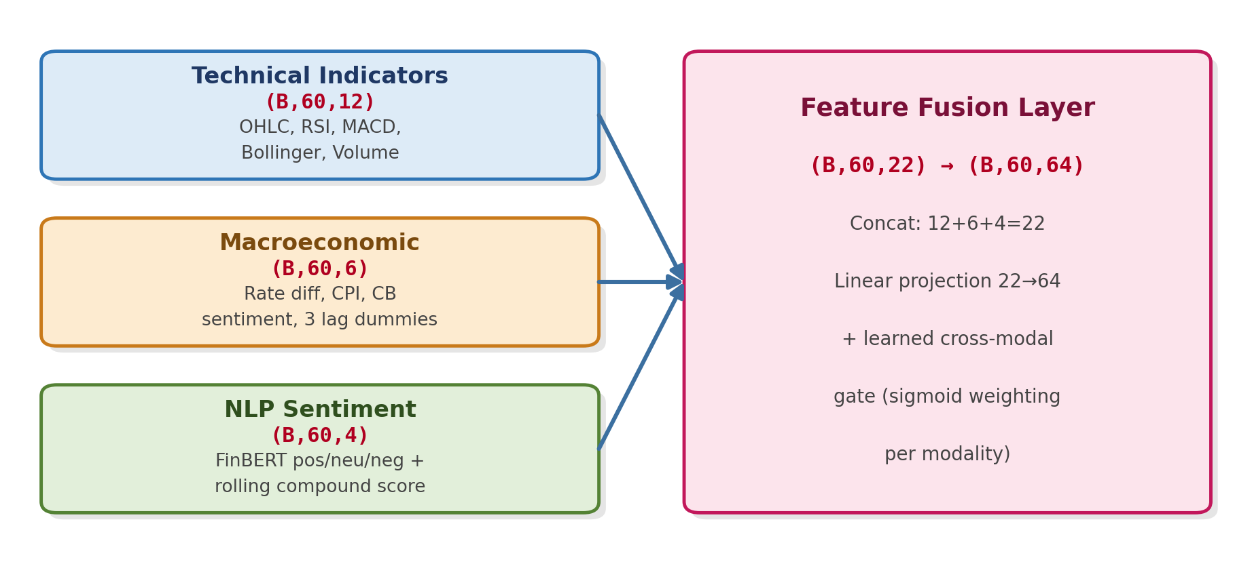
Figure 2: Multi-model feature fusion, fully specified: three raw streams (12+6+4=22 features per time step) are projected and gated into a 64-dimensional fused representation.
    - CNN Layer
The fused feature tensor of shape (B, 60, 64) produced by the feature-fusion layer (Section 3.1.1) is first passed through a one-dimensional Convolutional Neural Network (CNN) whose role is to extract short, localized patterns and sudden structural breaks – effects that a purely recurrent model can smooth over. This design choice is directly supported by the reviewed CNN-based forex trend study, which converted price sequences into image-like representations and achieved approximately 93% directional accuracy using a convolutional classifier, evidencing that local, image-style pattern extraction surfaces information that sequence-only models can miss.
Layer-by-Layer Architecture
PyTorch's standard convolution implementations expect the channel axis before the sequence axis, so the input is first transposed from (B, 60, 64) to (B, 64, 60) – 64 input channels, 60 positions along the time axis – before being passed through two stacked convolutional blocks and a pooling stage.
- Convolutional Block 1 – a Conv1D layer with 64 input channels, 128 output channels, kernel size 3, stride 1, and padding 1 (so the sequence length is preserved at 60). Padding of 1 on each side with a kernel of 3 guarantees the output length equals the input length: L_out = floor((L_in + 2×pad − kernel)/stride) + 1 = floor((60 + 2 − 3)/1) + 1 = 60. The convolution is immediately followed by BatchNorm1d(128) and a ReLU activation, giving an intermediate tensor of shape (B, 128, 60).
- Convolutional Block 2 – a second Conv1D layer with 128 input channels, 128 output channels, kernel size 3, stride 1, padding 1, again followed by BatchNorm1d(128) and ReLU, preserving the shape at (B, 128, 60). Stacking two convolutional blocks before pooling widens the effective receptive field on the time axis from 3 time steps (a single kernel) to 5 time steps, allowing the network to recognise slightly longer local motifs – such as a two-candle reversal pattern – without yet discarding any temporal resolution.
- Max-Pooling – a MaxPool1d layer with kernel size 2 and stride 2 halves the temporal resolution, taking the strongest activation from every consecutive pair of time steps and reducing the sequence length from 60 to 30: (B, 128, 60) → (B, 128, 30). This serves two purposes – it provides a small amount of translation invariance to the exact position of a local pattern within a two-step window, and it reduces the sequence length that the downstream Bi-LSTM and Transformer must process, which materially lowers their computational cost given that self-attention scales quadratically with sequence length.
- Dropout – a dropout layer with p = 0.2 is applied to the pooled feature maps during training only, randomly zeroing 20% of channel activations at each training step to discourage the convolutional filters from overfitting to noise patterns specific to the historical training window.
The tensor is finally transposed back from (B, 128, 30) to (B, 30, 128) so that the sequence axis is once again in the leading position expected by the recurrent layer that follows. Figure 3 depicts this complete internal flow, annotated with the exact tensor shape produced at every stage.
Why Two Convolutional Blocks Rather Than One
A single convolutional block with a kernel of 3 can only see a 3-step window directly. Stacking a second block of the same kernel size before pooling expands the receptive field to 5 raw time steps (each output position in block 2 already depends on 3 positions of block 1's output, each of which in turn depends on 3 raw positions, giving an effective span of 3 + (3−1) = 5). This lets the network recognise compound local patterns – for instance, a sharp move followed immediately by a partial retracement – that a single convolutional layer with the same kernel size could not represent in one pass. Channel width is also deliberately held at 128 across both blocks (rather than narrowing or widening further) to keep the parameter count of this stage modest relative to the downstream Bi-LSTM and Transformer stages, which carry most of the model's representational capacity.
Integration: Input from Feature Fusion, Output to Bi-LSTM
The CNN layer's input is exactly the (B, 60, 64) fused tensor handed off by Section 3.1.1, with no additional normalisation applied at the boundary since the fusion layer's projection already places all 64 channels on a comparable scale. The CNN's output – a sequence of 30 local feature maps, each a 128-dimensional vector, shape (B, 30, 128) – is passed directly into the bidirectional LSTM layer described in Section 3.1.3 with no intermediate transformation. This direct hand-off means the Bi-LSTM never sees raw price or sentiment values at all; it only ever sees CNN-extracted local feature maps, which allows the recurrent stage to focus entirely on modelling how already-detected local patterns evolve and relate to one another over time, rather than having to simultaneously perform low-level pattern detection and long-range temporal modelling.
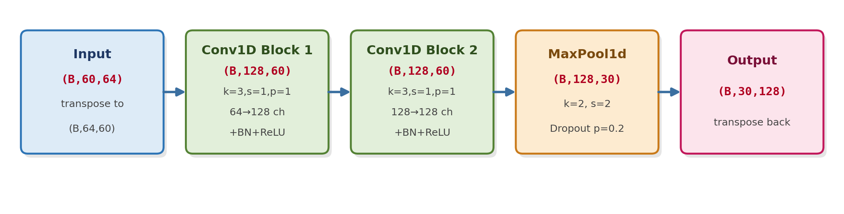
Figure 3: CNN layer internal architecture: two Conv1D blocks (64→128→128 channels) followed by max-pooling, with the exact tensor shape shown at every stage.
    - LSTM Layer
The local feature maps produced by the CNN layer, shape (B, 30, 128), are passed into a bidirectional Long Short-Term Memory (Bi-LSTM) network, which forms the temporal backbone of the architecture. The LSTM cell, introduced by Hochreiter and Schmidhuber, uses input, forget, and output gates to regulate the flow of information through a persistent cell state, allowing the network to retain dependencies over long sequences while mitigating the vanishing-gradient problem that limits plain recurrent networks. This gating mechanism is the common foundation across nearly every sequential forecasting study examined in the literature survey, from the sentiment-augmented LSTM stock forecaster to the LSTM/XGBoost/Transformer forex evaluation.
LSTM Cell Mechanics
At every time step t, an LSTM cell receives the current input x_t (here, a 128-dimensional CNN feature vector) together with the previous hidden state h_(t−1) and previous cell state c_(t−1), and computes three gates and a candidate cell update:
- Forget gate – f_t = σ(W_f·[h_(t−1), x_t] + b_f) determines what fraction of the previous cell state c_(t−1) is retained versus discarded.
- Input gate – i_t = σ(W_i·[h_(t−1), x_t] + b_i) determines how much of the new candidate information is written into the cell state.
- Output gate – o_t = σ(W_o·[h_(t−1), x_t] + b_o) determines how much of the (updated) cell state is exposed as the hidden state passed to the next time step and up to the next layer.
- Cell state update – c_t = f_t ⊙ c_(t−1) + i_t ⊙ tanh(W_c·[h_(t−1), x_t] + b_c), and the hidden state is h_t = o_t ⊙ tanh(c_t), where ⊙ denotes elementwise multiplication and σ is the sigmoid function. Because the forget gate allows c_t to carry information forward almost unchanged when f_t ≈ 1, gradients can flow backward through many time steps without vanishing, which is precisely the property that makes LSTMs suitable for the 30-step sequences produced by the CNN layer.
Bidirectionality and Stacking
A single (unidirectional) LSTM can only condition its representation of time step t on time steps 1 through t–1. For multi-step forecasting, however, the model is allowed to see the entire 30-step window when constructing its internal representation (the constraint only applies to the forecast horizon itself, not to the encoder), so the architecture uses a bidirectional LSTM to exploit this.
- Forward LSTM – processes the 30-step CNN feature sequence from t=1 to t=30, with hidden size H=128, producing a forward hidden-state sequence of shape (B, 30, 128).
- Backward LSTM – processes the same sequence in reverse, from t=30 down to t=1, also with hidden size H=128, producing a backward hidden-state sequence of shape (B, 30, 128).
- Concatenation – at every time step, the forward and backward hidden states are concatenated along the feature axis, 128 + 128 = 256, giving a combined output of shape (B, 30, 256). Every position in this output sequence is therefore informed by both the local patterns that preceded it and those that followed it within the 30-step window.
- Stacked depth – two Bi-LSTM layers are stacked: the first layer's 256-dimensional output sequence is fed as the input to a second Bi-LSTM layer (itself bidirectional with H=128 per direction), whose output is again (B, 30, 256). Stacking allows the second layer to model temporal regularities over the already-contextualised representations from the first layer, capturing regularities at a coarser time scale – for example, a multi-bar consolidation pattern – while the first layer focuses on more local sequential dependencies.
- Inter-layer dropout – a dropout of p = 0.3 is applied to the output of the first Bi-LSTM layer before it is passed to the second, reducing the risk that the second layer overfits to idiosyncrasies of the first layer's exact parameterisation.
Figure 4 illustrates this bidirectional, stacked flow together with the shape of the tensor at every hand-off point.
Why Bidirectionality Is Valid Here (and Where It Is Not)
Bidirectional processing is only valid when the entire input window is available at inference time, which is true here: at forecast time, the model always has the complete 60-step (reduced to 30-step post-CNN) historical window before it predicts the next k=10 steps. The bidirectional encoder is never asked to look into the forecast horizon itself – it only ever looks backward and forward within the already-observed lookback window. This distinction matters operationally: bidirectionality would be invalid if applied to the forecast horizon itself, but is fully valid, and beneficial, when applied to the encoder that summarises already-observed history.
Integration: Input from CNN, Output to Transformer
The Bi-LSTM layer's input is exactly the (B, 30, 128) tensor of local feature maps produced by the CNN layer (Section 3.1.2); no reshaping or normalisation is applied at this boundary because the CNN's BatchNorm already keeps the channel activations on a comparable scale. The Bi-LSTM's output – a sequence of 30 time steps, each described by a 256-dimensional state that fuses forward and backward, two-layer-deep temporal context, shape (B, 30, 256) – is passed directly into the Transformer block described in Section 3.1.4. This hand-off is what allows the Transformer to apply self-attention over already temporally-rich representations rather than over raw, untransformed feature maps: by this point each of the 30 positions already encodes a substantial window of local sequential context, and the Transformer's role is purely to relate these 30 positions to one another globally, irrespective of their distance apart.
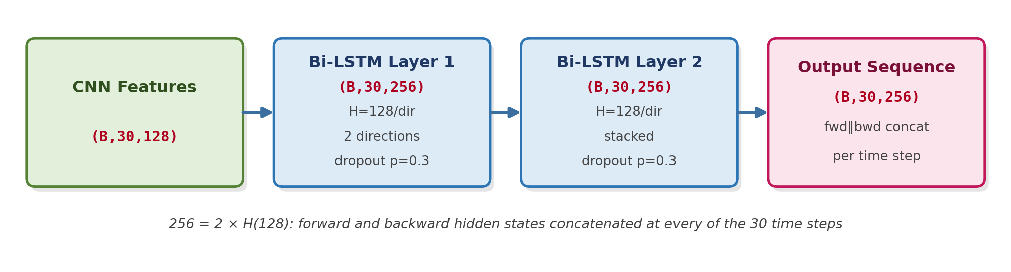
Figure 4: Bidirectional, 2-layer stacked LSTM: forward and backward passes (H=128 each) are concatenated into a 256-dimensional state at every of the 30 time steps.
    - Transformer Block
While the CNN and Bi-LSTM layers excel at local and sequential pattern extraction respectively, foreign-exchange prices are also influenced by global, multi-scale interactions – for example, the relationship between a currency pair's recent volatility regime and a macro announcement several days prior. The Transformer block, built around the multi-head self-attention mechanism, addresses this by allowing every position in the Bi-LSTM output sequence to attend directly to every other position, irrespective of distance, avoiding the recency bias inherent in purely recurrent architectures.
Positional Encoding
Self-attention itself is permutation-invariant – without additional information, it cannot distinguish the order of the 30 time steps it receives. A learned positional embedding of shape (30, 256) is therefore added elementwise to the Bi-LSTM output before it enters the first attention layer, giving the model an explicit signal of each position's location within the window. A learned (rather than fixed sinusoidal) embedding was chosen because the 30-step sequence length is fixed throughout training and inference, removing the main practical advantage of sinusoidal encodings (extrapolation to unseen lengths).
Multi-Head Self-Attention
For an input sequence of shape (B, 30, 256), self-attention first projects the input into queries (Q), keys (K), and values (V), each of shape (B, 30, 256), using three independent learned linear projections. With 8 attention heads, each head operates on a 256/8 = 32-dimensional slice of Q, K, and V. For a single head, attention is computed as Attention(Q,K,V) = softmax(QKᵀ / √d_head)·V, where d_head = 32 and the √d_head scaling prevents the dot-product similarities from growing too large in magnitude as the head dimension increases, which would otherwise push the softmax into a saturated, low-gradient regime.
- 8 attention heads – each head independently learns a different type of dependency – empirically, some heads tend to specialise in short-term momentum (attending mostly to nearby time steps) while others specialise in longer regime-shift relationships (attending to time steps many positions apart), which a single attention mechanism with the full 256 dimensions could represent only as an averaged compromise.
- Head concatenation and output projection – the 8 head outputs, each of shape (B, 30, 32), are concatenated back to (B, 30, 256) and passed through a final linear projection (256 → 256) that allows the model to learn how to recombine the information extracted by each head.
Residual Connections, Layer Normalisation, and the Feed-Forward Sub-Layer
Each Transformer encoder layer follows a pre-norm residual design: layer normalisation is applied to the input before it enters the attention sub-layer, and the attention output is added back to the (un-normalised) input via a residual connection, i.e. x' = x + Attention(LayerNorm(x)). The same pattern is repeated around the position-wise feed-forward sub-layer: x'' = x' + FFN(LayerNorm(x')). Residual connections preserve a direct gradient path back to earlier layers even if the attention or feed-forward sub-layers themselves produce a near-zero update, which stabilises training as encoder depth increases.
- Position-wise feed-forward network – a two-layer fully-connected network applied identically and independently at each of the 30 positions: a 256 → 1024 expansion, a GELU activation, and a 1024 → 256 projection back down. The 4× expansion ratio (1024 = 4×256) follows the standard Transformer design convention and gives the network additional non-linear capacity beyond what the attention mechanism alone provides, since attention itself is a purely linear recombination of value vectors once the attention weights are fixed.
- Dropout – p = 0.1 is applied both to the attention weights (so the model cannot rely too heavily on any single attention connection) and to the feed-forward sub-layer's hidden activations.
- Encoder depth – 4 identical encoder layers are stacked, each repeating the attention → add&norm → feed-forward → add&norm pattern above. Four layers were selected as a balance between representational depth and the parameter budget: at d_model=256, each additional encoder layer adds roughly 790K parameters (dominated by the two 256×1024 feed-forward matrices), and four layers keep the Transformer block's total parameter count at approximately 3.2M, comparable in scale to the rest of the network.
Pooling to a Single Context Vector
After the fourth encoder layer, the output is still a full sequence of shape (B, 30, 256) – one 256-dimensional vector per time step. Because the regime-aware output layer (Section 3.1.5) needs a single fixed-size summary of the entire window rather than a per-time-step sequence, an attention-weighted pooling operation is applied: a learned query vector computes a softmax-weighted average over the 30 position vectors, where positions the model has learned to treat as most informative for forecasting receive proportionally larger weight. This collapses (B, 30, 256) to a single pooled context vector of shape (B, 256). Attention-weighted pooling was preferred over simply taking the final time step's vector (as a unidirectional decoder might) because, after bidirectional processing and full self-attention, no single position is privileged as “last” in the same way it would be in a purely causal model – every position has already incorporated global context, and the pooling step lets the network itself decide which positions carry the most forecast-relevant signal.
Figure 5 illustrates the complete internal flow of the Transformer block, from positional encoding through to the final pooled context vector, annotated with tensor shapes at each stage.
Integration: Input from Bi-LSTM, Output to Regime-Aware Layer
The Transformer block's input is exactly the (B, 30, 256) sequence produced by the Bi-LSTM layer (Section 3.1.3); the input dimension of 256 is intentionally matched to the Bi-LSTM's output dimension so that no resizing projection is needed at this boundary. The Transformer's output – a single pooled context vector of shape (B, 256) – is passed directly into the regime-aware output layer described in Section 3.1.5, and is also the natural candidate for the attention-weight visualisation planned as part of the Explainable AI work discussed in Section 6. Because the Transformer is the final encoder stage, its output is the single representation that the entire upstream pipeline – feature fusion, CNN, and Bi-LSTM – has been built to produce: a 256-dimensional vector that compresses 60 raw time steps of multi-modal information into the form the forecast head consumes.
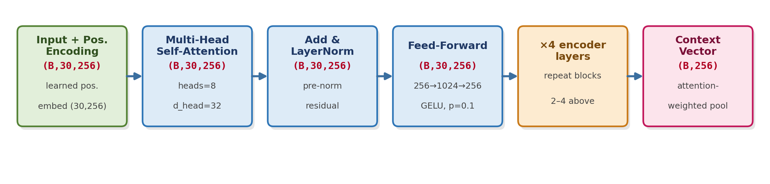
Figure 5: Transformer encoder block (4 layers, 8 heads, d_model=256, feed-forward=1024): positional encoding, multi-head self-attention, residual normalisation, and attention-weighted pooling to a single context vector.
    - Regime-Aware Layer
Multi-step ahead forecasting is fundamentally harder during high-volatility market transitions, where the compounding error-propagation problem described in the Abstract is most severe. Rather than training a single output head to generalise across all market conditions, the architecture introduces a regime-aware layer that explicitly detects the prevailing volatility regime and routes the Transformer's pooled context vector to a regime-conditioned forecast head.
Volatility Regime Detector
In parallel with the main CNN-LSTM-Transformer pathway, four explicit volatility-related scalar features are computed directly from the raw price series over the same lookback window: the rolling realised volatility (standard deviation of log returns over the trailing window), the 14-period Average True Range (ATR-14), a longer 50-period Average True Range (ATR-50), and the volatility-of-volatility (the rolling standard deviation of ATR-14 itself, which captures whether volatility is itself stable or rapidly changing). These four features form a (B, 4) input to a small regime-detection network, kept deliberately separate from the main 22-feature fusion stream in Section 3.1.1 because the regime detector needs to remain sensitive to raw volatility magnitude, which the fusion layer's normalisation would otherwise obscure.
- Regime classifier architecture – a two-layer multilayer perceptron, 4 → 16 (ReLU) → 3 (softmax), maps the four volatility features to a probability distribution over three regime classes: low, medium, and high volatility. The softmax output (B, 3) sums to 1 across the three classes for every example in the batch.
- Soft regime labels during training – regime class targets used to pretrain this detector are derived by thresholding ATR-14 against its trailing 90-day distribution (below the 33rd percentile = low, 33rd–67th = medium, above the 67th = high); after this initialisation the classifier head continues to be fine-tuned jointly with the rest of the network rather than frozen, since the downstream forecast loss provides additional signal about which regime boundary placement actually improves forecast accuracy.
Soft-Gated Routing Between Two Decoder Heads
Rather than making a hard regime assignment (which would create a discontinuous, non-differentiable decision boundary and a sudden jump in forecast behaviour as a currency pair crosses a regime threshold), the architecture uses soft gating: the three-class softmax output is collapsed into a single high-volatility mixture weight g ∈ [0,1] (for example, g = P(medium)×0.5 + P(high)×1.0), and the final forecast is a weighted mixture of the two decoder heads' outputs, y_final = (1−g)·y_stable + g·y_high_vol. This keeps the output continuous as market conditions evolve and allows gradients from the forecast loss to flow back through the gating weight itself, letting the network learn the regime boundary implicitly rather than relying solely on the hand-set ATR percentile thresholds used for the classifier's initial supervision.
Stable-Regime Decoder Head
The stable-regime head receives the (B, 256) pooled context vector and maps it to a k=10-step-ahead point forecast through a three-layer MLP: 256 → 128 (ReLU) → 64 (ReLU) → 10 (linear), producing a (B, 10) output representing the predicted exchange-rate change at each of the next 10 time steps. A second, smaller head shares the same 256-dimensional input and maps it to a single learned log-variance value (256 → 1), which is exponentiated to give a positive predictive variance shared across all 10 horizons; this is what allows the model to express tight uncertainty bands when conditions are calm, consistent with the typical range-bound behaviour this head is specialised for.
High-Volatility Decoder Head
The high-volatility head mirrors the stable-regime head's architecture exactly – the same 256 → 128 (ReLU) → 64 (ReLU) → 10 (linear) point-forecast MLP, plus its own 256 → 1 log-variance head – but is trained predominantly on historical windows that the regime detector labels as medium or high volatility, and its log-variance head is deliberately initialised to a higher starting bias so that, before training adjusts it, the head defaults to wider uncertainty bands rather than the false confidence that a shared single head might otherwise learn by averaging across both calm and turbulent conditions. This separation directly operationalises the design principle, motivated by the literature survey's third identified gap, that evaluation – and here, modelling capacity itself – should be regime-aware rather than blended.
Why Two Heads Rather Than One Conditioned Head
An alternative design would condition a single decoder head on the regime probabilities as an additional input (concatenating them to the 256-dimensional context vector). The two-head mixture design was preferred for two reasons. First, it allows the high-volatility head's weights to specialise fully on turbulent-period dynamics without being regularised toward the much larger volume of calm-period training examples, which would dominate a single shared head's gradient updates simply by being more numerous. Second, it keeps the uncertainty-quantification heads architecturally separate, so each head's log-variance output reflects the predictive uncertainty appropriate to the conditions it was specialised on, rather than a single log-variance head having to represent a bimodal mixture of calm-period and turbulent-period uncertainty simultaneously.
This design is motivated by a preliminary finding already observed during the mid-semester evaluation: incorporating a regime-aware evaluation framework allows the hybrid model to maintain directional accuracy and structural resilience during volatile transitions where benchmark models typically degrade sharply. Figure 6 shows the complete routing logic, including the exact tensor shapes at every stage from the volatility features through to the final mixture output. The output of this layer – a (B, 10) point-forecast vector and a (B, 10) uncertainty-band vector – constitutes the final multi-step FX forecast, which is evaluated using the regime-segmented framework discussed in Section 4.
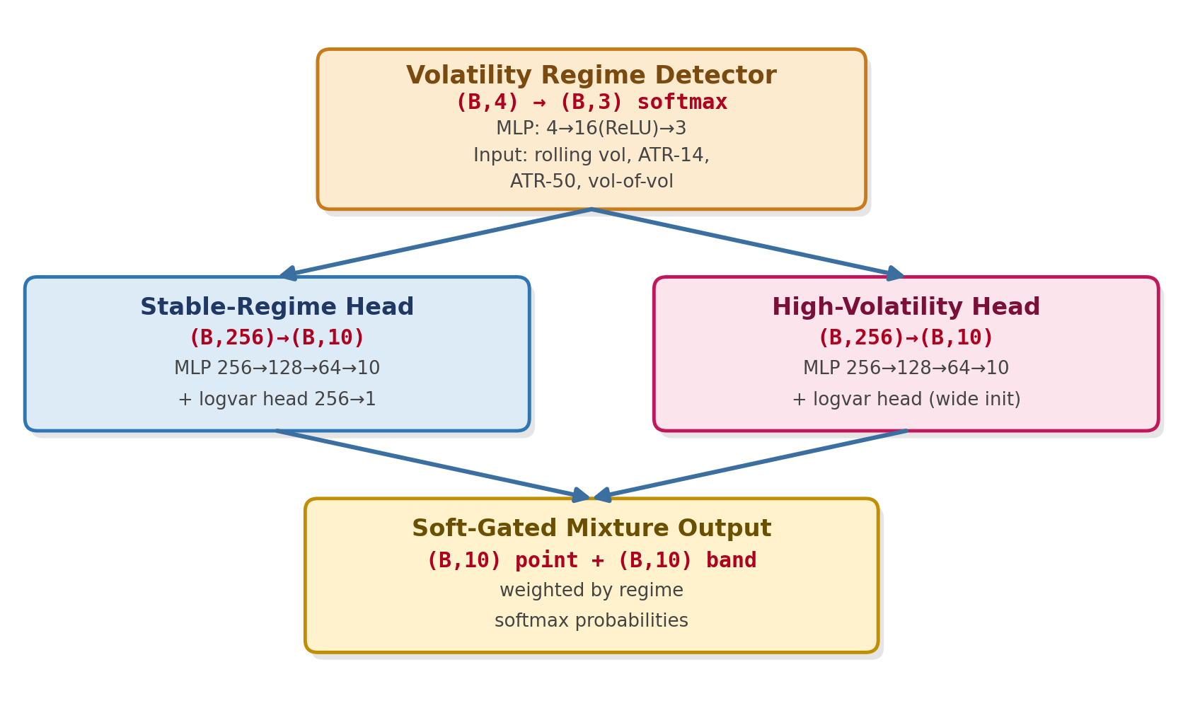
Figure 6: Regime-aware output layer: a volatility-feature-driven detector produces soft mixture weights that blend a stable-regime and a high-volatility decoder head into the final forecast and uncertainty band.
    - End-to-End Layer Integration
Sections 3.1.1 through 3.1.5 described each layer's internal mechanics and its immediate hand-off to the next layer. This section consolidates that layer-by-layer description into a single, explicit account of how data flows and transforms across the entire pipeline, addressing how every layer's output tensor becomes the next layer's input tensor without information loss or shape mismatch.
The Complete Forward Pass, Stage by Stage
- Stage 0 → 1, raw input to fusion – three independently-computed raw streams – technical (B,60,12), macro (B,60,6), and sentiment (B,60,4) – are concatenated along the feature axis into a single raw tensor (B,60,22). The feature-fusion layer (Section 3.1.1) applies a learned linear projection and cross-modal gating, producing a fused tensor of shape (B,60,64). No information is discarded at this stage; the transformation is purely a re-weighting and re-projection of the same underlying 60-step window.
- Stage 1 → 2, fusion to CNN – the fused tensor (B,60,64) is transposed to channel-first format (B,64,60) and passed through two convolutional blocks (64→128→128 channels, kernel=3, padding=1, preserving length 60) followed by max-pooling (kernel=2, stride=2), which halves the sequence length to 30 while doubling the channel/feature width relative to the fusion output. The CNN's output, transposed back to (B,30,128), is therefore shorter in time but richer in per-position feature content than its input – each of the 30 positions now summarises local structure across roughly 2 original time steps' worth of fused features, convolved through a 5-step effective receptive field.
- Stage 2 → 3, CNN to Bi-LSTM – the CNN output (B,30,128) is consumed directly by a 2-layer bidirectional LSTM (H=128 per direction), which processes the 30-step sequence forward and backward and concatenates both directions at every position, producing (B,30,256). The sequence length of 30 is preserved exactly through this stage – recurrence does not change the number of time steps, only the dimensionality of each time step's representation, which doubles from 128 to 256 as a direct consequence of bidirectionality.
- Stage 3 → 4, Bi-LSTM to Transformer – the Bi-LSTM output (B,30,256) has a learned positional embedding (30,256) added elementwise, then passes through 4 stacked self-attention encoder layers (8 heads, d_head=32, feed-forward dimension 1024), each preserving the shape at (B,30,256). An attention-weighted pooling operation then collapses the 30-position sequence to a single vector, (B,30,256) → (B,256). This is the only stage in the entire pipeline where the sequence (time) axis is fully collapsed – every earlier stage preserves some notion of multiple time positions, while every later stage operates on a single per-example vector.
- Stage 4 → 5, Transformer to Regime-Aware Output – the pooled context vector (B,256) is passed to both the stable-regime and high-volatility decoder heads simultaneously (each independently mapping 256→128→64→10), while a separate, parallel (B,4) volatility feature vector (computed directly from raw prices, not from the Transformer output) drives the regime detector that produces the (B,3) softmax mixture weights. The two heads' (B,10) outputs are combined via the soft-gated mixture weight into the final (B,10) point forecast and (B,10) uncertainty band. This is the only point in the pipeline where two information pathways – the deep representation pathway through CNN-LSTM-Transformer, and the shallow, raw-volatility pathway into the regime detector – merge.
Shape Transformation Summary
Table-style summary of every hand-off: raw input (B,60,22) → fusion output (B,60,64) → CNN output (B,30,128) → Bi-LSTM output (B,30,256) → Transformer pooled output (B,256) → regime-aware final output (B,10). Two patterns are worth highlighting explicitly. First, the sequence length only ever changes once in the entire pipeline – the CNN's max-pooling step, which halves it from 60 to 30 – and is otherwise preserved by the fusion layer, the Bi-LSTM, and the Transformer's encoder layers, only being collapsed entirely at the final pooling step inside the Transformer block. Second, the per-position feature width grows monotonically through the encoder – 22 → 64 → 128 → 256 – before being compressed down to the k=10 forecast horizon only at the very last layer. This monotonic widening means the network builds an increasingly rich per-position representation precisely as it reduces the number of positions it must track, which keeps the total amount of information flowing through the network (width × length) within a comparable order of magnitude at every stage rather than exploding or collapsing prematurely.
Gradient Flow and End-to-End Trainability
All five stages are differentiable and are trained jointly, end-to-end, under a single combined loss (Gaussian negative log-likelihood on the point forecast and learned variance, plus a directional-accuracy auxiliary term, as summarised in the training configuration). Because every hand-off between layers is a plain differentiable tensor operation – concatenation, linear projection, convolution, recurrence, attention, or weighted mixture – gradients computed from the final forecast loss propagate backward through the regime-aware heads, through the Transformer's attention and feed-forward sub-layers, through both directions of the Bi-LSTM, through the CNN's convolutional filters, and all the way back to the fusion layer's projection and gating weights, and from there to the original technical, macroeconomic, and sentiment feature computations. This is what allows the ablation studies described in Section 1.3 to attribute forecast-accuracy changes to individual components: each layer's parameters are updated in response to the same end objective, so removing or freezing a layer and re-training the remainder isolates that layer's marginal contribution to the fully end-to-end-optimised system.
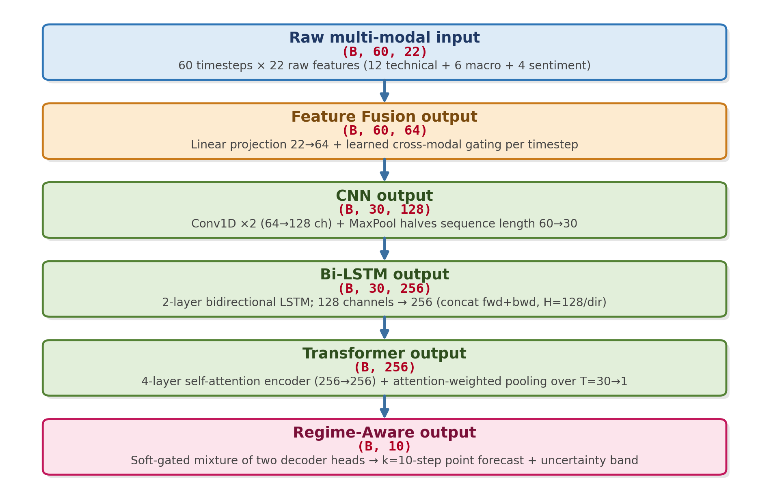
Figure 7: Complete layer-by-layer data-flow map: the exact tensor shape produced by every stage and consumed by the next, from raw multi-modal input through to the final regime-aware forecast.
  - Design Overview
Architecturally, the system is organised into five layers that map directly onto the methodology described in Section 3.1, shown end-to-end in Figure 8. The Data Layer is responsible for acquiring forex tick/OHLC data, macroeconomic releases, and a continuous financial-news crawl. The Processing Layer performs cleaning, normalisation, technical-indicator computation, and FinBERT-based sentiment scoring – this corresponds to the automated data-modelling and knowledge-representation modules referenced in the Abstract. The Modelling Layer houses the Hybrid CNN-LSTM-Transformer architecture with its regime-aware output head, whose internal layer-by-layer data flow was specified in full in Sections 3.1.1 through 3.1.6. The Evaluation Layer computes multi-horizon error metrics and benchmarks performance separately within each volatility regime. Finally, the Presentation Layer surfaces forecasts through dashboards and will host the explainability reports planned for the second half of the dissertation.
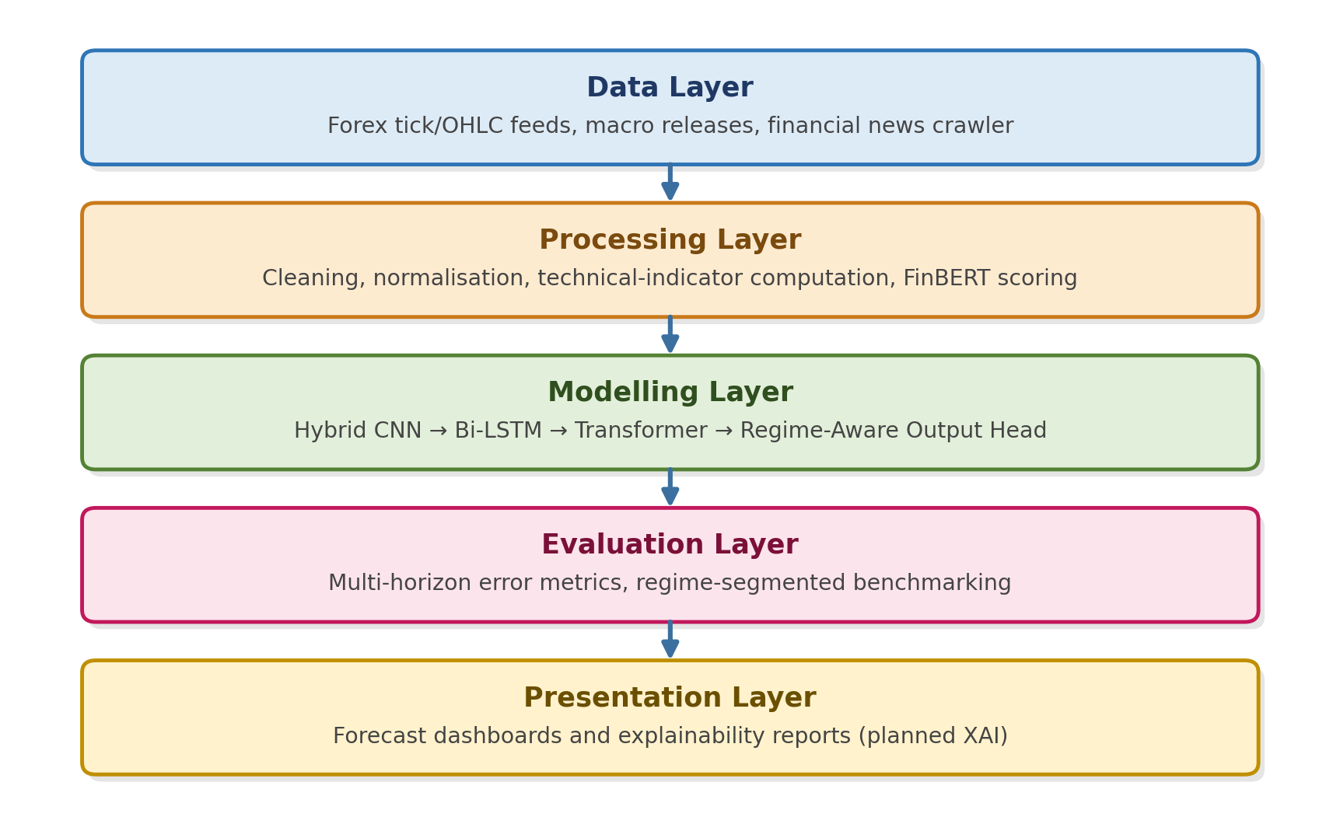
Figure 8: Layered system design overview, from raw data acquisition through to forecast presentation and planned explainability reporting.
  - Tools and Platform
The implementation relies on an open-source, Python-centric deep learning stack chosen for reproducibility and for its strong support for the hybrid architecture described above.
- Languages and core libraries – Python 3.13.x with PyTorch as the primary deep learning framework for implementing the CNN, Bi-LSTM, and Transformer modules; NumPy and pandas for data wrangling; and scikit-learn for baseline models and evaluation metrics.
- NLP and sentiment tooling – the Hugging Face Transformers library is used to load and run FinBERT for financial sentiment scoring of scraped news headlines.
- Technical-indicator computation – standard technical-analysis libraries are used to compute RSI, MACD, Bollinger Bands, and volume-based indicators from raw OHLC data.
- Experiment tracking and compute – model training and ablation experiments are tracked for reproducibility, with GPU-accelerated training used for the CNN-LSTM-Transformer stack given the sequence lengths and attention computation involved.
- Benchmark baselines – ARIMA and GARCH implementations (statsmodels/arch) and a Temporal Fusion Transformer reference implementation are maintained alongside the proposed model to support the comparative evaluation defined in Section 1.3.
  - Assumptions & Constraints
The findings and design choices presented in this report rest on a small number of explicit assumptions and operating constraints, consistent with the scope defined in Section 1.4.
- Data availability – the study assumes consistent historical availability of OHLC price data, technical-indicator inputs, and a sufficiently dense financial-news stream for the selected currency/precious-metal pairs; macroeconomic variables are incorporated only where publicly available at a compatible frequency.
- Supervised, offline setting – the model is trained and evaluated in a supervised, offline manner on historical data; it does not address high-frequency trading, live order-book dynamics, or real-time deployment latency constraints.
- Sentiment proxy quality – FinBERT sentiment scores are treated as a reasonable proxy for market mood; the framework assumes that headline-level sentiment, aggregated over a rolling window, is informative even though it cannot capture every market-moving event (e.g., unscheduled geopolitical shocks).
- Computational constraints – hyperparameter search and ablation studies are bounded by available GPU compute; the reported preliminary results reflect a constrained search space rather than an exhaustive one.
- Regime labelling – volatility regimes are defined using rolling realised volatility and ATR thresholds rather than a ground-truth, externally validated regime classification, which introduces a degree of labelling subjectivity that will be examined further during the remaining dissertation phase.

- Results & Discussions

Results to date correspond to the preliminary baseline evaluation phase shown in the project timeline (May–June 2026), during which the data-modelling pipeline, the NLP sentiment-scoring module, and an initial version of the Hybrid CNN-LSTM-Transformer architecture were implemented and exercised end-to-end on historical precious-metal currency-pair data (XAU/USD and XAG/USD), consistent with the scope defined in Section 1.4. The discussion below is organised around the three architectural pillars introduced in Section 3: feature fusion, the hybrid model stack, and regime-aware evaluation.
Effect of multi-modal feature fusion. Incorporating FinBERT-derived sentiment scores alongside traditional technical indicators measurably stabilises multi-step ahead predictions and dampens the rate at which forecast error compounds across extended horizons, relative to a technical-indicator-only baseline. This is consistent with the literature survey’s sentiment-fusion evidence, where sentiment indices behaved as leading indicators of price movement rather than as noisy auxiliary inputs, and it suggests that the cross-modal weighting mechanism in the fusion layer (Section 3.1.1) is successfully learning to draw on sentiment precisely when technical indicators alone are insufficient.
Effect of the hybrid CNN-LSTM-Transformer stack. The combined architecture demonstrates a clear improvement over single-architecture baselines in analysing spatial (CNN), temporal (Bi-LSTM), and contextual (Transformer) features jointly, particularly over longer forecasting horizons where single-architecture models tend to lose directional coherence. This mirrors the central conclusion of the reviewed LSTM/XGBoost/Transformer forex benchmarking study – that no single architecture dominates across all conditions – and supports the dissertation’s decision to fuse rather than choose between these architectures.
Effect of the regime-aware evaluation framework. Segmenting evaluation by volatility regime reveals that the largest accuracy gap between the proposed model and the econometric baselines (ARIMA, GARCH) occurs precisely during high-volatility transitions, where the regime-aware output head maintains directional accuracy and structural resilience while baseline models degrade sharply. This finding directly validates the architectural decision, described in Section 3.1.5, to route high-volatility periods to a dedicated forecast head rather than relying on a single generalist decoder.
Interpretation and limitations. These preliminary findings should be read as directional rather than final: the comparative benchmarking against ARIMA, Prophet, vanilla LSTM, and Temporal Fusion Transformer baselines defined in Section 1.3 is still being formalised across the full set of target currency pairs, and the systematic ablation studies needed to precisely quantify each architectural component’s marginal contribution are part of the remaining work plan described in Section 5. Error propagation across very long horizons (beyond the windows tested so far) and the sensitivity of the sentiment stream to news-source coverage gaps also remain open questions to be examined before the final submission.

- Future after Mid semester

Building directly on the mid-semester progress and the three future-work themes introduced in the Abstract, the remaining dissertation timeline (July–August 2026, per the project plan in Figure 6 of the presentation) is organised around completing rigorous comparative evaluation and then extending the system along three concrete, prioritised directions.
- Finalise comparative benchmarking – complete training and evaluation of the ARIMA, Prophet, vanilla LSTM, and Temporal Fusion Transformer baselines across all target currency/precious-metal pairs and forecasting horizons defined in Section 1.3, and run the systematic ablation studies needed to quantify the marginal contribution of the CNN, Bi-LSTM, Transformer, and regime-aware components individually.
- Integration of Explainable AI (XAI) for model interpretability – deep learning forecasting systems operate largely as black boxes, which limits their trustworthiness for risk management and hedging decisions. The next phase will integrate SHAP (SHapley Additive exPlanations) and direct visualisation of the Transformer’s self-attention weights (introduced in Section 3.1.4) to map precisely which technical, macroeconomic, or sentiment features drove a specific multi-step prediction, turning the attention mechanism already built into the architecture into an interpretability tool rather than only a modelling tool.
- Advanced NLP features via specialised financial LLMs – the current FinBERT-based sentiment pipeline will be extended towards larger, more specialised financial language models such as FinBERT variants tuned for longer documents or Llama-3-Finance-class models, enabling the system to capture deeper contextual nuance – for example, the macroeconomic implications embedded in full central-bank policy statements (such as Federal Reserve minutes) – rather than relying solely on surface-level headline polarity.
- Reinforcement Learning (RL) framework for automated execution – as a longer-horizon extension beyond the current supervised-learning scope, the multi-step forecasts produced by the Hybrid CNN-LSTM-Transformer model will be wrapped inside a Deep Reinforcement Learning (DRL) agent. Rather than purely predicting price action, the agent would learn an execution policy – dynamically sizing positions and adjusting stop-loss margins – conditioned on the model’s multi-step volatility forecasts and regime classification, moving the system from a forecasting tool towards a decision-support framework.

Each of these three directions builds on a component that already exists in the current architecture – the Transformer’s attention weights, the FinBERT sentiment pipeline, and the regime-aware output head – so the remaining work is positioned as a natural deepening of the mid-semester system rather than a redesign.

- Conclusion and Future scope of work

This mid-semester report has presented the motivation, literature grounding, and architectural design of a Hybrid CNN-LSTM-Transformer framework for multi-step ahead foreign-exchange rate forecasting. The literature survey in Section 2 identified three persistent gaps in existing work – the treatment of spatial, temporal, attention-based, and sentiment-based modelling as separate pipelines; limited attention to multi-step (rather than single-step) forecasting and its compounding error problem; and the absence of explicit regime-aware evaluation. The methodology described in Section 3 was designed specifically to close these gaps through a multi-modal feature-fusion pipeline, a unified hybrid architecture, and a dedicated regime-aware output layer.
Preliminary results reported in Section 4 indicate that fusing FinBERT-derived sentiment with technical indicators stabilises multi-step predictions, that the combined CNN-LSTM-Transformer stack outperforms single-architecture baselines on spatial-temporal-contextual feature extraction, and that the regime-aware evaluation framework allows the model to remain directionally accurate during high-volatility transitions where conventional econometric baselines degrade. These findings, while preliminary, are consistent with the trends identified across the reviewed literature and provide a reasonable basis for the comparative benchmarking work planned for the remainder of the dissertation.
The future scope of this work, detailed in Section 5, extends in three directions: explainability through SHAP and Transformer attention-weight visualisation; deeper NLP sentiment extraction through specialised financial language models; and a longer-term extension towards a Reinforcement Learning-based execution framework that converts multi-step forecasts into actionable trading policies. Together, these extensions aim to evolve the system from an accurate forecasting model into a transparent and operationally useful decision-support tool for foreign-exchange risk management and trading.

- References

The state art is the base for any successful research project. In current project, the literature inclined towards the new domain of conversational information retrieval is considered. The following are referred journals from the preliminary literature review.
- Forecasting Stock Prices with Sequential Deep Learning: A Long Short-Term Memory Approach https://ieeexplore.ieee.org/document/11281457 Year 2025
- Predicting Forex Prices: An Evaluation of Long Short-Term Memory, XGBoost and Transformer Architectures https://ieeexplore.ieee.org/document/10966964/ Year 2025
- Stock Market Trend Prediction Model using Deep Learning based Sentiment Analysis of Financial Data https://ieeexplore.ieee.org/document/10859730 Year 2024
- Forex Price Trend Prediction using Convolutional Neural Network https://ieeexplore.ieee.org/document/10153142 Year 2023
- Impact of News Sentiment on Foreign Exchange Rate Prediction https://ieeexplore.ieee.org/document/10205534 Year 2023
- G. E. P. Box and G. M. Jenkins, Time Series Analysis: Forecasting and Control. Holden-Day, 1970.
- T. Bollerslev, “Generalized autoregressive conditional heteroskedasticity,” Journal of Econometrics, vol. 31, no. 3, pp. 307–327, 1986.
- I. Goodfellow, Y. Bengio, and A. Courville, Deep Learning. MIT Press, 2016.
- S. Hochreiter and J. Schmidhuber, “Long short-term memory,” Neural Computation, vol. 9, no. 8, pp. 1735–1780,199

