CC-ResDiff: Bounding Seed-Dependent Color Drift in Residual-Space Diffusion Super-Resolution
Sudhir Kumar¹ and Sanjoy Chattopadhyay²
¹ TODO: Department, Institution, City, Country
² TODO: Department, Institution, City, Country
snghsudhirkumar06@gmail.com, chattopadhyaysanjoy18@gmail.com
Abstract. Residual-space diffusion models for super-resolution, such as SRDiff and ResDiff, train a diffusion model to predict the residual between a CNN prediction and the ground truth. Because that residual is mostly high-frequency, and recent work strengthens high-frequency guidance further, the global color of the output is never supervised directly. ResDiff reports the consequence—visible color discrepancy in under-trained models—and proposes a global color feature as future work. We implement that proposal as a Global Color-Consistency (GCC) loss: an auxiliary term comparing spatially pooled color statistics of the model's implied clean prediction with the ground truth. It is training-time only and leaves inference cost unchanged. Our main finding concerns the baseline rather than the loss: across three seeds of an otherwise identical configuration, baseline color error varies over 0.14–0.82, so single-run comparisons of color-consistency methods are unreliable. Against that variability the GCC loss acts as a stabiliser, confining color error to 0.15–0.26 across five paired experimental configurations spanning two datasets and an 8× range of training-set size, with 6.5× lower standard deviation. It bounds color drift where it occurs rather than improving color uniformly, recovering most of the gap on runs that drift and remaining neutral on those that do not—which also explains a DIV2K result that in isolation reads as a failure to generalise. The trade-off is explicit: PSNR, SSIM and LPIPS are unchanged within seed noise, and FID is consistently worse by 2.73. We report that regression, and an ablation refuting our own explanation for it.
Keywords: image super-resolution, diffusion models, color consistency, auxiliary loss, training stability, seed variance, residual learning, generative models.
- Introduction
Single image super-resolution (SISR) is ill-posed. Adversarial methods [8, 9] were long dominant but train unstably; denoising diffusion models [4] have largely displaced them. Residual-space variants are the strongest of these for SISR: SRDiff [2] and ResDiff [1] first use a CNN to recover low-frequency content, then train a diffusion model to generate only the residual between that prediction and the ground truth, which accelerates convergence.
This design has an under-examined consequence. The residual is mostly high-frequency, and the ε-prediction objective supervises the noise added to it, so nothing constrains the absolute color of the reconstruction. ResDiff sharpens the imbalance by adding frequency-domain losses and high-frequency-guided cross-attention—improving detail while supplying no color signal—and observes the result directly, noting that “the color will appear a large discrepancy when the model is under-trained,” attributing it to “a lack of color features in the guided high-frequency information,” and proposing that “utilizing a global color feature may well address this issue in future work” [1]. We take up that proposal.

Contributions. (i) A Global Color-Consistency loss for residual-space diffusion SISR, adding no parameters and leaving sampling unchanged, so inference cost is identical to the baseline. (ii) The observation that baseline color drift is itself strongly seed-dependent, varying sixfold across identical configurations, which implies single-run comparisons of color-consistency methods—including the first run of our own—can misstate an effect severalfold. (iii) A gradient-level analysis showing the auxiliary term's influence spans five orders of magnitude across the diffusion trajectory, with an ablation identifying that skew as the mechanism rather than an artefact. (iv) An explicit account of the costs: no distortion benefit, and a consistent FID regression we could not explain.
- Related Work

Diffusion SISR. SR3 [3] conditions DDPM on an upsampled LR image. SRDiff [2] introduces residual prediction; ResDiff [1] adds frequency-domain guidance. The trajectory of this line is towards stronger high-frequency supervision, leaving low-frequency content to the CNN and never supervising it directly.

Color correction and loss weighting. Established color methods are corrective and act outside the model: per-channel statistic matching [10], full distribution transfer [11] and color constancy [12, 13] all require a reference or an illuminant estimate at test time. Section 4.3 shows that distinction is decisive rather than academic. Separately, timestep reweighting of the primary diffusion objective is well studied [5, 6, 7]; we show that an auxiliary loss on the reconstructed x₀ inherits an extreme implicit weighting whether or not its designer intends it.
- Method
Let x_{LR}, x_{HR} and x_{up} denote the LR input, the ground truth and the bicubically upsampled input. Residual diffusion targets r = s (x_{HR} − x_{up}), clipped to [−1,1], with the usual forward process r_{t} = √ᾱ_{t} r + √(1−ᾱ_{t}) ε and objective
$L_{DDPM} = E\left[{\left\|ε − ε_{θ}\left(r_{t}, t, c\right)\right\|}_{1}\right]$ (1)
where c is CNN-derived conditioning. Nothing in Eq. 1 references the absolute color of the reconstruction.
We recover the implied clean residual through the standard closed form,
${\hat{r}}_{0} = \frac{r_{t} − \sqrt{1 − {\overline{α}}_{t}}ε_{θ}\left(r_{t}, t, c\right)}{\sqrt{{\overline{α}}_{t}}}$ (2)
clamp it to [−1,1], map it back to image space as x̂_{HR} = r̂₀/s + x_{up}, and compare pooled color statistics:
$L_{GCC} = {\left\|P_{k}\left({\hat{x}}_{HR}\right) − P_{k}\left(x_{HR}\right)\right\|}_{2}^{2}$ (3)
and add it to the primary objective with a single weight λ:
$L = L_{DDPM} + λL_{GCC}$ (4)
with P_{k} adaptive average pooling to a k × k grid. Pooling is what makes Eq. 3 complementary rather than redundant: at k=8 it discards texture and edges, retaining only the spatial color balance that Eq. 1 leaves unconstrained.
Eq. 4 is the complete objective; the remainder of the training step is unchanged. Two implementation details are load-bearing. Eq. 2 must be evaluated in fp32: under a cosine schedule ᾱ_{t} reaches 2.4 × 10⁻⁷ at t = T−1, so the reconstruction amplifies by ~2000× and overflows fp16 under mixed precision. And the clamp cannot be omitted—unclamped we measured L_{GCC} = 2.8 × 10⁴ at t = T−1 against a DDPM loss of ~0.8, so with t sampled uniformly roughly one step in a hundred would destabilise training. Sampling is untouched, so inference cost equals the baseline's.
- Experiments

Setup. CelebA [17] subsampled to 3,000 training and 300 test images at 16 × 16 → 64 × 64 (4×). Stage 1 is an RRDB; Stage 2 a 2.28M-parameter UNet, T=100, cosine schedule, up to 20,000 steps with early stopping on PSNR. The two arms are identical in data, schedule, seed, initialisation and Stage-1 checkpoint, differing only in the GCC term. Early stopping monitors PSNR rather than color error, so model selection cannot favour the proposed arm.

Scope. Our baseline is SRDiff. ResDiff motivates this work but is not reimplemented—its FD Info Splitter, HF-guided cross-attention and FFT/DWT losses are absent here—so every comparison is SRDiff versus SRDiff plus GCC. Absolute values are therefore not comparable with published SRDiff, ResDiff or SR3 results, which use different tasks (64 → 256, 20 → 160, 40 → 160), full training sets and larger models; our FID is computed over 300 images, which biases it upward. We make no state-of-the-art claim.

Metrics. PSNR, SSIM [16], LPIPS [15] and FID [14], plus color error: the mean absolute difference between per-channel RGB means of the output and the ground truth, in 0–255 units. We also report LR-PSNR, which measures low-frequency fidelity and is thus the quantity GCC most directly targets. Evaluating one fixed checkpoint under four seeds gives an evaluation noise floor (std): PSNR 0.018, SSIM 0.0004, LPIPS 0.0005, LR-PSNR 0.009, color error 0.0022, FID 0.15.
  - Baseline Color Drift is Seed-Dependent
Table 1 is the paper's central result, and it concerns the baseline. Under configurations differing only in random seed, baseline color error ranges from 0.14 to 0.82—a sixfold spread, orders of magnitude beyond the 0.0022 evaluation noise floor. Under the evaluated configuration, whether substantial color drift occurs is therefore strongly influenced by the random training seed.
This carries a methodological consequence independent of our loss: a single-run comparison of any color-consistency method can overstate or understate its effect severalfold. Our own first run showed a −70.6% reduction and our third a +4.6% increase; reporting either alone would have been misleading.
Table 1. Color error across five paired experimental configurations spanning two datasets and an 8× range of training-set size. The baseline spans 0.14–0.82; CC-ResDiff stays within 0.15–0.26.
Run | Baseline | CC-ResDiff | Change
CelebA 3k, seed A | 0.8234 | 0.2423 | −70.6%
CelebA 3k, seed B | 0.3878 | 0.2061 | −46.9%
CelebA 3k, seed C | 0.1397 | 0.1461 | +4.6%
CelebA 25k | 0.2948 | 0.2555 | −13.3%
DIV2K | 0.1650 | 0.2036 | +23.4%
std across runs | 0.2767 | 0.0426
range | 0.684 | 0.109
Against that variability the GCC loss acts as a stabiliser: its color error falls within 0.15–0.26 in every configuration, with a 6.5× smaller standard deviation and a 6.2× narrower range. We describe this as bounding color drift rather than reducing it, and are deliberate about the strength of the claim: the three-seed CelebA experiment is the only replicated evidence here—the 25k and DIV2K tiers are single runs—so these five configurations establish a consistent stabilising effect in our experiments rather than a formal guarantee. The benefit on any given run is governed by how far its baseline sits outside CC-ResDiff's band, which is why one mechanism produces both the −70.6% run and the DIV2K increase.
We deliberately omit one tempting statistic. The correlation between a run's baseline color error and the improvement obtained is r = 0.997, but improvement is defined as c_{CC} − c_{base}, so the baseline appears on both sides and the correlation is mechanically induced—it would be near unity even for random output. The variance comparison in Table 1 carries the same content without that coupling.
  - Aggregate Results and the FID Trade-off
Table 2 reports all metrics over three CelebA seeds. Only color error and FID differ by more than their across-seed spread. In particular, the −0.13 dB PSNR cost visible in our first run did not replicate: at n=3 the mean is −0.002 dB, and the apparent cost was seed noise.
Table 2. CelebA 4×, mean ± std over three training runs. Note the standard deviations: the baseline's color error varies by an order of magnitude more than CC-ResDiff's.
Metric | Baseline | CC-ResDiff | Δ
Color error ↓ | 0.4494 ± 0.3446 | 0.1981 ± 0.0486 | −0.2512
LR-PSNR ↑ | 44.66 ± 0.82 | 44.95 ± 0.66 | +0.29
PSNR ↑ | 25.033 ± 0.082 | 25.031 ± 0.075 | −0.002
SSIM ↑ | 0.8143 ± 0.0022 | 0.8141 ± 0.0021 | −0.0002
LPIPS ↓ | 0.0439 ± 0.0020 | 0.0446 ± 0.0021 | +0.0007
FID ↓ | 66.70 ± 2.19 | 69.43 ± 3.59 | +2.73
The FID regression is the method's principal cost, and we state it plainly. FID is worse in all four CelebA configurations tested—three seeds plus the larger-data tier—by +2.73 on average. Section 4.4 reports an experiment that refutes our own explanation for it, so the cause remains open. A practitioner should adopt GCC as a targeted mechanism for controlling seed-dependent color drift, not as a general improvement to perceptual quality.
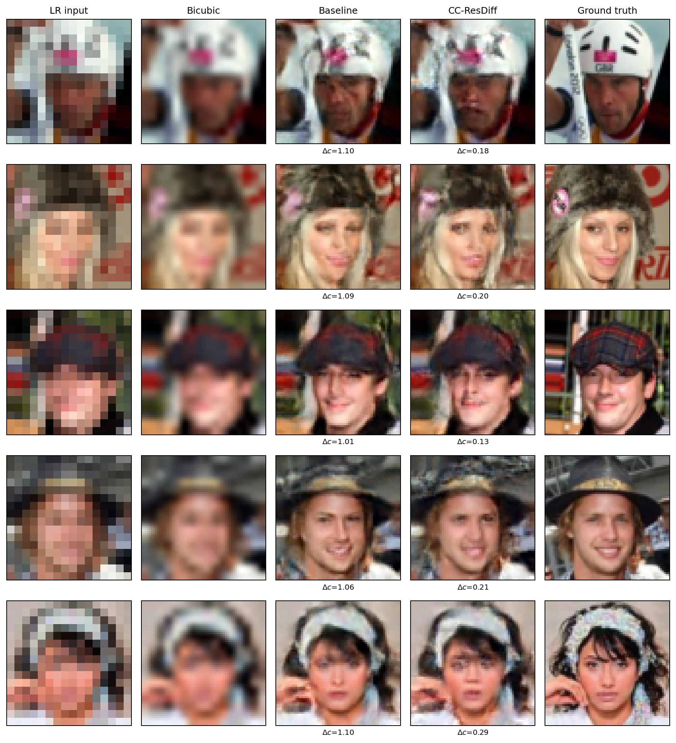
Fig. 1. CelebA 4×: LR input, bicubic, baseline, CC-ResDiff, ground truth. Rows are the test images with the largest color-error difference, a selection rule chosen to display the phenomenon under discussion; per-image color error Δc is printed beneath each result. Differences are measurable but visually subtle: color error is in 0–255 units, so 0.82 → 0.24 is a sub-one-level shift—far above the 0.0022 measurement noise and consistent across 298/300 images, yet near the limit of perceptibility.
  - Post-hoc Color Correction is Insufficient
A natural objection is that cheap post-processing might achieve the same effect. We applied per-channel mean and mean/standard-deviation matching to the baseline's outputs, using the upsampled LR image as reference—the only reference admissible at inference, since matching to the ground truth would be unusable in practice. Neither variant helps (Table 3): both increase color error, and matching the variance costs 7.4 dB of LR-PSNR by altering exactly the low-frequency content LR-PSNR measures.
Table 3. Post-hoc color correction versus learned supervision, CelebA, 300 test images.
Method | Color error ↓ | LR-PSNR ↑
Baseline | 0.8234 | 43.690
+ mean transfer | 0.8746 | 43.558
+ mean/std transfer | 0.9333 | 36.243
reference floor (x_{up} vs x_{HR}) | 0.4358 | —
CC-ResDiff | 0.2423 | 44.509
The reason is structural. Any post-hoc correction is bounded below by the accuracy of the reference it matches to, and the upsampled LR image itself differs from the ground truth by 0.4358. CC-ResDiff reaches 0.2423, below that floor, because supervision is applied during training against the true HR image and no test-time reference is required.
  - Gradient Analysis and a Refuted Hypothesis
Loss values suggest the GCC term is negligible—0.06% of the DDPM loss at λ= 0.1. Its gradient tells a different story (Table 4): 33.9% of the DDPM gradient averaged over uniformly sampled t, some 500× more than the loss ratio implies, and spanning five orders of magnitude across the trajectory. The clamp bounds the loss value but not the gradient: at t = T−1 nearly all elements saturate, yet the remainder still carry the ~2000× amplification.
Table 4. The GCC term's gradient contribution is concentrated at large t, spanning five orders of magnitude.
t | 0 | 75 | T−1
Clamped fraction | 0.4% | 0.1% | 97.4%
Gradient ratio to L_{DDPM} | 0.002% | 1.28% | 235.7%
Over uniformly sampled t: 33.9%
This suggested a hypothesis: if the term acts predominantly at large t, and that is what pulls global tone toward the dataset mean, then cancelling the skew by weighting with w_{t} = ᾱ_{t} should remove the FID regression while retaining the color benefit. The reweighting is effective as an intervention, taking the t = T−1 versus t = 0 gradient ratio from 2029× down to 0.0005×. The hypothesis, however, is wrong. FID becomes worse (77.81 versus 73.23), the color benefit largely disappears (0.673 versus 0.242), and the LR-PSNR gain vanishes entirely; the reweighted variant loses on every metric we measure.
Two conclusions follow. The concentration at large t is the mechanism, not a defect: large-t steps determine global low-frequency structure while small-t steps refine local detail, so a global color loss should act at large t, and an implementation that spread it uniformly would supervise color where color is no longer being decided. And the cause of the FID regression remains unexplained—we report the refutation rather than leave an untested explanation in the literature. More generally, any auxiliary loss defined on the reconstructed x₀ inherits this implicit weighting; we recommend reporting gradient ratios rather than loss ratios whenever such a term is introduced.
  - Ablations, Scale, and When the Loss Helps
At a reduced 5,000-step budget, with an identical budget for every run so the sweep does not partly measure training length (Table 5), pool size k=8 is best on every metric and five of six GCC settings beat the no-GCC reference on color error. LPIPS degrades monotonically in λ and FID worsens past λ= 0.01, so the cost side is consistent. We do not claim an optimal λ: color error across the six settings has standard deviation 0.109, comparable to the differences between them, so the sweep supports a usable range (λ ∈ [0.01, 0.1], k = 8) rather than a dose-response curve.
Table 5. Ablations at a 5,000-step budget; pool k=8 unless stated, and λ= 0.1 for the k rows. These runs are comparable to each other, never to Table 2.
Setting | Color err. ↓ | PSNR ↑ | LPIPS ↓ | FID ↓
no GCC | 0.4833 | 23.857 | 0.0612 | 111.51
λ= 0.01 | 0.3382 | 23.955 | 0.0635 | 109.11
λ= 0.1 | 0.1952 | 23.941 | 0.0653 | 110.43
λ= 0.5 | 0.4985 | 23.721 | 0.0665 | 115.43
λ= 1.0 | 0.2162 | 23.727 | 0.0680 | 116.71
k = 4 | 0.3385 | 23.839 | 0.0641 | 112.47
k = 16 | 0.3522 | 23.919 | 0.0658 | 111.05

Scale. Repeating the experiment with 8× the data (25,000 images) and Stage 1 at full capacity, on an identical test split, improves absolute quality substantially: PSNR 25.03 → 25.43, LR-PSNR 44.66 → 47.63, FID 66.70 → 61.83. The GCC benefit falls to −13.3%, but only because the baseline now drifts less (0.4494 → 0.2948); CC-ResDiff's own color error (0.2555) stays inside its usual band. This is a fifth confirmation of the bounding behaviour, obtained under conditions chosen to break it.

DIV2K. At matched scale on DIV2K [18], color error rises from 0.1650 to 0.2036 and every other sign flips relative to CelebA. Read against Section 4.1 this is not a separate phenomenon: DIV2K's baseline sits in the low-drift band alongside CelebA seed C (0.1397), so there is nothing to recover, and CC-ResDiff's own value again lands in its usual range. Per tile, CC-ResDiff has lower color error on 171/512 DIV2K tiles (33.4%) against 298/300 CelebA images (99.3%); on DIV2K the two arms are visually indistinguishable. Figure 1 shows CelebA examples, where the effect is present.
- Limitations
Our experiments use 3,000 CelebA images at 64 × 64 with a 2.28M-parameter diffusion model, and 25,000 at the larger tier—far below the resolutions and model sizes used by SRDiff and ResDiff, so whether the effect persists there is untested. We have three seeds on the main CelebA tier and one run each on the 25k and DIV2K tiers: enough to establish that baseline drift varies widely while CC-ResDiff's does not, but not to characterise either distribution or to place a confidence interval on the bound. We have no DIV2K noise floor, so the +23.4% there is not established as statistically real. FID over 300 images is biased upward and meaningful only as a relative comparison on identical images, and DIV2K metrics cover image interiors because partial edge tiles are dropped at packing time. The effect size is small in absolute terms—a sub-one-level shift in mean channel intensity—and we cannot predict in advance which training configurations will drift.
- Conclusion
We implemented the global color feature that ResDiff identified as future work and, in characterising it, arrived at a different claim than we set out to make. The reliable finding is that baseline color drift in residual diffusion SISR is strongly seed-dependent, varying sixfold across identical configurations—which makes single-run comparisons of color-consistency methods unreliable, our own first run included. Against that variability the GCC loss is a stabiliser: it confines color error to a narrow band in every run we performed, on both datasets and at both data scales, at no parameter or inference cost. What it buys is predictability rather than average improvement, and it costs a consistent FID regression that we report and could not explain. Two results were not what we expected: the implicit timestep weighting an auxiliary x₀ loss inherits proved to be the source of the benefit rather than a flaw, and our mechanism-based account of the FID regression was falsified by the same ablation. Establishing confidence intervals on the bound, and predicting which configurations drift, are the natural next steps.

References
- S. Shang et al. ResDiff: Combining CNN and Diffusion Model for Image Super-Resolution. AAAI, 2024.
- H. Li et al. SRDiff: Single Image Super-Resolution with Diffusion Probabilistic Models. Neurocomputing, 479:47–59, 2022.
- C. Saharia et al. Image Super-Resolution via Iterative Refinement. IEEE TPAMI, 2023.
- J. Ho, A. Jain and P. Abbeel. Denoising Diffusion Probabilistic Models. NeurIPS, 2020.
- A. Nichol and P. Dhariwal. Improved Denoising Diffusion Probabilistic Models. ICML, 2021.
- J. Choi et al. Perception Prioritized Training of Diffusion Models. CVPR, 2022.
- T. Hang et al. Efficient Diffusion Training via Min-SNR Weighting Strategy. ICCV, 2023.
- C. Ledig et al. Photo-Realistic Single Image Super-Resolution Using a Generative Adversarial Network. CVPR, 2017.
- X. Wang et al. ESRGAN: Enhanced Super-Resolution Generative Adversarial Networks. ECCV Workshops, 2018.
- E. Reinhard et al. Color Transfer between Images. IEEE Computer Graphics and Applications, 21(5):34–41, 2001.
- F. Pitié et al. N-Dimensional Probability Density Function Transfer and its Application to Colour Transfer. ICCV, 2005.
- J. T. Barron. Convolutional Color Constancy. ICCV, 2015.
- M. Afifi et al. When Color Constancy Goes Wrong: Correcting Improperly White-Balanced Images. CVPR, 2019.
- M. Heusel et al. GANs Trained by a Two Time-Scale Update Rule Converge to a Local Nash Equilibrium. NeurIPS, 2017.
- R. Zhang et al. The Unreasonable Effectiveness of Deep Features as a Perceptual Metric. CVPR, 2018.
- Z. Wang et al. Image Quality Assessment: From Error Visibility to Structural Similarity. IEEE TIP, 13(4):600–612, 2004.
- Z. Liu et al. Deep Learning Face Attributes in the Wild. ICCV, 2015.
- E. Agustsson and R. Timofte. NTIRE 2017 Challenge on Single Image Super-Resolution: Dataset and Study. CVPR Workshops, 2017.

