实验二 几何变换
- 二维变换：绘制防护栏图案
- 采用MFC的绘图函数（MoveTo()、LineTo()）绘制防护栏图案（如图1（a））
- 采用几何变换完成防护栏图案（如图1（b））
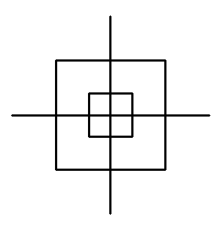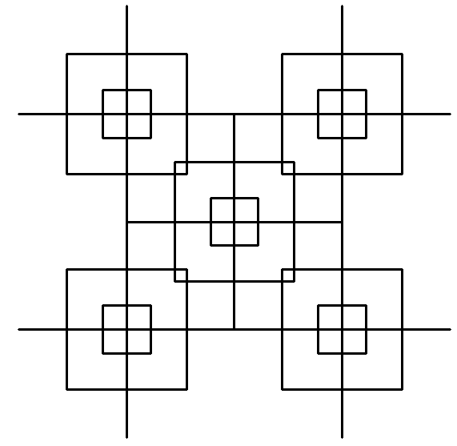
图1 二维变换（左：(a) 防护栏基本图元，右：(b) 防护栏图案）
【实验过程及编码】
（一）实验步骤
- 设计二维齐次坐标点类CP2
- 设计二维几何变换类CTransform2
- 设计防护栏图元类CFence
- 初始化二维变换对象
- 交互式绘制防护栏图案
- 实验编码
- 设计二维齐次坐标点类CP2
- CP2.h
class CP2
{
public:
CP2(void);
virtual ~CP2(void);
CP2(double x, double y);
friend CP2 operator + (const CP2 &p0, const CP2 &p1);//运算符重载
friend CP2 operator - (const CP2 &p0, const CP2 &p1);
friend CP2 operator * (const CP2 &p, double scalar);
friend CP2 operator * (double scalar, const CP2 &p);
friend CP2 operator / (const CP2 &p, double scalar);
friend CP2 operator += (CP2 &p0, CP2 &p1);
friend CP2 operator -= (CP2 &p0, CP2 &p1);
friend CP2 operator *= (CP2 &p, double scalar);
friend CP2 operator /= (CP2 &p, double scalar);
public:
double x;//直线段端点x坐标
double y;//直线段端点y坐标
double w;//齐次坐标
};
- CP2.cpp
#include "CP2.h"
CP2::CP2(void)
{
x = 0.0;
y = 0.0;
w = 1.0;
}
CP2::~CP2(void)
{
}
CP2::CP2(double x, double y)
{
this->x = x;
this->y = y;
this->w = 1.0;
}
CP2 operator + (const CP2 &p0, const CP2 &p1)//和
{
CP2 result;
result.x = p0.x + p1.x;
result.y = p0.y + p1.y;
return result;
}
CP2 operator - (const CP2 &p0, const CP2 &p1)//差
{
CP2 result;
result.x = p0.x - p1.x;
result.y = p0.y - p1.y;
return result;
}
CP2 operator * (const CP2 &p, double scalar)//点和常量的积
{
return CP2(p.x * scalar, p.y * scalar);
}
CP2 operator * (double scalar, const CP2 &p)//点和常量的积
{
return CP2(p.x * scalar, p.y * scalar);
}
CP2 operator / (const CP2 &p, double scalar)//数除
{
if (fabs(scalar) < 1e-4)
scalar = 1.0;
CP2 result;
result.x = p.x / scalar;
result.y = p.y / scalar;
return result;
}
CP2 operator+=(CP2 &p0, CP2 &p1)
{
p0.x += p1.x;
p0.y += p1.y;
return p0;
}
CP2 operator-=(CP2 &p0, CP2 &p1)
{
p0.x -= p1.x;
p0.y -= p1.y;
return p0;
}
CP2 operator*=(CP2 &p, double scalar)
{
p.x *= scalar;
p.y *= scalar;
return p;
}
CP2 operator/=(CP2 &p, double scalar)
{
if (fabs(scalar) < 1e-4)
scalar = 1.0;
p.x /= scalar;
p.y /= scalar;
return p;
}
- 设计二维几何变换类CTransform2
- CTransform2.h
#include "CP2.h"
class CTransform2
{
public:
CTransform2(void);
virtual ~CTransform2(void);
void SetMatrix(CP2* P, int ptNumber);//设置二维顶点数组
void Identity(void);//单位矩阵
void Translate(double tx, double ty);//平移变换
void Scale(double sx, double sy);//比例变换
void Scale(double sx, double sy, CP2 p);//相对于任意点的比例变换
void Rotate(double beta);//旋转变换矩阵
void Rotate(double beta, CP2 p);//相对于任意点的旋转变换
void ReflectOrg(void);//关于原点反射变换
void ReflectX(void);//关于X轴反射变换
void ReflectY(void);//关于Y轴反射变换
void Shear(double b, double c);//错切变换
void MultiplyMatrix(void);//矩阵相乘
private:
double T[3][3];//变换矩阵
CP2* P;//顶点数组
int ptNumber;//顶点个数
};
- CTransform2.cpp
#include "CTransform2.h"
#define PI 3.1415926//圆周率
CTransform2::CTransform2(void)
{
}
CTransform2::~CTransform2(void)
{
}
void CTransform2::SetMatrix(CP2* P, int ptNumber)
{
this->P = P;
this->ptNumber = ptNumber;
}
void CTransform2::Identity(void)//单位矩阵
{
T[0][0] = 1.0; T[0][1] = 0.0; T[0][2] = 0.0;
T[1][0] = 0.0; T[1][1] = 1.0; T[1][2] = 0.0;
T[2][0] = 0.0; T[2][1] = 0.0; T[2][2] = 1.0;
}
void CTransform2::Translate(double tx, double ty)//平移变换矩阵
{
Identity();
T[0][2] = tx;
T[1][2] = ty;
MultiplyMatrix();
}
void CTransform2::Scale(double sx, double sy)//比例变换矩阵
{
Identity();
T[0][0] = sx;
T[1][1] = sy;
MultiplyMatrix();
}
void CTransform2::Scale(double sx, double sy, CP2 p)//相对于任意点的整体比例变换矩阵
{
Translate(-p.x, -p.y);
Scale(sx, sy);
Translate(p.x, p.y);
}
void CTransform2::Rotate(double beta)//旋转变换矩阵
{
Identity();
T[0][0] = cos(beta*PI / 180); T[0][1] = -sin(beta*PI / 180);
T[1][0] = sin(beta*PI / 180); T[1][1] = cos(beta*PI / 180);
MultiplyMatrix();
}
void CTransform2::Rotate(double beta, CP2 p)//相对于任意点的旋转变换矩阵
{
Translate(-p.x, -p.y);
Rotate(beta);
Translate(p.x, p.y);
}
void CTransform2::ReflectOrg(void)//原点反射变换矩阵
{
Identity();
T[0][0] = -1;
T[1][1] = -1;
MultiplyMatrix();
}
void CTransform2::ReflectX(void)//X轴反射变换矩阵
{
Identity();
T[0][0] = 1;
T[1][1] = -1;
MultiplyMatrix();
}
void CTransform2::ReflectY(void)//Y轴反射变换矩阵
{
Identity();
T[0][0] = -1;
T[1][1] = 1;
MultiplyMatrix();
}
void CTransform2::Shear(double b, double c)//错切变换矩阵
{
Identity();
T[0][1] = b;
T[1][0] = c;
MultiplyMatrix();
}
void CTransform2::MultiplyMatrix(void)//矩阵相乘
{
CP2* PTemp = new CP2[ptNumber];
for (int i = 0; i < ptNumber; i++)
PTemp[i] = P[i];
for (int i = 0; i < ptNumber; i++)
{
P[i].x = T[0][0] * PTemp[i].x + T[0][1] * PTemp[i].y + T[0][2] * PTemp[i].w;
P[i].y = T[1][0] * PTemp[i].x + T[1][1] * PTemp[i].y + T[1][2] * PTemp[i].w;
P[i].w = T[2][0] * PTemp[i].x + T[2][1] * PTemp[i].y + T[2][2] * PTemp[i].w;
}
delete[]PTemp;
}
- 设计防护栏图元类
- CFence.h
#include "CP2.h"
class CFence
{
public:
CFence(void);
virtual ~CFence(void);
void ReadPoint(void);
void Draw(CDC* pDC);
public:
CP2 P[12];
};
- CFence.cpp
#include "CFence.h"
#define ROUND(d) int(d + 0.5)
CFence::CFence(void)
{
}
CFence::~CFence(void)
{
}
void CFence::ReadPoint(void)
{
P[0] = CP2(-1, -1);
P[1] = CP2(1, -1);
P[2] = CP2(1, 1);
P[3] = CP2(-1, 1);
P[4] = CP2(-2.5, -2.5);
P[5] = CP2(2.5, -2.5);
P[6] = CP2(2.5, 2.5);
P[7] = CP2(-2.5, 2.5);
P[8] = CP2((P[4].x + P[7].x) / 2 - 2, (P[4].y + P[7].y) / 2);
P[9] = CP2((P[4].x + P[5].x) / 2 , (P[4].y + P[5].y) / 2 - 2);
P[10] = CP2((P[5].x + P[6].x) / 2 + 2, (P[5].y + P[6].y) / 2 );
P[11] = CP2((P[6].x + P[7].x) / 2, (P[6].y + P[7].y) / 2 + 2);
}
void CFence::Draw(CDC* pDC)
{
CPen NewPen(PS_SOLID, 3, RGB(0, 0, 0));
CPen* pOldPen = pDC->SelectObject(&NewPen);
//内方
pDC->MoveTo(ROUND(P[0].x), ROUND(P[0].y));
pDC->LineTo(ROUND(P[1].x), ROUND(P[1].y));
pDC->LineTo(ROUND(P[2].x), ROUND(P[2].y));
pDC->LineTo(ROUND(P[3].x), ROUND(P[3].y));
pDC->LineTo(ROUND(P[0].x), ROUND(P[0].y));
//外方
pDC->MoveTo(ROUND(P[4].x), ROUND(P[4].y));
pDC->LineTo(ROUND(P[5].x), ROUND(P[5].y));
pDC->LineTo(ROUND(P[6].x), ROUND(P[6].y));
pDC->LineTo(ROUND(P[7].x), ROUND(P[7].y));
pDC->LineTo(ROUND(P[4].x), ROUND(P[4].y));
//十字线
pDC->MoveTo(ROUND(P[8].x), ROUND(P[8].y));
pDC->LineTo(ROUND(P[10].x), ROUND(P[10].y));
pDC->MoveTo(ROUND(P[9].x), ROUND(P[9].y));
pDC->LineTo(ROUND(P[11].x), ROUND(P[11].y));
pDC->SelectObject(pOldPen);
}
- 初始化二维变换对象
- CTestView.cpp
CTestView::CTestView() noexcept
{
// TODO: 在此处添加构造代码
bPlay = FALSE;
double a = 30;
double b = 4.5 * a;
CenterPoint[0] = CP2(0, 0);
CenterPoint[1] = CP2(-b, -b);
CenterPoint[2] = CP2(b, -b);
CenterPoint[3] = CP2(b, b);
CenterPoint[4] = CP2(-b, b);
for (int i = 0; i < 5; i++)
{
fence[i].ReadPoint();
transform[i].SetMatrix(fence[i].P, 12);
transform[i].Scale(a, a);
transform[i].Translate(CenterPoint[i].x, CenterPoint[i].y);
}
}
- 绘制图形：采用菜单命令，绘制防护栏图案
- 在“资源视图”的IDR_MAINFRAME中，添加菜单命令”Graph”----”Animation”
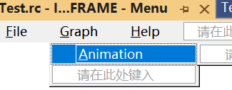
- CTestView.cpp
void CTestView::DrawObject(CDC* pDC)
{
if (FALSE == bPlay)
fence[0].Draw(pDC);
else
for (int i = 0; i < 5; i++)
fence[i].Draw(pDC);
}

void CTestView::OnDraw(CDC* pDC)
{
CTestDoc* pDoc = GetDocument();
ASSERT_VALID(pDoc);
if (!pDoc)
return;
// TODO: 在此处为本机数据添加绘制代码
CRect rect;
GetClientRect(&rect);
pDC->SetMapMode(MM_ANISOTROPIC);
pDC->SetWindowExt(rect.Width(), rect.Height());
pDC->SetViewportExt(rect.Width(), -rect.Height());
pDC->SetViewportOrg(rect.Width() / 2, rect.Height() / 2);
DrawObject(pDC);//绘制图形
}

- 三维变换：旋转立方体
- 采用边界表示法进行立方体建模，绘制立方体的线框模型（如图2（a））
- 采用三维变换完成立方体的旋转（如图2（b））
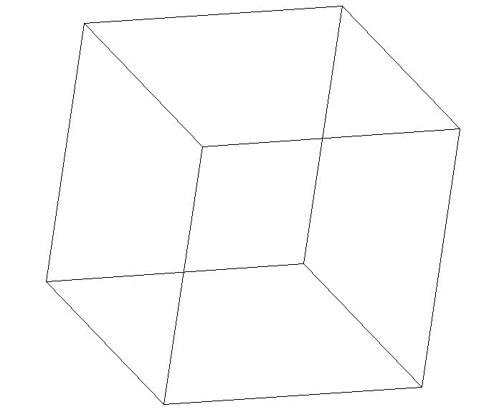

图2 三维变换（左：(a) 立方体线框模型，右：(b) 立方体旋转示意图）
【实验过程及编码】
（一）实验步骤
- 设计表面类CFacet
- 设计三维齐次坐标点类CP3
- 设计立方体类CCube
- 设计三维几何变换类CRevolution
- 初始化立方体
- 绘制立方体
- 旋转立方体
- 实验编码
- 设计表面类CFacet
- CFacet.h
class CFacet
{
public:
CFacet(void){}
virtual ~CFacet(void){}
public:
int Number;//表面顶点数目
int Index[4];//面的顶点索引号
};
- 设计三维齐次坐标点类CP3
- CP3.h
class CP3:public CP2
{
public:
CP3(void);
virtual ~CP3(void);
CP3(double x, double y, double z);
public:
double z;
};
- CP3.cpp
#include "P3.h"
CP3::CP3(void)
{
x = 0, y = 0, z = 0, w = 1;
}
CP3::CP3(double x, double y, double z) :CP2(x, y)
{
this->z = z;
}
CP3::~CP3(void)
{
}
- 设计立方体类CCube
- CCube.h
#include"CP3.h"
#include "CFacet.h"
class CCube
{
public:
CCube(void);
virtual ~CCube(void);
void ReadPoint(void);//读入点表
void ReadFacet(void);//读入面表
CP3* GetVertexArrayName(void);//得到顶点数组名
void Draw(CDC* pDC);//绘制立方体线框
private:
CP3 P[8];//点表
CFacet F[6];//面表
};
- CCube.cpp
#include "CCube.h"
#define ROUND(d) int(d + 0.5)
CCube::CCube(void)
{
}
CCube::~CCube(void)
{
}
CP3* CCube::GetVertexArrayName(void)
{
return P;
}
void CCube::ReadPoint(void)//点表
{
//顶点的三维坐标(x,y,z)
P[0].x = 0, P[0].y = 0, P[0].z = 0;
P[1].x = 1, P[1].y = 0, P[1].z = 0;
P[2].x = 1, P[2].y = 1, P[2].z = 0;
P[3].x = 0, P[3].y = 1, P[3].z = 0;
P[4].x = 0, P[4].y = 0, P[4].z = 1;
P[5].x = 1, P[5].y = 0, P[5].z = 1;
P[6].x = 1, P[6].y = 1, P[6].z = 1;
P[7].x = 0, P[7].y = 1, P[7].z = 1;
}
void CCube::ReadFacet(void)//面表
{
//面的顶点序号
F[0].Index[0] = 4; F[0].Index[1] = 5; F[0].Index[2] = 6; F[0].Index[3] = 7;//前面
F[1].Index[0] = 0; F[1].Index[1] = 3; F[1].Index[2] = 2; F[1].Index[3] = 1;//后面
F[2].Index[0] = 0; F[2].Index[1] = 4; F[2].Index[2] = 7; F[2].Index[3] = 3;//左面
F[3].Index[0] = 1; F[3].Index[1] = 2; F[3].Index[2] = 6; F[3].Index[3] = 5;//右面
F[4].Index[0] = 2; F[4].Index[1] = 3; F[4].Index[2] = 7; F[4].Index[3] = 6;//顶面
F[5].Index[0] = 0; F[5].Index[1] = 1; F[5].Index[2] = 5; F[5].Index[3] = 4;//底面
}
void CCube::Draw(CDC* pDC)//正交投影
{
CP2 ScreenPoint, temp;
for (int nFacet = 0; nFacet < 6; nFacet++)//面循环
{
for (int nPoint = 0; nPoint < 4; nPoint++)//顶点循环
{
ScreenPoint.x = P[F[nFacet].Index[nPoint]].x;
ScreenPoint.y = P[F[nFacet].Index[nPoint]].y;
if (0 == nPoint)
{
pDC->MoveTo(ROUND(ScreenPoint.x), ROUND(ScreenPoint.y));
temp = ScreenPoint;
}
else
{
pDC->LineTo(ROUND(ScreenPoint.x), ROUND(ScreenPoint.y));
}
}
pDC->LineTo(ROUND(temp.x), ROUND(temp.y));//闭合四边形
}
}
- 设计三维几何变换类CTransform3
- CTransform3.h
#include "CP3.h"
class CTransform3
{
public:
CTransform3(void);
virtual ~CTransform3(void);
void Identity(void);//单位矩阵初始化
void SetMatrix(CP3* P, int ptNumber);//三维顶点数组初始化
void Translate(double tx, double ty, double tz);//平移变换
void Scale(double sx, double sy, double sz);//比例变换
void Scale(double sx, double sy, double sz, CP3 p);//相对于任意点的比例变换
void RotateX(double beta);//绕X轴旋转变换
void RotateY(double beta);//绕Y轴旋转变换
void RotateZ(double beta);//绕Z轴旋转变换
void RotateX(double beta, CP3 p);//相对于任意点的绕X轴旋转变换
void RotateY(double beta, CP3 p);//相对于任意点的绕Y轴旋转变换
void RotateZ(double beta, CP3 p);//相对于任意点的绕Z轴旋转变换
void ReflectX(void);//关于X轴反射变换
void ReflectY(void);//关于Y轴反射变换
void ReflectZ(void);//关于Z轴反射变换
void ReflectXOY(void);//关于XOY面反射变换
void ReflectYOZ(void);//关于YOZ面反射变换
void ReflectZOX(void);//关于ZOX面反射变换
void ShearX(double b, double c);//沿X方向错切变换
void ShearY(double d, double f);//沿Y方向错切变换
void ShearZ(double g, double h);//沿Z方向错切变换
void MultiplyMatrix(void);//矩阵相乘
private:
double M[4][4];//三维变换矩阵
CP3* P;//三维顶点数组名
int ptNumber;//三维顶点个数
};
- CTransform3.cpp
#include "CTransform3.h"
#define PI 3.1415926//圆周率
CTransform3::CTransform3(void)
{
}
CTransform3::~CTransform3(void)
{
}
void CTransform3::Identity(void)//单位矩阵初始化
{
M[0][0] = 1.0; M[0][1] = 0.0; M[0][2] = 0.0; M[0][3] = 0.0;
M[1][0] = 0.0; M[1][1] = 1.0; M[1][2] = 0.0; M[1][3] = 0.0;
M[2][0] = 0.0; M[2][1] = 0.0; M[2][2] = 1.0; M[2][3] = 0.0;
M[3][0] = 0.0; M[3][1] = 0.0; M[3][2] = 0.0; M[3][3] = 1.0;
}
void CTransform3::SetMatrix(CP3* P, int ptNumber)//顶点数组初始化
{
this->P = P;
this->ptNumber = ptNumber;
}
void CTransform3::Translate(double tx, double ty, double tz)//平移变换
{
Identity();
M[0][3] = tx;
M[1][3] = ty;
M[2][3] = tz;
MultiplyMatrix();
}
void CTransform3::Scale(double sx, double sy, double sz)//比例变换
{
Identity();
M[0][0] = sx;
M[1][1] = sy;
M[2][2] = sz;
MultiplyMatrix();
}
void CTransform3::Scale(double sx, double sy, double sz, CP3 p)//相对于任意点的比例变换
{
Translate(-p.x, -p.y, -p.z);
Scale(sx, sy, sz);
Translate(p.x, p.y, p.z);
}
void CTransform3::RotateX(double beta)//绕X轴旋转变换
{
Identity();
double rad = beta * PI / 180;
M[1][1] = cos(rad); M[1][2] = -sin(rad);
M[2][1] = sin(rad); M[2][2] = cos(rad);
MultiplyMatrix();
}
void CTransform3::RotateY(double beta)//绕Y轴旋转变换
{
Identity();
double rad = beta * PI / 180;
M[0][0] = cos(rad); M[0][2] = sin(rad);
M[2][0] = -sin(rad); M[2][2] = cos(rad);
MultiplyMatrix();
}
void CTransform3::RotateZ(double beta)//绕Z轴旋转变换
{
Identity();
double rad = beta * PI / 180;
M[0][0] = cos(rad); M[0][1] = -sin(rad);
M[1][0] = sin(rad); M[1][1] = cos(rad);
MultiplyMatrix();
}
void CTransform3::RotateX(double beta, CP3 p)//相对于任意点的X轴旋转变换
{
Translate(-p.x, -p.y, -p.z);
RotateX(beta);
Translate(p.x, p.y, p.z);
}
void CTransform3::RotateY(double beta, CP3 p)//相对于任意点的Y轴旋转变换
{
Translate(-p.x, -p.y, -p.z);
RotateY(beta);
Translate(p.x, p.y, p.z);
}
void CTransform3::RotateZ(double beta, CP3 p)//相对于任意点的Z轴旋转变换
{
Translate(-p.x, -p.y, -p.z);
RotateZ(beta);
Translate(p.x, p.y, p.z);
}
void CTransform3::ReflectX(void)//X轴反射变换
{
Identity();
M[1][1] = -1;
M[2][2] = -1;
MultiplyMatrix();
}
void CTransform3::ReflectY(void)//Y轴反射变换
{
Identity();
M[0][0] = -1;
M[2][2] = -1;
MultiplyMatrix();
}
void CTransform3::ReflectZ(void)//Z轴反射变换
{
Identity();
M[0][0] = -1;
M[1][1] = -1;
MultiplyMatrix();
}
void CTransform3::ReflectXOY(void)//XOY面反射变换
{
Identity();
M[2][2] = -1;
MultiplyMatrix();
}
void CTransform3::ReflectYOZ(void)//YOZ面反射变换
{
Identity();
M[0][0] = -1;
MultiplyMatrix();
}
void CTransform3::ReflectZOX(void)//XOZ面反射变换
{
Identity();
M[1][1] = -1;
MultiplyMatrix();
}
void CTransform3::ShearX(double b, double c)//X方向错切变换
{
Identity();
M[0][1] = b; M[0][2] = c;
MultiplyMatrix();
}
void CTransform3::ShearY(double d, double f)//Y方向错切变换
{
Identity();
M[1][0] = d; M[1][2] = f;
MultiplyMatrix();
}
void CTransform3::ShearZ(double g, double h)//Z方向错切变换
{
Identity();
M[2][0] = g; M[2][1] = h;
MultiplyMatrix();
}
void CTransform3::MultiplyMatrix(void)//矩阵相乘
{
CP3* PTemp = new CP3[ptNumber];
for (int i = 0; i < ptNumber; i++)
PTemp[i] = P[i];
for (int i = 0; i < ptNumber; i++)
{
P[i].x = M[0][0] * PTemp[i].x + M[0][1] * PTemp[i].y + M[0][2] * PTemp[i].z + M[0][3] * PTemp[i].w;
P[i].y = M[1][0] * PTemp[i].x + M[1][1] * PTemp[i].y + M[1][2] * PTemp[i].z + M[1][3] * PTemp[i].w;
P[i].z = M[2][0] * PTemp[i].x + M[2][1] * PTemp[i].y + M[2][2] * PTemp[i].z + M[2][3] * PTemp[i].w;
P[i].w = M[3][0] * PTemp[i].x + M[3][1] * PTemp[i].y + M[3][2] * PTemp[i].z + M[3][3] * PTemp[i].w;
}
delete[]PTemp;
}
- 初始化立方体
- CTestView.cpp
CTestView::CTestView() noexcept
{
// TODO: 在此处添加构造代码
cube.ReadPoint();
cube.ReadFacet();
transform.SetMatrix(cube.GetVertexArrayName(), 8);
double nEdge = 400;
transform.Scale(nEdge, nEdge, nEdge);//比例变换
transform.Translate(-nEdge / 2, -nEdge / 2, -nEdge / 2);//平移变换
}
- 绘制立方体
- CTestView.cpp
void CTestView::DrawObject(CDC* pDC)//正交投影
{
cube.Draw(pDC);
}
void CTestView::DoubleBuffer(CDC* pDC)//双缓冲绘图
{
CRect rect;
GetClientRect(&rect);
pDC->SetMapMode(MM_ANISOTROPIC);
pDC->SetWindowExt(rect.Width(), rect.Height());
pDC->SetViewportExt(rect.Width(), -rect.Height());
pDC->SetViewportOrg(rect.Width() / 2, rect.Height() / 2);
CDC memDC;//声明内存DC
memDC.CreateCompatibleDC(pDC);//创建一个与显示DC兼容的内存DC
CBitmap NewBitmap, *pOldBitmap;
NewBitmap.CreateCompatibleBitmap(pDC, rect.Width(), rect.Height());//创建兼容内存位图
pOldBitmap = memDC.SelectObject(&NewBitmap);//将兼容位图选入内存DC
memDC.FillSolidRect(rect, pDC->GetBkColor());//设置客户区背景色
rect.OffsetRect(-rect.Width() / 2, -rect.Height() / 2);
memDC.SetMapMode(MM_ANISOTROPIC);//内存DC自定义坐标系
memDC.SetWindowExt(rect.Width(), rect.Height());
memDC.SetViewportExt(rect.Width(), -rect.Height());
memDC.SetViewportOrg(rect.Width() / 2, rect.Height() / 2);
DrawObject(&memDC);//绘制图形
pDC->BitBlt(rect.left, rect.top, rect.Width(), rect.Height(), &memDC, -rect.Width() / 2, -rect.Height() / 2, SRCCOPY); //将内存DC中的位图拷贝到显示DC
memDC.SelectObject(pOldBitmap);
NewBitmap.DeleteObject();
memDC.DeleteDC();
}
- 旋转立方体
- 在CTestView类中，通过“类向导”添加消息命令”WM_KEYDOWN”，并添加处理程序
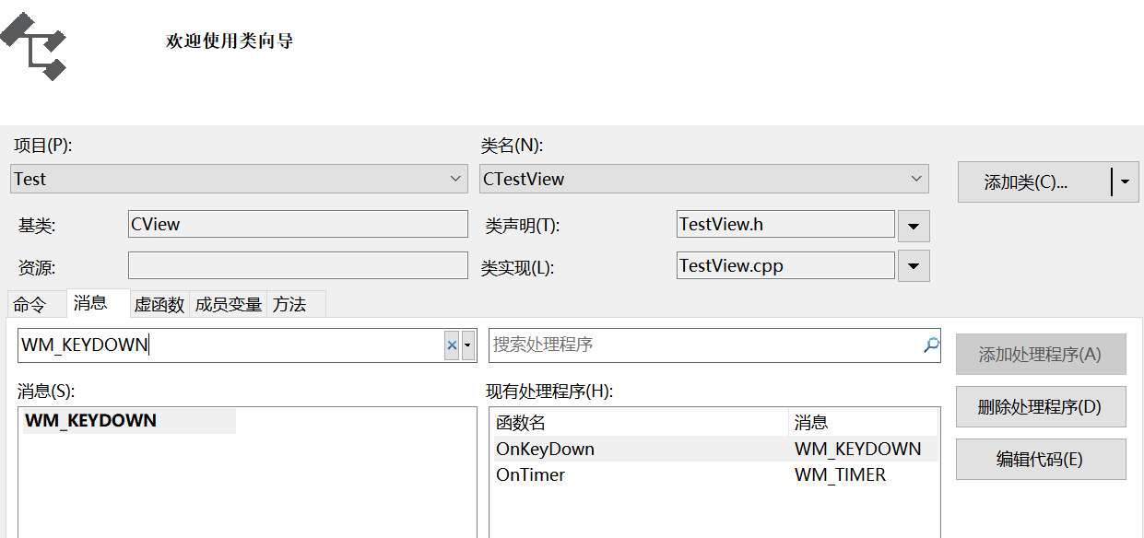
- CTestView.cpp
void CTestView::OnKeyDown(UINT nChar, UINT nRepCnt, UINT nFlags)
{
// TODO: 在此添加消息处理程序代码和/或调用默认值
switch (nChar)
{
case VK_UP:
Alpha = -5;
transform.RotateX(Alpha);
break;
case VK_DOWN:
Alpha = +5;
transform.RotateX(Alpha);
break;
case VK_LEFT:
Beta = -5;
transform.RotateY(Beta);
break;
case VK_RIGHT:
Beta = +5;
transform.RotateY(Beta);
break;
default:
break;
}
Invalidate(FALSE);
CView::OnKeyDown(nChar, nRepCnt, nFlags);
}

