

A 3-Day Personal Spending Tracker: Program Design, Implementation, and Testing

Sugam Thapa
International American University
AIM 401: Python Programming for Data Science
Professor Basyal
September 26, 2026

Introduction:
A budget tracker is simply a spreadsheet which logs the amount of money that a user spends over a given period and compares it to a budget set by the user themselves. So, rather than randomly estimating where a certain sum of money goes each month, a budget tracker allows me to see where my money is going I do this by entering the actual sum that I spend, and the budget tracker sums for me as I go along, letting me know exactly how much I have spent at any time. From a practical perspective, this means I am alerted to any overspending before it adds up, rather than finding out after the fact. If I overspend one day, I am aware of it immediately so I can restrict spending the next day, as opposed to only having my bank account tell me I am overdrawn at the end of the month. Even a small personal example such as this one, which I designed as part of this exercise, provides this same immediate feedback - whether I stay within my daily budget and whether I stay within my overall budget once the period of logging has ended. This is the essential advantage of this type of budgeting system.
For this assignment, I wrote a small Python program that recorded how much money I spent each day for three days and then checked that amount against a daily limit of $20 and a limit of $60 for the whole three days. I implemented it exactly as specified, 3 tasks, within the toolkit of: variables, primitive data types, standard operators, parsing input, and formatting output; simple if/elif/else, simple for/while loops, and no custom functions or user-defined classes, no input or output from external file, and no collection of data, list/tuple/dict/set, and so on.

Below I describe my implementation of each task in code, how I checked my program was meeting the requirements listed above, and how my program performed when I used it to run two different sets of sample inputs.
Program Design and Implementation:
I structured my program according to the three-task defined in the task such that each one relates to a chunk of code I generated.
Task 1: Getting My Name and Creating the Total
At the beginning of my program, I used input() to ask what my name is and put that in a variable called name. Then I created a second variable, total spent and set it to 0. I used that as a running total - I would begin it at zero because no money has been spent, and I would add one to that variable once each day that I'd spent money in the loop at the end. Both are primitives, one string, one integer, so already the data collection requirement is met.
Task 2: The Three-Day Spending Loop
I constructed a loop like for day in range(1, 4) so that my code repeats exactly three times, once for each day of spending. I invoked the range() call just to control how many times my loop runs, just as you would with a simple counter - I don't construct or store a list, tuple, or other collection based on its values. During each iteration of my loop, I prompt for input like: “Enter money spent today ($):” then I convert the results of input() to an actual number using float().
I then add that amount to total spent so that my total will be accumulating by whatever the spender is buying that day: total spent = total spent + spent. In the line that follows, I want to print out a warning if the person’s spending on a single day exceeds their limit of $20. This time, I write out the path in the case that the person did spend more than $20 using if/else: if spent > 20: print “Over your $20 budget today!”; else: print “Great! Under budget today.”
Task 3: The Final Summary
When my loop completes all three repetitions, I display the running total in the string Total money spent over 3 days: $. That I created using string concatenation and str() rather than a data structure. I then use a second if/else statement to compare total spent to my overall budget of 60 dollars.
If total spent is less than or equal to 60, I display the text Overall Result: You stayed under your 60-dollar total budget.
Using print() directly; if total spent is greater than 60, I do the same with Overall Result: You went over your 60-dollar total budget! I set this up to simulate, in an extremely simplified format, what a project manager might do at the end of a reporting period to compare actual spend to the approved budget.
Compliance with the Assignment Constraints:
I went through my entire program line by line, comparing each to the allowed and not-allowed list. I did not use anything but vars, the primitive str, int and float types, the basic arithmetic and comparison operators, input() and float() for parsing, print() for output, one for loop, two if/else tests, no def keyword, no class keyword, no file-handling functions like open() and no list, tuple, dictionary, or set literal anywhere in the program. My string handling was limited to concatenation and simple string conversion with str(), so I didn't need to do any string slicing or use the. format() method. I also didn't need the math or random modules, so I excluded those imports entirely.

Source Code
Below is the complete program I wrote, exactly as I tested it. I included the same file in my GitHub repository as budget_tracker.py.
Figure 1. Personal Spending Tracker Python code showing the use of loops, conditional statements, user input, and budget calculations.
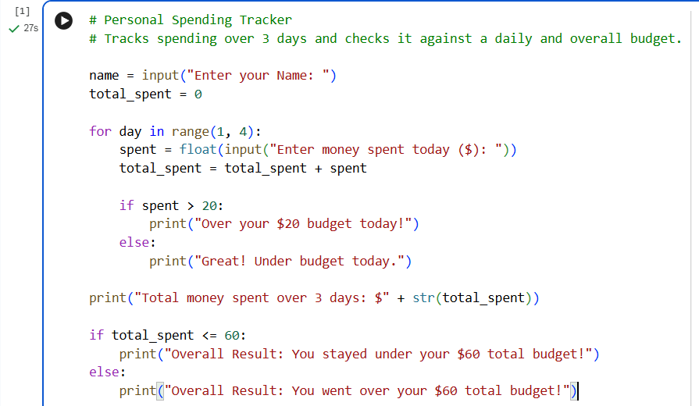
Testing and Sample Output
I test my program twice from the command line with each of two different sets of inputs (the same 2 inputs I used from the website). This confirms that I get both branches of each if/else statement: that with the first input I stay under budget each day and spend under $60 in three days, and with the second input I am over budget on two days and am over $60 spent in three days.
Test Run 1: Spending Remains Below Both Budgets
I submitted $15, $18, and $20 for the three days, for a total of $53. Since 53 is less than or equal to 60, my program told me I would have kept my costs below my total budget, and since the three days were all less than or equal to $20, I would have been able to stay within my daily budget.
Here is the console output I captured:
Figure 2. Output of the Personal Spending Tracker showing daily spending results and the total spending under budget
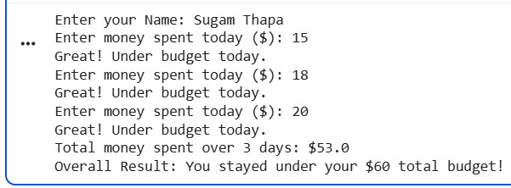Test Run 2: The Spending Surpasses Both Budgets
In this run I input the three days as $25, $10, and $30 respectively, or a combined total of $65. My program rounded out Day 1 and Day 3 days separately as both totalled over the $20 of the daily budget, but Day 2 was announced as under the budget. Since my final total was over $60 of my budget, the final totals correctly announced that I overspent.
Here is the console output I captured:
Figure 3. Output of the Personal Spending Tracker showing daily spending results and the total spending over budget.

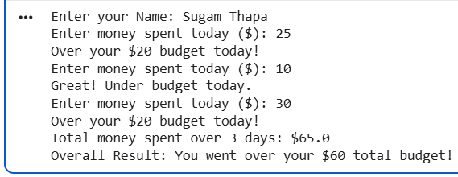
Both runs reassured me that per-day check inside my loop and total check after my loop work independently of each other and both are correct: as Test Run 2 demonstrates, a day can cross the budget while my loop is still running, and my final total of over/under is not decided until I reach the end of my three-day total.
Conclusion:
In this task, I discovered that one small suite of designing tools, together with variables, unsophisticated forms, a single for loop, and 2 if/else statements, was completely adequate to make a functioning, regulation compliant price range tracker. Limiting myself to this equipment additionally confirmed a lesson I realized in my web site software program administration class: that a design ought to use no bigger degree of complexity than the drawback truly calls for. Loops and conditionals of precisely this form are additionally the options that introductory programming research identify because the core logical constructing blocks new programmers should grasp earlier than they will transfer on to variables, features, collections, and different larger development. The identical self-discipline I used right here, monitoring a operating whole towards a hard ceiling and sounding an alarm once we go over, is, on a bigger scale, precisely what value administration advice additionally recommends for data and communication expertise initiatives, the place precise expenditure must be in contrast in opposition to a permitted price range in any respect instances, quite than solely on the finish of the venture.

References
Abdul-Samad, Z., & Kulandaisamy, P. P. (2022). Cost management for information and communication technology projects. Journal of Engineering, Project, and Production Management, 12(2), 166–178. https://doi.org/10.32738/JEPPM-2022-0015
Lockwood, E., & De Chenne, A. (2020). Enriching students’ combinatorial reasoning through the use of loops and conditional statements in Python. International Journal of Research in Undergraduate Mathematics Education, 6(3), 303–346. https://doi.org/10.1007/s40753-019-00108-2
Skuka, A., Kozanoğlu, O., & Bulut, F. (2025). A pedagogical method of teaching nested loops in introductory programming courses. Pedagogika-Pedagogy, 97(4s), 121–130. https://doi.org/10.53656/ped2025-4s.09
GitHub Repository
I submitted the complete source code for this program separately through the following GitHub repository link: https://github.com/SUGAMTHAPAiam/Data_Science

