Discussion Question 1:

Dynamic Typing Versus Static Typing
Programming languages differ in when and how they determine the data type of a variable. In statically typed languages such as C and Java, the programmer must declare a variable's type before the program runs, and the compiler checks that type at compile time (Xia et al., 2022). Once declared, the variable name is bound to a fixed memory location sized for that specific type, and this binding does not change while the program executes. For example, the Java statement int a = 1; fixes a as an integer for the rest of the program; writing a = "hello"; afterward would cause a compile-time error.
Python follows a different model. It is a dynamically typed language, which means that a variable's type is determined and checked while the program is running, not before (Xia et al., 2022). A Python variable name does not hold a value directly; instead, it acts as a reference, or label, that points to an object stored elsewhere in memory. The type information belongs to the object itself, not to the name. Consider the following example:
Figure 1. Demonstration of dynamic typing: the variable x is rebound from an integer object to a string object.

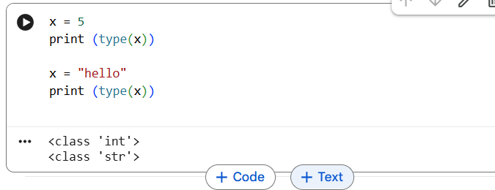
In this example, the first assignment creates an integer object in memory and makes x refer to it. The second assignment does not convert the existing memory slot; it creates a new string object and rebinds x to point to that object instead. This flexibility allows a single variable name to refer to objects of different types over the course of a program, which is not permitted in a statically typed language without explicit type conversion.

How Python Manages Memory Assignment
Because every value in Python is represented as an object, memory assignment works through references rather than direct storage. When one variable is assigned to another, such as y = x, the second name does not receive a separate copy of the data; both names simply refer to the same object in memory, as shown below:
Figure 2. Two variable names referencing the same list object in memory, showing that a change via y is visible through x.

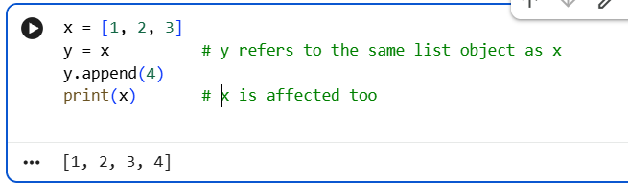
Because x and y point to the same list object, modifying the object through y also changes what x sees, since no copy was ever made. Python's runtime environment, most commonly the CPython interpreter, manages this memory automatically using reference counting together with a cyclic garbage collector, so that objects are removed from memory once nothing refers to them (Xia et al., 2022). This automatic, reference-based memory management is one of the main reasons dynamic typing makes Python convenient for rapid development, although the same flexibility can introduce type-related bugs that would otherwise be caught earlier by a compiler in a statically typed language.

Floor Division (//) Versus True Division (/)
Python provides two division operators that behave differently at the level of internal calculation, even though both begin from the same true mathematical quotient. The forward slash (/) performs true division and always returns a floating-point result, even when both operands are integers. Internally, the operands are represented and calculated using the IEEE 754 double-precision floating-point standard, which stores numbers as an approximation using a sign, exponent, and mantissa rather than as an exact value (Boldo et al., 2023). This is why an expression such as the one below returns a decimal value:
Figure 3. True division (/) returning a floating-point result for both an integer and a float operand.
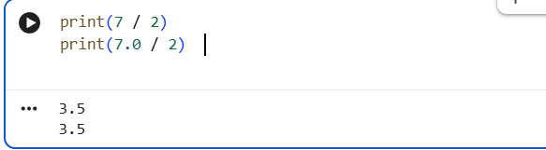
The double slash (//) performs floor division. Python first calculates the true quotient and then rounds the result down, or floors it, toward negative infinity rather than toward zero. If both operands supplied to // are integers, the result is returned as an integer; if either operand is a float, the result is still floored but is returned as a float. The example below shows how this differs from simple truncation once negative numbers are involved:
Figure 4. Comparison of floor division (//) and true division (/), showing that -7 // 2 floors toward negative infinity.
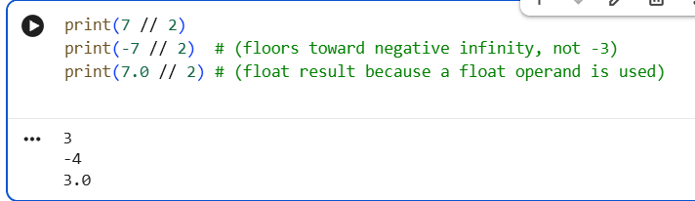
As the example shows, -7 // 2 evaluates to -4 rather than -3, because flooring always moves toward negative infinity. This differs from simple truncation, which would cut off the decimal portion and move toward zero instead. The distinction only becomes visible when negative numbers are involved; for positive operands, flooring and truncating produce the same result. Because floating-point values are stored as finite binary approximations under the IEEE 754 standard, both operators are also subject to small rounding errors inherent to floating-point representation, which is a well-documented source of unexpected results in numerical computing (Boldo et al., 2023).

Conclusion
Python's dynamic typing model binds variable names to objects at runtime rather than binding fixed, typed memory locations to names at compile time, as static languages do. This reference-based approach, combined with automatic memory management through reference counting and garbage collection, gives Python its flexibility but shifts type checking from compile time to runtime. Similarly, Python's two division operators diverge in their internal calculation: true division (/) always returns a floating-point approximation under the IEEE 754 standard, while floor division (//) computes the same quotient but rounds it down toward negative infinity, preserving the integer type when both operands are integers. Understanding these mechanics is essential for writing predictable, well-formed Python code, particularly in numerical and data-driven applications.

References
Boldo, S., Jeannerod, C.-P., Melquiond, G., & Muller, J.-M. (2023). Floating-point arithmetic. Acta Numerica, 32, 203–290. https://doi.org/10.1017/S0962492922000101
Xia, X., Yan, Y., He, X., Wu, D., Xu, L., & Xu, B. (2022). An empirical study on the impact of Python dynamic typing on the project maintenance. International Journal of Software Engineering & Knowledge Engineering, 32(5), 745–768. https://doi.org/10.1142/S0218194022500243
Discussion Question 2:

Short-Circuit Evaluation in a Complex Conditional
Short-circuit evaluation refers to the way a programming language evaluates a compound Boolean expression from left to right and stops as soon as the overall result can already be determined, without evaluating the remaining operands (Bergstra et al., 2021). In Python, both the and and or operators behave this way, and this behavior becomes important once operators are combined, as in the expression A and B or C.
Because the and operator has higher precedence than the or operator, the expression A and B or C is grouped internally as (A and B) or C. Evaluation proceeds in two stages, described below.
Stage one: Python evaluates A and B. If A is falsy, the and operator short-circuits immediately, B is never evaluated, and the sub-expression returns A. If A is truthy, Python evaluates B as well, and the sub-expression returns B.
Stage two: Python takes the result of (A and B) and evaluates it against or C. If that result is truthy, the or operator short-circuits, C is never evaluated, and the whole expression returns that result. If that result is falsy, Python evaluates C and returns it instead.
The overall consequence is that B only runs when A is truthy, and C only runs when A is falsy or B is falsy. This can be demonstrated using functions that print a message when they are called, which makes the skipped evaluations visible:
Figure 1. Function calls demonstrating short-circuit evaluation in the expression a() and b() or c(), with print statements revealing which functions execute.
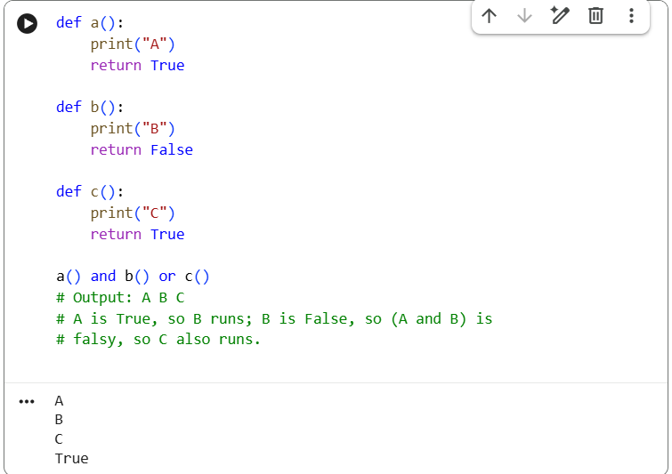
A common pitfall with this pattern is using A and B or C to imitate a ternary conditional (B if A else C). This substitution fails whenever B itself is falsy, because a falsy B makes the sub-expression (A and B) falsy, which then incorrectly falls through to C even though A was true. Python's built-in ternary expression, B if A else C, does not have this weakness and should be used instead whenever this behavior is intended (Bergstra et al., 2021).

Arranging Conditional Structures to Optimize Execution Speed
Because evaluation stops the moment a result is determined, the order in which conditions are written directly affects how much work the program performs at runtime. Arranging conditions deliberately can reduce the number of operations executed, particularly in code that runs frequently or evaluates expensive checks (Raman & Li, 2022).
The first principle is to place inexpensive checks before expensive ones. If one condition is a simple comparison and another involves a slow operation, such as a database lookup or a network call, placing the cheap condition first allows the expression to short-circuit before the expensive operation ever runs:
Figure 2. Ordering a cheap comparison before an expensive check_database() call so the expensive operation is skipped when short-circuiting occurs
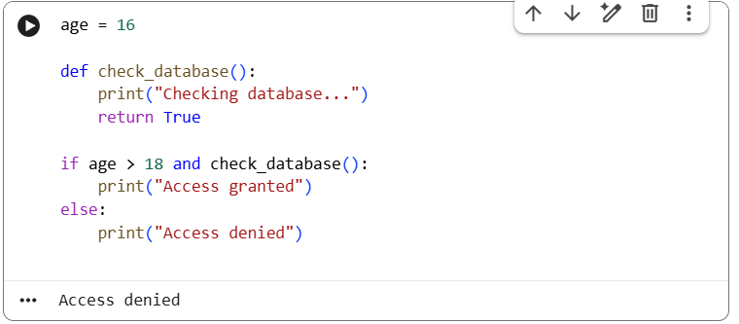
The second principle concerns the likelihood of each condition being true or false. In an and chain, placing the condition most likely to be False first causes the chain to stop sooner on average. In an or chain, placing the condition most likely to be True first causes the chain to stop sooner on average. Ordering conditions by their probability of short-circuiting in this way is the same principle compilers apply when using branch probability estimates to optimize conditional code paths (Raman & Li, 2022).
The third principle is to use short-circuit evaluation as a guard against runtime errors, not only as a speed optimization. This is one of the most common practical uses of and in real code:
Figure 3. Use of and as a guard clause (n != 0 and total / n > 5) to prevent a ZeroDivisionError.
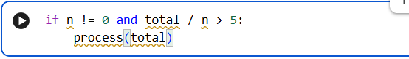
In this example, the condition n != 0 is not just an optimization; it prevents total / n from ever executing when n is zero, which avoids a ZeroDivisionError. Because Python guarantees left-to-right short-circuit evaluation, the division is only attempted once it is already known to be safe.

Conclusion
In a compound expression such as A and B or C, Python's operator precedence groups the statement as (A and B) or C, and left-to-right short-circuit evaluation means that B is skipped whenever A is falsy, and C is skipped whenever (A and B) is truthy. This behavior is not only a performance detail; it can be used deliberately to protect against invalid operations, such as division by zero. For execution speed, conditions should generally be ordered so that cheap checks precede expensive ones, and so that the condition most likely to determine the outcome is evaluated first, whether that means the condition most likely to be false in an and chain or the condition most likely to be true in an or chain (Bergstra et al., 2021; Raman & Li, 2022).

References
Bergstra, J. A., Ponse, A., & Staudt, D. J. C. (2021). Non-commutative propositional logic with short-circuit evaluation. Journal of Applied Non-Classical Logics, 31(3–4), 234–278. https://doi.org/10.1080/11663081.2021.2010954
Raman, E., & Li, X. D. (2022). Learning branch probabilities in compiler from datacenter workloads. arXiv. https://doi.org/10.48550/arXiv.2202.06728

