Question 1:
Python String Immutability and Safe File Handling
Python is a popular language for both beginners and professionals. Two of its basic ideas are strings and files. Strings cannot be changed after they are created. Files are read and written through buffers. This paper explains why Python strings are immutable and what this design gives and costs. It then explains how to write safe file code. It also clears up a common wrong idea about buffers.
Why Python Strings are Immutable?
An immutable object cannot change its state after it is created. In Python, when we write name = “Sugam”, the text inside that object is fixed. Methods such as upper() and replace() do not edit the old string. They build a new one and return it. Researchers and engineers have argued for a long time that immutability helps prevent bugs and security flaws (Coblenz et al., 2016). Python uses this idea for strings for a few practical reasons.
The first reason is hashing. Dictionary keys and set items need a hash value that never changes. If a string could change, its hash would change too, and Python could not find the key again. Python treats immutable built-in types like strings as hashable for this reason (Python Software Foundation, n.d.-a). In CPython, the hash can even be stored inside the string object, so it is not calculated again and again.
The second reason is safe sharing. Many variables can point to the same string with no risk. One part of a program cannot secretly change text that another part is using. This also helps with threads, because reading a string needs no lock. It helps with security too. If a program checks a file name or a username, the checked value stays the same until it is used.
The third reason is memory saving. Because strings never change, CPython can reuse some of them. For example, it can let equal names share one object. This would be unsafe if strings could be edited in place.
Performance Trade Offs
The main cost is copying. Every edit creates a new string, so the computer must copy characters. For short strings, this cost is very small. For long strings inside a loop, it adds up. The Python documentation warns that building a string by repeated concatenation has a quadratic running time and suggests str.join() instead (Python Software Foundation, n.d.-a). The example below shows the difference.
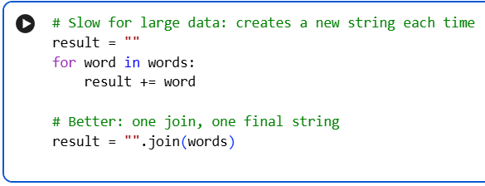
CPython can sometimes speed up += when only one reference to the string exists. However, the documentation says this optimization is not reliable and other Python versions may not have it (Python Software Foundation, n.d.-a). So a good programmer should not depend on it.
There are other costs too. Old and new strings exist in memory at the same time for a short moment. Slicing also makes a copy. To reduce these costs, we can collect pieces in a list and join them once. We can also use io.StringIO to build text step by step. For data that really must change in place, bytearray is a mutable choice. In short, immutability gives safety, hashing, and sharing. The price is extra copying, and the programmer can control that price by choosing the right tool.
Question 2:
Safety Mechanisms
Programs that use files can fail in many ways. The file may be missing, the user may not have permission, the disk may be full, or the program may stop halfway. Good code plans for these cases.
The first mechanism is the with statement. It closes the file even when an error happens inside the block. Closing a file also flushes its buffer (Python Software Foundation, n.d.-b). The second mechanism is exception handling. The code should catch specific errors such as FileNotFoundError, PermissionError, and OSError. It should show a clear message and write a log entry. A bare except should be avoided because it hides real problems.
The third mechanism is input checking. File names that come from users should never be trusted. The program should make sure the path stays inside an allowed folder. It should also set encoding="utf-8" so text is read the same way on every computer. Mode "w" erases the file the moment it is opened, so mode "x" is safer when the file should not be overwritten, because it fails if the file already exists (Python Software Foundation, n.d.-b).
The fourth mechanism is the atomic write. The program writes the new data to a temporary file in the same folder. It flushes and syncs that file. Only then does it replace the real file with os.replace(). If the replace works, the rename is atomic, so other programs see either the old file or the new file and never a half-written one (Python Software Foundation, n.d.-c). This pattern is easy to get wrong. Bornholt et al. (2016) describe the 2009 ext4 data loss case. A program wrote a temporary file and renamed it without forcing the data to disk. After a crash, the file could be empty or only partly new. Extra safety steps include keeping a backup copy, using file locks when several programs share a file, and giving the program only the permissions it needs.
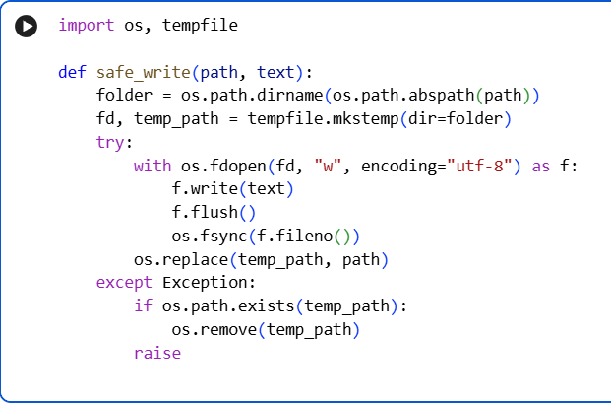
Buffers and Unexpected Termination
The question assumes that file buffers prevent data corruption when a program stops suddenly. This is not correct. Buffers are made for speed, not for safety. A Python file object keeps written data in memory and sends it to the operating system in larger pieces, because many tiny writes are slow. The buffer size is usually based on the file system block size, often about 4 KB or 8 KB (Python Software Foundation, n.d.-b).
If the program ends normally, or an exception leaves a with block, Python flushes and closes the file. If the program is killed suddenly, the buffer is lost. This can happen with a kill signal, an interpreter crash, or a power cut. The file then misses its last part. If a record was only partly written, the file can also hold a broken record. So the buffer does not protect the data. It is a risk that the programmer must manage.
Data passes through three layers. The first is the Python buffer in program memory. Calling flush() moves data from here to the operating system. Data that reached the operating system usually survives a crash of the Python program, but not a power failure. The second layer is the operating system cache. Calling os.fsync() asks the system to write the data to the storage device. The Python documentation says to call flush() first and then os.fsync() (Python Software Foundation, n.d.-c). The third layer is the cache inside the disk hardware, which the program cannot fully control.
Bornholt et al. (2016) show why this matters. The POSIX file system rules do not clearly define what a file looks like after a crash, so file operations may reach the disk in a different order than the program wrote them. This can leave application data corrupt. For this reason, the safe method is to combine flush(), os.fsync(), and the atomic replace shown above. For logs, line buffering (buffering=1 in text mode) can also reduce the amount of data lost. There is a trade-off here, just like with strings. fsync is slow, so it should be used only at important points, such as after saving a complete record.
Conclusion
Python strings are immutable to give safe hashing, safe sharing, and memory reuse. The cost is copying, which can be reduced with join() and similar tools. Safe file code needs the with statement, error handling, input checks, and atomic writes. Buffers improve speed, but they do not stop data loss. Only careful flushing, syncing, and atomic replacement protect data when a program stops without warning.

References
Bornholt, J., Kaufmann, A., Li, J., Krishnamurthy, A., Torlak, E., & Wang, X. (2016). Specifying and checking file system crash-consistency models. In Proceedings of the 21st International Conference on Architectural Support for Programming Languages and Operating Systems (pp. 83–98). ACM. https://doi.org/10.1145/2872362.2872406
Coblenz, M. J., Sunshine, J., Aldrich, J., Myers, B. A., Weber, S., & Shull, F. (2016). Exploring language support for immutability. In Proceedings of the 38th International Conference on Software Engineering (pp. 736–747). ACM. https://doi.org/10.1145/2884781.2884798
Python Software Foundation. (n.d.-a). Built-in types. Python 3 documentation. Retrieved September 28, 2026, from https://docs.python.org/3/library/stdtypes.html
Python Software Foundation. (n.d.-b). io — Core tools for working with streams. Python 3 documentation. Retrieved September 28, 2026, from https://docs.python.org/3/library/io.html
Python Software Foundation. (n.d.-c). os — Miscellaneous operating system interfaces. Python 3 documentation. Retrieved September 28, 2026, from https://docs.python.org/3/library/os.html

