

Decrypting and Filtering Caesar-Encrypted Security Logs with Python

Sugam Thapa
International American University
AIM 401: Python Programming for Data Science
Professor Dhiraj Basyal
September 26, 2026

Introduction
I was a junior data analyst at a security company, and I was given a server log that had been written after a simple Caesar shift cipher. My job was to write a python script that reads the encrypted file, decrypts the lines, saves all the readable lines to a full output file, and copies any lines that mention BREACH to a separate alert file. Log files enable cyber security experts to find incidents of interest (Landauer et al., 2020), however they are inefficient to analyze (Landauer et al., 2020), and they are the primary tool for problem detection in large complex systems (Le & Zhang, 2022). A Caesar cipher shifts each character forward a fixed number of places, making it easily programmable but also insecure.
Program Design and Implementation
Task 1: File ingestion I made up seven dummy lines and put them in raw_logs.txt, each line contains a date, time, level (either INFO, WARNING or CRITICAL) and a message, then I encrypted the lines with a right shift of 3 in the script. I used one pass to populate two output files by opening one file for reading while simultaneously opening two files for writing.
Task 2: Decryption. An outer for loop reads each line and an inner for loop reads each character. Spaces and new lines are simply copied. A letter has its number obtained using ord() - this returns its ASCII number. The script subtracts the number of As (or a's), subtracts 3, uses % 26 to wrap-around, and then adds the number of A (or a's) back. The chr() function then converts this back to the character. The % 26 construct ensures wrap-around, so an encrypted A becomes an X. eg FULWLFDO EUHDFK would become CRITICAL BREACH. Punctuation and numbers were not encrypted.
Task 3: Parsing and writing. The extra whitespace is stripped from the decrypted line before writing to the master file. This line is taken from the copy, which is made upper case with upper() and tested for BREACH using the in operator, which thus makes the search case insensitive. If found, the line is written to the alert file. Two counters keep a record of the number of lines processed, and all files are closed at the end. Table 1: Processes covered at each step.

Table 1
Requirement Checklist and Where Each One Is Met
Requirement | How the program meets it
Task 1: Create raw_logs.txt with at least 5 encrypted lines | raw_logs.txt has 7 lines, encrypted with a right shift of 3.
Task 1: Open two output files at the same time | decrypted_master.txt and security_alerts.txt are opened with mode "w" before the loop starts.
Task 2: Loop through each line and character | An outer for loop reads lines. An inner for loop reads characters.
Task 2: Left shift of 3 using ord() and chr() | (ord(ch) - ord("A") - 3) % 26 + ord("A"), and the same for small letters.
Task 2: Keep spaces and newlines | An if branch copies " " and "\n" without any change.
Task 3: Remove extra white space | decrypted.strip() is used on every decrypted line.
Task 3: Uppercase check for BREACH | "BREACH" in decrypted.upper() sends matching lines to security_alerts.txt.
Forbidden items | No lists, dictionaries, sets, def functions, or imports are used.

Figure 1: Source Code
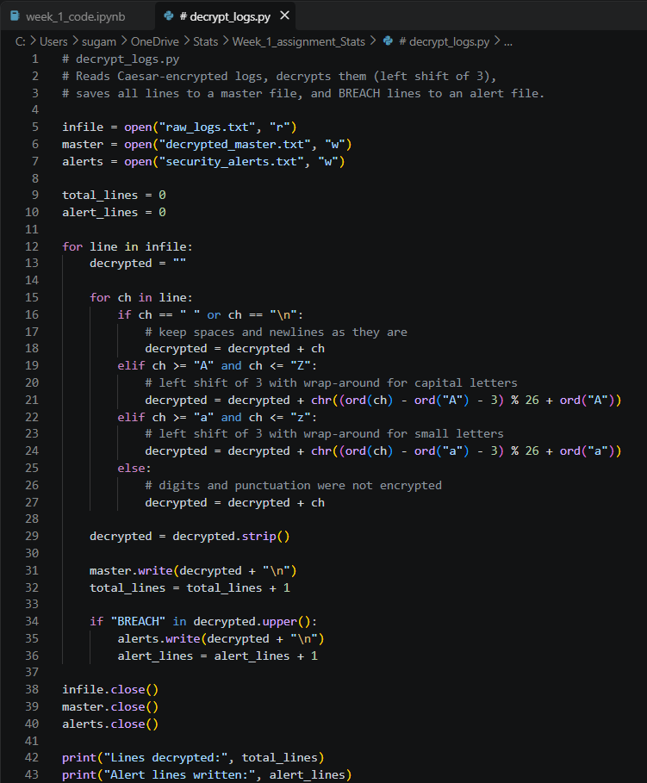
Testing and Output
I ran the program on the seven-line test file. The output matched the original plain messages, as Figures 1 and 2 show.
Figure 3: Encrypted Input File and Program Run
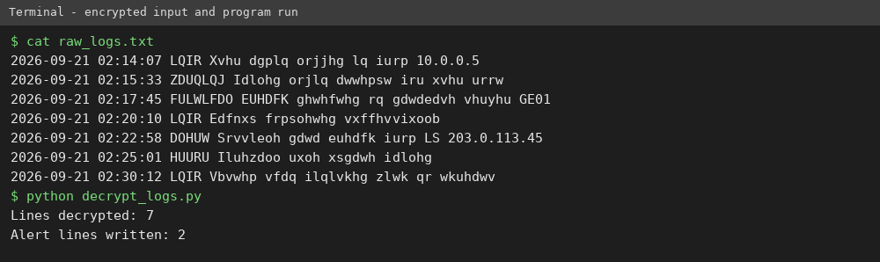
The top part shows raw_logs.txt, which is unreadable because of the shift. The bottom part shows the command python decrypt_logs.py and its result: 7 lines decrypted and 2 alert lines written.
Figure 3: Contents of the Two Output Files
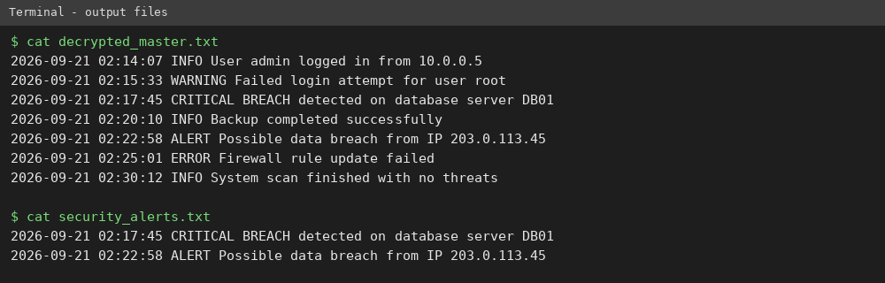
The first block is decrypted_master.txt with all 7 readable lines. The second block is security_alerts.txt with only the 2 lines that contain BREACH. One of them uses the lowercase word breach, which proves the case-insensitive check works.
Limitations and Conclusion
The Caesar cipher is also not secure – there are only 25 possible shifts so an attacker could brute-force all of them in seconds. Diffie and Hellman (1976) explained how computer systems adopted strong, key-based encryption rather than this type of shared-secret. Additionally, my script currently only uses a shift of 3 (a well-known public shift value) for English characters; in practice, a company would properly encrypt all logs and could not use this script without modification to find errors such as input file not found.
Overall, I have used the concepts of file handling, nested loops, ord() and chr() and string methods without collections or functions. This has successfully decrypted each line and maintains a comprehensive master copy, whilst identifying and flagging important BREACH events in an alerts file to easy review.

GitHub Repository Link:
I submitted the complete source code for this program separately through the following GitHub repository link: https://github.com/SUGAMTHAPAiam/Data_Science

References
Landauer, M., Skopik, F., Wurzenberger, M., & Rauber, A. (2020). System log clustering approaches for cyber security applications: A survey. Computers & Security, 92, Article 101739. https://doi.org/10.1016/j.cose.2020.101739
Le, V.-H., & Zhang, H. (2022). Log-based anomaly detection with deep learning: How far are we? In Proceedings of the 44th International Conference on Software Engineering (pp. 1356–1367). Association for Computing Machinery. https://doi.org/10.1145/3510003.3510155
Olanrewaju, B. S., Eguavoen, V. O., & Okunade, O. A. (2025). A modified Caesar cipher encryption technique for secured information sharing. FUDMA Journal of Sciences, 9(5), 180–186. https://doi.org/10.33003/fjs-2025-0905-3494

