

In Memory Inventory Management Tool in Python

Sugam Thapa
International American University
AIM 401: Python Programming for Data Science
Professor Dhiraj Basyal
October 1, 2026

Introduction
This document describes my Python program for the distribution centre. I wrote this as a notebook with three code cells (one per task), not as functions/classes/modules/files as the assignment constraints say I cannot. The program keeps a stock in a dictionary, reads an order queue, updates the stock, and outputs a report. Because of the constraints (no functions/classes/renaming/ imports/reading from file), I only use lists, dictionaries, tuples, for loops, and if-elif-else statements – which makes Python suitable (Harris et al., 2020).
Implementation and Screenshots
Task 1: Inventory and Order Queue
Figure 1 The first cell I initialize an inventory dictionary containing five items. The keys are the item names, and the values are the number of that item in stock. Sensor is initialized to 0 so I can test the out-of-stock case. The orders list contains eight small lists, each with an item name and a quantity. I added Gizmo (not in inventory) to test invalid item case. The output prints my starting data so I can check it later.

Figure 1. Task 1 cell: inventory dictionary and order queue with output.
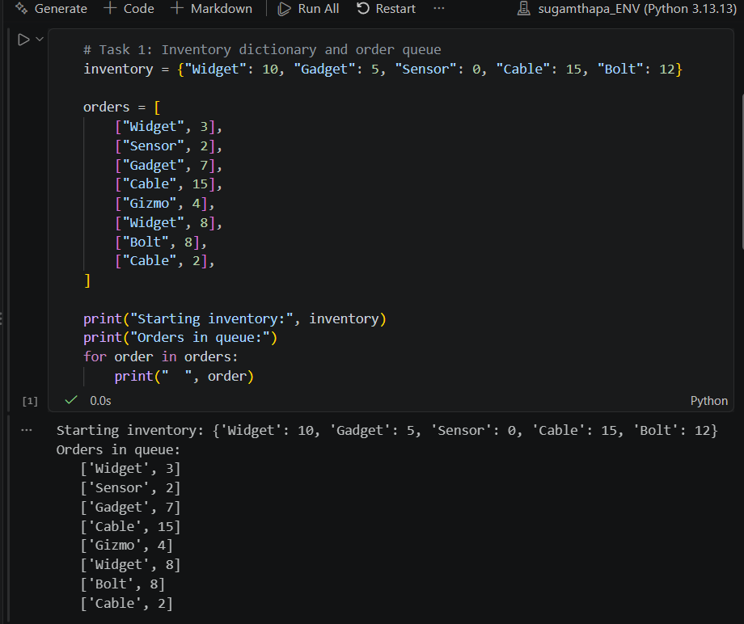
Task 2: Processing the Orders
The main logic is in Fig 2. A for loop takes each order. It uses.get() for the lookup, which gives a None if no key is available, so the program doesn't crash. Then if-elif-else checks four conditions: no stock results in a warning. Enough stock results in a success message, and adds one to number ordered. Some stock but not enough ships the rest, sets stock at 0, and returns the excess. No stock results in a message. And the output: for Gadget there were 5 in stock; 7 ordered; 5 shipped, so 2 go unfulfilled.

Figure 2. Task 2 cell: order processing loop and alerts.
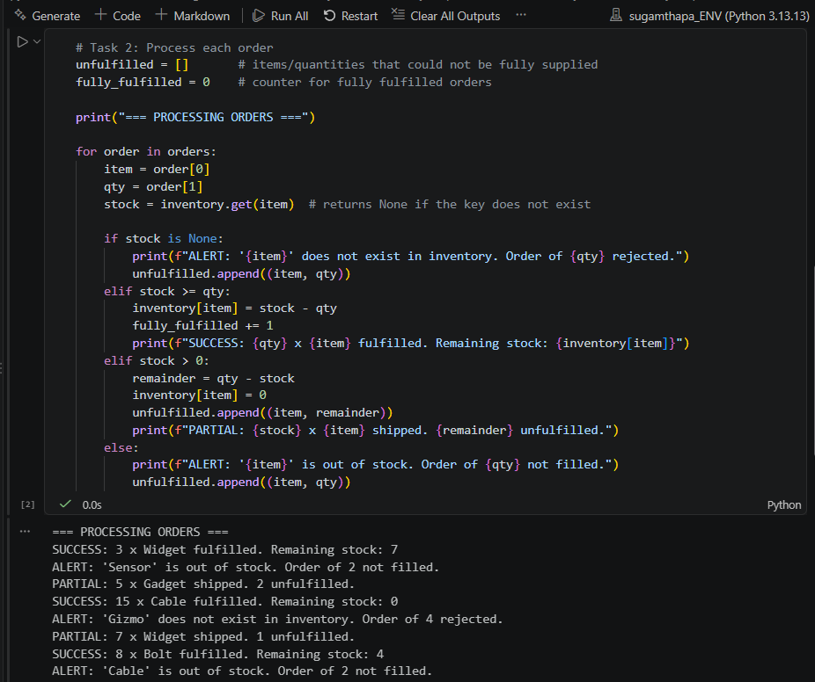
Task 3: Summary Report
Figure 3 is the summary. It prints the final inventory, the number of all the orders, and the unfulfilled list. The list is items of tuple the name, and how much was short.
This results in 3 'items' (full orders) and 5 'shorts' (leftover order without enough stock).
I checked it manually, widget had 10 stock, I took a 3, then took an 8, so one short. That agrees with the output. Keeping all the code in one notebook on GitHub allows for version control (Wilson et al., 2017).

Figure 3. Task 3 cell: final inventory, fulfilled count, and unfulfilled items.
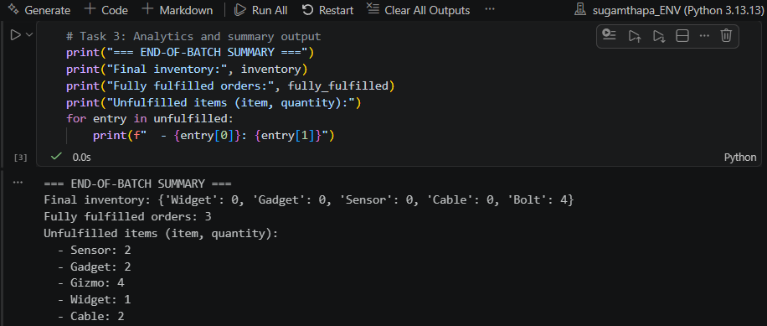
Conclusion
I implemented an inventory management tool in Python using a Jupyter Notebook. The inventory was represented in a dictionary and the orders were represented as a list of lists. Orders were checked using the.get() method so that the program would not error if an order was missing an item. It checked for four conditions – complete order, partial order, item out of stock, invalid item ordered and displayed the results at the end: stock remaining, fully delivered order count, list of remaining items. Test data worked as expected matching my hand calculations, demonstrating the logic of this task (Wilson et al., 2014). I learned how to use tuples for storing results and the use of if-else structures to control flow (Wilson et al., 2014). Having well-named variables made the code more readable and easier to debug (Wilson et al., 2014). Backing up the project on a Github repository helps with good version control practices (Wilson et al., 2017).

References
Harris, C. R., Millman, K. J., van der Walt, S. J., Gommers, R., Virtanen, P., Cournapeau, D., Wieser, E., Taylor, J., Berg, S., Smith, N. J., Kern, R., Picus, M., Hoyer, S., van Kerkwijk, M. H., Brett, M., Haldane, A., del Río, J. F., Wiebe, M., Peterson, P., … Oliphant, T. E. (2020). Array programming with NumPy. Nature, 585(7825), 357–362. https://doi.org/10.1038/s41586-020-2649-2
Wilson, G., Aruliah, D. A., Brown, C. T., Chue Hong, N. P., Davis, M., Guy, R. T., Haddock, S. H. D., Huff, K. D., Mitchell, I. M., Plumbley, M. D., Waugh, B., White, E. P., & Wilson, P. (2014). Best practices for scientific computing. PLoS Biology, 12(1), Article e1001745. https://doi.org/10.1371/journal.pbio.1001745
Wilson, G., Bryan, J., Cranston, K., Kitzes, J., Nederbragt, L., & Teal, T. K. (2017). Good enough practices in scientific computing. PLoS Computational Biology, 13(6), Article e1005510. https://doi.org/10.1371/journal.pcbi.1005510

