Discussion Questions 1:
Equality and Identity
In Python, == and is look like they do the same job, but they do not. The == operator checks equality. It asks if two objects have the same value. Python does this by calling the __eq__ method of the object. The is operator checks identity. It asks if two names point to the exact same object. Every object has an identity, and it never changes during the life of the object (Python Software Foundation, 2024). In oPython, “a is b” works like id(a) == id(b).
A short example shows the difference.
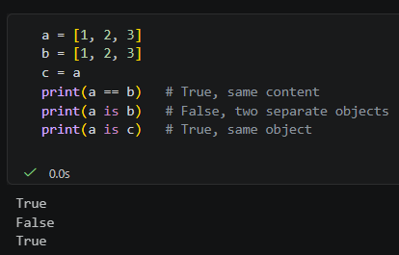
Lists a and b hold the same numbers, so a == b is True. But they are two separate objects, so “a is b” is False. The name c points to the same object as a, so “a is c” is True.
Because of this, == should be used to compare values. The is operator should be used mostly for singletons such as None, as in “if x is none”. It should not be used to compare numbers or strings. Python may reuse an existing object when two immutable values are equal (Python Software Foundation, 2024). CPython, for example, keeps small integers in a cache. So “x is y” may be True for small numbers and False for large ones. This makes the code unreliable.
List alising in Function
A list is mutable, which means it can change after it is created. When a list is passed to a function, Python does not make a copy. The parameter becomes a second name for the same object. This is called aliasing.
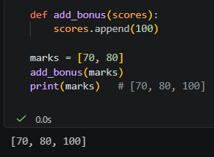
The function changed the list that belongs to the caller. The programmer may not expect this side effect. It causes logic errors when the original data is needed later. For example, a helper function may sort a list, and then the main program reports the original order by mistake.
A second common error is the mutable default argument. In def(f items = []), the default list is created only once, when the function is defined. Every call that uses the default shares the same list. So values from earlier calls stay in it, and the results change from call to call.
Rebinding is different from changing. If a function writes “score = score + [100]”, Python builds a new list and only the local name points to it. The caller's list stays the same. To avoid aliasing bugs, the function can work on a copy, using scores.copy(), list(scores) or score[ : ]. For nested lists, copy.deepcopy() is needed. For default arguments, the safe way is to use None and create the list inside the function.

Discussion Questions 2:
How dictionaries achieve O(1) lookups
A Python dictionary is a hash table. When a key is looked up, Python first calls hash(key), which gives an integer. Python then changes this integer into an index in an internal array, for example by taking the remainder after dividing by the table size. Then it goes straight to that slot. It does not check the items one by one. So the work does not grow when the dictionary gets bigger.
Two different keys can give the same index. This is called a collision. CPython handles it with open addressing. It checks other slots in a fixed pattern until it finds the key or an empty slot (Peterson, 2017). If the hash function spreads keys evenly, these searches stay short. (Carter and Wegman, 2019) showed that with a good choice of hash function, the expected time to store and retrieve keys is linear in the number of operations. This means the cost is constant for each operation on average. Python also makes the table bigger when it becomes too full, so collisions stay rare.
The O(1) result is an average, not a promise. In the worst case, when many keys collide, a lookup can slow down to O(n). Also, keys must be hashable. An object is hashable when its hash value never changes during its life (Python Software Foundation, 2024). This is why a list cannot be a dictionary key, but a tuple of immutable items can.
Choosing Tuples Over List
A tuple is immutable, so it cannot change after it is created. A tuple should be used when the data must stay fixed. Nobody can change it by accident, and this also removes the aliasing problem, because no function can modify it.
A tuple is also the right choice when a dictionary key or set member is needed. A pair such as (27.72, 85.32) can be a key for a location, but a list cannot. Tuples also suit fixed records, where each position has its own meaning, such as a name, an age, and a city. Functions that return several values use tuples too, as in “return low, high”. Finally, tuples use a little less memory and are slightly faster to create.
There is one warning. A tuple that contains a list is not hashable, and the inner list can still change. A list is the better choice when the collection needs to grow, shrink, or be sorted in place.
Conclusion
The == operator compares values and is compares identity. Lists are shared by reference, so functions can change the caller's data without warning. Dictionaries are fast because a hash gives the position of a key directly. Tuples give safety and can be used as keys. Knowing these four ideas helps a programmer avoid many hidden bugs.

References
Carter, J. L., & Wegman, M. N. (2019). Universal classes of hash functions. Journal of Computer and System Sciences, 18(2), 143–154. https://doi.org/10.1016/0022-0000(79)90044-8
Peterson, W. W. (2017). Addressing for random-access storage. IBM Journal of Research and Development, 1(2), 130–146. https://doi.org/10.1147/rd.12.0130
Python Software Foundation. (2024). Data model. In The Python language reference. https://docs.python.org/3/reference/datamodel.html

