**SUGANTHI G**

**727721EUIT163**

**CA – 1**

**QUESTION – 1:**

**package** com.exam.exam;

**import** org.openqa.selenium.By;

//import org.openqa.selenium.By;

**import** org.openqa.selenium.WebDriver;

**import** org.openqa.selenium.WebElement;

//import org.openqa.selenium.WebElement;

**import** org.openqa.selenium.chrome.ChromeDriver;

**import** org.openqa.selenium.chrome.ChromeOptions;

**import** io.github.bonigarcia.wdm.WebDriverManager;

**public** **class** Ques_1 {

**public** **static** **void** main(String[] args) **throws** InterruptedException {

// **TODO** Auto-generated method stub

ChromeOptions co=**new** ChromeOptions();

co.addArguments ("--remote-allow-origins=*");

WebDriverManager.*chromedriver*().setup ();

WebDriver driver=**new** ChromeDriver(co);

driver.get ("https://www.amazon.in/realme-Space-Black-Storage-Medium/dp/B09G6B9NL2/ref=dp_fod_3?pd_rd_w=5xYIr&content-id=amzn1.sym.88cae2b5-aa82-4578-8a66-64758f6fd17a&pf_rd_p=88cae2b5-aa82-4578-8a66-64758f6fd17a&pf_rd_r=ZGDCFFVJYCBBETN3JWDW&pd_rd_wg=R45Li&pd_rd_r=2ad6d3b1-37df-4988-9025-ca4b15f40b54&pd_rd_i=B09G6B9NL2&psc=1");

driver.manage().window().maximize() ;

String currentTitle=driver.getTitle();

System.***out***.println(currentTitle);

String expectedTitle="realme 8i (Space Black, 4GB RAM, 64GB Storage), Medium : Amazon.in: Electronics";

**if**(currentTitle.equals(expectedTitle)) {

System.***out***.println("Title Matched");

}

**else** {

System.***out***.println("Title not Matched");

}

driver.findElement(By.*xpath*("//*[@id=\"add-to-cart-button\"]")).click();

driver.findElement(By.*xpath*("//*[@id=\"nav-cart\"]")).click();

driver.findElement(By.*xpath*("//*[@id=\"a-autoid-0-announce\"]")).click();

driver.findElement(By.*xpath*("//*[@id=\"ap_email\"]"));

// driver.findElement(By.xpath("//*[@id=\"sc-buy-box-ptc-button\"]/span/input")).click();

WebElement txtBoxl=driver.findElement(By.*xpath*("//*[@id=\"ap_email\"]"));

txtBoxl.sendKeys("8248378123");

driver.findElement(By.*xpath*("//*[@id=\"continue\"]")).click();

WebElement txtBox2=driver.findElement(By.*xpath*("//*[@id=\"ap_password\"]"));

txtBox2.sendKeys("Sugan@123");

driver.findElement(By.*xpath*("//*[@id=\"signInSubmit\"]")).click();

driver.findElement(By.*xpath*("//*[@id=\"sc-buy-box-ptc-button\"]/span/input")).click();

}

}

**OUTPUT:**

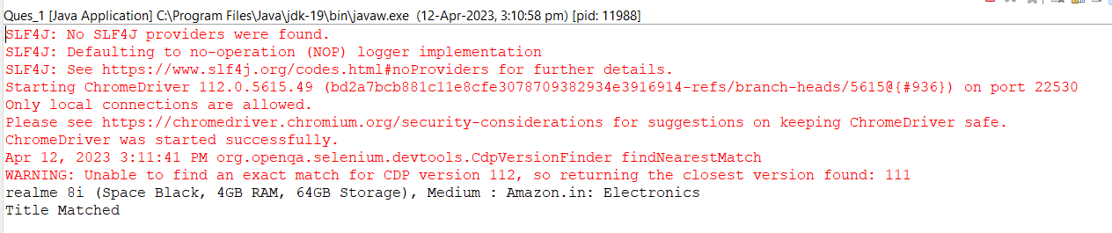

**QUESTION – 2:**

**package** com.exam.exam;

**import** org.openqa.selenium.By;

**import** org.openqa.selenium.JavascriptExecutor;

**import** org.openqa.selenium.Keys;

**import** org.openqa.selenium.WebDriver;

**import** org.openqa.selenium.WebElement;

**import** org.openqa.selenium.chrome.ChromeDriver;

**import** org.openqa.selenium.chrome.ChromeOptions;

**import** io.github.bonigarcia.wdm.WebDriverManager;

**public** **class** Ques_2 {

**public** **static** **void** main(String[] args) {

// **TODO** Auto-generated method stub

ChromeOptions co=**new** ChromeOptions();

co.addArguments ("--remote-allow-origins=*");

WebDriverManager.*chromedriver*().setup ();

WebDriver driver=**new** ChromeDriver(co);

driver.get("https://www.amazon.in/");

driver.manage().window().maximize();

String title=driver.getTitle();

System.***out***.println(title);

String etitle="Online Shopping site in India: Shop Online for Mobiles, Books, Watches, Shoes and More - Amazon.in";

**if**(title.equals(etitle))

{

System.***out***.println("TITLE MATCHED");

}

**else** {

System.***out***.println("TITLE NOT MATCHED");

}

WebElement txtbox=driver.findElement(By.*xpath*("//*[@id=\"twotabsearchtextbox\"]"));

txtbox.sendKeys("smart watches");

driver.findElement(By.*xpath*("//*[@id=\"nav-search-submit-button\"]"));

driver.findElement(By.*xpath*("//*[@id=\"nav-search-submit-button\"]")).sendKeys(Keys.***ENTER***);

JavascriptExecutor js=(JavascriptExecutor) driver;

js.executeScript("window.scrollBy(0,1000)", "");

String txt1=driver.findElement(By.*xpath*("//*[@id=\"search\"]/div[1]/div[1]/div/span[1]/div[1]/div[5]/div/div/div/div/div/div[2]/div/div/div[1]/h2/a/span")).getText();

System.***out***.println(txt1);

String txt2=driver.findElement(By.*xpath*("//*[@id=\"search\"]/div[1]/div[1]/div/span[1]/div[1]/div[6]/div/div/div/div/div/div[2]/div/div/div[1]/h2/a/span")).getText();

System.***out***.println(txt2);

String txt3=driver.findElement(By.*xpath*("//*[@id=\"search\"]/div[1]/div[1]/div/span[1]/div[1]/div[11]/div/div/div/div/div/div[2]/div/div/div[1]/h2/a/span")).getText();

System.***out***.println(txt3);

driver.findElement(By.*xpath*("//*[@id=\"search\"]/div[1]/div[1]/div/span[1]/div[1]/div[6]/div/div/div/div/div/div[2]/div/div/div[1]/h2/a/span")).click();

}

}

**OUTPUT:**

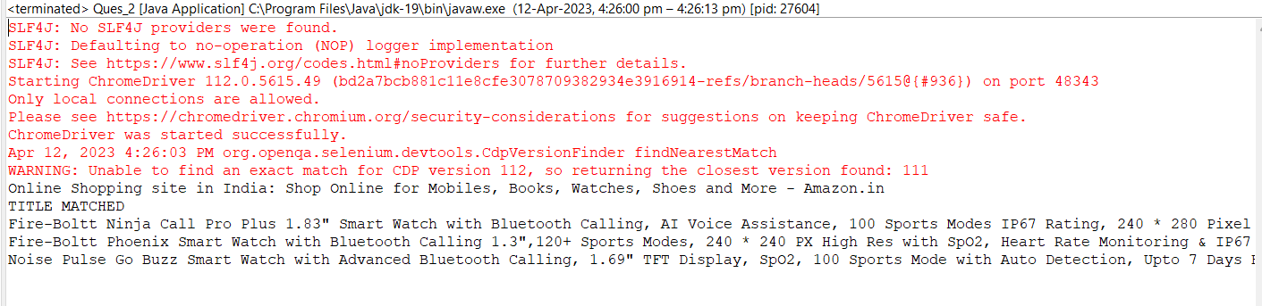

**QUESTION – 3:**

**package** com.exam.exam;

**import** org.openqa.selenium.By;

**import** org.openqa.selenium.WebDriver;

**import** org.openqa.selenium.WebElement;

**import** org.openqa.selenium.chrome.ChromeDriver;

**import** org.openqa.selenium.chrome.ChromeOptions;

**import** io.github.bonigarcia.wdm.WebDriverManager;

**public** **class** Ques_3 {

**public** **static** **void** main(String[] args) {

// **TODO** Auto-generated method stub

ChromeOptions co=**new** ChromeOptions();

co.addArguments ("--remote-allow-origins=*");

WebDriverManager.*chromedriver*().setup ();

WebDriver driver=**new** ChromeDriver(co);

driver.get ("https://www.amazon.in/");

driver.manage().window().maximize() ;

String currentTitle=driver.getTitle();

System.***out***.println(currentTitle);

String expectedTitle="Online Shopping site in India: Shop Online for Mobiles, Books, Watches, Shoes and More - Amazon.in";

**if**(currentTitle.equals(expectedTitle)) {

System.***out***.println("Title Matched");

}

**else** {

System.***out***.println("Title not Matched");

}

driver.findElement(By.*xpath*("//*[@id=\"nav-link-accountList\"]")).click();

WebElement txtBoxl=driver.findElement(By.*xpath*("//*[@id=\"ap_email\"]"));

txtBoxl.sendKeys("8248378123");

driver.findElement(By.*xpath*("//*[@id=\"continue\"]")).click();

WebElement txtBox2=driver.findElement(By.*xpath*("//*[@id=\"ap_password\"]"));

txtBox2.sendKeys("Sugan@2004");

driver.findElement(By.*xpath*("//*[@id=\"signInSubmit\"]")).click();

driver.findElement(By.*xpath*("//*[@id=\"nav-link-accountList\"]")).click();

driver.findElement(By.*xpath*("//*[@id=\"a-page\"]/div[2]/div/div[2]/div[1]/a/div/div")).click();

driver.findElement(By.*xpath*("//*[@id=\"a-autoid-2-announce\"]")).click();

driver.findElement(By.*xpath*("//*[@id=\"ordersInPackage-container\"]/div/div/a[1]")).click();

}

}

OUTPUT:

