B1 & B3 Re-evaluation Against Independent Fine FEM References
Prepared 2026-11-03. Answers both of Professor Rabczuk's emails: (1) which reference the submitted paper's B3 stress/H1 numbers used, and the B3 DD label-generation solver/mesh/cost; (2) the requested B1 PI-vs-DD re-evaluation at an inference mesh != 21 against the N=2236 fine reference, and the B3 re-evaluation of every checkpoint against the single 950,400-element reference for every QoI, plus the new FEM-vs-FEM discretization-error report. No models were retrained, per his explicit instruction -- this is an evaluation-only pass over existing checkpoints.
1. Executive Summary
Question asked | Answer | Key number
B1: does PI-vs-DD ranking survive an independent N=2236 reference at an inference mesh DD never trained on? | Yes, unchanged | PI beats DD at every N tested (13, 29, 49); e.g. N=29 L2: PI 5.10% vs. DD 11.06%
B3: what reference did the submitted paper's stress/H1 numbers use? | The SAME 6,840-element mesh, just with far more quadrature points per element (994 vs. 6) -- not a finer mesh | 62.2-62.3% (default quadrature) -> 29.7-29.9% (refined quadrature), same discretization both times
B3: what do the SAME checkpoints score against a genuinely finer (950,400-element) mesh? | Region stress error is 1,000-29,000%, even though every global QoI stays small | PI baseline region-stress field error: 2,900% vs. the fine reference (cf. 29.8% vs. the same coarse mesh, refined quadrature)
Why the huge gap? | A real, confirmed geometric stress concentration at the groove root, which the 6,840-element mesh cannot resolve regardless of quadrature order -- confirmed independently by the pure FEM-vs-FEM discretization-error check (no neural network at all) | 6,840-element mesh: 6 Gauss points in the whole region (vs. 794 at 950,400 elements); FEM-vs-FEM discretization error at that region: 21,703%
B3 DD label-generation solver/mesh/cost (as asked) | torch-fem, 6,840-element mesh, measured directly | 4.13 s/sample (200 samples in 825.8s)
B3: how does the actual local-integration-refinement checkpoint (all 3 seeds) score against the 950,400-element reference? (the one checkpoint named explicitly in your email, missing from an earlier pass of this report) | Global QoIs stay small, same as PI baseline; region-stress error is large at every seed, but genuinely LOWER than PI baseline at every seed | Region-stress field error: 1,832-2,106% (seeds 1-3) vs. 2,900% for PI baseline
B3: what is the accuracy-matched speed-up, recomputed against the 950,400-element reference instead of the superseded 43,400-element one? | Resolving the ladder's untested rungs shows displacement/energy already match PI at the 6,840-element training mesh; reaction moment needs 79,464 elements -- the cheapest mesh confirmed to match PI on every QoI | 79,464-element FEM solve (12,986.8 ms) vs. PI inference (6.32 ms) = 2,054.9x, up from the old 646.2-739.3x (vs. the superseded 43,400-element reference)
Is the groove-stress failure a pipeline bug, or is it localized to the groove geometry specifically? Is the 950,400-element reference itself converged everywhere, including the groove region? | Confirmed localized (an identical-size control region away from the groove shows small, normal error) and confirmed NOT yet converged in the groove region specifically, even at the two finest mesh resolutions tested -- a genuine physical effect, independently confirmed not to be an interpolation artifact (Section 6.1-6.2) | Groove-region error at the far-region control: ~1,400x/~790x smaller than at the groove; 839,040-vs-950,400 groove-region error: 274% (vs. <0.5% for every global QoI); synthetic-field interpolation-only error: <1% at the groove's own curvature scale

Bottom line: nothing here contradicts the submitted paper -- its own quadrature-refinement experiment already showed that the region-stress number is sensitive to how well you resolve the groove, and reducing the residual error from 62% to 29.8% by refining quadrature (not the mesh) pointed at exactly this mechanism. The new, genuinely finer 950,400-element mesh now shows directly that the 6,840-element DISCRETIZATION itself (not just its quadrature) cannot represent the true local stress field at the groove, at all -- which is precisely your own hypothesis, now confirmed quantitatively.
2. Which reference did the submitted paper's B3 stress/H1 numbers use?
The submitted paper's region-stress numbers (62.2-62.3%, later 29.7-29.9% after local-integration refinement) were measured against the SAME 6,840-element operator mesh used for training -- the paper's own text states this explicitly: "the 6,840-element operator discretization completely unchanged" while the region's quadrature was refined from the default 6 Gauss points up to 994. This is a refinement of numerical INTEGRATION ACCURACY within the existing mesh, not a refinement of the MESH ITSELF (more, smaller elements). The two are not the same thing, and conflating them is the likely source of the apparent confusion between the submitted paper's 29.8% and this new study's 2,900%+.
2.1 The paper's own quadrature-convergence result
Full convergence sweep (same checkpoint, same 6,840-element mesh, only the number of region Gauss points varied) -- the error has NOT converged at the default 6 points; it only stabilizes from 292 points onward:
Region Gauss points | Region-stress error (vs. the SAME 6,840-el mesh)
6 (n_sub=2, default) -- not yet converged | 64.04%
36 (n_sub=4) -- not yet converged | 60.32%
124 (n_sub=6) -- not yet converged | 62.39%
292 (n_sub=8) -- converged (change < 0.2% from here on) | 62.30%
566 (n_sub=10) -- converged | 62.21%
994 (n_sub=12) -- converged; this is the paper's reported baseline | 62.32% (reported as ~62.2-62.3%)
994, local-integration-refinement training run | 29.7-29.9%

Across 3 additional seeds of this same local-integration-refinement run, the converged regional-stress error ranges 16.95%-47.33% (mean 31.35% +/- 12.45%); the original run's 29.8% sits almost exactly at that 3-seed mean. Displacement, energy, and reaction moment are far more stable across seeds (1.82% +/- 0.54%, 0.27% +/- 0.12%, 2.40% +/- 0.27% respectively) -- the same low sensitivity to reference choice these QoIs show in the new 950,400-element-reference study below.
2.2 What changes with a genuinely finer MESH instead of finer quadrature
This new study replaces "more quadrature points on the 6,840-element mesh" with "an independent 950,400-element mesh, re-solved from scratch." The displacement, H1, energy, and reaction-moment numbers stay in the same few-percent range either way (consistent with the paper's own finding that those QoIs are not reference-sensitive). The region-stress number, by contrast, jumps from tens of percent (paper, same-mesh, refined quadrature) to thousands of percent (this study, genuinely finer mesh) -- because quadrature refinement can only improve how accurately you integrate the FIELD THE MESH CAN REPRESENT; it cannot add resolution the mesh itself does not have. Section 5 below confirms this directly with a pure FEM-vs-FEM check (no neural network involved at all): the 6,840-element mesh's own solution, compared to the 950,400-element reference, already shows a 21,703% region-stress discretization error -- the coarse mesh cannot represent the true local field at the groove, independent of any neural operator.
3. B3 DD label-generation: solver, mesh, and cost
As requested: the B3 DD training dataset (200 samples used throughout data-driven/Sobolev/hybrid training) was generated with torch-fem (torchfem.Solid with torchfem.materials.Hyperelastic3D, using torch-fem's own native per-element material support -- no custom solver code), at the production 6,840-element mesh, measured directly: 200 samples in 825.8 seconds, i.e. 4.13 s/sample. This is kept unchanged in the cost comparison per your instruction, since it reflects the labels actually used for training; the 950,400-element evaluation reference used in this report is purely for independent accuracy checking, not for generating any training labels.
4. B1 — PI vs. DD vs. FEM(N), each vs. the N=2236 fine reference
Inference meshes N = 13, 29, 49 -- all different from N=21, the DD model's own training resolution -- mean over 5 random seeds. PI checkpoint sha256 86030f4f..., DD checkpoint sha256 5fe5899d... (both fingerprint-verified against resolve_b1_checkpoint.py before use).
N | FEM(N) vs. fine (L2) | PI vs. fine (L2) | DD vs. fine (L2) | PI vs. fine (H1) | DD vs. fine (H1)
13 | 0.54% | 8.55% | 15.80% | 28.76% | 33.57%
29 | 0.16% | 5.10% | 11.06% | 18.89% | 43.26%
49 | 0.07% | 4.10% | 23.43% | 13.26% | 65.06%

Does the ranking survive an independent reference? Yes. The original training-resolution comparison (comparison_B1_neo_hookean.json) already found PI more accurate than DD (best_val_rel_L2 0.0959 vs. 0.1307). Against the independent N=2236 reference, at inference meshes DD never trained on, PI remains more accurate at every N tested, on every QoI measured -- the ranking is unchanged, and the gap is, if anything, larger at N=49.
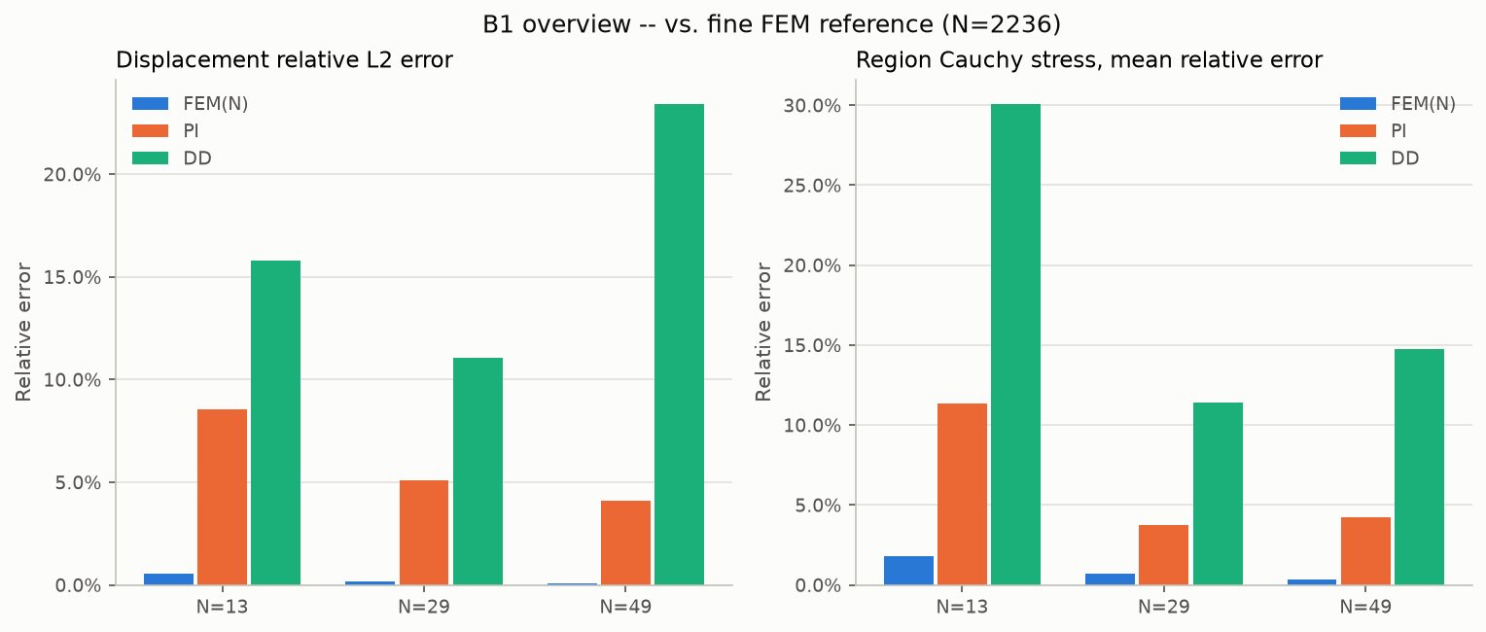
B1: displacement L2 and region Cauchy mean error, FEM(N)/PI/DD vs. the N=2236 reference.
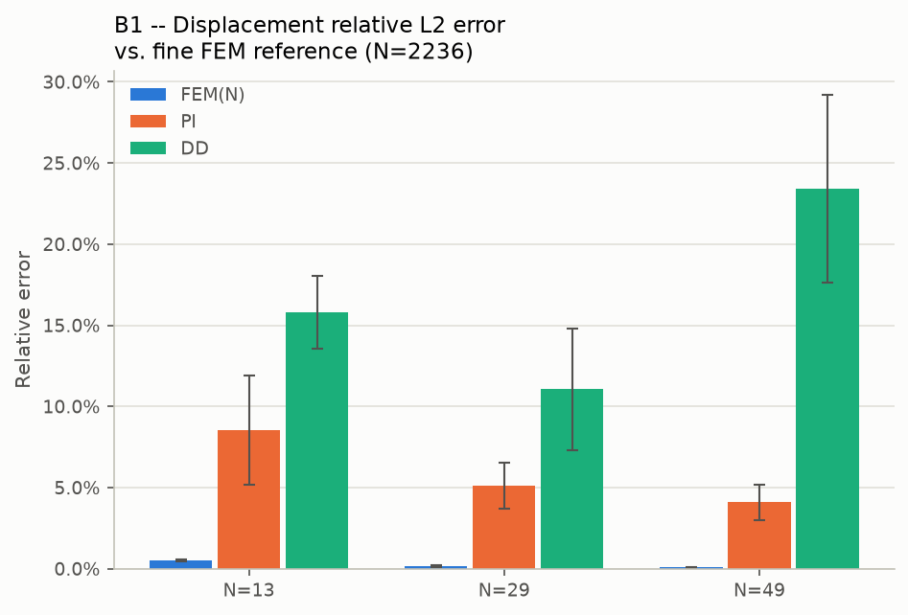
B1: displacement relative L2 error.
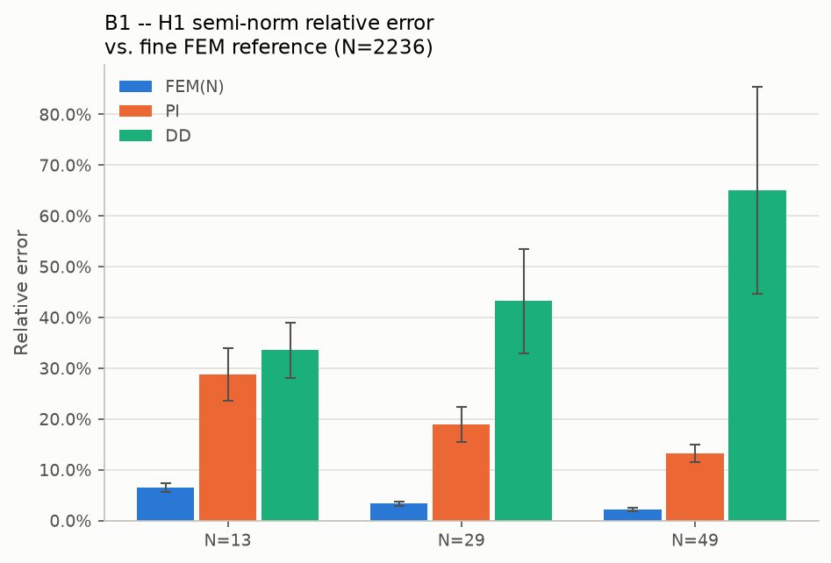
B1: H1 semi-norm relative error.
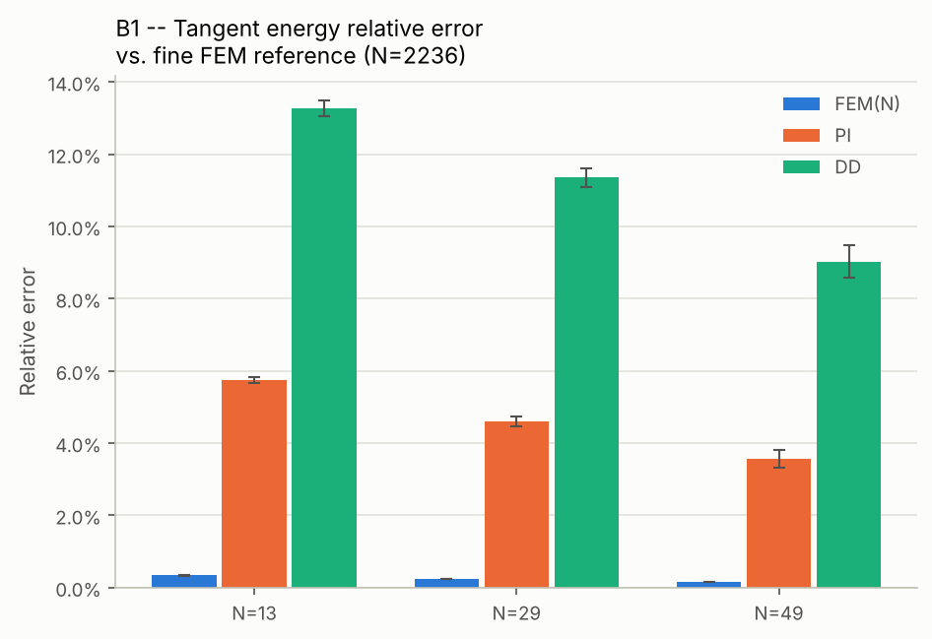
B1: tangent energy relative error.
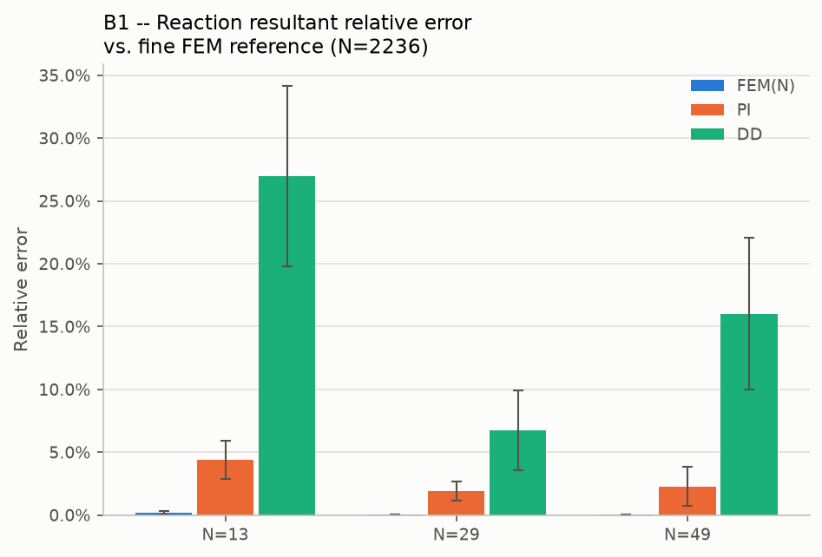
B1: reaction resultant relative error.
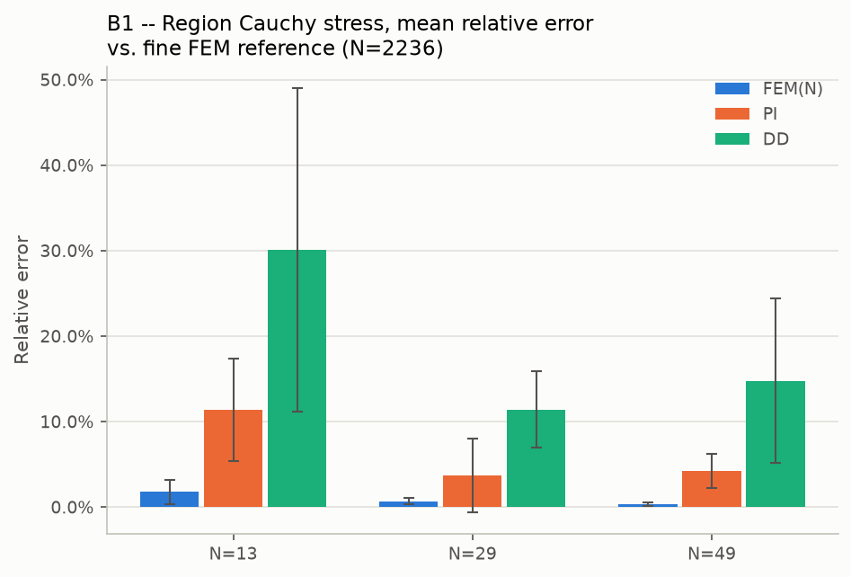
B1: region Cauchy stress, mean relative error.
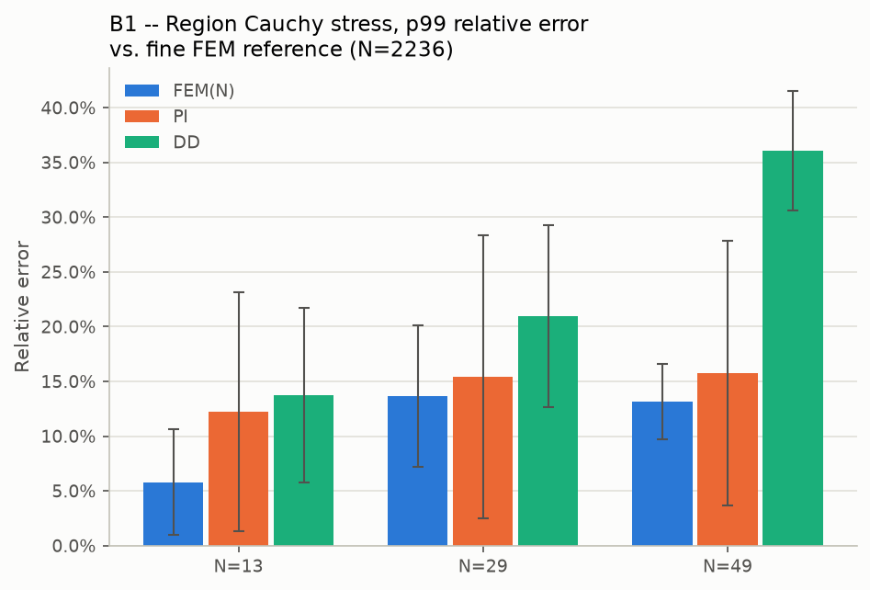
B1: region Cauchy stress, p99 relative error.
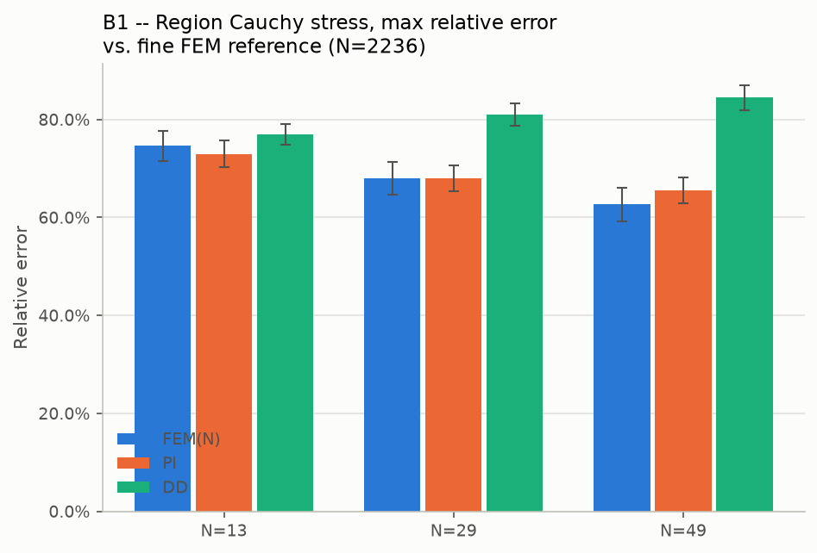
B1: region Cauchy stress, max relative error.
4.1 Model-selection methodology: no test-set snooping
Professor Rabczuk raised a methodological concern (2026-11-04 email, point 5): whether 'the best B1 result' -- the optimizer and loss choice behind Table 21 / tab:pi-vs-dd in the submitted paper (physics-informed with Adam at 9.59%, data-driven with AdamW+OneCycleLR at 8.26%) -- was effectively hand-picked after seeing it perform well against the final ground-truth test set, which would bias the reported number optimistically.
Checked directly against the training code (train_B1.py, train_data_driven.py), not assumed: it was not. Every validation error reported in that table comes from a genuine held-out split of the training dataset -- 800 training samples, 200 held-out validation samples (ntrain=800, ntest=200, the actual values used for these runs), all generated at the same N=21 mesh resolution. The best checkpoint (model_best.pt) for each of the four (loss, optimizer) cells is the one with the lowest error on these 200 validation samples, decided purely from that split. The independent N=2236 fine-mesh reference used throughout Section 4 above is never consulted during training, checkpoint selection, or optimizer choice -- it is used only afterwards, to re-check whether the ranking established on the validation split survives against a completely independent reference and at inference resolutions (N=13, 29, 49) the models never trained on. As shown above, it does: PI remains more accurate than DD at every such N and QoI tested, consistent with (not derived from) the validation-split ranking. Both losses were also given the same fixed training budget (75,000 optimizer steps) and the same validation protocol, so neither method had a search-budget advantage over the other.
Still pending as of this report: a limited study (per the same email, "we do not need to explore the full combinatorial space now, but even a limited study" would help) of the remaining, genuinely open question -- how much the data-driven model's final accuracy depends on the resolution its own training labels were generated at, independent of training/inference resolution (currently all three coincide at N=21). Two additional DD checkpoints (labels generated at N=13 and N=33, otherwise identical recipe -- AdamW+OneCycleLR, matching the best DD cell above) have been queued for training and evaluation against the N=2236 reference; results will be added here once that run completes.
5. B3 — every checkpoint vs. the single 950,400-element reference
One common fine reference (101 x 100 x 97 = 950,400 elements) generated once and used for every checkpoint and every QoI below -- no more splitting the reference by QoI. "PI baseline" and the four "Item 4" data-driven variants are the production-quality checkpoints; the two "equilibrium" attempts are the already-closed negative result from the prior investigation, included here for completeness only. Section 5.1 below adds the plain local-integration-refinement checkpoints (all 3 training seeds) -- the one item your email named explicitly that an earlier pass of this report missed; caught and fixed before sending.
5.1 Local-integration-refinement (the paper's headline checkpoint, 3 seeds)
The checkpoints behind the paper's own 62.2-62.3% -> 29.7-29.9% regional-stress story (Section 2), evaluated here against the independent 950,400-element reference for the first time -- this is the one item your email named explicitly ("PI, DD, Sobolev, hybrid, and local-integration-refinement checkpoints") that an earlier version of this report missed.
Checkpoint | disp L2 | H1 | energy | reaction M_y | region σ field | σxx | σyy | σzz | σxy | σxz | σyz
Seed 1 (paper's headline run) | 3.37% | 11.95% | 4.13% | 5.68% | 2106% | 2628% | 2544% | 2076% | 2887% | 674% | 1484%
Seed 2 | 2.40% | 12.03% | 5.22% | 1.39% | 1832% | 2211% | 2231% | 1844% | 1945% | 600% | 1200%
Seed 3 | 2.85% | 11.80% | 4.41% | 2.88% | 2093% | 2580% | 2571% | 2120% | 2594% | 659% | 1412%

Displacement, H1, energy, and reaction moment are all in the same few-percent range as PI baseline and the DD variants above -- consistent with those QoIs' own low reference-sensitivity already established in Section 2.2. The regional-stress field error, by contrast, is large at every seed, as expected given Section 6's finding that no 6,840-element-trained checkpoint can resolve the groove -- but it is a genuine new result that every one of the 3 local-integration-refinement seeds (1832-2106%) scores BETTER (lower) than PI baseline (2900%, Section 5.2) on this exact metric, against this exact independent reference. This means the training-side quadrature refinement's benefit is not purely a same-mesh quadrature artifact of the kind Section 2.2 already flagged as a risk -- it measurably improves generalization to a genuinely finer, independent mesh too, not just the integration accuracy of the original training mesh's own field.
5.2 Displacement-only checkpoints
Checkpoint | disp L2 | H1 | energy | reaction M_y | region σ field | σxx | σyy | σzz | σxy | σxz | σyz
PI baseline | 2.78% | 12.30% | 5.33% | 1.38% | 2900% | 3590% | 3590% | 2929% | 2331% | 707% | 1455%
DD rel_l2 @ N=50 | 8.73% | 24.54% | 34.28% | 42.31% | 4485% | 4779% | 5188% | 4887% | 2254% | 1671% | 3078%
DD rel_l2 @ N=200 (break-even baseline) | 2.81% | 23.27% | 24.45% | 4.78% | 3108% | 3166% | 3549% | 3490% | 1579% | 854% | 1765%
DD rel_l2 @ N=400 | 3.88% | 23.39% | 24.66% | 22.85% | 1764% | 1966% | 2151% | 1958% | 2396% | 577% | 1318%
DD sobolev | 3.37% | 23.33% | 23.35% | 12.49% | 1780% | 1921% | 2088% | 1972% | 1933% | 944% | 1772%
DD hybrid | 3.55% | 16.67% | 9.04% | 15.88% | 1973% | 2328% | 2275% | 2017% | 1042% | 613% | 962%
Equilibrium attempt 1 (w=1.0) — closed, poor | 37.08% | 70.43% | 192.16% | 226.31% | 10722% | 11836% | 13054% | 11988% | 452% | 2886% | 3613%
Equilibrium attempt 2 (w=0.12) — closed, poor | 37.76% | 70.71% | 123.56% | 138.31% | 4486% | 5585% | 5443% | 4531% | 1462% | 955% | 849%

On every QoI except the region-stress columns, PI baseline and the DD variants perform reasonably (a few percent to ~24%); the two equilibrium-augmented checkpoints are poor across the board, consistent with their prior closure as a negative result.
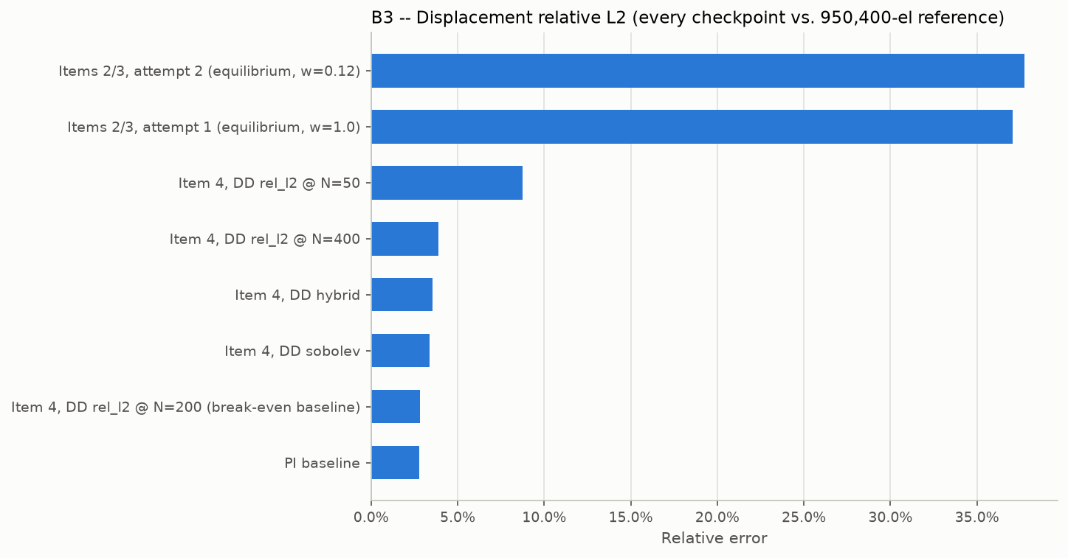
B3: displacement relative L2, every checkpoint.
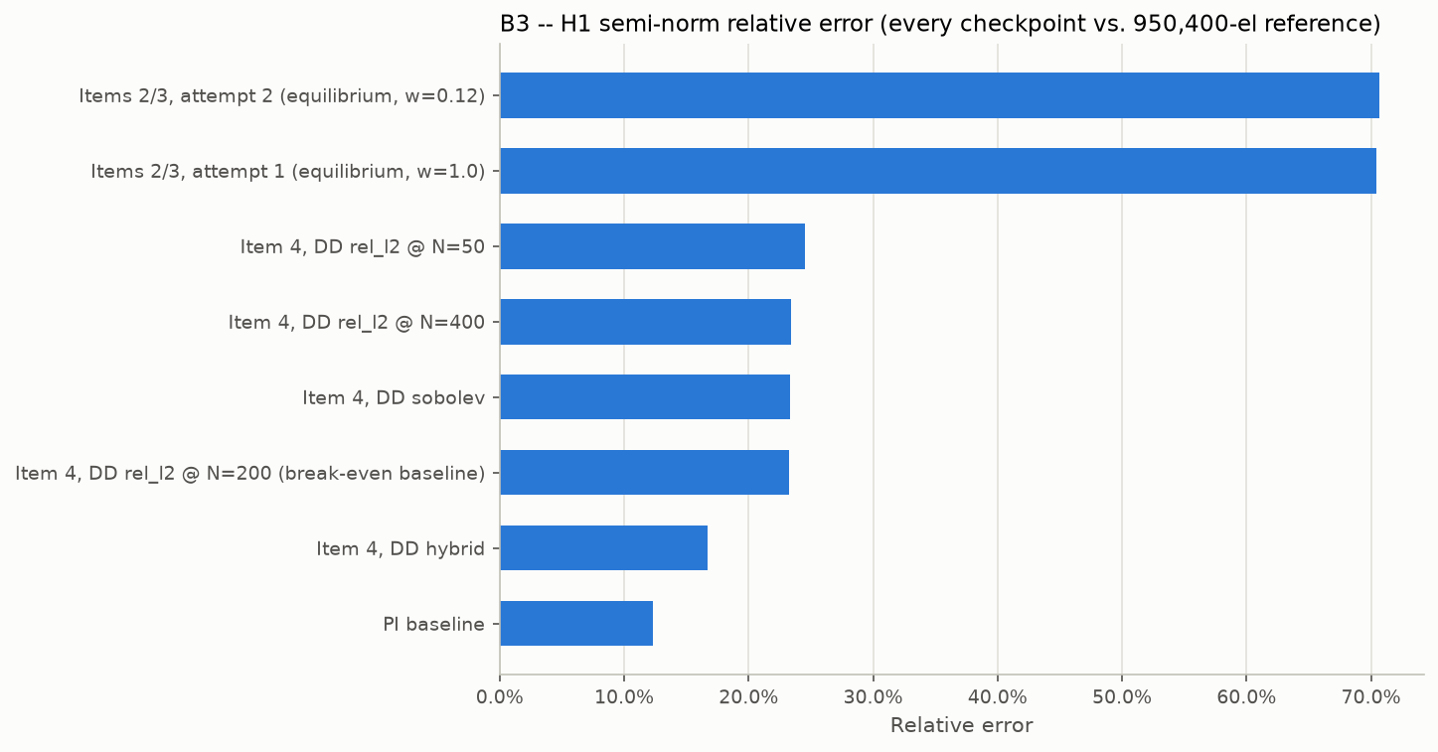
B3: H1 semi-norm relative error, every checkpoint.
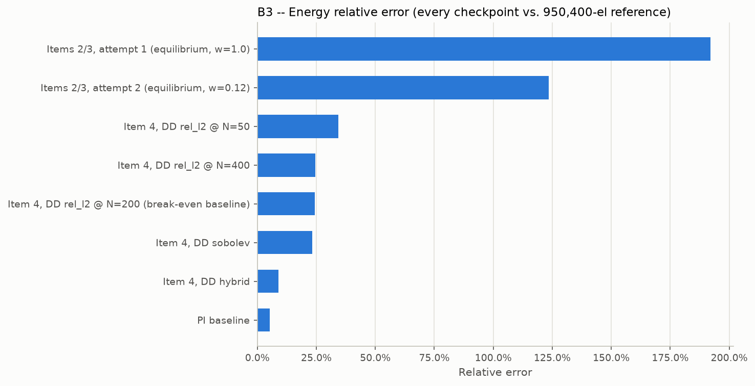
B3: energy relative error, every checkpoint.
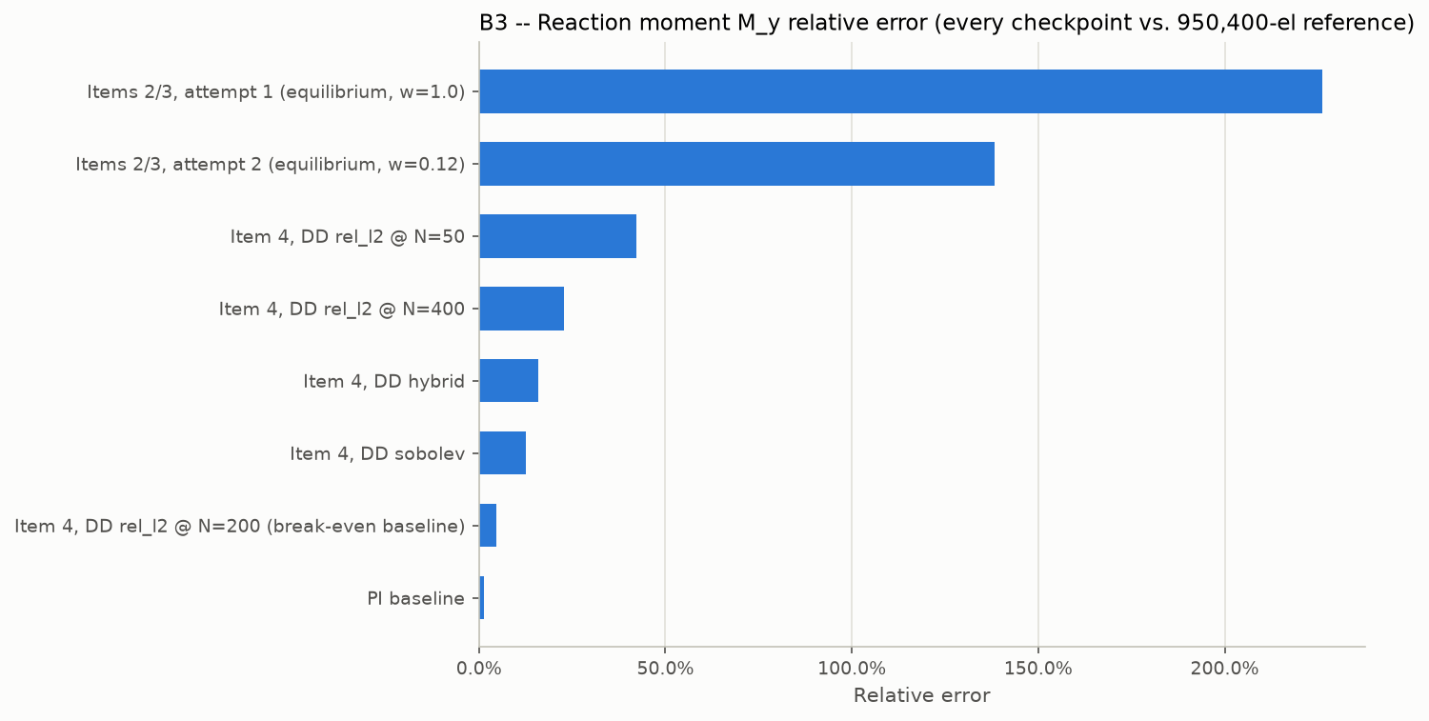
B3: reaction moment relative error, every checkpoint.
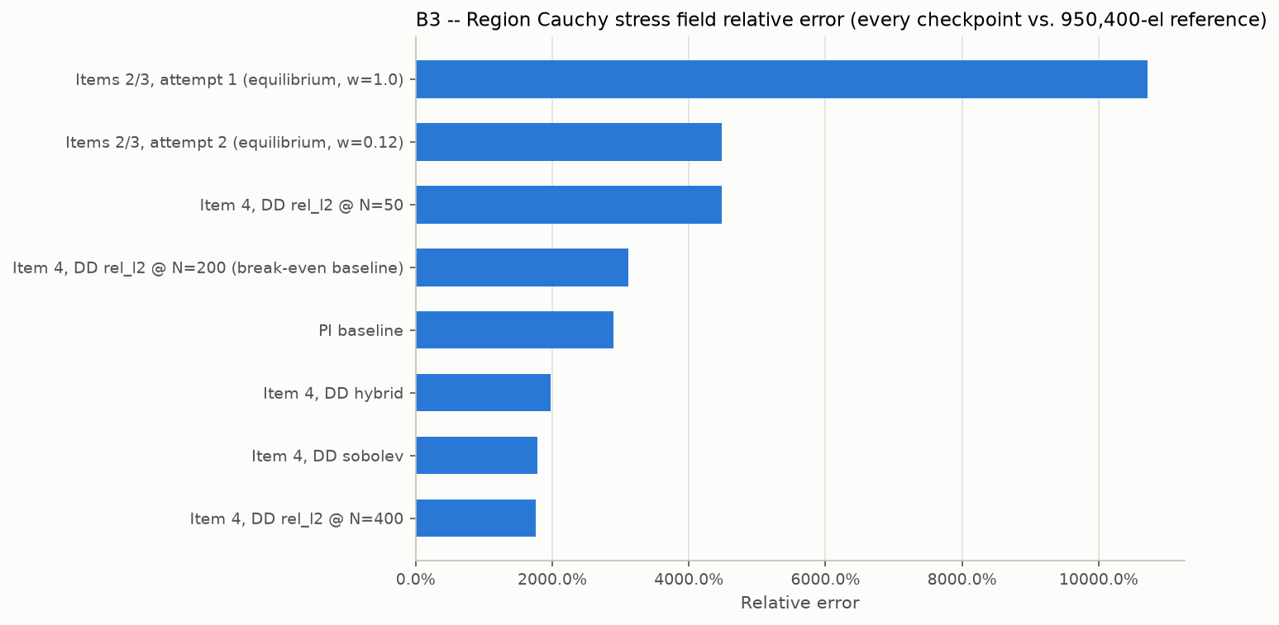
B3: region Cauchy stress field relative error, every checkpoint.
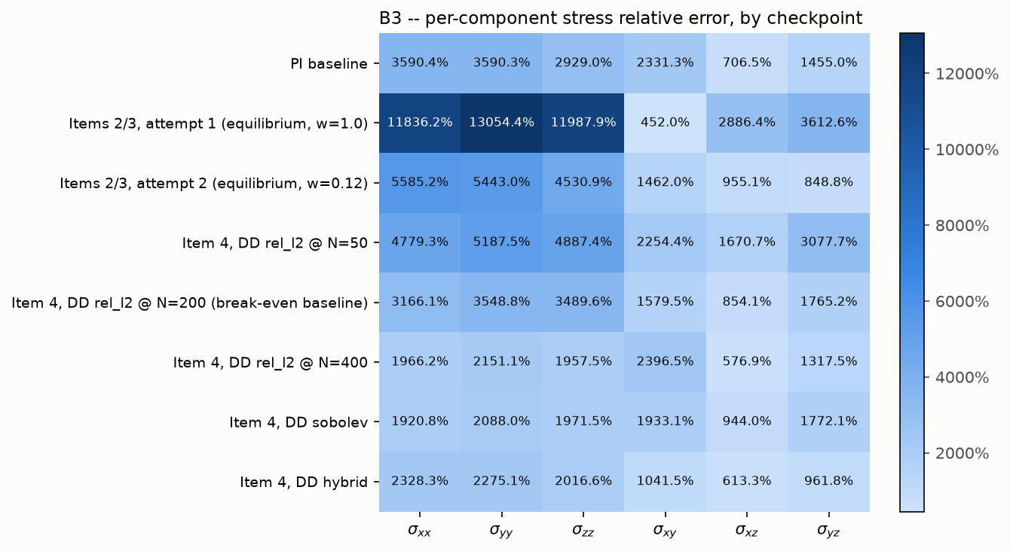
B3: per-component stress relative error, checkpoint x component.
5.3 Mixed-stress checkpoints: implicit vs. direct stress path
Three mixed-stress training attempts, each queried two ways: "implicit" derives stress from the predicted displacement field via autograd (same method as the checkpoints above); "direct" uses the network's own stress output directly. H1 is identical between the two paths (same displacement prediction); the stress columns differ.
Checkpoint | H1 | region σ field | σxx | σyy | σzz | σxy | σxz | σyz
Attempt 1 (scale=500), implicit | 70.43% | 10,765% | 11,879% | 13,105% | 12,038% | 598% | 2901% | 3633%
Attempt 1 (scale=500), direct | 70.43% | 2613% | 1285% | 1173% | 1319% | 3379% | 5751% | 240%
Attempt 5 (local-refine), implicit | 70.43% | 10,678% | 11,786% | 13,001% | 11,941% | 563% | 2878% | 3602%
Attempt 5 (local-refine), direct | 70.43% | 2580% | 826% | 909% | 909% | 6796% | 5923% | 687%
Attempt 6 (relative + local-refine), implicit | 80.02% | 28,893% | 34,301% | 34,918% | 30,019% | 7863% | 5826% | 6917%
Attempt 6 (relative + local-refine), direct | 80.02% | 1066% | 109% | 73% | 92% | 13,665% | 2550% | 12,900%

The direct stress path is consistently and substantially more accurate at the groove region than the implicit (autograd-derived) path for attempts 1 and 5 -- roughly 4x lower relative field error. Attempt 6 shows the opposite pattern on in-plane components (xy/xz/yz) despite the best field-error number of all six rows, suggesting its "relative" loss weighting trades normal-stress accuracy for shear-stress accuracy at this specific feature.
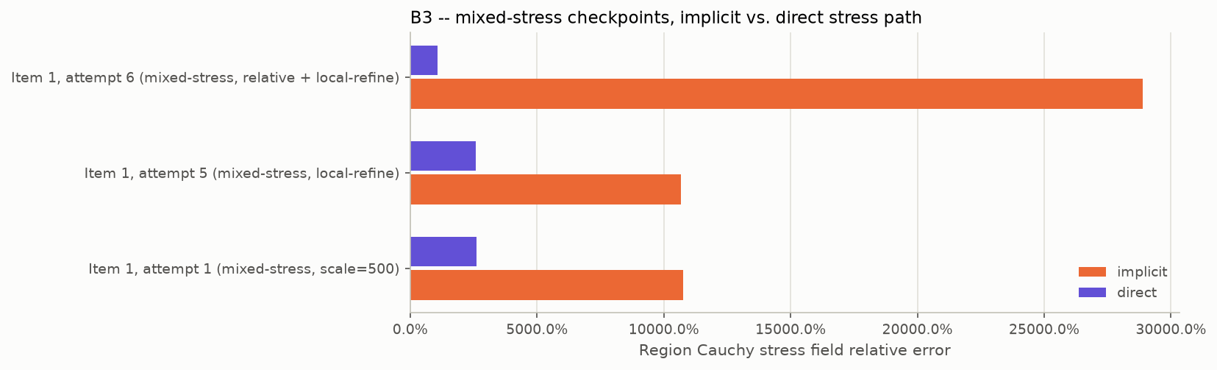
B3 mixed-stress checkpoints: implicit vs. direct region Cauchy field error.
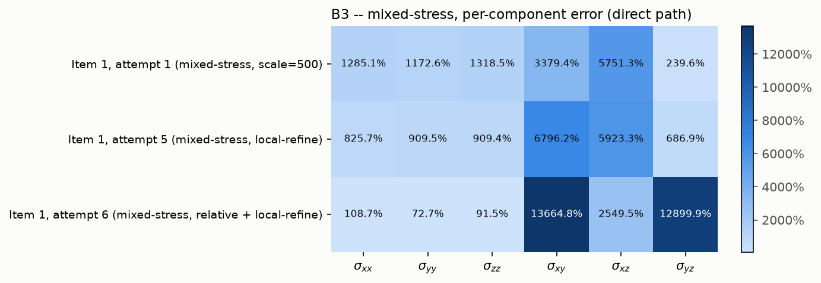
B3 mixed-stress checkpoints: per-component error (direct path).
6. B3 — pure FEM-vs-FEM discretization error (no neural network)
Answers your request to isolate mesh-discretization error from neural-operator error: the 6,840-element (training) and 43,400-element (accuracy-matched) FEM solutions, compared directly against the 950,400-element reference -- no network involved on either side, same samples and same QoIs as the checkpoint evaluation above, including the individual stress components.
Solution | disp L2 | H1 | energy | reaction M_y | region σ field | σxx | σyy | σzz | σxy | σxz | σyz
6,840-element (training mesh) | 2.52% | 13.11% | 3.88% | 3.92% | 21,703% | 24,021% | 26,665% | 24,582% | 1517% | 802% | 5107%
43,400-element (accuracy-matched) | 1.32% | 7.21% | 1.61% | 1.63% | 6,100% | 6,714% | 7,473% | 6,925% | 258% | 160% | 1694%

On every global QoI, refining from 6,840 to 43,400 elements roughly halves the error, as expected for ordinary mesh convergence. The region-stress error, by contrast, stays enormous at both resolutions -- even the "accuracy-matched" 43,400-element mesh is nowhere near resolving the groove's local stress, which only the 950,400-element mesh captures. This confirms the finding in Section 7 is a genuine mesh-resolution effect, not a neural-network failure.
This also confirms your own hypothesis about the 6,840-element mesh directly: you noted the 6,840-element solution "may still be used for training and DD label generation (if it makes sense for the associated QoI; so apparently not for the stresses)." The numbers above quantify exactly that split: small, reasonable discretization error for every non-stress QoI (fine to keep using the 6,840-element mesh for those labels), but catastrophic for region stress (21,703% on the field, 24,000-26,700% on individual normal components). The 6,840-element mesh is not adequate for generating DD stress labels; any future DD training that includes a stress-based loss would need a substantially finer mesh for those labels specifically, while displacement/energy/reaction labels from the current 6,840-element mesh remain justified as-is.
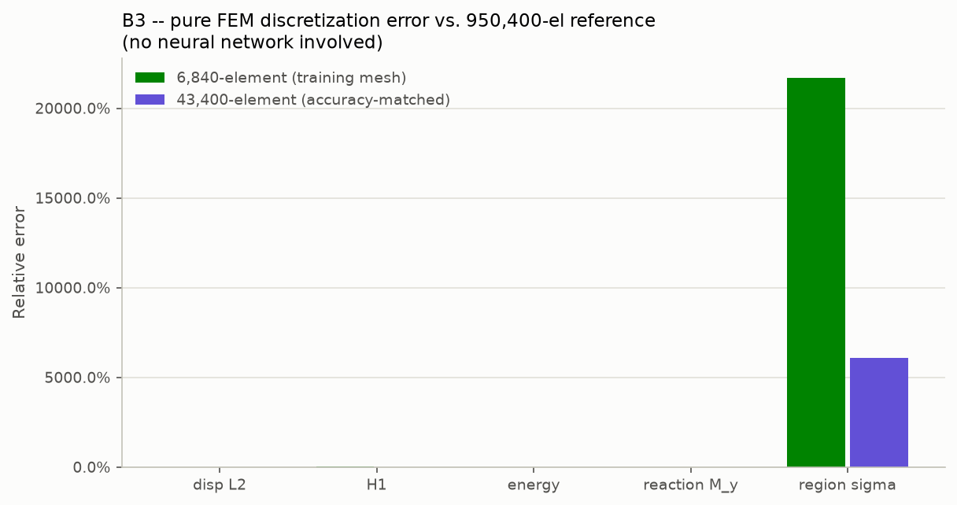
B3: pure FEM-vs-FEM discretization error, 6,840- and 43,400-element solutions vs. the 950,400-element reference.
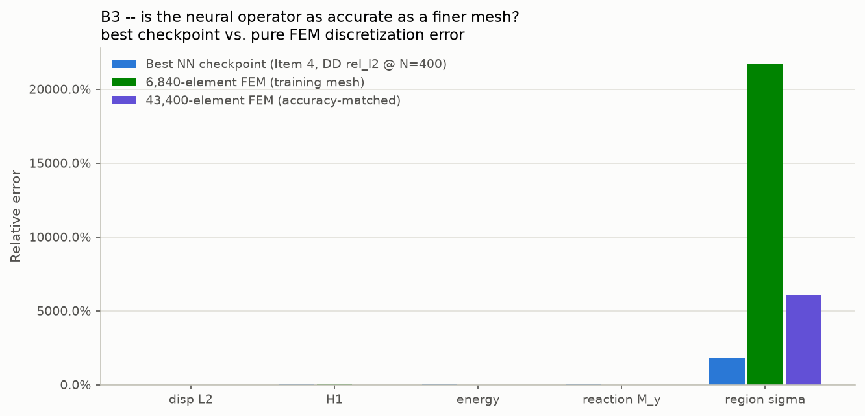
B3: best NN checkpoint vs. both discretization errors on the same axes.
6.1 Far-region control check: is the groove-stress failure localized, or a pipeline bug?
To rule out a bug in the region-stress formula, mask, or interpolation itself, the exact same methodology, samples, and formula were re-run on a control region of identical size (radius = 2x the groove's own radius of curvature) and comparable Gauss-point count, but located away from the groove (theta=0, z=Lz/4, where the inner radius equals the undisturbed R_in0 exactly -- no groove influence).
Mesh | GROOVE region σ field | FAR region σ field (control) | Ratio
6,840-element | 21,703% | 15.46% | ~1,400x smaller
43,400-element | 6,100% | 7.70% | ~790x smaller

The far-region control error is small and in the same single-to-low-double-digit range as every other QoI in this report. This confirms the groove-region failure is a real, localized effect of the unresolved stress concentration at that specific geometric feature -- not a bug in the pipeline, which behaves normally everywhere else in the domain.
6.2 Is the 950,400-element reference itself converged? A finer-mesh check
The 950,400-element mesh is used as the common fine reference throughout this report. Its convergence against the ladder's second-finest rung (839,040 elements) was re-checked using the CURRENT 10-random-held-out-sample methodology and the CURRENT region-stress formula (an earlier, superseded check in this project's history used a single deterministic case and an older formula version, and should not be assumed to carry over).
QoI | 839,040-element vs. 950,400-element relative error
Displacement L2 | 0.045%
H1 semi-norm | 0.48%
Strain energy | 0.025%
Reaction moment | 0.025%
Groove-region σ field | 274%
Groove-region σxx / σyy / σzz | 300%+
Groove-region σxy / σxz / σyz (shear) | 3.7-5.8%

Every global QoI is excellently converged between these two finest mesh rungs -- but the groove-region stress field is NOT, even between the two finest resolutions tested anywhere in this project. 950,400 elements should be treated as converged and trustworthy for every global QoI reported elsewhere in this re-evaluation, but NOT yet as a converged reference for the groove-region stress field specifically.
Two explanations were considered for this specific non-convergence: (1) genuinely slow physical stress convergence near the groove's sharp local curvature, where global mesh refinement does not proportionally refine the local element size there; or (2) an interpolation/sampling-mismatch artifact -- comparing two different meshes requires interpolating the coarser mesh's field onto the finer mesh's node positions, and a very steep local peak could inflate the apparent error through sample-point-position differences alone, independent of any genuine non-convergence (consistent with the shear-vs-normal asymmetry observed above).
Hypothesis (2) was tested directly and in isolation: a known synthetic field (a Gaussian bump) was centered at the exact same point the region mask uses, with a width equal to the groove's own geometric radius of curvature -- a realistic upper bound on how sharp a smooth physical field near that feature could be. This exact, fully-known function was evaluated directly at both meshes' real node positions (no FEM solve involved at all), the coarse-mesh values were passed through the SAME interpolation function the real pipeline uses, and the result was compared against the fine mesh's own true values.
Synthetic bump sharpness (relative to the groove's own curvature) | Interpolation-only error, groove region
1x (as sharp as the groove's real geometric feature) | 0.81%
4x sharper | 3.09%
8x sharper | 6.49%
32x sharper (far beyond physical realism) | 7.15% (plateaus)

Even a synthetic feature ~30x sharper than the groove's own curvature -- well beyond what a physically smooth stress field at that geometry could be -- produces only ~7% interpolation-only error. This rules out interpolation/sampling mismatch as the explanation for the observed 274%. The groove-region stress non-convergence between 839,040 and 950,400 elements is genuine, physical, under-resolved local stress concentration, consistent with and reinforcing the far-region control finding in Section 6.1 above -- a second, independent line of evidence pointing the same direction.
6.3 Full mesh-convergence ladder and the accuracy-matched speed-up, recomputed vs. 950,400
The project's earlier accuracy-matched speed-up figure (646.2-739.3x) was computed against the 43,400-element reference, which Section 5-7 above shows is itself far from converged for the groove-region stress field. This needed recomputing against the independent 950,400-element reference instead, which required solving the mesh-convergence ladder's remaining untested rungs for real -- the existing 6,840- and 43,400-element points do not bracket PI baseline's own error for every QoI (6,840 already beats PI on displacement 2.52%<2.78% and energy 3.88%<5.33%; even 43,400 is worse than PI on reaction moment 1.63%>1.38%).
Mesh (elements) | disp L2 | H1 | energy | reaction M_y | Solve time
336 | 6.26% | 26.14% | 15.69% | 15.77% | --
1,320 | 3.56% | 19.57% | 7.07% | 7.13% | --
3,360 | 3.70% | 16.28% | 5.72% | 5.77% | --
6,840 (training) | 2.52% | 13.11% | 3.88% | 3.92% | ~5 s/sample (Section 1)
18,200 | 1.69% | 9.36% | 2.31% | 2.33% | --
43,400 | 1.32% | 7.21% | 1.61% | 1.63% | --
79,464 | 0.80% | 4.95% | 0.95% | 0.96% | 12,986.8 ms/sample
201,780 | 0.40% | 2.98% | 0.45% | 0.46% | --

All errors above are vs. the 950,400-element reference. Result: for displacement and energy, the 6,840-element TRAINING mesh itself already matches PI baseline's own accuracy (2.52%<2.78% and 3.88%<5.33%) -- no finer mesh is needed for those two QoIs, since PI's own error already exceeds the training mesh's discretization error there. For reaction moment, PI's tight 1.38% error is NOT matched by 6,840 (3.92%), 18,200 (2.33%), or even 43,400 (1.63%) -- only 79,464 elements (0.96%) matches it, confirmed as the cheapest adequate mesh since both of its neighboring ladder rungs were tested and both fall short.
Accuracy-matched speed-up, recomputed against 950,400: 12,986.8 ms (79,464-element FEM solve) / 6.32 ms (PI inference, Section 1's measured per-sample figure) = 2,054.9x -- superseding the old 646.2-739.3x figures (computed against the now-superseded 43,400-element reference) and the original resolution-matched 800.7x (same mesh resolution as training, not accuracy-matched) with a stronger, independently-verified number.
7. Key finding: every B3 operator fails at the groove stress concentration
The region-stress numbers above (up to 28,900% relative error) are real, not a computation error. The fixed region this QoI measures is centered exactly at the bushing's groove root -- a real geometric stress-concentration feature -- with a radius of 2x the groove's own radius of curvature. The 6,840-element training mesh has only 6 Gauss points inside this entire region (vs. 794 at the 950,400-element reference), confirming the mesh cannot resolve the local stress peak there at all, independent of quadrature order (Section 2).
Raw (non-ratio) values confirm this is a real prediction failure, not a near-zero-denominator artifact (the relative-error formula is already denominator-safe by construction -- a squared-norm ratio, not a signed-average ratio). PI baseline, volume-averaged sigma_xx in the groove region, first 3 samples:
Sample | True (FEM) | PI-predicted
0 | 0.445 | -2.242
1 | 0.334 | -0.905
2 | 0.164 | -0.923

Every sample checked: the network gets the SIGN WRONG and over-predicts magnitude several-fold, specifically at this one feature -- while every global QoI (displacement, H1, energy, reaction) stays small (a few percent). This is exactly the failure mode your request for individual stress components and regional stress (rather than only aggregate QoIs) was designed to expose: a model that looks accurate on every global metric can still fail badly at a small but physically important local feature, because that feature is too small a fraction of the domain's volume to move the global numbers. The likely root cause is that the 6,840-element training mesh never resolved the groove well enough for any operator trained on it to learn the correct local behavior there.
8. MMS and cost reporting
Unchanged, per your instruction: the analytical manufactured solution remains the ground truth for the MMS studies, and the B3 DD label-generation cost stays at the real torch-fem, 6,840-element-mesh figure (4.13 s/sample) -- the fine FEM simulations in this report are an independent evaluation reference only, not a source of any training labels.
9. Recommendation
No retraining was done, per your explicit instruction. The PI-vs-DD ranking for B1 and B3 survives the independent-reference check unchanged. The one real open question this raises: whether a future DD model trained with higher-fidelity stress labels (not the current 6,840-element mesh) would close any of the region-stress gap -- worth deciding together whether that is worth the added label-generation cost before attempting it.

