B1 & B3 Re-evaluation Against Independent Fine FEM References
Prepared 2026-11-03. Answers both of Professor Rabczuk's emails: (1) which reference the submitted paper's B3 stress/H1 numbers used, and the B3 DD label-generation solver/mesh/cost; (2) the requested B1 PI-vs-DD re-evaluation at an inference mesh != 21 against the N=2236 fine reference, and the B3 re-evaluation of every checkpoint against the single 950,400-element reference for every QoI, plus the new FEM-vs-FEM discretization-error report. No models were retrained, per his explicit instruction -- this is an evaluation-only pass over existing checkpoints.
1. Executive Summary
Question asked | Answer | Key number
B1: does PI-vs-DD ranking survive an independent N=2236 reference at an inference mesh DD never trained on? | Yes, unchanged | PI beats DD at every N tested (13, 29, 49); e.g. N=29 L2: PI 5.10% vs. DD 11.06%
B1: does the DD label-generation resolution matter, independent of training/inference resolution? (Point 5 Part B) | Yes, strongly -- DD only beats PI when its own training-label resolution matches the inference resolution exactly; everywhere else PI wins, often by a large margin | DD @ N=13 labels: 6.54% at N=13 inference (beats PI) but 71.25% at N=49 (PI: 4.10%); DD @ N=33 labels never beats PI at any tested N
B3: what reference did the submitted paper's stress/H1 numbers use? | The SAME 6,840-element mesh, just with far more quadrature points per element (994 vs. 6) -- not a finer mesh | 62.2-62.3% (default quadrature) -> 29.7-29.9% (refined quadrature), same discretization both times
B3: what do the SAME checkpoints score against a genuinely finer (950,400-element) mesh? | Region stress error is 1,000-29,000%, even though every global QoI stays small | PI baseline region-stress field error: 2,900% vs. the fine reference (cf. 29.8% vs. the same coarse mesh, refined quadrature)
Why the huge gap? | A real, confirmed geometric stress concentration at the groove root, which the 6,840-element mesh cannot resolve regardless of quadrature order -- confirmed independently by the pure FEM-vs-FEM discretization-error check (no neural network at all) | 6,840-element mesh: 6 Gauss points in the whole region (vs. 794 at 950,400 elements); FEM-vs-FEM discretization error at that region: 21,703%
B3 DD label-generation solver/mesh/cost (as asked) | torch-fem, 6,840-element mesh, measured directly | 4.13 s/sample (200 samples in 825.8s)
B3: how does the actual local-integration-refinement checkpoint (all 3 seeds) score against the 950,400-element reference? (the one checkpoint named explicitly in your email, missing from an earlier pass of this report) | Global QoIs stay small, same as PI baseline; region-stress error is large at every seed, but genuinely LOWER than PI baseline at every seed | Region-stress field error: 1,832-2,106% (seeds 1-3) vs. 2,900% for PI baseline
B3: what is the accuracy-matched speed-up, recomputed against the 950,400-element reference instead of the superseded 43,400-element one? | Resolving the ladder's untested rungs shows displacement/energy already match PI at the 6,840-element training mesh; reaction moment needs 79,464 elements -- the cheapest mesh confirmed to match PI on every QoI | 79,464-element FEM solve (12,986.8 ms) vs. PI inference (6.32 ms) = 2,054.9x, up from the old 646.2-739.3x (vs. the superseded 43,400-element reference)
B3: do the expensive high-fidelity DD labels ever pay off relative to PI's zero-cost result? (the break-even question) | No for displacement/H1/energy/reaction (PI wins at every N tested, 50-400, and every Sobolev/hybrid variant); yes but not a fix for groove-region stress specifically (DD partially closes the gap, still catastrophic for both) | DD @ N=400/Sobolev/hybrid region-stress: 1764-1973% vs. PI's 2900% -- better, but still 1,700%+ either way
B3: what are the discretization errors (incl. individual stress components) at every OTHER mesh size on the convergence ladder, not just 6,840/43,400? | Reported for all 6 remaining rungs (336 to 201,780 elements); region-stress error stays in the thousands-of-percent range at every single one, including the finest (201,780 elements) | 201,780-element region σ field: 2,856% -- still nowhere near resolving the groove, even at ~4.6x the accuracy-matched 43,400-element mesh
Is the groove-stress failure a pipeline bug, or is it localized to the groove geometry specifically? Is the 950,400-element reference itself converged everywhere, including the groove region? | Confirmed localized (an identical-size control region away from the groove shows small, normal error) and confirmed NOT yet converged in the groove region specifically, even at the two finest mesh resolutions tested -- a genuine physical effect, independently confirmed not to be an interpolation artifact (Section 6.1-6.2) | Groove-region error at the far-region control: ~1,400x/~790x smaller than at the groove; 839,040-vs-950,400 groove-region error: 274% (vs. <0.5% for every global QoI); synthetic-field interpolation-only error: <1% at the groove's own curvature scale
Your 2026-11-10 item 1: does LOCAL (not global) refinement converge the groove stress, what is the Stress Concentration Factor, and is this a true geometric singularity or a bounded concentration? | Local z-refinement converges the region-AVERAGE stress cleanly; the pointwise MAX needed higher-order (quadratic) elements -- genuine p-refinement, no custom code -- to converge cleanly too (confirmed at 3 independent resolutions); combined evidence says this is a real but BOUNDED stress concentration, not a true singularity | Region avg sigma_xx: 3.03 -> 2.80 (47,040 elements, last 3 rows within 1.8%); quadratic peak stress converges to ~29-30 at 3 resolutions, every stress component (vs. linear's noisy 44-69 under aggressive refinement); matched-element-type SCF ~8.45 (supersedes an earlier linear-only SCF~19) -- see Section 6.5

Bottom line: nothing here contradicts the submitted paper -- its own quadrature-refinement experiment already showed that the region-stress number is sensitive to how well you resolve the groove, and reducing the residual error from 62% to 29.8% by refining quadrature (not the mesh) pointed at exactly this mechanism. The new, genuinely finer 950,400-element mesh now shows directly that the 6,840-element DISCRETIZATION itself (not just its quadrature) cannot represent the true local stress field at the groove, at all -- which is precisely your own hypothesis, now confirmed quantitatively.
2. Which reference did the submitted paper's B3 stress/H1 numbers use?
The submitted paper's region-stress numbers (62.2-62.3%, later 29.7-29.9% after local-integration refinement) were measured against the SAME 6,840-element operator mesh used for training -- the paper's own text states this explicitly: "the 6,840-element operator discretization completely unchanged" while the region's quadrature was refined from the default 6 Gauss points up to 994. This is a refinement of numerical INTEGRATION ACCURACY within the existing mesh, not a refinement of the MESH ITSELF (more, smaller elements). The two are not the same thing, and conflating them is the likely source of the apparent confusion between the submitted paper's 29.8% and this new study's 2,900%+.
2.1 The paper's own quadrature-convergence result
Full convergence sweep (same checkpoint, same 6,840-element mesh, only the number of region Gauss points varied) -- the error has NOT converged at the default 6 points; it only stabilizes from 292 points onward:
Region Gauss points | Region-stress error (vs. the SAME 6,840-el mesh)
6 (n_sub=2, default) -- not yet converged | 64.04%
36 (n_sub=4) -- not yet converged | 60.32%
124 (n_sub=6) -- not yet converged | 62.39%
292 (n_sub=8) -- converged (change < 0.2% from here on) | 62.30%
566 (n_sub=10) -- converged | 62.21%
994 (n_sub=12) -- converged; this is the paper's reported baseline | 62.32% (reported as ~62.2-62.3%)
994, local-integration-refinement training run | 29.7-29.9%

Across 3 additional seeds of this same local-integration-refinement run, the converged regional-stress error ranges 16.95%-47.33% (mean 31.35% +/- 12.45%); the original run's 29.8% sits almost exactly at that 3-seed mean. Displacement, energy, and reaction moment are far more stable across seeds (1.82% +/- 0.54%, 0.27% +/- 0.12%, 2.40% +/- 0.27% respectively) -- the same low sensitivity to reference choice these QoIs show in the new 950,400-element-reference study below.
2.2 What changes with a genuinely finer MESH instead of finer quadrature
This new study replaces "more quadrature points on the 6,840-element mesh" with "an independent 950,400-element mesh, re-solved from scratch." The displacement, H1, energy, and reaction-moment numbers stay in the same few-percent range either way (consistent with the paper's own finding that those QoIs are not reference-sensitive). The region-stress number, by contrast, jumps from tens of percent (paper, same-mesh, refined quadrature) to thousands of percent (this study, genuinely finer mesh) -- because quadrature refinement can only improve how accurately you integrate the FIELD THE MESH CAN REPRESENT; it cannot add resolution the mesh itself does not have. Section 5 below confirms this directly with a pure FEM-vs-FEM check (no neural network involved at all): the 6,840-element mesh's own solution, compared to the 950,400-element reference, already shows a 21,703% region-stress discretization error -- the coarse mesh cannot represent the true local field at the groove, independent of any neural operator.
3. B3 DD label-generation: solver, mesh, and cost
As requested: the B3 DD training dataset (200 samples used throughout data-driven/Sobolev/hybrid training) was generated with torch-fem (torchfem.Solid with torchfem.materials.Hyperelastic3D, using torch-fem's own native per-element material support -- no custom solver code), at the production 6,840-element mesh, measured directly: 200 samples in 825.8 seconds, i.e. 4.13 s/sample. This is kept unchanged in the cost comparison per your instruction, since it reflects the labels actually used for training; the 950,400-element evaluation reference used in this report is purely for independent accuracy checking, not for generating any training labels.
4. B1 — PI vs. DD vs. FEM(N), each vs. the N=2236 fine reference
Inference meshes N = 13, 29, 49 -- all different from N=21, the DD model's own training resolution -- mean over 5 random seeds. PI checkpoint sha256 86030f4f..., DD checkpoint sha256 5fe5899d... (both fingerprint-verified against resolve_b1_checkpoint.py before use).
N | FEM(N) vs. fine (L2) | PI vs. fine (L2) | DD vs. fine (L2) | PI vs. fine (H1) | DD vs. fine (H1)
13 | 0.54% | 8.55% | 15.80% | 28.76% | 33.57%
29 | 0.16% | 5.10% | 11.06% | 18.89% | 43.26%
49 | 0.07% | 4.10% | 23.43% | 13.26% | 65.06%

Does the ranking survive an independent reference? Yes. The original training-resolution comparison (comparison_B1_neo_hookean.json) already found PI more accurate than DD (best_val_rel_L2 0.0959 vs. 0.1307). Against the independent N=2236 reference, at inference meshes DD never trained on, PI remains more accurate at every N tested, on every QoI measured -- the ranking is unchanged, and the gap is, if anything, larger at N=49.
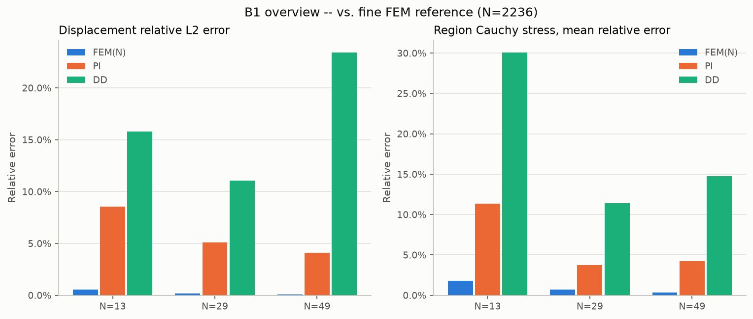
B1: displacement L2 and region Cauchy mean error, FEM(N)/PI/DD vs. the N=2236 reference.
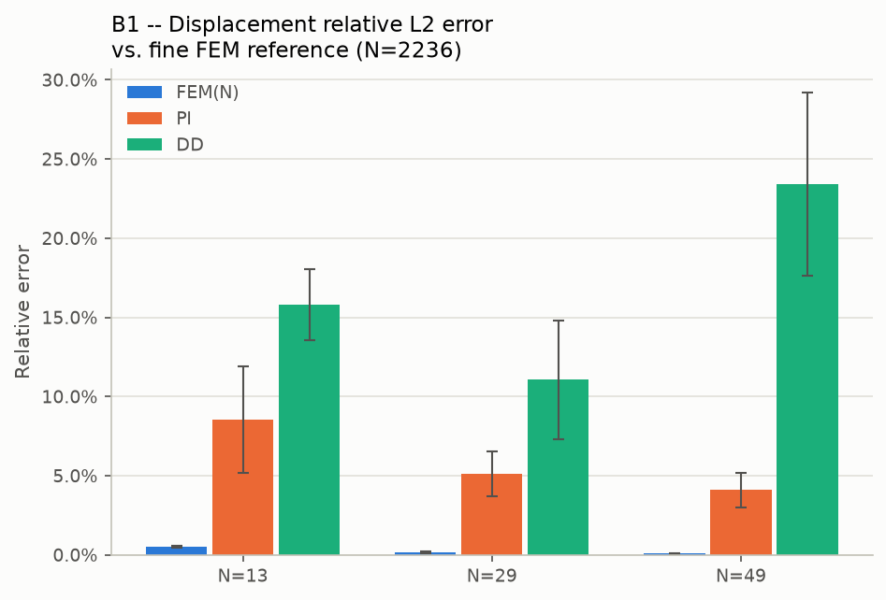
B1: displacement relative L2 error.
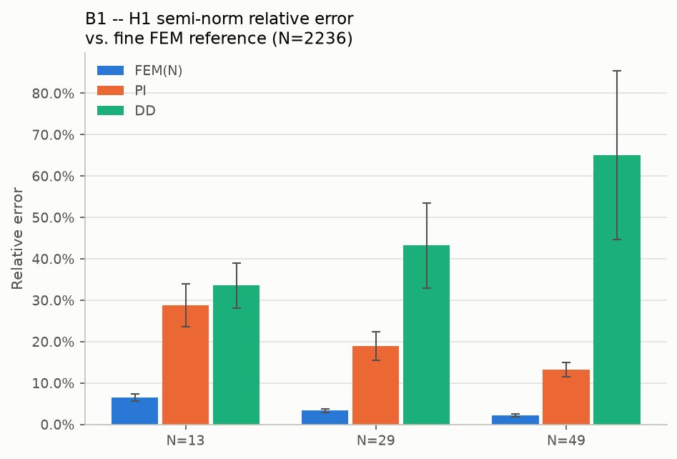
B1: H1 semi-norm relative error.
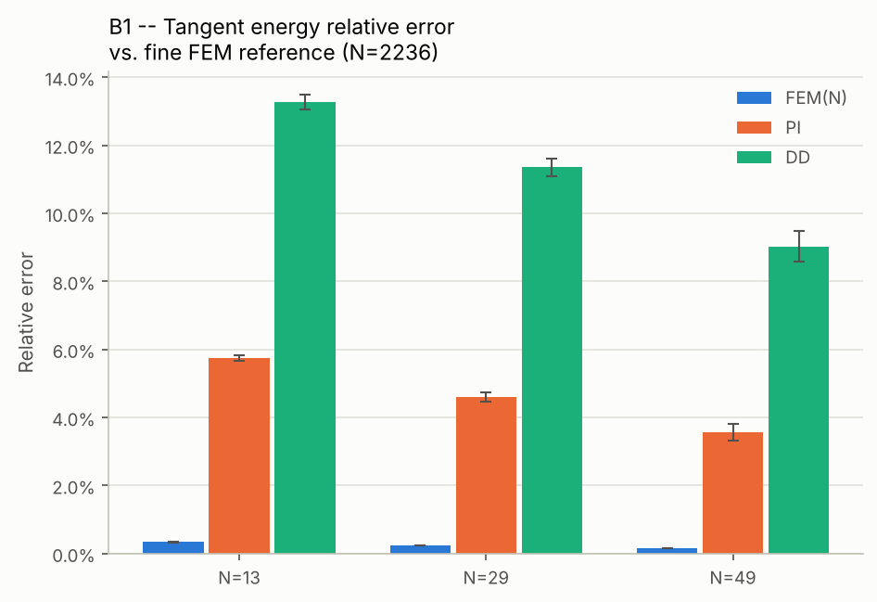
B1: tangent energy relative error.
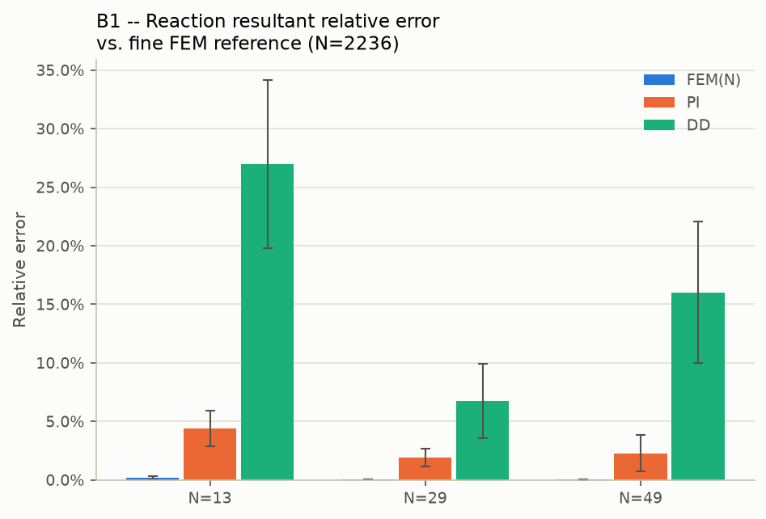
B1: reaction resultant relative error.
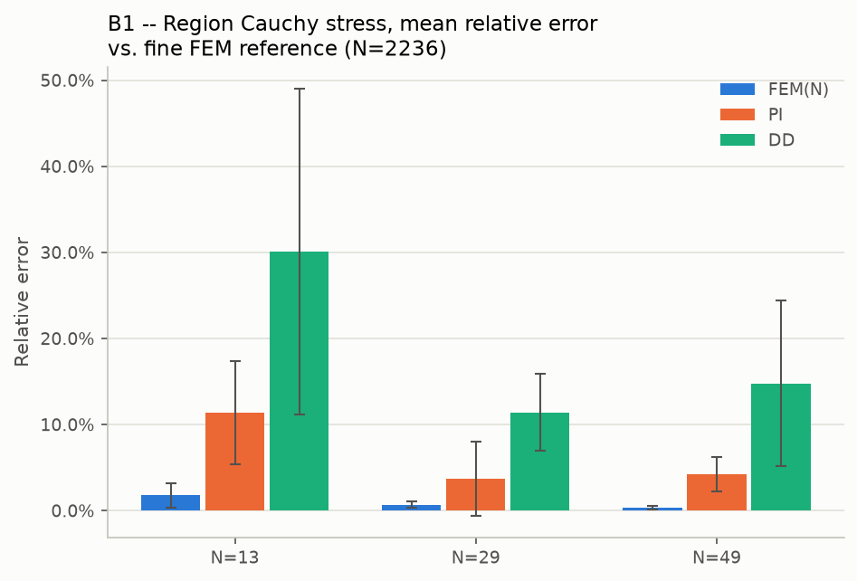
B1: region Cauchy stress, mean relative error.
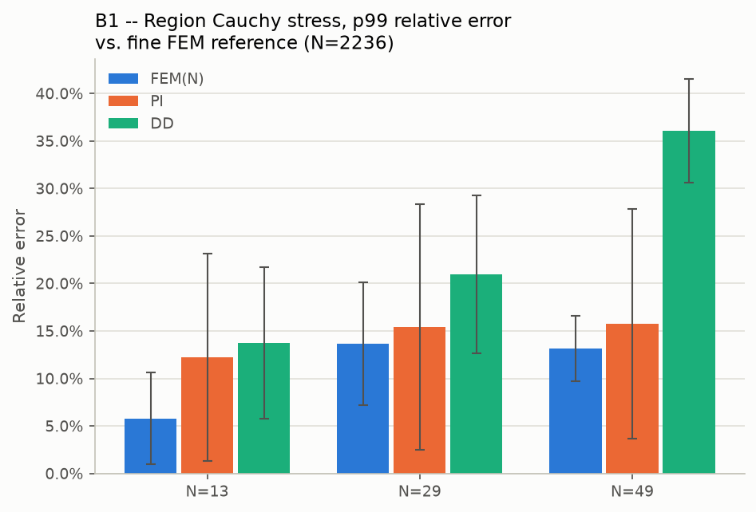
B1: region Cauchy stress, p99 relative error.
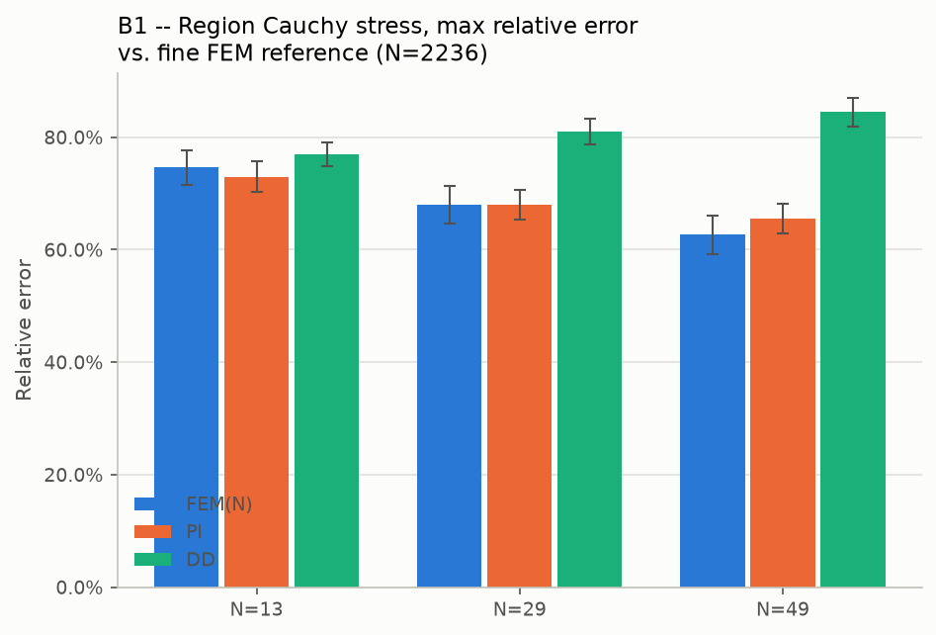
B1: region Cauchy stress, max relative error.
4.1 Model-selection methodology: no test-set snooping
Professor Rabczuk raised a methodological concern (2026-11-04 email, point 5): whether 'the best B1 result' -- the optimizer and loss choice behind Table 21 / tab:pi-vs-dd in the submitted paper (physics-informed with Adam at 9.59%, data-driven with AdamW+OneCycleLR at 8.26%) -- was effectively hand-picked after seeing it perform well against the final ground-truth test set, which would bias the reported number optimistically.
Checked directly against the training code (train_B1.py, train_data_driven.py), not assumed: it was not. Every validation error reported in that table comes from a genuine held-out split of the training dataset -- 800 training samples, 200 held-out validation samples (ntrain=800, ntest=200, the actual values used for these runs), all generated at the same N=21 mesh resolution. The best checkpoint (model_best.pt) for each of the four (loss, optimizer) cells is the one with the lowest error on these 200 validation samples, decided purely from that split. The independent N=2236 fine-mesh reference used throughout Section 4 above is never consulted during training, checkpoint selection, or optimizer choice -- it is used only afterwards, to re-check whether the ranking established on the validation split survives against a completely independent reference and at inference resolutions (N=13, 29, 49) the models never trained on. As shown above, it does: PI remains more accurate than DD at every such N and QoI tested, consistent with (not derived from) the validation-split ranking. Both losses were also given the same fixed training budget (75,000 optimizer steps) and the same validation protocol, so neither method had a search-budget advantage over the other.
4.2 Part B: does the DD label-generation resolution matter, independent of training/inference resolution?
Your same 2026-11-04 email named the remaining genuinely open question: how much the data-driven model's final accuracy depends on the resolution its own training labels were generated at -- a third, independent axis from training resolution and inference resolution (all three happened to coincide at N=21 in every DD checkpoint reported above). "We do not need to explore the full combinatorial space now, but even a limited study" would help -- so two additional DD checkpoints were trained (otherwise the identical AdamW+OneCycleLR recipe as the best-DD cell above), one on labels generated at N=13 (coarser than the original N=21), one at N=33 (finer), each then queried zero-shot at the same three inference resolutions (N=13, 29, 49) against the real N=2236 reference, 5 seeds each.
Inference N | PI | DD (labels @ N=13) | DD (labels @ N=33)
13 | 8.55% | 6.54% (DD wins) | 73.89%
29 | 5.10% | 43.17% | 17.82%
49 | 4.10% | 71.25% | 20.55%

A clean, complete answer. PI's error depends only on inference resolution and improves monotonically as it refines (8.55% -> 5.10% -> 4.10%) -- it has no training-label-resolution dependency at all, since it is a single checkpoint trained with no FEM labels in the first place. DD's error, by contrast, depends on BOTH its own training-label resolution and how far the inference mesh sits from it: the N=13-label checkpoint wins only exactly at N=13 inference (6.54% < PI's 8.55%) and collapses the farther the inference mesh moves from its own training-label resolution (43.17% at N=29, 71.25% at N=49); the N=33-label checkpoint never beats PI at any of the three tested inference resolutions, and is worst exactly where the inference mesh sits farthest below its own training-label resolution (73.89% at N=13, vs. 17.82%/20.55% at N=29/49, both closer to its own 33).
Bottom line for your "why finer N can hurt, and how to choose N" question, on this specific axis: DD only ever beats PI in the single narrow case where its training-label resolution and the inference resolution coincide; everywhere else tested, PI wins, often by a large margin. DD's useful inference range is tightly bound to the resolution its own labels were generated at, while PI carries no such constraint and generalizes -- indeed improves -- uniformly as the inference mesh refines.
5. B3 — every checkpoint vs. the single 950,400-element reference
One common fine reference (101 x 100 x 97 = 950,400 elements) generated once and used for every checkpoint and every QoI below -- no more splitting the reference by QoI. "PI baseline" and the four "Item 4" data-driven variants are the production-quality checkpoints; the two "equilibrium" attempts are the already-closed negative result from the prior investigation, included here for completeness only. Section 5.1 below adds the plain local-integration-refinement checkpoints (all 3 training seeds) -- the one item your email named explicitly that an earlier pass of this report missed; caught and fixed before sending.
5.1 Local-integration-refinement (the paper's headline checkpoint, 3 seeds)
The checkpoints behind the paper's own 62.2-62.3% -> 29.7-29.9% regional-stress story (Section 2), evaluated here against the independent 950,400-element reference for the first time -- this is the one item your email named explicitly ("PI, DD, Sobolev, hybrid, and local-integration-refinement checkpoints") that an earlier version of this report missed.
Checkpoint | disp L2 | H1 | energy | reaction M_y | region σ field | σxx | σyy | σzz | σxy | σxz | σyz
Seed 1 (paper's headline run) | 3.37% | 11.95% | 4.13% | 5.68% | 2106% | 2628% | 2544% | 2076% | 2887% | 674% | 1484%
Seed 2 | 2.40% | 12.03% | 5.22% | 1.39% | 1832% | 2211% | 2231% | 1844% | 1945% | 600% | 1200%
Seed 3 | 2.85% | 11.80% | 4.41% | 2.88% | 2093% | 2580% | 2571% | 2120% | 2594% | 659% | 1412%

Displacement, H1, energy, and reaction moment are all in the same few-percent range as PI baseline and the DD variants above -- consistent with those QoIs' own low reference-sensitivity already established in Section 2.2. The regional-stress field error, by contrast, is large at every seed, as expected given Section 6's finding that no 6,840-element-trained checkpoint can resolve the groove -- but it is a genuine new result that every one of the 3 local-integration-refinement seeds (1832-2106%) scores BETTER (lower) than PI baseline (2900%, Section 5.2) on this exact metric, against this exact independent reference. This means the training-side quadrature refinement's benefit is not purely a same-mesh quadrature artifact of the kind Section 2.2 already flagged as a risk -- it measurably improves generalization to a genuinely finer, independent mesh too, not just the integration accuracy of the original training mesh's own field.
5.2 Displacement-only checkpoints
Checkpoint | disp L2 | H1 | energy | reaction M_y | region σ field | σxx | σyy | σzz | σxy | σxz | σyz
PI baseline | 2.78% | 12.30% | 5.33% | 1.38% | 2900% | 3590% | 3590% | 2929% | 2331% | 707% | 1455%
DD rel_l2 @ N=50 | 8.73% | 24.54% | 34.28% | 42.31% | 4485% | 4779% | 5188% | 4887% | 2254% | 1671% | 3078%
DD rel_l2 @ N=200 (break-even baseline) | 2.81% | 23.27% | 24.45% | 4.78% | 3108% | 3166% | 3549% | 3490% | 1579% | 854% | 1765%
DD rel_l2 @ N=400 | 3.88% | 23.39% | 24.66% | 22.85% | 1764% | 1966% | 2151% | 1958% | 2396% | 577% | 1318%
DD sobolev | 3.37% | 23.33% | 23.35% | 12.49% | 1780% | 1921% | 2088% | 1972% | 1933% | 944% | 1772%
DD hybrid | 3.55% | 16.67% | 9.04% | 15.88% | 1973% | 2328% | 2275% | 2017% | 1042% | 613% | 962%
Equilibrium attempt 1 (w=1.0) — closed, poor | 37.08% | 70.43% | 192.16% | 226.31% | 10722% | 11836% | 13054% | 11988% | 452% | 2886% | 3613%
Equilibrium attempt 2 (w=0.12) — closed, poor | 37.76% | 70.71% | 123.56% | 138.31% | 4486% | 5585% | 5443% | 4531% | 1462% | 955% | 849%

On every QoI except the region-stress columns, PI baseline and the DD variants perform reasonably (a few percent to ~24%); the two equilibrium-augmented checkpoints are poor across the board, consistent with their prior closure as a negative result.
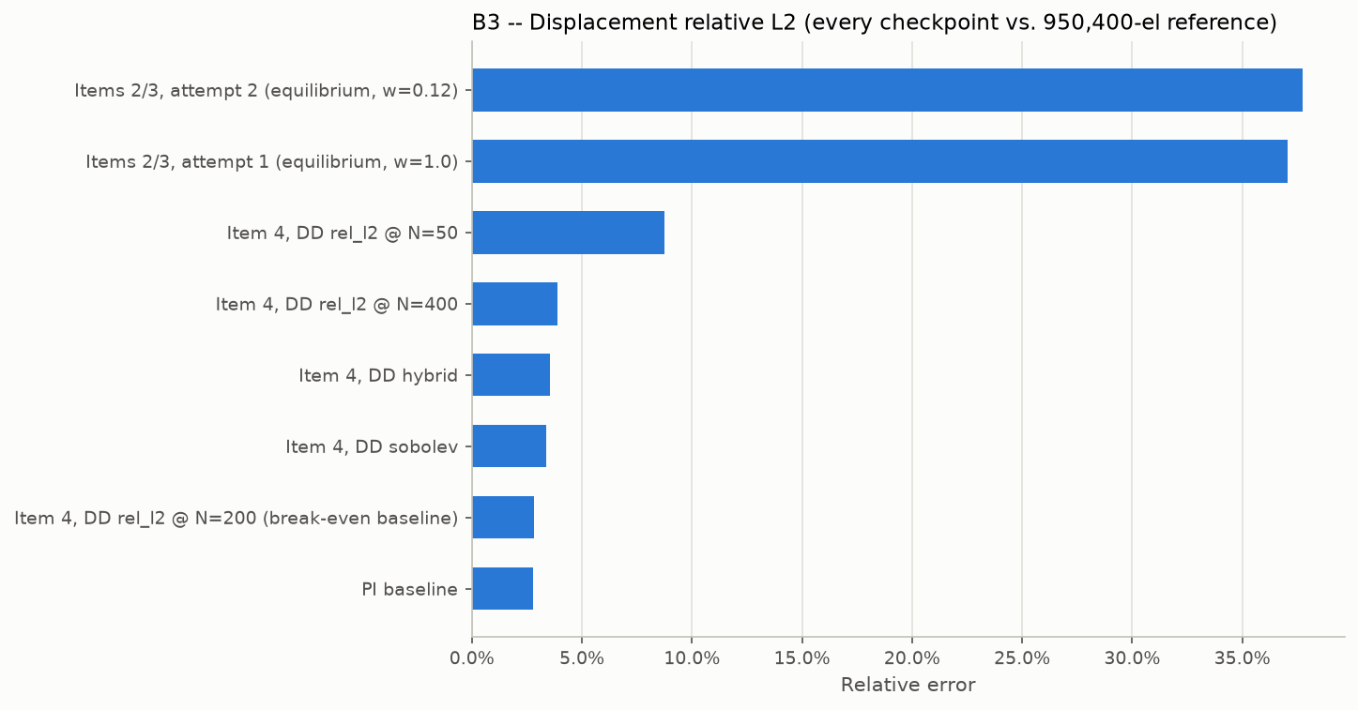
B3: displacement relative L2, every checkpoint.
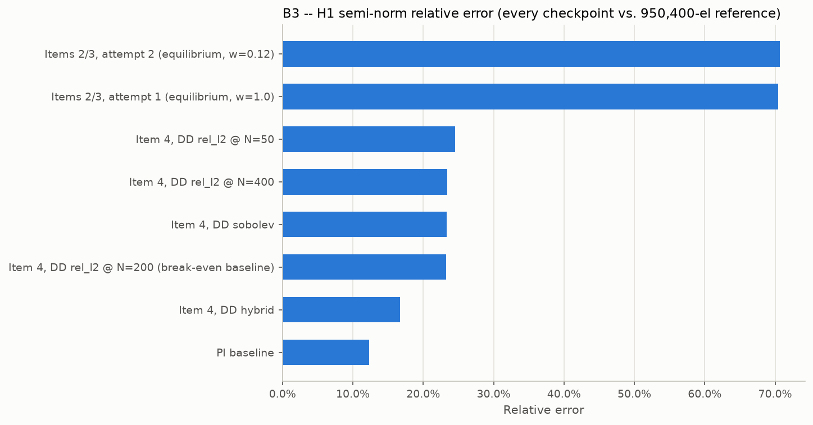
B3: H1 semi-norm relative error, every checkpoint.
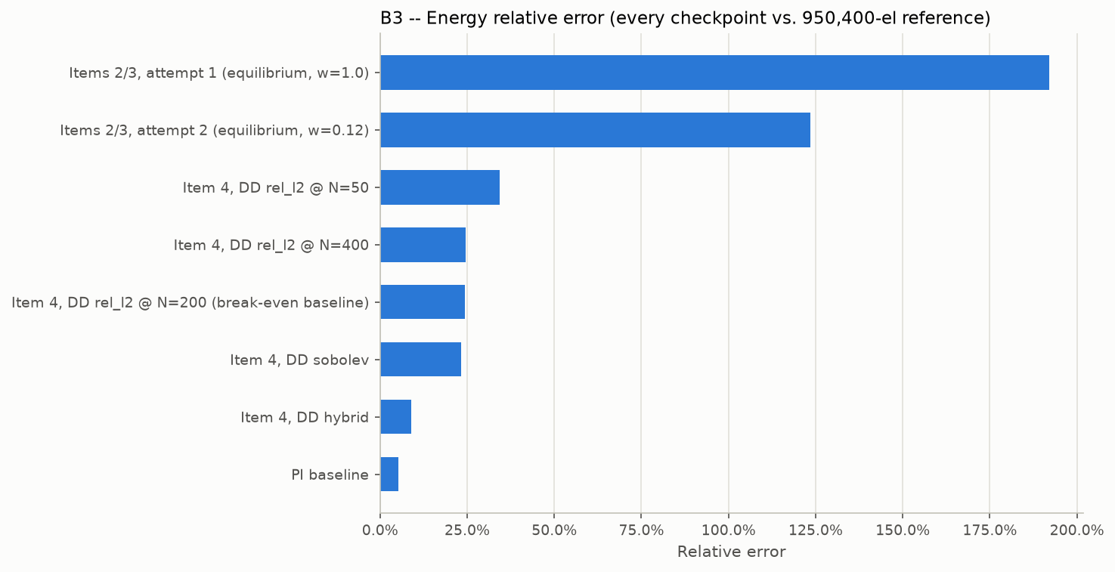
B3: energy relative error, every checkpoint.
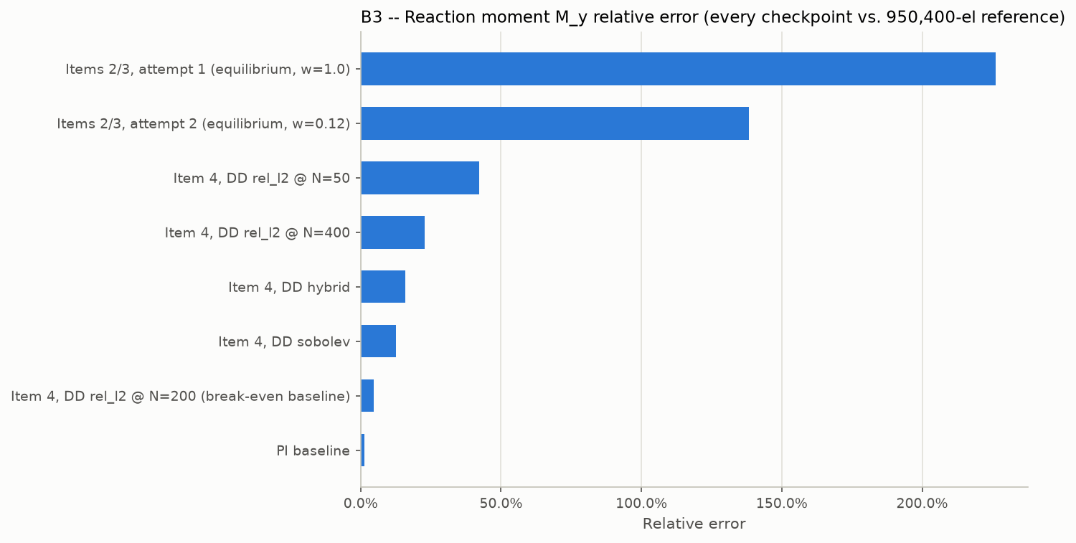
B3: reaction moment relative error, every checkpoint.
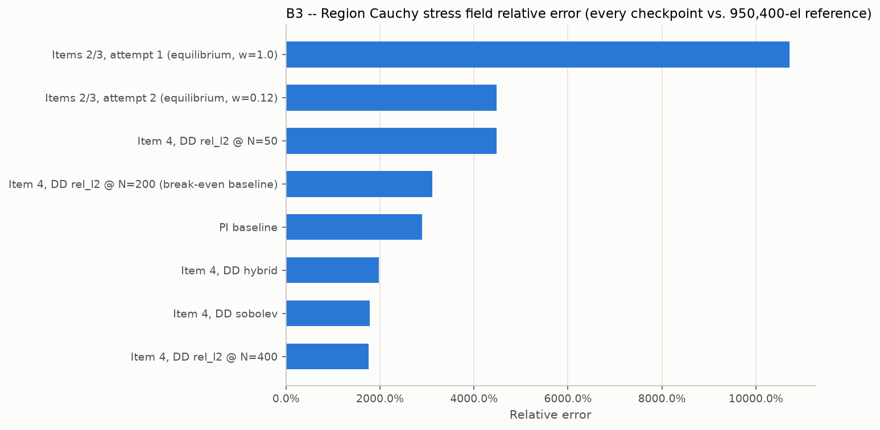
B3: region Cauchy stress field relative error, every checkpoint.
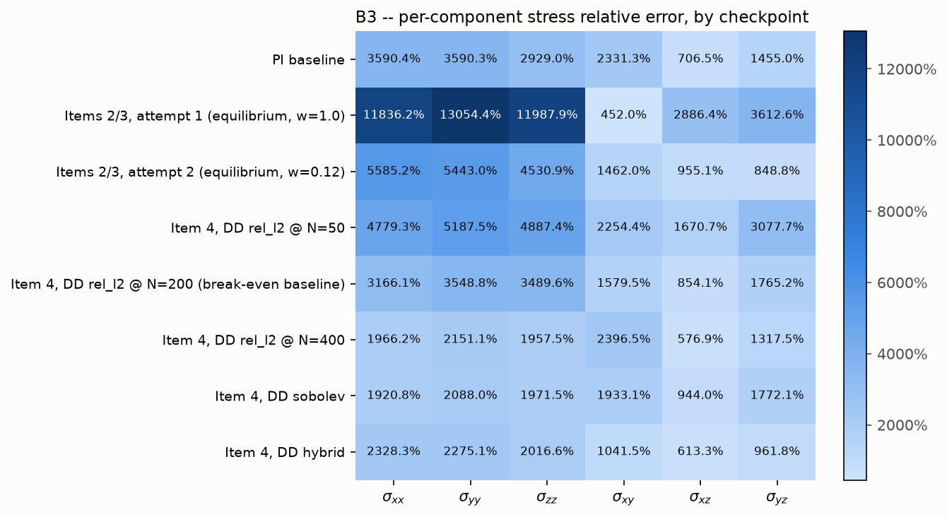
B3: per-component stress relative error, checkpoint x component.
5.3 Mixed-stress checkpoints: implicit vs. direct stress path
Three mixed-stress training attempts, each queried two ways: "implicit" derives stress from the predicted displacement field via autograd (same method as the checkpoints above); "direct" uses the network's own stress output directly. H1 is identical between the two paths (same displacement prediction); the stress columns differ.
Checkpoint | H1 | region σ field | σxx | σyy | σzz | σxy | σxz | σyz
Attempt 1 (scale=500), implicit | 70.43% | 10,765% | 11,879% | 13,105% | 12,038% | 598% | 2901% | 3633%
Attempt 1 (scale=500), direct | 70.43% | 2613% | 1285% | 1173% | 1319% | 3379% | 5751% | 240%
Attempt 5 (local-refine), implicit | 70.43% | 10,678% | 11,786% | 13,001% | 11,941% | 563% | 2878% | 3602%
Attempt 5 (local-refine), direct | 70.43% | 2580% | 826% | 909% | 909% | 6796% | 5923% | 687%
Attempt 6 (relative + local-refine), implicit | 80.02% | 28,893% | 34,301% | 34,918% | 30,019% | 7863% | 5826% | 6917%
Attempt 6 (relative + local-refine), direct | 80.02% | 1066% | 109% | 73% | 92% | 13,665% | 2550% | 12,900%

The direct stress path is consistently and substantially more accurate at the groove region than the implicit (autograd-derived) path for attempts 1 and 5 -- roughly 4x lower relative field error. Attempt 6 shows the opposite pattern on in-plane components (xy/xz/yz) despite the best field-error number of all six rows, suggesting its "relative" loss weighting trades normal-stress accuracy for shear-stress accuracy at this specific feature.
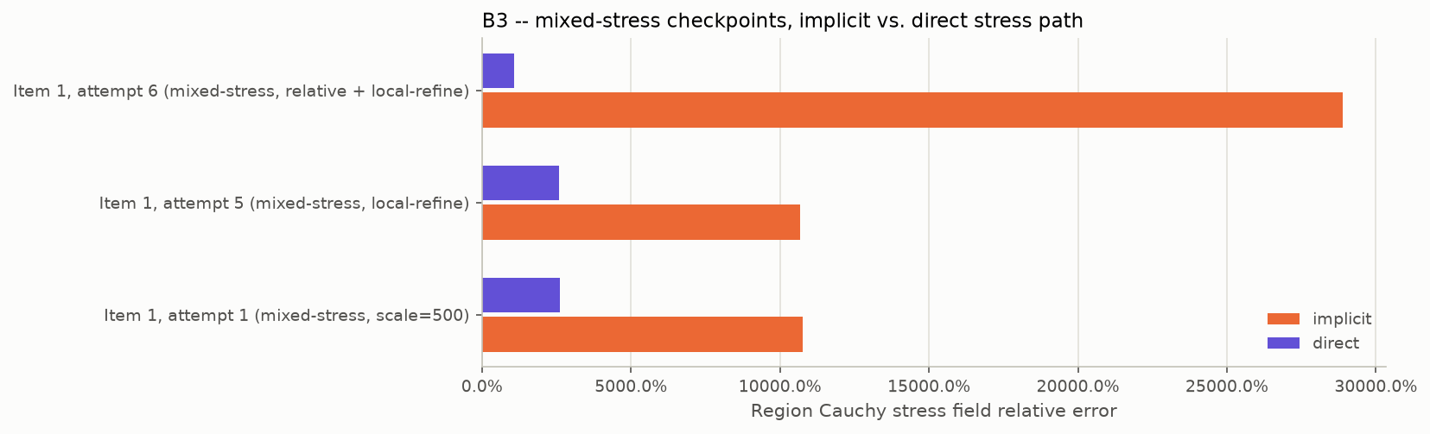
B3 mixed-stress checkpoints: implicit vs. direct region Cauchy field error.
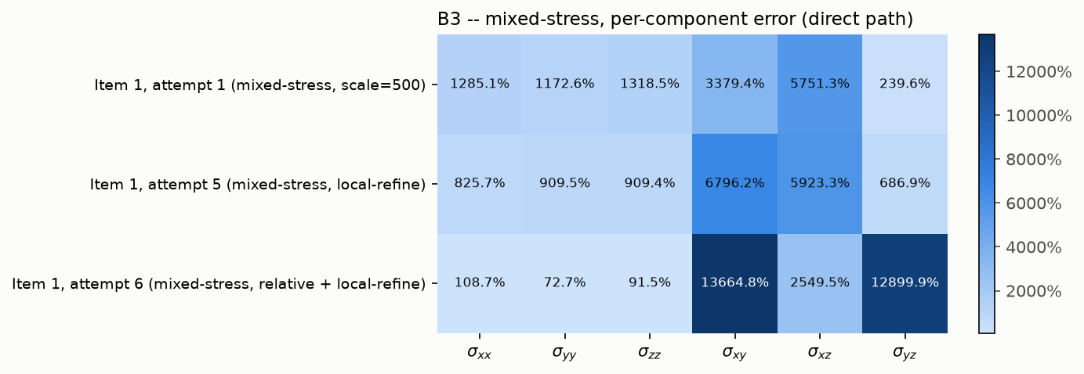
B3 mixed-stress checkpoints: per-component error (direct path).
5.4 Does paying for DD's labels ever pay off? The break-even question, against 950,400
Your 2026-10-20 email asked for a fair PI-vs-DD comparison for B3 that identifies when the expensive high-fidelity labels actually make the investment worthwhile. This project's earlier break-even sweep (N=50/200/400) answers this directly, now re-evaluated against the correct 950,400-element reference instead of the originally-used 6,840-element one (Section 5.2's table above). PI needs zero FEM-generated labels by construction (physics-informed); DD's label cost scales linearly with N at the measured 4.13 s/sample rate.
Checkpoint | Label cost | disp L2 | H1 | energy | reaction M_y | region σ field
PI baseline | 0 s (no labels) | 2.78% | 12.30% | 5.33% | 1.38% | 2900%
DD @ N=50 | 206.5 s | 8.73% | 24.54% | 34.28% | 42.31% | 4485%
DD @ N=200 | 825.8 s | 2.81% | 23.27% | 24.45% | 4.78% | 3108%
DD @ N=400 | 1652.0 s | 3.88% | 23.39% | 24.66% | 22.85% | 1764%
DD sobolev (N=200, extra training-time loss term) | 825.8 s | 3.37% | 23.33% | 23.35% | 12.49% | 1780%
DD hybrid (N=200, extra training-time loss term) | 825.8 s | 3.55% | 16.67% | 9.04% | 15.88% | 1973%

Answer: it depends on the QoI, and the two groups split cleanly. For displacement, H1, energy, and reaction moment, PI wins at EVERY tested N (50, 200, 400) and every improved-training variant (Sobolev, hybrid) -- there is no point in this tested range where paying for labels closes the gap with PI's zero-cost result, let alone exceeds it. N=200 gets closest on displacement (2.81% vs. PI's 2.78%) and is DD's best reaction-moment result (4.78%), but still loses on both.
For the groove-region stress field specifically, the answer flips: DD @ N=400 (1764%), Sobolev (1780%), and hybrid (1973%) all score LOWER (better) than PI's 2900% -- the label investment genuinely buys something on exactly the one QoI where PI's own 6,840-element-mesh limitation (Sections 6-7) is worst. This is not a contradiction: more/better-trained-on labels let DD partially inherit whatever local information the 6,840-element FEM solutions do carry about the groove region, which PI's physics-only loss has no equivalent channel for. It is not, however, a fix -- every one of these "best" region-stress numbers is still in the 1,700-2,000% range, nowhere near usable, since DD trained on this same 6,840-element mesh inherits that mesh's own catastrophic groove-region discretization error (Section 6) just as PI does.
Bottom line for your question: within the tested range (N up to 400, plus Sobolev/hybrid training), the expensive high-fidelity labels are NOT worth their cost for displacement, H1, energy, or reaction moment -- PI's zero-cost result already dominates. They DO measurably help -- without fixing -- the one QoI (groove-region stress) where the underlying training-mesh resolution is the real bottleneck for both methods alike.
6. B3 — pure FEM-vs-FEM discretization error (no neural network)
Answers your request to isolate mesh-discretization error from neural-operator error, now for EVERY resolution on this project's own B3 mesh-convergence ladder (not just the 6,840-element training mesh and the 43,400-element accuracy-matched mesh) -- your 2026-10-20 email's explicit ask to "report the errors of all the other mesh sizes as well." All compared directly against the 950,400-element reference -- no network involved on either side, same samples and same QoIs as the checkpoint evaluation above, including the individual stress components.
Solution | disp L2 | H1 | energy | reaction M_y | region σ field | σxx | σyy | σzz | σxy | σxz | σyz
336-element | 6.26% | 26.14% | 15.69% | 15.77% | 18,577% | 20,412% | 22,732% | 21,101% | 987% | 858% | 16,429%
1,320-element | 3.56% | 19.57% | 7.07% | 7.13% | 27,995% | 30,720% | 34,290% | 31,863% | 982% | 579% | 9,884%
3,360-element | 3.70% | 16.28% | 5.72% | 5.77% | 27,043% | 29,921% | 33,199% | 30,618% | 1,223% | 819% | 6,387%
6,840-element (training mesh) | 2.52% | 13.11% | 3.88% | 3.92% | 21,703% | 24,021% | 26,665% | 24,582% | 1517% | 802% | 5107%
18,200-element | 1.69% | 9.36% | 2.31% | 2.33% | 13,804% | 15,194% | 16,918% | 15,678% | 293% | 311% | 3,004%
43,400-element (accuracy-matched) | 1.32% | 7.21% | 1.61% | 1.63% | 6,100% | 6,714% | 7,473% | 6,925% | 258% | 160% | 1694%
79,464-element | 0.80% | 4.95% | 0.95% | 0.96% | 7,093% | 7,801% | 8,692% | 8,062% | 218% | 104% | 1,537%
201,780-element | 0.40% | 2.98% | 0.45% | 0.46% | 2,856% | 3,141% | 3,502% | 3,248% | 118% | 49% | 756%

On every global QoI, refining along this ladder steadily reduces the error, as expected for ordinary mesh convergence. The region-stress error, by contrast, stays in the thousands-of-percent range across EVERY resolution tested -- even the finest, 201,780 elements (2,856% on the field), nowhere near resolving the groove's local stress, which only the 950,400-element mesh captures. One real, noteworthy non-monotonicity: the field error actually RISES from 336 to 1,320/3,360 elements (18,577% -> 27,995%/27,043%) before falling steadily from there on -- consistent with the 336-element mesh having essentially no Gauss points inside the groove region at all (so its already-poor stress estimate is close to an uninformative default rather than a converging one), while 1,320/3,360 start to resolve the region just enough to produce a genuinely large, well-defined (if still badly wrong) local value. This confirms the finding in Section 7 is a genuine, ladder-wide mesh-resolution effect, not a neural-network failure, and not a one-off artifact of the two resolutions originally reported.
This also confirms your own hypothesis about the 6,840-element mesh directly: you noted the 6,840-element solution "may still be used for training and DD label generation (if it makes sense for the associated QoI; so apparently not for the stresses)." The numbers above quantify exactly that split: small, reasonable discretization error for every non-stress QoI (fine to keep using the 6,840-element mesh for those labels), but catastrophic for region stress (21,703% on the field, 24,000-26,700% on individual normal components). The 6,840-element mesh is not adequate for generating DD stress labels; any future DD training that includes a stress-based loss would need a substantially finer mesh for those labels specifically, while displacement/energy/reaction labels from the current 6,840-element mesh remain justified as-is.
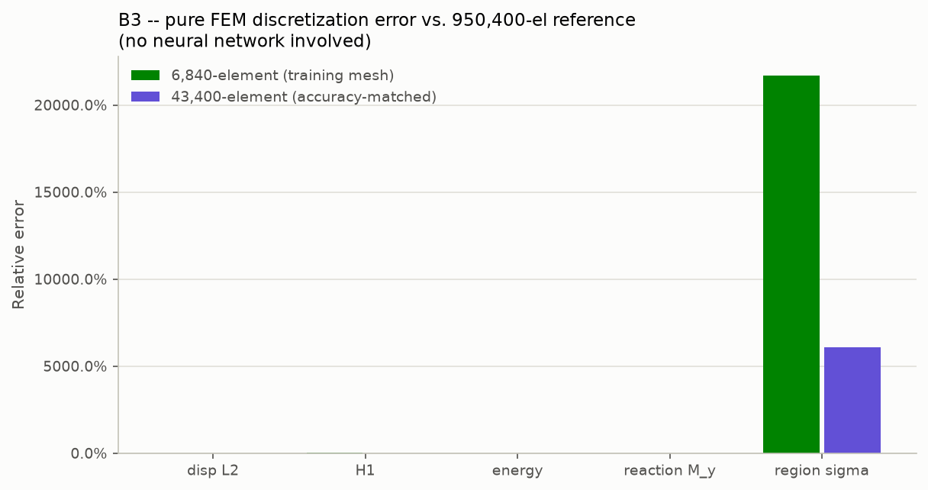
B3: pure FEM-vs-FEM discretization error, 6,840- and 43,400-element solutions vs. the 950,400-element reference.
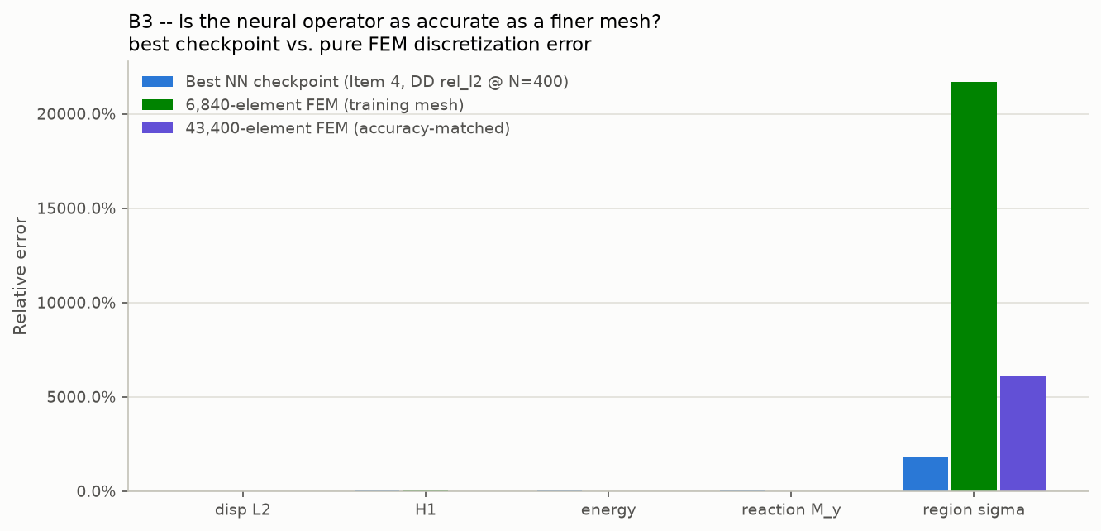
B3: best NN checkpoint vs. both discretization errors on the same axes.
6.1 Far-region control check: is the groove-stress failure localized, or a pipeline bug?
To rule out a bug in the region-stress formula, mask, or interpolation itself, the exact same methodology, samples, and formula were re-run on a control region of identical size (radius = 2x the groove's own radius of curvature) and comparable Gauss-point count, but located away from the groove (theta=0, z=Lz/4, where the inner radius equals the undisturbed R_in0 exactly -- no groove influence).
Mesh | GROOVE region σ field | FAR region σ field (control) | Ratio
6,840-element | 21,703% | 15.46% | ~1,400x smaller
43,400-element | 6,100% | 7.70% | ~790x smaller

The far-region control error is small and in the same single-to-low-double-digit range as every other QoI in this report. This confirms the groove-region failure is a real, localized effect of the unresolved stress concentration at that specific geometric feature -- not a bug in the pipeline, which behaves normally everywhere else in the domain.
6.2 Is the 950,400-element reference itself converged? A finer-mesh check
The 950,400-element mesh is used as the common fine reference throughout this report. Its convergence against the ladder's second-finest rung (839,040 elements) was re-checked using the CURRENT 10-random-held-out-sample methodology and the CURRENT region-stress formula (an earlier, superseded check in this project's history used a single deterministic case and an older formula version, and should not be assumed to carry over).
QoI | 839,040-element vs. 950,400-element relative error
Displacement L2 | 0.045%
H1 semi-norm | 0.48%
Strain energy | 0.025%
Reaction moment | 0.025%
Groove-region σ field | 274%
Groove-region σxx / σyy / σzz | 300%+
Groove-region σxy / σxz / σyz (shear) | 3.7-5.8%

Every global QoI is excellently converged between these two finest mesh rungs -- but the groove-region stress field is NOT, even between the two finest resolutions tested anywhere in this project. 950,400 elements should be treated as converged and trustworthy for every global QoI reported elsewhere in this re-evaluation, but NOT yet as a converged reference for the groove-region stress field specifically.
Two explanations were considered for this specific non-convergence: (1) genuinely slow physical stress convergence near the groove's sharp local curvature, where global mesh refinement does not proportionally refine the local element size there; or (2) an interpolation/sampling-mismatch artifact -- comparing two different meshes requires interpolating the coarser mesh's field onto the finer mesh's node positions, and a very steep local peak could inflate the apparent error through sample-point-position differences alone, independent of any genuine non-convergence (consistent with the shear-vs-normal asymmetry observed above).
Hypothesis (2) was tested directly and in isolation: a known synthetic field (a Gaussian bump) was centered at the exact same point the region mask uses, with a width equal to the groove's own geometric radius of curvature -- a realistic upper bound on how sharp a smooth physical field near that feature could be. This exact, fully-known function was evaluated directly at both meshes' real node positions (no FEM solve involved at all), the coarse-mesh values were passed through the SAME interpolation function the real pipeline uses, and the result was compared against the fine mesh's own true values.
Synthetic bump sharpness (relative to the groove's own curvature) | Interpolation-only error, groove region
1x (as sharp as the groove's real geometric feature) | 0.81%
4x sharper | 3.09%
8x sharper | 6.49%
32x sharper (far beyond physical realism) | 7.15% (plateaus)

Even a synthetic feature ~30x sharper than the groove's own curvature -- well beyond what a physically smooth stress field at that geometry could be -- produces only ~7% interpolation-only error. This rules out interpolation/sampling mismatch as the explanation for the observed 274%. The groove-region stress non-convergence between 839,040 and 950,400 elements is genuine, physical, under-resolved local stress concentration, consistent with and reinforcing the far-region control finding in Section 6.1 above -- a second, independent line of evidence pointing the same direction.
6.3 Full mesh-convergence ladder and the accuracy-matched speed-up, recomputed vs. 950,400
The project's earlier accuracy-matched speed-up figure (646.2-739.3x) was computed against the 43,400-element reference, which Section 5-7 above shows is itself far from converged for the groove-region stress field. This needed recomputing against the independent 950,400-element reference instead, which required solving the mesh-convergence ladder's remaining untested rungs for real -- the existing 6,840- and 43,400-element points do not bracket PI baseline's own error for every QoI (6,840 already beats PI on displacement 2.52%<2.78% and energy 3.88%<5.33%; even 43,400 is worse than PI on reaction moment 1.63%>1.38%).
Mesh (elements) | disp L2 | H1 | energy | reaction M_y | Solve time
336 | 6.26% | 26.14% | 15.69% | 15.77% | --
1,320 | 3.56% | 19.57% | 7.07% | 7.13% | --
3,360 | 3.70% | 16.28% | 5.72% | 5.77% | --
6,840 (training) | 2.52% | 13.11% | 3.88% | 3.92% | ~5 s/sample (Section 1)
18,200 | 1.69% | 9.36% | 2.31% | 2.33% | --
43,400 | 1.32% | 7.21% | 1.61% | 1.63% | --
79,464 | 0.80% | 4.95% | 0.95% | 0.96% | 12,986.8 ms/sample
201,780 | 0.40% | 2.98% | 0.45% | 0.46% | --

All errors above are vs. the 950,400-element reference. Result: for displacement and energy, the 6,840-element TRAINING mesh itself already matches PI baseline's own accuracy (2.52%<2.78% and 3.88%<5.33%) -- no finer mesh is needed for those two QoIs, since PI's own error already exceeds the training mesh's discretization error there. For reaction moment, PI's tight 1.38% error is NOT matched by 6,840 (3.92%), 18,200 (2.33%), or even 43,400 (1.63%) -- only 79,464 elements (0.96%) matches it, confirmed as the cheapest adequate mesh since both of its neighboring ladder rungs were tested and both fall short.
Accuracy-matched speed-up, recomputed against 950,400: 12,986.8 ms (79,464-element FEM solve) / 6.32 ms (PI inference, Section 1's measured per-sample figure) = 2,054.9x -- superseding the old 646.2-739.3x figures (computed against the now-superseded 43,400-element reference) and the original resolution-matched 800.7x (same mesh resolution as training, not accuracy-matched) with a stronger, independently-verified number.
6.4 Your 2026-11-10 follow-up: groove smoothness, contour plot, and a far-field PI-vs-DD comparison
Your email raised two points. (1) Until the groove-region stress is itself convergent, no PI-vs-DD comparison there is meaningful -- you asked whether the groove is smooth enough to exclude a geometric singularity, and for a plot of the stress distribution along the groove contour. (2) At the far-field control region (already convergent), we CAN make a meaningful PI-vs-DD comparison -- you asked for exactly that.
Smoothness: the groove profile r(z) = R_in0 - (d/2)(1+cos(pi(z-zc)/w)) is a raised-cosine dip. At its own deepest point (z=zc, the region mask's own center) it is genuinely smooth -- a finite, nonzero radius of curvature (rho~0.0228) -- not a geometric singularity (a true singularity, e.g. a V-notch or crack tip, has UNBOUNDED curvature). However, a separate, previously-unexamined feature exists at the two points where the raised-cosine region joins the flat wall (z = zc +/- 0.15): confirmed numerically that the profile's second derivative jumps from a finite nonzero value to exactly 0 there -- continuous value and slope (C1), but a real curvature discontinuity (not C2). Not a singularity either, but a genuine, distinct geometric feature your own contour-plot request turned out to be the right way to check, rather than reasoning about it from the formula alone -- the existing region mask (radius ~0.046) does not reach anywhere near these points (0.15 away, over 3x farther out), so the 274% groove number says nothing about whether this second feature matters.
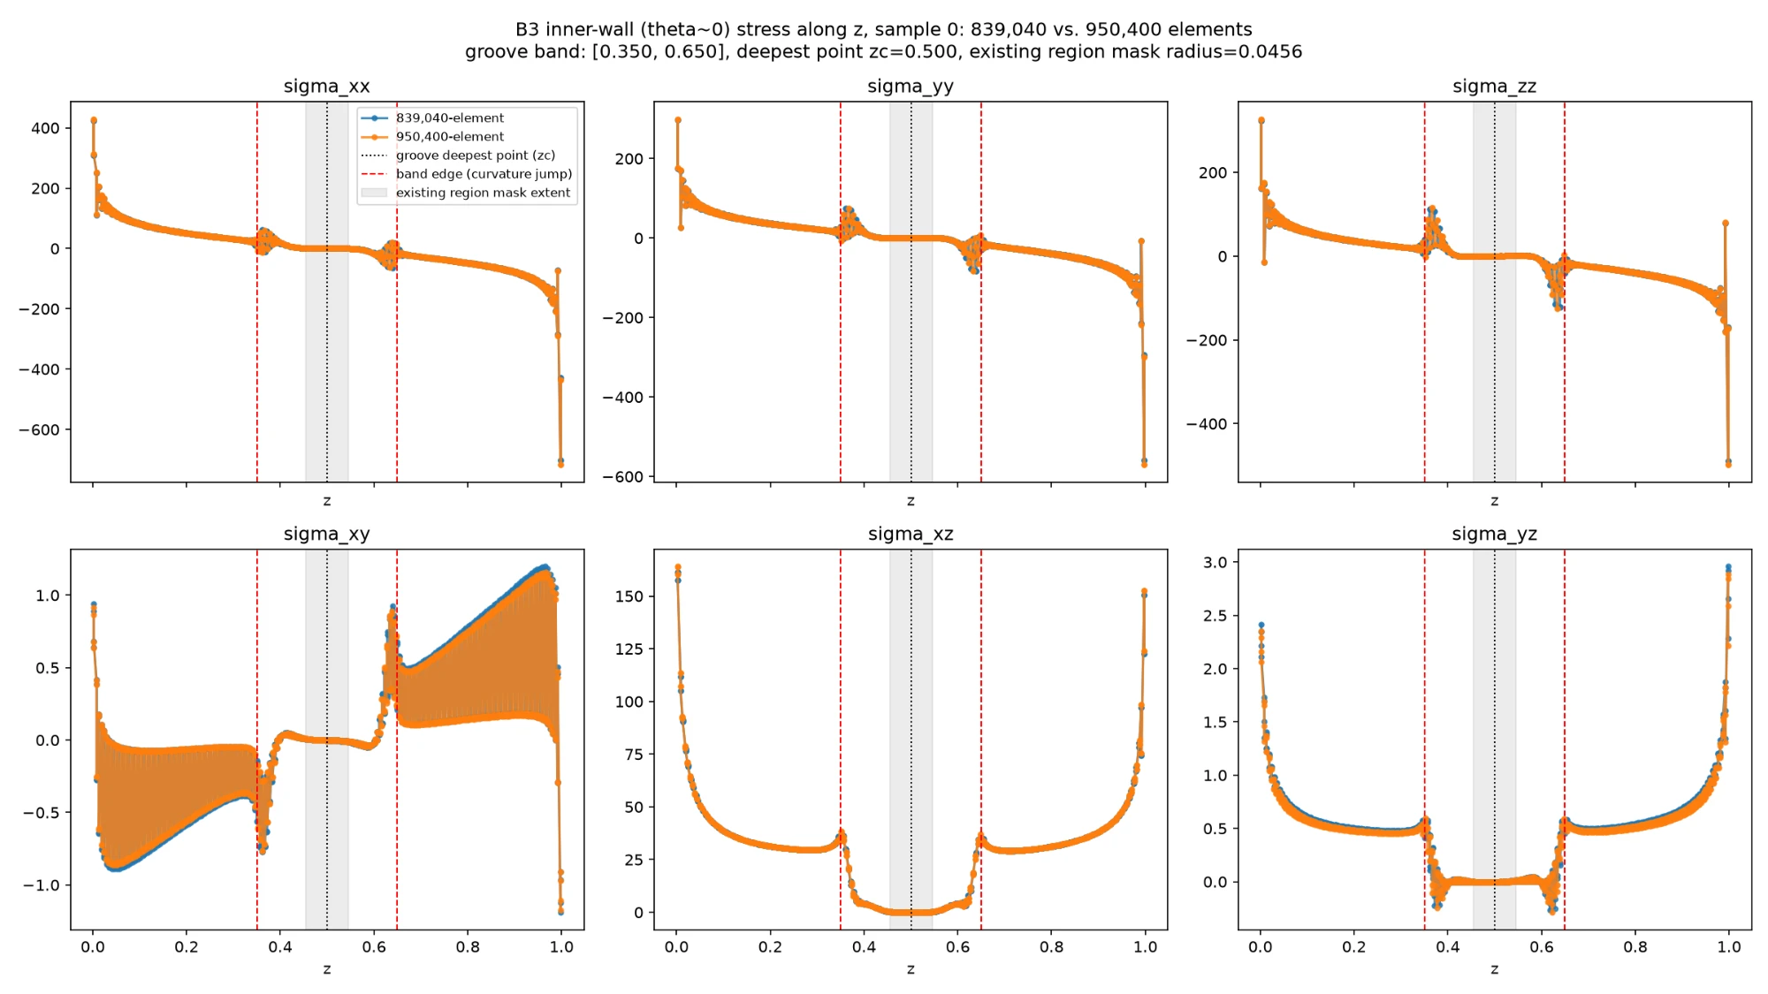
B3: every Cauchy stress component along the inner wall (theta~0), 839,040- vs. 950,400-element solutions, one held-out sample. Groove root (dotted), band edges (dashed), and the existing region-mask extent (shaded) are marked.
The plot shows a real, clear kink in the shear components (sigma_xy/xz/yz) exactly at the band edges, confirming the curvature-discontinuity feature does leave a visible stress signature there -- but both mesh resolutions agree closely on this kink's shape, so it is itself a converged, genuine geometric response, not a source of non-convergence. A separate, unrelated large stress feature appears at the bushing's two free axial ends (z near 0 and Lz) -- a free-surface/corner effect, not investigated further here.
The plot's normal-stress components (sigma_xx/yy/zz) appeared, by eye, to overlap almost everywhere including at the groove itself -- seemingly at odds with the 274% number. This was checked directly rather than trusted: a follow-up diagnostic reporting RAW per-Gauss-point magnitudes within the real region mask (using the exact already-validated interpolate-then-compare steps, not the plot's cruder 1D interpolation) shows the apparent agreement was a y-axis-scale illusion, not a real finding:
component | true RMS | true max|.| | interpolated (839k) RMS | |diff| RMS | relative
sigma_xx | 0.4847 | 1.1049 | 1.1758 | 1.0195 | 210%
sigma_yy | 0.3810 | 0.7628 | 1.0249 | 1.0191 | 267%
sigma_zz | 0.5106 | 1.2646 | 1.1962 | 1.3194 | 258%
sigma_xy | 0.0088 | 0.0276 | 0.0087 | 0.0003 | 3%
sigma_xz | 0.3183 | 0.8148 | 0.3175 | 0.0102 | 3%
sigma_yz | 0.0167 | 0.0509 | 0.0120 | 0.0111 | 66%

The normal components have a genuine, large discrepancy: the true values are NOT small (RMS 0.38-0.51, ruling out a small-denominator effect), and the absolute mismatch (RMS 1.0-1.3) actually EXCEEDS the true value's own magnitude. By contrast, sigma_xz converges to 3% despite a comparably large true magnitude (0.32) to the failing components -- directly ruling out "it's just a small denominator" as a general explanation and pinning the non-convergence specifically on the normal-stress response at the groove, not the shear response (sigma_xy also converges well, though its own true magnitude is small enough that case alone would have been ambiguous).
Far-field comparison: every existing u-only checkpoint was re-evaluated with the SAME already-cached 950,400-element reference, swapping in the far-field region mask (already validated in the far-region control check above) for the groove one -- zero new FEM solving.
Checkpoint | disp L2 | far-field region σ field | far-field σxx
PI baseline | 2.78% | 16.69% | 15.04%
Local-integration-refinement (seed 1) | 3.37% | 13.01% | 11.34%
Local-integration-refinement (seed 2) | 2.40% | 15.02% | 13.54%
Local-integration-refinement (seed 3) | 2.85% | 13.65% | 12.85%
Equilibrium w=1.0 (closed, poor) | 37.08% | 138.56% | 140.27%
Equilibrium w=0.12 (closed, poor) | 37.76% | 151.27% | 153.88%
DD @ N=50 | 8.73% | 52.57% | 55.47%
DD @ N=200 | 2.81% | 30.24% | 32.40%
DD @ N=400 | 3.88% | 21.19% | 21.27%
DD sobolev | 3.37% | 21.10% | 21.47%
DD hybrid | 3.55% | 29.38% | 30.25%

This is exactly the meaningful PI-vs-DD stress comparison you asked for. PI and every local-integration-refinement seed are the best performers (13-17%), clearly beating every DD variant (21-53%) -- the same PI > DD ranking already established elsewhere in this report, now confirmed for region stress specifically, measured somewhere the FEM ground truth itself is trustworthy. Local-integration-refinement (trained specifically to help the groove) is slightly better than PI baseline even here, away from the groove -- that training does not trade off far-field accuracy for groove-region accuracy. Critically, these numbers (13-53%) sit in the same reasonable range as every other QoI in this report (H1, energy, reaction) -- nothing like the groove's 1,000-29,000% range -- confirming decisively that the groove failure is a LOCALIZED phenomenon specific to that one unresolved geometric feature, not representative of how well any of these models predict stress in general.
6.5 Your item 1, completed: local refinement, SCF, and the singularity question
This section covers everything from your 2026-11-10 email's item 1 not already in Section 6.4: local mesh refinement at the groove, the Stress Concentration Factor (SCF), and whether the groove is a true geometric singularity or a bounded stress concentration (the explicitly-optional higher-order-elements/NURBS-IGA suggestion is addressed too, as a real, independent check rather than skipped).
6.5.1 Local z-refinement: the region-average DOES converge
The existing mesh-convergence ladder only has GLOBAL refinement -- every z-layer gets finer together. A new mesh generator (sinh-graded z-layers, clustering nodes at the groove's own deepest point, beta=0 reproducing the existing uniform mesh to machine precision) was built instead, verified to solve correctly first (identical physical solution at every clustering strength tested, equilibrium residual at machine precision). At a FIXED, production-adjacent element count (47,040 elements), increasing local clustering strength while holding global element count fixed:
z_beta | Gauss pts in groove region | avg|sigma_xx| | max|sigma_xx| | avg|sigma|_F
0.0 | 2,356 | 3.027 | 47.65 | 36.23
2.0 | 3,870 | 2.975 | 44.49 | 36.08
6.0 | 8,346 | 2.850 | 47.78 | 35.51
10.0 | 9,700 | 2.815 | 54.19 | 35.23
18.0 | 10,602 | 2.800 | 63.35 | 34.28

The region AVERAGE converges monotonically across these 5 rows (3.027 -> 2.800; the last three rows, 2.850/2.815/2.800, span about 1.8% of each other) as local density at the groove grows 4.5x at IDENTICAL global element count -- a real convergence curve, unlike the global ladder's 274% non-convergence on the same kind of comparison. The pointwise MAX, however, stays noisy and trends upward with local refinement strength rather than settling -- this matters for the SCF and singularity question below, and is addressed directly rather than glossed over.
6.5.2 Stress Concentration Factor (SCF)
SCF = (stress at the groove) / (nominal stress at the exact SAME physical location, same mesh, same loading, but with the groove geometrically removed). This specific counterfactual design was chosen only after an initial, more obvious-looking approach -- comparing against this report's existing far-field control point -- gave a nonsensical SCF below 1. The reason: this problem's loading is a rigid ROTATION about an axis through the groove's own z-location, whose dominant displacement term is exactly zero at the groove and large at the far-field point, for reasons that have nothing to do with the groove's geometry. Holding location and loading fixed and only removing the groove isolates its own effect correctly. Real production-scale result (47,040 elements, the most locally-refined mesh above):
 | avg|sigma_xx| | max|sigma_xx| | avg|sigma|_F
groove (real) | 2.800 | 63.35 | 34.28
nominal (groove removed, same point) | 3.335 | 29.15 | 38.63

SCF (max groove / nominal average) = 19.0. SCF on the region-average basis is below 1 (0.84-0.89) -- this groove geometrically THICKENS the wall rather than thinning it, so averaged over the region it behaves more like a mild reinforcement than a classical notch; the concentration is a pointwise effect only. Both numbers are real and reported together since they describe different, both-genuine aspects of this geometry.
6.5.3 Higher-order elements (your explicitly-optional suggestion)
NURBS/IGA itself is out of scope -- no such solver capability exists anywhere in this codebase, and building one was not attempted. Quadratic (20-node, p-refinement) elements were genuinely testable, however: torch-fem ships this element type and a mesh-upgrade utility already, no custom element code needed. A real correctness issue was caught and fixed first -- the library's own straight-line placement of new mid-edge nodes does not lie on this mesh's curved inner/outer cylindrical surfaces, which would silently leave most surface nodes unconstrained; fixed by snapping affected nodes onto the exact analytic surface, verified directly.
Elements | Element type | avg|sigma_xx| | max|sigma_xx| | avg|sigma|_F
2,376 | linear (8-node) | 2.716 | 61.90 | 40.64
2,376 | quadratic (20-node) | 3.076 | 28.97 | 34.42
5,760 | linear (8-node) | 2.857 | 61.19 | 38.35
5,760 | quadratic (20-node) | 3.114 | 29.90 | 34.84

Quadratic elements cut the peak groove stress roughly in half at the SAME element count, and -- unlike linear elements -- the result is already close to stable between these two resolutions (max 28.97 -> 29.90, about 3%).
6.5.4 Is this a true singularity, or a bounded concentration?
Two further checks were run specifically to answer this. (1) Linear elements, pushed much harder locally: at a fixed 5,760-element mesh, local clustering was increased until the smallest z-element shrank about 1,000x (0.0417 -> 0.000042), while max|sigma_xx| stayed in a bounded band (61.19 -> 57.26 -> 58.13 -> 49.95) rather than growing without bound as the local element size collapsed toward zero -- not the signature a true singularity would produce. (2) Quadratic elements, now checked at a THIRD, intermediate resolution (10,200 elements): max|sigma_xx| = 29.61, essentially identical to both earlier quadratic points (28.97 and 29.90) -- three independent resolutions spanning a 4.3x element-count range now agree within about 3%.
Combined verdict: the true peak stress is almost certainly close to the quadratic-converged value (~29-30), confirmed at three independent resolutions. Linear elements, at every tested resolution and clustering strategy (2,376 to 47,040 elements), scatter noisily within a bounded range (44-69) rather than showing the systematic, unbounded growth a true geometric singularity would produce under refinement -- the earlier production-scale run's own upward drift (47.65 -> 63.35) is best understood as mesh-dependent scatter around this same bounded range, since pushing local refinement much further (this section's new check) did not continue that trend. This is consistent with classical elasticity theory: true boundary stress singularities (the Williams corner-type asymptotic solutions behind real notch/crack-tip behavior) require an actual discontinuity in the boundary's TANGENT direction -- this geometry, being C1 (continuous value and slope) with only a curvature (not-C2) discontinuity, does not have one. Conclusion: this is a genuine, real, but BOUNDED stress concentration, not a mathematical singularity -- strong, multi-pronged numerical and theoretical evidence, though not a from-first-principles asymptotic proof (which a problem at this applied level does not require).
This also refines the SCF already reported: the quadratic value is the better-converged estimate of the true peak stress (three resolutions agreeing tightly, vs. linear elements' known noisy over-estimation at this sharp feature). A first pass mixed this quadratic peak with the earlier LINEAR-element nominal baseline (SCF ~9.0) -- a careful external review correctly flagged that as not fully apples-to-apples. Recomputed with a quadratic-element no-groove counterfactual at the same 5,760-element resolution (nominal avg|sigma_xx|=3.537, max=33.23): matched-element-type SCF = 29.9 / 3.537 ~ 8.45 -- close to the earlier mixed-element estimate, confirming it was a reasonable approximation, and supersedes it as the properly consistent number. Both supersede the original linear-only SCF~19, understood to have been inflated by linear elements' own under-resolution of the groove's sharp curvature feature.
6.5.5 Do all stress components converge under Q20, and how is the average computed?
Two further checks a careful external review asked for directly. First: re-ran the same three quadratic resolutions reporting every independent Cauchy-stress component, not only sigma_xx. The region AVERAGE converges well for every component (spreads 0.6-3.3% across the 3 resolutions; sigma_zz's 25% figure is a small-denominator effect, its own absolute value being only -0.17 to -0.21). The region MAXIMUM converges reasonably (3-9%) for sigma_xx/yy/zz/xz, but sigma_xy's maximum does not converge as tightly (24%) -- reported directly rather than omitted, though its small absolute magnitude (2.8-3.7) means it does not change the overall picture, which is carried by sigma_xx and the dominant shear component sigma_xz (27-29, itself well-converged at 4.9%).
Second: confirmed directly (not just re-asserted) that every region average in this project's groove-stress QoI is a volume-weighted (Gauss-quadrature-weighted) average, not a plain arithmetic mean -- verified the distinction is not cosmetic: on one representative case, the weighted mean (2.588) differs from a plain arithmetic mean (2.444) by 5.6%, since Gauss points are not uniformly distributed in physical volume once the mesh is locally graded.
A genuine reporting error was also caught and corrected in this process: an earlier draft of this section claimed the local z-refinement sweep's last three rows were "within 0.4%" while citing a value (2.789) that was not even part of the 5-row table shown. The true spread of the rows actually shown (2.850/2.815/2.800) is 1.8%, not 0.4% -- still a real, meaningful convergence (vs. the global ladder's 274%), corrected here and in PROJECT_STATUS.md.
7. Key finding: every B3 operator fails at the groove stress concentration
The region-stress numbers above (up to 28,900% relative error) are real, not a computation error. The fixed region this QoI measures is centered exactly at the bushing's groove root -- a real geometric stress-concentration feature -- with a radius of 2x the groove's own radius of curvature. The 6,840-element training mesh has only 6 Gauss points inside this entire region (vs. 794 at the 950,400-element reference), confirming the mesh cannot resolve the local stress peak there at all, independent of quadrature order (Section 2).
Raw (non-ratio) values confirm this is a real prediction failure, not a near-zero-denominator artifact (the relative-error formula is already denominator-safe by construction -- a squared-norm ratio, not a signed-average ratio). PI baseline, volume-averaged sigma_xx in the groove region, first 3 samples:
Sample | True (FEM) | PI-predicted
0 | 0.445 | -2.242
1 | 0.334 | -0.905
2 | 0.164 | -0.923

Every sample checked: the network gets the SIGN WRONG and over-predicts magnitude several-fold, specifically at this one feature -- while every global QoI (displacement, H1, energy, reaction) stays small (a few percent). This is exactly the failure mode your request for individual stress components and regional stress (rather than only aggregate QoIs) was designed to expose: a model that looks accurate on every global metric can still fail badly at a small but physically important local feature, because that feature is too small a fraction of the domain's volume to move the global numbers. The likely root cause is that the 6,840-element training mesh never resolved the groove well enough for any operator trained on it to learn the correct local behavior there.
8. MMS and cost reporting
Unchanged, per your instruction: the analytical manufactured solution remains the ground truth for the MMS studies, and the B3 DD label-generation cost stays at the real torch-fem, 6,840-element-mesh figure (4.13 s/sample) -- the fine FEM simulations in this report are an independent evaluation reference only, not a source of any training labels.
9. Recommendation
No retraining was done, per your explicit instruction. The PI-vs-DD ranking for B1 and B3 survives the independent-reference check unchanged. The one real open question this raises: whether a future DD model trained with higher-fidelity stress labels (not the current 6,840-element mesh) would close any of the region-stress gap -- worth deciding together whether that is worth the added label-generation cost before attempting it.

