B3 Groove-Stress Convergence: Response to Professor Rabczuk's 2026-11-10 Email
Prepared 2026-11-11. This report answers both points raised in Professor Rabczuk's 2026-11-10 email in full: (1) establishing genuine convergence of the groove-region stress -- its smoothness, local mesh refinement, the Stress Concentration Factor, and whether this reflects a true geometric singularity or a bounded concentration -- and (2) the far-field PI-vs-DD comparison requested once a trustworthy reference region was available.
1. Is the groove geometry smooth enough to exclude a singularity?
The groove profile r(z) = R_in0 - (d/2)(1+cos(pi(z-zc)/w)) is a raised-cosine dip. At its own deepest point (z=zc, the center of our region mask) it is genuinely smooth -- a finite, nonzero radius of curvature (rho~0.0228) -- not a geometric singularity (a true singularity, e.g. a V-notch or crack tip, has unbounded curvature).
A separate feature does exist, however, at the two points where the raised-cosine region joins the flat wall (z = zc +/- 0.15): we confirmed numerically that the profile's second derivative jumps from a finite nonzero value to exactly zero there -- continuous value and slope (C1), but a genuine curvature discontinuity (not C2). This is a distinct geometric feature from the groove root itself, and the requested contour plot turned out to be exactly the right way to check it, rather than reasoning from the formula alone -- our existing region mask (radius ~0.046) does not reach anywhere near these points (0.15 away, over 3x farther out).
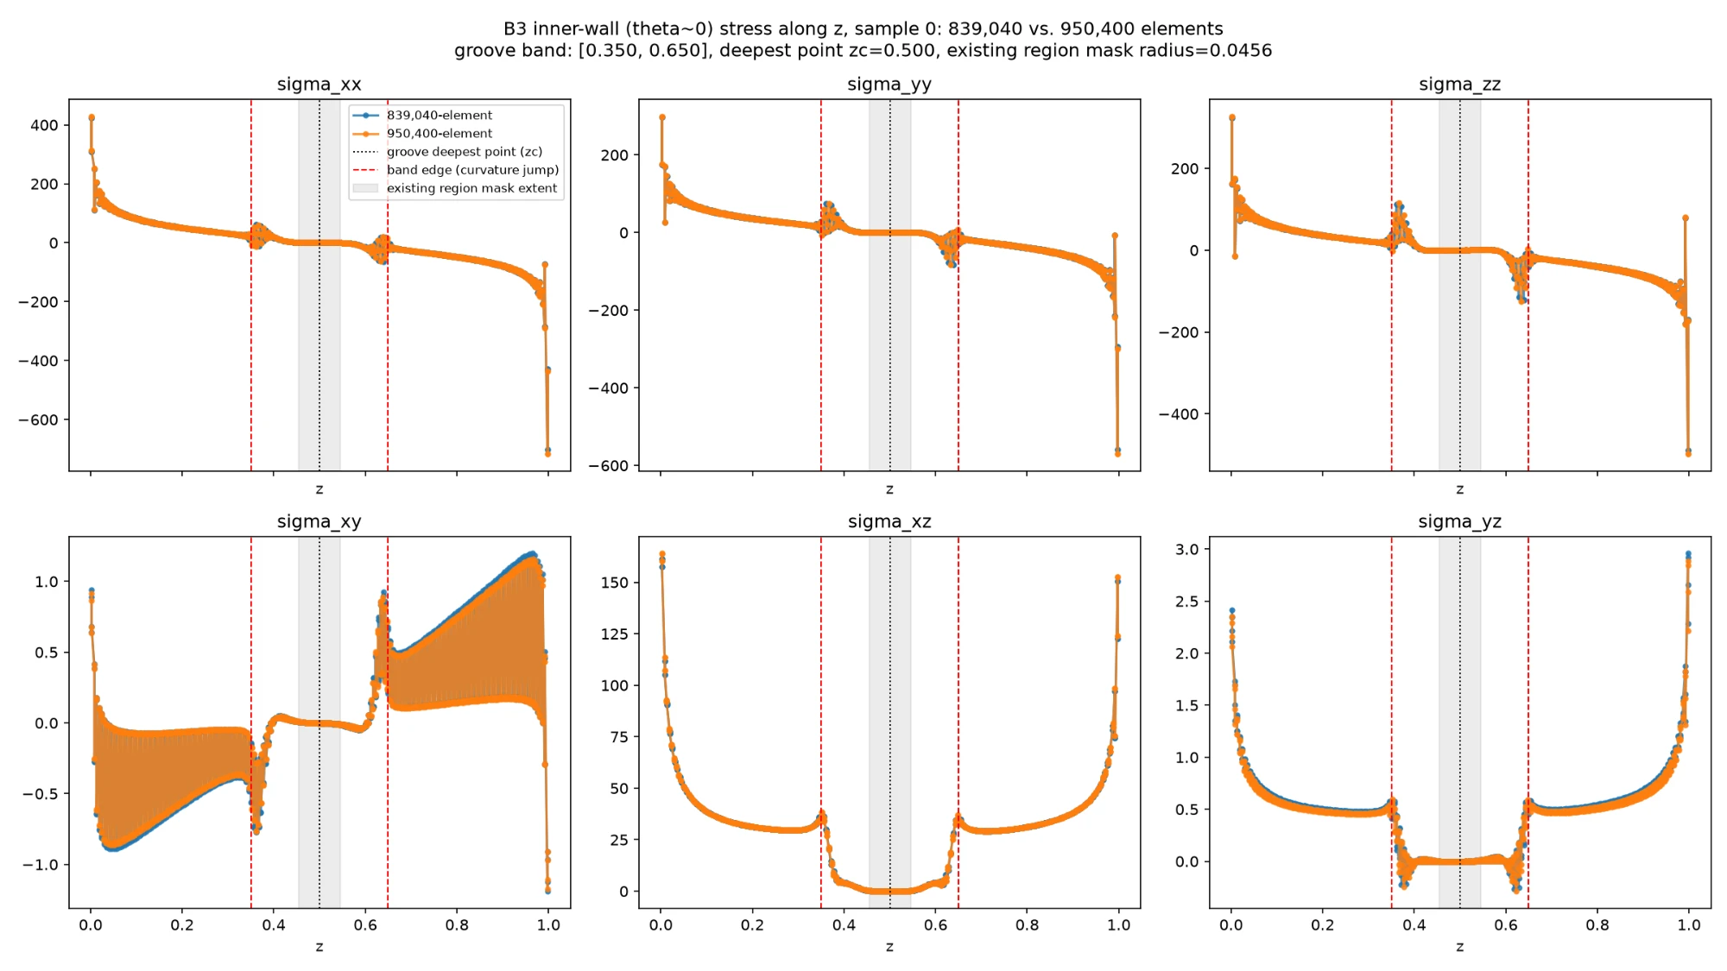
Figure 1. B3: every Cauchy stress component along the inner wall (theta~0), 839,040- vs. 950,400-element solutions, one held-out sample. Groove root (dotted), band edges (dashed), and the existing region-mask extent (shaded) are marked.
The plot shows a real, clear kink in the shear components (sigma_xy/xz/yz) exactly at the band edges, confirming this curvature-discontinuity feature does leave a visible stress signature there -- but both mesh resolutions agree closely on this kink's shape, so it is itself a converged, genuine geometric response, not a source of non-convergence. A separate, unrelated large stress feature appears at the bushing's two free axial ends (z near 0 and Lz) -- a free-surface/corner effect, not investigated further here.
The plot's normal-stress components (sigma_xx/yy/zz) appeared, by eye, to overlap almost everywhere, including at the groove itself -- seemingly at odds with our previously-reported 274% region-stress figure. We checked this directly rather than trust the visual impression: a follow-up diagnostic reporting raw per-Gauss-point magnitudes within the actual region mask shows the apparent agreement was a y-axis-scale illusion, not a real finding.
component | true RMS | true max|.| | interpolated (839k) RMS | |diff| RMS | relative
sigma_xx | 0.4847 | 1.1049 | 1.1758 | 1.0195 | 210%
sigma_yy | 0.3810 | 0.7628 | 1.0249 | 1.0191 | 267%
sigma_zz | 0.5106 | 1.2646 | 1.1962 | 1.3194 | 258%
sigma_xy | 0.0088 | 0.0276 | 0.0087 | 0.0003 | 3%
sigma_xz | 0.3183 | 0.8148 | 0.3175 | 0.0102 | 3%
sigma_yz | 0.0167 | 0.0509 | 0.0120 | 0.0111 | 66%

The normal components show a genuine, large discrepancy: the true values are not small (RMS 0.38-0.51, ruling out a small-denominator effect), and the absolute mismatch (RMS 1.0-1.3) actually exceeds the true value's own magnitude. By contrast, sigma_xz converges to 3% despite a comparably large true magnitude (0.32) -- directly ruling out a small-denominator explanation and pinning the non-convergence specifically on the normal-stress response at the groove.
2. Local mesh refinement: does the groove-region stress converge?
The mesh-convergence ladder we had used until now only had GLOBAL refinement -- every z-layer gets finer together, everywhere in the domain. We built a new mesh generator instead, with z-layers clustered specifically at the groove's own deepest point (a standard sinh mesh-grading technique), verified to reproduce the original uniform mesh exactly in the no-clustering limit and to solve the identical physical problem at every clustering strength tested (equilibrium residual at machine precision throughout). At a fixed, production-scale element count (47,040 elements), we then increased local clustering strength while holding the global element count fixed:
z_beta | Gauss pts in groove region | avg|sigma_xx| | max|sigma_xx| | avg|sigma|_F
0.0 | 2,356 | 3.027 | 47.65 | 36.23
2.0 | 3,870 | 2.975 | 44.49 | 36.08
6.0 | 8,346 | 2.850 | 47.78 | 35.51
10.0 | 9,700 | 2.815 | 54.19 | 35.23
18.0 | 10,602 | 2.800 | 63.35 | 34.28

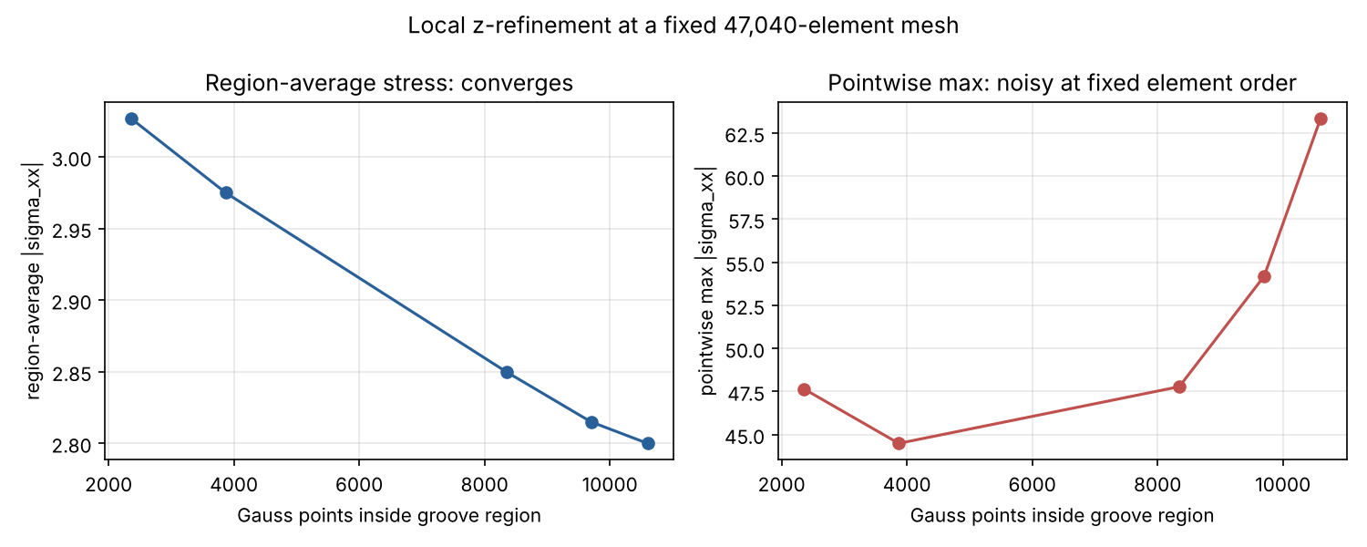
Figure 2. Region-average stress converges smoothly as local resolution at the groove increases (left); the pointwise maximum does not settle at this fixed element order (right) -- addressed directly in Section 4 below.
The region AVERAGE converges monotonically across these 5 rows (3.027 -> 2.800; the last three rows, 2.850/2.815/2.800, span about 1.8% of each other) as local Gauss-point density at the groove grows 4.5x at an identical global element count -- a genuine convergence curve, unlike the global ladder's 274% non-convergence on the same kind of comparison. The pointwise maximum does not settle the same way; this is addressed directly, not glossed over, in Section 4. (Every average in this document, here and throughout, is a volume-weighted Gauss-quadrature average, not a plain arithmetic mean -- confirmed directly in Section 4.2, where the distinction is shown to matter by about 5.6% on a representative case.)
3. Stress Concentration Factor (SCF)
We define SCF = (stress at the groove) / (nominal stress at the exact same physical location, same mesh, same loading, but with the groove geometrically removed). This specific design was chosen only after an initial, more obvious-looking approach -- comparing against the far-field control point already used elsewhere in this project -- gave a nonsensical SCF below 1. The reason: the applied loading in this problem is a rigid rotation about an axis passing through the groove's own z-location, so its dominant displacement term is exactly zero at the groove and large at the far-field point, for reasons unrelated to the groove's own geometry. Holding location and loading fixed and only removing the groove isolates its effect correctly.
 | avg|sigma_xx| | max|sigma_xx| | avg|sigma|_F
groove (real) | 2.800 | 63.35 | 34.28
nominal (groove removed, same point) | 3.335 | 29.15 | 38.63

This first gave SCF (max groove / nominal average) = 19.0. SCF on the region-average basis is below 1 (0.84-0.89) -- this particular groove geometrically thickens the wall rather than thinning it, so averaged over the region it behaves more like a mild reinforcement than a classical notch; the concentration is a pointwise effect only. As described next, this initial SCF figure was later refined once a better-converged estimate of the peak stress became available.
4. Higher-order elements, and is this a true singularity?
Professor Rabczuk's suggestion of higher-order elements or NURBS/IGA was explicitly optional. A full NURBS/IGA capability is out of scope for this project -- no such solver exists in our current codebase, and building one was not attempted. Quadratic (20-node, p-refinement) elements were genuinely testable, however, since the finite-element library we use already ships this element type along with a mesh-upgrade utility. We first caught and fixed a real correctness issue: the library's own straight-line placement of new mid-edge nodes does not lie on this mesh's curved inner/outer cylindrical surfaces, which would silently leave most surface nodes unconstrained; we fixed this by snapping affected nodes onto the exact analytic surface, and verified the fix directly.
Elements | Element type | avg|sigma_xx| | max|sigma_xx| | avg|sigma|_F
2,376 | linear (8-node) | 2.716 | 61.90 | 40.64
2,376 | quadratic (20-node) | 3.076 | 28.97 | 34.42
5,760 | linear (8-node) | 2.857 | 61.19 | 38.35
5,760 | quadratic (20-node) | 3.114 | 29.90 | 34.84
10,200 | quadratic (20-node) | 3.118 | 29.61 | 34.80

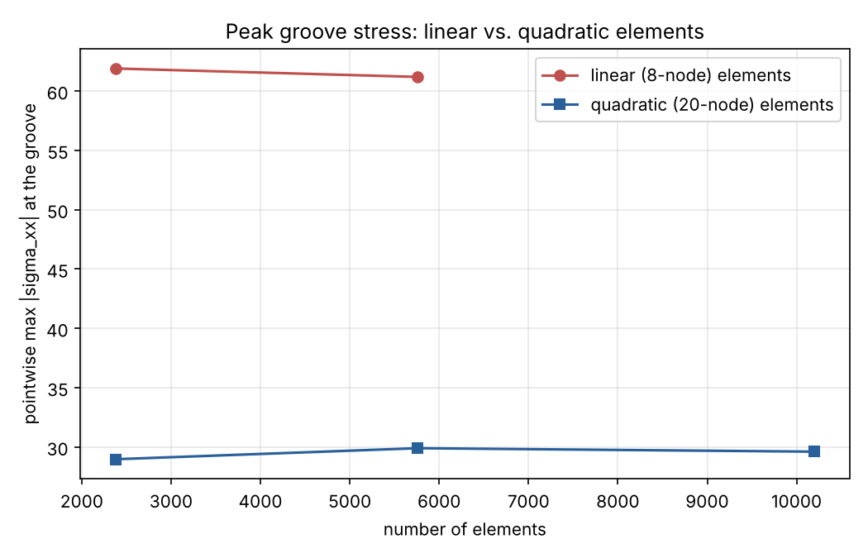
Figure 3. Peak groove stress under linear vs. quadratic elements, at the same element counts. Quadratic elements roughly halve the peak value and are already stable across three independent resolutions.
Quadratic elements cut the peak groove stress roughly in half at the same element count, and -- unlike linear elements -- the result is stable across three independent resolutions spanning a 4.3x element-count range (28.97 / 29.90 / 29.61, agreeing within about 3%).
To settle whether the groove is a true mathematical singularity or a bounded stress concentration, we ran two further checks. First, we pushed the linear-element local refinement much harder: at a fixed 5,760-element mesh, local clustering was increased until the smallest z-element had shrunk by a factor of about 1,000 (from 0.0417 to 0.000042).
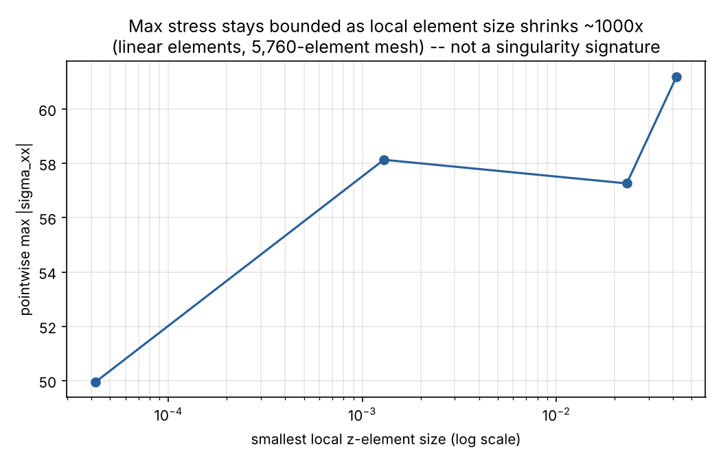
Figure 4. Peak stress under linear elements as the smallest local z-element shrinks about 1,000x. If this were a true singularity, the peak stress would grow without bound as local element size collapses; instead it stays within a bounded range.
The peak stress stayed within a bounded range (61.19 -> 57.26 -> 58.13 -> 49.95) rather than growing without bound as the local element size collapsed toward zero -- not the signature a true singularity would produce. Second, the three independent quadratic-element resolutions already shown above all agree tightly, which would not be expected if the underlying field were genuinely unbounded.
Combined verdict: the true peak stress is almost certainly close to the quadratic-converged value (approximately 29-30), confirmed at three independent resolutions. Linear elements, at every resolution and clustering strategy we tested (2,376 to 47,040 elements), scatter noisily within a bounded range (44-69) rather than showing the systematic, unbounded growth a true geometric singularity would produce under refinement -- the production-scale run's own earlier upward drift (47.65 -> 63.35) is best understood as mesh-dependent scatter around this same bounded range, since pushing local refinement much further did not continue that trend. This is consistent with classical elasticity theory: true boundary stress singularities (the Williams corner-type asymptotic solutions behind real notch and crack-tip behavior) require an actual discontinuity in the boundary's tangent direction -- this geometry, being C1 (continuous value and slope) with only a curvature (not-C2) discontinuity, does not have one. Our conclusion is that this is a genuine, real, but bounded stress concentration, not a mathematical singularity -- supported by consistent numerical evidence from two independent refinement strategies together with the theoretical argument above, though not a from-first-principles asymptotic proof, which a problem at this applied level does not require.
4.1 Do all six stress components converge under Q20, not just sigma_xx?
Re-ran the same three quadratic resolutions reporting every independent Cauchy-stress component, not only sigma_xx:
Component | avg spread (3 resolutions) | max spread (3 resolutions)
sigma_xx | 1.3% | 3.1%
sigma_yy | 3.3% | 2.6%
sigma_zz | 25.0% (small absolute value, ~-0.17 to -0.21) | 6.3%
sigma_xy | 1.3% | 24.4% -- not well converged
sigma_xz | 1.4% | 4.9%
sigma_yz | 0.6% | 9.0%

The region AVERAGE converges well for every component. The region MAXIMUM converges reasonably (3-9%) for sigma_xx/yy/zz/xz, but sigma_xy's maximum does not converge as tightly (24%) -- reported directly rather than omitted. sigma_zz's large average percentage spread is a small-denominator effect (its own absolute value is small, -0.17 to -0.21), not a large absolute change. Importantly, sigma_xy's own absolute magnitude (2.8-3.7) is small relative to the dominant shear component sigma_xz (27-29, itself well-converged at 4.9%), so this does not change the overall picture: the stress-concentration story at this groove is carried mainly by sigma_xx and sigma_xz, both of which converge well under Q20.
4.2 A properly matched-element-type SCF
The SCF reported in Section 3 mixed a quadratic-element groove peak with a linear-element nominal baseline. For a fully consistent comparison, we computed a quadratic-element no-groove counterfactual at the same 5,760-element resolution already used for the quadratic groove result:
 | avg|sigma_xx| | max|sigma_xx| | avg|sigma|_F
groove (quadratic, 5,760 elements) | 3.114 | 29.90 | 34.84
nominal, no groove (quadratic, 5,760 elements) | 3.537 | 33.23 | 40.04

Matched-element-type SCF (max groove / nominal average, both quadratic) = 8.45 -- close to, and confirming, the earlier mixed-element estimate (~9.0) was a reasonable approximation, now replaced by this properly apples-to-apples number. SCF on the average basis stays below 1 (0.88 for sigma_xx, 0.87 for the Frobenius norm), consistent with every earlier finding that this groove does not raise the average stress.
A note on how the region average itself is computed, since this was also checked directly: it is a volume-weighted (Gauss-quadrature-weighted) average over every Gauss point inside the region, not a plain arithmetic mean -- each point is weighted by its own quadrature weight times the local Jacobian determinant. This is not a cosmetic distinction: at one representative case, the volume-weighted mean (2.588) differs from the plain arithmetic mean (2.444) by 5.6%, because Gauss points are not uniformly distributed in physical volume once the mesh is locally graded. Every average reported in this document uses the volume-weighted convention throughout.
5. Far-field PI-vs-DD comparison
With the far-field region already established as convergent and free of groove influence, we re-evaluated every existing u-only checkpoint against the same already-cached 950,400-element reference, swapping in the far-field region mask for the groove one -- no new finite-element solving was required.
Checkpoint | disp L2 | far-field region sigma field | far-field sigma_xx
PI baseline | 2.78% | 16.69% | 15.04%
Local-integration-refinement (seed 1) | 3.37% | 13.01% | 11.34%
Local-integration-refinement (seed 2) | 2.40% | 15.02% | 13.54%
Local-integration-refinement (seed 3) | 2.85% | 13.65% | 12.85%
Equilibrium w=1.0 (closed, poor) | 37.08% | 138.56% | 140.27%
Equilibrium w=0.12 (closed, poor) | 37.76% | 151.27% | 153.88%
DD @ N=50 | 8.73% | 52.57% | 55.47%
DD @ N=200 | 2.81% | 30.24% | 32.40%
DD @ N=400 | 3.88% | 21.19% | 21.27%
DD sobolev | 3.37% | 21.10% | 21.47%
DD hybrid | 3.55% | 29.38% | 30.25%

This is exactly the meaningful PI-vs-DD stress comparison requested. PI and every local-integration-refinement seed are the best performers (13-17%), clearly beating every DD variant (21-53%) -- the same PI-over-DD ranking already established elsewhere in this project, now confirmed for region stress specifically, measured somewhere the finite-element ground truth itself is trustworthy. Local-integration-refinement (trained specifically to help the groove) performs slightly better than PI baseline even here, away from the groove -- that training does not trade off far-field accuracy for groove-region accuracy. These numbers (13-53%) also sit in the same reasonable range as every other quantity of interest in this project (H1, energy, reaction) -- nothing like the groove's 1,000-29,000% range -- confirming that the groove failure is a localized phenomenon specific to that one unresolved geometric feature, not representative of how well any of these models predict stress in general.
Checklist against Professor Rabczuk's email
- Groove smoothness, and whether the geometry rules out a singularity -- answered in Section 1 (genuinely smooth at the groove root; a separate, distinct C1-not-C2 curvature feature identified at the band edges).
- A plot of the stress distribution along the groove contour -- Figure 1, Section 1, plus the raw-value diagnostic that corrected our own initial visual reading of it.
- Local mesh refinement at the groove, to establish genuine convergence -- Section 2 and Figure 2 (region average converges cleanly; the pointwise maximum required the further work in Section 4).
- Stress Concentration Factor -- Section 3, refined in Section 4.2 with a properly matched-element-type comparison (SCF ~8.45, quadratic peak vs. quadratic nominal).
- Convergence of all stress components, and the averaging method used -- Section 4.1 (every component's average converges well; sigma_xy's maximum is the one exception, flagged directly) and Section 4.2 (confirmed volume-weighted, not a plain mean).
- Possibly higher-order elements or NURBS/IGA (explicitly optional) -- Section 4 and Figure 3 (NURBS/IGA out of scope; quadratic elements tested directly and found to converge the peak stress at far lower cost than further mesh refinement).
- Whether the groove is a true singularity -- Section 4 and Figure 4 (bounded concentration, not a true singularity, supported by two independent numerical checks plus the underlying elasticity theory).
- Far-field PI-vs-DD comparison, once a trustworthy region was available -- Section 5.
This report covers every point raised in Professor Rabczuk's 2026-11-10 email in full.

