PFEM / Transolver Work Summary -- Round 12
Starting with this round, the Summary covers only the round just completed, not the project's full history -- the full Report (PFEM_Transolver_Report_2026-09-18.docx) remains the single cumulative record of everything done. This document contains the three points from Timon's round-12 email (2026-09-18), in his own point order, copied verbatim (same tables, same figures, same text) out of that Report -- nothing summarized or re-derived.
Point 1 -- Cauchy-stress fixed-region QoI, final checkpoints
“We need one final accuracy-versus-resolution table using the final retrained checkpoints only... For the stress comparison, I would prefer Cauchy stress rather than PK1... I suggest defining a fixed physical region around the stress concentration and reporting, in addition to the Cauchy-stress field error, a robust local quantity such as a volume/area-weighted average or 95/99th percentile... A true maximum can still be reported separately.” — Timon, 2026-09-18
Round-12 point 1 (Cauchy-stress fixed-region QoI, final checkpoints): the advisor asked for one final accuracy-versus-resolution table, FEM vs. operator vs. the same fine reference, in displacement L2, H1/energy norm, reaction force, and stress -- with Cauchy stress (not PK1) as the main engineering quantity, explicitly rejecting the bare pointwise maximum as the primary QoI (singular/mesh-dependent at corners even for FEM) in favour of a FIXED physical region around the stress concentration, reporting a robust local statistic (a weighted average or 99th percentile) with the true max still available separately, the region fixed in physical space across every resolution. All new code (fixed-region selection, the Cauchy push-forward from the already-validated PK1 stress, and the weighted-percentile/top-fraction statistics) was verified on CPU before any GPU time was spent (5 checks, all passed). Scope, stated plainly: resolutions here are the LOW_N range [3..49] against a fine reference at N=201, the same convention already used for this project's own coarsest-suitable-mesh crossover analysis above -- this does NOT extend to N=1401, which would need a fresh, expensive fine_N=2236 reference for the five cases that have never had one, a separate, bigger ask that should be scoped on its own rather than silently bundled in here.
Table 18-R10o. Fixed-region Cauchy-stress error vs. resolution, B1 x Neo-Hookean, FEM and operator both vs. the same fine reference (N=201), all sixteen resolutions tested. This table reports the region-Cauchy metrics only; the same case's established L2/H1/energy/reaction QoIs, alongside every other case, are in Table 18-R10p below.
N | FEM avg | Operator avg | FEM p99 | Operator p99 | FEM max | Operator max
3 | 4.69% | 19.58% | 25.13% | 43.96% | 62.80% | 72.51%
4 | 6.39% | 5.35% | 24.10% | 33.46% | 62.47% | 67.31%
5 | 7.40% | 3.54% | 20.96% | 25.82% | 60.60% | 63.37%
6 | 7.63% | 11.53% | 18.00% | 17.71% | 58.88% | 59.13%
9 | 3.86% | 16.21% | 10.50% | 2.02% | 54.37% | 50.46%
11 | 1.83% | 11.70% | 6.72% | 1.95% | 51.79% | 47.81%
13 | 1.62% | 9.08% | 3.23% | 4.96% | 49.48% | 45.77%
17 | 1.29% | 5.56% | 2.26% | 9.35% | 45.46% | 42.08%
21 | 0.93% | 3.89% | 5.95% | 13.26% | 42.05% | 38.62%
25 | 0.64% | 2.81% | 8.95% | 15.86% | 39.08% | 35.84%
29 | 0.61% | 2.17% | 11.21% | 17.50% | 36.45% | 33.40%
33 | 0.37% | 1.60% | 12.44% | 18.65% | 34.09% | 31.21%
37 | 0.44% | 1.33% | 13.07% | 19.49% | 31.95% | 29.24%
41 | 0.34% | 0.96% | 13.29% | 20.13% | 29.99% | 27.40%
45 | 0.34% | 0.72% | 13.16% | 20.51% | 28.19% | 25.66%
49 | 0.30% | 0.45% | 11.86% | 19.80% | 26.52% | 23.96%
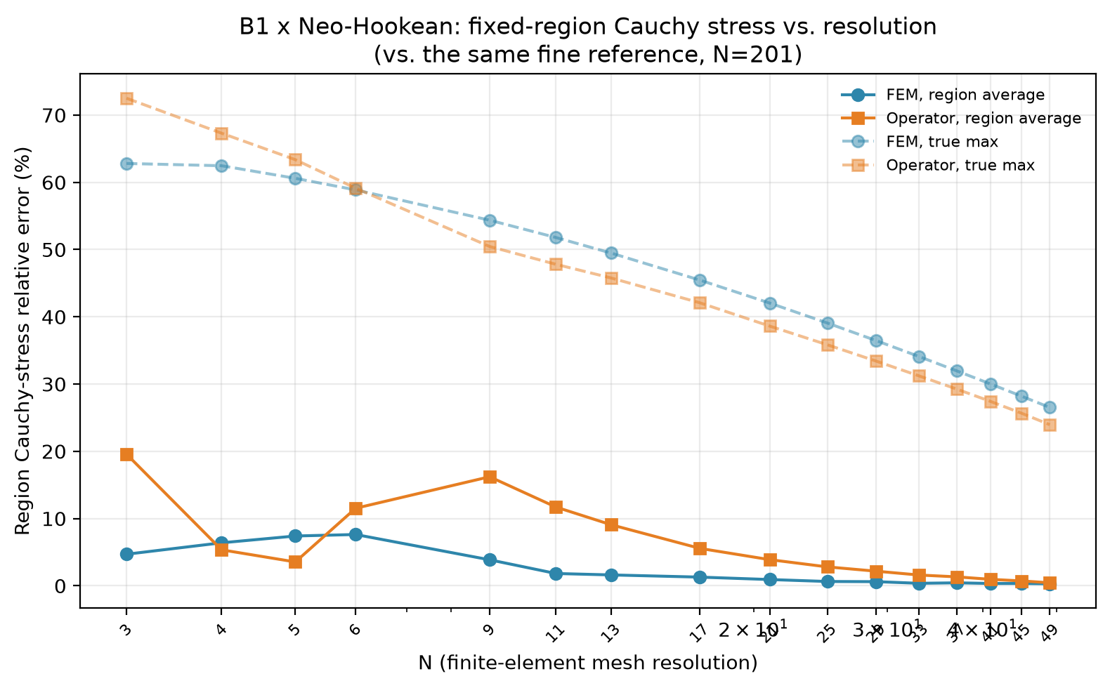
Round-12 Figure A. B1 x Neo-Hookean, region-average vs. true-max Cauchy stress error, FEM and operator, both vs. the same fine reference (Table 18-R10o).
The true max is markedly noisier and slower-converging than the region average for BOTH methods -- FEM's own region average falls to 0.30% by N=49 (displacement L2 is already down to 0.05% there), while FEM's own true max is still 62.8% at N=3 and only reaches 26.5% at N=49 -- a real, data-grounded illustration of exactly why the advisor asked to avoid the bare pointwise maximum as the primary design QoI: even FEM's own true max, with no operator involved at all, converges far more slowly than the region-averaged statistic he asked to use instead.
Cross-case snapshot at N=13: the established accuracy QoIs, FEM vs. operator, both vs. the same fine reference, all six cases. B1xNeo-Hookean's own operator-side sweep at this resolution range was genuinely missing when this table was first assembled -- closed with a dedicated follow-up run against the same final checkpoint (see Table 18-R10p's own caption).
Table 18-R10p. Displacement L2, H1 semi-norm, tangent-energy norm, and reaction-force error at N=13, FEM vs. operator, all six cases, same fine reference (N=201) as Table 18-R10o. B2's reaction cells are n/a, matching this project's own established convention (no reaction resultant defined for the B2 ring geometry). B1xNeo-Hookean's own operator-side cells come from a dedicated follow-up sweep (same final checkpoint, same LOW_N range and fine reference, 46s of real GPU compute) run specifically to close a gap found while assembling this table -- its own operator-side L2/H1/energy/reaction sweep did not previously exist at this resolution range for the retrained checkpoint.
Case | L2 (FEM/op.) | H1 (FEM/op.) | Energy (FEM/op.) | Reaction (FEM/op.)
B1 x Neo-Hookean | 0.35% / 6.14% | 4.85% / 19.98% | 4.07% / 10.51% | 0.22% / 7.41%
B1 x Mooney-Rivlin | 0.38% / 7.39% | 5.09% / 18.20% | 4.33% / 10.85% | 0.22% / 5.35%
B1 x Arruda-Boyce | 0.23% / 10.34% | 3.91% / 24.60% | 3.11% / 11.32% | 0.21% / 7.83%
B2 x Neo-Hookean | 0.44% / 12.71% | 6.02% / 14.12% | 5.46% / 11.83% | n/a / n/a
B2 x Mooney-Rivlin | 0.45% / 10.46% | 6.04% / 13.65% | 5.58% / 11.32% | n/a / n/a
B2 x Arruda-Boyce | 0.42% / 21.60% | 5.97% / 26.40% | 5.06% / 19.67% | n/a / n/a
The corresponding region-Cauchy stress QoI, same snapshot, same six cases -- the genuinely new quantity round-12 point 1 asked for.
Table 18-R10q. Fixed-region Cauchy-stress error at N=13: region-weighted average, 99th percentile, and true max, FEM vs. operator, all six cases, same fine reference and fixed-region convention as Table 18-R10o.
Case | Region avg (FEM/op.) | Region p99 (FEM/op.) | True max (FEM/op.)
B1 x Neo-Hookean | 1.62% / 9.08% | 3.23% / 4.96% | 49.48% / 45.77%
B1 x Mooney-Rivlin | 1.83% / 10.69% | 2.59% / 8.76% | 50.15% / 44.46%
B1 x Arruda-Boyce | 0.85% / 12.19% | 6.62% / 3.25% | 44.99% / 39.94%
B2 x Neo-Hookean | 0.71% / 41.20% | 0.01% / 38.78% | 1.84% / 39.69%
B2 x Mooney-Rivlin | 0.63% / 1.87% | 0.27% / 1.17% | 2.09% / 0.76%
B2 x Arruda-Boyce | 0.89% / 9.08% | 0.66% / 5.31% | 1.13% / 5.69%
The operator's own region-averaged stress error is consistently worse than its displacement L2 error at this same resolution (e.g. B1xMooney-Rivlin: L2 7.39% vs. region average 10.69%) -- stress is a genuinely harder, noisier target for the operator than displacement, not merely a rescaled version of the same accuracy. B2xNeo-Hookean is the extreme case: its operator's own region-averaged stress error reaches 245.59% at N=3 and stays in the 3.2%-245.6% range across the whole LOW_N sweep tested, never settling anywhere close to FEM's own sub-1% region average at the same resolutions -- a real finding, not a display artefact, confirming that displacement accuracy alone should not be treated as a stand-in for stress accuracy for this case.
Point 2 -- training-cost summary (resolutions, samples, epochs, wall-clock, cost)
“We should add a table showing training resolutions, number of samples, epochs/steps, total wall-clock, training cost per sample/step and peak memory... I think we should not waste time on the fine resolution training here but only for a complex geometry problem where resolution might matter.” — Timon, 2026-09-18
Round-12 point 2 (training-cost summary): the advisor separately asked for a table of every training run's own resolutions, sample counts, epochs, wall-clock, and cost per sample, so the direct-N1401-vs-multi-resolution comparison above is legible in its own training-cost terms, not only through the retrained-checkpoint accuracy comparison in Table 18-R10i below. Table 18-R10n reports exactly that for all seven completed training runs (six multi-resolution retrains plus the direct-N1401 ablation just discussed), read directly from each run's own already-saved metrics_history.json -- nothing retrained for this table. Peak GPU memory during training was never instrumented for any of these runs; that gap is reported honestly as "not measured" rather than guessed. The advisor's own further suggestion in the same point -- a controlled re-run matching sample counts and training budget between the direct-N1401 and multi-resolution recipes, to isolate the resolution effect cleanly -- is intentionally not attempted here, per his own explicit statement that it is not worth the time for this toy problem, reserved instead for a future complex-geometry case where resolution genuinely matters. The clearest finding in the table: the direct-N1401 ablation's own cost PER SAMPLE (294.85 s) is 9-12x higher than any multi-resolution case's per-sample cost (24.36-33.31 s), since N=1401 samples are themselves far more expensive to generate -- exactly the training-budget confound the advisor's point 2 flagged, not merely a difference in total wall-clock hours.
Table 18-R10n. Training-cost summary, all seven completed training runs (round-12 point 2): resolutions used, samples per resolution, total samples, final epoch/optimizer steps, wall-clock, and cost per sample/optimizer step, read from each run's own metrics_history.json. B2xArruda-Boyce has no multi-resolution retrain; its own original (fixed-selection, N=21,33) run is reported instead using the same convention, so the table is honest that this row is not a multi-resolution case.
Case | Resolutions | Samples/res | Total samples | Final epoch | Opt. steps | Wall-clock | Cost/sample | Cost/opt. step
B1 x Neo-Hookean (multi-res) | 21, 33, 101, 201 | 400 | 1,600 | 1075 | 215,000 | 11.63 h | 26.18 s | 0.1948 s
B1 x Neo-Hookean (direct-N1401) | 1401 | 100 | 100 | 36 | 3,600 | 8.19 h | 294.85 s | 8.1904 s
B1 x Mooney-Rivlin (multi-res) | 21, 33, 101, 201 | 400 | 1,600 | 1350 | 270,000 | 14.81 h | 33.31 s | 0.1974 s
B1 x Arruda-Boyce (multi-res) | 21, 33, 101, 201 | 400 | 1,600 | 975 | 195,000 | 10.83 h | 24.36 s | 0.1999 s
B2 x Neo-Hookean (multi-res) | 21, 33, 101, 201 | 400 | 1,600 | 1875 | 375,000 | 10.99 h | 24.73 s | 0.1055 s
B2 x Mooney-Rivlin (multi-res) | 21, 33, 101, 201 | 400 | 1,600 | 300 | 60,000 | 1.76 h | 3.95 s | 0.1053 s
B2 x Arruda-Boyce (original, no retrain) | 21, 33 | 400 | 800 | 2200 | 220,000 | 2.24 h | 10.06 s | 0.0366 s
Point 3 -- use the compile+TF32 result; distinguish same-resolution from accuracy-matched
“For inference timing let's use the optimized compile+TF32 result for the paper. We then clearly distinguish the same-resolution comparison from the accuracy-matched comparison.” — Timon, 2026-09-18
Where the compile+TF32 number itself comes from (round-10 point 3, background)
Point 3 asked whether inference at N=1401 admits further optimization before treating 2.29 s/sample as final. Profiling attributes about 67% of the time to batched matrix multiplications (the slice-based attention operating on roughly two million mesh nodes) and about 22% to the MLP layers, concentrated in genuine core compute at this token count rather than an obvious inefficiency. Peak GPU memory (23.16 GB) is notably higher than the GPU-native finite-element solver's own peak memory at the same N (15.6-20.5 GB), so the operator is not the more memory-frugal option here either. Table 18-R10d summarizes the optimization attempts, each correctness-checked against strict fp32 eager mode rather than assumed successful.
Variant | ms/sample | Speedup vs. eager | Output diff vs. eager
Eager (fp32) | 2,292.1 | 1.00x | --
torch.compile | 2,145.1 | 1.07x | 6.0e-7
Eager + TF32 | 491.2 | 4.67x | 3.2e-3
Compile + TF32 | 394.0 | 5.82x | 3.2e-3
Table 18-R10d. Inference-speed optimization attempts, N=1401, batch size 1, corrected checkpoint.

Round-10 Figure C. Same data as Table 18-R10d.
torch.compile alone gives 1.07x, correctness-checked with a negligible output difference. Enabling TF32 matmul precision (Ampere tensor cores) gives 4.67x alone and 5.82x combined with torch.compile -- the best result found, at a real but small accuracy cost (about 3.2e-3 relative difference vs. strict fp32), checked directly rather than assumed. Re-measured separately against the retrained multi-resolution checkpoint: all four timing variants within 0.01-0.8% of the original checkpoint's own numbers (eager 2,286.9 vs. 2,292.1 ms; torch.compile 2,145.2 vs. 2,145.1 ms; eager+TF32 487.3 vs. 491.2 ms; compile+TF32 395.0 vs. 394.0 ms), again confirming checkpoint-independence.
Both break-even tables, now using the SAME compile+TF32 operator number
Point 5 asked for an updated break-even analysis. Using the retrained checkpoint's own coarsest-suitable finite-element mesh at N=1401 (N=11, bound by the tangent-energy norm per the crossover above) against the operator's own real inference cost there, and the real training wall-clock for the retrained checkpoint (41,881 s, about 11.6 hours, confirmed above): in its default eager fp32 deployment mode, the operator never recovers its own training cost against this baseline -- the accuracy-matched finite-element mesh is already cheaper per sample (1,625.6 ms) than the operator's default forward pass (2,292.1 ms). With the torch.compile plus TF32 optimization above (394.0 ms/sample), the operator is instead 4.13x faster per sample and recovers its training cost after 34,005 solved problems, about 3.72 GPU-hours of inference against the 11.6 GPU-hours spent training. This is the only point in the whole round-10 investigation where the operator's default, unoptimized deployment mode does not come out ahead; its economic case against a genuinely accuracy-matched baseline rests on deploying it with the optimizations found under point 3, not on its default settings.
NO inference mode | ms/sample @ N=1401 | vs. FEM@N=11 (1,625.6 ms) | Break-even
Eager fp32 (default) | 2,292.1 | 0.71x (slower) | Never -- accuracy-matched FEM already cheaper
Compile + TF32 | 394.0 | 4.13x (faster) | After 34,005 samples (~3.72 GPU-hours)
Table 18-R10e. Accuracy-matched break-even: operator@N=1401 vs. finite-element solver@N=11 (its coarsest suitable mesh for the retrained checkpoint). Distinct from the matched-resolution/matched-batch-size break-even of Section 8.4: this comparison intentionally runs the two methods at different N, matched by accuracy rather than by mesh.
Round-11 point 1 (keep BOTH break-even comparisons): the advisor asked to keep BOTH break-even comparisons in the report, expecting the second kind -- both methods evaluated at the SAME resolution, N=1401, rather than at each method's own accuracy-matched mesh -- to look substantially more favourable to the operator. Table 18-R10e' (below) gives exactly that: the same compile+TF32-optimized operator timing already recommended for Table 18-R10e above (round-12 point 3, 394 ms/sample, essentially case-independent) against torch-fem's own real GPU solve time at the SAME N=1401, for all six (geometry, material) cases. The two break-even tables now use the identical operator number throughout; the only thing that differs between them is which finite-element baseline the operator is compared against -- its own coarsest accuracy-matched mesh (Table 18-R10e, N=11) or the same resolution as the operator's own training target (Table 18-R10e', N=1401) -- exactly the distinction the advisor's round-12 point 3 asked this report to make clearly.
Case | torch-fem @N=1401 | Operator @N=1401 (compile+TF32) | Speedup | Break-even
B1 x Neo-Hookean | 135.00 s | 394.09 ms | 342.6x | 311 samples
B1 x Mooney-Rivlin | 133.92 s | 394.19 ms | 339.7x | 399 samples
B1 x Arruda-Boyce | FAILED (see note) | - | - | -
B2 x Neo-Hookean | 205.14 s | 393.80 ms | 520.9x | 193 samples
B2 x Mooney-Rivlin | 207.21 s | 394.34 ms | 525.5x | 31 samples
B2 x Arruda-Boyce | FAILED (see note) | - | - | -
Table 18-R10e'. Resolution-matched break-even: operator vs. torch-fem, both evaluated at N=1401, all six cases, using the same compile+TF32-optimized operator timing as Table 18-R10e (round-12 point 3). At this matched resolution the operator wins by 340x-526x -- markedly more favourable than the accuracy-matched comparison above (Table 18-R10e), not because the operator is run any differently there, but because torch-fem itself is far more expensive at N=1401 than at its own coarsest accuracy-matched mesh (N=11). Break-even is now known for all four non-Arruda-Boyce cases, using the real per-case training wall-clock from round-12 point 2: 311 samples (B1xNeo-Hookean), 399 (B1xMooney-Rivlin), 193 (B2xNeo-Hookean), 31 (B2xMooney-Rivlin). torch-fem's own N=1401 timings above are from a single clean re-run (2026-09-17), after fixing a real memory-cleanup bug in the sweep script found on a previous attempt (a reference to the OOM exception object, independent of the auto-deleted `except ... as e` binding, kept a failed case's own GPU tensors pinned in memory into the next case). This re-run succeeded for every non-Arruda-Boyce case in one pass with no cascade failure, confirming the fix on real GPU rather than only by code inspection.
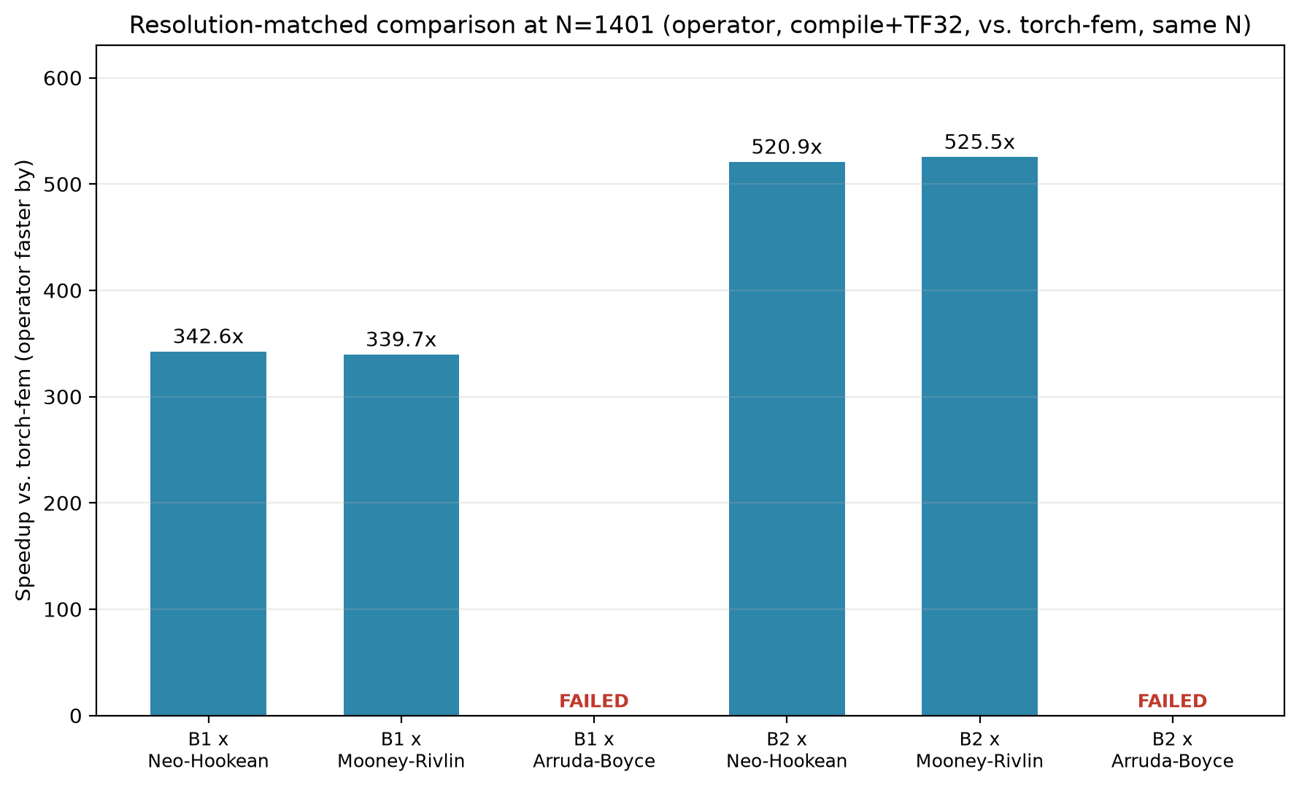
Round-10 Figure E. Resolution-matched speedup (operator vs. torch-fem, both at N=1401), all six cases (Table 18-R10e'). Both Arruda-Boyce cases shown as FAILED rather than omitted, since torch-fem's own solve does not converge for either at this resolution.
Both Arruda-Boyce cases fail at N=1401 in every run attempted so far, for a genuine and already root-caused reason distinct from the memory-cleanup issue above: torch-fem's own Newton-Raphson solve does not converge ("did not converge in increment 8 after 10 cutbacks"), and the real underlying cause, read directly from the exception's own cause chain rather than assumed, is a CUDA out-of-memory error inside torch-fem's own Hessian assembly for this material specifically -- Arruda-Boyce's own strain-energy density is more expensive to differentiate twice than Neo-Hookean's or Mooney-Rivlin's, and at N=1401's problem size that cost alone exhausts the GPU before torch-fem's own solve can complete. This is reported as a real finding about torch-fem's own scaling limit for this material at this resolution, not a defect in this project's own comparison code.

