ASSIGNMENT -1
Java Programming Basics

a) Write a program in java to initialize an integer value n and compute 4096n , (1/1024)n using shift operator.
CODE :-

public class Q1{
public static void main(String args[]){
int n = 76;
int mul = n << 12;
int div = n >> 10;
System.out.println("4096*" + n + " = " + mul);
System.out.println(n + "/1024 = " + div);
}
}

OUTPUT : -
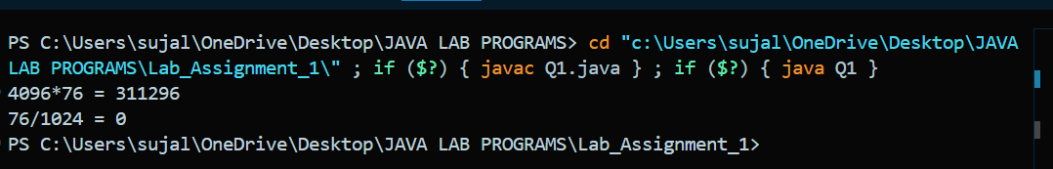
________________________________________________________

b) Write a program to perform following conversions: I) Reads a number in feet, converts it to meters, ii) Enter the minutes (e.g., 1 billion) and displays the number of years and days for the minutes.
CODE :-
import java.util.Scanner;
public class Q2 {
public static void main(String[] args) {
Scanner sc = new Scanner(System.in);

System.out.print("Enter a number(in metres) : ");
double m1 = sc.nextDouble();
System.out.println("In feet : " + m1 * 0.3048);

System.out.print("Enter a number(in Minutes) : ");
double y1 = sc.nextDouble();
System.out.println("In Days : " + (y1 / (24 * 60)));
System.out.println("In Years : " + (y1 / (24 * 60 * 365)));
}
}

OUTPUT : -
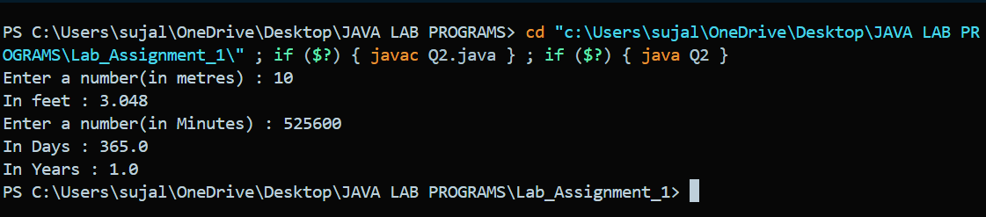

________________________________________________________
c) Write a program in java to create and initialize base and height of a triangle and compute its perimeter.

CODE :-
public class Q3 {
public static void main(String[] args) {
double base = 3;
double height = 4;
double hypotenuse = Math.sqrt((base* base) + (height * height));
double perimeter = base + height + hypotenuse;
System.out.println("The Perimeter of the triangle is : " + perimeter);
}
}

OUTPUT : -
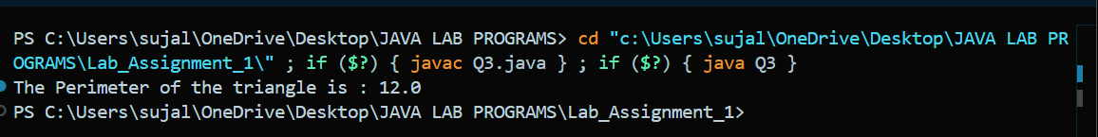
________________________________________________________

d) Write a java program to apply mod operation for each entry and display multiplication table of modulo n. The example for multiplication table modulo 4 is given below.
X 0 1 2 3
0 0 0 0 0
1 0 1 2 3
2 0 2 0 2
3 0 3 2 1

CODE :-
import java.util.Scanner;
public class Q4 {
public static void main(String[] args) {
Scanner sc = new Scanner(System.in);
System.out.print("Enter a number : ");
int n = sc.nextInt();
System.out.print("X ");
for(int i = 0; i < n ; i++){
System.out.print(i + " ");
}
System.out.println("");
for(int i = 0; i < n ; i++){
System.out.print(i + " ");
for(int j = 0 ; j < n ; j++){
System.out.print(((i * j) % n) + " ");
}
System.out.println("");
}
}
}

OUTPUT : -
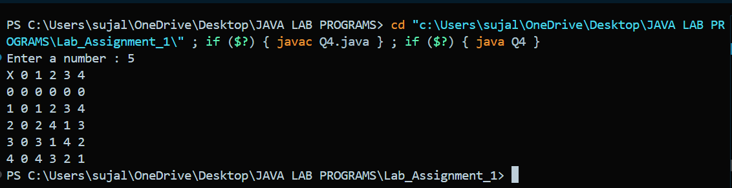
________________________________________________________

e) Write a program to input centre and radius of a circle with an arbitrary point and print whether the point is inside, outside, or on the boundary of the circle.

CODE :-
import java.util.Scanner;
public class Q5 {
public static void main(String[] args) {
Scanner sc = new Scanner(System.in);
System.out.print("Enter the x and y coordinates of center : ");
int x1 = sc.nextInt();
int y1 = sc.nextInt();
System.out.print("Enter the radius : ");
int r = sc.nextInt();
System.out.print("Enter the x and y cooridnates of the point : ");
int x2 = sc.nextInt();
int y2 = sc.nextInt();
double dis = Math.sqrt(((y2 - y1) * (y2 - y1)) + ((x2 - x1) * (x2 - x1)));
if(dis < r){
System.out.println("Point lies inside the circle.");
}
else if(dis == r){
System.out.println("Point lies on the boundary of the circle.");
}
else if(dis > r){
System.out.println("Point lies outside the circle.");
}
}
}

OUTPUT : -
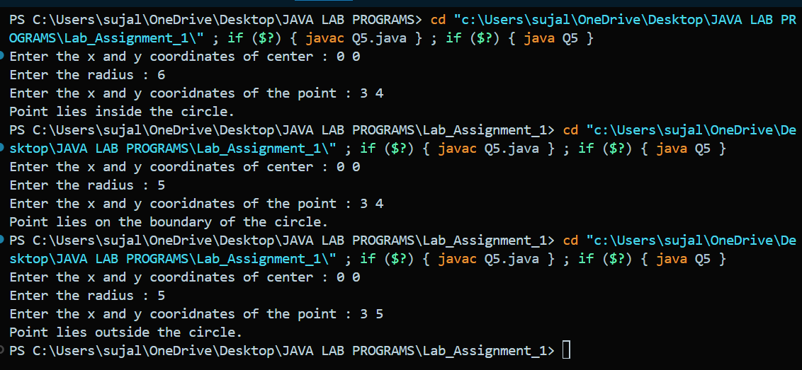
________________________________________________________

f) Write a java program to input two vector of length n using array and compute the dot product using for-each loop.
CODE :-

import java.util.Scanner;
public class Q6 {
public static void main(String[] args) {
Scanner sc = new Scanner(System.in);
System.out.print("Enter a Number : ");
int n = sc.nextInt();
int[] vec1 = new int[n];
int[] vec2 = new int[n];
System.out.print("Enter the first vector : ");
for(int i = 0; i < n ; i++){
vec1[i] = sc.nextInt();
}
System.out.print("Enter the second vector : ");
for(int i = 0; i < n ; i++){
vec2[i] = sc.nextInt();
}
int dot_product = 0;
int i = 0;
for(int vec : vec1){
dot_product += vec * vec2[i];
i++;
}
System.out.println("The dot product of two vectors is : " + dot_product);
}
}

OUTPUT : -
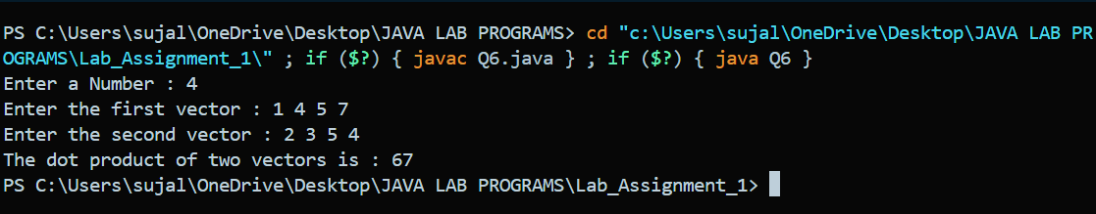
________________________________________________________
g) Write a program to input endpoints of two lines and display whether two lines are parallel or intersecting each other.
CODE :-
import java.util.Scanner;
public class Q7 {
public static void main(String[] args) {
Scanner sc = new Scanner(System.in);
System.out.println("Enter the endpoints of the first line : ");
int x1 = sc.nextInt();
int y1 = sc.nextInt();
int x2 = sc.nextInt();
int y2 = sc.nextInt();
System.out.println("Enter the endpoints of the second line : ");
int x3 = sc.nextInt();
int y3 = sc.nextInt();
int x4 = sc.nextInt();
int y4 = sc.nextInt();
double slope_1, slope_2;
if(x2 - x1 == 0 && x4 - x3 == 0){
System.out.println("The two lines are parallel");
}
else if(x2 - x1 == 0 || x4 - x3 == 0){
System.out.println("The two lines are intersecting");
}
else{
slope_1 = (double)(y2 - y1) / (x2 - x1);
slope_2 = (double)(y4 - y3) / (x4 - x3);
if(slope_1 == slope_2){
System.out.println("The two lines are parallel");
}
else{
System.out.println("The two lines are intersecting");
}
}
}
}

OUTPUT : -
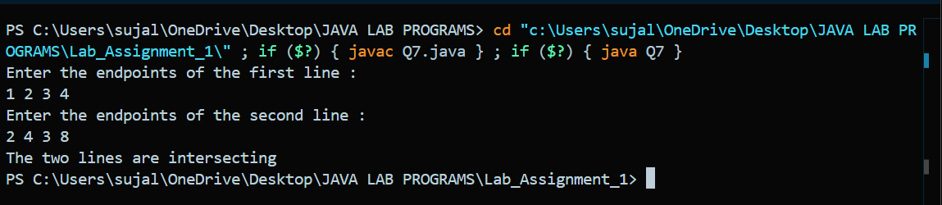
________________________________________________________

h) Write a program in java to input an integer n and approximate the value of e using formula e = 1+ 1/1! +1/2! ... + 1/n! .

CODE :-
import java.util.Scanner;
public class Q8 {
public static double factorial(int n){
if(n == 0 || n == 1)return 1;
return n * factorial(n - 1);
}
public static double euler(int n){
if(n == 0)return 1;
else return (1 / factorial(n)) + euler(n - 1);
}
public static void main(String args[]){
Scanner sc = new Scanner(System.in);
System.out.print("Enter a number : ");
int n = sc.nextInt();
double val = euler(n);
System.out.println("The value of e is : " + val);
}
}

OUTPUT : -



