Error: Reference source not found
–
Document ID: 0000.doc
Author(s): SUJEETH
Version: 1
Date: April 1, 2024

1. Objective and Scope ......................................................................................................3
2. Project end users ......................................................................................................... 3
3. Functional Requirements ..............................................................................................3
3.1 Data collection ................................................................................................ 3
3.2 Data prepocessing........................................................................................... 4
3.3 Prediction generation...................................................................................... 4
3.4 User interface.................................................................................................. 4
4. Non-Functional Requirements ...................................................................................... 4
4.1 Performance ................................................................................................... 4
4.2 Usability ......................................................................................................... 4
4.3 Compatability ................................................................................................. 4
5. Features ....................................................................................................................... 5
5.1 User input........................................................................................................ 5
5.2 Visualization.................................................................................................... 6
5.3 Output............................................................................................................. 6
5.4 Report............................................................................................................. 7
6. Project process flow ..................................................................................................... 8

Objective and Scope
The aim of the title "Stock Trend Prediction with Technical Indicators using SVM" is to investigate the effectiveness and accuracy of Support Vector Machines (SVM) as a predictive model for forecasting stock trends. It is useful to predict the price after buying or selling stock and SVM to increase the accuracy of the trained model.
The scope of the product includes the following basic features:
- Retrieve stock data using yfinance online API, which is our fundamental data to work with.
- The obtained stock data will be much useful in predicting the trend which will benefit the investors. Further the data will help us if the selected is relevant to the trend and can assure the correctness of the project workflow.
- A selected companies’ stock can be chosen by users, which are the most beneficial company that attracts more investors and may have some risk in investment.
- On the desired date the trend of the company will be predicted such as whether bullish or bearish for the day.
- Using the predicted results investors can analyze these results and do invest with further additional research.

Project End Users
Those who seek an online prediction model for reference.

Functional requirements

Data collection
The system should be able to collect historical and real-time stock market data from the Yahoo Finance API.

Data prepocessing
It should preprocess the data, including cleaning, normalization, and feature extraction from technical indicators like MACD, RSI, and moving averages.

Prediction generation
Generate real-time stock trend predictions based on the integrated machine learning model and technical indicators.

User Interface
Provide a user-friendly interface using Streamlit for users to input stock data and view predictions.

Non-functional requirements

Performance
The system should be able to process data and generate predictions quickly, ensuring real-time responsiveness.

Usability
The user interface should be intuitive and easy to use, even for users with limited technical knowledge.

Compatability
Ensure compatibility with different browsers and devices to reach a wider audience.

Features

User Input
Each and every user will be able to select different company stocks and date to prediction.
Users will be able to select a set of companies to make the website more faster.
Dates can be selected for the past 1 year
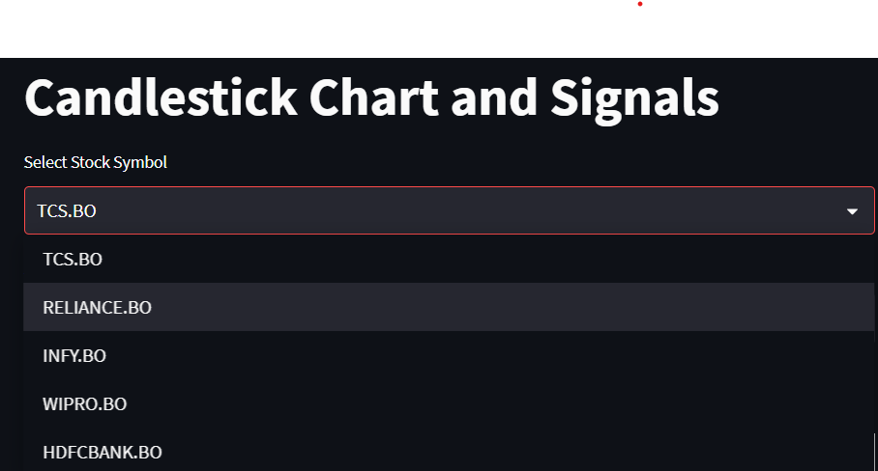

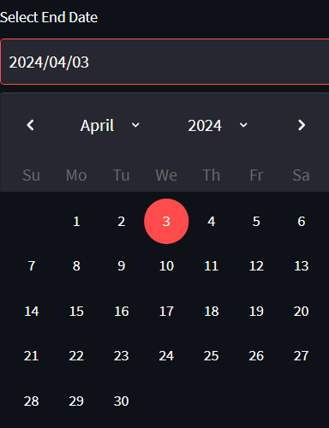

Visualization
A graph will be displayed for the visualization purpose of the company’s price against the date. It will be used for the users to check with other online resources whether the fetched stock data is correct.
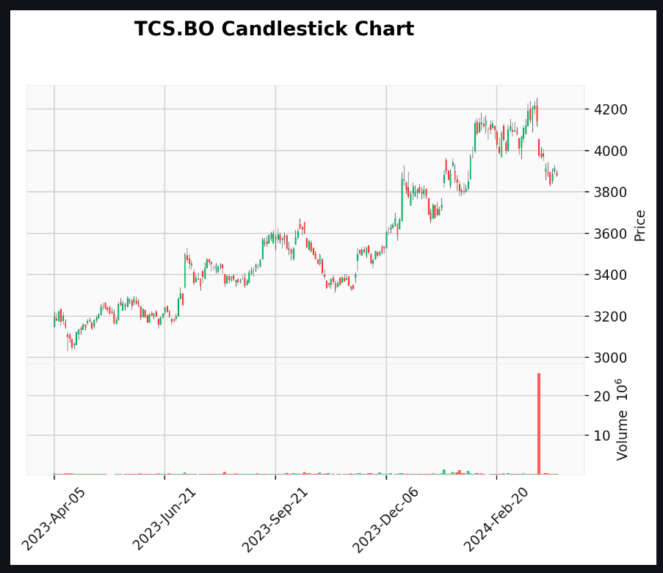

Output
The system will predict the trend for the last 15 days to train itself against the actual signal in the chart which can increase the accuracy of the model. For every day the actual and predicted signal will be displayed for the user to decide whether he/she can trust the system’s prediction. Prediction of bullish or bearish signals based on RSI and MACD indicators. It compares these predictions with actual signals and displays them in a table.
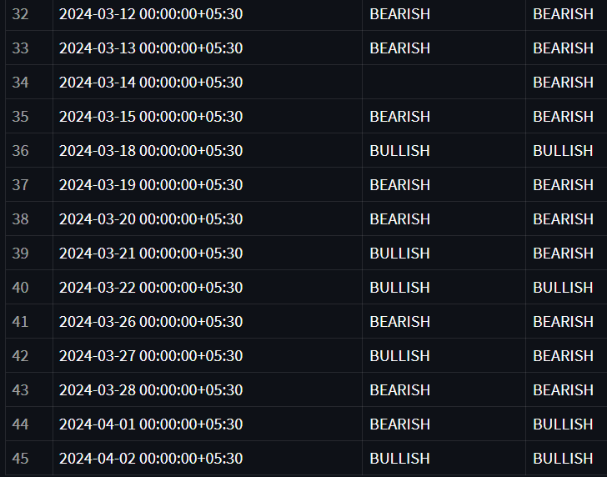

Reports
This system has reporting capabilities. It shows the report of bullish, bearish, accuracy, macro average and weighted average with the precision, recall, f1-score and support calculations. Finally it displays the overall accuracy of the prediction.
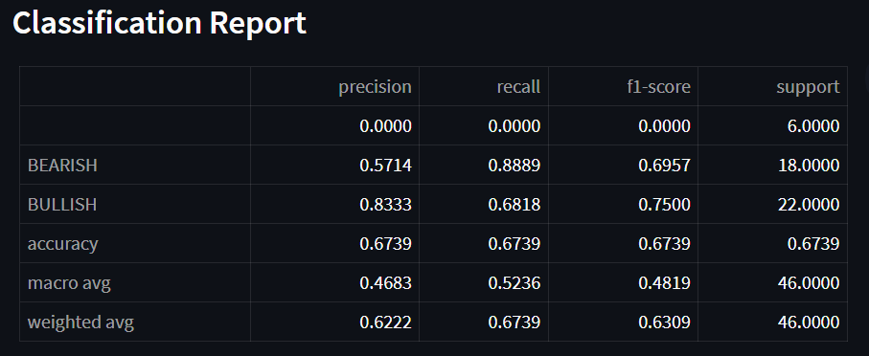

Project process flow
