The type of skin cancer a person gets is determined by where the cancer begins. If the cancer begins in skin cells called basal cells, the person has basal cell skin cancer. When cells that give our skin its color become cancerous, melanoma develops.

Here you’ll see what the most common types of skin cancer can look like and who tends to develop each type.

Basal cell carcinoma: This is the most common type of skin cancer. It looks like a flesh-colored, pearl-like bump, or pinkish patch of skin.**Basal cell carcinoma (BCC)**This is the most common type of skin cancer.

* BCC frequently develops in people who have fair skin. People who have skin of color also get this skin cancer.
* BCCs often look like a flesh-colored round growth, pearl-like bump, or a pinkish patch of skin.
* BCCs usually develop after years of frequent sun exposure or indoor tanning.
* BCCs are common on the head, neck, and arms; however, they can form anywhere on the body, including the chest, abdomen, and legs.
* Early diagnosis and treatment for BCC are important. BCC can grow deep. Allowed to grow, it can penetrate the nerves and bones, causing damage and disfigurement

Squamous cell carcinoma: The second most common type of skin cancer. Often looks like a red firm bump, scaly patch, or a sore that heals and then re-opens.**Squamous cell carcinoma (SCC) of the skin**SCC is the second most common type of skin cancer.

* People who have light skin are most likely to develop SCC. This skin cancer also develops in people who have darker skin.
* SCC often looks like a red firm bump, scaly patch, or a sore that heals and then re-opens.
* SCC tends to form on skin that gets frequent sun exposure, such as the rim of the ear, face, neck, arms, chest, and back.
* SCC can grow deep into the skin, causing damage and disfigurement.
* Early diagnosis and treatment can prevent SCC from growing deep and spreading to other areas of the body.

Actinic keratoses: These dry, scaly patches or spots are precancerous growths.**SCC can develop from a precancerous skin growth**Some people develop dry, scaly patches or spots on their skin called [actinic keratoses (AKs)](https://www.aad.org/public/diseases/skin-cancer/actinic-keratosis-overview). Also caused by too much sun, an AK isn’t skin cancer. An AK is a precancerous skin growth that can turn into a common type of skin cancer, squamous cell carcinoma.

* People who get AKs usually have fair skin.
* AKs usually form on the skin that gets lots of sun exposure, such as the head, neck, hands, and forearms.
* Because an AK can turn into a type of skin cancer, treatment is important.

Melanoma: The deadliest form of skin cancer. Frequently develops in a mole or suddenly appears as a new dark spot on the skin.**Melanoma**Melanoma is often called "the most serious skin cancer" because it has a tendency to spread.

* Melanoma can develop within a mole that you already have on your skin or appear suddenly as a dark spot on the skin that looks different from the rest.
* Early diagnosis and treatment are crucial.
* Knowing the[ABCDE warning signs of melanoma](https://www.aad.org/public/diseases/skin-cancer/find/at-risk/abcdes) can help you find an early melanoma.

## **Symptoms**

### Where skin cancer develops

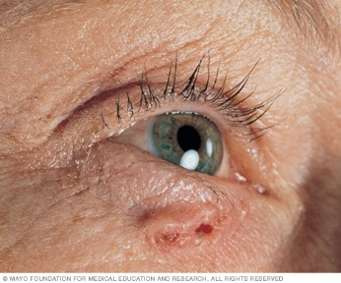**Basal cell carcinomaOpen pop-up dialog box**

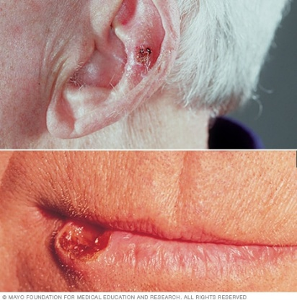**Squamous cell carcinoma of the skinOpen pop-up dialog box**

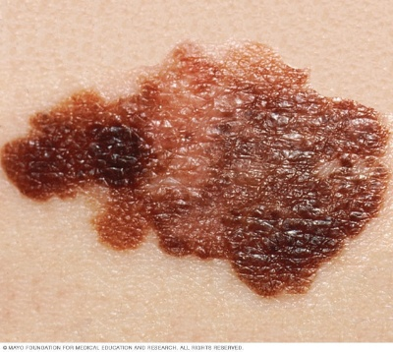**MelanomaOpen pop-up dialog box**

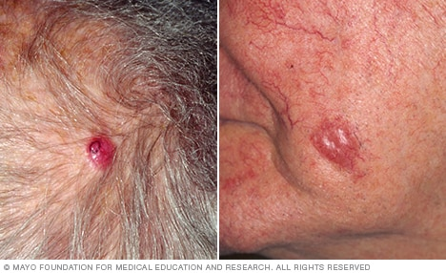**Merkel cell carcinomaOpen pop-up dialog box**

Skin cancer develops primarily on areas of sun-exposed skin, including the scalp, face, lips, ears, neck, chest, arms and hands, and on the legs in women. But it can also form on areas that rarely see the light of day — your palms, beneath your fingernails or toenails, and your genital area.

Skin cancer affects people of all skin tones, including those with darker complexions. When melanoma occurs in people with dark skin tones, it's more likely to occur in areas not normally exposed to the sun, such as the palms of the hands and soles of the feet.

### Basal cell carcinoma signs and symptoms

Basal cell carcinoma usually occurs in sun-exposed areas of your body, such as your neck or face.

Basal cell carcinoma may appear as:

* A pearly or waxy bump
* A flat, flesh-colored or brown scar-like lesion
* A bleeding or scabbing sore that heals and returns

### Squamous cell carcinoma signs and symptoms

Most often, squamous cell carcinoma occurs on sun-exposed areas of your body, such as your face, ears and hands. People with darker skin are more likely to develop squamous cell carcinoma on areas that aren't often exposed to the sun.

Squamous cell carcinoma may appear as:

* A firm, red nodule
* A flat lesion with a scaly, crusted surface

### Melanoma signs and symptoms

Melanoma can develop anywhere on your body, in otherwise normal skin or in an existing mole that becomes cancerous. Melanoma most often appears on the face or the trunk of affected men. In women, this type of cancer most often develops on the lower legs. In both men and women, melanoma can occur on skin that hasn't been exposed to the sun.

Melanoma can affect people of any skin tone. In people with darker skin tones, melanoma tends to occur on the palms or soles, or under the fingernails or toenails.

Melanoma signs include:

* A large brownish spot with darker speckles
* A mole that changes in color, size or feel or that bleeds
* A small lesion with an irregular border and portions that appear red, pink, white, blue or blue-black
* A painful lesion that itches or burns
* Dark lesions on your palms, soles, fingertips or toes, or on mucous membranes lining your mouth, nose, vagina or anus

### Signs and symptoms of less common skin cancers

Other, less common types of skin cancer include:

* **Kaposi sarcoma.** This rare form of skin cancer develops in the skin's blood vessels and causes red or purple patches on the skin or mucous membranes.

Kaposi sarcoma mainly occurs in people with weakened immune systems, such as people with AIDS, and in people taking medications that suppress their natural immunity, such as people who've undergone organ transplants.

Other people with an increased risk of Kaposi sarcoma include young men living in Africa or older men of Italian or Eastern European Jewish heritage.

* **Merkel cell carcinoma.** Merkel cell carcinoma causes firm, shiny nodules that occur on or just beneath the skin and in hair follicles. Merkel cell carcinoma is most often found on the head, neck and trunk.
* **Sebaceous gland carcinoma.** This uncommon and aggressive cancer originates in the oil glands in the skin. Sebaceous gland carcinomas — which usually appear as hard, painless nodules — can develop anywhere, but most occur on the eyelid, where they're frequently mistaken for other eyelid problems

### Other types of skin cancer

* [Cutaneous T-cell lymphoma](https://www.aad.org/public/diseases/skin-cancer/types/common/ctcl)
* [Dermatofibrosarcoma protuberans (DFSP)](https://www.aad.org/public/diseases/skin-cancer/types/common/dfsp)
* [Merkel cell carcinoma](https://www.aad.org/public/diseases/skin-cancer/types/common/merkel-cell)
* [Sebaceous carcinoma](https://www.aad.org/public/diseases/skin-cancer/types/common/sebaceous)

## **Risk factors**

Factors that may increase your risk of skin cancer include:

* **Fair skin.** Anyone, regardless of skin color, can get skin cancer. However, having less pigment (melanin) in your skin provides less protection from damaging UV radiation. If you have blond or red hair and light-colored eyes, and you freckle or sunburn easily, you're much more likely to develop skin cancer than is a person with darker skin.
* **A history of sunburns.** Having had one or more blistering sunburns as a child or teenager increases your risk of developing skin cancer as an adult. Sunburns in adulthood also are a risk factor.
* **Excessive sun exposure.** Anyone who spends considerable time in the sun may develop skin cancer, especially if the skin isn't protected by sunscreen or clothing. Tanning, including exposure to tanning lamps and beds, also puts you at risk. A tan is your skin's injury response to excessive UV radiation.
* **Sunny or high-altitude climates.** People who live in sunny, warm climates are exposed to more sunlight than are people who live in colder climates. Living at higher elevations, where the sunlight is strongest, also exposes you to more radiation.
* **Moles.** People who have many moles or abnormal moles called dysplastic nevi are at increased risk of skin cancer. These abnormal moles — which look irregular and are generally larger than normal moles — are more likely than others to become cancerous. If you have a history of abnormal moles, watch them regularly for changes.
* **Precancerous skin lesions.** Having skin lesions known as actinic keratoses can increase your risk of developing skin cancer. These precancerous skin growths typically appear as rough, scaly patches that range in color from brown to dark pink. They're most common on the face, head and hands of fair-skinned people whose skin has been sun damaged.
* **A family history of skin cancer.** If one of your parents or a sibling has had skin cancer, you may have an increased risk of the disease.
* **A personal history of skin cancer.** If you developed skin cancer once, you're at risk of developing it again.
* **A weakened immune system.** People with weakened immune systems have a greater risk of developing skin cancer. This includes people living with HIV/AIDS and those taking immunosuppressant drugs after an organ transplant.
* **Exposure to radiation.** People who received radiation treatment for skin conditions such as eczema and acne may have an increased risk of skin cancer, particularly basal cell carcinoma.
* **Exposure to certain substances.** Exposure to certain substances, such as arsenic, may increase your risk of skin cancer.

## **Prevention**

Most skin cancers are preventable. To protect yourself, follow these skin cancer prevention tips:

* **Avoid the sun during the middle of the day.** For many people in North America, the sun's rays are strongest between about 10 a.m. and 4 p.m. Schedule outdoor activities for other times of the day, even in winter or when the sky is cloudy.

You absorb UV radiation year-round, and clouds offer little protection from damaging rays. Avoiding the sun at its strongest helps you avoid the sunburns and suntans that cause skin damage and increase your risk of developing skin cancer. Sun exposure accumulated over time also may cause skin cancer.

* **Wear sunscreen year-round.** Sunscreens don't filter out all harmful UV radiation, especially the radiation that can lead to melanoma. But they play a major role in an overall sun protection program.

Use a broad-spectrum sunscreen with an SPF of at least 30, even on cloudy days. Apply sunscreen generously, and reapply every two hours — or more often if you're swimming or perspiring. Use a generous amount of sunscreen on all exposed skin, including your lips, the tips of your ears, and the backs of your hands and neck.

* **Wear protective clothing.** Sunscreens don't provide complete protection from UV rays. So cover your skin with dark, tightly woven clothing that covers your arms and legs, and a broad-brimmed hat, which provides more protection than a baseball cap or visor does.

Some companies also sell photoprotective clothing. A dermatologist can recommend an appropriate brand.

Don't forget sunglasses. Look for those that block both types of UV radiation — UVA and UVB rays.

* **Avoid tanning beds.** Lights used in tanning beds emit UV rays and can increase your risk of skin cancer.
* **Be aware of sun-sensitizing medications.** Some common prescription and over-the-counter drugs, including antibiotics, can make your skin more sensitive to sunlight.

Ask your doctor or pharmacist about the side effects of any medications you take. If they increase your sensitivity to sunlight, take extra precautions to stay out of the sun in order to protect your skin.

* **Check your skin regularly and report changes to your doctor.** Examine your skin often for new skin growths or changes in existing moles, freckles, bumps and birthmarks.

With the help of mirrors, check your face, neck, ears and scalp. Examine your chest and trunk, and the tops and undersides of your arms and hands. Examine both the front and back of your legs, and your feet, including the soles and the spaces between your toes. Also check your genital area and between your buttocks