**Task 1(b): Software Modelling and Specification-Activity Model (Patient)**

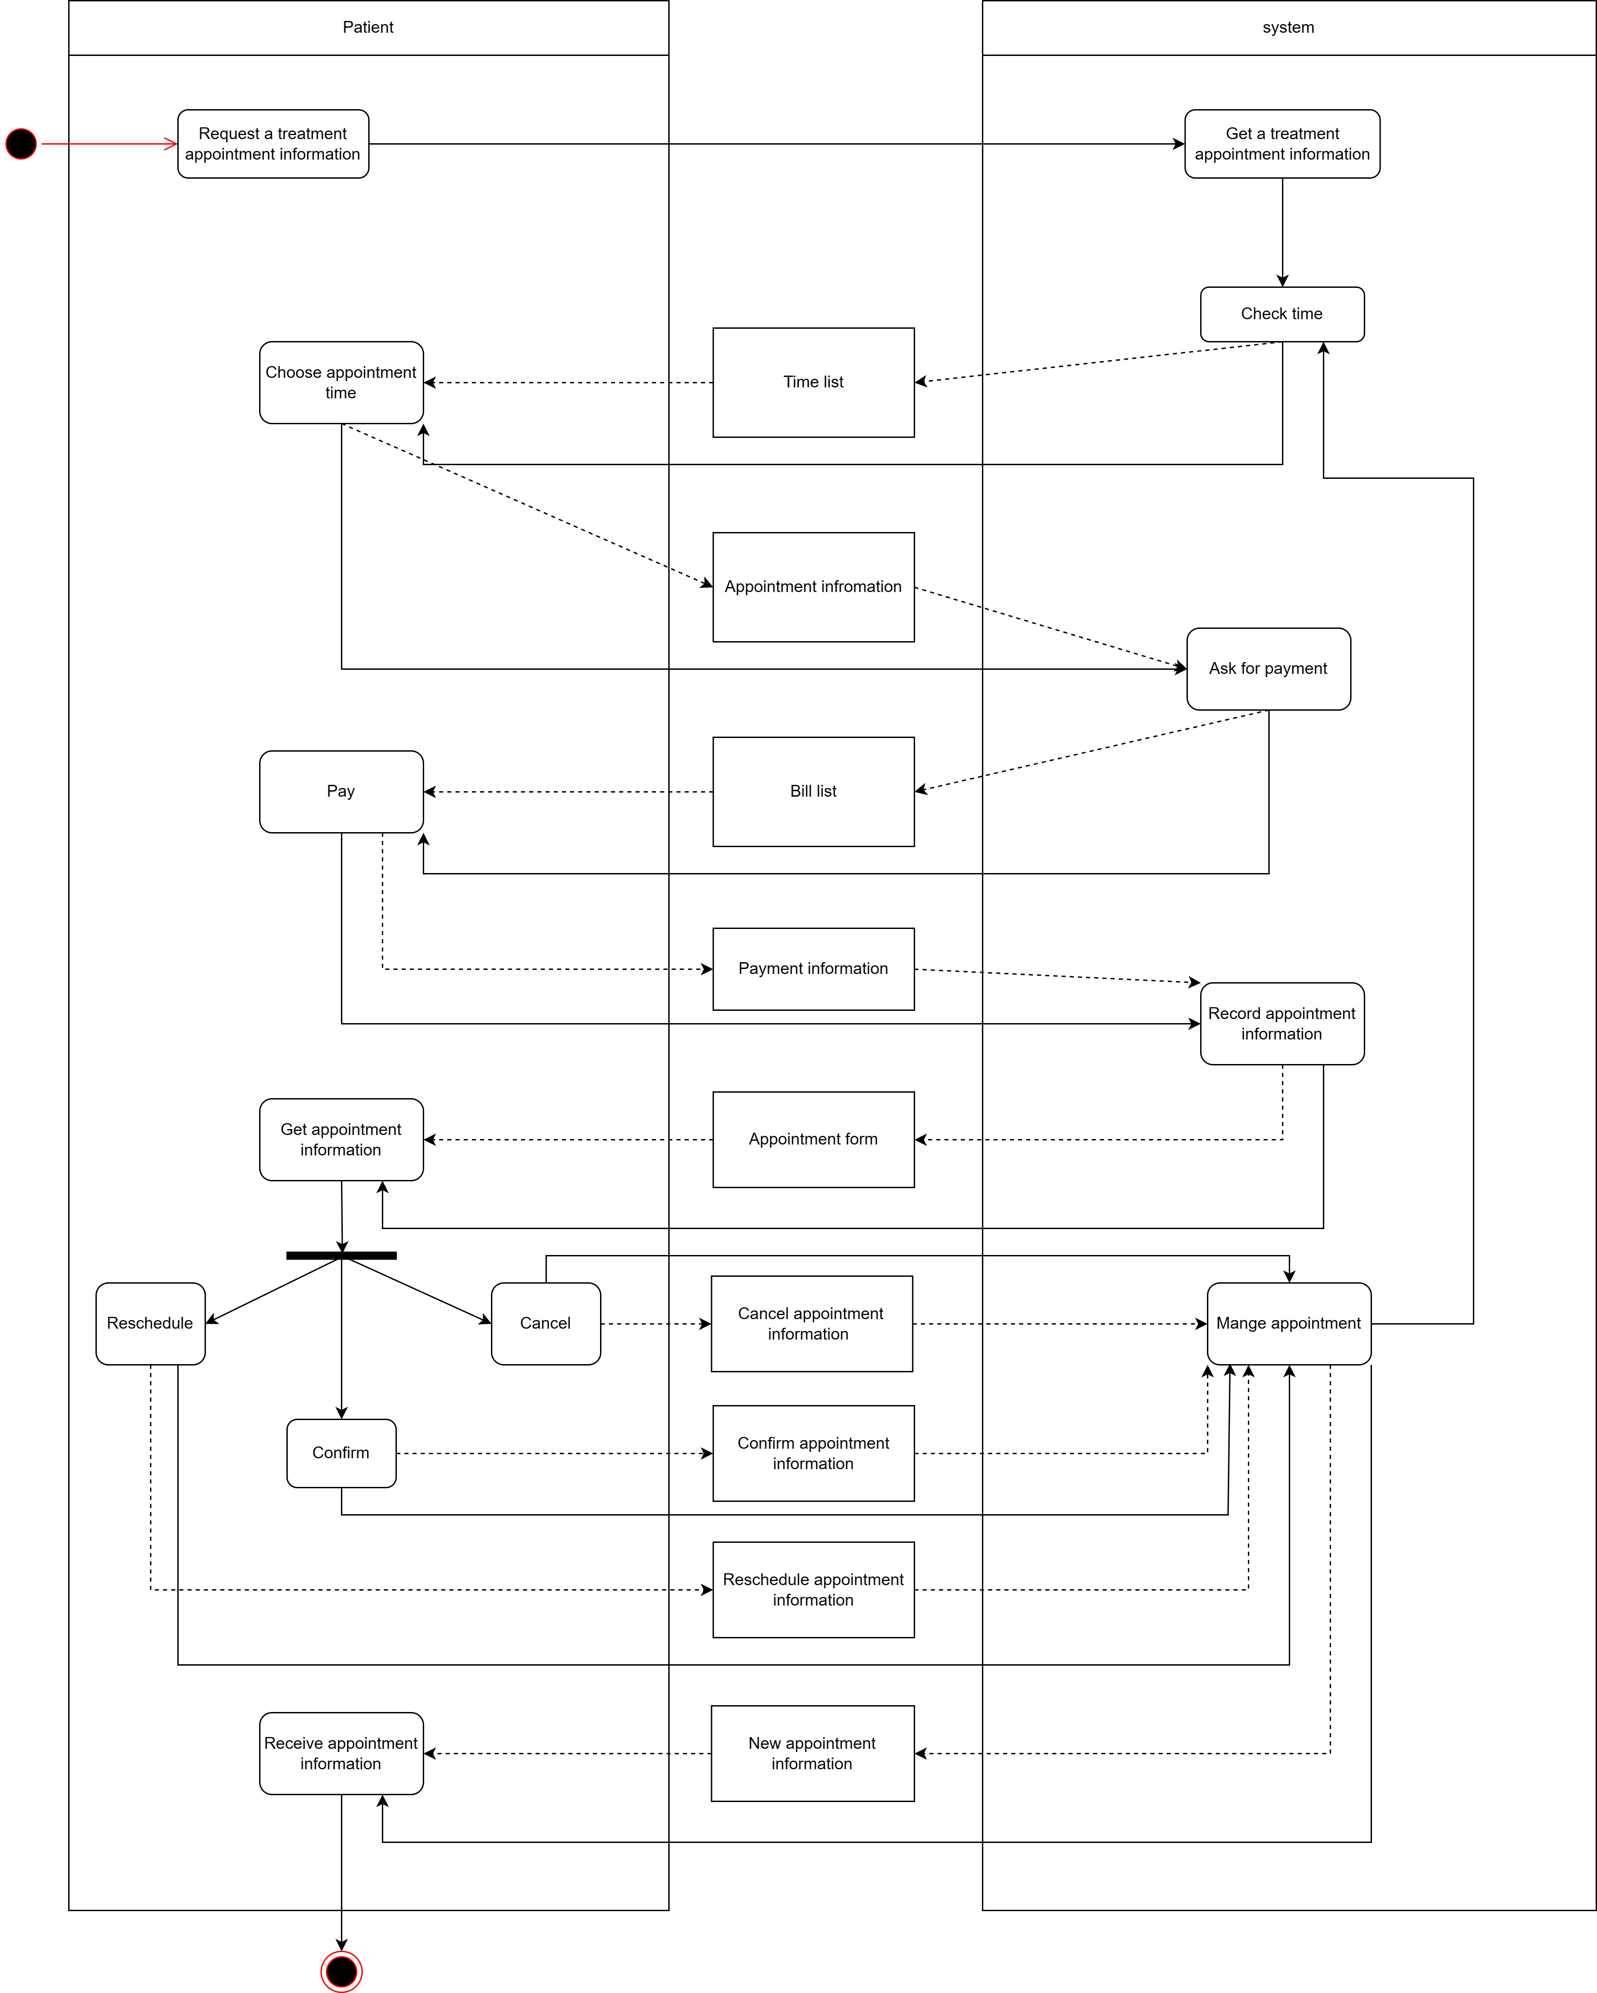

**Task 1(c): Software Modelling and Specification-Structural Model (Patient)**

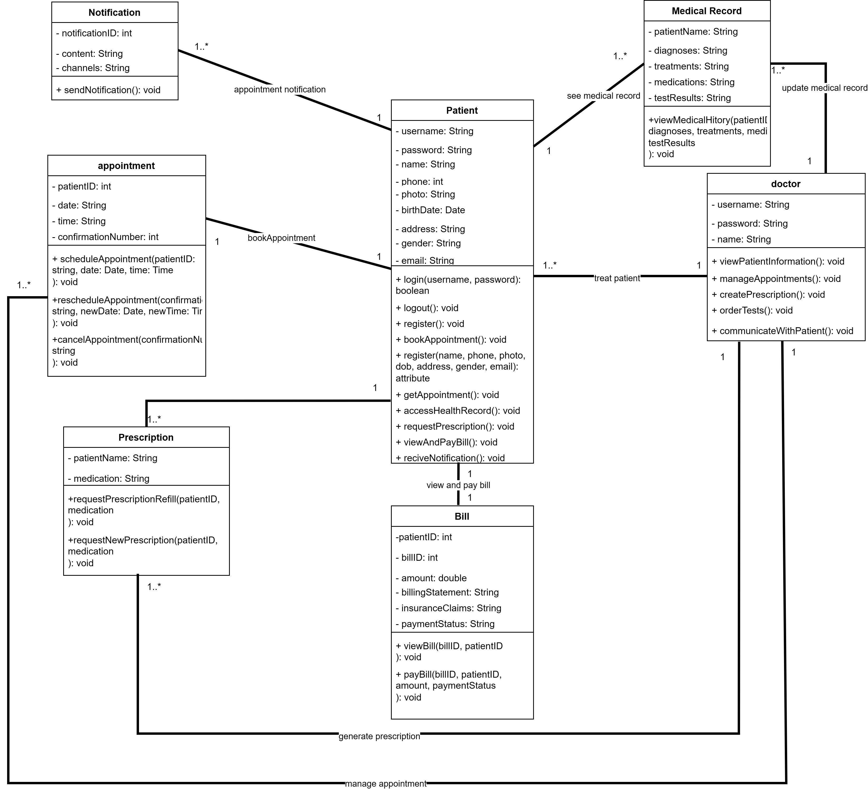

**Task 1(d): Software Modelling and Specification-Behaviour Model (Patient)**

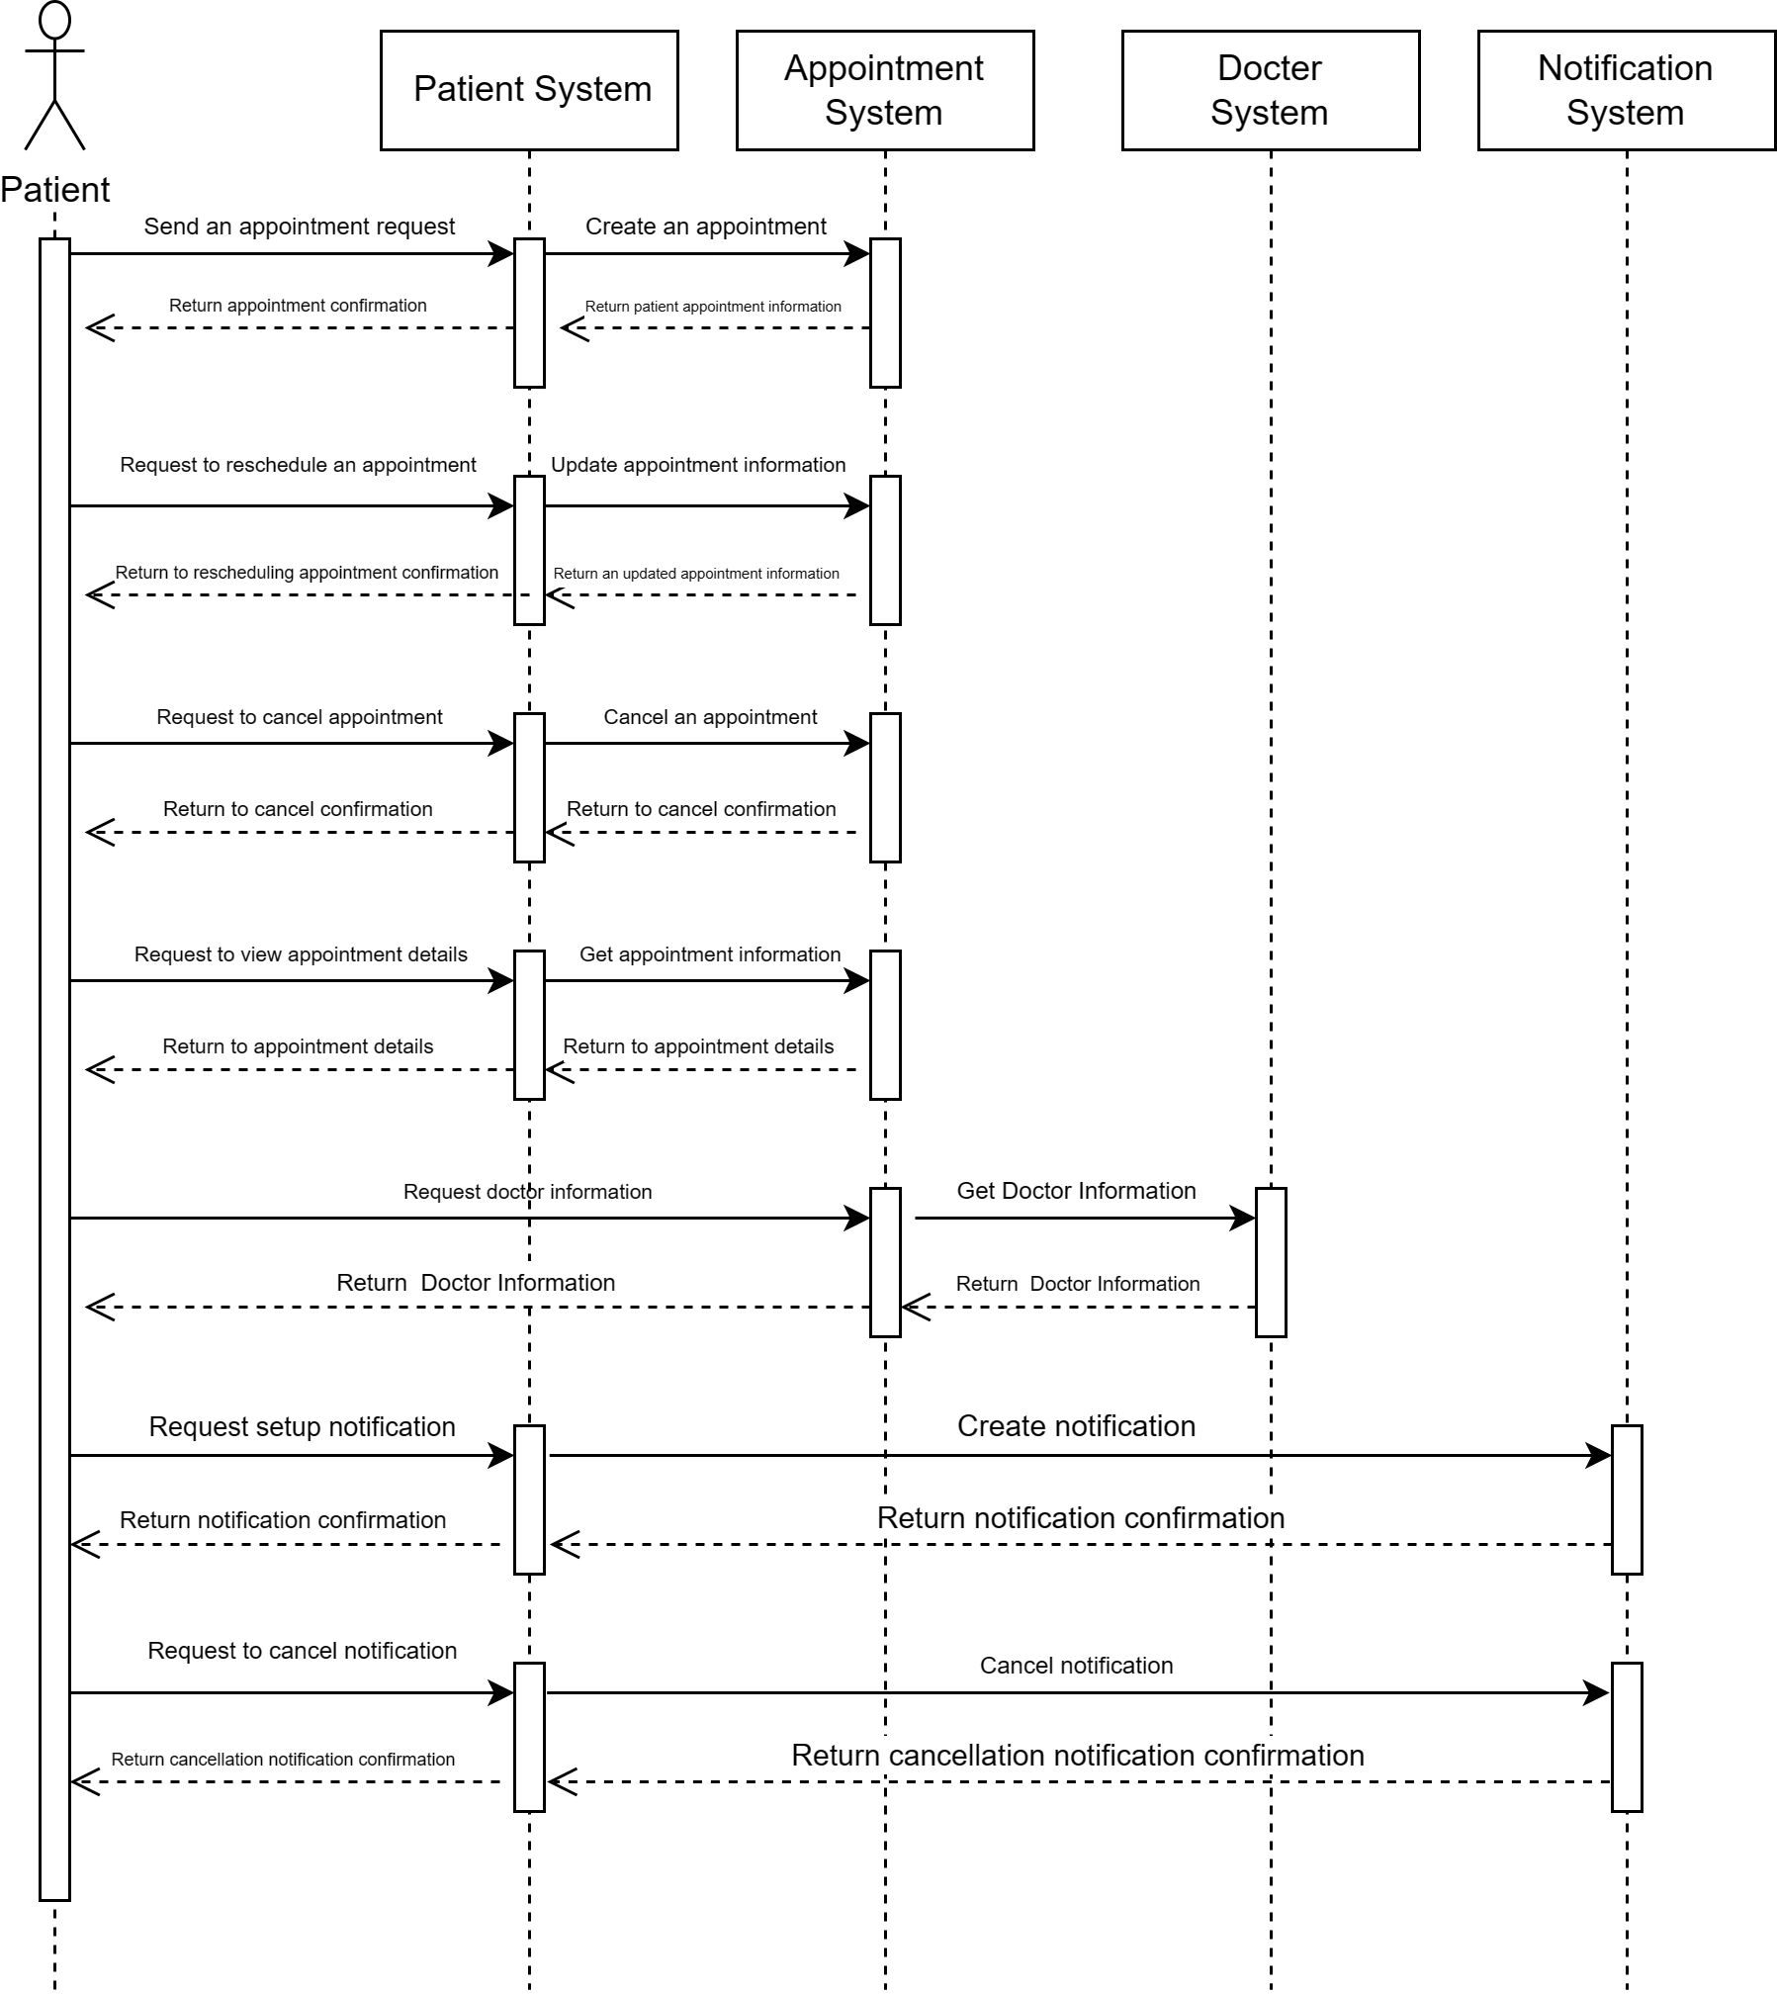

**Task 2（b）: Software Architectural Design**--**Subsystem architecture (Patient)**

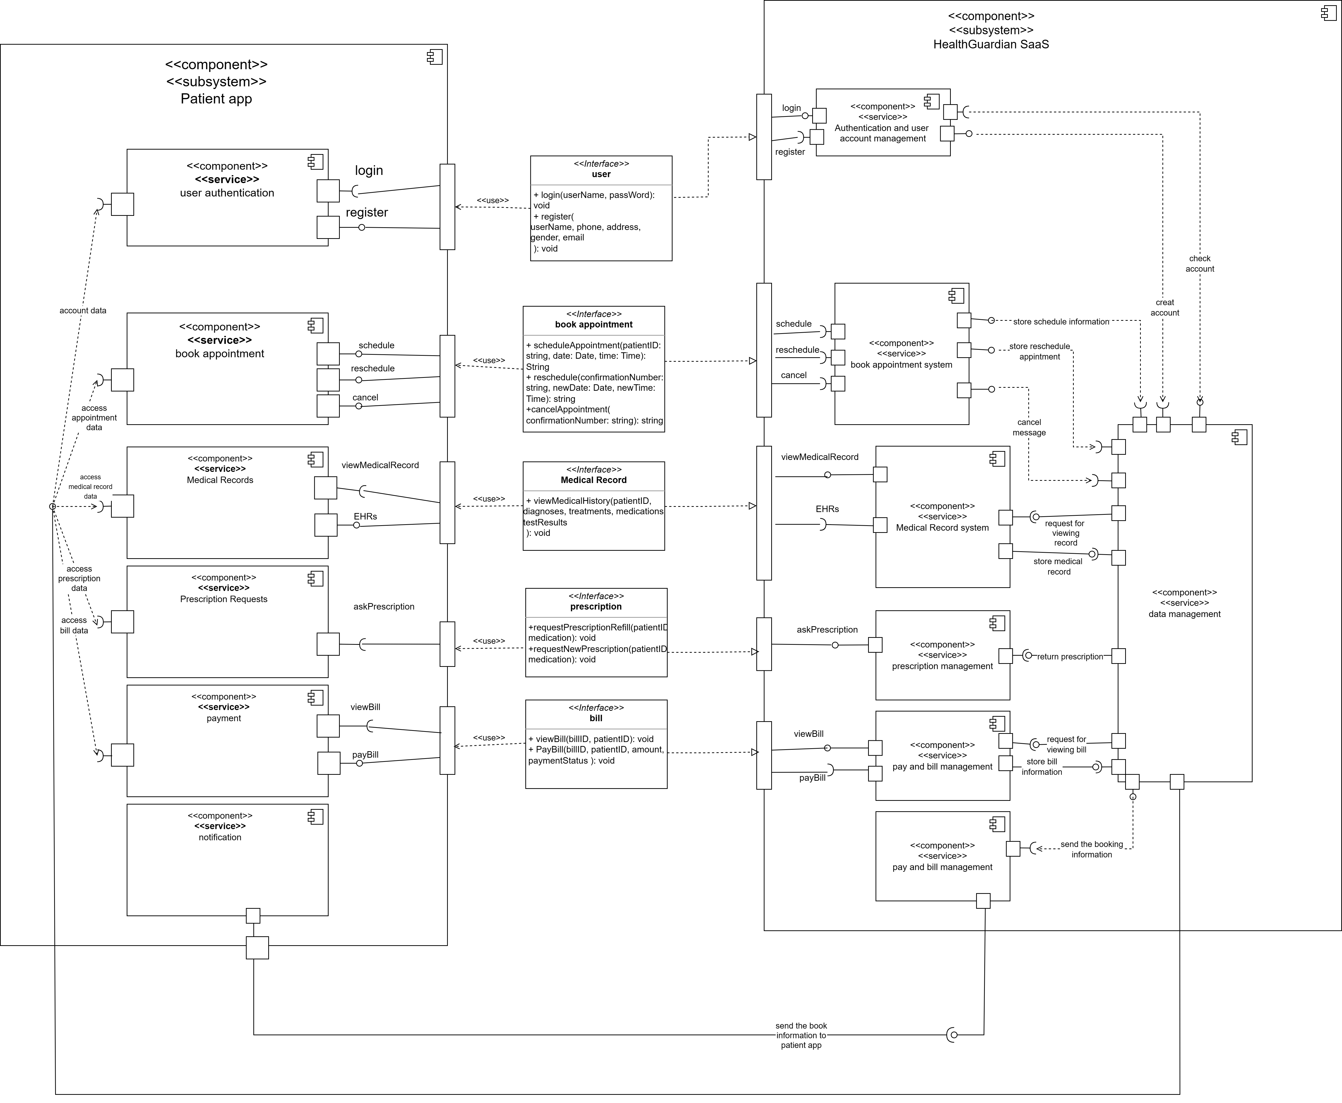

**Task 2（b）: Software Architectural Design**--**Subsystem architecture table (Patient)**

Component tables:

|  |  |
| --- | --- |
| Component | User authentication |
| Description | This component is for user to manage their account |
| Type | Microservice |
| Required interfaces | Account data, register |
| Provided interfaces | login |

|  |  |
| --- | --- |
| Component | Authentication and user account management |
| Description | This component is for requesting the user authentication include login and register |
| Type | Microservice |
| Required interfaces | Login, register, create account |
| Provided interfaces | check account |

|  |  |
| --- | --- |
| Component | Book appointment |
| Description | This component is for user to book appointment at app |
| Type | Microservice |
| Required interfaces | Access appointment data |
| Provided interfaces | schedule, reschedule, cancel |

|  |  |
| --- | --- |
| Component | Book appointment system |
| Description | This component is for managing booking appointment, and storing booking appointment information |
| Type | Microservice |
| Required interfaces | Schedule, reschedule, cancel |
| Provided interfaces | store schedule information, store reschedule information, cancel message |

|  |  |
| --- | --- |
| Component | Medical record |
| Description | This component is for user to view medical history |
| Type | Microservice |
| Required interfaces | Access medical record data, view medical record |
| Provided interfaces | EHRs |

|  |  |
| --- | --- |
| Component | Medical record system |
| Description | This component is for managing the medical history, and storing medical record information |
| Type | Microservice |
| Required interfaces | Request for viewing record, EHRs |
| Provided interfaces | View medical record, store medical record |

|  |  |
| --- | --- |
| Component | Data management |
| Description | This component is for saas to store all type of data, and in sometimes send the data to corresponding services |
| Type | Microservice |
| Required interfaces | Create account, check account, store schedule information, store reschedule appointment, cancel message, store medical record, store bill information |
| Provided interfaces | Request for viewing record, return prescription, request for viewing bill, send the booking information, account data, access appointment data, access medical record data, access prescription data, access bill data |

|  |  |
| --- | --- |
| Component | Prescription request |
| Description | This component is for patient to ask for prescription. |
| Type | Microservice |
| Required interfaces | Access prescription data, ask prescription |

|  |  |
| --- | --- |
| Component | Prescription management |
| Description | This component is for managing prescription of a patient |
| Type | Microservice |
| Required interfaces | Return prescription |
| Provided interfaces | Ask prescription |

|  |  |
| --- | --- |
| Component | Payment |
| Description | This component is for user to pay bill and view bill |
| Type | Microservice |
| Required interfaces | Access bill data, pay bill |
| Provided interfaces | view bill |

|  |  |
| --- | --- |
| Component | Pay and bill management |
| Description | This component is for managing prescription of a patient |
| Type | Microservice |
| Required interfaces | pay bill, Request for viewing bill |
| Provided interfaces | store bill information, View bill |

|  |  |
| --- | --- |
| Component | Notification |
| Description | This component is for user to see the notification from system |
| Type | Microservice |
| Required interfaces | Send the book information to patient app |

|  |  |
| --- | --- |
| Component | Notification management |
| Description | This component is for managing notification |
| Type | Microservice |
| Provided interfaces | Send the book information to patient app |
| Required interfaces | Send the booking information |

Interface tables:

|  |  |  |
| --- | --- | --- |
| Interface  Name | Book appointment | |
| Provider | HealthGuardian SaaS | |
|  | Operation: | scheduleAppointment |
| Request Parameters: patientID, date, time  Response parameters: BookAppointment  Function: Schedule the patientID, appointment date, appointment time from the BookAppointment. | |
|  | Operation: | rescheduleAppointment |
| Request Parameters: confirmationNumber, newDate, newTime  Response parameters: BookAppointment  Function: Reschedule the appointment confirmationNumber, appointment newdate, appointment newtime from the Book Appointment. | |
|  | Operation: | cancelAppointment |
| Request Parameters: confirmationNumber  Response parameters: BookAppointment  Function: Cancel the appointment onfirmationNumber from the BookAppointment | |

|  |  |  |
| --- | --- | --- |
| Interface  Name | Prescription | |
| Provider | HealthGuardian SaaS | |
|  | Operation: | requestPrescriptionRefill |
| Request Parameters: patientID, medication  Response parameters: Prescription Requests  Function: Request the patientID, medication from the Prescription Requests. | |
|  | Operation: | requestNewPrescription |
| Request Parameters: PatientID, medication  Response parameters: Prescription Requests  Function: Request the new patientID, medication from the Prescription Requests. | |

|  |  |  |
| --- | --- | --- |
| Interface  Name | Bill | |
| Provider | HealthGuardian SaaS | |
|  | Operation: | ViewBill |
| Request Parameters: billID, patientID  Response parameters: payment  Function: View the billID, patientID from the payment | |
|  | Operation: | PayBill |
| Request Parameters: PatientID, billID, amount, paymentStatus  Response parameters: payment  Function: Pay the bill from the payment | |

|  |  |  |
| --- | --- | --- |
| Interface name | User | |
| Provider | HealthGuardian SaaS | |
|  | Operation: | Login |
| Request parameters: username, password  Response parameters: user authentication  Function: use username and password to login to patient account | |
|  | Operation: | Register |
| Request parameters: name, phone, address, gender, email  Response parameters: user authentication  Function: patient can use name, phone, address, gender and email to create a new account | |

|  |  |  |
| --- | --- | --- |
| Interface name | Medical record | |
| Provider | HealthGuardian SaaS | |
|  | Operation: | ViewMedicalHistory |
| Request parameters: patientID, diagnoses, treatments, medications, testResults  Response parameters: Medical Record  Function: check the specific patientID patients’ diagnoses, treatments and medications. And print the testRuslts | |

**Task 3: Software Testing**

**(a)Unit Test Plan:**

Test case interface:

|  |
| --- |
| <<interface>> Appointment |
| +scheduleAppointment(patientID: string, date: Date, time: Time): string  +cancelAppointment(confirmationNumber: string): string  +rescheduleAppointment(confirmationNumber: string, newDate: Date, newTime: Time): string |

Test case:

|  |  |  |
| --- | --- | --- |
| Test Case | Method and Parameters | Expected output |
| Appointment scheduled  successfully | scheduleAppointment(PatientID, Date, Time) | Confirmation number  scheduled successfully |
| Scheduled failed with invalid patient ID | scheduleAppointment(InvalidID, Date, Time) | Error message |
| Scheduled failed with unavailable time slot | scheduleAppointment(PatientID, Date, Time) | Time is not available |
| Cancel appointment | cancleAppointment(ConfirmationNumber) | Cancel successfully |
| Cancel with wrong number | cancleAppointment(WrongNumber) | Error message |
| Reschedule appointment | rescheduleAppointment(ConfirmationNumber, NewDate, NewTime) | New confirmation number  rescheduled successfully |

**(b)System Test Plan:**

Use case: Book an appointment

Scenario: Appointment scheduled successfully

|  |  |
| --- | --- |
| Patient | System |
| 1. Request the data of appointment scheduling  information | 2. Find the data of appointment scheduling  information |
| 4. Get the data of appointment scheduling  information and time slot | 3. Return the data of appointment scheduling  information and time slot |
| 5. Select an available time | 6. Check and return the available time slot and the data of appointment scheduling information |
| 7. Get the available time slot and the data of appointment scheduling information |  |
| 8. Request the confirmation number of appointment scheduling | 9. Generate the confirmation number of appointment scheduling |
| 11. Get the confirmation number of appointment scheduling | 10. Return the confirmation number of appointment scheduling |

Test Data:

Input: patientID, date, time

Stored data: patientID, date, time

Output: patientID, date, time

Test Process:

|  |  |
| --- | --- |
| Patient | System |
| 1. Request the data of appointment scheduling  information about patientID: Su Kehan | 2. Find the data of appointment scheduling  information about patientID: Su Kehan |
| 4. Get the data of appointment scheduling  information and time slot about patientID: Su Kehan, date:2023/12/18, time: 19:00, …. | 3. Return the data of appointment scheduling  information and time slot about patientID: Su Kehan, date:2023/12/18, time:19:00, …. |
| 5. Select an available time about patientID: Su Kehan, date:2023/12/18, time: 19:00 | 6. Check and return the available time slot and the data of appointment scheduling information about patientID: Su Kehan, date:2023/12/18, time: 19:00 |
| 7. Get the available time slot and the data of appointment scheduling information about patientID: Su Kehan, date:2023/12/18, time: 19:00 |  |
| 8. Request the confirmation number of appointment scheduling about patientID: Su Kehan, date:2023/12/18, time: 19:00 | 9. Generate the confirmation number of appointment scheduling about patientID: Su Kehan, date:2023/12/18, time: 19:00 |
| 11. Get the confirmation number of appointment scheduling about patientID: Su Kehan, date:2023/12/18, time: 19:00 | 10. Return the confirmation number of appointment scheduling about patientID: Su Kehan, date:2023/12/18, time: 19:00 |

Additional test cases:

Cancel appointment

|  |  |
| --- | --- |
| Patient | System |
| 1. Request the data of appointment scheduling information about patientID: Su Kehan, date:2023/12/18, time: 19:00, confirmation number: 20 | 2. Find the data of appointment scheduling information about patientID: Su Kehan, date:2023/12/18, time: 19:00, confirmation number: 20 |
| 4. Get the data of appointment scheduling information about patientID: Su Kehan, date:2023/12/18, time: 19:00, confirmation number: 20 | 3. Return the data of appointment scheduling information about patientID: Su Kehan, date:2023/12/18, time: 19:00, confirmation number: 20 |
| 5. Cancel the data of appointment scheduling information about patientID: Su Kehan, date:2023/12/18, time: 19:00, confirmation number: 20 | 6. Manage the data of appointment scheduling information about patientID: Su Kehan, date:2023/12/18, time: 19:00, confirmation number: 20 |
|  | 7. Return the notification of appointment scheduling information about patientID: Su Kehan, date:2023/12/18, time: 19:00, confirmation number: 20 |
| 8. Get a cancellation notification about patientID: Su Kehan, date:2023/12/18, time: 19:00, confirmation number: 20 |  |

Reschedule appointment

|  |  |
| --- | --- |
| Patient | System |
| 1. Request the time slot about patientID: Su Kehan | 2. Find the time slot about patientID: Su Kehan |
| 4. Get the time slot about patientID: Su Kehan, date:2023/12/20, time: 20:00, …. | 3. Return the time slot about patientID: Su Kehan, date:2023/12/20, time: 20:00, …. |
| 5. Select an available time about patientID: Su Kehan, date:2023/12/20, time: 20:00 | 6. Check and return the available time slot and the data of appointment scheduling information about patientID: Su Kehan, date:2023/12/20, time: 20:00 |
| 7. Get the available time slot and the data of appointment scheduling information about patientID: Su Kehan, date:2023/12/20, time: 20:00 |  |
| 8. Request the new confirmation number of appointment scheduling about patientID: Su Kehan, date:2023/12/20, time: 20:00 | 9. Generate the new confirmation number of appointment scheduling about patientID: Su Kehan, date:2023/12/20, time: 20:00 |
| 11. Get the new confirmation number of appointment scheduling about patientID: Su Kehan, date:2023/12/20, time: 20:00 | 10. Return the new confirmation number of appointment scheduling about patientID: Su Kehan, date:2023/12/20, time: 20:00 |