🎾
Tennis Intelligence 360
Game Analytics: Unlocking Tennis Data with the SportRadar API
Project report — API → SQL warehouse → analytics → Streamlit

Author | P Suman Sangeet
Profile | Data Science & AI · PGDM (Big Data Analytics)
Ranking snapshot | 2026 · wk 44
Database engine | sqlite
Generated | 06 Nov 2026, 09:05
Data volume | 1,922 rows in 6 tables

Links: Portfolio
⚠ SAMPLE OUTPUT — generated from a small demo database to illustrate layout. Regenerate with your own database (python report_docx.py) before submitting.

Contents
Click any entry to jump to the section (Ctrl+Click in some Word versions).
1. Executive summary
2. Objectives and scope
3. Data and pipeline
4. Data profiling
5. Findings
6. SQL query catalogue
7. Challenges and solutions
8. Recommendations and future work
9. Appendix: SQL source

How to read this report: sections 1–2 give the business view, 3–4 the engineering view, 5–6 the analytical results, 7–8 lessons and next steps. Every figure is generated directly from the SQL warehouse, so the report can be regenerated at any time with one command or from the app's Project Report page.

1. Executive summary
ROWS IN WAREHOUSE  1,922 | COMPETITIONS  620 | VENUES  320 | RANKED COMPETITORS  450 | DATA HEALTH  100%

Key findings
- The top 10 players hold 20.6% of all ranking points; the points Gini coefficient is 0.48.
- Germany has the deepest player pool with 121 ranked players; 19 nations are represented.
- Most efficient player (≥5 events): Demo Player 017 (Spain) with 283 points per event.
- Biggest weekly climber: Demo Player 017 (+12 places).
- Doubles events are 26.3% and women's events 56.0% of 620 competitions across 12 categories.
- 320 venues in 17 countries cover 17 timezones.

Business use cases and where they are answered
Use case | What the analysis delivers | Where to look
Event exploration | Navigate competition hierarchies; filter by type, gender and category | Section 5.1 · app: Competitions
Trend analysis | Distribution of events by type, gender and level | Section 5.1 · app: Dashboard
Performance insights | Player participation, efficiency, tiers, inequality | Section 5.3 · app: Advanced Analytics
Decision support | Data-driven allocation of resources | Section 8

2. Objectives and scope
Problem statement. Build a solution that extracts sports-competition data from the Sportradar Tennis API, stores it in a normalised relational database, and lets users explore competition structures, venues and doubles rankings through an interactive application — supporting sports enthusiasts, analysts and organisations.

Objectives
- Automate API extraction and JSON → relational transformation.
- Design a normalised schema with keys, constraints and indexes.
- Answer 20 business questions with SQL (7 competitions, 7 venues, 6 rankings).
- Deliver an interactive Streamlit dashboard and complete documentation.

Deliverables
Deliverable | Evidence | Status
SQL database | schema.sql · 6 tables, PK/FK, indexes | Delivered
API scripts | etl.py · retries, pacing, idempotent loads | Delivered
Streamlit app | app.py · 12 interactive pages | Delivered
Documentation | README.md · sql_queries.sql · this report | Delivered

Evaluation criteria and how they are met
Criterion | How it is met | Where to verify
Data extraction accuracy | etl.py: typed flatteners, defaults for missing fields, de-duplication on keys | Data Quality tab · completeness
SQL database design | 6 normalised tables, PK/FK, self-reference for hierarchy | Data & pipeline tab · ERD + live data dictionary
Query efficiency | Indexes on every FK, country, period; timed execution of all 20 queries | SQL catalogue tab · Run all
Streamlit functionality | 12 interactive pages, filters, CSV export, live SQL | Sidebar navigation
Project completeness | API → SQL → analysis → app → docs | Objectives tab · deliverables
Documentation quality | This report + README.md + sql_queries.sql | Export tab
Presentation & usability | Recruiter showcase, KPI cards, consistent palette | Recruiter Showcase page
Error handling | Retries/back-off, transactions, SELECT-only guard, empty-state handling | Challenges tab
Innovation & creativity | Gini/Lorenz inequality, player tiers, efficiency quadrant, live data-health score | Advanced Analytics page

3. Data and pipeline

3.1 Pipeline architecture
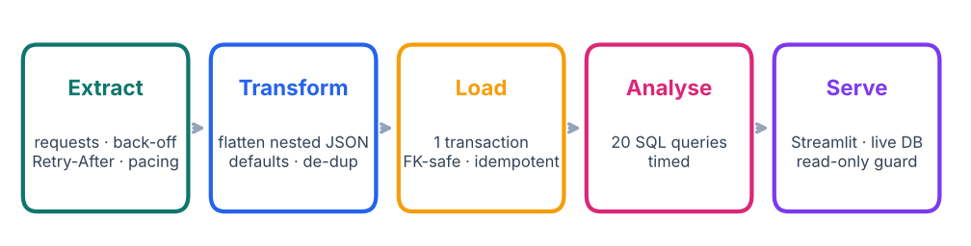
Figure 1. End-to-end data pipeline.

3.2 Source endpoints
Dataset | Endpoint | Tables loaded
Competitions | competitions.json | categories, competitions
Complexes | complexes.json | complexes, venues
Doubles competitor rankings | double_competitor_rankings.json | competitors, competitor_rankings

3.3 Entity-relationship diagram
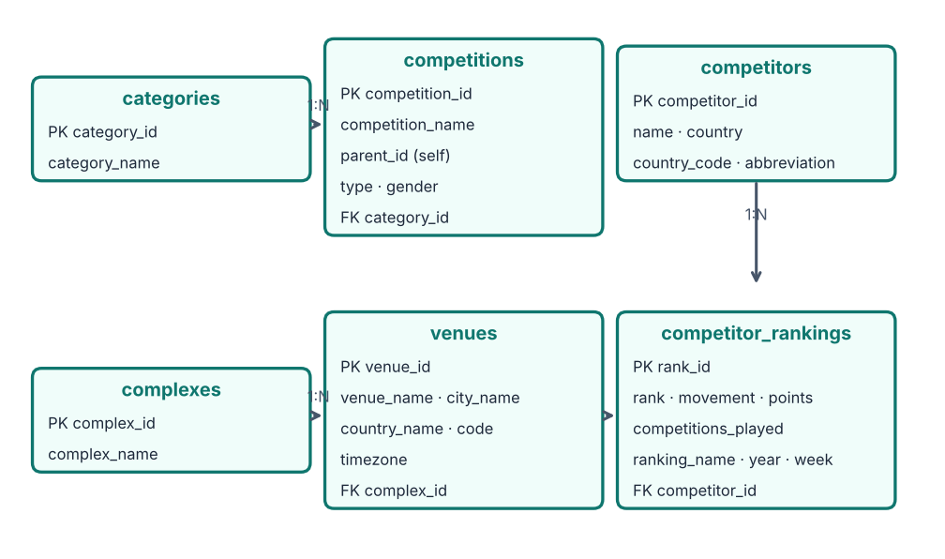
Figure 2. Normalised schema (3NF). competitions.parent_id references competitions itself to model the hierarchy.

3.4 Data dictionary (read from the database)
Table | Column | Type | Null | Key
categories | category_id | TEXT | YES | PK
categories | category_name | TEXT | NO
competitions | competition_id | TEXT | YES | PK
competitions | competition_name | TEXT | NO
competitions | parent_id | TEXT | YES | FK → competitions.competition_id
competitions | type | TEXT | NO
competitions | gender | TEXT | NO
competitions | category_id | TEXT | YES | FK → categories.category_id
complexes | complex_id | TEXT | YES | PK
complexes | complex_name | TEXT | NO
venues | venue_id | TEXT | YES | PK
venues | venue_name | TEXT | NO
venues | city_name | TEXT | YES
venues | country_name | TEXT | YES
venues | country_code | TEXT | YES
venues | timezone | TEXT | YES
venues | complex_id | TEXT | YES | FK → complexes.complex_id
competitors | competitor_id | TEXT | YES | PK
competitors | name | TEXT | NO
competitors | country | TEXT | YES
competitors | country_code | TEXT | YES
competitors | abbreviation | TEXT | YES
competitor_rankings | rank_id | INTEGER | YES | PK
competitor_rankings | rank | INTEGER | NO
competitor_rankings | movement | INTEGER | YES
competitor_rankings | points | INTEGER | YES
competitor_rankings | competitions_played | INTEGER | YES
competitor_rankings | competitor_id | TEXT | NO | FK → competitors.competitor_id
competitor_rankings | ranking_name | TEXT | YES
competitor_rankings | gender | TEXT | YES
competitor_rankings | year | INTEGER | YES
competitor_rankings | week | INTEGER | YES

4. Data profiling

4.1 Volume
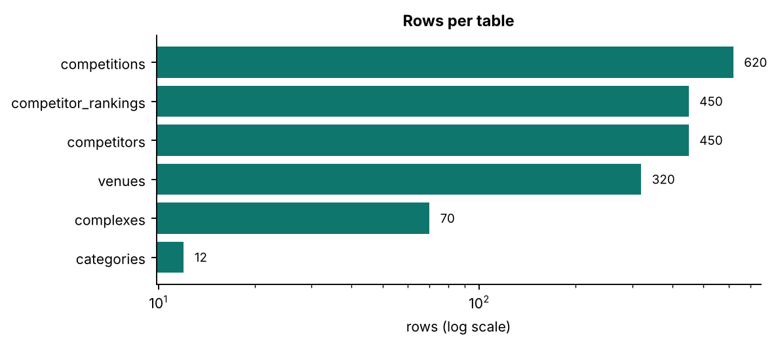
Figure 3. Row counts per table.

4.2 Completeness (% non-null)
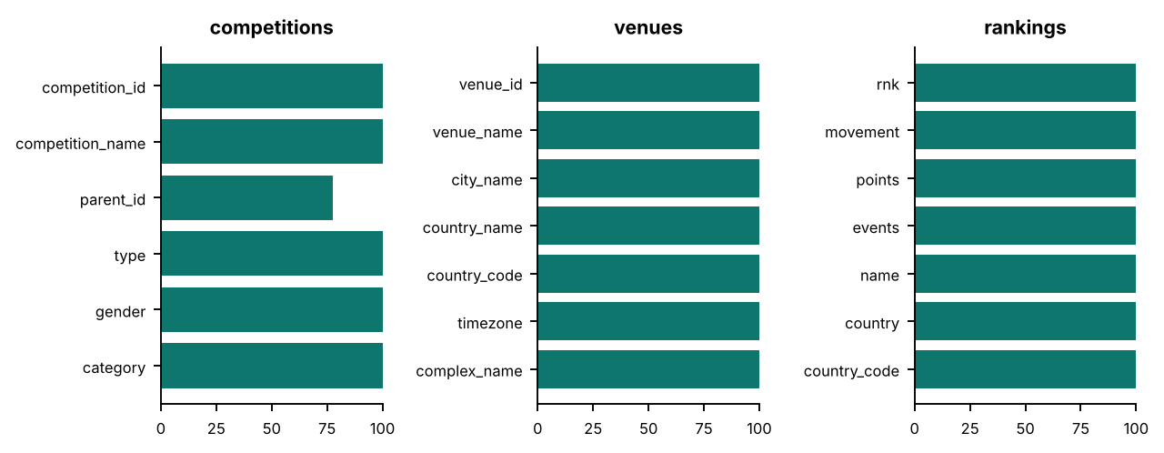
Figure 4. Share of non-null values per column.

4.3 Integrity checks — health score 100%
Check | Violations | Status
Competitions with unknown category | 0 | Pass
Competitions with missing parent record | 0 | Pass
Venues with unknown complex | 0 | Pass
Rankings without competitor | 0 | Pass
Duplicate competitor IDs | 0 | Pass
Duplicate venue IDs | 0 | Pass
Negative points | 0 | Pass
Venues missing timezone | 0 | Pass

5. Findings

5.1 Competitions
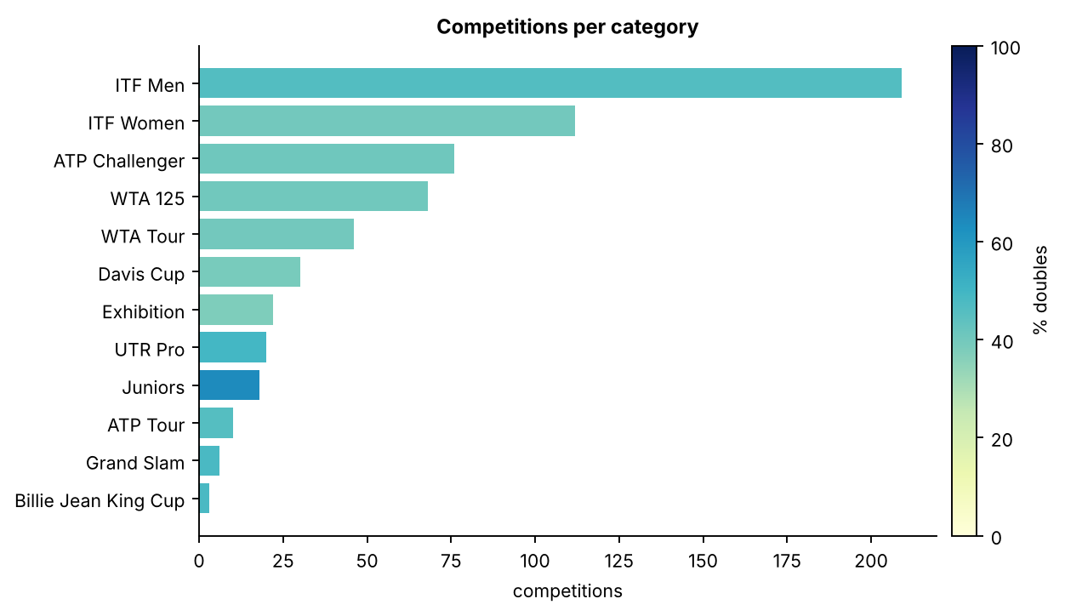
Figure 5. Largest categories; colour shows the share of doubles events.
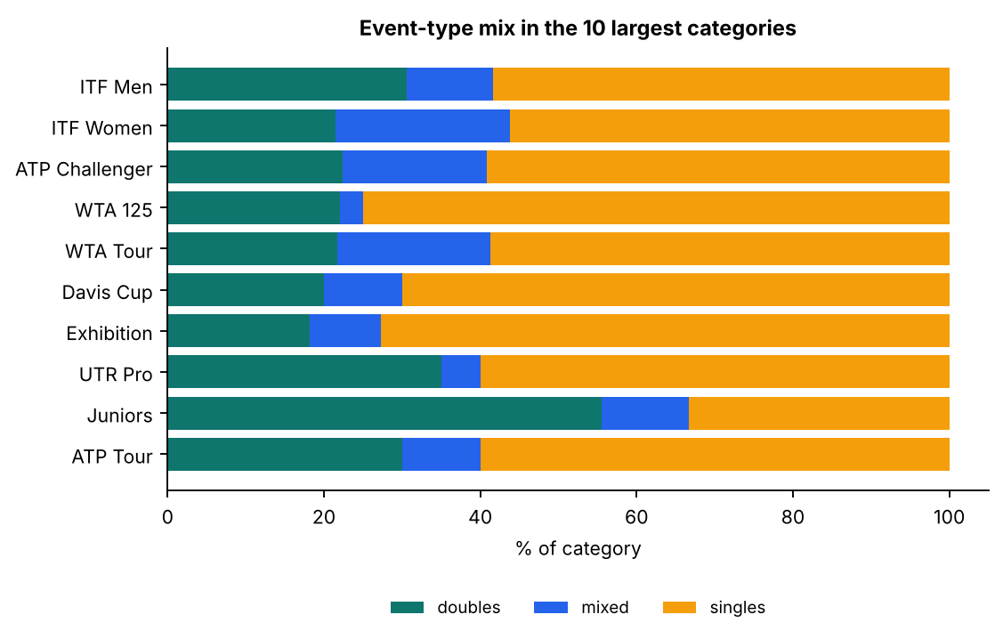
Figure 6. Type mix (singles / doubles / mixed) for the top categories.
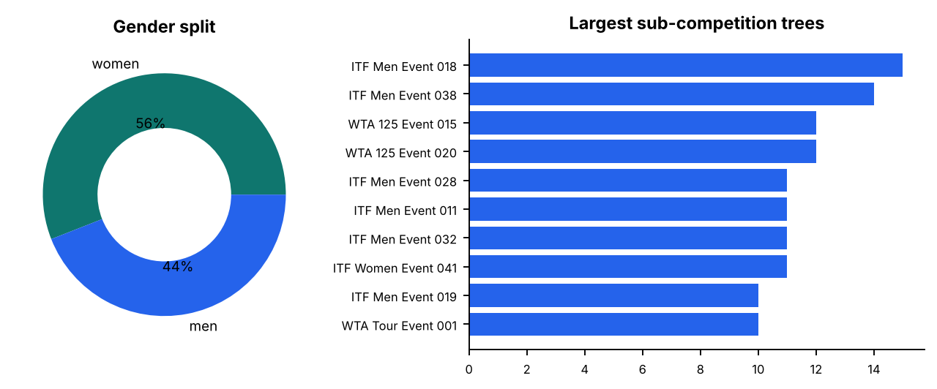
Figure 7. Gender split and the parent competitions with most sub-competitions.
Reading the data. 620 competitions fall into 12 categories; ITF Men is the largest (209). 22.6% are top-level and the largest parent has 15 sub-competitions. Doubles make up 26.3% and women's events 56.0% of the catalogue.

5.2 Venues and complexes
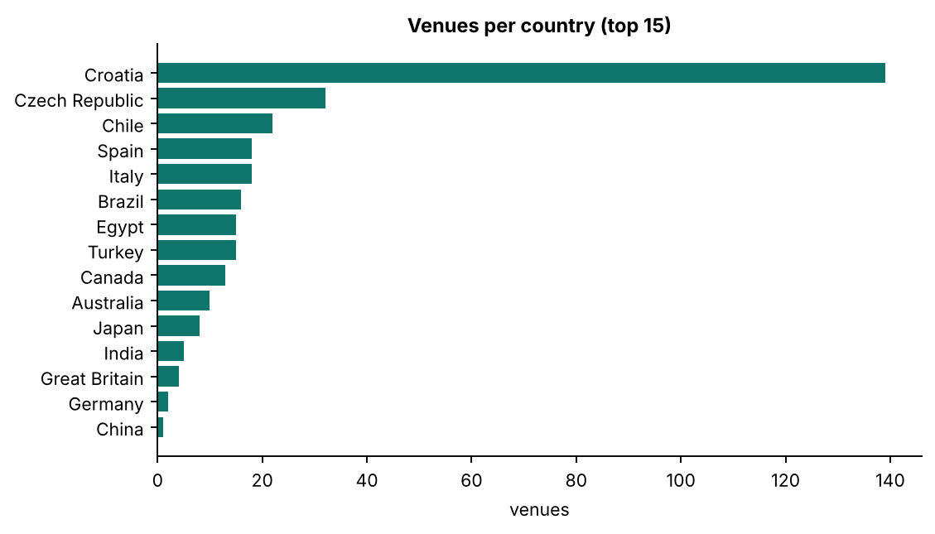
Figure 8. Countries with the most venues.
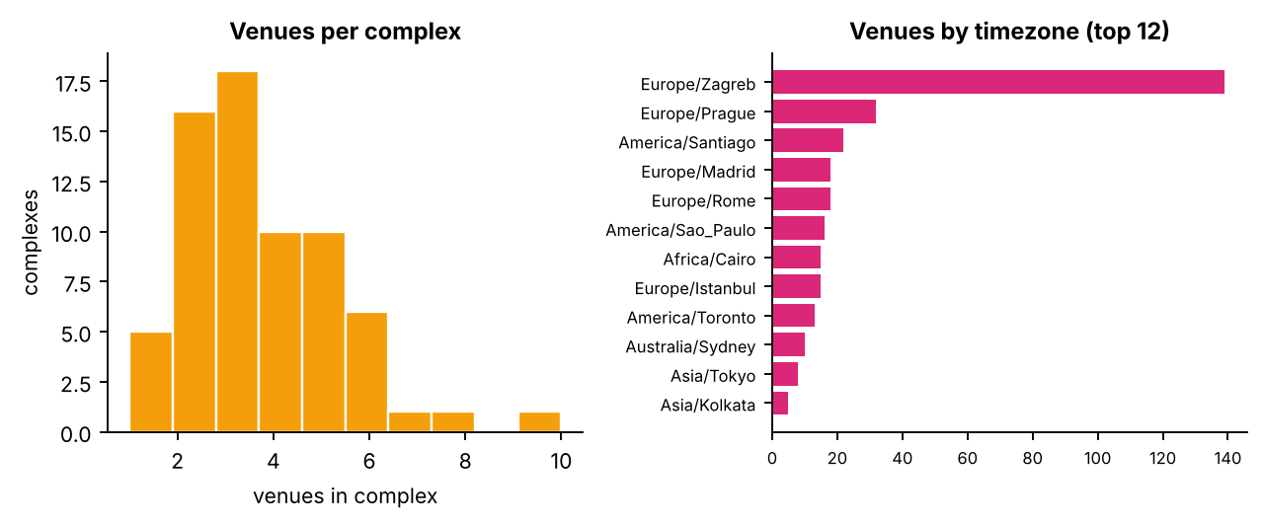
Figure 9. Complex size distribution and timezone coverage.
Reading the data. 320 venues across 17 countries and 17 timezones; Croatia has the most venues. 63 of 68 complexes host more than one venue (largest: 10).

5.3 Doubles rankings (snapshot 2026 · wk 44)
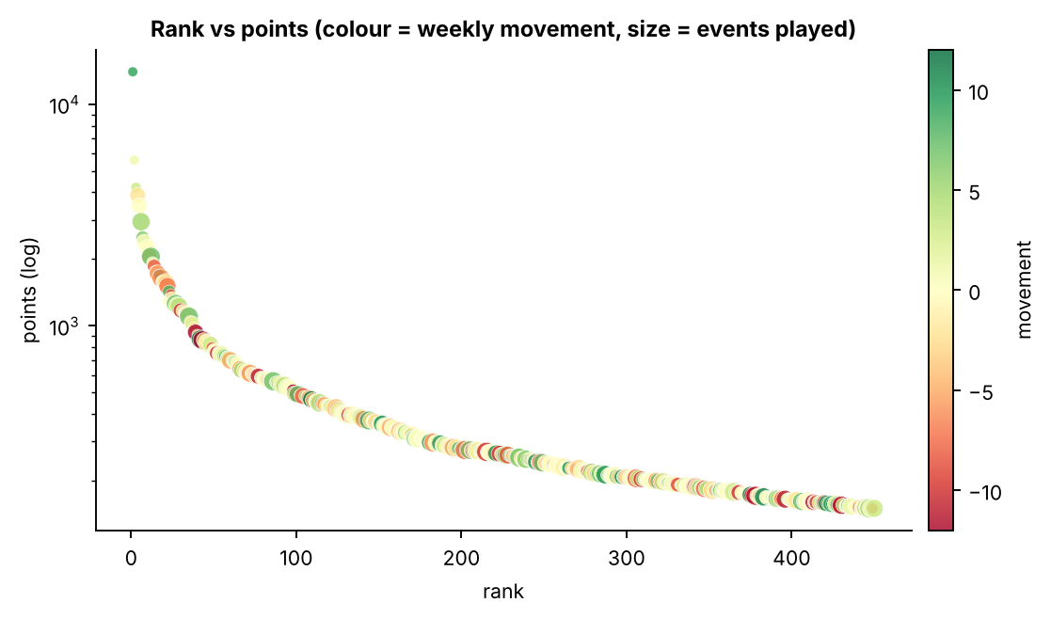
Figure 10. Points fall steeply with rank — a hallmark of a top-heavy ranking system.
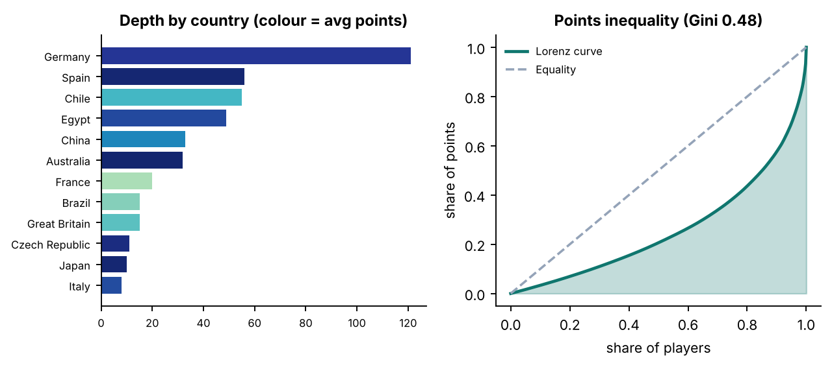
Figure 11. Country depth and inequality of ranking points.
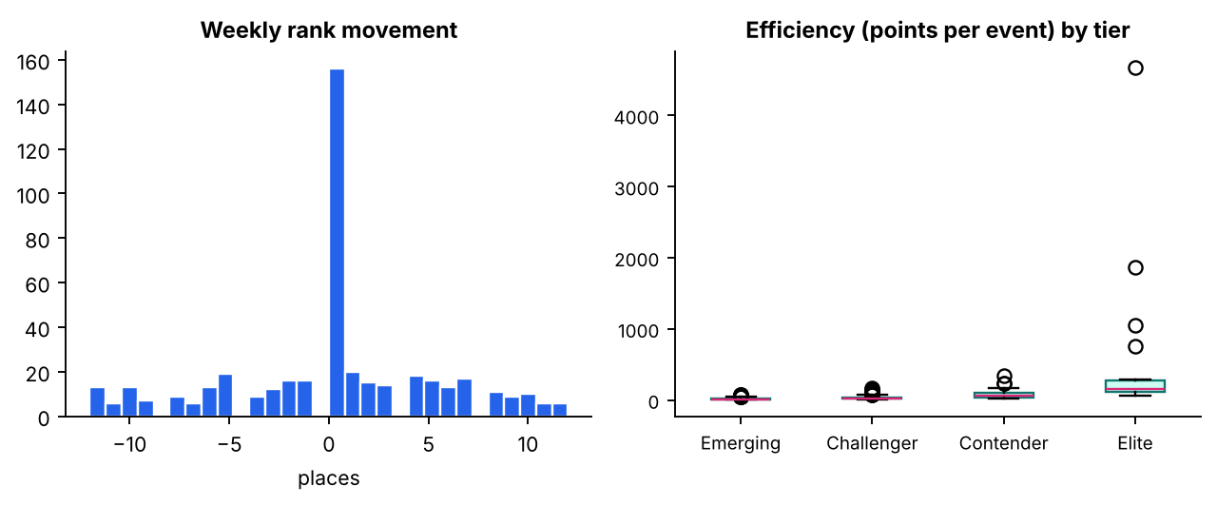
Figure 12. Movement distribution and efficiency by player tier.
Segmentation. Tiers are percentile-based: Emerging = bottom 50% by points · Challenger = 50–80% · Contender = 80–95% · Elite = top 5%.
Tier | Players | AvgPoints | AvgEvents | AvgMove | PtsPerEvent
Emerging | 225 | 193.8 | 15.4 | 0.2 | 18.2
Challenger | 135 | 360.4 | 16.6 | -0.0 | 31.8
Contender | 67 | 795.0 | 14.6 | -0.5 | 76.0
Elite | 23 | 2864.1 | 14.2 | 0.4 | 487.8

Top 10 competitors
Rank | Competitor | Country | Points | Move | Events
1 | Demo Player 001 | Germany | 14000 | 9 | 3
2 | Demo Player 002 | Australia | 5592 | 1 | 3
3 | Demo Player 003 | Spain | 4203 | 3 | 4
4 | Demo Player 004 | Argentina | 3879 | -2 | 18
5 | Demo Player 005 | Germany | 3478 | 0 | 19
6 | Demo Player 006 | Germany | 2949 | 5 | 26
7 | Demo Player 007 | Australia | 2500 | 6 | 11
8 | Demo Player 008 | Spain | 2380 | 0 | 20
9 | Demo Player 009 | Canada | 2259 | 0 | 3
10 | Demo Player 010 | China | 2250 | 0 | 20

Reading the data. The top 10 players hold 20.6% of all ranking points; the points Gini coefficient is 0.48. Germany has the deepest player pool with 121 ranked players; 19 nations are represented. Most efficient player (≥5 events): Demo Player 017 (Spain) with 283 points per event.

6. SQL query catalogue
All 20 queries from the brief were executed against the live database; row counts and execution times are measured at report-generation time (uncached).
Benchmark. 20/20 queries succeeded; total execution time 15.2 ms; slowest: A1 (1.5 ms).
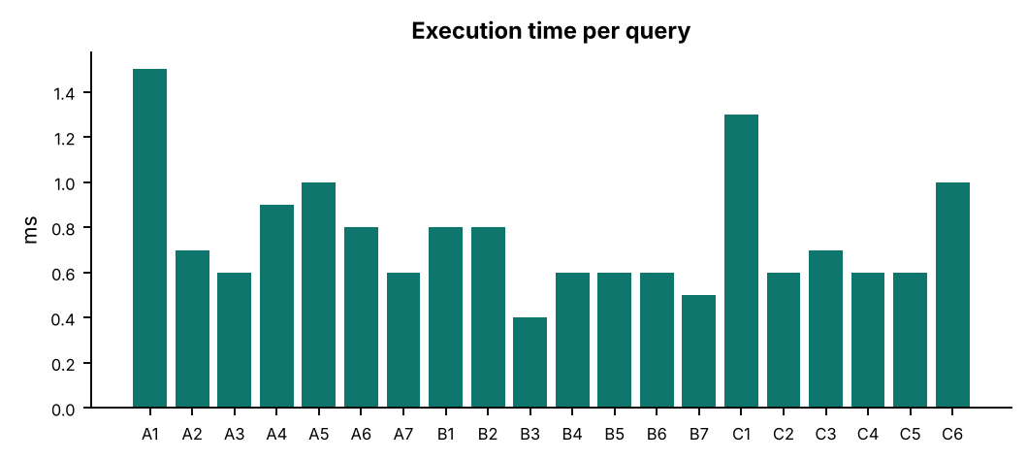
Figure 13. Query execution time (ms).
ID | Business question | Rows | ms
A1 | List all competitions along with their category name | 620 | 1.5
A2 | Count the number of competitions in each category | 12 | 0.7
A3 | Find all competitions of type 'doubles' | 163 | 0.6
A4 | Get competitions that belong to a specific category (e.g. ITF Men) | 209 | 0.9
A5 | Identify parent competitions and their sub-competitions | 480 | 1.0
A6 | Analyse the distribution of competition types by category | 35 | 0.8
A7 | List all competitions with no parent | 140 | 0.6
B1 | List all venues along with their associated complex name | 320 | 0.8
B2 | Count the number of venues in each complex | 70 | 0.8
B3 | Get details of venues in a specific country (e.g. Chile) | 22 | 0.4
B4 | Identify all venues and their timezones | 320 | 0.6
B5 | Find complexes that have more than one venue | 63 | 0.6
B6 | List venues grouped by country | 17 | 0.6
B7 | Find all venues for a specific complex (e.g. Nacional) | 3 | 0.5
C1 | Get all competitors with their rank and points | 450 | 1.3
C2 | Find competitors ranked in the top 5 | 5 | 0.6
C3 | List competitors with no rank movement | 156 | 0.7
C4 | Total points of competitors from a specific country (e.g. Croatia) | 1 | 0.6
C5 | Count the number of competitors per country | 19 | 0.6
C6 | Find competitors with the highest points in the current week | 10 | 1.0

7. Challenges and solutions
Challenge | Risk | Solution | Where
API rate limits (HTTP 429) | Extraction stalls or is blocked | Retry with exponential back-off, honour Retry-After, 1.2 s pacing | etl.py · make_session / fetch
Deeply nested JSON | Brittle parsing, KeyErrors | Per-endpoint flatteners with safe .get() defaults | etl.py · tf_* functions
Missing attributes vs NOT NULL | Insert failures | Explicit defaults (Unknown / UTC / 0) | etl.py · transforms
Reserved word `rank` | SQL syntax errors across engines | Dialect-aware quoting (backticks / double quotes) | app.py · RK
Re-running the pipeline | Duplicate rows, broken history | Idempotent delete-then-insert by key and ranking period | etl.py · load
Partial failures | Half-loaded database | One transaction per run (all-or-nothing) | etl.py · engine.begin()
Arbitrary SQL in the app | Data loss / injection | SELECT/WITH-only whitelist, single statement, bound parameters | app.py · safe_select
Slow repeated queries | Laggy UI | 60 s cache, indexes on FKs and filter columns | app.py · q · schema

Limitations
- Trial API quotas limit refresh frequency and history depth.
- Rankings cover doubles competitors only; singles would require another endpoint.
- Rank-history and trend charts need several weekly snapshots to become informative.

8. Recommendations and future work

Data-driven recommendations
- Resource allocation. ITF Men, ITF Women, ATP Challenger hold 64% of all 620 competitions — prioritise scheduling, officiating and broadcast capacity there first.
- Talent pipeline. Germany, Spain, Chile supply 52% of ranked doubles players — focus development partnerships where depth exists and study under-represented nations for growth.
- Venue footprint. Croatia, Czech Republic, Chile lead with 60% of 320 venues; 63 complexes host several venues and are natural hubs for multi-event weeks.
- Competitive balance. Points Gini is 0.48 and the top 10 hold 20.6% of points — monitor concentration weekly.
- Data operations. Schedule etl.py weekly (cron / GitHub Actions) so rank-history charts and mover analysis become available.

Future work
- Weekly scheduled ETL (GitHub Actions / cron) to build a ranking time series.
- Singles rankings and match-level results for win-probability models.
- Forecast rank movement and points (gradient boosting) with SHAP explanations.
- Pytest suite for the transformers plus a CI pipeline.
- Read-only database user and role-based access for production.

Live demo
The interactive version of every chart in this report is available in the Streamlit app (Project Report page): run `streamlit run app.py`.

9. Appendix: SQL source
A1 · Competitions with category
SELECT c.competition_id, c.competition_name, k.category_name FROM competitions c LEFT JOIN categories k ON k.category_id = c.category_id ORDER BY k.category_name, c.competition_name
A2 · Competitions per category
SELECT k.category_name, COUNT(*) AS competitions FROM competitions c JOIN categories k ON k.category_id = c.category_id GROUP BY k.category_name ORDER BY competitions DESC
A3 · Doubles competitions
SELECT competition_id, competition_name, gender FROM competitions WHERE type = 'doubles' ORDER BY competition_name
A4 · Competitions in a category
SELECT c.competition_name, c.type, c.gender FROM competitions c JOIN categories k ON k.category_id = c.category_id WHERE k.category_name = :category ORDER BY c.competition_name
-- default parameters: {'category': 'ITF Men'}
A5 · Parents and sub-competitions
SELECT p.competition_name AS parent, s.competition_name AS sub_competition FROM competitions s JOIN competitions p ON p.competition_id = s.parent_id ORDER BY parent, sub_competition
A6 · Type mix by category
SELECT k.category_name, c.type, COUNT(*) AS n FROM competitions c JOIN categories k ON k.category_id = c.category_id GROUP BY k.category_name, c.type ORDER BY k.category_name, n DESC
A7 · Top-level competitions
SELECT competition_id, competition_name, type, gender FROM competitions WHERE parent_id IS NULL ORDER BY competition_name
B1 · Venues with complex
SELECT v.venue_name, v.city_name, x.complex_name FROM venues v LEFT JOIN complexes x ON x.complex_id = v.complex_id ORDER BY x.complex_name
B2 · Venues per complex
SELECT x.complex_name, COUNT(v.venue_id) AS venues FROM complexes x LEFT JOIN venues v ON v.complex_id = x.complex_id GROUP BY x.complex_id, x.complex_name ORDER BY venues DESC
B3 · Venues in a country
SELECT venue_name, city_name, timezone FROM venues WHERE country_name = :country ORDER BY city_name
-- default parameters: {'country': 'Chile'}
B4 · Venues and timezones
SELECT venue_name, timezone FROM venues ORDER BY timezone, venue_name
B5 · Multi-venue complexes
SELECT x.complex_name, COUNT(v.venue_id) AS venues FROM complexes x JOIN venues v ON v.complex_id = x.complex_id GROUP BY x.complex_id, x.complex_name HAVING COUNT(v.venue_id) > 1 ORDER BY venues DESC
B6 · Venues grouped by country
SELECT country_name, COUNT(*) AS venues, GROUP_CONCAT(venue_name, '; ') AS venue_list FROM venues GROUP BY country_name ORDER BY venues DESC
B7 · Venues of a complex
SELECT v.venue_name, v.city_name, v.country_name FROM venues v JOIN complexes x ON x.complex_id = v.complex_id WHERE x.complex_name = :complex ORDER BY v.venue_name
-- default parameters: {'complex': 'Nacional'}
C1 · Competitors with rank and points
SELECT c.name, r.`rank` AS rnk, r.points FROM competitor_rankings r JOIN competitors c ON c.competitor_id = r.competitor_id ORDER BY r.`rank`
C2 · Top 5
SELECT c.name, r.`rank` AS rnk, r.points FROM competitor_rankings r JOIN competitors c ON c.competitor_id = r.competitor_id WHERE r.`rank` <= 5 ORDER BY r.`rank`
C3 · Stable rank
SELECT c.name, r.`rank` AS rnk FROM competitor_rankings r JOIN competitors c ON c.competitor_id = r.competitor_id WHERE r.movement = 0 ORDER BY r.`rank`
C4 · Points of a country
SELECT c.country, COUNT(*) AS competitors, SUM(r.points) AS total_points FROM competitor_rankings r JOIN competitors c ON c.competitor_id = r.competitor_id WHERE c.country = :country GROUP BY c.country
-- default parameters: {'country': 'Croatia'}
C5 · Competitors per country
SELECT country, COUNT(*) AS competitors FROM competitors GROUP BY country ORDER BY competitors DESC
C6 · Highest points this week
SELECT c.name, c.country, r.points FROM competitor_rankings r JOIN competitors c ON c.competitor_id = r.competitor_id WHERE r.year = (SELECT MAX(year) FROM competitor_rankings) AND r.week = (SELECT MAX(week) FROM competitor_rankings WHERE year = (SELECT MAX(year) FROM competitor_rankings)) ORDER BY r.points DESC LIMIT 10

