 PROPERTY INSIGHT LAB
PROJECT DOCUMENTATION
Real Estate Investment Advisor
Predicting property profitability and 5-year future value across India — an end-to-end data analytics, machine-learning and decision-support project.
Methodology · Findings · Use Cases

Python | Pandas | Plotly | scikit-learn | XGBoost | MLflow | Streamlit

At a glance | Details
Author | P Suman Sangeet
Domain | Real estate · investment analytics · financial decision support
Dataset | India housing listings — 250,000 rows × 23 columns (40,000-row sample powers the app)
Two questions answered | 1) Is this property a Good Investment? (classification) 2) What will it be worth in 5 years? (regression)
Deliverables | Reproducible notebook · shared feature module · MLflow-tracked models · Streamlit app with an Insight Lab
Version / date | 1.0 · October 2026

1. Recruiter snapshot
An at-a-glance view of what was built, how well it works, and which skills it demonstrates. Every number on this page is taken from the project notebook.

250,000  listings audited & cleaned | 28  MLflow runs tracked | 99.74%  classifier accuracy* | ₹1.73 L  5-yr price RMSE (MAE 0.58 %)

24  business questions answered | 5  add-on analytics models | 93.0%  accuracy with hidden market noise | 87.2%  accuracy with no price features
*On a rule-derived label — see Section 5. The document reports the honest, noise-adjusted figures next to the headline ones on purpose.

The 30-second summary
- Problem: an investor looking at a listing needs a verdict (good / not good) and a 5-year value estimate — with a reason, not just a number.
- Approach: audit and clean 250k listings → engineer 9 features → build transparent rule-based targets → train three models per task → track all runs in MLflow → serve through a Streamlit app.
- Differentiator: an Insight Lab on top of the two production models adds segmentation, anomaly detection, similarity search, Monte Carlo risk simulation and a counterfactual “what would change the verdict?” engine.
- Integrity: two independent honesty checks (feature ablation and hidden market noise) and an explicit limitations section show where the scores come from and what they do not mean.

Skills demonstrated
Area | Evidence in this project | Tools
Data quality & cleaning | Completeness / uniqueness / logic audit; 116,304 impossible floor records repaired; ₹/sq ft recomputed; outliers flagged, not deleted | pandas
Feature engineering | 9 domain features (infrastructure score, city-relative price, space per BHK…) in one shared module | pandas, NumPy
Statistics & EDA | 20 brief + 4 investment questions; Kruskal-Wallis, Mann-Whitney, χ², Pearson / Spearman | SciPy, Plotly
Supervised ML | Three models per task, stratified split, leakage control, cross-fitted target encoding | scikit-learn, XGBoost
MLOps | Two experiments, 28 runs, model registry with a champion alias, deployable pipelines | MLflow, joblib
Unsupervised & simulation | KMeans + PCA, Isolation Forest, KNN, Monte Carlo (GBM), counterfactual search | scikit-learn, NumPy
Explainability & rigour | Feature importance, price-feature ablation, noise-robustness test, error analysis | XGBoost, Plotly
Product & engineering | Four-tab Streamlit app, caching, no train/serve skew, presets, CSV export | Streamlit
Communication | Findings stated with effect sizes; limitations and next steps written openly | —

2. Project overview

2.1 Business problem
Buying property is one of the largest financial decisions most people make, yet listings arrive as a flat list of attributes. An investor needs two answers before committing capital:
- Is this a Good Investment? — a binary classification with a probability, so the verdict can be trusted or challenged.
- What will this property be worth in 5 years? — a regression estimate in ₹ Lakhs with a stated error band.

2.2 Objectives
- Clean and validate a large, real-world-shaped listing dataset and make the cleaning decisions explicit.
- Answer the 20 questions in the project brief plus four investment questions (price trends, area vs return, safety vs class, infrastructure vs resale).
- Train, compare and register classification and regression models with full experiment tracking.
- Turn the models into a product an investor can use without code — and make the reasoning visible.

2.3 End-to-end pipeline
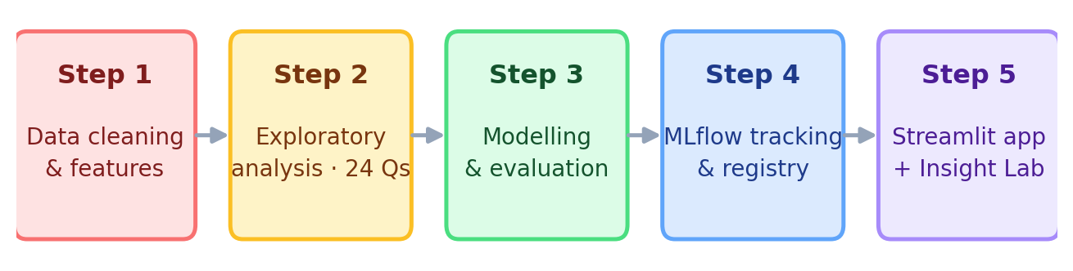
Figure 1 — Five-step pipeline from raw listings to a deployable application

2.4 Deliverables
Deliverable | What it contains
Notebook | Audit, cleaning, feature engineering, 24 EDA questions, six models, MLflow tracking, registry, conclusions
real_estate_features.py | Feature engineering + target helpers imported by both the notebook and the app (prevents train/serve skew)
app.py | Streamlit application: Investment Advisor, Insight Lab, Market Explorer, Model & Methodology tabs
Insights.py | Insight Lab module: segmentation, anomaly, twin-finder, Monte Carlo and counterfactual engines with a branded header
models/, data/ | Champion pipelines (clf_pipeline.joblib, reg_pipeline.joblib), reference + metadata JSON, cleaned data and a 40,000-row app sample
mlflow.db, mlruns/ | Experiment store — 15 classification and 13 regression runs, registered model versions

3. Methodology

3.1 Data and quality audit
The source file india_housing_prices.csv holds 250,000 listings × 23 columns (196 MB in memory). Before any modelling the data was audited for completeness, uniqueness and logical consistency — not only for nulls.
Issue found | Decision | Why
Missing values / duplicates | Median / mode imputation and drop_duplicates kept in the code (0 duplicates and 0 missing found) | The pipeline stays reusable on messier production data
Floor_No > Total_Floors in 116,304 rows | Raise Total_Floors to at least Floor_No | A flat on floor 22 implies a building of at least 22 floors; altering the floor would destroy information
Price_per_SqFt stored with 2 decimals in lakhs | Recompute in ₹ per sq ft from price and size | Rounding error of up to ±5 % otherwise
Price/sq ft outliers (19,723 rows, 7.9 %) | Flag with IQR fences; do not delete | Values are plausible (small flats at the top of the range); trees are robust and Log_PPSF tames influence

3.2 Feature engineering
Nine features were added in real_estate_features.py, the single source of truth shared with the app.
Feature | Definition
Price_per_SqFt_INR | Price (₹) ÷ built-up area
Infrastructure_Score (0–100) | 40 % schools + 30 % hospitals + 30 % public-transport access
School_Density_Score | Schools nearby ÷ the city's average number of schools
Amenity_Count | Number of amenities (gym, pool, clubhouse, garden, playground)
Floor_Ratio | Floor_No / Total_Floors — 0 is ground floor, 1 is top floor
Sqft_per_BHK | Space efficiency per bedroom
City_Median_PPSF, Price_vs_City_Median | Is this listing cheap or expensive for its city?

3.3 Target construction
The dataset contains no price history, rents or realised returns, so both targets are built from transparent domain rules. This choice shapes how every result should be read (Section 5).

Regression target — Future_Price_5Y
Future = Price × (1 + r)^5, where the annual growth rate r is feature-based:
Growth-rate rule
r = 6 % base + city price-tier premium (0–2 %) + property-type premium (Villa +0.5 %, House +0.25 %) ± infrastructure adjustment (±1 %) + under-construction uplift (+1 %) − age penalty (up to −1 %), clipped to 4 %–12 %.

The resulting assumed growth ranges from 4.3 % to 10.4 % (median 7.3 %), a typical 5-year multiple of 1.43×.

Classification target — Good_Investment
A five-point score, one point per rule; a listing is good if it scores 3 or more. 54.1 % of listings are labelled good — a near-balanced target, so accuracy is meaningful and no resampling is needed.
# | Rule | Investment logic
1 | Price per sq ft ≤ city median | Good value for the location
2 | Annual growth rate ≥ dataset median | Good appreciation outlook
3 | BHK ≥ 3 | Family-size demand and resale liquidity
4 | Ready to move | No construction risk
5 | Infrastructure score ≥ dataset median | Livability and future demand

3.4 Preprocessing and leakage control
- One ColumnTransformer is used at training time and inside the app: 17 numeric columns → StandardScaler; 9 low-cardinality categoricals → OneHotEncoder; 1 high-cardinality column (Locality, ~500 values) → cross-fitted TargetEncoder.
- Target-derived columns — Annual_Growth_Rate, Future_Price_5Y, Investment_Score, Good_Investment — are excluded from model inputs so the models cannot read the answer.
- Split: 80 / 20, stratified on the label → 200,000 training and 50,000 test rows; positive rate 0.541 in both.

3.5 Model development and experiment tracking
Task | Target | Models compared | Metrics
Classification | Good_Investment | Logistic Regression · Random Forest · XGBoost | Accuracy, Precision, Recall, F1, ROC-AUC
Regression | Future_Price_5Y (₹ L) | Linear Regression · Random Forest · XGBoost | RMSE, MAE, R²

- MLflow: local SQLite store, two experiments (RealEstate_Classification, RealEstate_Regression); each run logs parameters, test metrics, training time and the full pipeline artifact.
- Registry: the best model per task is registered and promoted with the champion alias; the app loads the same pipelines (preprocessing + model in one object).
- 28 runs (15 classification, 13 regression) were tracked, including the ablation and noise-robustness variants.

3.6 Application architecture
The app reproduces the notebook's inference path exactly: form → engineer_features → add_targets → champion pipelines. The Insight Lab then adds five analytical modules around the same property.
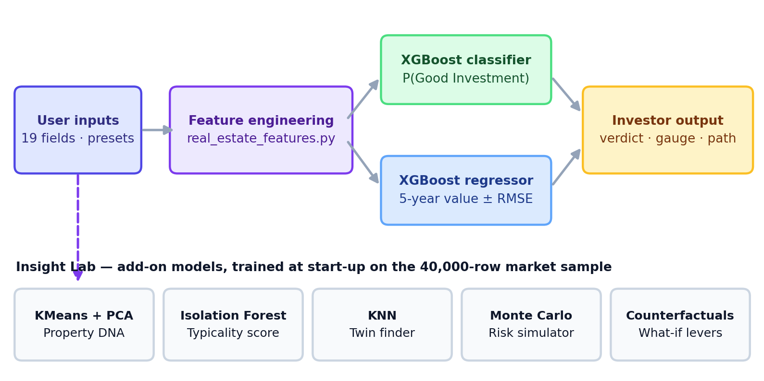
Figure 2 — Inference path (top) and Insight Lab add-on models (bottom)
App tab | What the user gets
🔮 Investment Advisor | Property form with example presets → verdict, probability gauge, 5-year value with ± RMSE band, price what-if curve, five-criteria checklist, comparable listings
🧪 Insight Lab | Property DNA, twin finder, live Monte Carlo risk simulator and counterfactual engine for the analysed property
📊 Market Explorer | Sidebar filters → KPIs, city × type heatmap, treemap, vintage and projection trends, opportunity quadrant, locality leaderboard, CSV download
🧠 Model & Methodology | Model metrics and comparison tables, feature importance, ablation result, how-it-works flow and limitations

3.7 Insight Lab — the five add-on models
These modules train in seconds at start-up on the 40,000-row sample (cached) and use only columns already present in the data. The twin finder deliberately ignores price when matching, so its fair-price band is not circular.
Module | Technique | How it works | What the user sees
Property DNA | KMeans (k = 5) + PCA | Clusters listings on 7 standardised features (log price, log size, BHK, log ₹/sq ft, infrastructure, growth, age); PCA flattens to 2-D; segments named by their centroids | Market map with a ⭐ for the property, auto-named segment, percentile radar
Typicality | Isolation Forest (200 trees) | Scores how unusual the listing is against the market | “More typical than X % of listings”
Twin finder | KNN (30 neighbours) | Matches on size, BHK, infrastructure, growth, age — not price | Fair ₹/sq ft band, implied fair price, twin table
Risk simulator | Monte Carlo (geometric Brownian motion, 4,000 paths) | Drift = regressor forecast; volatility calibrated from the regressor's RMSE; sliders for holding period, volatility, growth shock, FD rate | Fan chart, value histogram, chance of loss, odds of beating a fixed deposit, worst-5 % case
Counterfactual engine | Re-scoring with the real classifier and regressor | Applies each lever (price cut, ready-to-move, transit, schools, amenities…) and a greedy search for the best 4-step path | Δ probability bar chart and a waterfall to a better verdict

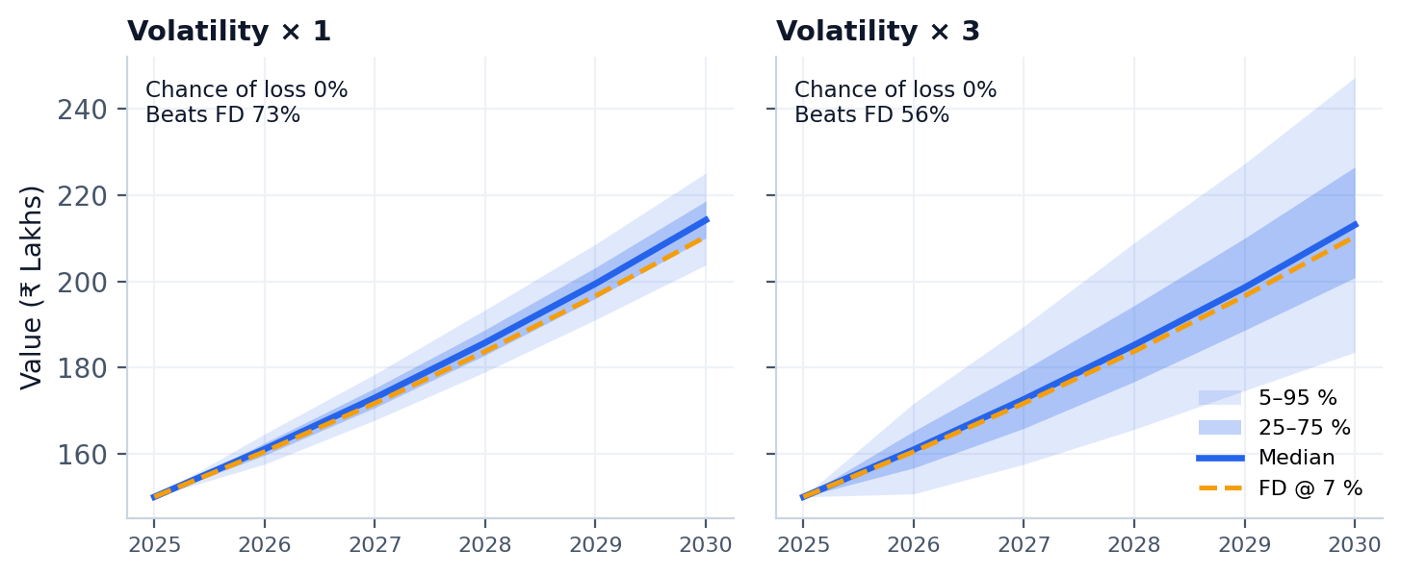
Figure 3 — Illustration of the risk simulator (₹150 L property, 1.43× forecast, ₹1.73 L RMSE; same formula as the app, not model output)

4. Findings

4.1 Headline findings
- The raw market is “flat”. Price correlates with size at only r = −0.003; state, city, facing, furnishing, parking and amenities each move price by about 3 % or less.
- Investment quality comes from value, readiness and infrastructure — not cosmetics. Facing, furnishing, owner type, parking and security share only 0.6 % of the classifier's importance.
- Larger homes are the better value play (lower ₹/sq ft against the city median); infrastructure and transport are the growth play (higher projected appreciation).
- The classifier is not just recomputing a price comparison: with every price feature removed it still reaches 87.2 % accuracy.
- Realistic expectation is ~93 %, not ~99.7 %: once hidden market noise is added, accuracy settles at 93.0 % (AUC 0.986).

4.2 Exploratory analysis
All 24 questions were answered with interactive Plotly charts in the notebook. The most decision-relevant results are below.
Question | Finding
Price distribution | ₹10 L – ₹500 L, median ₹253.9 L, skewness 0.01 — essentially uniform rather than the right-skewed shape of real housing markets
Size vs price | Pearson r = −0.003 (Spearman −0.011). Because price does not rise with area, price per sq ft falls sharply with size (r = −0.61)
Price / sq ft by type | Apartment ₹9,245 · House ₹9,305 · Villa ₹9,190 — a 0.6 % gap (Kruskal-Wallis p = 0.0186: significant but practically negligible)
State and city | Karnataka is the priciest state per sq ft (₹13,252) and Punjab the cheapest (₹12,931) — a 2.5 % spread; city averages differ by only 3.0 %
Outliers | 19,723 listings (7.9 %) are ₹/sq ft outliers, all on the high side; size has none. Flagged and retained
Schools / hospitals vs price | r ≈ 0.000 for both — no price premium today, so infrastructure is modelled as a growth driver
Furnishing, facing, parking | Gaps of 0.3 %, 0.9 % and 0.1 %; none statistically significant
Amenities | Amenity count vs ₹/sq ft r = +0.002; largest single effect (Gym) +0.75 % — within noise
Price trend by vintage | No consistent trend: median ₹/sq ft moves ~9 % between vintages with no persistent direction, so there is nothing to extrapolate in time
Mix of listings | BHK split is even (≈ 20 % each); owner type and availability are balanced, so no category is data-starved

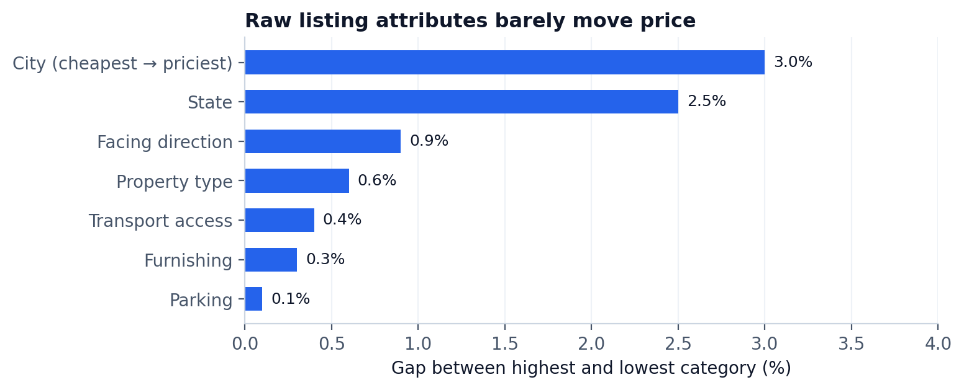
Figure 4 — Gap between the highest and lowest category for each raw attribute

4.3 What actually drives investment quality
Although current price barely varies, the investment label and projected return respond strongly to infrastructure, transport and size — because those are the factors the investment rules reward.
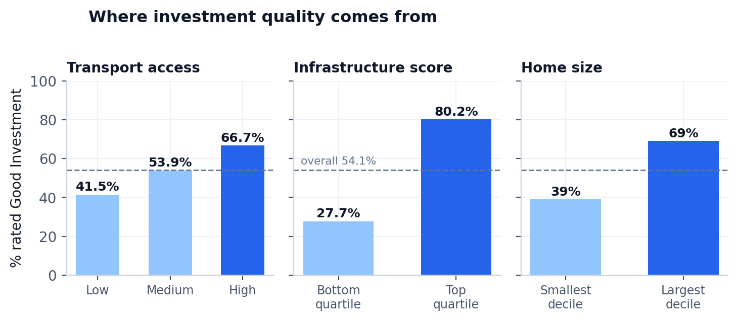
Figure 5 — Share of listings rated Good Investment by transport access, infrastructure quartile and home size
- Transport: the Good-Investment rate climbs 41.5 % → 53.9 % → 66.7 % from Low to High access, with projected 5-year return rising from 41.4 % to 44.1 %.
- Infrastructure: bottom-quartile locations are good 27.7 % of the time versus 80.2 % for the top quartile; top-decile locations are projected to appreciate 46.6 % against 38.9 % for the bottom decile (r = +0.311).
- Size: the Good rate rises from 39 % (smallest decile) to 69 % (largest). This is a value effect, not a growth effect — area vs projected return is r = −0.003.
- Safety proxy: crime rate is not in the dataset. The Security flag has no meaningful effect (54.2 % → 53.9 %, χ² p = 0.273), as expected, because it is not a label component.
- City trade-off: city Good-Investment rates run from 38.3 % to 70.4 % (Guwahati highest); high-tier cities' growth premium is partly offset by higher entry price per sq ft.

4.4 Model performance

Classification
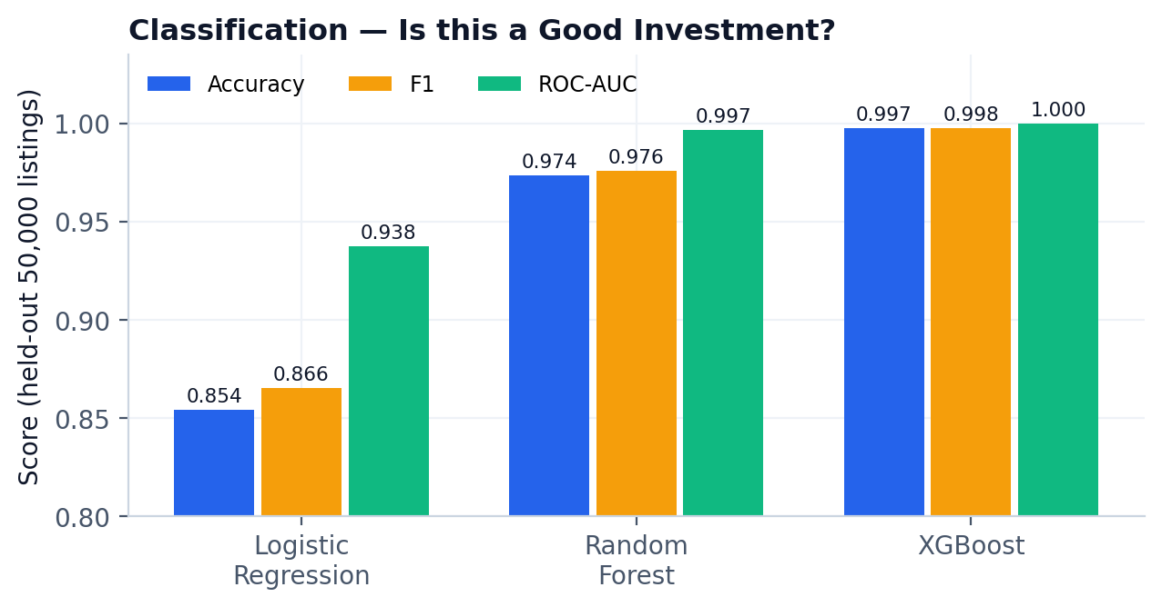
Figure 6 — Classifier comparison on 50,000 unseen listings
Model | Accuracy | F1 | ROC-AUC | Train time
Logistic Regression | 85.40 % | 0.8655 | 0.9376 | 20 s
Random Forest | 97.35 % | 0.9756 | 0.9967 | 15 s
XGBoost (champion) | 99.74 % | 0.9976 | 1.0000 | 34 s

XGBoost also reaches precision 99.70 % and recall 99.82 %. On the 50,000 test listings it makes 130 errors — 82 false alarms and 48 missed opportunities.

Regression
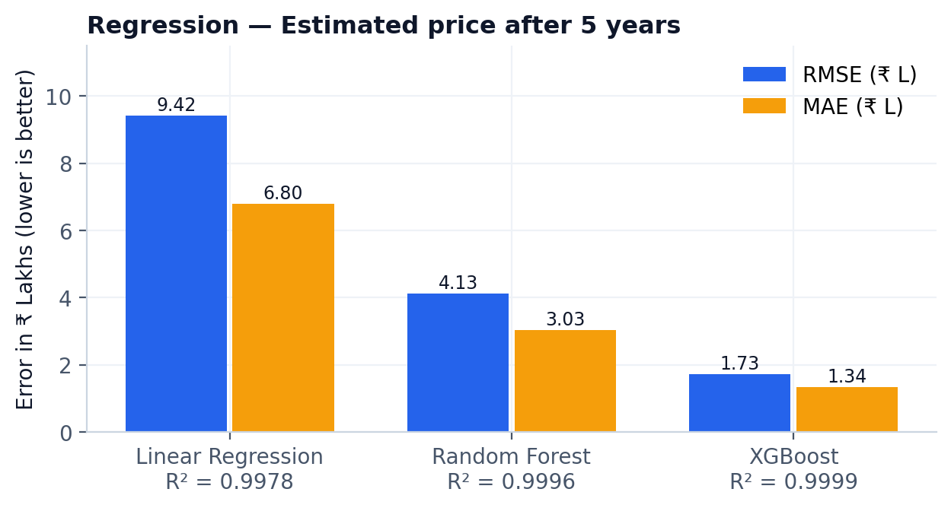
Figure 7 — Regressor comparison (error in ₹ Lakhs)
XGBoost predicts 5-year value with RMSE ₹1.73 L, MAE ₹1.34 L (≈ 0.58 % error) and R² = 0.9999; residuals are centred on −0.01 L with no funnel shape. Because future value is anchored on today's price by construction, the real skill is learning the growth component: a naive “price × median growth” baseline has an MAE of ₹14.99 L, so the model removes 91 % of that error.

4.5 Honesty checks
Near-perfect scores on a rule-derived label say that the model learned the rule, not that it can forecast the market. Two checks put the headline in context.
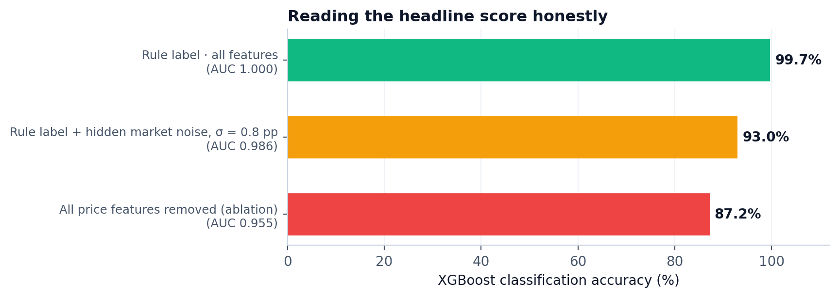
Figure 8 — Accuracy under the three evaluation settings
- Ablation (price features removed): XGBoost still reaches 87.2 % accuracy / 0.955 AUC, so most of the signal comes from property attributes — BHK, readiness, infrastructure, city tier. The price-versus-city-median rule supplies the remaining lift.
- Market-noise robustness: adding Gaussian noise (σ = 0.8 percentage points) to the growth rate — unseen by the model — lowers accuracy by 6.7 points to 93.0 %; the 5-year price model keeps R² = 0.994.
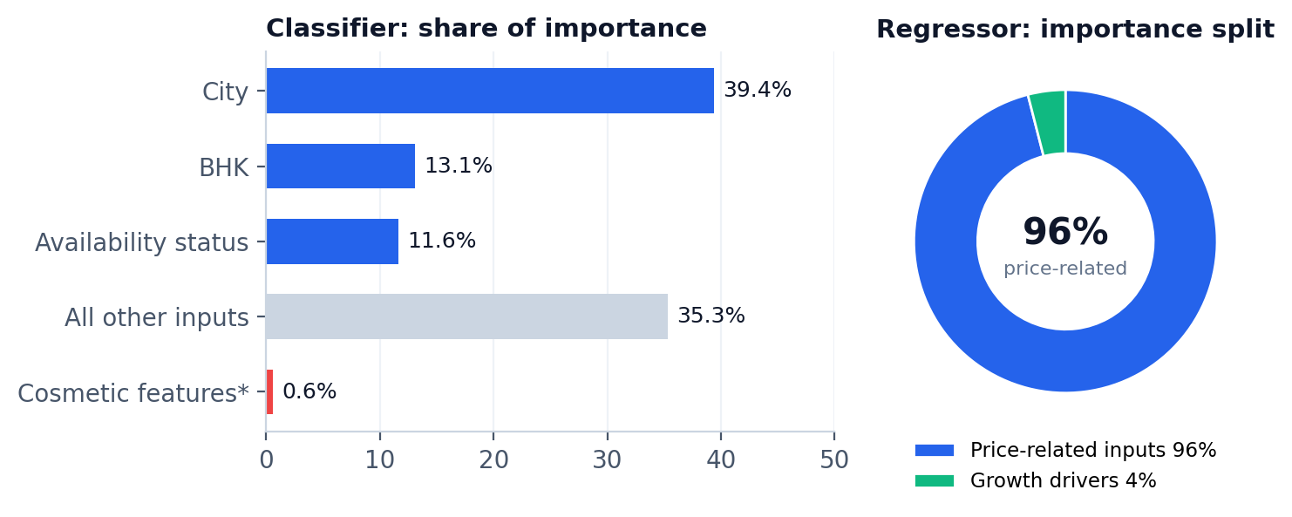
Figure 9 — Feature importance. *Cosmetic = facing, furnishing, owner type, parking, security
- Classifier drivers: City (39.4 %), BHK (13.1 %) and Availability status (11.6 %) lead; features outside the label rules share only 0.6 %, a good sign the model is not fitting noise.
- Regressor drivers: price-related inputs carry 96 % of importance — where you start matters most. Growth drivers carry 4 % but decide how fast value compounds; the single most important of them is Availability status (1.8 %).

4.6 Where to see the interactive versions
The figures above are static snapshots. Each insight has a live, interactive counterpart in the app:
Insight | App location | Interaction
Verdict and probability | Investment Advisor | Press Analyse; gauge and value path update per property
Price what-if / negotiation target | Investment Advisor | Hover the curve to see P(Good) and 5-year value at each asking price
City, type and BHK patterns | Market Explorer | Sidebar filters; heatmap metric, row and column selectors; treemap drill-down
Opportunity quadrant, infrastructure vs gain | Market Explorer | Hover and zoom; locality leaderboard and sortable listings
Property DNA map | Insight Lab | Recolour by segment, verdict or ₹/sq ft; hover any listing
Fair-price band | Insight Lab | Twin table with comparable listings
Risk simulation | Insight Lab | Sliders for holding period, volatility, growth shock and FD rate — recomputes instantly
Counterfactual levers | Insight Lab | Bar chart of Δ probability and a best-path waterfall

5. Use cases

5.1 Who benefits and how
User | Question they ask | How this project helps
Individual investor / home buyer | “Is this listing worth it, and what is a fair offer?” | Verdict with probability, 5-year value ± error, negotiation target from the what-if curve, twin-based fair-price band
Real-estate advisor / broker | “How do I justify a recommendation to a client?” | Five-criteria checklist, comparable listings, counterfactual levers that show what would change the verdict
Mortgage lender / banker | “How risky is the collateral over the loan tenor?” | Monte Carlo fan chart, chance of loss and worst-5 % value; typicality score flags unusual listings
Developer / builder | “Where and what should we build?” | Opportunity quadrant, infrastructure-vs-gain chart, segment profiles, readiness and BHK effects
PropTech product team | “Can we embed an investment score in our listing page?” | Shared feature module + registered champion pipelines + tested inference path ready to wrap in an API
Portfolio / investment analyst | “Which cities and localities screen best?” | Filterable market explorer, locality leaderboard, CSV export, city Good-Investment rates (38 %–70 %)

5.2 Worked scenarios (built-in presets)
The Advisor ships with three presets so a reviewer can see the product working in seconds.
Preset | Profile | What to look at
🏢 Starter apartment | 2 BHK, 950 sq ft, ₹60 L, Pune (or Bangalore), 2018 build, ready to move | Does a small ready-to-move unit pass the 3-of-5 rule? Which lever flips the verdict?
🏡 Family home | 3 BHK independent house, 1,800 sq ft, ₹150 L, Hyderabad (or Chennai), 2012 build | Value-versus-growth trade-off; fair-price band against structural twins
🏰 Premium villa | 4 BHK villa, 3,500 sq ft, ₹450 L, Mumbai (or Delhi), under construction | Risk simulator: widen volatility and see chance of loss and the fixed-deposit comparison

5.3 Suggested two-minute demo flow
- Open Investment Advisor, load Family home, press Analyse — read the verdict, gauge and 5-year value band.
- Drag along the what-if curve to find the asking price where the verdict flips — a data-backed negotiation target.
- Switch to Insight Lab: show the property's segment on the market map, then the twin-based fair-price band.
- Move the volatility and growth-shock sliders and watch the chance of loss change live.
- Open Model & Methodology and point to the ablation and noise checks to show the scores are interpreted honestly.

5.4 Path to production
- Wrap engineer_features → add_targets → champion pipelines in a REST endpoint; the inference path is already tested against the notebook.
- Replace rule-based labels with realised appreciation and rental yield (RERA, listing portals, census) and re-run the same MLflow comparison.
- Add monitoring for drift in city medians (reference.json) and re-register champions with the existing alias workflow.

6. Limitations and next steps
Read this before trusting the numbers
Targets are rule-based scenarios. With no price history or realised returns, both labels are engineered. High scores show that the models learned the investment logic — not that they forecast the real market.
The data looks synthetic: columns appear independently and uniformly generated (price is uncorrelated with size), so market charts describe patterns in this dataset only.
No dated prices or rents, so time-series models (ARIMA, Prophet, LSTM) were deliberately not used; the time axis is construction period.
Crime rate is not available; Security and Infrastructure_Score are used as proxies. The Insight Lab's Monte Carlo and counterfactual outputs are scenario analysis, not financial advice.

6.1 Roadmap
Horizon | Improvement | Benefit
Next | Merge real appreciation and rental-yield data to replace rule-based labels | Turns rule recovery into genuine forecasting
Next | Add SHAP explanations to the Advisor tab | Per-listing, model-faithful reasons
Next | Hyper-parameter search with Optuna | Tuned champions, tracked in MLflow
Later | Geospatial features (distance to CBD, metro) | Richer infrastructure signal
Later | Containerise with Docker; deploy on Streamlit Cloud | Shareable live demo
Later | EMI / rental-yield IRR calculator and city-vs-city comparison | Leveraged-return view for investors

Appendix

A. Project structure
├── Real_Estate_Investment_Advisor.ipynb ← notebook
├── real_estate_features.py ← shared features
├── app.py ← Streamlit app (4 tabs)
├── Insights.py ← Insight Lab module
├── requirements.txt
├── data/ cleaned_housing.csv · app_sample.csv
├── models/ clf_pipeline.joblib · reg_pipeline.joblib
│ reference.json · model_meta.json
└── mlflow.db · mlruns/ ← experiment tracking

B. How to run
pip install streamlit plotly scikit-learn xgboost joblib pandas mlflow
# 1) run the notebook once to write data/ and models/
streamlit run app.py
mlflow ui --backend-store-uri sqlite:///mlflow.db # optional: browse experiments
Keep Insights.py beside app.py (not inside a pages/ folder, or Streamlit treats it as a separate page).

C. Metric glossary
Metric | Plain-language meaning
Accuracy | Share of listings classified correctly
Precision / Recall | Of listings called good, how many truly are / of truly good listings, how many were found
F1 | Harmonic mean of precision and recall
ROC-AUC | Probability that a random good listing is ranked above a random not-good one (1.0 = perfect ranking)
RMSE / MAE | Typical size of the price error in ₹ Lakhs; RMSE penalises large misses more
R² | Share of price variation explained by the model
Ablation | Retraining without a group of features to see how much the model depends on them
Counterfactual | A re-scored “what if” version of the same property

Prepared by P Suman Sangeet · Real Estate Investment Advisor · October 2026

