DATA SCIENCE CAPSTONE · FINTECH / PROPTECH
Real Estate Investment Advisor
Predicting property profitability and 5-year future value across 42 Indian cities
Project documentation: Methodology · Findings · Use Cases

250,000  listings analysed | 42  Indian cities | 0.933  classifier ROC-AUC | 0.994  regressor R² | 3.2%  price MAPE

Item | Detail
Author | P Suman Sangeet · Data Science & AI Intern, INNOVEXIS (LABMENTIX Bold Analytics Cohort 2025)
Tech stack | Python · pandas · scikit-learn · XGBoost · Optuna · MLflow · SHAP · Plotly · Streamlit · Docker
Deliverables | Executed notebook (REALES_1) · shared feature module · two Streamlit apps (Insights.py committee app, app_v2.py production app) · MLflow registry · drift monitor · Dockerfile
Interactive version | Every chart in this document is a static capture of an interactive Plotly view in the notebook; the Streamlit apps re-score live on every slider change

Read this first: what the scores do and do not mean
The source CSV has no target columns, no listing dates and no realised returns. Good_Investment and Future_Price_5Y are engineered from documented growth rules plus 0.8% market noise, so the metrics show how well the pipeline recovers that logic, not real-market forecasting skill. This document states that openly, then shows the engineering built around it (leakage control, ablation, calibration, explainability, drift monitoring, and a realised-outcome mode that activates when real data is supplied).

1. Executive Summary
Investors, home-buyers and listing platforms need fast, data-backed answers to two questions: is this property a good investment, and what will it be worth in five years? This project answers both with a reproducible machine-learning pipeline and two deployable Streamlit applications that re-score a listing live as the user moves a slider.

Headline results (held-out test set, 50,000 listings)
Task | Best model | Key metrics | Versus naive baseline
Good_Investment (classification) | XGBoost (Optuna-tuned) | ROC-AUC 0.934 · accuracy 85.1% · F1 0.846 · log-loss 0.326 | City base-rate: AUC 0.795, log-loss 0.523
Future_Price_5Y (regression) | XGBoost (Optuna-tuned) | RMSE ₹15.5L · MAE ₹10.9L · R² 0.994 · MAPE 3.2% | Price × median multiple: MAE ₹22.9L (52% worse)
Probability honesty | Isotonic calibration | ECE 0.0041 → 0.0032 | AUC unchanged (monotone map)
Explainability | Grouped TreeSHAP | Additivity verified: max error 5.7e-06 (clf) | One bar per original feature, not per one-hot column
Monitoring | PSI + KS / χ² | 24 of 24 inputs stable (max PSI ≈ 0.025) | Stress test (+40% price premium) correctly raises WATCH

Five findings a hiring manager should take away
- Signal lives in engineered relationships, not raw columns. Size and price correlate at r = −0.003; all raw categorical effects on price are under 5%. Relative features (price vs city benchmark, infrastructure score, city tier) carry the model.
- Location tier dominates the investment verdict. Tier-1 cities average an 87% good-investment rate against 50% for Tier 2 and 12% for Tier 3; City alone holds 52% of classifier importance.
- Public transport is the under-priced lever. Prices differ by just 0.7% across transport levels, yet High-transport listings are rated good 62% of the time versus 35% for Low.
- The data is almost certainly synthetic, and the notebook proves it. Uniform distributions, mutually independent columns and a statistical-significance sweep (E6) quantify this instead of hiding it.
- Production hygiene separates this from a tutorial. Shared training/serving feature code, anti-leakage rules, ablation, tuned-vs-naive baselines, calibration, SHAP, MLflow registry, drift monitor and Docker.

2. Business Problem and Objectives
# | Business question | ML task | Output
1 | Is this property a good investment? | Binary classification | Good_Investment (0/1) with calibrated probability
2 | What will it be worth in 5 years? | Regression | Future_Price_5Y (₹ Lakh) and implied annual growth
3 | Why did the model say that? | Explainability | Per-listing SHAP breakdown in the app
4 | Can I trust it in production? | MLOps | Registry, drift monitor, containerised deployment

Success criteria
- Beat naive baselines on a held-out set, with no target-derived column ever used as a model input.
- Report calibration and effect sizes, not just accuracy, so a recruiter or analyst can judge reliability.
- Ship an interactive tool that a non-technical user can operate without a submit button.

3. Data and Honest Caveats
The dataset (india_housing_prices.csv) contains 250,000 listings and 23 columns across 42 cities: location, BHK, size, price, build year, furnishing, floors, nearby schools and hospitals, public-transport level, parking, security, amenities, facing, owner type and availability status.
Data-quality check | Result | Action taken
Duplicate rows (excluding ID) | 0 | None needed
Missing cells | 0 | Median/mode imputation kept in pipeline for fresh data
Floor_No > Total_Floors | 46.5% of rows | Handled in Floor_Ratio feature (capped)
Age ≠ 2025 − Year_Built | 0 | Age recomputed from BASE_YEAR for consistency
Supplied Price_per_SqFt = 0.00 | 1.0% of rows | Column dropped; ₹/sq ft recomputed from price and size
₹/sq ft IQR outliers | 7.89% (price and size: 0.0%) | Flagged, kept, and tamed with a log-ratio to city median

Four dataset caveats stated up front
(1) No target columns exist, so both labels are engineered from rules. (2) Crime rate and RERA status are absent; Security and a built Infrastructure Score are the proxies. (3) Locality_1…500 repeat across all 42 cities, so they are anonymised IDs, not neighbourhoods. (4) Distributions are near-uniform and features are independent, which strongly suggests synthetic data.

4. Methodology

4.1 End-to-end pipeline
Step | Stage | What was done | Output
1 | Preprocessing and features | Audit, clean, recompute ₹/sq ft, flag outliers, engineer 14 numeric + 9 categorical features, build targets | cleaned_housing_data.csv.gz (250,000 × 38)
2 | EDA | 20 brief questions + 6 investment analyses (E1–E6), each with a computed insight and significance test | Interactive Plotly charts
3 | Modelling | 3 classifiers and 3 regressors on one shared stratified 80/20 split; ablation study | Leaderboards, ROC, confusion matrix
4 | MLflow | Every model a tracked run; winners registered with a champion alias; registry round-trip asserted | 6 runs, 2 registered models
5 | Streamlit app | Advisor, market explorer, model insights | app.py
6–7 | Real-data layer | Purged chronological split, realised outcomes, as-of crime / RERA / metro joins | Activates when data/real/ is supplied
8 | Optuna | TPE search over 8 XGBoost parameters, every trial a nested MLflow run | 50 trials, ~465 s
9 | Calibration and SHAP | Out-of-fold isotonic calibration; grouped TreeSHAP with additivity assertion | Honest probabilities, explanations
10 | Ship and monitor | models_v2 bundle, PSI/KS drift monitor, Dockerfile, DEPLOY.md | app_v2.py, container image

4.2 Feature engineering
All feature logic lives in a single module, housing_utils.py, imported by the notebook and by both Streamlit apps. This guarantees that training and serving can never drift apart, which is the most common cause of production ML bugs.
- PPS_INR and Log_PPS_vs_City: ₹/sq ft recomputed from price and size, then expressed as a log ratio to the city median so skew and outliers stop distorting linear models.
- Infrastructure_Score (0–100): composite of nearby schools, hospitals and transport accessibility (Low/Medium/High mapped to 0/0.5/1).
- City_Tier: Tier 1 (11 metros), Tier 2 (19 cities), Tier 3 (rest), used as the base-growth driver.
- Floor_Ratio, Size_per_BHK, Amenity_Count, Age_of_Property: relative and count features that remove scale effects.

4.3 Target engineering (the step most tutorials skip)
Because the CSV carries no outcome, the targets are built from transparent rules defined in the shared module:
Component | Rule
Expected annual appreciation | City-tier base (8.5% / 7.0% / 5.5%) + property-type effect + infrastructure effect + under-construction premium − age penalty + value bonus (cheaper than city median) + market noise (σ = 0.8%)
Future_Price_5Y | Price × (1 + growth)^5, the regression target
Good_Investment | 1 if expected appreciation ≥ 7.5%, the classification target (48.4% positive, so accuracy is not misleading)

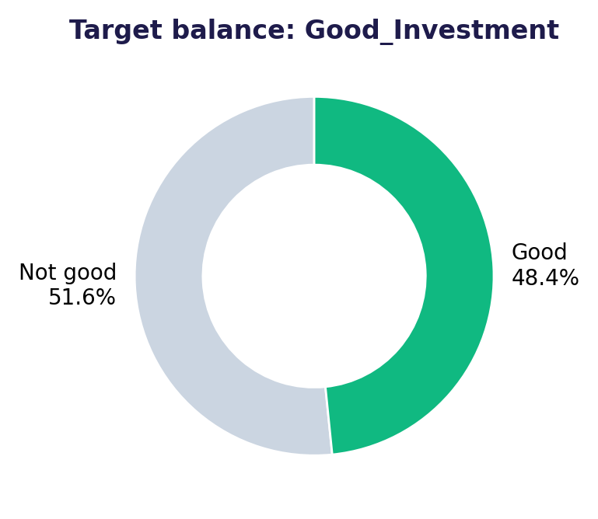
Figure 1. Class balance of the engineered Good_Investment target.

4.4 Modelling and anti-leakage design
- Target-derived columns (Simulated_Annual_Growth, Future_Price_5Y, Good_Investment) are never model inputs.
- One stratified 80/20 split (200,000 train / 50,000 test) is shared by both tasks; scaling and one-hot encoding live inside the sklearn Pipeline so they are fitted on training data only.
- Classifiers: Logistic Regression, Random Forest, XGBoost. Regressors: Linear, Random Forest, XGBoost. The Streamlit committee app extends this to six models plus a mean ensemble (Ridge/Logistic, Random Forest, Extra Trees, HistGradientBoosting, XGBoost, MLP).
- Price-feature ablation: XGBoost is retrained with every price input removed to show how much skill comes from location and infrastructure versus value-for-money.

4.5 Production upgrades
Upgrade | Method | Why it matters
Hyper-parameter tuning | Optuna TPE, 8 parameters, regularised ranges, objective = CV log-loss (clf) / RMSE (reg), nested MLflow runs | Tuning is auditable and reproducible
Calibration | Out-of-fold isotonic map fitted on 200,000 predictions, test block untouched | A displayed 70% should mean 70%
Explainability | TreeSHAP, one-hot columns summed back to the original feature, additivity asserted | Per-listing "why this verdict?"
Time-aware split (real mode) | Chronological split with a purge gap of one forecast horizon; as-of benchmark joins | Prevents future market moves leaking into training
External features (real mode) | Crime rate, RERA status, distance to metro, joined as of listing date | Replaces proxies with real signals when data exists
Drift monitoring | PSI (stable <0.10, watch 0.10–0.25, drift ≥0.25) + KS / χ² tests | Flags input shift before accuracy silently decays
Deployment | Dockerfile (python 3.12-slim, non-root user, health check), pinned requirements, DEPLOY.md, Streamlit Community Cloud / Cloud Run | One command from laptop to cloud

5. Findings

5.1 Exploratory analysis

Raw features are almost independent
Size and price correlate at −0.003; ₹/sq ft is therefore just a ratio of two unrelated numbers (r = −0.61 with size, +0.56 with price). City average prices sit in a narrow ₹251L–₹258L band and state ₹/sq ft differs by only 2.5%.
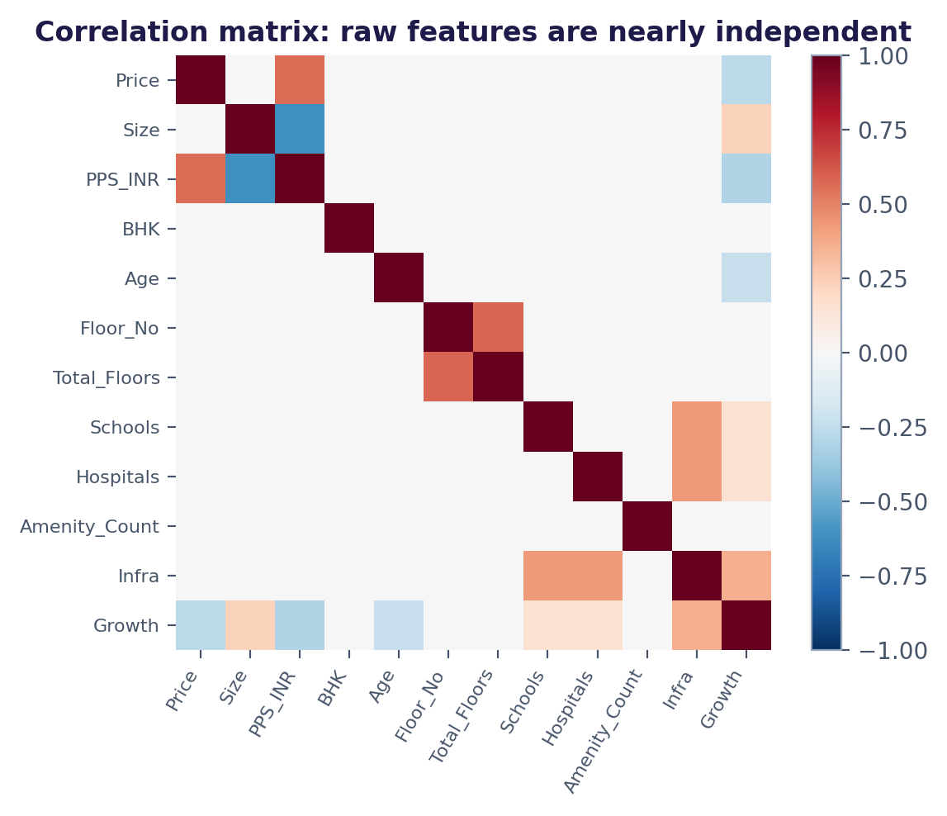
Figure 2. Pearson correlation matrix: the only structure is mechanical (₹/sq ft, floors) or engineered (infrastructure).

"No effect" findings were tested, not assumed
With 250,000 rows even trivial gaps become statistically significant, so E6 reports effect size beside the p-value. For price and ₹/sq ft the largest gap between best and worst group of any feature is only 4.8%. The good-investment rate, by contrast, moves by 76 pp with City, 75 pp with State and 27 pp with transport.
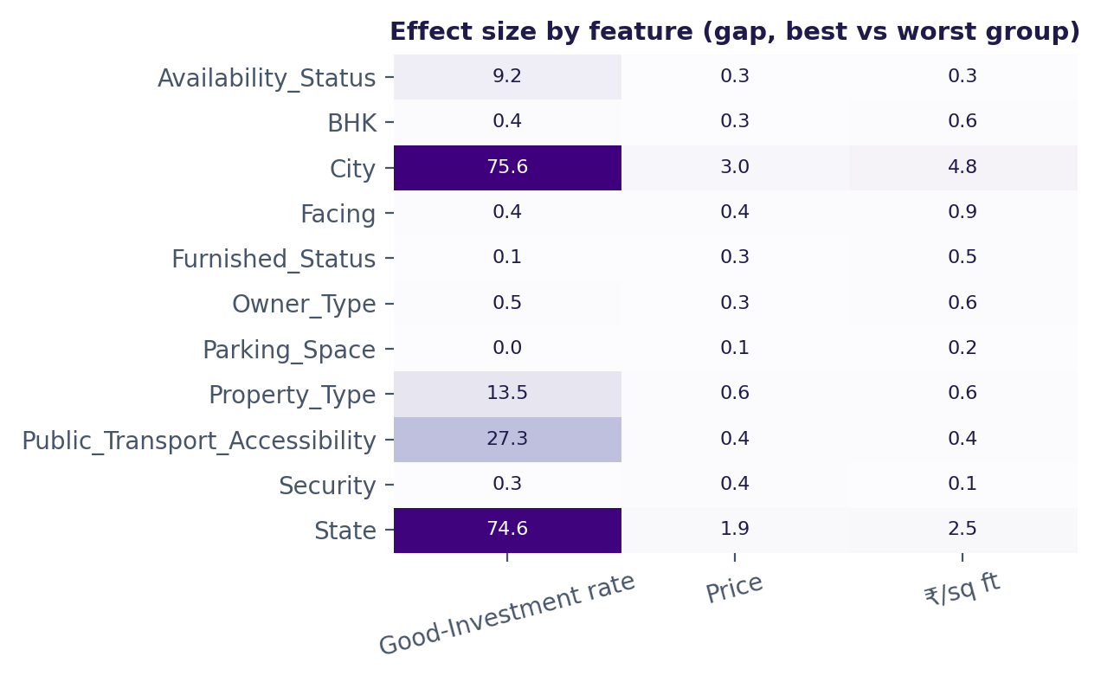
Figure 3. Effect-size heatmap (E6): only City, State, transport, property type and build status move the investment verdict.

Where the investment signal sits
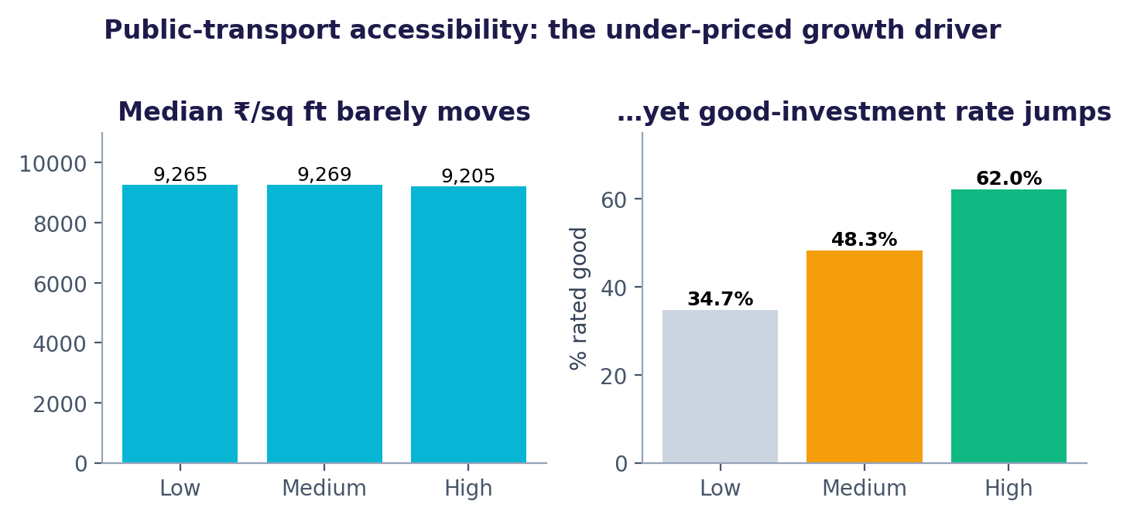
Figure 4. Transport accessibility is barely priced in, yet it separates good from poor investments.
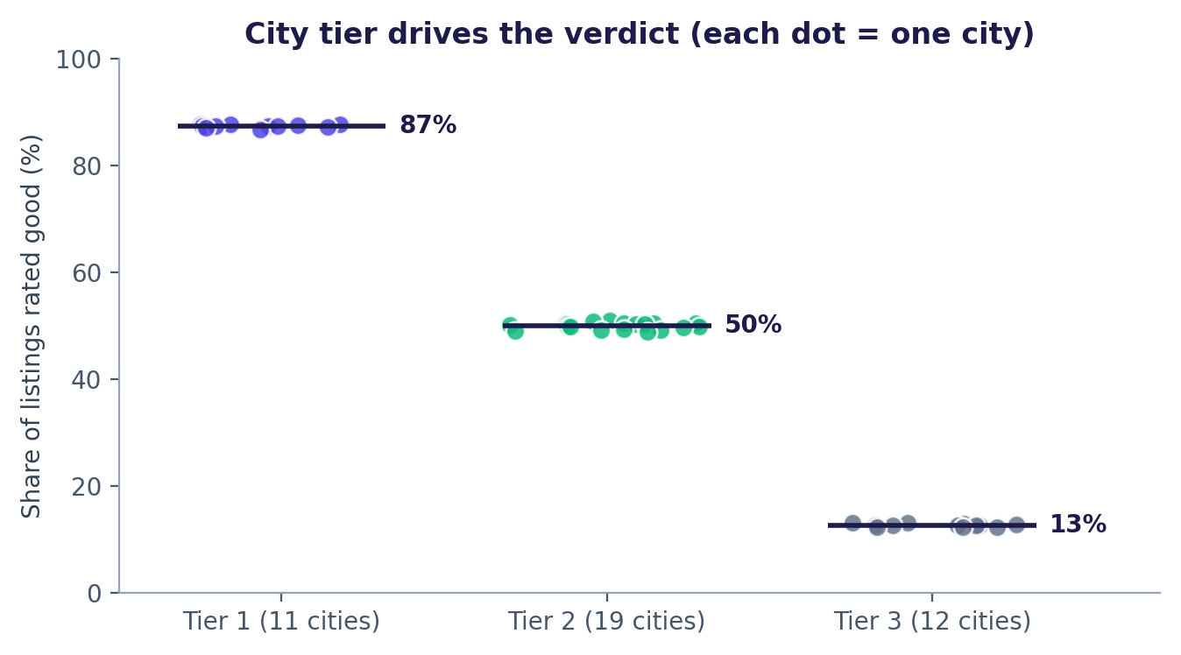
Figure 5. Tier-1 cities (Gurgaon, Pune and Noida lead at 88%) average 87% good-rated listings; Tier 3 averages 12%.
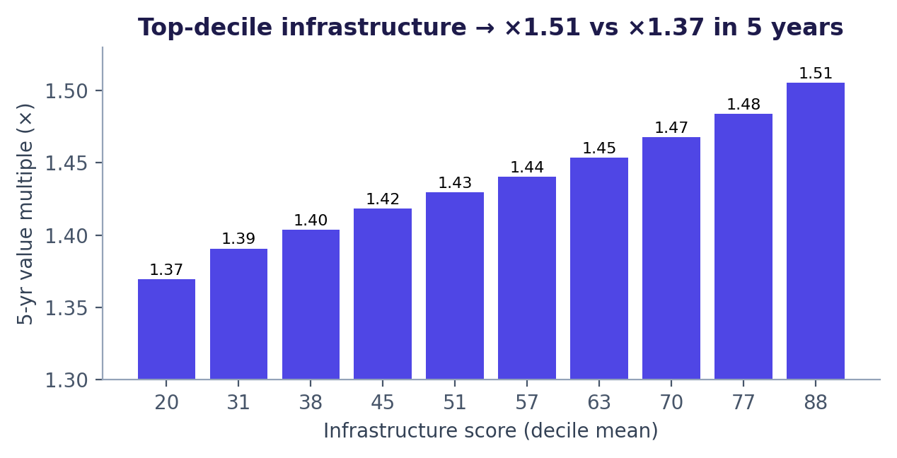
Figure 6. Top-decile infrastructure listings are projected to appreciate ×1.51 vs ×1.37 for the bottom decile.
Honest reading of these results
The transport, infrastructure and tier effects come from the growth rules in Step 1, not observed history. The EDA shows the pipeline recovers them correctly; it does not prove they hold in the real Indian market.

5.2 Model performance
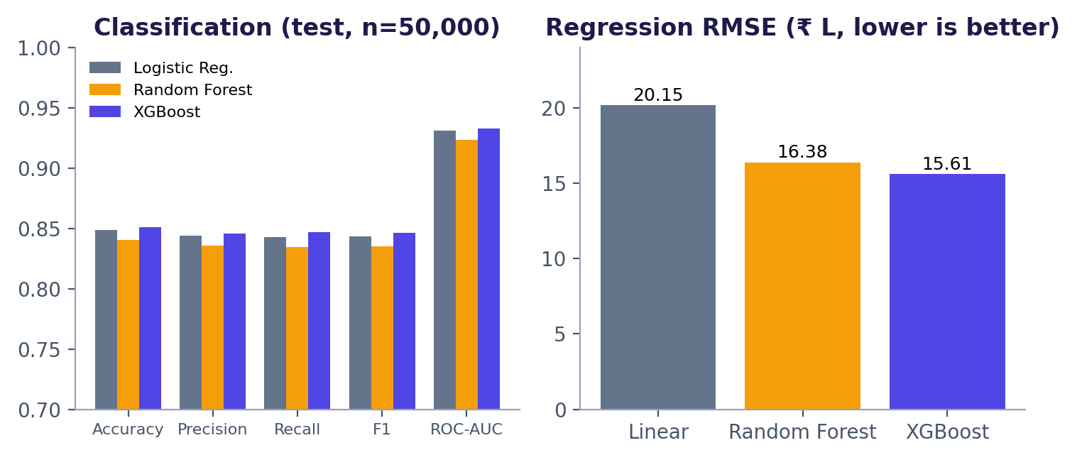
Figure 7. Leaderboards on the held-out test set: XGBoost wins both tasks.
Classifier | Accuracy | Precision | Recall | F1 | ROC-AUC | Fit (s)
Logistic Regression | 0.8485 | 0.8441 | 0.8425 | 0.8433 | 0.9307 | 2.6
Random Forest | 0.8404 | 0.8355 | 0.8346 | 0.8350 | 0.9231 | 7.7
XGBoost | 0.8511 | 0.8457 | 0.8468 | 0.8462 | 0.9329 | 11.7

Regressor | RMSE (₹L) | MAE (₹L) | R² | MAPE | Fit (s)
Linear Regression | 20.15 | 15.33 | 0.9896 | 8.22% | 3.6
Random Forest | 16.38 | 11.52 | 0.9931 | 3.23% | 32.0
XGBoost | 15.61 | 10.99 | 0.9938 | 3.15% | 13.4

XGBoost correctly flags 20,483 of 24,190 true good investments (recall 84.7%) and is right 84.6% of the time when it says buy; only 3,738 weak listings were wrongly recommended. On the regression side, error on the implied annual growth rate is 0.67 percentage points MAE (growth spans roughly 4.7%–10.2%), a stricter view than R², which is inflated because today's price already explains most of the future price.

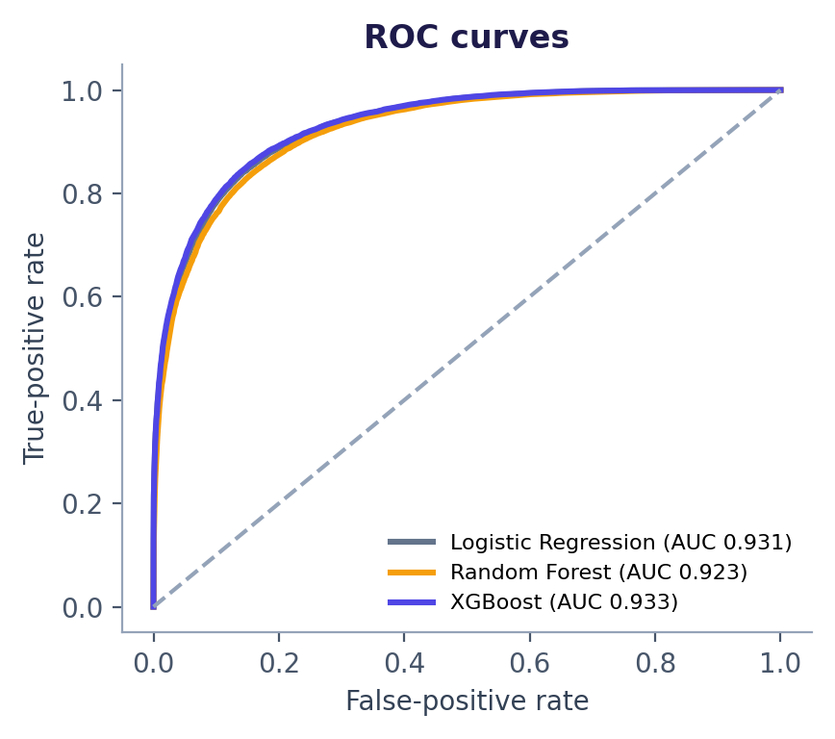
Figure 8. ROC curves: all three classifiers separate the classes well; XGBoost leads (AUC 0.933).
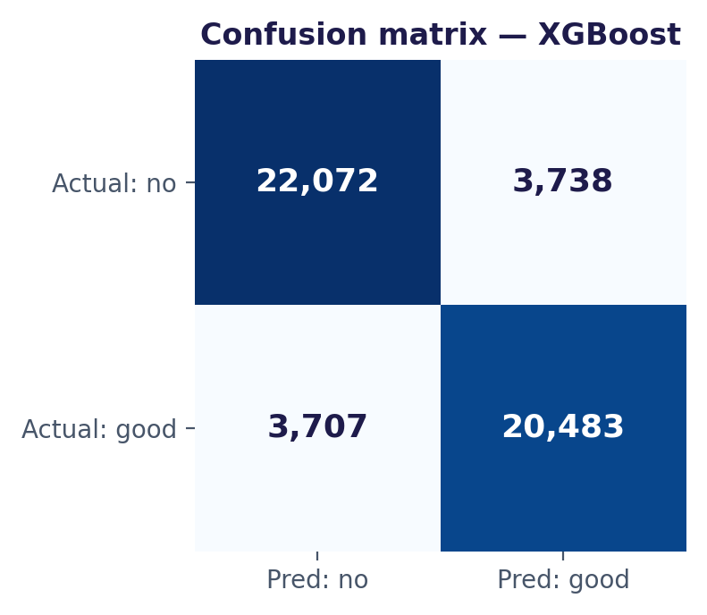
Figure 9. Confusion matrix for XGBoost on 50,000 test listings.

5.3 What drives the models
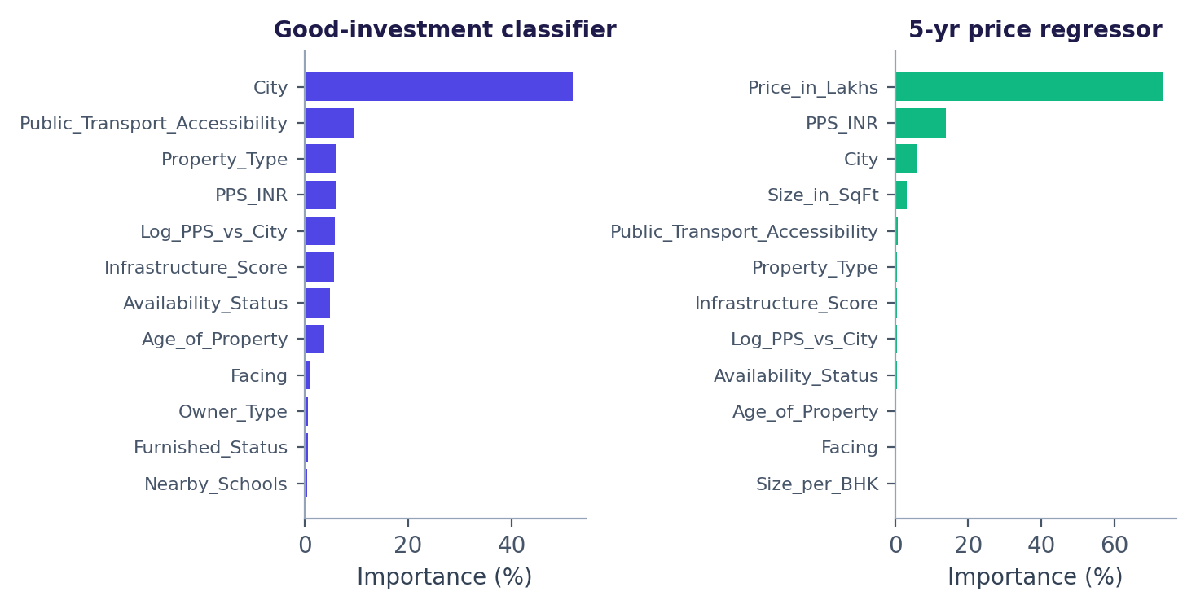
Figure 10. XGBoost importance, one-hot columns grouped back to the original feature.
City (which carries the tier-based growth), transport accessibility and property type lead the classifier. Today's price and ₹/sq ft dominate the price forecast, as expected. After tuning, SHAP re-ranks the classifier drivers as City_Tier, Infrastructure_Score, Log_PPS_vs_City and Age_of_Property, because the engineered tier feature absorbs the one-hot city columns.
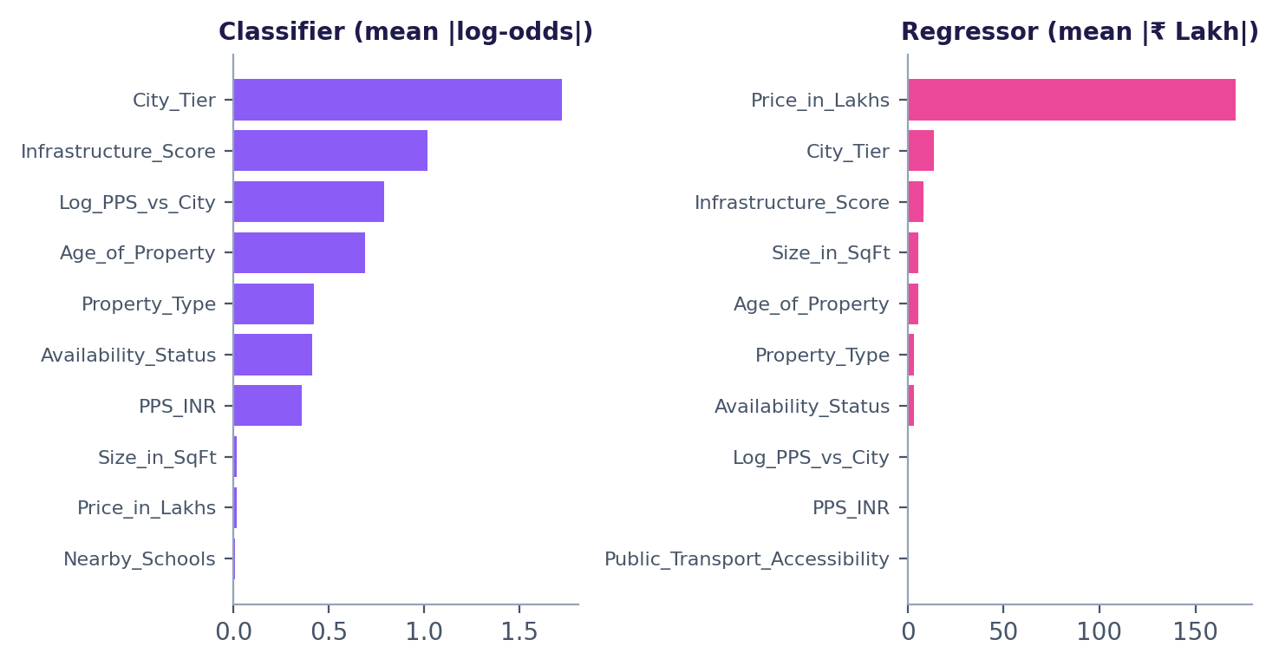
Figure 11. Global SHAP for the tuned models (additivity asserted: base + ΣSHAP = model output).

5.4 Is the model just re-computing the rule? Ablation and baselines
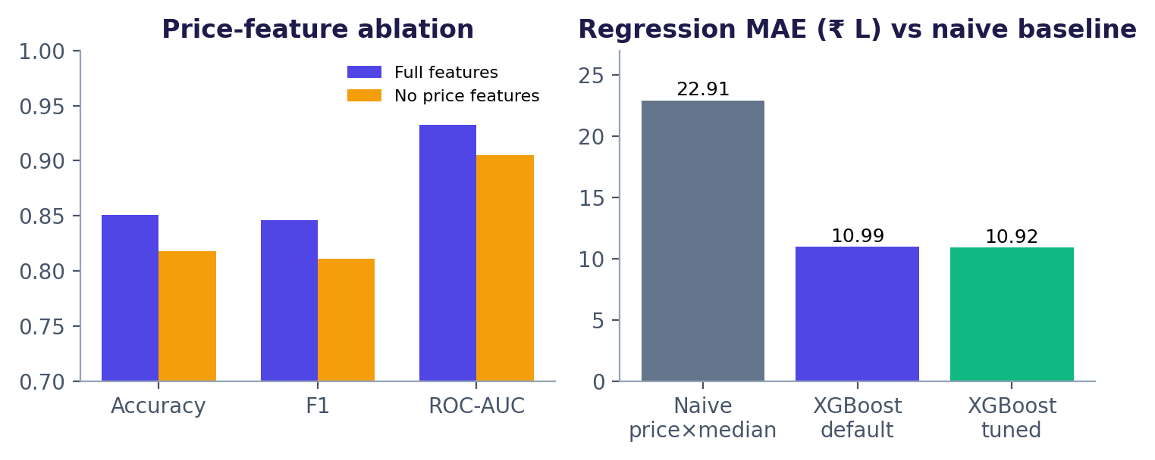
Figure 12. Without any price input the classifier still reaches 81.8% accuracy; the regressor halves the naive baseline error.
Removing Price_in_Lakhs, PPS_INR and Log_PPS_vs_City drops accuracy from 85.1% to 81.8% (AUC 0.933 to 0.905). The model therefore leans mainly on location tier, transport and infrastructure, with price adding the value-for-money signal on top.

5.5 Tuning, calibration and monitoring
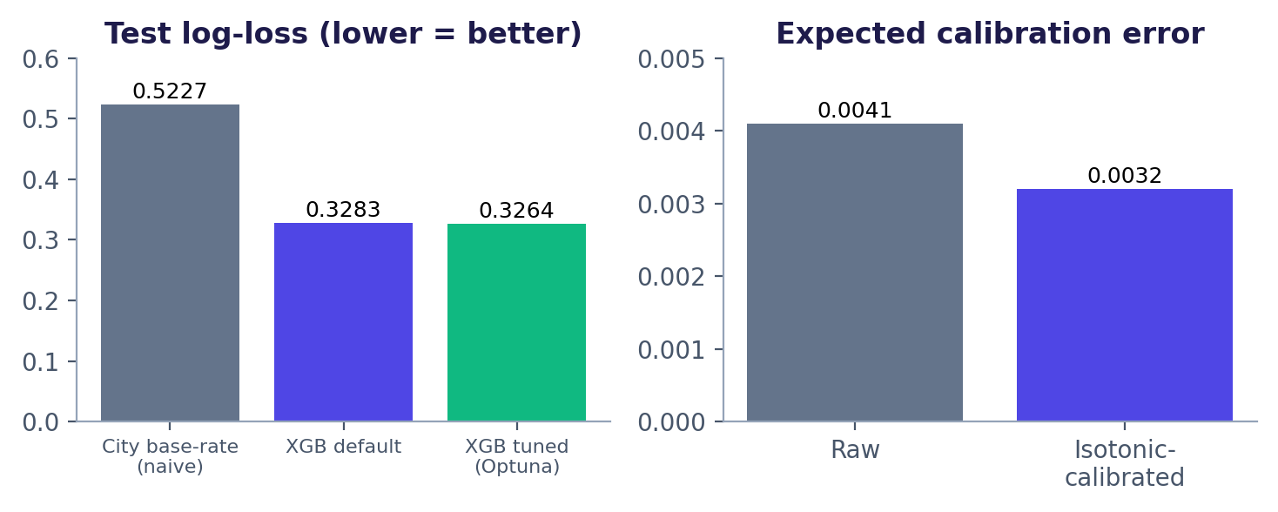
Figure 13. Optuna tuning beats the naive base-rate by 0.196 log-loss; calibration trims ECE by about 22%.
Held-out test metric | City base-rate (naive) | XGBoost default | XGBoost tuned
Log-loss | 0.5227 | 0.3283 | 0.3264
Brier score | 0.1741 | 0.1045 | 0.1038
ROC-AUC | 0.7954 | 0.9329 | 0.9337
Regression MAE (₹L) | 22.91 (price × median multiple) | 10.99 | 10.92
Regression RMSE (₹L) | 32.19 | 15.61 | 15.49

Tuning improves on defaults only marginally (log-loss −0.0019), which is the expected outcome when the target is a deterministic rule plus noise; the notebook reports this rather than overselling it. The calibration map changes little because the raw model was already near-calibrated (ECE 0.0041 to 0.0032), and AUC is unchanged by construction.
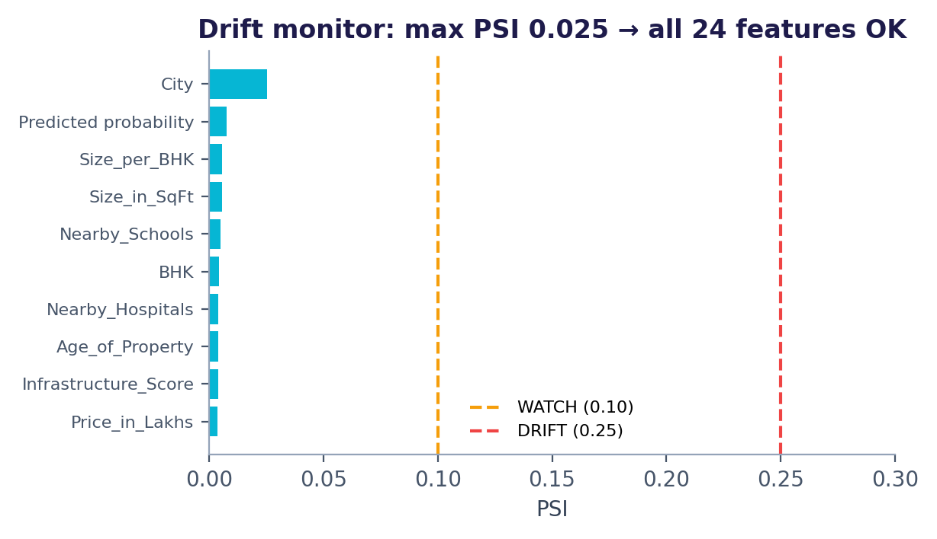
Figure 14. Drift monitor on the test block: every feature sits far below the 0.10 WATCH line.
In legacy (random-split) mode near-zero drift is the correct result and shows the monitor does not raise false alarms. A deliberate +40% price-premium stress test lifts Log_PPS_vs_City to PSI 0.135 (WATCH), confirming the alarm fires on real shifts.

6. Interactive Applications
Two Streamlit apps expose the models. Both use sidebar or form inputs that re-score the listing instantly, with no page reload.

6.1 Insights.py: the live "model committee" advisor
Tab | What the user gets
🔮 Live Advisor | Good / not-good verdict with committee probability, gauge, projected 5-year value with a band showing model disagreement, per-model consensus bars, a what-if curve of verdict vs asking price with an automatic negotiation ceiling, and a same-property-in-every-city comparison
💰 ROI Simulator | Down payment, loan rate, tenure and rental-yield sliders drive EMI, equity build-up vs outstanding loan, net 5-year gain and annualised ROI on equity
🗺️ Market Explorer | Filter by state, type, BHK and price; KPI strip, average price by city, treemap market map, city × type good-investment heatmap, infrastructure vs growth scatter
🧠 Model Arena | Held-out metrics for every model, selectable ROC curves, confusion matrix, actual-vs-predicted scatter, training time and feature importance
📘 About | Pipeline summary and the synthetic-data disclosure

6.2 app_v2.py: the production build (EstateIQ)
Tab | What the user gets
Advisor | Calibrated probability and tuned price forecast with a SHAP "Why this verdict?" breakdown for the listing; every request is logged for monitoring
Market Explorer and Opportunity Heatmap | Filterable market view and a map of where the opportunity is concentrated
Model Arena | Four algorithms compared on one held-out set, with the rule-based-target caveat flagged rather than celebrated
Model Insights | Training mode (real vs legacy), metrics, calibration and the honesty note stored in the model bundle
Monitoring | PSI / KS / χ² drift table and chart against the training reference sample

Why this is recruiter-friendly
A reviewer can open the app, drag the price slider and watch the verdict flip, see which model disagrees, read the SHAP reasons and check the drift tab, all in under two minutes, without opening a notebook.

7. Use Cases
Stakeholder | Use case | How the project supports it
Retail home-buyer or investor | Shortlist screening and negotiation | Instant verdict, 5-year value band, and the price ceiling above which the verdict flips
Buy-to-let investor | Return planning | ROI simulator combining EMI, rental yield, equity build-up and the forecast sale value
Property portal or listing platform | "Investment score" badge on listings | Calibrated probability plus SHAP reasons suitable for display to end users
Mortgage lender / fintech | Collateral appreciation outlook and portfolio screening | 5-year value forecast and city-tier risk view; drift monitor for model governance
Real-estate fund or analyst | City allocation | Same-property-in-every-city comparison and tier-level opportunity map
Developer or builder | Pricing and positioning | Feature effects (infrastructure, transport, under-construction premium) and value-for-money sensitivity
Data-science team (internal) | Reusable MLOps template | Shared feature module, MLflow registry, Optuna tuning, calibration, SHAP, drift monitoring and Docker

8. Limitations and Next Steps

Limitations stated openly
- Targets are rule-based scenarios; the scores measure rule recovery, not real forecasting skill. Nothing here is financial advice.
- No dated price history exists in the CSV, so ARIMA, Prophet and LSTM were deliberately not used.
- Crime rate and RERA are absent; Security and Infrastructure_Score are proxies. In realised mode all listings in a city-month share market growth unless repeat-sale prices are supplied.
- A 5-year horizon with a purge gap needs roughly 12+ years of dated data; the code refuses rather than silently shrinking the gap. Drift monitoring flags input shift, not accuracy loss.

Roadmap
- Supply real data in data/real/ (dated listings, registry price history, NCRB crime rates, RERA projects, metro stations) to switch the pipeline from legacy to realised-outcome mode with no code changes.
- Run the Docker image build and publish to Streamlit Community Cloud or Cloud Run (instructions in DEPLOY.md).
- Increase Optuna trials and add fairness / segment-level error reporting by city tier.

9. Skills Demonstrated and Interview Talking Points
Skill area | Evidence in this project
Data cleaning and EDA | 7-point quality audit, outlier policy, 26 analyses with computed insights and E6 significance-vs-effect-size sweep
Feature and target engineering | Shared housing_utils.py, log-ratio to city benchmark, transparent growth rules with noise to avoid fake 100% scores
Machine learning | Logistic/Ridge, Random Forest, Extra Trees, HistGradientBoosting, XGBoost, MLP, mean ensemble; classification and regression
Rigour | Anti-leakage rules, ablation, naive baselines, purged time split, additivity assertions, registry round-trip test
MLOps | MLflow runs and registry, Optuna, calibration, PSI drift monitor, Docker, pinned requirements
Communication | Interactive Plotly storytelling, Streamlit apps, and upfront disclosure of dataset limits

30-second pitch
I built an end-to-end investment advisor on 250,000 Indian listings. Because the data had no outcomes, I engineered transparent targets, proved the raw columns were nearly independent, and showed the model still beats naive baselines by 52% on price error and 0.20 log-loss on classification. I then calibrated the probabilities, explained each verdict with SHAP, tracked everything in MLflow, added a drift monitor, and shipped it as a live Streamlit app and Docker image, with a realised-outcome mode ready for real data.

Appendix: Repository Map and How to Run
File / folder | Purpose
REALES_1 notebook | Full narrative: preprocessing, EDA, models, MLflow, Optuna, calibration, SHAP, export, deployment files
housing_utils.py | Shared feature engineering, target rules and inference helpers (notebook and apps)
real_data.py | Real-data layer: realised targets, purged split, as-of joins (activates with data/real/)
modeling_v2.py | Optuna + MLflow tuning, calibration, grouped SHAP, serving helpers
monitoring.py | PSI / KS / χ² drift report and inference logging
Insights.py | Live six-model committee advisor with ROI simulator
app_v2.py | Production Streamlit app (calibrated, SHAP, monitoring)
models/, models_v2/, data/ | Model bundles, reference sample, market_sample.csv
Dockerfile, requirements.txt, DEPLOY.md | Containerised deployment and pinned dependencies

Run locally (from the project folder):
pip install -r requirements.txt
streamlit run app_v2.py # production app
streamlit run Insights.py # live committee advisor
mlflow ui --backend-store-uri sqlite:///mlflow.db

