Instagram Performance Analytics — Project Flow & Insights
Sugar Cosmetics · Data Analytics & AI portfolio project · Data window 19 Apr 2024 – 19 Apr 2025
Headline. Sugar Cosmetics' Instagram content performs consistently: 18.54% average engagement rate across 50,000 records. But no post format, weekday, hashtag or campaign type is a statistically proven winner — the gaps between best and worst are all under 2%. The real levers are reach, deeper engagement (comments, saves, shares) and profile-to-follow conversion.

1. Business objective and questions
The marketing team publishes steadily but cannot tell which content, timing and hashtags to invest in. This project answers five business questions from the data:
- Which post type earns the most likes, comments, saves and shares?
- Which weekdays and months are associated with stronger performance?
- Which hashtags are linked to better engagement or reach?
- Are people seeing posts but not interacting?
- What should the team publish — and test — next?

2. Data understanding and validation
Source: sugar_cosmetics_instagram_data (.xlsx and .csv — verified identical). One row = one post-level record.
Check | Result | Meaning
Rows × columns | 50,000 × 14 | 10 text/category fields, 8 numeric metrics
Missing values | 0 | No imputation required
Exact duplicate rows | 0 | No de-duplication required
Negative numbers | 0 | All counts valid
Reach greater than impressions | 0 | Logical relationship holds
Zero values | Shares: 9, Follows: 1 | Valid counts — kept as zero, not imputed
Date range | 19 Apr 2024 – 19 Apr 2025 | First and last months are partial
Categories | 4 post types, 5 campaigns, 4 sources, 5 emotions, 5 hashtags | Spellings consistent

Data caveats. The file has no caption or post ID, so records are labelled "#ID · Format · Campaign · Date". With about 137 records per day, a row is unlikely to be one literal Instagram post, and the flat distributions suggest synthetic or aggregated data. Treat the findings as a validated method and framework; re-run on the brand's real Instagram Insights export before acting.

3. Project flow — from raw file to recommendations
# | Stage | Tool | Output
1 | Understand the business problem | Brief, stakeholder questions | Objectives, questions, KPI list
2 | Understand the dataset | Python (pandas) | Data dictionary, quality report
3 | Clean and validate | preprocess.py | Validated CSV + preprocessed Excel
4 | Create calculated fields | preprocess.py | Total Engagement, Engagement Rate, Month, Day of Week
5 | Build the 10 visualizations | Plotly in Streamlit | 10 titled, insight-annotated views
6 | Build the interactive dashboard | Streamlit sidebar filters | Post type / month / campaign / source / hashtag filters
7 | Interpret and recommend | Analysis + statistical test | Insights doc, business summary, deck

4. KPI definitions
KPI | Formula | Note
Total Engagement | Likes + Comments + Shares + Saves | Project definition, not Instagram's official one
Engagement Rate (%) | Total Engagement ÷ Reach × 100 | Per record; headline = average of records
Profile Visit Rate (%) | Profile Visits ÷ Reach × 100 | Interest in the account
Follow Conversion (%) | Follows ÷ Profile Visits × 100 | Exploratory — attribution rules unverified
Reach Rate (%) | Reach ÷ Impressions × 100 | Share of views that are unique accounts
Summed reach counts the same account once per record, so it is not the number of unique people reached.

5. Findings by analysis

Task 1 — KPI Overview
50,000  Posts (records) | 147.73M  Likes | 18.46M  Comments | 987.42M  Total reach | 18.54%  Avg engagement rate

Total engagement is 183.16M on 1.28B impressions. Likes make up 81% of all interactions; comments 10%, saves 4.8%, shares 4.4%. Every 1,000 accounts reached produce about 185 interactions.

Task 2 — Monthly Posting Trend
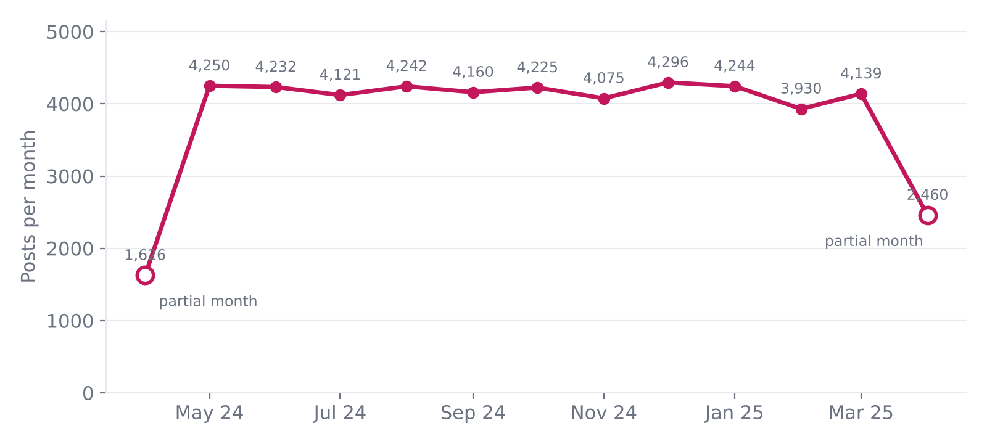
Publishing is steady at roughly 4,000–4,300 records a month. April 2024 and April 2025 look low only because the data covers just part of each month. Consistency is a strength; there is no seasonal posting gap.

Task 3 — Top 10 by Likes
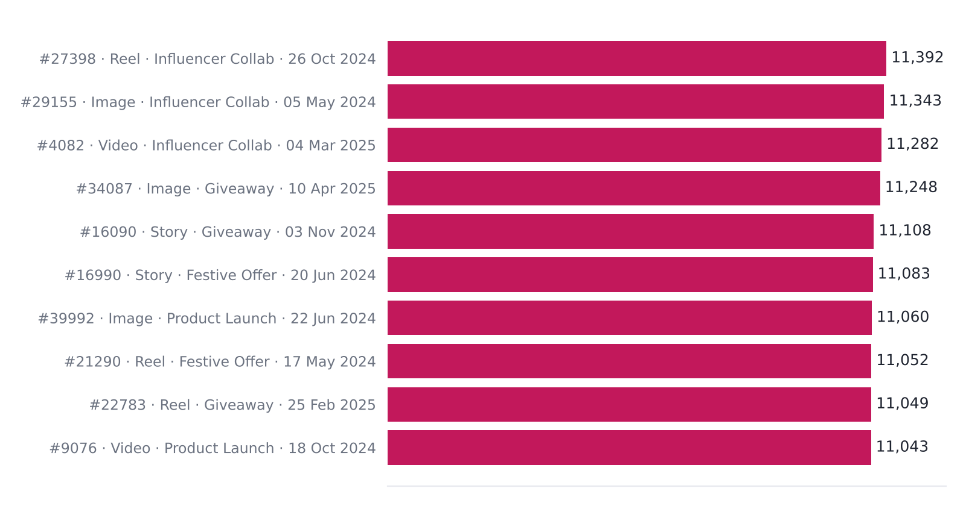
The top 10 average 45,308 reach against 19,748 overall. Likes and reach are strongly correlated (r = 0.79), so "most liked" largely means "most seen". Influencer Collab and Giveaway campaigns appear repeatedly.

Task 4 — Top 10 by Engagement Rate
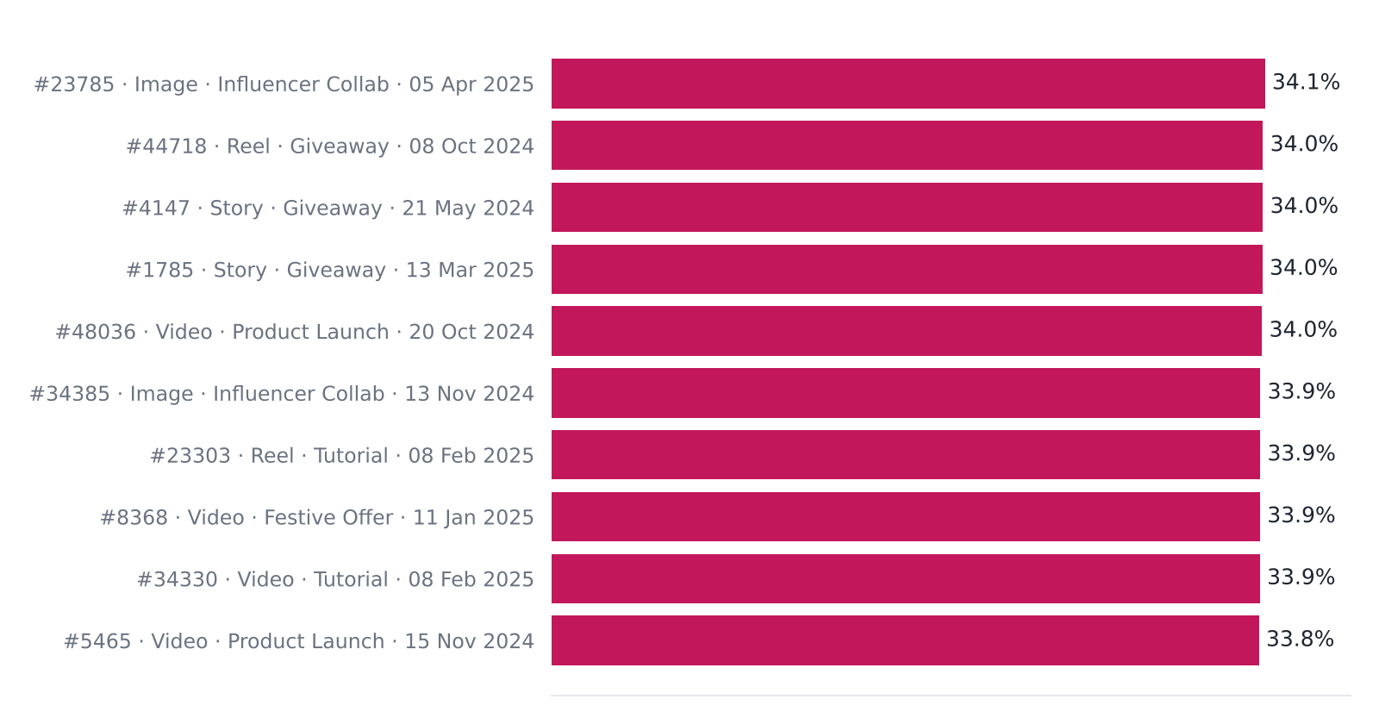
These hidden gems reach 34.1% engagement against the 18.5% average, with a median reach of 23,486 — below average. High engagement does not need huge reach, and none of them appear in the top-10-by-likes list.

Task 5 — Post Type Performance
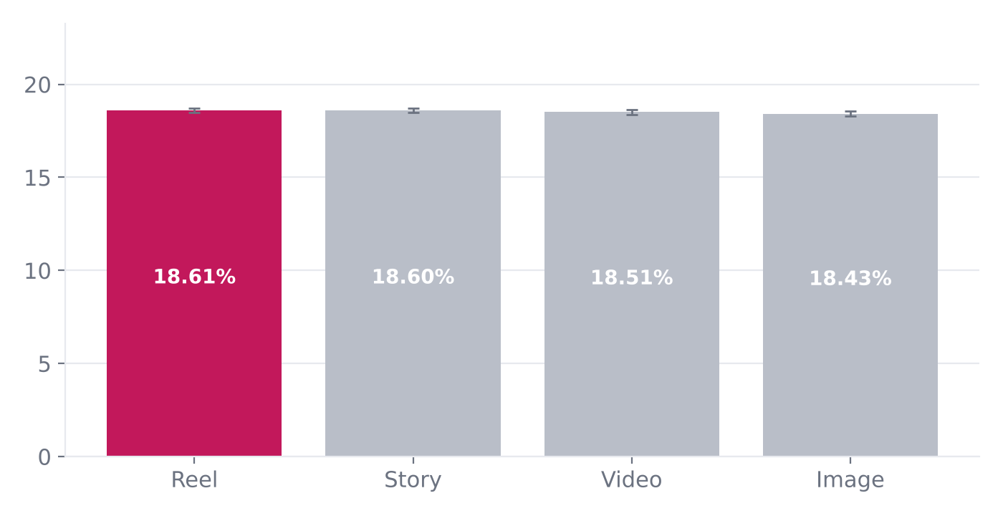
Post type | Records | Avg likes | Avg comments | Avg saves | Avg shares | Eng. rate
Reel | 12,599 | 2,960 | 369 | 178 | 162 | 18.61%
Story | 12,517 | 2,964 | 371 | 178 | 165 | 18.60%
Video | 12,485 | 2,941 | 370 | 176 | 162 | 18.51%
Image | 12,399 | 2,954 | 367 | 177 | 161 | 18.43%

Reel leads on engagement rate (18.61%), but the best-to-worst gap is only 1.0% and the difference is not statistically significant (ANOVA p = 0.15). Format alone is not what drives results.

Task 6 — Day of Week
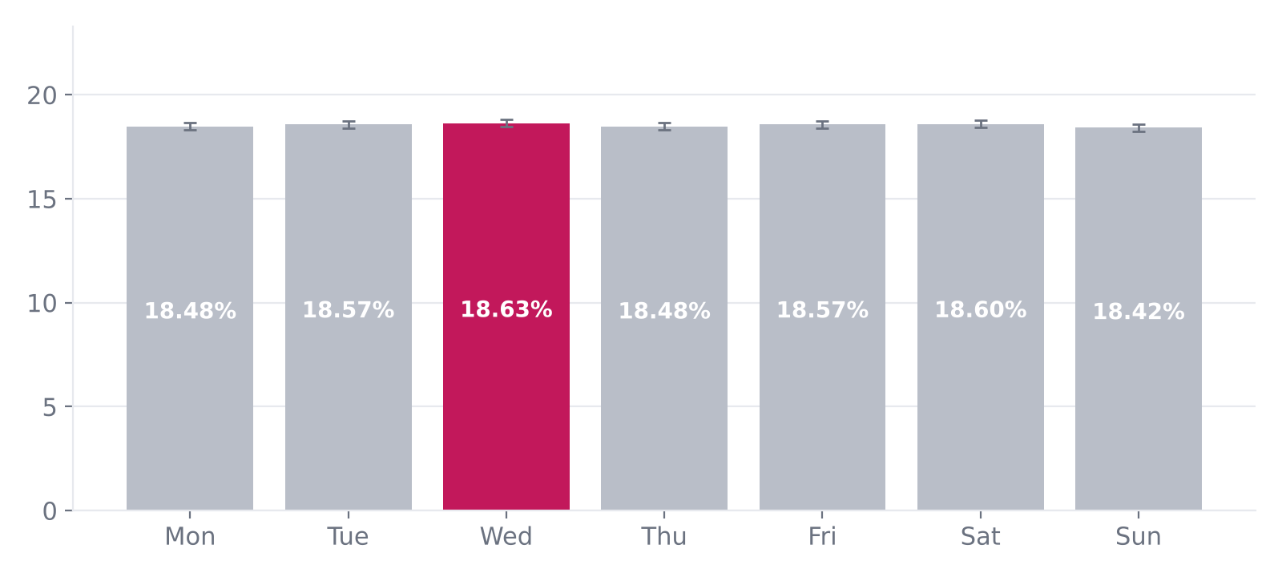
Wednesday is highest (18.63%) and Sunday lowest (18.42%) — a 0.21-point gap. Confidence whiskers overlap (p = 0.57), so there is no proven best day. Hour of posting is not in the data and should be captured.

Task 7 — Engagement Funnel
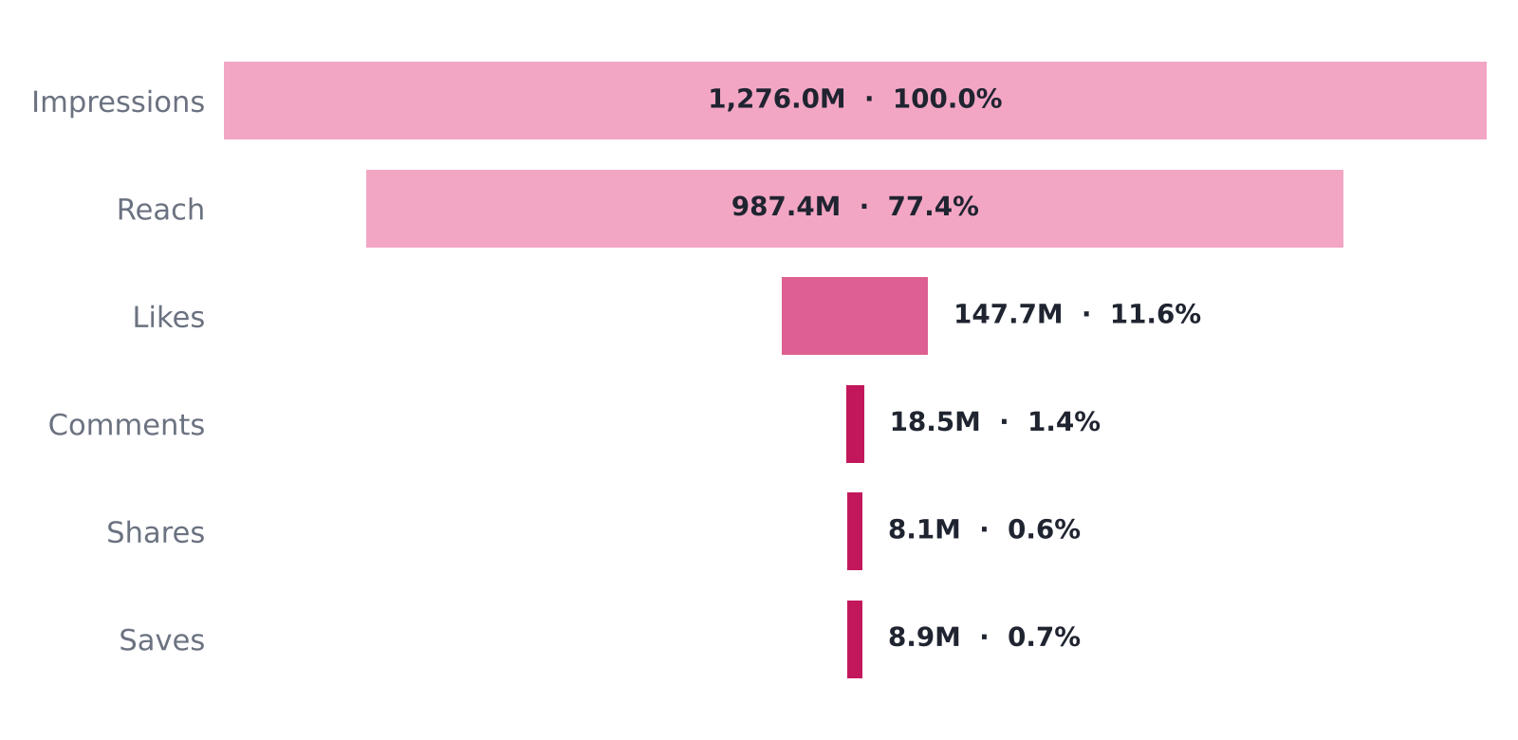
77 of every 100 impressions are unique accounts and about 12 become likes. Comments, shares and saves each convert under 1.5% of impressions — the big drop-off is from seeing to deeper actions. Of reached accounts, 3.0% visit the profile and 30% of visitors follow.

Reach without interaction
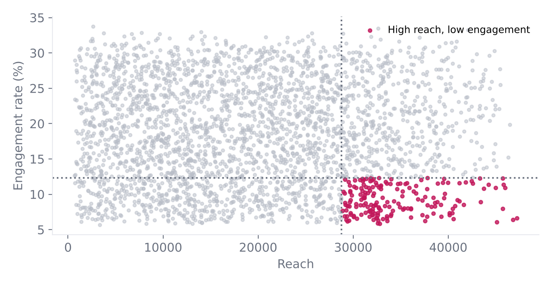
3,117 records (6.2%) combine top-quartile reach (≥ 28,763) with bottom-quartile engagement (≤ 12.3%). Overall, engagement rate is uncorrelated with reach (r = 0.00): more reach brings more interactions, not better ones. These records are the clearest optimisation target.

Task 8 — Hashtag Analysis
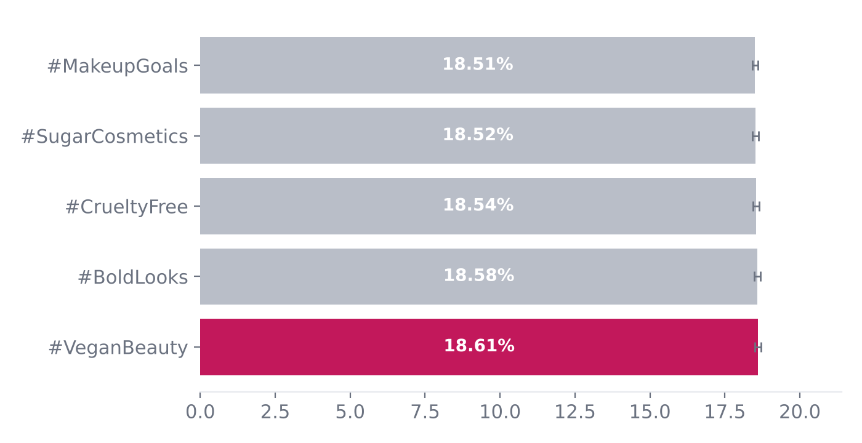
#VeganBeauty leads (18.61%) but all five hashtags sit within 0.10 points of each other and their confidence ranges overlap. Posts with 2 hashtags score marginally highest, again within noise.

Statistical check
Dimension | Best group | Gap (best vs worst) | ANOVA p-value | Verdict
Post type | Reel | 1.0% | 0.15 | Not significant
Weekday | Wednesday | 1.1% | 0.57 | Not significant
Campaign | Influencer Collab | 0.9% | 0.48 | Not significant
Hashtag | #VeganBeauty | 0.5% | 0.63* | Not significant
* Indicative: a post carrying several hashtags counts once per hashtag, so groups overlap.

6. Strategic recommendations
Action | What to do | Evidence
Scale reach | Invest in amplification: influencer collabs, boosted proven creatives, Reels/Stories distribution. | Engagement rate is flat as reach grows; ~185 interactions per 1,000 reached.
Fix 'seen but ignored' | Audit high-reach, low-engagement posts for weak hooks and missing calls-to-action; add polls, questions, giveaways. | 6.2% of records (3,117).
Deepen engagement | Create save-worthy tutorials and share-worthy festive/challenge content. | Likes are 81% of interactions.
Convert visitors | Strengthen bio, highlights, pinned posts and link-in-bio offers; add 'follow for shade drops' end frames. | 3.0% visit profile; 30% of visitors follow.
Test, don't guess | Run 4-week A/B tests: Reel vs Image, 2 vs 3 hashtags, morning vs evening. Act only on significant results. | All format/day/hashtag gaps are within noise.
Keep the base | Maintain steady cadence, balanced format mix and the five brand/value hashtags. | Posting volume and engagement are consistent month to month.
Close data gaps | Capture post ID, caption, posting hour, carousel format, ad spend and follower count. | Needed for timing, caption, ROI and growth analysis.

Content and campaign ideas
- Tutorial Reels series ("5-minute festive look") — built for saves and shares.
- Influencer collab takeovers with a giveaway mechanic — built for reach plus comments.
- Festive Offer Stories with poll and quiz stickers — interaction at scale.
- Vegan and cruelty-free brand-values content — on-brand, consistently performing hashtag themes.
- Profile-visit nudges in the last frame of high-reach posts.

