Business Summary — Sugar Cosmetics Instagram Performance
Executive brief for the marketing team · 19 Apr 2024 – 19 Apr 2025 · 50,000 post-level records
Bottom line. Instagram performance is healthy and steady, but none of the seven levers tested — format, weekday, campaign, audience emotion, source, hashtag and hashtag count — is a proven winner (gaps of only 0.5–1.1%). Growth will come from more reach, deeper engagement and better follower conversion, not from re-allocating effort between formats.

50,000  Posts (records) | 987.42M  Total reach | 147.73M  Likes | 18.46M  Comments | 18.54%  Avg engagement

What we found
- Performance is consistent. Posting is steady at about 4,100 records a month and engagement rate stays near 18.5% every month.
- No format is a clear winner. Reel (18.61%), Story, Video and Image are within 0.18 points; the difference is not statistically significant.
- No proven best day or hashtag. Wednesday (18.63%) edges Sunday (18.42%); hashtags differ by 0.10 points. Both are within noise.
- Reach, not format, drives volume. Likes track reach closely (r = 0.79); engagement rate does not (r = 0.00).
- Most interaction is shallow. Likes are 81% of interactions; comments, saves and shares together are 19%.
- Audience and source do not matter much either. Curious (18.62%) and Excited (18.47%) differ by 0.16 points; paid, organic, influencer and collab posts perform alike.
- Audience growth has a clear funnel. 3.0% of reach visits the profile and 30% of visitors follow — about 8.87M follows in the year, ~740K a month.
- One signal worth testing. Posts with 2 hashtags score 18.63% vs 18.44% for 1 hashtag — borderline significant (p = 0.05).
- A fixable gap exists. 6.2% of records (3,117) were widely seen but earned little engagement.
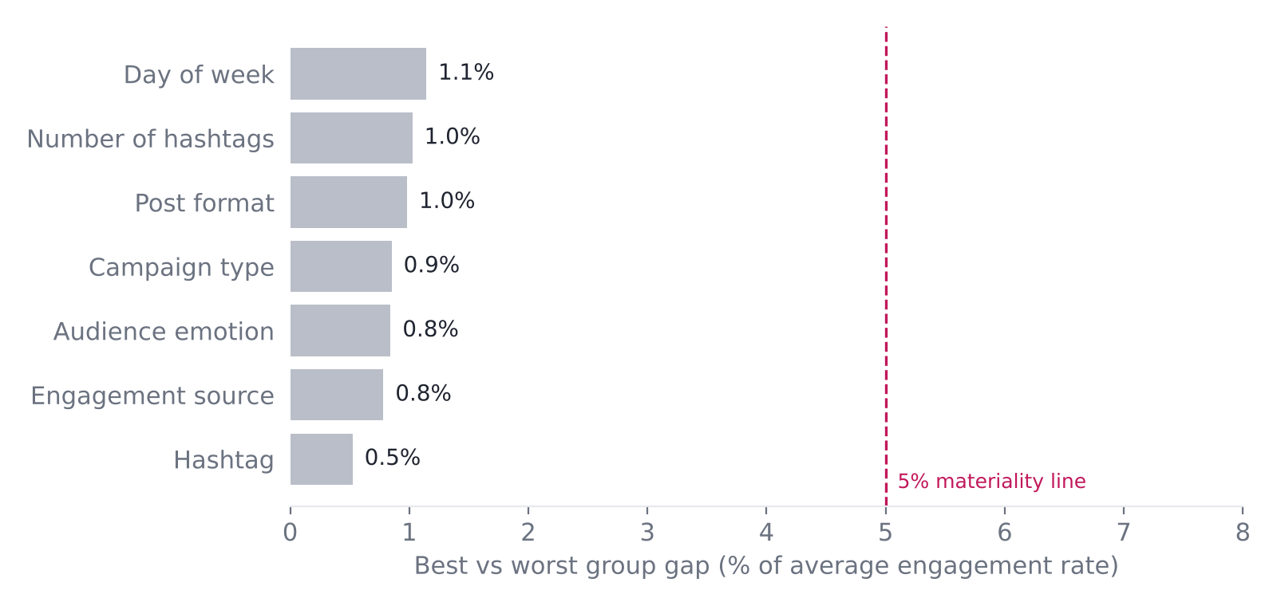

What to do next
- Scale reach through influencer collabs and boosting the strongest creatives.
- Rescue high-reach, low-engagement posts with stronger hooks and clear calls-to-action.
- Build save- and share-worthy content — tutorials, festive offers, challenges — to move beyond likes.
- Optimise the profile (bio, highlights, link-in-bio) to lift follow conversion.
- Run 4-week A/B tests starting with hashtag count (2 vs 1/3), then format and posting time, before changing the content mix.
- Capture richer data (post ID, caption, posting hour, ad spend, follower count).

Data note. The dataset has no captions or post IDs and shows about 137 records per day with unusually flat distributions, which suggests synthetic or aggregated data. Treat these results as a validated framework and confirm them on the brand's live Instagram Insights export.

