Instagram Performance Analytics — Project Flow & Insights
Sugar Cosmetics · Data Analytics & AI portfolio project · Data window 19 Apr 2024 – 19 Apr 2025
Headline. Sugar Cosmetics' Instagram content performs consistently: 18.54% average engagement rate across 50,000 records. But none of the seven levers tested — post format, weekday, campaign, audience emotion, engagement source, hashtag and hashtag count — is a proven winner: best-to-worst gaps are only 0.5–1.1%, far below a 5% materiality line. The real levers are reach, deeper engagement (comments, saves, shares) and profile-to-follow conversion.

1. Business objective and questions
The marketing team publishes steadily but cannot tell which content, timing and hashtags to invest in. This project answers five business questions from the data:
- Which post type earns the most likes, comments, saves and shares?
- Which weekdays and months are associated with stronger performance?
- Which hashtags are linked to better engagement or reach?
- Are people seeing posts but not interacting?
- What should the team publish — and test — next?

How the dashboard answers them
The Streamlit dashboard has ten tabs. A shared sidebar (date range, post type, campaign, engagement source, audience emotion, hashtag) filters every view.
Dashboard tab | Question it answers
Executive Summary | How is the account performing overall? (KPIs, key takeaways, engagement mix)
Trends | How consistent is publishing, and how is engagement moving? (monthly posts, engagement rate, content mix)
Content | Which formats and campaigns perform best? (averages, lift vs overall, campaign × format heatmap)
Timing | Does the day of the week matter? (weekday engagement with confidence intervals, volume, weekday × format)
Funnel & Growth | Are people seeing posts but not interacting — and do they follow? (funnel, reach-gap scatter)
Hashtags | Which hashtags and hashtag counts are linked to stronger performance?
Audience | Who engages, where do they come from, and do they follow? (emotion, source quality, follower growth, follow conversion)
Top Posts | Which records stand out on likes, engagement rate, reach, comments, shares, saves or follows?
Explorer | Can the team build its own view? (any metric × any dimension, two-way heatmap)
Strategy & AI | What should we do next? (lever scorecard, recommended actions, campaign ideas)

2. Data understanding and validation
Source: sugar_cosmetics_instagram_data (.xlsx and .csv — verified identical). One row = one post-level record.
Check | Result | Meaning
Rows × columns | 50,000 × 14 | 10 text/category fields, 8 numeric metrics
Missing values | 0 | No imputation required
Exact duplicate rows | 0 | No de-duplication required
Negative numbers | 0 | All counts valid
Reach greater than impressions | 0 | Logical relationship holds
Zero values | Shares: 9, Follows: 1 | Valid counts — kept as zero, not imputed
Date range | 19 Apr 2024 – 19 Apr 2025 | First and last months are partial
Categories | 4 post types, 5 campaigns, 4 sources, 5 emotions, 5 hashtags | Spellings consistent

Data caveats. The file has no caption or post ID, so records are labelled "#ID · Format · Campaign · Date". With about 137 records per day, a row is unlikely to be one literal Instagram post, and the flat distributions suggest synthetic or aggregated data. Treat the findings as a validated method and framework; re-run on the brand's real Instagram Insights export before acting.

3. Project flow — from raw file to recommendations
# | Stage | Tool | Output
1 | Understand the business problem | Brief, stakeholder questions | Objectives, questions, KPI list
2 | Understand the dataset | Python (pandas) | Data dictionary, quality report
3 | Clean and validate | preprocess.py | Validated CSV + preprocessed Excel
4 | Create calculated fields | preprocess.py | Total Engagement, Engagement Rate, Month, Day of Week
5 | Build the 10 visualizations | Plotly in Streamlit | 10 titled, insight-annotated views
6 | Build the interactive dashboard | Streamlit sidebar filters | Post type / month / campaign / source / hashtag filters
7 | Interpret and recommend | Analysis + statistical test | Insights doc, business summary, deck

4. KPI definitions
KPI | Formula | Note
Total Engagement | Likes + Comments + Shares + Saves | Project definition, not Instagram's official one
Engagement Rate (%) | Total Engagement ÷ Reach × 100 | Per record; headline = average of records
Profile Visit Rate (%) | Profile Visits ÷ Reach × 100 | Interest in the account
Follow Conversion (%) | Follows ÷ Profile Visits × 100 | Exploratory — attribution rules unverified
Reach Rate (%) | Reach ÷ Impressions × 100 | Share of views that are unique accounts
Summed reach counts the same account once per record, so it is not the number of unique people reached.

5. Findings by analysis

Task 1 — KPI Overview
50,000  Posts (records) | 147.73M  Likes | 18.46M  Comments | 987.42M  Total reach | 18.54%  Avg engagement rate

Total engagement is 183.16M on 1.28B impressions. Likes make up 81% of all interactions; comments 10%, saves 4.8%, shares 4.4%. Every 1,000 accounts reached produce about 185 interactions.

Task 2 — Monthly Posting Trend
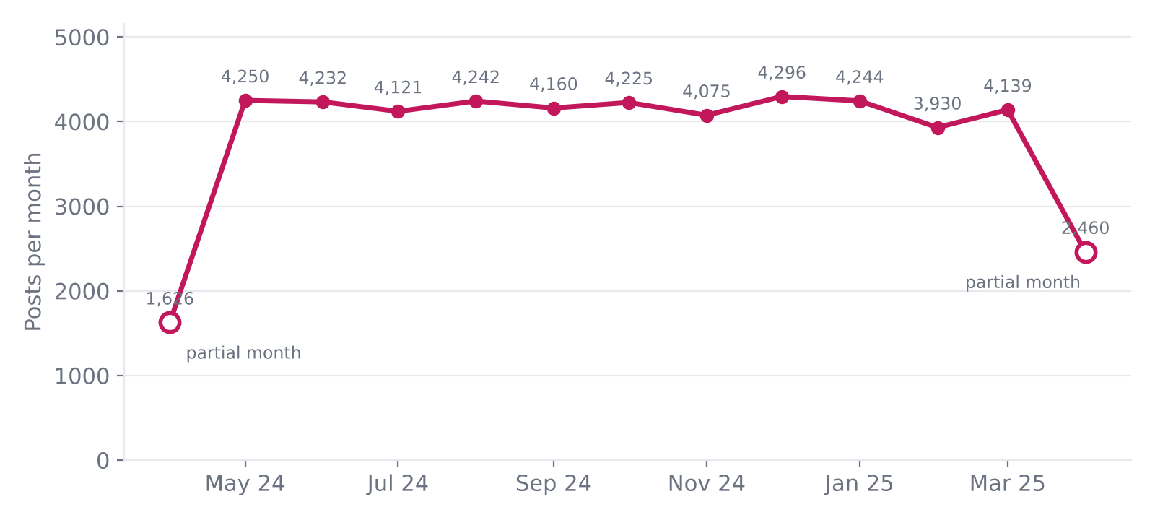
Publishing is steady at roughly 4,000–4,300 records a month. April 2024 and April 2025 look low only because the data covers just part of each month. Consistency is a strength; there is no seasonal posting gap.

Task 3 — Top 10 by Likes
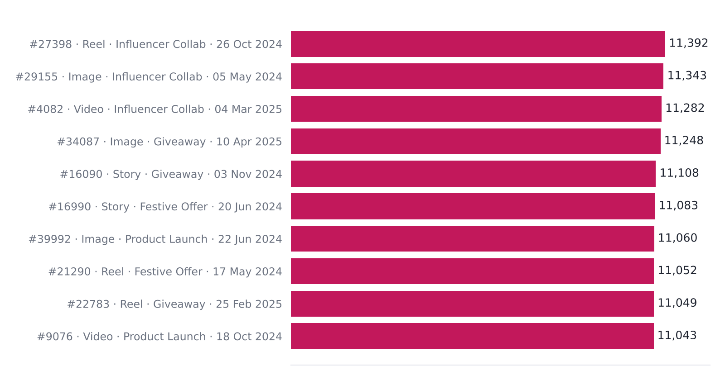
The top 10 average 45,308 reach against 19,748 overall. Likes and reach are strongly correlated (r = 0.79), so "most liked" largely means "most seen". Influencer Collab and Giveaway campaigns appear repeatedly.

Task 4 — Top 10 by Engagement Rate
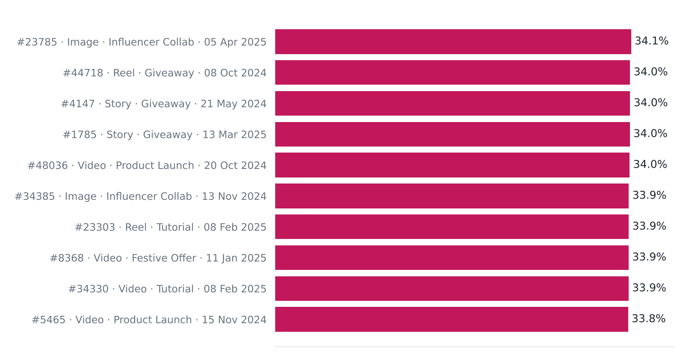
These hidden gems reach 34.1% engagement against the 18.5% average, with a median reach of 23,486 — below average. High engagement does not need huge reach, and none of them appear in the top-10-by-likes list.

Task 5 — Post Type Performance
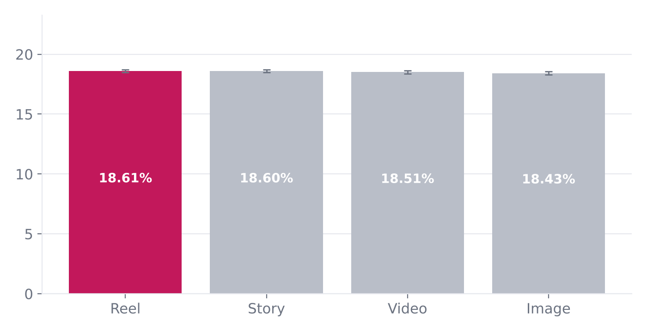
Post type | Records | Avg likes | Avg comments | Avg saves | Avg shares | Eng. rate
Reel | 12,599 | 2,960 | 369 | 178 | 162 | 18.61%
Story | 12,517 | 2,964 | 371 | 178 | 165 | 18.60%
Video | 12,485 | 2,941 | 370 | 176 | 162 | 18.51%
Image | 12,399 | 2,954 | 367 | 177 | 161 | 18.43%

Reel leads on engagement rate (18.61%), but the best-to-worst gap is only 1.0% and the difference is not statistically significant (ANOVA p = 0.15). Format alone is not what drives results.

Task 6 — Day of Week
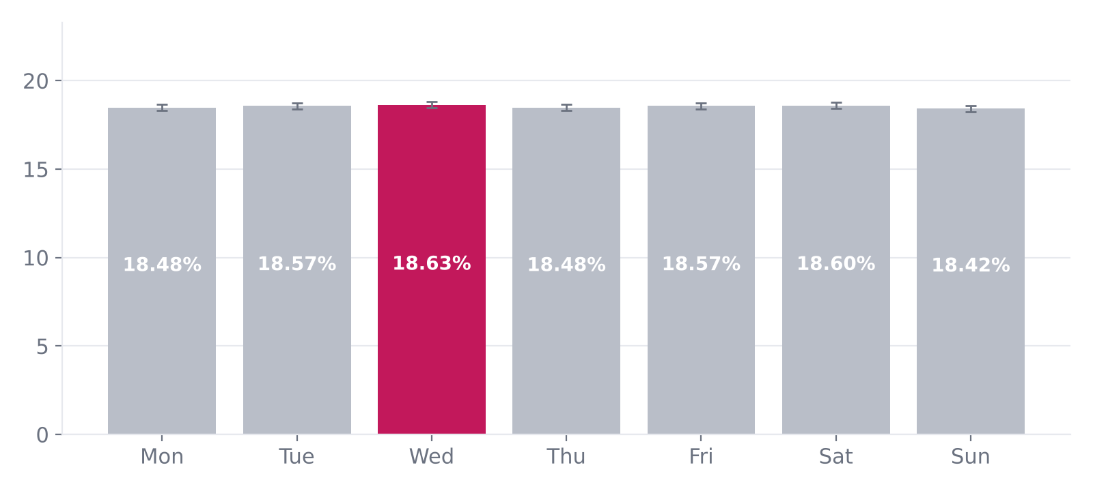
Wednesday is highest (18.63%) and Sunday lowest (18.42%) — a 0.21-point gap. Confidence whiskers overlap (p = 0.57), so there is no proven best day. Hour of posting is not in the data and should be captured.

Task 7 — Engagement Funnel
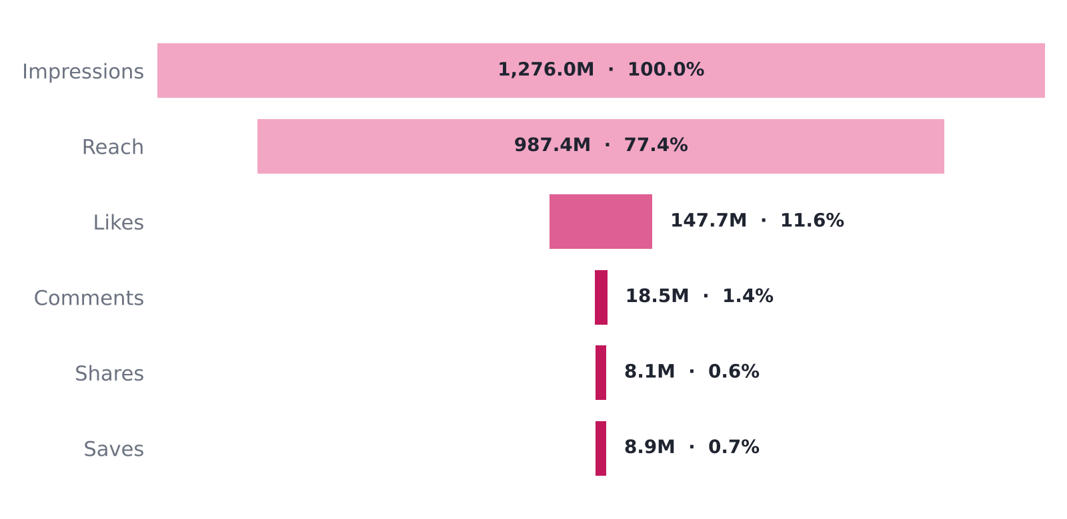
77 of every 100 impressions are unique accounts and about 12 become likes. Comments, shares and saves each convert under 1.5% of impressions — the big drop-off is from seeing to deeper actions. Of reached accounts, 3.0% visit the profile and 30% of visitors follow.

Reach without interaction
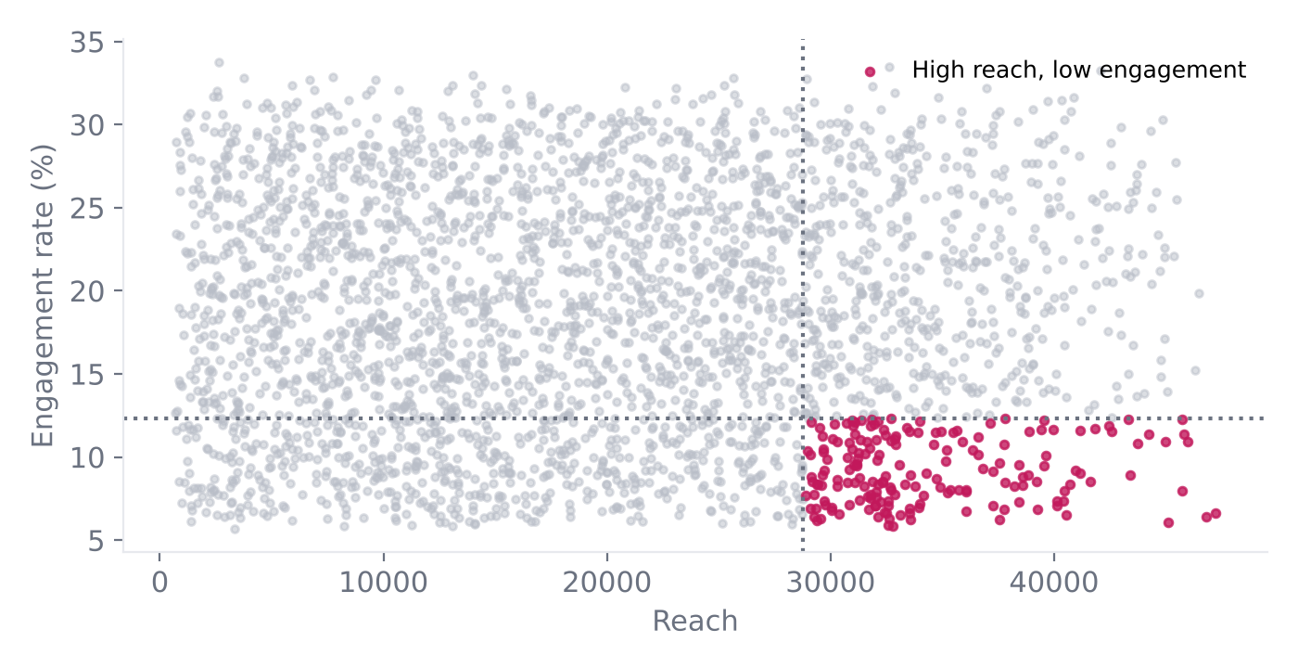
3,117 records (6.2%) combine top-quartile reach (≥ 28,763) with bottom-quartile engagement (≤ 12.3%). Overall, engagement rate is uncorrelated with reach (r = 0.00): more reach brings more interactions, not better ones. These records are the clearest optimisation target.

Task 8 — Hashtag Analysis
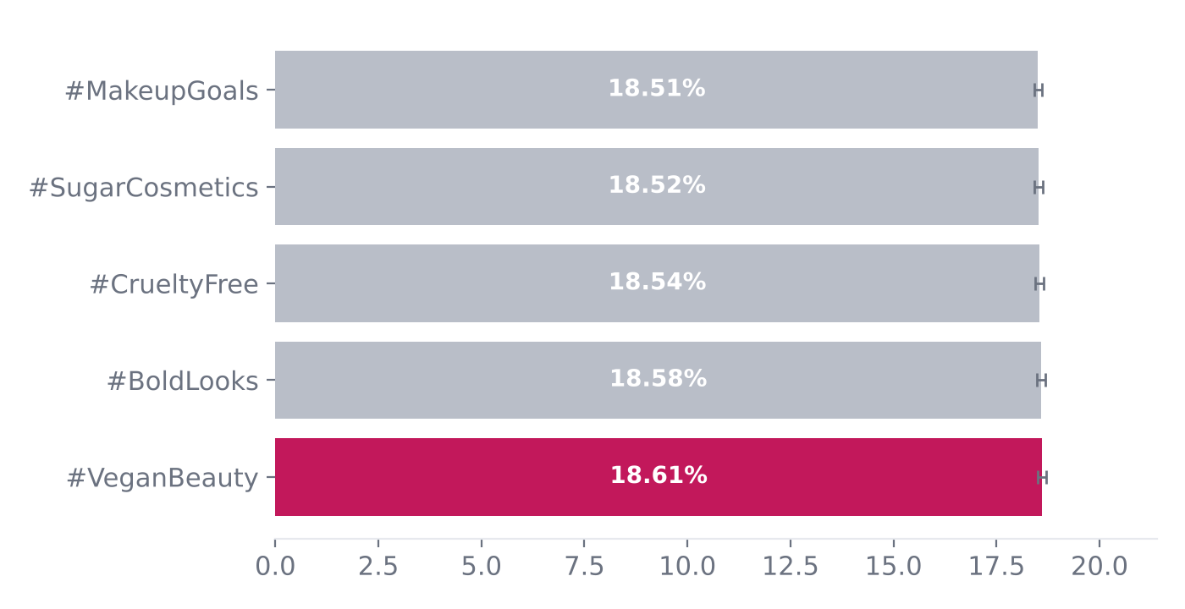
#VeganBeauty leads (18.61%) but all five hashtags sit within 0.10 points of each other and their confidence ranges overlap. Posts with 2 hashtags score highest (18.63% vs 18.44% for 1 hashtag). That gap is the largest hashtag-related signal and sits just outside conventional significance (ANOVA p = 0.054), so it is the first thing worth A/B testing.

Content lift versus the overall average
Relative to the 18.54% account average, Reel is +0.4% and Story +0.34%, while Image is -0.59% and Video -0.16%. By campaign, Influencer Collab is +0.32%, Tutorial +0.26%, Giveaway +0.16%, Product Launch -0.22% and Festive Offer -0.53%. Every lift is well under 1% — directionally useful, but too small to justify shifting budget on its own.

Audience — who engages and where from
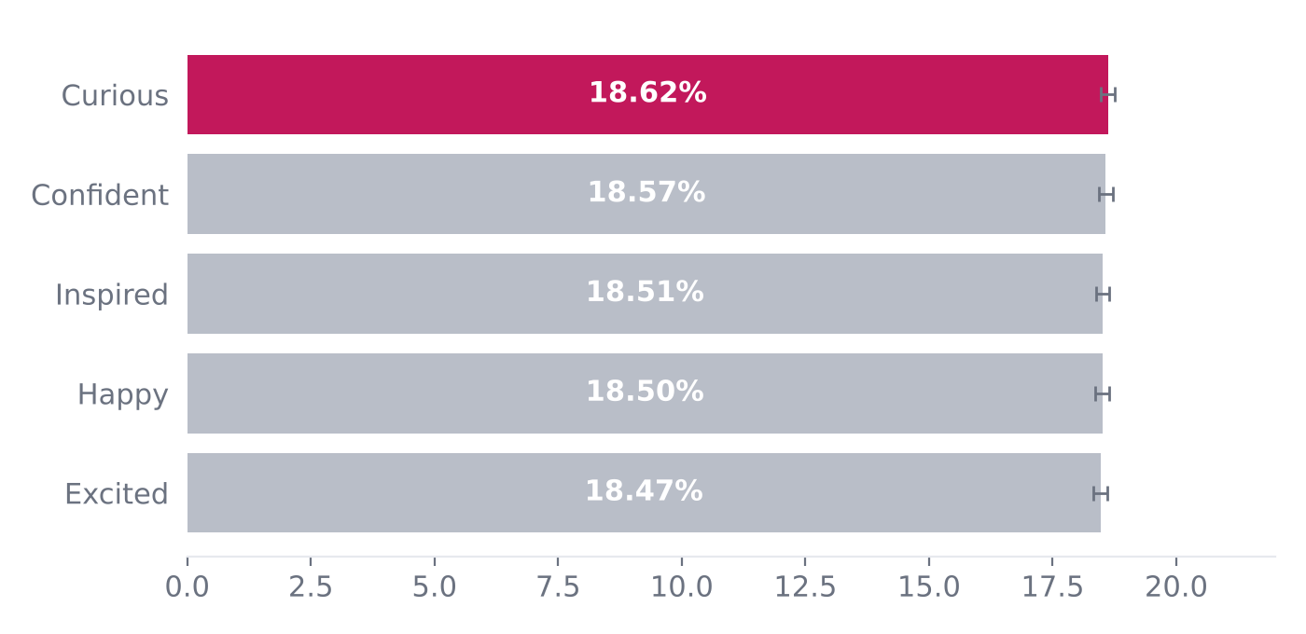
Curious content has the highest engagement rate (18.62%) and Excited the lowest (18.47%); whiskers overlap (p = 0.56), so emotion is not a reliable lever.
Engagement source | Records | Avg reach | Avg engagement rate | Avg follows
Collab | 12,633 | 19,707 | 18.59% | 177
Influencer | 12,501 | 19,699 | 18.58% | 175
Paid | 12,358 | 19,617 | 18.53% | 178
Organic | 12,508 | 19,970 | 18.44% | 179

Source quality is nearly identical. Organic posts reach the most accounts on average (19,970) but convert slightly less of that reach into interactions (18.44%); Collab leads on engagement rate (18.59%). The spread is 0.8% (p = 0.35), so paid, influencer, collab and organic are performing alike.

Follower growth and conversion
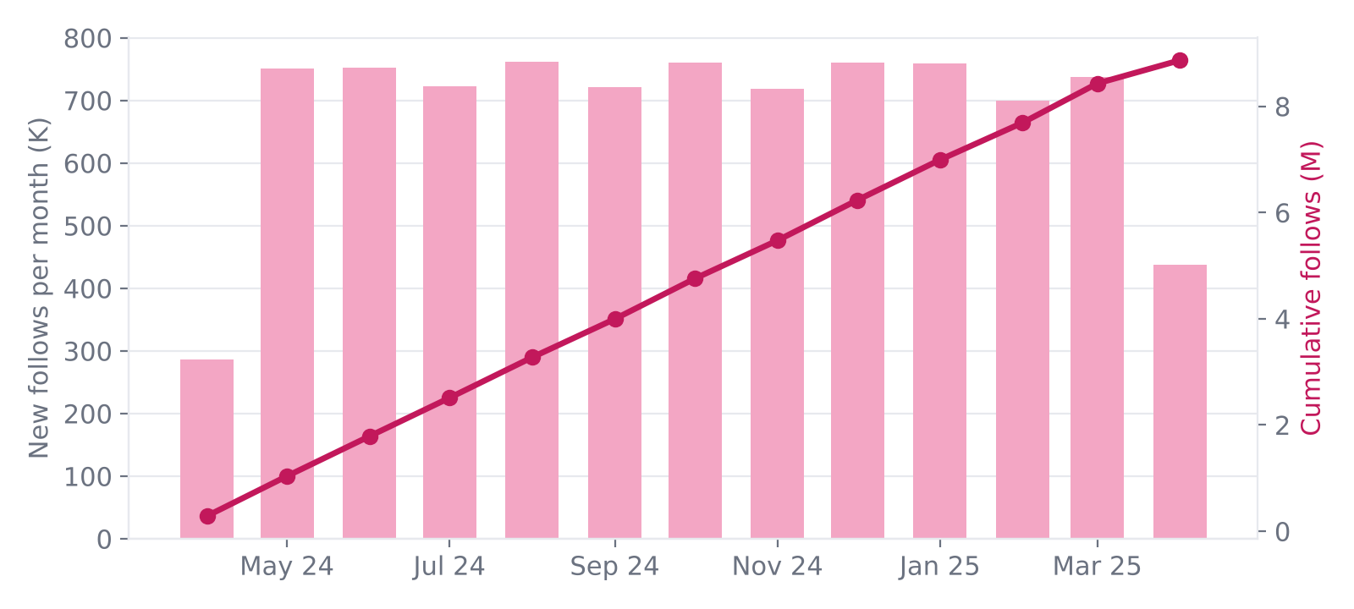
The account gained 8.87M follows over the period — about 740,236 in a typical full month — with growth tracking posting volume. 3.0% of reach visits the profile and 29.9% of visitors follow (follows ÷ profile visits; exploratory because attribution rules are unverified).
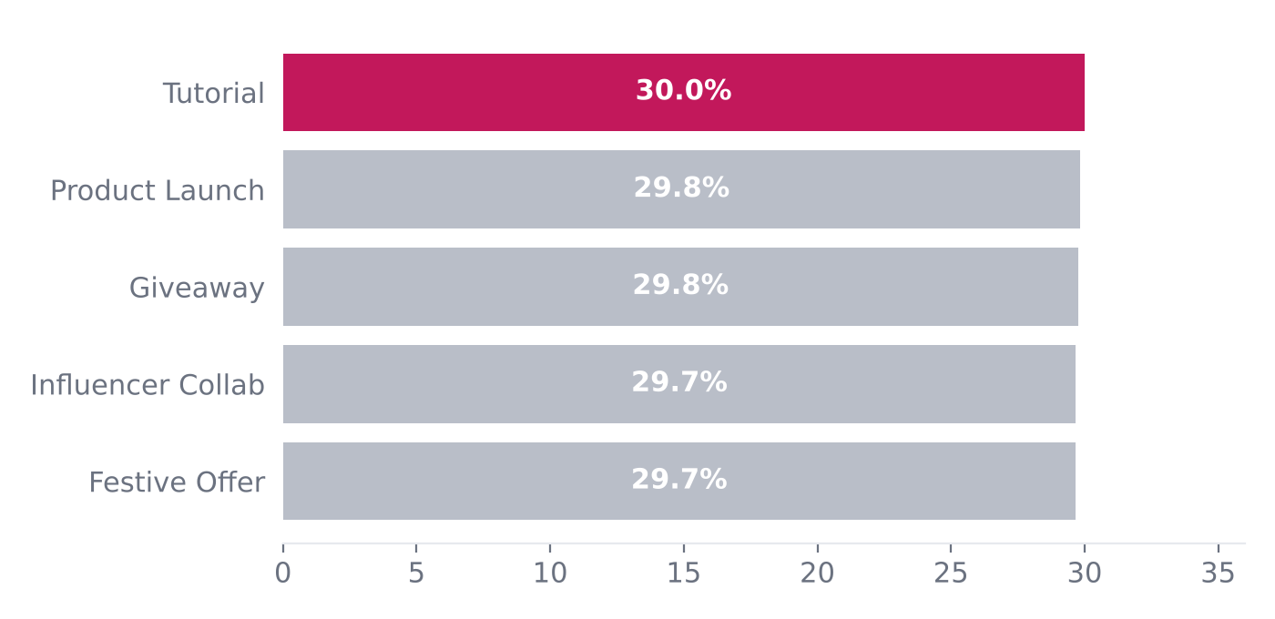
Average profile-visit-to-follow conversion by campaign is almost identical (about 29.7–30.0%): Tutorial is highest, Festive Offer and Influencer Collab lowest. Conversion is therefore a profile-level lever (bio, highlights, link-in-bio), not a campaign-level one.

Top posts across every metric
The Top Posts tab ranks records by likes, engagement rate, reach, comments, shares, saves or follows. Whatever the metric, the leaders are large-reach records: the top 8 for each metric average 43,848–45,553 reach against 19,748 overall. Reach correlates strongly with likes (r = 0.79), comments (0.68), saves (0.66), follows (0.66) and shares (0.62) — but not with engagement rate (0.00). The only ranking that surfaces smaller, over-performing records is engagement rate.

Lever scorecard — are any of these differences real?
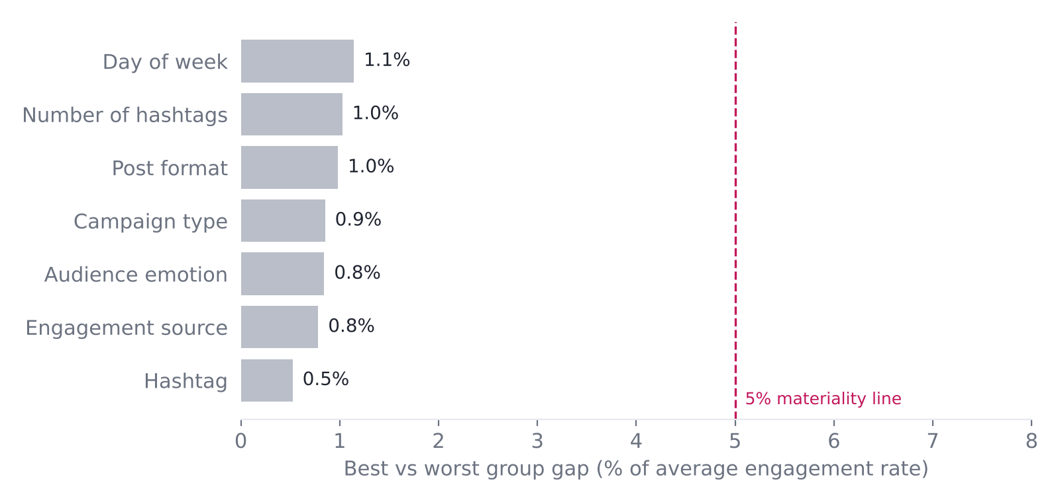
Lever | Best group | Worst group | Gap | ANOVA p | Verdict
Day of week | Wednesday | Sunday | 1.1% | 0.57 | Within noise
Number of hashtags | 2 hashtags | 1 hashtag | 1.0% | 0.05 | Borderline — test
Post format | Reel | Image | 1.0% | 0.15 | Within noise
Campaign type | Influencer Collab | Festive Offer | 0.9% | 0.48 | Within noise
Audience emotion | Curious | Excited | 0.8% | 0.56 | Within noise
Engagement source | Collab | Organic | 0.8% | 0.35 | Within noise
Hashtag | #VeganBeauty | #MakeupGoals | 0.5% | n/a | Within noise (CIs overlap)
Gap = (best group − worst group) ÷ average. Hashtags are compared on non-overlapping 95% confidence intervals because a post can carry several hashtags.
No lever clears the bar of a gap of at least 5% with statistical support. Only the number of hashtags comes close to significance (p = 0.054), which is why a 2-vs-1/3 hashtag test is the first experiment recommended.

6. Strategic recommendations
Action | What to do | Evidence
Scale reach | Invest in amplification: influencer collabs, boosted proven creatives, Reels/Stories distribution. | Engagement rate is flat as reach grows; ~185 interactions per 1,000 reached.
Fix 'seen but ignored' | Audit high-reach, low-engagement posts for weak hooks and missing calls-to-action; add polls, questions, giveaways. | 6.2% of records (3,117).
Deepen engagement | Create save-worthy tutorials and share-worthy festive/challenge content. | Likes are 81% of interactions.
Convert visitors | Strengthen bio, highlights, pinned posts and link-in-bio offers; add 'follow for shade drops' end frames. | 3.0% visit profile; 30% of visitors follow, regardless of campaign.
Test, don't guess | Run 4-week A/B tests: 2 vs 1/3 hashtags first, then Reel vs Image and morning vs evening. Act only on significant results. | All seven lever gaps are 0.5–1.1%; hashtag count is borderline (p = 0.05).
Keep the base | Maintain steady cadence, balanced format mix and the five brand/value hashtags. | Posting volume and engagement are consistent month to month.
Close data gaps | Capture post ID, caption, posting hour, carousel format, ad spend and follower count. | Needed for timing, caption, ROI and growth analysis.

Content and campaign ideas
- Tutorial Reels series ("5-minute festive look") — built for saves and shares.
- Influencer collab takeovers with a giveaway mechanic — built for reach plus comments.
- Festive Offer Stories with poll and quiz stickers — interaction at scale.
- Vegan and cruelty-free brand-values content — on-brand, consistently performing hashtag themes.
- Profile-visit nudges in the last frame of high-reach posts.

