SHOPIFY SALES INTELLIGENCE
Power BI & Interactive Dashboard — Project Portfolio Report
P Suman Sangeet · Data Analyst & AI Intern, LabMentix · PGDM in Big Data Analytics
Stack: Python · pandas · Plotly · Streamlit · Power Query (ETL) · Data Modeling · Power BI · DAX

Executive Summary
This project turns a raw Shopify transaction export (7,431 order lines, 4,431 customers, one week of sales across 49 U.S. states) into a two-part, decision-ready analytics product: a Power BI dashboard built on a proper star-schema data model with 15+ DAX measures, and a companion interactive Python/Streamlit dashboard so the same insights are reachable from any browser without Power BI installed. The goal throughout was to make every visual answer a specific stakeholder question — not just chart the data — and to be explicit about what the data can and can't support, rather than overstating thin signals.
Headline numbers: $4,598,960.87 in total revenue, 7,431 orders, $618.89 average order value, 4,431 unique customers, and a 46.0% repeat purchase rate.

The Dashboard
The screenshots below are the actual running Streamlit companion dashboard (built with the same KPIs, dimensions, and DAX-equivalent logic as the Power BI model), included here because it renders directly in a browser for anyone reviewing this report.

Overview: headline KPIs and the story up front
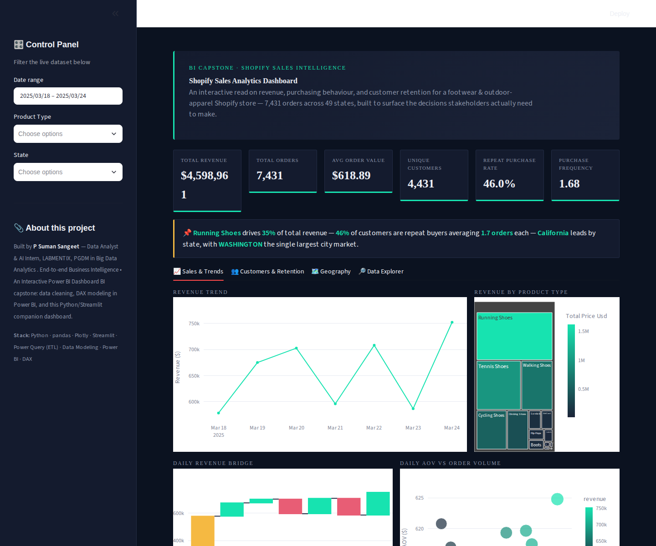
Hero header, live-filterable KPI scoreboard, and an auto-generated key-insight callout — the three things a recruiter or stakeholder sees in the first five seconds.

Sales & Trends

Revenue trend, product-type treemap, daily revenue waterfall, and AOV-vs-order-volume scatter — trend and composition together on one screen.

Customers & Retention
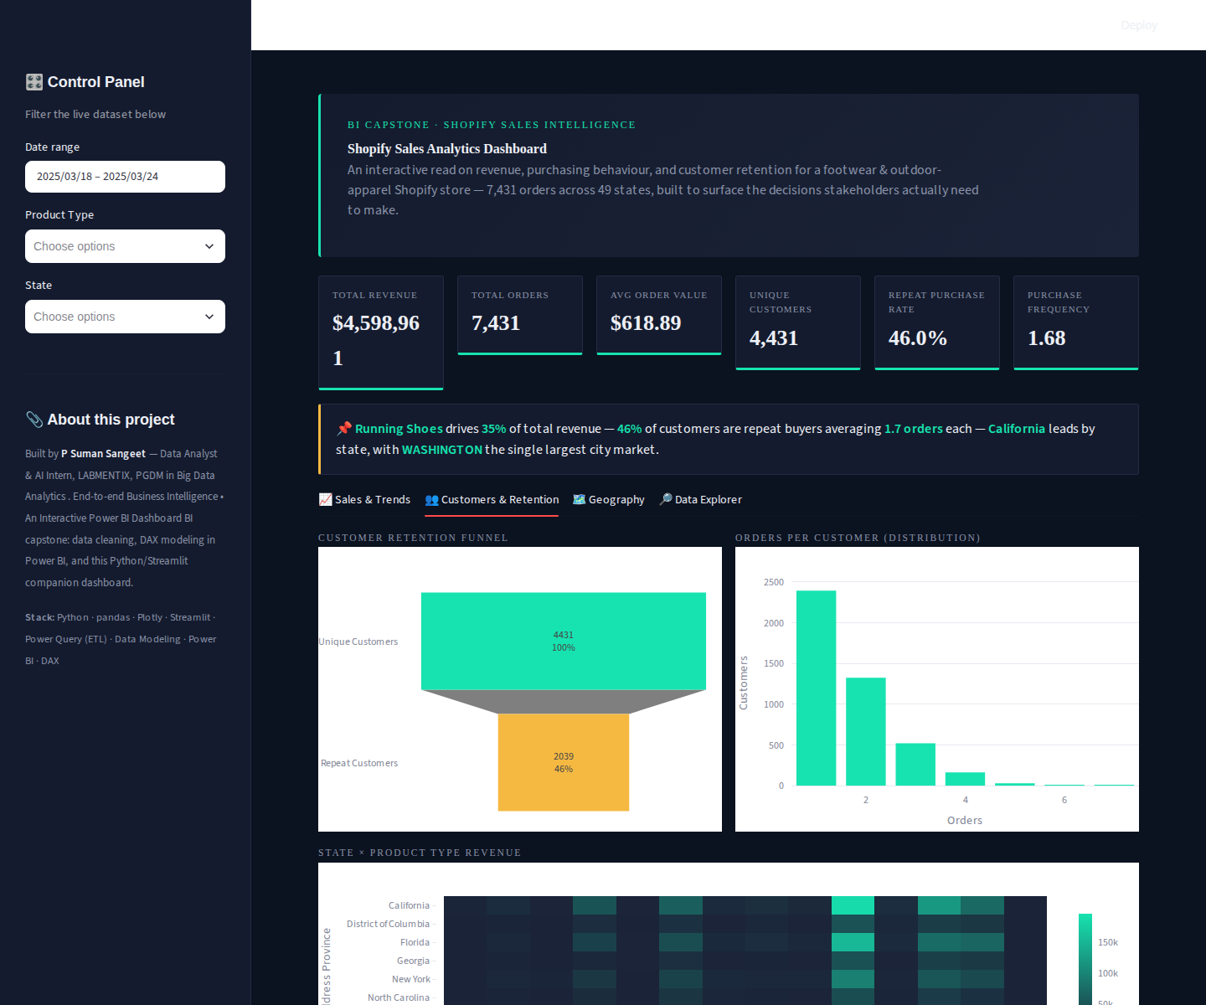
Customer retention funnel (Unique → Repeat), orders-per-customer distribution, and a State × Product Type revenue heatmap.

Geography
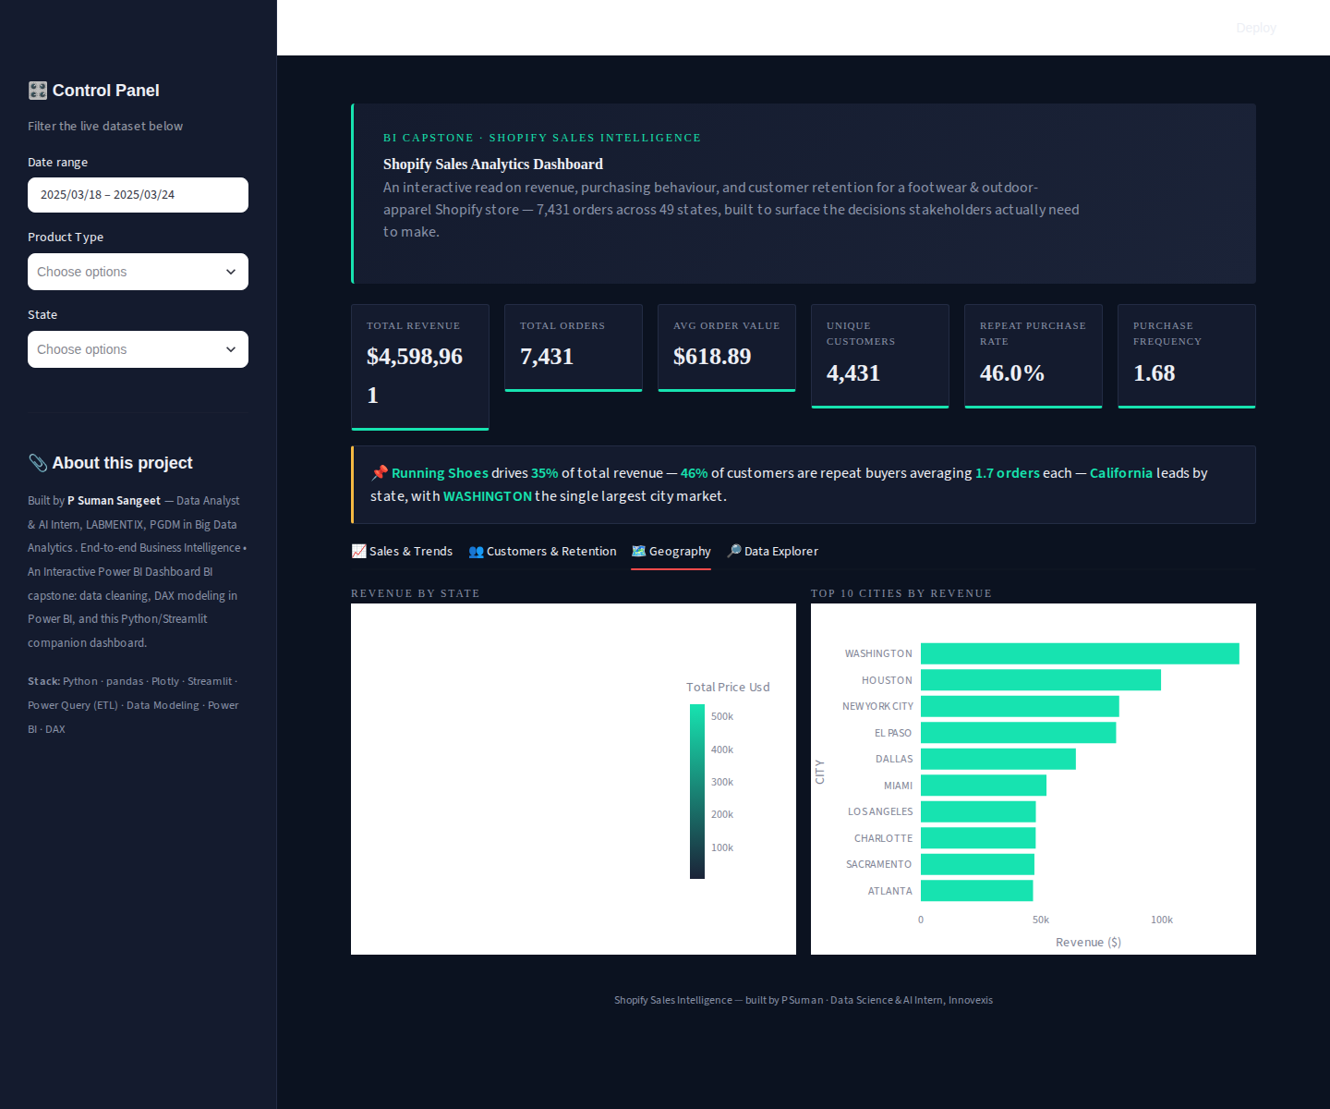
Revenue-by-state choropleth and Top 10 Cities by revenue. (The choropleth renders live in-browser; it did not render in this static export environment.)

Full Visual Inventory
The Power BI file ships two pages built on the same shared data model, so every visual below stays consistent with every other: filtering one updates all the rest.

Page 1 — Sales & Retention Overview (19 visuals)
Visual type | Fields / measures | What it answers
KPI cards | Total Revenue, Total Orders, AOV, Unique Customers | Headline numbers, answerable in seconds
KPI visual | Revenue Growth % | Trend-aware KPI with target/status formatting
Column charts | Revenue per Customer, CLV, Repeat Purchase Rate | Distribution of key per-customer metrics
Line chart | Total Revenue by Month/Year | Revenue trend over time
Clustered bar chart | Total Revenue by Product Type | Product-level revenue ranking
Donut chart | Customer Count by City | Geographic customer concentration
Table | Customer count, revenue, orders | Row-level detail for analysts
Cards | Repeat Customers, Purchase Frequency | Retention-focused KPIs
Slicers (4) | Month/Year, Product Type, Customer Id, City | Cross-filter every visual on the page at once

Page 2 — Insights & Trends (8 visuals added)
Visual type | Fields / measures | What it answers
Treemap | Product Type × Total Revenue | Proportional view of top revenue drivers
Ribbon chart | Month/Year × Product Type × Revenue | Which product ranks #1 each period
Scatter chart | AOV × Total Orders, sized by Revenue | Flags high-volume/low-value vs. reverse periods
Filled map | City × Total Revenue | Geographic revenue concentration
Waterfall chart | Month/Year × Total Revenue | Period-over-period revenue bridge
Funnel | Unique Customers → Repeat Customers | Retention drop-off at a glance
Matrix | City × Product Type × Revenue | Cross-tab of the two key segment dimensions
Gauge | Revenue Growth % vs. target | Target-tracking for leadership review

Key Business Insights
Insight 1: Running Shoes alone drives about 35% of total revenue ($1.62M of $4.6M) — more than the next two categories combined.
Visual: Treemap and clustered bar chart, Revenue by Product Type.
Recommendation: Protect Running Shoes inventory availability above all other lines, and test bundled promotions to convert that audience onto adjacent categories.
Insight 2: Revenue is not flat across the week — Monday ($752K) and Saturday ($708K) are the strongest days, Tuesday ($578K) the weakest, roughly a 30% swing.
Visual: Revenue trend line chart and daily revenue waterfall.
Recommendation: Shift promotional spend and flash-sale timing toward Monday and Saturday rather than spreading it evenly.
Insight 3: 46% of customers are repeat buyers, but the top 10% of customers by spend account for only 21.9% of revenue — retention depends on a broad base, not a small VIP tier.
Visual: Customer Retention Funnel and RFM segmentation.
Recommendation: Build retention programs that reach the broad Loyal/At-Risk middle segment (62% of customers), not just top spenders.
Insight 4: Orders peak in the late morning to mid-afternoon (11am-1pm), not evenings.
Visual: AOV-vs-order-volume scatter, supported by hour-of-day analysis.
Recommendation: Schedule ads, email sends, and support staffing around the late-morning window where buying intent is already highest.
Insight 5: Revenue is geographically concentrated — Washington, Houston, and New York City are the top three cities.
Visual: Revenue-by-state choropleth and Top 10 Cities bar chart.
Recommendation: Prioritise regional marketing and fulfilment decisions around the top cities/states first.

Tools & Skills Demonstrated
- Data cleaning & ETL: Power Query for cleaning, type correction, deduplication, and text standardisation on a 7,431-row transactional export.
- Data modeling: A star schema (Fact_Sales + Dim_Customer, Dim_Product, Dim_Date, Dim_Geography) with a marked Date table for correct time-intelligence behaviour.
- DAX: 15+ measures including Total Revenue, AOV, Repeat Purchase Rate, CLV, and a DATEADD-based Revenue Growth % measure.
- Power BI visualization: 27 visuals across two pages — cards, KPI, line, bar, treemap, ribbon, scatter, map, waterfall, funnel, matrix, and gauge — chosen deliberately per business question rather than defaulted to.
- Python: pandas for analysis, Plotly for charting, and a custom-themed Streamlit app (custom CSS, multi-tab layout, cross-filtering) deployed as a standalone interactive product.
- Applied analytics: RFM customer segmentation and a documented-assumption CLV model, both built to be re-calibrated automatically once more transaction history is loaded.
Data scope note: the source export covers 18-24 March 2025 (one week). Every trend and growth claim in this report is directionally sound but flagged as provisional pending a full month or more of transaction history — the data model, DAX, and dashboard layout are already built to absorb that history without redesign.

