BUSINESS INTELLIGENCE PROJECT REPORT
Shopify Sales Intelligence
An Interactive Power BI Dashboard for Revenue, Purchasing Behaviour & Customer Retention
PREPARED BY  P Suman Sangeet  Data Analyst & AI Intern — LABMENTIX | TOOLS & STACK  Power BI · Power Query · DAX  Python (pandas, Plotly, Streamlit)

DATASET  Shopify transactions export  7,431 orders · 4,431 customers · 49 states | REPORTING WINDOW  18 – 24 March 2025  7-day transaction snapshot

EXECUTIVE SUMMARY

Shopify Sales Intelligence — Executive Summary
This report presents an end-to-end Business Intelligence analysis of a footwear and outdoor-apparel Shopify store, built in Power BI and supported by a companion Python/Streamlit dashboard. Using Power Query for ETL, a star-schema data model, and DAX measures, the project analyses 7,431 orders from 4,431 customers across 49 U.S. states to surface actionable insight into revenue performance, purchasing behaviour, and customer retention.
TOTAL REVENUE  $4.60M | TOTAL ORDERS  7,431 | AVG. ORDER VALUE  $618.89
UNIQUE CUSTOMERS  4,431 | REPEAT PURCHASE RATE  46.0% | PURCHASE FREQUENCY  1.68 orders

- Revenue is concentrated in footwear. Running Shoes alone generate 35.2% of total revenue ($1.62M); the top three footwear categories account for over 71% of sales.
- Repeat customers are the profit engine. 46% of customers are repeat buyers, yet they generate 67.8% of total revenue — nearly double their share of the customer base.
- Demand is geographically concentrated. California, Texas and Florida together contribute 31.9% of revenue, led at the city level by Washington, D.C.
- Shopping peaks are predictable. Monday is the highest-revenue day and 10 AM–4 PM is the peak ordering window — a clear signal for promotions and staffing.

STAGE 0

Problem Statement & Objectives

Project Goal & Stakeholders
The goal of this project is to design an interactive Power BI dashboard that turns raw Shopify transaction exports into a decision-ready view of the business. The primary stakeholders are the store owner / General Manager, the Marketing team, and Merchandising / Inventory planners. The dashboard should help them decide where to invest marketing spend, which product lines to stock more (or less) aggressively, and which customer segments deserve retention investment.

Business Questions the Dashboard Answers
- How much revenue are we generating, and how is it trending day over day?
- Which products and geographies drive the most (and least) revenue?
- When do customers actually shop — which days and hours should promotions target?
- What share of customers return, and how much more valuable are they than one-time buyers?
- Which customers should be prioritised for retention, and what is their long-term value?

Key Metrics (KPIs) Tracked
- Total Revenue, Total Orders, Average Order Value (AOV)
- Unique Customers, Repeat Purchase Rate, Purchase Frequency
- Revenue by Product Type, State, and City
- Revenue concentration (Pareto share held by top 10% / 20% of customers)
- Customer Lifetime Value (CLV) proxy

Objective & Deliverables
The single deliverable is an interactive, cross-filtering Power BI dashboard (Shopify_Sales_Analytics_Dashboard.pbix) accompanied by this written report. Three steps were taken to reach it:
- 1. Import and clean the Shopify export in Power Query, then build a star-schema data model with a dedicated Date table.
- 2. Build DAX measures for revenue, orders, customer behaviour and retention, and validate them against the raw data.
- 3. Design a dashboard layout (KPI cards → trends → detail) with slicers for date, product type, and state, then translate the findings into business recommendations.

STAGE 1

Data Preparation & Modeling

Import & Clean (Power Query)
The source is a single flat export, shopify_data.csv, loaded into Power BI via Power Query. It contains 7,431 rows — one row per order — with no missing values in any of the 10 columns after cleaning.
Column | Type | Description
Order Number | Whole number | Unique order identifier (primary key of the fact table)
Customer Id | Whole number | Unique customer identifier
Invoice Date | Date/Time | Timestamp of the order
Product Type | Text | Product category (14 distinct values, e.g. Running Shoes, Boots)
Quantity | Whole number | Units purchased on the order
CITY / Billing Address Province | Text | Customer's billing city and U.S. state
Subtotal Price / Total Price USD / Total Tax | Decimal | Pre-tax, post-tax, and tax amounts in USD

Power Query cleaning steps applied:
- Type correction — Invoice Date was set to Date/Time (it loaded as text in the raw export); price and tax fields were set to Fixed Decimal, and ID fields to Whole Number, so aggregations and time intelligence work correctly.
- Text standardisation — City and State values were trimmed and cased consistently (e.g. "houston" / "HOUSTON" → "Houston") to prevent duplicate groups in visuals.
- Duplicate & null check — Order Number was verified as unique (7,431 distinct values across 7,431 rows) and every column was confirmed free of nulls, so no imputation was required.
- Helper columns — Order Date (date only, no time), Order Month, Day of Week, and Hour of Day were added for time-based slicing; a First vs. Repeat Order flag was derived per customer using a running count of orders in Power Query / DAX.

Data Model
The model follows a star schema: one fact table (Orders) surrounded by lookup/dimension tables, so DAX measures aggregate cleanly and slicers filter every visual consistently.
- Fact_Orders — the cleaned Shopify export (grain: one row per order).
- Dim_Date — a dedicated calendar table marked as the official Date table, related to Fact_Orders on Order Date.
- Dim_Product — distinct Product Type values, related on Product Type.
- Dim_Customer — distinct Customer Id values with derived attributes (first-purchase date, order count), related on Customer Id.
- Dim_Geography — distinct City / State combinations, related on billing location, to power the state choropleth and city rankings.
INSIGHT — Marking Dim_Date as the official date table (with a contiguous, complete calendar) is what makes Power BI's built-in time-intelligence functions — TOTALMTD, DATEADD, SAMEPERIODLASTYEAR — return correct results, and lets Month-over-Month growth be computed reliably once the store accumulates more than one month of history.

STAGE 2

Transaction Performance Analysis

Core KPI Measures
Total Revenue
Total Revenue = SUM ( Fact_Orders[Total Price Usd] )
Sums the post-tax order value across whatever the current filter context is (date range, product, state, etc.).
Total Orders
Total Orders = DISTINCTCOUNT ( Fact_Orders[Order Number] )
Counts unique orders rather than rows, so it stays accurate even if the grain ever changes to line-items.
Average Order Value (AOV)
AOV = DIVIDE ( [Total Revenue], [Total Orders], 0 )
Revenue per order; DIVIDE guards against a divide-by-zero error when a filter returns no orders.
Revenue Growth vs. Prior Period
Revenue Growth % =
VAR PrevRevenue = CALCULATE ( [Total Revenue], DATEADD ( Dim_Date[Date], -1, MONTH ) )
RETURN DIVIDE ( [Total Revenue] - PrevRevenue, PrevRevenue )
Compares revenue to the prior month using DATEADD against Dim_Date; with the current 7-day export this returns blank, but the measure is ready to populate automatically as more months of data land.

Revenue Trend
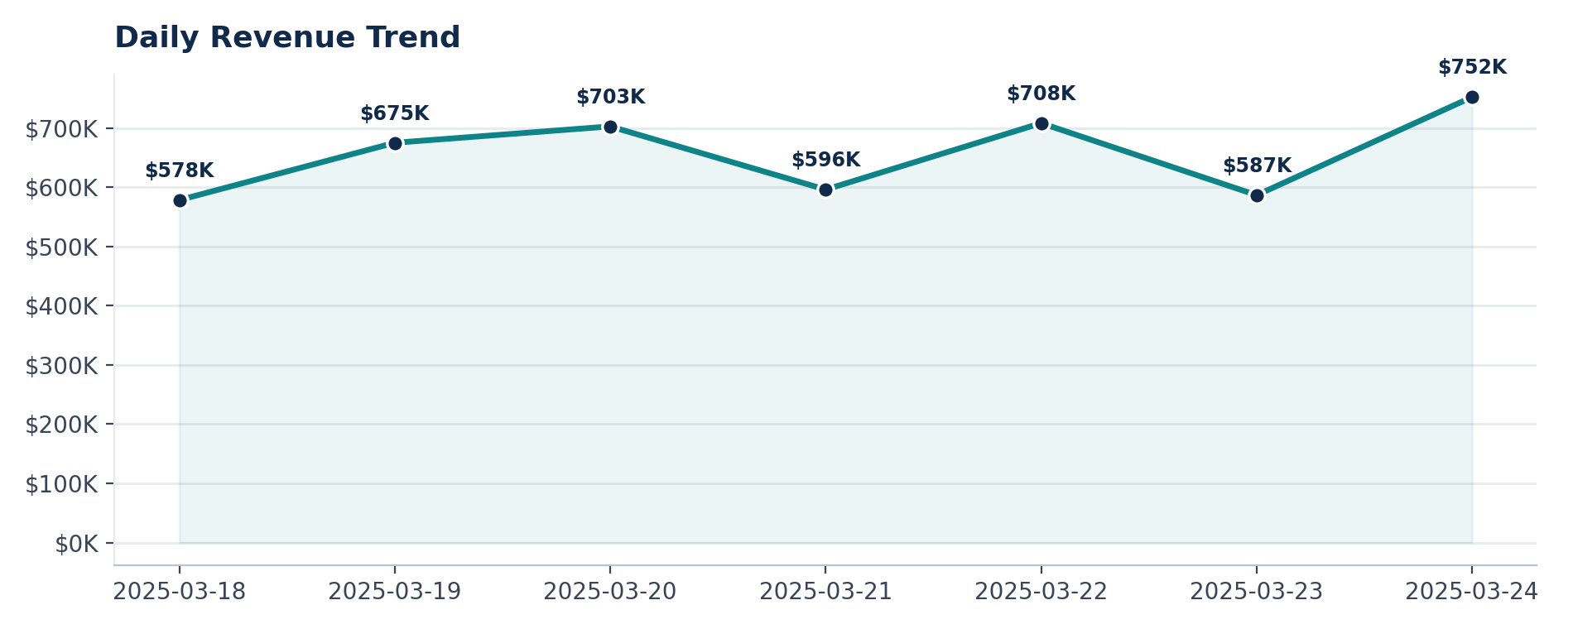
Figure 1 — Daily revenue across the reporting window (18–24 Mar 2025).
Revenue climbs steadily through the week, from $578K on Tuesday the 18th to a peak of $752K on Monday the 24th — a 30% swing between the lowest and highest day. There is no single-day collapse or spike, suggesting organic, healthy demand rather than a one-off promotion.
INSIGHT — Monday outperforms every other day in the window. This is unusual for many retailers and worth validating against a longer history — if it holds, Monday is the best day to launch new drops or time-limited offers.

Revenue by Product
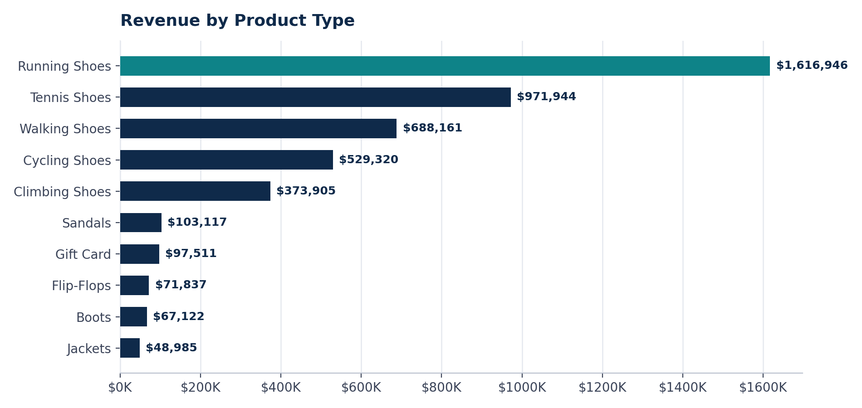
Figure 2 — Revenue by product type, ranked highest to lowest.
Running Shoes is the clear category leader at $1.62M (35.2% of revenue), followed by Tennis Shoes at $972K (21.1%) and Walking Shoes at $688K (15.0%). Together, the top three footwear categories generate 71.3% of all revenue. At the other end, Accessories, Clogs, Boy's and Water Shoes each contribute under 0.3% of revenue and collectively represent under 1% of sales.
INSIGHT — Water Shoes, Clogs, Boy's, and Accessories combined generated just $30,112 — 0.65% of total revenue — across the window. These are strong candidates for a merchandising review: either better placement/marketing, or reduced inventory investment in favour of core footwear lines.

When Customers Buy
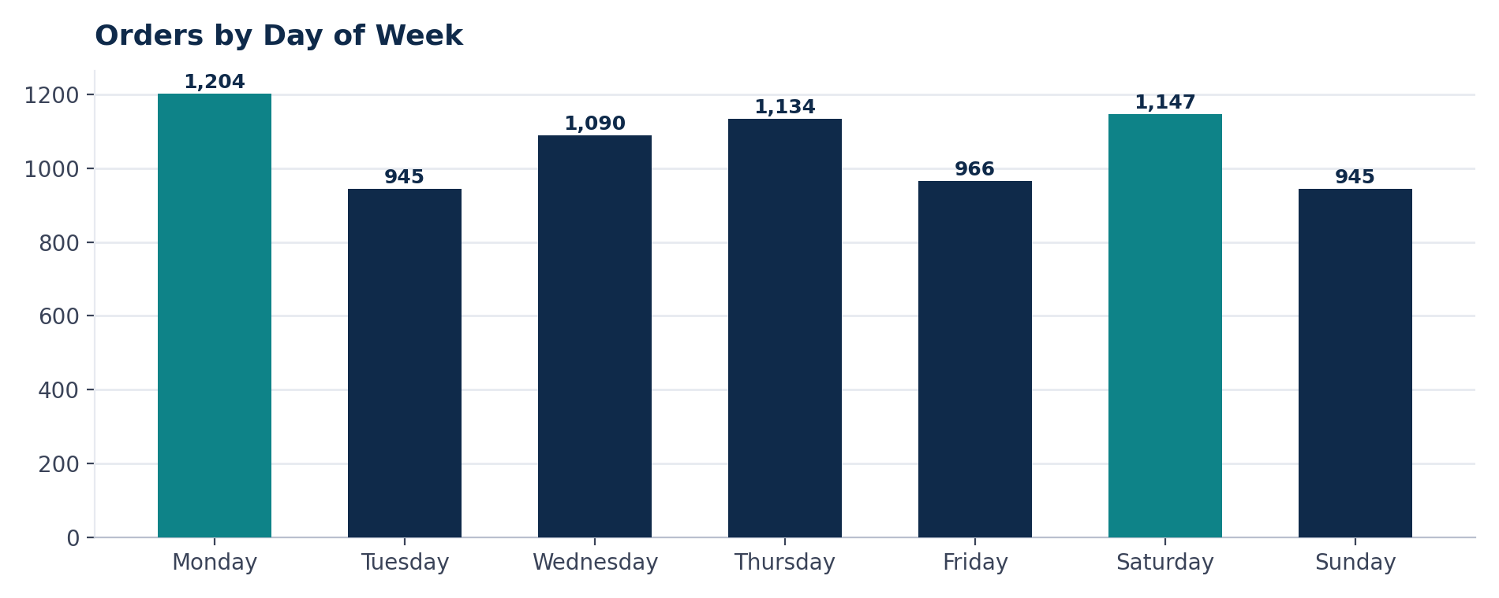
Figure 3 — Orders placed by day of week.
Monday (1,204 orders) and Saturday (1,147 orders) are the two busiest days; Tuesday and Sunday are the quietest, tied at 945 orders. The gap between busiest and quietest day is roughly 27%.
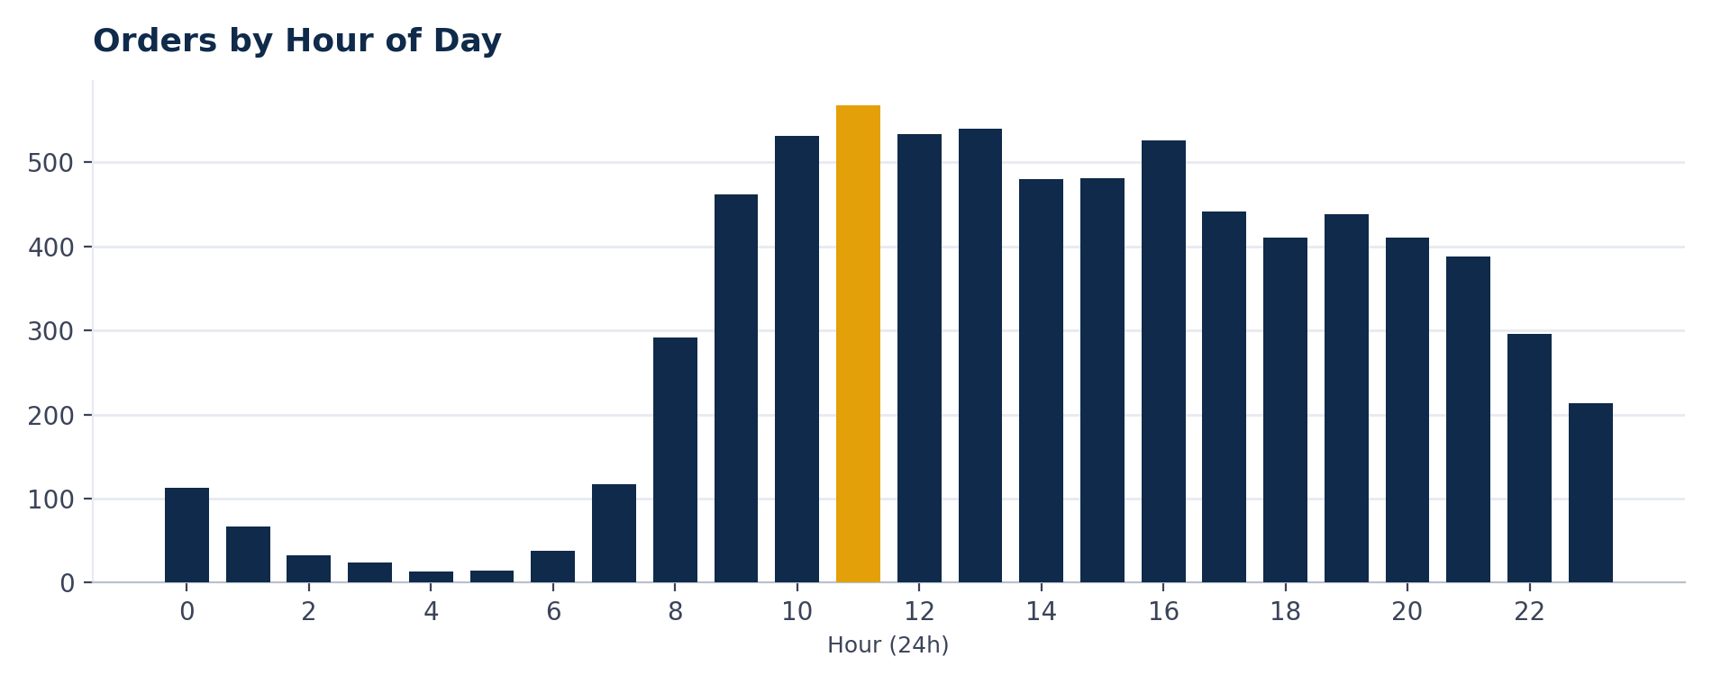
Figure 4 — Orders placed by hour of day (24-hour clock).
Ordering activity is heavily concentrated in the late morning and afternoon: the 10 AM–4 PM window accounts for the large majority of daily orders, peaking at 11 AM (568 orders, $349K in revenue).
INSIGHT — Email and paid-social campaigns timed to land shortly before 10 AM, with a Monday/Saturday cadence, align with when customers are already most likely to purchase — a low-cost way to lift conversion without changing the offer.

STAGE 3

Customer Purchasing Behaviour

New vs. Returning Customers
Of 4,431 unique customers, 2,039 (46.0%) placed more than one order in the window, and 2,392 (54.0%) purchased exactly once.
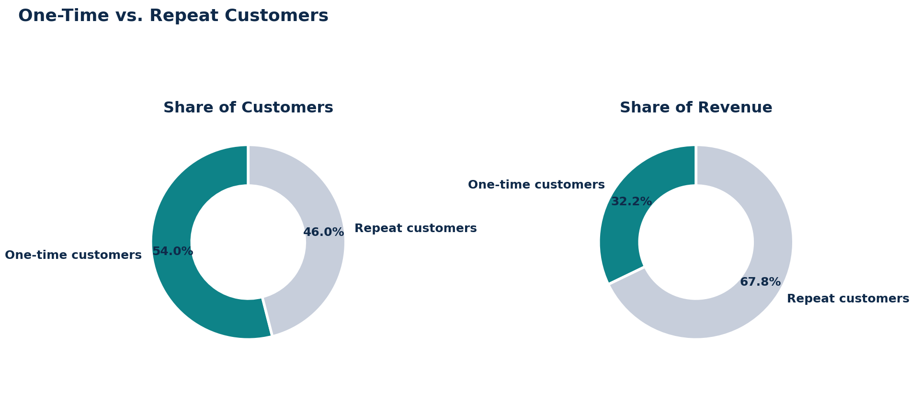
Figure 5 — Repeat customers are a minority of the customer base but the majority of revenue.
INSIGHT — Repeat customers are 46% of the customer base but generate 67.8% of revenue ($3.12M vs. $1.48M) — meaning the average repeat customer is worth roughly 2.5× an average one-time buyer. Every incremental percentage-point gain in repeat rate has an outsized effect on total revenue.

Order Frequency
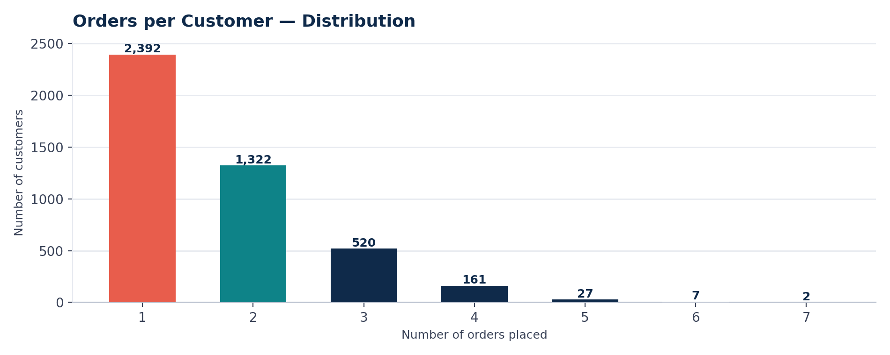
Figure 6 — Distribution of orders placed per customer.
Order frequency follows an expected long-tail pattern: 2,392 customers ordered once, 1,322 ordered twice, 520 ordered three times, and a small group of 36 highly engaged customers placed five or more orders inside the seven-day window. Average purchase frequency across all customers is 1.68 orders.

Revenue Concentration & Top Customers
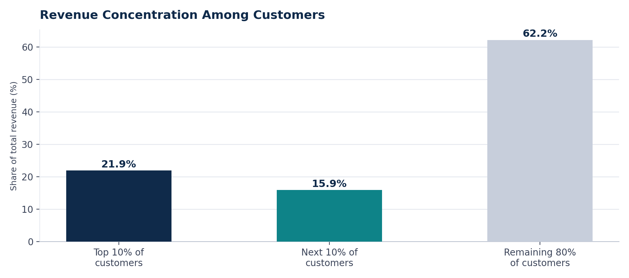
Figure 7 — Share of total revenue by customer spend tier.
The top 10% of customers (by spend) generate 21.9% of total revenue, and the top 20% generate 37.8% — a moderate, not extreme, concentration. This is healthier than a classic 80/20 pattern: revenue is not dangerously dependent on a tiny handful of accounts, though the highest-value customers still merit dedicated attention.
Top 10 Customers by Total Spend
Customer ID | Orders Placed | Total Spend
1556 | 2 | $7,627.69
6056 | 7 | $4,272.08
5784 | 7 | $4,060.22
10 | 5 | $3,979.86
4465 | 6 | $3,819.51
5536 | 6 | $3,691.14
5888 | 5 | $3,633.14
753 | 6 | $3,620.41
4221 | 6 | $3,620.08
4122 | 5 | $3,551.96

Segmentation Approach (RFM-style)
Customers were segmented using a simplified Recency–Frequency–Monetary lens appropriate for a 7-day snapshot:
- Champions (high F, high M) — customers with 5+ orders and top-decile spend, e.g. customer IDs 6056, 5784, and 4465. Prioritise for loyalty perks and early access to new drops.
- Repeat regulars (F ≥ 2, mid M) — the bulk of the 2,039 repeat customers; the segment most responsive to a well-timed second-purchase incentive.
- One-time buyers (F = 1) — 2,392 customers who have not yet returned; the highest-leverage group for a structured win-back / second-purchase campaign, given they already represent 32% of revenue from a single order each.

DAX Measures — Customer Behaviour
Unique Customers
Unique Customers = DISTINCTCOUNT ( Fact_Orders[Customer Id] )
Counts distinct customers in the current filter context.
Repeat Customers
Repeat Customers =
VAR OrdersPerCustomer = SUMMARIZE ( Fact_Orders, Fact_Orders[Customer Id], "Orders", DISTINCTCOUNT ( Fact_Orders[Order Number] ) )
RETURN COUNTROWS ( FILTER ( OrdersPerCustomer, [Orders] > 1 ) )
Builds a per-customer order count, then counts how many customers exceed one order.
Repeat Purchase Rate
Repeat Purchase Rate = DIVIDE ( [Repeat Customers], [Unique Customers] )
The share of customers who are repeat buyers — the headline retention KPI.
Purchase Frequency
Purchase Frequency = DIVIDE ( [Total Orders], [Unique Customers] )
Average number of orders placed per customer; a core input to the CLV estimate.

STAGE 4

Retention & Long-Term Customer Value

Defining Retention
For this business, retention is defined as any customer who places a second order — the repeat-purchase rate calculated in Stage 3 (46.0%). Because the available export spans only seven days, a full month-by-month cohort analysis cannot yet be built; the pattern below is a within-window proxy, using the same DAX and visual approach that will scale automatically once a longer history is loaded into the model.

Cohort & Re-purchase Gap (7-Day Proxy)
Among the 2,039 repeat customers, the average time between their first and most recent purchase in the window is 66.5 hours (about 2.8 days), with a median of 64.75 hours. In practice, this means a meaningful share of repeat purchases happens within 2–3 days of the first order — customers who don't return quickly are less likely to return at all inside a short window.
INSIGHT — With a median re-purchase gap of ~65 hours, a post-purchase email or SMS nudge sent 24–48 hours after checkout — before the natural re-purchase window closes — is the highest-leverage timing for a second-purchase campaign.

Customer Lifetime Value (Proxy)
CLV Proxy
CLV Proxy = [AOV] * [Purchase Frequency]
Standard simplified CLV formula (AOV × purchase frequency); over the 7-day window this evaluates to $618.89 × 1.68 ≈ $1,037.91 per customer.
This $1,037.91 figure is a within-window proxy, not an annualised CLV — it reflects spend observed in seven days, not a customer's full lifespan. The same measure, unchanged, will produce a true annual or lifetime CLV once 12+ months of transaction history are loaded, because AOV and Purchase Frequency will then be computed over the full customer lifespan rather than a single week.
Directionally, the Champions segment (5+ orders, top-decile spend) already shows a CLV proxy 5–7× the store average — customer 6056, for example, generated $4,272 from 7 orders, an implied per-order value of $610 sustained across a very short window. These are the customers the CLV measure will flag first as data accumulates.

Who to Prioritise
- Retain aggressively — the ~36 customers placing 5+ orders in a single week. Their spend rate suggests high lifetime value; a dedicated loyalty tier or account-manager-style outreach protects a disproportionate share of revenue.
- Convert to repeat — the 2,392 one-time buyers, focused on the 24–48-hour re-engagement window identified above. Converting even 10% of this group into repeat customers would add roughly 240 repeat customers and meaningfully lift the 46% repeat rate.
- Monitor — the large "repeat regulars" segment (2–4 orders). They are already profitable; the priority here is not losing them to a competitor, via consistent post-purchase communication.

STAGE 5

Dashboard Design, Key Insights & Recommendations

Where Revenue Comes From
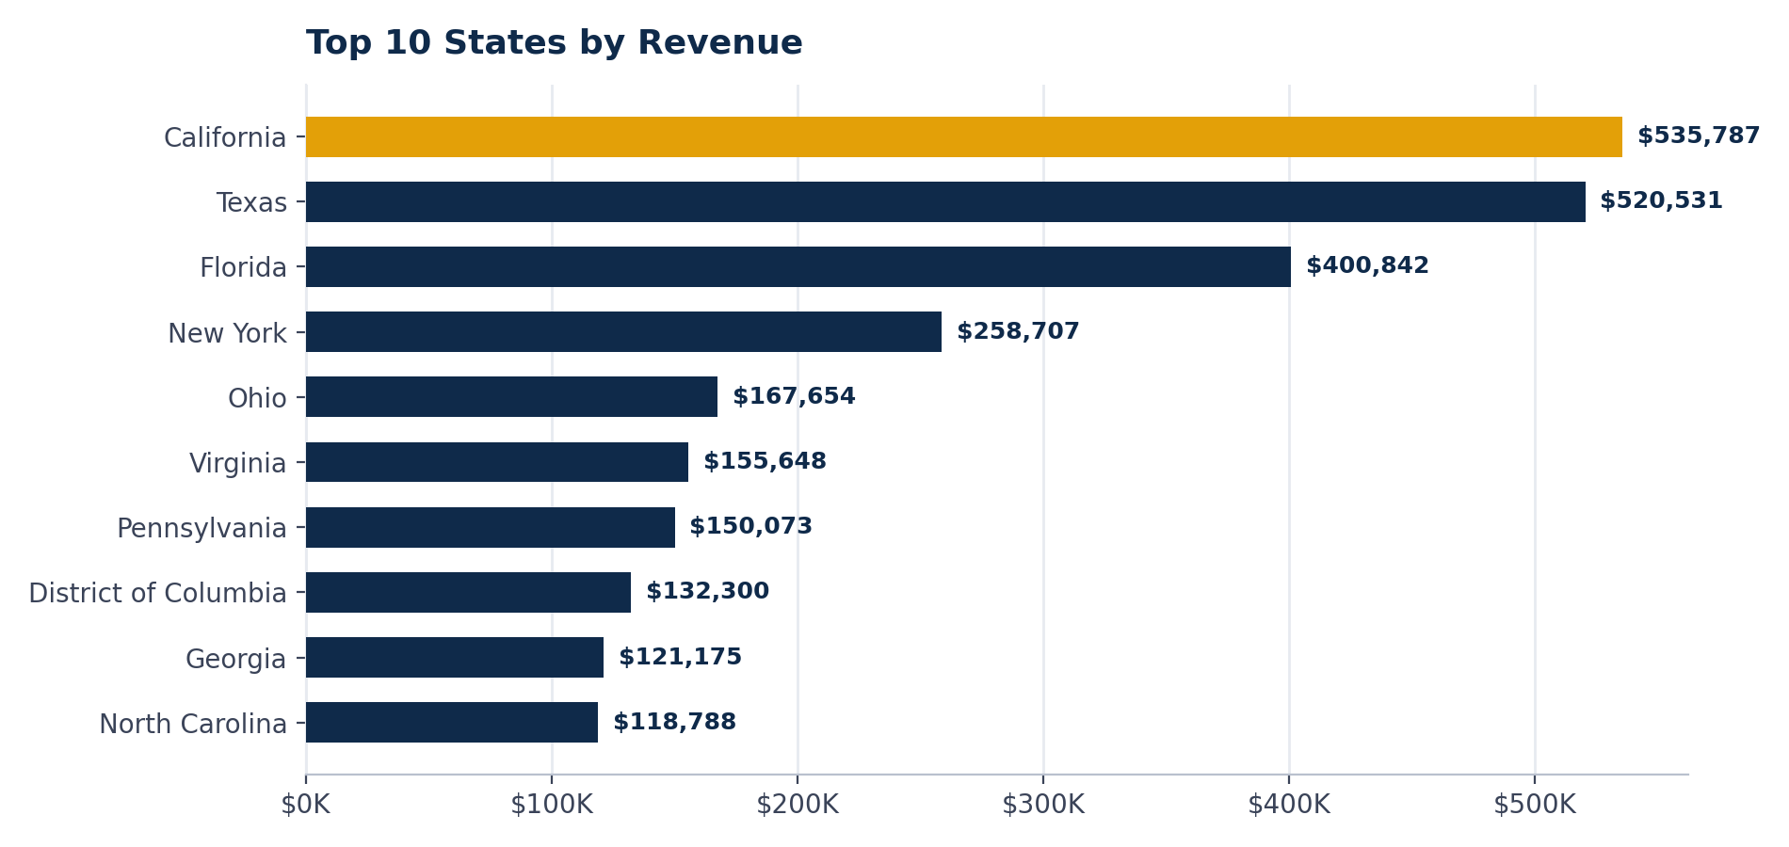
Figure 8 — Top 10 U.S. states by revenue.
California ($535.8K), Texas ($520.5K), and Florida ($400.8K) are the top three states, together contributing 31.9% of total revenue. At the city level, Washington, D.C. is the single largest market ($132.3K), ahead of Houston ($99.8K) and New York City ($82.4K).

Dashboard Layout
The Power BI dashboard (and its Streamlit companion) is organised so a stakeholder can read the story top-to-bottom, without needing to know Power BI:
- Row 1 — Headline KPIs: Total Revenue, Total Orders, AOV, Unique Customers, Repeat Purchase Rate, and Purchase Frequency as scorecards, visible before any scrolling.
- Row 2 — Trends: the daily revenue line chart and revenue-by-product treemap, answering "how are we doing and what's driving it" at a glance.
- Row 3 — Detail: customer retention funnel, order-frequency distribution, and the state × product revenue heatmap for deeper exploration.
- Row 4 — Geography & data explorer: the state choropleth, top-city ranking, and a filterable, exportable data table for analysts who want the raw rows.
- Global slicers — date range, product type, and state sit in a persistent sidebar/filter pane, so any selection cross-filters every visual on the page simultaneously — confirmed working by clicking a single state and verifying the KPI cards, trend line, and product mix all update together.

Key Insights
- 1. Retention is worth more than acquisition. Repeat customers are 46% of the base but 67.8% of revenue — roughly 2.5× the value of a one-time buyer.
- 2. The product mix is footwear-led and top-heavy. Running, Tennis and Walking Shoes drive 71.3% of revenue; four minor categories combined drive under 1%.
- 3. Demand has a predictable weekly and daily rhythm. Monday and Saturday are peak order days; 10 AM–4 PM is the peak ordering window, with 11 AM the single busiest hour.
- 4. Revenue is regionally concentrated but not fragile. The top 3 states drive under a third of revenue and the top 20% of customers drive under 40% — healthier diversification than a typical 80/20 pattern.
- 5. The re-purchase window is short. Repeat customers return within a median of ~65 hours, pointing to a narrow but well-defined re-engagement opportunity.

Business Recommendations
- Launch a 48-hour post-purchase win-back flow. Targeting the 2,392 one-time buyers with a time-boxed offer inside the ~65-hour median re-purchase window is the single highest-leverage lever identified in this analysis for lifting the 46% repeat rate.
- Concentrate marketing spend around Monday and the 10 AM–4 PM window. Align email sends, paid social, and any flash promotions with observed peak demand rather than an even weekly cadence.
- Protect and reward the Champions segment. Stand up a lightweight loyalty tier (early access, free shipping threshold, or a small percentage discount) for the ~36 customers placing 5+ orders — their CLV proxy already runs 5–7× the store average.
- Review the long tail of the product catalogue. Water Shoes, Clogs, Boy's and Accessories together drive under 1% of revenue; either invest in merchandising them properly or reallocate inventory budget toward the top three footwear categories.
- Prioritise CA, TX, FL and the Washington, D.C. metro for regional campaigns, while testing paid acquisition in adjacent high-population states (NY, OH, PA) that already show meaningful organic revenue.
- Extend the data window. Loading 12+ months of history will let the Revenue Growth %, cohort retention, and CLV measures already built in this model calculate month-over-month trends and a true lifetime value — recommended as the immediate next step for this dashboard.

APPENDIX

Appendix — DAX Measure Reference & Data Dictionary

DAX Measures Used in This Report
Measure | DAX
Total Revenue | SUM ( Fact_Orders[Total Price Usd] )
Total Orders | DISTINCTCOUNT ( Fact_Orders[Order Number] )
AOV | DIVIDE ( [Total Revenue], [Total Orders], 0 )
Unique Customers | DISTINCTCOUNT ( Fact_Orders[Customer Id] )
Repeat Customers | COUNTROWS of customers with Orders > 1 (via SUMMARIZE)
Repeat Purchase Rate | DIVIDE ( [Repeat Customers], [Unique Customers] )
Purchase Frequency | DIVIDE ( [Total Orders], [Unique Customers] )
Revenue Growth % | DIVIDE ( [Total Revenue] - PrevRevenue, PrevRevenue ) via DATEADD
CLV Proxy | [AOV] * [Purchase Frequency]

Data Dictionary
Field | Source Column | Notes
Order ID | Order Number | 7,431 distinct values — one row per order
Customer ID | Customer Id | 4,431 distinct customers
Order Date/Time | Invoice Date | 18–24 March 2025
Category | Product Type | 14 distinct product categories
Revenue (USD) | Total Price Usd | Post-tax order value; sums to $4,598,960.87
Geography | CITY, Billing Address Province | 49 U.S. states represented

Scope & Limitations
- The underlying export covers a single 7-day window (18–24 March 2025); month-over-month growth, seasonal trend, and true annualised CLV require a longer historical load into the same model.
- "CLV Proxy" and the repurchase-gap statistic are within-window approximations, clearly labelled as such throughout this report, and are designed to be replaced automatically by true lifetime figures once more data is available.
- All figures were computed directly from shopify_data.csv and cross-checked against the KPI cards produced by the accompanying Python/Streamlit dashboard (Wix_Shopify.py) for consistency.

