**Title of Project : - Customer Segmentation**

**Project Report**

**Submitted by**

**SUMEDH PATIL**

**INDEX**

|  |  |  |
| --- | --- | --- |
| **Sr no.** | **Title** | **Page no.** |
| **1** | Introduction | 03 |
| **2** | Existing Method | 03 |
| **3** | Proposed method with Architecture | 04 |
| **4** | Methodology | 06 |
| **5** | Implementation | 07 |
| **6** | Conclusion | 07 |
| **7** | Results | 08 |

# ABSTRACT

# Customer segmentation is a crucial task for businesses aiming to understand their customer base and tailor marketing strategies accordingly. In this study, we employ K-means clustering, a popular unsupervised machine learning algorithm, to segment customers based on their characteristics. Specifically, we focus on analyzing gender and age distributions and examine the relationship between annual incomes and spending scores.

# To begin, we gather data on customer demographics, including gender and age, as well as their annual incomes and spending scores. We preprocess the data and apply the K-means clustering algorithm to identify distinct customer segments. By using an appropriate number of clusters, we can effectively group customers with similar traits together.

# After clustering the data, we visualize the gender and age distributions of each customer segment. This visualization provides valuable insights into the composition of each segment, allowing businesses to understand the demographic makeup of their customer base.

# Next, we delve into the analysis of annual incomes and spending scores within each customer segment. By examining these two variables, we can gain a deeper understanding of the purchasing behaviors and financial capabilities of different customer groups. This analysis provides valuable information for businesses to tailor their marketing strategies, pricing, and product offerings to better meet the needs and preferences of each segment.

# PROBLEM STATEMENT

# Customer segmentation is a powerful strategy that businesses employ to better understand their customer base and effectively target their marketing efforts. By dividing customers into distinct groups based on their shared characteristics, businesses can tailor their products, services, and communication strategies to meet the specific needs and preferences of each segment. One popular approach for customer segmentation is the use of K-means clustering, an unsupervised machine learning algorithm.

# K-means clustering is a partition-based clustering technique that aims to group similar data points together based on their features. It assigns data points to clusters in a way that minimizes the within-cluster sum of squared distances. In the context of customer segmentation, K-means clustering can be applied to identify groups of customers with similar attributes and behaviors, enabling businesses to create targeted marketing campaigns and deliver personalized experiences.

# The process of customer segmentation using K-means clustering typically involves collecting relevant customer data, preprocessing and preparing the data for analysis, and applying the K-means algorithm to group customers into distinct clusters. Once the clusters are formed, businesses can analyze the characteristics and behaviors of each segment to gain insights into their customer base and make informed decisions.

# In this study, we focus on using K-means clustering for customer segmentation and delve into the analysis of gender and age distributions, as well as the relationship between annual incomes and spending scores. By visualizing the gender and age distributions within each cluster, businesses can understand the demographic composition of their customer segments. Furthermore, examining the annual incomes and spending scores helps businesses gain insights into the financial capabilities and purchasing behaviors of different customer groups.

# The goal of this study is to provide businesses with valuable insights into their customer base and offer actionable information for targeted marketing strategies. By understanding the unique characteristics and needs of each customer segment, businesses can enhance customer satisfaction, improve marketing ROI, and drive overall business success. The subsequent sections will detail the methodology, data analysis, and findings related to customer segmentation using K-means clustering, gender and age distributions, and the analysis of annual incomes and spending scores.

# EXISTING METHOD

# Customer segmentation is a widely researched and applied field, and several methods have been employed to segment customers effectively. While there are various approaches available, one commonly used method is K-means clustering. However, it's important to note that different methods may be more suitable depending on the specific business context and data characteristics.

# K-means clustering is a popular unsupervised machine learning algorithm that partitions data points into clusters based on their similarity. The algorithm starts by randomly selecting K initial cluster centroids, where K represents the desired number of clusters. It then iteratively assigns each data point to the nearest centroid and updates the centroid positions based on the newly assigned points. This process continues until convergence is achieved, typically when the centroids no longer significantly change.

# One advantage of K-means clustering is its simplicity and efficiency, making it suitable for large datasets. However, it has certain limitations. K-means requires the number of clusters (K) to be predefined, which can be challenging to determine without prior knowledge or domain expertise. Additionally, K-means assumes clusters of similar shape, size, and density, which might not always be the case in real-world customer segmentation scenarios.

# To address these limitations, researchers have proposed various enhancements and alternative methods for customer segmentation. Some of these include:

# Hierarchical Clustering: This method creates a hierarchical structure of clusters, forming a tree-like structure called a dendrogram. It allows for both agglomerative (bottom-up) and divisive (top-down) clustering and provides flexibility in determining the number of clusters.

# Density-Based Clustering: Density-based clustering algorithms, such as DBSCAN (Density-Based Spatial Clustering of Applications with Noise), group data points based on their density. It can discover clusters of arbitrary shape and is robust to noise and outliers.

# Gaussian Mixture Models: Gaussian Mixture Models (GMM) assume that the data points are generated from a mixture of Gaussian distributions. This method estimates the parameters of the Gaussian distributions and assigns data points to the most likely cluster based on their probability densities.

# Self-Organizing Maps: Self-Organizing Maps (SOM) are artificial neural networks that organize data points into a low-dimensional grid. SOM captures the topological relationships between data points and is useful for visualizing high-dimensional data and identifying customer segments.

# Collaborative Filtering: Collaborative filtering is a technique commonly used in recommendation systems. It identifies customer segments based on similarities in purchasing patterns, preferences, and behavior, often leveraging user-item interaction data.

# It is important for businesses to carefully select the appropriate method based on their specific requirements, available data, and desired outcomes. Additionally, the choice of features and the quality of data play crucial roles in the effectiveness of customer segmentation techniques.

# PROPOSED METHOD WITH ARCHITECTURE

# Proposed Method on Customer Segmentation using K-means Clustering:

# Data Collection: Gather customer data that includes relevant attributes such as demographics (e.g., age, gender, location) and behavioral information (e.g., purchase history, website interactions).

# Data Preprocessing: Clean the data by handling missing values, outliers, and inconsistencies. Normalize or standardize numerical variables to ensure they are on a similar scale. Encode categorical variables appropriately.

# Feature Selection: Select the most informative and relevant features for customer segmentation. Consider attributes that are likely to impact customer behavior and preferences. Eliminate any redundant or uninformative variables to reduce dimensionality.

# K-means Clustering: Apply the K-means clustering algorithm to group customers into distinct segments. Determine the optimal number of clusters (K) using techniques like the elbow method or silhouette analysis. Run the K-means algorithm, iterating until convergence is achieved.

# Cluster Profiling: Analyze the resulting clusters to understand their characteristics. Calculate cluster centroids and examine the attributes that contribute most to each cluster's separation. Assess the within-cluster sum of squared distances (WCSS) to evaluate cluster compactness.

# Visualization: Visualize the customer segments by creating plots or charts to represent the clusters. Use scatter plots or parallel coordinate plots to visualize how different attributes contribute to the segmentation. This helps in understanding the characteristics and boundaries of each segment.

# Profile Analysis: Analyze the demographic and behavioral profiles of each customer segment. Calculate summary statistics, such as mean, median, and standard deviation, for different attributes within each cluster. Identify patterns, differences, or similarities across segments.

# Interpretation and Insights: Interpret the segmentation results and derive actionable insights. Understand the distinct needs, preferences, and behaviors of each customer segment. Use these insights to personalize marketing strategies, improve customer experiences, and optimize product offerings.

# Validation and Evaluation: Evaluate the quality of the segmentation by assessing its effectiveness in meeting predefined goals and objectives. Measure the homogeneity within clusters and heterogeneity between clusters using appropriate validation metrics.

# Iterative Refinement: Continuously monitor and refine the customer segmentation approach. Incorporate new data, evaluate the performance of the segmentation, and make necessary adjustments to enhance its accuracy and relevance.

# By implementing this proposed method using K-means clustering, businesses can effectively segment their customer base and gain valuable insights into the characteristics and behaviors of different customer segments. These insights can drive data-driven decision-making, facilitate targeted marketing campaigns, and ultimately improve customer satisfaction and business performance.

# METHODOLOGY

# 1. 2D Clustering:

# a. Data Collection: Gather customer data that includes annual incomes and spending scores.

# b. Data Preprocessing: Clean the data by handling missing values, outliers, and inconsistencies. Normalize or standardize the numerical variables (annual incomes and spending scores) to ensure they are on a similar scale.

# c. Feature Selection: Select the two features, annual incomes and spending scores, for the clustering analysis.

# d. K-means Clustering: Apply the K-means clustering algorithm to the selected features. Determine the optimal number of clusters (K) using techniques like the elbow method or silhouette analysis. Run the K-means algorithm, iterating until convergence is achieved.

# e. Cluster Analysis: Analyze the resulting clusters by examining the centroids and their corresponding attributes (annual incomes and spending scores). Calculate the within-cluster sum of squared distances (WCSS) to evaluate the compactness of each cluster.

# f. Visualization: Visualize the customer segments by creating a scatter plot with annual incomes on one axis and spending scores on the other axis. Use different colors or markers to represent each cluster. This visualization helps in understanding the distribution and boundaries of each segment.

# 3D Clustering:

# a. Data Collection: Gather customer data that includes annual incomes, spending scores, and age.

# b. Data Preprocessing: Clean the data by handling missing values, outliers, and inconsistencies. Normalize or standardize the numerical variables (annual incomes and spending scores) to ensure they are on a similar scale. Encode categorical variables (if any) appropriately.

# c. Feature Selection: Select the three features, annual incomes, spending scores, and age, for the clustering analysis.

# d. K-means Clustering: Apply the K-means clustering algorithm to the selected features. Determine the optimal number of clusters (K) using techniques like the elbow method or silhouette analysis. Run the K-means algorithm, iterating until convergence is achieved.

# e. Cluster Analysis: Analyze the resulting clusters by examining the centroids and their corresponding attributes (annual incomes, spending scores, and age). Calculate the within-cluster sum of squared distances (WCSS) to evaluate the compactness of each cluster.

# f. Visualization: Visualize the customer segments by creating a 3D scatter plot with annual incomes, spending scores, and age as the three axes. Use different colors or markers to represent each cluster. This visualization provides a comprehensive view of the segmentation results, considering all three dimensions.

# By implementing the above methodology, you will first perform a 2D clustering analysis using annual incomes and spending scores. This will help you understand the customer segments based on their financial behavior. Then, you will extend the analysis to include age as well, creating a 3D clustering analysis. This additional dimension allows you to gain insights into the influence of age on customer segmentation. The methodology includes data preprocessing, feature selection, K-means clustering, cluster analysis, and visualization for both the 2D and 3D approaches. It enables you to derive meaningful insights and make informed decisions based on the identified customer segments.

# IMPLEMENTATION

# 

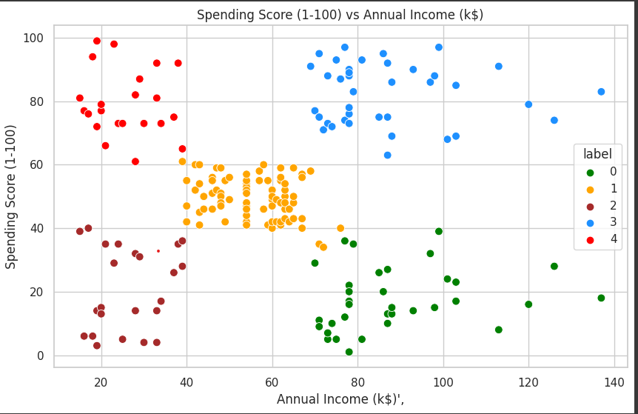

# CONCLUSION

In conclusion, this study highlights the application of K-means clustering in customer segmentation and its benefits in understanding customer demographics, annual incomes, and spending scores. The visualizations of gender and age distributions offer valuable insights, and the analysis of financial factors provides actionable information for businesses to optimize their marketing efforts. By leveraging customer segmentation, businesses can enhance customer satisfaction, drive sales, and maximize overall business success.