**Caption**

Here is resume builder android app that I have built in college 2021.

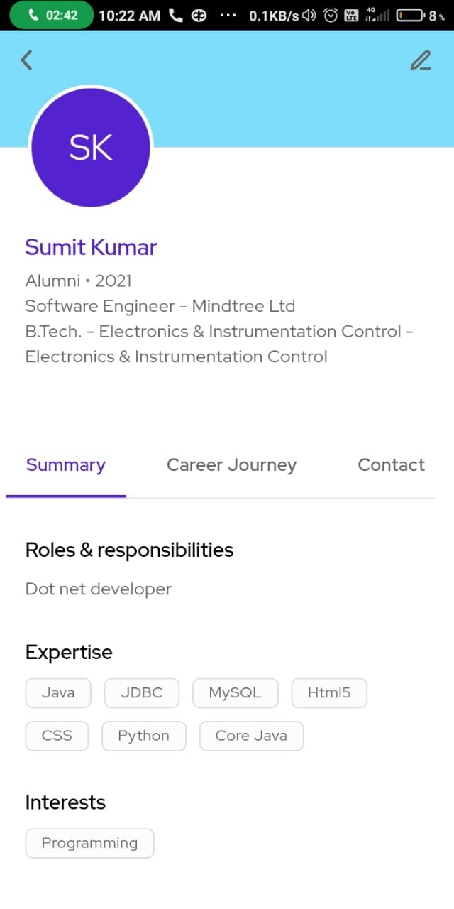

**Description:**

This android app that I have built is attractive and easy to use. It is a template essentially offer different features according to the different configuration, flexible and expanding. This app is custom designed and good looking, it saved the cost of human resource for application development for the most of our clients. I am excited about this and its impact.