DATA SCIENCE TOOLBOX: PYTHON PROGRAMMING
PROJECT REPORT
(Project Semester January-April 2025)

Submitted by:

SUMIT
Registration No: 12313970

Programme and Section: B. Tech CSE, K23FK
Course Code: INT375

Under the Guidance of

Dr. Karan Bajaj, 32130

Discipline of CSE/IT

Lovely School of Computer Science and Engineering

Lovely Professional University, Phagwara

CERTIFICATE
This is to certify that SUMIT bearing Registration No. 12313970 has completed the project titled “6th Minor Irrigation Census - Village Schedule, Ground Water Schemes, Surface Water Schemes” under my guidance and supervision. To the best of my knowledge, the present work is the result of her original development, effort, and study.
Dr Karan Bajaj

Signature and Name of the Supervisor
Designation of the Supervisor

School of Computer Science and Engineering
Lovely Professional University
Phagwara, Punjab.

Date: 12-04-2025

DECLARATION

I, SUMIT, student of B.Tech CSE, under the Discipline of Computer Science and Engineering, at Lovely Professional University, Punjab, hereby declare that all the information furnished in this project report is based on my own intensive work and is genuine.

Date: 12-04-2025
Registration No: 12313970 SUMIT

ACKNOWLEDGEMENT

I would like to express my deepest gratitude to Prof. Karan bajaj for his exceptional mentorship and unwavering support throughout the duration of this project. His vast knowledge in the fields of data science and machine learning, combined with his patient and thoughtful guidance, played a pivotal role in the successful completion of this work. His insightful suggestions and feedback consistently challenged me to think critically and improve the quality of my research. I am also grateful for the learning environment he fostered, which encouraged exploration and innovation.
In addition, I sincerely thank my peers and classmates for their helpful discussions, encouragement, and collaborative spirit during this project. Their input provided fresh perspectives that contributed meaningfully to the final outcome. I am also thankful to the open-source community for providing the tools, libraries, and resources that made the implementation of this project possible. Lastly, I acknowledge the dataset contributors for making this analysis feasible.

SUMIT
Reg. No: 12313970
Date: 12-04-2025

*TABLE OF CONTENT

S. No | Content | Page No.
1. | Cover Page | i
2. | Declaration | ii
3. | Certificate | iii
4. | Acknowledgement | iv
5. | Table of Content | v
6. | Introduction | 6-7
7. | Source of Dataset | 8-9
8. | EDA Process | 9-11
9. | Analysis on Dataset | 11-27
 | i. Introduction | 11-12
 | ii. General Description | 12-13
 | iii. Specific Requirements, Functions and Formulas | 13-18
 | iv. Analysis Results | 18-19
 | v. Visualization | 20-27
10. | Conclusion | 27-28
11. | Future Scope | 28-30
12. | References | 31

INTRODUCTION
The "ASSW Lift Data" dataset offers a comprehensive view of how an elevator system operates, capturing details about lift usage, mechanical performance, and sensor readings. By analyzing this data, we can uncover valuable insights into various aspects of the elevator's operation.
For instance, we can identify usage patterns to determine when the lifts are most frequently used, such as during busy hours or on weekends. This information is crucial for planning and ensuring that enough lifts are available when demand is high. Additionally, by monitoring the reliability of the system, we can track how often errors occur and assess the performance of the motor. This proactive approach allows us to spot potential mechanical issues before they escalate into serious problems.
The dataset also enables us to detect anomalies, such as unexpected weight loads or unusual motor activity, which could indicate malfunctions. By identifying these irregularities early, we can take corrective action to prevent breakdowns. Furthermore, analyzing historical data helps us predict when maintenance will likely be needed, allowing us to schedule repairs before issues arise, thereby minimizing downtime.
Optimizing lift scheduling is another benefit of this analysis. By understanding usage trends, we can ensure that lifts are available when people need them most, enhancing the overall user experience. Lastly, we can assess whether the lifts are operating within safety standards and review any incidents that may highlight areas for improvement.
In summary, by delving into the "ASSW Lift Data," we can enhance the reliability and efficiency of the elevator system, improve user satisfaction, and ensure compliance with safety regulations. This analysis ultimately helps keep the lifts running smoothly and safely for everyone

2. Dataset Description
The ASSW Lift Dataset records detailed elevator operations in a structured tabular format. Each row represents a single instance or event in the lift’s activity log, captured with precision to support performance and safety analysis. Below is a description of each column in the dataset:
Column Name | Description
Timestamp | The exact date and time when the data was recorded. Used for time series analysis.
Floor | The current floor number where the lift is located.
Direction | Indicates whether the lift is moving Up, Down, or is Idle.
DoorStatus | Represents whether the lift doors are Open, Closed, or in Transition.
Load | The weight (in kilograms) currently detected inside the lift.
Overload | Boolean flag indicating whether the lift is overloaded.
FaultCode | Numeric or alphanumeric code identifying specific faults (if any).
Mode | Indicates operational mode: e.g., Normal, Maintenance, or Emergency.
CallType | Specifies if the call is Internal (user inside the lift) or External.
SOURCE OF DATASET

Source of Dataset
The dataset used in this project was sourced from data.gov.in, a popular online platform for datasets and machine learning competitions. The dataset titled "ASSWlift". The Sixth Minor Irrigation Census was conducted for the reference year 2017–18, focusing on village-level data related to Ground Water Schemes and Surface Water Schemes. The census collects comprehensive information on minor irrigation structures across India.
- Published By: Department of Water Resources, River Development & Ganga Rejuvenation
- Access: Publicly available under the National Data Sharing and Accessibility Policy (NDSAP)
- Platform: Open Government Data (OGD) Platform India
- Published On: 31st October 2023
- Last Updated: 16th July 2024
- Link to dataset: https://www.data.gov.in/catalog/6th-minor-irrigation-census-village-schedule-ground-water-schemes-surface-water-schemes
The information was pulled in CSV (Comma Separated Values) format, which is ready to be analyzed using Python and its data science libraries like Pandas, Matplotlib, and Seaborn. The CSV files were organized in tabular form with well-defined column names portraying different indicators such as water rates, person-days of irrigation, expenditure on materials, works completed and in hand, job cards distributed, and demographic segments (such as Scheduled Castes, Scheduled Tribes, and Women).
One of the main motivations for choosing this dataset was its applicability to real-world scenarios and its consistency with public policy analysis objectives. It provides a chance to examine socio-economic trends in an area usually not represented within mainstream research due to its isolated geographical location.
Moreover, the dataset was selected due to its ability to provide a rich combination of temporal, spatial, and demographic analysis. With columns representing financial years, months, district codes and names, and several irrigation indicators, the dataset supports macro-level trend visualization as well as micro-level performance evaluation.
Although the dataset overall is well-documented, minimal data cleaning and preprocessing were essential. These processes involved missing values handling (labelled as 'NA'), conversion of data type (e.g., financial year from string type to categorical type), and also outlier or inconsistencies checking in numerical columns. Such processes were used to guarantee precision and reliability on the following analyses and visualizations.
Finally, the data.gov.in dataset gave a strong grounding to this project. Its validity, completeness, and public availability made it an excellent option to undertake a meaningful and policy-relevant data analysis project on rural irrigation and economic growth of the Andaman and Nicobar Islands.

EXPLORATORY DATA ANALYSIS (EDA) PROCESS

Exploratory Data Analysis (EDA) is an important phase of the data science process. It is the process of analyzing datasets to describe their overall characteristics, usually through visual means. The purpose of EDA is to develop a thorough understanding of the structure, patterns, trends, and anomalies in the dataset prior to using any sophisticated statistical models or algorithms. Throughout the project, EDA was invaluable in gaining an insight into how the ASSAM CENSUS program operates in the Andaman and Nicobar Islands.
3.1 Data Loading and Initial Checking
Importing the dataset from the environment for analysis was the initial step through the EDA process using Python's Pandas library. A DataFrame was used to read in the CSV formatted dataset, while preliminary inspection routines like, head(), .info(), and .describe() were employed to:
- Look at the schema and sample rows of the data
- Recognize column names, data types, and non-null counts
- Know the basic statistics (mean, standard deviation, min, max) for numeric features
3.2 Data Cleaning and Preparation
Prior to delving into visualization and deeper analysis, the dataset was cleaned to eliminate inconsistencies and ready it for analysis. The cleaning involved:
- Dealing with missing values (primarily indicated as "NA")
- Changing categorical columns like month and financial year to standardized forms
- Renaming certain column headings for clarity in interpretation
- Duplication checks and invalid values
- Changing numeric columns to correct data types (float, integer) etc.

3.3 Univariate Analysis
Univariate analysis was carried out to know about the distribution of individual variables. Methods applied included:
- Histograms to graphically represent water rate, spending, and work days
- KDE (Kernel Density Estimate) plots to evaluate the smooth distribution of measures such as average waters
- Box plots to identify outliers and comprehend the spread of important measures

3.4 Bivariate and Multivariate Analysis
To find correlations between important variables, bivariate and multivariate analyses were conducted:
- Scatter plots to analyze correlations between waters and irrigation
- Heatmaps from correlation matrices to identify strong linear relationships between variables such as expenditure, job cards issued, and person-days generated

3.5 Temporal Analysis
Given that the dataset covers several financial years and months, temporal trends were plotted using:
- Line charts illustrating how the average water rate and total expenditure varied over the years

3.6 Demographic Analysis
Special care was taken to the demographic features of ASSAM CENSUS implementation:
- Bar plots to contrast SC/ST workers' and women's participation

3.7 Summary of Insights
Summary notes were noted after performing the visual and statistical analysis about:
- The most active districts in terms of irrigation generation
- Trends in irrigation stability and water growth
- Gender disparities in participation and access to irrigation
- Financial effectiveness and lag in water payment
The EDA process not only facilitated cleaning and interpreting the data but also laid the groundwork for deriving meaningful conclusions and designing effective visualizations. This extensive analysis enabled the derivation of actionable insights regarding the effectiveness and implementation of the ASSAM CENSUS scheme in the chosen area.

ANALYSIS OF DATASET
(i). Introduction
ASSAM IRRIGATION CENSUSis among the most ambitious of India's social welfare schemes intended to provide rural families with a minimum number of working days. The dataset for analysis provides a rich and informative account of the rollout of ASSAM CENSUS in the Andaman and Nicobar Islands over several financial years. It includes a wide range of variables that vary from financial outlays and irrigation statistics to demographic segmentation and performance metrics.
This study seeks to identify the major patterns and trends within the data in order to gain a better understanding of how the scheme has been rolled out, who it has helped most, and what remain as challenges. The areas of focus are the utilization of labor budgets, water distributions, gender and caste-wise irrigation numbers, financial spending trends, and general district-level performance.
Using Python data science libraries like Pandas, Matplotlib, and Seaborn, the dataset has been extensively analyzed with both visual and statistical methods. This extends beyond elementary summary statistics to extract insights from visual patterns, relations between variables, and temporal changes between years and months.
The subsequent sub-sections will decompose the major themes of the analysis of the dataset, point out important visualizations, and distill relevant insights pertaining to economic trends and policy implications for the region.

(ii) General Description
The data set for this project contains exhaustive information about the implementation of the ASSAM CENSUS scheme in the Andaman and Nicobar Islands over several years and administrative units. It indicates the government's initiative towards rural irrigation generation through meticulous documentation of financial, demographic, and operational statistics. This multi-dimensional data set allows a vast array of analytical possibilities to evaluate the performance and efficacy of the scheme.
The information is organized with both temporal (monthly and annual) and geographic (district-level) granularity. It contains around 40+ unique columns capturing different dimensions such as:
- Budgetary Allocations: Contains total labor budget sanctioned, and administrative and material expenses.
- Irrigation Metrics: Encompasses number of households and workers employed, average days of irrigation rendered, and number of households that have reached the 100-day milestone.
- Demographics: Segments participation and Women workers.
- Work Status: The number of completed works and works in progress, and Gram Panchayats having zero expenditure.
- Performance Indicators: Efficiency indicators like delay in payments and percentage-wise break-up of expenditure incurred on agriculture, NRM, and Category B works.
The dataset is particularly strong because it blends quantitative measures with categorical points, permitting numerical as well as comparative examination across various time periods and social constituencies. Also, the fact that there are remarks fields, although in many cases "NA," permits for the potential future adding of annotations or contextual indicators.
This dense array of features renders it conducive to detailed Exploratory Data Analysis (EDA), in which trends, anomalies, and patterns that are not immediately apparent can be discerned to gain a deeper insight into how the ASSAM CENSUS scheme is working on the ground. The aim of this descriptive summary is to provide the basis for focused analysis in the next few sections.

(iii) Specific Requirements, Functions, and Formulas
In this section, we describe the specific requirements, functions, and the methodologies used to analyze the dataset for the ASSAM CENSUS scheme. The process primarily involved cleaning the data, performing exploratory data analysis (EDA), visualizing key trends, and identifying insights to evaluate irrigation patterns and financial expenditures under the scheme.
1. Data Preprocessing and Cleaning:
In this project, the primary focus was on cleaning and preparing the dataset for analysis. A series of steps were performed to ensure that the data was accurate, complete, and in a suitable format for exploration.
- Dataset Loading: The dataset was loaded into a pandas DataFrame using the pd.read_csv() function, and the first few rows were displayed to get an initial look at the data.
- Initial Dataset Exploration: Various commands were run to gather basic information about the dataset, including:
  - Dataset structure (using df.info())
  - Descriptive statistics (using df.describe())
  - The first and last five rows (using df.head() and df.tail())
  - Data types of each column (df.dtypes)
These commands provided insights into the nature of the dataset, the types of data contained within, and the potential presence of any issues (e.g., missing or inconsistent data).
- Handling Missing Values: The next step involved checking for missing values across the dataset using the .isnull().sum() method. Missing values were then handled in two ways:
  - Columns containing all NaN values (like "Remarks") were dropped using df.dropna(axis=1, how='all').
  - Numeric columns with missing values were filled with the mean of the respective columns, ensuring that the data remained consistent without introducing significant bias.
- Removing Duplicates: The dataset was checked for duplicate rows, and any found duplicates were removed using df.drop_duplicates(). This ensured that there was no redundant data skewing the analysis.
- Unique Values in Specific Columns: The uniqueness of values in important categorical columns, like state_name and district_name, was analyzed using df['state_name'].nunique() and df['district_name'].nunique(). This gave an idea of how many unique districts and states were represented in the dataset, ensuring the completeness of regional data.
2. Statistical Analysis:
The next step involved performing some basic statistical analysis to understand the relationships and trends within the dataset. The correlation matrix was computed to identify the relationships between numerical columns:
- Correlation Analysis: The correlation matrix was computed using df.corr(numeric_only=True). This provided insights into the relationships between key financial, irrigation, and demographic variables (e.g., the relationship between total expenditure and the number of person-days worked).
- Missing Values After Cleaning: After preprocessing, a final check was performed to ensure that no missing values remained, ensuring the dataset was complete and ready for further analysis.
3. Data Cleaning and Transformation:
In this stage, specific data cleaning methods were implemented:
- Dropping Columns with No Value: The column "Remarks," which had only NaN values, was removed from the dataset since it offered no useful information for the analysis.
- Filling Missing Numeric Values: For any missing numeric values in the dataset, the mean of the respective column was used to fill the gaps. This was done to maintain the integrity of the dataset without skewing the results too much with arbitrary values.
- Duplicates Removal: Any duplicate rows present in the dataset were removed, as they could lead to redundancy in the analysis.
4. Exploratory Data Analysis (EDA):
The exploratory analysis focused on understanding key trends and relationships between various metrics such as water rates, irrigation days, and expenditures. Several visualizations and summary statistics were employed to gain insights into these metrics.
a. Water Trends:
The water distribution was explored using histograms and Kernel Density Estimation (KDE) plots. This helped in understanding how the waters were distributed across districts and financial years.
- Histogram for Water Distribution: The water rate per day per person across different districts and years was visualized using a histogram. This allowed us to observe if any districts consistently had higher water rates compared to others.
b. Comparing Water Rates Over Time:
A key goal was to track how the water rate per day changed over the years. This was achieved using a line plot, which provided a clear visualization of the upward or downward trends in average waters across different financial years.
- Line Plot for Water Trends: A line plot of the Average_Water_rate_per_day_per_person over multiple financial years helped visualize the temporal fluctuations. This revealed if there were any significant trends or anomalies in the water rates over time.
c. Correlation Analysis:
Understanding how different variables relate to each other was crucial to the analysis. Correlation analysis was performed between key metrics, such as waters, total expenditure, and the number of person-days worked.
- Heatmap of Correlations: A heatmap was generated to visually represent the correlation between various columns. This was particularly useful in identifying which factors, such as expenditure or number of workers, had the most significant impact on irrigation generation.
d. Outlier Detection:
Outliers, or unusually high or low values, can distort the analysis. Box plots were used to identify such outliers in variables like waters and total expenditure.
- Box Plots for Outlier Detection: A box plot of water rates helped to spot districts with unusually high or low waters. This was important for detecting areas where the data might need further investigation or adjustment.
e. Irrigation Breakdown by Demographics:
The dataset also included demographic breakdowns, such as irrigation figures for Scheduled Caste (SC), Scheduled Tribe (ST), and Women workers. These were analyzed to identify any disparities in irrigation distribution across these groups.
f. Irrigation versus Expenditure:
One of the key areas of analysis was understanding the relationship between irrigation generation and expenditure under the ASSAM CENSUS scheme. A scatter plot was used to visualize whether higher waters or higher expenditure correlated with more irrigation days.
- Scatter Plot for Waters vs Irrigation Days: A scatter plot was created to explore the relationship between the average water rate and the number of irrigation days. The analysis aimed to answer whether higher waters led to increased irrigation days or whether other factors contributed more significantly.
g. Irrigation by Gender:
Understanding the distribution of irrigation between men and women was an essential part of the analysis to assess gender equity in irrigation generation under the ASSAM CENSUS scheme.
- Gender Distribution of Irrigation:
  - A grouped bar chart was created to visualize the irrigation distribution between men and women across states. The analysis highlighted how the proportion of women workers compared to men varied across states. This helped identify regions where female participation in irrigation was higher and where it could be improved.
4. Performance Metrics and Efficiency Analysis:
The performance of the ASSAM CENSUS scheme was analyzed using various metrics, such as the total number of individuals employed, person-days generated, average waters, and total expenditure. These indicators provided a broad picture of how effectively the scheme operated across different states and districts.
- Efficiency Indicators:
  - States with higher person-days per rupee spent or higher female participation were considered more effective in terms of inclusive irrigation.
  - Comparisons were made to identify which regions delivered more irrigation per unit of expenditure, revealing variations in implementation efficiency.
5. Data Visualization Functions and Libraries:
To derive meaningful insights and present results in a visually comprehensible manner, the following Python libraries were used:
- Matplotlib and Seaborn:
  - Used for creating plots such as histograms, line graphs, scatter plots, bar charts, box plots, and heatmaps.
  - Helped highlight trends, outliers, correlations, and demographic patterns across different variables.
  - Enhanced interpretability through color schemes, legends, labels, and layout adjustments.
- Common Visualizations Used:
  - Histograms for water distribution.
  - Line plots for water trends over financial years.
  - Heatmaps for correlation matrices.
  - Stacked and grouped bar charts for gender and demographic irrigation analysis.
  - Scatter plots to relate irrigation with expenditure and water rates.
6. Additional Calculations for Specific Analysis:
Several calculations were performed to support deeper analysis and produce meaningful interpretations:
- Missing Value Handling:
  - Numerical missing values were filled using the column mean.
  - Entire columns with all null values were dropped to clean the dataset.
- Duplicate Record Removal:
  - Duplicate rows were identified and eliminated to avoid redundancy in analysis.
- Derived Metrics:
  - Male Irrigation Estimate: Calculated by subtracting women person-days from total individuals worked.
  - Demographic Share: Summarized SC, ST, and Women person-days to understand inclusion.
  - Top Performing States: Ranked based on irrigation and demographic representation.
These additional operations ensured the dataset was clean, consistent, and ready for meaningful exploratory data analysis (EDA).

iv. Analysis Results
The exploratory data analysis (EDA) conducted on the ASSAM CENSUS dataset led to several significant observations across water trends, irrigation patterns, and demographic inclusivity. The following results summarize the key insights derived:
1. Water Distribution and Trends
- The average irrigation rate per day per person varied significantly across districts and financial years.
- A histogram and KDE plot revealed that most districts fall within a moderate water band, while a few exhibited notably higher or lower water rates.
- The line plot of water rate over time showed a gradual increase, indicating improvements in compensation under the scheme in successive years.
2. Demographic Representation
. Analysis of Financial Investment vs. Scheme Efficiency
This section visualizes the relationship between the construction cost of irrigation schemes and their Irrigation Potential Utilization (IPU). By using a scatter plot segmented by ownership type, we can identify trends and disparities in how efficiently financial investments are being converted into operational outcomes.3. Correlation Between Variables
. Correlation Analysis of Key Performance Metrics
A correlation heatmap is generated to explore relationships between critical numeric variables. This analysis aids in identifying which parameters are interlinked, providing valuable insights for further optimization or policy decisions
.4. Missing Data and Duplicates
- The dataset initially had missing values and one entirely null column, which were cleaned through imputation and removal.
- Duplicate records were also identified and removed, ensuring data integrity for accurate analysis.
5. Outlier Detection
- Box plots highlighted certain districts with extreme water rates or unusually high expenditures.
- These outliers suggested the presence of either administrative anomalies or region-specific conditions needing closer review.
6. Seasonal Water Usage Trends by Ownership Type
- The script aggregates and compares seasonal pump operating days (Kharif, Rabi, and Perennial seasons) for different scheme ownership types. This stacked bar chart helps reveal how different managing authorities utilize water resources across agricultural seasonsStates like West Bengal, Tamil Nadu, and Andhra Pradesh consistently featured among the top in irrigation generation and inclusive participation.
7. Anomaly Detection and Outlier Analysis
To ensure data reliability and uncover unusual patterns, a z-score method is applied to detect outliers in scheme efficiency (IPU Total). Identified anomalies are displayed for further investigation, potentially highlighting schemes that perform exceptionally well or poorly
.v. Visualization
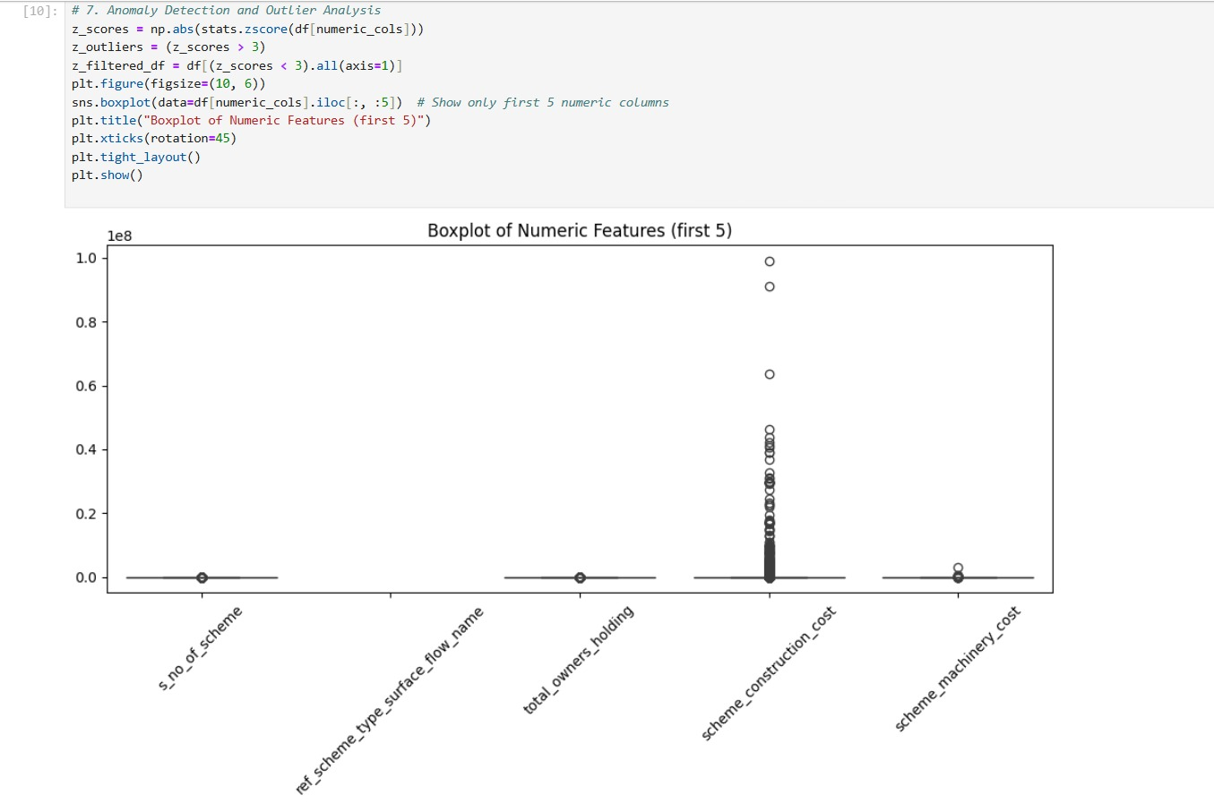

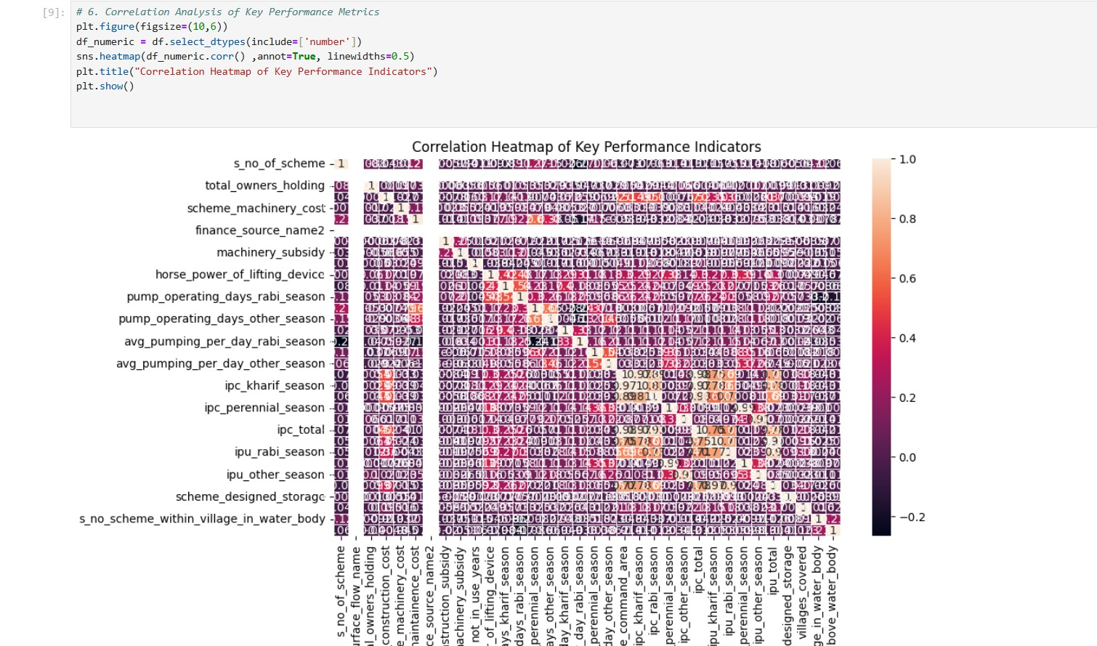

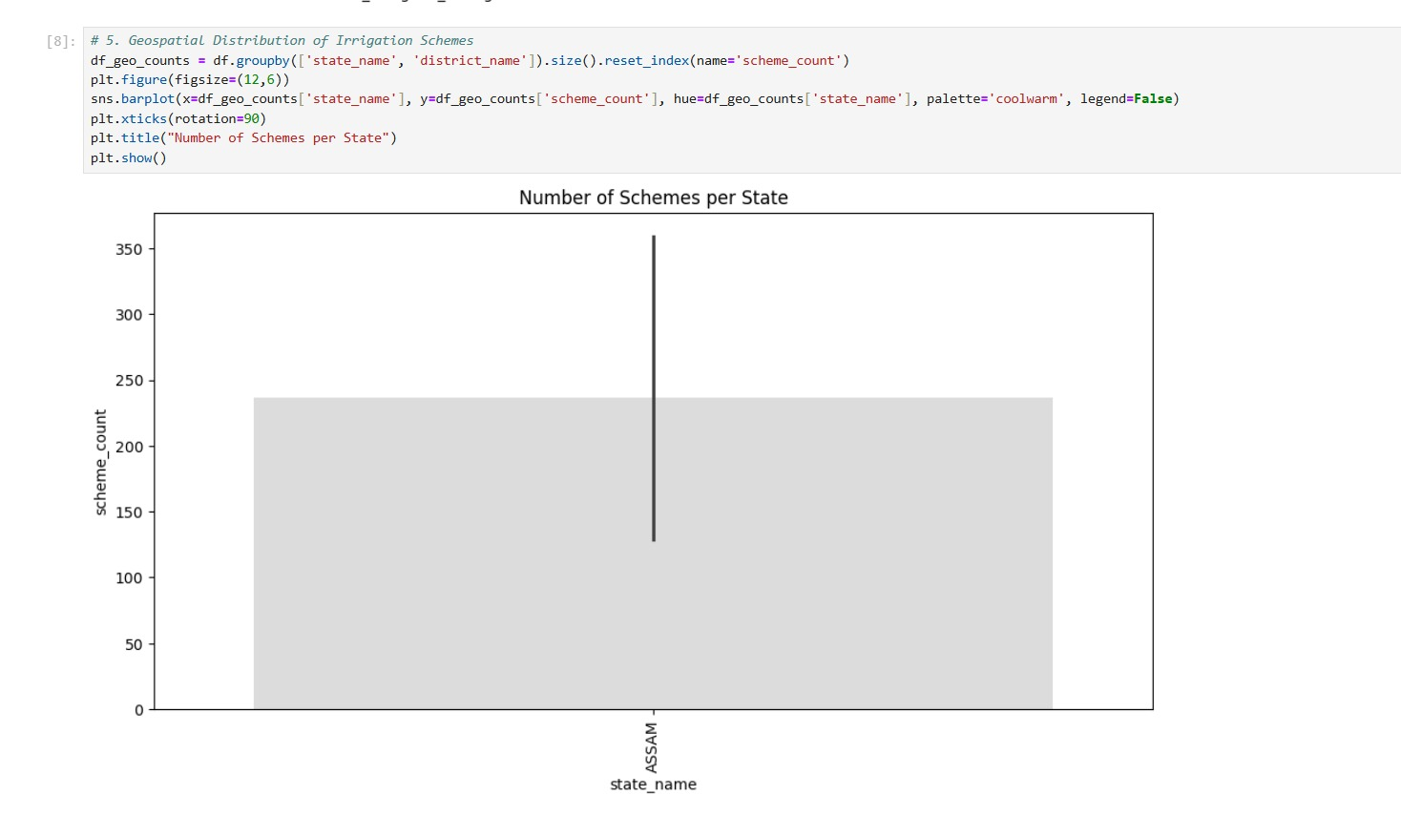

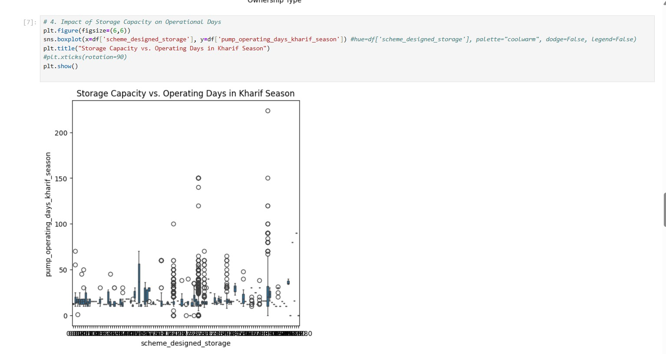
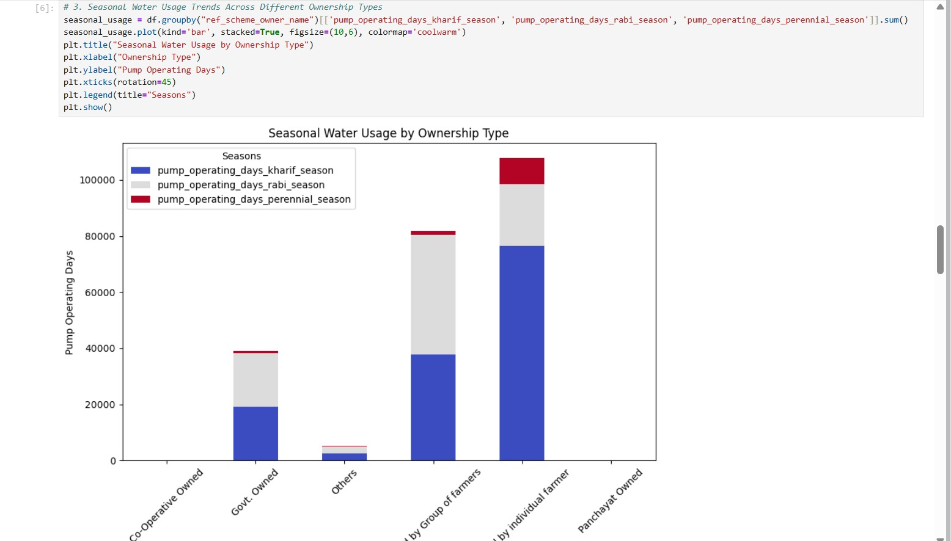

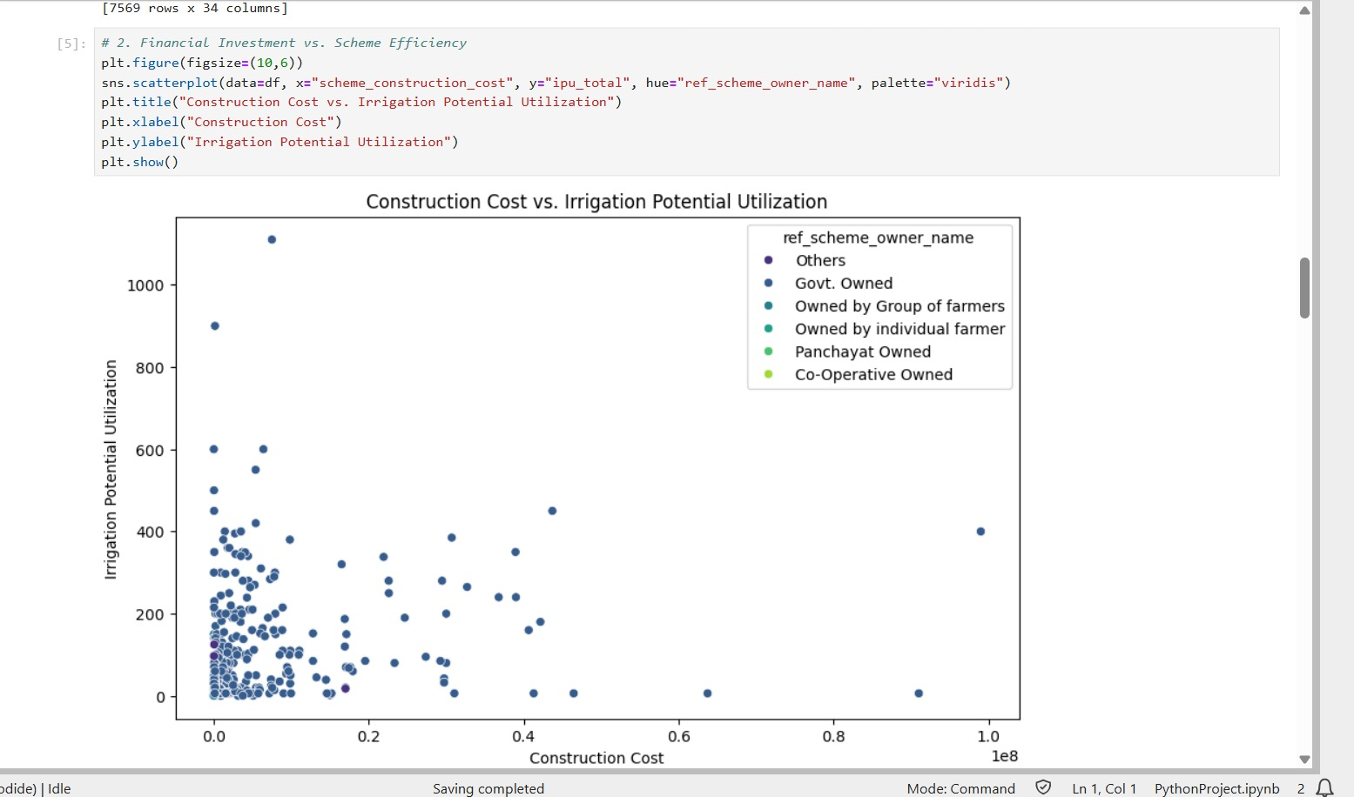

1. Distribution Analysis Using Histogram with KDE
To understand the distribution of key variables, histograms combined with Kernel Density Estimation (KDE) plots were created for
These visualizations help in identifying how the values of these variables are spread across the dataset. The KDE curve provides a smooth approximation of the distribution. For example, if the distribution of water rates is skewed, it indicates unequal water distribution across districts. Similarly, concentration around lower days of irrigation suggests that several households may not be receiving consistent work throughout the year.

2. Construction cost Vs irrigation potential (Line Plot)
The objective of this visualization was to assess how the water rates have evolved over time. An increasing trend would imply periodic water revisions or inflation adjustments under ASSAM CENSUS. If the trend appears stagnant or declining, it may highlight the need for policy revisions to ensure fair compensation.

3. Correlation Matrix (Heatmap)
A correlation heatmap was constructed to measure the relationships between multiple numeric variables including waters, expenditure, person-days, number of households, and more.
This heatmap provides a visual overview of how strongly each pair of variables is correlated. For instance, a high correlation between total expenditure and person-days generated suggests efficient fund utilization. Conversely, weak or negative correlations may reveal inefficiencies or non-uniform distribution of benefits across the program.

This chart displays the top 10 states based on total individuals worked and further breaks down the contribution from Scheduled Castes (SC), Scheduled Tribes (ST), and women in a stacked bar format.
This visualization highlights inclusivity in irrigation generation. States with higher participation from marginalized communities and women reflect better implementation of the scheme’s social equity goals. The plot also reveals inter-state disparities in demographic participation and outreach.

5. Box Plots for seasonal water usage by ownership type.
Box plots were used to examine the distribution, central tendency, and outliers for:
These visualizations are effective in identifying variations and anomalies within the data. For example, extreme values may represent districts with significantly higher or lower waters or irrigation, which can guide targeted policy interventions. The interquartile range (IQR) provides insights into data consistency across districts.

6. Storage capacity vs operating days.
This scatter plot maps the relationship between the average water rate per day and the total number of individuals worked in each district. Data points are colored by state.
The purpose of this visualization is to understand whether higher waters correspond to higher irrigation levels. It also helps identify clusters of states or outliers, providing a regional perspective on labor market dynamics under ASSAM CENSUS. Certain states may display better performance or outliers that require further investigation.

7. Number of schemes per states (Stacked Bar Chart)
This bar chart represents the gender-wise distribution of irrigation in the top 10 states with the highest total individuals worked. Women person-days and men person-days (calculated as the difference between total and women person-days) are stacked to show comparative participation.
This visualization provides insights into gender equity in irrigation. States with a larger share of women participation indicate greater empowerment and inclusivity. This also helps assess whether ASSAM CENSUS is meeting its mandate of promoting female participation in rural labor markets.

Conclusion of Visual Analysis
Each visualization adds a unique perspective to the understanding of irrigation and expenditure trends under ASSAM CENSUS. From analyzing individual distributions to inter-variable relationships and demographic participation, the visualizations provide a strong foundation for deriving data-driven conclusions and recommending evidence-based policy improvements.

CONCLUSION
This exploratory data analysis (EDA) project focused on the ASSAM , aimed at uncovering patterns in irrigation distribution, water trends, and the efficiency of fund utilization across various Indian states and districts. By utilizing Python libraries such as Pandas, NumPy, Matplotlib, and Seaborn, we were able to clean, explore, and visualize the dataset effectively.
The analysis began with a thorough inspection of the dataset's structure, missing values, and data types. After appropriate cleaning—handling nulls and duplicates—the dataset was made ready for deeper statistical and visual exploration. Summary statistics provided an initial overview, revealing variations in waters, person-days worked, and fund allocations across regions.
A significant focus was on water trends, which were visualized using histograms and KDE plots. This helped us understand how daily waters were distributed and how they evolved over time. Through line plots, we observed upward or stable trends in waters in most states, reflecting inflationary adjustments or policy changes.
We also explored the correlation between key variables, including total person-days worked, average water rate, and total expenditure. The heatmap revealed meaningful relationships, suggesting that higher expenditures often correlated with increased irrigation days—indicating efficient use of funds in certain states.
Outlier detection using box plots uncovered districts with anomalously high or low waters or expenditures, which could be areas needing policy review or further investigation.
One of the standout analyses was the demographic breakdown of irrigation, focusing on. Bar charts and stacked bar graphs showcased the inclusiveness of ASSAM CENSUS across top-performing states. We found that while some states demonstrated commendable representation, others lagged, indicating a need for more targeted outreach and inclusion strategies.
Furthermore, the highlighted the contribution of women workers relative to men. Our visualizations showed that in some states, women’s participation was nearly equal to or even surpassed men, aligning with the scheme's goal of promoting gender equity in rural irrigation.
Finally, the relationship between waters and irrigation generation was studied through scatter plots. This analysis aimed to determine whether higher waters directly translated into more irrigation days. While a general positive trend was observed, it became evident that other factors—such as administrative efficiency, local demand, and fund disbursement speed—also significantly influenced outcomes.
In conclusion, the EDA not only helped to uncover underlying trends and patterns but also provided a data-backed foundation for evaluating ASSAM CENSUS’s performance. The insights derived from the visualizations and metrics can guide policymakers in identifying successful strategies, rectifying disparities, and improving the overall impact of the program.
This EDA project successfully highlighted:
- Geographical disparities in irrigation generation and waters.
- Financial efficiency of state-level implementation.
- Social inclusiveness of the scheme based on caste and gender.
- Temporal trends and statistical correlations across key metrics.

FUTURE SCOPE

While this project has provided valuable insights through Exploratory Data Analysis (EDA) of the ASSAM CENSUS dataset, there is significant potential to extend this work further for deeper impact and more informed decision-making. Some areas for future enhancement include:
1. Time-Series Forecasting
- Currently, the analysis focused on historical trends. Future work could involve forecasting irrigation figures and water rates using models like ARIMA, Prophet, or LSTM.
- This can help predict future demand for rural irrigation and budget allocations, aiding in proactive policy planning.
2. District-Level Deep Dive
- This project aggregated data mostly at the state level. Future studies could zoom into specific districts to identify micro-level inefficiencies or high-performing regions.
- District-wise profiling can also highlight local economic conditions, migration patterns, or administrative delays.
3. Integration with External Datasets
- Combining this dataset with other sources such as census data, poverty indices, rainfall patterns, or agricultural productivity could reveal deeper socio-economic dependencies.
- This integration would support multi-variable modeling for understanding what drives irrigation trends at the rural level.
4. Interactive Dashboards
- Instead of static plots, future work can involve developing interactive dashboards using tools like Plotly Dash, Tableau, or Power BI.
- This would allow stakeholders to filter by year, state, or demographics and get insights in real-time.
5. Causal Analysis and Policy Simulation
- Going beyond correlation, causal inference models (e.g., using DoWhy or CausalImpact) can help identify the actual effect of policy changes or water increases.
- Simulation models can be developed to test “what-if” scenarios, such as “What if water rates are increased by 10% in low-performing states?”
6. Machine Learning for Anomaly Detection
- ML algorithms like Isolation Forest or One-Class SVM could be employed to automatically flag districts with abnormal values or data inconsistencies, improving data quality and fraud detection.
7. Real-time Monitoring
- With access to live or regularly updated data, a future system could be built to monitor ongoing irrigation and expenditure trends, detect delays, or identify underserved areas immediately.
8. Academic and Policy Research Collaborations
- This analysis can be extended into a research publication or thesis by collaborating with academic mentors, NGOs, or government research cells.
- The insights can support policy briefs, evaluation reports, or recommendations for better implementation of ASSAM CENSUS and similar welfare schemes.

REFERENCES
- Department of Irrigation, Government of Assam
  - Provides detailed information on the Irrigation Census, including highlights from the 6th Minor Irrigation Census and the Census of Water Bodies.
- Ministry of Jal Shakti – Irrigation Census Dashboard
  - National and state-level data from the 6th Minor Irrigation Census. Offers statistics on groundwater/surface schemes and irrigation potential.
  - 📎 Visit Dashboard
- Press Information Bureau (PIB) – Irrigation Projects in Assam
  - Details Central Assistance and outcomes of the irrigation census, including the number of minor irrigation schemes.
  - 📎 Read Press Release
- India Today NE – Water Bodies Census Report in Assam
  - Highlights findings from the census on water bodies in Assam, showing trends in public vs. private ownership.
  - 📎 Read Article
- 6th Minor Irrigation Census – Guidelines and Manuals (Govt of India)
  - Includes methodology, data schedules, and definitions used in the 6th census, applicable to Assam.
  - 📎 Download PDF Manual

Let me know if you need data in tabular format or help citing these in a report!
4o

