**1. SRS Document**

**1.1 Project Title: Smart learning**

**1.2 Category: Web application**

**1.3 Introduction**

**1.3.1 Purpose:**

Software Requirements Specification (SRS) documents are created to give detailed information regarding system functionalities and non-functionalities. It explains the functions of the program and how it should operate. The features needed for a web application are described in this document. Hardware, software, and other technical requirements are also covered in detail in this document.

**1.3.2 Intended Audiences and Reading Suggestions:**

This document is developed for the system developers to develop web applications that help the user to minimize their manual work and time management in the academic sector online, to track performance, centralize notes and get reminders of mentioned work. The end user for this web application will be Student. This document will serve as the development blueprint for the system, i.e. Smart Learning. As a result, users may use this document to learn about the features required in web applications.

**1.3.3 Project Scope:**

The web application is being developed for particular users(students) in order to resolve the time management problems faced during the study and track their performance on what they did on a daily basis by users (Student). Missing their work deadline by users(students). The features that are required for the developed web application are listed below.

a) upload photos, notes, and Pdf files according to the users’ categories.

b) To get a reminder of mentioned work like CW, assignments, or any important event. C) invitation and collaboration between student and teacher.

d) Store the necessary details of the teacher like email, phone number, name etc.

e) calendar so it can be easy to set reminders.

f) To-do list whether the task was successfully completed or not to track the performance of the student.

g) Student performance tracker so their work and the task they did within 24 hours and track their daily, weekly, or monthly performance.

h)Student can chat with each other.

**1.3.4 Existing System**

The present system does not satisfy the need of the student which are very important in their study life. Many people are still using manual ways to write their work done in their daily basis. Some of the disadvantages of the present system has been listed below:

a) It is a limited system that is not user appealing.

b) Cannot edit the reminder time which has already been selected.

c) In the existing system users (student) cannot store their screen shorts and pdfs in a centralized way.

d) If the deadline is missed, then the existing System does not get the reminder much before the deadline.

e) Many people are using manual study planning rather than tracking their study performance online and studying accordingly.

**1.3.5 Proposed System:**

The main aim of the proposed system is to update the existing system with some useful, needed features and by making the user-friendly, easy-to-use web application. There are many advantages of Smart Learning to the student and admin which are listed below: Advantage for students

a) Students can invite and collaborate with the teachers when they need help in their studies.

b) Students can store their screen shorts/pdf notes in an organized/centralized way.

c) Students can get a reminder of their mentioned work before the deadline.

d) Track their study performance weekly or monthly by checking the work done on a daily basis.

The advantage for Admin

1. Admin can notify the users about the update made in the system.
2. As per required by the systematic can delete user from the system.
3. Admin can Update their profile.

**1.4 Overall Description**

**1.4.1. System Features**

Some of the features that should be included in the web application are listed below:

**1.4.1.1. Register User**

The web application will facilitate users(students) to register to the system by requesting

the user’s name, email, password, and other relevant data.

**1.4.1.2. Calendar**

The web application will facilitate the user to see today’s date on the calendar and also it

can be easy to set reminders.

**1.4.1.3. Update Profile**

The web application will facilitate the user (students) and admin to update their details

and profile.

**1.4.1.4. Upload photos/notes**

The web application will facilitate the user (students) to upload photos/notes according

to their work and need categories.

**1.4.1.5. Set Reminder**

Set reminders will facilitate the user (students) to set the reminder for their mentioned

work and get it before their mentioned deadline.

**1.4.1.6. Add task**

The web application will facilitate the user (Students) to update their work according to

their category list to obtain how much they complete their task to track their

performance.

**1.4.1.6 Chat**

The web application will facilitate the user(students) to chat with other user(student) of the web application.

**1.4.1.7. Track Performance**

The web application will facilitate the user (Students) to know how much

users(students) did their work according to a task added by the user to track

performance by generating the report.

**1.4.1.8. Reset password.**

The web application will facilitate the user (Students) to reset their password by sending

opt number.

**1.4.1.9. Share file.**

The web application will facilitate the user (Students) to share and collaborate with the

users according to their needs.

**1.4.1.10. Notify Updates**

Notify Updates will be available for the admin to notify users(students) if any updates are

required or done in the system.

**1.4.1.11. Teacher details.**

The web application will facilitate the user (Students) to store the information of the

teacher and can view it whenever needed.

**1.4.2. User class and characteristics**

Smart learning web applications will be mainly used by the user student and others

will be Admin. Basically, there will be two users. According to the users their roles

are listed below:

UC1: Users (Students)

UC1.1

Can log in or register to the system.

UC1.2

Can upload and view their uploaded notes and pdf files.

UC1.3

Can Set and get reminders of their mentioned work.

UC1.4

Can collaborate with user by sending file for help and chat.

UC1.5

Tracking performance can be done by the user and generate the report.

UC1.6

Can write and view information of teacher which they have written.

UC2: Admin.

UC2.1

Can log in to the system.

UC2.2

Can Notify the users about the system update.

UC2.3

Can delete the user.

1.4.3. Operating Environment

OE1: In the present context, Smart Learning is focused on web platforms only.

Further planning is to make this web application on the mobile app and run on a

different platform.

1.4.4. Assumption and Dependencies

AS1: The main targeted audience of this application is users(students).

AS2: The application developed will be an online application.

AS3: Documents and reports for this system are available to developers and researchers

interested in developing this system with addition

**1.4.5 Functional Requirements**

**Register user.**

|  |  |  |  |  |
| --- | --- | --- | --- | --- |
| **Req.ID** | **Requirement Description** | | | |
| **FR.01** | Students can register through this application. | | | |
|  | **Sys.Req.**  **ID** | **System Requirement** |  |
| SR.01 | The user (student) can view the registration page. |
| SR.02 | The System should check whether the  Compulsory filling area is entered or not. |
| SR.03 | The System should check provided information is valid or not. |
|  |  | SR.04 | The System Should display a message about whether the user(student) registration is successful or not. |  |

**Login (Student/admin).**

|  |  |  |  |  |
| --- | --- | --- | --- | --- |
| **Req.ID** | **Requirement Description** | | | |
| **FR.02** | Students who have registered for the system and admin should log in to use this system. | | | |
|  | **Sys.Req.**  **ID** | **System Requirement** |  |
| SR.05 | The user (student/admin) can view the login page. |
| SR.06 | The System should check whether the  Compulsory filling area is entered or not. |
| SR.07 | The System should check provided information is valid or not. |
| SR.08 | The System Should display a message about whether the login is successful or not. |
| SR.09 | If the user entered details are valid then verify the user. |
| SR.10 | If the user is a student, then display the student dashboard otherwise the admin dashboard should be display. |

**Update Profile.**

|  |  |  |  |  |
| --- | --- | --- | --- | --- |
| **Req.ID** | **Requirement Description** | | | |
| **FR.03** | Students who have an account in this web app can update their profile details if needed. | | | |
|  | **Sys.Req.**  **ID** | **System Requirement** |  |
| SR.11 | Users should be able to see their profiles. |
| SR.12 | A user should be able to edit their information details. |
| SR.13 | The System should make a change and display. |

**Upload photos/notes.**

|  |  |  |  |  |
| --- | --- | --- | --- | --- |
| **Req.ID** | **Requirement Description** | | | |
| **FR.04** | Students can upload their notes/photos(screenshots) and manage them accordingly. | | | |
|  | **Sys.Req.**  **ID** | **System Requirement** |  |
| SR.14 | When the user clicks on the upload button then the system shall display the types i.e. Pdf or photos. |
| SR.15 | If the user wants to upload photos, then the system shall store them in the photo category. |
| SR.16 | If the user wants to upload a pdf, then the system shall store them in the notes category. |
| SR.17 | User should view their uploaded notes and pdfs. |

**Set a reminder.**

|  |  |  |  |  |
| --- | --- | --- | --- | --- |
| **Req.ID** | **Requirement Description** | | | |
| **FR.05** | Students can set and get a Reminder of their mentioned work before the deadline. | | | |
|  | **Sys.Req.**  **ID** | **System Requirement** |  |
| SR.18 | When the user clicks on reminder then the set reminder button should display. |
| SR.19 | The system should display the time and calendar when they want the reminder. |
| SR.16 | Users should view when they are getting reminders. |

**Track Performance.**

|  |  |  |  |  |
| --- | --- | --- | --- | --- |
| **Req.ID** | **Requirement Description** | | | |
| **FR.07** | Students can track performance how well they perform monthly. | | | |
|  | **Sys.Req.**  **ID** | **System Requirement** |  |
| SR.18 | When the user clicks on the complete, pending ,incomplete icon system should display how much they completed task monthly.. |
| SR.19 | If the user wants to generate the monthly report then the system should display report by searching month. |
| SR.20 | The system should display graphs and charts if the user wants monthly otherwise it should display empty month. |
| SR.21 | The user can view the chart/ Graph. |

**Add task.**

|  |  |  |  |  |
| --- | --- | --- | --- | --- |
| **Req.ID** | **Requirement Description** | | | |
| **FR.07** | Students can add a category list of what subjects they want to track performance. | | | |
|  | **Sys.Req.**  **ID** | **System Requirement** |  |
| SR.22 | The system should view and be able to add the work of the user. |
| SR.23 | If user work is done then the system shall check add mark it done. |
| SR.24 | If user work is not done, then the system shall check ad mark it incomplete. |

**Teachers’ details.**

|  |  |  |  |  |
| --- | --- | --- | --- | --- |
| **Req.ID** | **Requirement Description** | | | |
| **FR.08** | Students can add teacher details and view teacher details whenever they need. | | | |
|  | **Sys.Req.**  **ID** | **System Requirement** |  |
| SR.25 | When the user clicks on the add button then the system shall display the blank boxes to fill in the information of the teacher. |
| SR.26 | If the user wants to store the teacher’s details the system shall store them according to the information. |
| SR.27 | Users should view their added information of teachers. |

**Share File.**

|  |  |  |  |  |
| --- | --- | --- | --- | --- |
| **Req.ID** | **Requirement Description** | | | |
| **FR.08** | Students can Share File such as pdf/photo they need. | | | |
|  | **Sys.Req.**  **ID** | **System Requirement** |  |
| SR.28 | When the user clicks on the share file then the system shall display the blank boxes to fill in the information whom to share File to user. |
| SR.29 | If the user wants to store the ShareFile details the system shall store them according to the information. |
| SR.30 | Users should view their added information of Share File List. |

**Chat.**

|  |  |  |  |  |
| --- | --- | --- | --- | --- |
| **Req.ID** | **Requirement Description** | | | |
| **FR.08** | Students can chat with each other when they need. | | | |
|  | **Sys.Req.**  **ID** | **System Requirement** |  |
| SR.31 | When the user clicks on the chat then the system shall display Chat box. |
| SR.32 | If the user wants to send and receive text messages in real time. |

**Notify updates.**

|  |  |  |  |  |
| --- | --- | --- | --- | --- |
| **Req.ID** | **Requirement Description** | | | |
| **FR.09** | Admin can notify users about the updates made in the system. | | | |
|  | **Sys.Req.**  **ID** | **System Requirement** |  |
| SR.33 | The system should display the notification option when the admin made any changes. |
| SR.34 | The system should send the notification. |
| SR.35 | Users should view the notification about the changes made in the system or any new features added. |

**Delete user.**

|  |  |  |  |  |
| --- | --- | --- | --- | --- |
| **Req.ID** | **Requirement Description** | | | |
| **FR.10** | Admin can only delete user if necessary. | | | |
|  | **Sys.Req.**  **ID** | **System Requirement** |  |
| SR.36 | Total number of users should be stored into database. |
| SR.37 | Admin can delete the user and the system should display. |
| SR.38 | The system should display again display total users. |

**1.4.6 External Interfaces Requirements**

**Hardware.**

This application has been developed for students to make studying easier. So, to use this web application they must have their own laptop or desktop computer with an internet connection hardware requirement for this project are listed below:

* Processor: 2.0 GHz or higher.
* Memory: 4 GB or higher.
* Storage: 100 GB or higher.

**Software.**

Standard resources will be utilized to create and maintain an Smart learning application database. Coding necessitates the development of a web application rather than code. Similarly, MySQL databases are used to store user data and information that is required by the program.

**Other Non-Functional Requirements**

**Performance Requirements**

|  |  |  |
| --- | --- | --- |
| **Req.ID** | **Requirement Description** | **Priority** |
| **PR.01** | If the user is not logged in or registered, the application should display the login page or registration page initially. | Should |
| **PR.02** | After successfully logging in, the application will show the users' dashboard. | Should |
| **PR.03** | All the features of web applications will be functional, For the users. | Should |

**Safety Requirements**

|  |  |  |
| --- | --- | --- |
| **Req.ID** | **Requirement Description** | **Priority** |
| **SR.01** | Advertisements should not be displayed while using the application. | Should |
| **SR.02** | The application should be made free from any attacks. | Could. |
| **SR.03** | The application will take permission from users if any personal data of user need to access. | Should. |

**Software Quality Attributes**

|  |  |  |
| --- | --- | --- |
| **Req.ID** | **Requirement Description** | **Priority** |
| **SQA.01** | The requirements specified for this project must be completed. | Should |
| **SQA.02** | The application should be responsive and easy to operate. | Should |
| **SQA.03** | If needed, new functionality and modern UI might be added to the updated applications. | Could |

**Use case Diagram**

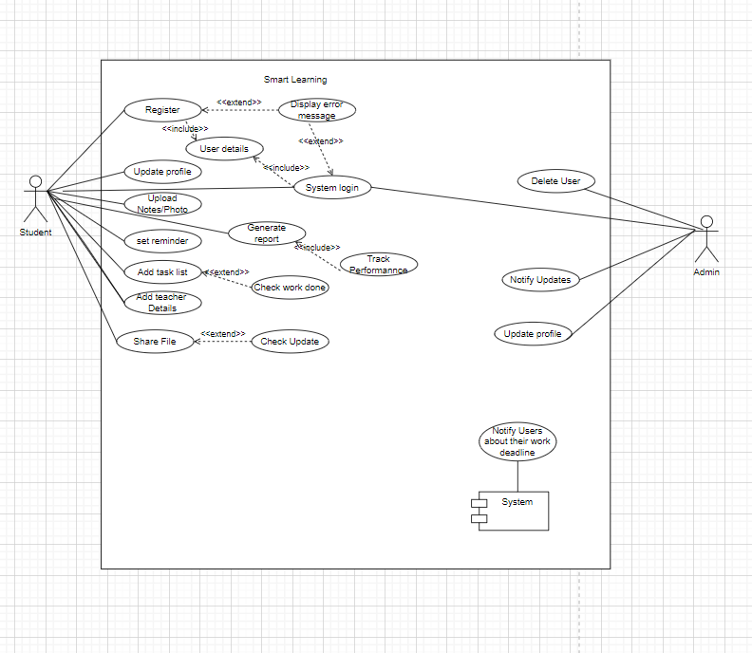

**1.Register**

Data flow diagram

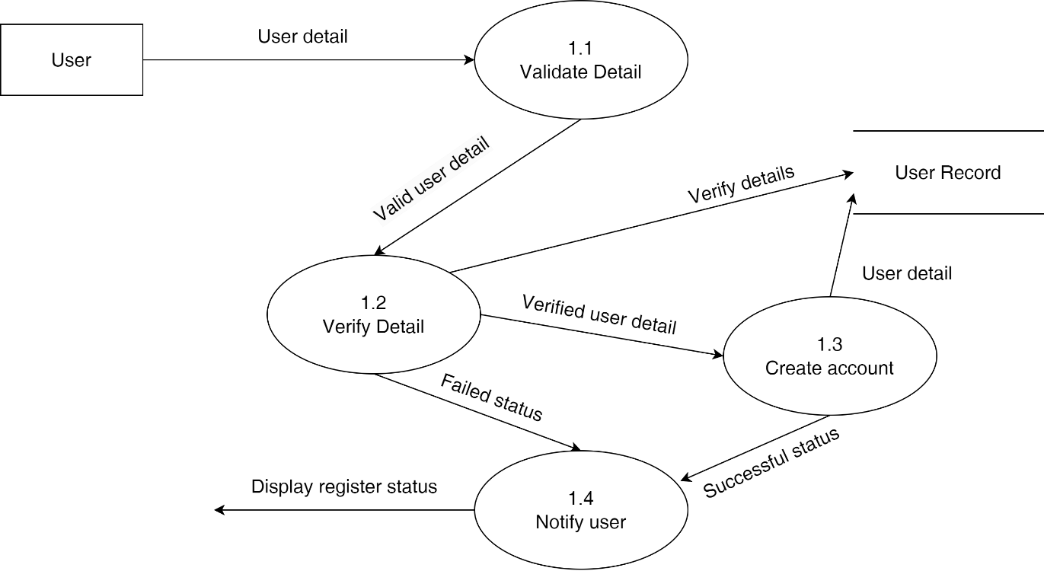

Sequence Diagram

**Login**

Data Flow Diagarm

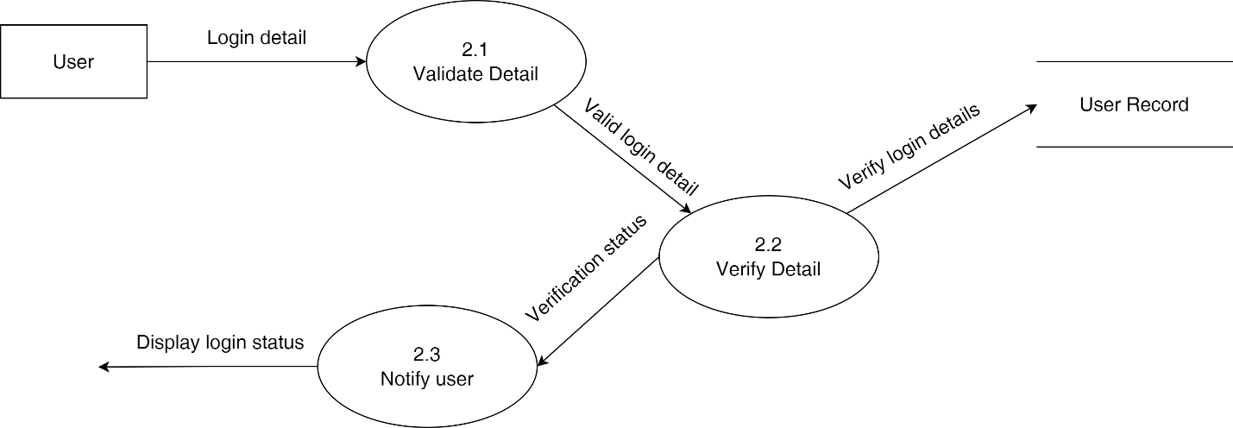

**Sequence Diagram**

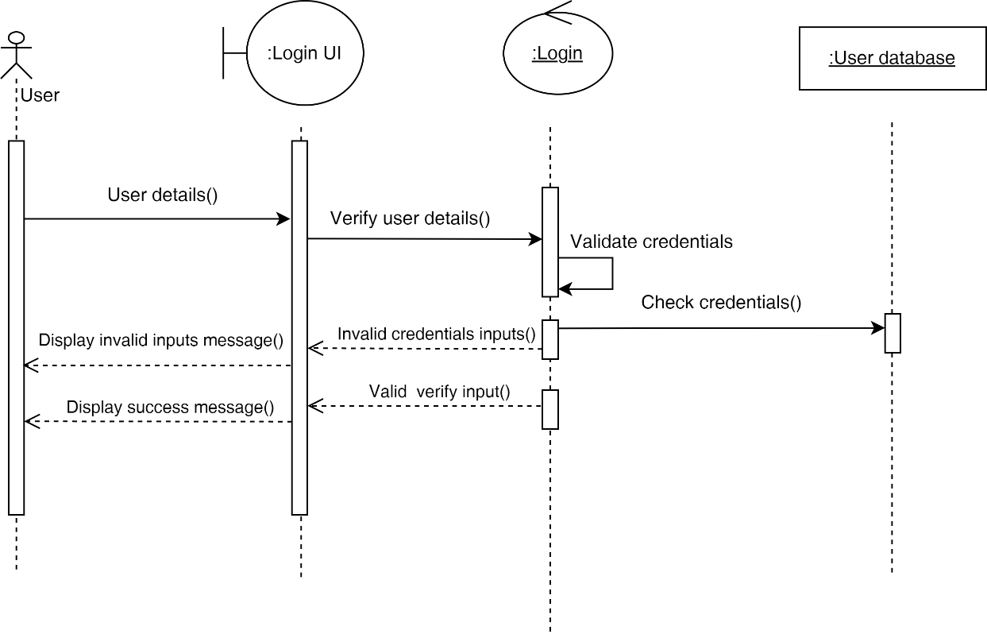

**Update Details**

**Data Flow Diagram**

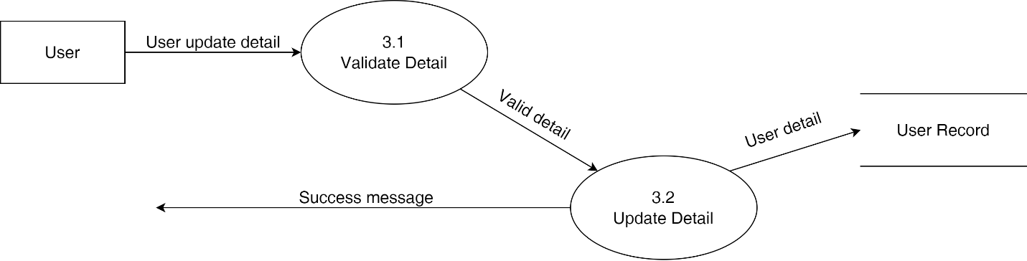

Sequence Diagram

**Category**

**Data Flow Diagram**

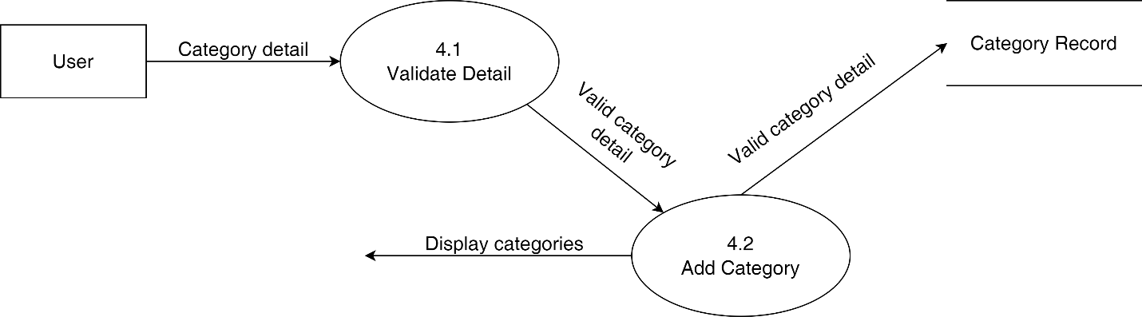

Sequence Diagram

**Note**

**Data Flow Diagram**

**Sequence Diagram**

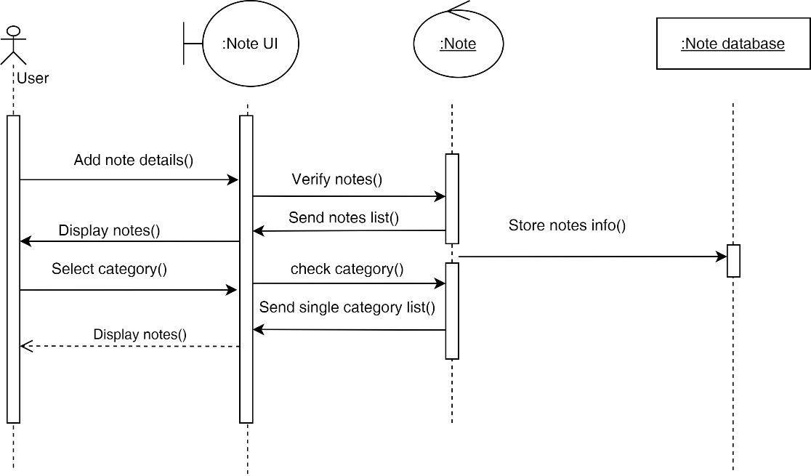

**Task**

**Data Flow Diagram**

**Sequence Diagram**

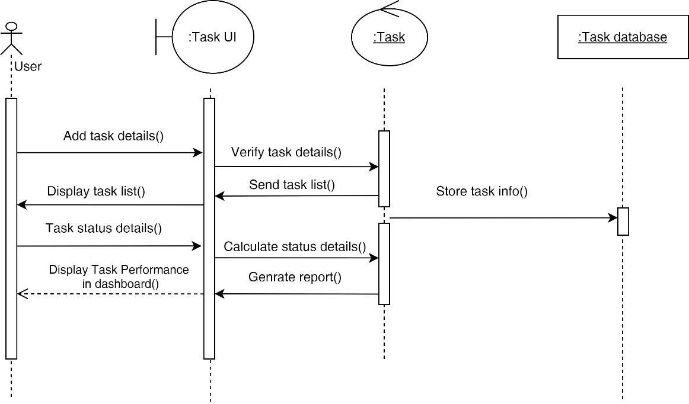

**Reminder**

Data Flow Diagram

Sequence Diagram

**Teacher**

Data Flow Diagram

Sequence Diagram

