

Requirement & Design Specification
KIZUNA NIHONGO - JAPANESE LEARNING SYSTEM OPTIMIZED WITH PERSONALIZED AI LEARNING PATHS
Version: 1.0

– Danang, May 2026 –

Record of Changes
Version | Date | A*M, D | In charge | Change Description
1.0 | 30/May/2026 | A | All member | Initial version of the Requirement & Design Specification.
*A - Added M - Modified D - Deleted

Contents
Record of Changes 2
Contents 3
I. Overview 9
1. User Requirements 9
1.1 Actors 9
1.2 Use Cases 9
2. Overall Functionalities 18
2.1 Screens Flow 18
2.2 Screen Descriptions 23
2.3 Screen Authorization 26
2.4 Non-UI Functions 27
3. System High Level Design 28
3.1 Database Design 28
3.2 Code Packages 39
II. Requirement Specifications 41
1. Authentication & Profile 41
1.1 UC-01_Register 41
1.2 UC-02_Submit Teacher Application 42
1.3 UC-03_Login 44
1.4 UC-04_Logout 44
1.5 UC-05_Change Password 45
1.6 UC-06_Forgot Password 46
1.7 UC-07_View Profile 47
1.8 UC-08_Edit Profile 47
2. Learning & Courses (Student) 48
2.1 UC-09_Take Placement Test 48
2.2 UC-10_Generate Personalized Learning Roadmap 49
2.3 UC-11_Enroll in Course 50
2.4 UC-12_View Course Content 51
2.5 UC-13_Take Course Quiz 52
3. Vocabulary, Kanji & Grammar (Student) 53
3.1 UC-14_View Vocabulary 53
3.2 UC-15_View Kanji 53
3.3 UC-16_View Grammar 54
4. Flashcard Management (Student) 55
4.1 UC-17_Create Flashcard Set 55
4.2 UC-18_Update Flashcard Set 55
4.3 UC-19_Delete Flashcard Set 56
4.4 UC-20_Review Flashcards (Flip Mode) 57
4.5 UC-21_Take Flashcard Test 57
5. Dictionary (Student) 58
5.1 UC-22_Look Up Dictionary 58
6. Reading Practice (Student) 59
6.1 UC-23_Practice Reading 59
6.2 UC-24_Answer Reading Comprehension Quiz 60
7. Listening & Speaking (Student) 61
7.1 UC-25_Listen to Dialogues 61
7.2 UC-26_Practice Dictation 61
7.3 UC-27_Practice Shadowing (Pronunciation) 62
7.4 UC-28_Create Own Listening Content 63
8. Writing (Student) 64
8.1 UC-29_Practice Kanji Writing 64
8.2 UC-30_Create Kanji Writing Practice Sheet 65
8.3 UC-31_Write Composition & Receive AI Feedback 66
9. JLPT Mock Exams (Student & Teacher) 66
9.1 UC-32_Take JLPT Mock Test 66
9.2 UC-33_View Mock Exam Results & History 68
9.3 UC-34_View Mock Test Leaderboard 68
10. AI Chat Sensei 69
10.1 UC-35_Chat with AI Sensei 69
11. Progress Tracking (Student) 70
11.1 UC-36_View Learning Dashboard 70
12. Subscription & Payment (Student) 71
12.1 UC-37_View Pricing Plans & Purchase Subscription 71
12.2 UC-38_View Billing History 71
13. Course Management (Admin & Teacher) 72
13.1 UC-39_View Courses (Management) 72
13.2 UC-40_Create Course 73
13.3 UC-41_Update Course 74
13.4 UC-42_Delete Course 75
14. Learning Material Posts (Admin & Teacher) 75
14.1 UC-43_Create Vocabulary Post 75
14.2 UC-44_Update Vocabulary Post 76
14.3 UC-45_Delete Vocabulary Post 77
14.4 UC-46_Create Kanji Post 77
14.5 UC-47_Update Kanji Post 78
14.6 UC-48_Delete Kanji Post 79
14.7 UC-49_Create Grammar Post 79
14.8 UC-50_Update Grammar Post 80
14.9 UC-51_Delete Grammar Post 81
15. Question Bank Management (Admin & Teacher) 82
15.1 UC-52_View Question Bank 82
15.2 UC-53_Add Question to Bank 82
15.3 UC-54_Update Question 83
15.4 UC-55_Delete Question 84
16. Reading Management (Admin & Teacher) 84
16.1 UC-56_Create Reading Passage 84
16.2 UC-57_Update Reading Passage 85
16.3 UC-58_Delete Reading Passage 86
17. Listening Content Management (Admin & Teacher) 87
17.1 UC-59_Create Listening Content 87
17.2 UC-60_Update Listening Content 87
17.3 UC-61_Delete Listening Content 88
18. JLPT Mock Exam Management (Admin) 89
18.1 UC-62_Create Mock Exam 89
18.2 UC-63_Update Mock Exam 90
18.3 UC-64_Delete Mock Exam 90
19. Placement Test Management (Admin) 91
19.1 UC-65_Create Placement Question 91
19.2 UC-66_Update Placement Question 92
19.3 UC-67_Delete Placement Question 92
20. User Management (Admin) 93
20.1 UC-68_View User List 93
20.2 UC-69_Review Teacher Applications 93
20.3 UC-70_Update User 94
20.4 UC-71_Reset User Password 95
20.5 UC-72_Delete User 96
21. Subscription & Payment Management (Admin) 96
21.1 UC-73_Grant Subscription to User 96
21.2 UC-74_Cancel User Subscription 97
21.3 UC-75_View Payments & Reconcile 98
22. Revenue Sharing (Teacher & Admin) 98
22.1 UC-76_View My Earnings (Teacher) 98
22.2 UC-77_Manage Revenue Pool (Admin) 99
23. Reports, Analytics & System (Admin) 100
23.1 UC-78_View Statistics & Activity 100
23.2 UC-79_Monitor System Status 100
III. Design Specification 102
1. Authentication & Profile 102
1.1 UC-01_Register 102
1.2 UC-02_Submit Teacher Application 102
1.3 UC-03_Login 102
1.4 UC-04_Logout 102
1.5 UC-05_Change Password 103
1.6 UC-06_Forgot Password 103
1.7 UC-07_View Profile 103
1.8 UC-08_Edit Profile 103
2. Learning & Courses (Student) 104
2.1 UC-09_Take Placement Test 104
2.2 UC-10_Generate Personalized Learning Roadmap 104
2.3 UC-11_Enroll in Course 104
2.4 UC-12_View Course Content 104
2.5 UC-13_Take Course Quiz 105
3. Vocabulary, Kanji & Grammar (Student) 105
3.1 UC-14_View Vocabulary 105
3.2 UC-15_View Kanji 105
3.3 UC-16_View Grammar 105
4. Flashcard Management (Student) 106
4.1 UC-17_Create Flashcard Set 106
4.2 UC-18_Update Flashcard Set 106
4.3 UC-19_Delete Flashcard Set 106
4.4 UC-20_Review Flashcards (Flip Mode) 106
4.5 UC-21_Take Flashcard Test 107
5. Dictionary (Student) 107
5.1 UC-22_Look Up Dictionary 107
6. Reading Practice (Student) 107
6.1 UC-23_Practice Reading 107
6.2 UC-24_Answer Reading Comprehension Quiz 107
7. Listening & Speaking (Student) 108
7.1 UC-25_Listen to Dialogues 108
7.2 UC-26_Practice Dictation 108
7.3 UC-27_Practice Shadowing (Pronunciation) 108
7.4 UC-28_Create Own Listening Content 108
8. Writing (Student) 109
8.1 UC-29_Practice Kanji Writing 109
8.2 UC-30_Create Kanji Writing Practice Sheet 109
8.3 UC-31_Write Composition & Receive AI Feedback 109
9. JLPT Mock Exams (Student & Teacher) 109
9.1 UC-32_Take JLPT Mock Test 109
9.2 UC-33_View Mock Exam Results & History 110
9.3 UC-34_View Mock Test Leaderboard 110
10. AI Chat Sensei 110
10.1 UC-35_Chat with AI Sensei 110
11. Progress Tracking (Student) 110
11.1 UC-36_View Learning Dashboard 110
12. Subscription & Payment (Student) 111
12.1 UC-37_View Pricing Plans & Purchase Subscription 111
12.2 UC-38_View Billing History 111
13. Course Management (Admin & Teacher) 111
13.1 UC-39_View Courses (Management) 111
13.2 UC-40_Create Course 111
13.3 UC-41_Update Course 112
13.4 UC-42_Delete Course 112
14. Learning Material Posts (Admin & Teacher) 112
14.1 UC-43_Create Vocabulary Post 112
14.2 UC-44_Update Vocabulary Post 112
14.3 UC-45_Delete Vocabulary Post 113
14.4 UC-46_Create Kanji Post 113
14.5 UC-47_Update Kanji Post 113
14.6 UC-48_Delete Kanji Post 113
14.7 UC-49_Create Grammar Post 113
14.8 UC-50_Update Grammar Post 114
14.9 UC-51_Delete Grammar Post 114
15. Question Bank Management (Admin & Teacher) 114
15.1 UC-52_View Question Bank 114
15.2 UC-53_Add Question to Bank 114
15.3 UC-54_Update Question 115
15.4 UC-55_Delete Question 115
16. Reading Management (Admin & Teacher) 115
16.1 UC-56_Create Reading Passage 115
16.2 UC-57_Update Reading Passage 115
16.3 UC-58_Delete Reading Passage 116
17. Listening Content Management (Admin & Teacher) 116
17.1 UC-59_Create Listening Content 116
17.2 UC-60_Update Listening Content 116
17.3 UC-61_Delete Listening Content 116
18. JLPT Mock Exam Management (Admin) 117
18.1 UC-62_Create Mock Exam 117
18.2 UC-63_Update Mock Exam 117
18.3 UC-64_Delete Mock Exam 117
19. Placement Test Management (Admin) 117
19.1 UC-65_Create Placement Question 117
19.2 UC-66_Update Placement Question 118
19.3 UC-67_Delete Placement Question 118
20. User Management (Admin) 118
20.1 UC-68_View User List 118
20.2 UC-69_Review Teacher Applications 118
20.3 UC-70_Update User 119
20.4 UC-71_Reset User Password 119
20.5 UC-72_Delete User 119
21. Subscription & Payment Management (Admin) 119
21.1 UC-73_Grant Subscription to User 119
21.2 UC-74_Cancel User Subscription 120
21.3 UC-75_View Payments & Reconcile 120
22. Revenue Sharing (Teacher & Admin) 120
22.1 UC-76_View My Earnings (Teacher) 120
22.2 UC-77_Manage Revenue Pool (Admin) 120
23. Reports, Analytics & System (Admin) 121
23.1 UC-78_View Statistics & Activity 121
23.2 UC-79_Monitor System Status 121
IV. Appendix 122
1. Assumptions & Dependencies 122
2. Limitations & Exclusions 122
3. Business Rules 122
4. Application Messages List 124

I. Overview

1. User Requirements

1.1 Actors
The Kizuna Nihongo platform serves four primary human actors and two supporting system actors. Their roles and responsibilities within the system are summarized below.
# | Actor | Description
1 | Guest | An unauthenticated visitor who can browse public information and register for a new account. A Guest must register and log in to access learning features.
2 | Student | A registered learner who takes placement tests, follows a personalized AI learning roadmap, practices the four skills (Listening, Speaking, Reading, Writing), uses flashcard to review vocabulary, takes exams, JLPT mock tests, and joins classes.
3 | Teacher | An instructor who manages classrooms, creates and assigns exams, builds a private question bank, and monitors students' exam sessions and progress.
4 | Admin | The highest-privilege manager who administers user accounts, manages global learning content (courses, vocabulary, kanji, grammar, listening/reading materials, JLPT tests, the global question bank) and views system-wide reports.
5 | AI Service | A supporting system actor providing automated placement scoring, adaptive exam generation, pronunciation evaluation, and writing feedback.
6 | Email Service | A supporting system actor that delivers account-verification and notification emails.

1.2 Use Cases

a. Diagram(s)
The overall use case diagram of the Kizuna Nihongo system is presented below. It groups the use cases by functional area and associates each use case with its primary actor (Guest, Student, Teacher, or Admin).
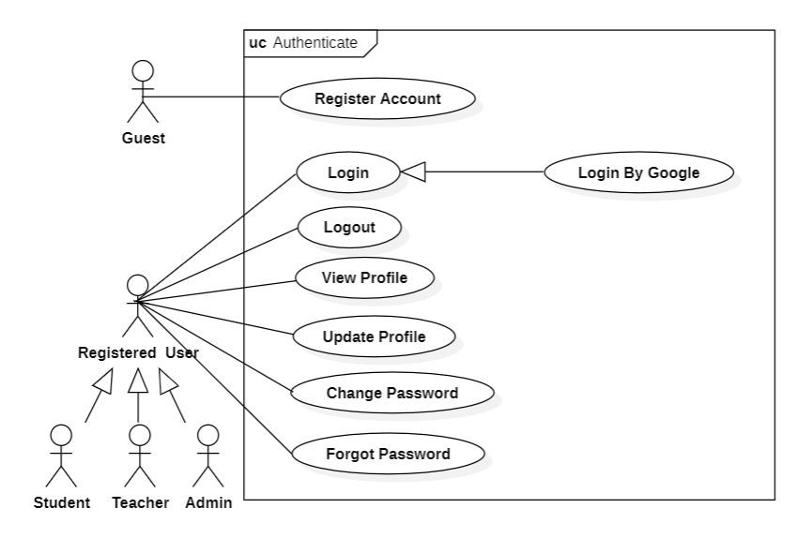
Figure 1. Authentication Use Case Diagram
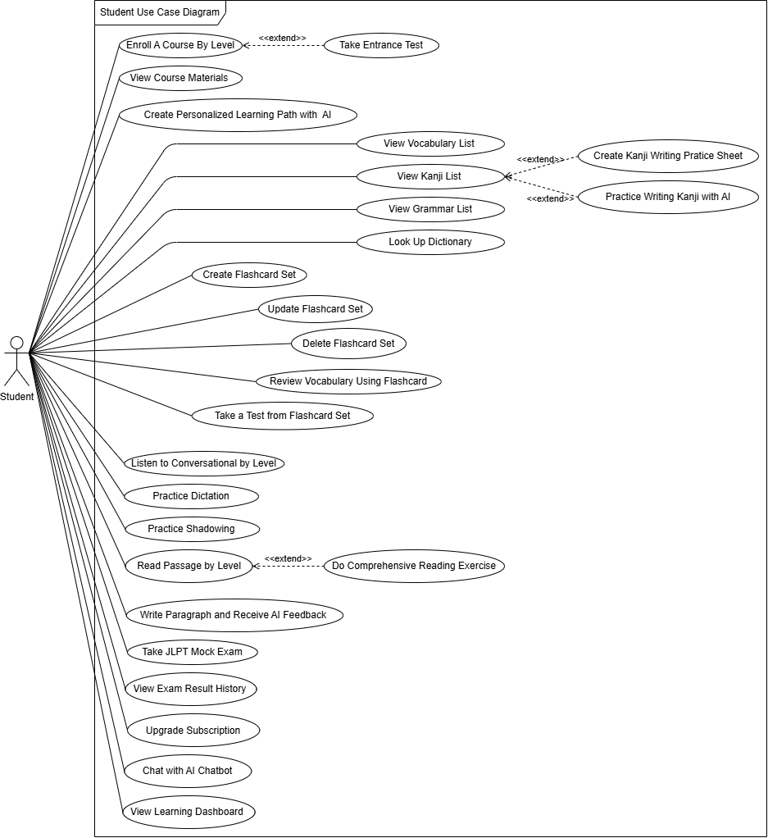
Figure 2. Student Use Case Diagram
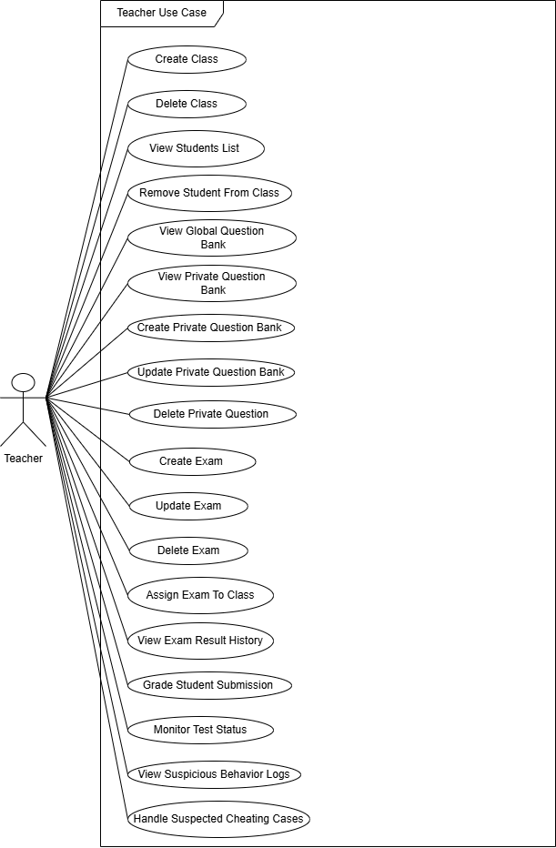
Figure 3. Teacher Use Case Diagram
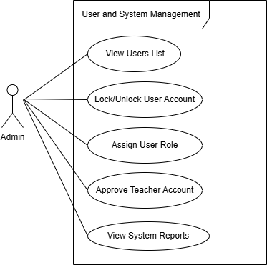
Figure 4. User and System Management Use Case Diagram

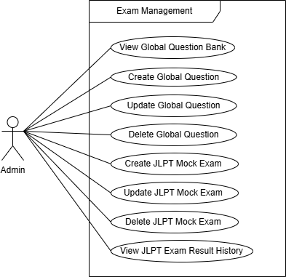
Figure 5. Exam Management Use Case Diagram

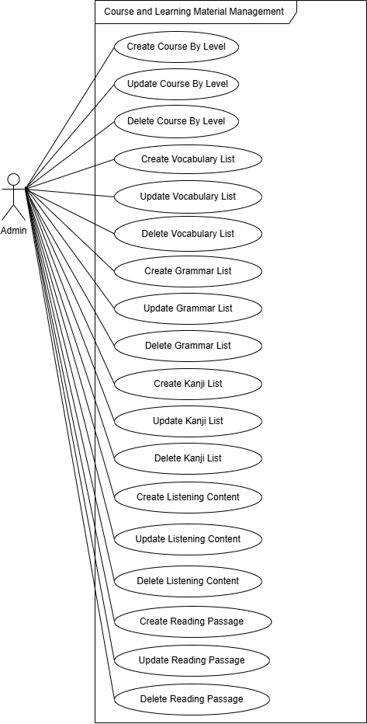
Figure 6. Course and Learning Material Management Use Case Diagram

b. Descriptions
The following table summarizes all use cases of the system, grouped by functional module, together with their primary actor and a brief description of what the user does.
UC ID | Use Case | Actor | Description
UC-01 | Register | Guest | Create a new account on Kizuna Nihongo by providing their full name, email address, and password.
UC-02 | Login | Student, Teacher, Admin | Log into the platform using their email and password.
UC-03 | Logout | Student, Teacher, Admin | Log out of the platform.
UC-04 | Change Password | Student, Teacher, Admin | Change their account password by providing their current password and a new password.
UC-05 | Forgot Password | Student, Teacher, Admin | Request a password reset by providing their registered email address.
UC-06 | View Profile | Student, Teacher, Admin | View their personal profile information.
UC-07 | Edit Profile | Student, Teacher, Admin | Edit their personal profile details — including their full name, avatar, phone number, and date of birth.
UC-08 | Take Placement Test | Student | Take an initial placement test covering vocabulary, grammar, and reading.
UC-09 | Generate Personalized Learning Roadmap (AI) | Student | Generate a personalized learning roadmap based on their placement test result and declared learning goals.
UC-10 | Enroll in Course | Student | Browse available courses and enroll in a course that matches their proficiency level.
UC-11 | View Course Content | Student | Access the full content of a course — including lesson list, lesson details (video, text, exercises), progress indicators, and completion status.
UC-12 | View Vocabulary List by Topic/Level | Student, Teacher | Browse vocabulary lists filtered by JLPT level (N5–N1) or by topic.
UC-13 | View Kanji List by Level | Student, Teacher | Browse kanji characters organized by JLPT level.
UC-14 | View Grammar List by Level | Student, Teacher | Browse grammar patterns organized by JLPT level.
UC-15 | Review Vocabulary with Flashcards | Student | Study saved vocabulary and grammar items using an interactive flashcard review session with spaced repetition.
UC-16 | Create Flashcard | Student | Manually create a custom flashcard by entering a front side (word/grammar pattern) and back side (meaning, example).
UC-17 | Update Flashcard | Student | Edit the content of a flashcard they have created — including the front text, back text, and example sentence.
UC-18 | Delete Flashcard | Student | Permanently delete a flashcard from their personal deck.
UC-19 | Look Up Dictionary | Student, Teacher | Search for Japanese words or kanji in the built-in dictionary using kanji, hiragana, katakana, romaji, or Vietnamese input.
UC-20 | Listen to Dialogues by Proficiency Level | Student | Access listening materials categorized by JLPT level, listen to audio dialogues, and optionally show or hide Japanese scripts, furigana, and Vietnamese translations to support different learning styles and listening practice.
UC-21 | Dictation Practice | Student | Listen to an audio clip and type out the full spoken content.
UC-22 | Practice Shadowing with AI | Student | Practice Japanese pronunciation by listening to dialogue segments and recording their own voice.
UC-23 | Read Articles / Passages | Student | Read Japanese articles or passages at their selected difficulty level with the option to toggle furigana on/off, Vietnamese translations.
UC-24 | Complete Reading Comprehension Exercise (AI-Generated) | Student | Generate comprehension questions.
UC-25 | Generate Kanji Writing Practice Sheet | Student | Generate a downloadable PDF kanji writing practice sheet for a selected kanji list or level.
UC-26 | Write a Paragraph & Receive AI Feedback | Student | Write a Japanese paragraph on a given topic or prompt and submit it.
UC-27 | Take Assigned Exam | Student | Take an exam assigned to their class by a teacher.
UC-28 | Take JLPT Mock Test | Student | Take a full-format JLPT mock test for a selected level (N5–N1) that simulates official conditions (time limits, section structure).
UC-29 | View Exam Result History | Student | View a history of all their exam and JLPT mock test results including score, date taken, section breakdown, and a score progression chart.
UC-30 | View Learning Dashboard | Student | View their personalized learning dashboard that summarizes their overall progress — including study streak, vocabulary and kanji mastered, recent activity, and JLPT level goal progress.
UC-31 | Join a Class | Student | Join a teacher's class by entering a class code.
UC-32 | Leave a Class | Student | Voluntarily leave a class.
UC-33 | Create Class | Teacher | Create a new class by providing a class name, description.
UC-34 | Delete Class | Teacher | Permanently delete a class they own.
UC-35 | View Student List in Class | Teacher | View the full list of students enrolled in their class — including each student's name, join date.
UC-36 | Remove Student from Class | Teacher | Remove a specific student from their class.
UC-37 | View Private Question Bank | Teacher | View their private question bank filtered by JLPT level, skill type, or question type.
UC-38 | Add Question to Private Bank | Teacher | Add new questions to their private question bank by providing question content, answer options, correct answer, explanation, skill tag, and difficulty level.
UC-39 | Edit Question in Private Bank | Teacher | Modify any question they have previously added to their private bank — including question text, answer options, correct answer, explanation, and metadata.
UC-40 | Delete Question from Private Bank | Teacher | Permanently delete a question from their private bank, with a confirmation prompt.
UC-41 | Create Exam (from Question Bank / AI-Generated) | Teacher | Create a new exam by selecting questions from their private or the shared global bank, or by requesting the AI to generate questions automatically.
UC-42 | Update Exam | Teacher | Modify an existing exam they have created — including adding/removing questions, changing the time limit, adjusting point values, and updating instructions.
UC-43 | Delete Exam | Teacher | Permanently delete an exam they created — only if it has not been assigned or has already been completed.
UC-44 | Assign Exam to Class | Teacher | Assign an exam to one or more of their classes by setting the start time, end time, time limit per attempt.
UC-45 | Grade Exam (Manual / AI-Assisted) | Teacher | Review student answers and assign scores — with objective questions auto-graded and subjective questions graded manually or with AI suggestions.
UC-46 | View Exam Result History (Teacher) | Teacher | View a complete history of all exams they have assigned, including per-student scores, average score, and downloadable reports.
UC-47 | Monitor Exam Status in Real Time | Teacher | Open the exam monitoring dashboard during an active exam.
UC-48 | View Abnormal Behavior Log | Teacher | View a detailed log of suspicious behaviors recorded during an exam for each student — including tab switching, copy-paste attempts, window focus loss, and rapid answer submission with timestamps.
UC-49 | Handle Suspected Cheating Cases | Teacher | Take action on flagged suspicious behavior cases — including sending a warning, invalidating the student's attempt, or marking for review — with all actions logged with a reason note.
UC-50 | View User List | Admin | View a complete list of all registered users with filters by role, account status, and registration date, plus search by name or email.
UC-51 | Lock/Unlock User Account | Admin | Lock a user account to prevent login access or unlock a previously locked account, providing a reason when locking and notifying the user, with the action recorded in the audit log.
UC-52 | Assign User Role | Admin | Assign or change a user's role (Student / Teacher / Admin) with a confirmation step.
UC-53 | Approve Teacher Account | Admin | Review teacher registration requests and either approve or reject them.
UC-54 | Create Course | Admin | Create a new course by specifying its name, target JLPT level, description, cover image, and syllabus structure.
UC-55 | Update Course | Admin | Edit an existing course's details including title, description, target level, cover image, and lesson structure.
UC-56 | Delete Course | Admin | Permanently delete a course — only if it has no active enrollments — with enrolled students notified before deletion.
UC-57 | Create Vocabulary List by Topic / Level | Admin | Create a new vocabulary list by specifying the list name, JLPT level or topic, and adding vocabulary entries.
UC-58 | Update Vocabulary List | Admin | Edit an existing vocabulary list — modifying list metadata and adding, updating, or removing individual entries.
UC-59 | Delete Vocabulary List | Admin | Permanently delete a vocabulary list — with a confirmation prompt — and notify users who have saved items from this list.
UC-60 | Create Kanji List by Topic / Level | Admin | Create a new kanji list by topic or JLPT level, with each entry including the kanji character, on-yomi, kun-yomi, meaning, stroke count, and example words.
UC-61 | Update Kanji List | Admin | Edit an existing kanji list — updating metadata or individual kanji entries — with changes immediately reflected in the user-facing kanji browser.
UC-62 | Delete Kanji List | Admin | Permanently delete a kanji list after a confirmation prompt, removing the list and all its entries from the database.
UC-63 | Create Grammar List by Level | Admin | Create a new grammar pattern list for a specific JLPT level, with each entry including the grammar pattern, structure formula, meaning, usage notes, conjugation rules, and multiple example sentences.
UC-64 | Update Grammar List | Admin | Edit an existing grammar list — updating the list name, level, or individual grammar entries — with updates immediately visible to users.
UC-65 | Delete Grammar List | Admin | Permanently delete a grammar list after a confirmation dialog, removing the list and all associated entries from the system.
UC-66 | Create Listening Material by Level | Admin | Upload a video or audio file with a text transcript.
UC-67 | Update Listening Material | Admin | Edit existing listening content — replacing the audio/video file, updating the transcript, correcting timestamps, and changing metadata — with changes saved and immediately available to users.
UC-68 | Delete Listening Material | Admin | Permanently delete a listening material item — including the audio/video file, transcript, and all related exercise data — after a confirmation prompt.
UC-69 | Create Reading Material | Admin | Create new reading content by entering article text, specifying JLPT level, topic, estimated reading time, and vocabulary highlights.
UC-70 | Update Reading Material | Admin | Edit existing reading materials — revising text, updating vocabulary highlights, changing difficulty level, and modifying tags — with updates immediately visible to users.
UC-71 | Delete Reading Material | Admin | Permanently delete a reading material — along with all associated AI-generated comprehension exercises — after a confirmation prompt.
UC-72 | Create JLPT Mock Test | Admin | Create a JLPT mock test for a specific level (N5–N1) by assembling questions across all required sections following official JLPT format rules for question count and time allocation.
UC-73 | Update JLPT Mock Test | Admin | Edit an existing JLPT mock test — modifying questions, adjusting section structure, updating time limits, and correcting answer keys.
UC-74 | Delete JLPT Mock Test | Admin | Permanently delete a JLPT mock test — only if it is not currently active — with all associated result data archived before removal.
UC-75 | View Student JLPT Result History | Admin | View a report of all students' JLPT mock test results — filterable by level, date range, and student name — including individual scores, pass/fail status, section breakdowns, and platform-wide statistics.
UC-76 | View Global Question Bank | Admin, Teacher | Browse the shared global question bank filtered by JLPT level, skill type, question type, and difficulty.
UC-77 | Add Question to Global Bank | Admin | Add new questions to the global question bank shared across all teachers, requiring complete content, answer options, correct answer, explanation, skill tag, level, and difficulty rating.
UC-78 | Edit Global Question Bank | Admin | Edit any question in the global bank — updating content, answer choices, correct answer, explanation, and metadata — with changes immediately visible to all teachers.
UC-79 | Delete Global Question Bank | Admin | Permanently delete a question from the global bank — protected if used in active exams — with a confirmation prompt and the deletion recorded in the audit log.
UC-80 | View System-wide Statistics Report | Admin | View a comprehensive analytics dashboard covering platform-wide statistics — including total users by role, active users, enrollment rates, exam scores, most-studied content, and feature usage metrics.

2. Overall Functionalities

2.1 Screens Flow
The screen flow describes how users navigate between the major screens of the platform, from the public landing page through authentication to the role-specific dashboards (Student, Teacher, Admin) and the feature screens.
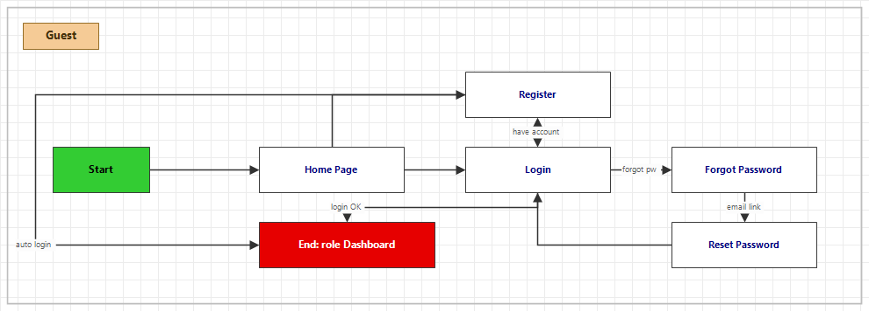
Figure 7. Screen Flow Diagram – Guest

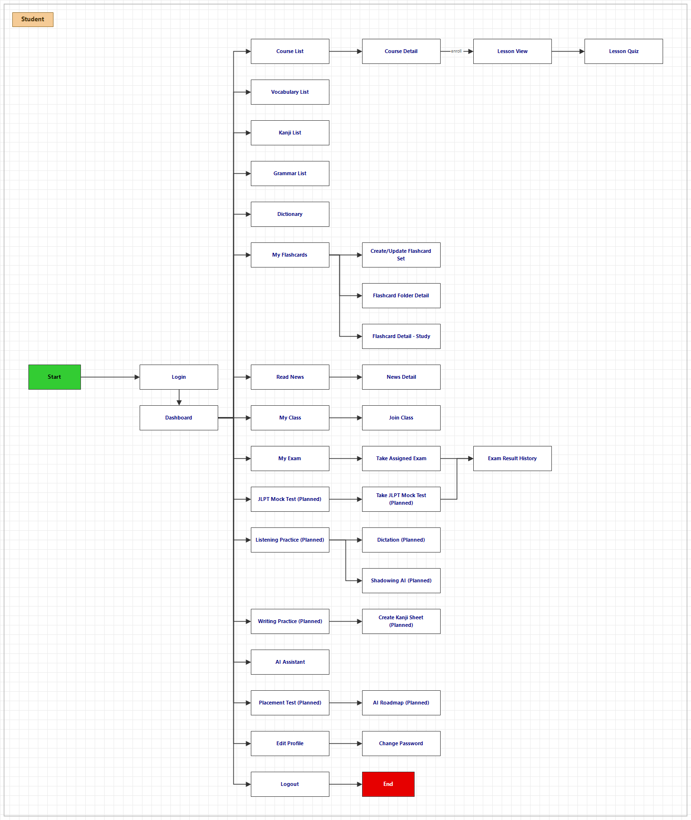
Figure 8. Screen Flow Diagram – Student
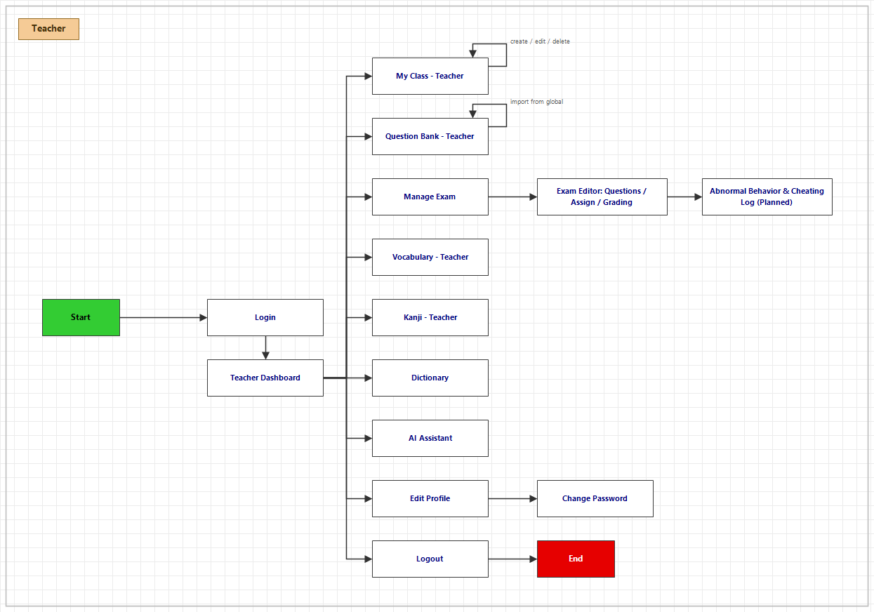
Figure 9. Screen Flow Diagram – Teacher
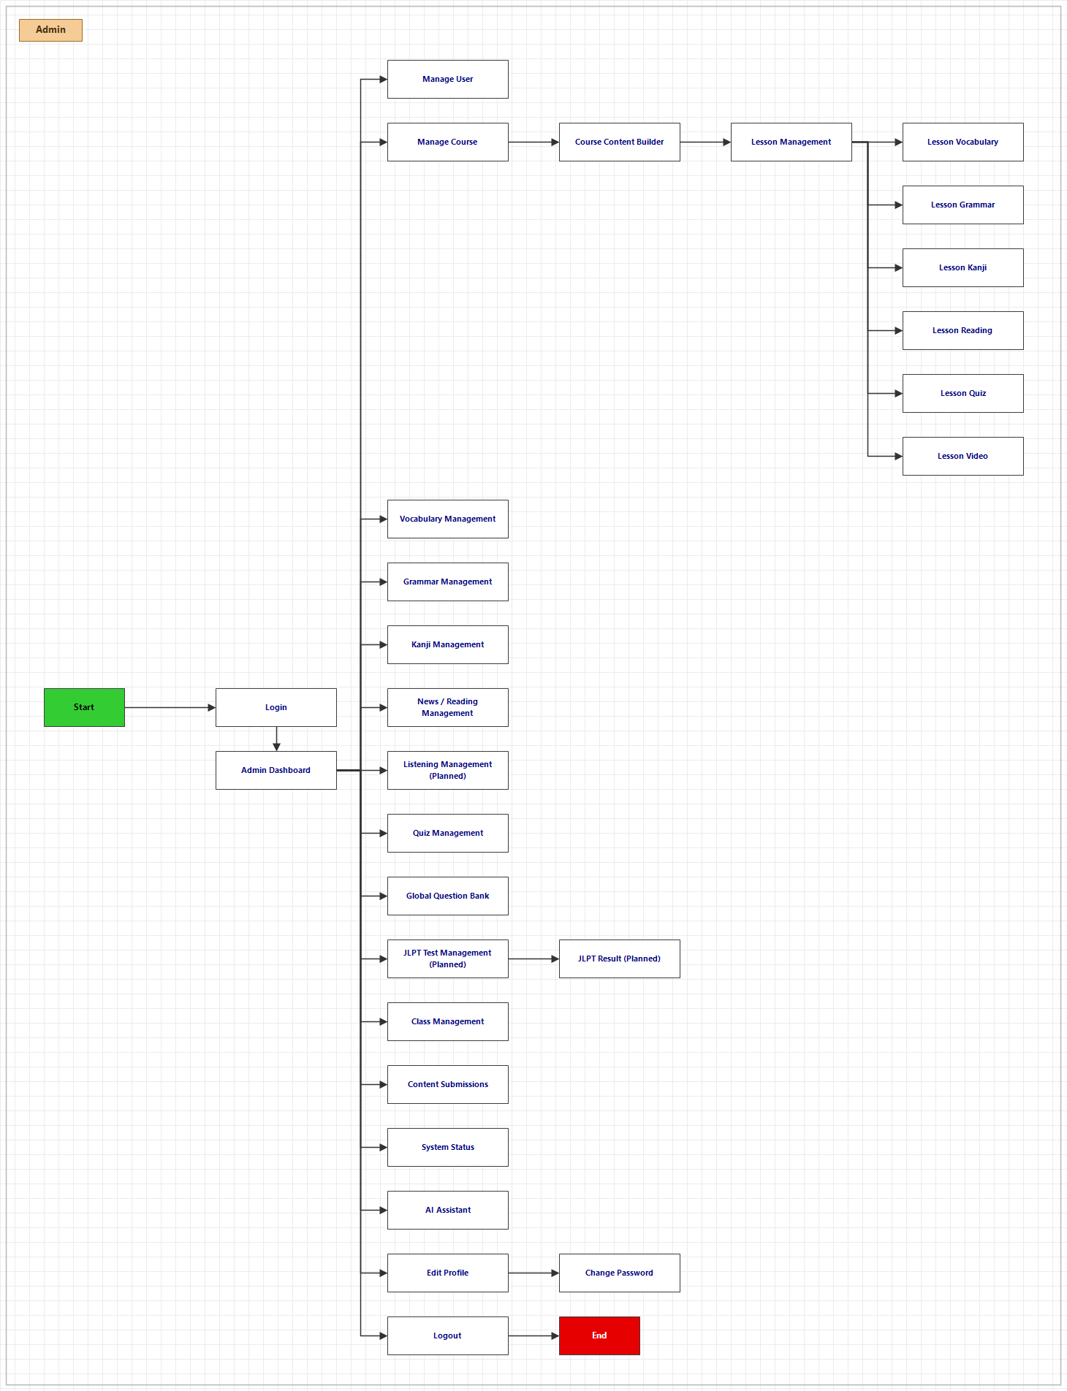
Figure 10. Screen Flow Diagram - Admin

2.2 Screen Descriptions
ID | Feature | Screen | Description
1 | Public | Home Page | Landing page introducing the platform with navigation to login/register.
2 | Login | Login | Email/password and Google sign-in. On success, role-based redirect to Student/Teacher/Admin area.
3 | Register | Register | Registration form (full name, email, password, confirm) that registers the account then signs the user in, with field-level validation.
4 | Reset Password | Reset Password | Requests a password-reset email then sets a new password from the emailed link.
5 | Edit Profile & Change Password | Profile | Editable avatar/name/phone, read-only email, JLPT target, study streak, and a change-password form.
6 | View Learning Dashboard (Student) | Dashboard | Personal learning hub: greeting, study streak (study days/hours), JLPT goal, next recommended course, enrolled classes and quick links.
7 | View Course List (Student) | Course List | Paginated catalog with search and level filters (N5–N1, Business) listing available courses.
8 | View Course Detail (Student) | Course Detail | Course detail shows thumbnail, level, lesson count, description, a module-grouped lesson list and the enroll / continue-learning action.
9 | View Vocabulary List (Student) | Vocabulary List | Grid of vocabulary cards with search and level/topic filters; detail modal shows meaning, Japanese definition, example sentences (furigana) and badges.
10 | View Kanji List (Student) | Kanji List | Grid of kanji with search and level filter; detail modal shows on-yomi/kun-yomi, meaning, stroke count and furigana toggle.
11 | View Grammar List (Student) | Grammar List | Standalone grammar list by JLPT level showing each pattern's structure, meaning, usage notes, conjugation and example sentences with furigana.
12 | Look Up Dictionary | Dictionary | Lookup of words: search bar, result entries with reading/meaning/level, detail panel and related-word navigation.
13 | View List Flashcards | My Flashcards | Sets and Folders tabs to create/edit/delete decks and organise them; set form with term/definition cards (add/insert/remove, bulk import); folder detail to add/remove sets.
14 | Create/ Update Flashcard | Create/Update Flashcard | Form to create or edit a flashcard — front (term) and back (meaning, reading, example) — saved to the user's personal deck.
15 | Review Vocabulary with Flashcard | Flashcard Detail | Study mode with click-to-flip cards, queue navigation, mastered/learning marking, progress tracker and settings (front-side preference, progress toggle).
16 | View News List (Student) | Read News | Catalog of Japanese news articles with search, level filters and article cards.
17 | View News Detail (Student) | News Detail | News reader with furigana toggle, sentence-by-sentence translation toggle, segmented text and an AI question helper.
18 | Listen to Audio by Level | Listening Practice | Dialogue catalog by level/topic with audio player (play/pause, rewind, speed) and togglable transcript/furigana/translation; plus dictation (type what you hear) and AI shadowing/pronunciation feedback.
19 | Practice Dictation | Dictation | Listen to an audio clip and type out the spoken content; the system compares it to the transcript, highlights errors and gives an accuracy score.
20 | Practice Shadowing with AI | Shadowing | Listen to dialogue segments and record your own voice so the AI can evaluate pronunciation accuracy and provide feedback.
21 | Write Paragraph & Receive AI Feedback | Writing Practice | Kanji writing-practice sheet (stroke-order guides) and a free-writing editor that returns AI feedback on grammar, vocabulary and style.
22 | Generate Kanji Writing Practice Sheet | Create Kanji Sheet | Generates a downloadable PDF kanji writing-practice sheet with stroke-order guides and blank grid boxes for a selected kanji list or level.
23 | View Class List (Student) | My Class | Lists enrolled classes (name, description, teacher, enrolment date); per-class leave action with confirmation.
24 | Join Class | Join Class | Modal to join a class by entering its enrolment key.
25 | Take Assigned Exam from Teacher | My Exam | Lists exams assigned via classes with window status, deadline, attempts and last score, plus the exam runner (question navigation, countdown auto-submit, furigana toggle) and post-submission score & answer review.
26 | View JLPT Mock Test List (Student) | JLPT Mock Test | Lists the available JLPT mock tests by level (N5–N1) that the student can take.
27 | Take JLPT Mock Test (Student) | Take JLPT Mock Test | Full-length timed JLPT mock test with level selection, sectioned questions, auto-submit and scored result. The current Take Exam screen only handles class-assigned exams.
28 | View Exam Result History (Student) | Exam Result History | History of the student's exam and mock-test results: score, date taken, time spent, section breakdown and a score-progression chart.
29 | AI Chatbot | AI Assitant | Multi-session Japanese-learning chatbot: conversation history sidebar, message thread with vocab/kanji context chips linking to detail modals, image upload and typing indicator. Shared across roles (layout adapts).
30 | Create Learning Roadmap with AI | AI Roadmap | After the student declares a target level and date, the AI generates a personalized learning roadmap with a timeline, recommended courses and milestones.
31 | Take Placement Test | Placement Test | Timed multiple-choice test (vocabulary, grammar, reading) that assesses the student and assigns a JLPT level (N5–N1).
32 | View Dashboard (Teacher) | Dashboard | Landing with performance metrics, quick-navigation cards (Classes, Question Bank, Vocabulary, Kanji, Grammar, Dictionary, Exam), pending action items and an activity feed.
33 | View Classes (Teacher) | My Class | Class cards with student count and enrolment key; create/edit/delete classes and manage enrolments (activate/deactivate, remove students).
34 | View Question Bank (Teacher) | Question Bank | Private bank with full CRUD plus AI question generation and reading-passage management; plus a read-only tab to browse/import from the admin global bank.
35 | Create Exam (Teacher) | Manage Exam | Exam list (create/edit-metadata/delete) and the editor's three tabs — Questions (add from private bank), Assign (to classes with start/end time and max attempts) and Results & Grading (view submissions, grade short answers with AI suggestions).
36 | Exam Proctoring (Teacher) | Abnormal Behavior & Cheating Log | Review proctoring logs of abnormal behavior and adjudicate suspected cheating cases. Only a face-detection test currently exists in Admin System Status.
37 | View Dashboard (Admin) | Dashboard | Platform overview: user/teacher/course/quiz counts, system-health metrics (backend/DB/AI status, latency), recent activity and quick actions.
38 | Manage User (Admin) | Manage User | CRUD over all users with search and role filter; edit name/phone/role, approve teacher accounts and reset passwords.
39 | Manage Course (Admin) | Manage Course | Course grid with level/status filters and create/edit/delete (title VI/JA, level, thumbnail, publish); content builder is a hierarchical modules→lessons editor with drag-reorder, lesson metadata and publish.
40 | Update Course (Admin) | Lesson Management | CRUD lessons across courses, plus per-lesson content editors: vocabulary & kanji (card CRUD with progress goal), grammar & reading (markdown editors with furigana helper and auto-save) and quiz (questions + settings).
41 | Manage Vocabulary List (Admin) | Vocabulary Management | CRUD vocabulary entries with search/level filter and bulk JSON import (AI validation/assist). Paginated.
42 | Manage Kanji List (Admin) | Kanji Management | CRUD kanji entries (character, on-yomi, kun-yomi, meaning, stroke count, examples) with search/level filter and bulk import. Paginated.
43 | Manage JLPT Mock Test (Admin) | JLPT Test | Create, edit and delete JLPT mock tests, assembling questions across sections following the official JLPT format.
44 | View JLPT Result | JLPT Result | Review students' JLPT mock-test result history with individual scores, pass/fail status and section breakdowns.
45 | System Monitoring (Admin) | System Status | Real-time backend/DB/AI/frontend health, service latency charts, a face-detection test, and system info (Node version, memory, uptime); auto-refreshes.
46 | Manage Global Question Bank (Admin) | Question Bank | Create/edit approved global questions (all types) with metadata (level, difficulty, skill, topic), reading/listening passages and publish toggle.
47 | Manage Reading Material (Admin) | News Management | Create/edit reading-news articles with AI sentence segmentation and furigana generation; level, thumbnail and publish status.
48 | Manage Listening Material (Admin) | Listening Management | Create/edit/delete listening materials (audio/video upload, transcript with speaker labels, level/topic).

2.3 Screen Authorization
The table below defines which actor roles are authorized to access each major screen. "X" indicates that the role can access the screen.
ID | Screen | Guest | Student | Teacher | Admin
1 | Home Page | X | X | X | X
2 | Login |  | X | X | X
3 | Register | X
4 | Reset Password |  | X | X | X
5 | Profile |  | X | X | X
6 | Dashboard |  | X | X | X
7 | Course List |  | X |  | X
8 | Course Detail |  | X |  | X
9 | Vocabulary List |  | X | X | X
10 | Kanji List |  | X | X | X
11 | Grammar List |  | X | X | X
12 | Dictionary |  | X | X
13 | My Flashcards |  | X
14 | Create/Update Flashcard |  | X
15 | Flashcard Detail |  | X
16 | Read News |  | X
17 | News Detail |  | X |  | X
18 | Listening Practice |  | X |  | X
19 | Dictation |  | X
20 | Shadowing |  | X
21 | Writing Practice |  | X
22 | Create Kanji Sheet |  | X
23 | My Class |  | X | X
24 | Join Class |  | X
25 | My Exam |  | X
26 | JLPT Mock Test |  | X |  | X
27 | Take JLPT Mock Test |  | X
28 | Exam Result History |  | X | X | X
29 | AI Assitant |  | X | X | X
30 | AI Roadmap |  | X
31 | Placement Test |  | X
34 | Private Question Bank |  |  | X
35 | Manage Exam |  |  | X
36 | Abnormal Behavior & Cheating Log |  |  | X
37 | Dashboard |  |  |  | X
38 | Manage User |  |  |  | X
39 | Manage Course |  |  |  | X
40 | Lesson Management |  |  |  | X
41 | Vocabulary Management |  |  |  | X
42 | Kanji Management |  |  |  | X
43 | JLPT Test |  | X |  | X
44 | JLPT Result |  | X |  | X
45 | System Status |  |  |  | X
46 | Global Question Bank |  |  | X | X
47 | News Management |  |  |  | X
48 | Listening Management |  |  |  | X

2.4 Non-UI Functions
In addition to the interactive screens, the platform performs a number of background (non-UI) functions:
ID | Feature | System Function | Description
1 | Exam Monitoring | Anti-Cheating Monitoring | Detects tab switching, focus loss and abnormal behavior during exams and logs violations.
2 | Notification | Email Notifications | Sends account-verification and system notification emails asynchronously.
3 | Analytics | Progress Aggregation | Periodically aggregates learning activity into dashboard statistics and analytics.

3. System High Level Design

3.1 Database Design

a. Database Schema
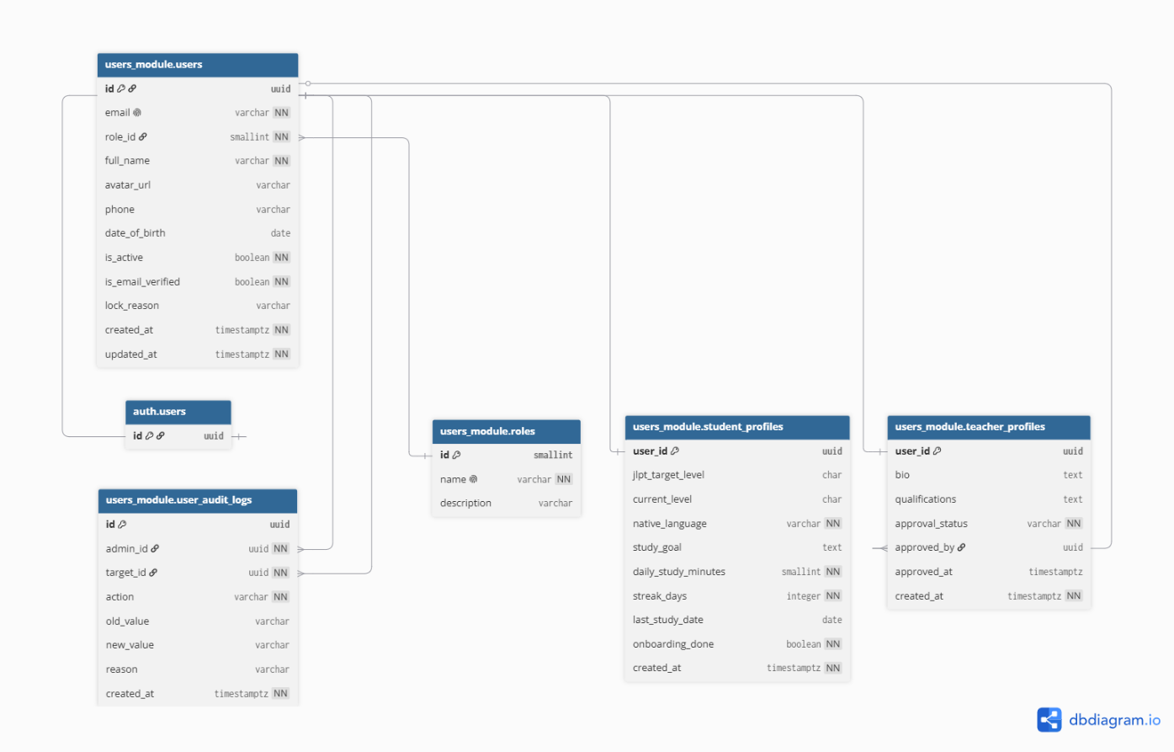
Figure 11. User_Module Schema
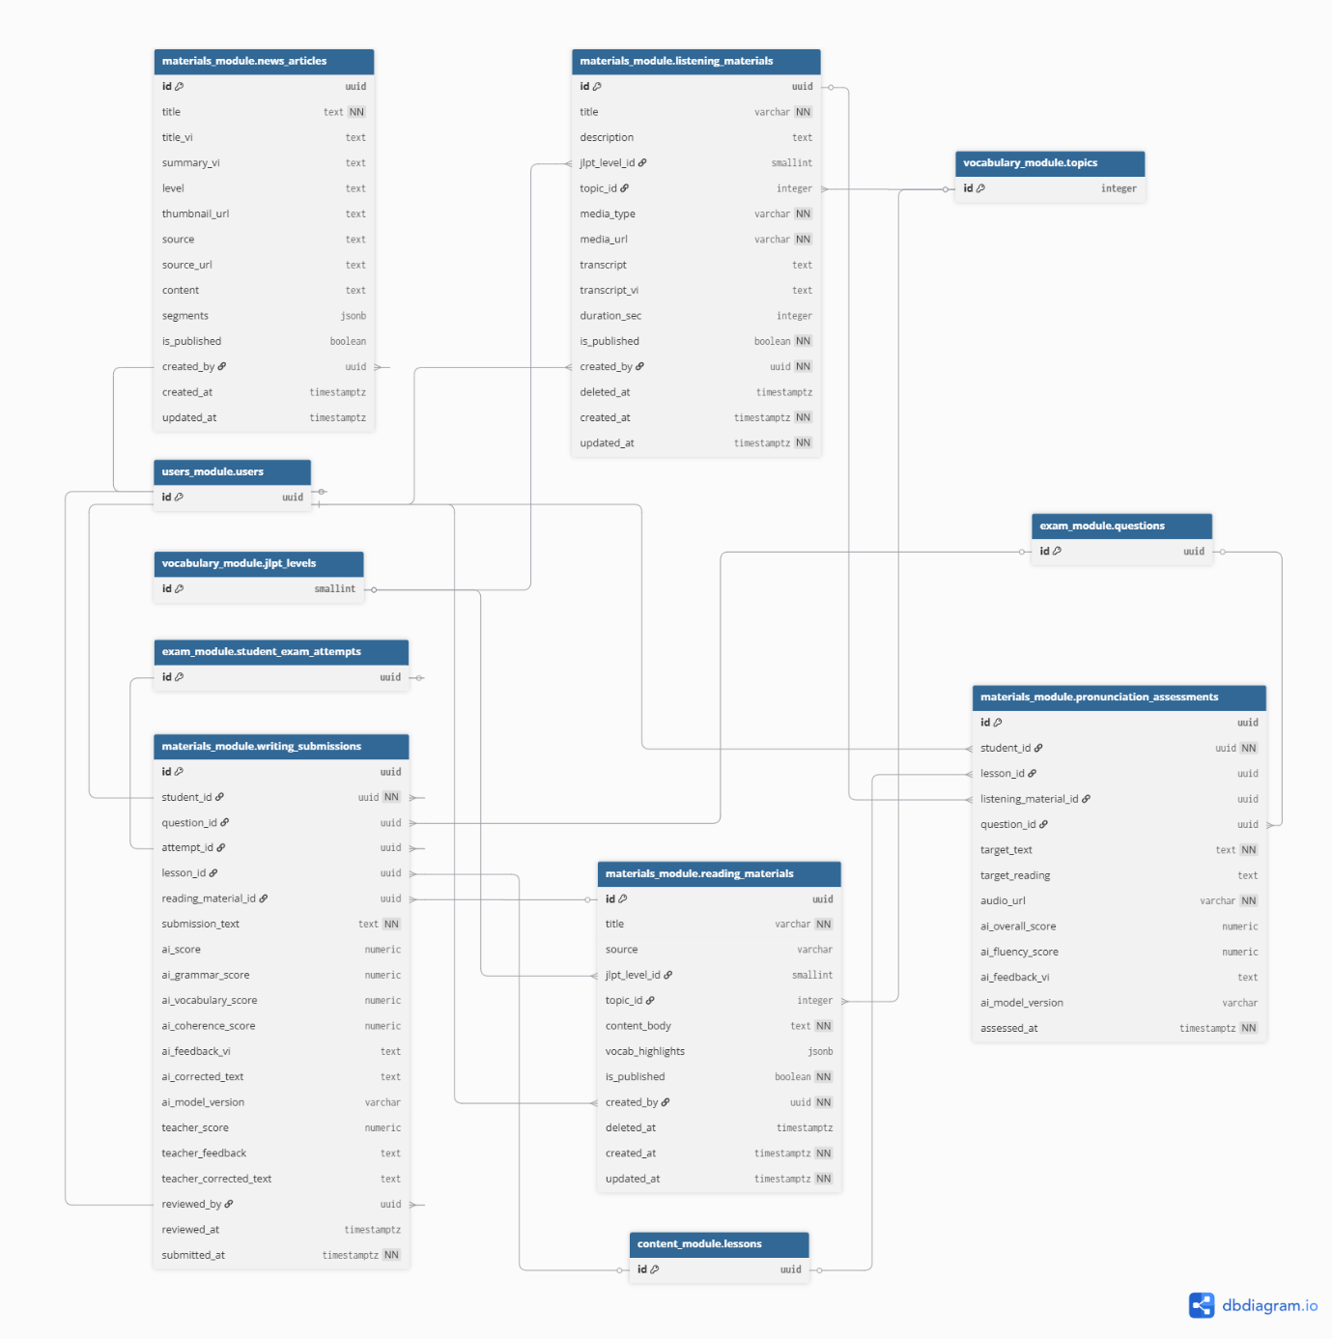

Figure 12. Materials_Module Schema

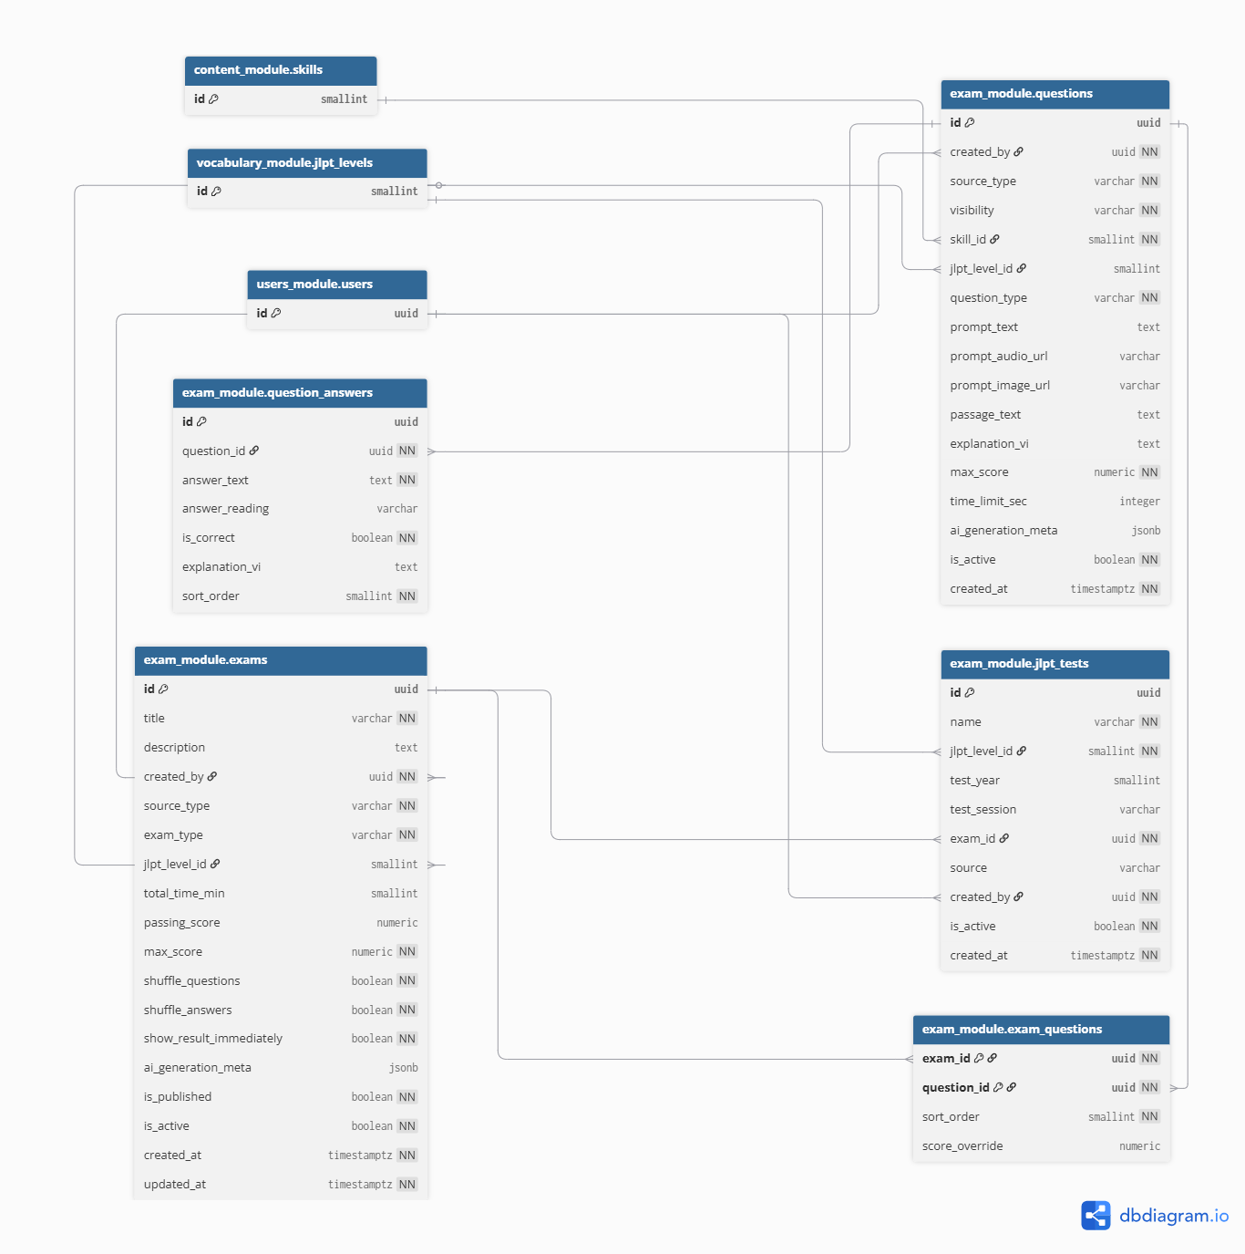

Figure 13. Exam_Module Schema (1)

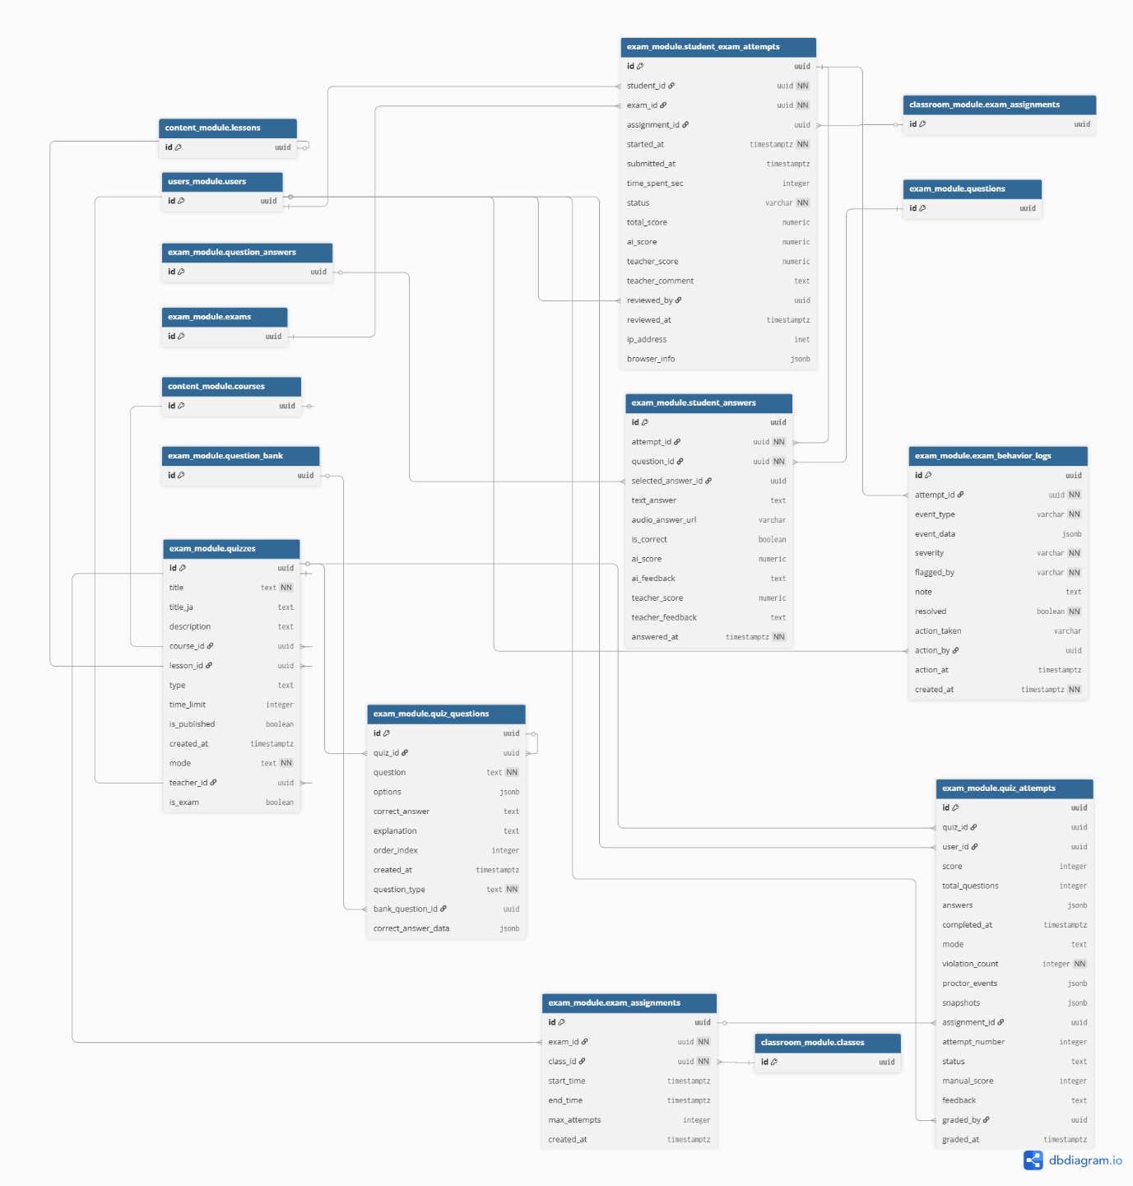

Figure 14. Exam_Module Schema (2)

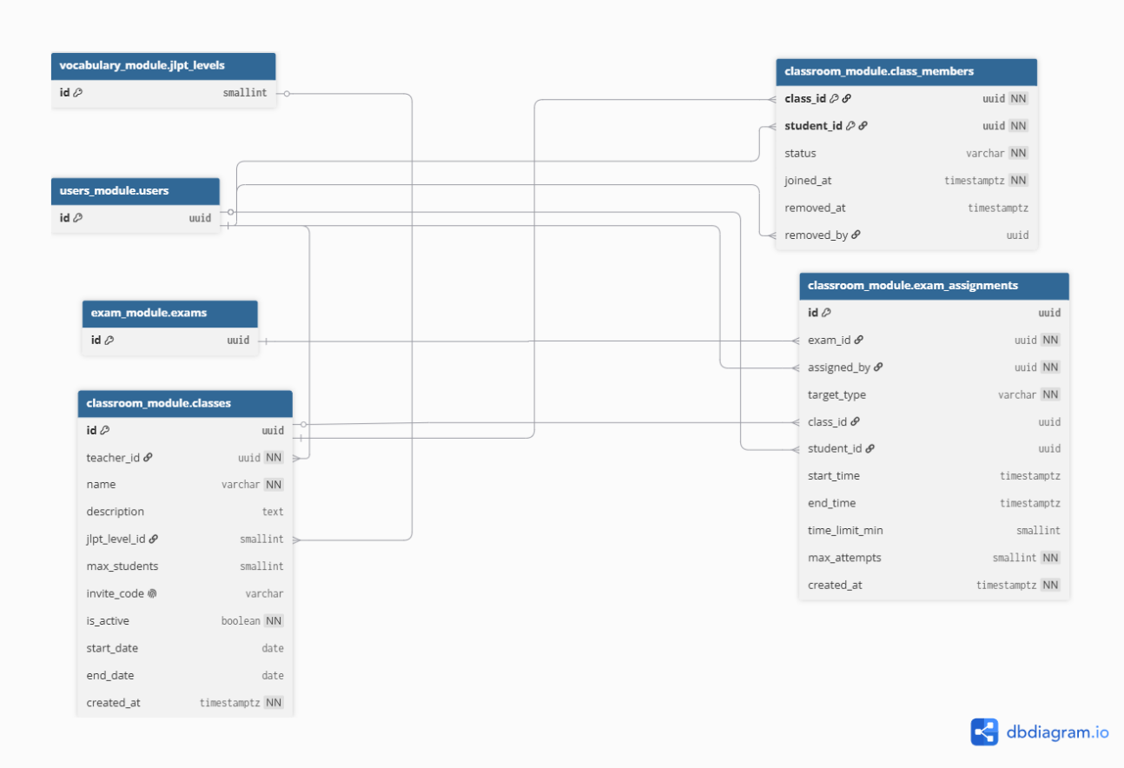
Figure 15. Classroom_Module Schema
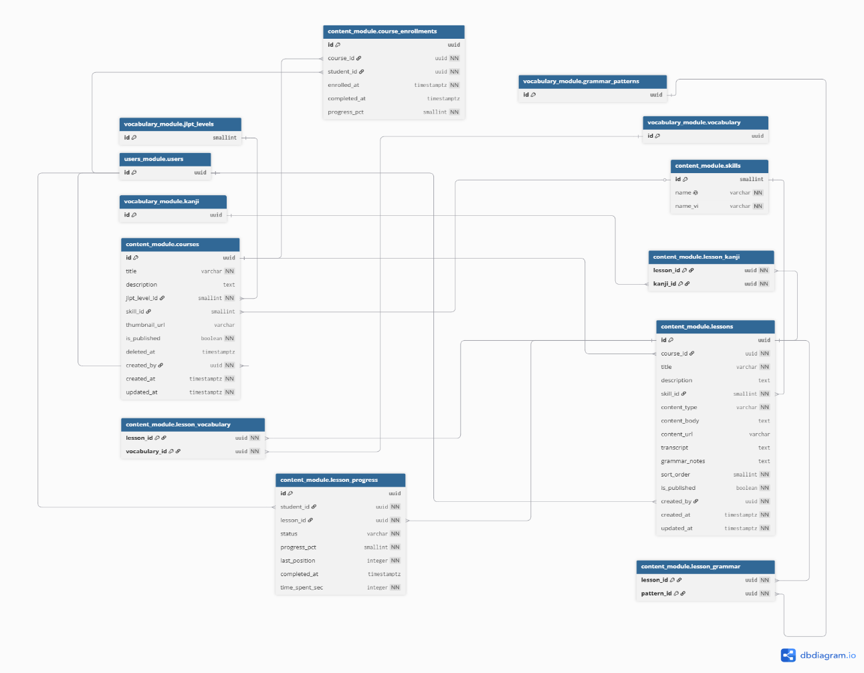
Figure 16. Content_Module Schema
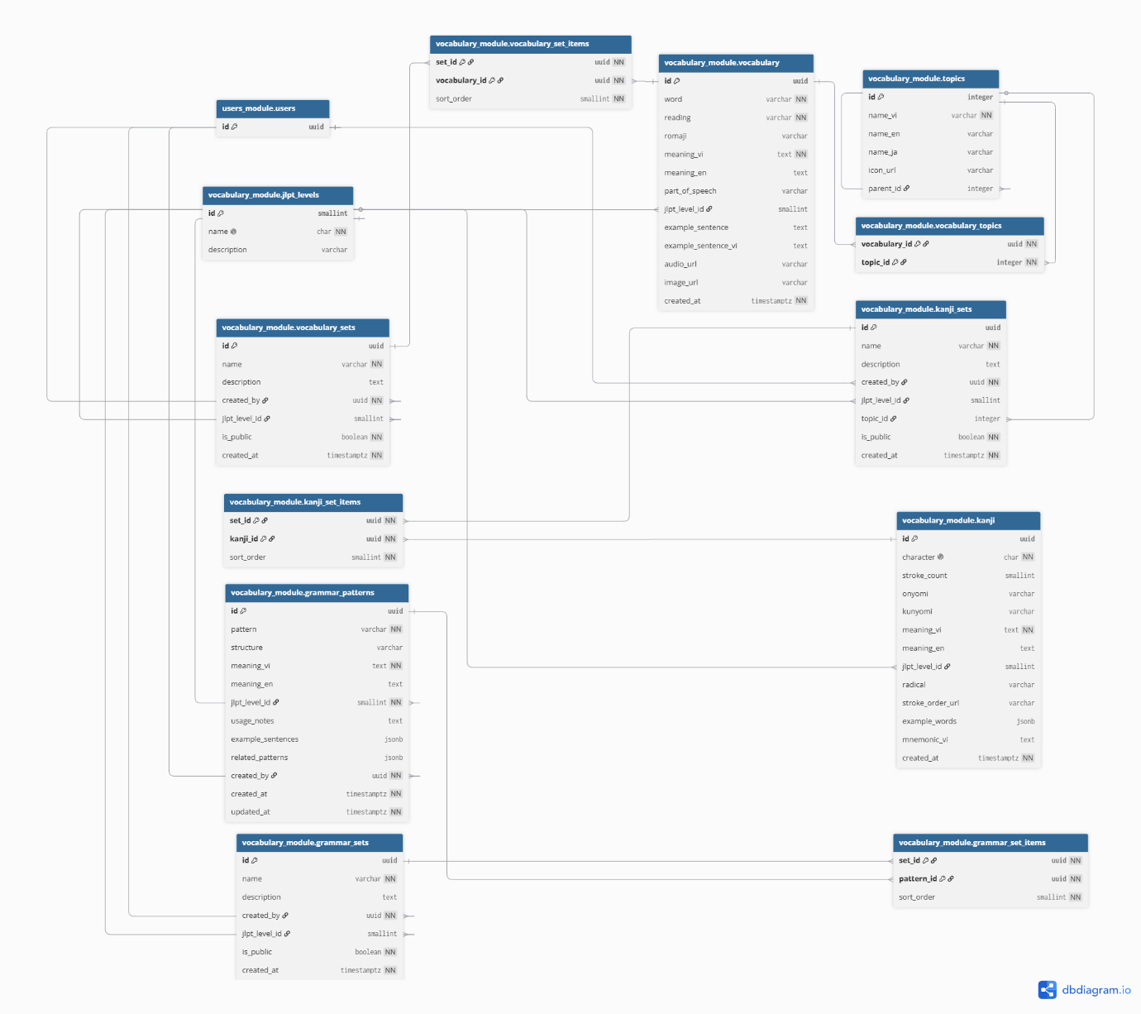
Figure 17. Vocabulary_Module Schema
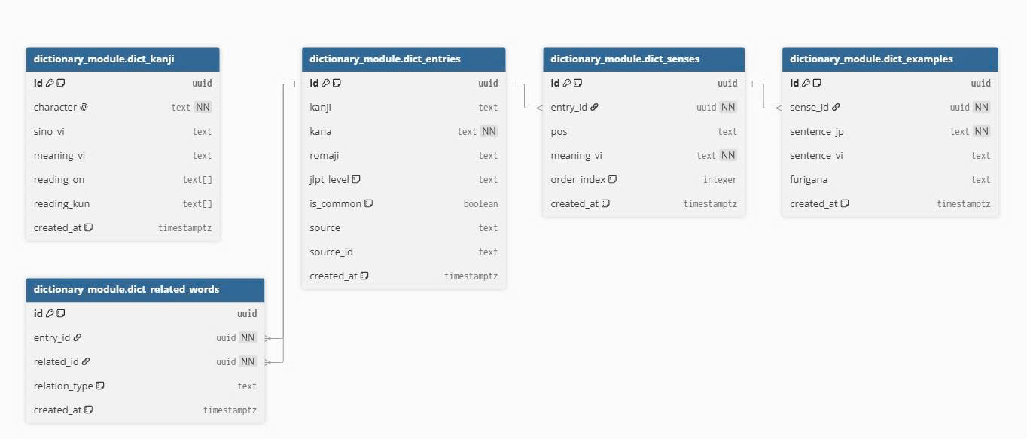
Figure 18. Dictionary_Module Schema
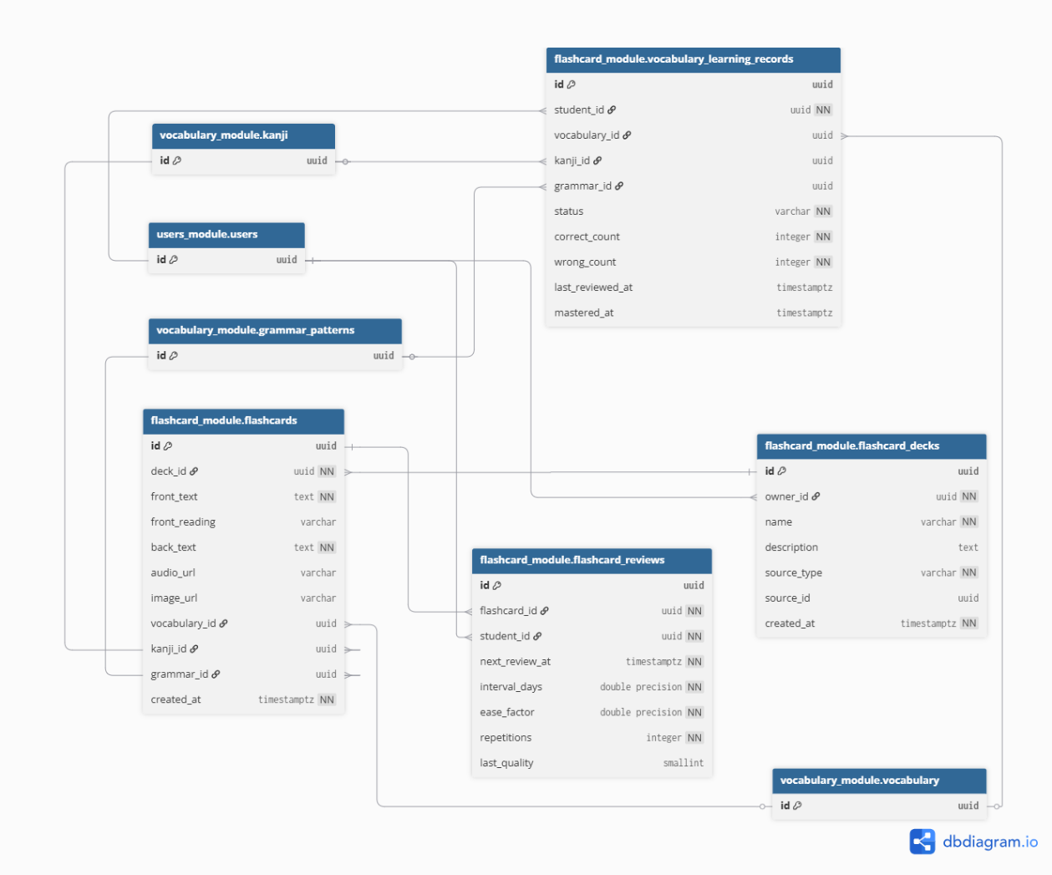
Figure 19. Flashcard_Module Schema
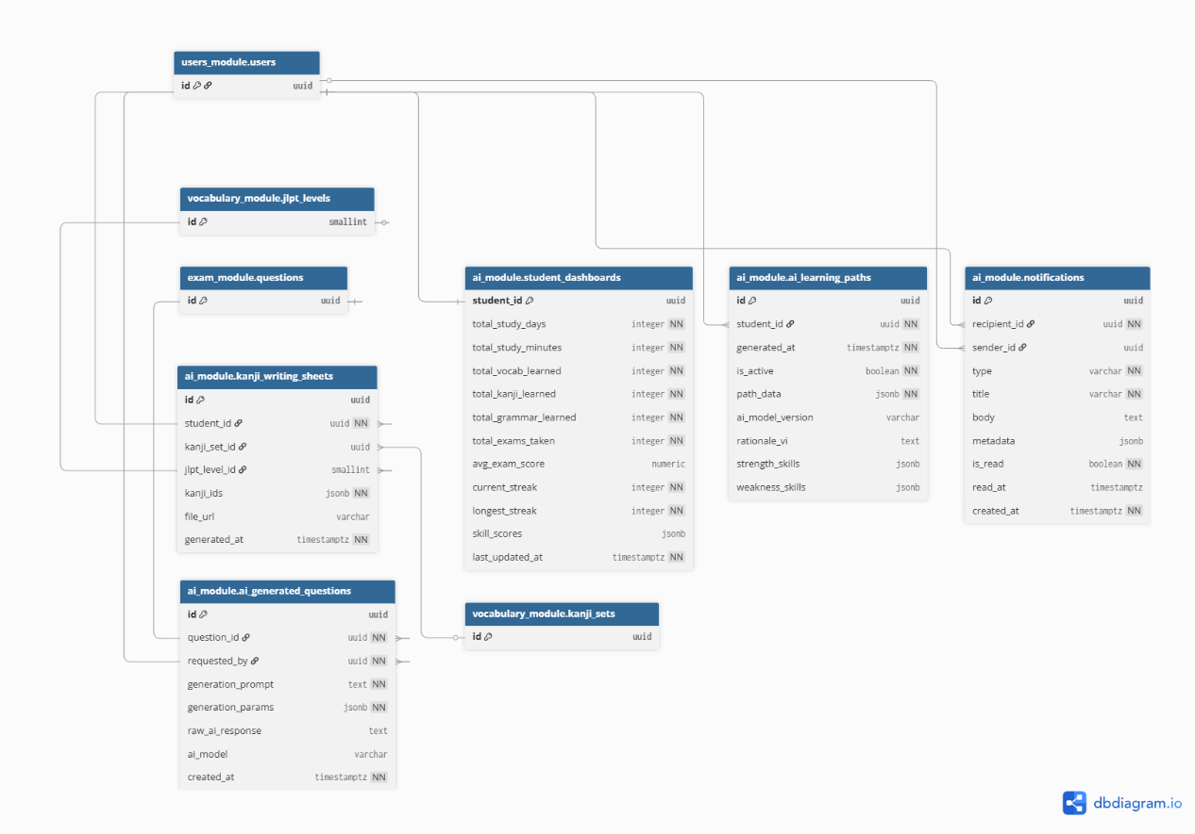
Figure 20. AI_Module Schema

b. Table Descriptions
No | Schema | Table | Description
1 | users_module | users | Stores core user account information including email, full name, role, active status, email verification flag, and account lock reason. Acts as the central identity table for all modules.
2 |  | roles | Defines the available user roles in the system (e.g., student, teacher, admin). Each user is assigned exactly one role.
3 |  | student_profiles | Extends the users table with student-specific details such as JLPT target level, current level, native language, daily study goal, and onboarding completion status. Has a 1-to-1 relationship with users.
4 |  | teacher_profiles | Extends the users table with teacher-specific details such as biography, qualifications, and approval status. Supports the teacher approval workflow managed by admins.
5 |  | user_audit_logs | Records administrative actions performed on user accounts, such as locking, unlocking, role changes, and teacher approvals or rejections, along with the admin who performed the action.
6 | vocabulary_module | jlpt_levels | Stores the five JLPT proficiency levels (N5 to N1). Used as a reference by vocabulary, kanji, grammar, and content tables to classify items by difficulty.
7 |  | topics | Stores hierarchical topic categories (e.g., Food, Travel) in Vietnamese, English, and Japanese. Supports parent-child relationships for nested topic trees.
8 |  | vocabulary | Stores Japanese vocabulary items including the word, reading (furigana), romaji, Vietnamese and English meanings, part of speech, JLPT level, example sentences, audio URL, and image URL.
9 |  | vocabulary_topics | Junction table linking vocabulary items to one or more topics. Enables many-to-many classification of vocabulary by topic.
10 |  | vocabulary_sets | Stores named collections of vocabulary items created by users. Can be public or private, and optionally filtered by JLPT level.
11 |  | vocabulary_set_items | Junction table linking vocabulary items to vocabulary sets, with a sort order for display sequence.
12 |  | kanji | Stores kanji characters with stroke count, on-yomi, kun-yomi readings, Vietnamese and English meanings, JLPT level, radical, stroke order URL, example words, and a mnemonic hint in Vietnamese.
13 |  | kanji_sets | Stores named collections of kanji created by users, optionally filtered by JLPT level and topic. Can be marked public for sharing with other learners.
14 |  | kanji_set_items | Junction table linking kanji to kanji sets with a sort order for display sequence.
15 |  | grammar_patterns | Stores Japanese grammar patterns with structure, Vietnamese and English meanings, JLPT level, usage notes, example sentences (JSON), and related patterns (JSON).
16 |  | grammar_sets | Stores named collections of grammar patterns, optionally filtered by JLPT level. Can be marked public for sharing.
17 |  | grammar_set_items | Junction table linking grammar patterns to grammar sets with a sort order.
18 | content_module | skills | Defines the language skills covered in the system (e.g., reading, listening, speaking, writing, grammar). Used to classify courses, lessons, and exam questions.
19 |  | courses | Stores structured courses with title, description, JLPT level, associated skill, thumbnail, and publication status. Each course is created by a teacher or admin.
20 |  | course_enrollments | Tracks which students are enrolled in which courses, along with enrollment date, completion date, and overall progress percentage.
21 |  | lessons | Stores individual lessons within a course. Each lesson has a content type (text, audio, video, etc.), content body or URL, transcript, grammar notes, and a sort order within its course.
22 |  | lesson_kanji | Junction table linking kanji items to lessons, allowing lessons to highlight specific kanji for study.
23 |  | lesson_vocabulary | Junction table linking vocabulary items to lessons, allowing lessons to highlight specific words for study.
24 |  | lesson_grammar | Junction table linking grammar patterns to lessons, allowing lessons to highlight specific grammar structures.
25 |  | lesson_progress | Tracks each student's progress on individual lessons, including completion status, progress percentage, last playback position, and time spent.
26 | materials_module | listening_materials | Stores audio and video listening materials with title, JLPT level, topic, media URL, transcript (Japanese and Vietnamese), and duration. Used for listening practice.
27 |  | reading_materials | Stores reading passages with title, JLPT level, topic, full content body, and highlighted vocabulary in JSON format. Used for reading comprehension practice.
28 |  | pronunciation_assessments | Stores AI-based pronunciation assessment results for students, including the target text, recorded audio URL, overall and fluency scores, and AI feedback in Vietnamese.
29 |  | writing_submissions | Stores student writing submissions with AI and teacher scoring, including grammar, vocabulary, and coherence scores, feedback, and corrected versions of the text.
30 |  | news_articles | Stores Japanese news articles with Vietnamese title and summary, JLPT difficulty level, full content, and structured segments in JSON format for interactive reading.
31 | exam_module | questions | Stores individual exam questions including question type, skill, JLPT level, prompt text, audio and image URLs, passage text, explanation, and maximum score. Supports both teacher-created and AI-generated questions.
32 |  | question_answers | Stores the answer options for a question, with text, furigana reading, correct flag, explanation, and sort order. Supports multiple-choice and similar question types.
33 |  | exams | Stores full exam definitions including title, exam type (practice, class test, JLPT mock, etc.), total time, passing score, shuffle settings, and publication status.
34 |  | exam_questions | Junction table linking questions to exams with a sort order and optional per-question score override.
35 |  | jlpt_tests | Stores JLPT mock test metadata linked to a full exam, including the JLPT level, test year, and test session information.
36 |  | student_exam_attempts | Records each student attempt on a full exam, including start and submit times, status, total score, AI and teacher scores, teacher comment, and anti-cheating browser info.
37 |  | student_answers | Stores each student answer within an exam attempt, referencing the selected answer or text input, along with AI and teacher evaluation scores and feedback.
38 |  | exam_behavior_logs | Logs suspicious behavior events detected during proctored exam attempts, such as tab switching, copy attempts, or devtools access, with severity and resolution tracking.
39 |  | quizzes | Stores quick quiz definitions linked to a course or lesson, with type, time limit, mode (normal or proctored), and publication status.
40 |  | quiz_questions | Stores individual questions within a quiz, including answer options in JSON, correct answer, explanation, and an optional reference to a question bank entry.
41 |  | exam_assignments | Assigns a quiz to a class with optional start/end times and maximum attempt count. Used for class-level quiz scheduling.
42 |  | quiz_attempts | Records each student attempt on a quiz, including score, total questions, answers in JSON, proctor events, violation count, and optional manual grading by a teacher.
43 | classroom_module | classes | Stores virtual class definitions created by teachers, including name, description, JLPT level, maximum student count, invite code, and active dates.
44 |  | class_members | Tracks student membership in classes with status (pending, active, removed), join date, and removal details including who removed the student.
45 |  | exam_assignments (classroom) | Assigns exams to either a class or an individual student, with configurable start/end times, time limit, and maximum attempt count. Used for formal class-level exam scheduling.
46 | flashcard_module | flashcard_decks | Stores flashcard deck definitions created by users, with a name, description, and source type (vocabulary set, lesson, custom, JLPT, grammar set, or kanji set).
47 |  | flashcards | Stores individual flashcards within a deck, with front text, reading, back text, audio URL, image URL, and optional links to vocabulary, kanji, or grammar items.
48 |  | flashcard_reviews | Tracks spaced-repetition review state for each flashcard per student, including next review date, interval, ease factor, repetition count, and last quality rating.
49 |  | vocabulary_learning_records | Tracks each student's long-term learning status for vocabulary, kanji, and grammar items, including mastery status, correct/wrong counts, and last reviewed date.
50 | dictionary_module | dict_entries | Stores dictionary word entries with kanji form, kana reading, romaji, JLPT level, and source metadata. Acts as the main lookup table for the built-in dictionary.
51 |  | dict_senses | Stores the meanings (senses) of a dictionary entry, including part of speech, Vietnamese meaning, and display order. One entry can have multiple senses.
52 |  | dict_examples | Stores example sentences for a dictionary sense, in both Japanese and Vietnamese, with optional furigana annotation.
53 |  | dict_related_words | Stores relationships between dictionary entries, such as synonyms, antonyms, or related words, using a self-referencing structure.
54 |  | dict_kanji | Stores standalone kanji dictionary entries with sino-Vietnamese reading, Vietnamese meaning, on-yomi and kun-yomi readings as arrays. Separate from the learner kanji table.
55 | ai_module | student_dashboards | Stores aggregated learning statistics for each student, including total study days, minutes, vocabulary/kanji/grammar learned, exams taken, average score, and current/longest streak. Has a 1-to-1 relationship with users.
56 |  | ai_learning_paths | Stores personalized AI-generated learning path recommendations for students, including path data in JSON, AI model version, rationale in Vietnamese, and identified strength and weakness skills.
57 |  | notifications | Stores in-app notifications sent to users, with type, title, body, optional metadata, read status, and the sender (system or another user).
58 |  | kanji_writing_sheets | Stores AI-generated kanji writing practice sheets for students, referencing a kanji set or JLPT level, with the list of kanji IDs and the generated file URL.
59 |  | ai_generated_questions | Records the history of AI question generation requests, including the generation prompt, parameters, raw AI response, and AI model version used.

3.2 Code Packages

a. Code Package Diagram
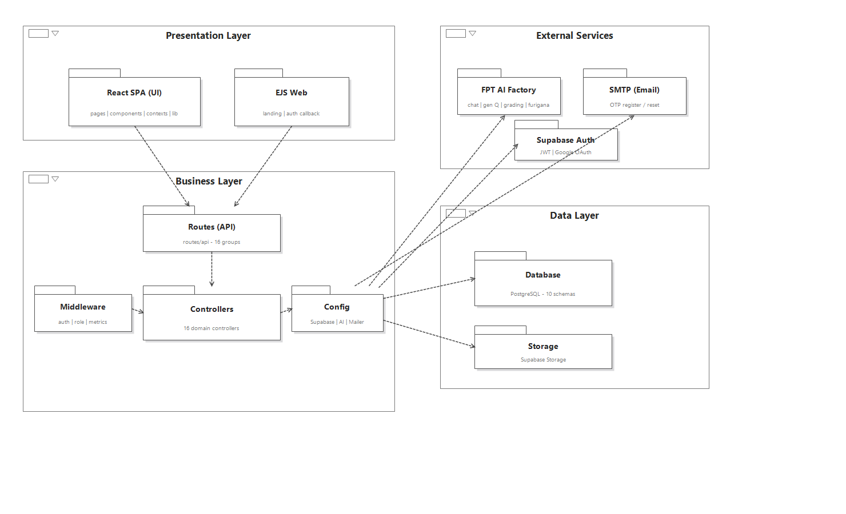
Figure 21. Code Package Diagram

b. Code Package Description
No | Package | Description
1 | frontend/src/pages | React SPA screens (Vite, port 5173) organized by role: public, student, teacher, admin and shared pages, rendered inside role-specific layouts (StudentLayout / TeacherLayout / AdminLayout).
2 | frontend/src/components | Reusable React components grouped into ui (buttons, inputs, modals…), layout, admin and dictionary.
3 | frontend/src/contexts | Global React contexts: AuthContext (session and role state) and LangContext (Vietnamese/Japanese i18n).
4 | frontend/src/lib | Frontend service libraries: api (axios HTTP client sending the Bearer JWT), supabase client, the useProctoring hook and faceDetector (MediaPipe face/gaze detection).
5 | routes/ + views/ (EJS server) | Express + EJS web server (port 3000) serving the public landing page and the Supabase OAuth callback.
6 | backend/routes/api | REST API route definitions (Express, port 3001): 16 route groups (auth, users, courses, lessons, vocabulary, kanji, grammar, dictionary, quizzes, exams, classes, flashcards, news, ai, admin, teacher). Each route is protected by auth/role middleware and delegates to a controller.
7 | backend/controllers | Domain business-logic controllers (one per area): authController, userController, courseController, lessonController, vocabularyController, kanjiController, grammarController, dictionaryController, quizController, examController, classController, flashcardController, newsController, adminController, teacherController and teacherQuestionBankController.
8 | backend/config | Shared external-service clients and configuration: Supabase client, FPT AI Factory client (chat, question generation, essay grading, furigana), SMTP mailer (Nodemailer, OTP email) and audio processing (VAD / ffmpeg).
9 | backend/middleware | Cross-cutting middleware: authentication and role-based authorization (requireAuth / requireRole) and request-metrics collection.
10 | database/ | PostgreSQL schema and migrations (schema.sql, migrate.sql): 10 module schemas plus a public layer of compatibility views and INSTEAD OF triggers used by the backend.

II. Requirement Specifications
This document specifies the functional requirements of Kizuna Nihongo (Sorakara) — an online Japanese-learning platform — from a Business Analysis perspective, expressed as use cases.
Product context. The platform is a public, self-service service open to the general public (not the internal system of a single school or centre). Therefore administrators do not issue teacher accounts; instead, anyone may register an account and then apply to become a teacher by submitting professional documents. Applications are screened automatically by an AI reviewer and either approved on the spot (when fully verifiable) or queued for an administrator's decision.
Actors. Guest (not logged in), Student, Teacher, Admin. A Teacher can also use every Student feature; an Admin can use every management feature.
Out of scope. Virtual classrooms and teacher-to-student assigned exams are intentionally excluded from this release and are not specified here.
Requirements that describe a target behaviour not yet built are marked (planned) in the Other Information field so the reader can distinguish current behaviour from agreed scope. Study material is published as posts, each holding a list of items of one type. Because the content entered differs per type, the use cases are specified separately for Vocabulary, Kanji and Grammar posts. Viewing published posts is specified on the student side (UC-14/15/16).

1. Authentication & Profile

1.1 UC-01_Register

a. Functionalities
UC ID and Name: | UC-01_Register
Created By: | Group 4 | Date Created: | 30/May/2025
Primary Actor: | Guest | Secondary Actors: | Email Service
Trigger: | A guest chooses "Đăng ký" (Register) on the home or login page.
Description: | As a guest, I want to create an account by entering my details and verifying my email with a one-time code so that I can start using the platform. During registration I can indicate that I intend to teach, in which case I am guided to the teacher application (UC-02) right after my account is created.
Preconditions: | PRE-1: The guest is not logged in.  PRE-2: The guest has access to a valid email inbox.
Postconditions: | POST-1: A verified account is created after email confirmation and the user is signed in.  POST-2: Every new account starts with Student-level access; choosing "Giáo viên" (Teacher) during registration only routes the user to the teacher application (UC-02) — it does not grant teaching rights by itself.
Normal Flow: | 1.0 Register  1. The guest opens the registration form and selects the intended account type: Student or Teacher.  2. The guest enters full name, email and password, and accepts the terms of use.  3. The guest submits the form.  4. The system checks the fields and that the email is not already in use (see E1–E3), then sends a 6-digit verification code to the email and shows the code-entry screen.  5. The guest enters the code and confirms (see E4, E5).  6. On a valid code, the system creates the account (Student-level access), signs the guest in and directs them onward: a Student goes to the Learning Dashboard; a guest who selected Teacher is taken to the teacher application form (UC-02).
Alternative Flows: | 1.1 Resend code — On the code screen the guest chooses "Gửi lại mã"; after a short cooldown the system issues a new code and returns to Step 5.  1.2 Sign up with Google — the guest chooses "Đăng nhập với Google"; the account is created through Google sign-in without the code step and the guest lands on the Learning Dashboard.
Exceptions: | E1 A required field is blank → "Vui lòng điền đầy đủ thông tin." → return to Step 2.  E2 Password is shorter than 8 characters → "Mật khẩu phải có ít nhất 8 ký tự." → return to Step 2.  E3 Email already registered → "Email này đã được đăng ký." (guest may log in instead — UC-03).  E4 Verification code is wrong → the system shows the remaining attempts; after too many wrong attempts the request is discarded and the guest must register again.  E5 Verification code has expired → the guest restarts registration or requests a new code (Alt-flow 1.1).  E6 The email cannot be delivered → "Không thể gửi email xác thực. Vui lòng thử lại."
Priority: | Must Have
Frequency of Use: | High — during onboarding and promotional periods.
Business Rules: | BR-01, BR-02, BR-03
Other Information: | The verification code is valid for a limited time, allows a limited number of attempts, and cannot be requested again within a short cooldown. Teaching privileges are granted only through the teacher application flow (UC-02, BR-04).
Assumptions: | Guests have a working email inbox; each person registers with their own email.

b. Business Rules
ID | Business Rule | Business Rule Description
BR-01 | Email Uniqueness | Each email address may be linked to only one account; duplicate registrations are rejected.
BR-02 | Password Strength | A password must contain at least 8 characters.
BR-03 | Email Verification | A new account is created only after the email is confirmed with the one-time code, which is valid for a limited time, permits a limited number of attempts, and can be resent only after a short cooldown.

1.2 UC-02_Submit Teacher Application

a. Functionalities
UC ID and Name: | UC-02_Submit Teacher Application
Created By: | Group 4 | Date Created: | 19/Jul/2026
Primary Actor: | Student (teacher applicant) | Secondary Actors: | AI Service, Admin
Trigger: | The user opens the teacher application page — automatically right after registering with the "Giáo viên" option (UC-01), or later from their account.
Description: | As a registered user who wants to teach, I want to submit my professional details and supporting documents so that the platform can verify my qualifications and grant me teaching privileges.
Preconditions: | PRE-1: The user is logged in with a Student-level account.  PRE-2: The user has digital copies of their CV, degree and/or certificates.
Postconditions: | POST-1: An application is recorded with its review outcome.  POST-2: If the AI screening fully verifies the application, the Teacher role is granted immediately; otherwise the application is saved as "Chờ duyệt" (Pending approval) for an administrator (UC-69).  POST-3: Until approval, the applicant keeps Student-level access.
Normal Flow: | 2.0 Submit Teacher Application  1. The user opens the application form.  2. The user fills in professional details (target teaching level(s), qualifications, teaching experience, self-introduction).  3. The user attaches at least one supporting document — CV, degree or certificate — as PDF, image or Word file (up to 6 files).  4. The user submits the application.  5. The system runs an AI screening over the details and documents, producing a summary, warning flags and a confidence level.  6. If the screening confidently verifies a complete application, the system approves it automatically and grants the Teacher role at once; otherwise it saves the application as Pending approval and informs the user that an administrator will review it.  7. The user can revisit the page at any time to see the application status and any reviewer note.
Alternative Flows: | 2.1 Reapply — after a rejection, the user submits a new application with clearer documents.  2.2 Meanwhile use the platform as a Student — a pending applicant continues with Student-level access.
Exceptions: | E1 The account already has Teacher or Admin rights → the system informs the user and does not accept a new application.  E2 The user already has a pending application → "Bạn đang có một đơn đăng ký chờ duyệt." — the new submission is refused.  E3 No document attached → the system asks for at least one document (CV, degree or certificate).  E4 A file is of an unsupported type or too large → the system rejects that file and asks for a valid one.
Priority: | Must Have
Frequency of Use: | Low — once per aspiring teacher.
Business Rules: | BR-04
Other Information: | The AI screening is advisory except in the clear-cut auto-approve case; every other decision is made by an administrator (UC-69), who can also revoke a previously granted approval.
Assumptions: | Applicants submit genuine documents about their own qualifications.

b. Business Rules
ID | Business Rule | Business Rule Description
BR-04 | Teacher Approval & AI Screening | Teaching privileges are granted only through an approved teacher application. An AI reviewer screens each application and may auto-approve it only when it is complete, verifiable and confidently assessed; in every other case an administrator decides. A user may have only one pending application at a time and keeps Student-level access until approval.

1.3 UC-03_Login

a. Functionalities
UC ID and Name: | UC-03_Login
Created By: | Group 4 | Date Created: | 30/May/2025
Primary Actor: | Student, Teacher, Admin | Secondary Actors: | Google (Sign-in)
Trigger: | The user chooses "Đăng nhập" (Login), or is asked to log in when opening a protected feature.
Description: | As a registered user, I want to log in with my email and password (or with Google) so that I can reach the features permitted for my role.
Preconditions: | PRE-1: The user has a registered account.
Postconditions: | POST-1: The user is authenticated for the session.  POST-2: The user lands on the workspace for their role (Student → Learning Dashboard, Teacher → Teaching workspace, Admin → Admin panel).
Normal Flow: | 3.0 Login  1. The user opens the login form and enters email and password.  2. The user submits (see E1).  3. The system verifies the credentials and starts a session.  4. The system directs the user to the workspace matching their role.
Alternative Flows: | 3.1 Sign in with Google — the user chooses "Đăng nhập với Google", completes Google sign-in, and is directed by role.  3.2 The user chooses "Quên mật khẩu?" → go to UC-06.  3.3 The user chooses "Đăng ký" → go to UC-01.
Exceptions: | E1 Wrong email or password → the system shows an invalid-credentials message; the user corrects and retries.
Priority: | Must Have
Frequency of Use: | Very High — the most frequently used action.
Business Rules: | BR-05
Other Information: | The session persists in the browser so the user stays logged in until they log out or the session expires.
Assumptions: | Users access the platform with a modern browser.

b. Business Rules
ID | Business Rule | Business Rule Description
BR-05 | Role-Based Access | After login the system shows each user only the features permitted for their role (Student, Teacher, or Admin).

1.4 UC-04_Logout

a. Functionalities
UC ID and Name: | UC-04_Logout
Created By: | Group 4 | Date Created: | 30/May/2025
Primary Actor: | Student, Teacher, Admin | Secondary Actors: | None
Trigger: | The user chooses "Đăng xuất" (Logout) from the account menu.
Description: | As a logged-in user, I want to log out so that my session ends and cannot be reused on the device.
Preconditions: | PRE-1: The user is logged in.
Postconditions: | POST-1: The session is ended.  POST-2: The user is returned to the public home/login page.
Normal Flow: | 4.0 Logout  1. The user opens the account menu.  2. The user chooses "Đăng xuất".  3. The system ends the session and returns the user to the public home/login page.
Alternative Flows: | None
Exceptions: | E1 A network problem occurs during logout → the session is still cleared on the device; the user is advised to close the browser if the problem persists.
Priority: | Must Have
Frequency of Use: | High.
Business Rules: | None
Other Information: | Logging out is recommended on shared devices.
Assumptions: | Users log out when they finish.

b. Business Rules
None.

1.5 UC-05_Change Password

a. Functionalities
UC ID and Name: | UC-05_Change Password
Created By: | Group 4 | Date Created: | 30/May/2025
Primary Actor: | Student, Teacher, Admin | Secondary Actors: | None
Trigger: | The user opens "Đổi mật khẩu" (Change Password) on the Profile page.
Description: | As a logged-in user, I want to change my password by confirming my current one and setting a new one so that my account stays secure.
Preconditions: | PRE-1: The user is logged in.  PRE-2: The user knows their current password.
Postconditions: | POST-1: The password is updated.
Normal Flow: | 5.0 Change Password  1. The user opens Profile → "Đổi mật khẩu".  2. The user enters current password, new password and confirmation.  3. The user submits.  4. The system verifies the current password (see E1), checks the new password (see E2, E3) and that the confirmation matches (see E4).  5. The system updates the password and confirms "Đổi mật khẩu thành công."
Alternative Flows: | None
Exceptions: | E1 Current password is wrong → "Mật khẩu hiện tại không đúng." → return to Step 4.  E2 New password shorter than 8 characters → "Mật khẩu mới phải có ít nhất 8 ký tự." → return to Step 4.  E3 New password same as current → "Mật khẩu mới phải khác mật khẩu hiện tại." → return to Step 4.  E4 Confirmation does not match → "Mật khẩu xác nhận không khớp." → return to Step 4.
Priority: | Must Have
Frequency of Use: | Low to Medium.
Business Rules: | BR-02
Other Information: | A user who has forgotten the current password uses UC-06 instead.
Assumptions: | The user is in control of their account.

b. Business Rules
None additional (see BR-02).

1.6 UC-06_Forgot Password

a. Functionalities
UC ID and Name: | UC-06_Forgot Password
Created By: | Group 4 | Date Created: | 30/May/2025
Primary Actor: | Student, Teacher, Admin | Secondary Actors: | Email Service
Trigger: | The user chooses "Quên mật khẩu?" (Forgot password) on the login page.
Description: | As a user who forgot my password, I want to receive a one-time code by email, verify it and set a new password so that I can regain access.
Preconditions: | PRE-1: The user has a registered account and access to that email inbox.
Postconditions: | POST-1: The password is reset.  POST-2: The one-time code is invalidated after a successful reset.
Normal Flow: | 6.0 Forgot Password  1. The user enters their email and chooses "Gửi mã".  2. The system replies with a neutral message ("Nếu email tồn tại, mã xác thực đã được gửi…") and, if the account is real, emails a 6-digit code.  3. The user enters the code and a new password, then chooses "Đặt lại mật khẩu".  4. The system checks the code (see E1, E2) and the new password (see E3), updates it, and directs the user to log in.
Alternative Flows: | 6.1 Resend code — after the cooldown the user chooses "Gửi lại mã"; the system issues a new code and returns to Step 3.
Exceptions: | E1 Code is wrong → the system shows the remaining attempts; after too many attempts the request is locked.  E2 Code has expired → go to Alt-flow 6.1.  E3 New password shorter than 8 characters → "Mật khẩu mới phải có ít nhất 8 ký tự." → return to Step 3.
Priority: | Must Have
Frequency of Use: | Medium.
Business Rules: | BR-02, BR-03, BR-06
Other Information: | The neutral reply is used whether or not the email exists, to avoid revealing which addresses have accounts.
Assumptions: | Users have access to their registered email.

b. Business Rules
ID | Business Rule | Business Rule Description
BR-06 | Account Privacy on Recovery | The forgot-password step gives the same response whether or not the email exists, and sends a code only when the account is real.

1.7 UC-07_View Profile

a. Functionalities
UC ID and Name: | UC-07_View Profile
Created By: | Group 4 | Date Created: | 30/May/2025
Primary Actor: | Student, Teacher, Admin | Secondary Actors: | None
Trigger: | The user selects "Thông tin cá nhân" from the account menu.
Description: | As a logged-in user, I want to view my profile (name, avatar, email, role and learning information) so that I can confirm my account details.
Preconditions: | PRE-1: The user is logged in.
Postconditions: | POST-1: The profile is displayed.
Normal Flow: | 7.0 View Profile  1. The user opens the Profile page.  2. The system shows full name, avatar, email (read-only), role and, for students, learning information (target level, current level, streak).  3. The system offers "Chỉnh sửa" (UC-08) and "Đổi mật khẩu" (UC-05).
Alternative Flows: | None
Exceptions: | E1 The session has expired → the user is sent to log in (UC-03).
Priority: | Must Have
Frequency of Use: | Medium.
Business Rules: | None
Other Information: | Email is read-only; only an admin changes a user's role (UC-70).
Assumptions: | Profile data is up to date.

b. Business Rules
None.

1.8 UC-08_Edit Profile

a. Functionalities
UC ID and Name: | UC-08_Edit Profile
Created By: | Group 4 | Date Created: | 30/May/2025
Primary Actor: | Student, Teacher, Admin | Secondary Actors: | None
Trigger: | The user chooses "Chỉnh sửa" on the Profile page.
Description: | As a logged-in user, I want to update my display information (full name, avatar and, for students, learning goals) so that my profile stays accurate.
Preconditions: | PRE-1: The user is logged in.
Postconditions: | POST-1: The updated profile is saved and shown.
Normal Flow: | 8.0 Edit Profile  1. The user opens the edit form pre-filled with current values.  2. The user updates full name and/or avatar and, for students, target JLPT level and current level.  3. The user saves.  4. The system validates the input (see E1), stores the changes and confirms success.  5. The system shows the updated profile.
Alternative Flows: | 8.1 Change avatar — the user uploads an image; the system checks the file type/size (see E2) and shows the new avatar.
Exceptions: | E1 Full name is empty → "Vui lòng nhập họ tên." → return to Step 2.  E2 The avatar file is not a supported image or is too large → the system rejects it and keeps the previous avatar.
Priority: | Must Have
Frequency of Use: | Low to Medium.
Business Rules: | BR-07
Other Information: | Email and role cannot be edited here.
Assumptions: | Users keep their own profile up to date.

b. Business Rules
ID | Business Rule | Business Rule Description
BR-07 | Profile Edit Restriction | A user may edit their display information only; email is fixed, and role can be changed only by an administrator.

2. Learning & Courses (Student)

2.1 UC-09_Take Placement Test

a. Functionalities
UC ID and Name: | UC-09_Take Placement Test
Created By: | Group 4 | Date Created: | 30/May/2025
Primary Actor: | Student | Secondary Actors: | None
Trigger: | The student starts the placement test to find out their level.
Description: | As a student, I want to take a short placement test so that the system can estimate my JLPT level and recommend where to start.
Preconditions: | PRE-1: The student is logged in.  PRE-2: The student has placement-test attempts remaining for the month (see BR-08).
Postconditions: | POST-1: The estimated level is calculated and saved to the student's profile.  POST-2: The attempt is recorded in the student's placement history and counted toward the monthly quota.
Normal Flow: | 9.0 Take Placement Test  1. The student opens the placement test and reads the instructions.  2. The system presents the questions drawn from the placement pool configured by an admin (UC-65).  3. The student answers the questions; each answer is saved as the student goes, so an interrupted attempt can be resumed.  4. The student submits the test.  5. The system scores the answers against the configured level thresholds, estimates the JLPT level and shows the result with a short explanation and a suggested next step.  6. The system saves the estimated level to the profile.
Alternative Flows: | 9.1 Retake — a student with attempts remaining may take the test again to refresh the estimate.  9.2 View history — the student reviews previous placement results.
Exceptions: | E1 No attempts remaining for the month → the system shows the limit reached and invites the student to upgrade (see BR-08) → go to UC-37.  E2 The student leaves before submitting → the in-progress attempt is kept so it can be resumed.
Priority: | Should Have
Frequency of Use: | Low — usually once at onboarding, occasionally to re-check.
Business Rules: | BR-08
Other Information: | The estimated level feeds course recommendations and the learning roadmap (UC-10).
Assumptions: | The placement pool covers the JLPT levels being estimated.

b. Business Rules
ID | Business Rule | Business Rule Description
BR-08 | Placement Test Quota | Free members may take a limited number of placement tests per month; paid members have a higher or unlimited allowance. When the limit is reached the student is prompted to upgrade.

2.2 UC-10_Generate Personalized Learning Roadmap

a. Functionalities
UC ID and Name: | UC-10_Generate Personalized Learning Roadmap
Created By: | Group 4 | Date Created: | 30/May/2025
Primary Actor: | Student | Secondary Actors: | AI Service
Trigger: | The student opens "Lộ trình học" and asks the system to build a personalized study plan.
Description: | As a student, I want the system to suggest a step-by-step learning roadmap based on my current level and target so that I know what to study and in what order, and I can tick off each step as I complete it.
Preconditions: | PRE-1: The student is logged in.  PRE-2: The student has a current level and a target level (e.g., from the placement test or profile).  PRE-3: The student has roadmap generations remaining for the month (see BR-09).
Postconditions: | POST-1: A roadmap of ordered steps with recommended content is saved to the student's account.  POST-2: The generation is counted toward the monthly quota.
Normal Flow: | 10.0 Generate Roadmap  1. The student opens "Lộ trình học" and confirms their current level, target level and study preferences.  2. The system (with AI assistance) generates a roadmap of ordered milestones and steps with recommended courses and skills for each stage.  3. The student reviews the roadmap; it is saved and shown on later visits.  4. As the student studies, they mark individual steps as done and the roadmap progress updates.
Alternative Flows: | 10.1 Regenerate — the student adjusts the target or preferences and requests a new roadmap (also counted toward the quota, see BR-09).
Exceptions: | E1 The AI service is temporarily unavailable → the system shows a friendly error and lets the student retry.  E2 No generations remaining for the month → the system shows the limit reached and invites the student to upgrade → UC-37.
Priority: | Could Have
Frequency of Use: | Low.
Business Rules: | BR-09
Other Information: | The roadmap is a study guide only; completing a step does not affect scores elsewhere.
Assumptions: | The catalogue of courses and skills is rich enough to support a meaningful plan.

b. Business Rules
ID | Business Rule | Business Rule Description
BR-09 | Roadmap Generation Quota | Free members may generate or regenerate the learning roadmap a limited number of times per month; paid members have a higher or unlimited allowance.

2.3 UC-11_Enroll in Course

a. Functionalities
UC ID and Name: | UC-11_Enroll in Course
Created By: | Group 4 | Date Created: | 30/May/2025
Primary Actor: | Student | Secondary Actors: | Payment Gateway
Trigger: | The student chooses "Đăng ký học" (Enroll) on a course page.
Description: | As a student, I want to enroll in a course — free courses instantly, paid courses after a bank-transfer payment — so that I can access its lessons and track my progress.
Preconditions: | PRE-1: The student is logged in.  PRE-2: The course is published.
Postconditions: | POST-1: The student is enrolled and the course appears in "Khóa học của tôi".  POST-2: For a paid course, enrollment is completed only after the payment gateway confirms the payment.
Normal Flow: | 11.0 Enroll  1. The student opens a course and reviews its overview, level and price.  2. The student chooses "Đăng ký học".  3. If the course is free, the system enrolls the student immediately.  4. If the course is paid, the system creates a payment order and shows the payment instructions (bank transfer with a QR code); the order stays pending until the payment gateway confirms it (see BR-10), then the system enrolls the student.  5. The system confirms enrollment and opens the course content (UC-12).
Alternative Flows: | 11.1 Already enrolled — the system opens the course content instead of enrolling again.  11.2 Cancel payment — the student cancels the pending order; no enrollment is created.  11.3 Unenroll — the student leaves a course they no longer follow; it is removed from "Khóa học của tôi".  11.4 View purchases — the student reviews their course purchase history.
Exceptions: | E1 Payment fails or is not confirmed before the order expires → enrollment is not granted; the student may start a new order.  E2 The course becomes unavailable → the system informs the student and returns to the catalogue.
Priority: | Must Have
Frequency of Use: | Medium.
Business Rules: | BR-10
Other Information: | The same bank-transfer payment approach is used for subscriptions (UC-37). Guests can browse the course catalogue, but must log in to enroll.
Assumptions: | Course prices and availability are current.

b. Business Rules
ID | Business Rule | Business Rule Description
BR-10 | Payment Confirmation | Access to a paid course or subscription is granted only after the payment gateway confirms a successful payment; unconfirmed or expired orders grant no access.

2.4 UC-12_View Course Content

a. Functionalities
UC ID and Name: | UC-12_View Course Content
Created By: | Group 4 | Date Created: | 30/May/2025
Primary Actor: | Student | Secondary Actors: | None
Trigger: | The student opens an enrolled course.
Description: | As an enrolled student, I want to move through a course's units and lessons — videos, reading passages, vocabulary/kanji/grammar and quizzes — so that I can learn and see my progress.
Preconditions: | PRE-1: The student is enrolled in the course (see BR-10 for paid courses).
Postconditions: | POST-1: Lesson progress is recorded as the student completes items.
Normal Flow: | 12.0 Study a Course  1. The student opens the course and sees its outline of units and lessons with progress indicators.  2. The student opens a lesson and studies its content: watch the video (with transcript where available), read the lesson's reading passage with reading aids, and review the attached vocabulary/kanji/grammar items.  3. The student marks the lesson complete.  4. When a lesson includes a quiz, the student may take it (UC-13).  5. The student continues to the next lesson; the course progress updates.
Alternative Flows: | 12.1 Resume — the course reopens at the student's last position.  12.2 Attached study items — the student opens an attached vocabulary/kanji/grammar item for its full detail (readings, meanings, examples).  12.3 Lesson reading — the lesson's reading passage opens in the same reader used for reading practice (furigana, tap-to-look-up, questions).
Exceptions: | E1 The student is not enrolled (or a paid course is unpaid) → the system shows the enroll/purchase prompt (UC-11).  E2 A media item fails to load → the system shows a retry option.
Priority: | Must Have
Frequency of Use: | High.
Business Rules: | BR-10
Other Information: | Course progress feeds the Learning Dashboard (UC-36).
Assumptions: | Course content has been published by its owner (UC-40/41).

b. Business Rules
None additional (see BR-10).

2.5 UC-13_Take Course Quiz

a. Functionalities
UC ID and Name: | UC-13_Take Course Quiz
Created By: | Group 4 | Date Created: | 30/May/2025
Primary Actor: | Student | Secondary Actors: | None
Trigger: | The student opens a quiz attached to a lesson.
Description: | As a student, I want to take the quiz within a lesson so that I can check my understanding and see my score with the correct answers.
Preconditions: | PRE-1: The student is enrolled in the course and has reached a lesson that contains a quiz.
Postconditions: | POST-1: The attempt is scored and the result is saved to the student's quiz history.  POST-2: Lesson/course progress is updated.
Normal Flow: | 13.0 Take Quiz  1. The student starts the quiz and reads the rules (number of questions, any time limit, integrity rules).  2. The system presents the questions; the student answers them.  3. The student submits (or the time runs out and the system submits automatically).  4. The system scores the attempt and shows the score, the correct answers and explanations.  5. The system records the result and updates progress.
Alternative Flows: | 13.1 Retake — if retakes are allowed the student may try again to improve the score.  13.2 Integrity monitoring — for a proctored quiz the system runs in full-screen and records occasional camera checkpoints; leaving full-screen shows a warning and is logged (see BR-11).  13.3 Quiz history — the student reviews past quiz attempts and their scores.
Exceptions: | E1 The student leaves the quiz early → the attempt is discarded or auto-submitted per the quiz rules.  E2 A connection problem occurs → answers are preserved where possible so the student can resume.
Priority: | Must Have
Frequency of Use: | High.
Business Rules: | BR-11
Other Information: | Quizzes are part of a lesson (see UC-12); managing quizzes is part of course management (UC-40/41/42).
Assumptions: | The quiz has questions configured by the course owner.

b. Business Rules
ID | Business Rule | Business Rule Description
BR-11 | Assessment Integrity | A proctored quiz or exam may require full-screen mode and record integrity checkpoints; violations are logged so results can be reviewed for fairness. While any quiz or mock-exam attempt is in progress, the AI assistant (UC-35) is locked.

3. Vocabulary, Kanji & Grammar (Student)

3.1 UC-14_View Vocabulary

a. Functionalities
UC ID and Name: | UC-14_View Vocabulary
Created By: | Group 4 | Date Created: | 30/May/2025
Primary Actor: | Student | Secondary Actors: | None
Trigger: | The student opens the Vocabulary section.
Description: | As a student, I want to browse curated vocabulary lists (published as posts) and open one to study its words so that I can build my vocabulary by topic and level.
Preconditions: | PRE-1: The student is logged in.
Postconditions: | POST-1: The selected vocabulary post and its words are displayed and its view count increases.
Normal Flow: | 14.0 View Vocabulary  1. The student opens Vocabulary and sees a list of vocabulary posts with their author, sortable by newest or most-viewed and filterable by level.  2. The student opens a post.  3. The system shows the post's words with reading, meaning and examples; the student can open a word for its full detail.  4. The student may look up a word (UC-22) or add words to a flashcard set (UC-17).
Alternative Flows: | 14.1 Search — the student searches by keyword and opens a matching post.
Exceptions: | E1 No posts match the filter → the system shows an empty-state message.
Priority: | Must Have
Frequency of Use: | High.
Business Rules: | None
Other Information: | Vocabulary posts are published by admins (shown as "Kizuna Nihongo") or teachers (UC-43).
Assumptions: | Published lists are accurate and level-tagged.

b. Business Rules
None.

3.2 UC-15_View Kanji

a. Functionalities
UC ID and Name: | UC-15_View Kanji
Created By: | Group 4 | Date Created: | 30/May/2025
Primary Actor: | Student | Secondary Actors: | None
Trigger: | The student opens the Kanji section.
Description: | As a student, I want to browse kanji lists and open a kanji to see its readings, meaning and examples so that I can study kanji by level and topic.
Preconditions: | PRE-1: The student is logged in.
Postconditions: | POST-1: The selected kanji post and details are displayed and its view count increases.
Normal Flow: | 15.0 View Kanji  1. The student opens Kanji and sees kanji posts with their author, filterable by level and sortable by newest or most-viewed.  2. The student opens a post and its kanji.  3. The system shows each kanji with on/kun readings, meaning, stroke count and examples.  4. The student may practise writing the kanji (UC-29) or add it to a flashcard set (UC-17).
Alternative Flows: | 15.1 Search — the student searches by character or meaning.
Exceptions: | E1 No kanji match the filter → the system shows an empty-state message.
Priority: | Must Have
Frequency of Use: | High.
Business Rules: | None
Other Information: | Kanji posts are published by admins or teachers (UC-46).
Assumptions: | Published kanji data is accurate.

b. Business Rules
None.

3.3 UC-16_View Grammar

a. Functionalities
UC ID and Name: | UC-16_View Grammar
Created By: | Group 4 | Date Created: | 30/May/2025
Primary Actor: | Student | Secondary Actors: | None
Trigger: | The student opens the Grammar section.
Description: | As a student, I want to browse grammar lists and open a grammar point to see its structure, meaning and example sentences so that I can study grammar by level.
Preconditions: | PRE-1: The student is logged in.
Postconditions: | POST-1: The selected grammar post and details are displayed and its view count increases.
Normal Flow: | 16.0 View Grammar  1. The student opens Grammar and sees grammar posts with their author, filterable by level and sortable by newest or most-viewed.  2. The student opens a post.  3. The system shows each grammar point with its pattern, structure, meaning, usage notes and example sentences.
Alternative Flows: | 16.1 Search — the student searches by keyword.
Exceptions: | E1 No grammar posts match the filter → the system shows an empty-state message.
Priority: | Must Have
Frequency of Use: | Medium to High.
Business Rules: | None
Other Information: | Grammar posts are published by admins or teachers (UC-49).
Assumptions: | Published grammar data is accurate.

b. Business Rules
None.

4. Flashcard Management (Student)

4.1 UC-17_Create Flashcard Set

a. Functionalities
UC ID and Name: | UC-17_Create Flashcard Set
Created By: | Group 4 | Date Created: | 30/May/2025
Primary Actor: | Student | Secondary Actors: | AI Service
Trigger: | The student chooses "Tạo bộ thẻ" (Create flashcard set).
Description: | As a student, I want to create my own flashcard set — typing cards or letting AI suggest definitions — so that I can study the words I care about.
Preconditions: | PRE-1: The student is logged in.
Postconditions: | POST-1: A new flashcard set with its cards is saved to the student's library.
Normal Flow: | 17.0 Create Flashcard Set  1. The student opens the create form and enters a title (and optional folder/description).  2. The student adds cards, each with a term (front) and definition (back).  3. The student may ask AI to suggest structured definitions for a batch of terms (see BR-12); the student can accept or edit each suggestion.  4. The student saves the set.
Alternative Flows: | 17.1 Add from a study post — the student adds selected items from a vocabulary/kanji list (UC-14/15) into a set.  17.2 Organise with folders — the student creates folders and files sets into them.
Exceptions: | E1 The title is empty or the set has no cards → the system asks the student to complete the set before saving.  E2 The AI suggestion quota is exhausted → the system disables AI suggestions and the student adds definitions manually (see BR-12).
Priority: | Must Have
Frequency of Use: | High.
Business Rules: | BR-12
Other Information: | AI suggestions recognise both single words and grammar patterns and return meanings with examples.
Assumptions: | Cards contain valid term/definition pairs.

b. Business Rules
ID | Business Rule | Business Rule Description
BR-12 | AI Suggestion Quota | The number of AI definition suggestions is limited per day for free members; paid members have a higher allowance. When the limit is reached, AI suggestions are unavailable until the next day.

4.2 UC-18_Update Flashcard Set

a. Functionalities
UC ID and Name: | UC-18_Update Flashcard Set
Created By: | Group 4 | Date Created: | 30/May/2025
Primary Actor: | Student | Secondary Actors: | AI Service
Trigger: | The student opens one of their sets and chooses "Chỉnh sửa" (Edit).
Description: | As a student, I want to edit a flashcard set — its title and its cards — so that I can keep it correct and up to date.
Preconditions: | PRE-1: The student is logged in and owns the set.
Postconditions: | POST-1: The updated set is saved.
Normal Flow: | 18.0 Update Flashcard Set  1. The student opens the set in edit mode.  2. The student changes the title/folder, edits card text, adds new cards or removes cards.  3. The student saves the changes.
Alternative Flows: | 18.1 AI suggestion — the student requests an AI definition for a new card (see BR-12).  18.2 Move between folders — the student adds the set to or removes it from a folder.
Exceptions: | E1 The student tries to save an empty set or empty title → the system asks them to complete it first.
Priority: | Must Have
Frequency of Use: | Medium.
Business Rules: | BR-12
Other Information: | Only the owner can edit their set.
Assumptions: | The set exists and belongs to the student.

b. Business Rules
None additional (see BR-12).

4.3 UC-19_Delete Flashcard Set

a. Functionalities
UC ID and Name: | UC-19_Delete Flashcard Set
Created By: | Group 4 | Date Created: | 30/May/2025
Primary Actor: | Student | Secondary Actors: | None
Trigger: | The student chooses "Xóa" (Delete) on one of their sets.
Description: | As a student, I want to delete a flashcard set I no longer need so that my library stays tidy.
Preconditions: | PRE-1: The student is logged in and owns the set.
Postconditions: | POST-1: The set and its cards are removed, along with their study progress.
Normal Flow: | 19.0 Delete Flashcard Set  1. The student chooses "Xóa" on a set.  2. The system asks for confirmation.  3. The student confirms.  4. The system removes the set and confirms deletion.
Alternative Flows: | 19.1 Cancel — the student cancels and the set is kept.  19.2 Delete a folder — deleting a folder removes the folder while its sets remain in the library.
Exceptions: | E1 The set no longer exists → the system refreshes the library.
Priority: | Should Have
Frequency of Use: | Low.
Business Rules: | None
Other Information: | Deletion is permanent.
Assumptions: | The student intends to permanently remove the set.

b. Business Rules
None.

4.4 UC-20_Review Flashcards (Flip Mode)

a. Functionalities
UC ID and Name: | UC-20_Review Flashcards (Flip Mode)
Created By: | Group 4 | Date Created: | 30/May/2025
Primary Actor: | Student | Secondary Actors: | None
Trigger: | The student opens a flashcard set to study it.
Description: | As a student, I want to review a set by flipping cards — optionally marking each as "known" or "not yet" — so that I can rehearse the set and see what still needs work.
Preconditions: | PRE-1: The student is logged in and the set has cards.
Postconditions: | POST-1: When progress tracking is on, each card's status (mastered / still learning) is saved.
Normal Flow: | 20.0 Review Flashcards  1. The student opens the set; the system resumes at the card where they last stopped.  2. The system shows a card's front; the student recalls the answer and flips to see the back.  3. With progress tracking on, the student marks the card "Đã thuộc" (known) or "Chưa thuộc" (not yet); with tracking off, they simply browse forward and back.  4. The system moves to the next card and tracks progress.  5. At the end the system summarises how many cards are known vs. still to learn.
Alternative Flows: | 20.1 Toggle progress tracking — the student turns tracking on or off at any time.  20.2 Undo — the student undoes the last mark.  20.3 Review only "not yet" cards — the student repeats the round with just the cards still being learned.  20.4 Reset progress — the student clears the set's saved progress and starts over.
Exceptions: | E1 The set has no cards → the system prompts the student to add cards first (UC-18).
Priority: | Must Have
Frequency of Use: | High.
Business Rules: | None
Other Information: | Flip-mode progress is independent from the flashcard test (UC-21).
Assumptions: | The student uses the mode honestly to self-assess.

b. Business Rules
None.

4.5 UC-21_Take Flashcard Test

a. Functionalities
UC ID and Name: | UC-21_Take Flashcard Test
Created By: | Group 4 | Date Created: | 30/May/2025
Primary Actor: | Student | Secondary Actors: | AI Service
Trigger: | The student opens a flashcard set and chooses "Kiểm tra" (Test mode).
Description: | As a student, I want the system to generate a test from my flashcard set with AI and grade my answers so that I can measure how well I know the set.
Preconditions: | PRE-1: The student is logged in and the set has cards.  PRE-2: To generate a new test, the student has test generations remaining for the day (see BR-13).
Postconditions: | POST-1: A test is stored with the set (one test per set) and the student's score is shown; the test is for assessment only and does not change flip-mode progress.
Normal Flow: | 21.0 Take Flashcard Test  1. The student opens Test mode for a set.  2. If the set has no test yet, the student asks the system to generate one; AI builds questions from the set's cards (generation is counted toward the daily quota, see BR-13).  3. The student answers the questions and submits.  4. The system grades the test, shows the score, and lets the student review correct vs. incorrect answers.
Alternative Flows: | 21.1 Retake — the student retakes the existing test at no quota cost.  21.2 Regenerate — the student generates a fresh test for the set (counted toward the quota).
Exceptions: | E1 The daily generation quota is exhausted → the system shows the limit reached and invites the student to upgrade → UC-37; an existing test can still be retaken.  E2 The set has no cards → the system prompts the student to add cards first.  E3 The AI service is unavailable → the system shows a friendly error and lets the student retry.
Priority: | Must Have
Frequency of Use: | Medium to High.
Business Rules: | BR-13
Other Information: | Each set keeps one generated test at a time; regenerating replaces it.
Assumptions: | The set is large enough for a meaningful test.

b. Business Rules
ID | Business Rule | Business Rule Description
BR-13 | Flashcard Test Generation Quota | Generating (or regenerating) a flashcard test with AI is limited per day for free members; paid members have a higher allowance. Retaking an already generated test is free.

5. Dictionary (Student)

5.1 UC-22_Look Up Dictionary

a. Functionalities
UC ID and Name: | UC-22_Look Up Dictionary
Created By: | Group 4 | Date Created: | 30/May/2025
Primary Actor: | Student | Secondary Actors: | None
Trigger: | The student searches a word in the Dictionary, or taps a word inside a reading passage.
Description: | As a student, I want to look up a Japanese or Vietnamese word so that I can see its reading, meaning and examples without leaving what I am studying.
Preconditions: | PRE-1: The student is logged in.
Postconditions: | POST-1: The word's details are displayed.
Normal Flow: | 22.0 Look Up Dictionary  1. The student enters a search term in the Dictionary.  2. The system shows matching entries.  3. The student opens an entry to see reading, meaning, part of speech and example senses.
Alternative Flows: | 22.1 In-context lookup — while reading a passage (UC-23) the student taps a word and the system shows a quick definition pop-up without leaving the page.  22.2 No results — the student refines the search term.
Exceptions: | E1 The word is not in the dictionary → the system shows "Không tìm thấy" and suggests checking the spelling.
Priority: | Should Have
Frequency of Use: | High.
Business Rules: | None
Other Information: | The pop-up lookup supports the reading experience (UC-23) and lesson readings (UC-12).
Assumptions: | The dictionary data covers common study vocabulary.

b. Business Rules
None.

6. Reading Practice (Student)

6.1 UC-23_Practice Reading

a. Functionalities
UC ID and Name: | UC-23_Practice Reading
Created By: | Group 4 | Date Created: | 30/May/2025
Primary Actor: | Student | Secondary Actors: | AI Service
Trigger: | The student opens a passage in the Reading section.
Description: | As a student, I want to read level-appropriate Japanese passages with reading aids (furigana, tap-to-look-up and an AI helper) so that I can practise reading in context.
Preconditions: | PRE-1: The student is logged in.  PRE-2: To open a passage they have not read before, the student has new-passage reads remaining for the day (see BR-14).
Postconditions: | POST-1: The passage is displayed; if it is new to the student, it is counted toward the daily reading quota.
Normal Flow: | 23.0 Practice Reading  1. The student browses Reading, filters by level or searches, and opens a passage.  2. The system displays the passage with furigana on the Japanese text.  3. The student taps any word to see a quick definition (UC-22).  4. The student reads the passage; opening it for the first time counts toward the daily quota (see BR-14), re-reading is free.  5. The student may continue to the comprehension quiz (UC-24), the passage's key vocabulary/grammar notes, or ask the AI helper questions about the passage.
Alternative Flows: | 23.1 Toggle furigana — the student shows or hides furigana.  23.2 View vocabulary & grammar — the student opens the key vocabulary/grammar attached to the passage.  23.3 Ask the AI helper — the student chats with the AI about the passage's content, words or grammar without leaving the reader.
Exceptions: | E1 The daily quota for new passages is exhausted → the system shows the limit reached and invites the student to upgrade (see BR-14) → UC-37; previously read passages remain open.
Priority: | Should Have
Frequency of Use: | High.
Business Rules: | BR-14
Other Information: | Passages are prepared by admins and teachers (UC-56).
Assumptions: | Passages are tagged with the correct level.

b. Business Rules
ID | Business Rule | Business Rule Description
BR-14 | Daily Reading Quota | Free members may open a limited number of new passages per day; re-reading an already opened passage is always free. Paid members have a higher or unlimited allowance. When the limit is reached the student is prompted to upgrade.

6.2 UC-24_Answer Reading Comprehension Quiz

a. Functionalities
UC ID and Name: | UC-24_Answer Reading Comprehension Quiz
Created By: | Group 4 | Date Created: | 30/May/2025
Primary Actor: | Student | Secondary Actors: | None
Trigger: | The student starts the comprehension quiz attached to a passage.
Description: | As a student, I want to answer a few comprehension questions after reading a passage so that I can check how well I understood it.
Preconditions: | PRE-1: The student has opened a passage that includes comprehension questions.
Postconditions: | POST-1: The answers are graded on the spot and the result is shown.
Normal Flow: | 24.0 Answer Comprehension Quiz  1. The student opens the quiz beside the passage.  2. The system shows the multiple-choice questions.  3. The student answers and submits.  4. The system marks the answers immediately and shows the score with the correct choices.
Alternative Flows: | 24.1 Review — the student re-reads the passage and retries the quiz.
Exceptions: | E1 The passage has no questions → the quiz is not offered.
Priority: | Could Have
Frequency of Use: | Medium.
Business Rules: | None
Other Information: | This is a self-check exercise, not a recorded exam; questions are prepared with the passage (UC-56).
Assumptions: | The questions match the passage content.

b. Business Rules
None.

7. Listening & Speaking (Student)

7.1 UC-25_Listen to Dialogues

a. Functionalities
UC ID and Name: | UC-25_Listen to Dialogues
Created By: | Group 4 | Date Created: | 30/May/2025
Primary Actor: | Student | Secondary Actors: | None
Trigger: | The student opens the Listening section and selects a listening item.
Description: | As a student, I want to listen to level-appropriate dialogues and audio with their transcript so that I can train my listening comprehension.
Preconditions: | PRE-1: The student is logged in.
Postconditions: | POST-1: The audio and transcript are available to the student.
Normal Flow: | 25.0 Listen to Dialogues  1. The student opens Listening and filters items by level.  2. The student opens an item — a published dialogue, one of their own uploaded audios, or content they created themselves (UC-28) — and plays the audio.  3. The system shows the transcript line by line; the student may show/hide the translation.  4. The student replays lines as needed.
Alternative Flows: | 25.1 Line repeat — the student repeats a single line.  25.2 Adjust playback speed.  25.3 Personal audio — the student uploads their own audio file; the system transcribes it automatically so it can be studied like other items.
Exceptions: | E1 The audio fails to load → the system offers a retry.
Priority: | Should Have
Frequency of Use: | Medium to High.
Business Rules: | None
Other Information: | Published dialogues are prepared by admins and teachers (UC-59).
Assumptions: | Audio and transcript are aligned.

b. Business Rules
None.

7.2 UC-26_Practice Dictation

a. Functionalities
UC ID and Name: | UC-26_Practice Dictation
Created By: | Group 4 | Date Created: | 30/May/2025
Primary Actor: | Student | Secondary Actors: | None
Trigger: | The student opens the "Chép chính tả" (Dictation) tab in Listening.
Description: | As a student, I want to listen to a line and type what I hear so that I can sharpen my listening and spelling, with the system checking my answer against the transcript.
Preconditions: | PRE-1: The student is logged in and a listening item with a transcript is selected.
Postconditions: | POST-1: The student's input is compared to the transcript and feedback is shown.
Normal Flow: | 26.0 Practice Dictation  1. The student starts dictation for a listening item.  2. The system plays a line (which can be replayed) and hides the transcript.  3. The student types what they hear and submits.  4. The system compares the input to the transcript and highlights matches and mistakes.  5. The student moves to the next line.
Alternative Flows: | 26.1 Reveal answer — the student reveals the correct line if stuck.  26.2 Replay slower — the student replays the line at a slower speed.
Exceptions: | E1 The item has no transcript → dictation is not available for it.
Priority: | Could Have
Frequency of Use: | Medium.
Business Rules: | None
Other Information: | Dictation works with published dialogues (UC-25) and with the student's own content (UC-28).
Assumptions: | Transcripts are accurate for self-checking.

b. Business Rules
None.

7.3 UC-27_Practice Shadowing (Pronunciation)

a. Functionalities
UC ID and Name: | UC-27_Practice Shadowing (Pronunciation)
Created By: | Group 4 | Date Created: | 30/May/2025
Primary Actor: | Student | Secondary Actors: | Speech Recognition Service
Trigger: | The student opens the "Shadowing" tab and records their voice.
Description: | As a student, I want to shadow a dialogue line by recording my own voice and receive a score for how close my speech is to the model sentence so that I can improve how I speak.
Preconditions: | PRE-1: The student is logged in and grants microphone access.  PRE-2: The student has pronunciation-practice attempts remaining for the month (see BR-15).
Postconditions: | POST-1: A similarity score with an encouragement message is shown.  POST-2: The monthly practice count is increased by one.
Normal Flow: | 27.0 Practice Shadowing  1. The student opens a line and listens to the model audio.  2. The student records themselves repeating the line.  3. The student submits the recording.  4. The system converts the recording to text with speech recognition, compares the recognised text with the model sentence, and returns a similarity score (0–100) with a feedback message matched to the score band.  5. The system counts the attempt toward the monthly quota.
Alternative Flows: | 27.1 Retry — the student re-records and submits again.  27.2 Read the transcript — the student compares what the system heard with the model sentence to see where they diverged.
Exceptions: | E1 The monthly practice quota is exhausted → the system shows the limit reached and invites the student to upgrade (see BR-15) → UC-37.  E2 The microphone is unavailable → the system explains how to enable it.  E3 Speech recognition fails → "Lỗi nhận dạng giọng nói." — the student retries.
Priority: | Could Have
Frequency of Use: | Medium.
Business Rules: | BR-15
Other Information: | Scoring is based on speech recognition and text comparison against the model sentence — it measures how recognisable the utterance is, not a phonetic judgement of accent quality.
Assumptions: | The student's device has a working microphone.

b. Business Rules
ID | Business Rule | Business Rule Description
BR-15 | Pronunciation Practice Quota | Free members may use speech-recognition scoring a limited number of times per month; paid members have a higher or unlimited allowance. When the limit is reached the student is prompted to upgrade.

7.4 UC-28_Create Own Listening Content

a. Functionalities
UC ID and Name: | UC-28_Create Own Listening Content
Created By: | Group 4 | Date Created: | 19/Jul/2026
Primary Actor: | Student | Secondary Actors: | AI Service, Speech Recognition Service
Trigger: | The student chooses to create their own listening material in the Listening section.
Description: | As a student, I want to turn my own material — a text, an audio/video file or a YouTube link — into a listening exercise with an automatic transcript so that I can practise listening, dictation and shadowing with content I choose.
Preconditions: | PRE-1: The student is logged in.  PRE-2: The student has content creations remaining for the month (see BR-16).
Postconditions: | POST-1: The new listening item is saved to the student's personal library with its transcript segments.  POST-2: The creation is counted toward the monthly quota.
Normal Flow: | 28.0 Create Own Listening Content  1. The student chooses the source type: text to be read aloud (text-to-speech), an uploaded audio/video file, or a YouTube link.  2. The student enters a title and level and provides the source.  3. The system prepares the audio and automatically generates a transcript split into segments.  4. The student reviews the item; it appears in their personal listening library.  5. The student practises with it using the listening, dictation and shadowing tabs (UC-25/26/27).
Alternative Flows: | 28.1 Edit — the student renames the item or fixes transcript segments.  28.2 Delete — the student removes an item from their library.  28.3 Re-transcribe — the student re-runs transcription if the first result is poor.
Exceptions: | E1 The monthly creation quota is exhausted → the system shows the limit reached and invites the student to upgrade (see BR-16) → UC-37.  E2 The file is of an unsupported type or too large → the system rejects it.  E3 Transcription fails → the item is kept and the student can retry transcription.
Priority: | Could Have
Frequency of Use: | Low to Medium.
Business Rules: | BR-16
Other Information: | Self-created content is private to the student and does not appear in the shared listening catalogue.
Assumptions: | The student uses material they are allowed to practise with.

b. Business Rules
ID | Business Rule | Business Rule Description
BR-16 | Listening Content Creation Quota | Free members may create a limited number of personal listening items per month; paid members have a higher or unlimited allowance.

8. Writing (Student)

8.1 UC-29_Practice Kanji Writing

a. Functionalities
UC ID and Name: | UC-29_Practice Kanji Writing
Created By: | Group 4 | Date Created: | 30/May/2025
Primary Actor: | Student | Secondary Actors: | AI Service
Trigger: | The student opens "Luyện viết Kanji" and selects the draw tab.
Description: | As a student, I want to draw a kanji on screen and get AI feedback on how close my writing is to the correct character so that I can practise handwriting kanji.
Preconditions: | PRE-1: The student is logged in and has selected one or more kanji to practise.
Postconditions: | POST-1: A similarity score and feedback for the drawn kanji are shown.
Normal Flow: | 29.0 Practice Kanji Writing  1. The student picks a level and selects kanji from the library (or searches by meaning/character).  2. The system shows a writing box with an optional faint guide of the character and adjustable brush size.  3. The student draws the kanji stroke by stroke, with undo/clear available.  4. The student asks for a score.  5. The system evaluates the drawing against the target character and returns a similarity score with specific comments.  6. The student moves to the next selected kanji.
Alternative Flows: | 29.1 Toggle guide — the student turns the faint guide character on or off.  29.2 Multiple kanji — the student navigates through several selected kanji in one session.
Exceptions: | E1 The student requests a score with an empty canvas → the system asks them to draw first.  E2 The scoring service is unavailable → the system shows a friendly error and lets the student retry.
Priority: | Could Have
Frequency of Use: | Medium.
Business Rules: | None
Other Information: | To practise on paper, the student can also generate a printable sheet (UC-30).
Assumptions: | The kanji library contains the characters the student wants to practise.

b. Business Rules
None.

8.2 UC-30_Create Kanji Writing Practice Sheet

a. Functionalities
UC ID and Name: | UC-30_Create Kanji Writing Practice Sheet
Created By: | Group 4 | Date Created: | 30/May/2025
Primary Actor: | Student | Secondary Actors: | None
Trigger: | The student opens "Tạo bộ luyện viết" in the Kanji Writing page.
Description: | As a student, I want to generate a printable kanji handwriting practice sheet from selected kanji so that I can practise writing them on paper.
Preconditions: | PRE-1: The student is logged in and has selected one or more kanji.  PRE-2: The student has practice-sheet quota remaining (see BR-17).
Postconditions: | POST-1: A printable practice sheet (PDF) is produced and downloaded.
Normal Flow: | 30.0 Create Practice Sheet  1. The student selects kanji (by level/search) to include in the sheet.  2. The student sets options: box size and how many faint guide characters appear per row.  3. The system shows a live preview of the practice sheet with writing grids for each kanji.  4. The student chooses "Tải PDF" (Download PDF).  5. The system generates the sheet as a PDF and downloads it.
Alternative Flows: | 30.1 Adjust layout — the student changes the box size or guide count and the preview updates before downloading.
Exceptions: | E1 No kanji are selected → the system shows an empty state and disables the download until at least one kanji is chosen.  E2 The monthly sheet quota, or the per-sheet character limit, is exceeded → the system shows the limit and invites the student to upgrade (see BR-17).
Priority: | Could Have
Frequency of Use: | Low to Medium.
Business Rules: | BR-17
Other Information: | The sheet is generated on the device; no server processing is required.
Assumptions: | The student has a way to print or store the PDF.

b. Business Rules
ID | Business Rule | Business Rule Description
BR-17 | Kanji Practice Sheet Quota | Free members may generate a limited number of practice sheets per month, each holding up to a limited number of characters; paid members have higher allowances.

8.3 UC-31_Write Composition & Receive AI Feedback

a. Functionalities
UC ID and Name: | UC-31_Write Composition & Receive AI Feedback
Created By: | Group 4 | Date Created: | 30/May/2025
Primary Actor: | Student | Secondary Actors: | AI Service
Trigger: | The student opens the Writing practice and starts a composition.
Description: | As a student, I want to write a short Japanese composition on a topic and receive AI feedback on grammar, vocabulary and expression so that I can improve my writing.
Preconditions: | PRE-1: The student is logged in.
Postconditions: | POST-1: AI feedback on the composition is shown and the submission is saved to the student's writing history.
Normal Flow: | 31.0 Write Composition  1. The student chooses or is given a topic and a target level.  2. The student writes the composition in the editor.  3. The student submits it for feedback.  4. The system returns feedback: corrections, suggestions and an overall comment/score.  5. The system saves the submission and feedback to the student's writing history.
Alternative Flows: | 31.1 View history — the student opens past submissions and their feedback.  31.2 Revise — the student edits and resubmits based on the feedback.
Exceptions: | E1 The composition is empty or too short → the system asks the student to write more before submitting.  E2 The AI service is unavailable → the system shows a friendly error and lets the student retry.
Priority: | Could Have
Frequency of Use: | Medium.
Business Rules: | None
Other Information: | Feedback is advisory and generated by the AI service.
Assumptions: | The student writes their own composition.

b. Business Rules
None.

9. JLPT Mock Exams (Student & Teacher)

9.1 UC-32_Take JLPT Mock Test

a. Functionalities
UC ID and Name: | UC-32_Take JLPT Mock Test
Created By: | Group 4 | Date Created: | 30/May/2025
Primary Actor: | Student, Teacher | Secondary Actors: | None
Trigger: | The user opens a published mock exam and starts it.
Description: | As a student (or a teacher who wants to try the exams), I want to browse and take a full JLPT mock exam under timed conditions so that I can practise for the real test and measure my readiness.
Preconditions: | PRE-1: The user is logged in.  PRE-2: The mock exam is published (see BR-18).
Postconditions: | POST-1: The completed attempt is scored and recorded in the user's history (UC-33).  POST-2: A student's first completed attempt is eligible for the leaderboard; a teacher's attempts are recorded for themselves only (see BR-20).
Normal Flow: | 32.0 Take Mock Test  1. The user browses the list of available mock exams (by level) and opens one to see its overview (sections, question count, time limits).  2. The user starts the attempt.  3. The system presents each section (e.g., Language Knowledge, Reading, Listening) with its own countdown timer.  4. The user answers the questions; the system keeps their answers as they go.  5. When a section's time ends or the user finishes it, that section is submitted and the next begins.  6. After the final section the system scores the whole attempt and shows the result (UC-33).
Alternative Flows: | 32.1 Resume — if the user is interrupted, the system lets them resume the in-progress attempt.  32.2 Section auto-submit — when a section's timer reaches zero the system submits it automatically.
Exceptions: | E1 The exam is unpublished or removed before starting → the system informs the user and returns to the list.  E2 A connection problem occurs → saved answers are preserved so the user can continue.
Priority: | Should Have
Frequency of Use: | Medium.
Business Rules: | BR-11, BR-18, BR-19
Other Information: | Browsing, starting, answering and submitting a mock exam are treated as one continuous flow. The AI assistant is locked while an attempt is in progress (BR-11). Mock exams are created and published by admins (UC-62).
Assumptions: | The exam structure is complete before it is published.

b. Business Rules
ID | Business Rule | Business Rule Description
BR-18 | Published Exams Only | Users can see and take only mock exams that an administrator has published.
BR-19 | Timed Sections | Each exam section has its own time limit; when the time expires the section is submitted automatically and cannot be reopened.

9.2 UC-33_View Mock Exam Results & History

a. Functionalities
UC ID and Name: | UC-33_View Mock Exam Results & History
Created By: | Group 4 | Date Created: | 30/May/2025
Primary Actor: | Student, Teacher | Secondary Actors: | None
Trigger: | The user finishes a mock exam, or opens their mock-exam history.
Description: | As a user who takes mock exams, I want to see each attempt's score with a per-section breakdown, review every question, and browse my whole attempt history with statistics so that I can understand my mistakes and track my progress over time.
Preconditions: | PRE-1: The user is logged in and has at least one completed attempt (for the history/review parts).
Postconditions: | POST-1: The result, question-by-question review and history are displayed.
Normal Flow: | 33.0 View Results & History  1. After an attempt is scored, the system shows the overall score, a pass/fail indication and the score per section.  2. The user opens the review to see each question, their answer, the correct answer and any explanation.  3. From the history page, the system lists past attempts with date, exam, score and result, plus summary statistics (e.g., best score, average, number of attempts).  4. The user opens any past attempt to see its result and review it the same way.  5. The user may continue to the exam's leaderboard (UC-34).
Alternative Flows: | 33.1 Filter the review — the user reviews only the questions they got wrong.
Exceptions: | E1 The attempt data is unavailable → the system shows a friendly error.  E2 No attempts yet → the history invites the user to take a mock exam (UC-32).
Priority: | Should Have
Frequency of Use: | Medium.
Business Rules: | None
Other Information: | History also feeds the student's Learning Dashboard (UC-36).
Assumptions: | Scoring is complete before the result is shown; attempt records are retained.

b. Business Rules
None.

9.3 UC-34_View Mock Test Leaderboard

a. Functionalities
UC ID and Name: | UC-34_View Mock Test Leaderboard
Created By: | Group 4 | Date Created: | 30/May/2025
Primary Actor: | Student, Teacher, Admin | Secondary Actors: | None
Trigger: | The user opens the leaderboard for a mock exam.
Description: | As a student I want to see the ranking of top scores for a mock exam so that I can compare my performance with others and stay motivated; as a teacher or admin I want to see the same ranking to follow how learners are doing on each exam.
Preconditions: | PRE-1: The user is logged in.  PRE-2: The mock exam has recorded attempts.
Postconditions: | POST-1: The ranking table is displayed.
Normal Flow: | 34.0 View Leaderboard  1. The user opens the leaderboard for a chosen mock exam.  2. The system shows a ranked table of the top student scores (rank, learner name/avatar, score and completion time), ranked by score then by faster time (see BR-20).  3. A student sees their own position highlighted where applicable.
Alternative Flows: | 34.1 Switch exam — the user selects a different mock exam to view its leaderboard.
Exceptions: | E1 No attempts recorded yet → the system shows an empty leaderboard.
Priority: | Could Have
Frequency of Use: | Medium.
Business Rules: | BR-20
Other Information: | Dedicated leaderboard views for teachers and admins per exam are (planned); today the ranking rules and data are already in place and the leaderboard is shown to exam takers.
Assumptions: | Ranking reflects completed, scored attempts.

b. Business Rules
ID | Business Rule | Business Rule Description
BR-20 | Leaderboard Ranking | Only students are ranked, and only their first completed attempt per exam counts. The board lists the top scorers ordered by score (higher first) then completion time (faster first). Teacher attempts never appear on the leaderboard.

10. AI Chat Sensei

10.1 UC-35_Chat with AI Sensei

a. Functionalities
UC ID and Name: | UC-35_Chat with AI Sensei
Created By: | Group 4 | Date Created: | 30/May/2025
Primary Actor: | Student, Teacher, Admin | Secondary Actors: | AI Service
Trigger: | The user opens AI Chat Sensei and sends a message.
Description: | As a logged-in user, I want to chat with an AI Japanese tutor — asking questions and attaching images — across saved conversations so that I can get help whenever I study.
Preconditions: | PRE-1: The user is logged in.  PRE-2: The user has chat messages remaining for the day (see BR-21).
Postconditions: | POST-1: The AI reply is shown and the conversation is saved.  POST-2: The daily chat usage is increased.
Normal Flow: | 35.0 Chat with AI Sensei  1. The user opens AI Chat and starts a new conversation or continues an existing one.  2. The user types a question (optionally attaching an image, e.g., a photo of text) and sends it.  3. The system replies as a Japanese tutor, using relevant vocabulary/kanji context where helpful.  4. The system counts the message toward the daily quota and keeps the conversation in the user's list.
Alternative Flows: | 35.1 Manage conversations — the user renames or deletes a saved conversation.  35.2 New session — the user starts a fresh conversation.
Exceptions: | E1 The daily chat quota is exhausted → the system shows the limit reached and invites the user to upgrade (see BR-21) → UC-37.  E2 The AI service is unavailable → the system shows a friendly error and lets the user retry.
Priority: | Should Have
Frequency of Use: | High.
Business Rules: | BR-21
Other Information: | Available to any logged-in user regardless of role.
Assumptions: | Users use the assistant for study-related questions.

b. Business Rules
ID | Business Rule | Business Rule Description
BR-21 | AI Chat Quota | Free members may send a limited number of AI chat messages per day; paid members have a higher or unlimited allowance. When the limit is reached the user is prompted to upgrade.

11. Progress Tracking (Student)

11.1 UC-36_View Learning Dashboard

a. Functionalities
UC ID and Name: | UC-36_View Learning Dashboard
Created By: | Group 4 | Date Created: | 30/May/2025
Primary Actor: | Student | Secondary Actors: | None
Trigger: | The student opens the Learning Dashboard (default screen after login).
Description: | As a student, I want a dashboard that summarises my progress — courses, streak, recent activity and study stats — so that I can see how I am doing and what to do next.
Preconditions: | PRE-1: The student is logged in.
Postconditions: | POST-1: The dashboard is displayed with the student's current progress.
Normal Flow: | 36.0 View Dashboard  1. The student opens the dashboard.  2. The system shows enrolled courses and their progress, learning streak, recent activity, and study statistics (e.g., words learned, mock-exam trend).  3. The system suggests next steps (continue a course, take a mock exam, review flashcards).  4. The student follows a suggestion to the relevant feature.
Alternative Flows: | None
Exceptions: | E1 The student is new with no activity → the system shows an onboarding-style empty state with suggestions.
Priority: | Should Have
Frequency of Use: | Very High.
Business Rules: | None
Other Information: | Data is drawn from course progress (UC-12), flashcards (UC-20), mock exams (UC-33) and other activities.
Assumptions: | Progress data is recorded across features.

b. Business Rules
None.

12. Subscription & Payment (Student)

12.1 UC-37_View Pricing Plans & Purchase Subscription

a. Functionalities
UC ID and Name: | UC-37_View Pricing Plans & Purchase Subscription
Created By: | Group 4 | Date Created: | 19/Jul/2026
Primary Actor: | Student | Secondary Actors: | Payment Gateway
Trigger: | To be updated after the subscription screen flow is revised.
Description: | To be updated after the subscription screen flow is revised.
Preconditions: | To be updated after the subscription screen flow is revised.
Postconditions: | To be updated after the subscription screen flow is revised.
Normal Flow: | To be updated after the subscription screen flow is revised.
Alternative Flows: | To be updated after the subscription screen flow is revised.
Exceptions: | To be updated after the subscription screen flow is revised.
Priority: | Should Have
Frequency of Use: | Medium.
Business Rules: | BR-10
Other Information: | This use case merges the former "View Pricing Plans" and "Purchase / Upgrade Subscription". Its detailed flows are intentionally left open: the pricing/upgrade screen flow is being revised and the specification will be completed once the revised flow is implemented. Payment follows the same confirmed-bank-transfer rule as paid courses (BR-10).
Assumptions: | To be updated after the subscription screen flow is revised.

b. Business Rules
None additional (see BR-10). To be updated after the subscription screen flow is revised.

12.2 UC-38_View Billing History

a. Functionalities
UC ID and Name: | UC-38_View Billing History
Created By: | Group 4 | Date Created: | 30/May/2025
Primary Actor: | Student | Secondary Actors: | None
Trigger: | The user opens their billing history.
Description: | As a student, I want to see my payment history, my current plan and my remaining usage allowances so that I can keep track of what I have paid for and what I can still use.
Preconditions: | PRE-1: The user is logged in.
Postconditions: | POST-1: The billing history and current usage are displayed.
Normal Flow: | 38.0 View Billing History  1. The user opens billing history.  2. The system lists past payments (subscriptions and course purchases) with date, item, amount and status.  3. The system shows the current plan and the remaining quota for each limited feature (AI chat, reading, pronunciation practice, and others).  4. The user opens an entry for its details.
Alternative Flows: | None
Exceptions: | E1 No payments yet → the system shows an empty state.
Priority: | Could Have
Frequency of Use: | Low.
Business Rules: | None
Other Information: | Course purchases can also be reviewed from "Khóa học của tôi" (UC-11).
Assumptions: | Payment records are retained.

b. Business Rules
None.

13. Course Management (Admin & Teacher)

13.1 UC-39_View Courses (Management)

a. Functionalities
UC ID and Name: | UC-39_View Courses (Management)
Created By: | Group 4 | Date Created: | 30/May/2025
Primary Actor: | Teacher, Admin | Secondary Actors: | None
Trigger: | The teacher or admin opens the course management area.
Description: | As a teacher I want to see and open the courses I own; as an admin I want to see every course on the platform — my own to manage, and teachers' courses to inspect — so that I can decide what to create, edit or follow up on.
Preconditions: | PRE-1: The user is logged in as a Teacher or Admin.
Postconditions: | POST-1: The relevant courses and the selected course's details are displayed.
Normal Flow: | 39.0 View Courses  1. The user opens course management.  2. The system lists courses with status (draft/published), level, price and enrollment count: a teacher sees the courses they own; an admin sees all courses, including those owned by teachers.  3. The user opens a course to see its units, lessons, attached content and quizzes — an admin opens a teacher's course in read-only preview (see BR-22).  4. From here the user may create, edit or delete the courses they own (UC-40/41/42).
Alternative Flows: | 39.1 Search/filter — the user filters by level, status or keyword.  39.2 Preview as learner — the owner (or admin) walks through the course the way a student would, without affecting enrollment data.
Exceptions: | E1 The user has no courses yet → the system shows an empty state with a "Create Course" action.
Priority: | Must Have
Frequency of Use: | High.
Business Rules: | BR-22
Other Information: | Course ownership is recorded when a course is created and drives every management permission.
Assumptions: | Course ownership records are accurate.

b. Business Rules
ID | Business Rule | Business Rule Description
BR-22 | Content Ownership | A teacher may manage only the content they created. An administrator may view every course, but on a teacher's course the admin has read-only access: no editing, no deleting and no publishing/unpublishing. Administrators fully manage only the platform's own (admin-created) courses.

13.2 UC-40_Create Course

a. Functionalities
UC ID and Name: | UC-40_Create Course
Created By: | Group 4 | Date Created: | 30/May/2025
Primary Actor: | Teacher, Admin | Secondary Actors: | AI Service
Trigger: | The user chooses "Tạo khóa học" (Create course).
Description: | As a teacher or admin, I want to create a course and build its content — units, lessons (video/reading), attached vocabulary/kanji/grammar and quizzes — then publish it so that students can enroll and learn.
Preconditions: | PRE-1: The user is logged in as a Teacher or Admin.
Postconditions: | POST-1: A new course with its content is saved under the creator's ownership.  POST-2: When published, the course becomes available to students.
Normal Flow: | 40.0 Create Course  1. The user enters course details: title (Vietnamese/Japanese), level, description and cover image. A teacher also sets the price (free or paid); admin-created courses are always free.  2. The user adds units and, within them, lessons.  3. For each lesson the user adds content: upload a video (a transcript can be generated automatically), compose a reading passage in the lesson reader format, attach vocabulary/kanji/grammar items — picked from the shared library, created new, or imported from a file with a preview step — and optionally add a quiz with its questions (typed, or imported from the question bank, UC-52).  4. The user reviews the course structure.  5. The user saves it as a draft or publishes it.
Alternative Flows: | 40.1 Save as draft — the user saves an unfinished course to continue later.  40.2 Upload media — the user uploads a lesson video or images for lesson content.  40.3 Bulk import — the user imports many vocabulary/kanji/grammar items into a lesson from a spreadsheet or document file; the system parses the file and shows a preview before saving.
Exceptions: | E1 Required course fields are missing → the system asks the user to complete them before saving.  E2 A media upload fails or is an unsupported type/size → the system rejects it and keeps the rest of the course.
Priority: | Must Have
Frequency of Use: | Medium.
Business Rules: | BR-22
Other Information: | Building lesson content and quizzes is part of creating the course rather than a separate use case.
Assumptions: | The user has the content ready to publish.

b. Business Rules
None additional (see BR-22).

13.3 UC-41_Update Course

a. Functionalities
UC ID and Name: | UC-41_Update Course
Created By: | Group 4 | Date Created: | 30/May/2025
Primary Actor: | Teacher, Admin | Secondary Actors: | None
Trigger: | The user opens one of their courses and chooses to edit it.
Description: | As the owner of a course (teacher for their own courses, admin for platform courses), I want to update the course — its details and its content (units, lessons, attachments, quizzes) — and change its published status so that the course stays accurate and current.
Preconditions: | PRE-1: The user is logged in and owns the course (see BR-22).
Postconditions: | POST-1: The course changes are saved.
Normal Flow: | 41.0 Update Course  1. The user opens the course in edit mode.  2. The user edits course details (title, level, description, cover; a teacher may also change the price).  3. The user edits the content: add/edit/reorder units and lessons, change attached vocabulary/kanji/grammar, and edit quizzes and their questions.  4. The user publishes or unpublishes the course.  5. The user saves the changes.
Alternative Flows: | 41.1 Reorder — the user rearranges units or lessons.  41.2 Unpublish — the user takes a course offline without deleting it.
Exceptions: | E1 The user is not the owner → the system blocks the edit (see BR-22); in particular an admin cannot edit or publish/unpublish a teacher's course.  E2 A required field is cleared → the system prevents saving until it is filled.
Priority: | Must Have
Frequency of Use: | Medium to High.
Business Rules: | BR-22
Other Information: | The current build still allows an admin to publish/unpublish a teacher's course; this is a known gap against BR-22 and will be corrected so that publishing is owner-only.
Assumptions: | Changes to a published course are reflected for enrolled students.

b. Business Rules
None additional (see BR-22).

13.4 UC-42_Delete Course

a. Functionalities
UC ID and Name: | UC-42_Delete Course
Created By: | Group 4 | Date Created: | 30/May/2025
Primary Actor: | Teacher, Admin | Secondary Actors: | None
Trigger: | The user chooses "Xóa" (Delete) on a course, unit or lesson they own.
Description: | As the owner of a course, I want to delete the course (or a single unit/lesson within it) so that outdated content is removed.
Preconditions: | PRE-1: The user is logged in and owns the course (see BR-22).
Postconditions: | POST-1: The selected course (or unit/lesson) and its contents are removed.
Normal Flow: | 42.0 Delete Course  1. The user chooses to delete a course (or a unit/lesson).  2. The system warns that the item and its content will be removed and, for a course, notes any enrolled students.  3. The user confirms.  4. The system removes the item and confirms deletion.
Alternative Flows: | 42.1 Cancel — the user cancels and nothing is deleted.  42.2 Delete part — the user removes a single unit or lesson instead of the whole course.
Exceptions: | E1 The user is not the owner → the system blocks the deletion (see BR-22); an admin cannot delete a teacher's course.
Priority: | Should Have
Frequency of Use: | Low.
Business Rules: | BR-22
Other Information: | Deletion is permanent; unpublishing (UC-41) is the non-destructive alternative.
Assumptions: | The user intends to permanently remove the content.

b. Business Rules
None additional (see BR-22).

14. Learning Material Posts (Admin & Teacher)

14.1 UC-43_Create Vocabulary Post

a. Functionalities
UC ID and Name: | UC-43_Create Vocabulary Post
Created By: | Group 4 | Date Created: | 19/Jul/2026
Primary Actor: | Teacher, Admin | Secondary Actors: | None
Trigger: | The user chooses to create a new Vocabulary post.
Description: | As a teacher or admin, I want to create a vocabulary post and fill it with words — typed individually, chosen from the shared library, or imported from a file — so that students can study the list.
Preconditions: | PRE-1: The user is logged in as a Teacher or Admin.
Postconditions: | POST-1: A new vocabulary post with its words is published and visible to students (UC-14).
Normal Flow: | 43.0 Create Vocabulary Post  1. The user enters the post title, level and description.  2. The user adds words to the post, each with kanji/writing, reading, Vietnamese (and optional Japanese) meaning, word type and an example sentence — by typing each word, selecting existing words from the library, or importing a file (JSON, CSV, Excel or Word).  3. For an imported file the system parses it and shows a preview so the user can fix or drop invalid rows before saving.  4. The user publishes the post; it goes live immediately without a review step (see BR-23).
Alternative Flows: | 43.1 Import file — the user uploads a file; the system parses it into words for review before saving.
Exceptions: | E1 The title is empty or the post has no words → the system asks the user to complete it before publishing.  E2 An imported file is malformed or unsupported → the system reports the problem and imports only valid rows.
Priority: | Must Have
Frequency of Use: | Medium to High.
Business Rules: | BR-22, BR-23
Other Information: | Posts created by an admin are attributed to "Kizuna Nihongo"; posts created by a teacher are attributed to that teacher.
Assumptions: | The user has the list content ready.

b. Business Rules
ID | Business Rule | Business Rule Description
BR-23 | Post Attribution & Direct Publishing | Each study post shows its author (admin as "Kizuna Nihongo", or the teacher's name). Posts are published immediately by their author without prior review.

14.2 UC-44_Update Vocabulary Post

a. Functionalities
UC ID and Name: | UC-44_Update Vocabulary Post
Created By: | Group 4 | Date Created: | 19/Jul/2026
Primary Actor: | Teacher, Admin | Secondary Actors: | None
Trigger: | The user opens one of their vocabulary posts and chooses to edit it.
Description: | As a teacher or admin, I want to edit a vocabulary post — its details and its words (add, edit, remove, import) — so that the list stays correct.
Preconditions: | PRE-1: The user is logged in and may manage the post (owner teacher or admin — see BR-22).
Postconditions: | POST-1: The updated post is saved.
Normal Flow: | 44.0 Update Vocabulary Post  1. The user opens the post in edit mode.  2. The user edits the title/level/description.  3. The user manages the words: add new ones (typed, from the library, or imported with preview), edit a word's reading/meaning/type/example, or remove words.  4. The user saves the changes.
Alternative Flows: | 44.1 Import more words — the user imports additional words from a file.
Exceptions: | E1 The user may not manage this post → the system blocks the edit (see BR-22).
Priority: | Must Have
Frequency of Use: | Medium.
Business Rules: | BR-22
Other Information: | Managing the post's words is part of updating the post.
Assumptions: | The post exists and is manageable by the user.

b. Business Rules
None additional (see BR-22).

14.3 UC-45_Delete Vocabulary Post

a. Functionalities
UC ID and Name: | UC-45_Delete Vocabulary Post
Created By: | Group 4 | Date Created: | 19/Jul/2026
Primary Actor: | Teacher, Admin | Secondary Actors: | None
Trigger: | The user chooses "Xóa" (Delete) on a vocabulary post.
Description: | As a teacher or admin, I want to delete a vocabulary post I no longer need so that the catalogue stays clean.
Preconditions: | PRE-1: The user is logged in and may manage the post (see BR-22).
Postconditions: | POST-1: The post and its word list are removed from the catalogue.
Normal Flow: | 45.0 Delete Vocabulary Post  1. The user chooses to delete a post.  2. The system asks for confirmation.  3. The user confirms.  4. The system removes the post and confirms deletion.
Alternative Flows: | 45.1 Cancel — the user cancels and the post is kept.
Exceptions: | E1 The user may not manage this post → the system blocks the deletion (see BR-22).
Priority: | Should Have
Frequency of Use: | Low.
Business Rules: | BR-22
Other Information: | Deletion is permanent.
Assumptions: | The user intends to permanently remove the post.

b. Business Rules
None additional (see BR-22).

14.4 UC-46_Create Kanji Post

a. Functionalities
UC ID and Name: | UC-46_Create Kanji Post
Created By: | Group 4 | Date Created: | 19/Jul/2026
Primary Actor: | Teacher, Admin | Secondary Actors: | None
Trigger: | The user chooses to create a new Kanji post.
Description: | As a teacher or admin, I want to create a kanji post and fill it with characters — typed individually, chosen from the shared library, or imported from a file — so that students can study the kanji list.
Preconditions: | PRE-1: The user is logged in as a Teacher or Admin.
Postconditions: | POST-1: A new kanji post with its characters is published and visible to students (UC-15).
Normal Flow: | 46.0 Create Kanji Post  1. The user enters the post title, level and description.  2. The user adds kanji to the post, each with the character, on-yomi and kun-yomi readings, Vietnamese meaning, stroke count and level — by typing each kanji, selecting existing kanji from the library, or importing a file (JSON, CSV, Excel or Word).  3. For an imported file the system parses it and shows a preview so the user can fix or drop invalid rows before saving.  4. The user publishes the post; it goes live immediately without a review step (see BR-23).
Alternative Flows: | 46.1 Import file — the user uploads a file; the system parses it into kanji for review before saving.
Exceptions: | E1 The title is empty or the post has no kanji → the system asks the user to complete it before publishing.  E2 An imported file is malformed or unsupported → the system reports the problem and imports only valid rows.
Priority: | Must Have
Frequency of Use: | Medium to High.
Business Rules: | BR-22, BR-23
Other Information: | Kanji added here also become available in the kanji writing practice library (UC-29).
Assumptions: | The user has the list content ready.

b. Business Rules
None additional (see BR-22, BR-23).

14.5 UC-47_Update Kanji Post

a. Functionalities
UC ID and Name: | UC-47_Update Kanji Post
Created By: | Group 4 | Date Created: | 19/Jul/2026
Primary Actor: | Teacher, Admin | Secondary Actors: | None
Trigger: | The user opens one of their kanji posts and chooses to edit it.
Description: | As a teacher or admin, I want to edit a kanji post — its details and its characters (add, edit, remove, import) — so that the list stays correct.
Preconditions: | PRE-1: The user is logged in and may manage the post (see BR-22).
Postconditions: | POST-1: The updated post is saved.
Normal Flow: | 47.0 Update Kanji Post  1. The user opens the post in edit mode.  2. The user edits the title/level/description.  3. The user manages the kanji: add new ones (typed, from the library, or imported with preview), edit a kanji's readings/meaning/stroke count, or remove kanji.  4. The user saves the changes.
Alternative Flows: | 47.1 Import more kanji — the user imports additional characters from a file.
Exceptions: | E1 The user may not manage this post → the system blocks the edit (see BR-22).
Priority: | Must Have
Frequency of Use: | Medium.
Business Rules: | BR-22
Other Information: | Managing the post's kanji is part of updating the post.
Assumptions: | The post exists and is manageable by the user.

b. Business Rules
None additional (see BR-22).

14.6 UC-48_Delete Kanji Post

a. Functionalities
UC ID and Name: | UC-48_Delete Kanji Post
Created By: | Group 4 | Date Created: | 19/Jul/2026
Primary Actor: | Teacher, Admin | Secondary Actors: | None
Trigger: | The user chooses "Xóa" (Delete) on a kanji post.
Description: | As a teacher or admin, I want to delete a kanji post I no longer need so that the catalogue stays clean.
Preconditions: | PRE-1: The user is logged in and may manage the post (see BR-22).
Postconditions: | POST-1: The post and its kanji list are removed from the catalogue.
Normal Flow: | 48.0 Delete Kanji Post  1. The user chooses to delete a post.  2. The system asks for confirmation.  3. The user confirms.  4. The system removes the post and confirms deletion.
Alternative Flows: | 48.1 Cancel — the user cancels and the post is kept.
Exceptions: | E1 The user may not manage this post → the system blocks the deletion (see BR-22).
Priority: | Should Have
Frequency of Use: | Low.
Business Rules: | BR-22
Other Information: | Deletion is permanent.
Assumptions: | The user intends to permanently remove the post.

b. Business Rules
None additional (see BR-22).

14.7 UC-49_Create Grammar Post

a. Functionalities
UC ID and Name: | UC-49_Create Grammar Post
Created By: | Group 4 | Date Created: | 19/Jul/2026
Primary Actor: | Teacher, Admin | Secondary Actors: | None
Trigger: | The user chooses to create a new Grammar post.
Description: | As a teacher or admin, I want to create a grammar post and fill it with grammar points — typed individually, chosen from the shared library, or imported from a file — so that students can study the grammar list.
Preconditions: | PRE-1: The user is logged in as a Teacher or Admin.
Postconditions: | POST-1: A new grammar post with its grammar points is published and visible to students (UC-16).
Normal Flow: | 49.0 Create Grammar Post  1. The user enters the post title, level and description.  2. The user adds grammar points to the post, each with its pattern, structure (how it attaches), meaning, usage notes and example sentences with translations — by typing each point, selecting existing points from the library, or importing a file (JSON, CSV, Excel or Word).  3. For an imported file the system parses it and shows a preview so the user can fix or drop invalid rows before saving.  4. The user publishes the post; it goes live immediately without a review step (see BR-23).
Alternative Flows: | 49.1 Import file — the user uploads a file; the system parses it into grammar points for review before saving.
Exceptions: | E1 The title is empty or the post has no grammar points → the system asks the user to complete it before publishing.  E2 An imported file is malformed or unsupported → the system reports the problem and imports only valid rows.
Priority: | Must Have
Frequency of Use: | Medium to High.
Business Rules: | BR-22, BR-23
Other Information: | Grammar points added here also enrich the shared grammar reference used across lessons.
Assumptions: | The user has the list content ready.

b. Business Rules
None additional (see BR-22, BR-23).

14.8 UC-50_Update Grammar Post

a. Functionalities
UC ID and Name: | UC-50_Update Grammar Post
Created By: | Group 4 | Date Created: | 19/Jul/2026
Primary Actor: | Teacher, Admin | Secondary Actors: | None
Trigger: | The user opens one of their grammar posts and chooses to edit it.
Description: | As a teacher or admin, I want to edit a grammar post — its details and its grammar points (add, edit, remove, import) — so that the list stays correct.
Preconditions: | PRE-1: The user is logged in and may manage the post (see BR-22).
Postconditions: | POST-1: The updated post is saved.
Normal Flow: | 50.0 Update Grammar Post  1. The user opens the post in edit mode.  2. The user edits the title/level/description.  3. The user manages the grammar points: add new ones (typed, from the library, or imported with preview), edit a point's structure/meaning/usage/examples, or remove points.  4. The user saves the changes.
Alternative Flows: | 50.1 Import more grammar points — the user imports additional points from a file.
Exceptions: | E1 The user may not manage this post → the system blocks the edit (see BR-22).
Priority: | Must Have
Frequency of Use: | Medium.
Business Rules: | BR-22
Other Information: | Managing the post's grammar points is part of updating the post.
Assumptions: | The post exists and is manageable by the user.

b. Business Rules
None additional (see BR-22).

14.9 UC-51_Delete Grammar Post

a. Functionalities
UC ID and Name: | UC-51_Delete Grammar Post
Created By: | Group 4 | Date Created: | 19/Jul/2026
Primary Actor: | Teacher, Admin | Secondary Actors: | None
Trigger: | The user chooses "Xóa" (Delete) on a grammar post.
Description: | As a teacher or admin, I want to delete a grammar post I no longer need so that the catalogue stays clean.
Preconditions: | PRE-1: The user is logged in and may manage the post (see BR-22).
Postconditions: | POST-1: The post and its grammar list are removed from the catalogue.
Normal Flow: | 51.0 Delete Grammar Post  1. The user chooses to delete a post.  2. The system asks for confirmation.  3. The user confirms.  4. The system removes the post and confirms deletion.
Alternative Flows: | 51.1 Cancel — the user cancels and the post is kept.
Exceptions: | E1 The user may not manage this post → the system blocks the deletion (see BR-22).
Priority: | Should Have
Frequency of Use: | Low.
Business Rules: | BR-22
Other Information: | Deletion is permanent.
Assumptions: | The user intends to permanently remove the post.

b. Business Rules
None additional (see BR-22).

15. Question Bank Management (Admin & Teacher)

15.1 UC-52_View Question Bank

a. Functionalities
UC ID and Name: | UC-52_View Question Bank
Created By: | Group 4 | Date Created: | 30/May/2025
Primary Actor: | Teacher, Admin | Secondary Actors: | None
Trigger: | The user opens the Question Bank.
Description: | As a teacher or admin, I want to browse the question bank — my own private questions and the shared global bank — so that I can reuse questions in course quizzes.
Preconditions: | PRE-1: The user is logged in as a Teacher or Admin.
Postconditions: | POST-1: The relevant questions are displayed.
Normal Flow: | 52.0 View Question Bank  1. The user opens the Question Bank.  2. The system shows questions the user may see: an admin manages the global bank; a teacher sees their own private bank and the shared global bank in read-only mode (see BR-24).  3. The user filters by level, skill or type, sees summary counts, and opens a question to view its details (including any attached reading passage).
Alternative Flows: | 52.1 Search — the user searches by keyword or tag.
Exceptions: | E1 No questions match the filter → the system shows an empty state.
Priority: | Should Have
Frequency of Use: | Medium.
Business Rules: | BR-24
Other Information: | Questions from the bank are reused when building course quizzes (UC-40/41).
Assumptions: | Questions are tagged for effective filtering.

b. Business Rules
ID | Business Rule | Business Rule Description
BR-24 | Question Bank Scope | The global question bank is managed by admins and readable by all teachers; a teacher's private questions are visible only to that teacher. Teachers may copy global questions into their private bank but cannot modify the global bank.

15.2 UC-53_Add Question to Bank

a. Functionalities
UC ID and Name: | UC-53_Add Question to Bank
Created By: | Group 4 | Date Created: | 30/May/2025
Primary Actor: | Teacher, Admin | Secondary Actors: | AI Service
Trigger: | The user chooses to add a question to the bank.
Description: | As a teacher or admin, I want to add questions to the bank — one at a time, in bulk, generated by AI, or copied from the global bank — so that I have a rich set of questions to reuse.
Preconditions: | PRE-1: The user is logged in as a Teacher or Admin.
Postconditions: | POST-1: The new question(s) are saved to the appropriate bank (private for a teacher, global for an admin).
Normal Flow: | 53.0 Add Question  1. The user chooses how to add: manual entry, AI generation, bulk entry, or (teacher only) copy from the global bank.  2. For manual entry, the user enters the stem, options, correct answer, explanation and tags (level/skill/type), optionally attaching a reading passage or image.  3. For AI generation, the user provides parameters and the system proposes questions the user can review and edit.  4. The user saves; the system stores the question(s) in the correct bank.
Alternative Flows: | 53.1 AI generation — the user reviews and adjusts AI-proposed questions before saving.  53.2 Copy from global — a teacher copies selected global questions into their private bank.  53.3 Bulk entry — the user adds many questions at once.  53.4 Reading passages — the user manages reusable reading passages (with images) that questions can attach to.
Exceptions: | E1 A question is incomplete (no correct answer, missing options) → the system prevents saving until it is fixed.  E2 The AI service is unavailable → the user falls back to manual entry.
Priority: | Should Have
Frequency of Use: | Medium.
Business Rules: | BR-24
Other Information: | Manual, AI, bulk and copy-from-global are all "add" operations grouped into this use case.
Assumptions: | Question tags are used to keep the bank searchable.

b. Business Rules
None additional (see BR-24).

15.3 UC-54_Update Question

a. Functionalities
UC ID and Name: | UC-54_Update Question
Created By: | Group 4 | Date Created: | 30/May/2025
Primary Actor: | Teacher, Admin | Secondary Actors: | None
Trigger: | The user opens a question and chooses to edit it.
Description: | As a teacher or admin, I want to edit a question in the bank so that it stays correct and well-tagged.
Preconditions: | PRE-1: The user is logged in and may manage the question (own private question, or admin on the global bank — see BR-24).
Postconditions: | POST-1: The updated question is saved.
Normal Flow: | 54.0 Update Question  1. The user opens a question in edit mode.  2. The user edits the stem, options, correct answer, explanation or tags.  3. The user saves the changes.
Alternative Flows: | None
Exceptions: | E1 The user is not permitted to edit this question → the system blocks the edit (see BR-24).  E2 The edited question is incomplete → the system prevents saving.
Priority: | Should Have
Frequency of Use: | Low to Medium.
Business Rules: | BR-24
Other Information: | Teachers edit only their own questions; admins manage the global bank.
Assumptions: | The question exists.

b. Business Rules
None additional (see BR-24).

15.4 UC-55_Delete Question

a. Functionalities
UC ID and Name: | UC-55_Delete Question
Created By: | Group 4 | Date Created: | 30/May/2025
Primary Actor: | Teacher, Admin | Secondary Actors: | None
Trigger: | The user chooses "Xóa" (Delete) on a question.
Description: | As a teacher or admin, I want to delete a question from the bank so that outdated questions are removed.
Preconditions: | PRE-1: The user is logged in and may manage the question (see BR-24).
Postconditions: | POST-1: The question is removed from the bank.
Normal Flow: | 55.0 Delete Question  1. The user chooses to delete a question.  2. The system asks for confirmation.  3. The user confirms.  4. The system removes the question and confirms deletion.
Alternative Flows: | 55.1 Cancel — the user cancels and the question is kept.
Exceptions: | E1 The user is not permitted to delete this question → the system blocks the deletion (see BR-24).
Priority: | Could Have
Frequency of Use: | Low.
Business Rules: | BR-24
Other Information: | Deletion does not affect quizzes that already recorded the question in past attempts.
Assumptions: | The user intends to permanently remove the question.

b. Business Rules
None additional (see BR-24).

16. Reading Management (Admin & Teacher)

16.1 UC-56_Create Reading Passage

a. Functionalities
UC ID and Name: | UC-56_Create Reading Passage
Created By: | Group 4 | Date Created: | 30/May/2025
Primary Actor: | Admin, Teacher | Secondary Actors: | AI Service
Trigger: | The user chooses to create a reading passage.
Description: | As an admin or teacher, I want to create a reading passage — optionally with AI help to draft the text, add furigana, and generate comprehension questions and key vocabulary/grammar — then publish it so that students can practise reading with it.
Preconditions: | PRE-1: The user is logged in as an Admin or Teacher.
Postconditions: | POST-1: A new passage with reading aids and questions is saved and, when published, appears in the students' Reading section (UC-23).
Normal Flow: | 56.0 Create Reading Passage  1. The user sets the topic and target level.  2. The user writes the passage, asks AI to draft it, or extracts the text from an uploaded document (.txt/.docx), then edits the text.  3. The system splits the text into segments and prepares reading aids (furigana on the Japanese text) — automatically or with manual adjustment.  4. The user generates (with AI) or writes the comprehension questions and the key vocabulary/grammar notes, editing the results as needed.  5. The user previews the passage as students will see it, then publishes it (or saves a draft).
Alternative Flows: | 56.1 AI assist — the user uses AI to draft the text, questions or vocabulary/grammar and edits the results.  56.2 Save draft — the user saves an unfinished passage.  56.3 Import from file — the user uploads a .txt/.docx document and the system extracts the text.
Exceptions: | E1 Required fields (title, body, level) are missing → the system prevents publishing.  E2 The AI service is unavailable → the user writes the content manually.
Priority: | Should Have
Frequency of Use: | Medium.
Business Rules: | BR-22
Other Information: | A teacher creates and manages their own passages; an admin manages the platform's passage catalogue. Published passages are read by students under the daily reading quota (UC-23, BR-14).
Assumptions: | Generated content is reviewed before publishing.

b. Business Rules
None additional (see BR-22).

16.2 UC-57_Update Reading Passage

a. Functionalities
UC ID and Name: | UC-57_Update Reading Passage
Created By: | Group 4 | Date Created: | 30/May/2025
Primary Actor: | Admin, Teacher | Secondary Actors: | AI Service
Trigger: | The user opens a passage they manage and chooses to edit it.
Description: | As an admin or teacher, I want to edit a reading passage — its text, reading aids, questions and vocabulary/grammar — and change its published status so that reading content stays accurate.
Preconditions: | PRE-1: The user is logged in and may manage the passage (see BR-22).
Postconditions: | POST-1: The updated passage is saved.
Normal Flow: | 57.0 Update Reading Passage  1. The user opens the passage in edit mode.  2. The user edits the text, segments/furigana, questions or vocabulary/grammar notes.  3. The user publishes or unpublishes the passage.  4. The user saves the changes.
Alternative Flows: | 57.1 Regenerate — the user re-runs AI generation for the questions or vocabulary/grammar and edits the result.
Exceptions: | E1 A required field is cleared → the system prevents saving.  E2 The user may not manage this passage → the system blocks the edit (see BR-22).
Priority: | Should Have
Frequency of Use: | Low to Medium.
Business Rules: | BR-22
Other Information: | Publishing records the publication date used for sorting in the Reading section.
Assumptions: | The passage exists.

b. Business Rules
None additional (see BR-22).

16.3 UC-58_Delete Reading Passage

a. Functionalities
UC ID and Name: | UC-58_Delete Reading Passage
Created By: | Group 4 | Date Created: | 30/May/2025
Primary Actor: | Admin, Teacher | Secondary Actors: | None
Trigger: | The user chooses "Xóa" (Delete) on a passage they manage.
Description: | As an admin or teacher, I want to delete a reading passage I no longer need so that the Reading catalogue stays current.
Preconditions: | PRE-1: The user is logged in and may manage the passage (see BR-22).
Postconditions: | POST-1: The passage and its questions are removed.
Normal Flow: | 58.0 Delete Reading Passage  1. The user chooses to delete a passage.  2. The system asks for confirmation.  3. The user confirms.  4. The system removes the passage and confirms deletion.
Alternative Flows: | 58.1 Cancel — the user cancels and the passage is kept.
Exceptions: | E1 The passage no longer exists → the system refreshes the list.
Priority: | Could Have
Frequency of Use: | Low.
Business Rules: | BR-22
Other Information: | Unpublishing (UC-57) is the non-destructive alternative.
Assumptions: | The user intends to permanently remove the passage.

b. Business Rules
None additional (see BR-22).

17. Listening Content Management (Admin & Teacher)

17.1 UC-59_Create Listening Content

a. Functionalities
UC ID and Name: | UC-59_Create Listening Content
Created By: | Group 4 | Date Created: | 30/May/2025
Primary Actor: | Admin, Teacher | Secondary Actors: | AI Service
Trigger: | The user chooses to create a listening dialogue/passage.
Description: | As an admin or teacher, I want to create listening content — a dialogue or passage with audio and a line-by-line transcript — so that students can practise listening, dictation and shadowing with it.
Preconditions: | PRE-1: The user is logged in as an Admin or Teacher.
Postconditions: | POST-1: A new listening item with audio and transcript is saved and available to students (UC-25).
Normal Flow: | 59.0 Create Listening Content  1. The user enters the title and level and provides the audio (upload) and/or the passage text.  2. The user adds the transcript line by line, optionally using auto-transcription to draft it, then edits it.  3. The user reviews the aligned audio and transcript.  4. The user saves/publishes the item.
Alternative Flows: | 59.1 Auto-transcribe — the user uses transcription to draft the transcript from the audio and corrects it.  59.2 Save draft.
Exceptions: | E1 Required fields (title, level, audio/text) are missing → the system prevents saving.  E2 The audio upload is an unsupported type/size → the system rejects it.
Priority: | Should Have
Frequency of Use: | Medium.
Business Rules: | BR-22
Other Information: | A teacher creates and manages their own dialogues; an admin manages the platform's listening catalogue.
Assumptions: | Audio and transcript are aligned before publishing.

b. Business Rules
None additional (see BR-22).

17.2 UC-60_Update Listening Content

a. Functionalities
UC ID and Name: | UC-60_Update Listening Content
Created By: | Group 4 | Date Created: | 30/May/2025
Primary Actor: | Admin, Teacher | Secondary Actors: | None
Trigger: | The user opens a listening item they manage and chooses to edit it.
Description: | As an admin or teacher, I want to edit listening content — its details, audio and transcript lines — so that the material stays accurate.
Preconditions: | PRE-1: The user is logged in and may manage the item (see BR-22).
Postconditions: | POST-1: The updated listening item is saved.
Normal Flow: | 60.0 Update Listening Content  1. The user opens the item in edit mode.  2. The user edits the title/level, replaces the audio, and adds, edits or reorders transcript lines.  3. The user saves the changes.
Alternative Flows: | None
Exceptions: | E1 A required field is cleared → the system prevents saving.  E2 The user may not manage this item → the system blocks the edit (see BR-22).
Priority: | Should Have
Frequency of Use: | Low to Medium.
Business Rules: | BR-22
Other Information: | Teachers manage only their own dialogues.
Assumptions: | The item exists.

b. Business Rules
None additional (see BR-22).

17.3 UC-61_Delete Listening Content

a. Functionalities
UC ID and Name: | UC-61_Delete Listening Content
Created By: | Group 4 | Date Created: | 30/May/2025
Primary Actor: | Admin, Teacher | Secondary Actors: | None
Trigger: | The user chooses "Xóa" (Delete) on a listening item (or a single line) they manage.
Description: | As an admin or teacher, I want to delete listening content I no longer need so that the library stays current.
Preconditions: | PRE-1: The user is logged in and may manage the item (see BR-22).
Postconditions: | POST-1: The listening item (or line) is removed.
Normal Flow: | 61.0 Delete Listening Content  1. The user chooses to delete an item (or a single transcript line).  2. The system asks for confirmation.  3. The user confirms.  4. The system removes it and confirms deletion.
Alternative Flows: | 61.1 Cancel — the user cancels and nothing is deleted.
Exceptions: | E1 The item no longer exists → the system refreshes the list.
Priority: | Could Have
Frequency of Use: | Low.
Business Rules: | BR-22
Other Information: | Deletion is permanent.
Assumptions: | The user intends to permanently remove the content.

b. Business Rules
None additional (see BR-22).

18. JLPT Mock Exam Management (Admin)

18.1 UC-62_Create Mock Exam

a. Functionalities
UC ID and Name: | UC-62_Create Mock Exam
Created By: | Group 4 | Date Created: | 30/May/2025
Primary Actor: | Admin | Secondary Actors: | AI Service
Trigger: | The admin chooses to create a JLPT mock exam.
Description: | As an admin, I want to build a full mock exam — sections, question groups and questions, with time limits and any audio/images — and publish it so that students can take it.
Preconditions: | PRE-1: The admin is logged in.
Postconditions: | POST-1: A new mock exam is saved.  POST-2: When published, it becomes available to students and teachers (see BR-18).
Normal Flow: | 62.0 Create Mock Exam  1. The admin enters the exam details (title, level) and adds sections with their time limits.  2. Within each section the admin adds question groups and questions — entered manually, generated by AI (with per-question regeneration), or imported from the JLPT question bank.  3. The admin adds any needed media: uploaded audio or images, or listening audio generated with text-to-speech.  4. The admin reviews the exam and publishes it (or saves a draft).
Alternative Flows: | 62.1 Import a whole exam from Excel — the admin downloads the exam template, fills it in, uploads it, reviews the parsed preview and commits it as a draft exam.  62.2 Fill from the JLPT bank — the admin pulls questions from the JLPT question bank into the exam structure.  62.3 Maintain the JLPT question bank — the admin manages the separate repository of JLPT-style questions and question groups (typed, AI-generated or imported from Excel/CSV) that serves as the import source for exams.  62.4 Save draft.
Exceptions: | E1 Required structure is incomplete (e.g., a section has no questions) → the system prevents publishing.  E2 A media upload is an unsupported type/size → the system rejects it.  E3 An imported file does not match the template → the system reports the rows that failed.
Priority: | Should Have
Frequency of Use: | Low to Medium.
Business Rules: | BR-18
Other Information: | Publishing is part of creating the exam (no separate publish use case). Mock exam management is admin-only; teachers take exams like students (UC-32).
Assumptions: | The admin has or can generate enough questions per section.

b. Business Rules
None additional (see BR-18).

18.2 UC-63_Update Mock Exam

a. Functionalities
UC ID and Name: | UC-63_Update Mock Exam
Created By: | Group 4 | Date Created: | 30/May/2025
Primary Actor: | Admin | Secondary Actors: | AI Service
Trigger: | The admin opens a mock exam and chooses to edit it.
Description: | As an admin, I want to edit a mock exam — its sections, groups, questions and time limits — and publish or unpublish it so that the exam stays correct and controlled.
Preconditions: | PRE-1: The admin is logged in and the exam exists.
Postconditions: | POST-1: The updated exam is saved.
Normal Flow: | 63.0 Update Mock Exam  1. The admin opens the exam in edit mode.  2. The admin edits details, sections, groups and questions (including reordering them), and adjusts time limits.  3. The admin publishes or unpublishes the exam.  4. The admin saves the changes.
Alternative Flows: | 63.1 Unpublish — the admin takes an exam offline without deleting it.  63.2 Regenerate a question — the admin has AI regenerate a single question and edits the result.
Exceptions: | E1 A required part is removed making the exam invalid → the system prevents publishing until fixed.
Priority: | Should Have
Frequency of Use: | Low.
Business Rules: | BR-18
Other Information: | Editing a published exam should consider students who may be mid-attempt.
Assumptions: | The exam exists.

b. Business Rules
None additional (see BR-18).

18.3 UC-64_Delete Mock Exam

a. Functionalities
UC ID and Name: | UC-64_Delete Mock Exam
Created By: | Group 4 | Date Created: | 30/May/2025
Primary Actor: | Admin | Secondary Actors: | None
Trigger: | The admin chooses "Xóa" (Delete) on a mock exam.
Description: | As an admin, I want to delete a mock exam I no longer need so that the exam list stays current.
Preconditions: | PRE-1: The admin is logged in and the exam exists.
Postconditions: | POST-1: The exam and its structure are removed.
Normal Flow: | 64.0 Delete Mock Exam  1. The admin chooses to delete an exam.  2. The system warns about existing attempts/leaderboard data and asks for confirmation.  3. The admin confirms.  4. The system removes the exam and confirms deletion.
Alternative Flows: | 64.1 Cancel — the admin cancels and the exam is kept.  64.2 Unpublish instead — the admin unpublishes rather than deletes (UC-63).
Exceptions: | E1 The exam no longer exists → the system refreshes the list.
Priority: | Could Have
Frequency of Use: | Low.
Business Rules: | None
Other Information: | Deletion is permanent.
Assumptions: | The admin intends to permanently remove the exam.

b. Business Rules
None.

19. Placement Test Management (Admin)

19.1 UC-65_Create Placement Question

a. Functionalities
UC ID and Name: | UC-65_Create Placement Question
Created By: | Group 4 | Date Created: | 30/May/2025
Primary Actor: | Admin | Secondary Actors: | None
Trigger: | The admin chooses to add a placement-test question.
Description: | As an admin, I want to add questions to the placement test and configure how it is scored (number of questions, level thresholds) so that new students are placed accurately.
Preconditions: | PRE-1: The admin is logged in.
Postconditions: | POST-1: The new placement question is saved.  POST-2: Any configuration changes to the test are saved.
Normal Flow: | 65.0 Create Placement Question  1. The admin enters a question: stem, options, correct answer and the level it represents.  2. The admin saves the question.  3. The system adds it to the placement pool and updates the pool statistics.
Alternative Flows: | 65.1 Configure test — the admin sets the number of questions and the score-to-level thresholds used to estimate a student's level.
Exceptions: | E1 The question is incomplete → the system prevents saving.
Priority: | Could Have
Frequency of Use: | Low.
Business Rules: | None
Other Information: | The placement test is taken by students in UC-09. Test configuration is handled here as an alternative flow rather than a separate use case.
Assumptions: | Questions are tagged with the level they represent.

b. Business Rules
None.

19.2 UC-66_Update Placement Question

a. Functionalities
UC ID and Name: | UC-66_Update Placement Question
Created By: | Group 4 | Date Created: | 30/May/2025
Primary Actor: | Admin | Secondary Actors: | None
Trigger: | The admin opens a placement question and chooses to edit it.
Description: | As an admin, I want to edit a placement question, enable/disable it, and adjust the test configuration so that the placement test stays reliable.
Preconditions: | PRE-1: The admin is logged in and the question exists.
Postconditions: | POST-1: The updated question and/or configuration is saved.
Normal Flow: | 66.0 Update Placement Question  1. The admin opens a question in edit mode.  2. The admin edits its content or level, or toggles whether it is active in the test.  3. The admin saves the changes.
Alternative Flows: | 66.1 Adjust configuration — the admin changes the number of questions or the level thresholds.
Exceptions: | E1 The edited question is incomplete → the system prevents saving.
Priority: | Could Have
Frequency of Use: | Low.
Business Rules: | None
Other Information: | Disabling a question removes it from the active pool without deleting it.
Assumptions: | The question exists.

b. Business Rules
None.

19.3 UC-67_Delete Placement Question

a. Functionalities
UC ID and Name: | UC-67_Delete Placement Question
Created By: | Group 4 | Date Created: | 30/May/2025
Primary Actor: | Admin | Secondary Actors: | None
Trigger: | The admin chooses "Xóa" (Delete) on a placement question.
Description: | As an admin, I want to delete a placement question I no longer need so that the pool stays clean.
Preconditions: | PRE-1: The admin is logged in and the question exists.
Postconditions: | POST-1: The question is removed from the placement pool.
Normal Flow: | 67.0 Delete Placement Question  1. The admin chooses to delete a question.  2. The system asks for confirmation.  3. The admin confirms.  4. The system removes the question and confirms deletion.
Alternative Flows: | 67.1 Cancel — the admin cancels and the question is kept.  67.2 Disable instead — the admin disables the question rather than deleting it (UC-66).
Exceptions: | E1 The question no longer exists → the system refreshes the list.
Priority: | Could Have
Frequency of Use: | Low.
Business Rules: | None
Other Information: | Deletion is permanent.
Assumptions: | The admin intends to permanently remove the question.

b. Business Rules
None.

20. User Management (Admin)

20.1 UC-68_View User List

a. Functionalities
UC ID and Name: | UC-68_View User List
Created By: | Group 4 | Date Created: | 30/May/2025
Primary Actor: | Admin | Secondary Actors: | None
Trigger: | The admin opens the user management page.
Description: | As an admin, I want to see and search the list of users so that I can manage accounts.
Preconditions: | PRE-1: The admin is logged in.
Postconditions: | POST-1: The user list is displayed.
Normal Flow: | 68.0 View User List  1. The admin opens user management.  2. The system lists users with name, email, role, subscription and registration date, paged for large lists.  3. The admin searches or filters (by role, keyword) and opens a user to see details.  4. From here the admin may act on a user (UC-70/71/72) or grant a subscription (UC-73).
Alternative Flows: | 68.1 Filter by role — the admin views only teachers, students or admins.
Exceptions: | E1 No users match the filter → the system shows an empty state.
Priority: | Must Have
Frequency of Use: | Medium.
Business Rules: | None
Other Information: | The list is the entry point for all user actions.
Assumptions: | User records are current.

b. Business Rules
None.

20.2 UC-69_Review Teacher Applications

a. Functionalities
UC ID and Name: | UC-69_Review Teacher Applications
Created By: | Group 4 | Date Created: | 30/May/2025
Primary Actor: | Admin | Secondary Actors: | Teacher (applicant), AI Service
Trigger: | The admin opens the queue of teacher applications.
Description: | As an admin, I want to review teacher applications — including the applicant's professional details, uploaded documents and the AI screening result — and approve or reject them so that only qualified teachers gain teaching privileges.
Preconditions: | PRE-1: The admin is logged in.  PRE-2: There is at least one application to review.
Postconditions: | POST-1: On approval, the account is granted the Teacher role and teaching features are unlocked.  POST-2: On rejection, the applicant keeps Student-level access and can see the outcome and any note.  POST-3: On revocation, a previously approved account loses the Teacher role.
Normal Flow: | 69.0 Review Teacher Applications  1. The admin opens the applications queue, filtered by status (pending by default).  2. The admin opens an application and reviews the applicant's details, the attached documents (CV, degrees, certificates) and the AI screening result — summary, warning flags and confidence.  3. The admin approves or rejects the application, optionally adding a note/reason.  4. The system updates the account's role/status accordingly; the applicant sees the outcome on their application page (UC-02).
Alternative Flows: | 69.1 Request more information — the admin rejects with a note asking the applicant to reapply with clearer documents.  69.2 Revoke — the admin revokes a previously approved application, returning the account to Student-level access.  69.3 Review auto-approved applications — the admin inspects applications the AI approved automatically and may revoke them.
Exceptions: | E1 No applications in the selected status → the system shows an empty queue.
Priority: | Should Have
Frequency of Use: | Low.
Business Rules: | BR-04
Other Information: | The AI screening is advisory; the admin's decision always prevails and can override an earlier automatic approval.
Assumptions: | Applicants supply enough information for a fair review.

b. Business Rules
None additional (see BR-04).

20.3 UC-70_Update User

a. Functionalities
UC ID and Name: | UC-70_Update User
Created By: | Group 4 | Date Created: | 30/May/2025
Primary Actor: | Admin | Secondary Actors: | None
Trigger: | The admin opens a user and chooses to edit it.
Description: | As an admin, I want to update a user's role and account information so that access and details are correct.
Preconditions: | PRE-1: The admin is logged in and the user exists.
Postconditions: | POST-1: The user's role/information is updated and takes effect on their next actions.
Normal Flow: | 70.0 Update User  1. The admin opens a user's details.  2. The admin changes the role (Student/Teacher/Admin) and/or account information (full name, phone).  3. The admin saves the changes.  4. The system applies the new role/information (see BR-25).
Alternative Flows: | 70.1 Promote/demote — the admin changes a user between roles (e.g., grant or revoke teacher access outside the application flow).
Exceptions: | E1 The admin tries to demote their own admin role → "Không thể tự hạ quyền admin của chính mình." — the system prevents it.
Priority: | Must Have
Frequency of Use: | Low to Medium.
Business Rules: | BR-25
Other Information: | The normal way to grant teacher access is the application flow (UC-02/69); direct role changes here are for administrative corrections.
Assumptions: | Role changes are made deliberately.

b. Business Rules
ID | Business Rule | Business Rule Description
BR-25 | Role Assignment Authority | Only an administrator may change a user's role; role changes govern which features that user can access. An admin cannot demote their own account.

20.4 UC-71_Reset User Password

a. Functionalities
UC ID and Name: | UC-71_Reset User Password
Created By: | Group 4 | Date Created: | 30/May/2025
Primary Actor: | Admin | Secondary Actors: | None
Trigger: | The admin chooses to reset a user's password (e.g., support request).
Description: | As an admin, I want to set a new password for a user so that I can help a user who cannot access their account.
Preconditions: | PRE-1: The admin is logged in and the user exists.
Postconditions: | POST-1: The user's password is replaced with the new value the admin entered, effective immediately.
Normal Flow: | 71.0 Reset User Password  1. The admin opens a user and chooses "Đặt lại mật khẩu" (Reset password).  2. The admin enters the new password (see BR-02) and confirms the action.  3. The system applies the new password and confirms success.  4. The admin communicates the password to the user, who is expected to change it after logging in (UC-05).
Alternative Flows: | None
Exceptions: | E1 The new password is shorter than 8 characters → the system rejects it (BR-02).  E2 The user no longer exists → the system refreshes the list.
Priority: | Should Have
Frequency of Use: | Low.
Business Rules: | BR-02
Other Information: | Users who can access their email should use self-service forgot password (UC-06) instead.
Assumptions: | The admin verifies the requester's identity before resetting.

b. Business Rules
None additional (see BR-02).

20.5 UC-72_Delete User

a. Functionalities
UC ID and Name: | UC-72_Delete User
Created By: | Group 4 | Date Created: | 30/May/2025
Primary Actor: | Admin | Secondary Actors: | None
Trigger: | To be updated once the account removal/locking policy is decided.
Description: | To be updated once the account removal/locking policy is decided.
Preconditions: | To be updated once the account removal/locking policy is decided.
Postconditions: | To be updated once the account removal/locking policy is decided.
Normal Flow: | To be updated once the account removal/locking policy is decided.
Alternative Flows: | To be updated once the account removal/locking policy is decided.
Exceptions: | To be updated once the account removal/locking policy is decided.
Priority: | Should Have
Frequency of Use: | Low.
Business Rules: | To be updated.
Other Information: | The current build removes the account permanently (with a guard preventing an admin from deleting their own account). Whether this use case should remain a permanent deletion or become a lock/unlock of the account is still being decided; the specification will be completed once that policy is settled.
Assumptions: | To be updated once the account removal/locking policy is decided.

b. Business Rules
None.

21. Subscription & Payment Management (Admin)

21.1 UC-73_Grant Subscription to User

a. Functionalities
UC ID and Name: | UC-73_Grant Subscription to User
Created By: | Group 4 | Date Created: | 30/May/2025
Primary Actor: | Admin | Secondary Actors: | None
Trigger: | The admin chooses to grant a subscription to a user.
Description: | As an admin, I want to grant or extend a subscription for a user so that I can handle promotions, compensation or manual sales.
Preconditions: | PRE-1: The admin is logged in and the target user exists.
Postconditions: | POST-1: The user's subscription is set/extended and the higher limits apply immediately.
Normal Flow: | 73.0 Grant Subscription  1. The admin opens the subscription management area (or a user's details) and chooses to grant a subscription.  2. The admin selects the plan and duration.  3. The admin confirms.  4. The system activates the subscription for the user.
Alternative Flows: | 73.1 Extend — the admin extends an existing subscription.
Exceptions: | E1 The user no longer exists → the system refreshes the list.
Priority: | Could Have
Frequency of Use: | Low.
Business Rules: | None
Other Information: | Complements the self-service purchase flow (UC-37).
Assumptions: | Manual grants are authorised.

b. Business Rules
None.

21.2 UC-74_Cancel User Subscription

a. Functionalities
UC ID and Name: | UC-74_Cancel User Subscription
Created By: | Group 4 | Date Created: | 30/May/2025
Primary Actor: | Admin | Secondary Actors: | None
Trigger: | The admin chooses to cancel a user's subscription.
Description: | As an admin, I want to cancel a user's subscription so that I can handle refunds, disputes or policy violations.
Preconditions: | PRE-1: The admin is logged in and the user has an active subscription.
Postconditions: | POST-1: The subscription is cancelled and the user reverts to free-tier limits per policy.
Normal Flow: | 74.0 Cancel Subscription  1. The admin opens the user's subscription.  2. The admin chooses to cancel and optionally records a reason.  3. The admin confirms.  4. The system cancels the subscription and updates the user's limits.
Alternative Flows: | None
Exceptions: | E1 The user has no active subscription → the system informs the admin.
Priority: | Could Have
Frequency of Use: | Low.
Business Rules: | None
Other Information: | Cancellation timing (immediate vs. end of period) follows business policy.
Assumptions: | Cancellations are authorised and recorded.

b. Business Rules
None.

21.3 UC-75_View Payments & Reconcile

a. Functionalities
UC ID and Name: | UC-75_View Payments & Reconcile
Created By: | Group 4 | Date Created: | 30/May/2025
Primary Actor: | Admin | Secondary Actors: | Payment Gateway
Trigger: | The admin opens the payments list.
Description: | As an admin, I want to view payment transactions and reconcile them against orders so that revenue and access are consistent and issues are resolved.
Preconditions: | PRE-1: The admin is logged in.
Postconditions: | POST-1: Payments are displayed and any reconciliation actions are recorded.
Normal Flow: | 75.0 View Payments & Reconcile  1. The admin opens the payments list with date, user, amount, order and status.  2. The admin filters/searches to find a transaction.  3. In normal operation the payment gateway notifies the system of each transfer and the matching order is confirmed automatically (see BR-10).  4. For pending or mismatched orders, the admin runs reconciliation; the system re-checks pending orders against gateway transactions and updates their status, granting or correcting access as appropriate.
Alternative Flows: | 75.1 Re-run reconciliation — the admin triggers the pending-order check again after a delay.
Exceptions: | E1 A transaction cannot be matched to any order → the system flags it for manual handling.
Priority: | Could Have
Frequency of Use: | Low to Medium.
Business Rules: | BR-10
Other Information: | Supports the payment confirmation rule that underpins paid access (UC-11, UC-37).
Assumptions: | The payment gateway provides transaction data for reconciliation.

b. Business Rules
None additional (see BR-10).

22. Revenue Sharing (Teacher & Admin)

22.1 UC-76_View My Earnings (Teacher)

a. Functionalities
UC ID and Name: | UC-76_View My Earnings
Created By: | Group 4 | Date Created: | 19/Jul/2026
Primary Actor: | Teacher | Secondary Actors: | None
Trigger: | The teacher opens "Thu nhập" (Earnings) in the teaching workspace.
Description: | As a teacher, I want to see my share of the platform's revenue pool — finalized amounts per month, a live estimate for the current month, and payout status — so that I know what I have earned from my content.
Preconditions: | PRE-1: The user is logged in as a Teacher.
Postconditions: | POST-1: The teacher's earnings overview is displayed.
Normal Flow: | 76.0 View My Earnings  1. The teacher opens the Earnings page.  2. The system lists finalized payouts by month with the amount and whether it has been paid out.  3. For the current (not yet finalized) month, the system shows a live estimate based on the pool so far and the usage of the teacher's content.  4. The system shows the total earned to date.
Alternative Flows: | None
Exceptions: | E1 The teacher has no earnings yet → the system shows an empty state explaining how the revenue pool works.
Priority: | Could Have
Frequency of Use: | Low to Medium.
Business Rules: | BR-26
Other Information: | Amounts become payable only after an admin finalizes the month (UC-77).
Assumptions: | Content-usage records driving the split are accurate.

b. Business Rules
ID | Business Rule | Business Rule Description
BR-26 | Revenue Sharing Pool | Each month, a configurable percentage of subscription revenue forms a shared pool that is divided among teachers in proportion to how much their content was used. Figures are estimates until an administrator finalizes the month; only finalized amounts are recorded as payouts.

22.2 UC-77_Manage Revenue Pool (Admin)

a. Functionalities
UC ID and Name: | UC-77_Manage Revenue Pool
Created By: | Group 4 | Date Created: | 19/Jul/2026
Primary Actor: | Admin | Secondary Actors: | None
Trigger: | The admin opens the revenue pool management page.
Description: | As an admin, I want to configure the revenue pool, review each month's figures and finalize the month so that teachers' earnings are calculated and paid out correctly.
Preconditions: | PRE-1: The admin is logged in.
Postconditions: | POST-1: Configuration changes, finalizations and payout confirmations are recorded.
Normal Flow: | 77.0 Manage Revenue Pool  1. The admin opens the revenue pool page and selects a month.  2. For an open month the system shows a live preview: total subscription revenue, the pool percentage and amount, total content usage, and each teacher's projected share.  3. The admin finalizes the month; the system locks the figures and records each teacher's payout.  4. As money is transferred outside the platform, the admin marks each payout as paid.
Alternative Flows: | 77.1 Configure the pool — the admin changes the percentage of subscription revenue that goes into the pool (applies to future calculations).  77.2 Review a past month — the admin opens a finalized month to see its recorded payouts.
Exceptions: | E1 The percentage entered is out of range → the system rejects it.  E2 The month is already finalized → figures can no longer be changed.
Priority: | Could Have
Frequency of Use: | Low — typically once per month.
Business Rules: | BR-26
Other Information: | Actual money transfer happens outside the platform; the system tracks the amounts and paid status.
Assumptions: | The admin finalizes months on a regular schedule.

b. Business Rules
None additional (see BR-26).

23. Reports, Analytics & System (Admin)

23.1 UC-78_View Statistics & Activity

a. Functionalities
UC ID and Name: | UC-78_View Statistics & Activity
Created By: | Group 4 | Date Created: | 30/May/2025
Primary Actor: | Admin | Secondary Actors: | None
Trigger: | The admin opens the Admin dashboard/reports.
Description: | As an admin, I want to see key statistics and recent activity — users, content, revenue and traffic — so that I can monitor the platform's health and growth.
Preconditions: | PRE-1: The admin is logged in.
Postconditions: | POST-1: The statistics and recent activity are displayed.
Normal Flow: | 78.0 View Statistics  1. The admin opens the dashboard.  2. The system shows headline metrics (total users, new sign-ups, courses, enrollments, revenue) and recent activity.  3. The system charts request traffic and response performance by hour so the admin can spot spikes.  4. The admin adjusts the time range and drills into a metric.
Alternative Flows: | 78.1 Change range — the admin switches the reporting period.
Exceptions: | E1 No data for the selected range → the system shows an empty state.
Priority: | Should Have
Frequency of Use: | Medium.
Business Rules: | None
Other Information: | Reports are read-only summaries drawn from platform activity.
Assumptions: | Activity is recorded consistently across features.

b. Business Rules
None.

23.2 UC-79_Monitor System Status

a. Functionalities
UC ID and Name: | UC-79_Monitor System Status
Created By: | Group 4 | Date Created: | 30/May/2025
Primary Actor: | Admin | Secondary Actors: | None
Trigger: | The admin opens the system status view.
Description: | As an admin, I want to see the status of key services (application server, database and AI integration) so that I can spot and respond to outages.
Preconditions: | PRE-1: The admin is logged in.
Postconditions: | POST-1: The current status of key services is displayed.
Normal Flow: | 79.0 Monitor System Status  1. The admin opens system status.  2. The system shows each key service as healthy or degraded with basic indicators: application server (uptime, memory), database (response time, content counts) and the AI service (model, reachability).  3. The admin notes any problem and follows up outside the platform as needed.
Alternative Flows: | 79.1 Refresh — the admin refreshes to re-check status.  79.2 Send a test receipt email — the admin sends a test email to verify the mailing setup.
Exceptions: | E1 A status check itself fails → the system marks that service as unknown/unreachable.
Priority: | Could Have
Frequency of Use: | Low.
Business Rules: | None
Other Information: | The view is for monitoring only; it does not change service configuration.
Assumptions: | Service health can be checked from the platform.

b. Business Rules
None.

III. Design Specification

1. Authentication & Profile

1.1 UC-01_Register

a. UI Design
Field Name | Field Type | Description

b. Database Access
Table | CRUD | Description | SQL Command

1.2 UC-02_Submit Teacher Application

a. UI Design
Field Name | Field Type | Description

b. Database Access
Table | CRUD | Description | SQL Command

1.3 UC-03_Login

a. UI Design
Field Name | Field Type | Description

b. Database Access
Table | CRUD | Description | SQL Command

1.4 UC-04_Logout

a. UI Design
Field Name | Field Type | Description

b. Database Access
Table | CRUD | Description | SQL Command

1.5 UC-05_Change Password

a. UI Design
Field Name | Field Type | Description

b. Database Access
Table | CRUD | Description | SQL Command

1.6 UC-06_Forgot Password

a. UI Design
Field Name | Field Type | Description

b. Database Access
Table | CRUD | Description | SQL Command

1.7 UC-07_View Profile

a. UI Design
Field Name | Field Type | Description

b. Database Access
Table | CRUD | Description | SQL Command

1.8 UC-08_Edit Profile

a. UI Design
Field Name | Field Type | Description

b. Database Access
Table | CRUD | Description | SQL Command

2. Learning & Courses (Student)

2.1 UC-09_Take Placement Test

a. UI Design
Field Name | Field Type | Description

b. Database Access
Table | CRUD | Description | SQL Command

2.2 UC-10_Generate Personalized Learning Roadmap

a. UI Design
Field Name | Field Type | Description

b. Database Access
Table | CRUD | Description | SQL Command

2.3 UC-11_Enroll in Course

a. UI Design
Field Name | Field Type | Description

b. Database Access
Table | CRUD | Description | SQL Command

2.4 UC-12_View Course Content

a. UI Design
Field Name | Field Type | Description

b. Database Access
Table | CRUD | Description | SQL Command

2.5 UC-13_Take Course Quiz

a. UI Design
Field Name | Field Type | Description

b. Database Access
Table | CRUD | Description | SQL Command

3. Vocabulary, Kanji & Grammar (Student)

3.1 UC-14_View Vocabulary

a. UI Design
Field Name | Field Type | Description

b. Database Access
Table | CRUD | Description | SQL Command

3.2 UC-15_View Kanji

a. UI Design
Field Name | Field Type | Description

b. Database Access
Table | CRUD | Description | SQL Command

3.3 UC-16_View Grammar

a. UI Design
Field Name | Field Type | Description

b. Database Access
Table | CRUD | Description | SQL Command

4. Flashcard Management (Student)

4.1 UC-17_Create Flashcard Set

a. UI Design
Field Name | Field Type | Description

b. Database Access
Table | CRUD | Description | SQL Command

4.2 UC-18_Update Flashcard Set

a. UI Design
Field Name | Field Type | Description

b. Database Access
Table | CRUD | Description | SQL Command

4.3 UC-19_Delete Flashcard Set

a. UI Design
Field Name | Field Type | Description

b. Database Access
Table | CRUD | Description | SQL Command

4.4 UC-20_Review Flashcards (Flip Mode)

a. UI Design
Field Name | Field Type | Description

b. Database Access
Table | CRUD | Description | SQL Command

4.5 UC-21_Take Flashcard Test

a. UI Design
Field Name | Field Type | Description

b. Database Access
Table | CRUD | Description | SQL Command

5. Dictionary (Student)

5.1 UC-22_Look Up Dictionary

a. UI Design
Field Name | Field Type | Description

b. Database Access
Table | CRUD | Description | SQL Command

6. Reading Practice (Student)

6.1 UC-23_Practice Reading

a. UI Design
Field Name | Field Type | Description

b. Database Access
Table | CRUD | Description | SQL Command

6.2 UC-24_Answer Reading Comprehension Quiz

a. UI Design
Field Name | Field Type | Description

b. Database Access
Table | CRUD | Description | SQL Command

7. Listening & Speaking (Student)

7.1 UC-25_Listen to Dialogues

a. UI Design
Field Name | Field Type | Description

b. Database Access
Table | CRUD | Description | SQL Command

7.2 UC-26_Practice Dictation

a. UI Design
Field Name | Field Type | Description

b. Database Access
Table | CRUD | Description | SQL Command

7.3 UC-27_Practice Shadowing (Pronunciation)

a. UI Design
Field Name | Field Type | Description

b. Database Access
Table | CRUD | Description | SQL Command

7.4 UC-28_Create Own Listening Content

a. UI Design
Field Name | Field Type | Description

b. Database Access
Table | CRUD | Description | SQL Command

8. Writing (Student)

8.1 UC-29_Practice Kanji Writing

a. UI Design
Field Name | Field Type | Description

b. Database Access
Table | CRUD | Description | SQL Command

8.2 UC-30_Create Kanji Writing Practice Sheet

a. UI Design
Field Name | Field Type | Description

b. Database Access
Table | CRUD | Description | SQL Command

8.3 UC-31_Write Composition & Receive AI Feedback

a. UI Design
Field Name | Field Type | Description

b. Database Access
Table | CRUD | Description | SQL Command

9. JLPT Mock Exams (Student & Teacher)

9.1 UC-32_Take JLPT Mock Test

a. UI Design
Field Name | Field Type | Description

b. Database Access
Table | CRUD | Description | SQL Command

9.2 UC-33_View Mock Exam Results & History

a. UI Design
Field Name | Field Type | Description

b. Database Access
Table | CRUD | Description | SQL Command

9.3 UC-34_View Mock Test Leaderboard

a. UI Design
Field Name | Field Type | Description

b. Database Access
Table | CRUD | Description | SQL Command

10. AI Chat Sensei

10.1 UC-35_Chat with AI Sensei

a. UI Design
Field Name | Field Type | Description

b. Database Access
Table | CRUD | Description | SQL Command

11. Progress Tracking (Student)

11.1 UC-36_View Learning Dashboard

a. UI Design
Field Name | Field Type | Description

b. Database Access
Table | CRUD | Description | SQL Command

12. Subscription & Payment (Student)

12.1 UC-37_View Pricing Plans & Purchase Subscription

a. UI Design
Field Name | Field Type | Description

b. Database Access
Table | CRUD | Description | SQL Command

12.2 UC-38_View Billing History

a. UI Design
Field Name | Field Type | Description

b. Database Access
Table | CRUD | Description | SQL Command

13. Course Management (Admin & Teacher)

13.1 UC-39_View Courses (Management)

a. UI Design
Field Name | Field Type | Description

b. Database Access
Table | CRUD | Description | SQL Command

13.2 UC-40_Create Course

a. UI Design
Field Name | Field Type | Description

b. Database Access
Table | CRUD | Description | SQL Command

13.3 UC-41_Update Course

a. UI Design
Field Name | Field Type | Description

b. Database Access
Table | CRUD | Description | SQL Command

13.4 UC-42_Delete Course

a. UI Design
Field Name | Field Type | Description

b. Database Access
Table | CRUD | Description | SQL Command

14. Learning Material Posts (Admin & Teacher)

14.1 UC-43_Create Vocabulary Post

a. UI Design
Field Name | Field Type | Description

b. Database Access
Table | CRUD | Description | SQL Command

14.2 UC-44_Update Vocabulary Post

a. UI Design
Field Name | Field Type | Description

b. Database Access
Table | CRUD | Description | SQL Command

14.3 UC-45_Delete Vocabulary Post

a. UI Design
Field Name | Field Type | Description

b. Database Access
Table | CRUD | Description | SQL Command

14.4 UC-46_Create Kanji Post

a. UI Design
Field Name | Field Type | Description

b. Database Access
Table | CRUD | Description | SQL Command

14.5 UC-47_Update Kanji Post

a. UI Design
Field Name | Field Type | Description

b. Database Access
Table | CRUD | Description | SQL Command

14.6 UC-48_Delete Kanji Post

a. UI Design
Field Name | Field Type | Description

b. Database Access
Table | CRUD | Description | SQL Command

14.7 UC-49_Create Grammar Post

a. UI Design
Field Name | Field Type | Description

b. Database Access
Table | CRUD | Description | SQL Command

14.8 UC-50_Update Grammar Post

a. UI Design
Field Name | Field Type | Description

b. Database Access
Table | CRUD | Description | SQL Command

14.9 UC-51_Delete Grammar Post

a. UI Design
Field Name | Field Type | Description

b. Database Access
Table | CRUD | Description | SQL Command

15. Question Bank Management (Admin & Teacher)

15.1 UC-52_View Question Bank

a. UI Design
Field Name | Field Type | Description

b. Database Access
Table | CRUD | Description | SQL Command

15.2 UC-53_Add Question to Bank

a. UI Design
Field Name | Field Type | Description

b. Database Access
Table | CRUD | Description | SQL Command

15.3 UC-54_Update Question

a. UI Design
Field Name | Field Type | Description

b. Database Access
Table | CRUD | Description | SQL Command

15.4 UC-55_Delete Question

a. UI Design
Field Name | Field Type | Description

b. Database Access
Table | CRUD | Description | SQL Command

16. Reading Management (Admin & Teacher)

16.1 UC-56_Create Reading Passage

a. UI Design
Field Name | Field Type | Description

b. Database Access
Table | CRUD | Description | SQL Command

16.2 UC-57_Update Reading Passage

a. UI Design
Field Name | Field Type | Description

b. Database Access
Table | CRUD | Description | SQL Command

16.3 UC-58_Delete Reading Passage

a. UI Design
Field Name | Field Type | Description

b. Database Access
Table | CRUD | Description | SQL Command

17. Listening Content Management (Admin & Teacher)

17.1 UC-59_Create Listening Content

a. UI Design
Field Name | Field Type | Description

b. Database Access
Table | CRUD | Description | SQL Command

17.2 UC-60_Update Listening Content

a. UI Design
Field Name | Field Type | Description

b. Database Access
Table | CRUD | Description | SQL Command

17.3 UC-61_Delete Listening Content

a. UI Design
Field Name | Field Type | Description

b. Database Access
Table | CRUD | Description | SQL Command

18. JLPT Mock Exam Management (Admin)

18.1 UC-62_Create Mock Exam

a. UI Design
Field Name | Field Type | Description

b. Database Access
Table | CRUD | Description | SQL Command

18.2 UC-63_Update Mock Exam

a. UI Design
Field Name | Field Type | Description

b. Database Access
Table | CRUD | Description | SQL Command

18.3 UC-64_Delete Mock Exam

a. UI Design
Field Name | Field Type | Description

b. Database Access
Table | CRUD | Description | SQL Command

19. Placement Test Management (Admin)

19.1 UC-65_Create Placement Question

a. UI Design
Field Name | Field Type | Description

b. Database Access
Table | CRUD | Description | SQL Command

19.2 UC-66_Update Placement Question

a. UI Design
Field Name | Field Type | Description

b. Database Access
Table | CRUD | Description | SQL Command

19.3 UC-67_Delete Placement Question

a. UI Design
Field Name | Field Type | Description

b. Database Access
Table | CRUD | Description | SQL Command

20. User Management (Admin)

20.1 UC-68_View User List

a. UI Design
Field Name | Field Type | Description

b. Database Access
Table | CRUD | Description | SQL Command

20.2 UC-69_Review Teacher Applications

a. UI Design
Field Name | Field Type | Description

b. Database Access
Table | CRUD | Description | SQL Command

20.3 UC-70_Update User

a. UI Design
Field Name | Field Type | Description

b. Database Access
Table | CRUD | Description | SQL Command

20.4 UC-71_Reset User Password

a. UI Design
Field Name | Field Type | Description

b. Database Access
Table | CRUD | Description | SQL Command

20.5 UC-72_Delete User

a. UI Design
Field Name | Field Type | Description

b. Database Access
Table | CRUD | Description | SQL Command

21. Subscription & Payment Management (Admin)

21.1 UC-73_Grant Subscription to User

a. UI Design
Field Name | Field Type | Description

b. Database Access
Table | CRUD | Description | SQL Command

21.2 UC-74_Cancel User Subscription

a. UI Design
Field Name | Field Type | Description

b. Database Access
Table | CRUD | Description | SQL Command

21.3 UC-75_View Payments & Reconcile

a. UI Design
Field Name | Field Type | Description

b. Database Access
Table | CRUD | Description | SQL Command

22. Revenue Sharing (Teacher & Admin)

22.1 UC-76_View My Earnings (Teacher)

a. UI Design
Field Name | Field Type | Description

b. Database Access
Table | CRUD | Description | SQL Command

22.2 UC-77_Manage Revenue Pool (Admin)

a. UI Design
Field Name | Field Type | Description

b. Database Access
Table | CRUD | Description | SQL Command

23. Reports, Analytics & System (Admin)

23.1 UC-78_View Statistics & Activity

a. UI Design
Field Name | Field Type | Description

b. Database Access
Table | CRUD | Description | SQL Command

23.2 UC-79_Monitor System Status

a. UI Design
Field Name | Field Type | Description

b. Database Access
Table | CRUD | Description | SQL Command

IV. Appendix

1. Assumptions & Dependencies
Assumptions:
AS-1: Users have a stable internet connection to access and use the Kizuna Nihongo platform.
AS-2: Users access the platform through a modern, up-to-date web browser (e.g., Chrome, Edge, Firefox).
AS-3: Users possess basic computer literacy to navigate the platform and its features.
AS-4: For proctored exams, users have a working webcam and grant the required camera and full-screen permissions.
AS-5: The personal information and content provided by users (registration details, submissions) are accurate and valid.
AS-6: Each user has a valid, accessible email account to receive OTP codes and system notifications.
Dependencies:
DE-1: The platform depends on Supabase (PostgreSQL database, GoTrue authentication, and Storage) for data persistence, authentication, and file storage.
DE-2: AI-powered features (chatbot, question generation, essay grading, furigana annotation) depend on the FPT AI Factory service.
DE-3: Account-verification and password-reset emails depend on an external SMTP email service.
DE-4: Exam proctoring (face and gaze detection) depends on the MediaPipe Tasks Vision library delivered via CDN and runs in the user's browser.
DE-5: The platform is built on modern web technologies (React, Node.js / Express) over a PostgreSQL database management system.
DE-6: Webcam and full-screen capabilities for proctored exams require the application to be served over HTTPS (or localhost).

2. Limitations & Exclusions
LI-1: No Native Mobile Applications (iOS / Android): Kizuna Nihongo is delivered exclusively as a responsive web application; dedicated native mobile apps are excluded from the current scope.
LI-2: No Real-Time Video Call or Live Tutoring: The platform does not provide synchronous video conferencing or live one-on-one tutoring; learner-teacher interaction is handled asynchronously through classroom tools and AI feedback.

3. Business Rules
ID | Business Rule | Business Rule Description
BR-01 | Email Uniqueness Rule | Each email address may only be associated with one account on the platform. Duplicate email registration attempts must be rejected.
BR-02 | Password Strength Rule | Password must be at least 8 characters long and contain at least one uppercase letter, one lowercase letter, and one number.
BR-03 | Password Hashing Rule | User passwords must be stored using a secure hashing algorithm (e.g., bcrypt). Plaintext passwords must never be stored.
BR-04 | Email Verification Rule | Newly registered accounts must verify their email address within 24 hours. Unverified accounts cannot log in. The verification link expires after 24 hours.
BR-05 | Login Failure Limit Rule | If a user enters incorrect credentials 5 consecutive times, the account is temporarily locked for 30 minutes. An email notification is sent to the account owner.
BR-06 | Session Timeout Rule | An authenticated session expires after 59 minutes of inactivity. The user must log in again.
BR-07 | Role-Based Redirect Rule | After successful login, the system must redirect users to the dashboard corresponding to their role: Student → Learning Dashboard; Teacher → Teaching Dashboard; Admin → Admin Control Panel.
BR-08 | Session Invalidation Rule | Upon logout, the server-side session must be immediately invalidated. Client-side tokens (cookies, localStorage) must also be cleared to prevent unauthorized reuse.
BR-09 | Password History Rule | Users cannot reuse their last 3 passwords. The system must store hashed previous passwords for validation purposes.
BR-11 | Avatar Format Rule | Acceptable avatar file formats are JPG and PNG only. The maximum file size is 5 MB. The system will automatically resize the image to a standard dimension (e.g., 200x200 pixels).
BR-12 | Profile Field Restriction Rule | The email address and user role fields are read-only on the profile edit page. These fields can only be modified by system administrators.
BR-13 | Placement Test Retake Rule | A user may retake the placement test after a minimum cooldown of 30 days from their last attempt. The most recent result overwrites the previous proficiency level on their profile.
BR-14 | Enrollment Prerequisite Rule | Advanced courses (e.g., N5, N4) may require the user's assigned proficiency level to meet a minimum threshold. The system should warn users who enroll below the recommended level but should not block enrollment.
BR-15 | Spaced Repetition Rule | The system uses an SRS algorithm (SM-2 model) to schedule card reviews. Cards rated 'Again' are shown again within the same session. Cards rated 'Hard/Good/Easy' are scheduled for future dates based on their current interval multiplier.
BR-16 | Exam Attempt Limit Rule | Students can only take an assigned exam up to the maximum number of attempts set by the teacher. Once the limit is reached, the exam button is disabled.
BR-17 | Exam Window Rule | Students can only start an exam within the assigned start and end time window. Attempts outside this window are rejected by the system.
BR-18 | JLPT Mock Test Format Rule | Each mock test must adhere to the official JLPT section structure and time allocation for the selected level (e.g., N3: Vocabulary 25 min, Grammar/Reading 69 min, Listening 40 min).
BR-19 | Class Deletion Safety Rule | A class can only be deleted if there are no active (in-progress) exams. Completed exam result data is archived before the class is permanently removed.
BR-20 | Private Question Visibility Rule | Questions in a teacher's private bank are only visible to that teacher and system administrators. They are not shared with other teachers unless explicitly submitted to the global question bank.
BR-21 | Active Exam Protection Rule | A question that is part of an active (in-progress) exam cannot be deleted or significantly edited until all students have submitted the exam or the exam window has closed.
BR-22 | Minimum Question Rule | An exam must contain at least 1 question and cannot be saved or assigned without any questions. Total points must be greater than 0.
BR-23 | Behavior Monitoring Rule | The system records the following events during an exam as potential abnormal behaviors: browser tab switching (>2 times), window focus loss (>2 times), Ctrl+C or right-click attempts on question text, and submitting all answers within the first 20% of the time limit.
BR-24 | Reason Required for Lock Rule | A mandatory reason must be provided when locking a user account. This reason is stored in the audit log and communicated to the user via email.
BR-25 | Teacher Approval Workflow Rule | All teacher account registrations require admin approval before the user can access teacher features. A rejected account can be reconsidered if the user provides additional verification.
BR-26 | Listening Content Format Rule | Accepted audio formats are MP3 and WAV. Accepted video formats are MP4. Maximum file size per upload is 490 MB. Transcripts must be provided for all listening materials.

4. Application Messages List
# | Message Code | Message Type | Context | Content

