TRƯỜNG ĐẠI HỌC FPT
KHOA CÔNG NGHỆ THÔNG TIN

BÁO CÁO ĐỀ TÀI

HỆ THỐNG LUYỆN THI IELTS TRỰC TUYẾN
(IELTS Practice & Shadowing Platform)

Software Design Specification (SDS)

Môn học: SWP-391
Giảng viên: Ms. Hạnh
Nhóm: 4
Năm học: 2026

– Da Nang, 2026 –

Record of Changes
Date | A/M/D | In charge | Change Description
01/01/2026 | A | All | Initial version
*A – Added M – Modified D – Deleted

Table of Contents
I. Overview
1. Code Packages
2. Database Design
a. Database Schema
b. Table Description
II. Code Designs
1. Authentication
1.1. Register / Sign Up
1.2. Login
1.3. Logout
1.4. Forgot Password / Reset Password
1.5. View & Edit Profile
2. Subscription & Payment (Sepay)
2.1. Đăng ký gói Premium
2.2. Xem lịch sử giao dịch
3. Luyện Listening
3.1. Chọn và làm bài thi Listening
3.2. Xem kết quả & giải thích
4. Luyện Reading
4.1. Chọn và làm bài thi Reading
4.2. Lưu từ vựng yêu thích
5. Luyện Writing
5.1. Làm bài thi Writing & nhận AI Feedback
6. Luyện Speaking (ASR)
6.1. Ghi âm và chấm điểm Speaking
7. Shadowing
7.1. Thực hiện Shadowing theo video YouTube
8. Lộ trình học & Tiến trình (Adaptive Learning)
8.1. Làm bài Diagnostic Test
8.2. Xem & Chấp nhận lộ trình đề xuất
8.3. Học bài tập hàng ngày
8.4. Xem báo cáo tiến độ
9. Vocabulary & Flashcard
9.1. Ôn tập từ vựng (SRS Flashcard)
10. AI Chatbot
10.1. Sử dụng AI Chatbot hỗ trợ học tập
11. Admin – Quản lý hệ thống
11.1. Quản lý người dùng
11.2. Thêm/Sửa/Xóa đề thi
11.3. Phê duyệt video Shadowing
11.4. Quản lý gói thanh toán & hóa đơn
11.5. Xem báo cáo thống kê tổng quan

I. Overview

1. Code Packages

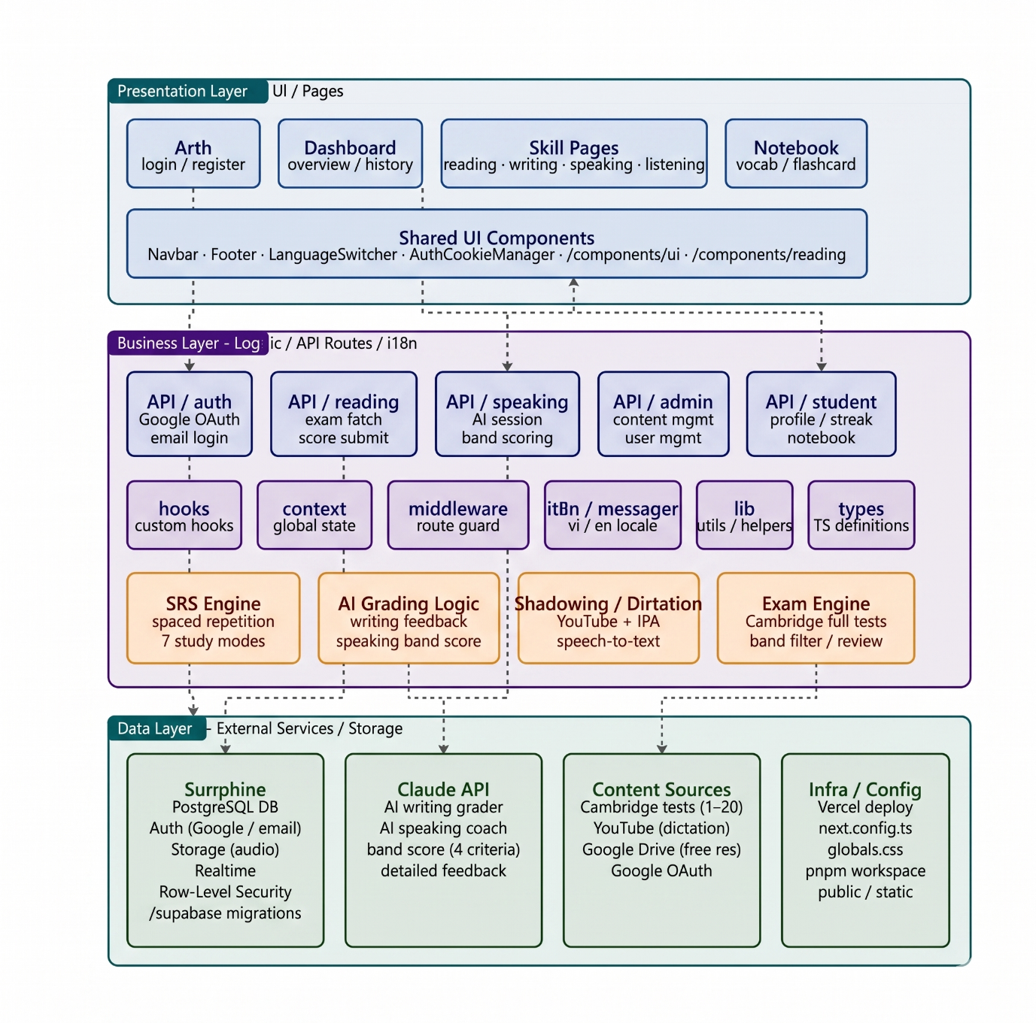

Package Descriptions
No | Package | Description
1 | Presentation Layer | Contains UI components (React/Next.js pages, components) handling user interactions with the system.
2 | Business Layer | Contains core business logic: scoring algorithms, ASR pipeline, Adaptive Learning engine, and AI Chatbot integration.
3 | Data Layer | Manages data access logic for PostgreSQL, Redis cache, and Vector DB (pgvector/Pinecone).
4 | Controller | Express.js / FastAPI route handlers acting as bridge between UI and Business Layer services.
5 | Utils | Shared utility functions: JWT helpers, email sender, file upload handler, FFmpeg/yt-dlp wrappers.
6 | Config | Application configuration: environment variables, database connection strings, ASR model settings, Sepay keys.
7 | Filter / Middleware | Authentication guards (JWT verify), rate limiting, request validation, and CORS middleware.
8 | Models | Data models and entity definitions (User, Course, Test, Question, Attempt, Vocabulary, ShadowingSession, etc.).
9 | DAL (Data Access Layer) | Handles all database operations: CRUD for PostgreSQL tables, Redis cache reads/writes, Vector DB upsert/query.
10 | ASR Pipeline | OpenAI Whisper integration: audio preprocessing (FFmpeg), speech-to-text transcription, phonics accuracy scoring.

2. Database Design

a. Database Schema
The diagram below shows the full Entity-Relationship schema of the IELTS Practice & Shadowing Platform.
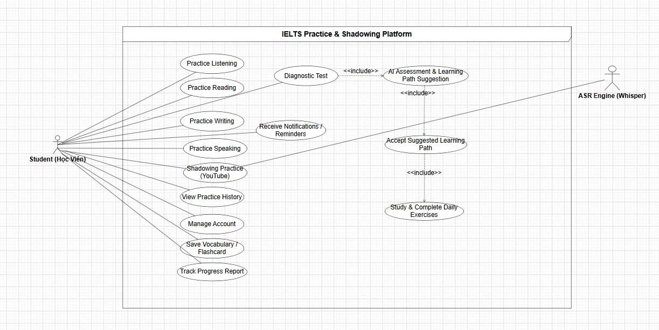

Figure 1: Database Schema – IELTS Practice & Shadowing Platform

b. Table Description
No | Table | Description
1 | users | Stores user account information: user_id, username, email, password (hashed), role (student/admin), status, avatar_url, target_band, created_at, oauth_provider, oauth_id, is_premium, premium_expiry.
2 | tests | Cambridge IELTS test metadata: test_id, title, cambridge_book (9–20), skill (Listening/Reading/Writing/Speaking), test_type (Academic/General), difficulty, created_by, created_at.
3 | questions | Individual questions within a test: question_id, test_id (FK), question_type (MC/TF/Fill/Matching), content, correct_answer, explanation, audio_url, order_index.
4 | test_attempts | Records of student test submissions: attempt_id, user_id (FK), test_id (FK), started_at, submitted_at, score, band_score_estimated, status (in_progress/completed).
5 | attempt_answers | Per-question answers within an attempt: answer_id, attempt_id (FK), question_id (FK), user_answer, is_correct, time_spent_seconds.
6 | writing_submissions | Writing task submissions: submission_id, user_id (FK), test_id (FK), task_type (Task1/Task2), content, submitted_at, ai_feedback_tr, ai_feedback_cc, ai_feedback_lr, ai_feedback_gra, band_score.
7 | speaking_sessions | Speaking practice sessions: session_id, user_id (FK), test_id (FK), question_part (1/2/3), audio_url, transcript, fluency_score, pronunciation_score, band_estimate, created_at.
8 | shadowing_sessions | Shadowing sessions per video: session_id, user_id (FK), video_id (FK), started_at, completed_at, phonics_accuracy_pct, total_sentences, correct_sentences.
9 | shadowing_videos | YouTube videos approved for Shadowing: video_id, youtube_url, title, topic, difficulty, subtitle_url, status (pending/approved/rejected), submitted_by, reviewed_by, created_at.
10 | learning_paths | Personalised learning roadmaps: path_id, user_id (FK), created_at, target_band, target_date, status (active/completed), diagnostic_attempt_id (FK).
11 | daily_tasks | Daily tasks assigned within a learning path: task_id, path_id (FK), day_number, skill, test_id (FK), is_completed, completed_at.
12 | user_vocabulary | Saved vocabulary items: vocab_id, user_id (FK), word, definition, example_sentence, source_test_id, saved_at, next_review_at, repetition_level (SRS).
13 | flashcard_reviews | SRS review log: review_id, vocab_id (FK), reviewed_at, quality (0–5), interval_days, new_repetition_level.
14 | notifications | In-app and email notifications: noti_id, user_id (FK), title, content, type (reminder/badge/streak/payment), is_read, created_at, link.
15 | transactions | Sepay payment records: transaction_id, user_id (FK), amount, currency, plan_type (monthly/yearly), status (pending/success/failed/refunded), sepay_ref, created_at, confirmed_at.
16 | badges | Achievement definitions: badge_id, name, description, icon_url, condition_type, condition_value.
17 | user_badges | Badges earned by users: id, user_id (FK), badge_id (FK), earned_at.
18 | chatbot_logs | AI Chatbot conversation history: log_id, user_id (FK), message, response, created_at, tokens_used.
19 | system_config | Configurable system parameters: config_key (PK), config_value, updated_by, updated_at.

II. Code Designs

Authentication

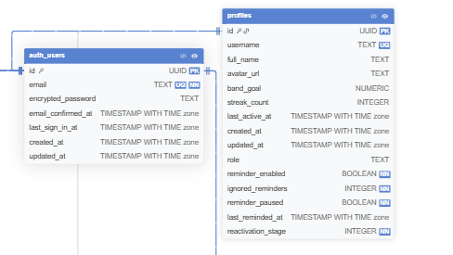

1.1. Register / Sign Up

a. Use Case Diagram

Figure: UC-G02 – Đăng ký tài khoản

b. Class Specifications
DBConnection Class
No | Method | Description
01 | openConnection() | Opens a connection to the PostgreSQL database and returns a Connection object. Throws an Exception on failure.
02 | getInstance() | Implements the Singleton pattern to ensure only one DBConnection instance exists. Creates a new instance if null.
UserDAO Class
No | Method | Description
01 | checkExistEmail(String email) | Checks whether a given email already exists in the users table. Returns boolean.
02 | addUserByRegister(User user) | Inserts a new user record into the users table with hashed password, default role "student", and status "pending".
RegisterController Class
No | Method | Description
01 | sendVerificationMail(username, email, code) | Sends an OTP verification email to the newly registered user using the configured email service.
02 | register(req, res) | Handles POST /auth/register: validates input, checks duplicate email, hashes password (bcrypt), inserts user, sends verification email.
03 | verifyOTP(req, res) | Handles GET/POST /auth/verify: validates OTP code against stored value, activates user account on success.

c. Sequence Diagram(s)
[Sequence Diagram – Register: Guest → RegisterController → UserDAO → DB → Email Service]

d. Database Queries
Check exist email:
SELECT * FROM users WHERE email = ?
Insert new user:
INSERT INTO users(username, email, password_hash, role, status, oauth_provider, oauth_id, avatar_url) VALUES (?, ?, ?, ?, ?, ?, ?, ?)
Activate account after OTP:
UPDATE users SET status = 'active' WHERE email = ?

e. Code Implementation
supabaseClient.js (Khoi tao Supabase Client):
import { createClient } from '@supabase/supabase-js';
export const supabase = createClient(
process.env.NEXT_PUBLIC_SUPABASE_URL,
process.env.NEXT_PUBLIC_SUPABASE_ANON_KEY
);
authController.js - Register & Verify OTP:
// authController.js - Register / Sign Up
import { createClient } from '@supabase/supabase-js';

const supabase = createClient(
process.env.NEXT_PUBLIC_SUPABASE_URL,
process.env.NEXT_PUBLIC_SUPABASE_ANON_KEY
);

// 1. Register new user (Supabase Auth)
export async function register(email, password, username, fullName) {
const { data, error } = await supabase.auth.signUp({
email,
password,
options: {
data: { username, name: fullName } // raw_user_meta_data
}
});
if (error) throw error;
// Trigger handle_new_user() tu dong tao profiles record
return data;
}

// 2. Verify OTP email
export async function verifyOTP(email, token) {
const { data, error } = await supabase.auth.verifyOtp({
email,
token,
type: 'signup'
});
if (error) throw error;
return data;
}

// 3. Check if email already exists in profiles
export async function checkExistEmail(email) {
const { data } = await supabase
.from('profiles')
.select('id')
.eq('username', email)
.maybeSingle();
return !!data;
}

1.2. Login

a. Use Case Diagram

Figure: UC-G03 – Đăng nhập (Email/Password & Google OAuth2)

b. Class Specifications
UserDAO Class
No | Method | Description
01 | getUserByEmail(String email) | Retrieves a User object from the database by email. Returns null if not found.
02 | checkLogin(String email, String password) | Verifies credentials by comparing bcrypt-hashed password. Returns User on success, null on failure.
AuthController Class
No | Method | Description
01 | login(req, res) | Handles POST /auth/login: validates credentials, generates JWT access token + refresh token, returns tokens and user info.
02 | googleOAuthCallback(req, res) | Handles OAuth2 Google callback: retrieves user profile from Google, creates account if new, issues JWT and redirects to Dashboard.

c. Sequence Diagram(s)
[Sequence Diagram – Login: User → AuthController → UserDAO → DB → JWT → Dashboard]

d. Database Queries
Check login:
SELECT * FROM users WHERE email = ?
Get user by email:
SELECT * FROM users WHERE email = ?

e. Code Implementation
authController.js - Login (Email & Google OAuth):
// authController.js - Login

// 1. Login with Email & Password
export async function login(email, password) {
const { data, error } = await supabase.auth.signInWithPassword({
email,
password
});
if (error) throw error;
// data.session chua access_token va refresh_token
return data;
}

// 2. Login with Google OAuth2
export async function loginWithGoogle() {
const { data, error } = await supabase.auth.signInWithOAuth({
provider: 'google',
options: {
redirectTo: `${window.location.origin}/auth/callback`
}
});
if (error) throw error;
return data;
}

// 3. Get current user profile after login
export async function getCurrentUser() {
const { data: { user } } = await supabase.auth.getUser();
if (!user) return null;
const { data: profile } = await supabase
.from('profiles')
.select('*')
.eq('id', user.id)
.single();
return { ...user, profile };
}

1.3. Logout

a. Class Specifications
AuthController Class
No | Method | Description
01 | logout(req, res) | Invalidates the JWT refresh token by removing it from the Redis token store. Clears client-side cookies and redirects to landing page.

b. Sequence Diagram(s)
[Sequence Diagram – Logout: User → AuthController → Redis (invalidate token) → Redirect]

c. Database Queries
None (token invalidation handled by Redis)

e. Code Implementation
authController.js – Logout:
// authController.js - Logout

// Logout - huy session hien tai (Supabase tu xu ly token)
export async function logout() {
const { error } = await supabase.auth.signOut();
if (error) throw error;
// Supabase tu dong xoa session khoi localStorage/cookies
// Redirect ve trang landing
window.location.href = '/';
}

// Listen auth state change (dung trong _app.js hoac layout)
supabase.auth.onAuthStateChange((event, session) => {
if (event === 'SIGNED_OUT') {
// Clear local state, redirect to login
console.log('User signed out');
}
});

1.4. Forgot Password / Reset Password

a. Class Specifications
UserDAO Class
No | Method | Description
01 | getUserByEmail(String email) | Retrieves User object by email. Used to verify the email exists before sending reset link.
02 | changePassword(String email, String newPassword) | Updates the password_hash field for the given email with the bcrypt-hashed new password.
ForgotPasswordController Class
No | Method | Description
01 | verifyEmail(req, res) | Validates that the submitted email exists in the system and sends a password reset link with a signed token.
02 | verifyToken(req, res) | Validates the reset token (expiry and signature) from the link. Renders the new-password form on success.
03 | resetPassword(req, res) | Accepts the new password, hashes it with bcrypt, and updates the users table. Invalidates the reset token.

b. Sequence Diagram(s)
[Sequence Diagram – Forgot Password: User → ForgotPasswordController → UserDAO → DB → Email]

c. Database Queries
Change password:
UPDATE users SET password_hash = ? WHERE email = ?

e. Code Implementation
authController.js - Forgot & Reset Password:
// authController.js - Forgot Password / Reset Password

// 1. Gui email reset password
export async function forgotPassword(email) {
const { error } = await supabase.auth.resetPasswordForEmail(email, {
redirectTo: `${window.location.origin}/auth/reset-password`
});
if (error) throw error;
return { message: 'Password reset email sent' };
}

// 2. Cap nhat mat khau moi (sau khi click link trong email)
export async function resetPassword(newPassword) {
const { data, error } = await supabase.auth.updateUser({
password: newPassword
});
if (error) throw error;
return data;
}

// 3. Xu ly callback URL (trong trang /auth/reset-password)
// Supabase tu dong xu ly token tu URL params
export async function handlePasswordReset(accessToken, refreshToken) {
const { data, error } = await supabase.auth.setSession({
access_token: accessToken,
refresh_token: refreshToken
});
if (error) throw error;
return data;
}

1.5. View & Edit Profile

a. Class Specifications
UserDAO Class
No | Method | Description
01 | getUserByEmail(String email) | Returns a User object with full profile information based on email.
02 | updateProfile(User user) | Updates username, avatar_url, target_band, and address fields in the users table.
ProfileController Class
No | Method | Description
01 | viewProfile(req, res) | Handles GET /profile: retrieves user data from the database and returns full profile JSON to the frontend.
02 | editProfile(req, res) | Handles PATCH /profile: validates and updates user profile data. Supports avatar upload via multipart form.
03 | changePassword(req, res) | Validates existing password, hashes new password with bcrypt, and updates the users table.

b. Sequence Diagram(s)
[Sequence Diagram – Edit Profile: User → ProfileController → UserDAO → DB]

c. Database Queries
Select user by email:
SELECT * FROM users WHERE email = ?
Update profile:
UPDATE users SET username = ?, avatar_url = ?, target_band = ?, description = ?, date_of_birth = ? WHERE user_id = ?
Change password:
UPDATE users SET password_hash = ? WHERE user_id = ?

e. Code Implementation
profileController.js - View, Edit Profile & Upload Avatar:
// profileController.js - View & Edit Profile

// 1. Lay thong tin profile nguoi dung
export async function viewProfile(userId) {
const { data, error } = await supabase
.from('profiles')
.select(`
id, username, full_name, avatar_url,
band_goal, streak_count, last_active_at,
role, reminder_enabled, created_at
`)
.eq('id', userId)
.single();
if (error) throw error;
return data;
}

// 2. Cap nhat profile
export async function editProfile(userId, updates) {
// updates: { username, full_name, avatar_url, band_goal }
const { data, error } = await supabase
.from('profiles')
.update({
...updates,
updated_at: new Date().toISOString()
})
.eq('id', userId)
.select()
.single();
if (error) throw error;
return data;
}

// 3. Upload avatar len Supabase Storage
export async function uploadAvatar(userId, file) {
const ext = file.name.split('.').pop();
const path = `avatars/${userId}.${ext}`;
const { error: uploadError } = await supabase.storage
.from('avatars')
.upload(path, file, { upsert: true });
if (uploadError) throw uploadError;
const { data } = supabase.storage.from('avatars').getPublicUrl(path);
// Cap nhat avatar_url vao profiles
return editProfile(userId, { avatar_url: data.publicUrl });
}

// 4. Doi mat khau
export async function changePassword(newPassword) {
const { data, error } = await supabase.auth.updateUser({
password: newPassword
});
if (error) throw error;
return data;
}

2. Subscription & Payment (Sepay)

2.1. Đăng ký gói Premium

a. Use Case Diagram

Figure: UC-S15 – Đăng ký gói Premium / Thanh toán qua Sepay

b. Class Specifications
TransactionDAO Class
No | Method | Description
01 | addTransaction(Transaction t) | Inserts a new transaction record (user_id, amount, plan_type, status=pending, sepay_ref) into the transactions table.
02 | confirmTransaction(String sepayRef) | Updates transaction status to "success" and sets confirmed_at timestamp upon Sepay webhook callback.
03 | getTransactionsByUser(int userId) | Retrieves all transactions for a specific user ordered by created_at descending.
UserDAO Class
No | Method | Description
01 | activatePremium(int userId, Date expiry) | Sets is_premium=true and premium_expiry for the given user upon successful payment confirmation.
PaymentController Class
No | Method | Description
01 | createPaymentOrder(req, res) | Generates a Sepay payment QR code/link for the selected plan. Creates a pending transaction record.
02 | sepayWebhook(req, res) | Receives Sepay payment callback, verifies signature, confirms transaction, and activates Premium for the user.

c. Sequence Diagram(s)
[Sequence Diagram – Payment: User → PaymentController → Sepay API → Webhook → TransactionDAO → UserDAO]

d. Database Queries
Insert transaction:
INSERT INTO transactions(user_id, amount, currency, plan_type, status, sepay_ref, created_at) VALUES (?, ?, ?, ?, ?, ?, ?)
Confirm transaction:
UPDATE transactions SET status = 'success', confirmed_at = ? WHERE sepay_ref = ?
Activate premium:
UPDATE users SET is_premium = true, premium_expiry = ? WHERE user_id = ?
Get transactions by user:
SELECT * FROM transactions WHERE user_id = ? ORDER BY created_at DESC

Luyện Listening

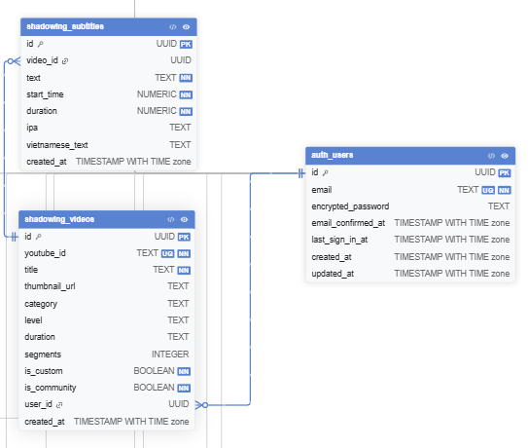

e. Code Implementation
listeningController.js - Chon va lam bai thi Listening:
// 1. Lay danh sach bai thi Listening
export async function getListeningTests() {
const { data, error } = await supabase
.from('exams')
.select('id, title, category, category_id, duration_minutes, description, audio_url, created_at')
.eq('category', 'Listening')
.order('created_at', { ascending: true });
if (error) throw error;
return data;
}

// 2. Lay chi tiet bai thi + cac section va cau hoi
export async function getExamDetail(examId) {
const { data: exam, error } = await supabase
.from('exams')
.select(`
*,
exam_sections (
id, section_no, title, content, answers,
questions:questions!exam_id (
id, section, question_type, text, options, correct_answer, explanation, order_index
)
)
`)
.eq('id', examId)
.single();
if (error) throw error;
return exam;
}

// 3. Tao attempt moi (bat dau lam bai)
export async function startExam(userId, examId, examTitle) {
const { data, error } = await supabase
.from('practice_history')
.insert({
user_id: userId,
category: 'Listening',
test_id: examId,
test_name: examTitle,
metadata: { status: 'in_progress' }
})
.select()
.single();
if (error) throw error;
return data;
}

// 4. Nop bai va luu ket qua
export async function submitListeningExam(userId, examId, answers, score, total) {
const { data, error } = await supabase
.from('user_submissions')
.insert({
user_id: userId,
exam_id: examId,
score: score,
answers: answers, // jsonb: { question_id: user_answer }
completed_at: new Date().toISOString()
})
.select()
.single();
if (error) throw error;
// Cap nhat practice_history
await supabase.from('practice_history')
.update({ score, total, completed_at: new Date().toISOString(),
metadata: { status: 'completed' } })
.eq('user_id', userId).eq('test_id', examId);
return data;
}

// 5. Xem ket qua chi tiet
export async function getSubmissionResult(submissionId) {
const { data, error } = await supabase
.from('user_submissions')
.select('*, exam:exams(title, category)')
.eq('id', submissionId)
.single();
if (error) throw error;
return data;
}

3.1. Chọn và làm bài thi Listening

a. Use Case Diagram

Figure: UC-S01 – Làm bài thi Listening (Cambridge Tests 9–20)

b. Class Specifications
TestDAO Class
No | Method | Description
01 | getTestsBySkill(String skill) | Retrieves all tests filtered by skill = "Listening". Returns list of Test objects ordered by cambridge_book.
02 | getTestById(int testId) | Returns a full Test object including all associated questions and audio_url for the given test ID.
AttemptDAO Class
No | Method | Description
01 | createAttempt(int userId, int testId) | Creates a new test_attempts record with status="in_progress" and returns the new attempt_id.
02 | submitAttempt(Attempt attempt) | Saves all attempt_answers, calculates score and band_score_estimated, and sets status="completed".
03 | getAttemptById(int attemptId) | Retrieves attempt details including all answers and per-question correctness for the results view.
ListeningController Class
No | Method | Description
01 | listTests(req, res) | Returns paginated list of Listening tests to the frontend for the test-selection page.
02 | startTest(req, res) | Creates a new attempt record and returns the test content (questions, audio URL) to the client.
03 | submitTest(req, res) | Receives submitted answers, calls AttemptDAO.submitAttempt(), and redirects to results page.
04 | viewResult(req, res) | Returns full attempt results including per-question explanation and band score estimate.

c. Sequence Diagram(s)
[Sequence Diagram – Listening: User → ListeningController → TestDAO + AttemptDAO → DB → Results]

d. Database Queries
Get tests by skill:
SELECT * FROM tests WHERE skill = 'Listening' ORDER BY cambridge_book, test_id
Get test by ID:
SELECT t.*, q.* FROM tests t JOIN questions q ON t.test_id = q.test_id WHERE t.test_id = ?
Create attempt:
INSERT INTO test_attempts(user_id, test_id, started_at, status) VALUES (?, ?, NOW(), 'in_progress')
Insert answer:
INSERT INTO attempt_answers(attempt_id, question_id, user_answer, is_correct, time_spent_seconds) VALUES (?, ?, ?, ?, ?)
Complete attempt:
UPDATE test_attempts SET submitted_at = NOW(), score = ?, band_score_estimated = ?, status = 'completed' WHERE attempt_id = ?

4. Luyện Reading

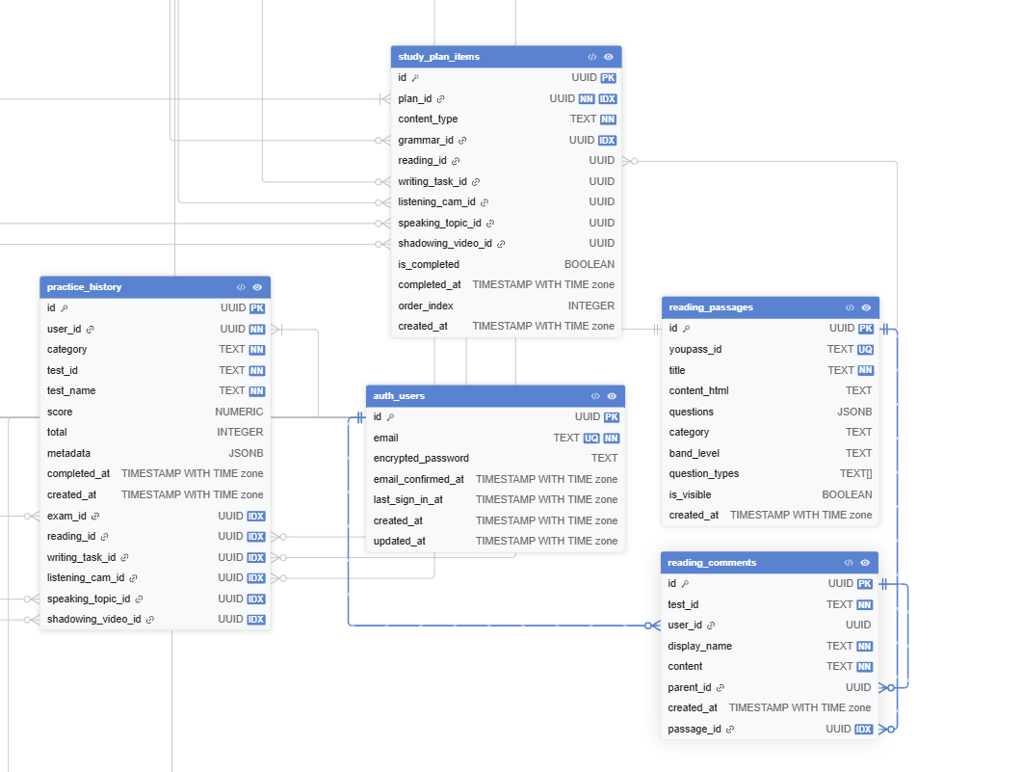

e. Code Implementation
readingController.js - Chon va lam bai thi Reading:
// 1. Lay danh sach bai Reading (reading_passages)
export async function getReadingPassages(bandLevel = null) {
let query = supabase
.from('reading_passages')
.select('id, title, category, band_level, question_types, is_visible, created_at')
.eq('is_visible', true)
.order('created_at', { ascending: false });
if (bandLevel) query = query.eq('band_level', bandLevel);
const { data, error } = await query;
if (error) throw error;
return data;
}

// 2. Lay chi tiet passage + cau hoi
export async function getPassageDetail(passageId) {
const { data, error } = await supabase
.from('reading_passages')
.select('*')
.eq('id', passageId)
.single();
if (error) throw error;
return data; // questions luu trong jsonb
}

// 3. Luu tu vung yeu thich tu bai Reading
export async function saveVocabulary(userId, word, meaning, phonetic, example) {
// Kiem tra trung lap
const { data: existing } = await supabase
.from('user_vocabulary')
.select('id')
.eq('user_id', userId)
.eq('word', word)
.maybeSingle();
if (existing) return { message: 'Word already saved' };
const { data, error } = await supabase
.from('user_vocabulary')
.insert({ user_id: userId, word, meaning, phonetic, example })
.select().single();
if (error) throw error;
return data;
}

// 4. Lay va luu comment tren bai Reading
export async function getReadingComments(testId) {
const { data, error } = await supabase
.from('reading_comments')
.select('id, user_id, display_name, content, parent_id, created_at')
.eq('test_id', testId)
.order('created_at', { ascending: true });
if (error) throw error;
return data;
}

export async function postReadingComment(testId, userId, displayName, content, parentId = null) {
const { data, error } = await supabase
.from('reading_comments')
.insert({ test_id: testId, user_id: userId,
display_name: displayName, content, parent_id: parentId })
.select().single();
if (error) throw error;
return data;
}

4.1. Chọn và làm bài thi Reading

a. Use Case Diagram

Figure: UC-S02 – Làm bài thi Reading (Cambridge Tests 9–20)

b. Class Specifications
TestDAO Class
No | Method | Description
01 | getTestsBySkill(String skill) | Retrieves all Reading tests ordered by cambridge_book. Same signature as Listening, parameterised by skill.
02 | getTestById(int testId) | Returns full Reading test with passage text and all questions (MC, T/F/NG, Matching, Fill-in).
VocabularyDAO Class
No | Method | Description
01 | saveWord(int userId, String word, int testId) | Inserts a new record into user_vocabulary. Sets initial repetition_level=0 and next_review_at=NOW()+1day.
02 | checkWordExists(int userId, String word) | Checks if the user has already saved the given word to avoid duplicates.

c. Sequence Diagram(s)
[Sequence Diagram – Reading: User → ReadingController → TestDAO → DB; Save Word → VocabularyDAO]

d. Database Queries
Get Reading tests:
SELECT * FROM tests WHERE skill = 'Reading' ORDER BY cambridge_book
Save vocabulary word:
INSERT INTO user_vocabulary(user_id, word, definition, source_test_id, saved_at, next_review_at, repetition_level) VALUES (?, ?, ?, ?, NOW(), NOW() + INTERVAL '1 day', 0)

Luyện Writing

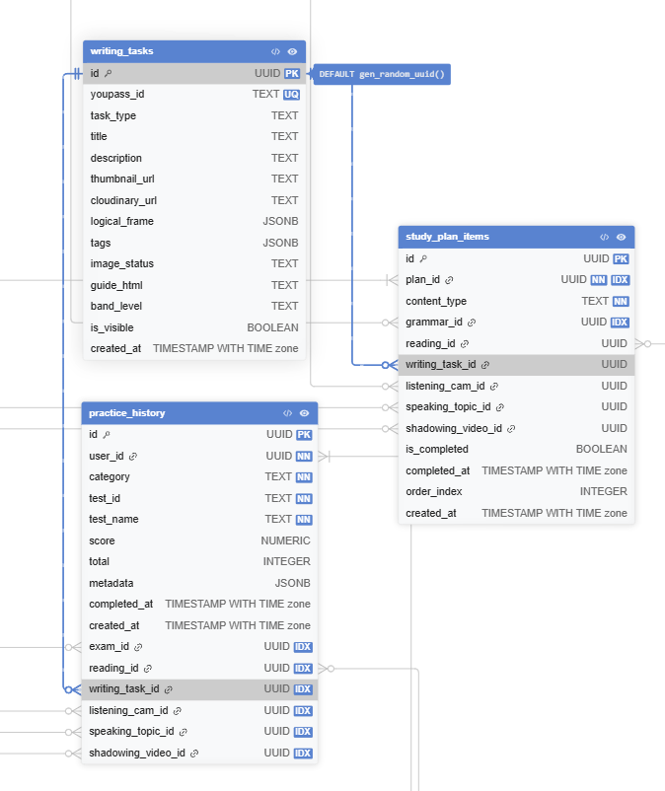

e. Code Implementation
writingController.js - Lam bai Writing va nhan AI Feedback:
// 1. Lay danh sach de Writing
export async function getWritingTasks(taskType = null) {
let query = supabase
.from('writing_tasks')
.select('id, task_type, title, description, thumbnail_url, band_level, guide_html, is_visible')
.eq('is_visible', true)
.order('created_at', { ascending: false });
if (taskType) query = query.eq('task_type', taskType);
const { data, error } = await query;
if (error) throw error;
return data;
}

// 2. Nop bai Writing
export async function submitWriting(userId, examId, answers, metadata = {}) {
const { data, error } = await supabase
.from('user_submissions')
.insert({
user_id: userId,
exam_id: examId,
answers: answers, // { task1: '...', task2: '...' }
completed_at: new Date().toISOString()
})
.select().single();
if (error) throw error;
return data;
}

// 3. Goi AI Feedback qua Anthropic API (server-side)
export async function getAIFeedback(essay, taskType) {
const response = await fetch('/api/writing/feedback', {
method: 'POST',
headers: { 'Content-Type': 'application/json' },
body: JSON.stringify({ essay, taskType })
});
if (!response.ok) throw new Error('AI feedback failed');
return response.json();
// Returns: { tr_score, cc_score, lr_score, gra_score,
// band_score, feedback_text }
}

// 4. Cap nhat AI feedback vao submission
export async function updateWritingFeedback(submissionId, feedback) {
const { data, error } = await supabase
.from('user_submissions')
.update({ metadata: feedback })
.eq('id', submissionId)
.select().single();
if (error) throw error;
return data;
}

// 5. Lay lich su nop bai Writing
export async function getWritingHistory(userId) {
const { data, error } = await supabase
.from('user_submissions')
.select('*, exam:exams(title, category)')
.eq('user_id', userId)
.order('created_at', { ascending: false });
if (error) throw error;
return data;
}

5.1. Làm bài thi Writing & nhận AI Feedback

a. Use Case Diagram
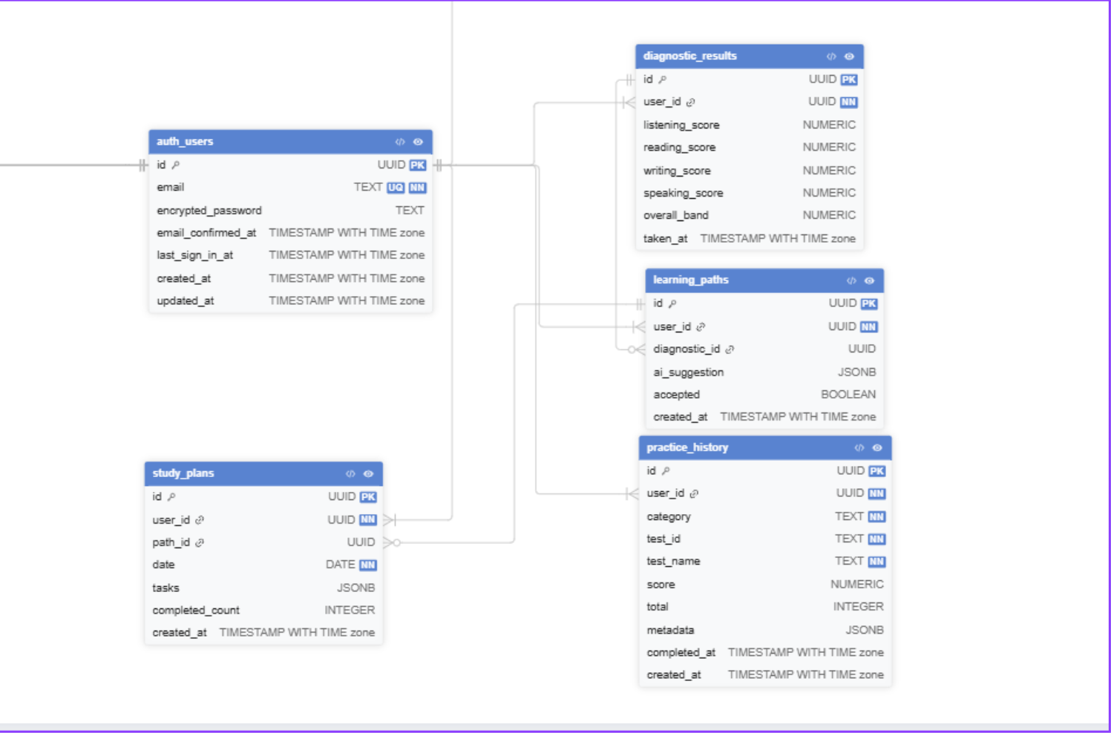
Figure: UC-S03 – Làm bài thi Writing, nộp bài và nhận AI Feedback

b. Class Specifications
WritingDAO Class
No | Method | Description
01 | saveSubmission(WritingSubmission ws) | Inserts a new writing_submissions record with user_id, test_id, task_type, content, and submitted_at.
02 | updateAIFeedback(int submissionId, AIFeedback fb) | Updates ai_feedback_tr, ai_feedback_cc, ai_feedback_lr, ai_feedback_gra, and band_score after AI analysis completes.
03 | getSubmissionsByUser(int userId) | Returns all writing submissions for a user ordered by submitted_at, used for history view.
AIFeedbackService Class
No | Method | Description
01 | analyzeWriting(String essay, String taskType) | Sends the essay to the AI model with IELTS scoring rubric prompt. Returns feedback object with scores and comments for TR, CC, LR, and GRA criteria.

c. Sequence Diagram(s)
[Sequence Diagram – Writing: User → WritingController → WritingDAO (save) → AIFeedbackService → WritingDAO (update feedback)]

d. Database Queries
Insert writing submission:
INSERT INTO writing_submissions(user_id, test_id, task_type, content, submitted_at) VALUES (?, ?, ?, ?, NOW())
Update AI feedback:
UPDATE writing_submissions SET ai_feedback_tr=?, ai_feedback_cc=?, ai_feedback_lr=?, ai_feedback_gra=?, band_score=? WHERE submission_id=?
Get submissions by user:
SELECT * FROM writing_submissions WHERE user_id = ? ORDER BY submitted_at DESC

6. Luyện Speaking (ASR)

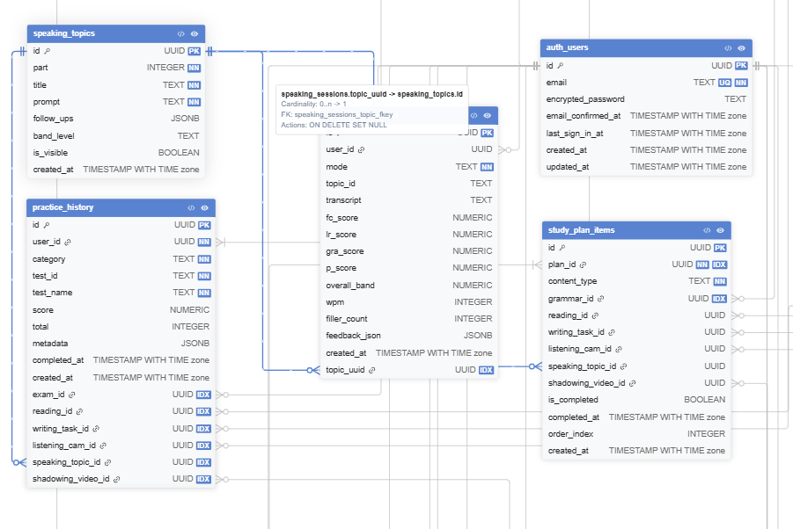

e. Code Implementation
speakingController.js - Ghi am va cham diem Speaking:
// 1. Lay danh sach chu de Speaking (speaking_topics)
export async function getSpeakingTopics(part = null) {
let query = supabase
.from('speaking_topics')
.select('id, part, topic, questions, band_target, is_active')
.eq('is_active', true)
.order('part', { ascending: true });
if (part) query = query.eq('part', part);
const { data, error } = await query;
if (error) throw error;
return data;
}

// 2. Upload audio va luu Speaking session
export async function uploadSpeakingAudio(userId, audioBlob, topicId, mode) {
// Upload audio len Supabase Storage
const fileName = `speaking/${userId}/${Date.now()}.webm`;
const { error: uploadError } = await supabase.storage
.from('audio')
.upload(fileName, audioBlob, { contentType: 'audio/webm' });
if (uploadError) throw uploadError;
// Tao speaking session record
const { data, error } = await supabase
.from('speaking_sessions')
.insert({
user_id: userId,
mode: mode, // 'practice' | 'exam'
topic_id: topicId
})
.select().single();
if (error) throw error;
return { session: data, audioPath: fileName };
}

// 3. Cap nhat ket qua ASR sau khi phan tich xong
export async function updateSpeakingResult(sessionId, result) {
// result: { transcript, fc_score, lr_score, gra_score,
// p_score, overall_band, wpm, filler_count, feedback_json }
const { data, error } = await supabase
.from('speaking_sessions')
.update(result)
.eq('id', sessionId)
.select().single();
if (error) throw error;
return data;
}

// 4. Lay lich su Speaking cua user
export async function getSpeakingHistory(userId, limit = 20) {
const { data, error } = await supabase
.from('speaking_sessions')
.select('*, topic:speaking_topics(topic, part)')
.eq('user_id', userId)
.order('created_at', { ascending: false })
.limit(limit);
if (error) throw error;
return data;
}

6.1. Ghi âm và chấm điểm Speaking

a. Use Case Diagram

Figure: UC-S04 – Luyện Speaking, ghi âm và phân tích qua ASR Engine (Whisper)

b. Class Specifications
SpeakingDAO Class
No | Method | Description
01 | saveSpeakingSession(SpeakingSession ss) | Inserts a new speaking_sessions record with user_id, test_id, question_part, audio_url, and created_at.
02 | updateASRResult(int sessionId, ASRResult result) | Updates transcript, fluency_score, pronunciation_score, and band_estimate after ASR processing completes.
ASRService Class
No | Method | Description
01 | transcribe(String audioPath) | Sends audio file to OpenAI Whisper model. Returns transcript text with word-level timestamps.
02 | analyzeFluency(String transcript) | Computes fluency metrics: speech rate (words/min), pause frequency, filler word count.
03 | analyzePronunciation(String audioPath, String transcript) | Compares phoneme-level ASR output against standard IPA. Returns pronunciation_score (0–9) and list of mispronounced words with IPA corrections.
SpeakingController Class
No | Method | Description
01 | getSpeakingQuestion(req, res) | Returns Speaking question (Part 1/2/3) and cue card content for the selected topic.
02 | uploadAudio(req, res) | Receives recorded audio from the browser (WebRTC), saves to storage, creates speaking session, triggers ASR pipeline.
03 | getResult(req, res) | Returns ASR analysis results: transcript, fluency score, pronunciation score, band estimate, and improvement suggestions.

c. Sequence Diagram(s)
[Sequence Diagram – Speaking: User (mic) → SpeakingController → upload audio → ASRService (Whisper) → SpeakingDAO → Results]

d. Database Queries
Insert speaking session:
INSERT INTO speaking_sessions(user_id, test_id, question_part, audio_url, created_at) VALUES (?, ?, ?, ?, NOW())
Update ASR result:
UPDATE speaking_sessions SET transcript=?, fluency_score=?, pronunciation_score=?, band_estimate=? WHERE session_id=?
Get sessions by user:
SELECT * FROM speaking_sessions WHERE user_id = ? ORDER BY created_at DESC

7. Shadowing

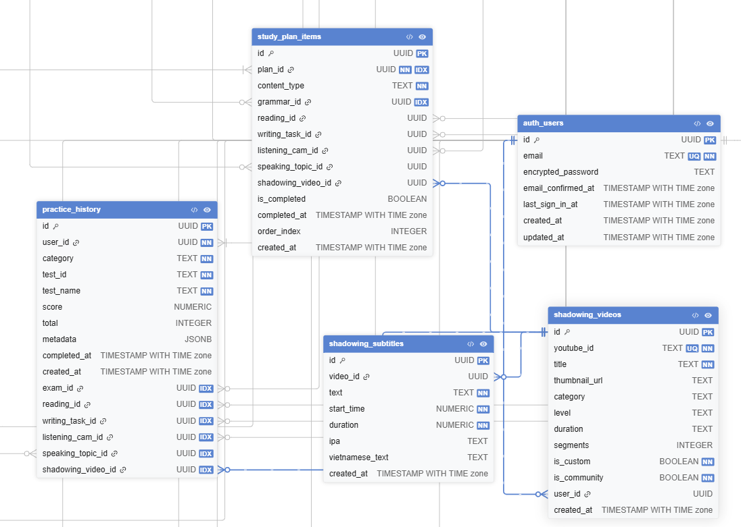

e. Code Implementation
shadowingController.js - Shadowing theo video YouTube:
// 1. Lay danh sach video Shadowing da duoc duyet
export async function getApprovedVideos(category = null, level = null) {
let query = supabase
.from('shadowing_videos')
.select('id, youtube_id, title, thumbnail_url, category, level, duration, segments')
.eq('is_community', false)
.order('created_at', { ascending: false });
if (category) query = query.eq('category', category);
if (level) query = query.eq('level', level);
const { data, error } = await query;
if (error) throw error;
return data;
}

// 2. Lay phu de (subtitles) cua video
export async function getVideoSubtitles(videoId) {
const { data, error } = await supabase
.from('shadowing_subtitles')
.select('id, text, start_time, duration, ipa, vietnamese_text')
.eq('video_id', videoId)
.order('start_time', { ascending: true });
if (error) throw error;
return data;
}

// 3. User de xuat video cong dong
export async function submitCommunityVideo(userId, youtubeId, title, category, level) {
const { data, error } = await supabase
.from('shadowing_videos')
.insert({
user_id: userId,
youtube_id: youtubeId,
title,
category,
level,
is_custom: true,
is_community: true
})
.select().single();
if (error) throw error;
return data;
}

// 4. Luu ket qua Shadowing session
export async function saveShadowingResult(userId, videoId, videoTitle, accuracy, total) {
const { data, error } = await supabase
.from('practice_history')
.insert({
user_id: userId,
category: 'Shadowing',
test_id: videoId,
test_name: videoTitle,
score: accuracy,
total: total,
completed_at: new Date().toISOString()
})
.select().single();
if (error) throw error;
return data;
}

7.1. Thực hiện Shadowing theo video YouTube

a. Use Case Diagram

Figure: UC-S05 – Shadowing theo video YouTube với ASR phonics scoring

b. Class Specifications
ShadowingVideoDAO Class
No | Method | Description
01 | getApprovedVideos() | Returns all videos with status="approved" ordered by topic and difficulty.
02 | getVideoById(int videoId) | Returns a single video record including subtitle_url and youtube_url.
03 | submitVideoSuggestion(ShadowingVideo sv) | Inserts a new video record with status="pending" for Admin review.
ShadowingSessionDAO Class
No | Method | Description
01 | createSession(int userId, int videoId) | Creates a new shadowing_sessions record with started_at timestamp.
02 | updateSessionResult(int sessionId, float accuracy, int correct, int total) | Updates phonics_accuracy_pct, correct_sentences, total_sentences, and completed_at on session completion.
VideoPipelineService Class
No | Method | Description
01 | downloadAudio(String youtubeUrl) | Uses yt-dlp to download audio from the YouTube URL and saves as WAV file for ASR processing.
02 | generateSubtitles(String audioPath) | Runs OpenAI Whisper on the downloaded audio to generate sentence-level subtitles. Returns subtitle_url.
03 | scorePhonics(String userAudioPath, String referenceSentence) | Compares user recording against reference sentence using Whisper phoneme-level alignment. Returns Phonics Accuracy % and list of mispronounced words with IPA suggestions.

c. Sequence Diagram(s)
[Sequence Diagram – Shadowing: User → ShadowingController → VideoPipelineService (yt-dlp + Whisper) → ShadowingSessionDAO → Phonics score display]

d. Database Queries
Get approved videos:
SELECT * FROM shadowing_videos WHERE status = 'approved' ORDER BY difficulty
Create shadowing session:
INSERT INTO shadowing_sessions(user_id, video_id, started_at) VALUES (?, ?, NOW())
Update session result:
UPDATE shadowing_sessions SET phonics_accuracy_pct=?, correct_sentences=?, total_sentences=?, completed_at=NOW() WHERE session_id=?
Submit video suggestion:
INSERT INTO shadowing_videos(youtube_url, title, topic, difficulty, submitted_by, status, created_at) VALUES (?, ?, ?, ?, ?, 'pending', NOW())

8. Lộ trình học & Tiến trình (Adaptive Learning)

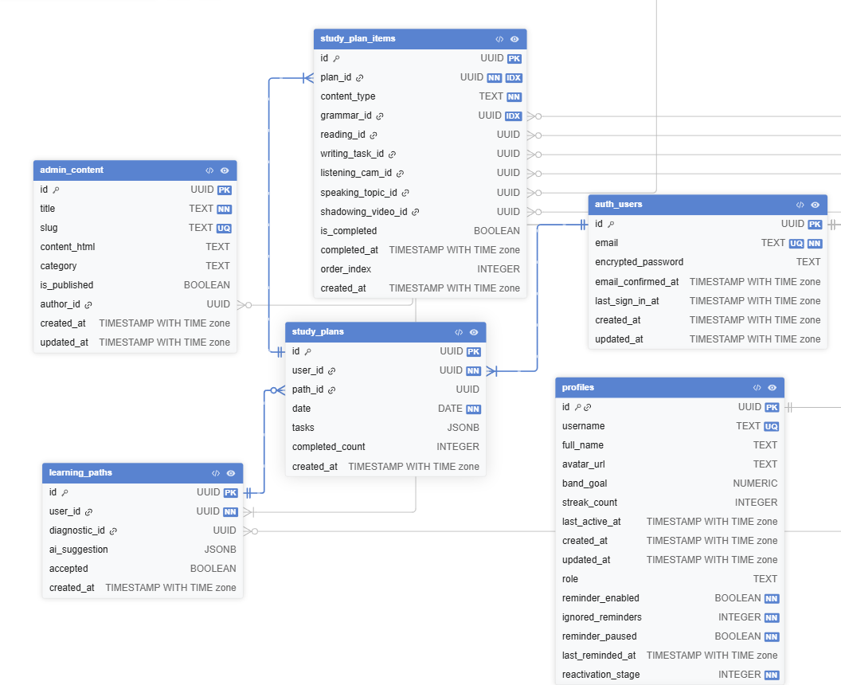e. Code Implementation
diagnosticController.js - Lam bai Diagnostic Test:
// 1. Lay cau hoi Diagnostic Test (tu diagnostic_questions)
export async function getDiagnosticQuestions(skill = null) {
let query = supabase
.from('diagnostic_questions')
.select('id, skill, question_order, source_table, source_id, section_index, question_indices, extra_data')
.eq('is_active', true)
.order('skill').order('question_order');
if (skill) query = query.eq('skill', skill);
const { data, error } = await query;
if (error) throw error;
return data;
}

// 2. Luu ket qua Diagnostic
export async function saveDiagnosticResult(userId, result) {
// result: { overall_band, listening_band, reading_band,
// writing_band, speaking_band, full_result, answers }
const { data, error } = await supabase
.from('diagnostic_results')
.insert({
user_id: userId,
...result
})
.select().single();
if (error) throw error;
// Cap nhat band_goal trong profiles
await supabase.from('profiles')
.update({ band_goal: result.overall_band })
.eq('id', userId);
return data;
}

// 3. Lay ket qua Diagnostic gan nhat cua user
export async function getLatestDiagnosticResult(userId) {
const { data, error } = await supabase
.from('diagnostic_results')
.select('*')
.eq('user_id', userId)
.order('created_at', { ascending: false })
.limit(1).single();
if (error) throw error;
return data;
}

8.1. Làm bài Diagnostic Test

a. Class Specifications
DiagnosticController Class
No | Method | Description
01 | startDiagnostic(req, res) | Creates a diagnostic test_attempt encompassing all 4 skills. Returns a mixed-skill question set.
02 | submitDiagnostic(req, res) | Scores the diagnostic, computes per-skill band estimates, and triggers the Adaptive Learning engine to generate a personalised path.
AdaptiveLearningService Class
No | Method | Description
01 | generateLearningPath(int userId, DiagnosticResult dr) | Applies i+1 principle and SRS scheduling to build a learning_paths record and creates daily_tasks for the next 30 days based on skill gaps.

b. Sequence Diagram(s)
[Sequence Diagram – Diagnostic: User → DiagnosticController → AttemptDAO → AdaptiveLearningService → LearningPathDAO → DB]

c. Database Queries
Create learning path:
INSERT INTO learning_paths(user_id, target_band, target_date, status, diagnostic_attempt_id, created_at) VALUES (?, ?, ?, 'active', ?, NOW())
Insert daily tasks:
INSERT INTO daily_tasks(path_id, day_number, skill, test_id, is_completed) VALUES (?, ?, ?, ?, false)

8.2. Xem & Chấp nhận lộ trình đề xuất

a. Class Specifications
LearningPathDAO Class
No | Method | Description
01 | getPathByUserId(int userId) | Retrieves the active learning path for a user with all associated daily_tasks.
02 | updatePathGoal(int pathId, float targetBand, Date targetDate) | Allows the student to adjust target band score and target date before confirming the path.

b. Sequence Diagram(s)
[Sequence Diagram – Accept Path: User → LearningPathController → LearningPathDAO → DB → Dashboard]

c. Database Queries
Get active path:
SELECT lp.*, dt.* FROM learning_paths lp JOIN daily_tasks dt ON lp.path_id = dt.path_id WHERE lp.user_id = ? AND lp.status = 'active'

8.3. Học bài tập hàng ngày

a. Class Specifications
DailyTaskDAO Class
No | Method | Description
01 | getTodayTasks(int userId) | Returns all daily_tasks for today (by day_number) in the user's active learning path.
02 | markTaskComplete(int taskId) | Sets is_completed=true and completed_at=NOW() for the given task. Triggers streak update.

b. Sequence Diagram(s)
[Sequence Diagram – Daily Task: User → DailyTaskController → DailyTaskDAO → TestDAO → DB; on complete → StreakService]

c. Database Queries
Get today tasks:
SELECT dt.*, t.title, t.skill FROM daily_tasks dt JOIN tests t ON dt.test_id = t.test_id JOIN learning_paths lp ON dt.path_id = lp.path_id WHERE lp.user_id = ? AND lp.status = 'active' AND dt.day_number = ?
Mark task complete:
UPDATE daily_tasks SET is_completed = true, completed_at = NOW() WHERE task_id = ?

e. Code Implementation
progressController.js - Xem bao cao tien do:
// 1. Lay lich su diem theo ky nang
export async function getBandScoreHistory(userId) {
const { data, error } = await supabase
.from('practice_history')
.select('category, score, total, completed_at, test_name')
.eq('user_id', userId)
.not('score', 'is', null)
.order('completed_at', { ascending: true });
if (error) throw error;
return data;
}

// 2. Lay tong quan thong ke (dashboard)
export async function getOverallStats(userId) {
const { data: history } = await supabase
.from('practice_history')
.select('category, score, total, completed_at')
.eq('user_id', userId);

const { data: profile } = await supabase
.from('profiles')
.select('streak_count, band_goal, last_active_at')
.eq('id', userId).single();

const completed = history?.filter(h => h.score !== null) || [];
return {
total_attempts: history?.length || 0,
completed: completed.length,
streak: profile?.streak_count || 0,
band_goal: profile?.band_goal,
by_skill: ['Listening','Reading','Writing','Speaking','Shadowing']
.map(skill => ({
skill,
count: completed.filter(h => h.category === skill).length,
avg_score: completed.filter(h => h.category === skill)
.reduce((a, b) => a + Number(b.score), 0) /
(completed.filter(h => h.category === skill).length || 1)
}))
};
}

8.4. Xem báo cáo tiến độ

a. Class Specifications
ProgressDAO Class
No | Method | Description
01 | getBandScoreHistory(int userId) | Returns band_score_estimated values from test_attempts grouped by skill and ordered by submitted_at.
02 | getOverallStats(int userId) | Returns total attempts, completion rate, current streak, and badges earned for the dashboard overview.

b. Sequence Diagram(s)
[Sequence Diagram – Progress: User → ProgressController → ProgressDAO → DB → Charts]

c. Database Queries
Get band history:
SELECT skill, band_score_estimated, submitted_at FROM test_attempts WHERE user_id = ? AND status = 'completed' ORDER BY submitted_at ASC
Get overall stats:
SELECT COUNT(*) AS total_attempts, SUM(CASE WHEN status='completed' THEN 1 ELSE 0 END) AS completed FROM test_attempts WHERE user_id = ?

9. Vocabulary & Flashcard (SRS)

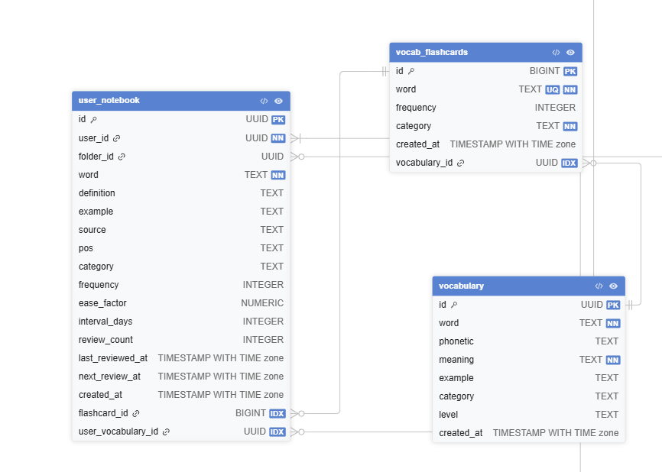

e. Code Implementation
vocabularyController.js - On tap tu vung qua Flashcard SRS:
// 1. Lay the can on tap hom nay (SRS: next_review_at <= NOW)
export async function getDueFlashcards(userId) {
const { data, error } = await supabase
.from('user_notebook')
.select('id, word, definition, example, phonetic, pos, category, ease_factor, interval_days, review_count, next_review_at')
.eq('user_id', userId)
.lte('next_review_at', new Date().toISOString())
.order('next_review_at', { ascending: true });
if (error) throw error;
return data;
}

// 2. Ghi nhan ket qua on tap (SM-2 SRS Algorithm)
export async function recordFlashcardReview(cardId, quality) {
// quality: 0-5 (0=quen hoan toan, 5=nho rat tot)
const { data: card } = await supabase
.from('user_notebook')
.select('ease_factor, interval_days, review_count')
.eq('id', cardId).single();

let { ease_factor, interval_days, review_count } = card;
// SM-2 Algorithm
if (quality < 3) {
interval_days = 1;
review_count = 0;
} else {
if (review_count === 0) interval_days = 1;
else if (review_count === 1) interval_days = 6;
else interval_days = Math.round(interval_days * ease_factor);
ease_factor = Math.max(1.3, ease_factor + 0.1 - (5 - quality) * (0.08 + (5 - quality) * 0.02));
review_count += 1;
}
const next_review = new Date();
next_review.setDate(next_review.getDate() + interval_days);

const { data, error } = await supabase
.from('user_notebook')
.update({ ease_factor, interval_days, review_count,
last_reviewed_at: new Date().toISOString(),
next_review_at: next_review.toISOString() })
.eq('id', cardId).select().single();
if (error) throw error;
return data;
}

// 3. Them tu vung moi vao notebook
export async function addToNotebook(userId, wordData, folderId = null) {
const { data, error } = await supabase
.from('user_notebook')
.insert({
user_id: userId,
word: wordData.word,
definition: wordData.definition,
phonetic: wordData.phonetic,
example: wordData.example,
pos: wordData.pos,
category: wordData.category,
source: wordData.source || 'manual',
folder_id: folderId,
next_review_at: new Date().toISOString()
})
.select().single();
if (error) throw error;
return data;
}

// 4. Quan ly folder trong notebook
export async function getNotebookFolders(userId) {
const { data, error } = await supabase
.from('notebook_folders')
.select('id, name, created_at')
.eq('user_id', userId)
.order('created_at', { ascending: true });
if (error) throw error;
return data;
}

9.1. Ôn tập từ vựng qua Flashcard SRS

a. Class Specifications
VocabularyDAO Class
No | Method | Description
01 | getDueCards(int userId) | Returns all user_vocabulary cards where next_review_at <= NOW() for the current SRS review session.
02 | recordReview(FlashcardReview review) | Inserts a flashcard_reviews record and updates next_review_at and repetition_level using the SM-2 SRS algorithm.

b. Sequence Diagram(s)
[Sequence Diagram – Flashcard: User → FlashcardController → VocabularyDAO (getDue) → Display cards → User rates → recordReview → DB]

c. Database Queries
Get due cards:
SELECT * FROM user_vocabulary WHERE user_id = ? AND next_review_at <= NOW() ORDER BY next_review_at
Record review:
INSERT INTO flashcard_reviews(vocab_id, reviewed_at, quality, interval_days, new_repetition_level) VALUES (?, NOW(), ?, ?, ?)
Update SRS schedule:
UPDATE user_vocabulary SET next_review_at = NOW() + (interval_days || ' days')::interval, repetition_level = ? WHERE vocab_id = ?

10. AI Chatbot

10.1. Sử dụng AI Chatbot hỗ trợ học tập

a. Class Specifications
ChatbotDAO Class
No | Method | Description
01 | saveLog(int userId, String message, String response) | Inserts a chatbot_logs record with user message, AI response, timestamp, and tokens_used.
02 | getLogs(int userId, int limit) | Returns the last N chatbot conversation logs for the user to restore conversation history.
ChatbotService Class
No | Method | Description
01 | queryVectorDB(String question) | Converts the question to an embedding vector and queries pgvector/Pinecone for the most relevant IELTS knowledge chunks.
02 | generateResponse(String question, List context) | Sends question + retrieved context chunks to the LLM. Returns a concise answer within 5 seconds. Response time target: <5s.

b. Sequence Diagram(s)
[Sequence Diagram – Chatbot: User → ChatbotController → ChatbotService (Vector DB query + LLM) → ChatbotDAO (save log) → Response]

c. Database Queries
Save chatbot log:
INSERT INTO chatbot_logs(user_id, message, response, created_at, tokens_used) VALUES (?, ?, ?, NOW(), ?)
Get conversation history:
SELECT * FROM chatbot_logs WHERE user_id = ? ORDER BY created_at DESC LIMIT ?

11. Admin – Quản lý hệ thống

e. Code Implementation
adminUserController.js - Quan ly nguoi dung:
// 1. Lay danh sach tat ca user (co phan trang)
export async function getAllUsers(page = 1, pageSize = 20, filters = {}) {
const from = (page - 1) * pageSize;
let query = supabase
.from('profiles')
.select('id, username, full_name, avatar_url, role, band_goal, streak_count, created_at', { count: 'exact' })
.order('created_at', { ascending: false })
.range(from, from + pageSize - 1);
if (filters.role) query = query.eq('role', filters.role);
const { data, count, error } = await query;
if (error) throw error;
return { data, total: count, page, pageSize };
}

// 2. Cap nhat role user (ban / unban / nang cap admin)
export async function updateUserRole(userId, newRole) {
// newRole: 'user' | 'admin' | 'banned'
const { data, error } = await supabase
.from('profiles')
.update({ role: newRole })
.eq('id', userId)
.select().single();
if (error) throw error;
return data;
}

// 3. Tim kiem user theo username hoac email
export async function searchUsers(keyword) {
const { data, error } = await supabase
.from('profiles')
.select('id, username, full_name, role, created_at')
.or(`username.ilike.%${keyword}%,full_name.ilike.%${keyword}%`)
.order('created_at', { ascending: false });
if (error) throw error;
return data;
}

11.1. Quản lý người dùng (UC-A01)

a. Class Specifications
UserDAO Class
No | Method | Description
01 | getAllUsers(int page, int size) | Returns paginated list of all users ordered by created_at descending.
02 | updateStatus(int userId, String status) | Updates user status to "active", "banned", or "pending". Used for ban/unban operations.
03 | upgradePremium(int userId, Date expiry) | Manually sets is_premium=true and premium_expiry for a user by Admin action.
AdminUserController Class
No | Method | Description
01 | viewAllUsers(req, res) | Returns paginated user list with search/filter support (by email, status, role).
02 | banUser(req, res) | Sets user status="banned" and sends a notification email to the affected user.
03 | unbanUser(req, res) | Sets user status="active" and restores full access.

b. Sequence Diagram(s)
[Sequence Diagram – Admin User Management: Admin → AdminUserController → UserDAO → DB; ban → NotificationDAO]

c. Database Queries
Get all users (paginated):
SELECT * FROM users ORDER BY created_at DESC LIMIT ? OFFSET ?
Ban/Unban user:
UPDATE users SET status = ? WHERE user_id = ?

e. Code Implementation
adminExamController.js - Them/Sua/Xoa de thi:
// 1. Them de thi moi
export async function insertExam(examData) {
// examData: { title, category, category_id, duration_minutes,
// description, passage_content, audio_url }
const { data, error } = await supabase
.from('exams')
.insert(examData)
.select().single();
if (error) throw error;
return data;
}

// 2. Them section va cau hoi cho de thi
export async function insertExamSection(examId, sectionData, questions) {
const { data: section, error } = await supabase
.from('exam_sections')
.insert({ exam_id: examId, ...sectionData })
.select().single();
if (error) throw error;
// Insert cau hoi
const qs = questions.map((q, i) => ({
exam_id: examId,
section: section.section_no,
question_type: q.question_type,
text: q.text,
options: q.options,
correct_answer: q.correct_answer,
explanation: q.explanation,
order_index: i
}));
const { data: qData, error: qErr } = await supabase
.from('questions').insert(qs).select();
if (qErr) throw qErr;
return { section, questions: qData };
}

// 3. Cap nhat de thi
export async function updateExam(examId, updates) {
const { data, error } = await supabase
.from('exams')
.update(updates)
.eq('id', examId)
.select().single();
if (error) throw error;
return data;
}

// 4. Xoa de thi (xoa mem - an khoi danh sach)
export async function deleteExam(examId) {
// Khong co is_active trong schema -> xoa that su hoac dung RLS
const { error } = await supabase
.from('exams')
.delete()
.eq('id', examId);
if (error) throw error;
return { message: 'Exam deleted' };
}

// 5. Lay danh sach de thi co phan trang
export async function findExams(page = 1, pageSize = 20, category = null) {
const from = (page - 1) * pageSize;
let query = supabase
.from('exams')
.select('*', { count: 'exact' })
.order('created_at', { ascending: false })
.range(from, from + pageSize - 1);
if (category) query = query.eq('category', category);
const { data, count, error } = await query;
if (error) throw error;
return { data, total: count };
}

11.2. Thêm/Sửa/Xóa đề thi (UC-A02)

a. Class Specifications
TestDAO Class
No | Method | Description
01 | insertTest(Test test) | Inserts a new test record. For Listening, uploads audio file and stores audio_url.
02 | updateTest(Test test) | Updates test metadata (title, difficulty, cambridge_book) and replaces audio/passage if new file uploaded.
03 | deleteTest(int testId) | Soft-deletes a test by setting is_active=false. Preserves existing attempt records.
04 | findTests(int page, int size, String skill) | Returns paginated test list filtered by skill for the admin management view.

b. Sequence Diagram(s)
[Sequence Diagram – Manage Tests: Admin → AdminTestController → TestDAO → DB; file upload → Storage service]

c. Database Queries
Insert test:
INSERT INTO tests(title, cambridge_book, skill, test_type, difficulty, audio_url, created_by, created_at) VALUES (?, ?, ?, ?, ?, ?, ?, NOW())
Update test:
UPDATE tests SET title=?, difficulty=?, cambridge_book=?, audio_url=? WHERE test_id=?
Soft-delete test:
UPDATE tests SET is_active = false WHERE test_id = ?
Find tests paginated:
SELECT * FROM tests WHERE skill = ? AND is_active = true ORDER BY cambridge_book LIMIT ? OFFSET ?

e. Code Implementation
adminShadowingController.js - Phe duyet video Shadowing:
// 1. Lay danh sach video cong dong cho nhom Admin duyet
export async function getCommunityVideos(approved = null) {
let query = supabase
.from('shadowing_videos')
.select('id, youtube_id, title, category, level, user_id, is_custom, is_community, created_at')
.eq('is_community', true)
.order('created_at', { ascending: true });
const { data, error } = await query;
if (error) throw error;
return data;
}

// 2. Phe duyet video (chuyen is_community = true -> hien thi cong khai)
export async function approveVideo(videoId) {
const { data, error } = await supabase
.from('shadowing_videos')
.update({ is_community: true, is_custom: false })
.eq('id', videoId)
.select().single();
if (error) throw error;
return data;
}

// 3. Tu choi / xoa video
export async function rejectVideo(videoId) {
const { error } = await supabase
.from('shadowing_videos')
.delete()
.eq('id', videoId);
if (error) throw error;
return { message: 'Video rejected and removed' };
}

11.3. Phê duyệt video Shadowing (UC-A05)

a. Class Specifications
ShadowingVideoDAO Class
No | Method | Description
01 | getPendingVideos() | Returns all videos with status="pending" ordered by created_at for Admin review queue.
02 | approveVideo(int videoId, int reviewedBy) | Sets status="approved" and records reviewed_by and reviewed_at. Triggers subtitle generation pipeline.
03 | rejectVideo(int videoId, String reason) | Sets status="rejected" and notifies the submitting user with the rejection reason.

b. Sequence Diagram(s)
[Sequence Diagram – Approve Video: Admin → AdminShadowingController → ShadowingVideoDAO → DB; approve → VideoPipelineService (generate subtitles)]

c. Database Queries
Get pending videos:
SELECT * FROM shadowing_videos WHERE status = 'pending' ORDER BY created_at
Approve video:
UPDATE shadowing_videos SET status='approved', reviewed_by=?, reviewed_at=NOW() WHERE video_id=?
Reject video:
UPDATE shadowing_videos SET status='rejected', reviewed_by=?, reviewed_at=NOW() WHERE video_id=?

11.4. Quản lý gói thanh toán & hóa đơn (UC-A08)

a. Class Specifications
TransactionDAO Class
No | Method | Description
01 | getAllTransactions(int page, int size) | Returns paginated list of all transactions ordered by created_at descending.
02 | manualConfirm(String sepayRef, int adminId) | Manually sets transaction status="success" when automatic webhook fails. Activates Premium for user.
03 | processRefund(int transactionId) | Sets transaction status="refunded" and revokes is_premium for the user.

b. Sequence Diagram(s)
[Sequence Diagram – Admin Payment: Admin → AdminPaymentController → TransactionDAO → UserDAO (activate/revoke premium)]

c. Database Queries
Get all transactions:
SELECT t.*, u.email FROM transactions t JOIN users u ON t.user_id = u.user_id ORDER BY created_at DESC LIMIT ? OFFSET ?
Manual confirm:
UPDATE transactions SET status='success', confirmed_at=NOW() WHERE sepay_ref=?
Process refund:
UPDATE transactions SET status='refunded' WHERE transaction_id=?

e. Code Implementation
adminStatsController.js - Xem bao cao thong ke tong quan:
// 1. Tong so user theo role
export async function getTotalUsers() {
const { data, error } = await supabase
.from('profiles')
.select('role');
if (error) throw error;
return data.reduce((acc, p) => {
acc[p.role] = (acc[p.role] || 0) + 1;
return acc;
}, {});
}

// 2. Tong so bai lam theo ky nang
export async function getTotalAttempts() {
const { data, error } = await supabase
.from('practice_history')
.select('category');
if (error) throw error;
return data.reduce((acc, h) => {
acc[h.category] = (acc[h.category] || 0) + 1;
return acc;
}, {});
}

// 3. Diem trung binh theo ky nang
export async function getAverageBandBySkill() {
const { data, error } = await supabase
.from('practice_history')
.select('category, score')
.not('score', 'is', null);
if (error) throw error;
const grouped = data.reduce((acc, h) => {
if (!acc[h.category]) acc[h.category] = [];
acc[h.category].push(Number(h.score));
return acc;
}, {});
return Object.entries(grouped).map(([skill, scores]) => ({
skill,
avg_score: (scores.reduce((a, b) => a + b, 0) / scores.length).toFixed(2)
}));
}

// 4. Quan ly noi dung Admin (admin_content)
export async function getAdminContent(category = null) {
let query = supabase
.from('admin_content')
.select('id, title, slug, category, is_published, author_id, created_at')
.order('created_at', { ascending: false });
if (category) query = query.eq('category', category);
const { data, error } = await query;
if (error) throw error;
return data;
}

export async function publishContent(contentId, published) {
const { data, error } = await supabase
.from('admin_content')
.update({ is_published: published, updated_at: new Date().toISOString() })
.eq('id', contentId)
.select().single();
if (error) throw error;
return data;
}

11.5. Xem báo cáo thống kê tổng quan (UC-A04)

a. Class Specifications
StatisticsDAO Class
No | Method | Description
01 | getTotalUsers() | Returns total user count grouped by role and status.
02 | getTotalAttempts() | Returns total test attempts grouped by skill and date range.
03 | getAverageBandBySkill() | Returns the system-wide average band_score_estimated per skill (Listening/Reading/Writing/Speaking).
04 | getRevenueStats() | Returns total and monthly revenue from successful Sepay transactions.

b. Sequence Diagram(s)
[Sequence Diagram – Stats: Admin → AdminStatsController → StatisticsDAO → DB → Dashboard charts]

c. Database Queries
Total users by role:
SELECT role, status, COUNT(*) AS total FROM users GROUP BY role, status
Total attempts by skill:
SELECT skill, COUNT(*) AS total FROM tests t JOIN test_attempts ta ON t.test_id = ta.test_id WHERE ta.status='completed' GROUP BY skill
Average band by skill:
SELECT t.skill, AVG(ta.band_score_estimated) AS avg_band FROM test_attempts ta JOIN tests t ON ta.test_id = t.test_id WHERE ta.status = 'completed' GROUP BY t.skill
Revenue stats:
SELECT DATE_TRUNC('month', confirmed_at) AS month, SUM(amount) AS revenue FROM transactions WHERE status='success' GROUP BY month ORDER BY month DESC

