

Requirement & Design Specification
Integrated HR and Project Management System (HRP Management System)
Version: 1.0

– DaNang, June 2026 –
Record of Changes

Version | Date | A*  M, D | In charge | Change Description
V1.0 | 15/2 | A | KienNTHE11
*A - Added M - Modified D - Deleted

Contents
Contents 3
I. Overview 5
1. User Requirements 5
1.1 Actors 5
1.2 Use Cases 5
2. Overall Functionalities 12
2.1 Screens Flow 12
2.2 Screen Descriptions 13
2.3 Screen Authorization 14
2.4 Non-UI Functions 15
3. System High Level Design 16
3.1 Database Design 16
3.2 Code Packages 22
II. Requirement Specifications 24
1. Common Functions 24
1.1. Authentication 24
1.2. Authorization & Security 30
2. Patron Feature 35
2.1. Employee Management Feature 35
2.2. Attendance Management Feature 41
2.3. Payroll Management Feature 60
2.4. Project Management Feature 67
2.5. Task Management Feature 74
III. Design Specifications 79
1. Common Functions 79
1.1 System Access 79
2. Employee Management Feature 92
2.1 Employee List Screen 92
2.2 Employee Details Screen 92
2.3 Create Employee Screen 92
2.4 Edit Profile Screen 92
3. Attendance Management Feature 93
3.1 Attendance Dashboard 93
3.2 Attendance History Screen 94
3.3 Application Form Screen 94
3.4 Recruitment Proposal Screen 94
3.5 Working Shift Screen 94
3.6 Application Approval Screen 97
4. Payroll Management Feature 98
4.1 Payroll Dashboard 98
4.2 Payroll Template Screen 98
4.3 Payroll Approval Screen 99
4.4 Payslip Screen 100
4.5 Payroll Scheduler Screen 101
5. Project Management Feature 103
5.1 Project List Screen 103
5.2 Project Details Screen 107
6. Task Management Feature 113
6.1 Task Board Screen 113
IV. Appendix 122
1. Assumptions & Dependencies 122
2. Limitations & Exclusions 122
3. Business Rules 122

I. Overview

1. User Requirements

1.1 Actors

# | Actor | Description
1 | Employee | A staff member of the organization. Can log in, view profile, submit attendance requests, view payroll slips, and use task/project features.
2 | HR Manager | Manages employee records, payroll, attendance configurations, and recruitment processes.
3 | Team Leader | Inherits Employee role. Additionally manages team members in projects, assigns tasks, and approves attendance-related requests for direct reports.
4 | General Manager | Oversees projects, approves/rejects payroll, and modifies payroll generation triggers.
5 | Administrator | Manages system security: creates/modifies/deletes roles, assigns/revokes permissions, views login activity, and monitors suspicious activity.
6 | Internal Agent | An automated internal agent that processes commands after authorization by user credentials.

1.2 Use Cases

a. Diagram(s)
Employee Management UCD:
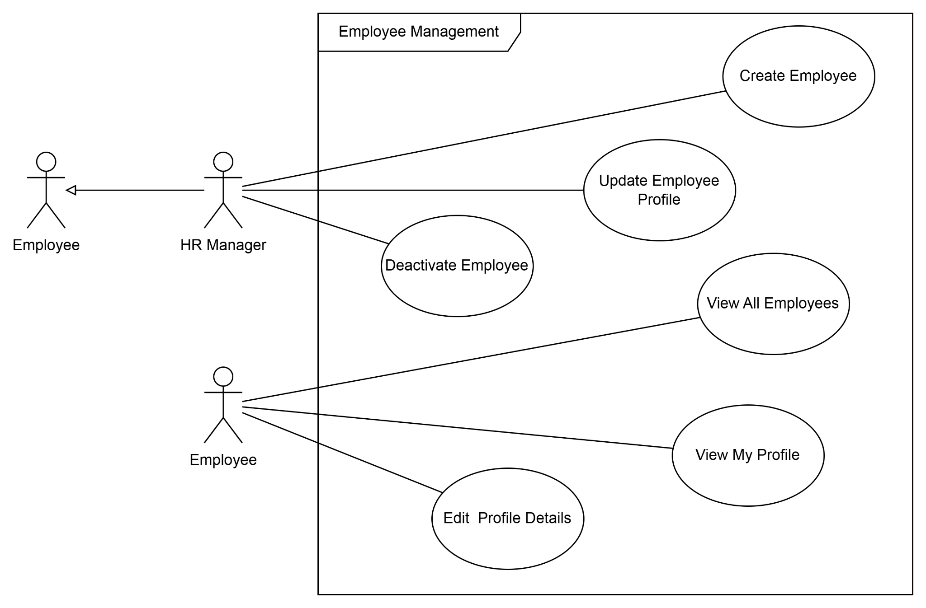
Payroll Management UCD: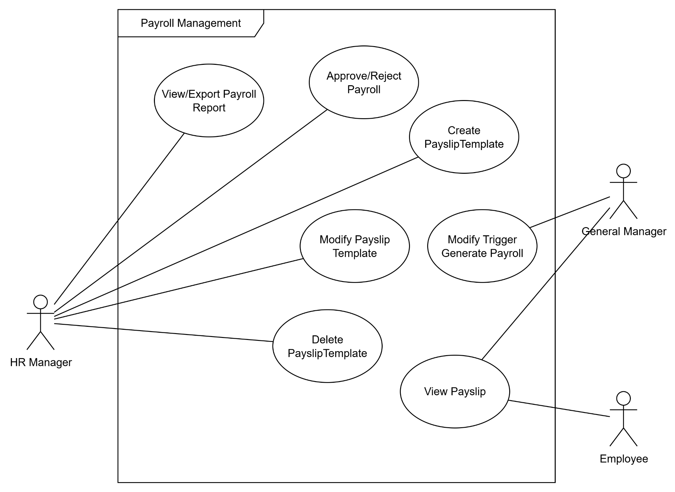

Authentication UCD:
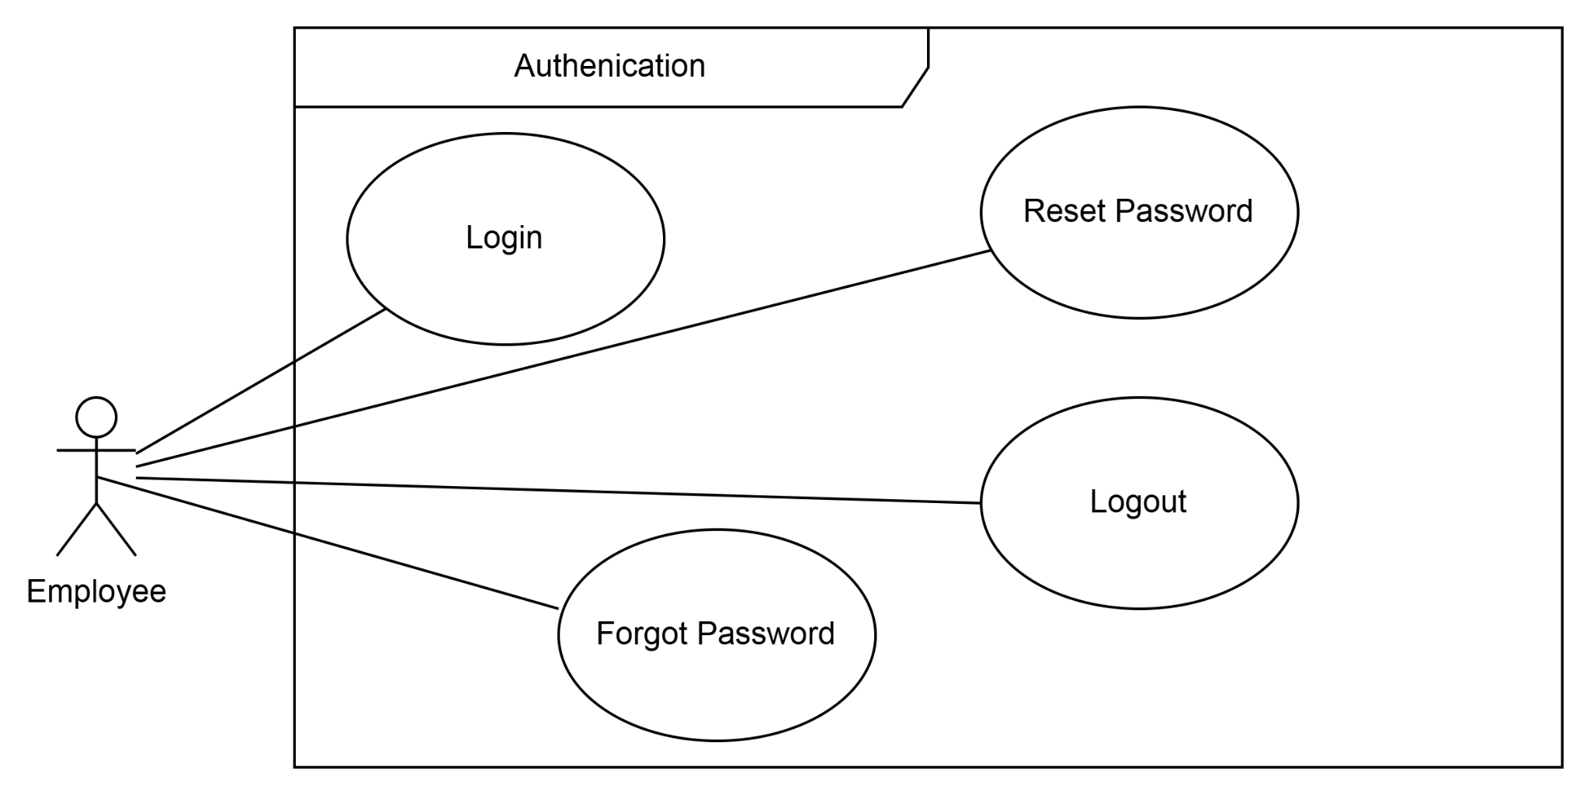

Task Management UCD:
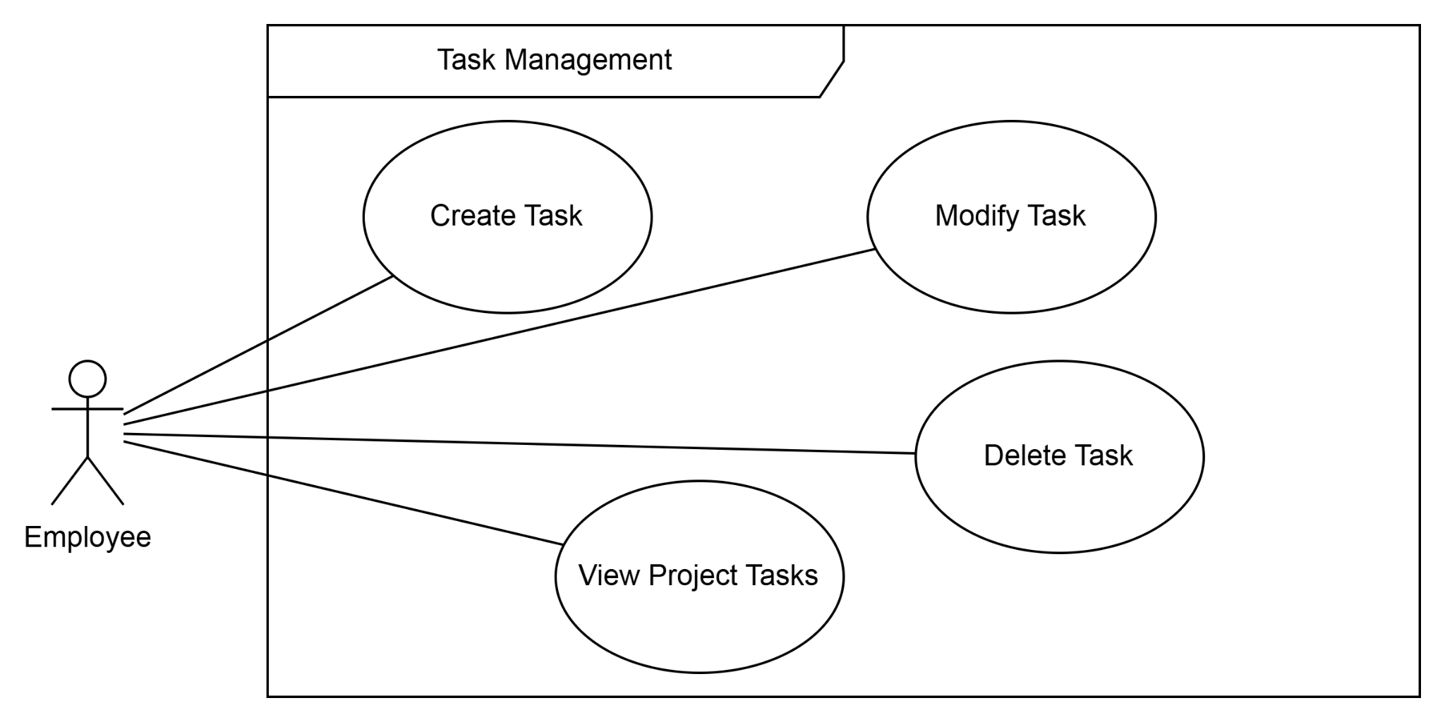

Agent Support UCD:
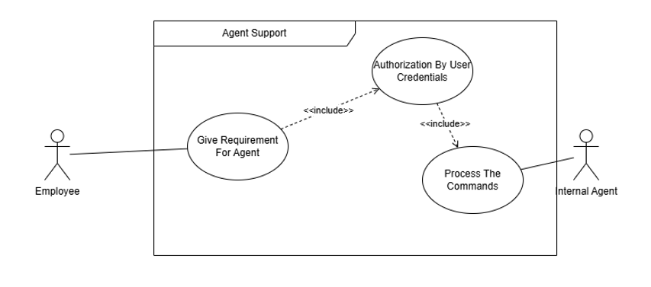

Project Management UCD:
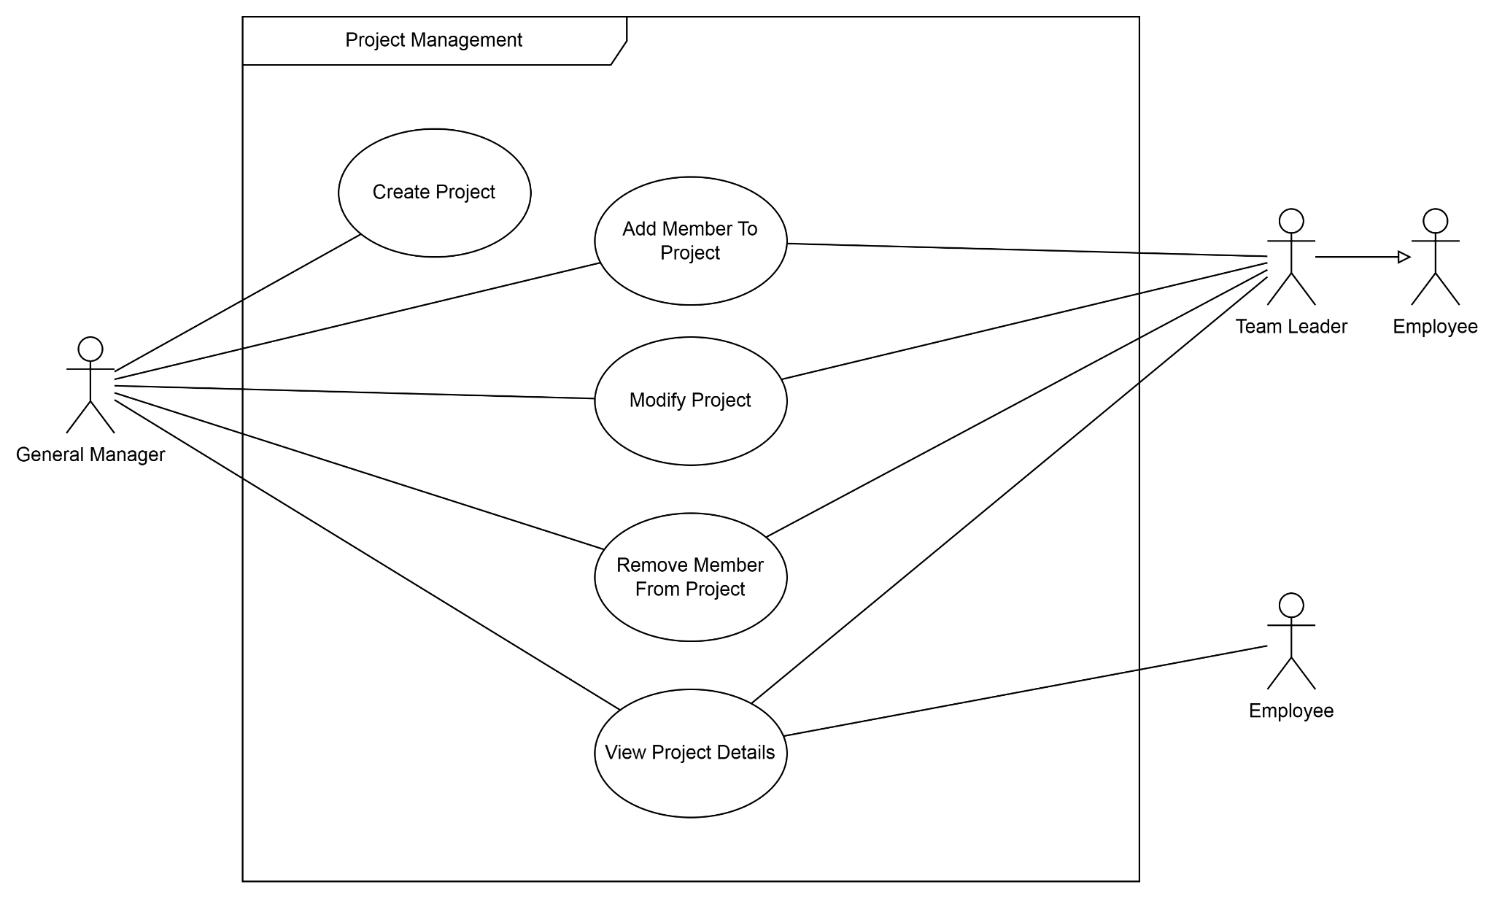

Attendance Management UCD:
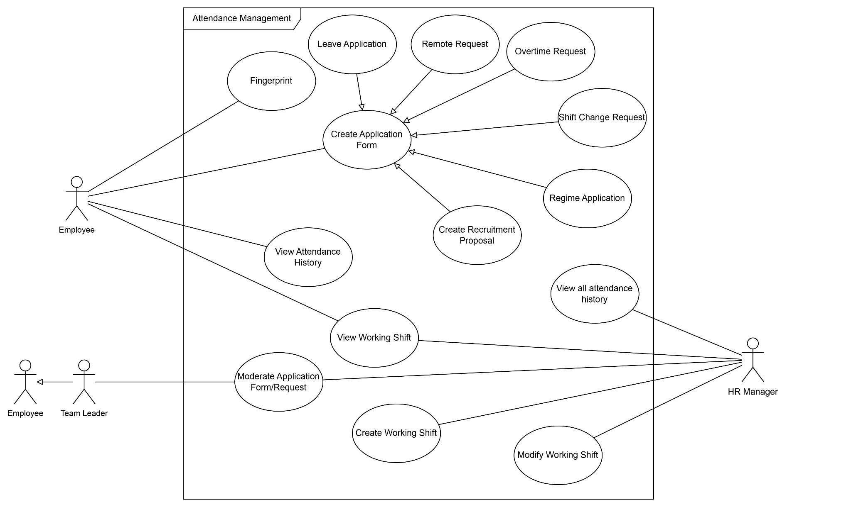

b. Descriptions

# | Feature | Use Case | Use Case Description
01 | Authentication | Login | Employee logs into the system with credentials.
02 | Authentication | Logout | Employee logs out and terminates the current session.
03 | Authentication | Reset Password | Employee resets their password by requesting Admin to reset it, then entering a new password and confirming it.
04 | Authentication | Forgot Password | Employees who cannot access their account initiates a password recovery flow.
05 | Authorization & Security | View Login Activity | Administrator views the login history and activity logs of all users in the system.
06 | Authorization & Security | Detect Suspicious Activity | The system detects abnormal login patterns (e.g., multiple failed attempts). This use case extends View Login Activity when suspicious behavior is identified. (<<extend>>)
07 | Authorization & Security | Assign Role | Administrator assigns a role (e.g., HR Manager, Team Leader, Employee) to a user account, granting the corresponding set of permissions.
08 | Authorization & Security | Revoke Role | Administrator revokes a previously assigned role from a user, removing the associated access rights.
09 | Authorization & Security | Reissue Password | Administrator reissues a temporary password for an employee who has lost access, typically triggered by a Reset Password request.
10 | Employee Management | Create Employee | HR Manager adds a new employee profile to the system.
11 | Employee Management | Update Employee Profile | HR Manager updates personal and professional details of an employee.
12 | Employee Management | Deactivate Employee | HR Manager deactivates an employee account (e.g., upon resignation).
13 | Employee Management | View All Employees | HR Manager views the list of all employees.
14 | Employee Management | View My Profile | Employee views their own profile information.
15 | Employee Management | Edit Profile Details | Employee edits their own editable profile fields such as phone number or address.
16 | Attendance Management | Fingerprint | Employee records their check-in or check-out by scanning their fingerprint. The system automatically logs the timestamp and updates their attendance status.
17 | Attendance Management | View Attendance History | Employee views their own attendance records.
18 | Attendance Management | View All Attendance History | HR Manager views attendance records of all employees.
19 | Attendance Management | Create Application Form | Employee creates an application form (Leave, Overtime, Remote, Shift Change, or Regime).
20 | Attendance Management | Leave Application | Employee submits a leave request (extends Create Application Form).
21 | Attendance Management | Overtime Request | Employee submits an overtime request (extends Create Application Form).
22 | Attendance Management | Remote Request | Employee submits a remote work request  form stating the reason for working  outside the office. By default, employees  work on-site; a Remote Request is  required to be approved before working  remotely.
23 | Attendance Management | Shift Change Request | Employee requests a change to their working shift.
24 | Attendance Management | Regime Application | Employee applies for a special work regime.
25 | Attendance Management | Create Recruitment Proposal | Employee submits a proposal requesting new headcount for their team, including justification and the required position details.
26 | Attendance Management | View Working Shift | Employee views their assigned working shift schedule.
27 | Attendance Management | Create Working Shift | HR Manager creates a new working shift template.
28 | Attendance Management | Modify Working Shift | HR Manager modifies an existing working shift.
29 | Attendance Management | Moderate Application Form | Team Leader or HR Manager reviews submitted application forms and approves or rejects them. The system notifies the employee of the outcome.
30 | Payroll Management | View/Export Payroll Report | HR Manager views and exports payroll reports.
31 | Payroll Management | Modify Salary Template | HR Manager modifies an existing salary template.
32 | Payroll Management | Moderate Payroll | HR Manager submits the generated payroll for review. The General Manager moderates (approves or requests revision of) the payroll before it is finalized.
33 | Payroll Management | View Payslip | Employee views their monthly payslip
34 | Payroll Management | Modify Trigger Generate Payroll | General Manager modifies the schedule/trigger for automatic payroll generation.
35 | Project Management | Create Project | General Manager creates a new project.
36 | Project Management | Modify Project | General Manager or Team Leader modifies project details.
37 | Project Management | Add Member To Project | General Manager or Team Leader adds an employee to a project.
38 | Project Management | Remove Member From Project | General Manager or Team Leader removes a member from a project.
39 | Project Management | View Project Details | General Manager, Team Leader, or Employee views project information.
40 | Task Management | Create Task | Employee creates a new task within a project.
41 | Task Management | Modify Task | Employee modifies an existing task.
42 | Task Management | Delete Task | Employee deletes a task.
43 | Task Management | View Project Tasks | Employee views all tasks associated with a project.
44 | Agent Support | Give Requirement For Agent | Employee provides a natural language command or requirement to the internal AI agent. This use case includes Authorization By User Credentials before any command is executed. (<<include>>) .
45 | Agent Support | Authorization By User Credentials | The agent verifies the employee's identity and permission level before processing the command. Upon successful authorization, it includes Process The Commands. (<<include>>)
46 | Agent Support | Process The Commands | The agent interprets and executes the authorized command, interacting with the relevant system modules to fulfill the employee's request.

2. Overall Functionalities

2.1 Screens Flow
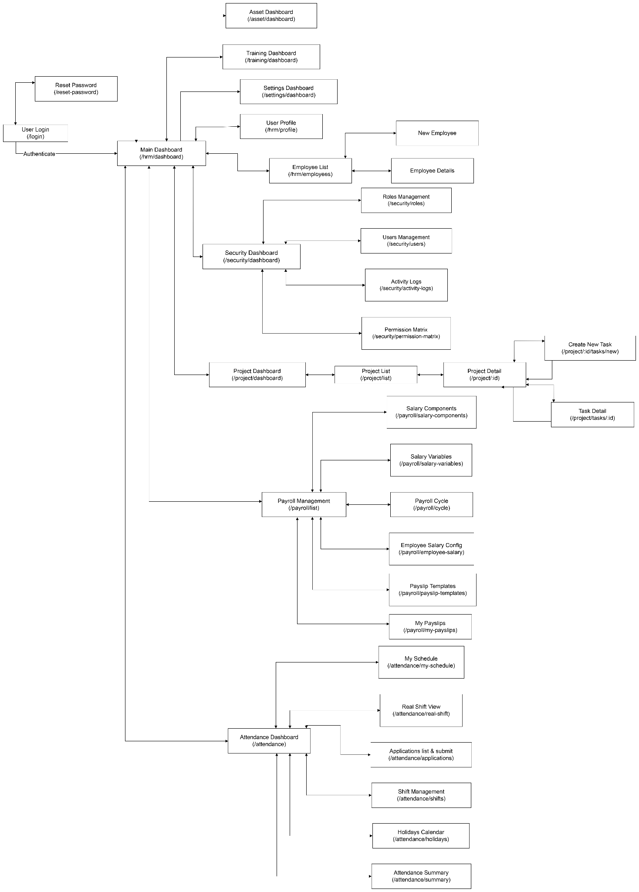

2.2 Screen Descriptions

# | Feature | Screen | Description
1 | Authentication | Login Screen | Screen for employees to enter credentials and log in.
2 | Authentication | Reset Password Screen | Screen for Admin to reset an employee's  password, or for employee to enter and  confirm a new password.
 | Authorization & Security | Role & Security Management Screen | Screen for Administrator to assign/revoke roles, view login activity, and manage suspicious activity alerts.
3 | Employee Management | Employee List | Displays all employee records with search and filter options.
4 | Employee Management | Employee Details | Displays full profile of an individual employee.
5 | Employee Management | Add/Edit Employee | Form screen for creating or updating an employee record.
6 | Attendance Management | Attendance Dashboard | Overview of attendance statistics and quick-access links.
7 | Attendance Management | Attendance History | List of check-in/check-out records for an employee
8 | Attendance Management | Application Form Screen | Form for submitting Leave, Overtime, Remote, Shift Change, or Regime requests.
9 | Attendance Management | Working Shift Management | Screen to create, view, and modify working shifts.
10 | Attendance Management | Recruitment Proposal Screen | Form screen for employees to submit or close a recruitment proposal for new headcount.
11 | Payroll Management | Payroll Dashboard | Summary of payroll status and navigation to sub-features.
12 | Salary Management | Salary Template Management | CRUD screen for salary templates.
13 | Payroll Management | Payroll Report | View and export payroll reports by period.
14 | Payroll Management | Payslip View | Employee's personal payslip screen.
18 | Project Management | Project List | List of all projects with status and key information.
19 | Project Management | Project Details | Detailed view of a project including members and tasks.
20 | Task Management | Task Board/List | Kanban or list view of tasks for a project.
21 | Agent Support | Agent Chat Interface | Chat-based interface for submitting commands to the internal agent.

2.3 Screen Authorization

Screen | Employee | Team Leader | HR Manager | General Manager | Administrator
Login / Logout / Reset Password | X | X | X | X | X
View My Profile | X | X | X | X | X
View Employee Details | X | X | X
View All Employees |  |  | X | X
Add / Update / Deactivate Employee |  |  | X
View Attendance History (own) | X | X
View All Attendance History |  |  | X
Submit Application Forms | X | X
Approve/Reject Application Form |  | X | X
Create / Modify Working Shift |  |  | X
View Working Shift | X | X | X
View/Export Payroll Report |  |  | X | X
Manage Salary Components & Templates |  |  | X
Approve/Reject Payroll |  |  | X | X
Modify Trigger Generate Payroll |  |  |  | X
View Payslip | X | X
Manage Recruitment Postings & Candidates |  |  | X
Create / Close Recruitment Proposal | X | X
Create / Modify Project |  | X |  | X
Add / Remove Project Members |  | X |  | X
View Project Details | X | X |  | X
Create / Modify / Delete Task | X | X
View Project Tasks | X | X |  | X
Agent Support (Give Requirement) | X | X

2.4 Non-UI Functions

# | Feature | System Function | Description
1 | Attendance Management | Fingerprint Sync Service | Background service that synchronizes fingerprint data from hardware devices to the database.
2 | Payroll Management | Auto Payroll Generation (Cron Job) | Scheduled job that automatically generates payroll on a configured trigger date each month.
3 | Authorization & Security | Suspicious Activity Detection | Background service that monitors login patterns and flags anomalies (e.g., multiple failed logins).
4 | Agent Support | Agent Command Processor | Internal service that parses, validates, and executes commands submitted by authorized users.

3. System High Level Design

3.1 Database Design

a. Database Schema

Module 1: Quản lý Nhân sự & Hệ thống (HR & Core System)
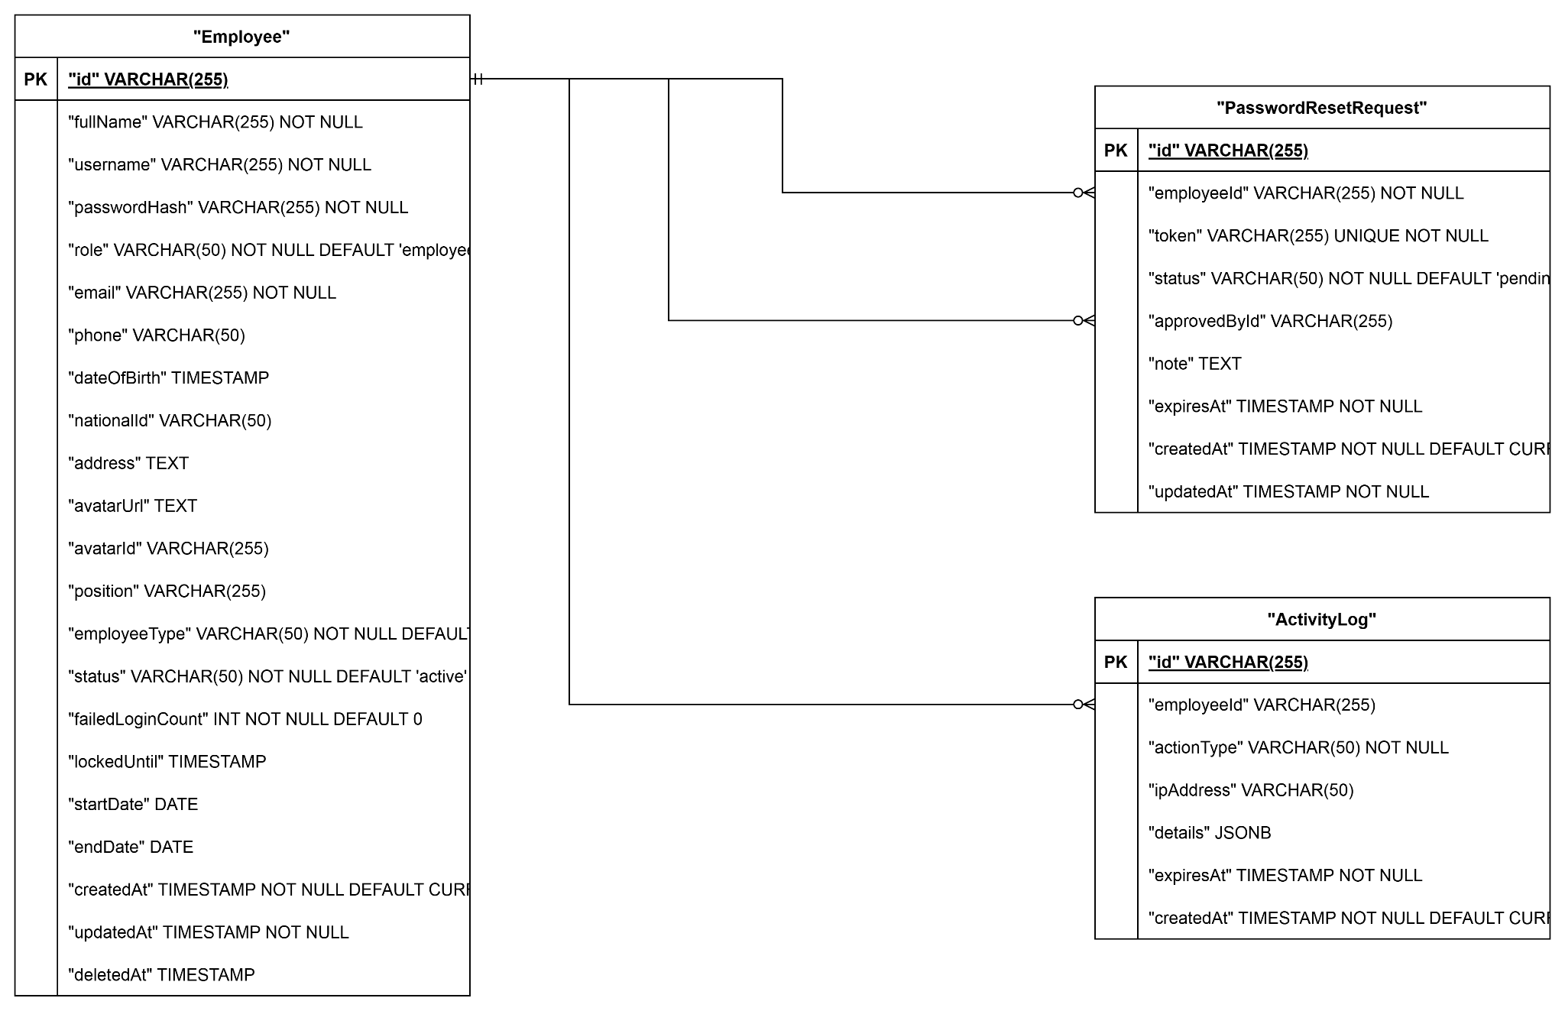

Module 2: Chấm công & Ca làm việc (Attendance & Shifts)
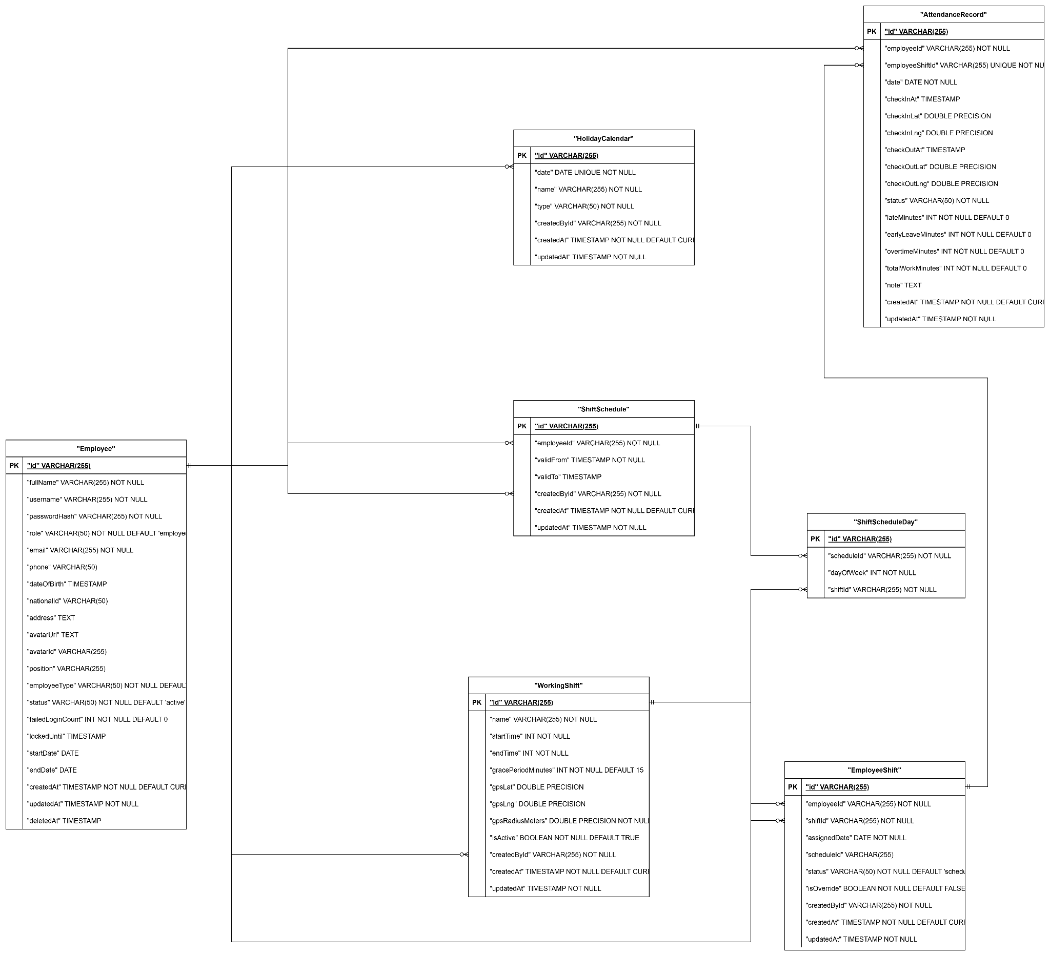

Module 3: Quản lý Đơn từ & Phê duyệt (Applications & Leaves)

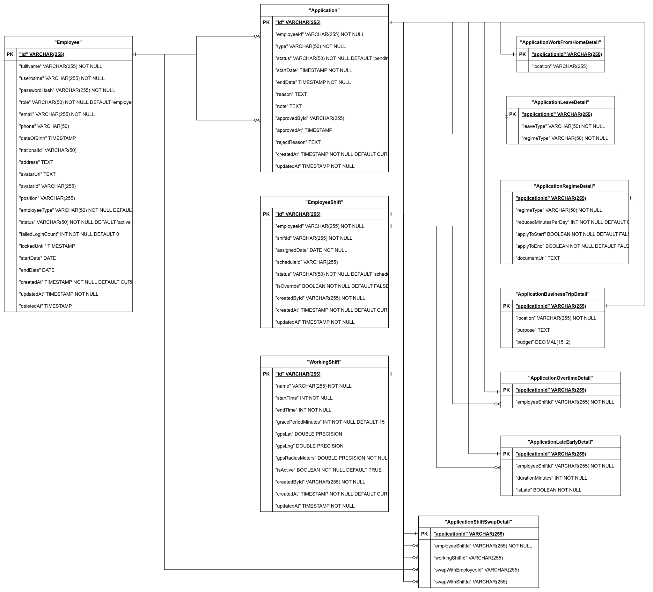

Module 4: Cấu hình Lương & Bảng lương (Payroll & Salaries)

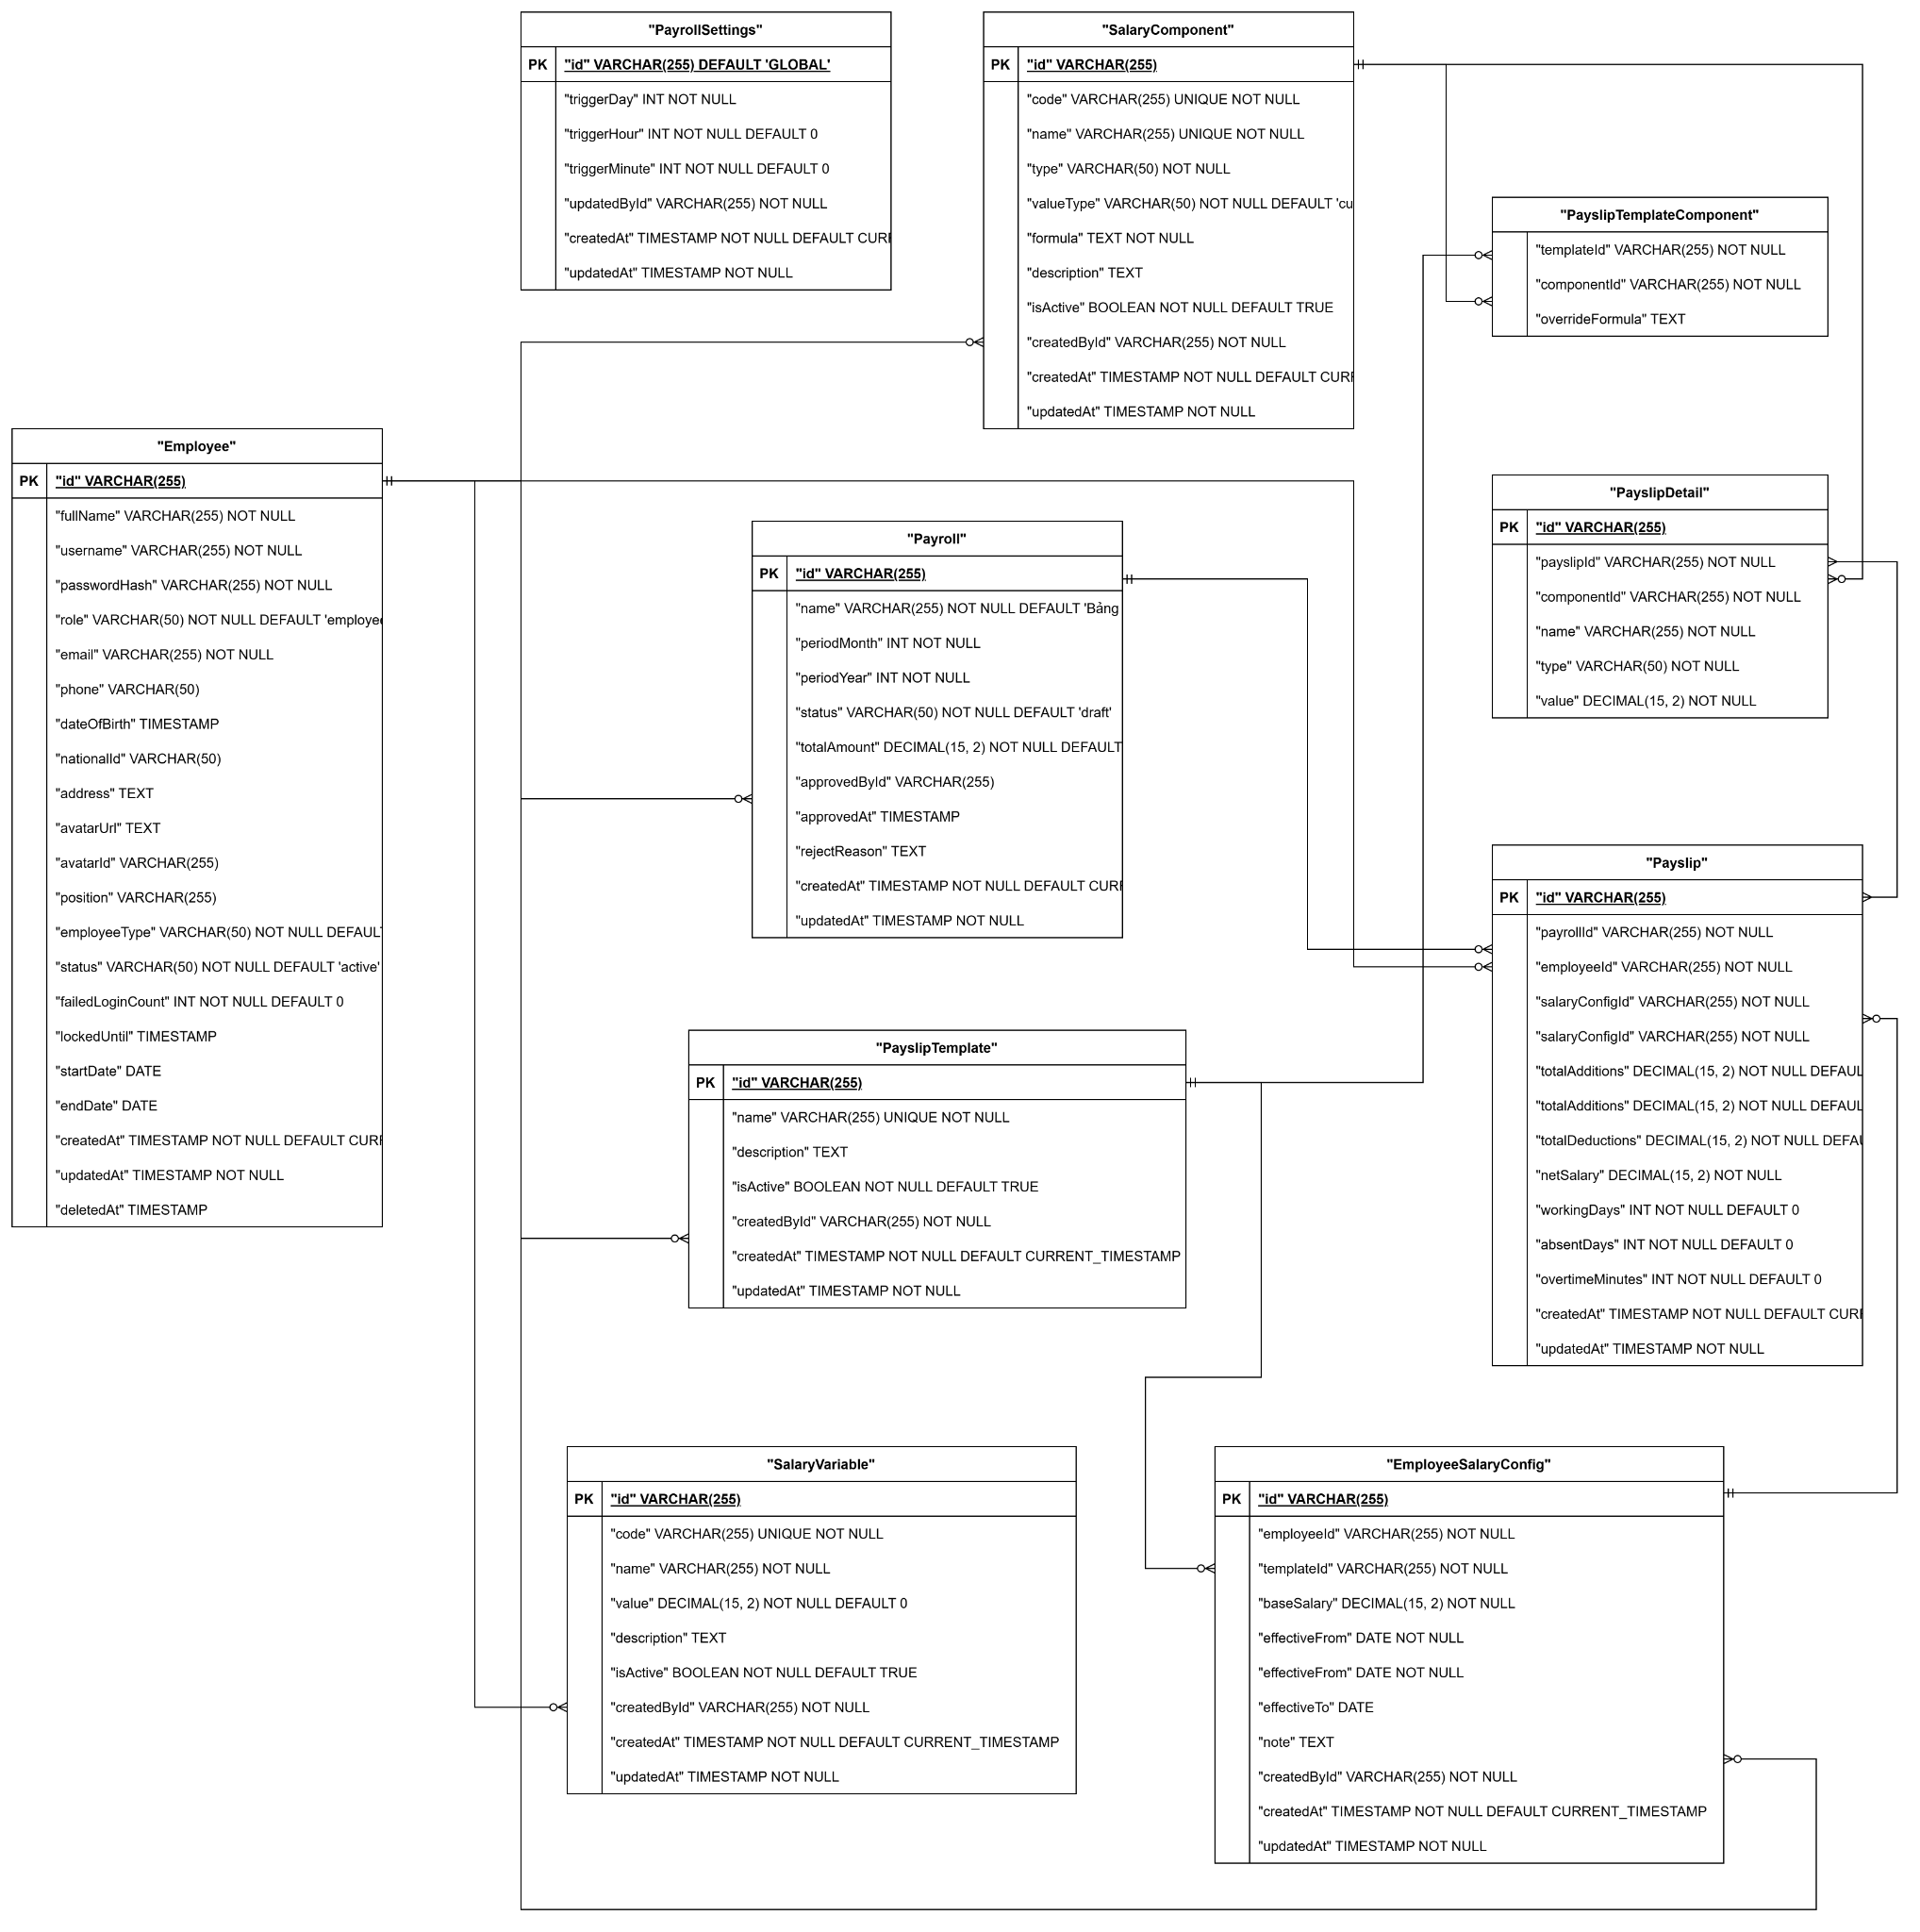

Module 5: Quản lý Dự án & Công việc (Projects & Tasks)
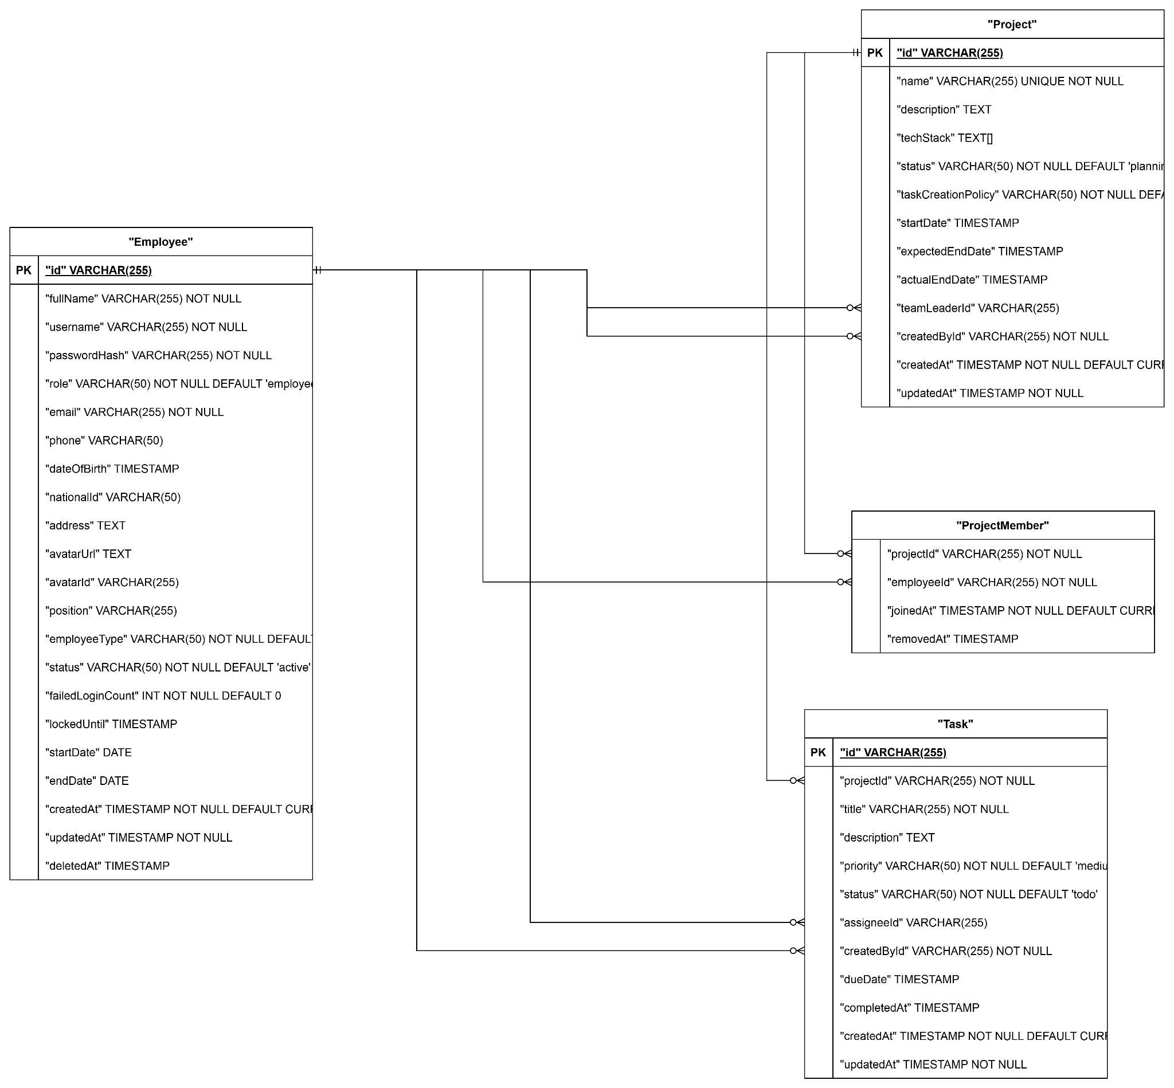

b. Table Descriptions

# | Table | Description
01 | Employee | Stores employee personal and employment information. - Primary keys: employee_id - Foreign keys: role_id (Role)
02 | Role | Defines system roles (Employee, Team Leader, HR Manager, General Manager, Administrator). - Primary keys: role_id
03 | Permission | Defines granular permissions assignable to roles. - Primary keys: permission_id
04 | RolePermission | Junction table mapping roles to permissions. - Primary keys: role_id, permission_id - Foreign keys: role_id, permission_id
05 | Attendance | Records employee check-in/check-out events from fingerprint device. - Primary keys: attendance_id - Foreign keys: employee_id
06 | WorkingShift | Defines working shift schedules. - Primary keys: shift_id
07 | ApplicationForm | Stores leave, overtime, remote, shift change, and regime application forms. - Primary keys: form_id - Foreign keys: employee_id, approver_id
08 | SalaryComponent | Stores salary components such as base pay, bonuses, allowances, deductions. - Primary keys: component_id
09 | SalaryTemplate | Defines salary calculation templates. - Primary keys: template_id
10 | Payroll | Stores generated payroll records per period. - Primary keys: payroll_id - Foreign keys: template_id, approved_by
11 | Payslip | Individual employee payslip for each payroll period. - Primary keys: payslip_id - Foreign keys: payroll_id, employee_id
12 | RecruitmentPosting | Stores job postings for open positions. - Primary keys: posting_id - Foreign keys: created_by (HR Manager)
13 | Candidate | Stores applicant/candidate information. - Primary keys: candidate_id - Foreign keys: posting_id
14 | InterviewSchedule | Tracks scheduled interviews for candidates. - Primary keys: interview_id - Foreign keys: candidate_id, interviewer_id
15 | Project | Stores project information. - Primary keys: project_id - Foreign keys: created_by
16 | ProjectMember | Junction table mapping employees to projects. - Primary keys: project_id, employee_id - Foreign keys: project_id, employee_id
17 | Task | Stores tasks within projects. - Primary keys: task_id - Foreign keys: project_id, assignee_id, created_by
18 | LoginActivity | Logs all login events for audit and security monitoring. - Primary keys: log_id - Foreign keys: employee_id

3.2 Code Packages
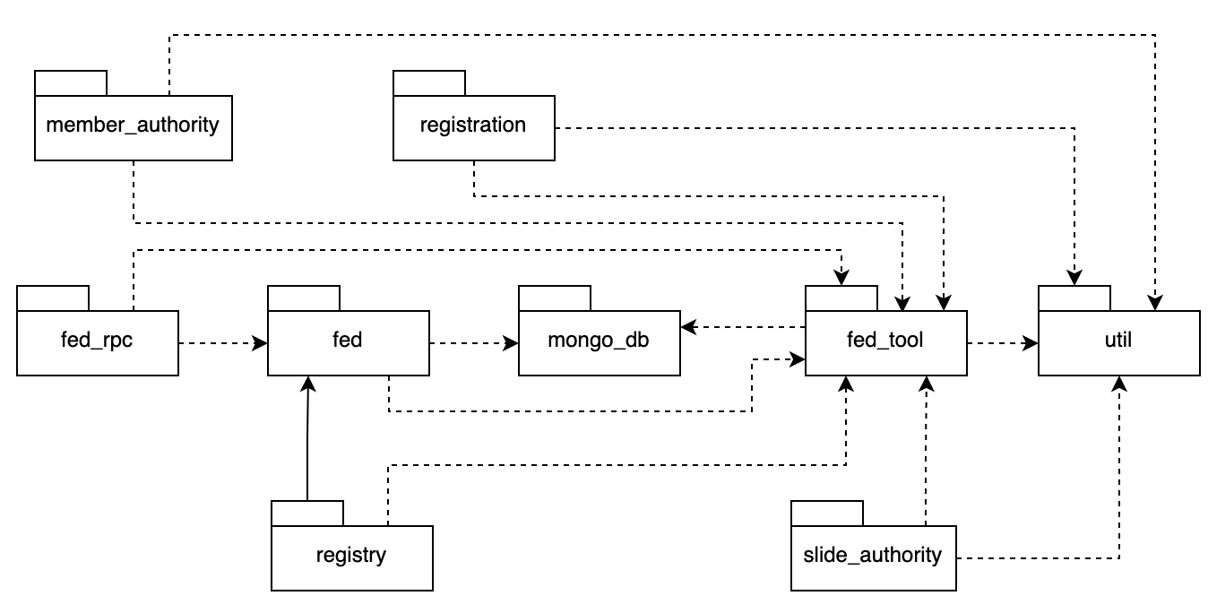
Package descriptions:

# | Package | Description
01 | hrp.authentication | Handles login, logout, session management, and password reset functionality.
02 | hrp.employee | Contains controllers, services, and repositories for employee management.
03 | hrp.attendance | Handles attendance recording, working shifts, and application forms processing.
04 | hrp.payroll | Manages salary components, salary templates, payroll generation, and payslips.
05 | hrp.recruitment | Handles job postings, candidate profiles, interview scheduling, and recruitment proposals.
06 | hrp.project | Manages projects, project members, and project details.
07 | hrp.task | Manages task items within projects, including task assignees, priorities, due dates, and progress status tracking.
08 | hrp.application | Manages creation, submission, and multi-level approval workflows (via Leader, HR, GM) for request forms (Leave, Overtime, WFH, Shift Swap, etc.)
09 | hrp.security | Manages roles, permissions, login activity log, and suspicious activity detection.
10 | hrp.common | Shared utilities, base classes, exception handlers, and common DTOs.

II. Requirement Specifications

1. Common Functions

1.1. Authentication

UC01 Login
a. Functional Description
UC ID and Name | UC01 - User Login
Created By | LoanTTB
Date Created | 01/06/2026
Primary Actor | Employee
Secondary Actors | Authentication System
Trigger | Employee submits login form
Description | Employee authenticates to access the HR & Project Management System using valid credentials
Preconditions | PRE-1: Employee account exists  PRE-2: Account is active
Postconditions | POST-1: JWT token generated  POST-2: User redirected to dashboard
Normal Flow | 1.0 Login  - User opens Login page  - User enters username and password  - User clicks Login  - System validates credentials  - System generates JWT token  - System redirects user to Dashboard
Alternative Flows | 1.1 Invalid Credentials  - System detects invalid username or password  - System displays authentication error  - Return to step 2
Exceptions | 1.0.E1 Account Locked  - System detects account is temporarily locked  - System displays lockout message  - Use case terminates  1.0.E2 System Failure  - Authentication service unavailable  - System displays error message  - Use case terminates
Priority | Must Have
Frequency of Use | Very High
Business Rules | BR-AUTH-01, BR-AUTH-02, BR-AUTH-03, BR-AUTH-04
Other Information | None
Assumptions | User has valid credentials

b. Business Rules
ID | Business Rule | Description
BR-AUTH-01 | Active Account Only | Only active employees may log in
BR-AUTH-02 | Password Hashing | Passwords must be stored using bcrypt hashing
BR-AUTH-03 | JWT Authentication | System uses JWT token-based authentication
BR-AUTH-04 | Account Lockout | Account is locked for 5 minutes after 5 consecutive failed login attempts

UC02 Logout
a. Functional Description
UC ID and Name | UC02 - User Logout
Created By | LoanTTB
Date Created | 01/06/2026
Primary Actor | Employee
Secondary Actors | Authentication System
Trigger | Employee clicks Logout button
Description | Employee terminates the current authenticated session and exits the system securely
Preconditions | PRE-1: Employee is authenticated  PRE-2: Valid JWT session exists
Postconditions | POST-1: JWT token invalidated or removed from client storage  POST-2: Logout activity recorded  POST-3: User redirected to Login page
Normal Flow | 2.0 Logout  - Employee clicks Logout  - System receives logout request  - System records logout activity  - System removes authentication token  - System redirects employee to Login page
Alternative Flows | 2.1 Session Expired  - System detects session already expired  - System clears local authentication data  - System redirects employee to Login page
Exceptions | 2.0.E1 System Failure  - Logging service unavailable  - System completes logout process locally  - User is redirected to Login page
Priority | Must Have
Frequency of Use | Very High
Business Rules | BR-AUTH-05
Other Information | None
Assumptions | User has an active session

b. Business Rules
ID | Business Rule | Description
BR-AUTH-05 | Session Termination | Logout must invalidate current session and remove authentication token

UC03 Reset Password
a. Functional Description
UC ID and Name | UC03 - Reset Password
Created By | LoanTTB
Date Created | 01/06/2026
Primary Actor | Employee
Secondary Actors | Authentication System
Trigger | Employee submits reset password form using a valid reset token
Description | Employee resets account password using a valid password reset link
Preconditions | PRE-1: Valid reset token exists  PRE-2: Reset request status is Pending
Postconditions | POST-1: Password updated successfully  POST-2: Reset token marked as Used  POST-3: User can log in using the new password
Normal Flow | 3.0 Reset Password  - Employee opens Reset Password page  - System validates reset token  - System displays reset password form  - Employee enters new password  - Employee confirms new password  - Employee submits form  - System validates reset token  - System validates password policy  - System updates password  - System marks reset token as Used  - System displays success message
Alternative Flows | 3.1 Password Validation Failed  - System detects password policy violation  - System displays validation error  - Return to step 2
Exceptions | 3.0.E1 Invalid Token  - System detects invalid token  - System displays error message  - Use case terminates  3.0.E2 Expired Token  - System detects expired token  - System displays expiration message  - Use case terminates
Priority | Must Have
Frequency of Use | Medium
Business Rules | BR-AUTH-06, BR-AUTH-07
Other Information | None
Assumptions | User has received the reset email

b. Business Rules
ID | Business Rule | Description
BR-AUTH-06 | Reset Token Expiration | Password reset token expires after 15 minutes
BR-AUTH-07 | Password Reuse Restriction | New password must be different from the current password

UC04 Forgot Password
a. Functional Description
UC ID and Name | UC04 - Forgot Password
Created By | LoanTTB
Date Created | 01/06/2026
Primary Actor | Employee
Secondary Actors | Authentication System, Email Service
Trigger | Employee selects "Forgot Password"
Description | Employee requests a password reset link through the registered email address
Preconditions | PRE-1: Employee has access to an email address
Postconditions | POST-1: Reset token is generated  POST-2: Password reset request is stored  POST-3: Reset email is sent
Normal Flow | 4.0 Forgot Password  - Employee clicks Forgot Password  - Employee enters email address  - Employee submits request  - System validates email  - System generates reset token  - System creates password reset request  - System sends reset email  - System displays confirmation message
Alternative Flows | 4.1 Existing Pending Request  - System detects active reset request  - System returns generic confirmation message  - Use case ends
Exceptions | 4.0.E1 Email Service Unavailable  - Email service fails  - System logs error  - Generic response still displayed
Priority | Must Have
Frequency of Use | Medium
Business Rules | BR-AUTH-08, BR-AUTH-09
Other Information | System must not reveal whether the email exists
Assumptions | Employee has access to registered email

b. Business Rules
ID | Business Rule | Description
BR-AUTH-08 | Email Enumeration Protection | System must not reveal whether an email exists
BR-AUTH-09 | Single Active Reset Request | Only one pending password reset request is allowed per employee

UC05 Change Password
a. Functional Description
UC ID and Name | UC05 - Change Password
Created By | LoanTTB
Date Created | 01/06/2026
Primary Actor | Employee
Secondary Actors | Authentication System
Trigger | Employee submits change password form
Description | Employee changes current account password
Preconditions | PRE-1: Employee is authenticated  PRE-2: Employee account is active
Postconditions | POST-1: Password updated successfully  POST-2: Previous password becomes invalid
Normal Flow | 5.0 Change Password  - Employee opens Change Password page  - Employee enters current password  - Employee enters new password  - Employee confirms new password  - Employee submits form  - System validates current password  - System validates password policy  - System updates password  - System displays success message
Alternative Flows | 5.1 Password Validation Failed  - System detects invalid password format  - System displays validation error  - Return to step 3
Exceptions | 5.0.E1 Incorrect Current Password  - System detects incorrect current password  - System displays error message  - Use case terminates  5.0.E2 Password Reuse Detected  - System detects new password matches current password  - System displays error message  - Use case terminates
Priority | Must Have
Frequency of Use | Medium
Business Rules | BR-AUTH-10, BR-AUTH-11, BR-AUTH-12
Other Information | None
Assumptions | Employee remembers current password

b. Business Rules
ID | Business Rule | Description
BR-AUTH-10 | Password Complexity | Password must satisfy minimum security requirements
BR-AUTH-11 | Password Reuse Prevention | New password must be different from current password
BR-AUTH-12 | Password Hashing | Updated passwords must be stored using bcrypt hashing

1.2. Authorization & Security

UC06 View Login Activity
a. Functional Description
UC ID and Name | UC06 - View Login Activity
Created By | LoanTTB
Date Created | 01/06/2026
Primary Actor | Employee
Secondary Actors | Activity Logging System
Trigger | Employee requests login activity history
Description | Employee reviews authentication activity associated with their account
Preconditions | PRE-1: Employee is authenticated
Postconditions | POST-1: Login activity records displayed
Normal Flow | 6.0 View Login Activity  - Employee navigates to Login Activity page  - System retrieves activity records  - System displays login history  - Employee reviews activity details
Alternative Flows | 6.1 Apply Filter  - Employee specifies filter criteria  - System filters activity records  - System displays filtered results
Exceptions | 6.0.E1 No Activity Records  - System finds no records  - System displays empty state message
Priority | Should Have
Frequency of Use | Medium
Business Rules | BR-SEC-01
Other Information | Activity records are read-only
Assumptions | Activity logs are stored by the system

b. Business Rules
ID | Business Rule | Description
BR-SEC-01 | Activity Logging | Every authentication attempt must be logged

UC07 Detect Suspicious Activity
a. Functional Description
UC ID and Name | UC07 - Detect Suspicious Activity
Created By | LoanTTB
Date Created | 01/06/2026
Primary Actor | Authentication System
Secondary Actors | Security Administrator
Trigger | System detects abnormal authentication behavior
Description | System monitors login activities and identifies suspicious behavior
Preconditions | PRE-1: Activity logging is enabled
Postconditions | POST-1: Security event recorded  POST-2: Alert generated if required
Normal Flow | 7.0 Detect Suspicious Activity  - System monitors login attempts  - System evaluates security rules  - System identifies suspicious behavior  - System records security event  - System notifies administrator
Alternative Flows | 7.1 Auto Lock Account  - System detects excessive failed attempts  - System locks account temporarily  - System records security event
Exceptions | 7.0.E1 Monitoring Service Failure  - Monitoring service unavailable  - System records error log  - Use case terminates
Priority | Should Have
Frequency of Use | Medium
Business Rules | BR-SEC-02, BR-SEC-03
Other Information | Detection process runs automatically
Assumptions | Security thresholds are predefined

b. Business Rules
ID | Business Rule | Description
BR-SEC-02 | Failed Login Monitoring | System monitors consecutive failed login attempts
BR-SEC-03 | Security Alert | Suspicious activities must generate alerts

UC08 Assign Role
a. Functional Description
UC ID and Name | UC08 - Assign Role
Created By | LoanTTB
Date Created | 01/06/2026
Primary Actor | HR Manager
Secondary Actors | Authorization System
Trigger | HR Manager assigns role to employee
Description | HR Manager grants a role to an employee account
Preconditions | PRE-1: HR Manager is authenticated  PRE-2: Employee account exists
Postconditions | POST-1: Role assignment saved  POST-2: Employee permissions updated  POST-3: Audit log created
Normal Flow | 8.0 Assign Role  - HR Manager opens Employee Details page  - HR Manager selects Assign Role  - System displays available roles  - HR Manager selects role  - HR Manager confirms action  - System updates employee role  - System records audit log
Alternative Flows | 8.1 Replace Existing Role  - Employee already has a role  - System requests confirmation  - HR Manager confirms replacement  - Continue at step 6
Exceptions | 8.0.E1 Unauthorized Action  - User lacks permission to assign roles  - System denies access  - Use case terminates
Priority | Must Have
Frequency of Use | Medium
Business Rules | BR-RBAC-01, BR-RBAC-02
Other Information | All role changes must be logged
Assumptions | Roles are predefined by the system

b. Business Rules
ID | Business Rule | Description
BR-RBAC-01 | Authorized Role Assignment | Only authorized users can assign roles
BR-RBAC-02 | Audit Logging | Every role assignment must be logged

UC09 Revoke Role
a. Functional Description
UC ID and Name | UC09 - Revoke Role
Created By | LoanTTB
Date Created | 01/06/2026
Primary Actor | HR Manager
Secondary Actors | Authorization System
Trigger | HR Manager revokes an employee role
Description | HR Manager removes role permissions from an employee account
Preconditions | PRE-1: HR Manager is authenticated  PRE-2: Employee has assigned role
Postconditions | POST-1: Role revoked  POST-2: Employee permissions updated  POST-3: Audit log created
Normal Flow | 9.0 Revoke Role  - HR Manager opens Employee Details page  - HR Manager selects assigned role  - HR Manager chooses Revoke Role  - System requests confirmation  - HR Manager confirms action  - System removes role assignment  - System records audit log
Alternative Flows | 9.1 Assign Replacement Role  - HR Manager selects replacement role  - System updates role assignment  - System records audit log
Exceptions | 9.0.E1 Unauthorized Action  - User lacks permission to revoke roles  - System denies access  - Use case terminates
Priority | Must Have
Frequency of Use | Medium
Business Rules | BR-RBAC-03, BR-RBAC-04
Other Information | All role removals must be logged
Assumptions | Employee account remains active after role revocation

b. Business Rules
ID | Business Rule | Description
BR-RBAC-03 | Authorized Role Revocation | Only authorized users can revoke roles
BR-RBAC-04 | Permission Update | Permission changes take effect immediately after role revocation

2. Patron Feature

2.1. Employee Management Feature

UC10 Create Employee

UC ID and Name: | UC10 — Create Employee
Created By: | ThangDX
Date Created: | 01/06/2026
Primary Actor: | HR Manager
Secondary Actors: | Admin, General Manager, System
Trigger: | HR opens Employee List and submits Create Employee form
Description: | Privileged user registers a new employee account with credentials, role, employment type, and personal/employment details.
Preconditions: | PRE-1: Actor authenticated (BR-AUTH-01, BR-AUTH-02)  PRE-2: Actor role is admin, hr_manager, or general_manager (BR-AUTH-04)  PRE-3: Username, email, phone, nationalId not already used (BR-EMP-01)
Postconditions: | POST-1: New Employee record persisted with hashed password  POST-2: Employee available in list and auth system  POST-3: Default status active unless specified
Normal Flow: | 1.0 Create Employee  1. HR opens HRM → Employees  2. HR clicks Create Employee  3. HR enters fullName, username, email, password, role, employeeType, optional personal fields  4. HR clicks Save  5. System validates via createEmployeeSchema  6. POST /api/employees  7. System hashes password and persists record  8. System displays success and refreshes employee list
Alternative Flows: | 1.1 Create with Optional Fields — phone, position, dateOfBirth, nationalId, address, startDate  1.2 Create Intern/Contractor — employeeType set accordingly
Exceptions: | 1.0.E1 Not Authenticated — 401  1.0.E2 Insufficient Permission — 403  1.0.E3 Duplicate Credentials — 409 (username/email/phone/nationalId)  1.0.E4 Invalid Input — 400 (password policy, email format)  1.0.E5 System Failure — service unavailable
Priority: | Must Have
Frequency of Use: | Low
Business Rules: | BR-AUTH-01, BR-AUTH-02, BR-AUTH-03, BR-AUTH-04, BR-EMP-01, BR-EMP-02, BR-EMP-03, BR-EMP-04, BR-EMP-05, BR-EMP-06
Other Information: | API: POST /api/employees. Frontend: EmployeeCreateModal.tsx, EmployeeList.tsx (/hrm/employees). Password min 8 chars with upper/lower/digit/special.
Assumptions: | HR has authority to onboard staff. Initial password communicated securely to employee.

UC11 Update Employee Profile

UC ID and Name: | UC11 — Update Employee Profile
Created By: | ThangDX
Date Created: | 01/06/2026
Primary Actor: | HR Manager
Secondary Actors: | Admin, General Manager, System
Trigger: | HR selects employee and submits updated profile form
Description: | Privileged user updates any employee's HR-managed profile fields (name, contact, role, type, status, employment dates, password reset).
Preconditions: | PRE-1: Actor authenticated (BR-AUTH-01, BR-AUTH-02)  PRE-2: Privileged role (BR-AUTH-04)  PRE-3: Target employee exists and not soft-deleted  PRE-4: Updated unique fields do not conflict (BR-EMP-01)
Postconditions: | POST-1: Employee record updated with new updatedAt  POST-2: Role change logged to activity audit if role changed (BR-EMP-07)  POST-3: Password re-hashed if password field provided
Normal Flow: | 1.0 Update Employee Profile  1. HR opens Employee List  2. HR selects employee → Edit  3. HR modifies one or more fields in EmployeeEditDrawer  4. HR clicks Save  5. System validates via updateEmployeeSchema  6. PATCH /api/employees/:id  7. System persists changes  8. System displays success and refreshes list/detail
Alternative Flows: | 1.1 Partial Update — only changed fields sent  1.2 Role Change — activity log ROLE_ASSIGNED or ROLE_REVOKED  1.3 Reset Password — HR sets new password, system hashes before save
Exceptions: | 1.0.E1 Not Authenticated — 401  1.0.E2 Insufficient Permission — 403  1.0.E3 Employee Not Found — 404  1.0.E4 Duplicate Credentials — 409  1.0.E5 Invalid Input — 400  1.0.E6 System Failure — service unavailable
Priority: | Must Have
Frequency of Use: | Medium
Business Rules: | BR-AUTH-01, BR-AUTH-02, BR-AUTH-03, BR-AUTH-04, BR-EMP-01, BR-EMP-02, BR-EMP-07, BR-EMP-08, BR-EMP-09, BR-EMP-10
Other Information: | API: PATCH /api/employees/:id. Frontend: EmployeeEditDrawer.tsx.
Assumptions: | HR maintains accurate employment records. Role changes follow company policy.

UC12 Deactivate Employee

UC ID and Name: | UC12 — Deactivate Employee
Created By: | ThangDX
Date Created: | 01/06/2026
Primary Actor: | HR Manager
Secondary Actors: | Admin, General Manager, System
Trigger: | HR changes employee status to inactive/on_leave/terminated
Description: | Privileged user deactivates an employee by updating employment status. Inactive/on_leave blocks normal use; terminated ends employment (UI: "Cho nhân sự nghỉ việc").
Preconditions: | PRE-1: Actor authenticated (BR-AUTH-01, BR-AUTH-02)  PRE-2: Privileged role (BR-AUTH-04)  PRE-3: Target employee exists  PRE-4: Actor is not deactivating own admin account without policy approval
Postconditions: | POST-1: Employee status updated (inactive, on_leave, or terminated)  POST-2: Inactive/terminated users blocked from login (BR-AUTH-03)  POST-3: Employee remains in database (soft status change, not hard delete)
Normal Flow: | 1.0 Deactivate Employee  1. HR opens Employee List  2. HR selects employee  3. HR sets status to inactive via Edit, OR confirms "Cho nhân sự nghỉ việc" (terminated)  4. System validates status value  5. PATCH /api/employees/:id/status or PATCH /api/employees/:id  6. System persists new status  7. System displays success message
Alternative Flows: | 1.1 Set On Leave — status = on_leave  1.2 Reinstate — terminated → active (handleReinstate)  1.3 Soft Delete API — DELETE /api/employees/:id marks terminated + deletedAt + anonymizes unique fields
Exceptions: | 1.0.E1 Not Authenticated — 401  1.0.E2 Insufficient Permission — 403  1.0.E3 Employee Not Found — 404  1.0.E4 Invalid Status — 400  1.0.E5 System Failure — service unavailable
Priority: | Must Have
Frequency of Use: | Low
Business Rules: | BR-AUTH-01, BR-AUTH-02, BR-AUTH-03, BR-AUTH-04, BR-EMP-11, BR-EMP-12, BR-EMP-13, BR-EMP-14, BR-EMP-15
Other Information: | API: PATCH /api/employees/:id/status, PATCH /api/employees/:id, DELETE /api/employees/:id. Status values: active, inactive, on_leave, terminated.
Assumptions: | HR follows offboarding policy before termination. Terminated employees can be reinstated to active.

UC13 View All Employees

UC ID and Name: | UC13 — View All Employees
Created By: | ThangDX
Date Created: | 01/06/2026
Primary Actor: | HR Manager
Secondary Actors: | Admin, General Manager, Team Leader, System
Trigger: | User opens Employee List page or applies search/filter
Description: | Authenticated user views paginated company employee directory with search, status/type filters, sorting, and employee detail drawer.
Preconditions: | PRE-1: User authenticated (BR-AUTH-01, BR-AUTH-02)  PRE-2: User account active (BR-AUTH-03)  PRE-3: Employee records exist in system
Postconditions: | POST-1: Paginated employee list displayed read-only  POST-2: No employee data modified by view action
Normal Flow: | 1.0 View All Employees  1. User opens HRM → Employees (/hrm/employees)  2. System calls GET /api/employees with page, limit  3. System retrieves paginated records  4. System displays table: name, email, role, type, status  5. User searches or switches filter tabs (all, full_time, terminated, etc.)  6. User opens employee detail drawer for full profile
Alternative Flows: | 1.1 Search by Name/Email — search query param  1.2 Filter by Status — status=terminated tab  1.3 Filter by Type — type=full_time|part_time|intern|contractor  1.4 Sort — sortBy, sortOrder params  1.5 Export — CSV download from list page
Exceptions: | 1.0.E1 Not Authenticated — 401  1.0.E2 Invalid Query Parameters — 400  1.0.E3 No Results — empty state shown  1.0.E4 System Failure — service unavailable
Priority: | Must Have
Frequency of Use: | High
Business Rules: | BR-AUTH-01, BR-AUTH-02, BR-AUTH-03, BR-EMP-16, BR-EMP-17, BR-EMP-18, BR-EMP-19, BR-EMP-20
Other Information: | API: GET /api/employees, GET /api/employees/:id. Frontend: EmployeeList.tsx, EmployeeDetailsDrawer.tsx.
Assumptions: | All authenticated HRM users may browse directory. HR actions require privileged role.

UC14 View My Profile

UC ID and Name: | UC14 — View My Profile
Created By: | ThangDX
Date Created: | 01/06/2026
Primary Actor: | Employee
Secondary Actors: | System
Trigger: | User opens My Profile page
Description: | Authenticated user views their own profile: personal info, employment info, avatar, role, status, and linked personal employee record.
Preconditions: | PRE-1: User authenticated (BR-AUTH-01, BR-AUTH-02)  PRE-2: User account active (BR-AUTH-03)  PRE-3: Profile linked to employee record
Postconditions: | POST-1: Profile displayed read-only  POST-2: No profile data modified by view action
Normal Flow: | 1.0 View My Profile  1. User opens HRM → Profile (/hrm/profile)  2. System resolves empId from JWT  3. GET /api/profile/me  4. System retrieves profile DTO  5. System displays personal tab (name, phone, DOB, nationalId, address, avatar)  6. User switches employment tab (role, type, status, position, startDate)
Alternative Flows: | 1.1 View Avatar — displays Cloudinary image or placeholder  1.2 View Linked Employee — personalEmployee section if linked and active  1.3 Password Tab — view change-password form (read-only until submit in UC15)
Exceptions: | 1.0.E1 Not Authenticated — 401  1.0.E2 Profile Not Found — 404  1.0.E3 System Failure — service unavailable
Priority: | Must Have
Frequency of Use: | High
Business Rules: | BR-AUTH-01, BR-AUTH-02, BR-AUTH-03, BR-EMP-21, BR-EMP-22, BR-EMP-23, BR-EMP-24
Other Information: | API: GET /api/profile/me. Frontend: Profile.tsx, useProfileMaster.ts.
Assumptions: | JWT empId maps to valid employee. Employment fields are HR-managed and read-only on profile page.

UC15 Edit Profile Details

UC ID and Name: | UC15 — Edit Profile Details
Created By: | ThangDX
Date Created: | 01/06/2026
Primary Actor: | Employee
Secondary Actors: | System, Cloudinary (avatar)
Trigger: | User clicks Edit on profile or uploads avatar / changes password
Description: | User updates self-service profile fields (fullName, phone, dateOfBirth, nationalId, address), uploads avatar, or changes own password.
Preconditions: | PRE-1: User authenticated (BR-AUTH-01, BR-AUTH-02)  PRE-2: User account active (BR-AUTH-03)  PRE-3: New password meets policy if changing password (BR-EMP-04)
Postconditions: | POST-1: Editable profile fields updated  POST-2: Avatar URL/ID saved after Cloudinary upload  POST-3: Password hash updated after successful change-password  POST-4: Role/status/employment fields unchanged (HR-only via UC11)
Normal Flow: | 1.0 Edit Profile Details  1. User opens Profile → clicks Edit  2. User modifies allowed fields  3. User clicks Save  4. System validates via updateProfileSchema  5. PATCH /api/profile/me  6. System persists changes  7. System displays updated profile
Alternative Flows: | 1.1 Upload Avatar — POST /api/profile/me/avatar (multipart), Cloudinary webp 400×400  1.2 Change Password — POST /api/profile/me/change-password with oldPassword + newPassword  1.3 Cancel Edit — discards unsaved form state
Exceptions: | 1.0.E1 Not Authenticated — 401  1.0.E2 Invalid Input — 400 (phone, DOB, nationalId, password policy)  1.0.E3 Wrong Old Password — change-password rejected  1.0.E4 Avatar Upload Failed — Cloudinary/network error  1.0.E5 System Failure — service unavailable
Priority: | Must Have
Frequency of Use: | Medium
Business Rules: | BR-AUTH-01, BR-AUTH-02, BR-AUTH-03, BR-EMP-04, BR-EMP-21, BR-EMP-25, BR-EMP-26, BR-EMP-27, BR-EMP-28
Other Information: | API: PATCH /api/profile/me, POST /api/profile/me/avatar, POST /api/profile/me/change-password. Frontend: Profile.tsx.
Assumptions: | User may only edit own profile. HR-managed fields updated via UC11 only.

2.2. Attendance Management Feature

UC16 Fingerprint

UC ID and Name: | UC16 - Fingerprint
Created By: | ThangDX
Date Created: | 01/06/2026
Primary Actor: | Employee
Secondary Actors: | System, GPS Service
Trigger: | Employee taps the virtual fingerprint scanner to record attendance
Description: | Employee uses the virtual fingerprint scanner to check in or check out. The system captures GPS location, resolves today's shift, validates time window and geofence, then records attendance and calculates work metrics on checkout.
Preconditions: | PRE-1: Employee account exists and is active (BR-AUTH-01, BR-AUTH-03)  PRE-2: Employee is authenticated with a valid JWT (BR-AUTH-01, BR-AUTH-02)  PRE-3: Employee has a shift assigned for today  PRE-4: Device can provide GPS coordinates
Postconditions: | POST-1: On check-in - AttendanceRecord created with checkInAt and GPS  POST-2: On check-out - checkOutAt saved and work metrics calculated  POST-3: Attendance status determined (on_time, late, early_leave, overtime)
Normal Flow: | 1.0 Fingerprint Scan  1. Employee opens Attendance module  2. Employee opens Virtual Scanner  3. Employee taps scan button  4. System captures GPS (lat, lng)  5. System resolves today's shift for employee  6. System validates check-in/check-out time window  7. System validates GPS geofence (if configured)  8. If no check-in today → system records check-in  9. If checked in and within checkout window → system records check-out  10. System displays attendance result to employee
Alternative Flows: | 1.1 Late Check-in  1. Employee checks in after grace period  2. System still records check-in  3. Status set to late at checkout  4. Return to step 10 of 1.0  1.2 Checkout Overwrite  1. Employee scans again during checkout window  2. System overwrites previous checkOutAt  3. System recalculates metrics  4. Return to step 10 of 1.0  1.3 Overnight Shift Carryover  1. System finds open record from previous day  2. System applies overnight carryover rule  3. Continue checkout flow  4. Return to step 9 of 1.0
Exceptions: | 1.0.E1 Not Authenticated - 401 Unauthorized  1.0.E2 Check-in Too Early - "Not yet check-in time"  1.0.E3 Check-in Too Late - "Check-in too late"  1.0.E4 Already Checked In - "Already checked in"  1.0.E5 Outside GPS Radius - "Outside attendance radius"  1.0.E6 No Shift Found - shift-not-found error  1.0.E7 System Failure - service unavailable
Priority: | Must Have
Frequency of Use: | Very High
Business Rules: | BR-AUTH-01, BR-AUTH-02, BR-AUTH-03, BR-AUTH-04, BR-ATT-01, BR-ATT-02, BR-ATT-03, BR-ATT-04, BR-ATT-05, BR-ATT-06, BR-ATT-07, BR-ATT-08, BR-ATT-09, BR-ATT-10
Other Information: | API: POST /api/attendance/scan. Frontend: VirtualScanner.tsx. Default grace period: 15 minutes.
Assumptions: | Virtual scanner simulates fingerprint hardware. GPS available on client. Shift data maintained by HR (UC27/UC28).

UC17 View Attendance History

UC ID and Name: | UC17 - View Attendance History
Created By: | ThangDX
Date Created: | 01/06/2026
Primary Actor: | Employee
Secondary Actors: | System
Trigger: | Employee opens personal attendance overview page
Description: | Employee views own attendance history: check-in/out, shift, duration, status. Weekly calendar (planned vs actual) and monthly summary.
Preconditions: | PRE-1: Employee account active (BR-AUTH-03)  PRE-2: Employee authenticated (BR-AUTH-01, BR-AUTH-02)  PRE-3: Attendance module accessible to employee role
Postconditions: | POST-1: Read-only records scoped to authenticated employee  POST-2: No data modified
Normal Flow: | 1.0 View Personal Attendance History  1. Employee opens Attendance → My Schedule / Summary  2. System resolves employeeId from JWT  3. Employee selects date range  4. System calls GET /api/attendance (own employeeId)  5. System retrieves records  6. System displays date, shift, check-in/out, minutes, status  7. Employee views weekly calendar tabs
Alternative Flows: | 1.1 No Records - empty state  1.2 Filter by Status - re-query with status param  1.3 Actual vs Planned - overlay real times on grid (green/yellow)
Exceptions: | 1.0.E1 Not Authenticated - 401  1.0.E2 Invalid Query Parameters - 400  1.0.E3 System Failure - service unavailable
Priority: | Must Have
Frequency of Use: | High
Business Rules: | BR-AUTH-01, BR-AUTH-02, BR-AUTH-03, BR-AUTH-04, BR-ATT-11, BR-ATT-12, BR-ATT-13, BR-ATT-14, BR-ATT-15
Other Information: | API: GET /api/attendance. Frontend: MySchedule.tsx, AttendanceSummary.tsx, WeeklyScheduleCalendar.tsx.
Assumptions: | Records created via UC16. Employee–account link exists.

UC18 View All Attendance History

UC ID and Name: | UC18 - View All Attendance History
Created By: | ThangDX
Date Created: | 01/06/2026
Primary Actor: | HR Manager
Secondary Actors: | Admin, General Manager, System
Trigger: | HR/Admin opens company-wide attendance summary or applies filter
Description: | Privileged users view attendance for all or one employee, with optional CSV export.
Preconditions: | PRE-1: Actor authenticated (BR-AUTH-01, BR-AUTH-02)  PRE-2: Role is admin, hr_manager, or general_manager (BR-AUTH-04)  PRE-3: Attendance data exists
Postconditions: | POST-1: Filtered list for one or all employees  POST-2: Optional CSV downloaded  POST-3: No data modified
Normal Flow: | 1.0 View All Attendance History  1. HR opens Attendance → Summary / Dashboard  2. HR sets startDate, endDate, optional employeeId, status  3. System validates privileged role  4. System calls GET /api/attendance (no employee scope)  5. System retrieves matching records  6. System displays name, email, shift, check-in/out, status  7. HR reviews data
Alternative Flows: | 1.1 Filter by Employee - single employeeId  1.2 Export CSV - GET /api/attendance/export → attendance_report_YYYY-MM-DD.csv  1.3 No Results - empty result set
Exceptions: | 1.0.E1 Not Authenticated - 401  1.0.E2 Insufficient Permission - 403 on export  1.0.E3 Invalid Query Parameters - 400  1.0.E4 System Failure - service unavailable
Priority: | Must Have
Frequency of Use: | High
Business Rules: | BR-AUTH-01, BR-AUTH-02, BR-AUTH-03, BR-AUTH-04, BR-ATT-16, BR-ATT-17, BR-ATT-18, BR-ATT-19, BR-ATT-20
Other Information: | API: GET /api/attendance, GET /api/attendance/export. Frontend: AttendanceSummary.tsx, AttendanceDashboard.tsx.
Assumptions: | UC16 generates source data. HR authorized to monitor attendance.

UC19 Create Application Form
a. Functional Description

UC ID and Name | UC19 - Create Application Form
Created By | TuyetNA
Date Created | 01/06/2026
Primary Actor | Employee
Secondary Actors | Notification Service, Audit System
Trigger | Employee wants to submit a new application form.
Description | Employee creates and submits an application form for approval. The system validates required information, saves the application, and notifies the appropriate approver.
Preconditions | PRE-1: Employee is authenticated and has permission to create application forms.  PRE-2: Application form type is available and active.
Postconditions | POST-1: Application form is successfully created and saved.  POST-2: Application status is set to 'Pending Approval'.  POST-3: Notification is sent to the designated approver.  POST-4: Creation activity is recorded in the audit trail.
Normal Flow | 19.1 Create Application Form  1. Employee accesses the Application Form module.  2. System displays available application form types.  3. Employee selects a form type.  4. System displays the corresponding application form.  5. Employee enters required information and attachments (if applicable).  6. Employee clicks Submit.  7. System validates all required fields and business rules.  8. System creates the application record.  9. System sets application status to 'Pending Approval'.  10. System sends a notification to the designated approver.  11. System displays a successful submission message.
Alternative Flows | 19.2 Save Draft  1. Employee enters application information.  2. Employee clicks Save Draft.  3. System validates draft requirements.  4. System saves the application with status 'Draft'.  5. Employee may continue editing later.
Exceptions | 19.0.E1 Validation Failure  1. Required fields are missing or invalid.  2. System displays validation error messages.  3. Employee corrects the information and resubmits.  19.0.E2 Notification Service Failure  1. Notification service is unavailable.  2. System successfully creates the application.  3. System queues the notification for retry.
Priority | Must Have
Frequency of Use | High
Business Rules | BR-PAY-01
Other Information | Supporting documents may be attached depending on the application type.
Assumptions | A valid approval workflow has already been configured. The designated approver exists and is active in the system.

.b. Business Rules

ID | Business Rule | Description
BR-APP-01 | Mandatory Fields Validation | All required fields must be completed before an application can be submitted.

UC20 Leave Application
a. Functional Description
UC ID and Name | UC20 - Create Leave Application
Created By | TuyetNA
Date Created | 01/06/2026
Primary Actor | Employee
Secondary Actors | Leave Approver, Notification Service, Audit System
Trigger | Employee wants to request leave.
Description | Employee creates and submits a leave application. The system validates leave information, checks leave balance and eligibility, then routes the request for approval.
Preconditions | PRE-1: Employee is authenticated.  PRE-2: Employee has permission to submit leave requests.  PRE-3: Leave type is active and available.
Postconditions | POST-1: Leave application is successfully created.  POST-2: Application status is set to 'Pending Approval'.  POST-3: Notification is sent to the designated approver.  POST-4: Leave request is recorded in the audit trail.
Normal Flow | 20.1 Create Leave Application  1. Employee accesses the Leave Application module.  2. System displays the leave request form.  3. Employee selects leave type.  4. Employee enters start date, end date, reason, and supporting documents (if required).  5. Employee clicks Submit.  6. System validates the entered information.  7. System checks leave balance and leave policy rules.  8. System creates the leave application.  9. System sets status to 'Pending Approval'.  10. System sends notification to the designated approver.  11. System displays a successful submission message.
Alternative Flows | 20.2 Save Draft  1. Employee enters leave information.  2. Employee clicks Save Draft.  3. System saves the application with status 'Draft'.  4. Employee may continue editing later.  5. Employee may continue editing later.
Exceptions | 20.0.E1 Insufficient Leave Balance  1. Employee requests more leave days than available.  2. System displays an error message.  3. Leave application is not submitted.  20.0.E2 Validation Failure  1. Required fields are missing or invalid.  2. System displays validation errors.  3. Employee corrects the information and resubmits.  20.0.E3 Notification Service Failure  1. Notification service is unavailable.  2. System successfully creates the leave application.  3. System queues the notification for retry.
Priority | Must Have
Frequency of Use | High
Business Rules | BR-PAY-01
Other Information | Supporting documents may be required for specific leave types such as sick leave or maternity leave.
Assumptions | Leave policies and approval workflow have been configured in the system.

b. Business Rules

ID | Business Rule | Description
BR-LEAVE-01 | Leave Balance Validation | Employees cannot request leave exceeding their available leave balance.

UC21 Overtime Request
a. Functional Description

UC ID and Name | UC21 - Create Overtime Request
Created By | TuyetNA
Date Created | 01/06/2026
Primary Actor | Employee
Secondary Actors | Manager, Notification Service, Audit System
Trigger | Employee needs to work beyond normal working hours and requests overtime approval.
Description | Employee creates and submits an overtime request. The system validates overtime information and routes the request to the designated approver for review.
Preconditions | PRE-1: Employee is authenticated.  PRE-2: Employee has permission to submit overtime requests.  PRE-3: Overtime request period is within company policy limits.
Postconditions | POST-1: Overtime request is successfully created.  POST-2: Request status is set to 'Pending Approval'.  POST-3: Notification is sent to the designated approver.  POST-4: Request creation is recorded in the audit trail.
Normal Flow | 21.1 Create Overtime Request  1. Employee accesses the Overtime Request module.  2. System displays the overtime request form.  3. Employee enters overtime date, start time, end time, total hours, and reason.  4. Employee uploads supporting documents (if required).  5. Employee clicks Submit.  6. System validates the entered information.  7. System verifies overtime duration against company policy.  8. System creates the overtime request.  9. System sets status to 'Pending Approval'.  10. System sends notification to the designated approver.  11. System displays a successful submission message.
Alternative Flows | 21.2 Save Draft  1. Employee enters overtime information.  2. Employee clicks Save Draft.  3. System saves the request with status 'Draft'.  4. Employee may continue editing later.
Exceptions | 21.0.E1 Invalid Overtime Hours  1. Requested overtime hours exceed company limits or contain invalid time ranges.  2. System displays an error message.  3. Request is not submitted.  21.0.E2 Validation Failure  1. Required fields are missing or invalid.  2. System displays validation errors.  3. Employee corrects the information and resubmits.  21.0.E3 Notification Service Failure  1. Notification service is unavailable.  2. System successfully creates the overtime request.  3. System queues the notification for retry.
Priority | Must Have
Frequency of Use | High
Business Rules | BR-OT-01
Other Information | Supporting documents may be required for special overtime cases.
Assumptions | Overtime policy and approval workflow have been configured in the system.

b. Business Rules

ID | Business Rule | Description
BR-OT-01 | Overtime Hours Validation | Overtime requests must not exceed the maximum overtime hours defined by company policy.

UC22 Remote Request
a. Functional Description

UC ID and Name | UC22 - Create Remote Work Request
Created By | TuyetNA
Date Created | 01/06/2026
Primary Actor | Employee
Secondary Actors | Manager, Notification Service, Audit System
Trigger | Employee wants to work remotely and submits a remote work request.
Description | Employee creates and submits a remote work request. The system validates request information and routes the request to the designated approver for review.
Preconditions | PRE-1: Employee is authenticated.  PRE-2: Employee has permission to submit remote work requests.  PRE-3: Remote work policy is active and applicable to the employee.
Postconditions | POST-1: Remote work request is successfully created.  POST-2: Request status is set to 'Pending Approval'.  POST-3: Notification is sent to the designated approver.  POST-4: Request creation is recorded in the audit trail.
Normal Flow | 22.1 Create Remote Work Request  1. Employee accesses the Remote Work Request module.  2. System displays the remote work request form.  3. Employee enters remote work date(s), location, and reason.  4. Employee uploads supporting documents (if required).  5. Employee clicks Submit.  6. System validates the entered information.  7. System verifies compliance with remote work policy.  8. System creates the remote work request.  9. System sets status to 'Pending Approval'.  10. System sends notification to the designated approver.  11. System displays a successful submission message.  11. System displays a successful submission message.
Alternative Flows | 22.2 Save Draft  1. Employee enters remote work request information.  2. Employee clicks Save Draft.  3. System saves the request with status 'Draft'.  4. Employee may continue editing later.
Exceptions | 22.0.E1 Policy Violation  1. Requested remote work arrangement violates company policy.  2. System displays an error message.  3. Request is not submitted.  22.0.E2 Validation Failure  1. Required fields are missing or invalid.  2. System displays validation errors.  3. Employee corrects the information and resubmits.  22.0.E3 Notification Service Failure  1. Notification service is unavailable.  2. System successfully creates the remote work request.  3. System queues the notification for retry.
Priority | Must Have
Frequency of Use | High
Business Rules | BR-REMOTE-01
Other Information | Employees may be required to specify their remote working location and availability during working hours.
Assumptions | Remote work policy and approval workflow have been configured in the system.

b. Business Rules

ID | Business Rule | Description
BR-REMOTE-01 | Remote Work Eligibility | Only employees eligible under company policy may submit remote work requests.

UC23 Shift Change Request
a. Functional Description

UC ID and Name | UC22 - Create ShiftChange Request
Created By | TuyetNA
Date Created | 01/06/2026
Primary Actor | Employee
Secondary Actors | Manager, Notification Service, Audit System
Trigger | Employee wants to change an assigned work shift and submits a shift change request.
Description | Employee creates and submits a shift change request. The system validates the request details and routes it to the designated approver for review.
Preconditions | PRE-1: Employee is authenticated.  PRE-2: Employee has permission to submit shift change requests.  PRE-3: Employee has an assigned shift that is eligible for change.
Postconditions | POST-1: Shift change request is successfully created.  POST-2: Request status is set to 'Pending Approval'.  POST-3: Notification is sent to the designated approver.  POST-4: Request creation is recorded in the audit trail.
Normal Flow | 23.1 Create Shift Change Request  1. Employee accesses the Shift Change Request module.  2. System displays the shift change request form.  3. Employee selects the current shift and requested shift.  4. Employee enters the shift change date and reason.  5. Employee uploads supporting documents (if required).  6. Employee clicks Submit.  7. System validates the entered information.  8. System verifies shift availability and company policies.  9. System creates the shift change request.  10. System sets status to 'Pending Approval'.  11. System sends notification to the designated approver.  12. System displays a successful submission message.  8. System creates the overtime request.  9. System sets status to 'Pending Approval'.  10. System sends notification to the designated approver.  11. System displays a successful submission message.
Alternative Flows | 23.2 Save Draft  1. Employee enters shift change information.  2. Employee clicks Save Draft.  3. System saves the request with status 'Draft'.  4. Employee may continue editing later.
Exceptions | 23.0.E1 Shift Not Available  1. Requested shift is unavailable or exceeds staffing limits.  2. System displays an error message.  3. Request is not submitted.  23.0.E2 Validation Failure  1. Required fields are missing or invalid.  2. System displays validation errors.  3. Employee corrects the information and resubmits.  23.0.E3 Notification Service Failure  1. Notification service is unavailable.  2. System successfully creates the shift change request.  3. System queues the notification for retry.
Priority | Must Have
Frequency of Use | High
Business Rules | BR-SHIFT-01
Other Information | Employees may only request changes for future shifts that have not yet started.
Assumptions | Shift schedules and approval workflows have been configured in the system.

b. Business Rules

ID | Business Rule | Description
BR-SHIFT-01 | Future Shift Restriction | Employees may only request changes for future scheduled shifts.

UC24 Resignation Request
a. Functional Description

UC ID and Name | UC24 - Create Resignation Request
Created By | TuyetNA
Date Created | 01/06/2026
Primary Actor | Employee
Secondary Actors | Manager, Notification Service, Audit System
Trigger | Employee decides to resign and submits a resignation request.
Description | Employee creates and submits a resignation request. The system validates the resignation information and routes the request to the designated approver for review and processing.
Preconditions | PRE-1: Employee is authenticated.  PRE-2: Employee has permission to submit resignation requests.  PRE-3: Employee is currently active in the organization. .
Postconditions | POST-1: Resignation request is successfully created.  POST-2: Request status is set to 'Pending Approval'.  POST-3: Notification is sent to the designated approver and HR department.  POST-4: Request creation is recorded in the audit trail.
Normal Flow | 24.1 Create Resignation Request  1. Employee accesses the Resignation Request module.  2. System displays the resignation request form.  3. Employee enters resignation date, last working day, and reason for resignation.  4. Employee uploads supporting documents (if required).  5. Employee clicks Submit.  6. System validates the entered information.  7. System verifies compliance with resignation notice period requirements.  8. System creates the resignation request.  9. System sets status to 'Pending Approval'.  10. System sends notification to the designated approver and HR department.  11. System displays a successful submission message.
Alternative Flows | 24.2 Save Draft  1. Employee enters resignation information.  2. Employee clicks Save Draft.  3. System saves the request with status 'Draft'.  4. Employee may continue editing later.
Exceptions | 24.0.E1 Invalid Resignation Date  1. The resignation date does not satisfy the required notice period.  2. System displays an error message.  3. Request is not submitted.  24.0.E2 Validation Failure  1. Required fields are missing or invalid.  2. System displays validation errors.  3. Employee corrects the information and resubmits.  24.0.E3 Notification Service Failure  1. Notification service is unavailable.  2. System successfully creates the resignation request.  3. System queues the notification for retry.
Priority | Must Have
Frequency of Use | High
Business Rules | BR-RES-01
Other Information | Employees may be required to complete an exit process after resignation approval.
Assumptions | Resignation policy, notice period rules, and approval workflow have been configured in the system.

b. Business Rules

ID | Business Rule | Description
BR-RES-01 | Notice Period Requirement | The proposed last working day must satisfy the minimum notice period defined by company policy.

UC25 Late Arrival / Early Departure Request
a. Functional Description

UC ID and Name | UC25 - Create Late Arrival / Early Departure Request
Created By | TuyetNA
Date Created | 01/06/2026
Primary Actor | Employee
Secondary Actors | Manager, Notification Service, Audit System
Trigger | Employee needs to arrive late or leave work early and submits a request for approval.
Description | Employee creates and submits a late arrival or early departure request. The system validates the request details and routes it to the designated approver for review.
Preconditions | PRE-1: Employee is authenticated.  PRE-2: Employee has permission to submit late arrival/early departure requests.  PRE-3: The requested date is a valid working day.
Postconditions | POST-1: Request is successfully created.  POST-2: Request status is set to 'Pending Approval'.  POST-3: Notification is sent to the designated approver.  POST-4: Request creation is recorded in the audit trail.
Normal Flow | 25.1 Create Late Arrival / Early Departure Request  1. Employee accesses the Late Arrival / Early Departure Request module.  2. System displays the request form.  3. Employee selects request type (Late Arrival or Early Departure).  4. Employee enters request date, expected arrival/departure time, and reason.  5. Employee uploads supporting documents (if required).  6. Employee clicks Submit.  7. System validates the entered information.  8. System creates the request.  9. System sets status to 'Pending Approval'.  10. System sends notification to the designated approver.  11. System displays a successful submission message.
Alternative Flows | 25.2 Save Draft  1. Employee enters request information.  2. Employee clicks Save Draft.  3. System saves the request with status 'Draft'.  4. Employee may continue editing later.
Exceptions | 25.0.E1 Invalid Request Time  1. The requested arrival or departure time is invalid or outside working schedule constraints.  2. System displays an error message.  3. Request is not submitted.  25.0.E2 Validation Failure  1. Required fields are missing or invalid.  2. System displays validation errors.  3. Employee corrects the information and resubmits.  25.0.E3 Notification Service Failure  1. Notification service is unavailable.  2. System successfully creates the request.  3. System queues the notification for retry.
Priority | Must Have
Frequency of Use | High
Business Rules | BR-LAED-01
Other Information | The request may affect attendance records and payroll calculations after approval.
Assumptions | Attendance policies and approval workflows have been configured in the system.

b. Business Rules

ID | Business Rule | Description
BR-LAED-01 | Working Time Validation | Requested arrival or departure time must be within allowable limits defined by company policy.

UC26 View Working Shift

UC ID and Name: | UC26 - View Working Shift
Created By: | ThangDX
Date Created: | 01/06/2026
Primary Actor: | Employee
Secondary Actors: | HR Manager, Admin, System
Trigger: | User opens schedule or shift view page
Description: | User views shift definitions and personal weekly schedule (name, start/end, assigned days). HR may view company-wide schedules.
Preconditions: | PRE-1: User authenticated (BR-AUTH-01, BR-AUTH-02)  PRE-2: Account active (BR-AUTH-03)  PRE-3: Shift/schedule data exists
Postconditions: | POST-1: Shift/schedule displayed read-only  POST-2: No data modified
Normal Flow: | 1.0 View Working Shift  1. Employee opens Attendance → My Schedule  2. Employee selects week  3. System calls GET /api/schedules/my?date=YYYY-MM-DD  4. System resolves pattern per day  5. System renders weekly grid with shift blocks  6. Employee views assigned shifts
Alternative Flows: | 1.1 No Schedule - "No shift assigned this week"  1.2 Shift Detail - GET /api/shifts/:id  1.3 HR Company Schedules - privileged calendar view  1.4 Rotating Template - resolve week index by cycleWeeks
Exceptions: | 1.0.E1 Not Authenticated - 401  1.0.E2 Shift Not Found - 404  1.0.E3 Invalid Date - 400  1.0.E4 System Failure - service unavailable
Priority: | Must Have
Frequency of Use: | High
Business Rules: | BR-AUTH-01, BR-AUTH-02, BR-AUTH-03, BR-AUTH-04, BR-SHF-01, BR-SHF-02, BR-SHF-03, BR-SHF-04, BR-SHF-05, BR-SHF-06
Other Information: | API: GET /api/shifts, GET /api/shifts/:id, GET /api/schedules/my. Frontend: MySchedule.tsx, WorkSchedules.tsx, WeeklyScheduleCalendar.tsx.
Assumptions: | Shifts from UC27. Schedules assigned by HR via templates or direct assignment.

UC27 Create Working Shift

UC ID and Name: | UC27 - Create Working Shift
Created By: | ThangDX
Date Created: | 01/06/2026
Primary Actor: | HR Manager
Secondary Actors: | Admin, General Manager, System
Trigger: | HR submits new working shift form
Description: | HR creates reusable shift template (name, hours, grace period, optional GPS, active flag) for scheduling and UC16 validation.
Preconditions: | PRE-1: Actor authenticated (BR-AUTH-01, BR-AUTH-02)  PRE-2: Privileged role (BR-AUTH-04)  PRE-3: Shift name not in use
Postconditions: | POST-1: WorkingShift persisted  POST-2: Available for assignment and UC16  POST-3: createdById recorded
Normal Flow: | 1.0 Create Working Shift  1. HR opens Shifts → Create  2. HR enters name, startTime, endTime (HH:mm)  3. HR optionally sets gracePeriod, GPS, isActive  4. HR clicks Save  5. System validates (Zod)  6. POST /api/shifts  7. System persists record  8. Success message returned
Alternative Flows: | 1.1 With GPS Geofence - UC16 enforces radius  1.2 Overnight Shift - endTime < startTime = next-day boundary
Exceptions: | 1.0.E1 Not Authenticated - 401  1.0.E2 Insufficient Permission - 403  1.0.E3 Duplicate Name - retry form  1.0.E4 Invalid Input - 400  1.0.E5 System Failure - service unavailable
Priority: | Must Have
Frequency of Use: | Low
Business Rules: | BR-AUTH-01, BR-AUTH-02, BR-AUTH-03, BR-AUTH-04, BR-SHF-07, BR-SHF-08, BR-SHF-09, BR-SHF-10, BR-SHF-11, BR-SHF-12, BR-SHF-13
Other Information: | API: POST /api/shifts. Frontend: ShiftManagement.tsx. Schema: createWorkingShiftSchema.
Assumptions: | HR knows shift policy. GPS accurate when geofence enabled.

UC28 Modify Working Shift

UC ID and Name: | UC28 - Modify Working Shift
Created By: | ThangDX
Date Created: | 01/06/2026
Primary Actor: | HR Manager
Secondary Actors: | Admin, General Manager, System
Trigger: | HR selects existing shift and submits updates
Description: | HR updates shift definition. Changes affect future UC16 validation and schedule display.
Preconditions: | PRE-1: Actor authenticated (BR-AUTH-01, BR-AUTH-02)  PRE-2: Privileged role (BR-AUTH-04)  PRE-3: Target shift exists  PRE-4: New name not duplicated
Postconditions: | POST-1: WorkingShift updated  POST-2: Past attendance unchanged  POST-3: Future scans use new rules
Normal Flow: | 1.0 Modify Working Shift  1. HR opens Shifts  2. HR selects shift to edit  3. HR modifies fields  4. HR clicks Save  5. System validates (updateWorkingShiftSchema)  6. PATCH /api/shifts/:id  7. System persists update  8. Success message returned
Alternative Flows: | 1.1 Partial Update - only changed fields  1.2 Deactivate - isActive=false, history kept  1.3 Delete - DELETE /api/shifts/:id
Exceptions: | 1.0.E1 Not Authenticated - 401  1.0.E2 Insufficient Permission - 403  1.0.E3 Shift Not Found - 404  1.0.E4 Duplicate Name - retry  1.0.E5 Invalid Input - 400  1.0.E6 System Failure - service unavailable
Priority: | Should Have
Frequency of Use: | Low
Business Rules: | BR-AUTH-01, BR-AUTH-02, BR-AUTH-03, BR-AUTH-04, BR-SHF-14, BR-SHF-15, BR-SHF-16, BR-SHF-17, BR-SHF-18, BR-SHF-19, BR-SHF-20
Other Information: | API: PATCH/DELETE /api/shifts/:id. Frontend: ShiftManagement.tsx.
Assumptions: | Shift from UC27. HR notifies employees before major time changes.

UC29 Moderate Application Form
a. Functional Description
UC ID and Name | UC29- Moderate Application Form
Created By | TuyetNA
Date Created | 01/06/2026
Primary Actor | HR Manager
Secondary Actors | Reporting System, File Export Service
Trigger | HR Manager navigates to the Payroll Report section and selects reporting period
Description | HR Manager or Payroll Admin views payroll summary data for a selected period and optionally exports the report in PDF or Excel format.
Preconditions | PRE-1: User is authenticated and has HR Manager or Payroll Admin role.  PRE-2: At least one payroll cycle has been processed for the selected period.
Postconditions | POST-1: Payroll report is displayed on screen with accurate data.  POST-2: If exported, a file (PDF/Excel) is downloaded to the user's device.  POST-3: Export activity is logged in the audit trail.
Normal Flow | 30.1 View/Export Payroll Report  User navigates to Payroll Report module.  System displays report filter options (period, department, employee group).  User selects reporting period and optional filters.  System retrieves and displays payroll summary data.  User reviews the report.  User clicks Export (PDF/Excel).  System generates the file and initiates download.
Alternative Flows | 30.2 No Data for Selected Period  System finds no payroll data for selected period.  System displays message: 'No payroll records found for this period.'  User may change filter and retry.
Exceptions | 30.0.E1 Export Service Unavailable  File generation service fails.  System notifies user: 'Export failed. Please try again later.'  Report remains visible on screen.
Priority | Must Have
Frequency of Use | High
Business Rules | BR-PAY-01
Other Information | None
Assumptions | Supports PDF and Excel export formats.

b. Business Rules

ID | Business Rule | Description
BR-PAY-01 | Report Access Control | Only HR Manager or Payroll Admin roles may view or export payroll reports.

2.3. Payroll Management Feature

UC30 View/Export Payroll Report
a. Functional Description
UC ID and Name | UC30 - View/Export Payroll Report
Created By | AnhLD
Date Created | 01/06/2026
Primary Actor | HR Manager
Secondary Actors | Reporting System, File Export Service
Trigger | HR Manager navigates to the Payroll Report section and selects reporting period
Description | HR Manager or Payroll Admin views payroll summary data for a selected period and optionally exports the report in PDF or Excel format.
Preconditions | PRE-1: User is authenticated and has HR Manager or Payroll Admin role.  PRE-2: At least one payroll cycle has been processed for the selected period.
Postconditions | POST-1: Payroll report is displayed on screen with accurate data.  POST-2: If exported, a file (PDF/Excel) is downloaded to the user's device.  POST-3: Export activity is logged in the audit trail.
Normal Flow | 30.1 View/Export Payroll Report  User navigates to Payroll Report module.  System displays report filter options (period, department, employee group).  User selects reporting period and optional filters.  System retrieves and displays payroll summary data.  User reviews the report.  User clicks Export (PDF/Excel).  System generates the file and initiates download.
Alternative Flows | 30.2 No Data for Selected Period  System finds no payroll data for selected period.  System displays message: 'No payroll records found for this period.'  User may change filter and retry.
Exceptions | 30.0.E1 Export Service Unavailable  File generation service fails.  System notifies user: 'Export failed. Please try again later.'  Report remains visible on screen.
Priority | Must Have
Frequency of Use | High
Business Rules | BR-PAY-01
Other Information | None
Assumptions | Supports PDF and Excel export formats.

b. Business Rules

ID | Business Rule | Description
BR-PAY-01 | Report Access Control | Only HR Manager or Payroll Admin roles may view or export payroll reports.

- UC31 Modify Salary Template
a. Functional Description
UC ID and Name | UC31 - Approve/Reject Payroll
Created By | AnhLD
Date Created | 01/06/2026
Primary Actor | HR Manager
Secondary Actors | Notification Service, Audit System
Trigger | Approver receives notification that a payroll cycle is pending approval
Description | An authorized approver reviews a submitted payroll cycle and either approves it for processing or rejects it with a reason, triggering appropriate notifications.
Preconditions | PRE-1: Payroll cycle has been generated and submitted for approval.  PRE-2: User has Approver role with sufficient permissions.
Postconditions | POST-1: Payroll status updated to 'Approved' or 'Rejected'.  POST-2: Notification sent to Payroll Admin with decision.  POST-3: Decision and timestamp recorded in audit trail.
Normal Flow | 31.1 Approve Payroll  - Approver opens pending payroll from notification or dashboard.  - System displays payroll summary with employee breakdown.  - Approver reviews payroll details.  - Approver clicks Approve.  - System prompts for confirmation.  - Approver confirms.  - System updates payroll status to 'Approved'.  - System sends notification to Payroll Admin.
Alternative Flows | 31.2 Reject Payroll  - Approver clicks Reject.  - System prompts Approver to enter rejection reason.  - Approver enters reason and confirms.  - System updates payroll status to 'Rejected'.  - System notifies Payroll Admin with rejection reason.
Exceptions | 31.0.E1 Notification Service Failure  - Notification service unavailable.  - System completes approval/rejection.  - System queues notification for retry.
Priority | Must Have
Frequency of Use | Medium
Business Rules | BR-PAY-02
Other Information | Rejection requires a mandatory reason field.
Assumptions | Only one approval level is required.

b. Business Rules

ID | Business Rule | Description
BR-PAY-02 | Payroll Approval Authority | Only designated Finance Approver or HR Manager may approve or reject payroll cycles.

UC32 Moderate Payroll
a. Functional Description
UC ID and Name | UC32 - Create Payslip Template
Created By | AnhLD
Date Created | 01/06/2026
Primary Actor | HR Manager
Secondary Actors | Template Engine, Storage Service
Trigger | Payroll Admin clicks 'Create New Template' in the Payslip Template management screen
Description | Payroll Admin defines a new payslip template by configuring layout, salary components, deductions, and formatting rules to be used in future payroll cycles.
Preconditions | PRE-1: User is authenticated with Payroll Admin or HR Manager role.  PRE-2: No duplicate template name exists in the system.
Postconditions | POST-1: New payslip template saved with unique ID.  POST-2: Template available for selection in payroll configuration.  POST-3: Template creation logged in audit trail.
Normal Flow | 32.1 Create Payslip Template  - User navigates to Payslip Template management.  - User clicks 'Create New Template'.  - System displays template configuration form.  - User enters template name and description.  - User configures salary components (basic, allowances, bonuses).  - User configures deduction items (tax, insurance).  - User previews generated payslip layout.  - User clicks Save.  - System validates and saves the template.  - System confirms: 'Template created successfully.'
Alternative Flows | 32.2 Duplicate Template Name  - System detects template name already exists.  - System displays error: 'Template name already in use.'  - User modifies the name and resubmits.
Exceptions | 32.0.E1 Storage Service Failure  - Storage service unavailable during save.  - System displays error: 'Unable to save template. Please try again.'  - Template data retained in form for retry.
Priority | Must Have
Frequency of Use | Low
Business Rules | BR-PAY-03
Other Information | Supports multiple component types: earnings, deductions, employer contributions.
Assumptions | Salary component definitions are already configured in the system.

b. Business Rules

ID | Business Rule | Description
BR-PAY-03 | Unique Template Name | Each payslip template must have a unique name within the organization.

UC33 View Payslip
a. Functional Description
UC ID and Name | UC33 - Modify Payslip Template
Created By | AnhLD
Date Created | 01/06/2026
Primary Actor | HR Manager
Secondary Actors | Template Engine, Storage Service
Trigger | Payroll Admin selects an existing template and clicks 'Edit'
Description | Payroll Admin modifies an existing payslip template by updating components, layout, or formatting. Changes take effect for future payroll cycles only.
Preconditions | PRE-1: User is authenticated with Payroll Admin or HR Manager role.  PRE-2: The target payslip template exists and is not locked (not in use by an active payroll run).
Postconditions | POST-1: Template updated with new configuration.  POST-2: Version history entry created for the template.  POST-3: Modification logged in audit trail.
Normal Flow | 33.1 Modify Payslip Template  - User navigates to Payslip Template list.  - User selects the target template and clicks Edit.  - System loads current template configuration in editable form.  - User modifies desired fields (components, labels, ordering).  - User previews updated payslip layout.  - User clicks Save Changes.  - System validates changes.  - System saves updated template and creates version snapshot.  - System confirms: 'Template updated successfully.'
Alternative Flows | 33.2 Cancel Modification  - Cancel Modification  - User clicks Cancel before saving.  - System prompts: 'Discard unsaved changes?'  - User confirms discard.  - System returns to template list without changes.
Exceptions | 33.0.E1 Template Locked by Active Payroll  - System detects template is in use by running payroll cycle.  - System displays error: 'Template cannot be edited while a payroll cycle is active.'  - User is returned to template list.
Priority | Must Have
Frequency of Use | Low
Business Rules | BR-PAY-04
Other Information | Changes do not retroactively affect previously generated payslips.
Assumptions | No active payroll cycle is using the template at the time of modification.

b. Business Rules

ID | Business Rule | Description
BR-PAY-04 | Template Modification Lock | A payslip template cannot be modified while it is referenced by an active payroll cycle.

UC34 Modify Trigger Generate Payroll
a. Functional Description
UC ID and Name | UC34 - Modify Trigger Generate Payroll
Created By | AnhLD
Date Created | 01/06/2026
Primary Actor | Administrator
Secondary Actors | Scheduler Service, Notification Service
Trigger | Payroll Admin navigates to Payroll Trigger settings and selects Edit
Description | Payroll Admin updates the automated payroll generation trigger configuration including schedule (date/time), frequency (monthly/bi-weekly), and associated payslip template.
Preconditions | PRE-1: User is authenticated with Payroll Admin role.  PRE-2: Existing payroll trigger configuration is present in the system.
Postconditions | POST-1: Payroll trigger updated with new schedule/frequency settings.  POST-2: Scheduler service rescheduled with new configuration.  POST-3: Configuration change logged in audit trail.
Normal Flow | 34.1 Modify Trigger Generate Payroll  - User navigates to Payroll Configuration > Trigger Settings.  - System displays current trigger configuration.  - User clicks Edit.  - User modifies trigger parameters (date, frequency, template).  - User clicks Save.  - System validates new schedule (no conflicts, valid date).  - System updates trigger and reschedules in Scheduler Service.  - System confirms: 'Payroll trigger updated successfully.'
Alternative Flows | 34.2 Conflict with Existing Schedule  - System detects the new trigger date conflicts with a pending payroll run.  - System warns: 'Conflict detected with scheduled payroll on [date].'  - User adjusts the date or cancels.
Exceptions | 34.0.E1 Scheduler Service Unavailable  - Scheduler service fails to update.  - System stores configuration change locally.  - System displays warning: 'Schedule saved but may not sync until service is restored.'
Priority | Must Have
Frequency of Use | Low
Business Rules | BR-PAY-05
Other Information | Supports monthly, bi-weekly, and custom cron-based scheduling.
Assumptions | The scheduler service is operational and integrated with the payroll system.

b. Business Rules

ID | Business Rule | Description
BR-PAY-05 | Trigger Schedule Validation | Payroll trigger date must not conflict with an already-queued payroll run for the same period.

2.4. Project Management Feature

UC35 Create Project
a. Functional Description
UC ID and Name | UC35 – Create Project
Created By | NhatTPD
Date Created | 01/06/2026
Primary Actor | Admin, HR Manager, General Manager
Secondary Actors | Employee (assigned as Team Leader)
Trigger | The actor navigates to the Project Management page and selects "Create Project".
Description | Allows authorized management users to create a new project, define project information, configure task creation policy, and assign a Team Leader.
Preconditions | PRE-1: User is authenticated.  PRE-2: User has one of the following roles: Admin, HR Manager, or General Manager.
Postconditions | POST-1: A new project record is created.  POST-2: Project status is initialized as Planning.  POST-3:Assigned Team Leader is linked to the project.
Normal Flow | - Actor selects Create Project.  - System displays the Project Creation Form.  - Actor enters project information:  - Project Name  - Description  - Tech Stack  - Start Date  - Expected End Date  - Actor selects Task Creation Policy.  - Actor selects a Team Leader.  - Actor submits the form.  - System validates the entered information.  - System creates the project.  - System displays a success message.
Alternative Flows | 1.1 Invalid Credentials  A1. Team Leader is not assigned.  Actor leaves Team Leader empty.  System creates the project with no Team Leader assigned.
Exceptions | E1. Duplicate Project Name  System detects an existing project with the same name.  System displays an error message.  E2. Invalid Date Range  Expected End Date is earlier than Start Date.  System rejects the submission.
Priority | Must Have
Frequency of Use | Medium
Business Rules | - • BR-PROJ-01 (Unique Project Name)  - • BR-PROJ-02 (Valid Team Leader Assignment)  - BR-PROJ-04 (Task Creation Authorization )
Other Information | None
Assumptions | The designated Team Leader is notified of their assignment automatically.

b. Business Rules
ID | Business Rule | Description
BR-AUTH-01 | Unique Project Name | The project name must be unique across the entire system. Duplicate names are not allowed.
BR-AUTH-02 | Password Hashing | Only active employees can be assigned as Project Team Leaders.
BR-AUTH-04 | Task Creation Authorization | Project task creation policy must be defined as either leader_only or all_members.

UC36 Modify Project
a. Functional Description
UC ID and Name | UC36 – Modify Project
Created By | NhatTPD
Date Created | 01/06/2026
Primary Actor | Admin, HR Manager, General Manager, Project Team Leader
Secondary Actors | None
Trigger | The actor selects "Edit Project" from the Project Details page.
Description | Allows authorized users to update project information including status, dates, technology stack, project policies, and Team Leader assignment.
Preconditions | PRE-1: User is authenticated.  PRE-2: Project exists.  PRE-3: User has project modification permission.
Postconditions | POST-1: Project information is updated.  POST-2: Activity log is recorded.  POST-3: Updated project information is displayed
Normal Flow | 1. Actor selects Edit Project.  2. System displays the Project Edit Form.  3. Actor updates project information.  • Project Name  • Description  • Tech Stack  • Start Date  • End Date  • Project Status  • Task Creation Policy  • Team Leader  4. Actor submits the changes.  5. System validates the entered information.  6. System updates the project record.  7. System records the modification history.  8. System displays a success message.
Alternative Flows | A1. Project Completion  A1.1 Actor changes status to Completed.  A1.2 System automatically records Actual End Date.  A1.3 System saves the project.
Exceptions | E1. Unauthorized User  E1.1 User does not have edit permission.  E1.2 System displays "Access Denied".  E2. Invalid Dates  E2.1 End Date is earlier than Start Date.  E2.2 System displays validation error.
Priority | High / Must Have
Frequency of Use | Medium
Business Rules | - BR-PROJ-01 (Unique Project Name)  - BR-PROJ-02 (Valid Team Leader Assignment)  - BR-PROJ-03 (Project Status Transitions)
Other Information | None
Assumptions | Updating project information does not automatically modify existing tasks.

b. Business Rules
ID | Business Rule | Description
BR-AUTH-01 | Unique Project Name | Updated project name must remain unique within the system.
BR-AUTH-02 | Valid Team Leader Assignment | Only active employees can be assigned as Team Leaders.
BR-PROJ-03 | Project Status Transitions | Project status must follow the defined ProjectStatus values. Completing a project automatically sets Actual End Date.

UC37 Add Member To Project
a. Functional Description
UC ID and Name | UC37 – Add Member To Project
Created By | NhatTPD
Date Created | 01/06/2026
Primary Actor | Project Team Leader, Admin, HR Manager
Secondary Actors | Employee (being added)
Trigger | The actor selects "Add Member" from the Project Members page.
Description | Allows authorized users to add active employees to a project team so they can participate in project activities and task assignments.
Preconditions | PRE-1: User is authenticated.  PRE-2: Project exists.  PRE-3: Employee exists and is active.  PRE-4: Employee is not already an active member of the project.
Postconditions | POST-1: Employee is added to the project.  POST-2: ProjectMember record is created.  POST-3: Employee gains access to project resources.
Normal Flow | 1. Actor opens Project Members tab.  2. Actor selects Add Member.  3. System displays active employee list.  4. Actor searches and selects an employee.  5. Actor confirms the addition.  6. System verifies membership eligibility.  7. System creates ProjectMember record.  8. System updates member list.  9. System displays success message.
Alternative Flows | A1. Re-Add Previous Member  A1.1 Existing member record has removedAt value.  A1.2 System clears removedAt field.  A1.3 Membership becomes active again
Exceptions | E1. Employee Already Exists  E1.1 Employee is already an active member.  E1.2 System displays error message.
Priority | High / Must Have
Frequency of Use | High
Business Rules | BR-PROJ-05
Other Information | Joined date is automatically generated.
Assumptions | Added members can access project tasks.

b. Business Rules
ID | Business Rule | Description
BR-PROJ-05 | Active Member Eligibility | Only employees with active status can be added to a project.

UC38 Remove Member From Project
a. Functional Description
UC ID and Name | UC38 – Remove Member From Project
Created By | NhatTPD
Date Created | 01/06/2026
Primary Actor | Project Team Leader, Admin, HR Manager
Secondary Actors | Employee (being removed)
Trigger | The actor clicks Remove beside a project member..
Description | Allows authorized users to remove a member from a project while preserving historical project records.
Preconditions | PRE-1: User is authenticated.  PRE-2: Project exists.  PRE-3: Employee is an active project member.
Postconditions | POST-1: Member is removed from active membership.  POST-2: removedAt timestamp is recorded.
Normal Flow | 1. Actor views member list.  2. Actor selects Remove.  3. System displays confirmation dialog.  4. Actor confirms removal.  5. System updates removedAt field.  6. System refreshes member list.  7. System displays success message.
Alternative Flows | None
Exceptions | E1. Team Leader Removal  E1.1 Selected member is Team Leader.  E1.2 System blocks the action.  E1.3 System requests assignment of a new Team Leader first.
Priority | High / Must Have
Frequency of Use | Low
Business Rules | BR-PROJ-06
Other Information | Soft delete mechanism is used.
Assumptions | Historical records remain unchanged.

b. Business Rules
ID | Business Rule | Description
BR-PROJ-05 | Team Leader Retention | A Project Team Leader cannot be removed until another Team Leader is assigned.

UC39 View Project Details
a. Functional Description
UC ID and Name | UC39 – View Project Details
Created By | NhatTPD
Date Created | 01/06/2026
Primary Actor | Any Authenticated Employee
Secondary Actors | None
Trigger | User selects a project from the project list.
Description | Allows authorized users to view complete project information, member details, and project statistics.
Preconditions | PRE-1: User is authenticated.  PRE-2: Project exists.  PRE-3: User has access permission.
Postconditions | POST-1: Project details are displayed.
Normal Flow | 1. User selects a project.  2. System verifies access rights.  3. System retrieves project information.  4. System retrieves project members.  5. System retrieves task statistics.  6. System displays project overview page.
Alternative Flows | None
Exceptions | E1. Unauthorized Access  E1.1 User lacks permission.  E1.2 System displays Access Denied message.
Priority | High / Must Have
Frequency of Use | Very High
Business Rules | BR-PROJ-05
Other Information | Includes Overview, Members, Tasks, and Settings tabs.
Assumptions | None

b. Business Rules
ID | Business Rule | Description
BR-PROJ-05 | Project Access Control | Only project members or authorized management roles can view project details.

2.5. Task Management Feature

UC40 Create Task
a. Functional Description

UC ID and Name | UC40 – Create Task
Created By | NhatTPD
Date Created | 01/06/2026
Primary Actor | Project Team Leader, Task Creator, Admin
Secondary Actors | Employee (Assignee)
Trigger | Actor selects New Task.
Description | Allows authorized users to create a new task within a project and assign it to a project member.
Preconditions | PRE-1: User is authenticated.  PRE-2: Project exists.  PRE-3: User has task creation permission.
Postconditions | POST-1: Task record is created.  POST-2: Task status is initialized as Todo.
Normal Flow | 1. Actor selects New Task.  2. System displays task creation form.  3. Actor enters task information.  • Title  • Description  • Tracker Type  • Priority  • Due Date  • Assignee  • Estimated Time  4. Actor submits the form.  5. System validates information.  6. System creates task.  7. System displays success message.
Alternative Flows | A1. Unassigned Task  A1.1 Actor leaves assignee empty.  A1.2 System creates task without assignee.
Exceptions | E1. Policy Restriction  E1.1 Task creation policy is leader_only.  E1.2 Actor is not Team Leader.  E1.3 System rejects request.
Priority | High / Must Have
Frequency of Use | High
Business Rules | BR-PROJ-04, BR-TASK-01, BR-TASK-05
Other Information | Default status = Todo.
Assumptions | Assignee receives notification.
b. Business Rules
ID | Business Rule | Description
BR-PROJ-04 | Task Creation Authorization | A Project Team Leader cannot be removed until another Team Leader is assigned.
BR-TASK-01 | Assignee Membership Validation | Task assignee must be an active member of the project.
BR-TASK-05 | Valid Tracker and Priority | Tracker type and priority must be valid enum values.

UC41 Modify Task
a. Functional Description
UC ID and Name | UC41 – Modify Task
Created By | NhatTPD
Date Created | 01/06/2026
Primary Actor | Project Team Leader, Task Assignee, Task Creator, Admin
Secondary Actors | None
Trigger | Actor opens Task Details and edits information.
Description | Allows authorized users to update task information and progress.
Preconditions | PRE-1: Task exists.  PRE-2: User has edit permission.
Postconditions | POST-1: Task information is updated.
Normal Flow | 1. Actor opens task details.  2. Actor updates task information.  3. Actor modifies progress or status.  4. Actor selects Save.  5. System validates data.  6. System updates task.  7. System refreshes task board.
.Alternative Flows | A1. Complete Task  A1.1 Status changed to Done.  A1.2 System sets Progress = 100%.  A1.3 System records completedAt.  A2. Reopen Task  A2.1 Status changed from Done to Reopened.  A2.2 System clears completedAt value.
Exceptions | E1. Unauthorized User  E1.1 User has no edit permission.  E1.2 System blocks update.
Priority | High / Must Have
Frequency of Use | Very High
Business Rules | BR-TASK-02, BR-TASK-03
Other Information | None
Assumptions | Progress is updated regularly.
b. Business Rules
ID | Business Rule | Description
BR-TASK-02 | Task Status Transitions | Task status must follow predefined workflow transitions.
BR-TASK-03 | Progress Range Validation | Progress value must be between 0 and 100 percent.

UC42 Delete Task
a. Functional Description
UC ID and Name | UC42 – Delete Task
Created By | NhatTPD
Date Created | 01/06/2026
Primary Actor | Project Team Leader, Task Creator, Admin
Secondary Actors | None
Trigger | Actor selects Delete Task.
Description | Allows authorized users to permanently remove a task from the project.
Preconditions | PRE-1: Task exists.  PRE-2: User has delete permission.
Postconditions | POST-1: Task is removed from database.  POST-2: Related records are deleted.
Normal Flow | 1. Actor opens task details.  2. Actor selects Delete Task.  3. System displays confirmation dialog.  4. Actor confirms deletion.  5. System deletes task.  6. System removes related logs.  7. System redirects to task board.
Alternative Flows | None
Exceptions | E1. Unauthorized Deletion  E1.1 User lacks delete permission.  E1.2 System blocks deletion request.
Priority | Medium / Should Have
Frequency of Use | Low
Business Rules | BR-TASK-04
Other Information | Deletion is permanent.
Assumptions | Deleted tasks cannot be recovered.
b. Business Rules
ID | Business Rule | Description
BR-TASK-04 | Cascade Deletion of Time Logs | Deleting a task automatically removes related spent time records.

UC43 View Project Tasks
a. Functional Description
UC ID and Name | UC43 – View Project Tasks
Created By | NhatTPD
Date Created | 01/06/2026
Primary Actor | Project Member, Team Leader, Admin, HR Manager
Secondary Actors | None
Trigger | Actor opens Tasks tab.
Description | Allows users to view project tasks in list or Kanban board format.
Preconditions | PRE-1: User is authenticated.  PRE-2: User has project access permission.
Postconditions | POST-1: Project tasks are displayed.
Normal Flow | 1. Actor selects Tasks tab.  2. System retrieves project tasks.  3. System retrieves assignees and progress data.  4. System groups tasks by status.  5. System displays Kanban board.
Alternative Flows | A1. Filter Tasks  A1.1 Actor applies filter criteria.  A1.2 System refreshes task list..  A2. Sort Tasks  A2.1 Actor selects sorting option.  A2.2 System rearranges tasks.
Exceptions | None
Priority | High / Must Have
Frequency of Use | Very High
Business Rules | BR-TASK-02
Other Information | Supports drag-and-drop task movement.
Assumptions | Drag-and-drop triggers UC41 Modify Task.
b. Business Rules
ID | Business Rule | Description
BR-TASK-02 | Task Status Transitions | Tasks must be displayed according to their current status.

III. Design Specifications

1. Common Functions

1.1 System Access

a. Login Screen
Related UC:
- UC01 Login
UI Design:
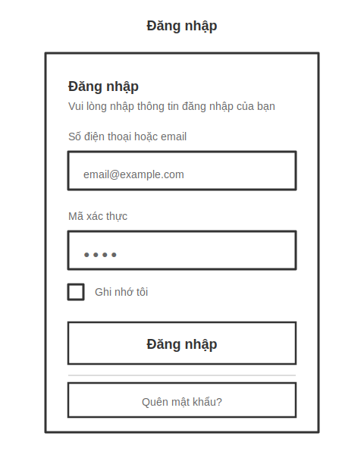

UI Elements:
Field Name | Field Type | Description
Tên đăng nhập hoặc Email* | Text Box | This is for user to input their username for logging in
Mật khẩu* | Password Box | User enters their password to log in to the system.
Hiển thị/Ẩn mật khẩu | Button (Icon Toggle) | User clicks to switch password visibility between plain text and masked characters.
Ghi nhớ tôi | Checkbox | User selects this option to save their login session for future visits.
Đăng nhập | Button | User clicks to authenticate and access the system using the provided username and password.
Quên mật khẩu? | Button | User clicks to button to navigate to the Forgot Password page

Database Access:
Table | CRUD | Description
user | R | Verify UserName & Password information
user_setting | R | Specify the authorizations of the logged-in user

PostgreSQL (Supabase) Commands:
1/ User authentication:
SELECT user_id, username, email, password_hash, is_active
FROM user
WHERE (username = $1 OR email = $1)
AND is_active = TRUE;

2/ Get User Settings:
SELECT user_id, role_id, permissions, theme_preference, language
FROM user_setting
WHERE user_id = $1;

3/ Last login time update:
UPDATE user
SET last_login_at = NOW()
WHERE user_id = $1;

4/ Create a login session:
INSERT INTO login_session (user_id, session_token, login_at, ip_address, device_info)
VALUES ($1, $2, NOW(), $3, $4);

- UC04 Forgot Password
UI Design:
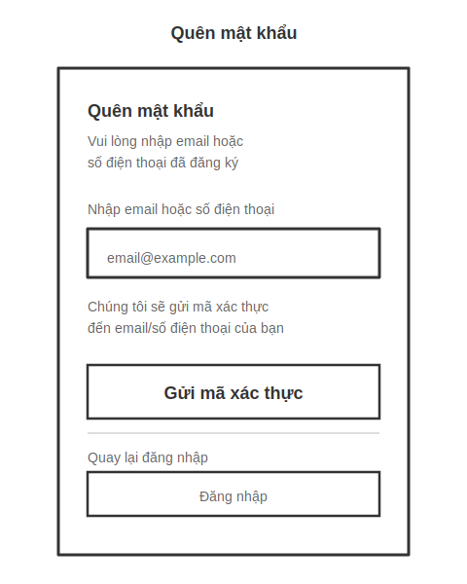
UI Elements:
Field Name | Field Type | Description
Email* | Text Box | Users enter their registered email or phone number to receive a verification code.
Gửi mã xác thực | Button | Button to send verification code to user's email/SMS
Quay lại đăng nhập | Button | Button to return to the Login screen
Gửi lại mã | Button (Timer) | Button to resend code (displayed after the code is sent, with a 60-second timer)

Database Access:
Table | CRUD | Description
user | R | Search for users based on email or phone number
password_reset_token | C | Generate a 24-hour reset token

PostgreSQL (Supabase) Commands:
1/ Search users by email/phone:
SELECT user_id, username, email, phone_number, is_active
FROM user
WHERE (email = $1 OR phone_number = $1)
AND is_active = TRUE;

2/ Generate reset authentication code:
INSERT INTO password_reset_token (user_id, token, created_at, expires_at)
VALUES ($1, $2, NOW(), NOW() + INTERVAL '24 hours')
RETURNING token;

3/ Check out the recently submitted code:
SELECT COUNT(*) FROM password_reset_token
WHERE user_id = $1
AND created_at > NOW() - INTERVAL '5 minutes';

b. Reset Password Screen
Related UC:
- UC03 Reset Password
UI Design:
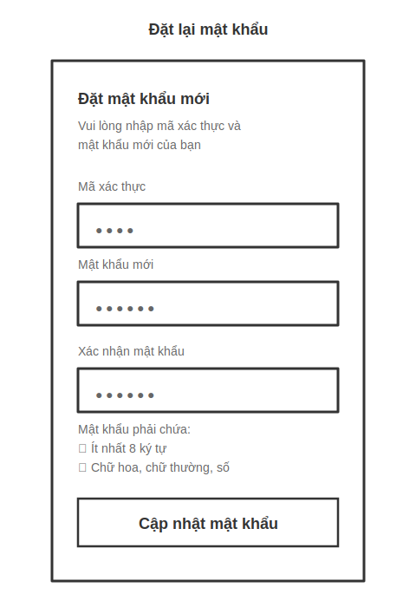
UI Elements:
Field Name | Field Type | Description
Mã xác thực* | Text Box | User enters 6-digit verification code or token from reset email
Mật khẩu mới* | Password Box | User enters new password. Password is masked as dots
Xác nhận mật khẩu* | Password Box | User re-enters new password to confirm. Must match "Mật khẩu mới"
Hiển thị/Ẩn mật khẩu | Button (Icon Toggle) | User clicks to toggle password visibility for both password fields
Yêu cầu mật khẩu | Text Display | Shows password requirements: minimum 8 characters, uppercase, lowercase, numbers, special characters
Cập nhật mật khẩu | Button | User clicks to update password with new credentials

Database Access:
Table | CRUD | Description
password_reset_token | R | Verify reset token is valid and not expired
user | U | Update password hash for user
password_reset_token | U | Mark token as used after successful reset
audit_log | C | Log password change for security audit

PostgreSQL (Supabase) Commands:
1/ Verify reset token validity:
SELECT user_id, expires_at
FROM password_reset_token
WHERE token = $1
AND expires_at > NOW()
AND is_used = FALSE;

2/ Update user password:
UPDATE user
SET password_hash = $1,
updated_at = NOW(),
password_changed_at = NOW()
WHERE user_id = $2;

3/ Mark token as used:
UPDATE password_reset_token
SET is_used = TRUE,
used_at = NOW()
WHERE token = $1;

4/ Log password change:
INSERT INTO audit_log (user_id, action, details, ip_address, created_at)
VALUES ($1, 'PASSWORD_CHANGED', 'Password reset via UC03', $2, NOW());

5/ Check password history:
SELECT password_hash FROM password_history
WHERE user_id = $1
ORDER BY changed_at DESC
LIMIT 5;

c. User Role Management Screen
Related UC:
- UC07 Assign Role
UI Design:
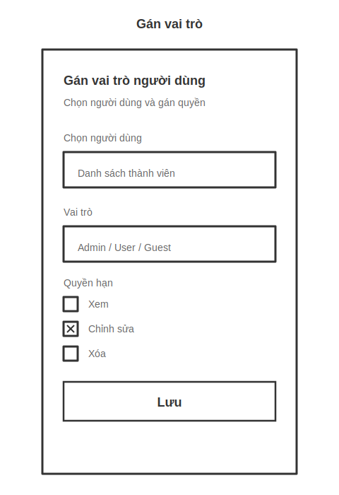
UI Elements:
Field Name | Field Type | Description
Chọn người dùng* | Dropdown/Search Box | Admin selects user from member list. Supports search by name and email
Vai trò* | Dropdown/Radio Button | Admin selects role for user: Admin, Manager, User, Guest
Quyền hạn | Checkbox Group | Permission checkboxes: View, Edit, Delete, Export Reports
Chi tiết quyền hạn | Table/List | Display detailed permissions for each selected role
Lưu | Button | Save role and permission assignments
Hủy | Button | Save role and permission assignments
Xóa quyền hạn | Button (Danger) | Clear all permissions for the selected user

Database Access:
Table | CRUD | Description
user | R | Get list of users for assignment
role | R | Get available roles in system
user_role | C/U | Assign role to user
user_permission | C/U | Assign specific permissions to user
audit_log | C | Log role assignment changes

PostgreSQL (Supabase) Commands:
1/ Get list of active users:
SELECT user_id, username, email, first_name, last_name, is_active
FROM user
WHERE is_active = TRUE
ORDER BY username ASC;

2/ Get available roles:
SELECT role_id, role_name, description
FROM role
WHERE is_active = TRUE
ORDER BY role_id ASC;

3/ Assign role to user:
INSERT INTO user_role (user_id, role_id, assigned_at, assigned_by)
VALUES ($1, $2, NOW(), $3)
ON CONFLICT (user_id)
DO UPDATE SET role_id = $2, assigned_at = NOW();

4/ Assign permissions to user:
INSERT INTO user_permission (user_id, permission_id, is_granted, assigned_at, assigned_by)
VALUES ($1, $2, TRUE, NOW(), $3)
ON CONFLICT (user_id, permission_id)
DO UPDATE SET is_granted = TRUE, assigned_at = NOW();

5/ Log role assignment:
INSERT INTO audit_log (user_id, action, details, changed_by, ip_address, created_at)
VALUES ($1, 'ROLE_ASSIGNED', $2, $3, $4, NOW());

6/ Get current user role:
SELECT ur.user_id, ur.role_id, r.role_name
FROM user_role ur
JOIN role r ON ur.role_id = r.role_id
WHERE ur.user_id = $1 AND ur.is_active = TRUE;

- UC08 Revoke Role
UI Design:
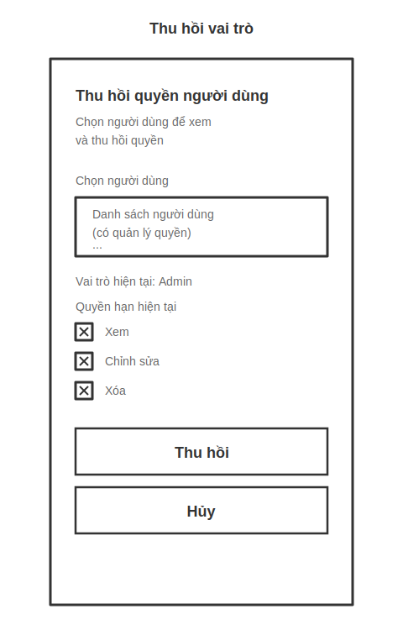
UI Elements:
Field Name | Field Type | Description
Chọn người dùng* | Dropdown/Search Box | Admin selects user to revoke role. Supports search by name and email
Vai trò hiện tại | Display Text | Show current user role (read-only)
Quyền hạn hiện tại | Checkbox Group (Disabled) | List current permissions (view only, cannot edit)
Lý do thu hồi* | Text Area | Admin enters reason for revoking role
Thu hồi | Button (Danger) | Revoke all role and permissions from user
Gửi thông báo | Checkbox | Send email notification to user when role is revoked
Hủy | Button | Cancel and return to previous page

Database Access:
Table | CRUD | Description
user | R | Get list of users with roles
user_role | R/U | View current role and set inactive
user_permission | R/D | View permissions and delete them
audit_log | C | Log role revocation for audit trail

PostgreSQL (Supabase) Commands:
1/ Get users with active roles:
sqlSELECT u.user_id, u.username, u.email, u.first_name, u.last_name, r.role_name
FROM user u
LEFT JOIN user_role ur ON u.user_id = ur.user_id AND ur.is_active = TRUE
LEFT JOIN role r ON ur.role_id = r.role_id
WHERE u.is_active = TRUE AND ur.user_id IS NOT NULL
ORDER BY u.username ASC;

2/ Get current user role:
sqlSELECT ur.user_id, ur.role_id, r.role_name, ur.assigned_at
FROM user_role ur
JOIN role r ON ur.role_id = r.role_id
WHERE ur.user_id = $1 AND ur.is_active = TRUE;

3/ Get current user permissions:
sqlSELECT up.permission_id, p.permission_name, p.description, up.assigned_at
FROM user_permission up
JOIN permission p ON up.permission_id = p.permission_id
WHERE up.user_id = $1 AND up.is_granted = TRUE;

4/ Revoke role (mark as inactive):
sqlUPDATE user_role
SET is_active = FALSE,
revoked_at = NOW(),
revoked_by = $2,
revoke_reason = $3
WHERE user_id = $1;

5/ Revoke all permissions:
sqlUPDATE user_permission
SET is_granted = FALSE,
revoked_at = NOW(),
revoked_by = $2
WHERE user_id = $1;

6/ Log role revocation:
sqlINSERT INTO audit_log (user_id, action, details, changed_by, ip_address, created_at)
VALUES ($1, 'ROLE_REVOKED', $2, $3, $4, NOW());

d. Login Activity Screen
Related UC:
- UC05 View Login Activity
UI Design:
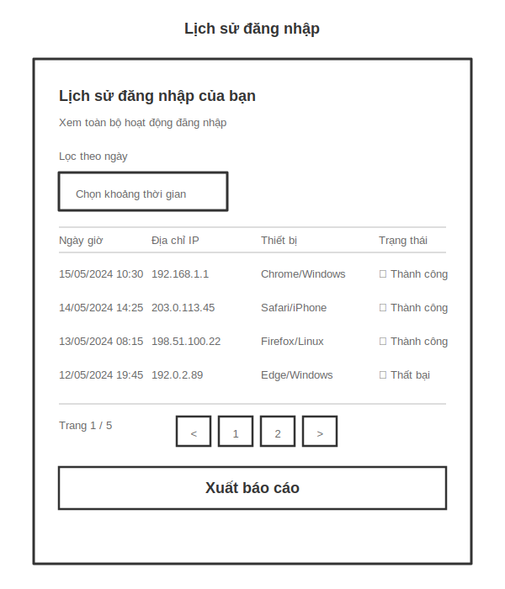
UI Elements:
Field Name | Field Type | Description
Lọc theo thời gian | Date Picker (From-To) | This is for user to input their username for logging in
Lọc theo trạng thái | Dropdown | User enters their password to log in to the system.
Tìm kiếm thiết bị | Text Box | User clicks to switch password visibility between plain text and masked characters.
Bảng lịch sử đăng nhập | Data Table | User selects this option to save their login session for future visits.
Phân trang | Pagination Control | User clicks to authenticate and access the system using the provided username and password.
Xuất báo cáo | Button | User clicks to negative to the Password Reset page in case they forgot their password

Database Access:
Table | CRUD | Description
login_session | R | Get login history for current user
user | R | Get user information

PostgreSQL (Supabase) Commands:
1/ Get user login history
sqlSELECT
ls.session_id,
ls.user_id,
ls.login_at,
ls.logout_at,
ls.ip_address,
ls.device_info,
ls.browser,
ls.os,
ls.location,
ls.country,
ls.city,
ls.is_successful,
ls.failure_reason,
EXTRACT(EPOCH FROM (COALESCE(ls.logout_at, NOW()) - ls.login_at)) as duration_seconds
FROM login_session ls
WHERE ls.user_id = $1
AND ls.login_at BETWEEN $2 AND $3
ORDER BY ls.login_at DESC
LIMIT 20 OFFSET $4;

2/ Filter by status
sqlSELECT *
FROM login_session
WHERE user_id = $1
AND login_at BETWEEN $2 AND $3
AND is_successful = $4
ORDER BY login_at DESC
LIMIT 20 OFFSET $5;

3/ Search by device
sqlSELECT *
FROM login_session
WHERE user_id = $1
AND login_at BETWEEN $2 AND $3
AND (browser ILIKE $4 OR os ILIKE $4 OR device_info ILIKE $4)
ORDER BY login_at DESC
LIMIT 20 OFFSET $5;

4/ Count total login records
sqlSELECT COUNT(*) as total_count
FROM login_session
WHERE user_id = $1
AND login_at BETWEEN $2 AND $3;

2. Employee Management Feature

2.1 Employee List Screen
Related UC:
- UC13 View All Employees

2.2 Employee Details Screen
Related UC:
- UC14 View My Profile
- UC11 Update Employee Profile
- UC12 Deactivate Employee

2.3 Create Employee Screen
Related UC:
- UC10 Create Employee

2.4 Edit Profile Screen
Related UC:
- UC15 Edit Profile Details

3. Attendance Management Feature

3.1 Attendance Dashboard
Related UC:
- UC16 Fingerprint
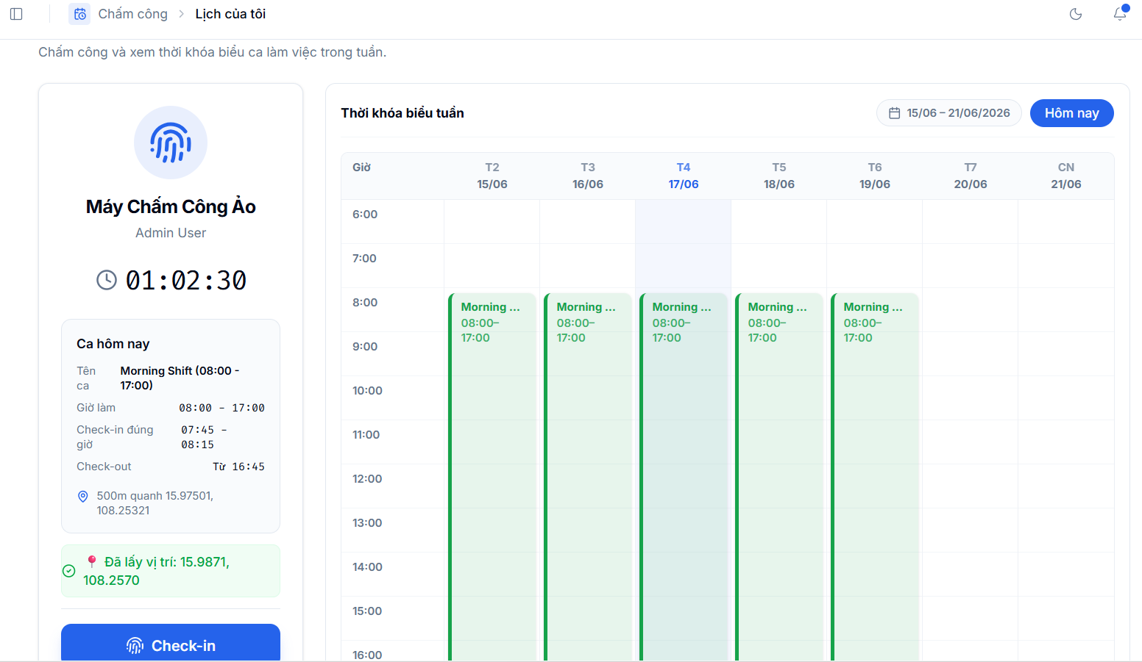

- UC17 View Attendance History
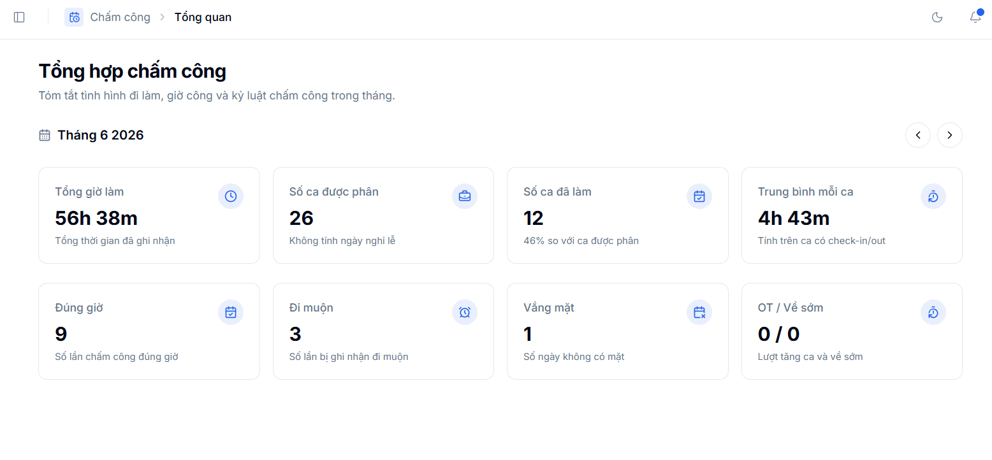

- UC18 View All Attendance History
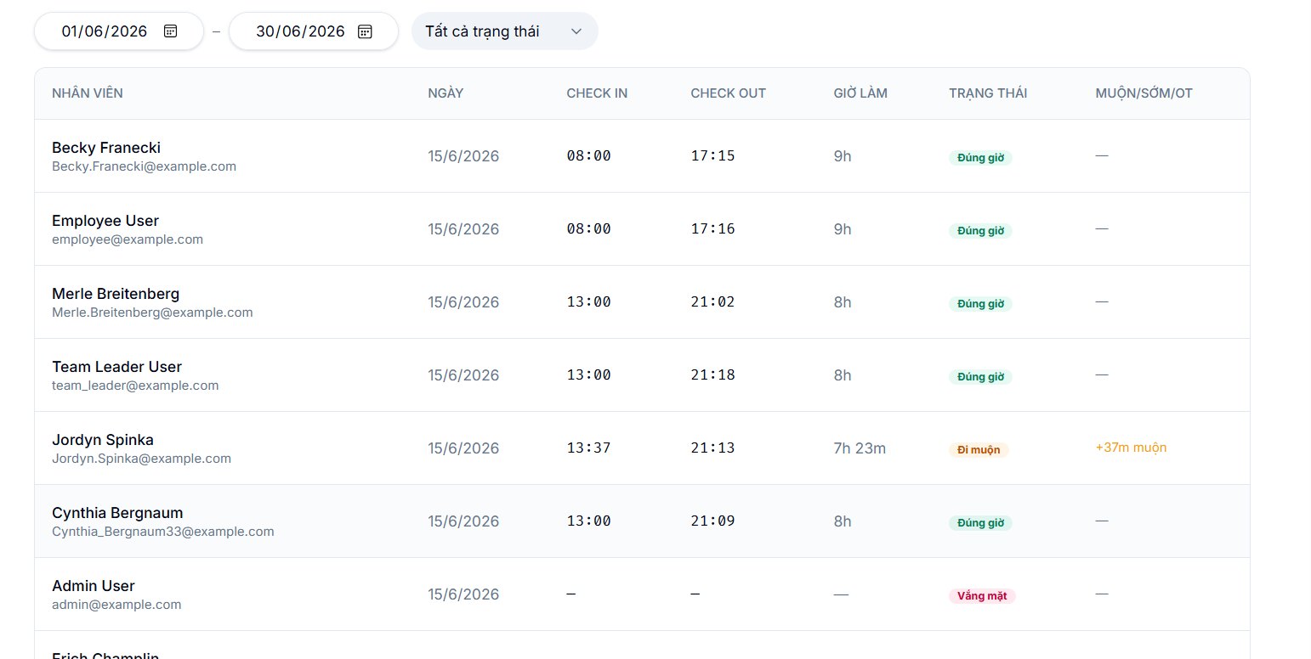

3.2 Attendance History Screen
Related UC:
- UC17 View Attendance History
- UC18 View All Attendance History

3.3 Application Form Screen
Related UC:
- UC19 Create Application Form
- UC20 Leave Application
- UC21 Overtime Request
- UC22 Remote Request
- UC23 Shift Change Request
- UC24 Regime Application

3.4 Recruitment Proposal Screen
Related UC:
- UC25 Create Recruitment Proposal

3.5 Working Shift Screen
Related UC:
- UC26 View Working Shift
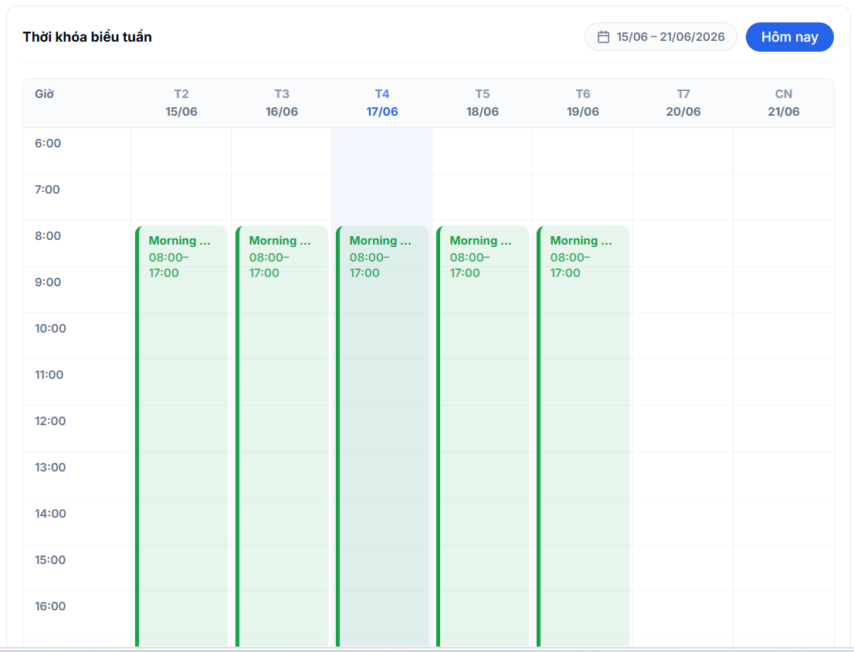

- UC27 Create Working Shift
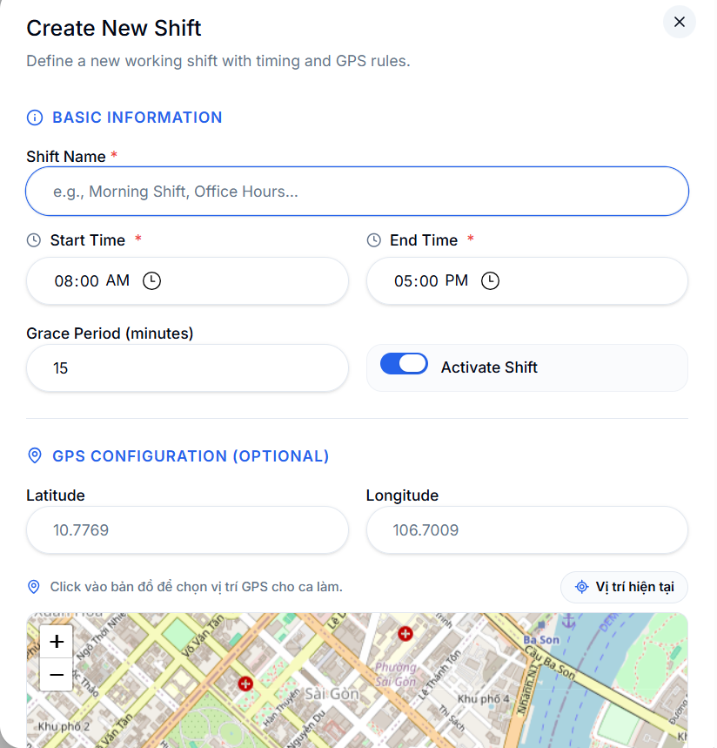

- UC28 Modify Working Shift
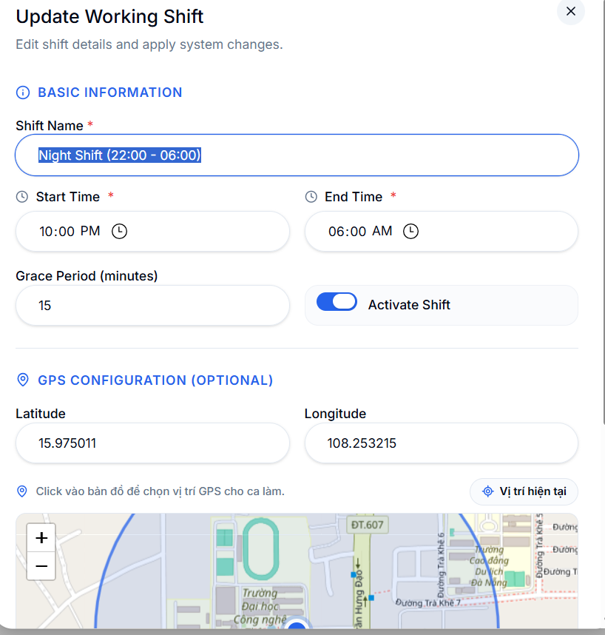

3.6 Application Approval Screen
Related UC:
- UC29 Moderate Application Form

4. Payroll Management Feature

4.1 Payroll Dashboard
Related UC:
- UC30 View/Export Payroll Report
UI Design:
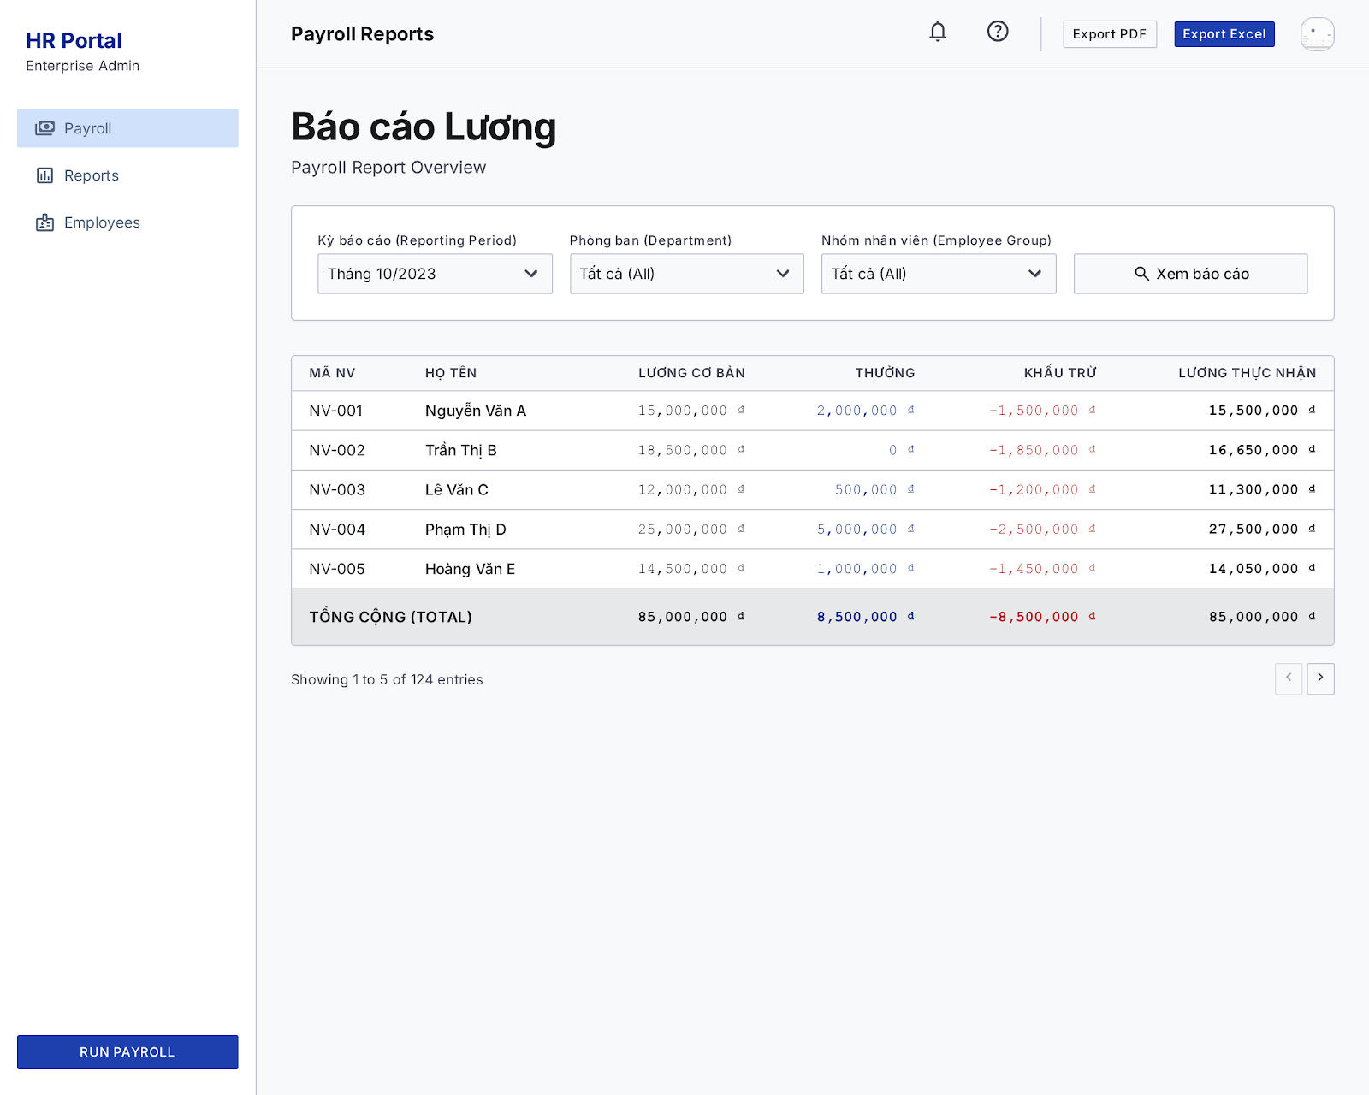

4.2 Payroll Template Screen
Related UC:
- UC31 Modify Payroll Template
UI Design:
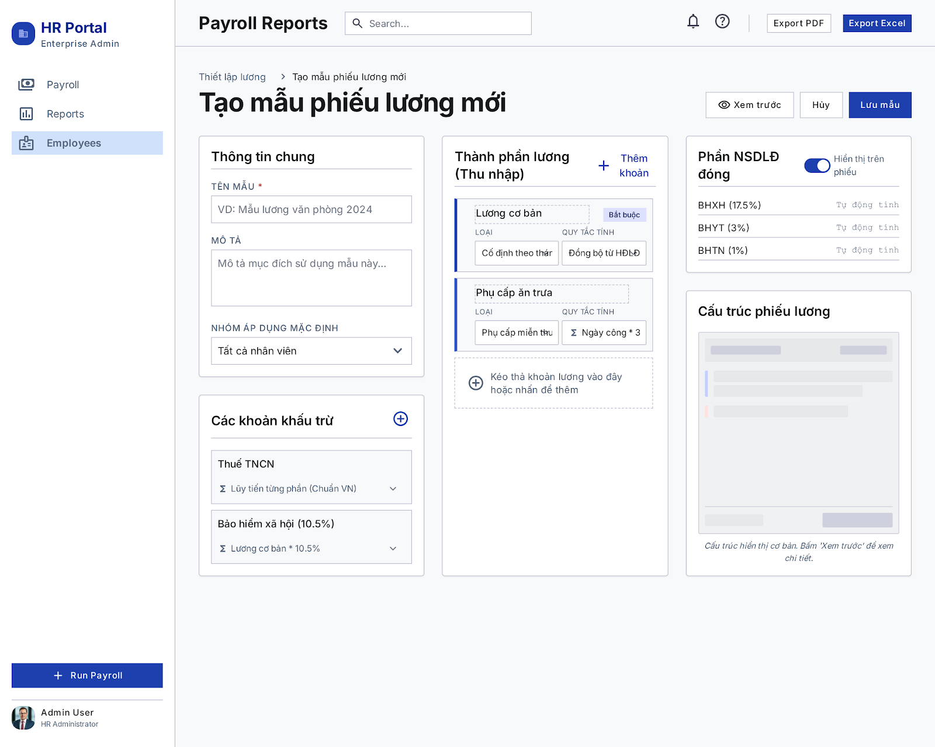

4.3 Payroll Approval Screen
Related UC:
- UC32 Moderate Payroll
UI Design:
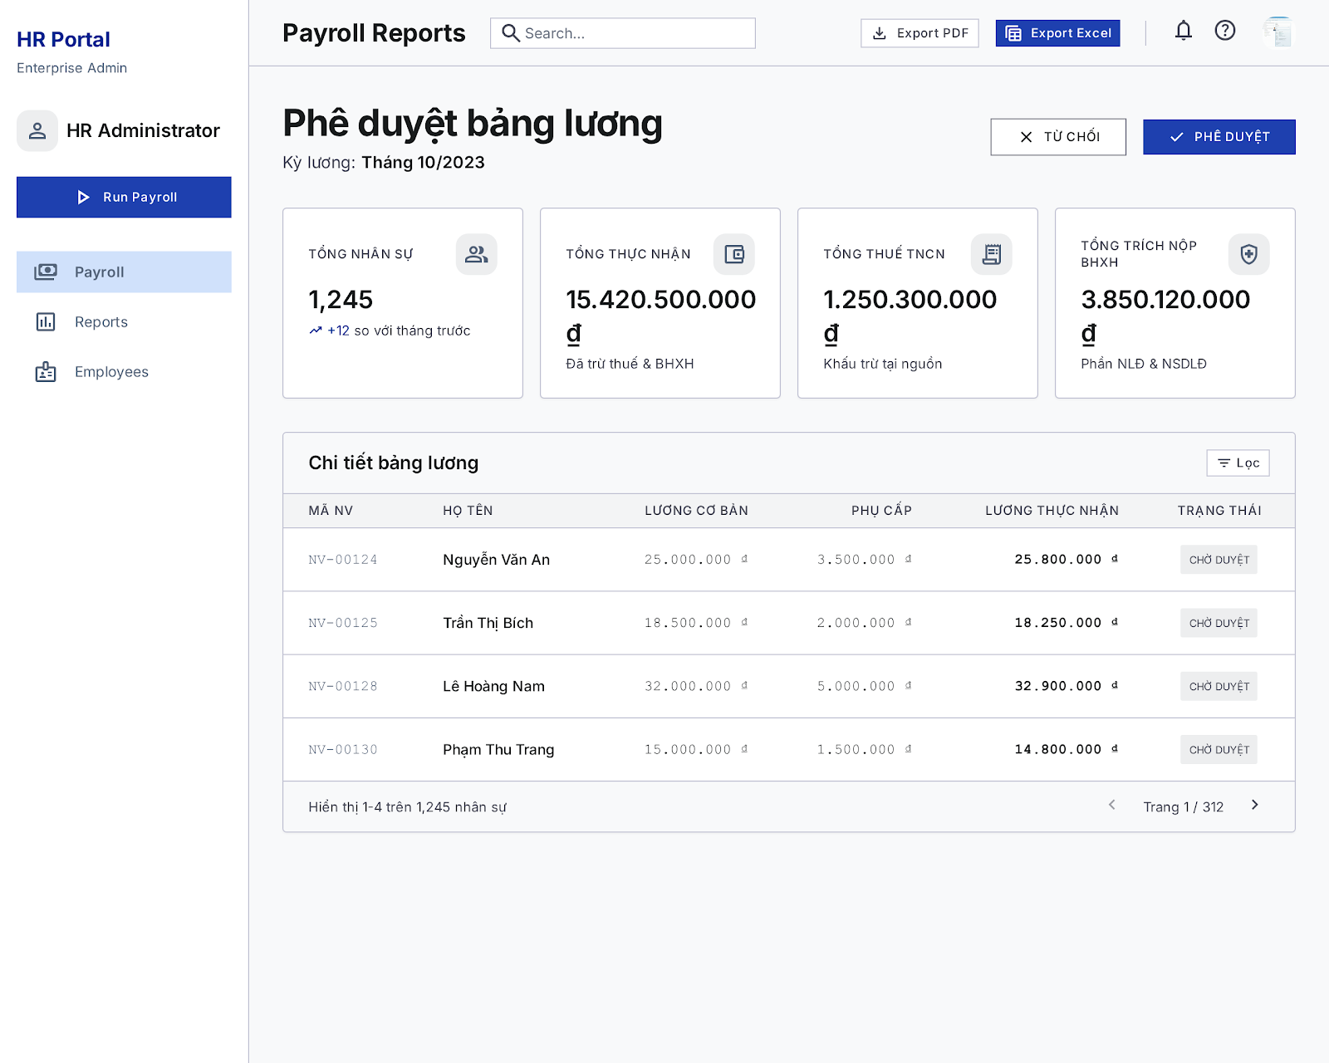

4.4 Payslip Screen
Related UC:
- UC33 View Payslip
UI Design:
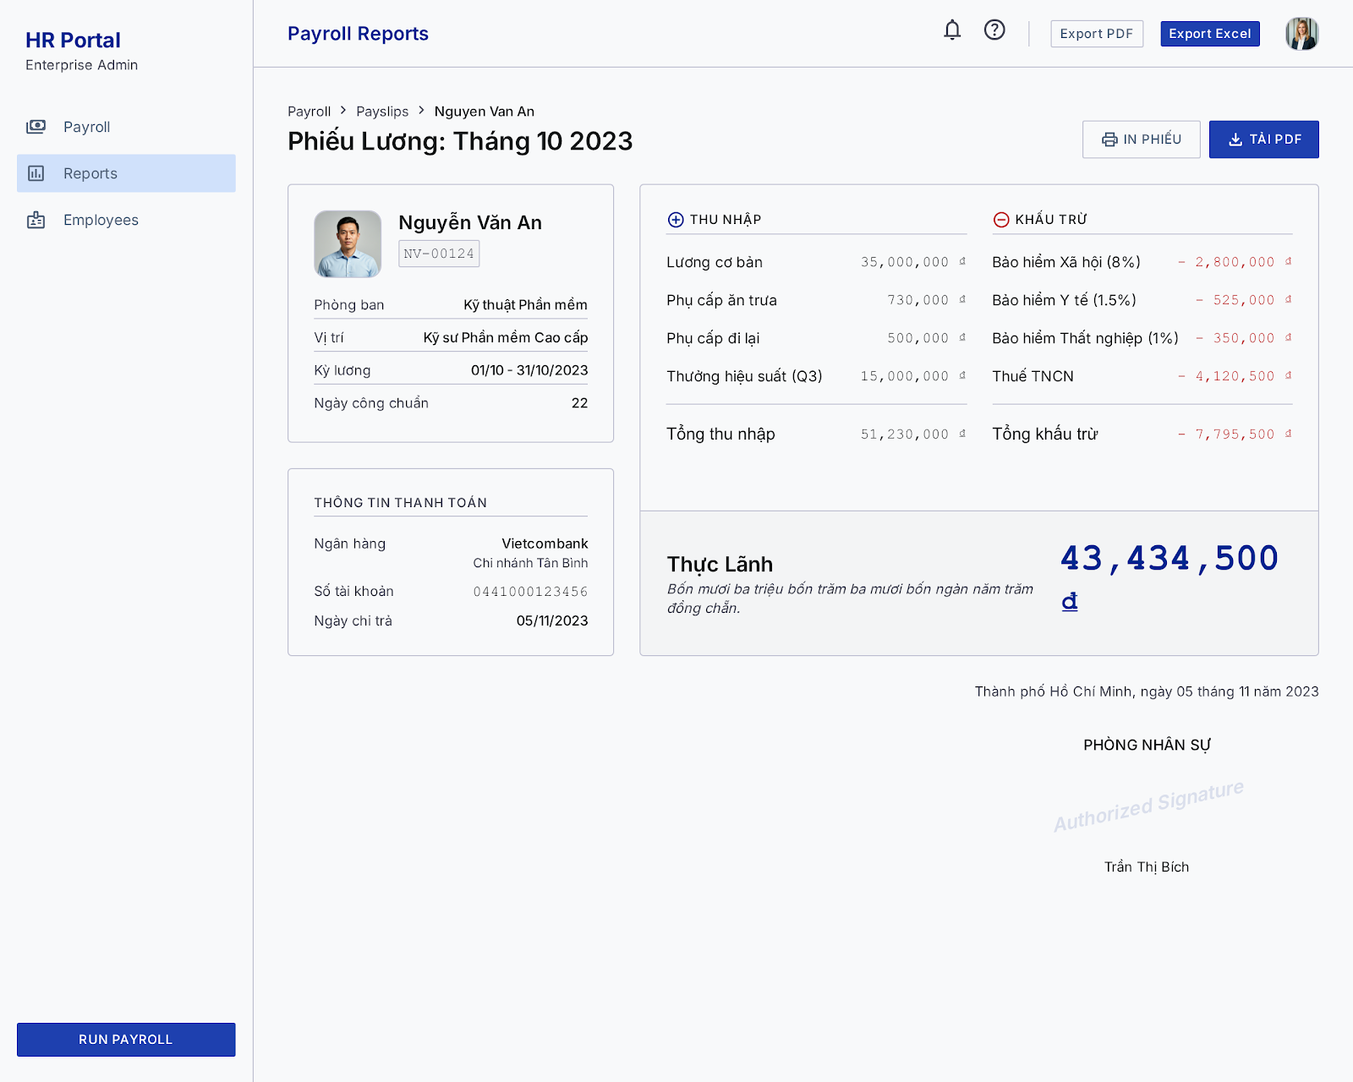

4.5 Payroll Scheduler Screen
Related UC:
- UC34 Modify Trigger Generate Payroll
UI Design:
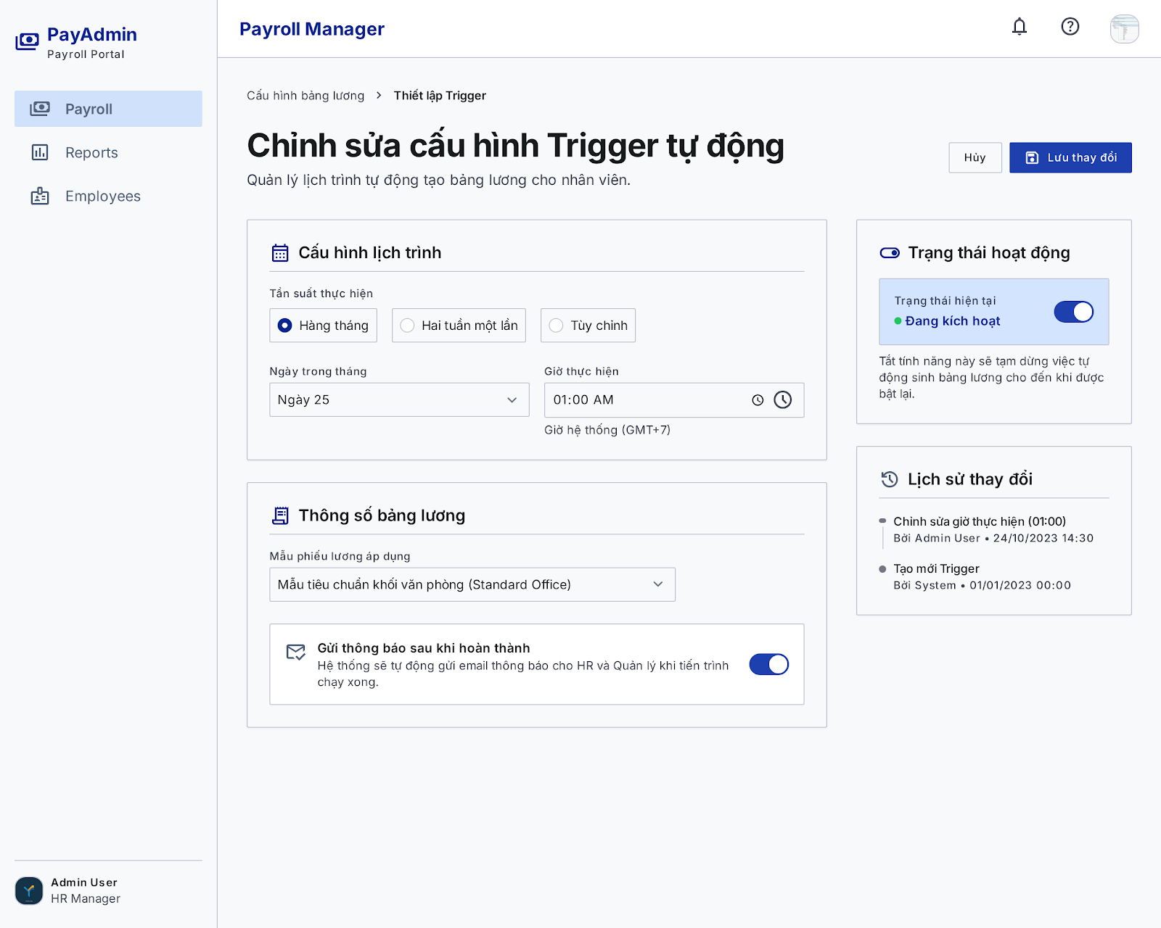

5. Project Management Feature

5.1 Project List Screen
Related UC:
- UC35 Create Project
UI Design:
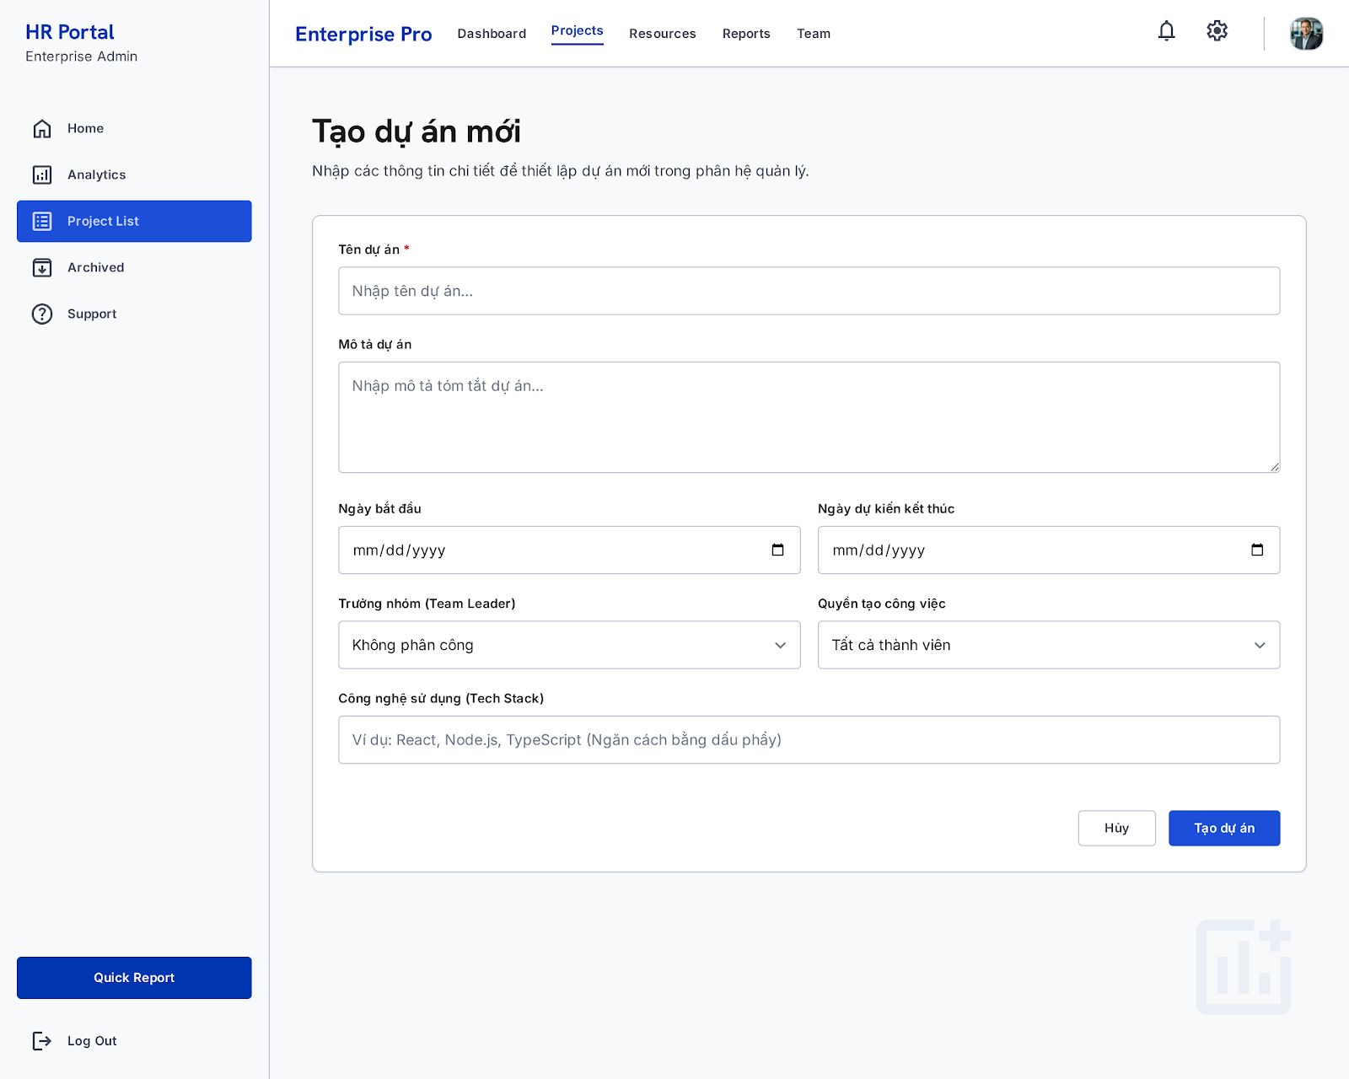

UI Elements:
Field Name | Field Type | Description
Tên dự án * | Text Box | Validates and inputs the unique project name.
Mô tả dự án | Text Area | Optional textual description of the project scope.
Ngày bắt đầu | Date Picker | Sets the initial date of the project.
Ngày dự kiến kết thúc | Date Picker | Sets the target deadline of the project.
Trưởng nhóm (Team Leader) | Dropdown Select | Selects an active employee to lead the project. Defaults to "Không phân công"
Quyền tạo công việc | Dropdown Select | Selects task creation policy: "Tất cả thành viên" (all_members) or "Chỉ trưởng nhóm" (leader_only).
Công nghệ sử dụng (Tech Stack) | Text Box | Input list of technologies separated by commas.
Tạo dự án | Button | Triggers input validation and saves the project record.
Hủy | Button | Discards inputs and redirects to the Project List page.

Database Access:
Table | CRUD | Description
Project | C | Create a new project row with the form parameters.
Employee | R | Query active employees to populate the Team Leader dropdown.
PostgreSQL (Supabase) Commands:
1/ Populate Team Leader Dropdown:
SELECT "id", "fullName", "email"
FROM "Employee"
WHERE "status" = 'active' AND "deletedAt" IS NULL
ORDER BY "fullName" ASC;

2/ Create New Project:
INSERT INTO "Project" (
"id", "name", "description", "techStack", "status",
"taskCreationPolicy", "startDate", "expectedEndDate",
"teamLeaderId", "createdById", "createdAt", "updatedAt"
) VALUES (
'project_target_uuid_123', 'Data Warehouse Integration', 'Set up Snowflake and ETL pipelines',
ARRAY['React', 'Node.js', 'TypeScript'], 'planning',
'all_members', '2026-06-16 00:00:00', '2026-12-31 00:00:00',
'emp_leader_id_123', 'emp_creator_id_456', NOW(), NOW()
);

- UC39 View Project Details
UI Design:
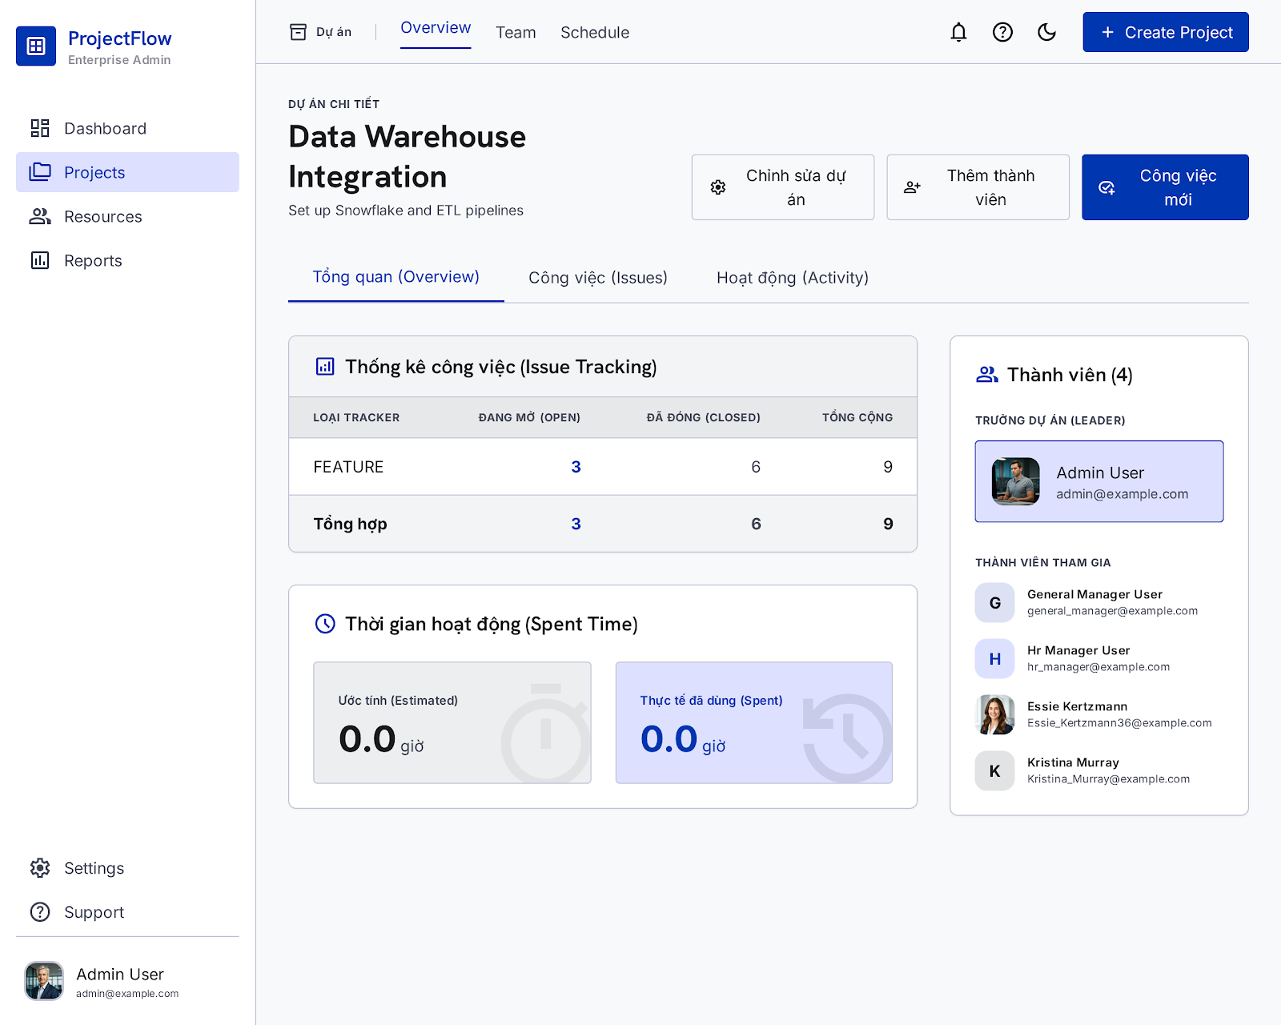

UI Elements:
Field Name | Field Type | Description
Chỉnh sửa dự án | Button | Opens the "Chỉnh sửa dự án" (Modify Project) Modal dialog.
Thêm thành viên | Password Box | Opens the "Thêm thành viên dự án" (Add Member) Modal dialog.
Công việc mới | Button | Redirects the user to the Create Task Screen.
Tổng quan (Overview) | Tab | Displays the spent time charts and tracker statistics widgets.
Công việc (Issues) | Tab | Navigates to the active Kanban board/tasks list of the project.
Hoạt động (Activity) | Tab | Navigates to the active Kanban board/tasks list of the project.
Thống kê công việc (Issue Tracking) | Table Widget | Shows active tasks count grouped by tracker type (feature, bug, etc.) and status.
Thời gian hoạt động (Spent Time) | Card Widget | Displays total estimates vs total actual spent hours.
Thành viên (4) | Sidebar Widget | Displays the project leader and list of active members.

Database Access:
Table | CRUD | Description
Project | R | Query metadata of the project.
ProjectMember | R | Query active members in the project.
Task | R | Retrieve tasks count grouped by status and tracker type.
SpentTime | R | Sum up logged hours vs task estimated times.

PostgreSQL (Supabase) Commands:
1/ Fetch Project Metadata & Lead Details:
SELECT p.*, e."fullName" AS "teamLeaderName", e."email" AS "teamLeaderEmail"
FROM "Project" p
LEFT JOIN "Employee" e ON p."teamLeaderId" = e."id"
WHERE p."id" = 'project_target_uuid_123';

2/ Fetch Active Project Members list:
SELECT pm.*, e."fullName", e."email", e."position", e."avatarUrl"
FROM "ProjectMember" pm
INNER JOIN "Employee" e ON pm."employeeId" = e."id"
WHERE pm."projectId" = 'project_target_uuid_123'
AND pm."removedAt" IS NULL;

3/ Aggregate Task Counts by Status & Tracker:
SELECT "tracker", "status", COUNT(*) as "count"
FROM "Task"
WHERE "projectId" = 'project_target_uuid_123'
GROUP BY "tracker", "status";

4/ Sum Task Estimates and Logged Hours:
SELECT
COALESCE(SUM(t."estimatedTime"), 0) AS "totalEstimated",
COALESCE(SUM(s."hours"), 0) AS "totalSpent"
FROM "Task" t
LEFT JOIN "SpentTime" s ON t."id" = s."taskId"
WHERE t."projectId" = 'project_target_uuid_123';

5.2 Project Details Screen
Related UC:
- UC36 Modify Project
UI Design:
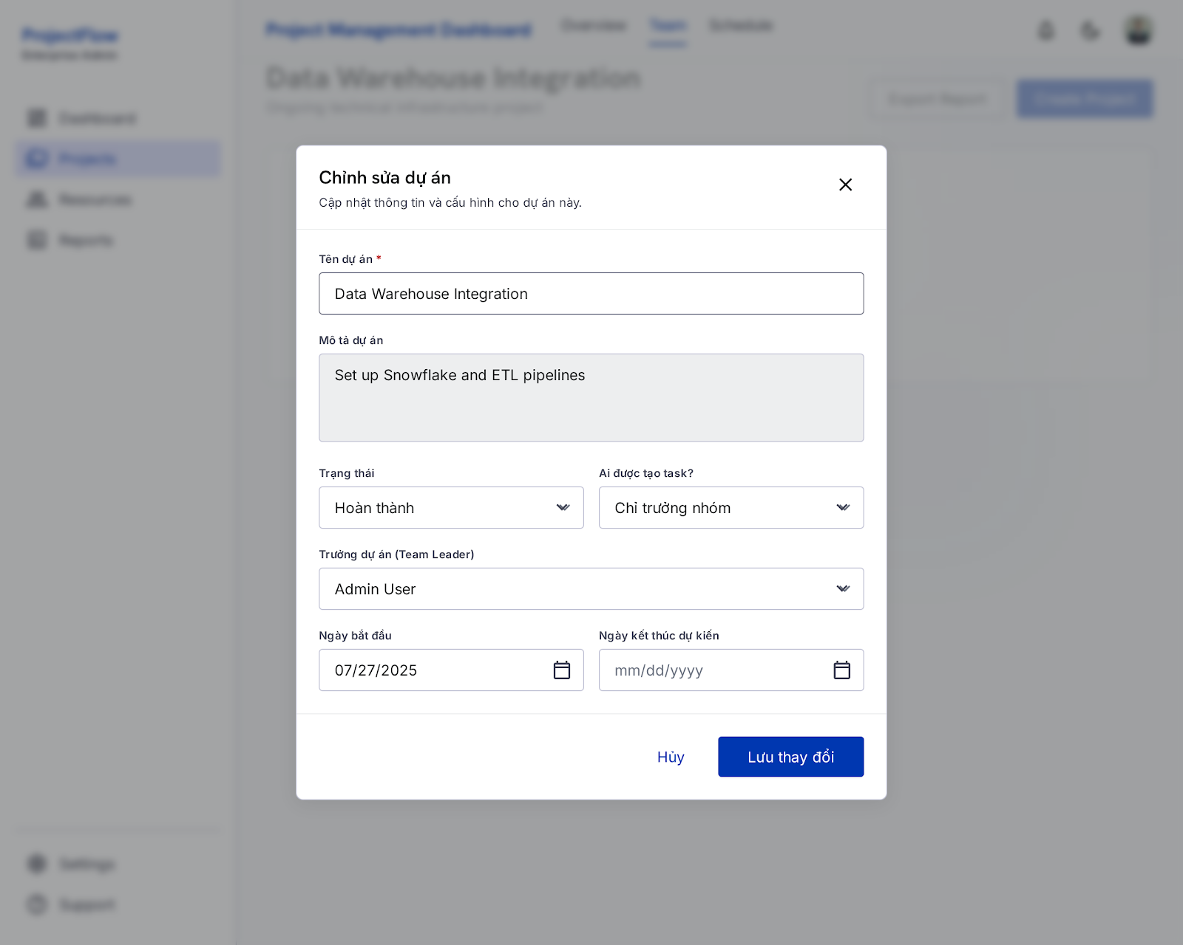

UI Elements:
Field Name | Field Type | Description
Tên dự án * | Text Box | Modifies the unique project name.
Mô tả dự án | Text Area | Modifies the description.
Trạng thái | Dropdown Select | Selects status: planning, active, on_hold, completed (translates to "Hoàn thành"), cancelled.
Ai được tạo task? | Dropdown Select | Maps to taskCreationPolicy: "Tất cả thành viên" (all_members) or "Chỉ trưởng nhóm" (leader_only).
Trưởng dự án (Team Leader) | Dropdown Select | Re-assigns the project's Team Leader.
Ngày bắt đầu | Date Picker | Modifies start date.
Ngày kết thúc dự kiến | Date Picker | Modifies expected end date.
Lưu thay đổi | Button | Triggers validation and saves changes to the database.
Hủy | Button | Discards updates and closes the modal dialog.

Database Access:
Table | CRUD | Description
Project | U | Update fields of the target project record.
Employee | R | Query active employees to populate the Team Leader dropdown list.

UI Elements:
Field Name | Field Type | Description
Tên dự án * | Text Box | Modifies the unique project name.
Mô tả dự án | Password Box | Modifies the description.
Trạng thái | Dropdown Select | Selects status: planning, active, on_hold, completed (translates to "Hoàn thành"), cancelled.
Ai được tạo task? | Tab | Displays the spent time charts and tracker statistics widgets.
Công việc (Issues) | Tab | Navigates to the active Kanban board/tasks list of the project.
Hoạt động (Activity) | Tab | Navigates to the active Kanban board/tasks list of the project.
Thống kê công việc (Issue Tracking) | Table Widget | Shows active tasks count grouped by tracker type (feature, bug, etc.) and status.
Thời gian hoạt động (Spent Time) | Card Widget | Displays total estimates vs total actual spent hours.
Thành viên (4) | Sidebar Widget | Displays the project leader and list of active members.

Database Access:
Table | CRUD | Description
Project | R | Query metadata of the project.
ProjectMember | R | Query active members in the project.
Task | R | Retrieve tasks count grouped by status and tracker type.
SpentTime | R | Sum up logged hours vs task estimated times.

PostgreSQL (Supabase) Commands:
1/ Update Project Details:
SQL
UPDATE "Project"
SET
"name" = 'Data Warehouse Integration',
"description" = 'Set up Snowflake and ETL pipelines',
"status" = 'completed',
"taskCreationPolicy" = 'leader_only',
"startDate" = '2025-07-27 00:00:00',
"expectedEndDate" = NULL, -- Or specific updated expected end date
"actualEndDate" = NOW(), -- Because status is set to Completed/Hoàn thành
"teamLeaderId" = 'emp_admin_user_uuid',
"updatedAt" = NOW()
WHERE "id" = 'project_target_uuid_123';

- UC37 Add Member To Project
UI Design:
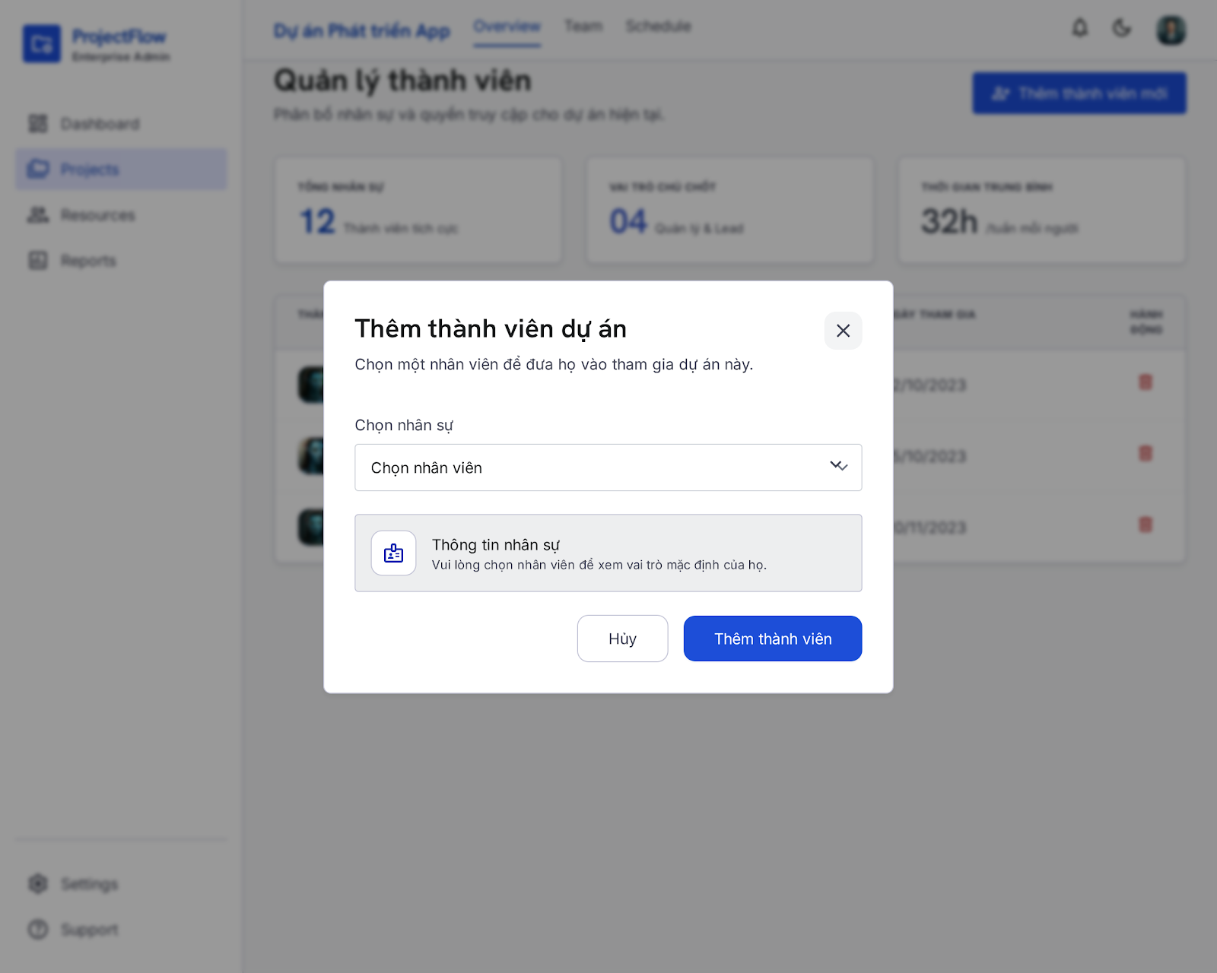

UI Elements:
Field Name | Field Type | Description
Chọn nhân sự | Dropdown Select | Search and select an active employee not currently in the project.
Thông tin nhân sự | Info Box panel | Displays context role information dynamically once a member is selected.
Thêm thành viên | Button | Triggers validation and registers project membership in database.
Hủy | Button | Closes the modal dialog without saving.

Database Access:
Table | CRUD | Description
ProjectMember | C / U | Upsert member link. Re-enables membership if removedAt was set.
Employee | R | Query active employees who are not already active members of the project.

PostgreSQL (Supabase) Commands:
1/ Fetch Non-Member Active Employees:
SQL
SELECT "id", "fullName", "email", "position"
FROM "Employee"
WHERE "status" = 'active'
AND "deletedAt" IS NULL
AND "id" NOT IN (
SELECT "employeeId"
FROM "ProjectMember"
WHERE "projectId" = 'project_target_uuid_123'
AND "removedAt" IS NULL
)
ORDER BY "fullName" ASC;

2/ Add Member (Upsert Query):
SQL
INSERT INTO "ProjectMember" ("projectId", "employeeId", "joinedAt", "removedAt")
VALUES ('project_target_uuid_123', 'emp_selected_uuid_777', NOW(), NULL)
ON CONFLICT ("projectId", "employeeId")
DO UPDATE SET "removedAt" = NULL, "joinedAt" = NOW();

- UC38 Remove Member From Project
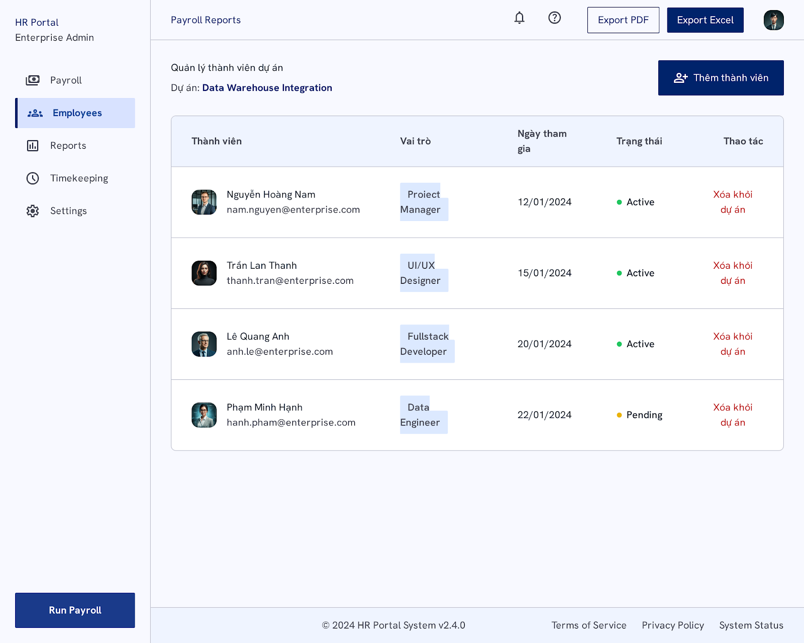

UI Elements:
Field Name | Field Type | Description
Thêm thành viên | Button | Opens the Add Member pop-up modal.
Xóa khỏi dự án (Xóa) | Link / Button | Triggers member removal confirmation dialog for the selected employee row.

Database Access:
Table | CRUD | Description
ProjectMember | R / U | Retrieve all project members and soft-delete selected memberships.
Employee | R | Retrieve employee names, emails, avatars, and default roles.

PostgreSQL (Supabase) Commands:
1/ Fetch Project Members with Roles and Status:
SELECT pm."joinedAt", pm."removedAt", e."id", e."fullName", e."email", e."position", e."status"
FROM "ProjectMember" pm
INNER JOIN "Employee" e ON pm."employeeId" = e."id"
WHERE pm."projectId" = 'project_target_uuid_123'
AND pm."removedAt" IS NULL;

2/ Soft Delete Member:
UPDATE "ProjectMember"
SET "removedAt" = NOW()
WHERE "projectId" = 'project_target_uuid_123'
AND "employeeId" = 'emp_target_uuid_to_remove';

6. Task Management Feature

6.1 Task Board Screen
Related UC:
- UC40 Create Task
UI Design:
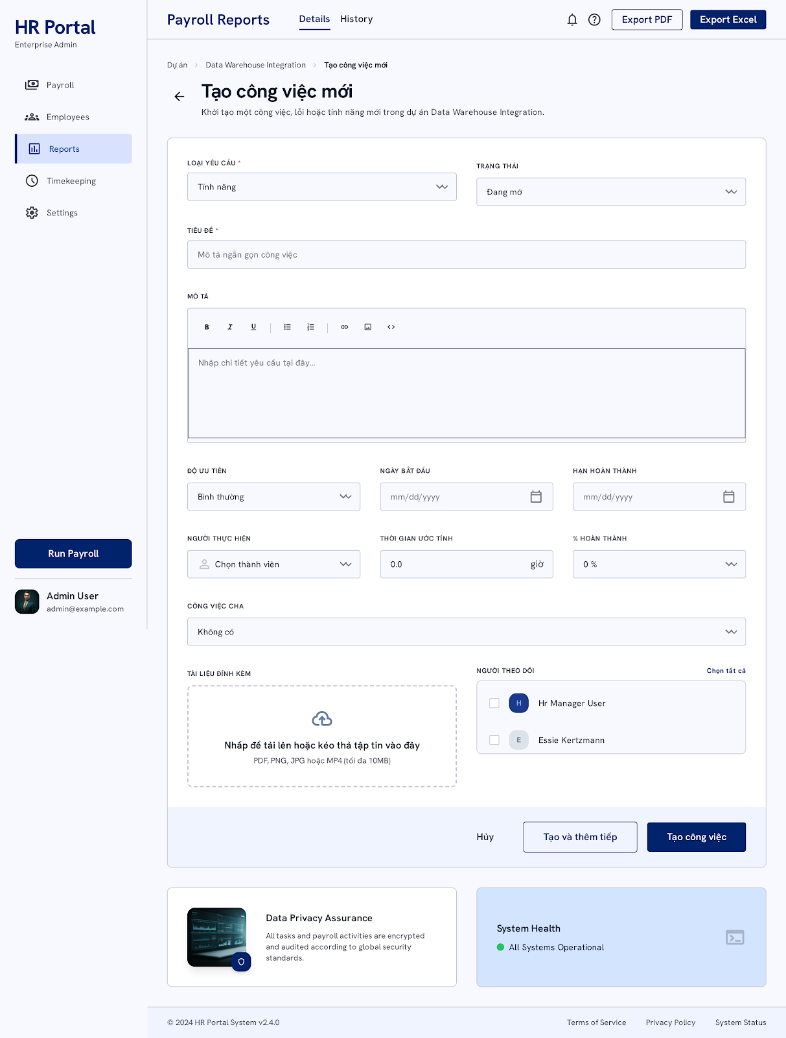

UI Elements:
Field Name | Field Type | Description
LOẠI YÊU CẦU * | Dropdown Select | Selects Tracker: feature ("Tính năng"), bug, etc.
TRẠNG THÁI | Dropdown Select | Selects TaskStatus: todo ("Đang mở"), etc.
TIÊU ĐỀ * | Text Box | Input task name title.
MÔ TẢ | Rich Text Editor | Inputs detailed task descriptions.
ĐỘ ƯU TIÊN | Dropdown Select | Selects Priority: low, medium ("Bình thường"), high, urgent.
NGÀY BẮT ĐẦU | Date Picker | Sets task start date.
HẠN HOÀN THÀNH | Date Picker | Sets task due date.
NGƯỜI THỰC HIỆN | Dropdown Select | Assigns a member from the project.
THỜI GIAN ƯỚC TÍNH | Number Box | Estimated hours (e.g. 0.0).
% HOÀN THÀNH | Dropdown Select | Progress indicator (defaults to 0 %).
CÔNG VIỆC CHA | Dropdown Select | Links a parent task if creating a subtask.
TÀI LIỆU ĐÍNH KÈM | File Upload Zone | Upload files up to 10MB.
Tạo công việc (Tạo) | Button | Saves the task and returns to the board.
Tạo và thêm tiếp | Button | Saves the task and clears inputs to allow creating another task.
Hủy | Button | Discards inputs and closes form.

Database Access:
Table | CRUD | Description
Task | C | Insert new task row.
ProjectMember | R | Fetch members for assignee selection list.

PostgreSQL (Supabase) Commands:
1/ Save Task:

INSERT INTO "Task" (
"id", "projectId", "title", "description", "tracker",
"priority", "status", "assigneeId", "createdById",
"dueDate", "estimatedTime", "progress", "createdAt", "updatedAt"
) VALUES (
'cuid_task_uuid_101', 'project_target_uuid_123', 'Implement Auth Middleware',
'Secure the routing with JWT token checks', 'feature',
'medium', 'todo', 'emp_developer_id_888', 'emp_creator_id_456',
'2026-06-30 23:59:59', 8.0, 0, NOW(), NOW()
);

- UC41 Modify Task
UI Design:
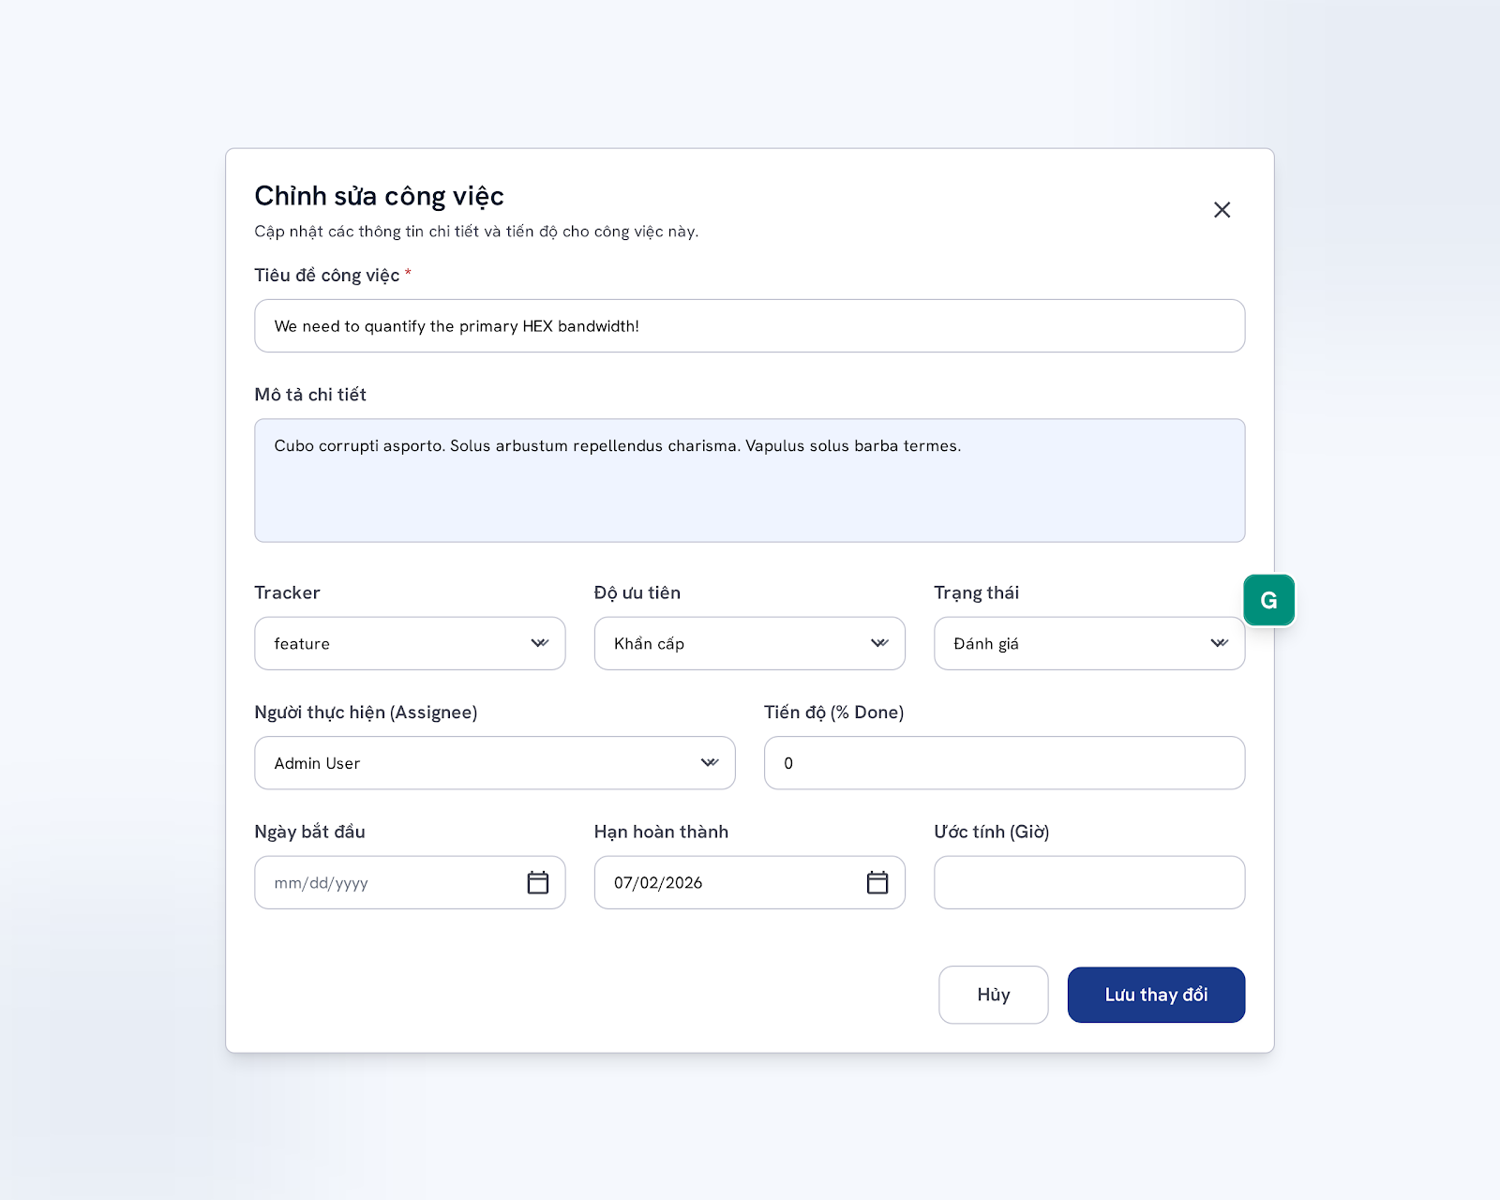

UI Elements:
Field Name | Field Type | Description
Tiêu đề công việc * | Text Box | Edits task title.
Mô tả chi tiết | Text Area | Edits task description.
Tracker | Dropdown Select | Selects category: feature, bug, etc.
Độ ưu tiên | Dropdown Select | Selects priority: low, medium, high, urgent ("Khẩn cấp").
Trạng thái | Dropdown Select | Selects status: todo, in_progress ("Đang làm"), in_review ("Đánh giá"), done ("Hoàn thành"), etc.
Người thực hiện (Assignee) | Dropdown Select | Selects assignee.
Tiến độ (% Done) | Number Input | Input progress value (0 to 100).
Ngày bắt đầu | Date Picker | Edits start date.
Hạn hoàn thành | Date Picker | Edits due date.
Ước tính (Giờ) | Number Input | Edits estimate.
Lưu thay đổi | Button | Saves updates and registers activity.
Hủy | Button | Closes modal discarding changes.

Database Access:
Table | CRUD | Description
Task | U | Update target task row attributes.

PostgreSQL (Supabase) Commands:
1/ Save Updated Task Details:
SQL
UPDATE "Task"
SET
"title" = 'We need to quantify the primary HEX bandwidth!',
"description" = 'Cubo corrupti asporto. Solus arbustum repellendus charisma...',
"tracker" = 'feature',
"priority" = 'urgent',
"status" = 'in_review',
"assigneeId" = 'emp_admin_user_uuid',
"progress" = 0,
"dueDate" = '2026-07-02 00:00:00',
"estimatedTime" = NULL,
"updatedAt" = NOW()
WHERE "id" = 'cuid_task_uuid_101';

- UC42 Delete Task
UI Design:

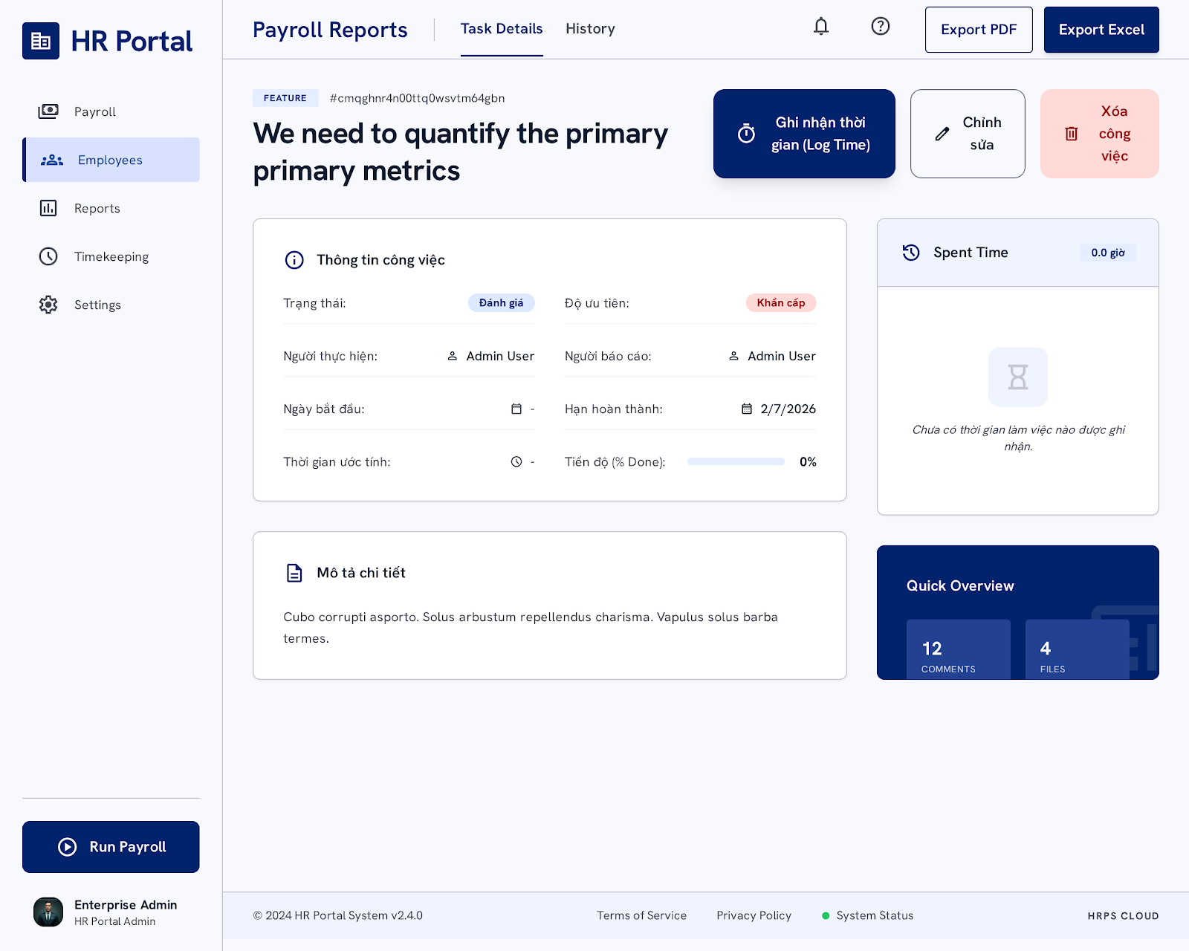

UI Elements:
Field Name | Field Type | Description
Ghi nhận thời gian | Button | Opens Log Time modal popup dialog.
Chỉnh sửa | Button | Opens Modify Task Modal.
Xóa công việc | Button | Triggers confirmation dialog to permanently delete the task.
Confirm Delete | Button | Deletes task from database permanently.
Cancel | Button | Closes dialog without deletion.

Database Access:
Table | CRUD | Description
Task | R / D | Query task details or delete task record.
SpentTime | R / D | Retrieve time logs or cascade-delete time logs when task is deleted.

PostgreSQL (Supabase) Commands:
1/ Delete Task from Database (Cascades SpentTime deletion):
DELETE FROM "Task"
WHERE "id" = 'cuid_task_uuid_101';

- UC43 View Project Tasks
UI Design:
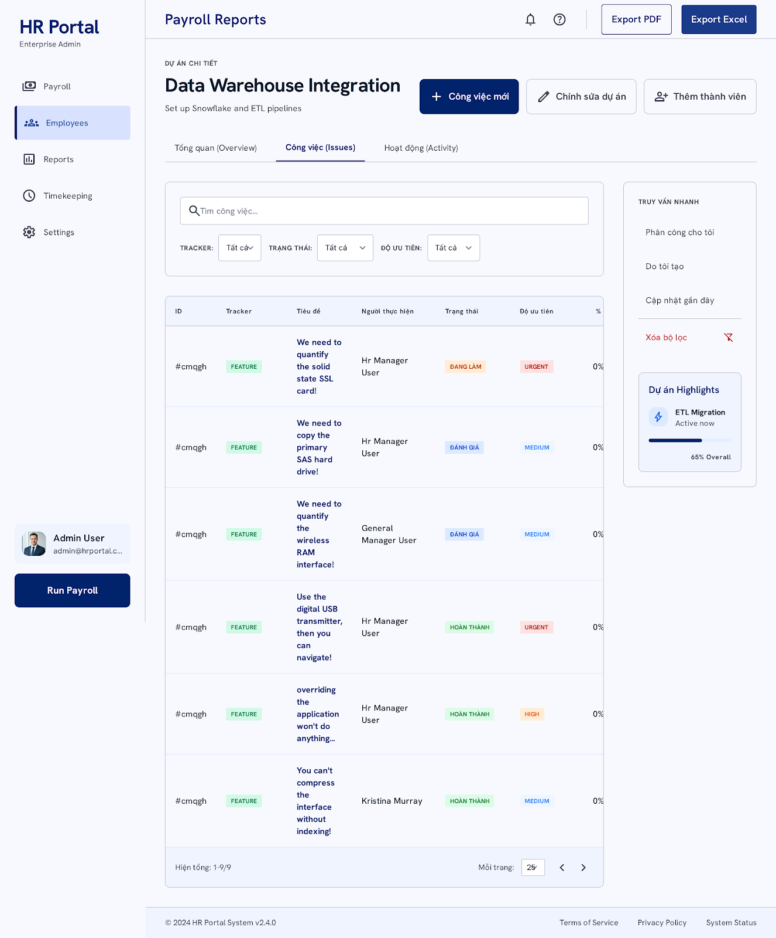

UI Elements:
Field Name | Field Type | Description
Tìm công việc... | Text Box | Filters tasks dynamically by search keywords matched against titles/descriptions.
Tracker | Dropdown Filter | Filters list by task category (feature, bug, etc.).
Trạng thái | Dropdown Filter | Filters list by status (todo, in_progress, etc.).
Độ ưu tiên | Dropdown Filter | Filters list by priority (low, medium, high, urgent).
ID / Tracker / Tiêu đề | Table Columns | Double-click or click a row to view task details.
Công việc mới | Button | Navigates the user to the Create Task Screen.

Database Access:
Table | CRUD | Description
Task | R | Retrieve all tasks linked to the project ID.
Employee | R | Join employee table to display assignee name and avatar.

PostgreSQL (Supabase) Commands:
1/ Fetch Project Tasks with Filtering:
SQL
SELECT t.*, e."fullName" AS "assigneeName", e."avatarUrl" AS "assigneeAvatar"
FROM "Task" t
LEFT JOIN "Employee" e ON t."assigneeId" = e."id"
WHERE t."projectId" = 'project_target_uuid_123'
AND t."title" ILIKE '%search_term%'
AND t."tracker" = 'feature' -- Optional filters
AND t."status" = 'in_progress'
ORDER BY t."createdAt" DESC
LIMIT 25 OFFSET 0;

IV. Appendix

1. Assumptions & Dependencies
[Record any assumptions that were made when conceiving the project and writing this vision and scope document. Note any major dependencies the project must rely upon for success, such as specific technologies, third-party vendors, development partners, or other business relationships.]
<<Sample:
AS-1: Systems with appropriate user interfaces will be available for cafeteria employees to process the expected volume of meals ordered.
AS-2: Cafeteria staff and vehicles will be available to deliver all meals for specified delivery time slots within 15 minutes of the requested delivery time.
DE-1: If a restaurant has its own on-line ordering system, the Cafeteria Ordering System must be able to communicate with it bi-directionally.
>>

2. Limitations & Exclusions
[Identify any product features or characteristics that a stakeholder might anticipate, but which are not planned to be included in the new product]

3. Business Rules
[Provide common business rules that you must follow. The information can be provided in the table format as the sample below]
<<Sample
ID | Category | Rule Definition
BR-01 | Constraints | Delivery time windows are 15 minutes, beginning on each quarter hour.
BR-02 | Constraints | Deliveries must be completed between 10:00 A.M. and 2:00 P.M. local time, inclusive.
BR-03 | Facts | All meals in a single order must be delivered to the same location.
BR-04 | Facts | All meals in a single order must be paid for by using the same payment method.
BR-11 | Constraints | If an order is to be delivered, the patron must pay by payroll deduction.
BR-12 | Computations | Order price is calculated as the sum of each food item price times the quantity of that food item ordered, plus applicable sales tax, plus a delivery charge if a meal is delivered outside the free delivery zone.
>>

