Code Documentation: Procedural Music Generator
COMP 4980, Portfolio Element 2
1. What the code does
music_project.py makes short pieces of background music using simple rules (no AI) and saves them as MIDI files. It builds the music in four versions, each adding one rule (A: random, B: C major scale, C: weighted walk and rhythm rules, D: chords and bass), measures what each rule changes, and checks it like a PCG system: is it fast, does it follow its rules, does it give variety, and can a designer control it.
2. How to run it
Install the libraries once:
pip3 install numpy matplotlib midiutil
Then run it from the project folder:
python3 music_project.py
It takes a few seconds. The results go into a results folder: the MIDI files in midi/, the note lists in notes/, two piano-roll figures and summary.txt. Each piece uses a fixed seed, so the output is the same every time.
3. How the music is built
A note is stored as (pitch, start beat, length in beats), where the pitch is a MIDI number such as 60 for middle C. Every piece is 8 bars of 4/4. The full version builds a piece in three layers:
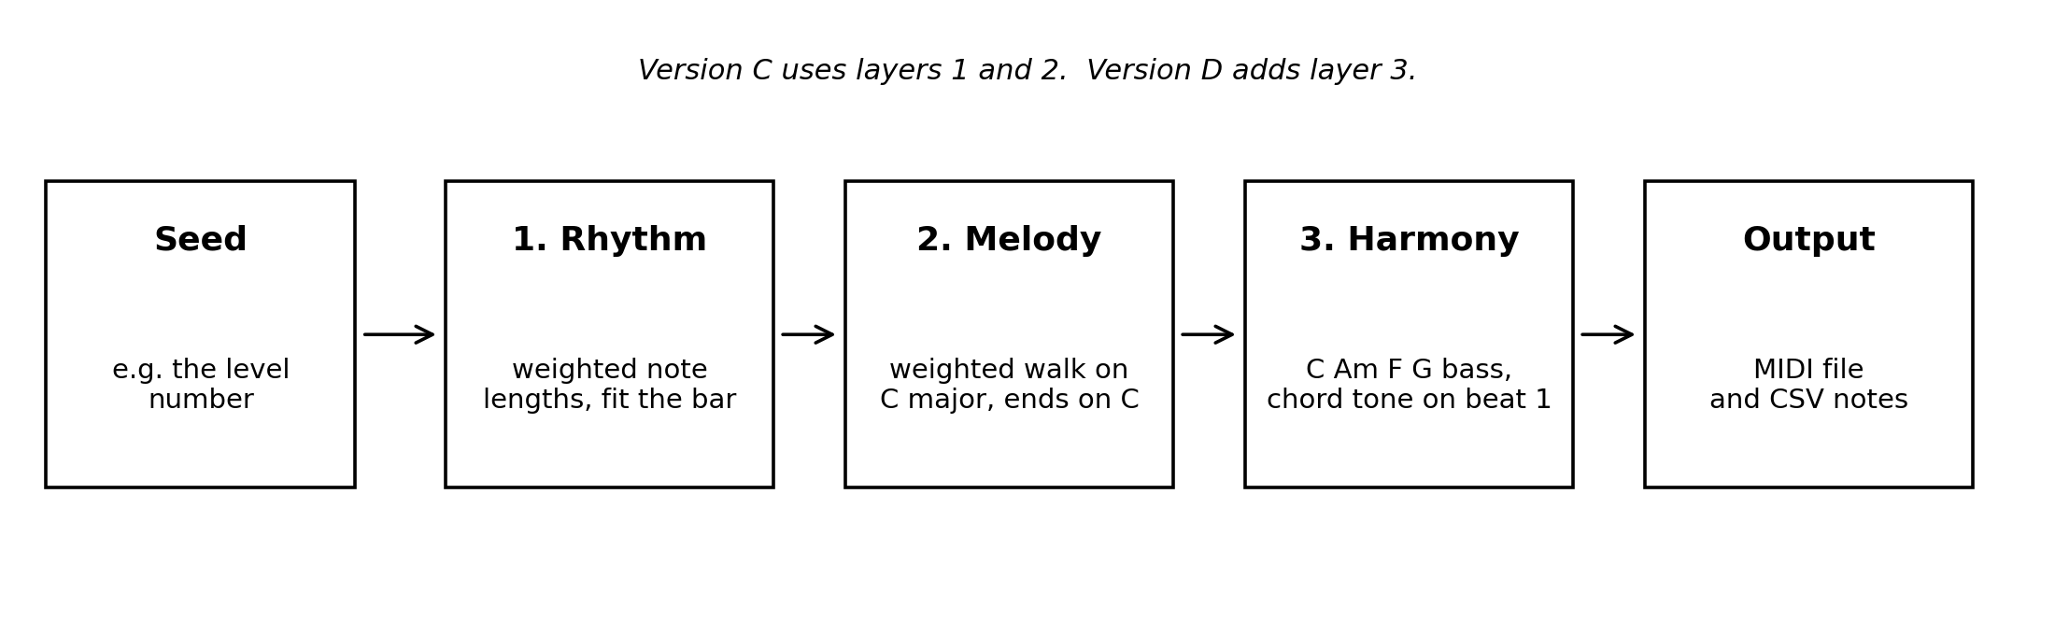
Fig. 1. The three layers of the generator
- Rhythm: ruled_rhythm picks eighth, quarter and half notes with weights 3, 5 and 2, and only picks lengths that still fit in the bar.
- Melody: walk moves along the C major scale. A move of one step is 6 times as likely as a jump of four steps, so the tune mostly moves to nearby notes. The last note becomes the closest C.
- Harmony: version_d adds a bass note per bar (C, Am, F, G, ending G then C), and the first melody note of each bar has to be a note of that bar's chord.
4. How the code is organized
- Settings at the top: tempo, number of bars, the scale, the note-length weights, the step weights and the chords.
- Helpers: free_rhythm, ruled_rhythm, chord_for_bar and add_starts.
- The four versions: version_a to version_d. Each takes a seed and returns the melody and the bass notes.
- Metrics: measure works out the values for one piece, and difference compares pieces with each other.
- Output: save_midi writes the MIDI file with MIDIUtil, save_csv writes the note list and draw_piano_rolls draws the figures.
- Main: main makes the samples, compares 200 pieces per version, runs the PCG checks, the sample size check and the step weight check, and makes three level pieces for the game demo.
5. Use cases
- Run everything: run the script and get the results folder.
- Make one piece: version_d(7) gives a full piece for seed 7. The same seed always gives the same piece.
- Music for a game level: use the level number as the seed, so each level always gets its own piece without storing any audio.
- Measure a piece: measure(melody) gives back values such as the share of notes in key and the average jump.
6. Limitations
- The measures describe structure, not how good the music sounds to a listener.
- Only C major, one tempo and one chord loop are used.
- The pieces have no repeated themes, so longer pieces could sound aimless.

