From Random Notes to Game Music: Measuring What Simple Rules Add to a Procedural Music Generator
COMP 4980, Portfolio Element 2
Abstract: Games often use procedural content generation (PCG) so that content is different each time, and background music can be made the same way. This paper presents a small rule-based music generator written in Python that writes MIDI files, and measures what each rule changes. Four versions are compared: random notes, notes limited to the C major scale, a weighted random walk with rhythm rules, and the same walk with a chord progression and bass line. Over 200 pieces per version, the scale alone puts every note in key but leaves an average jump of 8.7 semitones between notes. The weighted walk lowers this to 2.6, and the chord rule places a chord tone on every downbeat. The final version followed all of its rules in every piece, two pieces still differed at about 90% of note positions, and one 19-second piece took about 0.1 ms to make.
Keywords: procedural content generation, algorithmic composition, game music, Markov process, MIDI

Introduction
Procedural content generation creates game content with algorithms instead of by hand, so that each play can be different [1]. Music is a good fit for this, because a normal soundtrack plays the same way every time a level is played, while generated music can change on every run [2]. Using computers to compose is not new. Hiller and Isaacson produced the Illiac Suite with rules and random choices in the 1950s [3], and many later systems use Markov models, grammars or other algorithms [4].
The simplest generator just picks random notes, but that rarely sounds like music. So the question for this project is: which simple rules turn random notes into music a game could use, and what does each rule add? To answer it, the generator is built in four versions that each add one rule, and every version is measured over 200 pieces. The generator is also checked against the properties PCG expects from a content generator: speed, reliability, diversity and control [1].

Method

Note Representation
A piece is a list of notes, each stored as a MIDI pitch, a start beat and a length in beats. All pieces are eight bars of 4/4 at 100 beats per minute, so each lasts 19.2 s. The melody uses the two octaves from C4 (MIDI 60) to C6 (MIDI 84).

Four Versions
Version A picks any of the 25 notes in the range and an eighth, quarter or half note with equal chance. Version B keeps the same rhythm but picks only from the 15 notes of the C major scale in that range.
Version C adds three rules. First, the melody is a weighted random walk on the scale: from the current note it moves up to four scale steps down or up, with weights 1, 1, 3, 6, 2, 6, 3, 1, 1 for moves of -4 to +4. A one-step move is therefore six times as likely as a four-step leap, following the finding that small intervals are the most common in real melodies [6]. This is a simple first-order Markov process, where the next note depends only on the current one [5]. Second, note lengths are weighted 3:5:2 for eighth, quarter and half notes, and only lengths that fit in the rest of the bar are allowed. Third, the last note is moved to the nearest C so the piece sounds finished.
Version D adds harmony. A bass line plays one note per bar following the common progression C, Am, F, G, and the last two bars are always G and C. At the start of every bar, the walk may only choose notes from that bar's chord.

Measures
Each piece is measured by the share of notes in key, the average move between notes in semitones, the share of small moves (two semitones or less) and big leaps (more than seven), the share of notes crossing a bar line, whether it ends on C, and the share of bars that start on a chord tone. For the PCG checks, speed is the time to build one piece, reliability is the number of pieces that follow all rules, and diversity is the share of eighth-note positions where two pieces play different notes, averaged over all pairs of the first 100 pieces. This follows the idea of judging a generator by its whole output rather than a few samples [7].

Implementation
The generator is one Python file that uses MIDIUtil to write MIDI files, NumPy for the statistics and Matplotlib for the figures. Each version is a function that takes a seed and returns the melody and bass notes, so the same seed always gives the same piece. This is useful for games, because a level can store its number as the seed instead of an audio file and still get the same music every time. A run writes a sample MIDI file and note list per version, three level pieces from version D, the figures and a summary of all results in about 1.5 s.

Results
TABLE I
Effect of Each Rule (Mean of 200 Pieces)
Measure | A | B | C | D
In key (%) | 61.0 | 100 | 100 | 100
Avg move (semitones) | 8.6 | 8.7 | 2.6 | 2.6
Small moves (%) | 18.4 | 18.3 | 60.7 | 59.2
Big leaps (%) | 50.5 | 50.2 | 0.3 | 0.2
Cross bar line (%) | 14.4 | 14.4 | 0 | 0
Ends on C (%) | 14.5 | 19.5 | 100 | 100
Chord tone on beat 1 (%) | 26.9 | 46.4 | 50.7 | 100

Table I shows the effect of each rule. The scale (B) puts every note in key, up from 61% in A, but leaves the melody as jumpy as random notes: about half of all moves are leaps larger than a fifth. The weighted walk (C) is what makes it sound like a melody. The average move drops from 8.7 to 2.6 semitones and big leaps almost disappear. The rhythm rules remove all bar-line crossings, and every piece ends on C. Version C already starts about half of its bars on a chord tone by chance, and the chord rule in D raises this to every bar. Fig. 1 shows one piece from each version.
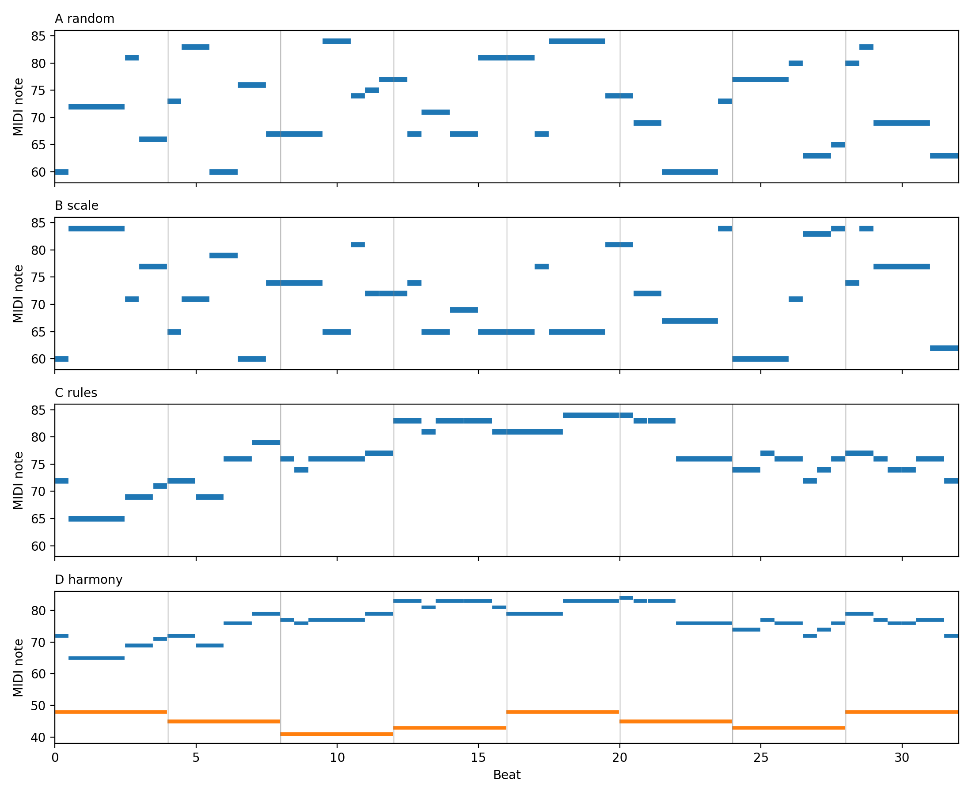
Fig. 1. Piano rolls of one piece from each version (seed 1). Blue is the melody and orange is the bass.
TABLE II
PCG Checks (200 Pieces per Version)
Check | A | B | C | D
Time per piece (ms) | 0.02 | 0.02 | 0.09 | 0.10
Follows all rules | 0 | 0 | 200 | 200
Unique pieces | 200 | 200 | 200 | 200
Different notes (%) | 96.0 | 93.3 | 90.0 | 88.6

Table II gives the PCG checks. Versions C and D followed all of their rules in all 200 pieces, while A and B never did. Every piece of every version was unique, and two D pieces differ at 88.6% of note positions against 96.0% for random notes, so adding the rules only lowered the variety a little. Each piece takes about 0.1 ms to build, far less than its 19.2 s length.
Two checks support the setup. With 25 pieces the margin of error for the share of small moves is about 3 to 4 points, at 200 it is about 1, and 400 pieces improve it only slightly, while the order of the versions is the same at every size. For the step weights, making every move equally likely raises the average move to 3.6 semitones and lowers small moves to 38%, while allowing only single steps gives 98% small moves but shrinks the range from 18.1 to 12.4 semitones, so the melody barely travels. The chosen weights are in between the two.

Conclusion
Each rule fixed one problem that could be measured. The scale fixed wrong notes, the weighted walk fixed the big jumps, the rhythm rules fixed notes crossing bar lines and the endings, and the chord rule made the melody fit the chords. Together they make a generator that a game could use for background music, since it is fast, follows its rules every time and still makes a different piece for every seed. The main limitation is that the measures only describe structure, not whether the music sounds good, so a listening test with players would be the next step. All pieces also share one key, tempo and chord loop. Future work could offer minor keys and other progressions as designer controls, repeat short motifs to give longer pieces shape, and let the music react to events in the game [2].

References
[1] N. Shaker, J. Togelius, and M. J. Nelson, Procedural Content Generation in Games. Cham, Switzerland: Springer, 2016.
[2] C. Plut and P. Pasquier, “Generative music in video games: State of the art, challenges, and prospects,” Entertainment Computing, vol. 33, Art. no. 100337, 2020, doi: 10.1016/j.entcom.2019.100337.
[3] L. A. Hiller and L. M. Isaacson, Experimental Music: Composition with an Electronic Computer. New York, NY, USA: McGraw-Hill, 1959.
[4] G. Nierhaus, Algorithmic Composition: Paradigms of Automated Music Generation. Vienna, Austria: Springer, 2009.
[5] C. Ames, “The Markov process as a compositional model: A survey and tutorial,” Leonardo, vol. 22, no. 2, pp. 175-187, 1989.
[6] P. G. Vos and J. M. Troost, “Ascending and descending melodic intervals: Statistical findings and their perceptual relevance,” Music Perception, vol. 6, pp. 383-396, 1989.
[7] G. Smith and J. Whitehead, “Analyzing the expressive range of a level generator,” in Proc. Workshop Procedural Content Generation in Games (PCGames), Monterey, CA, USA, 2010, pp. 1-7.

